Contents lists available at ScienceDirect

Food and Chemical Toxicology

journal homepage: www.elsevier.com/locate/foodchemtox

N-phenethyl caffeamide and photodamage: Protecting skin
by inhibiting type I procollagen degradation
and stimulating collagen synthesis
Hsiu-Mei Chiang a,⇑, Chien-Wen Chen a, Tzu-Yu Lin a, Yueh-Hsiung Kuo b,c,⇑
a Department of Cosmeceutics, China Medical University, Taichung 404, Taiwan
b Department of Chinese Pharmaceutical Sciences and Chinese Medicine Resources, China Medical University, Taichung 404, Taiwan
c Department of Biotechnology, Asia University, Taichung 413, Taiwan

a r t i c l e i n f o

Keywords:
N-phenethyl caffeamide
Photodamage
Collagen
Mitogen-activated protein (MAP) kinase
Activator protein-1 (AP-1)
Smad

1. Introduction

a b s t r a c t

Skin is mainly damaged by genetic and environmental factors such as ultraviolet (UV) light and pollu-
tants. UV light is a well-known factor that causes various types of skin damage and premature aging.
Reactive oxygen species (ROS) are commonly involved in the pathogenesis of skin damage by activating
the metalloproteinases that break down type I collagen. This study investigated the antioxidant and anti-
photodamage activity and mechanisms of N-phenethyl caffeamide (K36) in human skin ﬁbroblasts. The
results indicated that K36 demonstrated strong 1,1-diphenyl-2-picrylhydrazyl radical (DPPH) scavenging
activity, which dose-dependently reduced the production of UVB-induced intracellular ROS in human
dermal ﬁbroblasts. K36 prevented UVB-irradiation-induced type I collagen degradation by inhibiting
the expression of matrix metalloproteins-1, -3, and -9 and the phosphorylation of mitogen-activated
protein (MAP) kinases. Furthermore, K36 elevated collagen synthesis in skin ﬁbroblasts by inhibiting
UVB-induced Smad7 overexpression. K36 downregulated the expression of the transcription factor,
activator protein-1 (AP-1). Our results indicated that K36 exhibited antioxidant properties and prevented
skin collagen degradation caused by UV exposure and the stimulation of collagen synthesis, which
suggests the potential use of K36 in preventing photodamage.

kinase and PI3K/AKT (Lopez-Camarillo et al., 2012). MAP kinases
directly phosphorylate proteins of the activator protein-1 (AP-1)

Ultraviolet (UV) irradiation is a major cause of extrinsic skin
damage and generates reactive oxygen species (ROS), which cause
skin disorders including DNA damage and skin cancer (D’Orazio
et al., 2013). ROS triggers a series of signaling transductions and
activating inﬂammatory cytokines, which subsequently activate
protein kinases such as the mitogen-activated protein (MAP)

Abbreviations: AP-1, activator protein-1; CAPE, caffeic acid phenethyl ester;
DCFDA, 20 ,70-dichloroﬂuorescin diacetate; DMEM, Dulbecco’s modiﬁed Eagle’s
medium; DMSO, dimethyl sulfoxide; DPPH, 1,1-diphenyl-2-picrylhydrazyl radical;
ECM, extracellular matrix; K36, N-phenethyl caffeamide; MAP kinase, mitogen-
activated protein kinase; MMPs, matrix metalloproteins; MTT, thiazolyl blue
tetrazolium bromide; ROS, reactive oxygen species; SDS, sodium dodecyl sulfate;
UV, ultraviolet.
⇑ Corresponding authors. Tel.: +886 4 22053366x5302; fax: +886 4 22078083
(H.-M. Chiang). Address: Department of Chinese Pharmaceutical Sciences and
Chinese Medicine Resources, China Medical University, Taichung 404, Taiwan. Tel.:
+886 4 22053366x5701 (Y.-H. Kuo).
E-mail addresses: hmchiang@mail.cmu.edu.tw (H.-M. Chiang), kuoyh@mail.cmu.
edu.tw (Y.-H. Kuo).

complex, promoting the translocation of this transcription factor
into the nucleus that regulates the expression and activity of
downstream protein (Bachelor and Bowden, 2004; Lopez-
Camarillo et al., 2012). AP-1 upregulates the matrix metalloprotein
(MMP) gene and protein expression, resulting in an extracellular
matrix (ECM), such as collagen and elastin degradation, which
subsequently causes ﬁne lines, wrinkles, and sagging skin
(Hwang et al., 2011; Kim et al., 2013). In addition, AP-1 downreg-
ulates human alpha1(I) collagen (COL1A1) and human alpha2(I)
collagen (COL1A2) gene expression, causing a decrease in type I
collagen mRNA (Bornstein, 1996; Chung et al., 1996).
The transforming growth factor b (TGF-b) induces synthesis and
the secretion of collagen and elastin, and also inhibits the expres-
sion of enzymes involved in the breakdown of collagens such as
MMP-1, MMP-3, and MMP-9 (Chiang et al., 2012; Rittie and
Fisher, 2002). TGF-b binds with TGF-b receptor I and phosphory-
lates Smad proteins Smad2 and Smad3, which can form hetero-
meric complexes with Smad4. The complex is transferred into
the nucleus of ﬁbroblasts, resulting in collagen gene transcription.





(a)

(b) 120
100

80

60

40

20

2.2. Measuring DPPH radical scavenging activity

The DPPH radical scavenging activity assay was modiﬁed from that used in a
previous study (Chiang et al., 2013a). Reaction mixtures containing a methanolic
solution of DPPH and 2–100 lM samples were placed in a 96-well microplate at
room temperature and incubated for 30 min. After incubation, the absorbance
was determined at 492 nm by using an ELISA reader (Tecan, Austria).

2.3. Cell culture and UV irradiation

Human foreskin ﬁbroblasts (Hs68) were obtained from the Bioresource
Collection and Research Center (Hsinchu, Taiwan). Hs68 cells were maintained in
DMEM, and supplemented with 10% FBS, 100 U/mL of penicillin, and 100 U/mL of
streptomycin in a humidiﬁed atmosphere of 5% CO2 at 37 °C. The cells in a
phosphate-buffered saline (PBS) were exposed to UVB at a dosage of 40 mJ/cm2.
A CL-1000M UV Crosslinker (UVP, Upland, CA, USA) was used as the UVB source,
delivering a UVB energy spectrum of 302 nm. After UV exposure, the cells were
incubated for 24 h at 37 °C in a humidiﬁed atmosphere of 5% CO2 in serum-free
DMEM containing various concentrations of K36. The cytotoxicity of K36 was eval-
uated in the cells cultured for 3 h by using the MTT assay described previously
(Chiang et al., 2012, 2011). The concentrations of K36 used in this study were based
on preliminary studies that have reported the successful prevention of photodam-
age and no cytotoxicity.

0

0 5 10 25 50

K36 (∝M)

2.4. Intracellular reactive oxygen species assay

Fig. 1. (a) Structure of N-phenethyl caffeamide (K36). (b) Cell viability (%) of K36.

UV can modulate TGFb/Smad signal transduction by reducing the
TGFb receptor, subsequently inhibiting the phosphorylation of
Smad2/Smad3 and increasing Smad7 (inhibitory Smads), and
resulting in the inhibition of collagen synthesis (Rittie and Fisher,
2002; Wen et al., 2012).
Studies have suggested that antioxidant materials that inhibit
MMP expression can be used to protect the skin from photodamage
(Chiang et al., 2012, 2011). N-phenethyl caffeamide (K36) (Fig. 1a) is
an analogue of caffeic acid phenethyl ester (CAPE), which is derived
from caffeic acid and is an active component of propolis (Grunberger
et al., 1988). Caffeic acid derivatives have been reported to demon-
strate antioxidant, analgesic, and neuroprotective activities (Chiang
et al., 2011; de Campos Buzzi et al., 2009; Fu et al., 2013). A previous
study reported that caffeic acid inhibits UVB-induced MMP-3 over-
expression (Chiang et al., 2011). CAPE exhibits antioxidant, immu-
nomodulatory, and antineoplastic activities (Akyol et al., 2013;
Ozturk et al., 2012), and its antioxidant and ROS-scavenging capabil-
ities accelerates wound healing in rats (Serarslan et al., 2007). In
addition, CAPE inhibits MMP expression in human hepatocellular
carcinoma cells (Lee et al., 2008). Caffeamide derivatives are a more
stable compound than CAPE is and could potentially extend the
beneﬁcial effects of CAPE (Yang et al., 2012). However, few studies
have explored how K36 protects against UV-induced skin damage;
therefore, this study explored the photodamage prevention activity
and signaling transduction of K36 in human skin ﬁbroblasts.

2. Materials and methods

2.1. Materials and reagents

K36 was synthesized and identiﬁed by the author, Professor Yueh-Hsiung Kuo
(Chou et al., 2010), and was dissolved in dimethyl sulfoxide (DMSO) for experimen-
tation; the ﬁnal concentration of DMSO in the treated medium was less than 0.1%. A
Bradford reagent was supplied by Bio-Rad Laboratories (Hercules, CA, USA). The 1,1-
diphenyl-2-picrylhydrazyl radical (DPPH); 1,2-propandiol; 20,70-dichloroﬂuorescin
diacetate (DCFDA); bovine serum albumin; DMSO; phenylmethylsulfonyl ﬂuoride;
leupeptin; c-Jun amino-terminal kinase (JNK) inhibitor II; PD98059; and SB203580
were purchased from Sigma–Aldrich (St. Louis, MO, USA). Thiazolyl blue tetrazo-
lium bromide (MTT), sodium dodecyl sulfate (SDS), IGEPAL CA-630, Tris, and Tween
20 were obtained from USB Corporation (Cleveland, OH, USA). Fetal bovine serum
(FBS), penicillin–streptomycin, trypsin–EDTA, and Dulbecco’s modiﬁed Eagle’s
medium (DMEM) were purchased from Gibco, Invitrogen (Carlsbad, CA, USA). A
Western blotting detection reagent and PageRuler™ prestained protein ladder were
purchased from Amersham Biosciences (Little Chalfont, Buckinghamshire, England).
All other chemicals used in this study were reagent grade.
The intracellular ROS levels were assessed using a DCFDA reagent, as described
in previous studies (Chiang et al., 2012, 2011). Brieﬂy, the cells were seeded into
24-well plates, exposed to and treated with various concentrations of K36, and
washed with PBS. The ROS detection reagent DCFDA was then added to each well
for 30 min. Images were captured using a ﬂuorescence microscope (Leica DMIL,
Germany), and the ﬂuorescence (emission, 520 nm; excitation, 488 nm) was mea-
sured using a microplate reader (Thermo Electron Corporation, Vantaa, Finland).

2.5. Measuring total collagen synthesis

The total collagen synthesis exhibited by the cells was measured using a Sir-
col™ soluble collagen assay kit, which was modiﬁed based on a previous study
(Chiang et al., 2013a,b). In brief, the cell culture medium was collected, mixed with
an isolation and concentration reagent, and incubated. The Sircol™ dye was added
to the sample and the mixture was incubated. After centrifugation, an ice-cold acid-
salt washing reagent was added to the precipitate and the mixture was recentri-
fuged. The precipitate was dissolved with an alkali reagent and the absorbance
was determined at 555 nm by using an ELISA reader (Tecan, Grödig, Austria).

2.6. Western blot analysis

Changes in the levels of photodamaged proteins were evaluated using Western
blot analysis, as reported previously but with slight modiﬁcations (Chiang et al.,
2012, 2014). Cells were collected and washed with PBS and then lysed in a lysis buf-
fer. The cell supernatant was collected and the protein concentration was measured
using the Bradford reagent. The cell lysates contained 30 lg of protein per lane and
were separated using sodium dodecyl sulfate–polyacrylamide gel electrophoresis,
transferred to poly(vinylidene diﬂuoride) membranes, and treated with appropri-
ated antibodies for Western blotting. b-actin was used to normalize the total
protein amount. Immunoreactive proteins were detected using an ECL Western
blotting detection system (Fujiﬁlm, LAS-4000, Japan), and the signal strengths were
quantiﬁed using a densitometric program (MultiGauge V2.2).

2.7. MMP-1 and MMP-9 activity assays

The cells were planted in 6-well plates, exposed to UVB irradiation, and incu-
bated with various concentrations of samples for 24 h. The amount of active
MMP-1 and MMP-9 in the cells after UVB exposure was measured using the Human
Active MMP-1 Fluorescent Assay Kit and Human Active MMP-9 Fluorescent Assay
Kit (R&D Systems, Inc., USA) according to manufacturer protocols. The ﬂuorescence
(emission, 405 nm; excitation, 320 nm) was measured using a microplate reader
(Thermo Electron Corporation, Finland).

2.8. Data analysis

All data were recorded as the averages derived from independent experiments
performed in triplicate; the results were expressed as means ± standard deviation.
The differences between groups were analyzed for statistical signiﬁcance by using
the Student’s t test or analysis of variance; p < 0.05 was considered statistically sig-
niﬁcant. The dose–response relationship was analyzed using the Jonckheere Trend
test.
Cell viability (%)
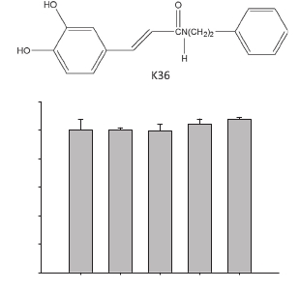

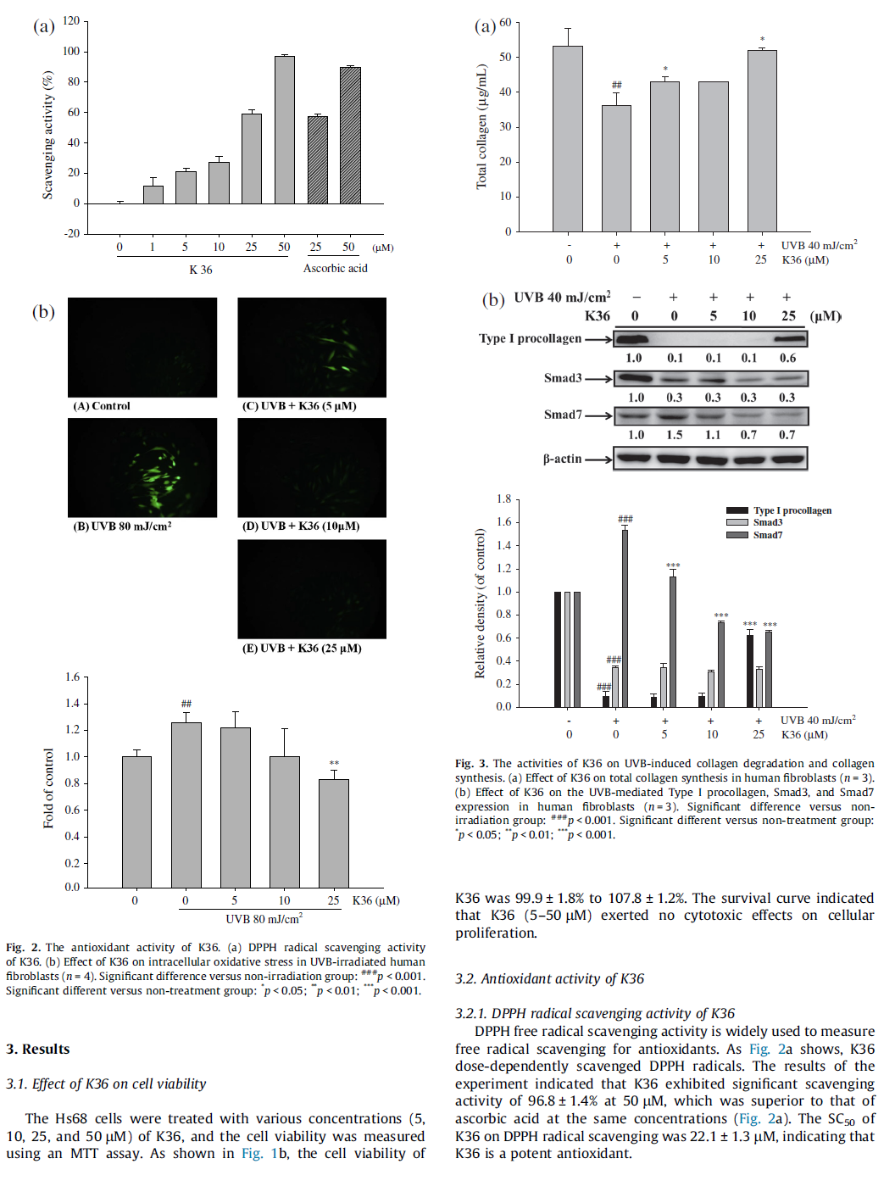

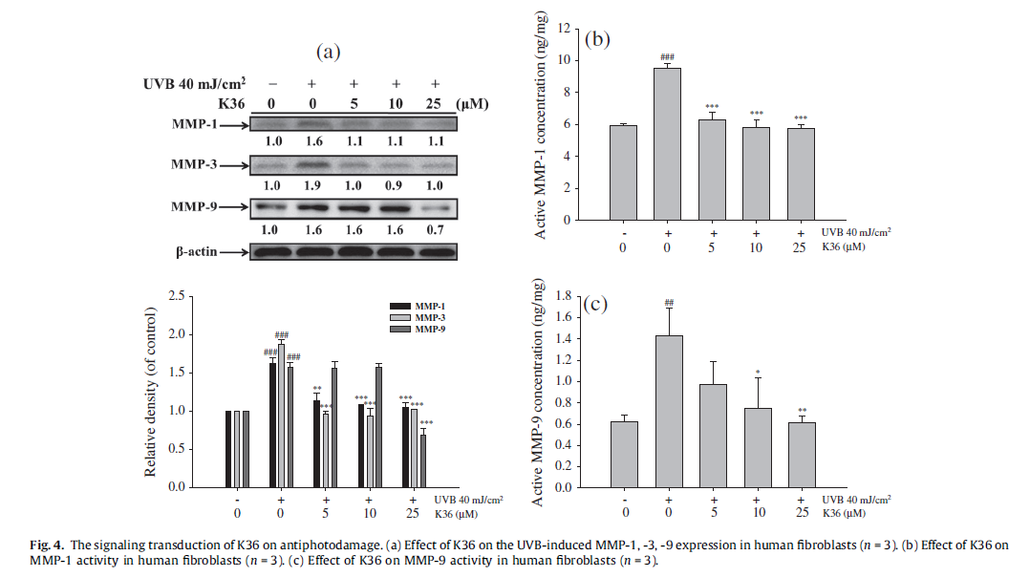

3.2.2. K36 reduced UVB-induced intracellular ROS in human skin
ﬁbroblasts
The DCFDA method involves measuring the intracellular
generation of hydrogen peroxide and is an indirect procedure
for estimating ROS. K36 pretreatment inhibited the intracellu-
lar ROS production in UVB-irradiated ﬁbroblasts in a dose-
dependent manner and signiﬁcantly inhibited that at 25 lM
(Fig. 2b). These results indicated that treatment with K36 signif-
icantly suppressed ROS generation induced by UVB in human
skin ﬁbroblasts.

3.3. Activity of K36 on type I collagen expression and collagen
synthesis

3.3.1. K36 attenuated the UVB-induced reduction in total collagen
synthesis in human skin ﬁbroblasts
Fig. 3a shows that the total collagen in the control was

3.0

2.5

###
p-ERK
p-JNK
p-p38
53.3 ± 4.9 lg/mL, which decreased to 36.2 ± 3.6 lg/mL after UV
irradiation. K36 treatment dose-dependently restored collagen
and K36, signiﬁcantly increasing collagen synthesis at 5 lM, and

2.0

###
*
restored the collagen (51.9 ± 0.9 lg/mL) to a level similar to that
of the control at 25 lM (Fig. 3a).

###

1.5

1.0

0.5

0.0
**
** **
**
**
***

3.3.2. K36 up-regulated type I procollagen expression reduced by UVB
irradiation
ECM, including collagen, is responsible for skin strength and
elasticity. The ﬁbroblasts were treated with K36 (5–25 lM) for
24 h after exposure to UVB irradiation, and type I procollagen lev-
els were measured using Western blot analysis. UVB exposure

- + + + +
0 0 5 10 25
UVB 40 mJ/cm2
K36 (∝M)
reduced the type I procollagen expression 0.1-fold compared with
the control and K36 treatment, and signiﬁcantly increased the

Fig. 5. Effect of K36 on the UVB-induced phosphorylation of MAP kinases in human
ﬁbroblasts (n = 3).
expression of type I procollagen to 0.6-fold of the control at the
concentration of 25 lM (Fig. 3b).
Relative density (of control)
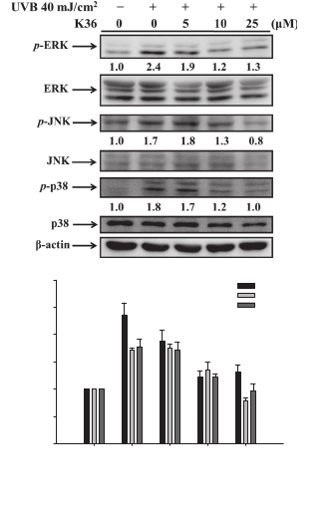

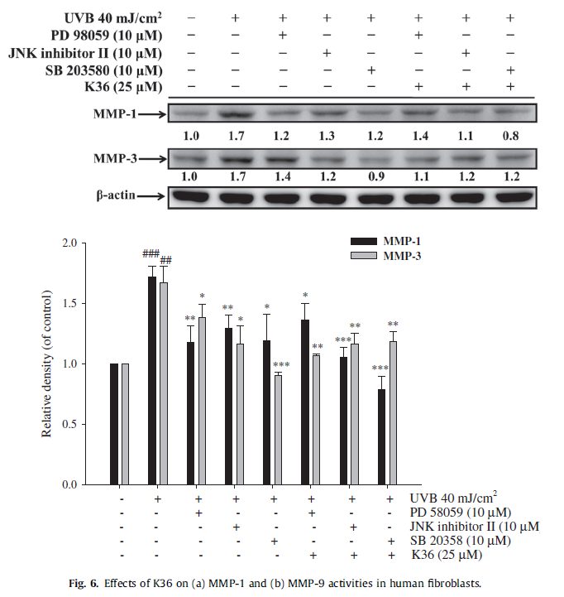

3.3.3. Effect of K36 on Smad3 and Smad7 expressions
UVB irradiation downregulated Smad3 expression and
upregulated Smad7, resulting in collagen synthesis inhibition. As
Fig. 3b shows, UVB irradiation reduced Smad3 protein expression
to 0.3-fold of that of the control group, and increased Smad7 to
1.5-fold. The Smad7 expression in ﬁbroblasts treated with K36
was 1.1-fold higher in cells treated with 5 lM K36 (Fig. 3b).

3.4. The signaling transduction of K36 on antiphotodamage activity

3.4.1. Effect of K36 on MMP expression
To evaluate the effects of K36 on MMP expression in
UVB-induced ﬁbroblasts, cells were exposed to UVB and the
MMP-1, -3, and -9 expressions were measured. Fig. 4a shows that
the UVB irradiation signiﬁcantly elevated the MMP-1, -3, and -9
protein expression levels (1.6-, 1.9-, and 1.6-fold compared with
those of the control group), whereas K36 treatment attenuated
the expression of MMPs. The UVB-induced MMP-1 and MMP-3
expressions were reduced 1.1- and 1.0-fold, respectively, by using
5 lM K36 treatment. K36 treatment at 25 lM signiﬁcantly sup-
pressed the level of UVB-induced MMP-9 expression 0.7-fold com-
pared with that of the control group.

3.4.2. Effect of K36 on MMP-1 and -9 activities
The activity levels of MMP-1 and -9 increased after UVB expo-
sure (Fig. 4b and c). The MMP-1 activity level increased 1.6-fold
compared with that of the control group after UVB irradiation,
and signiﬁcantly decreased to 1.1-fold after 5 lM K36 treatment
(Fig. 4b). The MMP-9 activity level increased 2.3-fold compared
with that of the control group after UVB irradiation, and

signiﬁcantly decreased to 1.2-fold after 10 lM K36 treatment
(Fig. 4c). The results indicated that K36 dose-dependently inhibited
UVB-induced MMP-1 and -9 activities.

3.4.3. Effect of K36 on MAP kinase expression
To determine whether K36 inhibited MMP expression in UVB-
induced ﬁbroblasts by blocking MAP kinase phosphorylation, we
examined the effects of K36 on the phosphorylation of extracellu-
lar signal-regulated kinase (ERK), JNK, and p38. Fig. 5 shows that
ERK phosphorylation increased 2.4-fold compared with that of
the control after UVB irradiation, although treatment with
5 lM K36 signiﬁcantly diminished this effect. The JNK and p-38
phosphorylation results resembled those of ERK; treatment with
10 lM K36 signiﬁcantly and dose-dependently decreased the
phosphorylation of JNK and p-38 protein expression to 1.3- and
1.2-fold, respectively (Fig. 5).

3.4.4. Effect of the K36 of MAP kinase inhibitors on MMP expression
To conﬁrm whether the inhibition of K36 on MMPs is caused by
MAP kinase, we used MAP kinase inhibitors to examine the effects
of K36 on MMP expression. Inhibition of ERK phosphorylation by
pretreatment with PD98059 resulted in the inhibition of MMP-1
and -3 expressions. The JNK inhibitor II and p-38 phosphorylation
inhibitors’ (SB 203580) results resembled those of ERK inhibitors.
Cotreatment with K36 and MAP kinase inhibitors signiﬁcantly
decreased MMP-1 and -3 expressions (Fig. 6).

3.4.5. Inhibition of K36 on AP-1 expression
Fig. 7 shows that UV irradiation induced the expression of c-Fos,
p-c-Jun, and c-Jun (1.4-, 1.9-, and 1.4-fold compared with those of

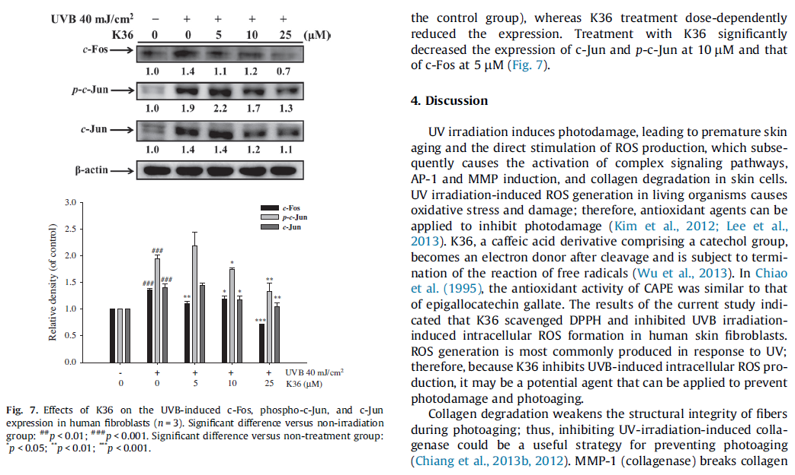

Fig. 8. Schematic diagram showing inhibitory effects of K36 on photodamage.
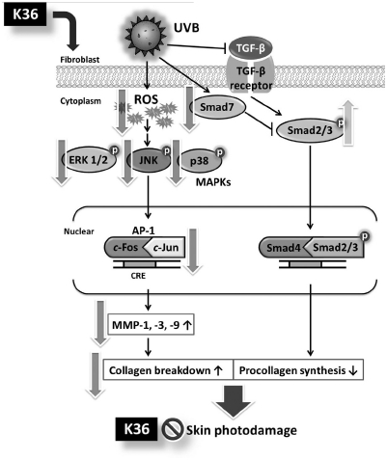

down in the skin, including type I, II, and III collagens; MMP-3 is a
stromelysin; and MMP-9 (gelatinase) degrades denatured colla-
gens (Quan et al., 2009). In our previous study, caffeic acid inhib-
ited the expression of MMP-1 and -9 but not that of MMP-3
(Chiang et al., 2011). Regarding human skin ﬁbroblasts, the results
from the current study indicated that K36 suppressed the
UVB-irradiation-induced expression of MMP-1, -3, and -9 and the
activities of MMP-1 and -9. Furthermore, K36 treatment restored
the degradation of UVB-induced type I collagen and promoted total
collagen synthesis.
Regulatory sites in MMP genes (50-ﬂanking regions) contain an
AP-1 regulatory element and several factors such as MAP kinases
regular AP-1 expression. AP-1 downregulates the expression of
COL1A1 and COL1A2 in the skin (Bornstein, 1996). In the current
study, K36 treatment inhibited the protein expression of UVB-
irradiation-induced c-Fos and c-Jun and the phosphorylation of
MAP kinases in ﬁbroblasts. Therefore, K36 can block MAP kinase/
AP-1/MMP signaling, thereby protecting skin collagen from
UV-induced degradation.
TGF-b bound to TGF-b receptors induces Smad2 and Smad3
phosphorylation (Szabo et al., 2010). Activated Smad2 and Smad3
bound to Smad4 translocate to the nucleus and cause collagen gene
expression. UV irradiation stimulates inhibitory Smad (Smad6 and
Smad7), thus inhibiting Smad2 and Smad3, and thereby reducing
the expression of type I procollagen and collagen synthesis (Choi
et al., 2007; Wen et al., 2012). K36 treatment inhibits UVB-induced
Smad7 expression. The modulating effects of K36 on Smad may
increase collagen synthesis and protect skin from UV damage.

5. Conclusion

In this study, K36 exhibited free radical scavenging activity;
inhibited UVB-induced ROS generation; suppressed the UVB-
induced overexpression of phosphorylated p38, JNK, and ERK;
and attenuated the overexpression of MMP-1, -3, and -9, thereby
increasing the expression of type I procollagen (Fig. 8). In addition,
K36 inhibited UVB-induced Smad7 overexpression to increase
collagen synthesis. K36 may inhibit UVB-induced collagen degra-
dation and stimulate collagen synthesis; therefore, it can serve as
an ideal antiphotodamage and antiphotoaging agent. Future stud-
ies can investigate the protective effects of K36 on skin from UV
irradiation damage in animal models.

Conﬂict of Interest

The authors declare that there are no conﬂicts of interest.

Transparency Document

The Transparency document associated with this article can be
found in the online version.

Acknowledgments

This study was sponsored by the National Science Council (NSC
100-2320-B-039-002-MY3 and 99-2622-B-039-001-CC3) and
partially by China Medical University under the Aim for the Top
University Plan of the Ministry of Education, Taiwan.

References

Akyol, S., Ozturk, G., Ginis, Z., Armutcu, F., Yigitoglu, M.R., Akyol, O., 2013. In vivo
and in vitro antineoplastic actions of caffeic acid phenethyl ester (CAPE):
therapeutic perspectives. Nutr. Cancer 65, 515–526.

Bachelor, M.A., Bowden, G.T., 2004. UVA-mediated activation of signaling pathways
involved in skin tumor promotion and progression. Semin. Cancer Biol. 14, 131–
138.
Bornstein, P., 1996. Regulation of expression of the alpha 1 (I) collagen gene: a
critical appraisal of the role of the ﬁrst intron. Matrix Biol.: J. Int. Soc. Matrix
Biol. 15, 3–10.
Chiang, H.M., Lin, T.J., Chiu, C.Y., Chang, C.W., Hsu, K.C., Fan, P.C., Wen, K.C., 2011.
Coffea arabica extract and its constituents prevent photoaging by suppressing
MMPs expression and MAP kinase pathway. Food Chem. Toxicol.: Int. J. Publ.
Brit. Indust. Biol. Res. Assoc. 49, 309–318.
Chiang, H.M., Chen, H.C., Lin, T.J., Shih, I.C., Wen, K.C., 2012. Michelia alba extract
attenuates UVB-induced expression of matrix metalloproteinases via MAP
kinase pathway in human dermal ﬁbroblasts. Food Chem. Toxicol.: Int. J. Publ.
Brit. Indust. Biol. Res. Assoc. 50, 4260–4269.
Chiang, H.-M., Chen, H.-C., Chiu, H.-H., Chen, C.-W., Wang, S.-M., Wen, K.-C., 2013a.
Neonauclea reticulata (Havil.) Merr stimulates skin regeneration after UVB
exposure via ROS scavenging and modulation of the MAPK/MMPs/collagen
pathway. Evidence-Complem. Altern. Med. 2013, 9.
Chiang, H.-M., Chiu, H.-H., Liao, S.-T., Chen, Y.-T., Chang, H.-C., Wen, K.-C., 2013b.
Isoﬂavonoid-rich Flemingia macrophylla extract attenuates UVB-induced skin
damage by scavenging reactive oxygen species and inhibiting MAP kinase and
MMP expression. Evidence-Complem. Altern. Med. 2013, 12.
Chiang, H.M., Chien, Y.C., Wu, C.H., Kuo, Y.H., Wu, W.C., Pan, Y.Y., Su, Y.H., Wen, K.C.,
2014. Hydroalcoholic extract of Rhodiola rosea L. (Crassulaceae) and its
hydrolysate inhibit melanogenesis in B16F0 cells by regulating the CREB/
MITF/tyrosinase pathway. Food and Chem. Toxicol.: Int. J. Publ. Brit. Indust. Biol.
Res. Assoc. 65, 129–139.
Chiao, C., Carothers, A.M., Grunberger, D., Solomon, G., Preston, G.A., Barrett, J.C.,
1995. Apoptosis and altered redox state induced by caffeic acid phenethyl ester
(CAPE) in transformed rat ﬁbroblast cells. Cancer Res. 55, 3576–3583.
Choi, M.S., Yoo, M.S., Son, D.J., Jung, H.Y., Lee, S.H., Jung, J.K., Lee, B.C., Yun, Y.P., Pyo,
H.B., Hong, J.T., 2007. Increase of collagen synthesis by obovatol through
stimulation of the TGF-beta signaling and inhibition of matrix
metalloproteinase in UVB-irradiated human ﬁbroblast. J. Dermatol. Sci. 46,
127–137.
Chou, Y.C., Sheu, J.R., Chung, C.L., Chen, C.Y., Lin, F.L., Hsu, M.J., Kuo, Y.H., Hsiao, G.,
2010. Nuclear-targeted inhibition of NF-kappaB on MMP-9 production by N-2-
(4-bromophenyl) ethyl caffeamide in human monocytic cells. Chem. Biol.
Interact. 184, 403–412.
Chung, K.Y., Agarwal, A., Uitto, J., Mauviel, A., 1996. An AP-1 binding sequence is
essential for regulation of the human alpha2(I) collagen (COL1A2) promoter
activity by transforming growth factor-beta. J. Biol. Chem. 271, 3272–3278.
de Campos Buzzi, F., Franzoi, C.L., Antonini, G., Fracasso, M., Cechinel Filho, V.,
Yunes, R.A., Niero, R., 2009. Antinociceptive properties of caffeic acid derivatives
in mice. Eur. J. Med. Chem. 44, 4596–4602.
D’Orazio, J., Jarrett, S., Amaro-Ortiz, A., Scott, T., 2013. UV Radiation and the Skin. Int.
J. Mol. Sci. 14, 12222–12248.
Fu, W., Du, G., Liu, D., Ruan, J.L., 2013. Neuroprotective effect of a caffeic acid
derivative from Abacopteris penangiana. Pharmaceut. Biol. 51, 376–382.
Grunberger, D., Banerjee, R., Eisinger, K., Oltz, E.M., Efros, L., Caldwell, M., Estevez, V.,
Nakanishi, K., 1988. Preferential cytotoxicity on tumor cells by caffeic acid
phenethyl ester isolated from propolis. Experientia 44, 230–232.
Hwang, Y.P., Kim, H.G., Choi, J.H., Han, E.H., Kwon, K.I., Lee, Y.C., Choi, J.M., Chung,
Y.C., Jeong, T.C., Jeong, H.G., 2011. Saponins from the roots of Platycodon
grandiﬂorum suppress ultraviolet A-induced matrix metalloproteinase-1
expression via MAPKs and NF-kappaB/AP-1-dependent signaling in HaCaT
cells. Food Chem. Toxicol.: Int. J. Publ. Brit. Indust. Biol. Res. Assoc. 49, 3374–
3382.
Kim, J.K., Mun, S., Kim, M.S., Kim, M.B., Sa, B.K., Hwang, J.K., 2012. 5,7-
Dimethoxyﬂavone, an activator of PPARalpha/gamma, inhibits UVB-induced
MMP expression in human skin ﬁbroblast cells. Exp. Dermatol. 21, 211–216.
Kim, M.S., Oh, G.H., Kim, M.J., Hwang, J.K., 2013. Fucosterol inhibits matrix
metalloproteinase expression and promotes type-1 procollagen production in
UVB-induced HaCaT cells. Photochem. Photobiol. 89, 911–918.
Lee, K.W., Kang, N.J., Kim, J.H., Lee, K.M., Lee, D.E., Hur, H.J., Lee, H.J., 2008. Caffeic
acid phenethyl ester inhibits invasion and expression of matrix
metalloproteinase in SK-Hep1 human hepatocellular carcinoma cells by
targeting nuclear factor kappa B. Genes Nutr. 2, 319–322.
Lee, J.K., Ko, S.H., Ye, S.K., Chung, M.H., 2013. 8-Oxo-20 -deoxyguanosine ameliorates
UVB-induced skin damage in hairless mice by scavenging reactive oxygen
species and inhibiting MMP expression. J. Dermatol. Sci. 70, 49–57.
Lopez-Camarillo, C., Ocampo, E.A., Casamichana, M.L., Perez-Plasencia, C., Alvarez-
Sanchez, E., Marchat, L.A., 2012. Protein kinases and transcription factors
activation in response to UV-radiation of skin: implications for carcinogenesis.
Int. J. Mol. Sci. 13, 142–172.
Ozturk, G., Ginis, Z., Akyol, S., Erden, G., Gurel, A., Akyol, O., 2012. The anticancer
mechanism of caffeic acid phenethyl ester (CAPE): review of melanomas, lung
and prostate cancers. Eur. Rev. Med. Pharmacol. Sci. 16, 2064–2068.
Quan, T., Qin, Z., Xia, W., Shao, Y., Voorhees, J.J., Fisher, G.J., 2009. Matrix-degrading
metalloproteinases in photoaging. J. Investigat. Dermatol. Symp. Proc./Soc.
Investigat. Dermatol., Inc. [and] Eur. Soc. Dermatol. Res. 14, 20–24.
Rittie, L., Fisher, G.J., 2002. UV-light-induced signal cascades and skin aging. Age.
Res. Rev. 1, 705–720.
Serarslan, G., Altug, E., Kontas, T., Atik, E., Avci, G., 2007. Caffeic acid phenethyl ester
accelerates cutaneous wound healing in a rat model and decreases oxidative
stress. Clin. Exp. Dermatol. 32, 709–715.

Szabo, H., Fiorino, G., Spinelli, A., Rovida, S., Repici, A., Malesci, A.C., Danese, S., 2010.
Review article: anti-ﬁbrotic agents for the treatment of Crohn’s disease –
lessons learnt from other diseases. Aliment. Pharmacol. Ther. 31, 189–201.
Wen, K.C., Fan, P.C., Tsai, S.Y., Shih, I.C., Chiang, H.M., 2012. Ixora parviﬂora protects
against UVB-induced photoaging by inhibiting the expression of MMPs, MAP
kinases, and COX-2 and by promoting Type I procollagen synthesis. Evidence-
Complement. Altern. Med.: eCAM 2012, 417346.

Wu, Y., Zheng, X., Xu, X.G., Li, Y.H., Wang, B., Gao, X.H., Chen, H.D., Yatskayer, M.,
Oresajo, C., 2013. Protective effects of a topical antioxidant complex containing
vitamins C and E and ferulic acid against ultraviolet irradiation-induced
photodamage in Chinese women. J. Drugs Dermatol.: JDD 12, 464–468.
Yang, J., Kerwin, S.M., Bowman, P.D., Stavchansky, S., 2012. Stability of caffeic acid
phenethyl amide (CAPA) in rat plasma. Biomed. Chromatogr.: BMC 26, 594–598.

