Article

DiteDiterpene Glycosides and Polyketides from Xylotumulus gibbisporus
Ya-Chih Chang,† Chung-Kuang Lu,‡ Yin-Ru Chiang,§ Guei-Jane Wang,⊥,∥ Yu-Ming Ju,▽
Yueh-Hsiung Kuo,○,Δ and Tzong-Huei Lee*,#
†
‡
§
⊥

∥
Department of Health and Nutrition Biotechnology, Asia University, Taichung, Taiwan 413

▽
○

Δ
Department of Biotechnology, Asia University, Taichung, Taiwan 413

#

S
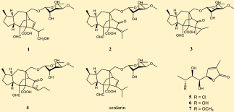

ABSTRACT: Four new tetracyclic diterpene glycosides,
namely, sordarins C−F (1−4), and three new γ-lactone
polyketides, namely, xylogiblactones A−C (5−7), along with
sordarin were isolated from the ethyl acetate extracts of the
fermented broths of Xylotumulus gibbisporus YMJ863. The
structures of 1−7 were elucidated on the basis of spectroscopic
data analyses. The conﬁgurations of 1−4 were deduced by
NOESY, molecular modeling, and comparison with the
literature. The relative conﬁgurations of 5−7 were deduced
by X-ray crystallographic analysis of 5. Compounds 1−5 and
sordarin were evaluated in an antifungal assay using Candida
albicans ATCC 18804, C. albicans ATCC MYA-2876, and
Saccharomyces cerevisiae ATCC 2345, and only sordarin exhibited signiﬁcant antifungal activities against these fungal strains, with
MIC values of 64.0, 32.0, and 32.0 μg/mL, respectively. The eﬀect of compounds 1−7 and sordarin on the inhibition of NO
production in lipopolysaccharide-activated murine macrophages was also evaluated. Compounds 2 and sordarin inhibited NO
production with IC50 values of 327.2 ± 46.6 and 157.1 ± 24.1 μM, respectively.

he family Xylariaceae is one of the most commonly
encountered groups of ascomycetes and is found
throughout the temperate and tropical regions of the world.
Some species categorized in this family have long been used in
traditional Chinese medicine preparations, suggesting that fungi
of the Xylariaceae could potentially be developed for medicinal
uses.1,2 Xylotumulus gibbisporus J. D. Rogers, Y.-M. Ju &
Hemmes, classiﬁed in Xylariaceae, was described for the ﬁrst
time from dead angiosperm wood collected from the Bird Park
area in Hawaii Volcanoes National Park in 2006.3 It has
aﬃnities with certain Xylaria species and is closely related
morphologically to Amphirosellinia Y.-M. Ju, J.D. Rogers, H.-M.
Hsieh & Vasilyeva in the same family.4 Although bioactive
compounds have been reported from Xylaria spp.,5−8 no
reports of secondary metabolites from this fungal species were
found in our survey of the scientiﬁc literature. Preliminary
pharmacological screenings demonstrated that the ethyl acetate
extracts of the fermented broths of X. gibbisporus YMJ863
displayed signiﬁcant antifungal activities. In an attempt to
identify the bioactive constituents of the fermented broths of

this fungus, a series of fermentation, extraction, isolation, and
structural elucidation experiments were performed, which
resulted in the characterization of seven new compounds, 1−
7 (Figure 1). In this report we describe the isolation and
identiﬁcation of these compounds as well as their bioactivities.

RESULTS AND DISCUSSION
From the EtOAc extracts of the fermented broths of X.
gibbisporus YMJ863, eight major compounds including four
new tetracyclic diterpene glycosides, 1−4, three new γ-lactone
polyketides, 5−7, and a known diterpene glycoside were
isolated by sequential separation on Sephadex LH-20, Diaion
HP-20, and reversed-phase HPLC. The known compound was
obtained as an amorphous white solid whose 1H and 13C NMR,
IR, optical rotation, and MS were consistent with those of
sordarin isolated originally from Sordaria araneosa.9 So far, a



College of Pharmacy, Taipei Medical University, Taipei, Taiwan 110
National Research Institute of Chinese Medicine, Taipei, Taiwan 112
Biodiversity Research Center, Academia Sinica, Taipei, Taiwan 115
Graduate Institute of Clinical Medical Science, China Medical University, Taichung, Taiwan 404
Institute of Plant and Microbial Biology, Academia Sinica, Taipei, Taiwan 115
Tsuzuki Institute for Traditional Medicine, College of Pharmacy, China Medical University, Taichung, Taiwan 404
Graduate Institute of Pharmacognosy, Taipei Medical University, Taipei, Taiwan 110
* Supporting Information
T
■

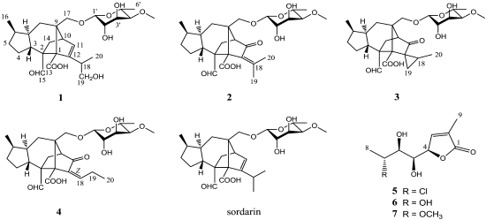

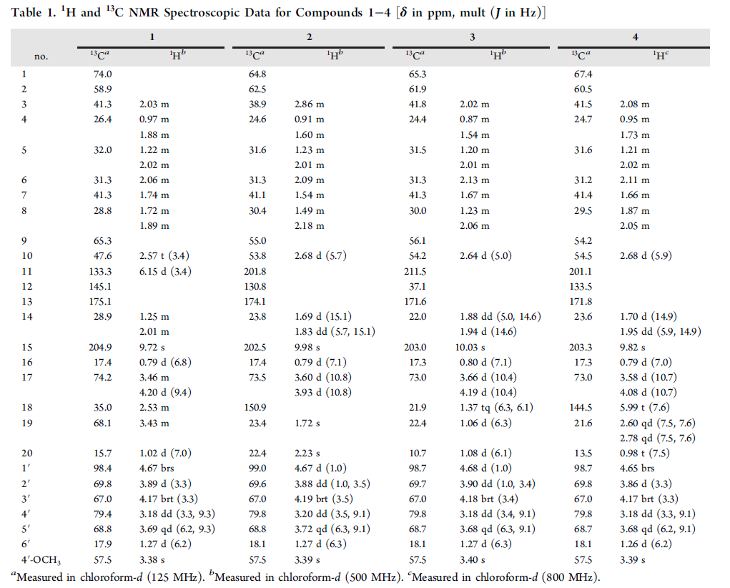
Figure 1. Chemical structures of 1−7 and sordarin identified in this report.

large number of semisynthetic sordarin derivatives have been reported,10 and some of the synthetic analogues were developed as antifungal agents such as zofimarin11 and FR231956.¹²

Compound 1 was obtained as an amorphous white solid, and
its IR absorptions at 3400−2500 coupled with 1705 and 1636
cm−1 indicated the presence of a carboxylic acid group and a
double bond, respectively. Its molecular formula, C27H40O9,

Figure 2. Key HMBC, COSY, and NOESY of 1.

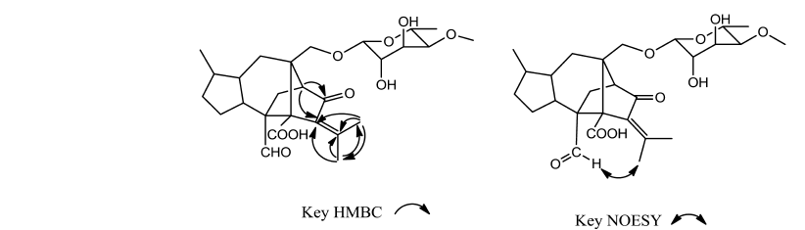

Figure 3. Key HMBC and NOESY of 2.

was deduced by 13C NMR and HRESIMS data. The 13C NMR
coupled with DEPT revealed 27 resonances including a set of
deoxy-sugar signals at δC 98.4 (d), 79.4 (d), 69.8 (d), 68.8 (d),
67.0 (d), and 17.9 (q), a methoxyl signal at δC 57.5 (q), a
residual C20 diterpenoid containing two carbonyl groups at δC
175.1 (s) and 204.9 (s), an oleﬁnic functionality at δC 145.1 (s)
and 133.3 (d), and two oxymethylenes at δC 74.2 (t) and 68.1
(t) (Table 1). The 1H NMR of 1 showed a set of deoxy-
monosaccharide signals at δH 4.67 (1H, brs), 4.17 (1H, brt, J =
3.3 Hz), 3.89 (1H, d, J = 3.3 Hz), 3.69 (1H, qd, J = 6.2, 9.3 Hz),
3.18 (1H, dd, J = 3.3, 9.3 Hz), and 1.27 (3H, d, J = 6.2 Hz), a
methoxy at δH 3.38 (s), an aldehyde at δH 9.72 (1H, s), a
trisubstituted oleﬁnic resonance at δH 6.15 (1H, d, J = 3.4 Hz),
two oxymethylenes at δH 4.20 (1H, d, J = 9.4 Hz), 3.46 (1H,
m), and 3.43 (2H, m), and two terminal methyls at δH 1.02
(3H, d, J = 7.0 Hz) and 0.79 (3H, d, J = 6.8 Hz). All the above
data indicated a sordaricin-type diterpene aglycone bearing a 6-
deoxy-4-O-methylaltrose moiety.9 Further comparison of the
1
diﬀerence was solely the H3-19 located on C-18 of sordarin
substituted by a −CH2OH [δC 68.1, C-19; δH 3.43, m, H2-19]
in 1 (Table 1). This was corroborated by key cross-peaks of H3-
20/C-18, -19, and -12 and H-18/C-12 and -11 in the HMBC
spectrum and key cross-peaks of H3-20/H-18 and H-18/H2-19
in the COSY spectrum of 1 (Figure 2). The conﬁguration of
the chiral C-18 of 1 was determined to prefer the shown
conformer by distinctive cross-peaks of H-18/H-15 and H3-20/
H-11 in the NOESY spectrum of 1 (Figure 2) and supported
by the three-dimensional molecular modeling. Accordingly, the
structure of 1 was characterized as shown, and was named
sordarin C.
The physical data of 2 were similar to those of sordarin. Its
molecular formula, C27H38O9, deduced from HRESIMS and
UV λmax at 247 nm, were the major diﬀerences. When
comparing the 1H and 13C NMR data of 2 with those of
sordarin, 2 was almost identical with sordarin except that the

H-11 in sordarin was oxidized to give a carbonyl (δC 201.8) in 2
and a double bond at Δ11 in sordarin was changed to Δ12(18)
(δC 130.8 and 150.9) of 2 (Table 1), as shown by key HMBC
correlations of H-10/C-11 and -12, H3-19/C-18, -20, and -12,
and H3-20/C-18, -19, and -12 (Figure 3). The H3-19 at δH 1.72
in the 1H NMR of 2 was assigned as trans to the carbonyl
attached at C-11 due to the cross-peak of H3-19/H-15 in the
NOESY spectrum (Figure 3) and from molecular modeling,
and the H3-20 downﬁeld shifted to δH 2.23 was caused by the
anisotropic eﬀect of the same carbonyl group at C-11. Thus, 2
was determined as shown and was named sordarin D.
The physical data of 3 were similar to those of 2, and the
major diﬀerence was its UV λmax adopted a hypsochromic shift
to lower than 210 nm, indicating a structural change of the α,β-
unsaturated carbonyl at C-11 and Δ12(18) of 3. The diﬀerences
of 1H and 13C NMR data between 3 and 2 were due to the
disappearance of an oleﬁnic functionality at Δ12(18) and a
methyl group and the presence of a methylene [δH 1.06 (2H, d,
J = 6.3 Hz); δC 22.4 (t)] as well as a methine [δH 1.37 (1H, tq, J
= 6.3, 6.1 Hz); δC 21.9 (d)] (Table 1). Key HMBC cross-peaks
of H-10/C-11 and -12, H3-20/C-12, -18, and -19, and H2-19/
C-12 (Figure 4) corroborated that C-12−C-19−C-18−C-20
formed a spiro-methylcyclopropane moiety connected with the
core structure of 3 by C-12. The chemical shift of the
methylene in cyclopropane at δH 0.2213 downﬁeld shifted to δH

Figure 4. Key HMBC and NOESY of 3.

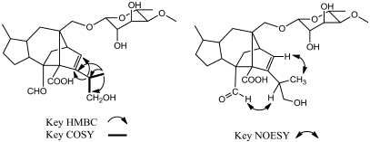

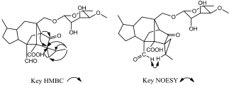

H and 13C NMR data of 1 with those of sordarin showed the

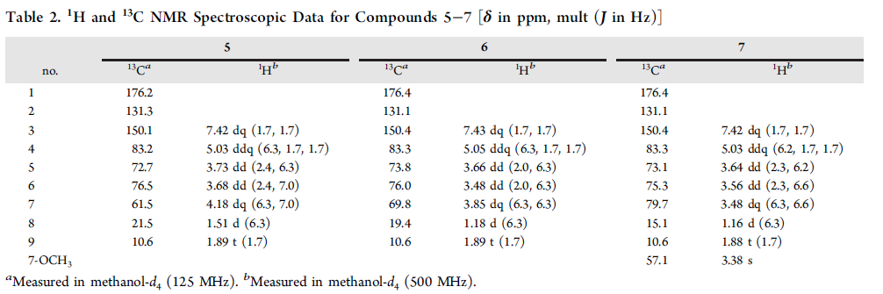

Figure 5. Key HMBC, COSY, and NOESY of 4.

1.06 for H2-19 in 3 was speculated to be caused by the
anisotropic eﬀect of the carbonyl at C-11. The shown
conﬁgurations of C-12 and C-18 were deduced based on the
key cross-peak of H-18/H-15 in the NOESY spectrum (Figure
4) and from molecular modeling. The structure of 3, with a
unique 5/6/5/5/3-fused ring system, was assigned as shown
and was named sordarin E.
The physical data for compound 4 was similar to those of 2.
It also showed a UV maximum absorption at 242 nm indicating
the presence of the same α,β-unsaturated carbonyl group as
that of 2. The 1H NMR data of 4 coincided well with those of 2
except that a methyl group at δH 1.72 (3H, s, H3-19) in 2 was
replaced by an oleﬁnic proton at δH 5.99 (1H, t, J = 7.6 Hz, H-
18) and a methylene group at δH 2.60 and 2.78 (each 1H, qd, J
= 7.5, 7.6 Hz, H2-19), and the other methyl group at δH 2.23
(3H, s, H3-20) in 2 shifted upﬁeld to δH 0.98 (3H, t, J = 7.5 Hz,
H3-20) in 4. These changes are also reﬂected in the 13C NMR
(Table 1). Key HMBC cross-peaks of H-10/C-11 and -12, H-
18/C-11 and -12, H2-19/C-18, and H3-20/C-18 and -19 along
with key COSY correlations of H3-20/H2-19 and H2-19/H-18
(Figure 5) corroborated that the 2-propylene attached at C-12
of 2 was changed to a 1-propylene in 4. The conﬁguration of
Δ12(18) was deduced to be Z due to a distinctive cross-peak of
H-18/H-15 in the NOESY spectrum (Figure 5) and from
molecular modeling. The anisotropic eﬀect and steric hindrance
of the carbonyl located at C-11 would account for the
downﬁeld shifts and nonequivalence of the H2-19 cis to the
carbonyl. The structure of compound 4 was thus deduced to be
as shown and was named sordarin F.
Compound 5 was obtained as one colorless crystal, and its IR
absorptions at 3338 and 1734 cm−1 indicated the presence of
hydroxyl group and conjugated γ-lactone carbonyl function-
alities. HRESIMS of 5 showed two prominent pseudomolecular
ions, [M + Na]+ at m/z 243.0397 (calcd for C9H1335ClO4Na,
243.0400) and [M + 2 + Na]+ at m/z 245.0409 (calcd for
C9H1337ClO4Na, 245.0400), with a ratio of around 3:1,
suggesting the presence of a chloride in 5. Nine carbon
resonances observed in the 13C NMR coupled with DEPT
spectra of 5 were attributable to two primary carbons at δC 10.6
(C-9) and 21.5 (C-8), ﬁve tertiary carbons at δC 61.5 (C-7),
72.7 (C-5), 76.5 (C-6), 83.2 (C-4), and 150.1 (C-3), and two
quaternary carbons at δC 131.3 (C-2) and 176.2 (C-1) (Table
2). The 1H NMR spectrum of 5 exhibited signals for two
methyls at δH 1.51 (H3-8) and 1.89 (H3-9), four carbinoyl
protons at δH 3.68 (H-6), 3.73 (H-5), 4.18 (H-7), and 5.03 (H-
4), and one oleﬁnic proton at δH 7.42 (H-3) (Table 2). The
lower ﬁeld shifts of a methine at δH-7 4.18 and δC-7 61.5 and a
nearby methyl at δH-8 1.51 and δC-8 21.5 accompanied by key
COSY cross-peaks of H3-8/H-7 and H-7/H-6 and key HMBC
correlations of H3-8/C-7 and -6 (Figure 6) suggested the
chloride was located at C-7. Further complete interpretations of
other COSY signals of H-6/H-5 and H-5/H-4 as well as
residual HMBC cross-peaks of H3-9/C-1, -2 and -3, H-3/C-2,
H-4/C-1 and -6, and H-5/C-3 (Figure 6) established the gross
structure of 5 as shown. The relative conﬁgurations of C-4−C-7

Figure 6. Key HMBC and COSY of 5.

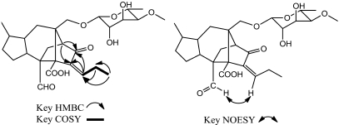

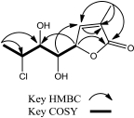

of 5 were determined by the single-crystal X-ray diﬀraction
analysis to be R*, S*, S*, and R* (Figure 7), respectively.

Figure 7. ORTEP drawing of 5.

The 1H and 13C NMR data of 6 were similar to those of 5
except signals for C-7 and −8 were shifted to δC 69.8 and 19.4,
respectively, with their corresponding H-7 and H3-8 shifted
upﬁeld to δH 3.85 and 1.18, respectively, implying the −Cl at C-
7 of 5 was substituted by −OH in 6 and supported by a
prominent sodium adduct at m/z 225.0733 (calcd for
C9H14O5Na, 225.0739) in the HRESIMS of 6. The 1H and
13C NMR data of 7 were consistent with those of 6 except for
an additional methyl group at δH 3.38 (−OCH3) and δC 57.1
(−OCH3) (Table 2). The methoxyl group was assigned to be
located at C-7 due to the key cross-peak of −OCH3/C-7 in the
HMBC spectrum of 7. Thus, 7 was assigned to be the methyl
ether of 6, as evidenced from the pseudomolecular ion [M +
Na]+ at m/z 239.0893 (calcd for C10H16O5Na, 239.0895), 14
Da more than that of 6, in the HRESIMS of 7. Due to the
NMR data consistency and biogenetic relationship of 5−7, the
relative conﬁgurations of C-4−C-7 of 6 and 7 were determined
to be consistent with those of 5. Accordingly, 5−7 were
determined to possess a C9 polyketide skeleton containing a γ-
lactone moiety, as shown in Figure 1, and were named
xylogiblactones A−C, respectively. To our knowledge, only one
analogue of 5−7, namely, hypoxylactone, was isolated from the
marine fungus Hypoxylon croceum.14
Compounds 1−5 and sordarin were subjected to an
antifungal assay against Candida albicans ATCC 18804, C.
albicans ATCC MYA-2876, and Saccharomyces cerevisiae ATCC
2345, and only sordarin exhibited signiﬁcant antifungal
activities against the three fungal strains, with MIC values of
64.0, 32.0, and 32.0 μg/mL, respectively. Under the same
conditions, the MIC values of amphotericin B were 0.5, 1.0, and
1.0/mL, respectively. The eﬀect of compounds 1−7 and
sordarin on the inhibition of NO production in lipopolysac-
charide-activated RAW264.7 cells was further evaluated. The
most potent compounds, 2 and sordarin, inhibited NO
production with IC50 values of 327.2 ± 46.6 and 157.1 ±
24.1 μM, respectively, without any cytotoxicity. The IC50 values
of the positive inhibitors aminoguanidine and L-NNA were 22.3
± 0.3 and 146.4 ± 0.7 μM, respectively.
The natural sordarin analogues, soradrins C−F (1−4),
described in this report varied at the C-11 position and at
the branch attached to C-12 of the sordaricin-type diterpene
skeleton. Soradrins C−F exhibited a mild antifungal eﬀect
compared to that of sordarin. It was reported that sordarin
inhibits fungal protein synthesis by blocking the function of
translation elongation factor 2 (EF2).15 Co-crystallization of
sordarin and EF2 showed that no van der Waals interactions
between the C-12−isopropyl moiety and EF2 were involved,
indicating the branch on C-12 does not play a role in antifungal
activity.16 The structure−activity relationship studies of
sordarins have been conﬁned mostly to the glycosyl moiety,
which makes the antifungal activity more potent, while
modiﬁcation of the isopropyl group at C-12 does not eﬀect
the antifungal activity.17 Our results were consistent with the
ﬁndings reported in the literature.

EXPERIMENTAL SECTION
General Experimental Procedures. Optical rotations were
measured on a JASCO P-2000 polarimeter (Tokyo, Japan). 1H and
13 C NMR were acquired on a Bruker Avance DRX-500 and AVIII-800
spectrometer (Ettlingen, Germany). Low-resolution and high-
resolution mass spectra were obtained using an API4000 triple
quadrupole mass spectrometer (Applied Biosystems, Foster City, CA,
USA) and Synapt High Deﬁnition Mass Spectrometry system with an
ESI interface and a TOF analyzer (Waters Corp., Manchester, UK),
respectively. IR spectra were recorded on a JASCO FT/IR 4100
spectrometer (Tokyo, Japan). Single-crystal data were collected on an
Oxford Diﬀraction Gemini A Ultra diﬀractometer using Cu Kα
radiation (Oxford Diﬀraction, Oxford, UK). Sephadex LH-20
(Amersham Biosciences, Filial Sverige, Sweden) and Diaion HP-20
(Mitsubishi Chemical, Tokyo, Japan) were used for open column
chromatography. TLC was performed using silica gel 60 F254 plates
(200 μm, Merck). A reﬂective index detector (Bischoﬀ, Leonberg,
Germany) was used in HPLC puriﬁcation.
Fermentation of Xylotumulus gibbisporus YMJ863. Xylotumu-
lus gibbisporus J. D. Rogers, Y.-M. Ju & Hemmes YMJ863 was isolated
from dead angiosperm wood collected from the Bird Park area in
Hawaii Volcanoes National Park.3 This fungal strain was deposited at
the Institute of Plant and Microbial Biology, Academia Sinica, Taipei,
Taiwan. The mycelium of X. gibbisporus was inoculated into 5 L serum
bottles, each containing 60 g of Bacto malt extract (Becton, Dickinson
and Company, Sparks, USA) and 3 L of deionized water. The
fermentation was conducted with aeration at 25−30 °C for 30 days.
Extraction and Isolation. The ﬁltered fermented broth (60 L) of
X. gibbisporus was partitioned three times with 60 L of recycled ethyl
acetate, then concentrated in vacuum to dryness (3.7 g). Subsequently,
the crude extract was redissolved in 25 mL of MeOH, then applied
onto a Sephadex LH-20 column (2.8 cm i.d. × 70 cm) eluted by
MeOH with a ﬂow rate of 2.2 mL/min. Each subfraction (22 mL)
collected was checked for its compositions by TLC using EtOAc−
AcOH−H2O (85:10:10, v/v/v) for development, and dipping in
vanillin−sulfuric acid was used in the detection of compounds with
similar skeletons. All the fractions were combined into ﬁve portions,
I−IV. Portion II (frs. 5−12) was puriﬁed by HPLC on a
semipreparative reversed-phase column (Phenomenex Luna 5 μ
PFP, 10 × 250 mm, Torrance, CA, USA) with MeCN−H2O
(37:100, v/v) containing 0.05% triﬂuoroacetic acid as eluent, 2 mL/
min, giving 1 (5.3 mg, tR = 20.07 min), 2 (5.8 mg, tR = 27.59 min), 3
(15.8 mg, tR = 29.83 min), 4 (7.8 mg, tR = 35.41 min), and sordarin
(25.8 mg, tR = 56.96 min). Portion III (frs. 13−19) was
rechromatographed on a Diaion HP-20 resin (2.0 cm i.d. × 20 cm)
eluted with aqueous MeOH in a stepwise gradient mode with a ﬂow
rate of 5.0 mL/min. Each subfraction (125 mL) collected was checked
for its composition by the above-mentioned TLC system and
combined into four subportions, III-I−III-V. Subportion III-I (subfrs.
1 and 2) was puriﬁed by HPLC on the same column with MeCN−
H2O (10:100, v/v) as eluent, 2 mL/min, aﬀording 6 (9.7 mg, tR =
20.42 min). Subportion III-III (subfrs. 5−7) was puriﬁed by HPLC on
the same column with MeCN−H2O (15:100, v/v) as eluent, 2 mL/
min, aﬀording 5 (11.3 mg, tR = 33.28 min) and 7 (6.8 mg, tR = 18.33
min).
X-ray Crystallographic Analysis of 5 (CCDC 949280).
Xylogiblactone A (5) was crystallized from CHCl3 to give colorless
crystals. The crystal data were recorded at 295 K on an Oxford
Diﬀraction Gemini A Ultra diﬀractometer with Cu Kα radiation (λ =

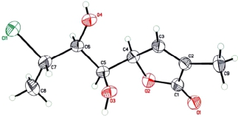

■

1.54178 Å). The structure was solved by direct methods (SHELXS-
97) and reﬁned using full-matrix least-squares diﬀerence Fourier
techniques. All non-hydrogen atoms were reﬁned anisotropically, and
all hydrogen atoms were placed in idealized positions and reﬁned as
riding atoms with the relative isotropic parameters. Crystal data:
C9H13ClO4, Mr = 220.64, monoclinic, space group P21, a = 9.6443(6)
Å, b = 4.7764(3) Å, c = 11.5683(7) Å, α = 90°, β = 94.929(5)°, γ =
90°, V = 530.92(6) Å3, Z = 2, Dcalc = 1.380 Mg/m3. Crystal
dimensions: 0.20 × 0.15 × 0.10 mm3. Independent reﬂections: 1299
(Rint = 0.0162). The ﬁnal R1 values were 0.0523, wR2 = 0.1409 [I >
2σ(I)]. Flack parameter = −0.03(3).
Sordarin C (1): amorphous, white solid; [α]26D −51.3 (c 0.75,
MeOH); IR (ZnSe) νmax 3400−2500, 2937, 2878, 1705, 1635, 1588,
1543, 1453, 1374, 1258, 1175, 1077, 1018 cm−1; 1H and 13C NMR
data, see Table 1; ESIMS [M − H]− m/z 507; HREIMS [M − H]− m/
z 507.2590 (calcd for C27H39O9, 507.2594).
Sordarin D (2): amorphous, white solid; [α]26D −68.0 (c 0.55,
MeOH); IR (ZnSe) νmax 3400−2500, 2934, 2871, 1709, 1630, 1578,
1547, 1454, 1377, 1240, 1177, 1087, 1028 cm−1; UV λmax (log ε,
MeOH) 247 (3.7); 1H and 13C NMR data, see Table 1; ESIMS [M −
H]− m/z 505; HRESIMS [M − H]− m/z 505.2439 (calcd for
C27H37O9, 505.2438).
Sordarin E (3): amorphous, white solid; [α]26D −8.73 (c 0.90,
MeOH); IR (ZnSe) νmax 3400−2500, 2944, 2899, 2875, 1714, 1631,
1447, 1371, 1307, 1269, 1175, 1143, 1090, 1025 cm−1; 1H and 13C
NMR data, see Table 1; ESIMS [M − H]− m/z 505; HRESIMS [M −
H]− m/z 505.2440 (calcd for C27H37O9, 505.2438).
Sordarin F (4): amorphous, white solid; [α]26D −50.5 (c 1.10,
MeOH); IR (ZnSe) νmax 3400−2500, 2935, 2875, 2855, 1715, 1642,
1602, 1560, 1454, 1370, 1265, 1188, 1146, 1086, 1026 cm−1; UV λmax
(log ε, MeOH) 242 (3.7); 1H and 13C NMR data, see Table 1; ESIMS
[M − H]− m/z 505; HRESIMS [M − H]− m/z 505.2440 (calcd for
C27H37O9, 505.2438).
Xylogibloactone A (5): colorless crystal; [α]26D +62.1 (c 1.50,
MeOH); IR (ZnSe) νmax 3338, 3120, 2981, 2931, 2856, 1734, 1659,
1586, 1545,1436, 1355, 1265, 1206, 1119, 1049 cm−1; UV λmax (log ε,
MeOH) 209 (3.9); 1H and 13C NMR data, see Table 2; ESIMS [M +
Na]+ m/z 243, [M + 2 + Na]+ m/z 245; HRESIMS [M + Na]+ m/z
243.0397 (calcd for C9H1335ClO4Na, 243.0400), [M + 2 + Na]+ m/z
245.0409 (calcd for C9H1337ClO4Na, 245.0400).
Xylogiblactone B (6): amorphous, white solid; [α]26D +78.9 (c 0.75,
MeOH); IR (ZnSe) νmax 3389, 2982, 2925, 2857, 1739, 1673, 1580,
1540, 1410, 1331, 1260, 1200, 1104, 1058 cm−1; UV λmax (log ε,
MeOH) 212 (3.9); 1H and 13C NMR data, see Table 2; ESIMS [M +
Na]+ m/z 225; HRESIMS [M + Na]+ m/z 225.0733 (calcd for
C9H14O5Na, 225.0739).
Xylogiblactone C (7): amorphous, white solid; [α]26D +94.5 (c 0.85,
MeOH); IR (ZnSe) νmax 3404, 2925, 2857, 1744, 1654, 1571, 1445,
1386, 1326, 1204, 1062, 1007, 955 cm−1; UV λmax (log ε, MeOH) 212
(4.0); 1H and 13C NMR data, see Table 2; ESIMS [M + Na]+ m/z
239; HRESIMS [M + Na]+ m/z 239.0893 (calcd for C10H16O5Na,
239.0895).
Antimicrobial Bioassay. Antifungal assays were conducted with
the National Committee for Clinical Laboratory Standards (NCCLS)
reference method.18−20 All the compounds except 6 and 7 were tested
against the microorganisms Candida albicans (ATCC 18804), C.
albicans (ATCC MYA-2876), and Saccharomyces cerevisiae (ATCC
2345). Test samples were dissolved in DMSO and were serially diluted
using RPMI-1640 medium (Sigma-Aldrich R8755). These were
transferred to 96-well microplates in triplicate, and the suspension of
the test organisms was added to each well, achieving a ﬁnal volume of
200 μL. Amphotericin B (Sigma-Aldrich A2411) was used as positive
control for testing antifungal agents, and blank (medium only)
controls were added to each test plate. The plates were read
turbidimetrically at 612 nm using a TECAN Sunrise ELISA reader
(TECAN Group Ltd., Mannedorf, Switzerland) prior to and after
incubation. The percent growth was calculated and plotted versus
concentration to aﬀord the MIC. The MIC values were determined as
the lowest concentration where test compounds inhibited fungal
growth.20

Nitric Oxide Production Inhibition Assay. RAW 264.7 cells
obtained from the Bioresource Collection and Research Center
(Hsinchu, Taiwan) were maintained by twice-weekly passage in
Dulbecco’s modiﬁed Eagle medium (DMEM) supplemented with 10%
fetal calf serum (FCS) and penicillin−streptomycin. The methods of
nitrite measurement were the same as reported previously.21 Cell
aliquots (5 × 105 cells/mL) were grown to conﬂuence on 24-well
plates for 24 h. The medium was switched to the serum-free DMEM
for another 4 h to render attached cells quiescent. To assess the eﬀects
on lipopolysaccharide-induced NO production, compounds 1−7 and
sordarin (purity >98% as checked by their 1H NMR) and two positive
controls, Nω-nitro-L-arginine (L-NNA, a NOS inhibitor) and amino-
guanidine (a speciﬁc inhibitor of iNOS), or vehicle (0.1%, DMSO)
were added in the presence of LPS (200 ng/mL) to the RAW 264.7
cells. The nitrite concentration in the culture medium was determined
spectrophotometrically as an index of NO production.22 The Alamar
Blue assay was used to examine whether the amount of the test
specimens used in this study caused cytotoxicity.23 Both positive
controls were purchased from Sigma-Aldrich Chemical Co., and the
purity of each compound was more than 98%.

ASSOCIATED CONTENT
S
1
material is available free of charge via the Internet at http://
pubs.acs.org.

AUTHOR INFORMATION
Corresponding Author
*Tel: 886-2-27361661, ext. 6156. E-mail: thlee@tmu.edu.tw.
Notes
The authors declare no competing ﬁnancial interest.

ACKNOWLEDGMENTS
This work was supported by a grant from the National Science
Council of the Republic of China. We thank Ms. S.-H. Wang of
the Instrumentation Center of Taipei Medical University and
Ms. S.-L. Huang of the Instrumentation Center of the College
of Science, National Taiwan University, for the NMR data
acquisition and Ms. Y.-C. Wu of the Small Molecule
Metabolomics Core Facility, the Institute of Plant and
Microbial Biology and Academia Sinica Scientiﬁc Instrument
Center, Academia Sinica, for the MS data acquisition.

REFERENCES
(1) Ko, H. J.; Song, A.; Lai, M. N.; Ng, L. T. J. Ethnopharmacol. 2011,
138, 762−768.
(2) Liang, W. L.; Hsiao, C. J.; Ju, Y. M.; Lee, L. H.; Lee, T. H. Chem.
Biodiversity 2011, 8, 2285−2290.
(3) Rogers, J. D.; Ju, Y.-M.; Hemmes, D. E. Sydowia 2006, 58, 290−
299.
(4) Ju, Y. M.; Rogers, J. D.; Hsieh, H. M.; Vasilyeva, L. Mycologia
2004, 96, 1393−1402.
(5) Song, Y.; Wang, J.; Huang, H.; Ma, L.; Wang, J.; Gu, Y.; Liu, L.;
Lin, Y. Mar. Drugs 2012, 10, 340−348.
(6) Song, Y. X.; Wang, J.; Li, S. W.; Cheng, B.; Li, L.; Lin, Y. C.; Gu,
Y. C. Planta Med. 2012, 78, 172−176.
(7) Isaka, M.; Yangchum, A.; Auncharoen, P.; Srichomthong, K.;
Srikitikulchai, P. J. Nat. Prod. 2011, 74, 300−302.
(8) Wu, W.; Dai, H.; Bao, L.; Ren, B.; Lu, J.; Luo, Y.; Guo, L.; Zhang,
L.; Liu, H. J. Nat. Prod. 2011, 74, 1303−1308.
(9) Hauser, D.; Sigg, H. P. Helv. Chim. Acta 1971, 54, 1178−1190.
(10) Hanadate, T.; Tomishima, M.; Shiraishi, N.; Tanabe, D.;
Morikawa, H.; Barrett, D.; Matsumoto, S.; Ohtomo, K.; Maki, K.
Bioorg. Med. Chem. Lett. 2009, 19, 1465−1468.

■
* Supporting Information
H and ¹³C NMR spectra of the new compounds 1−7. This
■
■
■
̈

(11) Ogita, T.; Hayashi, T.; Sato, A.; Furutani, W. JP Patent
62,040,292, 1987.
(12) Hori, Y.; Nitta, K., Kobayashi, M.; Takase, S.; Hino, M. Patent
01/000639, 2001.
(13) Baranac-Stojanovic, M.; Stojanovic, M. J. Org. Chem. 2013, 78,
1504−1507.
(14) Michael, D.; Sarah, M.; Timm, A.; Olov, S. Z. Naturforsch. C
1999, 54, 474−480.
(15) Odds, F. C.; Brown, A. J.; Gow, N. A. Trends Microbiol. 2003,
11, 272−279.
(16) Jørgensen, R.; Ortiz, P. A.; Carr-Schmid, A.; Nissen, P.; Kinzy,
T. G.; Andersen, G. R. Nat. Struct. Biol. 2003, 10, 379−385.
(17) Liang, H. Beilstein J. Org. Chem. 2008, 4, 31.
(18) Pfaller, M. A.; Vu, Q.; Lancaster, M.; Espinel-Ingroff, A.;
Fothergill, A.; Grant, C.; Mcginnis, M. R.; Pasarell, L.; Rinaldi, M. G.;
Steele-Moore, L. J. Clin. Microbiol. 1994, 32, 1625−1628.
(19) Vicente, F.; Basilio, A.; Platas, G.; Collado, J.; Bills, G. F.;
Gonzales Del Val, A.; Martín, J.; Tormo, J.; Harris, G. H.; Zink, D. L.;
Justice, M.; Nielsen Kahn, J.; Pelaez, F. Mycol. Res. 2009, 113, 754−
770.
(20) NCCLS. Reference Method for Broth Dilution Antifungal
Susceptibility Testing of Yeasts; Approved Standard; NCCLS Document
M27-A, 2nd ed.; National Committee on Clinical Laboratory
Standards: Wayne, PA, 2002.
(21) Lee, L. W.; Wang, G. J.; Lin, M. H.; Ju, Y. M.; Lin, Y. W.; Chen,
F. Y.; Lee, T. H. Phytochemistry 2013, 85, 129−136.
(22) Green, L. C.; Wagner, D. A.; Glogowski, J.; Wishnik, I. S.;
Tannenbaum, S. R. Anal. Biochem. 1982, 126, 131−138.
(23) Kwack, K.; Lynch, R. G. Mol. Cell 2000, 10, 575−578.

́ ́
́
́

