Hindawi Publishing Corporation
BioMed Research International
Volume 2014, Article ID 378358, 13 pages
http://dx.doi.org/10.1155/2014/378358
Research Article
Methylation-Associated Gene Silencing of RARB in Areca
Carcinogens Induced Mouse Oral Squamous Cell Carcinoma
Zi-Lun Lai,1 Yung-An Tsou,1,2,3 Shin-Ru Fan,4 Ming-Hsui Tsai,2,3 Hsiao-Ling Chen,5 Nai-
Wen Chang,6 Ju-Chien Cheng,4 and Chuan-Mu Chen1,7
1
Department of Life Sciences, Agricultural Biotechnology Center, National Chung Hsing University, No. 250 Kao-Kuang Road,
Taichung 402, Taiwan
2Department of Otolaryngology Head and Neck Surgery, China Medical University, Taichung 404, Taiwan
3School of Medicine, College of Medicine, China Medical University, Taichung 404, Taiwan
4Department of Medical Laboratory Science and Biotechnology, China Medical University, No. 91 Hsueh-Shih Road,
Taichung 404, Taiwan
5Department of Bioresources, Da-Yeh University, Changhwa 515, Taiwan
6Department of Biochemistry, College of Medicine, China Medical University, Taichung 404, Taiwan
7Rong Hsing Research Center for Translational Medicine, iEGG Center, National Chung Hsing University, Taichung 402, Taiwan
Correspondence should be
cmchen7010978@gmail.com
addressed
to
Ju-Chien
Cheng;
jccheng@mail.cmu.edu.tw
and
Chuan-Mu
Chen;
Received 7 May 2014; Revised 8 June 2014; Accepted 10 June 2014
Academic Editor: Calvin Yu-Chian Chen
Copyright © 2014 Zi-Lun Lai et al. This is an open access article distributed under the Creative Commons Attribution License,
which permits unrestricted use, distribution, and reproduction in any medium, provided the original work is properly cited.
Regarding oral squamous cell carcinoma (OSCC) development, chewing areca is known to be a strong risk factor in many Asian
cultures. Therefore, we established an OSCC induced mouse model by 4-nitroquinoline-1-oxide (4-NQO), or arecoline, or both
treatments, respectively. These are the main two components of the areca nut that could increase the occurrence of OSCC. We
examined the effects with the noncommercial MCGI (mouse CpG islands) microarray for genome-wide screening the DNA
methylation aberrant in induced OSCC mice. The microarray results showed 34 hypermethylated genes in 4-NQO plus arecoline
induced OSCC mice tongue tissues. The examinations also used methylation-specific polymerase chain reaction (MS-PCR) and
bisulfite sequencing to realize the methylation pattern in collected mouse tongue tissues and human OSCC cell lines of different
grades, respectively. These results showed that retinoic acid receptor 𝛽 (RARB) was indicated in hypermethylation at the promoter
region and the loss of expression during cancer development. According to the results of real-time PCR, it was shown that de
novo DNA methyltransferases were involved in gene epigenetic alternations of OSCC. Collectively, our results showed that RARB
hypermethylation was involved in the areca-associated oral carcinogenesis.
1. Introduction
Throughout the world, oral squamous cell carcinoma (OSCC)
is one of the most common types of cancers. It has a high cure
rate for small primary tumors and involves the development
of second primary tumors and the long-term survival rate
is <60% [1]. Furthermore, in Taiwan, according to statistics
from the Department of Health, Executive Yuan, Taiwan,
OSCC ranks as fourth among the ten leading causes of cancer
among males and is the fourth leading cancer in the male
population and the number of deaths increases every year [2].
The main risk factor for developing OSCC is chewing areca,
especially in many Asian cultures.
In a clinical study, the incidence of oral cancer was
elevated 28 times for betel quid users as compared to nonbetel
quid users [3]. Cigarette smoking has synergistic effect with
areca chewing, and such users have an 89 times higher
incidence rate than nonusers. If one has the habit of drinking,
smoking, and betel quid chewing combined, there will be
a 123 times higher incidence rate of having oral cancer
than those average individuals in the general population
that are nonusers. There is the longitudinal cohort study
2
on the alcohol, betel quid, and smoking, to the oral cancer
risk. The betel quid partook the significant higher hazard
risk to the oral carcinogenesis [4]. The most tumorigenic
part of betel quid is the Piper longum L. and the calcium
hydroxide (slaked lime) which will cause the oral cavity
to develop into an alkaline condition which will promote
the tumorigenic effect of the Safrole in the Piper longum
L. The fibers of areca also cause oral mucosa damage and
increased mucosa to be exposed to the tumorigenic material
in the betel quid. In a clinical survey, oral cancer with areca
chewing had far more incidence of oral submucosa fibro-
sis and erythroplakia; furthermore, the pathologic findings
also show severe hyperkeratosis, caries, and gingivitis as
compared to nonareca users. The oral cancer patients who
had the habit of betel quid chewing were also found to
have a higher percentage of dysplastic change surrounding
the tumor margin, and skip cancer lesion was frequently
noted in the upper aerodigestive tract (tongue, hypopharynx,
and esophagus). The condemned mucosa even reached the
esophagus. In an average clinical survey, 18% of cases were
found to have esophagus cancer diagnosed at the same time
when oral cancer presented [5]. Synchronous double cancer
(second primary cancer) in the upper aerodigestive tract is
frequently noted [6].
There was a stimulating effect when areca nut is chewed
along with betel leaf [7]. Furthermore, in Chiang et al. [8],
they used areca nut extract (ANE) and saliva-reacted ANE
(sANE) to treat three oral carcinoma cell lines, KB (epi-
dermoid carcinoma), SAS (tongue carcinoma), and Ca9-22
(gingival carcinoma). The higher cytotoxic effects involving
cell morphologic changes and upregulation of inflammatory
signaling in mRNA expression levels were observed in these
treatments. In addition, arecoline is the major alkaloid
in areca nut extracts and betel quid. It is the primary
active ingredient responsible for the central nervous system
simulation that is roughly comparable to that of nicotine,
which has a similar chemical structure [9–12]. There is
also another carcinogen, 4-nitroquinoline 1-oxide (4-NQO),
which effectively induces oral and esophageal cancers that
closely resemble early human lesions in mice and rats [13, 14].
In this study, we followed Chang et al. [15] who established
an effective mouse model of oral cancer and used this model
to identify potential markers of oral tumor progression by
utilizing a noncommercial methylation microarray.
The promoter hypermethylation now has a key role for
research in the area of human multistage carcinogenesis.
Silencing of certain tumor suppressor genes may occur in
the absence of genetic change, via aberrant methylation of
CpG islands [16–18]. OSCC is believed to arise through
the accumulation of numerous genetic and epigenetic alter-
ations [19–21]. There are several methods to determine
whether promoter methylation has been developed including
combination of bisulfite restriction assay (COBRA) [22],
genomic bisulfate sequencing [23], methylation-specific PCR
(MS-PCR) [24], and microarray-based methylation analysis
[25]. Methylation microarray is a high throughput tool
for genome-wide methylation analysis [26–31]. To identify
and characterize potential targets for treating oral cancer, a
genome-wide approach was taken to quantitatively measure
BioMed Research International
genomic alterations in OSCC [32, 33]. Consequently, we used
home-made mouse CpG island microarray to understand
aberrant methylation profile during OSCC tumorigenesis in
this study and validated the methylation status by MS-PCR,
bisulfite sequencing, and real-time PCR.
In many previous studies, retinoid acid suppresses car-
cinogenesis and inhibits the growth of human head and neck
squamous cell carcinoma (HNSCC) [34, 35]. Loss of retinoids
and their receptors has been associated with malignant
progression in HNSCC [36]. Their receptors (RAR) are
central regulators to the normal growth and differentiation of
a variety of epithelial cells. RAR changes have been associated
with cell immortalization, and re-expression of RAR-beta
(RARB) leads to growth inhibition in some circumstances
[19]. Loss of RARB expression is associated with a change in
proliferative life span potential from mortality to immortal-
ity in HNSCC [37–39]. The promoter hypermethylation of
RARB could inhibit the gene expression when added to the
methylation inhibitor and deacetylation inhibitor like 5󸀠 -aza-
2󸀠 -deoxycytidine (5-aza-dC) and trichostatin A (TSA) which
could recover the gene expression and inhibit tumor cells
growth [36, 39].
In the present study, we investigated the role of RARB
hypermethylation of CpG islands in OSCC mouse model and
its association with RARB expression in human oral cancer
cell lines. In addition, we examined whether the repression of
RARB transcription could be reversed by 5-aza-dC in human
oral cancer cell lines, and finally, we evaluated the three
main DNA methyltransferases that were involved in RARB
hypermethylation.
2. Materials and Methods
2.1. Mouse Model for Oral Cancer. The mouse model devel-
opment was modified as highlighted by Chang et al. [15,
40]. Briefly, the OSCC model was established by treating
arecoline (Sigma, St. Louis, MO), as well as in combina-
tion with 4-NQO (Fluka, St. Louis, MO) in 4-5 week age
old of C57BL/6JNarl male mice. The conditions for OSCC
formation are 500 𝜇g/mL arecoline (A), 200 𝜇g/mL 4-NQO
(N), and 4-NQO (200 𝜇g/mL) combined with arecoline
(500 𝜇g/mL) (NA) in the drinking water for 8 weeks. The
drinking water was changed every day, and mice were allowed
access to the drinking water at all times while receiving treat-
ment. After the treatment, the drinking water was changed to
ddH2 O and mice were sacrificed at week 8, 12, 14, 18, 20, 26,
and 28, respectively. The tongues were collected and classified
into tumor parts (T) and nontumor parts (NT) for mouse
CpG island microarray analysis.
2.2. Cell Culture and 5-aza-dC Treatment. Normal human
oral keratinocytes (NHOK) were cultured in Keratinocyte
Growth Medium (KGM, GIBCO, CA, USA). Oral cancer
cell lines, DOK, OC2, and Ca9-22, were cultured in DMEM
(GIBCO, CA, USA). HSC3 and TW2.6 were cultured in
DMEM-F12 (GIBCO, CA, USA). All cells supplemented with
10% fetal calf serum and 1% penicillin-streptomycin and
cultured at 37∘ C with 5% CO2 . Oral cancer cells were treated

BioMed Research International
Table 1: Primer sets used for RT-PCR, MS-PCR, and bisulfite sequencing.
Primer sets
RARB-Hu-RT
Dnmt1-Hu-RT
Dnmt3a-Hu-RT
Dnmt3b-Hu-RT
RARB-Mo-M
RARB-Mo-U
RARB-Mo-BS
RARB-Hu-M
RARB-Hu-U
RARB-Hu-BS
∗
3
Sense primer (5󸀠 → 3󸀠 )
AGGAGACTTCGAAGCAAG
TACCTGGACGACCCTGACCTC
TATTGATGAGCGCACAAGAGAGC
GGCAAGTTCTCCGAGGTCTCTG
GGATTAGAGTTTTCGTGCGTCG
GGATTAGAGTTTTTGTGTGTTG
CCACCCAACTCCATCAAACTC
ATGTCGAGAACGCGAGCGATTC
GGATGTTGAGAATGTGAGTGATTT
GTGTGATAGAAGTAGTAGGAAG
Antisense primer (5󸀠 → 3󸀠 )
GTCAAGGGTTCATGTCCTTC
CGTTGGCATCAAAGATGGACA
GGGTGTTCCACCCTAACATTGAG
TGGTACATGGCTTTTCGATAGGA
TACCCCGCCGATACCCAAACG
TACCCCACCAATACCCAAACA
CCATACAATCAAACATAATCTC
CTCGACCAATCCAACCGAAACG
TACTCAACCAATCCAACCAAAACA
GTGATAGAAGTGGTAGGAAG
Tm (∘ C)
60
60
64
62
65
62
58
64
62
55
PCR size (bp)
771
102
110
112
90
90
476
151
155
401
Hu: human, Mo: mouse, RT: real-time RT-PCR, M: methylated set, U: unmethylated set, BS: bisulfite sequencing.
Table 2: The selected gene list of hypermethylation.
Accession numberGene symbol Description
S80555
AF069985
AL355176
AL928664
AF457187
RARB
Nit1
BRCA2
Hoxd4
p21
Functions
DNA binding,
Retinoic acid receptor-beta ligand-dependent nuclear
receptor activity
Nitrilase homolog IHydrolase activity
Breast cancer II geneProtein binding
Homeo box D4 geneDNA binding
Cyclin-dependent kinase
inhibitor IA
Multidrug-resistance
protein gene
Embryonic large molecule
derived from yolk sac
Cyclin-dependent protein
kinase inhibitor activity
ATP binding, ATPase
activity
DNA binding
Related carcinoma types
Nonsmall cell lung cancer, hepatoma, bladder
cancer, rectal cancer, breast cancer, head and
neck squamous cancer
Oral squamous cell carcinoma (in this study)
Bladder cancer, breast cancer, ovarian cancer
Breast cancer, leukemia, neuroblastoma
Nonsmall cell lung cancer, bladder cancer,
breast cancer, ovarian cancer,
medulloblastoma, hepatoma
Pancreatic cancer, breast cancer, colorectal
cancer, glioblastoma, leukemia, laryngeal
cancer cell
Oral squamous cell carcinoma (in this study)
M60348
AB081498
MDR1
ELYS
by 5-aza-dC at 2 𝜇M to reverse the methylation status as
described in [36, 41].
2.3. DNA and RNA Extraction. The genomic DNA extraction
was conducted as noted in our previous report [42]. We
used collected nontumor parts (NT) and tumor parts (T) of
tongues for DNA and RNA extractions.
2.4. RT-PCR and Real-Time PCR. Total RNA was prepared
using the TRI REAGENT (Invitrogen, CA, USA). One micro-
gram of total RNA was treated with 10 units of RQ1 RNase-
Free DNase (Prome ga, WI, USA) and extracted with phenol-
chloroform. DNase that treated total RNA (1 𝜇g) was reverse
transcribed with the ImProm II Reverse Transcription System
(Promega, WI, USA). For RT-PCR amplification was per-
formed with 2720 thermal cycler (Applied Biosystems Inc.,
CA, USA) and Real-Time PCR amplification was performed
with Rotor-Gene 6000 (Corbett, CA, USA). The amplification
of RT-PCR was repeated for 28 cycles as follows: 95∘ C, 30 sec
for denature of the annealing temperature depending on
the pair of gene specific primer sets (Table 1) for 30 sec and
72∘ C, 30 sec for extension. PCR reactions were performed
in triplicate and the transcription level was normalized
with the GAPDH. For Real-Time PCR, the calculated gene
expression fold from CT value was performed according to
the previously mentioned study, with a P value of less than
0.05 exhibiting an obviously significant difference.
2.5. Preparation of Mouse CpG Island Microarray and Ampli-
con Generation. The mouse CpG island microarray was
based on previously described human CpG island microar-
rays [43–46]. A total 2,304 mouse CpG islands library
(mCGI) clones were spotted on UltraGAPS Coated Slides
(Corning, MA, USA) by the BioDot AD1500 (BIODOT, CA,
USA). The amplicons for methylation analysis were prepared
as previously described [47, 48].
2.6. Microarray Hybridization and Data Analysis. The puri-
fied amplicons (5 𝜇g) were conducted using the BioPrime
DNA labeling system (Invitrogen, CA, USA). Cyanine 5-
ddUTP (Cy5-ddUTP) and Cyanine 3-ddUTP (Cy3-ddUTP)
(Perkin-Elmer Life Sciences, NJ, USA) fluorescent dyes
were coupled to tumor (T) and normal (NT) amplicons,
respectively, and cohybridized to the microarray panel. The
combined tumor/normal control pair, with 8 𝜇g DNA, more
than 180 pmol Cy5, and 150 pmol Cy3, would give strong
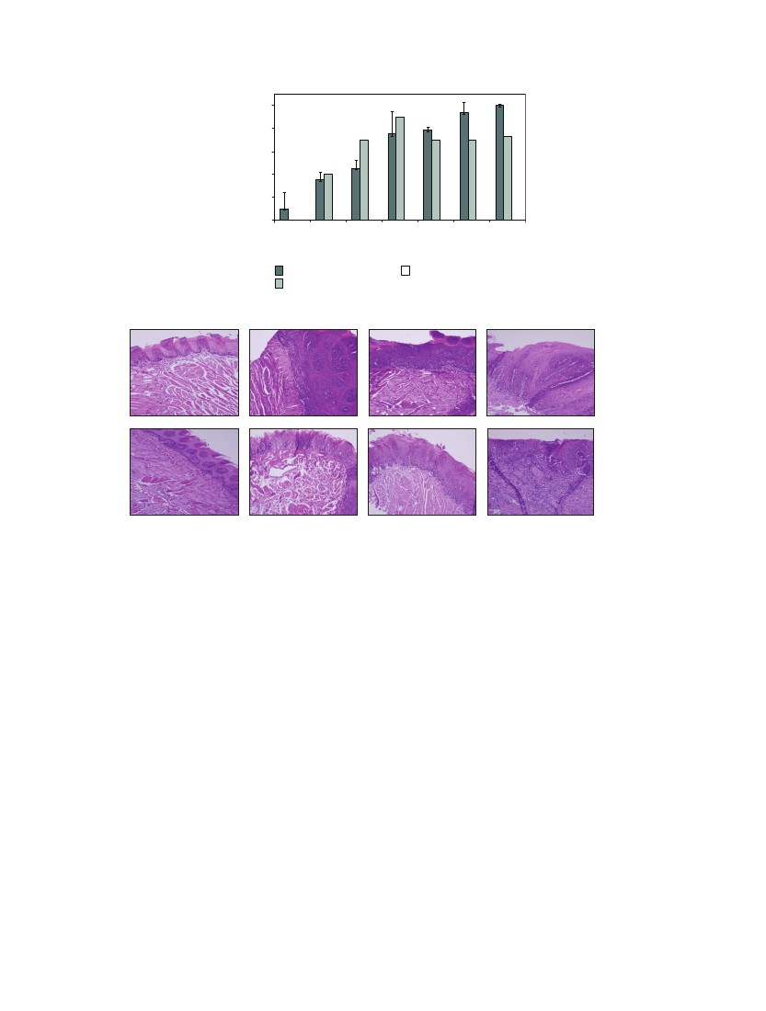
4
100
BioMed Research International
Carcinogenesis (%)
80
60
40
20
0
8
12
14
18
Week
20
26
28
4-NQO/arecoline
4-NQO
(a)
18 weeks
18 weeks
Arecoline
26 weeks
28 weeks
Control
4-NQO
Arecoline
4-NQO + arecoline
(b)
Figure 1: The progression of mouse model development for OSCC. (a) The ratio of carcinogenesis in mouse OSCC model. There were three
treatments, 4-NQO/arecoline, 4-NQO, and arecoline. Mice were sacrificed at weeks 8, 12, 14, 18, 20, 26, and 28, respectively. The scoring criteria
for mouse OSCC model are described in Section 2. (b) OSCC tongue tissues with tumors were excised, fixed, embedded, and sectioned for
H&E staining. The mice that were treated with 4-NQO + arecoline would induce more serious OSCC formation than 4-NQO only and
arecoline only. The order of severity was followed the time of treatment.
hybridization signals. The hybridization of 4,608 spots is
carried out under a 24 × 50 mm cover glass sealed tightly
within a moistened hybridization chamber, GeneMachines
HybChambers (Genomic Solutions, MI, USA), in a 65∘ C
water bath from 12 to 16 h. The posthybridization wash-
ing steps are essentially those described by UltraGAPS
Coated Slides instruction Manual. The hybridized slides were
scanned with the GenePix 4000B scanner (Axon, CA, USA)
and the acquired images were analyzed with the software
GenePix Pro 4.0 (Axon, CA, USA). The microarray data
was analyzed as described previously [43–46, 48, 49]. Briefly,
the Cy5/Cy3 ratio and the hybridization intensity from the
tumor amplicons to the hybridization intensity from the
normal amplicons, from each image, are normally guided
by both the average global Cy5/Cy3 ratio from each image
and the Cy5/Cy3 ratios from 9 internal controls (clones
without restriction cutting sites whose copy numbers remain
the same in tumors and normal samples). Yellow spots
(normalized Cy5/Cy3 = 1) represent equal amounts of bound
DNA from each amplicon, indicating no methylation differ-
ences between tumor (T) and nontumor (NT) genomes. The
analyzed data were using hierarchical clustering to classify
the relationships of all genes between collected T and NT
samples. A hierarchical clustering algorithm was used to
investigate relationships among tumor samples. The complete
linkage and the dissimilarity measure (1 minus the Pearson
correlation coefficient of the log-adjusted Cy5 : Cy3 ratios)
were used for the analysis. The resultant dendrogram showed
linked closely related colorectal tumors into a phylogenetic
tree whose branch lengths represented the degree of similar-
ity between these tumors.
2.7. Bisulfite Sequencing and Methylation-Specific PCR
(MS-PCR) for Methylation Status Analysis. Genomic DNA
(∼0.5 𝜇g) was treated with sodium bisulfite according to the
manufacture’s recommendations (EZ DNA Methylation Kit;
Zymo Research, CA, USA). All selected genes methylation
statuses were examined by methylation-specific PCR (MS-
PCR) and sodium bisulfite genomic sequencing. The PCR
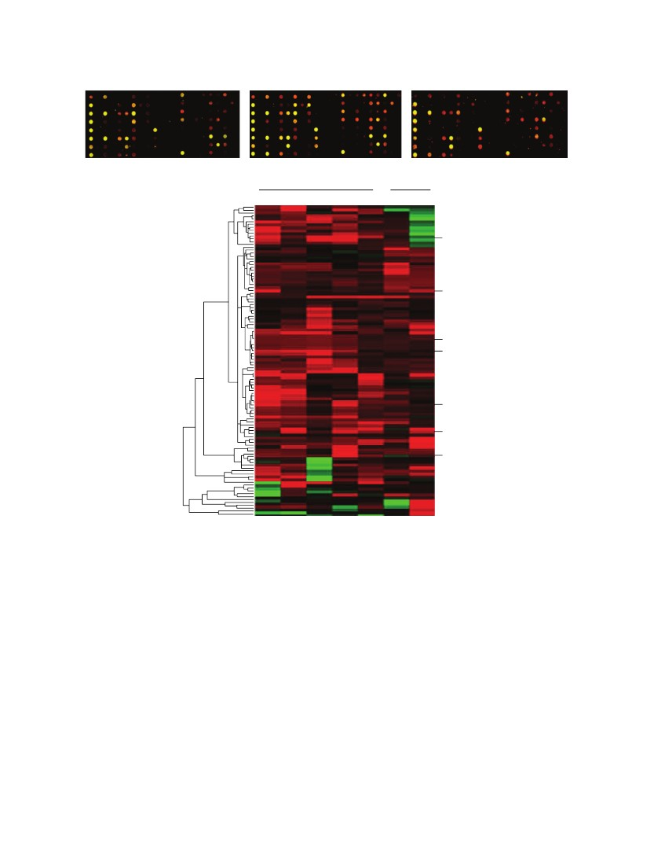
BioMed Research International
4-NQO (28 weeks)
4-NQO/arecoline (26 weeks)
5
4-NQO/arecoline (28 weeks)
(a)
4-NQO/arecoline
4-NQO
26NA3 26NA6 28A
28C 28NA3 28N7 28N8
Nit1
MDR1
Hoxd4
BRCA2
ELYS
p21
RARB
(b)
Figure 2: Presenting of MCGI microarray hybridization results and hierarchical clustering of methylation data of OSCC model mice. (a)
MCGI microarray hybridization panel contained 4,608 duplicated CpG island tags. The expanded hybridization views showed the usefulness
of the MCGI microarrays cohybridized with fluorescently labeled T (tumor part) and NT (nontumor part) with N at 28 weeks and NA at
26 and 28 weeks. Spots hybridized predominantly with tumor amplicon but not with normal amplicon would appear red and are indicative
of hypermethylated CpG island loci present in the tumor genome. (b) Hierarchical clustering of N (4-NQO) and NA (4-NQO/arecoline)
samples. At the top lists the 5 NA and 2 N studied. The row corresponds to each of 109 CpG island loci selected for methylation analysis. CpG
islands (the normalized Cy5 : Cy3 ratios are ≧ 2) are those with hypermethylation in tumor DNA. The selected hypermethylated candidates
were showed on the right sides. They are described in greater detail in Table 2.
reaction was as follows: 95∘ C for 5 min, followed by 45
cycles of 95∘ C, 30 sec, Tm for 30 sec (Table 1), 72∘ C for
45 sec and ended with an extension of 72∘ C for 5 min and
quick chill to 4∘ C on a Geneamp2400 PCR system (Applied
Biosystems, CA, USA). For bisulfate sequencing analysis,
each PCR product was subcloned into the pGEM-T Easy
Vector (Promega, WI, USA) and performed 5–10 clones
in each selection, respectively. Each colony was sequenced
using the BigDye Terminator v3.1 Cycle Sequencing Kit and
the automated ABI PRISM 3100 Genetic Analyzed (Applied
Biosystems, CA, USA).
2.8. Statistical Analysis. Statistical analysis was performed
using t-test to examine the association between NHOK and
other cell lines. One-sided testing was used to calculate the P,
and 𝑃 < 0.05 was considered statistically significant.
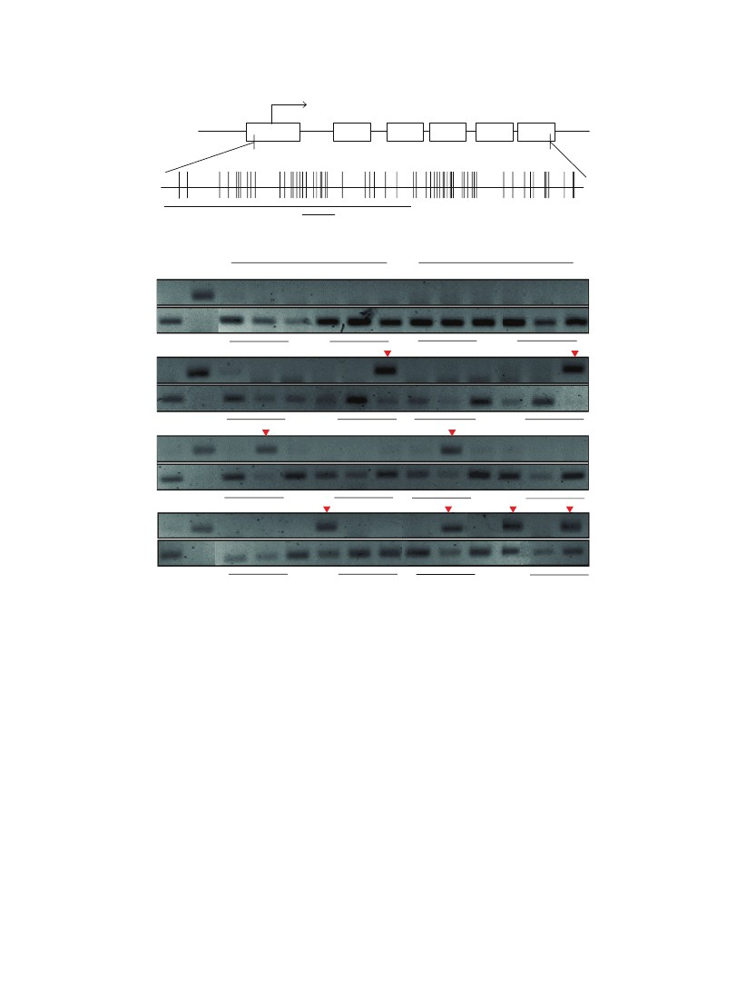
6
CDS
BioMed Research International
Exon 1
Exon 2
Exon 3
Exon 4
Exon 5
Exon 6
Probe
MS-PCR analytic region
(a)
4-NQO
1170 bp
4-NQO/arecoline
T
N
T
N
T
N
T
N
T
18 weeks
B
M
U
Methylation (%)
M
S
N
T
N
0 (0/3)
0 (0/3)
20 weeks
U
Methylation (%)
M
26 weeks
U
Methylation (%)
M
28 weeks
U
Methylation (%)
20 (1/5)
(b)
33.3 (1/3)
33.3 (1/3)
33.3 (1/3)
33.3 (1/3)
60 (3/5)
Figure 3: Methylation status of RARB gene in mouse OSCC model. (a) The CpG island diagram of RARB gene. The hybridized probe used to
microarray located from exon one to exon three. We designed the MS-PCR primer sets located within this region. (b) The designed MS-PCR
analysis results in 4-NQO and 4-NQO/arecoline at 18, 20, 26, and 28 weeks, respectively. The RARB gene showed hypermethylation (60%) in
4-NQO/arecoline at 28 week. M: methylated set, U: unmethylated set, B: blood DNA for methylation negative control, S: SssI treated DNA
for methylation positive control, and %methylation: the percentages of methylation. The red inverted triangle showed that the methylated
RARB gene could be amplified.
3. Results
3.1. OSCC Mouse Model Induced by Arecoline and 4-NQO. To
evaluate the efficiency of mouse model involving cotreating
with arecoline and 4-NQO that mimic the etiology for OSCC
tumor growth, the percentage of mice exhibiting carcinogen-
esis was calculated in Figure 1(a). Tumor development was
assessed when treated with 4-NQO (N) and 4-NQO plus
arecoline (NA) but not in arecoline. Mice were also sacrificed
at 18, 26, and 28 weeks, and tongues with tumors were
excised, fixed, embedded, and sectioned for H&E staining
(Figure 1(b)). The H&E staining also showed that the tumor
progresses were dealing with time and according to the
treatments. According to the results, the incidence of tongue
carcinogenesis in NA group was significantly higher than N
group and arecoline group. Taken together, the treatment
of NA at week 28 was much more serious than other
weeks. These results suggest that arecoline promotes 4-NQO
carcinogenesis in damaged oral epithelia cells.
3.2. Identification of Hypermethylation Genes from OSCC Tis-
sues by CpG Island Microarray. According to the tumor pro-
gression percentages and H&E staining results, we selected
the tongues tissues to be targets from OSCC mouse model
with N and NA at 26 and 28 weeks for MCGI microarray
screening. Figure 2(a) depicts representative data from the
OSCC study. The expanded hybridization views showed
the usefulness of the MCGI microarrays cohybridized with
fluorescently labeled T (tumor part) and NT (nontumor
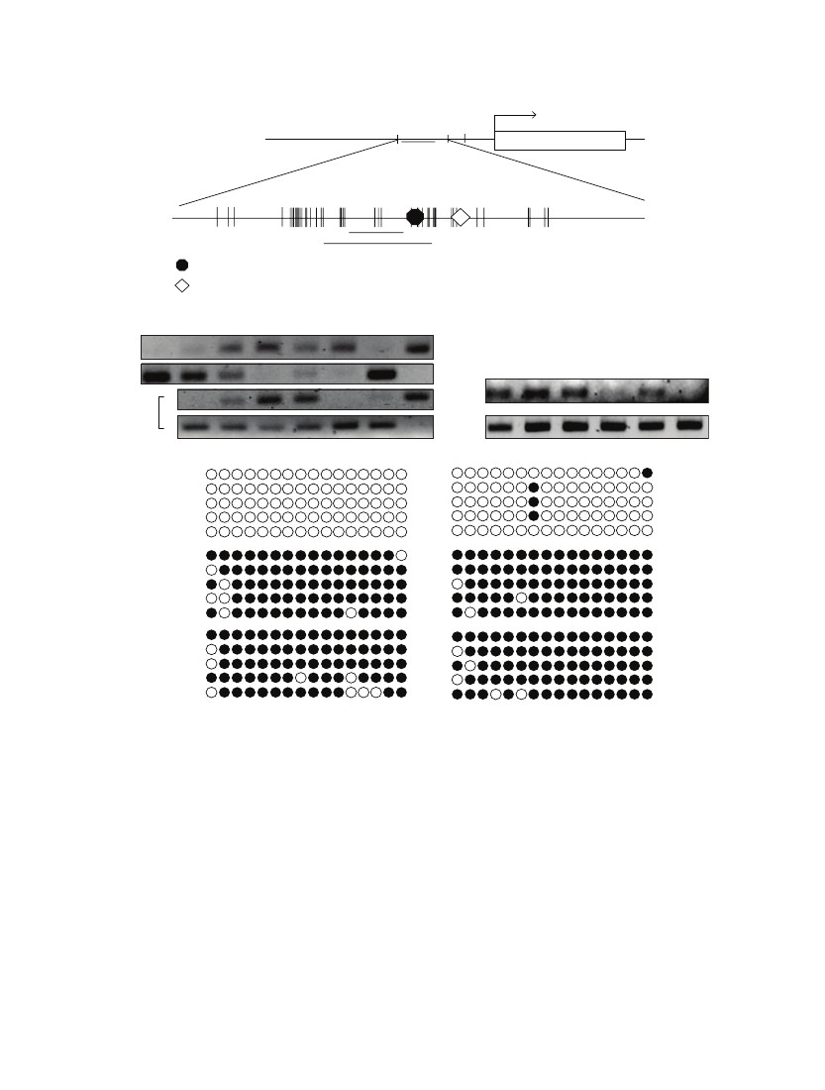
BioMed Research International
CDS
Promoter
7
+1
Human RARB
CpG island
RT
MS-PCR analytic region
Bisulfite sequencing region
R RA response element (RARE)
T TATA box
(a)
1469 bp
NHOK DOK TW2.6 Ca922
M
OC2
HSC3
Blood
SssI
U
M
RARB
NHOK DOK
TW2.6 Ca922
OC2
HSC3
5-aza-dC
U
(b)
NHOK
0%
𝛽-Actin
(c)
DOK
5%
TW2.6
92.5%
Ca922
96.3%
OC2
90%
HSC3
93.8%
(d)
Figure 4: Methylation status in human oral cancer cell lines of RARB. (a) The schematic for CpG island presentation of RARB. There was
a CpG island located in promoter region. We designed the MS-PCR and bisulfite sequencing primer sets in this region. (b) The RARB
methylation status in different human oral cancer cell lines. The cell lines were also treated with 5󸀠 -aza-dC. The methylation status was
recovered because of 5󸀠 -aza-dC treatment. (c) The RARB mRNA expression in different human oral cancer cell lines. The RARB was not
expressed in Ca922, OC2, and HSC3 obviously. (d) The RARB bisulfite sequencing in different human oral cancer cell lines. There were more
methylated RARB in TW2.6, Ca922, OC2, and HSC3 than in NHOK and DOK. The hollow circle is the unmethylated CpG site and the full
circle is the methylated CpG site.
part) with N at week 28 and NA at weeks 26 and 28,
respectively. Spots hybridized predominantly with tumor
amplicon, but not with nontumor amplicon, would appear
red and are indicative of hypermethylated CpG island loci,
present in the tumor genome. The hybridization results
showed that treatment with NA at week 28 represented
much more spots that were obviously more hypermethylated
than other treatments. Yellow spots (Cy5 : Cy3 = 1) represent
equal amounts of bound DNA from each amplicon, an
indication of no methylation differences between tumor and
nontumor genomes. Selection of genes was based on the
criteria described in the Materials and Methods. Figures
6(b) and 6(c) showed specific genes of selection results
in hypermethylation and hypomethylation, respectively. We
conducted a confirmation study to determine whether the
cutoff ratio (≧2) could accurately identify hypermethylation.
The hierarchical clustering presented the 109 gene loci of
hypermethylation in the classifier in N and NA (Figure 2(b)).
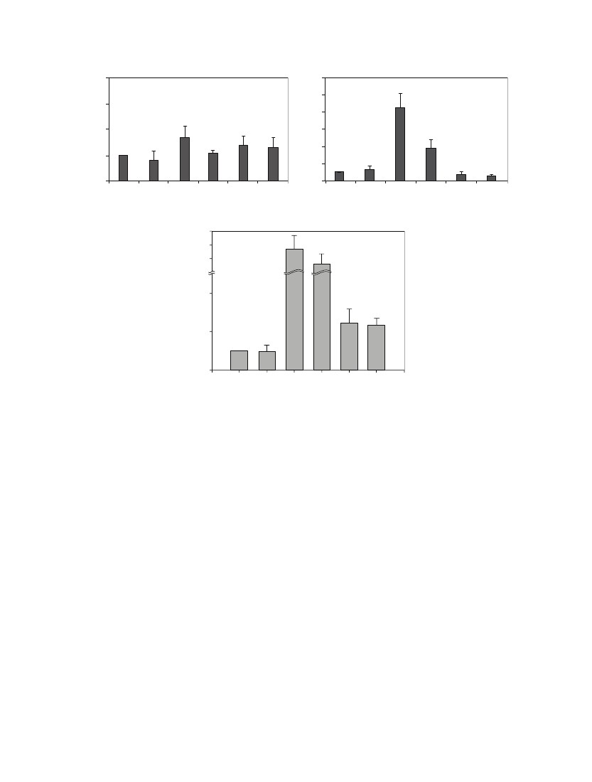
8
Related mRNA expression (fold)
Related mRNA expression (fold)
4
12
BioMed Research International
Dnmt1
Dnmt3a
10
8
6
4
2
0
NHOK
DOK
∗
3
2
1
0
NHOK
DOK
TW2.6
(a)
30
Dnmt3b
∗
Ca922
OC2
HSC3
Cell lines
TW2.6 Ca922
Cell lines
(b)
OC2
HSC3
Related mRNA expression (fold)
25
20
15
4
∗
2
0
NHOK DOK TW2.6 Ca922
Cell lines
(c)
OC2
HSC3
Figure 5: DNMTs RNA expression in human oral cancer cell lines. The measurement of DNMTs expression levels by real-time PCR was
showed in (a), (b), and (c), respectively. (a) The Dnmt1 expression was not changed in all human oral cancer cell lines. (b) and (c) TW2.6 and
Ca922 were higher expression in Dnmt3a and Dnmt3b than others. The figures shown are the mean of three experiments where all of the
samples were analyzed in triplicate. The start sign showed the statistically significant (𝑃 < 0.05).
This methylation profile analysis has led to the identification
of CpG island clusters that could evaluate many new genes
correlating with OSCC progression in mouse model. These
newly collected genes are shown in detail in Table 2. Upon
further examination, we selected the RARB gene to examine
in greater detail by MS-PCR bisulfite sequencing and semi-
quantitative RT-PCR. The locations of CpG islands in mouse
and human RARB genes were predicted using MethPrimer
(http://www.urogene.org/methprimer/index1.html), respec-
tively (Figure 3(a) and Figure 4(a)).
3.3. Verification of Methylated Genes by MS-PCR and Bisulfite
Sequencing. The RARB gene was a candidate target to verify
the methylation status in these mouse OSCC tongues tissues
and in human oral cancer cell lines that were also treated by
5󸀠 -aza-2󸀠 -deoxycytidine (5-aza-dC). Interestingly, RARB was
hypermethylated in mouse OSCC and reexpression by 5-aza-
dC treatment in human oral cancer cell lines. In Figure 3(b),
RARB was hypermethylated in mouse OSCC tumor parts
of N (4-NQO) and NA (4-NQO + Arecoline) compared to
normal parts. Furthermore, the methylation ratio of RARB
in NA treatment at 28 week was 60%. It was much higher
than the 4-NQO treatment (20%) at 28 week. These results
correlated with the microarray analysis data. RARB also
investigated the methylation status in human oral cancer
lines (Figure 4(b)). The results showed that Ca922, TW2.6,
and HSC3 were hypermethylated than in NHOK. It also lost
expressions in Ca922, TW2.6, and HSC3 but not in NHOK
(Figure 4(c)). In Figure 4(d), the bisulfite sequencing showed
the hypermethylation in TW2.6 (92.5%), Ca922 (96.3%),
OC2 (90%), and HSC3 (93.8%), but in the NHOK and DOK,
the normal and precancer cell lines were not methylated
in bisulfite sequencing results. Taken together, these results
showed that the promoter methylation of RARB plays the
main role in OSCC progression.
3.4. Methyltransferase Expressions in Human OSCC Cell
Lines. DNA methylation is catalyzed by the family of DNA
methyltransferases (DNMT) including Dnmt1, Dnmt3a, and
Dnmt3b. Figure 5 shows the measurement of gene expres-
sions via real-time PCR on Dnmt1, Dnmt3a, and Dnmt3b in
human oral cancer lines. For Dnmt1, there were no expression

BioMed Research International
Mouse
4-NQO/arecoline induced
oral cancer tumorigenesis
9
Amplicons preparations
45s rRNA, 3
CpG island microarray
26 and 28 week normal/tumor part
Selective ratio median ≥ 2
Nonblast, 13
18s rRNA, 3
Others, 8
34 genes upregulated in mouse OSCC
RARB
ELYSNit1Hosd4
RRCA2MDR p211
Rule out the ratio of minus and ≥ 10000
15 genes upregulated in mouse OSCC
Selective ratio of median ≥ 2
34 genes upregulated in mouse OSCC
(a)
(b)
Others, 8
45s rRNA
18s rRNA
Nonblast
p21
RARB
Hoxd4
BRCA2
Rule out the ratio of minus and ≥10000
15 genes upregulated in mouse OSCC
(c)
Figure 6: Outline of this study. (a) The flowchart of research project. (b) The selection from MCGI microarray hybridization results by the
ratio higher or equal two. There were 34 genes that were hypermethylated in OSCC mouse model. (c) The selection from MCGI microarray
hybridization results by ruling out the ratio was minus and higher or equal to 10,000. There were 15 genes that were hypermethylated in OSCC
mouse model.
differences between NHOK and other cell lines (Figure 5(a)).
However, Dnmt3a and Dnmt3b showed significantly higher
expression levels in TW2.6 and Ca922 than others (Figures
5(b) and 5(c)).
4. Discussion
OSCC is the most common head and neck neoplasm, affect-
ing 270,000 people worldwide each year [20, 32]. According
to related research, patients who smoke, drink, and chew
betel quid experience a 5.32-fold increased likelihood of
death as compared to those without any oral habits [50].
In Taiwan and other Southeast Asian countries, betel quid
chewing is one of the most important risk factors for oral
cancer patients and associates as the main cause between
betel quid chewing and oral cancer development [51]. 4-
NQO is quinoline derivative and a tumorigenic compound
which can induce DNA lesions. Quinone oxidoreducatase
is one of the major enzymes that convert 4-NQO to the
more active metabolite, 3-hydroxyaminoquinoline 1-oxide
[52]. This oxidoreducatase can be produced from the mucosal
of the sublingual in humans and mice. Arecoline is a natural
alkaloid product found in the areca nut. In this study, these
two compounds were used to induce oral carcinogenesis in
a mouse model. When we added 4-NQO plus Arecoline to
the drinking water of mice, the results showed that mice were
shown to have induced carcinogenesis at 100% at week 26
10
and 28 (Figure 1(a)). In H&E staining, resected oral tissue at
the end of week 28 (Figure 1(b)) also showed that NA and
N treatment could induce squamous cell carcinoma, respec-
tively. However, treatment with arecoline alone revealed that
it did not induce tumorigenesis after 28 weeks.
Methylation is important in the development of OSCC
and many tumor suppressor genes targeted by promoter
methylation will by no doubt be described in the future.
The techniques used at present to detect methylation provide
good sensitivity, specificity, and speed. There are many types
of methylation arrays for a genome-wide approach to realize
methylation profile. In this study, we applied a home-made
high throughput MCGI array to analyze DNA methylation
across the entire genome in the OSCC mouse tongue tissues.
This home-made MCGI array not only could identify methy-
lation profile but also could detect mRNA expression (in our
previous studies). The chip was cohybridized with mouse
Cot-I DNA and total RNA mixture to evaluate the quality
and the exon-containing portions can be used to measure
levels of gene expression. According to the previous research,
the methylation status and mRNA expression levels could be
verified by MCGI array.
According to the depicted representative data from pre-
vious studies, RARB expression is thought to be associated
with cellular sensitivity to retinoid in numerous cancer cells,
including HNSCC cells, breast cancer cells, lymphocytic
leukemia, and lung cancer cells [53–57]. Methylation of RARB
was identified which had a correlation with primary oral
malignant diseases [58, 59]. The methylation array of 4,608
genes (duplicate on chip) that we used in this study included
the majority of genes which have previously been associated
with head and neck cancer (e.g., DAPK, MGMT, and CDH1,
etc.). However, only RARB in previously studied genes
were shown to be positive for methylation. To explain the
possibility of this discrepancy, the hybridized probes maybe
located on different regions between our array and previous
methylation studies. However, we found some interesting
genes and described this in greater detail in Table 2 as they
were shown to have hypermethylation on the chip, but this
was not reported before in OSCC.
In our study, DNMT1 does not affect the expression
in human OSCC cell lines. Nevertheless, DNMT3a and
DNMT3b did affect the expressions in human OSCC cell lines
(Figure 5). These results showed that DNMT3a and DNMT3b
were higher expressions in TW2.6 and Ca922, the primary
oral cancer cell lines, but not in OC2 and HSC3. As compared
to other tumors, no correlation was seen between DNMT
upregulation and promoter hypermethylation-induced inac-
tivation of tumor-related genes. The exact mechanisms of
DNMT upregulation remain unclear, but it is suggested that
aberrant DNMT activity, especially with regard to DNMT1,
is due to a rapid proliferation of cancer cells because DNMT1
binds to proliferating cell nuclear antigen (PCNA) [60].
Overexpression of all the DNMTs at the mRNA level has been
shown for several cancers [45, 61, 62]. However, DNMT3a and
DNMT3b were the de novo methyltransferases. In this result
(Figures 5(b) and 5(c)), we thought DNMT3a and DNMT3b
were added to new methyl groups to DNA to cause DNA
methylation aberrant at the early stage of OSCC progression.
BioMed Research International
We used some different approaches to deal with the
sparseness of data. To begin with we used a methylation array
of 4,086 genes (duplicated on chip), which provided more
comprehensive data. Here we also suggest that this study
could offer a basic evidence that promoter hypermethylation
of RARB is correlated with the occurrence of betel-related
OSCC.
Isotretinoin (13-cis-retinoic acid) is considered to have
the effect of preventing second primary cancers and local
or regional recurrence after head and neck cancer is treated.
However, in a previous clinical trial, chemoprevention ther-
apy involving retinoid acid does not cause significant dif-
ferences in early head and neck cancers. The nonsignificant
benefit result is due to the small number of patients. The
prospective study rendered a small percentage of patients that
have second primary cancers and local regional recurrence,
thus causing the results to be less significant even though
there was trend to have reduced second primary cancers
developed and less local regional recurrence in prior studies
[63]. However, there was another clinical research using
the isotretinoin (13-cis-retinoic acid) (50 to 100 mg per
square meter of body-surface area per day) as compared
with placebo, to be taken daily for 12 months. They offer
significantly reduced second primary cancer development
after 32 months of follow-up, and multiple second primary
tumors developed in the placebo group [64]. Therefore, they
suggest that isotretinoin still has the ability to prevent second
primary cancers, but there was less use in preventing the
primary site recurrence [64]. There was another human
cohort study using an in situ hybridization (ISH) analysis
checker with 38 pairs of surgical specimens of primary OSCC
and noncancerous matched normal control to compare the
cellular expression level of RARB. They found the loss of
RARB in the advanced OSCCs especially when they are
betel quid users [65]. This prominent result also give us
an understanding that RARB is really an important factor
for chemoprevention for tumor progression. Therefore, betel
quid related hypermethylation of RARB will really increase
the tumorigenesis and poor treatment outcome of oral cancer.
Concerning the mechanisms of the chemoprevention func-
tion, there was another study that revealed that the retinoids
could suppress basal expression of Cox-2 or EGF-mediated
induction of Cox-2 in human oral squamous carcinoma cells
[66]. Thus, RARB not only has cell cycle inhibition and tumor
suppressant effects, but also anti-inflammatory effects that
cease COX-2 related cancerization effects on the oral mucosa.
This is pilot study that talked about the detailed mech-
anisms of retinoid acid function affected by areca. In the
future, we should consider retinoid acid use or RARB related
drugs for areca users who are found to have oral tumors or
oral cancer to reduce the incidence of oral cancer and to
provide a better treatment outcome.
Conflict of Interests
The authors declare that there is no conflict of interests
regarding the publication of this paper.
BioMed Research International
11
analysis,” Journal of Oral Pathology and Medicine, vol. 28, no.
9, pp. 385–388, 1999.
C. Chung, Y. Yang, T. Wang, T. Shieh, and S. Warnakula-
suriya, “Oral precancerous disorders associated with areca quid
chewing, smoking, and alcohol drinking in southern Taiwan,”
Journal of Oral Pathology and Medicine, vol. 34, no. 8, pp. 460–
466, 2005.
X. Tang, B. Knudsen, D. Bemis, S. Tickoo, and L. J. Gudas, “Oral
cavity and esophageal carcinogenesis modeled in carcinogen-
treated mice,” Clinical Cancer Research, vol. 10, no. 1, part 1, pp.
301–313, 2004.
M. Kitano, “Host genes controlling the susceptibility and
resistance to squamous cell carcinoma of the tongue in a rat
model,” Pathology International, vol. 50, no. 5, pp. 353–362,
2000.
N. W. Chang, R. J. Pei, H. C. Tseng et al., “Co-treating with
arecoline and 4-nitroquinoline 1-oxide to establish a mouse
model mimicking oral tumorigenesis,” Chemico-Biological
Interactions, vol. 183, no. 1, pp. 231–237, 2010.
R. J. Shaw, T. Liloglou, S. N. Rogers et al., “Promoter methylation
of P16, RAR𝛽, E-cadherin, cyclin A1 and cytoglobin in oral
cancer: quantitative evaluation using pyrosequencing,” The
British Journal of Cancer, vol. 94, no. 4, pp. 561–568, 2006.
C. Y. Fan, “Epigenetic alterations in head and neck cancer:
prevalence, clinical significance, and implications,” Current
Oncology Reports, vol. 6, no. 2, pp. 152–161, 2004.
M. Esteller, “Cancer epigenetics: DNA methylation and chro-
matin alterations in human cancer,” Advances in Experimental
Medicine and Biology, vol. 532, pp. 39–49, 2003.
P. K. Ha and J. A. Califano, “Promoter methylation and
inactivation of tumour-suppressor genes in oral squamous-cell
carcinoma,” The Lancet Oncology, vol. 7, no. 1, pp. 77–82, 2006.
E. Suzuki, I. Imoto, A. Pimkhaokham et al., “PRTFDC1, a
possible tumor-suppressor gene, is frequently silenced in oral
squamous-cell carcinomas by aberrant promoter hypermethy-
lation,” Oncogene, vol. 26, no. 57, pp. 7921–7932, 2007.
C. Scully, J. K. Field, and H. Tanzawa, “Genetic aberrations in
oral or head and neck squamous cell carcinoma (SCCHN): 1.
Carcinogen metabolism, DNA repair and cell cycle control,”
Oral Oncology, vol. 36, no. 3, pp. 256–263, 2000.
Z. Xiong and P. W. Laird, “COBRA: A sensitive and quantitative
DNA methylation assay,” Nucleic Acids Research, vol. 25, no. 12,
pp. 2532–2534, 1997.
M. Frommer, L. E. McDonald, D. S. Millar et al., “A genomic
sequencing protocol that yields a positive display of 5-
methylcytosine residues in individual DNA strands,” Proceed-
ings of the National Academy of Sciences of the United States of
America, vol. 89, no. 5, pp. 1827–1831, 1992.
J. G. Herman, J. R. Graff, S. My¨ h¨nen, B. D. Nelkin, and S.o a
B. Baylin, “Methylation-specific PCR: a novel PCR assay for
methylation status of CpG islands,” Proceedings of the National
Academy of Sciences of the United States of America, vol. 93, no.
18, pp. 9821–9826, 1996.
T. H. Huang, M. R. Perry, and D. E. Laux, “Methylation profiling
of CpG islands in human breast cancer cells,” Human Molecular
Genetics, vol. 8, no. 3, pp. 459–470, 1999.
L. R. Adrien, N. F. Schlecht, N. Kawachi et al., “Classification of
DNA methylation patterns in tumor cell genomes using a CpG
island microarray,” Cytogenetic and Genome Research, vol. 114,
no. 1, pp. 16–23, 2006.
Authors’ Contribution
Zi-Lun Lai, Yung-An Tsou, and Shin-Ru Fan contributed
equally to this work.
[12]
Acknowledgments
This research was supported in part by Grants NSC-98-
2313-B-005-012 and NSC-101-2313-B-005-014-MY3 from the
National Science Council, DMR-103-025 from China Medical
University Hospital, Grant COA-97-6.2.1-U1(9) from the
Council of Agriculture, and grant from the Ministry of
Education, Taiwan, under the Aiming for the Top University
plan (ATU-101-s0508). This work was supported by Grants
CMU95-302, CMU97-098, and CMU97-099 from China
Medical University, Taiwan (J.-C. Cheng). The authors also
thank technique support from Ms. Chia-Fan Lin.
[13]
[14]
[15]
References
[1] A. Jemal, R. Siegel, E. Ward et al., “Cancer statistics, 2008,” CA
Cancer Journal for Clinicians, vol. 58, no. 2, pp. 71–96, 2008.
[2] C. Li-Ting, C. Chung-Ho, Y. Yi-Hsin, and H. Pei-Shan, “The
development and validation of oral cancer staging using admin-
istrative health data,” BMC Cancer, vol. 14, no. 1, article 380,
2014.
[3] Y. C. Ko, Y. L. Huang, and C. H. Lee, “Betel quid chewing,
cigarette smoking and alcohol consumption related to oral
cancer in Taiwan,” Journal of Oral Pathology and Medicine, vol.
24, no. 10, pp. 450–453, 1995.
[4] W. L. Hsu, Y. C. Chien, C. J. Chiang et al., “Lifetime risk of
distinct upper aerodigestive tract cancers and consumption of
alcohol, betel and cigarette,” International Journal of Cancer, vol.
135, no. 6, pp. 1480–1486, 2014.
[5] S. H. Hung, M. C. Tsai, T. C. Liu, H. C. Lin, and S. D. Chung,
“Routine endoscopy for esophageal cancer is suggestive for
patients with oral, oropharyngeal and hypopharyngeal cancer,”
PLoS ONE, vol. 8, no. 8, Article ID e72097, 2013.
[6] M. Chen, W. Huang, C. H. Chan, P. Chen, and K. Lee, “Impact
of second primary esophageal or lung cancer on survival of
patients with head and neck cancer,” Oral Oncology, vol. 46, no.
4, pp. 249–254, 2010.
[7] C. R. P. C. Gupta, “Ranks number three among ten leading
causes of death,” ANNALS Academy of Medicine Singapore, vol.
33, pp. 31S–36S, 2004.
[8] S. Chiang, P. Chen, C. Lee et al., “Up-regulation of inflammatory
signalings by areca nut extract and role of cyclooxygenase-
2 -1195G>A polymorphism reveal risk of oral cancer,” Cancer
Research, vol. 68, no. 20, pp. 8489–8498, 2008.
[9] P. Rajalalitha and S. Vali, “Molecular pathogenesis of oral
submucous fibrosis—a collagen metabolic disorder,” Journal of
Oral Pathology and Medicine, vol. 34, no. 6, pp. 321–328, 2005.
[10] A. Ariyawardana, A. D. S. Athukorala, and A. Arulanandam,
“Effect of betel chewing, tobacco smoking and alcohol con-
sumption on oral submucous fibrosis: a case-control study in
Sri Lanka,” Journal of Oral Pathology and Medicine, vol. 35, no.
4, pp. 197–201, 2006.
[11] T. Ramaesh, B. R. R. N. Mendis, N. Ratnatunga, and R. O.
Thattil, “The effect of tobacco smoking and of betel chewing
with tobacco on the buccal mucosa: a cytomorphometric
[16]
[17]
[18]
[19]
[20]
[21]
[22]
[23]
[24]
[25]
[26]
12
[27] S. H. Wei, C. M. Chen, G. Strathdee et al., “Methylation microar-
ray analysis of late-stage ovarian carcinomas distinguishes
progression-free survival in patients and identifies candidate
epigenetic markers,” Clinical Cancer Research, vol. 8, no. 7, pp.
2246–2252, 2002.
[28] P. S. Yan, C. Chen, H. Shi, F. Rahmatpanah, S. H. Wei, and T.
H. Huang, “Applications of CpG island microarrays for high-
throughput analysis of DNA methylation,” Journal of Nutrition,
vol. 132, no. 8, pp. 2430S–2434S, 2002.
[29] C. M. Chen, H. L. Chen, T. H. Hsiau et al., “Methylation target
array for rapid analysis of CpG island hypermethylation in
multiple tissue genomes,” The American Journal of Pathology,
vol. 163, no. 1, pp. 37–45, 2003.
[30] R. S. Gitan, H. Shi, C. Chen, P. S. Yan, and T. H. Huang,
“Methylation-specific oligonucleotide microarray: a new
potential for high-throughput methylation analysis,” Genome
Research, vol. 12, no. 1, pp. 158–164, 2002.
[31] V. Beier, C. Mund, and J. D. Hoheisel, “Monitoring methy-
lation changes in cancer,” Advances in biochemical engineer-
ing/biotechnology, vol. 104, pp. 1–11, 2007.
[32] D. M. Parkin, F. Bray, J. Ferlay, and P. Pisani, “Global cancer
statistics, 2002,” CA: A Cancer Journal for Clinicians, vol. 55, no.
2, pp. 74–108, 2005.
[33] B. W. Neville and T. A. Day, “Oral cancer and precancerous
lesions,” Ca: A Cancer Journal for Clinicians, vol. 52, no. 4, pp.
195–215, 2002.
[34] R. Lotan, “Retinoids in cancer chemoprevention,” The FASEB
Journal, vol. 10, no. 9, pp. 1031–1039, 1996.
[35] D. R. Shalinsky, E. D. Bischoff, W. W. Lamph et al., “A novel
retinoic acid receptor-selective retinoid, ALRT1550, has potent
antitumor activity against human oral squamous carcinoma
xenografts in nude mice,” Cancer Research, vol. 57, no. 1, pp. 162–
168, 1997.
[36] F. McGregor, A. Muntoni, J. Fleming et al., “Molecular changes
associated with oral dysplasia progression and acquisition of
immortality: potential for its reversal by 5-azacytidine,” Cancer
Research, vol. 62, no. 16, pp. 4757–4766, 2002.
[37] F. McGregor, E. Wagner, D. Felix, D. Soutar, K. Parkinson, and P.
R. Harrison, “Inappropriate retinoic acid receptor-𝛽 expression
in oral dysplasias: correlation with acquisition of the immortal
phenotype,” Cancer Research, vol. 57, no. 18, pp. 3886–3889, 1997.
[38] X. Xu, J. Y. Ro, J. S. Lee, D. M. Shin, W. K. Hong, and R. Lotan,
“Differential expression of nuclear retinoid receptors in normal,
premalignant, and malignant head and neck tissues,” Cancer
Research, vol. 54, no. 13, pp. 3580–3587, 1994.
[39] L. Hu, D. L. Crowe, J. G. Rheinwald, P. Chambon, and L.
J. Gudas, “Abnormal expression of retinoic acid receptors
and keratin 19 by human oral and epidermal squamous cell
carcinoma cell lines,” Cancer Research, vol. 51, no. 15, pp. 3972–
3981, 1991.
[40] J. J. Sheu, C. H. Hua, L. Wan et al., “Functional genomic analysis
identified epidermal growth factor receptor activation as the
most common genetic event in oral squamous cell carcinoma,”
Cancer Research, vol. 69, no. 6, pp. 2568–2576, 2009.
[41] K. Kozaki, I. Imoto, S. Mogi, K. Omura, and J. Inazawa,
“Exploration of tumor-suppressive microRNAs silenced by
DNA hypermethylation in oral cancer,” Cancer Research, vol. 68,
no. 7, pp. 2094–2105, 2008.
[42] C. M. Chen, C. H. Wang, S. C. Wu, C. Lin, S. Lin, and W.
T. K. Cheng, “Temporal and spatial expression of biologically
active human factor VIII in the milk of transgenic mice
BioMed Research International
driven by mammary-specific bovine 𝛼-lactalbumin regulation
sequences,” Transgenic Research, vol. 11, no. 3, pp. 257–268, 2002.
A. Ahluwalia, P. Yan, J. A. Hurteau et al., “Dna methylation and
ovarian cancer: I. Analysis of CpG island hypermethylation in
human ovarian cancer using differential methylation hybridiza-
tion,” Gynecologic Oncology, vol. 82, no. 2, pp. 261–268, 2001.
S. H. Cross, J. A. Charlton, X. Nan, and A. P. Bird, “Purification
of CpG islands using a methylated DNA binding column,”
Nature Genetics, vol. 6, no. 3, pp. 236–244, 1994.
K. P. Nephew and T. H. Huang, “Epigenetic gene silencing in
cancer initiation and progression,” Cancer Letters, vol. 190, no.
2, pp. 125–133, 2003.
P. S. Yan, M. R. Perry, D. E. Laux, A. L. Asare, C. W. Caldwell,
and T. H. Huang, “CpG island arrays: an application toward
deciphering epigenetic signatures of breast cancer,” Clinical
Cancer Research, vol. 6, no. 4, pp. 1432–1438, 2000.
H. Shi, P. S. Yan, C. Chen et al., “Expressed CpG island sequence
tag microarray for dual screening of DNA hypermethylation
and gene silencing in cancer cells,” Cancer Research, vol. 62, no.
11, pp. 3214–3220, 2002.
P. S. Yan, C.-. Chen, H. Shi et al., “Dissecting complex epigenetic
alterations in breast cancer using CpG island microarrays,”
Cancer Research, vol. 61, no. 23, pp. 8375–8380, 2001.
P. S. Yan, T. Efferth, H. L. Chen et al., “Use of CpG island
microarrays to identify colorectal tumors with a high degree
of concurrent methylation,” Methods, vol. 27, no. 2, pp. 162–169,
2002.
Y. K. Chen, H. C. Huang, L. M. Lin, and C. C. Lin, “Primary oral
squamous cell carcinoma: an analysis of 703 cases in southern
Taiwan,” Oral Oncology, vol. 35, no. 2, pp. 173–179, 1999.
J. H. Jeng, M. C. Chang, and L. J. Hahn, “Role of areca
nut in betel quid-associated chemical carcinogenesis: current
awareness and future perspectives,” Oral Oncology, vol. 37, no.
6, pp. 477–492, 2001.
J. Tanuma, M. Hirano, Y. Hirayama et al., “Genetic predis-
position to 4NQO-induced tongue carcinogenesis in the rat,”
Medical Principles and Practice, vol. 14, no. 5, pp. 297–305, 2005.
X. Zhang, Y. Liu, M. Lee, and M. Pfahl, “A specific defect in the
retinoic acid response associated with human lung cancer cell
lines,” Cancer Research, vol. 54, no. 21, pp. 5663–5669, 1994.
B. Seeliger, S. Wilop, R. Osieka, O. Galm, and E. Jost, “CpG
island methylation patterns in chronic lymphocytic leukemia,”
Leukemia and Lymphoma, vol. 50, no. 3, pp. 419–426, 2009.
H. Wan, N. Oridate, D. Lotan, W. K. Hong, and R. Lotan,
“Overexpression of retinoic acid receptor 𝛽 in head and neck
of squamous cell carcinoma cells increases their sensitivity to
retinoid-induced suppression of squamous differentiation by
retinoids,” Cancer Research, vol. 59, no. 14, pp. 3518–3526, 1999.
S. Sun, H. Wan, P. Yue, W. K. Hong, and R. Lotan, “Evidence
that retinoic acid receptor 𝛽 induction by retinoids is important
for tumor cell growth inhibition,” The Journal of Biological
Chemistry, vol. 275, no. 22, pp. 17149–17153, 2000.
M. Widschwendter, G. Daxenbichler, O. Dapunt, and C. Marth,
“Effects of retinoic acid and 𝛾-interferon on expression of
retinoic acid receptor and cellular retinoic acid-binding protein
in breast cancer cells,” Cancer Research, vol. 55, no. 10, pp. 2135–
2139, 1995.
S. Maruya, J. J. Issa, R. S. Weber et al., “Differential methylation
status of tumor-associated genes in head and neck squamous
carcinoma: incidence and potential implications,” Clinical Can-
cer Research, vol. 10, no. 11, pp. 3825–3830, 2004.
[43]
[44]
[45]
[46]
[47]
[48]
[49]
[50]
[51]
[52]
[53]
[54]
[55]
[56]
[57]
[58]
BioMed Research International
[59] E. M. Youssef, D. Lotan, J. P. Issa et al., “Hypermethylation of the
retinoic acid receptor-𝛽2 gene in head and neck carcinogenesis,”
Clinical Cancer Research, vol. 10, no. 5, pp. 1733–1742, 2004.
[60] I. Tischoff and A. Tannapfel, “DNA methylation in hepatocel-
lular carcinoma,” World Journal of Gastroenterology, vol. 14, no.
11, pp. 1741–1748, 2008.
[61] K. D. Robertson, E. Uzvolgyi, G. Liang et al., “The human DNA
methyltransferases (DNMTs) 1, 3a and 3b: coordinate mRNA
expression in normal tissues and overexpression in tumors,”
Nucleic Acids Research, vol. 27, no. 11, pp. 2291–2298, 1999.
[62] S. Xie, Z. Wang, M. Okano et al., “Cloning, expression and
chromosome locations of the human DNMT3 gene family,”
Gene, vol. 236, no. 1, pp. 87–95, 1999.
[63] F. R. Khuri, J. J. Lee, S. M. Lippman et al., “Randomized phase III
trial of low-dose isotretinoin for prevention of second primary
tumors in stage I and II head and neck cancer patients,” Journal
of the National Cancer Institute, vol. 98, no. 7, pp. 441–450, 2006.
[64] W. K. Hong, S. M. Lippman, L. M. Itri et al., “Prevention
of second primary tumors with isotretinoin in squamous-cell
carcinoma of the head and neck,” The New England Journal of
Medicine, vol. 323, no. 12, pp. 795–801, 1990.
[65] S. Y. Kao, H. F. Tu, K. W. Chang, C. Chang, C. Yang, and S. Lin,
“The retinoic acid receptor-𝛽 (RAR-𝛽) mRNA expression in the
oral squamous cell carcinoma associated with betel quid use,”
Journal of Oral Pathology and Medicine, vol. 31, no. 4, pp. 220–
226, 2002.
[66] J. R. Mestre, K. Subbaramaiah, P. G. Sacks et al., “Retinoids
suppress epidermal growth factor-induced transcription of
cyclooxygenase-2 in human oral squamous carcinoma cells,”
Cancer Research, vol. 57, no. 14, pp. 2890–2895, 1997.
13

