Hydrolyzed 5-azacytidine enhanced the differentiation of rat mesenchymal stem cells into cardiomyocytes

Shwu Jen Chang¹, Yi-Jhen Wu¹, Shu Ching Tang¹, Hung-Yi Wang², Chun-Hsu Yao^{3,*}
Shyh Ming Kuo^{1,*}

¹Department of Biomedical Engineering, I-Shou University, Kaohsiung, Taiwan
²Center for General Education, I-Shou, University
³Department of Biomedical Imaging and Radiological Science, China Medical University, Taichung, Taiwan

*Corresponding author. Department of Biomedical Engineering, I-Shou University, Kaohsiung City, Taiwan Tel.: 886-7-6151100 ext.7469. E-mail address: smkuo@isu.edu.tw (S.M.Kuo).
*Co-corresponding author: chyao@mail.cmu.edu.tw(C.H.Yao)

Abstract
The demethylation agent 5-azacytidine (5-aza) is often used to induce the cardiomyogenic differentiation of mesenchymal stem cells (MSCs). Due to the poor stability of 5-aza, it hydrolyzes into two intermediate products, N- (formylamidino)- N'- β- D- ribofuranosylurea (RGU-CHO) and 1-β-D-ribofuranosyl-3-guanylurea (RGU) within days in physiological environment. However, the effects of these intermediate products on the differentiation of mesenchymal stem cells (MSCs) into cardiomyocytes have not been investigated. The aim of this study was to elucidate the effects these hydrolysis products on the differentiation of MSCs into cardiomyocytes. The preliminary results revealed that MSCs treated with hydrolyzed 5-aza exhibited higher differentiation ratio of MSCs into cardiomyocytes with the evidences of cardiac markers expressions (assessed by gene expression assay, immunofluorescence staining and flow cytometry assays) after short incubation. These results suggest that the efficiency of the cardiomyogenic differentiation of MSCs can be enhanced by treating the cells with hydrolyzed 5-aza.

Keywords: 5-azacytidine, mesenchymal stem cells, cardiomyocytes, hydrolysis

1. Introduction
DNA methylation is a crucial aspect of normal development and cellular differentiation in higher organisms. DNA methylation may affect the gene expression pattern in cells or decrease gene expression by physically impeding the binding of transcription factor proteins to the gene. 5-Aza has been useful for studying the effects of DNA methylation on gene activation and cell differentiation [1,2]. MSCs can exhibit cardiomyocyte-like phenotypes following 5-aza treatment using different experimental procedures, and changes in parameters such as delivery frequency, dose and incubation duration affect the outcomes of cardiomyogenic differentiation [3,4]. The stimulation of cardiomyocyte development appears to correlate with particular time and concentration parameters, indicating that various switch points are needed in the differentiation process. 5-aza is moderately stable in acid solutions but quickly hydrolyzed into N-(formylamidino)-N'-β-D-ribofuranosylurea (the intermediate hydrolysis product of 5-aza, RGU-CHO) in alkaline media as the result of heterocyclic nitrogen ring opening caused by nucleophilic attack at N5. Saurina et al have also demonstrated that 5-aza degrades within days and that this degradation is accelerated dramatically at higher temperatures. The degradation of 5-aza was almost complete within approximately 150 minutes, and an intermediate hydrolysis product of 5-aza formed thereafter, under conditions simulating those in human body, i.e., 37°C and pH 7.4 [5]. The rapid decomposition of 5-aza may hinder the efficient characterization of its properties and may affect the differentiation of MSCs when 5-aza is used as an induction agent. MSC differentiation experiments are regularly conducted in a 37°C incubator with pH 7.4 culture medium. Thus, in the present study, we intended to evaluate the effects of 5-aza and its hydrolysis products on the differentiation of MSCs into cardiomyocytes.
Our published results have shown that the ability of MSCs to differentiate toward cardiomyocytes was enhanced by combing nano-sized collagen I molecules and 5-aza treatment. These extra treatments of nano-sized collagen I molecules on MSCs significantly increased the cardio-specific markers expression, such as GATA-4, Nkx2.5, troponin I, β-myosin heavy chain and cardiac α-actin. As known, many strategies such as the use of chemical supplements and growth factors have been developed to facilitate the differentiation of MSCs to specific cell types [6], such as 5-aza was utilized to initiate the differentiation of MSCs toward cardiomyocytes [2]. However, aforementioned, 5-aza is a relatively unstable in 37°C and pH 7.4 environment. Furthermore, MSC differentiation experiments are regularly conducted in a similar environmental condition in culture medium. Thus, the present experimental protocols involving the use of fresh prepared 5-aza and hydrolyzed 5-aza were used to induce the differentiation of MSCs into cardiomyocytes, and the effects of the different protocols on the protein and gene expression levels of the cardiomyocytes were analyzed. The preliminary results demonstrated that hydrolyzed 5-aza could effectively enhance the differentiation of MSCs to cardiomyocytes as compared to fresh prepared 5-aza.

- Materials and methods
2.1 Preparation of 5-aza solutions and stability analysis by HPLC
5-Aza was purchased from Sigma-Aldrich (St. Louis, MO, USA). Three different 5-aza solutions were prepared: 10 μM freshly prepared 5-aza (H0) and 10 μM hydrolyzed 5-aza (prepared and stored in 37°C incubator for 1 day prior to the experimental run, H1) and 10 μM hydrolyzed 5-aza (prepared and stored in 37°C incubator for 7 days prior to the experimental run, H7). The stability of 5-aza was analyzed using a modified HPLC method [7].

2.2 Isolation of rat mesenchymal stem cells
Bone marrow was aspirated from the femur and tibia bones of 3-week-old Sprague Dawley rats following dislocation. The marrow was collected and diluted with 4 mL of Dulbecco’s modified Eagle’s medium (DMEM, GIBCO) mixed with an equal volume of 1.073 g/ml Percoll solution (Sigma, USA) and then centrifuged at 1500 g for 15 min. The enriched cells were cultured in low-glucose DMEM supplemented with 10% fetal bovine serum, 100 U/mL penicillin and 100 μg/mL streptomycin at 37°C in a humidified atmosphere containing 5% CO₂. All experiments were performed using cells from the second passage.

2.3 Differentiation of rat MSCs into cardiomyocytes
MSCs (1×10⁵ cells/mL) were incubated at 37°C in a 5 % CO₂ incubator for 24 h, and 10 μM freshly prepared 5-aza (H0), 10 μM hydrolyzed 5-aza (H1), or 10 μM hydrolyzed 5-aza (H7) was then added for the induction of cardiomyocytic differentiation. After incubation for another 24 h, the cells were washed twice with PBS, and the medium was changed to a fresh medium without 5-aza. The medium was refreshed every 3 days. The experiment was terminated at the indicated time after the 5-aza treatments, and the cells were then prepared for the following experiments.

2.4 Real-Time Quantitative Reverse Transcription Polymerase Chain Reaction (qRT-PCR)
Total RNA was extracted from cells using TRIzol reagent as recommended by the manufacturer (Invitrogen). RNA (1 μg) was reverse transcribed into cDNA using the SuperScriptTM III One-step RT-PCR System with Platinum Taq DNA Polymerase (Invitrogen) according to the manufacturer’s instructions. ABI TaqMan® Gene Expression assay probes and gene-specific primers were used in this study. The endogenous acidic ribosomal phosphoprotein P0 (Arbp) ‘house-keeping’ gene was used to evaluate the efficiency of reverse transcription. The primers for cardiac α-actin (5'- CCCAGCACCATGAAGATTAAGATTATTG-3', 5'-CCTCATCGTACTCTTGCTTGCTGA TC-3'), troponin-I (5'-CCATGATGCAGGCACTACTGGG-3', 5'-GGTTTTCCTTCTCAAT GTCCTCCTTC-3'), β-myosin heavy chain (5'-CACAGATGCCGCCATGATGG-3', 5'-CGAT CTGCTCTGCCTCGTCCAG-3'), GATA-4 (5'-GTCCCAGACATTCAGTACTGT GTCCG-3', 5'-GTGACAGGAGATGGATAGCCTTGTGG-3'), NkX2.5 (5'-CCAAGTGCTCTCCTGCTT TCC-3', 5'-CGCACAGCTCTTTCTTATCCG-3') and Arbp (5'-GTACCATTGAAATCCTGAGCGATGTG-3', 5'-GATGCTGCCATTGTCAAACACCTG-3') were used to detect specific cDNAs. The amplification of the cDNA was performed using the T StepOneTM Real-Time PCR System (Applied Biosystems, ABI). The level of each PCR product was normalized to the level of Arbp. The relative quantity (RQ) of specific gene expression was determined using the 2^{-Ct} method [8].

2.5 Immunofluorescence staining
To identify whether MSCs induced by freshly prepared and hydrolyzed 5-aza differentiated to cardiomyocytes, cells were fixed, permeabilized, and blocked with 5 % albumin for 30 min before a 1 h incubation with cardiac-specific antibodies (Santa Cruz), including anti-cardiac α-actin, anti-connexin 43 and anti-troponin I (1:50), followed by a 1 h incubation with rhodamine-conjugated or FITC-conjugated secondary antibodies. Nuclei were visualized by staining with DAPI solution for 30 min. Cell images were taken at a magnification of 200 × using a fluorescence microscope (Olympus IX-71, Japan).

2.6 Flow cytometric analysis
The treated MSCs were recovered from tissue-culture flasks and centrifuged with 1000 rpm for 10 min and washed with PBS solution. The cells were treated with 4 % paraformaldehyde for 10 min, then treated with 0.1 % Triton-X 100 for 20 min, and blocking by 5 % BSA for 10 min. The cells were then incubated with cardiac α-actin primary antibody (Santa Cruz) for 60 min, followed by PE-conjugated goat anti-rabbit secondary antibody (Santa Cruz) for another 30 min. The sample was subjected to fluorescence-activated cell sorting (FACS) analysis using a flow cytometer (BD Accuri C6, CA, USA).

2.7 Protein expression using Western blot analysis
The proteins were separated by 12 % sodium dodecyl sulfate-polyacrylamide gel (SDS-PAGE) with Bio-Rad electrophoresis system (USA). The separated proteins were then transferred to a PVDF Western Blotting membrane (Millipore) using the Trans-Blot electrophoretic transfer cell (Bio-Rad). The transferred membrane was blocked with 5% nonfat dried milk (in TBS-Tween 20 buffer solution) for 2 h at room temperature and then incubated with primary antibody overnight at 4°C. After that, the membrane was washed with TBS-Tween 20 buffer solution three times and incubated with horseradish peroxidase-conjugated secondary antibodies for 1 h at room temperature. After washing with TBS-Tween 20 buffer solution three times, the membrane was treated with enhanced chemilluminescence reagent and following the image was analyzed by ChemiDocTMXRS+ imaging system (BIO-RAD, USA).

2.8 Statistical analysis
The results are presented as the mean ± SD. Data were compared using an ANOVA statistical analysis. P-value of less than 0.05 was considered statistically significant.

- Results
3.1 Study of degradation of 5-aza
The rapid degradation of 5-aza in distilled water (pH 7.2) was demonstrated by HPLC analysis. The chromatogram displayed a large peak for freshly prepared 5-aza (H0) and a small peak for RGU-CHO, the intermediate hydrolysis product of 5-aza, accounting for approximately 0.51 % (area ratio) and no evidences of RGU (Fig. 1). When 5-aza was prepared and stored at 37°C incubator for 24 hours (H1), the concentration of RGU-CHO increased to 28.21 % and RGU increased to 13.88 %. After aging to 7 days, 5-aza continuously hydrolyzed into RGU-CHO and RGU and yielded higher concentrations of RGU-CHO and RGU (Table 1).

3.2 Differentiation of MSCs into cardiomyocytes with 5-aza treatments
Flow cytometry assays (approximately 10⁴ cells) demonstrated that 99. 8% and 86.6 % of cells expressed the cardiomyocyte-specific cell surface antigens CD90 and CD44, respectively. Only 0.12 % of cells expressed the hematopoietic antigen CD34, which demonstrated the high purity of the isolated MSCs (data not shown).
At the initial cultures, the majority of undifferentiated MSCs displayed a characteristic morphology with spindle and triangle-like shapes and gradually transformed into broad, flattened cells with unclear cell boundaries as growth continued (Fig. 2(A)). The sizes of cells increased significantly and different cellular morphology characteristic of cardiomyocytes, giant and straight-fiber cell morphology with nucleus translocation to the cell surface, was observed after MSCs treated with freshly prepared (H0) or hydrolyzed 5-aza (H1 and H7) (Fig.2 (B-G)). These morphological changes demonstrated that MSCs have differentiated into cardiomyogentic cells after treated with 5-aza and hydrolyzed 5-aza products.
To assess the effects of freshly prepared and hydrolyzed 5-aza on gene expressions of important transcription factors and proteins of cardiomyogensis from MSCs, the expression of two transcription factors (GATA-4 and Nkx2.5) and three cardiac specific markers (troponin I, β-myosin heavy chain and cardiac α-actin) was evaluated by real-time RT-PCR. In according to our previous research results, we demonstrated that the expression of these genes was barely detectable on the MSCs did not treated with 5-aza. Thus, we focused the studies on the effects of hydrolyzed 5-aza (the intermediate products of 5-aza, H1 and H7) on the differentiation of MSCs in the present study and the freshly prepared 5-aza acted as the control group. It has been reported that GATA-4 and Nkx2.5 paly essential roles in early heart development by regulating expression on many genes that encode cardiac specific proteins. As shown in Fig. 3, the transcription factors GATA-4 and Nkx2.5 were expressed in freshly prepared 5-aza and hydrolyzed 5-aza induced MSCs. MSCs treated with hydrolyzed 5-aza (H1) express the highest gene expression with a 2.0-fold increase (3-day incubation) and 3.5-fold (7-day incubation) increase in GATA-4 and 3.0-fold (3-day incubation) increase in Nkx2.5 compared with the expressions in group treated with freshly prepared 5-aza (Fig.3 (A-B)). Similarly, MSCs treated with hydrolyzed 5-aza (H7) also exhibited higher gene expression in GATA-4. Furthermore, MSCs treated with H1 significantly increased the three cardiac-specific gene expressions, with a 1.9-fold increase in troponin I, 1.3-fold increase in β-myosin heavy chain and 2.1-fold increase in cardiac α-actin compared with the freshly prepared 5-aza in 3-day incubation. These gene expressions increased as the incubation continued to 7 d period (Fig.3 (C-E)). The MSCs treated with hydrolyzed 5-aza (H7) demonstrate lower level gene expressions as H1. The results demonstrate that MSCs treated with hydrolyzed 5-aza (H1) could yield higher differentiation ratio of MSCs into cardiomyocytes. MSCs also demonstrate higher ratio of cardiac α-actin expression, with 8-fold increase after treated with H1, from flow cytometric analysis (Fig. 4).
To elucidate the effect of freshly prepared 5-aza and hydrolyzed 5-aza treatments on the differentiation of MSCs into cardiomyocytes, specific markers of cardiomyogenic differentiation were also examined by immunoblot analysis. It was found that protein levels of cardiomyogenic differentiation markers increased when incubation continued to 7-day period as compared to 3-day incubation (Fig 5(A)). However, the differences between these protein levels were not obvious and various, which probably due to an immature differentiated cardiomyocytes that can secret such proteins in a relatively short incubation period. The results between these protein levels demonstrated no statistical difference.
Immunofluorescence analysis was performed to confirm the presence of cardiac-specific proteins in differentiated cardiomyogenic cells. Fig. 5(B) shows that the cells were positively immune-stained with cardiac α-actin, connexin-43 and troponin I after 3- and 7-day incubation. We found that these cardiac-specific proteins were localized around the cells that demonstrated that most of the differentiated cells expressed cardiomyocytic markers. The cells expressed higher intensity of fluorescent staining at 7-day incubation period. This tendency was qualitative and consistent with the values of gene expression measurements (Fig.3).

4. Discussion
It has been well demonstrated that 5-aza, a DNA demethylating agent, can remove methyl groups from a myogenic-determinant locus in MSCs, allowing the induction of myogenic differentiation [9]. Several studies have reported that initial bone marrow stem cell cultures are heterogeneous, containing several different cell populations with different growth rates, cell morphologies and ALP activities, and that fewer than 30% of the MSCs present contribute to cardiomyocyte differentiation [3,10]. Zhang et al. also demonstrated that the potential of MSCs to differentiate into cardiomyocytes was restricted by proliferation ability and cell passage [11].
In this study, one important finding was that the use of hydrolyzed 5-aza as an inducing agent significantly and effectively enhanced the differentiation of MSCs into cardiomyocytes over a much shorter period (7 days) as compared with other research reports [12]. These interesting findings provide a novel method including new induction agents for the induction of MSC differentiation and provide useful information that can be used to exploit the clinical therapeutic potential of MSCs.
Treatment with MSCs with demethylating 5-aza induces alternations of chromosome structure. The alternation is highly dependent on 5-aza concentration and treatment time, indication the existence of different execution points and/or mechanisms casting a condensed chromosome structures. However, the decondensation of chromatin structure takes place before cells become hypomethylated or is merely a consequence of the genome-wide demethylation process remains unanswered. It remains possible the hemi-methylation of a few critical sites as early as 2-h after 5-aza treatments is sufficient to interfere dramatically with proper chromatin condensation. Many evidences postulate that the specific patterns of CpG methylation in gene sequences are associated with cellular differentiation [13]. 5-aza that alters these patterns can induce reproducible changes in phenotypic expression of cells. Considering the potential of MSCs to differentiate into multiple line-ages, it is likely that only a small fraction of cells would differentiate into cardiomyocytes. There is a strong likelihood that both the engraftment efficiency of the MSCs, as well as the clinical efficacy of treatment may be improved. However, the poor stability of 5-aza and decompose rapidly into an intermediate products RUG-CHO and RGU at 37°C and pH 7.4 environment. The rapid decomposition undergone by 5-aza may bring a distinct induction of MSCs into cardiomyocytes as results obtained in the present study. The genomic demethylation activity of hydrolyzed 5-aza and the mechanisms of hydrolyzed 5-aza-mediated MSC differentiation are currently undergoing further evaluation in our lab.

5. Conclusion
This study utilized two hydrolyzed products of 5-aza to induce MSCs differentiate into cardiomyocytes, instead of normally used 5-aza. The most important finding is that these hydrolyzed 5-aza products can effectively enhance the differentiation of MSCs to cardiomyocytes as compared to 5-aza at a relative short culture period.

Acknowledgement
This study was supported by the grant from National Science Council (98-2221-E-214-011-MY3), Taiwan.

References
- M. Hupkes, EP. Van Someren, S. Middelkamp, E. Piek, E. Van Zoelen, K. Dechering, “DNA methylation restricts spontaneous multi-lineage differentiation of mesenchymal progenitor cells, but is stable during growth factor-induced terminal differentiation,” Biochim. Biophys. Acta. 1813:839-49,2011.
- A. Polychronis, I.P. Elisavet, K. Aikaterini, P. Christos, “In vitro cardiomyogenic differentiation of adult human bone marrow mesenchymal stem cells. The role of 5 azacytidine,” Interact. Cardiovasc. Thorac. Surg., 6:593-97,2007.
- E. Martin-Rendon, D. Sweeney, F. Lu, J. Gridlestone, C. Navarrete, SM. Watt, “5-azacytidine-treated human mesenchymal stem/progenitor cells derived from umbilical cord, cord blood and bone marrow do not generate cardiomyocytes in vitro at high frequencies,” Vox Sanguinis., 95:137-48,2008.
- A. Burlacu, A. M. Rosca, H. Maniu, I. Titorencu, E. Dragan, V. Jinga, M. Simionescu, “Promoting effect of 5-azacytidine on the myogenic differentiation of bone marrow stromal cells,” Eur. J. Cell Biol., 87:173-84,2008.
- A. Argemi, J. Saurina, “Study of the degradation of 5-azacytidine as a model of unstable drugs using a stopped-flow method and further data analysis with multivariate curve resolution,” Talanta., 74:176-82,2007.
- P. L. Kang, C. H. Chen, S. Y. Chen, Y. J. Wu, C. Y. Lin, F. H. Lin, S. M. Kuo, “Nano-sized collagen I molecules enhanced the differentiation of rat mesenchymal stem cells into cardiomyocytes,” J. Biomed. Mater. Res. Part A., 101A: 2808-2816 ,2013.
- R. Mahalingam, H. Ravivarapu, S. Redkar, X. Li, B. R. Jasti, “Transbuccal delivery of 5-aza-2’-deoxycytidine: effect of drug concentration, buffer solution and bile salts on permeation,” AAPS Pharm. Sci. Tech., 8:E28-33,2007.
- K. J. Livak, T. D. Schmittgen, “Analysis of relative gene expression data using real-time quantitative PCR and the 2^{-Ct} method,” Methods, 25:402- 408,2001.
- S. F. Konieczny, C. P. Emerson, “5-Azacytidine induction of stable mesodermal stem cell lineages from 10T1/2 cells: evidence for regulatory genes controlling determination,” Cell, 38:791-800,1984.
- P. Antonitsis, E. Ioannidou-Papagiannaki, A. Kaidoglou, C, Papakonstantinou, “In vitro cardiomyogenic differentiation of adult human bone marrow mesenchymal stem cells: the role of 5-azacytidine,” Interact. Cardiovasc. Thorac. Surg., 6:593-597,2007.
- F. B. Zhang, L. Li, B. Fang, D. L. Zhu, H. T. Yang, P. J. Gao, “Passage-restricted differentiation potential of mesenchymal stem cells into cardiomyocyte-like cells,” Biochem. Biophys. Res. Commun. 336:784-792,2005.
- N. Naeem, K. Haneef, N. Kabir, H. Iqbal, S. Jamall, A. Salim, “DNA Methylation Inhibitors, 5-azacytidine and Zebularine Potentiate the Transdifferentiation of Rat Bone Marrow Mesenchymal Stem Cells into Cardiomyocytes,” Cardiovasc. Ther., 31:201-209,2013.
- R. Mostoslavsky, Y. Bergman, “DNA methylation: regulation of gene expression and role in the immune system,” Biochim. Biophys. Acta, 1333:F29-F50,1997.

Table 1 The chromatographic monitoring of the degradation of 5-aza.
 | (1) | (2) | (3)
H0 | 99.49 % | 0.51 % | 0
H1 | 55.52 % | 28.21 % | 13.88 %
H7 | 27.18 % | 24.47 % | 33.44 %
H0: freshly prepared 5-aza, H1: hydrolyzed 1-d 5-aza, H7: hydrolyzed 7-d 5-aza

(A)
(1)
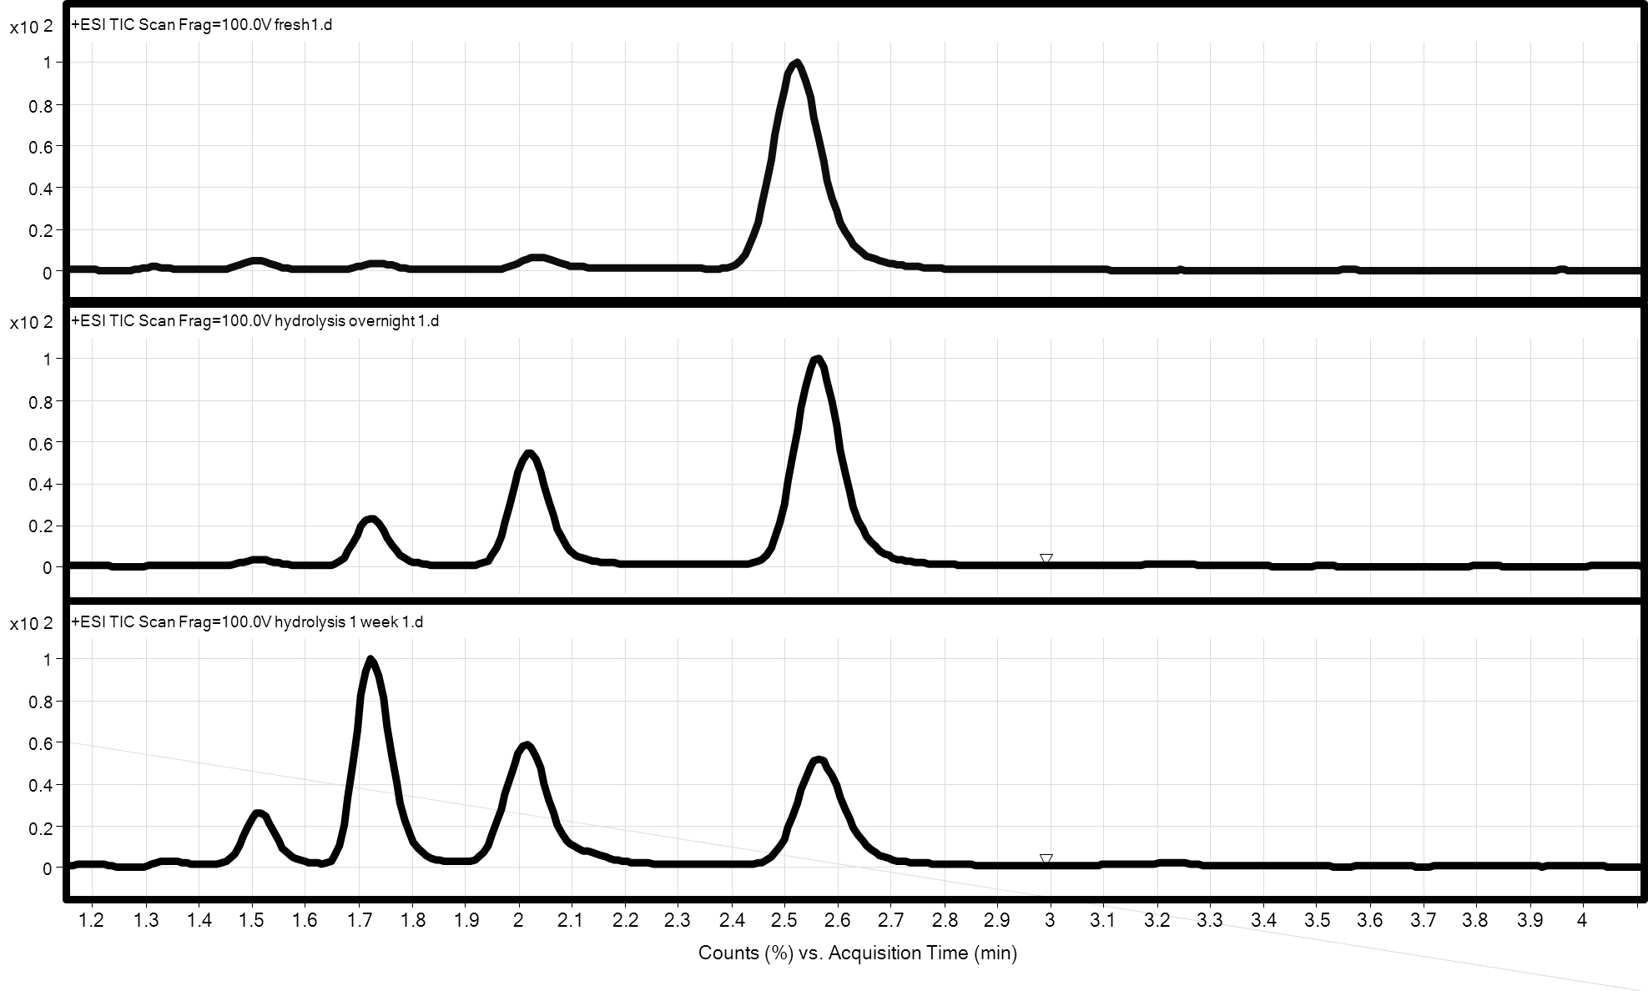
H0
H1
H7
(1)
(1)
(2)
(2)
(2)
(3)
(3)
(B)
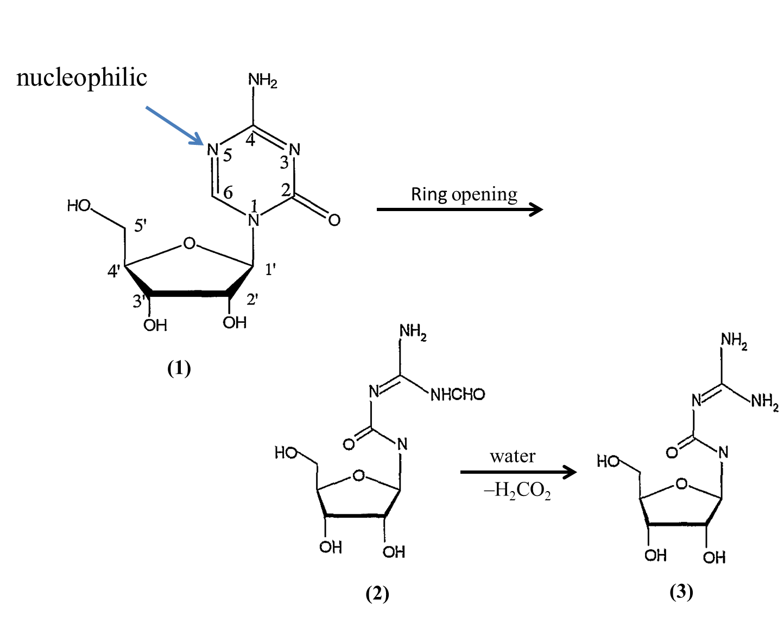
Figure 1. (A) Results obtained in the chromatographic monitoring of the degradation of 5-aza, (B) The decomposition mechanisms and the intermediate products. (1): 5-aza, (2): RGU-CHO and (3): RGU.

- (B)
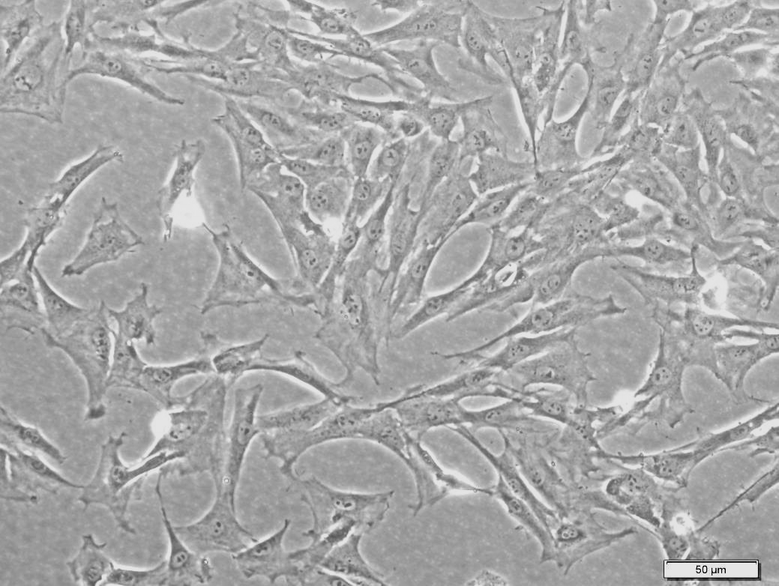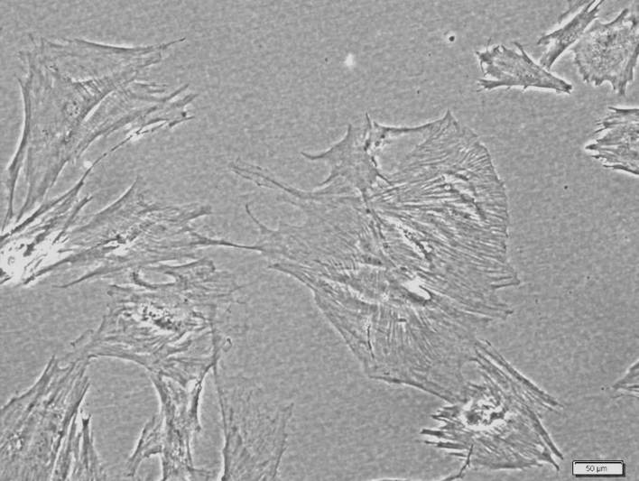
- (D)
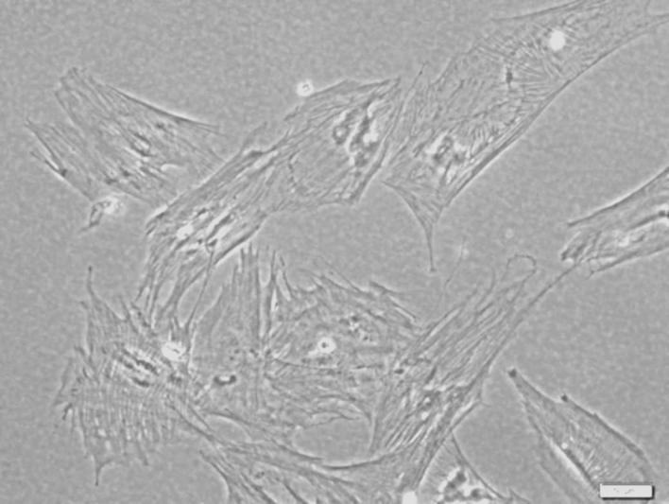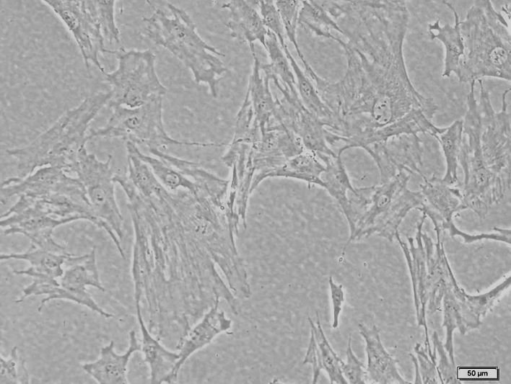
- (F)
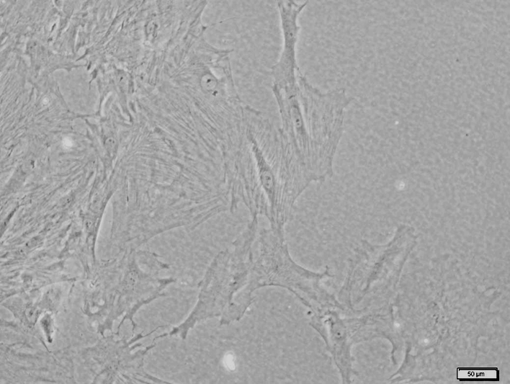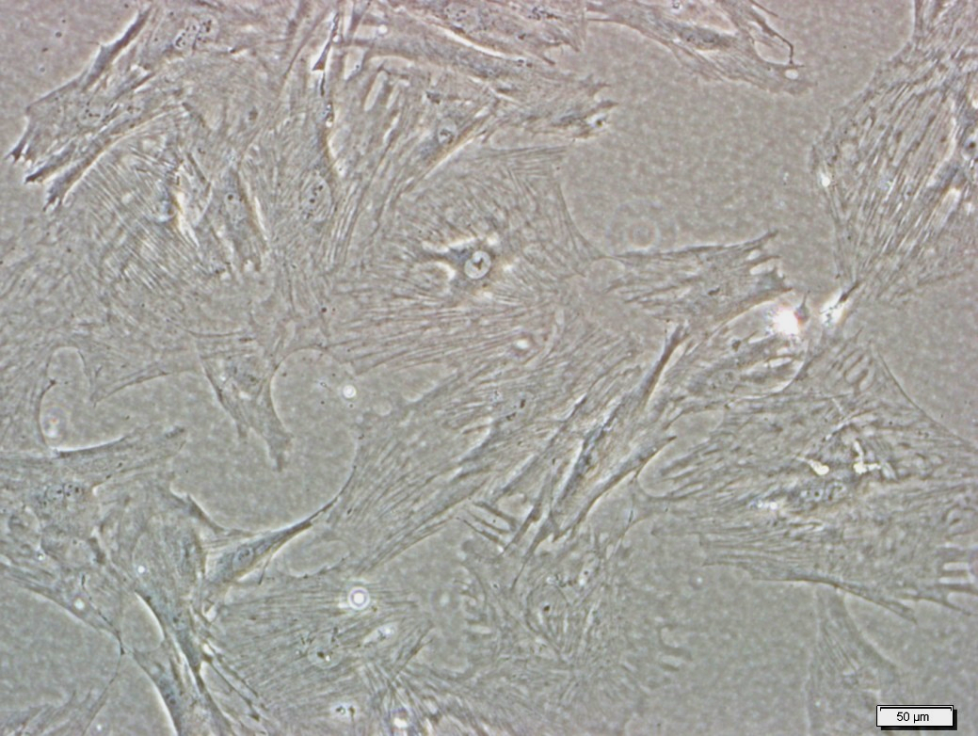
(G)
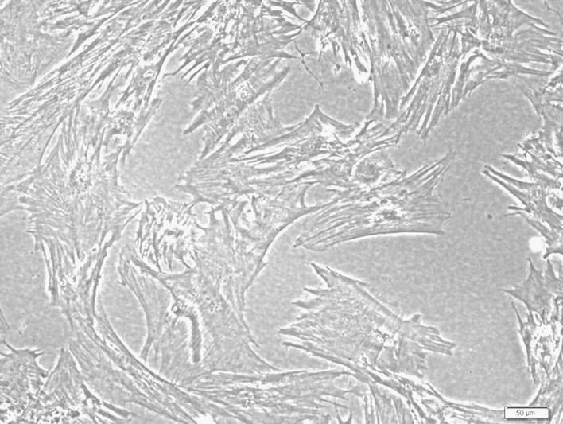
Figure 2. Phase contrast photographs of MSCs before and after 5-aza treatments. (A) MSCs showed fibroblast-like morphology before 5-aza treatments (3 d incubation). (B-D) Three-day post-treatment with H0, H1 and H7, the sizes of cells increased and has acquired a flattened morphology. Some cells are connecting with adjoining cells forming myotube-like structures. (E-G) Seven-day post-treatment with H0, H1 and H7, similar cell morphological features (B), myotube-like structures were also pronounced. Bar: 50 μm.

(A)
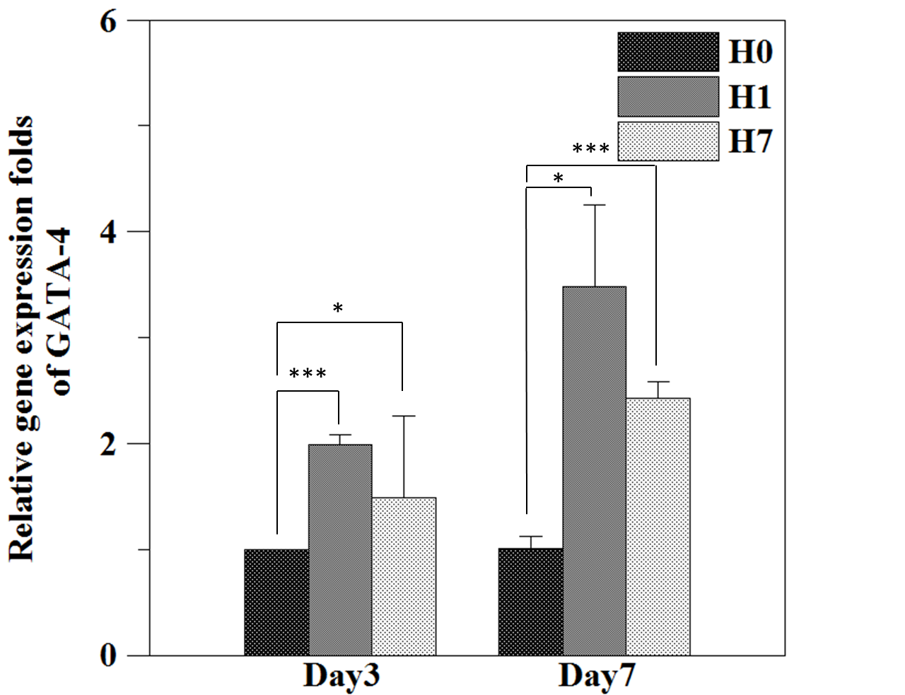
(B)
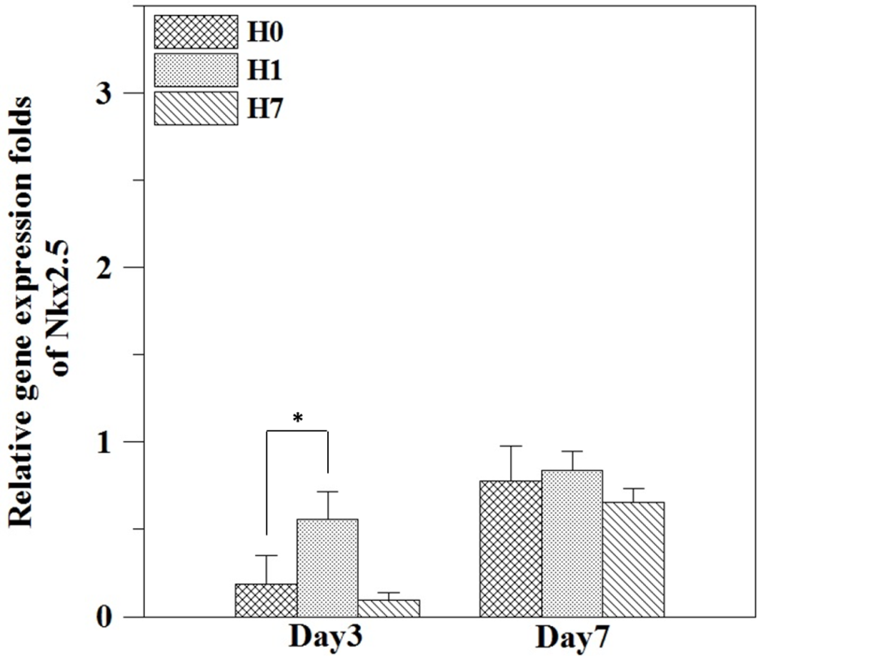

(C)
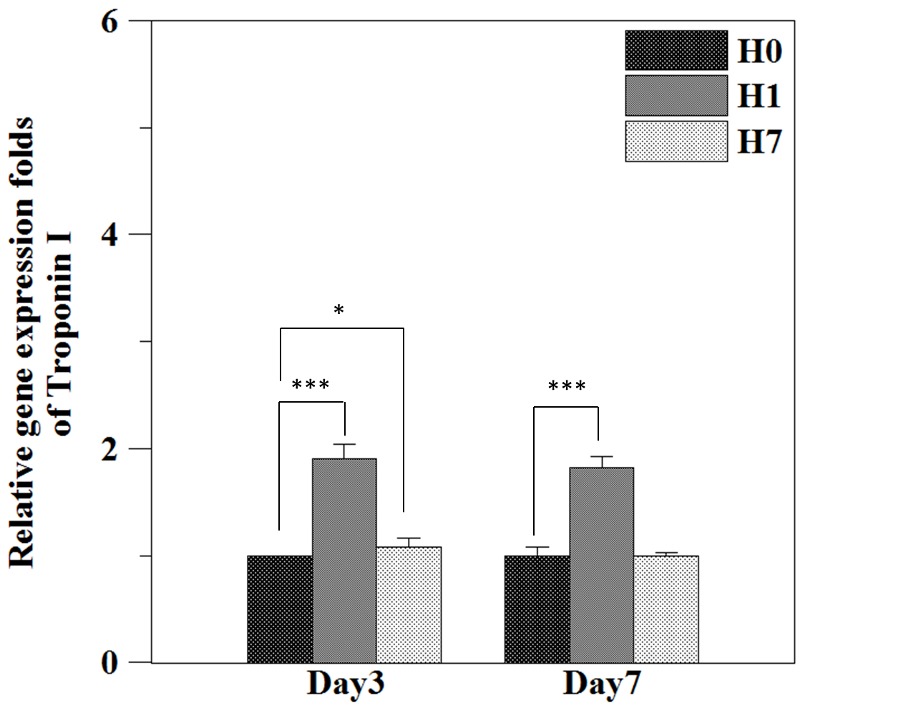

(D)
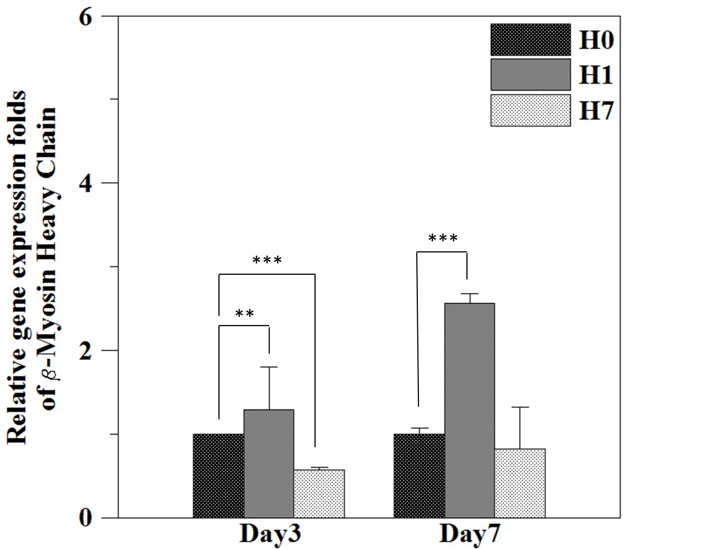

(E)
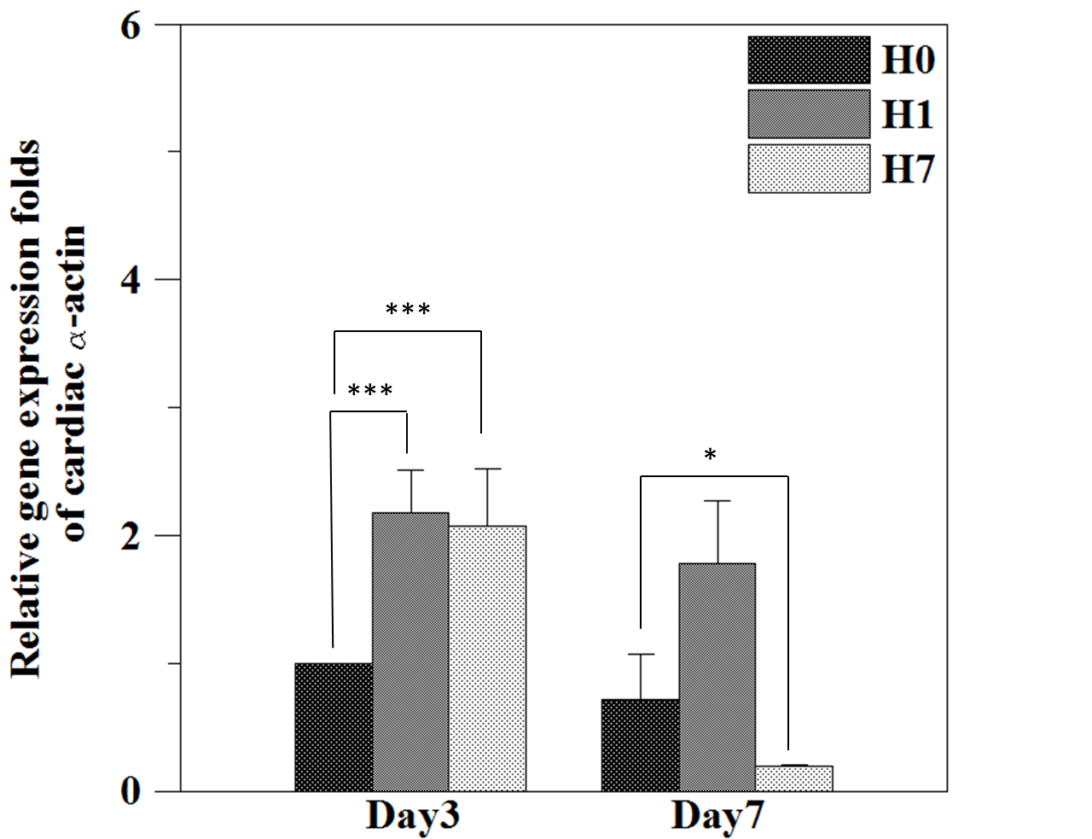

Figure 3. Effects of freshly prepared 5-aza (H0) and hydrolyzed 5-aza (H1 and H7) on the MSCs differentiation into cardiomyocytes. After 3- and 7-day incubation, the RQ of specific gene expression was detected by quantitative RT-PCR and analyzed by statistic software. (A) GATA-4 (B) Nkx2.5 (C) troponin I (D) β-myosin heavy chain and (E) cardiac α-actin. *p<0.05, **p<0.01, ***p<0.001.

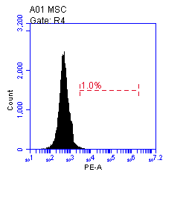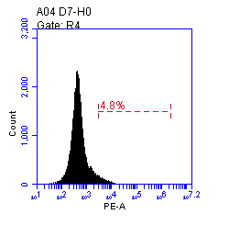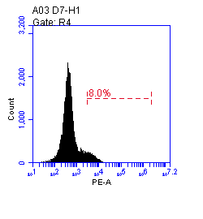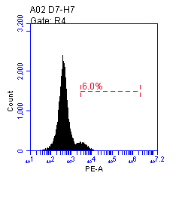
Figure 4. Flow cytometry assays demonstrated that 6 %, 8 % and 4.8 % of cells expressed cardiomyocyte-specific cardiac α-actin after treated with 5-aza (H0), hydrolyzed 5-aza (H1 and H7) after 7-day incubation.

(A)

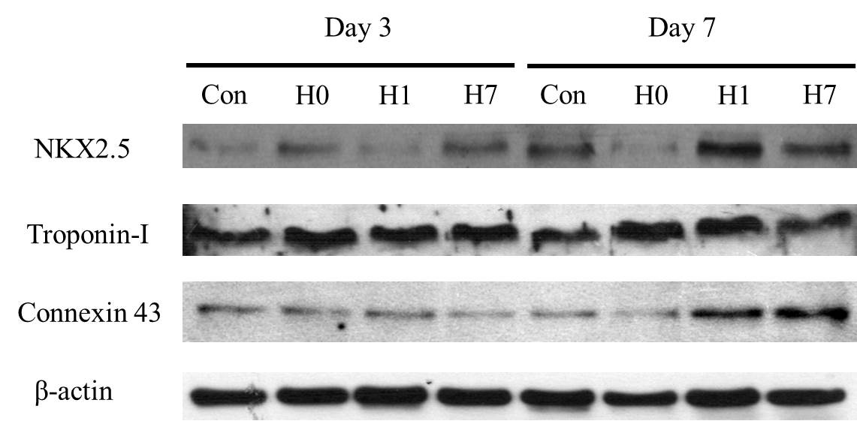

(B)
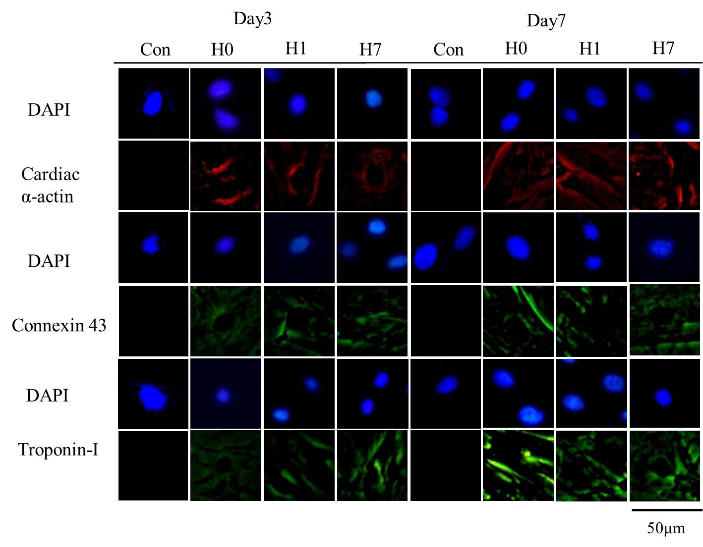

Figure 5. (A) Western blot analysis showed that the expressions of cardiac-specific proteins Nkx2.5, troponin I and connexin 43 increased in H0, H1 or H7 groups after 7-day incubation. (B) Immunostaining analysis of effects of freshly prepared and hydrolyzed 5-aza-induced MSCs differentiation into cardiomyocytes. Positive staining for cardiac α-actin (red), connexin 43 (green) and troponin I (green) were demonstrated in all groups at 3- and 7-day of incubation. Con: control group: without any 5-aza treatments. All nuclei were stain with DAPI (blue).

