Reciprocal relationship of Tn/NF-κB and sTn as an indicator of the prognosis of oral squamous cell carcinoma

Chi-Yu Lin,^{1,2} Jar-Yi Ho,^{1,3} Meng-Ti Hsieh,⁴ Hsiao-Ling Chiang,^{1,2} Jei-Min Chuang,²
Jacqueline Whang-Peng,⁵ Yun-Ching Chang,⁶ Yi-Han Tseng,³ Su-Feng Chen,⁷ Shin Nieh³ & Jaulang Hwang²

1. Graduate Institute of Life Sciences, National Defense Medical Centre
2. Department of Biochemistry, Medical College, Taipei Medical University
3. Department of Pathology and Graduate School of Pathology, National Defense Medical Centre and Tri-Service General Hospital
4. Institute of Cancer Biology and Drug Discovery
5. Centre of Excellence for Cancer Research, Taipei Medical University, Taipei
6. Department of Medical Research and Education, Taipei Veterans General Hospital
7. Department of Dental Hygiene, China Medical University, Taichung, Taiwan

Address for correspondence: J Hwang, Department of Biochemistry, Medical College, Taipei Medical University, No. 250, Wusing Street, Sinyi District, Taipei, Taiwan 11031, Taiwan. e-mail: jaulang@tmu.edu.tw
Co-correspondence: Su-Feng Chen. e-mail: csf@mail.cmu.edu.tw, Shin Nieh. e-mail: niehshin1014@yahoo.com.tw

Aims: In order to determine whether the expression of tumour-associated carbohydrate antigens (Tn/sTn) and a representative inflammation marker, nuclear factor-κB (NF-κB), is associated with the invasiveness of oral squamous cell carcinoma (OSCC), this study has attempted to investigate the correlation of the aforementioned markers with the well-established invasive pattern grading score (IPGS) and clinicopathological parameters.
Methods and results: Specimens from 143 OSCC patients with classified clinicopathological parameters and IPGS were stained immunohistochemically using anti-Tn, sTn and NF-κB antibodies. Our results showed that the expression of both Tn and NF-κB was correlated positively with staging (P = 0.036; P = 0.015), recurrence (P < 0.001; P < 0.001) and distant metastasis (P = 0.005; P = 0.009), as well as with IPGS, while the expression of sTn was correlated inversely. In addition, poor survival was associated with overexpression of Tn and NF-κB but not with expression of sTn.
Conclusions: Our results indicate that a reciprocal relationship between Tn and sTn expression may serve as a reliable indicator for OSCC prognostic evaluation. In addition, expression of Tn rather than sTn may play an important role in deeply invasive OSCC via regulation of NF-κB signalling.

Keywords: invasive pattern grading score, nuclear factor-κB, oral squamous cell carcinoma, tumour-associated carbohydrate antigen

Introduction
Morbidity and mortality due to oral squamous cell carcinoma (OSCC) are increasing, both in Taiwan and worldwide.¹ In spite of substantial developments in both diagnostic and therapeutic strategies during recent years, the prognosis for patients with OSCC is still unfavourable,^{2,3} due to the presence of extensive local invasion or frequent regional lymph node metastasis, even at initial diagnosis. Therefore, there is an urgent need to develop effective biomarker(s) that can provide a valid assessment of the biological behaviour of the tumour as an aid to both diagnosis and therapy in OSCC.
Expression of tumour-associated carbohydrate antigens (TACAs) is associated with many infectious diseases and cancers.^{4–6} A variety of malignant and normal tissues have been screened by immunochemistry using antibodies against TACAs.^{7,8} Overexpression of TACAs is always observed on the cell surface of malignant tumour cells. Two common TACAs, Tn and sialyl-Tn (sTn), are presented as mucin-type carbohydrates.^{9–11} To synthesize Tn antigen (GalNAc-Ser/Thr), N-acetylgalactosamine (GalNAc) is conjugated to the serine (Ser) or threonine (Thr) sites of mucin by GalNAc transferase (ppGalNAcT), while the synthesis of sTn (NeuAc-6GalNAc-Ser/Thr) involves addition of the sialyl moiety to Tn by sialyltransferase. Thus, sTn is regarded as a progression of Tn.¹² In normal tissue, Tn and sTn are generally masked by the addition of further carbohydrate moieties. Previous studies have shown that Tn and sTn are often expressed by human carcinomas, including prostate and breast cancer,^{13,14} and are strongly associated with advanced cancers that are more invasive, highly proliferative and metastasize easily, resulting in a poor clinical outcome.^{5,13} Although Tn and sTn were thought to be the result of abnormal glycosylation related to cancer, it is still not completely understood whether the appearance of Tn/sTn correlates with cancer invasion and metastasis.
Various factors affect both tumour invasion and metastasis in the tumour microenvironment, which is composed of infiltrating immune cells, secretory cytokines and chemokines. These factors accelerate the motility, invasiveness and metastasis of tumour cells.^{15–17} Extensive studies have shown that nuclear factor-κB (NF-κB) plays a pivotal role in tumour progression and metastasis via its regulation of expression of target genes.^{18–21} Activation of NF-κB can be induced by various factors, including inflammatory stimuli such as tumour necrosis factor-α(TNF-α), interleukin-1, reactive oxygen species (ROS) and pathogens. It has been reported that NF-κB can also regulate the epithelial–mesenchymal transition (EMT) phenotype via Snail and/or Twist, leading to suppression of epithelial markers, primarily E-cadherin, and enhancement of mesenchymal markers, including vimentin, fibronectin and N-cadherin.^{20,22,23} There is therefore evidence of a close interaction between NFκB and EMT-associated proteins. However, the association of NF-κB and TACAs (Tn/sTn) needs further clarification.
In our previous study,²⁴ we developed the invasive pattern grading score (IPGS) system for classifying OSCC, and confirmed that this simple and easy method not only provides a link between histological assessment and biological behaviour, but also provides independent prognostic information in planning treatment for OSCC. Recently, we have also successfully developed an anti-Tn vaccine that protects against prostate cancer in transgenic adenocarcinoma of the mouse prostate (TRAMP) mice. Using anti-Tn vaccine, we were able to obtain anti-Tn antibodies with high specificity and high affinity. Applying anti-Tn antibody, we have demonstrated that the expression of Tn is correlated positively with the degree of malignancy in prostate cancer.²⁵ However, it is not known if Tn, sTn and NF-κB are involved in the biological behaviour of invasive OSCC. This study was therefore undertaken to determine whether or not the expression of Tn, sTn and NF-κB and the relationships between them are of prognostic significance in OSCC.
Materials and methods
P A T I E N T S A N D T I S S U E S P E C I M E N S
Tissue specimens from 200 patients with OSCC were retrieved from the archives of the Department of Pathology, Tri-Service General Hospital (Taipei, Taiwan). The study of all specimens received ethics approval from the Tri-Service General Hospital Institutional Review Board (no. 099-05-229). We obtained these specimens from radical surgical resections of OSCC undertaken between January 2000 and December 2002. Fifty-seven patients either without follow-up or insufficient clinicopathological data for analysis were excluded. Therefore, only 143 cases of OSCC were included in this study and reclassified according to the classical grading system²⁶ and IPGS.²⁴

I M M U N O H I S T O C H E M I S T R Y
Tissue sections were de-waxed in xylene and rehydrated in alcohol, followed by incubation in 0.01 M citrate buffer pH 6.0 at 95°C for 40 min in a waterbath. They were then treated with 0.3% H2O2 for 30 min to block endogenous peroxidase; and incubated with 5% normal goat serum in phosphate-buffered saline (PBS) for 2 h at room temperature to block non-specific antibody reactions. After three washes with PBS containing 0.1% Tween 20 (PBST), sections were incubated with anti-Tn (1 in 200 dilution), anti-sTn (1 in 200 dilution)25 or anti-NF-κB antibody (1 in 200 dilution; Cell Signalling Technology, Denver, CO, USA) for 30 min at room temperature, while negative controls were incubated with PBS under the same conditions. After rinsing in PBST, tissue sections were incubated with Envision horseradish peroxidase (Dako, Glostrup, Denmark) for 30 min at room temperature and subsequently incubated with a substrate–DAB chromogen buffer (Dako), before being counterstained with Mayer’s haematoxylin, dehydrated and coverslipped with mounting medium.

G E N E R A T I O N O F A N T I - T N A N D A N T I - S T N A N T I B O D I E S
Anti-Tn and -sTn antibodies were generated as described elsewhere.²⁵ In brief, we conjugated Tn and sTn individually to a bipartite antigen carrier protein (Mw = 34 kDa). The carrier protein contains two domains. One has a synthetic cysteine-rich motif for glycotope conjugation and hence effective activation of naive B cells. The other is an IgG Fc domain that binds the Fc receptor on antigen-presenting cells to facilitate activation of type 2 T helper cells and hence class-switching and affinity selection, leading to the production of high-affinity IgG antibodies. We then used these two glycotope–carrier protein conjugates to immunize BALB/c mice and successfully produced anti-Tn and anti-sTn antibodies with high affinity and high specificity.

C A L C U L A T I O N O F I N V A S I V E P A T T E R N G R A D I N G S C O R E
Use of the IPGS was as described in a previous report.²⁴ A search was carried out for the deep invasive front of the OSCC interfacing the stromal tissue, where carcinoma-associated fibroblasts are present, to identify the invasive pattern or patterns, which were scored under both low- and high-power field microscopy. Because of the histological variation within each tumour, the scores of the two most prevalent patterns at the invasive front of OSCC – the predominant (primary) grade, and the less extensive (secondary) grade – were combined to give a total score, the IPGS. Tertiary patterns were not considered in the IPGS. Because each invasive pattern was assigned a score between 1 and 4, the total summed scores ranged from 2 to 8. In the case of a consistent invasive pattern where only one grade was present, IPGS was calculated by doubling the invasive score. The minimal cut-off for inclusion in the IPGS was a pattern comprising at least 20% of the tumour invasive front. The tumours were divided into two groups classified as high (>5) or low IPGS (≤4), with a score of 4 as the threshold.
I M M U N O H I S T O C H E M I C A L S T A I N I N G E V A L U A T I O N
The histopathological slides of all the OSCC specimens were reviewed concurrently and independently by two expert pathologists using the same type of microscope without prior knowledge of each patient’s clinical details. To evaluate precisely and objectively the intensity of Tn, sTn and NF-κB staining, we used a Zeiss AxioImager-Z1 microscope to capture images of all sections, and measured the intensity of staining for the three markers using Program Metamorph software. Intensity was classified into three categories: no staining scored 0, less than average intensity (low intensity) scored 1, and higher than average (high intensity) scored 2. Adobe Photoshop CS5 was used to measure the distribution of each of the three markers as a percentage of the total tumour area. We multiplied the intensity score by the distribution percentage to obtain an immunoreactivity score, ranging from 0 to 200. The mean immunoreactivity score of each marker was selected as the cut-off point to separate tumours showing low (≤mean) and high (>mean) expression.
S T A T I S T I C A L A N A L Y S I S
The χ2 test was used to correlate the expression levels of Tn, sTn and NF-κB with clinicopathological parameters and IPGS. The prognostic significance (overall survival) of the expression levels of the three markers and of the clinicopathological parameters was assessed using Cox regression. The Kaplan–Meier method was used to obtain survival curves. SPSS software version 15.0 (SPSS UK Ltd, Woking, UK) was used for the analysis. P < 0.05 was considered significant.
Results
T H E E X P R E S S I O N L E V E L S O F T N , S T N A N D N F - κ B A R E C L O S E L Y C O R R E L A T E D WI T H C L I N I C O P A T H O L O G I C A L
P A R A M E T E R S

As shown in Table 1, both Tn and NF-κB expression were correlated significantly with tumour size, regional lymph node metastasis, distant metastasis, stage, tumour recurrence, patient survival and IPGS, but not with age, sex or tumour differentiation. NF-κB expression was also correlated significantly with tumour location. However, sTn only correlated significantly with tumour recurrence, patient survival and IPGS, but not with age, sex, tumour size, regional lymph node or distant metastasis, stage, location or tumour differentiation. This implied that the Tn/NFκB signalling axis is involved in OSCC progression.

T N A N D N F - κB A R E C O R R E L A T E D P O S I T I V E L Y W I T H I P G S ; S T N IS C O R R E L A T E D N E G A T I V E L Y W I T H I P G S
To further confirm that tumour invasion and the expression of Tn, sTn and NF-κB are closely associated, we reclassified the 143 samples of OSCC using our IPGS system. When correlated with different IPGS from low to high (2–8), gradients of expression of Tn, sTn and NF-κB were observed in the cytoplasm and on the cell surface of OSCC. In tumours with the lowest IPGS, indicating that the tumour invaded on a broad front with a smooth outline, weak expression of Tn and NF-κB was observed in contrast to intense and diffuse expression of sTn. However, in tumours with the highest IPGS, Tn and NF-κB were markedly increased, especially at the infiltrating edge or invasive front of the tumour, in contrast to a decrease in sTn expression (Figure 1). The expression of Tn/NFκB and sTn showed a reciprocal relationship with the IPGS: the levels of Tn and NF-κB increased with increasing IPGS, while the levels of sTn declined as the IPGS increased (Figure 2).

T N I S A N I N D E P E N D E N T R I S K F A C T O R F O R P R O G N O S I S I N O S C C
In univariate analysis, there was a significant association between patient survival and the levels of Tn, sTn and NF-κB, stage, recurrence and IPGS. Similar results were also found using log-rank analysis (Table 2). As shown in Figure 3, we followed-up the 143 patients with OSCC from initial diagnosis for 10 years, and the levels of Tn, sTn and NF-κB all showed a significant association with patient survival by Kaplan–Meier analysis. This implies that higher expression of Tn/NFκB and lower expression of sTn are associated significantly with poorer survival. In multivariate analysis, including the risk factors (Tn, sTn, NF-κB, stage, recurrence, and IPGS) identified by univariate analysis, only the level of Tn was an independent risk factor for overall survival in OSCC: higher expression of Tn conferred a 2.39-fold higher risk of poorer survival compared with lower expression.

Discussion
In assessing Tn, sTn and NF-κB expression, we used an immunoreactivity score comprising both the intensity and distribution of staining, which may help to produce more representative indicators and also to avoid miscalculation resulting from tumour heterogeneity in cancer tissues. In OSCC, expression of both Tn and NF-κB, but not sTn, were correlated positively with various prognostic factors, including tumour size, regional lymph node or distant metastasis, stage, recurrence and patient survival. Tn and NF-κB expression correlated positively with IPGS, whereas sTn correlated inversely with IPGS. Although univariate analysis showed that Tn, sTn and NF-κB were all associated with overall survival, on multivariate analysis only Tn was an independent prognostic factor. In other words, high-level expression of sTn is usually found in tumours with a low IPGS, and sTn expression attenuates in deeply invasive OSCC, which often have a high IPGS. Thus, sTn expression may be regarded as an indicator of the initial stages of invasiveness of OSCC. In contrast, Tn and NF-κB were overexpressed in deeply invasive OSCC with high IPGS, but neither was overexpressed in superficial invasive OSCC. Thus, Tn plays a crucial role in deep invasion and metastasis of OSCC, when overexpression of NF-κB is also involved in the interaction between the tumour and its microenvironment. As reported in previous studies,^{27–29} overexpression of sTn reduces cell growth but increases cell invasion in breast cancer cells. This study appears to contradict our observation that the level of sTn was low in OSCC with high IPGS. A possible explanation is that sTn may be involved in the initial stage of invasion, and at later stages Tn, but not sTn, may play a pivotal role. The result of the cell assay may reflect the role of sTn in the initial stage of invasion. Thus, there is no conflict between these studies and our finding that Tn and sTn have a reciprocal relationship with cancer invasion in OSCC. It has been shown comprehensively that in many cancers Tn and sTn are strongly associated with metastatic potential and poor prognosis. Therefore, immunotherapy targeted at Tn or sTn has been developed in the past 20 years.5,^{30–32} Recently, we have successfully produced anti-Tn and anti-sTn monoclonal antibodies (mAb) with high affinity and high specificity. These two antibodies recognize their cognate antigens exclusively.²⁵ In this study, we have reported the reciprocal relation of Tn and sTn in OSCC progression. A number of studies have evaluated the association between Tn and sTn profiles in several cancer types using different antibodies from various sources. Lower expression of sTn has been reported in verrucous oral carcinoma using TKH2 anti-sTn mAb.³³
Higher expression of Tn (with Dako anti-Tn mAb) and lower expression of sTn (with Dako anti-sTn mAb) were also reported in head and neck squamous cell carcinoma (HNSCC), although the positivity rate was very low.³⁴ However, the same authors also reported that Tn and sTn profiles were no different among a larger-scale HNSCC population.³⁵ sTn antigen was detected in both colon cancer and normal colon tissue using TKH2 and B72.3 mAb, and TKH2 mAb when the O-acetyl group was removed.³⁶ One possible explanations for the differences between their results and ours may be the effects of enzymatic or chemical treatment, which may cause conformational and structural change and lead to low positivity or alternative specificity. For example, neuraminidase treatment or NaOH saponification may have uncovered the epitopes (glycotopes) and increased sensitivity to the antibodies they used; however, conformational and structural alteration may lead to lower specificity and/or inconsistent findings. In our study, we did not perform any pretreatment of our tissue specimens before using our anti-Tn and sTn antibodies. Thus, our result suggests that our antibodies recognize the more compact structure of Tn and sTn antigens. Interestingly, we observed that both Tn and sTn were intensely expressed at the invasive front or infiltrating border of OSCC. In this area, tumour cells show cytoskeleton rearrangement and alterations in adhesion and motility, and progress easily to advanced invasion and metastasis resulting from EMT. EMT is caused directly by loss of epithelial cell markers and gain of mesenchymal cell markers.17 Our previous studies showed that fascin, an actin bundle protein, was also intensely expressed at the invasive front or infiltrating borders of OSCC, and small inhibitory (si) RNA down-regulation of fascin resulted in alterations in expression of E-cadherin, bcatenin and Twist, implicating the association of invasiveness with EMT.³⁷ As demonstrated previously, ¹⁸ the pro-inflammatory cytokine TNF-a can be induced by overexpression of Twist via activation of NF-κB. TNF-a-induced Twist expression in breast cancer leads to EMT, invasion and metastasis. Such studies suggest the provocative possibility that crosstalk between Tn/sTn and EMT-associated molecules may be involved in the development of EMT and tumour invasion. Overexpression of Tn and sTn antigens may affect the recognition of tumour cells by immune cells, including B and T lymphocytes, macrophages and dendritic cells, resulting in immune escape of tumour cells and a poor prognosis for cancer patients.³⁸ In addition, Ishino et al.³⁹ reported that overexpression of Tn and sTn was correlated with COX-2 expression, and that mucin induced COX-2 in tumour-infiltrating macrophages in the tumour microenvironment. Collectively, such evidence provoked our interest in exploring whether or not Tn and sTn are correlated with these EMT-related molecules and are regulated by inflammatory cytokines via activation of NF-κB during the process of invasion and metastasis. However, more evidence is needed to dissect the signalling axis of NF-κB and Tn/sTn. Further studies of the correlations between Tn/sTn expression and EMT-associated molecules in OSCC with an assigned IPGS are under way in our laboratory.
In conclusion, this study presents evidence of a reciprocal relationship between Tn and sTn expression in OSCC during tumour progression and acquisition of a high IPGS score. These markers may represent new adjunct targets for treatment strategies in patients with invasive OSCC.

References
- Chen YJ, Chang JT, Liao CT et al. Head and neck cancer in the betel quid chewing area: recent advances in molecular carcinogenesis. Cancer Sci. 2008; 99; 1507–1514.
- Yuen AP, Wei WI, Lam LK, Ho WK, Kwong D. Results of surgical salvage of locoregional recurrence of carcinoma of the tongue after radiotherapy failure. Ann. Otol. Rhinol. Laryngol. 1997; 106; 779–782.
- Olasz L, Szabo I, Horvath A. A combined treatment for advanced oral cavity cancers. Cancer 1988; 62; 267–1274.
- Kobata A, Amano J. Altered glycosylation of proteins produced by malignant cells, and application for the diagnosis and immunotherapy of tumours. Immunol. Cell Biol. 2005; 83; 429–439.
- Dube DH, Bertozzi CR. Glycans in cancer and inflammation—potential for therapeutics and diagnostics. Nat. Rev. Drug Discov. 2005; 4; 477–488.
- Dabelsteen E. Cell surface carbohydrates as prognostic markers in human carcinomas. J. Pathol. 1996; 179; 358–369.
- Zhang S, Zhang HS, Cordon-Cardo C et al. Selection of tumor antigens as targets for immune attack using immunohistochemistry: II. Blood group-related antigens. Int. J. Cancer 1997; 73; 50–56.
- Zhang S, Cordon-Cardo C, Zhang HS et al. Selection of tumor antigens as targets for immune attack using immunohistochemistry: I. Focus on gangliosides. Int. J. Cancer 1997; 73; 42–49.
- Springer GF. Immunoreactive t and tn epitopes in cancer diagnosis, prognosis, and immunotherapy. J. Mol. Med. 1997; 75; 594–602.
- Brockhausen I. Mucin-type O-glycans in human colon andbreast cancer: glycodynamics and functions. EMBO Rep. 2006;7; 599–604.
- Itzkowitz SH, Yuan M, Montgomery CK et al. Expression of tn, sialosyl-Tn, and T antigens in human colon cancer. Cancer Res. 1989; 49; 197–204.
- Tarp MA, Clausen H. Mucin-type O-glycosylation and its potential use in drug and vaccine development. Biochim. Biophys. Acta 2008; 1780; 546–563.
- Ju T, Otto VI, Cummings RD. The Tn antigen-structural simplicity and biological complexity. Angew. Chem. Int. Ed. Engl. 2011; 50; 1770–1791.
- Konska G, Guerry M, Caldefie-Chezet F, De Latour M, Guillot J. Study of the expression of Tn antigen in different types of human breast cancer cells using VVA-B4 lectin. Oncol. Rep. 2006; 15; 305–310.
- Lee DF, Hung MC. Advances in targeting IKK and IKK-related kinases for cancer therapy. Clin. Cancer Res. 2008; 14; 5656–5662.
- Wu Y, Zhou BP. TNF-alpha/NF-kappaB/Snail pathway in cancer cell migration and invasion. Br. J. Cancer 2010; 102; 639–644.
- Thiery JP. Epithelial–mesenchymal transitions in tumour progression. Nat. Rev. Cancer 2002; 2; 442–454.
- Li CW, Xia W, Huo L et al. Epithelial–mesenchymal transition induced by TNF-alpha requires NF-kappaB-mediated transcriptional upregulation of Twist1. Cancer Res. 2012; 72; 1290–1300.
- Ben-Neriah Y, Karin M. Inflammation meets cancer, with NFkappaB as the matchmaker. Nat. Immunol. 2011; 12; 715–723.
- Chua HL, Bhat-Nakshatri P, Clare SE, Morimiya A, Badve S, Nakshatri H. NF-kappaB represses E-cadherin expression and enhances epithelial to mesenchymal transition of mammary epithelial cells: potential involvement of ZEB-1 and ZEB-2. Oncogene 2007; 26; 711–724.
- Huber MA, Azoitei N, Baumann B et al. NF-kappaB is essential for epithelial–mesenchymal transition and metastasis in a model of breast cancer progression. J. Clin. Invest. 2004; 114;569–581.
- Wu Y, Deng J, Rychahou PG, Qiu S, Evers BM, Zhou BP. Stabilization of Snail by NF-kappaB is required for inflammationinduced cell migration and invasion. Cancer Cell 2009; 15;416–428.
- Pham CG, Bubici C, Zazzeroni F et al. Upregulation of Twist-1 by NF-kappaB blocks cytotoxicity induced by chemotherapeutic drugs. Mol. Cell. Biol. 2007; 27; 3920–3935.
- Chang YC, Nieh S, Chen SF, Jao SW, Lin YL, Fu E. Invasive pattern grading score designed as an independent prognostic indicator in oral squamous cell carcinoma. Histopathology 2010; 57; 295–303.
- Chiang HL, Lin CY, Jan FD et al. A novel synthetic bipartite carrier protein for developing glycotope-based vaccines. Vaccine 2012; 52; 7573–7581.
- Chen SF, Yang SF, Li JW et al. Expression of fascin in oral and oropharyngeal squamous cell carcinomas has prognostic significance—a tissue microarray study of 129 cases. Histopathology 2007; 51; 173–183.
- Sewell R, Backstrom M, Dalziel M et al. The ST6GalNAc-isialyltransferase localizes throughout the Golgi and is responsible for the synthesis of the tumor-associated sialyl-Tn O-glycan in human breast cancer. J. Biol. Chem. 2006; 281;3586–3594.
- Julien S, Adriaenssens E, Ottenberg K et al. ST6GalNAc I expression in MDA-MB-231 breast cancer cells greatly modifies their O-glycosylation pattern and enhances their tumorigenicity. Glycobiology 2006; 16; 54–64.
- Vazquez-Martin C, Cuevas E, Gil-Martin E, Fernandez-Briera A. Correlation analysis between tumor-associated antigen sialyl-Tn expression and ST6GalNAc I activity in human colon adenocarcinoma. Oncology 2004; 67; 159–165.
- Ragupathi G. Carbohydrate antigens as targets for active specific immunotherapy. Cancer Immunol. Immunother. 1996; 43;152–157.
- Slovin SF, Keding SJ, Ragupathi G. Carbohydrate vaccines as immunotherapy for cancer. Immunol. Cell Biol. 2005; 83; 418–428.
- Danishefsky SJ, Allen JR. From the laboratory to the clinic: a retrospective on fully synthetic carbohydrate-based anticancer vaccines frequently used abbreviations are listed in the appendix. Angew. Chem. Int. Ed. Engl. 2000; 39; 836–863.
- Bryne M, Gravdahl C, Koppang HS, Kjaerheim A, Dabelsteen E. Is the carbohydrate sialosyl-Tn a marker for altered, nonmalignant activity in squamous epithelium in the head and neck region? J. Pathol. 1995; 175; 237–242.
- Croce MV, Rabassa ME, Pereyra A, Segal-Eiras A. Influence of sialic acid removal on MUC1 antigenic reactivity in head and neck carcinoma. Pathol. Oncol. Res. 2005; 11; 74–81.
- Croce MV, Rabassa ME, Pereyra A, Segal-Eiras A. Differential expression of MUC1 and carbohydrate antigens in primary and secondary head and neck squamous cell carcinoma. Head Neck 2008; 30; 647–657.
- Ogata S, Koganty R, Reddish M et al. Different modes of sialyl-Tn expression during malignant transformation of human colonic mucosa. Glycoconj. J. 1998; 15; 29–35.
- Chen SF, Lin CY, Chang YC et al. Effects of small interfering RNAS targeting fascin on gene expression in oral cancer cells. J. Oral Pathol. Med. 2009; 38; 722–730.
- Freire T, Lo-Man R, Bay S, Leclerc C. Tn glycosylation of the MUC6 protein modulates its immunogenicity and promotes the induction of Th17-biased T cell responses. J. Biol. Chem. 2011;286; 7797–7811.
- Ishino H, Kawahito Y, Hamaguchi M et al. Expression of Tn and sialyl Tn antigens in synovial tissues in rheumatoid arthritis. Clin. Exp. Rheumatol. 2010; 28; 246–249.

Figure 1. Comparisons of the expression of Tn, sTn and NF-κB in specimens of oral squamous cell carcinoma with different invasive pattern grading scores (IPGS). Microscopic photographs are shown of seven representative tumours with different IPGS, stained with H&E (first panel) and using immunohistochemistry for Tn, sTn and NF-κB (second to fourth panels). Higher-power magnification images of each figure with better resolution are shown in the insets. The expression of Tn (second panel) increased, and the expression of sTn (third panel) decreased, as IPGS increased. Expression of NF-κB (fourth panel) was correlated positively with IPGS, similar to the expression of Tn. In tumours with the lowest IPGS (2, left-most column) indicating tumour invasion on a broad front with a smooth outline, faint and weak expression of Tn and NF-κB was observed, in contrast to intense and diffuse immunoreactivity for sTn. In tumours with the highest IPGS (8, right-most column), the immunoreactivity for Tn was markedly increased, especially at the infiltrating edge or invasive front of the tumour.

Figure 2. The three curves show the correlation between invasive pattern grading score (IPGS) and immunoreactivity for Tn, sTn and NF-κB. The expression of Tn and NF-κB increased with increasing IPGS from 2 to 8. In contrast, the expression of sTn decreased with increasing IPGS.

Figure 3. Associations between cumulative survival and Tn, sTn and NF-jB expression in 143 patients with oral squamous cell carcinoma (Kaplan–Meier analysis).

Fig. 1
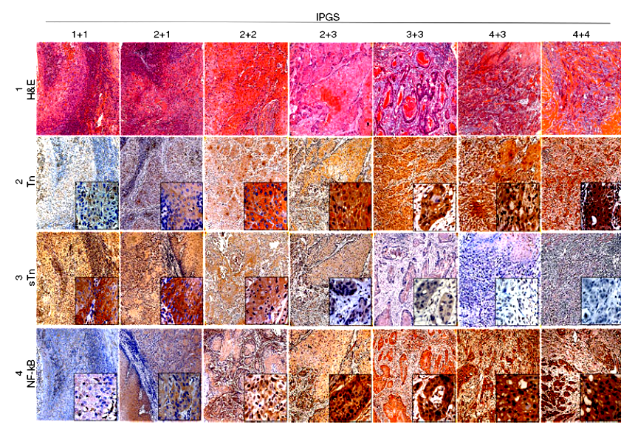
Fig. 2
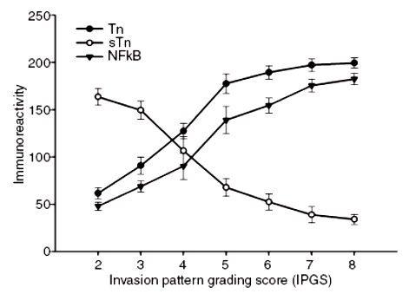
Fig. 3

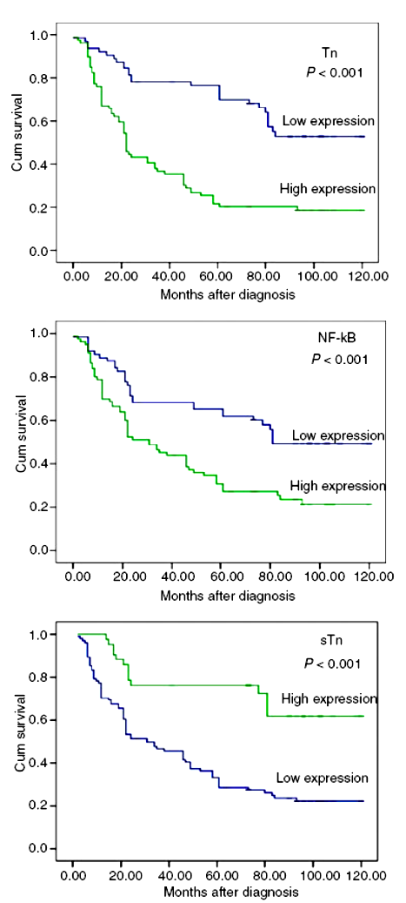

Table 1. Correlation of expression of Tn, sTn and NF-κB with clinical variables in 143 patients with oral squamous cell carcinoma
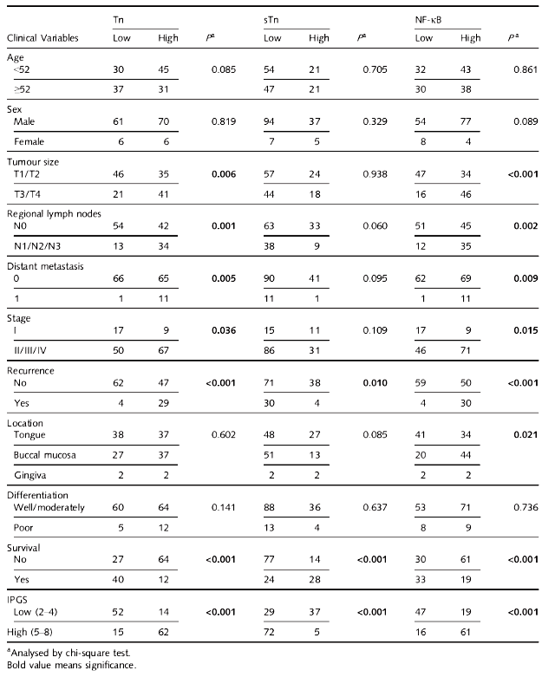

Table 2. Correlations of Tn, sTn, NF-κB and clinical parameters with survival

