Cantharidin induces G2/M phase arrest via the inhibitions of Cdc25c and Cyclin A and triggers apoptosis through reactive oxygen species and the mitochondria-dependent pathways of A375.S2 human melanoma cells

Yu-Ping Hsiao^{1,2}, Chung Hung Tsai^{1,3}, Ping-Ping Wu⁴, Shu-Chun Hsu⁵, Hsin-Chung Liu⁵, Yi-Ping Huang⁶, Jen-Hung Yang^{7,8,*} and Jing-Gung Chung^{5,9,*}

¹Institute of Medicine, Chung Shan Medical University, Taichung, Taiwan.
²Department of Dermatology, Chung Shan Medical University Hospital, Taichung, Taiwan.
³Department of Pathology, Chung Shan Medical University Hospital, Taichung, Taiwan.
⁴School of Pharmacy, China Medical University, Taichung, Taiwan.
⁵Department of Biological Science and Technology, China Medical University, Taichung, Taiwan.
⁶Department of Physiology, China Medical University, Taichung, Taiwan.
⁷School of Medicine, Tzu Chi University, Hualien, Taiwan
⁸Department of Dermatology, Buddhist Tzu Chi General Hospital, Hualien, Taiwan
⁹Department of Biotechnology, Asia University, Wufeng, Taichung, Taiwan

Running title: Cantharidin induced apoptosis in A375.S2 cells

*Correspondence to:
Professors Jen-Hung Yang and Jing-Gung Chung contributed equally to this work.
Jing-Gung Chung, Ph. D., Department of Biological Science and Technology, China Medical University, No 91, Hsueh-Shih Road, Taichung 404, Taiwan. Tel.: +886-4-2205-3366 ext 2161; Fax: +886-4-2205-3764.
E-mail address: jgchung@mail.cmu.edu.tw
Jen-Hung Yang, Ph. D., School of Medicine, Tzu Chi University, and Department of Dermatology, Buddhist Tzu Chi General Hospital, No. 707, Sec. 3, Chung Yang Road, Hualien 970, Taiwan. Tel: +886-3-8565301.
E-mail address: jh.med.edu@hotmail.com

Key words: Cantharidin, mitochondria, sub-G1 phase, apoptosis, A375.S2 cells

Abstract. Cantharidin (CTD), a component of natural mylabris (Mylabris phalerata Pallas) was reported to have high cyto-toxicity in many human cancer cell lines. However, it was not reported to affect human melanoma A375-S2 cells. In the present study, we found that CTD induced cell morphological changes and decreased the percentage of viable cells and induced G2/M phase arrest and induction of apoptosis in A375.S2 cells. Results also showed that CTD induced the generation of reactive oxygen species and Ca²⁺ and decreased mitochondria membrane potential and lead to the release of cytochrome c, AIF and Endo G. Further investigation revealed that CTD induced A375.S2 cells with an increase of caspase activation and caspase-dependent apoptotic proteins to trigger correlated pathway mechanisms according to Western blotting results. Western blotting was used for examining the changes of G2/M phase arrest and apoptosis associated protein expression and confocal laser microscopy was used to examine the translocation apoptosis associated protein. Results showed that CTD increased the protein expression of caspase-3, -8 and -9, cytochrome c, Bax, Bid, Endo G and AIF but inhibited the levels of Bcl-2 and Bcl-x. CTD induced ER stress associated protein expression such as GRP78, IRE1β, ATF6α and caspase-12. Based on those observations, we suggest that CTD may be used as a novel anti-cancer agent for the treatment of skin cancer in the future.

Introduction
Human melanoma, an aggressive skin cancer, accounts for only 10% of all skin cancers, was estimated to be involved in more than 80% of deaths from skin cancers . In Western countries, skin cancer melanoma is becoming more common and resulting in increased mortality . In the USA, the incidence of melanoma has increased by 15-fold in the last 40 years . In individuals of European origin, the incidence of melanoma is still rising . Survival ratio for metastatic melanoma is low and the ten-year survival rate for patients with metastatic melanoma is less than 10% . It was reported that human melanoma is highly resistant to conventional chemotherapy . Currently, the effective treatment of human melanoma such as surgery, radiation, chemotherapy or a combination of radiotherapy with chemotherapy has not been satisfying. Thus, numerous studies had focused on finding novel potent drugs from natural products to combat this disease.
In nature, insects produce different defensive molecules against predators, and these molecules may can be clinically used as medicinal drugs for therapeutic purposes . The dried body of mylabris (Mylabris phalerata Pallas) has been used in Chinese traditional medicine for the treatment of cancer since long ago . Cantharidin (CTD), a terpenoid, was isolated from mylabris (blister beetles) and other insects and was shown to induce cancer cell apoptosis such as leukemia , myeloma , bladder , breast , colon , liver , pancreatic and lung . It was reported that CTD inhibits migration and invasion of A549 human lung cancer cells via the inhibition of matrix metalloproteinase 2 . Recently, we also found that CTD induces cell apoptosis through mitochondria-dependent pathways and induced DNA damage and inhibits DNA repair-associated protein levels in NCI-H460 human lung cancer cells .
Although numerous studies have shown that CTD induced cytotoxic effects in many human cancer cell lines through the induction of apoptosis, however, there is no available information to show CTD induced apoptosis in human skin cancer cells. Therefore, in the present study, A375.S2 human melanoma cells were selected for using as a cell model to investigate the anti-melanoma potential of CTD in vitro. The results indicated that CTD induced G2/M phase arrest and cell apoptosis in A375.S2 cells via the caspase- and mitochondrial-dependent signaling pathways.

Materials and Methods
Chemicals and reagents. Cantharidin (CTD), propidium iodide (PI), Trypsin-EDTA, dimethyl sulfoxide (DMSO) and DAPI were purchased from Sigma Chemical Co. (St. Louis, MO, USA). CTD was dissolved in DMSO to make a stock solution. Minimum essential medium (MEM), fetal bovine serum (FBS), L-glutamine and penicillin-streptomycin were purchased from GIBCO®/Invitrogen Life Technologies (Carlsbad, California, USA). Primary antibody such as WEE1, Cdc25c, Cyclin A, CDK1, p21, Fas, Fas-L, AIF, Endo G, cytochrome c, caspase-3, -8 and -9, Bax, Bid, Bcl-2, Bcl-x, XBP-1, GADD153, GRP78, caspase-12, IRE1β, ATF6α and Calpain 1 and peroxidase conjugated secondary antibodies were purchased from Cell Signaling Technology, Inc. (Beverly, MA, USA). The enhanced chemiluminescence (ECL) detection system was obtained from Amersham Life Sciences, Inc. (Arlington Heights, IL, USA).

Cell culture. The A375.S2 human malignant melanoma cancer cells were obtained from the Food Industry Research and Development Institute (Hsinchu, Taiwan). The cells were cultured in minimum essential medium supplemented with 10% fetal bovine serum, 1% antibiotics (100 units/ml penicillin and 100 mg/ml streptomycin) and 2 mM L-glutamine (Gibco/Life Technologies, Grand Island, New York, USA) and maintained at 37 °C with 5% CO₂ in a humidified atmosphere. The medium was changed every 2 days .

Observation of morphologic changes and measurement of viable cells. A375.S2 cells (2 x 10⁵ cells/well) were seeded into 12-well plates for 24 h. CTD diluted in DMSO was then individually added to a final concentration of 0, 1, 2, 3, 4 and 5 μM, and an equal amount of DMSO was added to the well as the control group for 48 h. The cellular morphology was observed and photographed by using a phase contrast microscope at 200 x. Cells from each well were harvested for the measurement of percentage of viability using a flow cytometric method (BD Bioscience, FACSCalibur flow cytometer, Becton-Dickinson, San Jose, CA, USA) as described previously .

Measurement of cell cycle distribution by flow cytometry. A375.S2 cells (2 x 10⁵ cells/well) were seeded into a 12 well culture plates for 24 h and then were incubated with 0, 1, 2, 3, 4 and 5 μM of CTD, or only with vehicle (DMSO, 1% in culture media) for 24 and 48 h. Cells were harvested by centrifugation and washed with phosphate-buffered saline (PBS). Then cells were fixed with 70% ethanol overnight at least for 24 h at 4°C and were washed twice with PBS and stained with 1 ml PI working solution (100 mg/ml RNase A and 40 mg/ml PI and 0.1% Triton X-100) for cellular staining at room temperature for 30 min in darkness. Analysis of cell cycle distribution was performed by Flow Cytometer and analyzed by Cell Quest software package (BD Bioscience, FACSCalibur, Becton-Dickinson, San Jose, CA, USA) as described previously . Every experiment was repeated three times.

Reactive oxygen species (ROS), intracellular Ca²⁺ and mitochondrial membrane potential (ΔΨ_{m}) assays. Flow cytometry was used for measuring the levels of ROS, Ca²⁺ and ΔΨ_{m} in A375.S2 cells. Briefly, A375.S2 cells (2 × 10⁵ cells/well) placed in 12 well plated for 24 h were then treated with 4 μM of CTD for various timer periods. All cells were collected from each timer point and then were re-suspended in 500 μl of DCFH-DA (10 μM) for 30 min for ROS (H₂O₂) measurement, re-suspended in 500 μl of DiOC₆ (4 μM) for 30 min for the levels of ΔΨ_{m} measurement and re-suspended in 500 μl of Fluo-3/AM (2.5 μg/mL) for 30 min for intracellular Ca²⁺ measurement and all samples were analyzed by flow cytometry as described previously.

Caspase-3, -8 and -9 activities assay. A375.S2 cells (2 x 10⁵ cells/well) were seeded onto 12 well plates for 24 h and then were pretreated with Z-VAD-FMK, Z-IETD-FMK, Z-LEHD-FMK and Z-DEVD-FMK (inhibitors of caspase-pan, -8, -9 and -3, respectively) and then treated with 4 μM of CTD for 0, 6, 24 and 48 h. Then cells were harvested and washed with PBS, and were re-suspended in 50 μl of 10 μM substrate solution of caspase-8, -9 and -3 substrates (CaspaLux8-L1D2,- CaspaLux 9-M1D2 and PhiPhiLux-G1D2, respectively) (OncoImmunin, Inc. Gaithersburg, MD, USA) for 30 min in darkness. Cells were measured for the activities of caspase-8, -9 and -3 by using flow cytometric assay as described previously .

Western blotting analysis. A375.S2 cells (1 x 10⁶ cells/dish) were placed in 10 cm dish for 24 h and then were incubated with or without 4 μM CTD for 0, 6, 12, 24 and 48 h then lysed in a ice-cold lysis buffer (10 mM Tris-HCl (pH7.4), 150 mM NaCl, 1 mM EGTA, 0.3 mM PMSF, 0.2 mM sodium orthovanadate, 0.1%SDS, 1 mM EDTA, 1% NP-40, 10 mg/mL leupeptin, and 10 mg/mL aprotinin), followed by denaturation. Then centrifugated at 13000 rpm for 20 minutes at 4°C, before getting the supernatant to measure protein concentration by using a Bio-Rad protein assay kit (Hercules, California, USA). Protein per 30 μg were done electrophoresis experiment in 12% SDS-PAGE gel at 4°C, steady flow (10 mA in composition gel, 15 mA in separation gel) followed by being transferred onto nitrocellulose membranes, The membranes were blocked with 5% skim milk in TBST (20 mmol/L Tris-HCl at PH 8.0, 150 mmol/L NaCl, and 0.05% Tween 20) for 1 h at room temperature, and were probed with relevant primary antibodies (anti-WEE1, Cdc25c, Cyclin A, CDK1, Fas, AIF, Endo G, cytochrome c, caspase-3, -8 and -9, Bax, Bid, Bcl-2, Bcl-x, XBP-1, GADD153, GRP 78, caspase-12, IRE1β, ATF6α and Calpain 1) over night at 4°C followed by peroxidase-conjugated secondary antibody for 1 h at 25°C. Proteins on the membrane were visualized by ECL detection (Amersham Biosciences ECLTM) and exposed to X-ray film and bands obtained were quantified using NIH Image analyzer (NIH, Bethesda, MD). β-actin staining served as the internal standard for the membranes. All of the Western blots were performed at least three times.

Confocal laser scanning microscopy assay. A375.S2 cells (5 × 10⁴ cells/well) were placed on 4 well chamber slides and incubated with or without 4 μM CTD for 24 h and were fixed in 4% formaldehyde in PBS for 15 min. They then were permeabled using 0.3% Triton-X 100 in PBS for 1 h, followed using 2% BSA for blocking non-specific binding sites. Cells were stained by primary antibodies such as anti- Endo G, -cytochrome c and -AIF (all in green fluorescence) overnight and then were washed with PBS. Cells were incubated with fluorescein isothiocyanate-conjugated second antibody (Santa Cruz Biotechnology, Santa Cruz, CA, USA) followed by mitotracker (red fluorescence) staining for nuclein examination. The stained cells were analyzed with Leica TCS SP2 Confocal Spectral Microscope as described previously .

Statistical analysis. All data were expressed as mean ± SD from triplicate experiments. Statistically significant of differences between the CTD-treated and -untreated (control) groups were assessed by Student’s t test with SPSS 11.0 statistic software. P < 0.05 was considered statistically significant.

Results
CTD induced cell morphological changes and decreased the cell viability of A375.S2 cells. A375.S2 cells were incubated with 0, 1, 2, 3, 4 and 5 μM of CTD for 48 h before then cells were photographed by phase contrast microscopy and were harvested for the total percentage of viable cells and the results are shown in Figure 1A and B. Figures 1A showed that CTD induced cell morphological changes. Figure 1B shows a significant dose-dependent reduction of living cells with CTD treatment when compared to the control groups in A375.S2 cells and these effects are dose-dependent manners.

CTD induced G2/M phase arrest and sub-G1 phase (apoptosis) of A375.S2 cells. A375.S2 cells were treated with various dose of CTD for 24 and 48 h before the cells were examined for sub-G1 phase in cell cycle assay by flow cytometry and the results are shown in Figure 2A, B and C. Figure 2A is the representative profiles from flow cytometry assay which indicated that CTD induced sub-G1 phase occur and induced G2/M phase arrest in A375.S2 cells. Data from Figure 2B and C indicated that CTD induced G2/M phase arrest and induced sub-G1 phase development, respectively, and these effects are dose-dependent manners. At the 48 h treatment of CTD, that is a higher percentage of G2/M phase arrest and sub-G1 phase (apoptosis) than that of control groups.

CTD induced reactive oxygen species and Ca²⁺ production and decreased the levels of mitochondrial membrane potential (ΔΨm) in A375.S2 cells. In order to confirm whether CTD induced apoptotic cell death in A375.S2 cells via the production of ROS and Ca²⁺ or dysfunction of mitochondrial, cells were treated with CTD then analyzed by flow cytometry and that results are shown in Figure 3A, B and C. Figure 3A showed that CTD increased ROS production at 2-6 h treatment. Furthermore, CTD induced Ca²⁺ production (Fig. 3C) from 1-9 h treatment in A375.S2 cells and these effects are of a time-dependent manner. However, Figure 3B indicated that CTD decreased the levels of mitochondrial membrane potential (ΔΨm) at 24 h treatment and showed CTD induced apoptosis of A375.S2 cells are associated with dysfunction of mitochondria.

CTD affect the activities of caspase-8, -9 and -3 in A375.S2 cells. To confirm whether CTD induced apoptosis through the activation of caspase-8, -9 and -3 in A375.S2 cells, cells were pretreated with or without the inhibitors (Z-VAD-FMK, Z-IETD-FMK, Z-LEHD-FMK and Z-DEVD-FMK: caspase-pan, -8, -9 and -3, respectively) and then were treated with 4 μM of CTD and were harvested and assessed by flow cytometeric assay and the results are shown in Figure 4A, B, C and D. Results from figure 4A, B and C indicated that CTD increased the activities of caspase-8, -9 and -3 and these effects are in time-dependent manner. Cells were pretreated with the inhibitors of caspas-pan, -8, -9 and -3 and then were treated with CTD and the total percentage of viable cells were measured and the results (Fig. 4D) showed increased percentage of viable cells when compared to the without inhibitor treatment. These results showed that CTD induced apoptosis via caspase-dependent pathway.

CTD affects G2/M phase arrest and apoptosis associated protein expression in A375.S2 cells. To further investigate whether CTD induced G2/M phase arrest and apoptosis in A375.S2 cells through the presented alterations of G2/M phase and apoptosis associated protein, cells were treated with 4 μM of CTD for 0, 6, 12, 24 and 48 h and then associated proteins alterations were examined by Western blotting and the results are shown in Figure 5A, B, C and D. Figure 5A indicated that CTD inhibited Cdc25c, Cyclin A and CDK1 but increased p21 and WEE1 proteins in A375.S2 cells. These cellular proteins were known to respond to G2/M phase in cell cycle progression. We inferred that CTD could bring about the proteolytic activations of various G2/M phase proteins to obstruct the cell cycle progression of A375.S2 cells. Results from Figure 5C showed that CTD significantly increased the expression of Fas, Fas-L, and caspase-8 that is associated with extrinsic pathway. Furthermore, results showed that CTD increased cytochrome c, AIF, Endo G, caspase-9 and -3 (Fig. 5C), increased Bid, Bax, but decreased the levels of Bcl-2, Bcl-x and XBP-1 (Fig. 5B) that are all associated with intrinsic apoptotic pathway. Additionally, figure 5D indicated that CTD increased ER stress associated protein expression such as GADD153, GRP78, IRE1β, ATF6α and caspase-12. Those results indicated that CTD induced G2/M phase arrest via inhibited cell cycle progression associated protein and induced apoptosis through extrinsic, intrinsic and ER stress pathways in A375.S2 cells.

CTD affected the translocation of apoptotic associated proteins in A375.S2 cells. To further confirm CTD affecting the translocation of cytochrome c, AIF, and Endo G involved in apoptosis in A375.S2 cells, cells were treated with 4 μM of CTD for 48 h and then stained by anti- cytochrome c, AIF and Endo G to examine and photograph by confocal laser microscopic systems and the results are shown in Figure 6A, B and C. Results showed that CTD promoted Endo G (Fig. 6B), cytochrome c (Fig. 6A), AIF (Fig. 6C) releases from mitochondria in A375.S2 cells when compared to untreated (control) groups that indicated CTD induced apoptosis via mitochondria-dependent pathway.

Discussion
It was reported that over 50% of anti-cancer drugs used in patients are directly or indirectly derived from natural plants . CTD, a natural active compound isolated form various insects, was found to have in vitro anti-tumor activity against many human cancer cell lines . In this study, for the first time, we demonstrated that CTD induced G2/M phase arrest via the inhibition of CDC25c and cyclin A and induced apoptosis was through death receptor (extrinsic), intrinsic (mitochondria) and ER stress pathways in A375.S2 cells. Furthermore, results indicated that CTD induced cell morphological changes (Fig. 1 A) and decreased the percentage of viable cells (Fig. 1 B) via the induction of G2/M phase arrest, sub-G1 phase (apoptosis) (Fig. 2 A and B).
It is well known that cells undergo cell cycle from G0/G1, S, and G2/M phase that are controlled by checkpoint associated proteins and agents including anticancer drug can affect check point proteins leading to distribute the progression of cell cycle then lead to cells undergoing apoptosis . Herein, we found CTD induced G2/M phase arrest in A375.S2 cells, furthermore, it also inhibited the protein expression of CDC25c, Cyclin A and CDK1 (Fig. 6A) that are associated with G2/M arrest.
It is well documented that the induction of apoptosis triggered by anticancer drug has been recognized as the best strategy for anticancer therapy . It was reported that intracellular ROS generation plays an important role in physiological and pathological processes. Furthermore, higher ROS is involved in apoptotic cell death . Mitochondria plays a critical role in cell apoptosis and has been suggested to act as the central executioner in apoptotic signaling pathways . Herein, we found that CTD increased the production of ROS (Fig. 3 A) in time-dependent manners and decreased the levels of ΔΨm (Fig. 3 B) in A375.S2 cells. It was reported that the mitochondria-derived ROS is caused by the dysfunction of mitochondrial electron transport chain . These observations indicated the mitochondrial dysfunction occurred during CTD-induced A375-S2 cell apoptosis. At 48 h treatment of CTD, it led to the mitochondria dysfunction and results from western blotting also showed that CTD increased the release of cytochrome c, AIF and Endo G (Fig. 5 C) release. Furthermore, it increased Bid and Bax but decreased Bcl-2 and Bcl-x (Fig. 5 B) in A375.S2 cells. Bcl-2 gene family is divided mainly into the Bax, Bcl-2, and Bid proteins. Bax is an apoptosis-promoting proteins, while Bcl-2 is an anti-apoptotic protein that plays a critical role in regulating cell apoptosis . Through the western blot assay, herein, we found that the expression of Bax was increased and that of Bcl-2 was reduced in A375.S2 cells were treated with CTD, therefore increasing the Bax/Bcl-2 ratio significantly.
Other studies have shown that oxidative stress stimulates translocation of Bax from cytosol to mitochondria that can cause cytochrome c release inside cytoplasm during liver apoptosis . CTD-induced ROS generation, and we may suggest that CTD-induced apoptosis might be modulated by the ROS-mediated pathways in A375.S2 cells.
It was well known that cysteine-containing aspartate-specific proteases (caspases) are involved in cell apoptosis . Caspase-8 is related to extrinsic pathway and caspase-9 is involved in intrinsic pathway, however, caspase-3 is related to the common path of cell apoptosis and it is a key executor of cell apoptosis. In our study, the results from figure 5 showed that increased activations of caspase-8, -9 and -3 (Fig. 4), and expression of protein (Fig. 6 B) are associated with cell apoptosis. Furthermore, cells were pretreated with the inhibitors of caspase-8, -9 and -3 and then were treated with CTD leading to increase the percentage of viable cells when compared to CTD treated only.
In conclusion, caspase-pathway activation, mitochondria dysfunction and oxidative stress (ROS generation) induced by CTD contribute to the activation of the apoptotic pathway in CTD-treated A375.S2 cells. Furthermore, the modulating expression and translocation of apoptotic proteins induced mitochondrial pathways in A375.S2 cells are showed in Figure 8. Based on the observation, CTD inhibits human skin cancer A375.S2 cellular growth and provided a better understanding of the molecular mechanism of CTD function. In the future, CTD will be applied for the treatment of some human skin cancer.

Acknowledgement
This study is supported in part by a research grant from China Medical University [CMU101-ASIA-09]. Experiments and data analysis were performed in part through the use of the Medical Research Core Facilities Center, Office of Research & Development at China medical University, Taichung, Taiwan, R.O.C.

References
1. Postovit LM, Margaryan NV, Seftor EA and Hendrix MJ: Role of nodal signaling and the microenvironment underlying melanoma plasticity. Pigment Cell Melanoma Res 21: 348-357, 2008.
2. Bergomi M, Pellacani G, Vinceti M, et al.: Trace elements and melanoma. J Trace Elem Med Biol 19: 69-73, 2005.
3. Chudnovsky Y, Khavari PA and Adams AE: Melanoma genetics and the development of rational therapeutics. J Clin Invest 115: 813-824, 2005.
4. Thompson JF, Scolyer RA and Kefford RF: Cutaneous melanoma in the era of molecular profiling. Lancet 374: 362-365, 2009.
5. Miller AJ and Mihm MC, Jr.: Melanoma. N Engl J Med 355: 51-65, 2006.
6. Bhatia S, Tykodi SS and Thompson JA: Treatment of metastatic melanoma: an overview. Oncology (Williston Park) 23: 488-496, 2009.
7. Gava B, Zorzet S, Spessotto P, Cocchietto M and Sava G: Inhibition of B16 melanoma metastases with the ruthenium complex imidazolium trans-imidazoledimethylsulfoxide-tetrachlororuthenate and down-regulation of tumor cell invasion. J Pharmacol Exp Ther 317: 284-291, 2006.
8. Newman DJ, Cragg GM and Snader KM: The influence of natural products upon drug discovery. Nat Prod Rep 17: 215-234, 2000.
9. Wang GS: Medical uses of mylabris in ancient China and recent studies. J Ethnopharmacol 26: 147-162, 1989.
10. Xu B: The influence of several anticancer agents on cell proliferation, differentiation and the cell cycle of murine erythroleukemia cells. Am J Chin Med 9: 268-276, 1981.
11. Sagawa M, Nakazato T, Uchida H, Ikeda Y and Kizaki M: Cantharidin induces apoptosis of human multiple myeloma cells via inhibition of the JAK/STAT pathway. Cancer Sci 99: 1820-1826, 2008.
12. Kuo JH, Chu YL, Yang JS, et al.: Cantharidin induces apoptosis in human bladder cancer TSGH 8301 cells through mitochondria-dependent signal pathways. Int J Oncol 37: 1243-1250, 2010.
13. Williams LA, Moller W, Merisor E, Kraus W and Rosner H: In vitro anti-proliferation/cytotoxic activity of cantharidin (Spanish Fly) and related derivatives. West Indian Med J 52: 10-13, 2003.
14. Huang WW, Ko SW, Tsai HY, et al.: Cantharidin induces G2/M phase arrest and apoptosis in human colorectal cancer colo 205 cells through inhibition of CDK1 activity and caspase-dependent signaling pathways. Int J Oncol 38: 1067-1073, 2011.
15. Wang CC, Wu CH, Hsieh KJ, Yen KY and Yang LL: Cytotoxic effects of cantharidin on the growth of normal and carcinoma cells. Toxicology 147: 77-87, 2000.
16. Li W, Chen Z, Zong Y, et al.: PP2A inhibitors induce apoptosis in pancreatic cancer cell line PANC-1 through persistent phosphorylation of IKKalpha and sustained activation of the NF-kappaB pathway. Cancer Lett 304: 117-127, 2011.
17. Hsia TC, Yu CC, Hsu SC, et al.: Cantharidin induces apoptosis of H460 human lung cancer cells through mitochondria-dependent pathways. Int J Oncol 45: 245-254, 2014.
18. Kim YM, Ku MJ, Son YJ, Yun JM, Kim SH and Lee SY: Anti-metastatic effect of cantharidin in A549 human lung cancer cells. Arch Pharm Res 36: 479-484, 2013.
19. Hsia TC, Lin JH, Hsu SC, et al.: Cantharidin induces DNA damage and inhibits DNA repair-associated protein levels in NCI-H460 human lung cancer cells. Environ Toxicol, 2014.
20. Huang SH, Hsu MH, Hsu SC, et al.: Phenethyl isothiocyanate triggers apoptosis in human malignant melanoma A375.S2 cells through reactive oxygen species and the mitochondria-dependent pathways. Hum Exp Toxicol 33: 270-283, 2014.
21. Chang Y-M, Velmurugan BK, Kuo W-W, et al.: Inhibitory effect of alpinate Oxyphyllae fructus extracts on Ang II-induced cardiac pathological remodeling-related pathways in H9c2 cardiomyoblast cells. Biomedicine 3: 148-152, 2013.
22. Lin M-C, Tsai S-Y, Wang F-Y, Liu F-H, Syu J-N and Tang F-Y: Leptin induces cell invasion and the upregulation of matrilysin in human colon cancer cells. Biomedicine 3: 174-180, 2013.
23. Das KC and Ravi D: Altered expression of cyclins and cdks in premature infant baboon model of bronchopulmonary dysplasia. Antioxid Redox Signal 6: 117-127, 2004.
24. Lee KH: Anticancer drug design based on plant-derived natural products. J Biomed Sci 6: 236-250, 1999.
25. Das KC and Wasnick JD: Biphasic response of checkpoint control proteins in hyperoxia: exposure to lower levels of oxygen induces genome maintenance genes in experimental baboon BPD. Mol Cell Biochem, 2014.
26. Salameh A, Galvagni F, Anselmi F, De Clemente C, Orlandini M and Oliviero S: Growth factor stimulation induces cell survival by c-Jun. ATF2-dependent activation of Bcl-XL. J Biol Chem 285: 23096-23104, 2010.
27. Shirali S, Aghaei M, Shabani M, Fathi M, Sohrabi M and Moeinifard M: Adenosine induces cell cycle arrest and apoptosis via cyclinD1/Cdk4 and Bcl-2/Bax pathways in human ovarian cancer cell line OVCAR-3. Tumour Biol 34: 1085-1095, 2013.
28. Kelly PN and Strasser A: The role of Bcl-2 and its pro-survival relatives in tumourigenesis and cancer therapy. Cell Death Differ 18: 1414-1424, 2011.
29. Strasser A, Cory S and Adams JM: Deciphering the rules of programmed cell death to improve therapy of cancer and other diseases. EMBO J 30: 3667-3683, 2011.
30. Laurent A, Nicco C, Chereau C, et al.: Controlling tumor growth by modulating endogenous production of reactive oxygen species. Cancer Res 65: 948-956, 2005.
31. Gillies LA and Kuwana T: Apoptosis regulation at the mitochondrial outer membrane. J Cell Biochem 115: 632-640, 2014.
32. Wang Z, Cai F, Chen X, Luo M, Hu L and Lu Y: The role of mitochondria-derived reactive oxygen species in hyperthermia-induced platelet apoptosis. PLoS One 8: e75044, 2013.
33. Crompton M: The mitochondrial permeability transition pore and its role in cell death. Biochem J 341 ( Pt 2): 233-249, 1999.
34. Murphy MP: How mitochondria produce reactive oxygen species. Biochem J 417: 1-13, 2009.
35. Korsmeyer SJ, Shutter JR, Veis DJ, Merry DE and Oltvai ZN: Bcl-2/Bax: a rheostat that regulates an anti-oxidant pathway and cell death. Semin Cancer Biol 4: 327-332, 1993.
36. Lindsay J, Esposti MD and Gilmore AP: Bcl-2 proteins and mitochondria--specificity in membrane targeting for death. Biochim Biophys Acta 1813: 532-539, 2011.
37. Guha M, Kumar S, Choubey V, Maity P and Bandyopadhyay U: Apoptosis in liver during malaria: role of oxidative stress and implication of mitochondrial pathway. FASEB J 20: 1224-1226, 2006.
38. Galluzzi L, Vitale I, Abrams JM, et al.: Molecular definitions of cell death subroutines: recommendations of the Nomenclature Committee on Cell Death 2012. Cell Death Differ 19: 107-120, 2012.
39. Kroemer G, Galluzzi L and Brenner C: Mitochondrial membrane permeabilization in cell death. Physiol Rev 87: 99-163, 2007.

Figure legends
Figure 1. Cantharidin (CTD) induced cell morphological changes and decreased the percentage of viable A375.S2 cells. A375.S2 cells (2 x 10⁵ cells/well) were treated with 0, 1, 2, 3, 4 and 5 μM of CTD for 48 h before the cells were photographed for examining the cell morphological changes (A) and were harvested for the percentage of viable cell measurements (B) and analyzed by flow cytometry as described in Materials and Methods. *p < 0.05, significant difference between CTD-treated groups and the control as analyzed by Student’s t test.

Figure 2. CTD induced sub-G1 phase and G2/M phase arrest of A375.S2 cells. A375.S2 cells were treated with 0, 1, 2, 3, 4 and 5 μM of CTD for 24 and 48 h before the cells were examined for cell cycle distribution and sub-G1 phase of cell cycle (A: 48 h profiles; B: percentage of G2/M phase; C: percentage of sub-G1 phase) and analyzed by flow cytometry as described in Materials and Methods. *p < 0.05, significant difference between CTD-treated groups and the control as analyzed by Student’s t test.

Figure 3. CTD induced reactive oxygen species and Ca²⁺ production and decreased the levels of mitochondrial membrane potential (ΔΨm) in A375.S2 cells. A375.S2 cells (2 × 10⁵ cells/well) were treated with 4 μM of CTD for various time periods. Cells were isolated and suspended in 500 μL of DCFH-DA (10 μM) for ROS (H₂O₂) (A), re-suspended in 500 μl of DiOC₆ (4 μmol/L) for the levels of ΔΨ_{m} measurement (B) and re-suspended in 500 μl of Fluo-3/AM (2.5 μg/mL) for intracellular Ca²⁺ concentrations (C) as described in Materials and Methods. The results are shown as a mean ± SD (n =3); *p < 0.05, significant difference between CTD-treated groups and the control as analyzed by Student’s t test.

Figure 4. CTD affect caspase-3, -8 and -9 activities in A375.S2 cells. A375.S2 cells (2 x 10⁵ cells/well) were pretreated with or without Z-VAD-FMK, Z-IETD-FMK, Z-LEHD-FMK and Z-DEVD-FMK (inhibitors of caspase-pan, -8, -9 and -3, respectively) then were incubated 4 μM CTD for different time periods. After harvesting and washing, the cells were re-suspended in 50 μl of 10 μM substrate solution of caspase-8, -9 and -3 substrates (CaspaLux8-L1D2,- CaspaLux 9-M1D2 and PhiPhiLux-G1D2), respectively, then the activities of caspase-3 (A), -8 (B) and -9 (C) and percentage of viable cells (D) were measured by using flow cytometric as described in Materials and Methods. The results are shown as a mean ± SD (n =3); *p < 0.05, significant difference between CTD-treated groups and the control as analyzed by Student’s t test.

Figure 5. CTD affects G2/M phase and apoptosis associated protein expression in A375.S2 cells. A375.S2 cells were treated with 4 μM of CTD for 0, 6, 12, 24 and 48 h and then total proteins were quantitated and apoptosis associated proteins were examined by Western blotting as described in Materials and Methods. A: Wee1, Cdc25c, Cyclin A, CDK1 and p21; B: Fas, Fas-L, caspase-8, AIF, Endo G, cytochrome c, caspase-3 and -9, C: Bcl-2, Bcl-x, Bid, Bax and XBP-1; D: GADD153, GRP78, caspase-12, calpain 1, IRE1β and ATF6α.

Figure 6. CTD affect the translocation of apoptosis associated proteins in A375.S2 cells. A375.S2 cells were treated with 4 μM of CTD for 48 h and cells were stained by anti- cytochrome c (A), Endo G (B) and AIF (C) then were stained with secondary antibody (FITC-conjugated goat anti-mouse IgG, green fluorescence) and were examined and photographed by a Leica TCS SP2 confocal laser microscopic systems as described in Materials and Methods.

Figure 7. The possible signaling pathways for CTD induced G2/M phase arrest and apoptosis in A375.S2 human skin cancer cells.
Figure 1

A
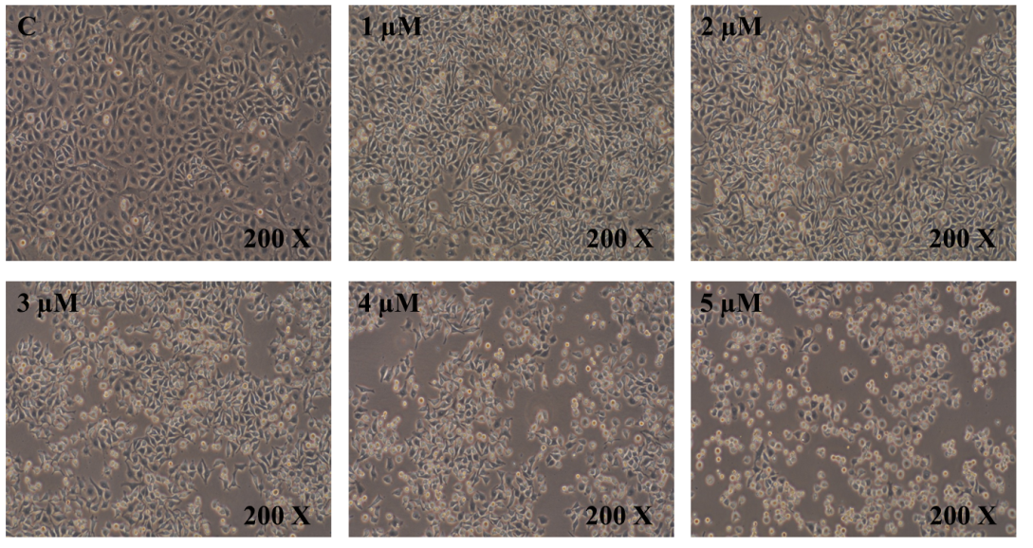

B
Figure 2

A
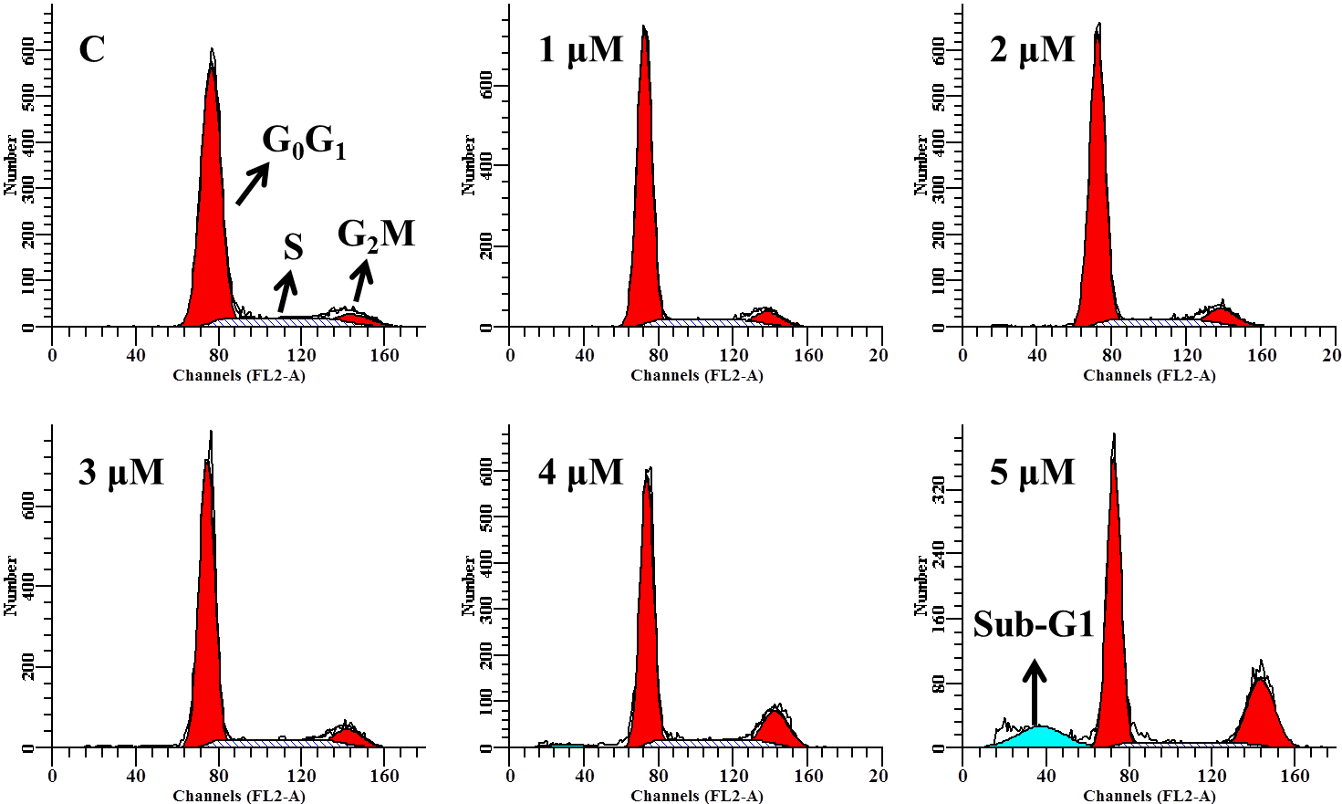

B
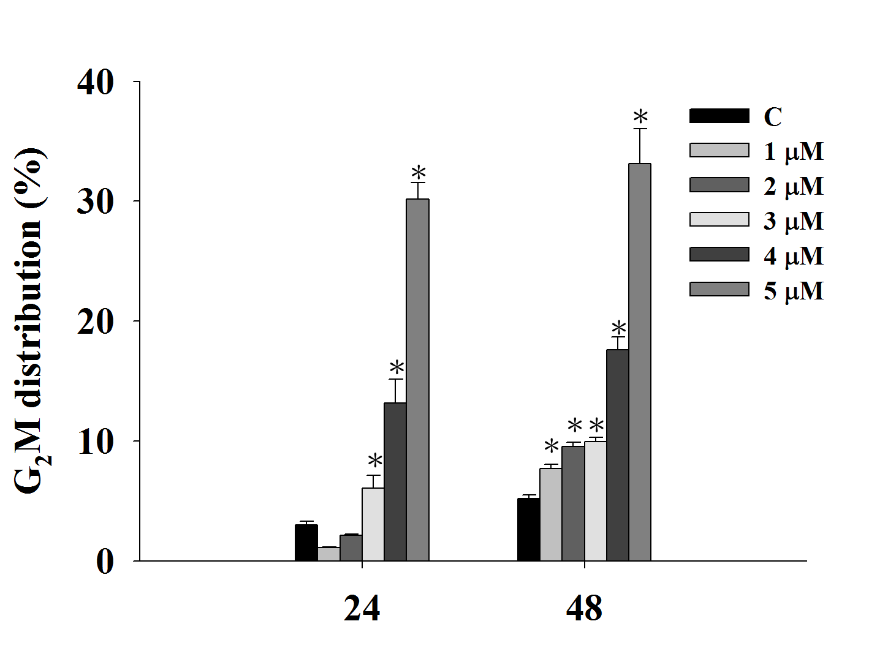

C
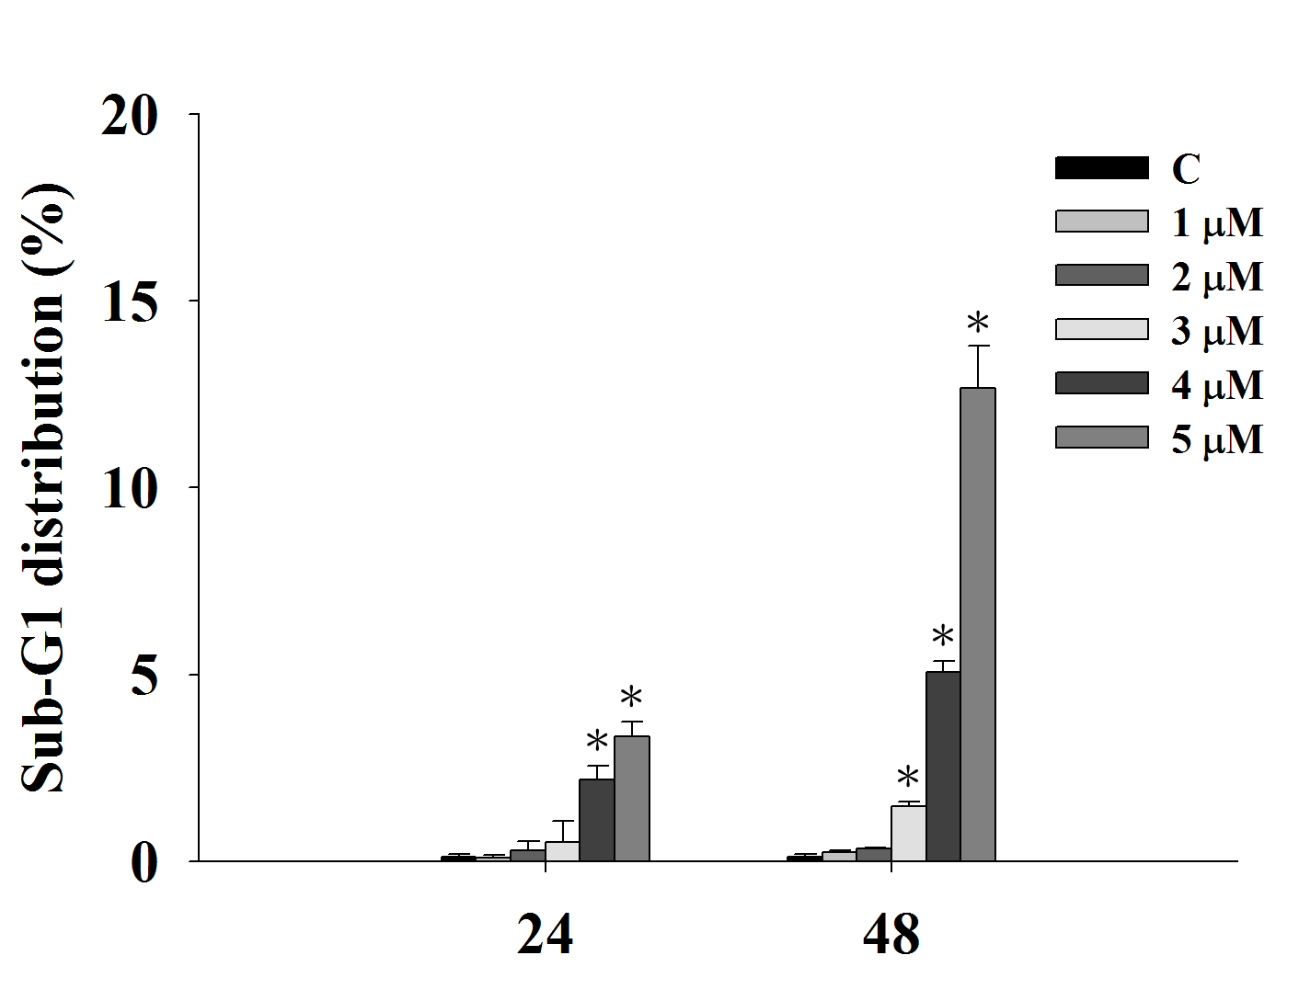
Figure 3

A
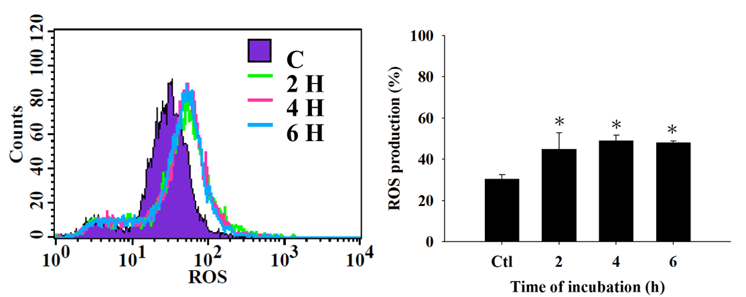
B
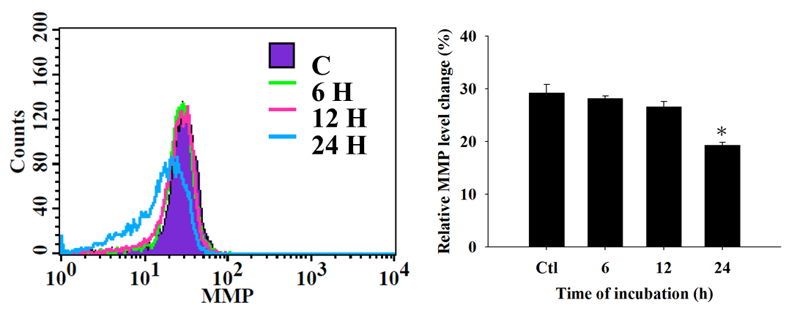
C
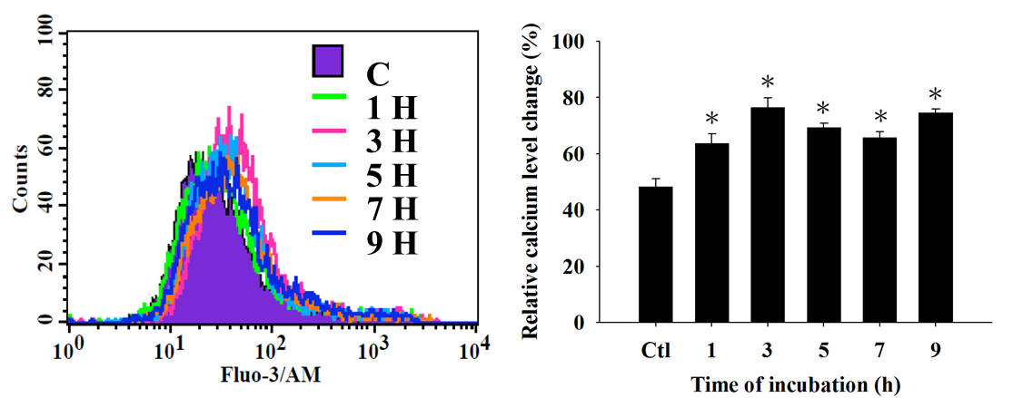
Figure 4

A
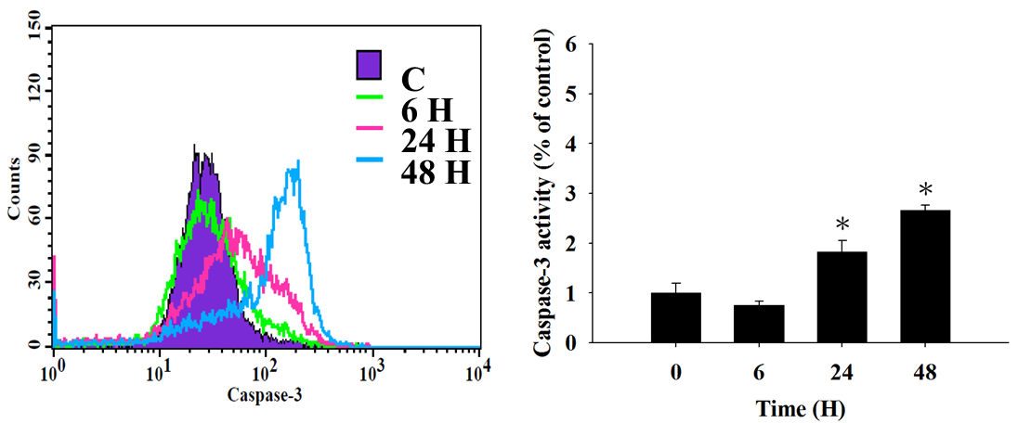
B
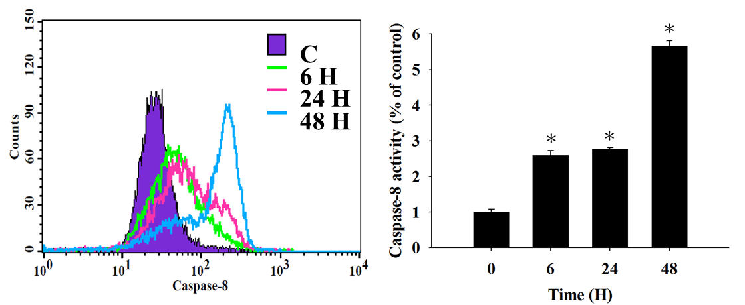
C
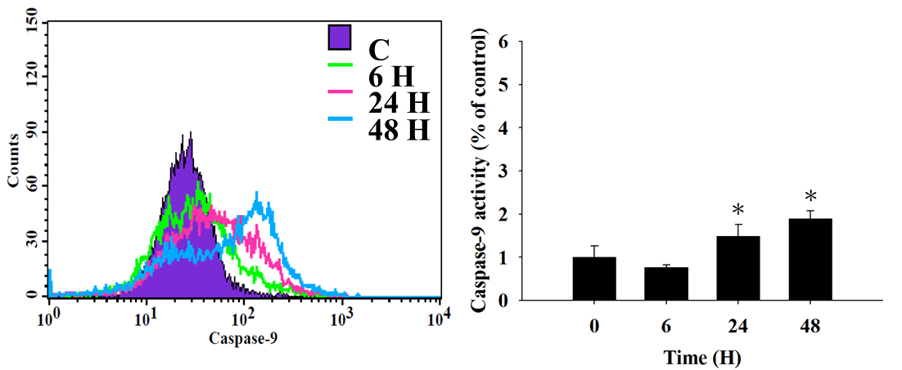
D

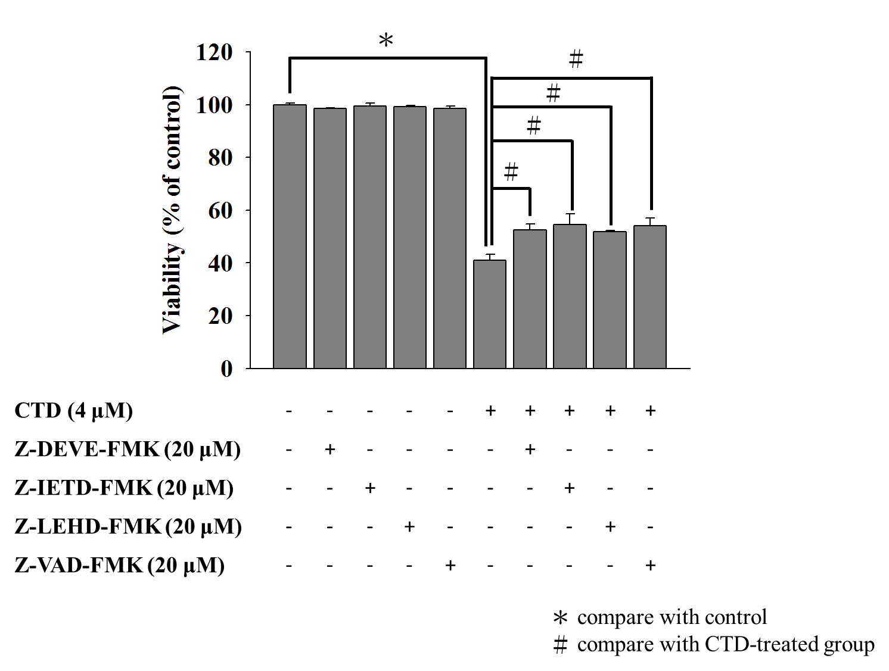
Figure 5

A B
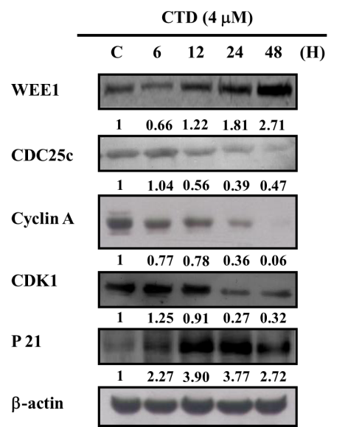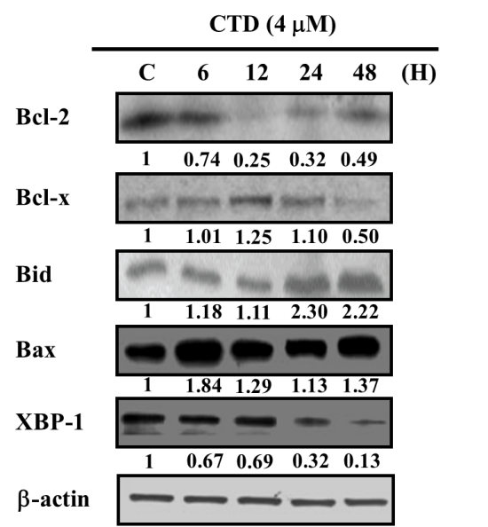

C D
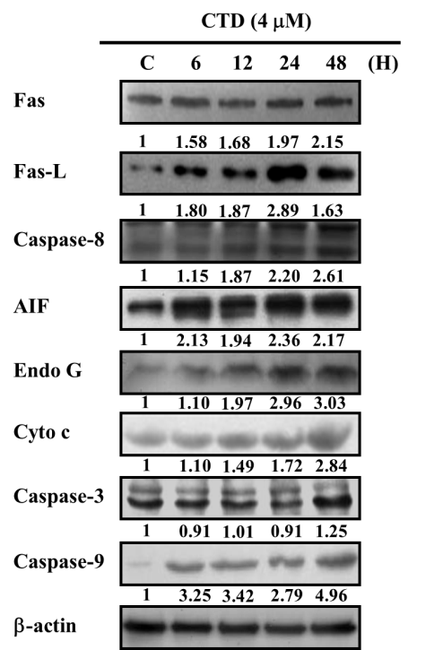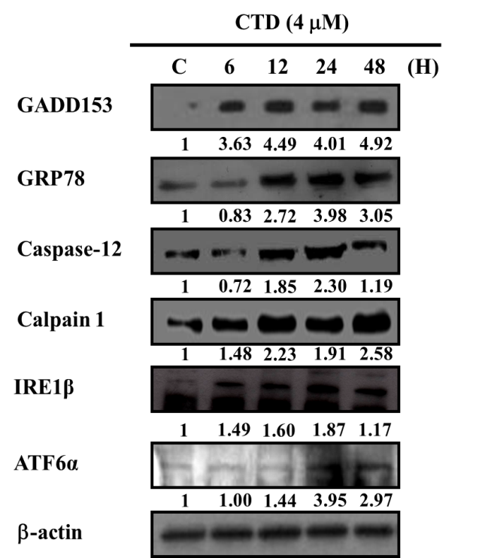

Figure 6

A
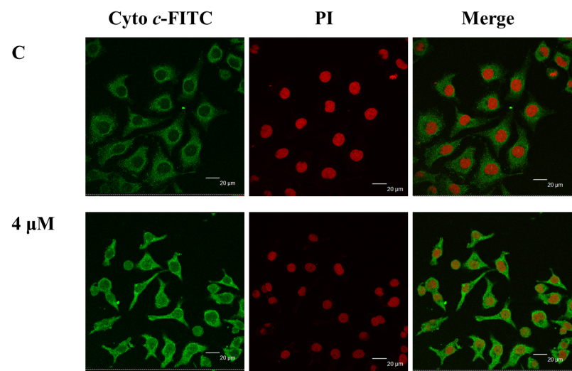

B
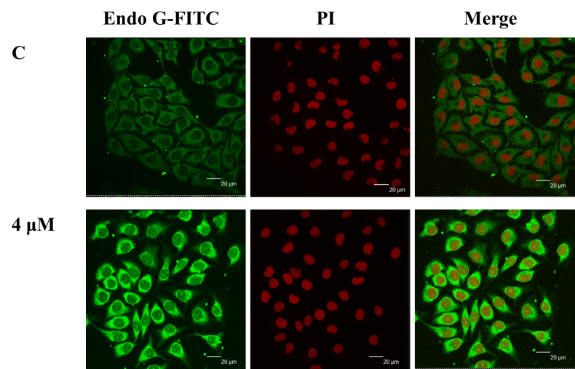

C
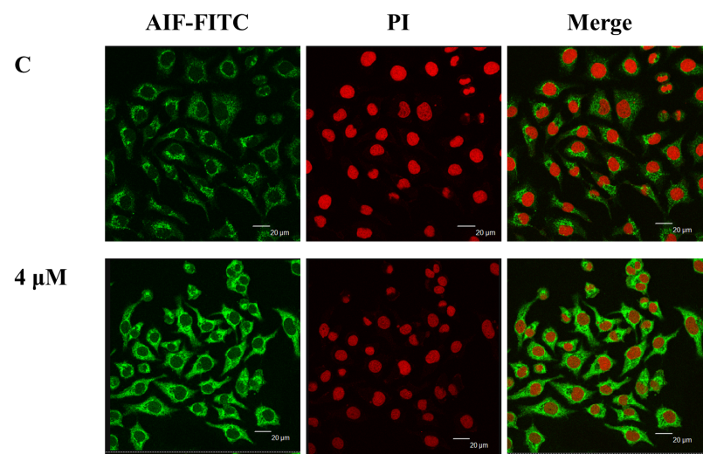
Figure 7

