Fecal calprotectin is a novel biomarker that differentiates in inflammatory bowel disease (IBD) and irritable bowel syndrome (IBS)

Ming-Hui Chang^{1,2} , Jen-Wei Chou^{3,4}, Shan-Ming Chen^{5,6}, Ming-Chang Tsai^{1,2} , Yu-Shu Sun⁷, Chun-Che Lin^{1,8}, Ching-Pin Lin^{1,9}

1Division of Hepatology and Gastroenterology, Department of Internal Medicine, Chung Shan Medical University Hospital; 2Institute of Medicine, Chung Shan Medical University; 3Division of Gastroenterology and Hepatology,Department of Internal Medicine, China Medical University Hospital; 4College of Medicine, China Medical University; 5Department of Pediatrics, Chung Shan Medical University Hospital; 6Department of Pediatrics, School of Medicine Colorectal Division, Chung Shan Medical University, Taichung; 7National Defense Medical Center, Taipei; 8School of Medicine; 9Institute of Microbiology and Immunology, Chung Shan Medical University, Taichung, Taiwan, R.O.C.

* Ming-Hui Chang and Jen-Wei Chou contributed equally to this work. Ming-Hui Chang and Jen-Wei Chou interpreted the data and drafted the manuscript.
* Correspondence: Ching-Pin Lin
E-mail: anitayen1971@yahoo.com.tw
Addresses of the institutions: 110, Sec.1, Chien-Kuo N. Road. Taichung, Taiwan.402
Institute of Microbiology and Immunology, Chung Shan Medical University, Department of Internal Medicine, Chung Shan Medical University Hospital, Taichung, Taiwan
Tel: 880-4-24739595 ext 38829
Fax: 880-4-24755333

Background and Aim: The aim of the present study was to evaluate if fecal calprotectin could serve as a diagnostic marker to differentiate patients with inflammatory bowel diseases (IBD) and irritable bowel syndrome (IBS). We assessed and compared the concentrations of fecal calprotectin. C-reactive protein (CRP), erythrocyte sedimentation rate (ESR) in different groups of patients with IBD , IBS and normal control.
Materials and Methods: 20 normal controls, 26 patients with IBS, and 58 patients were diagnosis with IBD including 22 with ulcerative colitis (UC) and 36 Crohn’s disease (CD) were recruited. All IBD patients underwent one or more ileocolonoscopies and were diagnosed on histological finding criteria. IBS was diagnosed using the Rome Ⅲ criteria. Calprotectin in stool samples and CRP/ESR in blood samples were determined.
Results: The CRP, ESR and calprotectin levels were all significantly higher in CD (n=36) and in the UC patients (n=22) compared with normal controls (n=20) (all p <0.0001). There were significant increases in fecal calprotectin (mean, 694.8±685.0 μg/g) and CRP between IBD and IBS patients (694.8±685.0 μg/g in IBD versus 85.8±136.1 μg/g in IBS and 0.851±1.200 mg/dl in IBD versus 0.16±0.23 mg/dl in IBS, respectively) (p <0.0001). There was no statistical difference in the mean ESR between the IBD and IBS patients (p =0.22). Our study showed that the areas under the curve (AUC) with ROC curve analysis for fecal calprotectin (0.931±0.029, 95% confidence interval (CI), 0.874-0.987) in IBD patients was significantly higher than CRP (0.865±0.041, 95% CI 0.785-0.946) or ESR (0.869±0.042, 95% CI 0.786 -0.952). AUC for fecal calprotectin concentrations in UC (0939, 95% CI 0.869–1.01) was significantly higher than CD patients (0.925, 95% CI 0.84-1.00). The median value of fecal calprotectin in CD groups (595 μg/g, 95% CI 571–1059 μg/g) or UC groups (219 μg/g, 95% CI 238–756 μg/g) were increased when compared to IBS or normal control.
Conclusions: These data suggest fecal calprotectin is a novel biomarker for the diagnosis of IBD and it could be effectively used to distinguish between IBD or IBS.

Key Words: Fecal calprotectin, Inflammatory bowel diseases, Irritable bowel syndrome
INTRODUCTION
Calprotectin is a calcium binding protein with molecular weight 36 KD that originates mainly from neutrophils, to play a regulatory role in the inflammatory processes. It is stable and resistant to bacterial degradation in the feces . The calprotectin protein levels were increased by the inflammatory damage of the intestinal mucosa and released into the intestinal lumen and it appeared to be a noninvasive biomarker of intestinal inflammation. The level of fecal calprotectin may provide a useful marker for the diagnosis and follow up of inflammatory bowel disease . Several studies have been proposed that concentration of fecal calprotectin was significantly higher in the inflammatory bowel disease (IBD) including ulcerative colitis (UC) and Crohn’s disease (CD). The fecal Calprotectin levels were correlated with histological disease activity in colonic biopsies of UC and CD. Therefore, calprotectin has been considered as a surrogate marker of intestinal inflammation . Normalization of fecal calprotectin as a predictor marker of mucosal healing in patients with inflammatory bowel disease has been reported and it is an important measurement in treatment of IBD. Although endoscopy is the gold standard for diagnosing intestinal inflammation, it is invasive and not suitable for frequent. The fecal calprotectin concentration reflects the increased of neutrophils and the calprotectin value in feces correlates very well with disease activity . Our study aimed to differentiate patients with IBD and IBS by the fecal calprotectinin and monitor disease activity in follow up of IBD.
MATERIALS AND METHODS
Patient samples
The stool samples were obtained from 104 patients in the study. We recruited 20 healthy patients, 26 patients with IBS, 58 patients were diagnosis with IBD including 22 with UC and 36 CD. All patients were collect 5 g fecal samples over a 12 month period. The diagnosis of CD and UC was based on standard criteria . IBS was diagnosed using the Rome Ⅲ criteria. Patients provided stool samples for calprotectin measurements and blood samples for measurement of CRP and ESR.

Inclusion criteria
All IBD patients were diagnosed on the basis of standard typical endoscopic, radiological, and histological finding criteria. Disease duration >3 months, complete ileocolonoscopy including biopsies, age 20-70 years, fecal samples delivered from 3 days to 1 day before bowel preparation started.

Exclusion criteria
Patients with following conditions were excluded in this study, gastric cancer, incomplete ileocolonoscopy (ileum not intubated), infectious enterocolitis, acute infection diseases, pregnancy history of extensive bowel resection, alcohol abue, symptoms related mainly to perianal penetrating disease, regular intake of aspirin, antibiotics, cytotoxic drugs and nonsteroidal anti-inflammatory drugs (NSAID, more than two tablets per week).

Fecal calprotectin
Stool specimens were collected into clean tubes within 72 hrs and stored at 2-8℃, fecal calprotectin was measured by a commercially qualitative point-of-care (POCT) assays using the Buhlmann Quantum Bluew Kit (Buhlmann, Schonenbuch, Switzerland). Briefly, fecal samples were placed in the extraction tube and diluted in extraction buffer (weight/volume ratio, 1:16) or diluted in chase buffer (weight/volume ratio, 1:150) to high fecal calprotectin concentration, and the mixture vortexed for 1 min, centrifugal force at 3’000 x g* for 5 min, and continue with lateral flow assay. Following a predetermined dilution large particles were allowed to settle and a small aliquot of supernatant was assayed for 12 minutes or fecal calprotectin high range was assayed for 15 minutes in the calibrated Bühlmann Quantum Blue Reader® (Buhlmann, Schonenbuch, Switzerland). The cut-off level of fecal calprotectin in this study was 50 μg/g.

Statistical analysis
The statistical analysis was performed with the SPSS software for Windows 16.0 (SPSS, Inc; Chicgo. IL, USA). Biochemical parametric data were presented as mean ± SD, range. Calprotectin values are presented as the medians, ranges and 95% confidence interval (CI). The Mann–Whitney test were used to compare fecal calprotectin, CRP, and ESR in the group with CD, UC, normal control, IBS and IBD (CD and UC as a whole), respectively. The cut off values for ESR (normal range >9 mm/hr) and CRP (upper limit of normal <0.4 mg/dl) were determined as routine laboratory values, for the clinical arm of our study applying the cut-off point was 50 μg/g to recommended as positive for gastrointestinal inflammation. The kruskal-Wallis test was used to evaluate different groups in fecal calprotectin levels, while Dunn’s Multiple Comparisn was used to compare differences in fecal calprotectin levels among groups. Among IBD patients, receiver operating curves (ROC) for all patients (CD and UC as a whole), separate ROC curves were calculated for cases with CD and UC. The ROC curves (sensitivity and specificity) were assessed by curve analysis as previously described by Henderson . All values of signifcance were two sided. A p value of < 0.05 was considered as statistically significant.

RESULTS
Baseline laboratory parameters
The clinical and biochemical parametric data of CD (n=36), UC patients (n=22) and normal controls (n = 20) are demonstrated in Table 1. The mean CRP (1.045 ± 1.333 mg/dl, range 0.017-4.900), ESR (21.94 ± 25.32 mm/hr, range 4-104) and fecal calprotectin (815.4 ± 720.7 μg/g, range 30-1800) were significantly higher in CD patients when compared with normal controls (all p<0.0001). Similar to CD, the mean CRP (0.536 ± 0.882 mg/dl, range 0.014-3.330), ESR (11.9 ± 9.05 mm/hr, range 2-42) and fecal calprotectin (497.4 ± 584.8 μg/g, range 35-1810) in the UC patients were significantly higher when compared with normal controls (all p < 0.0001).
Clinical laboratory parameters in the IBD and IBS patients
Table 2 showed the laboratory parametric data in IBD (n=58) and IBS patients (n=26). The mean CRP (0.851 ± 1.200 mg/dl, range 0.014-4.900) and fecal calprotectin (694.8±685.0 μg/g, range 30-622) in IBD patients were significantly increased when compared with IBS patients with the mean CRP (0.162±0.229 mg/dl, range 0.010-1.040) and fecal calprotectin (85.77±136.1 μg/g, range 30-622) (p <0.0001). There was no statistical difference in mean ESR between IBD (18.14±21.16 mm/hr, range 2-104) and IBS patients(9.11±4.02 mm/hr, range 5-22) (p =0.220).
ROC curve analysis for fecal calprotectin CRP, ESR in the IBD group
The AUC of fecal calprotectin in IBD patients (0.931±0.029, 95% CI 0.874-0.987) was significantly higher than CRP (AUC, 0.865±0.041, 95% CI 0.785-0.946) and ESR (AUC, 0.869±0.042, 95% CI 0.786 -0.952) (Fig. 1). The ROC curve showed that a faecal calprotectin level of 48.5 μg/g was chosen as the best cut-off value with a sensitivity of 90%, a specificity of 95%, a positive predictive value (PPV) of 94%, a negative predictive value (NPV) of 89% in the IBD group. The sensitivity, specificity, PPV, NPV were 62%, 95%, 92%, 71% for CRP and 86%, 75%, 77%, 84% for ESR, respectively.

ROC curve analysis for fecal calprotectin in the CD and UC patients
The median calprotectin concentration was 595 μg/g (95% CI 571–1059, range 30–1800 μg/g) in CD patients and 219 μg/g (95% CI 238–756, range 35–1810 μg/g) in UC patients. The AUC was significantly higher for UC patients (0939, 95% CI 0.869–1.01) (Fig.2B) than for CD patients (0.925, 95% CI 0.84-1.00) (Fig. 2A). The sensitivity, specificity, PPV and NPV were 86%, 95%, 94%, 87% for UC patients and 91%, 95%, 94%, 91% for CD patients, respectively.

Fecal calprotectin concentration in the CD, UC, IBS patients and normal control
Fecal calprotectin levels in the different groups of patients were shown in Fig. 3. The increased median calprotectin values in the CD patients (595 μg/g, 95% CI 571–1059 μg/g) and the UC patients (219 μg/g, 95% CI 238–756 μg/g) were observed when compared to the normal control (35 μg/g, 95% CI 33–40 μg/g)(both p<0.0001).When IBS group compared to the CD group and the UC group, it was also significant differences (p <0.0001 or p <0.01, respectively). Normal calprotectin levels were found in the IBS patients (44.50 μg/g, 95% CI 32.6–141.9 μg/g) and there was no statistical difference between IBS group and the normal control. Our results showed that the group with CD and UC patients had higher fecal calprotectin levels than those of the groups with IBS patients. Our data suggest that fecal calprotectin level could be used to differentiate IBD and IBS.

DISCUSSION
In the present study, we found that the CRP, ESR and fecal calprotectin levels were significantly higher in CD and UC patients compared with normal controls. We also found that fecal calprotectin may serve as a promising marker for intestinal inflammation to differentiate IBD from IBS. Our results show that CRP and fecal calprotectin were significant by difference between IBS and IBD patients, but not for ESR. In the IBD patients, the AUC was significantly higher for fecal calprotectin than CRP and ESR, the sensitivity was low for ESR and CRP. Our study showed that the fecal calprotectin levels could be used to distinguish between IBD from IBS by its high sensitivity, specificity, positive predictive value and high negative predictive value in ruling out IBD in undiagnosed, patients with abdominal pain or diarrhea. We observed that the AUC of fecal calprotectin concentration was significantly higher for UC patients than for CD patients in our study. A previous study reported that a high concentration of fecal calprotectin was associated with a two-fold relapse risk in CD patients and 14-fold risk of relapse in UC patients and demonstrated that a predictive marker of relapse in UC than in CD. Therefore, detecting fecal calprotectin may help to identify UC and CD at high risk of clinical disease relapse .
A study showed that fecal calprotectin could be used to distinguish between active UC and inactive UC , and fecal calprotectin as well as CRP was better than ESR to distinguish leukocytosis in patients with active ulcerative colitis.. A previous report indicated that fecal calprotectin level was useful in predicting clinical relapse, especially during the following three months in IBD patients including UC and CD . The usefulness of fecal calprotectin measurements in screening for spontaneous bacterial peritonitis and hepatic encephalopathy in cirrhosis has also been reported, it may facilitate grading of HE-severity . In addition, a previous report indicated that measuring faecal calprotectin levels is a useful screening tool for identifying patients who are most likely to need endoscopy for suspected inflammatory bowel disease, the sensitivity and specificity of fecal calprotectin testing in adults was better than in children (0.93 versus 0.92 in sensitivity and 0.96 versus 0.76 in specificity). Measuring fecal calprotectin levels could be have a discriminative power to safely exclude inflammatory bowel disease was better in studies of adults than in children and teenagers.
In conclusion, the fecal calprotectin is a direct and useful biomarker for the diagnosis of intestinal inflammation in the IBD patients better than CRP and ESR, and it may help to identify UC and CD at high risk of clinical relapseand could be used to distinguish between IBD and IBS.

Conflict of interest statement
The authors declare no competing financial interest.

REFERENCES
1. Walkiewicz D, Werlin SL, Fish D et al. Fecal calprotectin is useful in predicting disease relapse in pediatric inflammatory bowel disease. Inflammatory bowel diseases 2008; 14: 669-73.
2. Paduchova Z, Durackova Z. Fecal calprotectin as a promising marker of inflammatory diseases. Bratislavske lekarske listy 2009; 110: 598-602.
3. Jahnsen J, Roseth AG, Aadland E. [Measurement of calprotectin in faeces]. Tidsskrift for den Norske laegeforening : tidsskrift for praktisk medicin, ny raekke 2009; 129: 743-5.
4. Costa F, Mumolo MG, Bellini M et al. Role of faecal calprotectin as non-invasive marker of intestinal inflammation. Digestive and liver disease : official journal of the Italian Society of Gastroenterology and the Italian Association for the Study of the Liver 2003; 35: 642-7.
5. Tibble JA, Sigthorsson G, Bridger S et al. Surrogate markers of intestinal inflammation are predictive of relapse in patients with inflammatory bowel disease. Gastroenterology 2000; 119: 15-22.
6. Onal IK, Beyazit Y, Sener B et al. The value of fecal calprotectin as a marker of intestinal inflammation in patients with ulcerative colitis. The Turkish journal of gastroenterology : the official journal of Turkish Society of Gastroenterology 2012; 23: 509-14.
7. Roseth AG, Aadland E, Grzyb K. Normalization of faecal calprotectin: a predictor of mucosal healing in patients with inflammatory bowel disease. Scandinavian journal of gastroenterology 2004; 39: 1017-20.
8. Sherwood RA. Faecal markers of gastrointestinal inflammation. Journal of clinical pathology 2012; 65: 981-5.
9. Malchow H, Ewe K, Brandes JW et al. European Cooperative Crohn's Disease Study (ECCDS): results of drug treatment. Gastroenterology 1984; 86: 249-66.
10. Drossman DA. The functional gastrointestinal disorders and the Rome III process. Gastroenterology 2006; 130: 1377-90.
11. Henderson AR. Assessing test accuracy and its clinical consequences: a primer for receiver operating characteristic curve analysis. Annals of clinical biochemistry 1993; 30 ( Pt 6): 521-39.
12. Costa F, Mumolo MG, Ceccarelli L et al. Calprotectin is a stronger predictive marker of relapse in ulcerative colitis than in Crohn's disease. Gut 2005; 54: 364-8.
13. D'Inca R, Dal Pont E, Di Leo V et al. Can calprotectin predict relapse risk in inflammatory bowel disease? The American journal of gastroenterology 2008; 103: 2007-14.
14. Hanai H, Takeuchi K, Iida T et al. Relationship between fecal calprotectin, intestinal inflammation, and peripheral blood neutrophils in patients with active ulcerative colitis. Digestive diseases and sciences 2004; 49: 1438-43.
15. Gisbert JP, Bermejo F, Perez-Calle JL et al. Fecal calprotectin and lactoferrin for the prediction of inflammatory bowel disease relapse. Inflammatory bowel diseases 2009; 15: 1190-8.
16. Gundling F, Schmidtler F, Hapfelmeier A et al. Fecal calprotectin is a useful screening parameter for hepatic encephalopathy and spontaneous bacterial peritonitis in cirrhosis. Liver international : official journal of the International Association for the Study of the Liver 2011; 31: 1406-15.
17. van Rheenen PF, Van de Vijver E, Fidler V. Faecal calprotectin for screening of patients with suspected inflammatory bowel disease: diagnostic meta-analysis. BMJ 2010; 341: c3369.

鈣衛蛋白是一個新的生物指標在於區別發炎性腸道疾病與腸躁症

Ming-Hui Chang^{1,2} , Jen-Wei Chou^{3,4}, Shan-Ming Chen^{5,6}, Ming-Chang Tsai^{1,2} , Yu-Shu Sun⁷, Chun-Che Lin^{1,8}, Chen-Kun Lin¹, Tzy-Yen Chen^{1,8}, Chi-Chou Huang⁹, Ching-Pin Lin^{1,10}

張明輝^{1,2}周仁偉^{3,4}陳善銘^{5,6}蔡明璋^{1,2}孫玉書⁷林俊哲^{1,8}林金坤¹陳滋彥^{1,8}黃啟洲⁹林敬斌^{1,10}

Division of Gastroenterology, Department of Internal Medicine¹, Department of Pediatrics⁵, Colorectal Division, Department of Surgery⁹, Chung Shan Medical University Hospital, Taichung, Taiwan
Institute of Medicine², Department of Pediatrics, School of Medicine⁶, School of Medicine⁸, Institute of Microbiology and Immunology¹⁰ , Chung Shan Medical University , Taichung, Taiwan.
Division of Gastroenterology and Hepatology, Department of Internal Medicine³, China Medical University Hospital, China Medical University, Taichung, Taiwan
College of Medicine⁴, China Medical University, Taichung, Taiwan
National defense medical center⁷, Taipei, Taiwan.

中山醫學大學附設醫院 肝膽腸胃科¹兒童部⁵大腸直腸外科⁹
中山醫學大學 醫學研究所²醫學系兒童學科⁶醫學系⁸ 微生物免疫研究所¹⁰
中國醫藥大學附設醫院內科部消化系³
中國醫藥大學中醫研究所⁴
國防大學國防醫學院⁷

背景與目標 : 本研究主要目的是評估糞便鈣衛蛋白 (fecal calprotectin) 可作為區別發炎性腸道疾病與腸躁症的一個診斷指標，分析與比較fecal calprotectin、C反應蛋白 (CRP) 和紅血球沉降速率 (ESR) 的濃度分別在發炎性腸道疾病，腸躁症與正常族群之間的比對。
材料與方法 : 本研究納入正常患者 (NC) 20人作為對照組、腸躁症患者 (IBS) 26人、發炎性腸道病患者 (IBD) 58人包括潰瘍性結腸炎 (UC) 22人和克隆氏症 (CD) 36人，36個CD的病人皆接受過全大腸腸鏡一次或重複一次以上的檢查且經過克隆氏症活動性指數 (CDAI) 的評估後而診斷，腸躁症的診斷則是依照羅馬準則Ⅲ (Rome Ⅲ criteria)，病人採檢糞便檢測fecal calprotectin及抽血檢驗血清學指標CRP ESR。
結果 : CRP、ESR和fecal calprotectin都明顯有較高的濃度在CD 病人 (n = 36) 和UC 病人 (n = 22)，與正常對照組 (n = 20) 比較均有統計學上的意義 (all P < 0.0001)。有個明顯的差異性在IBD病人的fecal calprotectin的濃度 (mean, 694.8±685.0 μg/g) 和CRP濃度 (mean, 0.851±1.200 mg/dl) 比較於IBS病人的 fecal calprotectin濃度 (mean, 85.77± 136.1 μg/g) 和 CRP濃度 (mean, 0.16 ±0.23mg/dl)，具有統計學上的意義(p < 0.0001)，但檢測ESR的濃度則並沒有統計上的差異 (p = 0.22)。我們的研究結果顯示，在IBD的病人以反應者操作特徵曲線(ROC curve )分析fecal calprotectin, CRP 和 ESR，fecal calprotectin的曲線下面積the areas under the curve (AUC) 0.931±0.029, 95%信賴區間confidence interval (CI) 0.874-0.987明顯較高於CRP和 ESR (AUC, 0.865±0.041, 95% CI 0.785-0.946，AUC, 0.869±0.042, 95% CI 0.786 -0.952)。同樣以ROC curve分析fecal calprotectin濃度，比較CD和UC的病人，UC的病人 (AUC, 0939, 95% CI 0.869–1.01) 明顯較高於CD的病人(AUC, 0.925, 95% CI 0.84-1.00)。檢測fecal calprotectin的濃度在不同的群組中比較，上升的中間值濃度在於CD病人群組(595 μg/g, 95% CI 571–1059 μg/g) 和UC病人群組 (219 μg/g, 95% CI 238–756 μg/g)相對比較於IBS和正常群組。
結論 : 本研究結果建議糞便鈣衛蛋白 (fecal Calprotectin) 是一個有益於幫助診斷發炎性腸道疾病的新指標，且有效於區別出發炎性腸道疾病和腸躁症。

關鍵語 : 糞便鈣衛蛋白，發炎性腸道疾病，腸躁症

Table. 1. Laboratory Parameters at baseline of the patients with CD, UC and control. The mean CRP, ESR and fecal calprotectin levels in CD and UC patients compared with controls.
 | C D ( n = 36 ) |  | UC ( n = 22 ) |  | Control ( n = 20 )
Laboratory  Parameter | Mean±S.D. | Range | Mean±S.D. | Range | Mean±S.D. | Range
CRP (mg/dl) | 1.045 ± 1.333*** | 0.017-4.900 | 0.536 ± 0.882*** | 0.014-3.330 | 0.064 ± 0.062 | 0.007-0.191
ESR (mm/hr) | 21.94 ± 25.32*** | 4-104 | 11.9 ± 9.05*** | 2.0-42.0 | 4.45 ± 2.16 | 1-8
FecalCalprotectin (μg/g) | 815.4 ± 720.7*** | 30-1800 | 497.4 ± 584.8*** | 35-1810 | 36.85 ± 6.80 | 30-51

CRP: C-reactive protein. ESR: erythrocyte sedimentation rate. *** p < 0.0001.

 | IBD ( n = 58 ) |  | IBS ( n = 26 ) |  | P value
Laboratory Parameter | Mean±S.D. | Range | Mean±S.D. | Range
CRP (mg/dl) | 0.851 ± 1.200 | 0.014-4.900 | 0.162 ± 0.229 | 0.010-1.040 | <0.0001
ESR (mm/hr) | 18.14 ± 21.16 | 2-104 | 9.11 ± 4.02 | 5-22 | 0.220
fecal calprotectin (μg/g) | 694.8 ± 685.0 | 30-1810 | 85.77 ± 136.1 | 30-622 | <0.0001
Table. 2. Clinical Laboratory Parameters at baseline of IBD and IBS patients. The mean CRP, ESR and fecal calprotectin levels in IBD patients compared with IBS patients.
CRP: C-reactive protein. ESR: erythrocyte sedimentation rate.

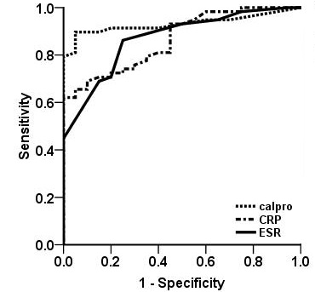

Fig. 1. The receiver operator characteristics (ROC) curves of the ability of fecal calprotectin, CRP, and ESR in all patients with IBD.

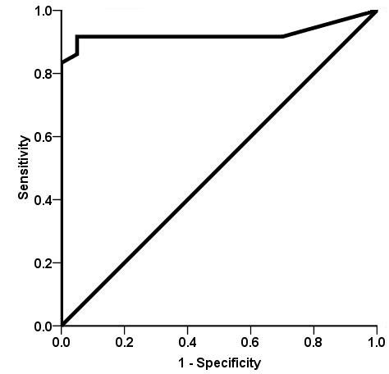
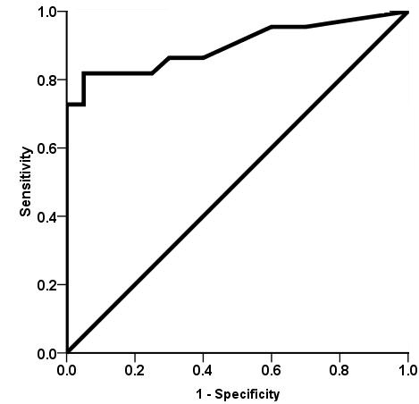

Panel A Panel B

Fig. 2. The ROC curve for fecal calprotectin in CD (Panel A) and UC (Panel B). (A) AUC 0.925, 95% CI 0.84-1.00, asymptotic significance p <0.0001. (B) AUC 0.939, 95% CI 0.869–1.01, asymptotic significance p <0.0001.
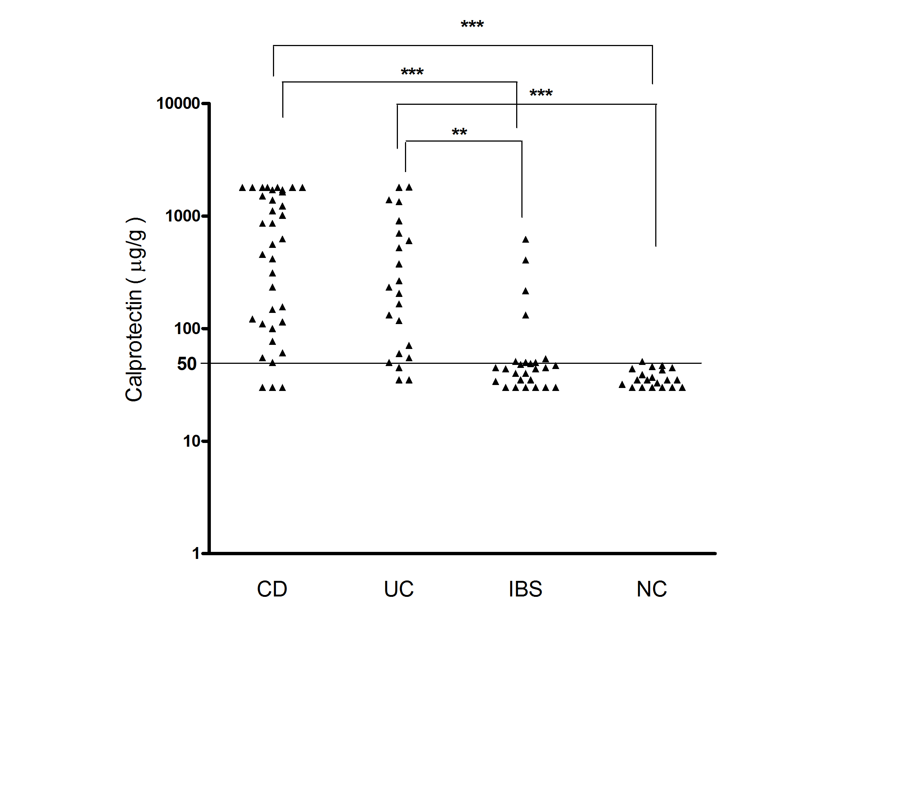
Fig. 3. Fecal calprotectin levels (log scale) in the different groups, the cut-off was 50 μg/g. The group with NC (Normal control) was compared to the groups with CD (Crohn’s disease) ,UC ( ulcerative colitis) and IBS (irritable bowel syndrome). *** p < 0.0001, ** p < 0.001.

