Title: Prevalence of Cavum Septum Pellucidum and/or Cavum Vergae in Brain Computed Tomographies of Taiwanese

Category of paper: Original article

Authors: Jiann-Jy Chen ^{1,2}, Chi-Jen Chen ², Hsin-Feng Chang ³, Dem-Lion Chen ⁴, Yung-Chu Hsu ⁵, Tzu-Pu Chang ⁶

Affiliation: ¹ Department of Neurology, China Medical University Hospital, China Medical University, Taichung; ² Department of Medical Imaging, Taipei Medical University & Shuang Ho Hospital, New Taipei; ³ Faculty of Chinese Medicine, Medical College, China Medical University, Taichung;⁴ G-Home Clinic, Kaohsiung; ⁵ Division of Neurology, Department of Internal Medicine, Ditmanson Medical Foundation Chia-Yi Christian Hospital, Chiayi; ⁶ Department of Neurology, Neuro-Medical Scientific Center, Buddhist Tzu Chi General Hospital, Taichung Branch, Taichung, Taiwan

Correspondence to: Tzu-Pu Chang, MD. Department of Neurology, Neuro-Medical Scientific Center, Buddhist Tzu Chi General Hospital, Taichung Branch, No. 66 or 88, Section 1, Fongsing Road, Tanzih District, Taichung City 42743, Taiwan

E-mail: birdpaul@yahoo.com
Telephone: +886-915-915589
Fax: +886-5-277451

Running title: Cavum septum pellucidum, cavum Vergae

No conference or meeting where the paper was presented.
We declare that we have no conflict of interest.

Prevalence of Cavum Septum Pellucidum and/or Cavum Vergae in Brain Computed Tomographies of Taiwanese

Abstract-
Objective: The reported prevalence of cavum septum pellucidum (CSP) and cavum Vergae (CV) in brain computed tomography (CT) is 5.5% in Great Britain and 1.24% in China but unknown in Taiwan. Moreover, CSP and/or CV has generally been thought to decrease as age progresses, but the evidence of actual prevalence at different age levels is still limited in the literature.
Methods: A total of 19,031 patients with brain CT at a regional hospital in northern Taiwan from July 2008 to August 2010 were included in this study. Their radiological official reports were retrospectively reviewed to check for CSP and/or CV. An X² test was used for statistical analysis (α= .05).
Results: The prevalence of CSP and/or CV in all brain CT was 0.93% (n = 177), which was lower than that in the Chinese and British studies. Among them, 2.8% (n = 5) had only CSP, 1.7% (n = 3) had only CV, and 95.5% (n = 169) had coexistent CSP and CV. There is a significant difference in prevalence between the age groups (p = .009), and the prevalence is the highest in the group aged 20-29 years (1.56%) and lowest in the group aged above 80. After age 20-29, the prevalence tends to decrease with increasing age.
Conclusion: This is not only the first study of CSP and CV in the Taiwanese population but the study population is also larger than those in the literature. The prevalence was found to approximately decrease as age progresses, but would reach the peak in the young adult group rather than the children or adolescent group.

Key Words: cavum septum pellucidum, cavum Vergae

INTRODUCTION

Background
Cavum septi pellucidi (CSP) and cavum Vergae (CV) are anterior midline intracranial cysts ⁽¹⁾, which were mistakenly named the 5th and 6th cerebral ventricles, respectively ^{(2,3)}. CSP is defined as a crevice-like space between the left and right transparent septum, and is anteriorly bounded by the genu of the corpus callosum, superiorly by the body of the corpus callosum, posteriorly by the anterior limb and pillars of the fornix, and inferiorly by the anterior commissure and the rostrum of the corpus callosum ⁽¹⁾; therefore, CSP is very similar to the finding of “empty sella”. If CSP extends posteriorly past the columns of the fornix and foramina of Monro, it is called CV, which is superiorly and posteriorly bounded by the corpus callosum, and inferiorly by the body of fornix (^{4,5)}. CSP may exist alone without CV. If both CSP and CV exist, the passage between these two cavities is known as Verga’s aqueduct ⁽¹⁾.
Although most CSP and CV are asymptomatic ⁽⁶⁾, the prolonged presence of CSP in relation to headaches, seizures, dementia, personality changes, schizophrenia, post-traumatic stress disorder, and chronic brain trauma has been studied ⁽⁷⁻¹⁰⁾. In addition, expansion of a lesion inside the cava can produce symptoms caused by mass effect ^{(4,11,12)}. If CSP and CV are coexistent, a transcavum interforniceal approach is recommended for endoscopic surgery in the third ventricle because it may be safer than a transforaminal approach ⁽¹⁾. Therefore, investigating the prevalence of CSP and/or CV is beneficial for further research on the associated disorders and clinical applications.

Objective
Among the brain computed tomography (CT) of 1,000 British boxers, 5.5% (n = 55) had CSP and/or CV, including CSP alone (90.9%) and coexistent CSP and CV (9.1%) ⁽²⁾. Among the brain CT of 9,074 Chinese, 1.24% (n = 112) had CSP and/or CV, including coexistent CSP and CV (52.7%), CSP alone (41.1%), and CV alone (6.3%) ⁽⁷⁾. Nevertheless, there is no study yet on the prevalence of CSP and/or CV in the Taiwanese population. Moreover, CSP and/or CV has generally been thought to decrease with increasing age, but the evidence of actual prevalence at different age levels is still limited in the literature. Furthermore, a 77-year-old woman with a large CSP has been considered a rare curiosity ⁽¹³⁾. In this study, brain CT results at a regional hospital newly founded in northern Taiwan are retrospectively reviewed.

MATERIALS AND METHODS

Study design
In order to avoid the issues of ethics, this research is a retrospective cross-sectional study involving a review of all radiological official reports and films of brain CT at a regional hospital in northern Taiwan.

Study setting, participants and size
From July 2008 to December 2011, a total of 19,031 patients (9,946 males and 9,085 females), aged 52.6 ± 22.1 years (average ± SD) (range: 0-99), had received brain CT at that hospital.

Brain CT
The CT parameters for the 16 detector helical CT scanner (BrightSpeed TM Elite, GE Healthcare, USA) include a detector configuration of 0.625 mm × 16, a gantry rotation time of 1.0 seconds, 280 effective mAs, 120 kVp, 5.0-mm slice thickness and 5.0-mm interval, a matrix of 512, and a field of view of 25 cm. During CT scanning all patients tidally respired and lay supinely, except some were asked to hold the breath for concomitant chest or abdominal CT. The axial scan range was performed from the level of the skull base to the vertex, and then a series of axial images (5.0-mm slice thickness and 5.0-mm interval) were created with a standard brain parenchyma window setting (window centre 40 HU, window width 160 HU). The image data of all scans were stored in a digital medical imaging reading system (EBM technologies: safety-critical system, EBM Technologies Incorporated, Taiwan).

Official Reports
The radiology technicians assigned the brain CT image data to the on-duty resident physicians, who would make an initial report according to the format required by the supervisory visiting physicians. Then, the on-duty supervisory visiting physician checked and revised initial reports, and issued official reports before the deadline, which was one day for emergent patients, three days for hospitalizing ones, 5 days for out-patient ones, and 7 days for those receiving health examinations. Nine radiological diplomates had worked as the supervisory visiting physicians at that hospital during the period from July 2008 to December 2011.

Data sources/management
In the digital medical imaging reading system, we searched for the warrant data by setting the conditions listed below: the beginning date “2008/07/01”, the ending date “2011/12/31”, the equipment “CT”, and the scanning site “brain”. During the assigned period, all the supervisory visiting physicians habituated to use the whole name of “cavum septum pellucidum” and “cavum vergae” rather than any abbreviation, such as CSP or CV; besides, they did not use the old wrong name “5th ventricle”, “5th cerebral ventricle”, “6th ventricle” or “6th cerebral ventricle”; therefore, “cavum septum pellucidum” and “cavum vergae” were set for the condition of key words, and “or” was set for the association builder. Eventually, we got a warrant patient list.

Statistical methods
All data collection and statistical analysis were performed with Excel 2000 software. X² test is employed to compare (1) the respective gender prevalence among each age group, and (2) the prevalence among different age groups. The α-values were all .05.

Specificity
The films in the patient list were arranged in the order of their chart numbers. All films were examined to check for any inconsistency again the official reports of each supervisory visiting physicians; that is, any false positive reported. The lower the false positive rate, the higher the diagnostic specificity was.

RESULTS

Participants
The false positive rate was 0%; hence, the diagnostic specificity was 100% for all cases reviewed. Of the 19,031 patients, 0.93% (n = 177, 103 males and 74 females) had CSP and/or CV. Their ages were 46.1 ± 21.1 years, with a range from 3 to 94 years. CSP alone (Figure 1A) was seen in 2.8% (n = 5) of all patients, CV alone (Figure 1B) in 1.7% (n = 3) and coexistent CSP and CV (Figure 1C) in 95.5% (n = 169). Among these patients, the main diagnosis included old infarction (n = 28), brain atrophy (n = 20), intra-cranial hemorrhage (n = 9), hydrocephalus (n = 2), pituitary tumor (n = 2), acute infarction (n=1), brain neoplasm (n = 1), internal carotid arterial aneurysm (n = 1) and so on.

Outcome and descriptive data
The prevalence in the male group (1.04%, 103 of 9,946) was not significantly higher than that in the female group (0.81%, 74 of 9,085) (p = .113). However, the prevalence was significantly higher in the male group than in the female group at the age levels of 50-59 (p = 1.1 × 10⁻⁵³), 60-69 (p = 2.1 × 10⁻⁴), 70-79 (p = .001) and ≥ 80 (p = 3.5 × 10⁻⁸), and significantly lower at the age level of 40-49 (p = 2.2 × 10⁻⁴)(Figure 2A).

Main result
There is a significant difference in prevalence between the age groups (p = .009), and the prevalence is the highest in the group aged 20-29 years (1.56%) and lowest in the group aged above 80. After age 20-29, the prevalence tends to decrease with increasing age (Figure 2).

DISCUSSION

Key results
The prevalence (0.93%) of CSP and/or CV in this study was similar to that among the Chinese population (1.24%), but much less than that among British boxers (5.5%) ⁽²⁾. The much higher prevalence in the study of British boxers may be attributed to either racial difference or the existence of acquired CSP caused by head trauma of the boxers ⁽¹⁴⁾. In addition, the ratio of patients with both CSP and CV to those with either CSP or CV alone was much higher in this study (95.5%) than in the Chinese (52.7%) or British (9.1%) study.
A previous research has found no significant gender difference in the prevalence of CSP ⁽¹⁵⁾. Similar research on CV is lacking. In this study, the prevalence of CSP and/or CV in the male group is not significantly higher than that in the female group as a whole, but significantly lower in the group aged 40-49 years (Figure 2A), and significantly higher in the group aged above 50.

Interpretations
The embryologic origins of CSP and CV differ from that of the ventricular system ⁽³⁾. It is debatable that CSP and CV develop together. During the fifth embryonic month, the corpus callosum closes superiorly and the anterior forceps enlarge to form the frontal lobes while the fornix stays in its initial position. The corpus callosum forms from anterior to posterior, except for the rostrum, which connects the genu and the terminal lamina. In the seventh month, during the frontalization of fibers in the genu portion, the leaflets of the septum pellucidum are pulled towards the terminal lamina, sealing the cavum from the posterior fornix to the rostrum of the corpus callosum. If the gap is not closed, the condition of CSP and/or CV remains ⁽¹⁾. During development, the CV usually obliterates before CSP, resulting in CSP alone. However, in some cases, CSP obliterates before CV, resulting in CV alone. The unique racial genetic factor of the Taiwanese population might have contributed to the higher ratio of patients with both CSP and CV to those with either CSP or CV alone in this study compared with that among the Chinese or British populations.
CSP is present in all fetuses; and in over 85% of them, it fuses around 3-6 months after birth. It is present in up to 30% of newborns but persists into adulthood in less than 1% of individuals ⁽¹⁾. Theoretically, the prevalence of CSP and/or CV beyond the neonatal period should be constant at different age levels. However, it is surprising to find a significant difference in prevalence between the age groups in this study, with the highest prevalence among young adults (20-39 years old) (Figure 2), and the lowest prevalence among the extremely aged ( 80 years old). Such finding may be attributed to the rapid development during adolescence, which may render the shrunken CPS and CV to grow again and become recognizable. However, as age progresses, the grown CPS and CV shrink again.

Limitations
Ideally, a large prospective study of normal volunteers should be performed to ascertain the true prevalence of CSP and/or CV in a general population. However, it is against ethics to expose those without any clinical indication to ionizing radiation; hence, no satisfactory study has yet been done. In this study, all persons with brain CT in the past four years were non-exclusively enrolled, and selection bias was almost excluded. Thus, the sample size was much larger than those of previous studies. The non-exclusive large sample size in this study may approximately represent the general population in Taiwan. However, the gender difference in some specific age groups is worthy of further attention, and requires further study.
Although the diagnostic specificities of CSP and/or CV of all cases were 100%, their diagnostic sensitivities were not available because it was the major limitation of this article to review all the films of the 19,031 patients. Except for the 177 patients with CSP and/or CV, the other 18,854 patients without CSP and/or CV might still have false negative reports of CSP and/or CV because the majority of neuroradiologists, neurologists and neurosurgeons do not care about the presence of CSP and CV or not so the neuroradiologists do not describe these findings in their report in Taiwan; therefore, we hope a hard work to review the brain CT case by case under 1-2 specialists in the future. Besides, in case of severe mass effect such as traumatic hemorrhage, or focal brain tissue destruction in case of a major frontal surgery, the CSP and/or CV will be compressed or destructed; these common conditions can have false negative CT finding.

CONCLUSION
This is not only the first study of CSP and CV in the Taiwanese population but the study population is also larger than those in the literature. The prevalence of CSP and/or CV was 0.93% in those with brain CT. The prevalence was found to decrease as age progresses, but would reach the peak in the young adult group rather than the children or adolescent group.

REFERENCES
- Tubbs RS, Krishnamurthy S, Verma K, Shoja MM, Loukas M, Mortazavi MM, Cohen-Gadol AA. Cavum velum interpositum, cavum septum pellucidum, and cavum vergae: a review. Childs Nerv Syst 2011;27:1927–1930.
- Macpherson P, Teasdale E. CT demonstration of a 5th ventricle – a finding to KO boxers ? Neuroradiology 1988;30:506–510.
- Sarwar M. The septum pellucidum. normal and abnormal. AJNR 1989;10:989–1005.
- Li ST, Chiu NC, Hsu CH, Chiang MF. Empyema of the cavum septum pellucidum. Pediatr Neurol 2002;26:391–393.
- Miyamori T, Miyamori K, Hasegawa T, Tokuda K, Yamamoto Y. Expanded cavum septi pellucidi and cavum vergae associated with behavioral sympotoms relieved by a stereotactic procedure: case report. Surg Neurol 1995;44:471–475.
- Chen JJ, Chen DL. Chronic daily headache in a patient with cavum septum pellucidum and cavum verge. Ghana Med J 2013;47:46–49.
- 林菊香, 强丽娟, 梅今, 顾菊萍. 第五、六脑室的临床意义. 临床神经病学杂志1998;11:110–111.
- Galarza M, Merlo AB, Ingratta A, Albanese EF, Albanese AM. Cavum septum pellucidum and its increased prevalence in schizophrenia. a neuroembryological classification. J Neuropsychiatry Clin Neurosci 2004;16:41–46.
- May FS, Chen QC, GilbertsonMW, ShentonME, Pitman RK. Cavum septum pellucidum in monozygotic twins discordant for combat exposure: relationship to posttraumatic stress disorder. Biol Psych 2004;55:656–658.
- Pearce JM. Some observations on the septum pellucidum. Eur Neurol 2008;59:332–334.
- Lancon JA, Haines DE, Raila FA, Parent AD, Vedanarayanan VV. Expanding cyst of the septum pellucidum. Case report. J Neurosurg 1996;85:1127–1134.
- Bikmaz K, Dinc C, Cakabay M, Iplikcioglu AC. Epidermoid cyst of the cavum septum pellucidum. Acta Neurochir (Wien) 2007;149:1271–1272.
- Chen JJ, Chen DL. A 5th cerebral ventricle in an aged woman: pictorial neurological disease. Acta Neurol Taiwan 2010:19:223–224.
- Bogdanoff B, Natter HM. Incidence of cavum septum pellucidum in adults: a sign of boxer's encephalopathy. Neurology 1989;39:991–992.
- Hagino H, Suzuki M, Kurokawa K, Mori K, Nohara S, Takahashi T, Yamashita I, Yotsutsuji T, Kurachi M, Seto H. Magnetic resonance imaging study of the cavum septi pellucidi in patients with schizophrenia. Am J Psychiatry 2001;158:1717–1719.
FIGURE LEGENDS
Figure 1a: Cavum septi pellucidi (filled arrow) alone. Figure 1b: Cavum Vergae (hollow arrow) alone. Figure 1c: Coexistent cavum septi pellucidi (filled arrow) and cavum Vergae (hollow arrow).

Figure 2a: Prevalence of each age level in male and female groups respectively. Figure 2b: Prevalence of each age level in both gender groups.
Figure 1

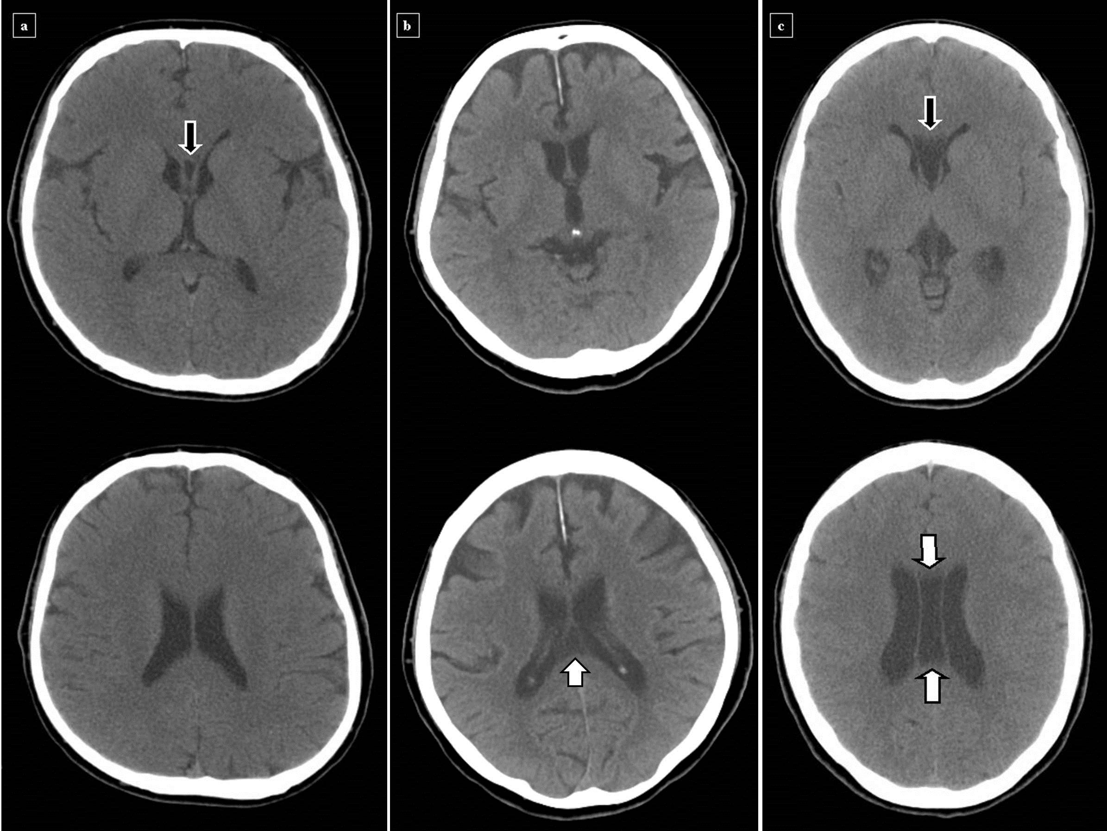

Figure 2
