Evidence of Sleep-Facilitating Effect on Formation of Novel Semantic Associations: an Event-related Potential (ERP) Study

Chun-Cheng Lin^{1,2}
¹ Department of Psychiatry, China Medical University Hospital, Taichung, Taiwan
² Department of Psychiatry, College of Medicine, China Medical University, Taichung, Taiwan.

Chien-Ming Yang^{3,4}
³ Department of Psychology, National Chengchi University, Taipei, Taiwan
⁴ Research Center for Mind, Brain and Learning, National Chengchi University, Taipei, Taiwan

Disclosure Statement: This is not an industry-supported study. The authors have indicated no financial conflict of interest.

Corresponding author: Chien Ming, Yang
Institution: National Chengchi University, Department of Psychology
Address: No.64, Sec.2, ZhiNan Rd., Wenshan District, Taipei City 11605, Taiwan
Phone: 886-2-29393091, ext. 67383
Fax: 886-2-29390644
E-Mail: yangcm@nccu.edu.tw
ABSTRACT

Paired-associates learning of unrelated words can reflect the formation of a new association in the semantic network. Research results on the facilitating effect of sleep on unrelated word-pair associates learning remain contradictory. The behavioral measures used in previous studies may not have been sensitive enough to reflect the process of new word association during sleep. The present study used the N400 component of event-related potential (ERP) to further assess the facilitating effect of sleep on the formation of new semantic associations. Thirty subjects were randomly assigned to either the Sleep group or the Wakefulness group. After paired-associates learning, they underwent nocturnal sleep and sleep deprivation, respectively A post-test was conducted after the subjects had one night of recovery sleep. ERPs were recorded during both test phases. Behavioral data showed significant differences in improvements in recognition and decreases in reaction time from pre-test to post-test between the Sleep and Wakefulness groups. The N400 peak amplitude attenuated significantly after sleep, but not after wakefulness. These results suggest that sleep has a facilitating effect on the formation of novel associations. Unexpectedly, slow wave sleep was negatively correlated with improvement in recognition during the post-test but was positively correlated with the number of word-pairs acquired during the learning phase. This may the result of a ceiling effect limiting the improvement achieved in subjects who learned better during the learning phase.

Keywords: sleep, memory, new association, event-related potential, ERP, N400

- Introduction
Since Jenkins and Dallenbach (1924) demonstrated that the strength of memory traces might be better preserved following an intervening period of sleep compared with an equivalent period of wakefulness, a substantial number of studies explored the possibility that sleep facilitates learning and memory. Although some studies produced negative results (Vertes, 2004; Vertes and Eastman, 2000; Vertes and Siegel, 2005), most showed that sleep improves memory retrieval (Conte and Ficca, 2013; Diekelmann and Born, 2010; Ellenbogen, Payne, and Stickgold, 2006; Rasch and Born, 2013; Rauchs, Desgranges, Foret, and Eustache, 2005; Stickgold and Walker, 2005; 2013; Walker and Stickgold, 2006).
As traditional theory divides memory into declarative or explicit memory and non-declarative or implicit memory (Graf and Schacter, 1985; Squire, 2004; Squire and Zola, 1996), past research that explored the role of sleep on memory consolidation also focused on certain memory categories. However, more recent theoretical models suggest that explicit and implicit memories are not two categories but two types of memory processes that may interact with each other (Kinoshita and Wayland, 1993; Schacter, Dobbins, and Schnyer, 2004). For example, Moscovitch (2008) proposed that explicit memory is a two-stage process from a neurophysiological viewpoint. The first stage is a fast and relatively automatic process (ecphory) that operates outside conscious awareness and is hippocampus dependent. The second stage is a slower and more strategic process that requires conscious awareness and depends on the interaction of the prefrontal and parietal cortices with the hippocampus (Cabeza, Ciaramelli, Olson, and Moscovitch, 2008; Ciaramelli, Grady, and Moscovitch, 2008).
These perspectives were recently adopted in the understanding of the role of sleep on memory. Recent models of sleep-related memory focus on the neurophysiological process of memory formation rather than the types of memory involved. For example, a neurophysiological model of sleep-memory relationships proposed by Born and colleagues portrays that sleep facilitates two memory consolidation processes. The first process, called system consolidation, is a dialogue between the neocortex and the hippocampus that enhances newly acquired information from the hippocampus to the neocortex. The second process, called synaptic consolidation, stabilizes the newly acquired memories in the neocortex through the reorganization of relevant memory representations in long-term stores (Diekelmann and Born, 2010; Inostroza and Born, 2013; Rasch and Born, 2013). This model further suggests that slow wave sleep (SWS) promotes the system consolidation process, and REM is more related to the synaptic consolidation process.
Among the tasks used to examine the facilitating effect of sleep on memory, the unrelated word-pair association task is common for measuring the formation of new associations in a semantic network. This task requires subjects to learn word pairs by forming associations between semantically unrelated words. Therefore, this learning requires both the systematic and synaptic consolidation processes of Born’s model. However, studies that explored the role of sleep on learning unrelated word pairs showed mixed results (Schabus, Gruber, Parapatics, Sauter, Klosch, Anderer, Klimesch, Saletu, and Zeitlhofer, 2004; Stickgold, 2004; Walker and Stickgold, 2006). Although some studies demonstrated a positive effect of sleep on unrelated paired-associates learning (Barrett and Ekstrand, 1972; Benson and Feinberg, 1977; Ficca, Lombardo, Rossi, and Salzarulo, 2000; Fowler, Sullivan, and Ekstrand, 1973; Schabus et al., 2004; Stickgold, Scott, Rittenhouse, and Hobson, 1999; Yaroush, Sullivan, and Ekstrand, 1971), other studies showed no such effect (Castaldo, Krynicki, and Goldstein, 1974; Chernik, 1972; Ekstrand, Sullivan, Parker, and West, 1971; Grosvenor and Lack, 1984). However, the absence of behavioral improvement following sleep in previous studies does not necessarily entail that sleep has no effect on newly formed associations. The effect may be too subtle to be consistently shown in behavioral measures. Additionally, the behavioral task requires both encoding and retrieval processes and cannot purely reflect the formation of new associations.
Electrophysiologically, a stronger semantic association was also demonstrated to be associated with a smaller deflection in the N400 component of event-related potential (ERP), a negative deflection within a period of 300–500 ms. Using the semantic-priming paradigm and after the presentation of the target word, N400 was shown to be a reliable index of semantic relatedness (Kutas and Federmeier, 2011; Kutas and Hillyard, 1980; Lau, Phillips, and Poeppel, 2008). A few studies used ERPs to explore the influence of sleep on memory consolidation. One study recorded ERPs during sleep in reacting to word-pairs and demonstrated that the N400 amplitude for pairs of unrelated words was significantly greater than for related pairs, suggesting that the lexical processes of semantic memory might remain active during sleep (Brualla, Romero, Serrano, and Valdizan, 1998). Another series of ERP studies were conducted to verify the effect of sleep on facial memory (Mograss, Godbout, and Guillem, 2006; Mograss, Guillem, and Godbout, 2008). Subjects were instructed to memorize a series of unfamiliar faces, and then were asked to recognize old items intermixed with new ones after a retention interval of either sleep or wakefulness. The behavior performance data showed sleep-dependent improvement. Additionally, both late positive component (LPC) and N400 revealed greater differences between old and new items after sleep than after sleep deprivation. In a recent study, participants were asked to memorize series of verbal or spatial associations. A retrieval test was conducted both immediately after learning and two days later with slow event-related EEG potential recordings. The results demonstrated that slow event-related EEG potentials were more reduced after sleep than after wakefulness (Verleger, Ludwig, Kolev, Yordanova, and Wagner, 2011). Another recent study showed that a positive ERP over the frontal cortex around 300 ms post-stimulus onset increased when viewing old emotional pictures compared with new emotional pictures and neutral pictures (Groch, Wilhelm, Diekelmann, and Born, 2013). These results suggest that ERPs and event-related EEG potentials are sensitive measures for detecting the facilitating effect of sleep on the consolidation of novel association; therefore, N400 may be a good measure to detect the facilitating effect of sleep on newly formed semantic associations.
Hence, the present study clarifies the role of sleep in the consolidation of newly acquired semantic associations by measuring the N400 component of ERP. Because the reduction of N400 reflects the strengthening of semantic association (Borovsky, Kutas, and Elman, 2013; Dobel, Junghofer, Breitenstein, Klauke, Knecht, Pantev, and Zwitserlood, 2010), attenuation of the N400 amplitude obtained after sleep was hypothesized as being significantly more than that obtained after wakefulness, regardless of the findings using behavioral data.

- Methods

2.1. Subjects

Thirty subjects (15 males, 15 females; mean age = 20.70 ± 2.71 years) were recruited from a university campus through advertisements. They were randomly assigned to two groups: a Sleep group (7 females, 8 males; mean age = 19.67 years) and a Wakefulness group (8 females, 7 males; mean age = 21.73 years). Potential subjects were screened for a present or past history of mental illness and sleep disorder through a clinical interview and one night of polysomnographic recording (PSG). For participation, they either received extra credit for an undergraduate class or monetary compensation. All subjects provided written informed consent to participate in the study. The study was conducted following the Ethical Standards of the Taiwan Psychological Association and conformed to the principles outlined by the Declaration of Helsinki. Table 1 presents the demographic data of the subjects.

2.2. Procedures

Before coming to the laboratory, subjects were instructed to follow a constant sleep schedule (sleep time 12:00 ± 1:00 A.M. and wake time 8:00 ± 1 A.M.) for three days, as verified by sleep logs and actigraphy. They were also required to refrain from alcohol and caffeine for three days before and during the entire study. Before the day of learning, subjects of the Sleep group had to come to the sleep laboratory the night before the experiment for a PSG exam to rule out sleep disorders and to avoid the first night effect following the experiment. Subjects of the Wakefulness group were allowed to sleep at home, and their sleep was monitored using actigraphy.
On the first night of the experiment, subjects in both groups were instructed to arrive at the laboratory at 8:00 P.M. After preparing for the EEG recording, subjects went through a learning phase between 8:30 P.M. and 9:30 P.M. Following a 10-minute break, pretesting was conducted between 9:40 P.M. and 10:10 P.M. The subjects then underwent either sleep with PSG recording (Sleep group) or sleep deprivation (Wakefulness group). During sleep deprivation, a subject’s activities were limited to Internet use, e-mail, short walks, reading, movie watching, and board games.
Subjects of the Sleep group went to sleep at 12:00 A.M. and were awakened at 08:00 A.M. Subjects of both groups were allowed to leave the laboratory around this
Table 1. Demographic and Subjective Variables
Variables | Sleep Group (n = 15) | Wakefulness Group (n = 15)
Age (Years) | 19.67 ± 2.32 | 21.73 ± 2.74
Gender | 8 males and 7 Females | 7 males and 8 females
Mean Sleep Prior to Test(min)
Pre-test Session | 455.67 ± 42.04 | 462.00 ± 53.18
Post-test Session | 444.33 ± 27.31 | 542.33 ± 76.55**
Stanford Sleepiness Scale (1–7)
Pre-test Session (9:30 P.M.) | 2.40 ± 0.51 | 2.60 ± 0.63
Post-test Session (9:30 A.M.) | 2.20 ± 0.68 | 2.73 ± 1.28
Sleep time was assessed through actigraphy. The sleep time of recovery sleep in the Wakefulness group is significantly longer than that in the Sleep group. Differences between the groups were compared using the Student’s t test. **P < .01. All data are demonstrated as mean ± S.D.

time and were instructed to follow their usual daytime activities and to abstain from napping during the day. In addition to actigraphy monitoring, subjects in the Wakefulness group were required to check in with the Sleep Lab every hour until 06:00 P.M. to prohibit napping. All subjects were allowed to have one night of recovery sleep on the following night, and then the post-test was administrated the next morning. Subjects arrived at 09:00 A.M. and underwent the post-test phase. The pre-test and post-test phases lasted approximately 30 minutes, and EEG recordings were conducted during both test phases. All subjects completed the Stanford Sleepiness Scale to rate sleepiness before both test phases (see Figure 1 for the procedures).

2.3. Stimuli and presentation

Two hundred and forty unrelated word-pairs were used for the study. The words were selected from medium frequency, two-character Chinese nouns (frequency range from 10 to 20 per million). These pairs were randomly allocated into one of three unrelated word-pair lists. Each list consisted of 80 word pairs. One list was chosen as learning materials and was presented during the study phase. Among these pairs, 40 were randomly selected to maintain their original pairing and served as “old-intact” (OI) pairs. The other 40 pairs were randomly recombined and served as “old-rearranged” (OR) pairs. The word pairs from the other two lists served as new pairs (New) in either the pre-test or post-test phase. Therefore, the study list contained a total of 80 word-pairs, whereas each test list included 160 pairs (40 OI, 40 OR, and 80 New; see Figure 2, upper section). During the pre- and post-test sessions, 80 learned pairs were randomly selected, with 40 of them being OI pairs and the remaining 40 pairs randomly recombined to form the OR pairs. Therefore, each

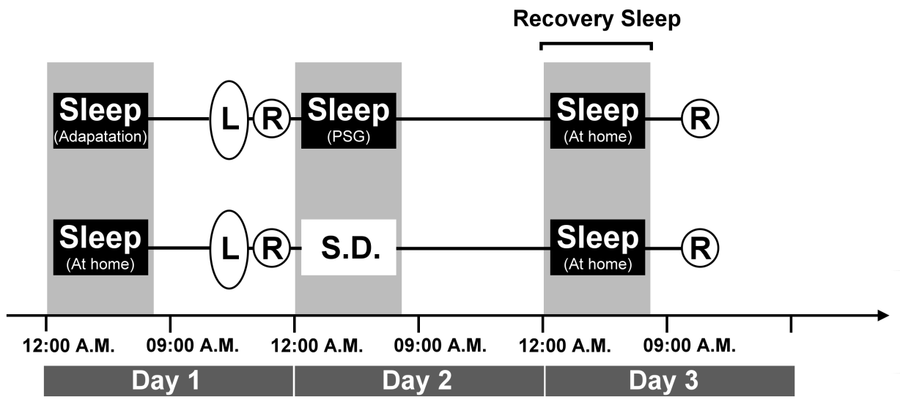
Figure 1—Experimental procedure. Abbreviation: L (Learning phase), R (Recognition test), SD (Sleep deprivation)

subject underwent distinct OI or OR pairs in pre- and post-test sessions.
Presentation® software (Neurobehavioral System, Inc., Albany, CA, USA) was used to control both the timing of the stimuli (onset and duration) presentation and registration of the response. Subjects sat in a comfortable chair in a sound-attenuated room. All words were presented using a font size of 36 on a 17-inch flat-panel monitor at a viewing distance of 90 cm, with words of 3 × 3 cm in length × width.
Stimuli were presented in central vision against a black background on a computer monitor. During the learning phase, the subjects were told to memorize each pair on the list for a subsequent recognition test. The learning phases were self-paced. During each trial, an initial fixation character—an exclamation mark “!”—was displayed, signaling that subjects could begin the trial when ready. When a response button was pressed, this character was then replaced by a second fixation character—a plus sign “+”—that was displayed for 500 ms (see Figure 2, lower section). This character was then replaced with a word pair, which was followed by the original fixation character. When subjects finished learning this pair, they pressed the response button to proceed to the next word pair.
During the pre- and post-test sessions, the random sequences of 80 studied pairs containing 40 OI pairs and 40 OR pairs, intermixed with 80 unstudied New pairs, were presented to subjects. Each trial began with the presentation of an initial fixation point—an exclamation mark “!”—for 2 s. This point was immediately followed by the presentation of a second fixation point—a plus sign “+”—for 1 s. The screen was then blanked for 200 ms. The prime word was presented for 400 ms, followed by display of the target word for 650 ms, with an interstimulus interval (ISI) of 350 ms separating prime and target. After the offset of the target word, a question mark “?” was presented for 3000 ms as a cue for the response; subjects had to judge as quickly and accurately as possible whether these two words were OI, OR, or New pairs by
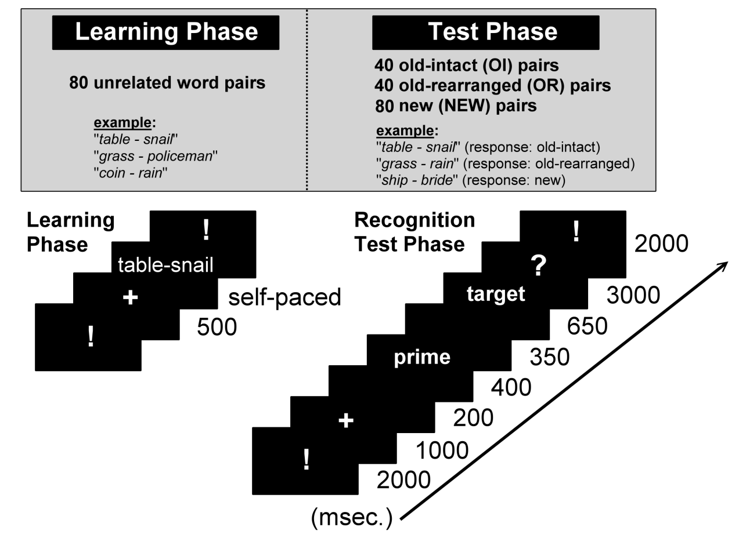
Figure 2—Presentation of experiment stimuli. Upper section: the stimuli presentation during the learning and test phases. Lower section: the time scale of stimuli presentation.

pressing one of three buttons on the response tool. If a response was not made until 3000 ms, the screen was replaced with the next trial. The response buttons were counter-balanced for each test session to avoid a confounding factor from the practice effect. The test list was administered in four blocks of 40 trials, with a short break intervening between each block.

2.4. Polysomnography Recording

Sleep was recorded using an Embla digital system (REMbrandt®, USA). The montage of first-night nocturnal PSG recording included electrooculography (EOG), chin and legs electromyography (EMG), oral or nasal airflow measured using thermosensors, thoracic and abdominal respiratory efforts, finger-probe oxymeter, electrocardiogram (EKG), and EEG leads (F3, F4, O1, O2, C3, Cz, C4) with each electrode referenced to the contralateral mastoid. The montage of sleep recording on the learning night included EOG, EMG, and EEG leads, with each electrode referenced to the contralateral mastoid. Sleep stages and events were scored manually in 30-s epochs by trained graduate students following the standard criteria (Rechtschaffen and Kales, 1968).

  - ERP Recording and Signal Extraction

The EEG was recorded from 30 scalp Ag/AgCl electrodes (Easycap GmbH, Herrsching, Germany) placed according to the 10–20 International System montage, which comprises Fp1/2, Fz, F3/4, F7/8, FC1/2, FC5/6, Cz, C3/4, CP1/2, CP5/6, Pz, P3/4, P7/8, T7/8, FT9/10, Oz, and O1/2. For the horizontal EOG, electrodes were placed at the outer canthus of each eye. For the vertical EOG, electrodes were placed infra- and supra-orbital to the left eye in line with the pupil. The impedance of all electrodes was maintained below 5 kΩ. The EEG and EOG were sampled on each trial at a rate of 1000 Hz.
EEG data were analyzed using the Brain-Vision Analyzer (Brain Products GmbH, Gilching, Germany) software. All EEG channels were offline referenced to the linked pair of electrodes on each mastoid (A1 + A2), with the notch-filter set at 60 Hz, the low-cutoff filtered at 0.3 Hz, and the high-cutoff filtered at 30 Hz. EOG were further analyzed to assess the influence of electro-ocular activity on the EEG trials. Ocular artifacts were corrected using linear regression methods implemented through the Analyzer software.
EEG data were segmented from 100 ms before onset of the target word until 900 ms afterward. The mean amplitude of the 100 ms before the onset of the target word was used as a baseline for the adjustment of the averaged data. Artifact rejection was conducted to remove the trials with EEG amplitude higher than 75 μV and base-to-peak EOG amplitude higher than 100 μV. These segmentations were then averaged according to distinct pair types. ERPs were derived for three response categories: new pairs correctly judged as such (New); correctly recognized original learned intact pairs (OI); and “rearranged” (OR). Only the correctly recognized items were included in the analyses of ERPs. ERP positive (P) and negative (N) peaks were automatically detected and manually corrected where necessary. The N400 peak amplitude was defined as the most negative voltage within the 300–500 ms interval. EEG data were only assessed at midline electrodes (Fz, Cz, and Pz) given a previous finding that N400 is prominent over central–parietal sites (Kutas and Federmeier, 2011; Lau et al., 2008). Furthermore, although previous components of N100 and P200 are not involved in the memory process, they can be used to control for confounding effects during testing at different times given that the earlier ERP components within a latency of 60 to 200 ms (N1–P2 complex) were previously linked to changes in vigilance and attention (Haider, Spong, and Lindsley, 1964; Näätänen, Gaillard, and Mäntysalo, 1978). Therefore, the N100 and P200 components were analyzed for controlling the differences in vigilance between the sleep and awake test sessions (Mograss et al., 2006; Mograss, Guillem, Brazzini-Poisson, and Godbout, 2009; Mograss et al., 2008). The N100 and P200 components were quantiﬁed within 60–150 ms and 150–210 ms time windows, respectively, at all sites.

  - Statistical Analysis

Behavioral performance data were obtained simultaneously with the EEG data. The percentages of correct judgment (CJ%) and reaction time (RT) were compared using a 2 × 2 × 3 three-way repeated measure analysis of variance (ANOVA) with two groups (Sleep vs. Wakefulness), two test sessions (Pre- and Post-tests), and three pair types (OI, OR, and New) as the factors.
Repeated measurement ANOVAs were also computed on either peak amplitudes or latencies of N400 with pair types (OI, OR, and New), test sessions (pre- vs. post-test) and sites (Fz, Cz and Pz) as within-subject factors, and groups (Sleep vs. Wakefulness) as the between-subject factor. The amplitude of the N400 components induced by OI pairs were further analyzed on three sites (Fz, Cz, and Pz) and test sessions (pre- and post-tests), and groups (Sleep vs. Wakefulness) as a between-subject factor using a 3 × 2 × 2 three-way ANOVA. For post-hoc comparisons, the Scheffé tests were applied. In these analyses, the degrees of freedom associated with the F ratios of all ANOVAs were corrected by applying the Geisser–Greenhouse procedure to compensate for the violation of non-sphericity.
Scores of the Stanford Sleepiness Scale were analyzed using two-way ANOVAs, comparing between two groups (Sleep vs. Wakefulness) and two test sessions (Pre-test vs. Post-tests). To explore the role of different sleep stages in memory formation, correlations between changes in CJ% of OI pairs and sleep stage variables were carried out using Pearson’s correlation analysis. Improvement in behavior data for both CJ% and RT was defined as differences in pre- and post-test performances. Furthermore, correlations between changes in ERP components at electrode sites (Fz, Cz, and Pz) and sleep stages were also obtained. For all analyses, a p-value less than 0.05 was considered significant.
- Results
3.1. Behavior Data
The ANOVA of CJ% revealed significant main effects of the Groups [F(1,28) = 5.07, p < .05] and Test sessions [F(1,28) = 7.36, p = .01]. The performance of subjects in the Sleep group was significantly better than those in the Wakefulness group. Significant Groups × Test sessions [F(1,28) = 15.96, p < .001] and Test sessions × Pair types [F(2,56) = 15.96, p < .01] interactions existed. The CJ% of OI pairs showed significant improvement from pre- to post-test sessions in the Sleep group [F(1,14) = 17.90, P = .001], but showed a significant decrease after sleep deprivation [F(1,14) = 4.88, P < .05]. In the pre-test session, no significance existed between Sleep and Wakefulness in CJ% [F(1, 28) = .51, P = .48]; however, the CJ% in the Sleep group was significantly better than that in the Wakefulness group [F(1, 28) = 11.24, P < .05]. The analyses of OR and New pairs showed similar pattern as in the OI analysis; however, no significance existed between the pre- and post-test in the Wakefulness group in OR pairs [F(1,14) = 2.34, P = .15] (Figure 3).
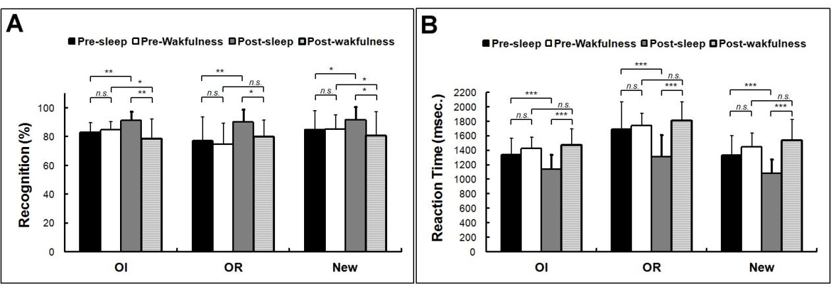

Figure 3—Demonstration of the results of correct judgment (CJ%) (Figure 3A) and reaction time (RT) (Figure 3B) in each pair types between groups. The data were analyzed using ANOVAs. The bars demonstrate mean ± S.D. *P < .05, **P < .01, ***P < .01. Abbreviation: OI (Old-Intact pairs), OR (Old-Rearranged pairs), New (New pairs).

In the RT analysis, the main effects of Groups [F(1,28) = 12.35, p < .01], Test sessions [F(1,28)= 10.92, p < .01], Pair types [F(1,28) = 64.30, p < .001], and significant interactions of Groups × Test sessions [F(1,28)_{1,28} = 29.46, p < .01] existed. The results of the comparison of the RT in the pre- and post-test for the three types of pairs demonstrate that the RT of the Sleep group was significantly faster in the post-test compared with the pre-test [F(1, 14) = 47.38, 18.83, and 24.13, respectively, all Ps < 001]; however, no significance existed between test sessions in the Wakefulness group [F(1, 14) = 1.03, 0.88, and 2.70, respectively, all Ps > .05]. Between groups, no significant difference existed at the baseline for all three pair types; in contrast, the RTs in the Sleep group were faster than those in the Wakefulness group after sleep manipulation for all OI, OR, and New pairs [F(1,28) = 17.82, 22.83, and 25.82, respectively, all Ps < .001] (see Figure 3).
3.2. ERP Data
3.2.1 Peak Amplitude of N400
A four-way ANOVA of N400 amplitude revealed a significant main effect of Sites [F(2,56) = 27.89, P < .001], Test sessions [F(2,56) = 27.89, P < .001], and Pair types [F(2,56) = 27.89, P < .001]; in contrast, the main effect of Groups failed to achieve significance [F(1,28) = .61, P = .45]. Two-way interactions of Sites × Types [F(4,112) = 9.41, P < .001], Test sessions × Groups [F(1,28) = 7.09, P < .05], Test sessions × Types [F(2,56) = 13.26, P < .001], and Types × Groups [F(2,56) = 5.41, P < .01] were significant; however, interactions of Sites × Test sessions [F(2,56) = 2.08, P = .13] and Sites × Groups Sites × Groups [F(2,56) = .71, P = .49] demonstrated no significant effects. No other significant three-way interactions existed except for Test sessions × Types × Groups interaction [F(2,56) = 9.28, P < .001]. The four-way interaction also showed statistical significance [F(4,112) = 2.57, P < .05].
Because N400 elicited by OI pairs is to be an index of a new association, a three-way ANOVA was then conducted using the within-subject factors of Sites (Fz, Cz and Pz) × Test Sessions (Pre- and Post-test), and a between-subject factor of Groups (Sleep vs. Wakefulness). Figure 4 presents the grand-averaged waveforms evoked by OI pairs for both the Sleep and Wakefulness groups. The ANOVA on the midline (Fz, Cz, Pz) data for the N400 amplitude induced by OI pairs showed significant main effects of the Groups [F(1,28) = 82.20, p < .001] and Test sessions [F(1,28) = 6.32, p < .05], whereas ANOVA did not show a main effect for electrode sites [F(2,56) = 0.96, p = .39]. A significant interaction existed for Electrode sites × Test sessions [F(2,56) = 7.11, p < .01] and Group × Test sessions [F(1,28) = 19.33, p < .001]. The analysis of the simple main effect showed that the peak amplitude of N400 in the pre-test session attenuated more than that in the post-test session [F(1,14) = 15.27, p < .01] in the Sleep group. Moreover, the attenuation of N400 after sleep was significant at the Cz [F(1,29) = 7.52, p = .011] and Pz [F(1,29) = 4.96, p < .05] electrode sites, but not at the Fz site [F(1,29) = 0.41, p = .53]. In the Wakefulness group, no significant difference existed between the test sessions [F(1,14) = 4.06, p = .06]. No significant difference of N400 changes existed between electrode sites [F(2,28) = 2.67, p = .09]. Additionally, the N400s between groups were not significantly different at the baseline [F(1,89) = 1.81, p = .18], whereas the N400 of the Wakefulness group was significantly more negative than that of the Sleep group [F(1,89) = 12.96, p = .001].

3.2.2 Peak Amplitude of N400 from Different Pairs

The N400 induced by OI pairs at Cz sites was more obvious than that at other
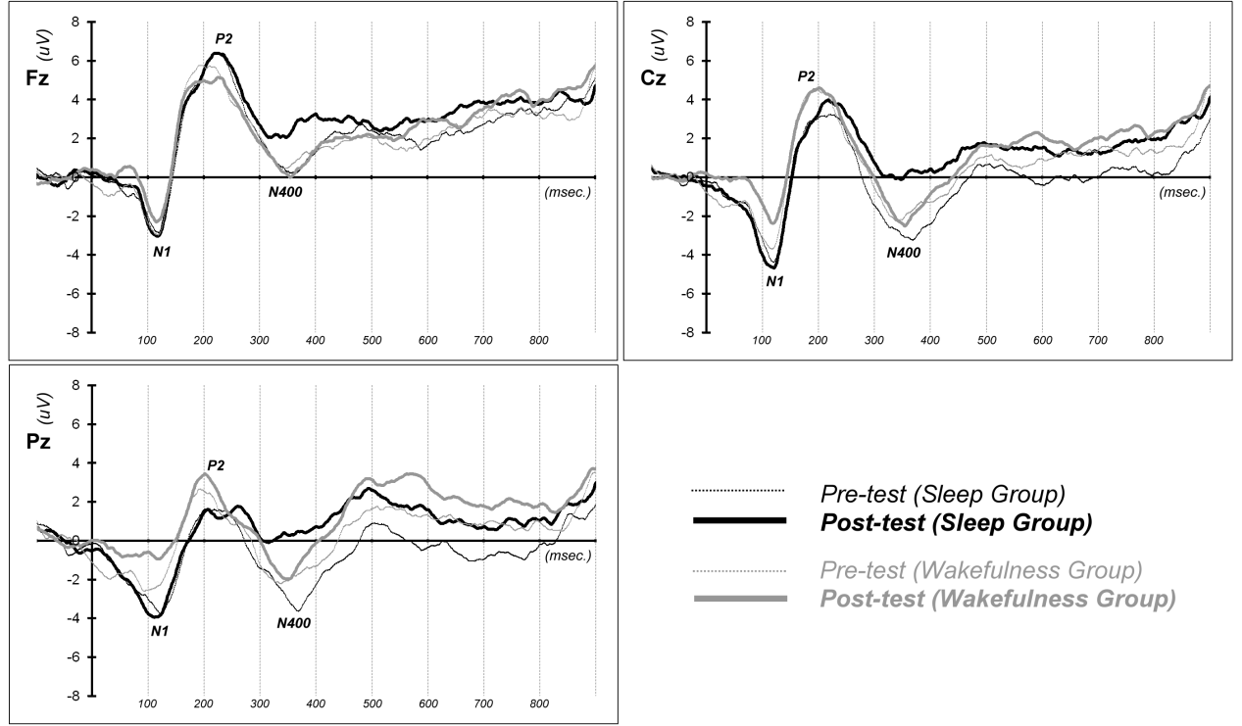

Figure 4—Grand average event-related potentials (ERPs) elicited by correctly recognized studied stimuli of OI pairs at the midline (Fz, Cz, Pz) sites. Vertical dot-lines represent the ERP time scales and the y-axis marks the target presentation. Black line: Sleep group; Gray line: Wakefulness group. Negativity is plotted downward. ERP components: N100 (N1), P200 (P2), and N400. The marked area indicates the N400 difference between the Sleep and Wakefulness groups during the post-test session. The figure demonstrating the attenuation of N400 was more obvious after sleep, whereas changes in N400 were fewer after Wakefulness. Moreover, the peak amplitude of N400 after sleep was smaller than that after sleep deprivation.

sites, thus 2 (Groups) × 2 (Test sessions) × 3 (Pair types) three-way ANOVAs were conducted to compare the amplitude and latency of N400s at Cz. Figure 5 shows the N400s induced by different stimulus types in both test sessions. All two-way interactions of Groups × Pair types [F(2,56) = 4.86, p < .05], Test sessions × Pair types [F(2,56) = 12.46, p < .001], and Test sessions × Groups [F(1,28) = 8.38, p < .05] were significant. The Groups × Test sessions × Pair types interaction was also significant [F(2,56) = 15.44, p < .001]. In the analyses of simple main effects, the N400s between groups in three distinct pair types were not significantly different at the baseline [F(1,29) = 0.76, 0.69, and 0.77 for OI, OR, and New pairs, respectively, all Ps > .05]. During the post-test, only N400 induced by OI pairs in the Sleep group was significantly smaller than that in the Wakefulness group [F(1,29) = 33.44, p < .05] (Figure 4, middle). The differences in N400s of OR pairs between the Sleep and Wakefulness groups were marginally significant [F(1,29) = 3.99, p = .056].
In the Sleep group, the simple main effect of the Test sessions achieved significance [F(1,14) = 10.07, p < .01). A post-hoc comparison demonstrated that N400 was significantly attenuated from pre-test to post-test. Furthermore, the simple main effect of Pair types was also significant [F(1,28) = 21.97, p < .001]. A post-hoc comparison demonstrated that the peak amplitude of N400 induced by New pairs was significantly larger, whereas N400 induced by OI pairs was smaller than that induced by the other types (all Ps < .01). Furthermore, N400s of both OI and OR pairs were attenuated after sleep [F(1,29) = 7.52 and 5.38, respectively; both p < .05], whereas N400s of New pairs did not change significantly [F(1,29) = 0.44, p = .55] (Figure 5, left).
In the Wakefulness group, the simple main effect of Pair types revealed a significant difference [F(1,14) = 24.23, p < .001]. A post-hoc comparison showed that the peak amplitude of N400 subsequently attenuated in the order of the N400 induced by New,
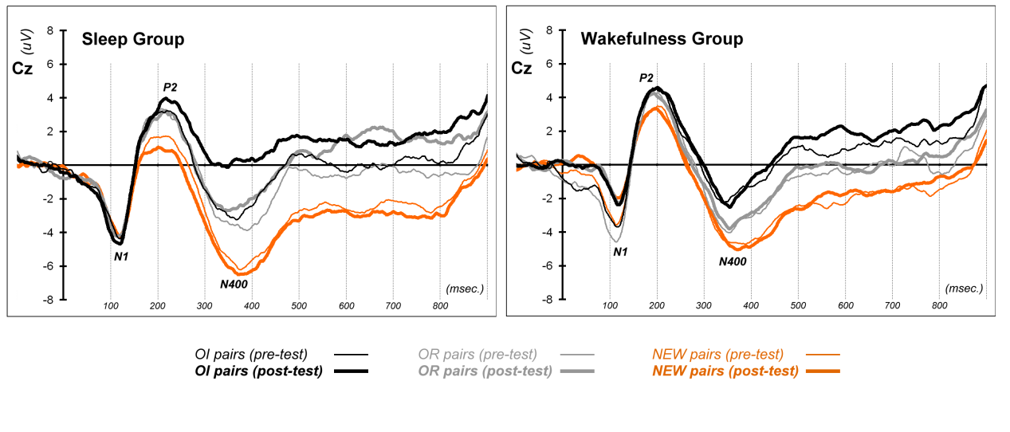

Figure 5—Grand average event-related potentials (ERPs) elicited by correctly recognized studied stimuli of OI pairs (black line), OR pairs (gray line), and unstudied stimuli of New pairs (orange line) at Cz sites. Left: Sleep group; Right: Wakefulness group. Negativity is plotted downward. Three peaks appear at 100, 200, and 400 ms after the stimulus presentation, respectively.

OR, and OI pairs (all Ps < .01). Neither the simple main effect of the Test sessions [F(1,14) = 0.19, p = .67] or the interaction of the Test sessions × Types [F(1,14) = 0.08, p = .78] was significant (Figure 5, right).
The N400 at Fz sites also showed significant main effects for Types [F(2,56) = 9.56, P < .001] but not for Test sessions [F(1,18) = .97, P = .33] and Groups [F(1,28) = .11, P = .74]. A two-way interaction of Types × Groups [F(2,56) = 3.50, P < .05] occurred. The analyses of N400 at the Pz site demonstrated the main effects of the Test sessions [F(1,28) = 10.05, P < .01] and Pair types [F(2,56) = 33.85, P < .001]; however, the main effect of Groups failed to achieve significance [F(1,28) = 1.19, P = .28]. Two-way interactions of Test session × Pair types [F(2,56) = 4.96, P = .01] and Types × Groups [F(2,56) = 5.05, P = .01] occurred.

3.2.3 Peak Latency of N400
Analysis of N400 latency induced by different pairs at the Cz site revealed no main effects of both Test sessions [F(1,28) = 0.48, p = .49] and Groups [F(1,28) = 0.12, p = .73]. The main effect of the pair types achieved statistical significance [F(2,56) = 5.14, p < .01). A post-hoc comparison showed that the N400 latency of New pairs was significantly longer than that of either OI or OR pairs. No significant two-way or three-way interactions occurred. At the Fz sites, no significant main effect of the Test sessions [F(1,28) = .44, P = .51], Pair types [F(2,56) = 1.49, P =.24], and Groups [F(1,28) =.24, P = .63] existed. All two-way interactions of Test sessions × Groups [F(1,28) = .08, P = .79], Groups × Pair type [F(2,56) = .64, P = .53], Test sessions × Pair types [F(2,56) = .56, P = .53], and three-way interactions [F(2,56) = .54, P = .59] failed to achieve significance. At the Pz site, the main effect of Pair types achieved significance [F(2,56) = 7.44, P = .001], whereas neither the main effect of Groups [F(1,28) = 2.70, P = .11] nor the Test sessions [F(1,28) = .02, P = .88] demonstrated significance. Aside from the significant Test sessions × Pair types [F(2,56) = 3.23, P < .05] interaction, no other significant two-way or three-way interactions existed.
3.2.4 N1-P2 Components
An ANOVA analysis of the N1 peak amplitude at the Cz site showed a significant main effect of the Test sessions [F(1,28) = 6.20, p < 0.05] and Groups × Test sessions interaction [F(1,28) = 6.82, p < 0.05]. In the Wakefulness group, the simple main effect of the Test sessions revealed a significant difference [F(1,14) = 19.07, p = .001), which demonstrated that N1 in the post-test session was more attenuated than that in the pre-test session. For the analysis of the P2 peak amplitude, only the main effect of Pair types showed a significant difference [F(2,56) = 12.64, p < 0.001]. A post-hoc analysis showed that P2 elicited by New pairs was significantly smaller than that induced by OI pairs.

3.3. Correlations between Sleep Stages and Memory Measures

Table 2 shows the sleep parameters of subjects on the first night and on the learning night. Table 3 demonstrates the correlations between sleep stages on the learning night and memory parameters, including behavioral (CJ% and RT improvement of OI pairs) and neurophysiological (difference of N400 between test sessions at different sites) measures. The results show that the better the memory improvement between pre-test and post-test, as indicated by CJ%, the less time was
Table 2. nPSG: Sleep statistics of the Sleep group
Sleep Variables | First night (min) | Percentage (%) | Learning night (min) | Percentage (%)
Total sleep time | 409.81 ± 36.35 |  | 436.74 ± 62.28
Sleep onset latency | 12.53 ± 7.64 |  | 12.17 ± 11.28
Stage 1 sleep | 52.96 ± 30.25 | 12.67 ± 6.37 | 29.93 ± 13.14 | 6.40 ± 2.67
Stage 2 sleep | 243.15 ± 40.43 | 53.77 ± 8.13 | 253.80 ± 41.78 | 54.55 ± 6.43
Slow wave sleep (SWS) | 53.70 ± 25.32 | 11.89 ± 5.58 | 65.07 ± 30.44 | 15.31 ± 9.41
Rapid eye movement (REM) sleep | 63.65 ± 24.11 | 13.98 ± 5.06 | 87.95 ± 20.71 | 18.79 ± 3.40
Sleep onset latency is defined as the first epoch of sleep. Time is measured in minutes. Data are showed as Mean ± S.D.

Table 3. Correlation between memory measures and distinct sleep stages
Variables | N1 | N2 | SWS | NREM | REM
CJ% improvement | 0.51 | 0.36 | -0.57* | -0.23 | -0.30
RT improvement | -0.18 | 0.07 | -0.08 | -0.11 | -0.27
N400 changes at Fz | -0.16 | -0.06 | -0.06 | -0.2 | 0.03
N400 changes at Cz | -0.47 | 0.14 | 0.15 | 0.14 | 0.31
N400 changes at Pz | -0.50 | -0.07 | 0.11 | -0.11 | 0.23
N1: Stage 1 sleep; N2: Stage 2 sleep; SWS: Slow wave sleep; NREM: Non-rapid eye movement sleep; REM: Rapid eye movement sleep; CJ%: Correct judgment (%) of OI; RT: Reaction time of OI. Improvement defined as the performance changes from pre-test to post-test. * Pearson correlation is significant at the 0.05 level.

spent in SWS (Pearson’s r = –0.57, p < .05). However, the SWS% was positively correlated with the CJ% during the pre-test session (Pearson’s r = 0.54, p < .05). Moreover, the improvement in OI pairs from pre- to post-test was negatively associated with the CJ% of OI in the pre-test (Pearson’s r =–.68, p < .01), which demonstrated that subjects who learned better in the pre-test improved less after sleep.
3.4. Subjective Rating: Stanford Sleepiness Scale
The ANOVA result showed no Groups main effect [F(1,28) = 2.76, p = 0.11], Sessions main effect [F(1,28) = 0.03, p = .87], or interaction [F(1,28)= 0.65, p = .43] of the ratings on the Stanford Sleepiness Scale. Therefore, the differences in behavioral or electrophysiological measures between groups are not likely the result of the fatigue influence or changes in alertness.

- Discussion

This study investigated the effect of sleep on the formation of new semantic associations. The results show significantly greater improvement in the learning of unrelated pair associations with decreased RTs and increased performance on the recognition task, and an attenuated amplitude of N400 for subjects who were allowed to sleep after learning than those who were kept awake for a night followed by one night of recovery sleep. The findings provided clear behavioral and electrophysiological evidence supporting a facilitating effect of sleep on the formation of novel associations.
From the perspective of the semantic network as proposed by Loftus and Collin (1975), the activation of a certain node in the semantic network can then spread to related nodes and make them available for further cognitive processing. This process may be reflected by an increase in the speed and accuracy of memory retrieval. In the present study, subjects with sleep that followed learning performed faster and more accurately, whereas those who stayed awake for a night showed no significant changes in performance even after recovery sleep. This result suggests that sleep prevents the learning from decaying and plays an active role in facilitating and consolidating the newly learned association.
As indicated in the literature review, previous studies on the effect of sleep on unrelated word-pair learning showed inconsistent results. Our results of the behavioral performance add additional positive findings to the literature and demonstrate the role of sleep in facilitating the recognition of pair-associates (Koulack, 1997; Wagner, Kashyap, Diekelmann, and Born, 2007). The present study further demonstrates neurophysiological evidence that sleep facilitates the strengthening of novel semantic associations, as indicated by the finding that N400 induced by OI word pairs attenuated significantly more with sleep rather than wakefulness following learning. However, an alternative explanation of this finding is that the attenuation of the N400 amplitude may arise from the repetition priming effect (Kutas and Federmeier, 2000; Matsumoto, Iidaka, Nomura, and Ohira, 2005; Renoult, Wang, Mortimer, and Debruille, 2012). Therefore, sleep may not enhance the formation of associations but the activation of the target words per se given repeated exposure. To control for this effect, we applied the OR pairs to test the effect of repetition without associations. The results showed that more N400 attenuation of OI pairs than OR pairs in the sleep condition but not in the wakefulness condition, suggesting that N400 attenuation after sleep is not merely the result of repetition priming. Our results support the notion that the newly acquired association between representations of words in the semantic neural network may be strengthened through a sleep-related consolidation process. The failure to find improved memory performance after post-learning sleep in previous studies may be the result of limited sensitivity of the behavioral measures in detecting subtle changes in the association of semantic representations in the brain.
Some studies attempted to identify the brain areas responsible for the N400 (Lau et al., 2008) and to link the component to specific neural functions (Federmeier and Laszlo, 2009). Semantic processing engages a sizeable network of neural areas, including the left inferior prefrontal cortex, anterior and posterior temporal lobes, and tempo-parietal areas (Martin, 2007; Price, 2000; Thompson-Schill, 2003). The N400 reflects processing in semantic memory and its neural origins, including the superior and middle temporal gyri, the temporoparietal junction, and the medial temporal lobe, highlighted by magnetoencephalogram studies (Halgren, Dhond, Christensen, Van Petten, Marinkovic, Lewine, and Dale, 2002; Helenius, Salmelin, Service, and Connolly, 1998; 1999; Helenius, Salmelin, Service, Connolly, Leinonen, and Lyytinen, 2002; Kwon, Kuriki, Kim, Lee, Kim, and Nam, 2005; Pylkkanen and McElree, 2007; Simos, Basile, and Papanicolaou, 1997; Uusvuori, Parviainen, Inkinen, and Salmelin, 2008) and event-related optical signal studies (Tse, Lee, Sullivan, Garnsey, Dell, Fabiani, and Gratton, 2007). Intracranial studies further identified a source of N400 in the anterior medial temporal lobe that patterns closely with the scalp-recorded N400 in its sensitivity to semantic priming, semantic anomaly, repetition, and verbal memory (Elger, Grunwald, Lehnertz, Kutas, Helmstaedter, Brockhaus, Van Roost, and Heinze, 1997; Fernandez, Heitkemper, Grunwald, Van Roost, Urbach, Pezer, Lehnertz, and Elger, 2001; Guillem, N’Kaoua, Rougier, and Claverie, 1996; McCarthy, Nobre, Bentin, and Spencer, 1995; Nobre, Allison, and McCarthy, 1994; Nobre and McCarthy, 1994; Smith, Stapleton, and Halgren, 1986). These areas are all near the hippocampus and surrounding areas implied in Born’s model of sleep-related memory consolidation processes.
Furthermore, recent studies have suggested that newly acquired information is replayed in the hippocampus during sleep (Ji and Wilson, 2007; Louie and Wilson, 2001; Nadasdy, Hirase, Czurko, Csicsvari, and Buzsaki, 1999; Ribeiro, Gervasoni, Soares, Zhou, Lin, Pantoja, Lavine, and Nicolelis, 2004; Wilson and McNaughton, 1994). These reactivated patterns may serve to consolidate the transient effects of sensory stimulation into long-lasting circuit modiﬁcations. A previous fMRI study also demonstrated that associative learning triggers a stronger combined activation of the neocortical and hippocampal regions during subsequent sleep (Bergmann, Molle, Diedrichs, Born, and Siebner, 2012). Interestingly, these regions activated during sleep are similar to the neuronal sources of N400 as previously mentioned. Because the N400 amplitude correlates negatively with the semantic relatedness of word pairs, it could also reflect the strength of the hippocampus-dependent memory consolidation in newly acquired associations. Our finding that N400 diminished after post-learning sleep provides electrophysiological evidence that sleep facilitates systematic consolidation to form new associations in the semantic network in the neocortex.
Another possible explanation for the differentiating effects between the two groups may come from the decrease in vigilance or attention attributable to sleep deprivation in the Wakefulness group. Although the attenuated N1 during a post-test of the Wakefulness group reflected a decrease in vigilance or attention, self-ratings of sleepiness did not differ between the groups. To the best of our knowledge, no studies demonstrated the influence of vigilance as reflected by N1 on the amplitude of N400. Furthermore, both groups went through a full night of recovery sleep before the post-test. Therefore, the amplitude of N400 is less likely to create a significant effect on vigilance or attention during the post-test. Moreover, even if sleep deprivation had an effect on vigilance during retrieval, it would contribute partially to the differences in behavioral performance but would not result in a significant difference in semantic networking as reflected by the N400.
Regarding the association between specific sleep stages and memory formation, the beneficial effect of sleep was suggested to arise from the reactivation of newly encoded information in the hippocampus during SWS (Born and Wilhelm, 2011; Wilson and McNaughton, 1994). Through this process, the information encoded in the hippocampus may be transferred from the hippocampus to the neocortex for long-term storage (Marshall and Born, 2007). A previous study also showed an association between recognition memory and SWS (Daurat, Terrier, Foret, and Tiberge, 2007). Unexpectedly, our results show that the better the memory improvement from pre-test to post-test, the lesser time spent in SWS (r =–0.57). Further, our results showed a positive correlation between the performance during the pre-test session and the percentage of SWS after learning (r = 0.54), suggesting that SWS might be involved in the processing of newly encoded memory. Moreover, a negative correlation between the performance in the pre-test and improvement from pre-test to post-test (r =–0.68) suggests a possible ceiling effect that limited the improvement in subjects who learned better during the pre-test session. This finding is consistent with the previous finding that the facilitating effect of sleep is reduced for well-learned items (Drosopoulos, Schulze, Fischer, and Born, 2007). Nonetheless, our results are correlational in nature and should preclude any definite conclusion of causal inference. Further studies are required to clarify this issue.
One potential limitation of the current study is that subjects of the Wakefulness group did not undergo a PSG screening for possible sleep disorders but were screened through a clinical interview. Therefore, potential sleep disorders might result in poorer memory performance. However, our subjects were young, healthy college students who reported no sleep disturbances and were screened for possible sleep disorders through the clinical interview; therefore, the study did not likely include subjects with significant sleep problems. The other possible confounding effect is the age difference between the two groups—the Sleep group is younger than the Wakefulness group. Evidence suggests the critical role of sleep in the age-dependent decline of declarative memory consolidation (Backhaus, Born, Hoeckesfeld, Fokuhl, Hohagen, and Junghanns, 2007). In the present study, we analyzed the correlations between age and either behavioral performance or N400, and the results demonstrate that both behavioral and N400 effects are not associated with age within the groups. Therefore, the influence of age may be minor.
In conclusion, the present study explored the effects of sleep on the memory of new associations through both behavioral and ERP measures. The results demonstrate a facilitating effect of sleep on the recognition of new associations, as shown behaviorally, and on the strengthening of newly encoded associations in a semantic network, as indicated by ERP measures. The results not only support memory consolidation during sleep but also demonstrate that ERP is a useful measure for investigating the relatively subtle effect of sleep on unrelated word-pair associations. This protocol may be applied in future studies on related topics.

REFERENCES

Backhaus, J., Born, J., Hoeckesfeld, R., Fokuhl, S., Hohagen, F., & Junghanns, K. (2007). Midlife decline in declarative memory consolidation is correlated with a decline in slow wave sleep. Learning & Memory, 14, 336-341.
Barrett, T. R., & Ekstrand, B. R. (1972). Effect of sleep on memory. 3. Controlling for time-of-day effects. Journal of Experimental Psychology: General, 96, 321-327.
Benson, K., & Feinberg, I. (1977). The beneficial effect of sleep in an extended Jenkins and Dallenbach paradigm. Psychophysiology, 14, 375-384.
Bergmann, T. O., Molle, M., Diedrichs, J., Born, J., & Siebner, H. R. (2012). Sleep spindle-related reactivation of category-specific cortical regions after learning face-scene associations. Neuroimage, 59, 2733-2742.
Born, J., & Wilhelm, I. (2011). System consolidation of memory during sleep. Psychological Research, 76, 192-203.
Borovsky, A., Kutas, M., & Elman, J. L. (2013). Getting it right: word learning across the hemispheres. Neuropsychologia, 51, 825-837.
Brualla, J., Romero, M. F., Serrano, M., & Valdizan, J. R. (1998). Auditory event-related potentials to semantic priming during sleep. Electroencephalography and Clinical Neurophysiology, 108, 283-290.
Cabeza, R., Ciaramelli, E., Olson, I. R., & Moscovitch, M. (2008). The parietal cortex and episodic memory: an attentional account. Nature Reviews Neuroscience, 9, 613-625.
Castaldo, V., Krynicki, V., & Goldstein, J. (1974). Sleep stages and verbal memory. Perceptual and Motor Skills, 39, 1023-1030.
Chernik, D. A. (1972). Effect of REM sleep deprivation on learning and recall by humans. Perceptual and Motor Skills, 34, 283-294.
Ciaramelli, E., Grady, C. L., & Moscovitch, M. (2008). Top-down and bottom-up attention to memory: a hypothesis (AtoM) on the role of the posterior parietal cortex in memory retrieval. Neuropsychologia, 46, 1828-1851.
Collins, A. M., & Loftus, E. F. (1975). A spreading-activation theory of semantic processing. Psychological Review, 82, 407-428.
Conte, F., & Ficca, G. (2013). Caveats on psychological models of sleep and memory: a compass in an overgrown scenario. Sleep Medical Reviews, 17, 105-121.
Daurat, A., Terrier, P., Foret, J., & Tiberge, M. (2007). Slow wave sleep and recollection in recognition memory. Consciousness and Cognition, 16, 445-455.
Diekelmann, S., & Born, J. (2010). The memory function of sleep. Nature Reviews Neuroscience, 11, 114-126.
Dobel, C., Junghofer, M., Breitenstein, C., Klauke, B., Knecht, S., Pantev, C., & Zwitserlood, P. (2010). New names for known things: on the association of novel word forms with existing semantic information. Journal of Cognitive Neuroscience, 22, 1251-1261.
Drosopoulos, S., Schulze, C., Fischer, S., & Born, J. (2007). Sleep’s function in the spontaneous recovery and consolidation of memories. Journal of Experimental Psychology: General, 136, 169-183.
Ekstrand, B. R., Sullivan, M. J., Parker, D. F., & West, J. N. (1971). Spontaneous recovery and sleep. Journal of Experimental Psychology: General, 88, 142-144.
Elger, C. E., Grunwald, T., Lehnertz, K., Kutas, M., Helmstaedter, C., Brockhaus, A., Van Roost, D., & Heinze, H. J. (1997). Human temporal lobe potentials in verbal learning and memory processes. Neuropsychologia, 35, 657-667.
Ellenbogen, J. M., Payne, J. D., & Stickgold, R. (2006). The role of sleep in declarative memory consolidation: passive, permissive, active or none? Current Opinion in Neurobiology, 16, 716-722.
Federmeier, K. D., & Laszlo, S. (2009). Time for meaning: Electrophysiology provides insights into the dynamics of representation and processing in semantic memory. In B. H. Ross (Ed.), Psychology of Learning and Motivation (pp. 1-44): Burlington: Academic Press.
Fernandez, G., Heitkemper, P., Grunwald, T., Van Roost, D., Urbach, H., Pezer, N., Lehnertz, K., & Elger, C. E. (2001). Inferior temporal stream for word processing with integrated mnemonic function. Human Brain Mapping, 14, 251-260.
Ficca, G., Lombardo, P., Rossi, L., & Salzarulo, P. (2000). Morning recall of verbal material depends on prior sleep organization. Behavioural Brain Research, 112, 159-163.
Fowler, M. J., Sullivan, M. J., & Ekstrand, B. R. (1973). Sleep and memory. Science, 179, 302-304.
Graf, P., & Schacter, D. L. (1985). Implicit and explicit memory for new associations in normal and amnesic subjects. Journal of Experimental Psychology: Learning, Memory and Cognition, 11, 501-518.
Groch, S., Wilhelm, I., Diekelmann, S., & Born, J. (2013). The role of REM sleep in the processing of emotional memories: evidence from behavior and event-related potentials. Neurobiology of Learning and Memory, 99, 1-9.
Grosvenor, A., & Lack, L. C. (1984). The effect of sleep before or after learning on memory. Sleep, 7, 155-167.
Guillem, F., N’Kaoua, B., Rougier, A., & Claverie, B. (1996). Differential involvement of the human temporal lobe structures in short- and long-term memory processes assessed by intracranial ERPs. Psychophysiology, 33, 720-730.
Haider, M., Spong, P., & Lindsley, D. B. (1964). Attention, vigilance, and cortical evoked-potentials in humans. Science, 145, 180-182.
Halgren, E., Dhond, R. P., Christensen, N., Van Petten, C., Marinkovic, K., Lewine, J. D., & Dale, A. M. (2002). N400-like magnetoencephalography responses modulated by semantic context, word frequency, and lexical class in sentences. Neuroimage, 17, 1101-1116.
Helenius, P., Salmelin, R., Service, E., & Connolly, J. F. (1998). Distinct time courses of word and context comprehension in the left temporal cortex. Brain, 121 ( Pt 6), 1133-1142.
Helenius, P., Salmelin, R., Service, E., & Connolly, J. F. (1999). Semantic cortical activation in dyslexic readers. Journal of Cognitive Neuroscience, 11, 535-550.
Helenius, P., Salmelin, R., Service, E., Connolly, J. F., Leinonen, S., & Lyytinen, H. (2002). Cortical activation during spoken-word segmentation in nonreading-impaired and dyslexic adults. Journal of Neuroscience, 22, 2936-2944.
Inostroza, M., & Born, J. (2013). Sleep for preserving and transforming episodic memory. Annual Review of Neuroscience, 36, 79-102.
Jenkins, J. G., & Dallenbach, K. M. (1924). Obliviscence during sleep and waking. The American Journal of Psychology, 35, 605-612.
Ji, D., & Wilson, M. A. (2007). Coordinated memory replay in the visual cortex and hippocampus during sleep. Nature Neuroscience, 10, 100-107.
Kinoshita, S., & Wayland, S. V. (1993). Effects of surface features on word-fragment completion in amnesic subjects. American Journal of Psychology, 106, 67-80.
Koulack, D. (1997). Recognition memory, circadian rhythms, and sleep. Perceptual and Motor Skills, 85, 99-104.
Kutas, M., & Federmeier, K. D. (2000). Electrophysiology reveals semantic memory use in language comprehension. Trends in Cognitive Sciences, 4, 463-470.
Kutas, M., & Federmeier, K. D. (2011). Thirty years and counting: finding meaning in the N400 component of the event-related brain potential (ERP). Annual Review of Psychology, 62, 621-647.
Kutas, M., & Hillyard, S. A. (1980). Reading senseless sentences: brain potentials reflect semantic incongruity. Science, 207, 203-205.
Kwon, H., Kuriki, S., Kim, J. M., Lee, Y. H., Kim, K., & Nam, K. (2005). MEG study on neural activities associated with syntactic and semantic violations in spoken Korean sentences. Neuroscience Research, 51, 349-357.
Lau, E. F., Phillips, C., & Poeppel, D. (2008). A cortical network for semantics: (de)constructing the N400. Nature Reviews. Neuroscience, 9, 920-933.
Louie, K., & Wilson, M. A. (2001). Temporally structured replay of awake hippocampal ensemble activity during rapid eye movement sleep. Neuron, 29, 145-156.
Marshall, L., & Born, J. (2007). The contribution of sleep to hippocampus-dependent memory consolidation. Trends in Cognitive Sciences, 11, 442-450.
Martin, A. (2007). The representation of object concepts in the brain. Annual Review of Psychology, 58, 25-45.
Matsumoto, A., Iidaka, T., Nomura, M., & Ohira, H. (2005). Dissociation of conscious and unconscious repetition priming effect on event-related potentials. Neuropsychologia, 43, 1168-1176.
McCarthy, G., Nobre, A. C., Bentin, S., & Spencer, D. D. (1995). Language-related field potentials in the anterior-medial temporal lobe: I. Intracranial distribution and neural generators. Journal of Neuroscience, 15, 1080-1089.
Mograss, M., Godbout, R., & Guillem, F. (2006). The ERP old-new effect: A useful indicator in studying the effects of sleep on memory retrieval processes. Sleep, 29, 1491-1500.
Mograss, M., Guillem, F., Brazzini-Poisson, V., & Godbout, R. (2009). The effects of total sleep deprivation on recognition memory processes: a study of event-related potential. Neurobiology of Learning and Memory, 91, 343-352.
Mograss, M., Guillem, F., & Godbout, R. (2008). Event-related potentials differentiates the processes involved in the effects of sleep on recognition memory. Psychophysiology, 45, 420-434.
Moscovitch, M. (2008). The hippocampus as a “stupid,” domain-specific module: Implications for theories of recent and remote memory, and of imagination. Canadian Journal of Experimental Psychology, 62, 62-79.
Näätänen, R., Gaillard, A., & Mäntysalo, S. (1978). The N1 effect of selective attention reinterpreted. Acta Psychologica, 42, 312-329.
Nadasdy, Z., Hirase, H., Czurko, A., Csicsvari, J., & Buzsaki, G. (1999). Replay and time compression of recurring spike sequences in the hippocampus. Journal of Neuroscience, 19, 9497-9507.
Nobre, A. C., Allison, T., & McCarthy, G. (1994). Word recognition in the human inferior temporal lobe. Nature, 372, 260-263.
Nobre, A. C., & McCarthy, G. (1994). Language-related ERPs: Scalp distributions and modulation by word type and semantic priming. Journal of Cognitive Neuroscience, 6, 233-255.
Price, C. J. (2000). The anatomy of language: contributions from functional neuroimaging. Journal of Anatomy, 197 Pt 3, 335-359.
Pylkkanen, L., & McElree, B. (2007). An MEG study of silent meaning. Journal of Cognitive Neuroscience, 19, 1905-1921.
Rasch, B., & Born, J. (2013). About sleep’s role in memory. Physiological Reviews, 93, 681-766.
Rauchs, G., Desgranges, B., Foret, J., & Eustache, F. (2005). The relationships between memory systems and sleep stages. Journal of Sleep Research, 14, 123-140.
Rechtschaffen, A., & Kales, A. (1968). A manual of standardized terminology, techniques and scoring systems for sleep stages of human subjects: Los Angeles: Brain Information Service/Brain Research Institute.
Renoult, L., Wang, X., Mortimer, J., & Debruille, J. B. (2012). Explicit semantic tasks are necessary to study semantic priming effects with high rates of repetition. Clinical Neurophysiology, 123, 741-754.
Ribeiro, S., Gervasoni, D., Soares, E. S., Zhou, Y., Lin, S. C., Pantoja, J., Lavine, M., & Nicolelis, M. A. (2004). Long-lasting novelty-induced neuronal reverberation during slow-wave sleep in multiple forebrain areas. PLOS Biology, 2, E24.
Schabus, M., Gruber, G., Parapatics, S., Sauter, C., Klosch, G., Anderer, P., Klimesch, W., Saletu, B., & Zeitlhofer, J. (2004). Sleep spindles and their significance for declarative memory consolidation. Sleep, 27, 1479-1485.
Schacter, D. L., Dobbins, I. G., & Schnyer, D. M. (2004). Specificity of priming: a cognitive neuroscience perspective. Nature Reviews Neuroscience, 5, 853-862.
Simos, P. G., Basile, L. F., & Papanicolaou, A. C. (1997). Source localization of the N400 response in a sentence-reading paradigm using evoked magnetic fields and magnetic resonance imaging. Brain Research, 762, 29-39.
Smith, M. E., Stapleton, J. M., & Halgren, E. (1986). Human medial temporal lobe potentials evoked in memory and language tasks. Electroencephalography and Clinical Neurophysiology, 63, 145-159.
Squire, L. R. (2004). Memory systems of the brain: a brief history and current perspective. Neurobiology of Learning and Memory, 82, 171-177.
Squire, L. R., & Zola, S. M. (1996). Structure and function of declarative and nondeclarative memory systems. Proceedings of the National Academy of Sciences of the United States of America, 93, 13515-13522.
Stickgold, R. (2004). Dissecting sleep-dependent learning and memory consolidation. Comment on Schabus M et al. Sleep spindles and their significance for declarative memory consolidation. Sleep 2004;27(8):1479-85. Sleep, 27, 1443-1445.
Stickgold, R., Scott, L., Rittenhouse, C., & Hobson, J. A. (1999). Sleep-induced changes in associative memory. Journal of Cognitive Neuroscience, 11, 182-193.
Stickgold, R., & Walker, M. P. (2005). Memory consolidation and reconsolidation: what is the role of sleep? Trends in Neurosciences, 28, 408-415.
Stickgold, R., & Walker, M. P. (2013). Sleep-dependent memory triage: evolving generalization through selective processing. Nature Neuroscience, 16, 139-145.
Thompson-Schill, S. L. (2003). Neuroimaging studies of semantic memory: inferring “how” from “where”. Neuropsychologia, 41, 280-292.
Tse, C. Y., Lee, C. L., Sullivan, J., Garnsey, S. M., Dell, G. S., Fabiani, M., & Gratton, G. (2007). Imaging cortical dynamics of language processing with the event-related optical signal. Proceedings of the National Academy of Sciences of the United States of America, 104, 17157-17162.
Uusvuori, J., Parviainen, T., Inkinen, M., & Salmelin, R. (2008). Spatiotemporal interaction between sound form and meaning during spoken word perception. Cerebral Cortex, 18, 456-466.
Verleger, R., Ludwig, J., Kolev, V., Yordanova, J., & Wagner, U. (2011). Sleep effects on slow-brain-potential reflections of associative learning. Biological psychology, 86, 219-229.
Vertes, R. P. (2004). Memory consolidation in sleep; dream or reality. Neuron, 44, 135-148.
Vertes, R. P., & Eastman, K. E. (2000). The case against memory consolidation in REM sleep. Behavioural Brain Research, 23, 867-876; discussion 904-1121.
Vertes, R. P., & Siegel, J. M. (2005). Time for the sleep community to take a critical look at the purported role of sleep in memory processing. Sleep, 28, 1228-1229; discussion 1230-1223.
Wagner, U., Kashyap, N., Diekelmann, S., & Born, J. (2007). The impact of post-learning sleep vs. wakefulness on recognition memory for faces with different facial expressions. Neurobiology of Learning and Memory, 87, 679-687.
Walker, M. P., & Stickgold, R. (2006). Sleep, memory, and plasticity. Annual Review of Psychology, 57, 139-166.
Wilson, M. A., & McNaughton, B. L. (1994). Reactivation of hippocampal ensemble memories during sleep. Science, 265, 676-679.
Yaroush, R., Sullivan, M. J., & Ekstrand, B. R. (1971). Effect of sleep on memory. II. Differential effect of the first and second half of the night. Journal of Experimental Psychology: General, 88, 361-366.

