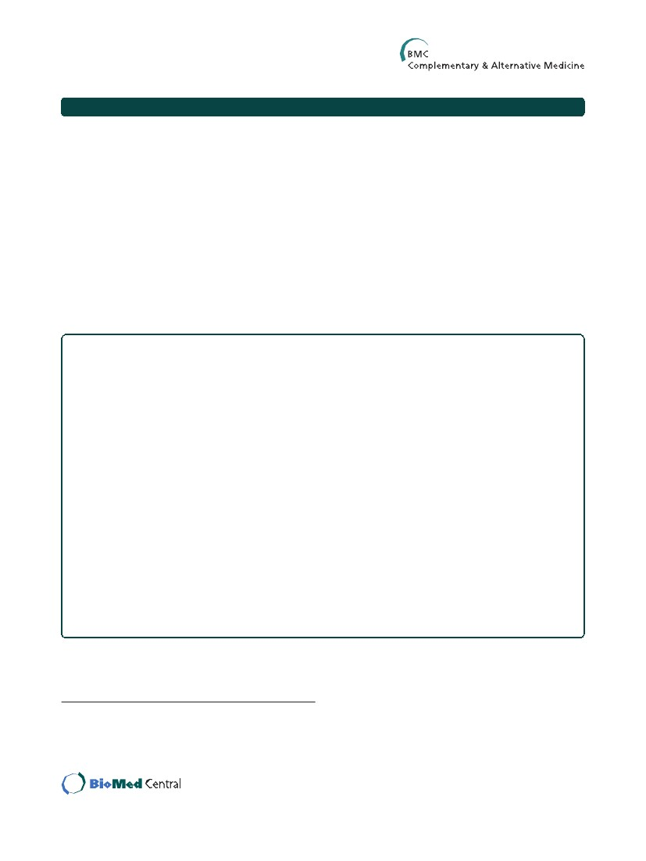
Chen et al. BMC Complementary and Alternative Medicine 2014, 14:30
http://www.biomedcentral.com/1472-6882/14/30
RESEARCH ARTICLE
Open Access
Peroxisome proliferator-activated receptor
activating hypoglycemic effect of Gardenia
jasminoides Ellis aqueous extract and
improvement of insulin sensitivity in steroid
induced insulin resistant rats
Ying-I Chen1, Yu-Wen Cheng2,3, Chung-Yuh Tzeng2,4, Yu-Chen Lee5, Yaw-Nan Chang6, Shih-Chieh Lee7,
Chin-Chun Tsai8,9, Jaw-Chyun Chen10, Jason Tze-Cheng Tzen1* and Shih-Liang Chang5,10*
Abstract
Background: The active components of Gardenia (Gardenia jasminoides Ellis, GJ) exhibit a hypoglycemic effect by
improving insulin secretion and lowering plasma lipids. In the present study, we fed a water extract of gardenia to
steroid-induced insulin-resistant (SIIR) rats and observed changes in signaling proteins in order to elucidate the
mechanisms of the insulin-sensitizing effect of GJ and evaluate its possibility as an insulin-sensitizing agent.
Methods: Normal Wistar rats were randomly divided into a control group (i.e., saline) and experimental groups
(GJ 100 and 200 mg/kg). Blood samples were taken at 0, 30, and 60 min for plasma glucose assay in order to
determine the optimal dose to induce the hypoglycemic effect. SIIR rats were then randomly divided into a control
group (i.e., saline) and an experimental group (optimal dose of gardenia extract) to observe the insulin-sensitizing
effect of the extract. Finally, western blot analysis was performed to detect intracellular signaling proteins to
elucidate the mechanisms of the insulin-sensitization effect of GJ.
Results: The normal Wistar rats in the GJ 200 mg/kg group exhibited significant hypoglycemic activity. Meanwhile,
the SIIR rats had higher plasma glucose levels than normal rats. There was no obvious change in insulin level, but
the insulin sensitivity index and homeostasis model assessment index were significantly elevated. Meanwhile, a
significant hypoglycemic effect was observed with GJ 200 mg/kg. In addition, intracellular signaling proteins
including insulin receptor substrate-1 (IRS-1) and peroxisome proliferator-activated receptor (PPARγ) were elevated
in muscle cells.
Conclusions: The optimal dose of GJ aqueous extract of 200 mg/kg exerts a PPARγ-activating hypoglycemic effect
and improves insulin resistance in SIIR rats. Therefore, it is a potential insulin-sensitizing agent in type 2 diabetes
mellitus with insulin resistance.
Keywords: Gardenia, Blood glucose, Insulin resistance, Peroxisome proliferator-activated receptor
* Correspondence: tctzen@dragon.nchu.edu.tw; slc0124@gmail.com
1Graduate Institute of Biotechnology, National Chung Hsing University,
Taichung, Taiwan
5Department of Acupuncture, China Medical University Hospital and School
of Chinese Medicine, China Medical University, Taichung, Taiwan
Full list of author information is available at the end of the article
© 2014 Chen et al.; licensee BioMed Central Ltd. This is an Open Access article distributed under the terms of the Creative
Commons Attribution License (http://creativecommons.org/licenses/by/2.0), which permits unrestricted use, distribution, and
reproduction in any medium, provided the original work is properly cited. The Creative Commons Public Domain Dedication
waiver (http://creativecommons.org/publicdomain/zero/1.0/) applies to the data made available in this article, unless otherwise
stated.
Chen et al. BMC Complementary and Alternative Medicine 2014, 14:30
http://www.biomedcentral.com/1472-6882/14/30
Page 2 of 7
Background
Good control of blood glucose can effectively reduce the
microvascular and macrovascular complications of dia-
betes mellitus (DM). Lifestyle modifications such as de-
ceasing body weight, exercise, and diet control can
decrease insulin resistance (IR). In turn, this can im-
prove plasma glucose level and decrease the HbA1c level
to 1% to 2% [1]. Unfortunately, most patients with DM
only transiently maintain stable plasma glucose levels
and ultimately require medication therapy.
The main targets of insulin are the muscle, liver, and
adipose tissue; therefore, IR [2] induces abnormal glu-
cose and lipid metabolism [3]. Several factors can induce
IR, including decreased physical activity, high-fat diet,
medications, and glucose intoxication. Some studies in-
dicate that increased serum free fatty acid induces IR as
well as obesity and type 2 DM [4,5].
IR and inadequate insulin secretion are the main mecha-
nisms of type 2 DM, but IR may manifest 5 to 10 years
prior to DM development. Metabolic syndrome, which
comprises IR, obesity, hyperlipidemia, and hypertension
[6,7], can increase the risk of cardiovascular disease by 79%,
especially large-vessel disease and DM [8,9]. According to
the diagnostic criteria of the National Cholesterol Educa-
tion Program Expert Panel, Adult Treatment Panel III, the
incidence of metabolic syndrome is 23.9% [10]. There are
several ways of improving IR, including diet modification,
exercise, medication, acupuncture, and massage. Moreover,
there are several categories of oral anti-diabetic agents, in-
cluding α-glycosidase inhibitors, biguanides, sulfonylureas,
benzoic acid derivatives, phenylalanines, and thiazolidine-
diones [11-16]. Thiazolidinediones are specific anti-diabetic
agents because they can modify genes regulating lipids and
carbohydrates by activating peroxisome proliferator-
activated receptors (PPARs) [17,18].
Gardenia jasminoides (GJ) has the potential to induce
hypoglycemia and decrease serum lipid concentrations.
One study reports that geniposide derived from GJ in-
hibits glucose phosphate and glucose-6-phosphatase activ-
ity, decreasing glycogenolysis and glucose release into the
blood [19]. Ursolic acid, a component of GJ, can prevent
diabetic complications by improving lipid metabolism and
polyol pathways as well as inhibiting glycogenolysis. The
active compounds of GJ are crocin [20], geniposide, and
genipin. Several studies have confirmed that GJ protects
liver function and has anti-inflammatory, hypoglycemic,
and lipid-lowering effects [21].
IR usually progresses to DM over the course of several
years [22]. Therefore, if IR can be successfully treated, DM
should be preventable [23]. Thiazolidinediones are a type
of oral anti-diabetes agent administered to improve IR.
The first commercially available medicine in this category
was troglitazone (Rezulin®), which was introduced in 1997
[24,25]. Some prospective studies confirmed that this drug
decreases serum insulin level and preserves the insulin se-
cretion function of islet cells. In addition, it can even pre-
vent type 2 DM development [26,27]. However, it induces
hepatotoxicity, which resulted in hepatic failure in some
patients with diabetes, necessitating liver transplantation or
even causing mortality; therefore, it was ultimately with-
drawn from the market [28-30]. Rosiglitazone (Avandia®)
and pioglitazone (Actos®) are the only thiazolidinediones
currently available; their common hypoglycemic mechan-
ism is the activation of PPARγ [31,32].
Our previous studies revealed that GJ has a hypoglycemic
effect. In normal Wistar rats, GJ effectively induces insulin
secretion and reduces blood glucose levels, simultaneously
eliciting increases in insulin receptor substrate-1 (IRS-1)
and PPARγ signals. Therefore, cholinergic nerve activation
is involved in the hypoglycemic mechanism of GJ. Rats with
dexamethasone-induced type 2 diabetes do not have suffi-
cient insulin. Therefore, the present study investigated
whether aqueous extracts of GJ produce such hypoglycemic
effects in rats with diabetes.
In order to evaluate the effects of hypoglycemia and im-
proved IR, we administered GJ aqueous extracts to steroid-
induced insulin-resistant (SIIR) rats. In addition, western
blotting was used to evaluate intracellular signaling pro-
teins to study the possible underlying mechanisms [33].
Methods
Animal model
Normal male Wistar rats weighing approximately 250–
350 g and aged 8–10 weeks were purchased from the Bio-
LASCO Animal Center, Taipei, Taiwan. SIIR rats were cre-
ated by administrating dexamethasone (1 mg⋅kg−1⋅day−1
i.p. for 5 days) via the femoral vein in a fasting state [34,35].
Animals were housed in Plexiglas cages held at a room
temperature of 25 ± 2°C with a relative humidity of 60 ±
5%. Rats were fed standard rat chow and water ad libitum.
Animals were randomly divided into experimental and con-
trol groups after a 1-week acclimation period. All animals
were anesthetized using pentobarbital (40 mg/kg i.p.). All
animals were treated in accordance with the National Insti-
tute of Health Guide for the Care and Use of Laboratory
Animals, and the study protocol was approved by the ethics
committee of the Da-Yeh University, Changhua, Taiwan.
GJ aqueous extract
GJ Ellis extract was provided by Challenge Bioproducts
Co., Ltd. (Taiwan). The powder was mixed with normal
saline to create a solution (500 mg/mL), which was
stored at 4°C.
Plasma glucose assay
Animals were anesthetized using pentobarbital (40 mg/
kg i.p.). Approximately 0.3–0.5 mL blood was obtained
from a femoral vein using a 1-mL syringe containing
Chen et al. BMC Complementary and Alternative Medicine 2014, 14:30
http://www.biomedcentral.com/1472-6882/14/30
Page 3 of 7
heparin. Blood was obtained for glucose assay 30 min
after treatment (baseline, 0 min) and 30 and 60 min after
baseline. The collected blood was placed into Eppendorf
tubes, shaken lightly, and stored on ice. Following cen-
trifugation at 21,880 × g for 5 min, Glucose UV reagent
(Raichem, USA) was added to assay the amount of bio-
logical index glucose contained in the serum. The con-
tent was measured using a fully automatic biochemical
analyzer (Roche COBAS-MIRA-PLUS, USA). Hypoglycemic
activity (%) was calculated as follows: [(glucose level at 30 or
60 min − glucose level at baseline)/glucose level at base-
line] × 100%.
Hypoglycemic effect measurement
Optimal dose of GJ for the hypoglycemic effect
Normal Wistar rats were separated randomly into 2 ex-
perimental groups: GJ 100 (oral feeding GJ, 100 mg/kg)
and GJ 200 (oral feeding GJ, 200 mg/kg), and a control
group (oral feeding normal saline). Each group consisted
of 6 rats.
Comparisons between normal Wistar and SIIR rats
were used to estimate the amount of protein using an
assay kit from Bio-Rad Laboratories. The supernatant (i.e.,
protein) was mixed with 4× sodium dodecyl sulfate load-
ing dye and boiled for 15 min at 95°C for denaturation.
Separating (8%) and stacking gels were prepared. Protein
in buffer (90 μg/mL) was subsequently loaded into each
well for electrophoresis. Proteins were electrophoretically
transferred to polyvinylidene difluoride membranes at
4°C. The membranes were then blocked with 5% nonfat
dry milk in phosphate-buffered saline for 1 h at room
temperature and incubated with specific primary anti-
bodies (Santa Cruz Biotechnology, Inc.). After the mem-
branes were washed in buffer containing 0.1% Tween 20
in 1× phosphate-buffered saline, the blots were incubated
with horseradish peroxidase-linked specific secondary
antibody (Santa Cruz Biotechnology, Inc.) and evaluated
using an enhanced chemiluminescence detection using
ECL Reagent Plus (PerkinElmer Life Sciences, Inc.). Band
intensities were quantified by densitometry to observe the
target proteins.
Statistical analysis
Normal Wistar rats were separated randomly into saline
and SIIR groups (n = 6 each). The rats in the SIIR group
were induced into SIIR by dexamethasone as described
above. The same procedure was performed in the saline
group, except saline was injected instead. Blood samples
were taken at 0, 30, and 60 min.
Hypoglycemic activity of GJ in SIIR rats
The experimental results of all groups are expressed as
mean ± standard error of mean; Student’s t-test and
analysis of variance were performed to determine sig-
nificance. The level of statistical significance was set at
P < 0.05.
Results
Optimal dose of GJ for hypoglycemia
The SIIR rats were divided into 2 groups (n = 6 each). The
baseline (i.e., 0 min) glucose level was checked 30 min
after solution feeding. Another blood glucose sample was
drawn 30 min after the baseline (i.e., 30 min).
Insulin and insulin resistance assay
The concentration of plasma insulin was analyzed by hu-
man enzyme-linked immunosorbent assay (Seminariega-
tan 29, S-752 28, Mercodia AB, Uppsala, Sweden) in
both groups. IR was assessed according to the homeosta-
sis model assessment index calculated using the follow-
ing formula: (fasting plasma insulin level [μU/mL] ×
fasting plasma glucose [mmol/L])/22.5 [36]; Insulin sen-
sitivity is expressed as insulin sensitivity index (ISI),
which was calculated as follows: ISI = 1/(log[fasting insu-
lin μU/mL] + log[fasting glucose mg/dL]) [37]. The re-
sults of this experiment are expressed as ISI × 103.
Western blotting
In the normal Wistar rats, plasma glucose levels were
checked at 0, 30, and 60 min to determine the hypoglycemic
effect in the control and 2 experimental groups (i.e., GJ and
GJ 200). The GJ-fed groups exhibited a tendency towards
decreasing glucose level with time. The GJ 200 group exhib-
ited a significantly greater hypoglycemic effect than the con-
trol and GJ 100 groups.
In the 2 experimental groups, the plasma glucose level of
the GJ 100 group did not change significantly until 60 min.
Furthermore, the GJ 200 group exhibited significantly de-
creased plasma glucose levels starting at 30 min. Therefore,
we used GJ 200 mg/kg as the therapeutic dose in subse-
quent experiments (Table 1). In addition, the hypoglycemic
activities (%) changed in a dose-dependent manner. The
GJ 200 group exhibited the best hypoglycemic activity
(Figure 1).
Hypoglycemic effect of GJ in SIIR rats
At the end of treatment (i.e., 60 min) in each group, por-
tions of the gastrocnemius muscles were taken as samples
to analyze the insulin signaling proteins, IRS-1 and
PPARγ. Muscle samples were homogenized in buffer solu-
tion before centrifugation at 21,880 × g. The supernatants
The SIIR rats exhibited higher serum glucose levels than
those of the saline group (Figure 2). The serum glucose
levels of SIIR rats fed saline at 0, 30, and 60 min were
165.1, 153.3, and 153.7 mg/dL, respectively, compared to
165.1, 135.5, and 113.6 mg/dL in the GJ 200 group of
SIIR rats, respectively. There was a significant difference
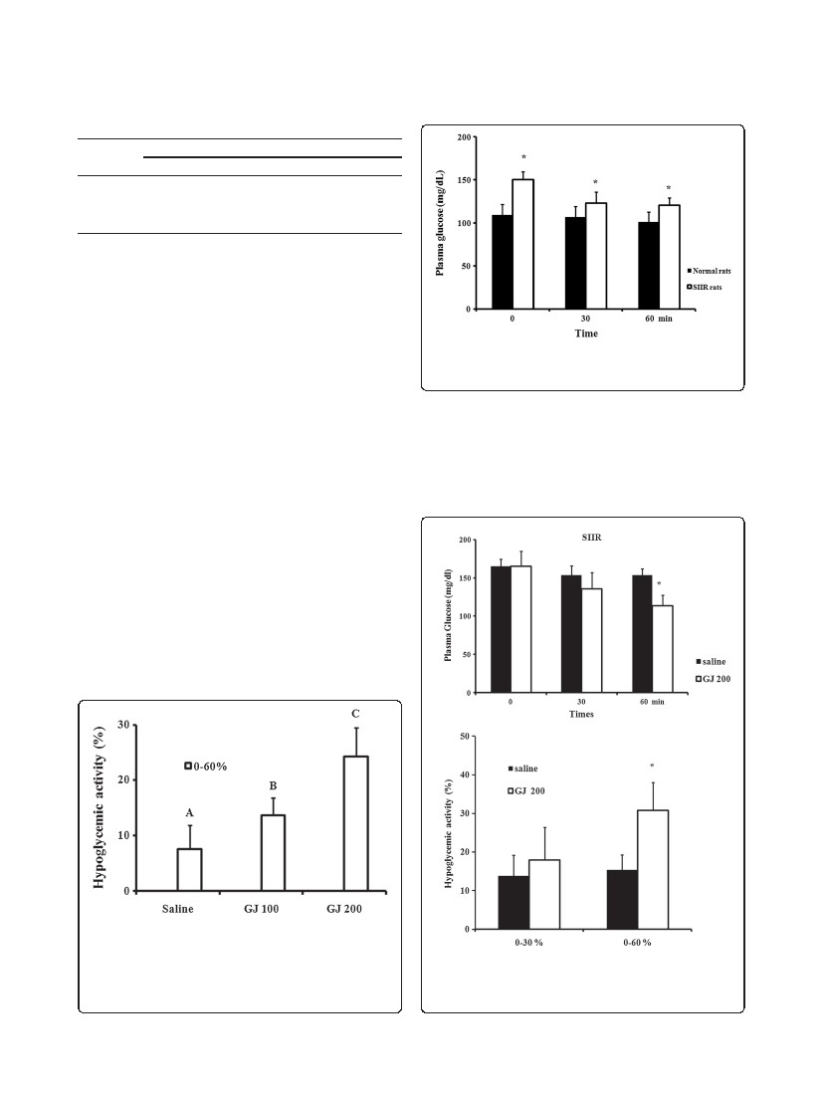
Chen et al. BMC Complementary and Alternative Medicine 2014, 14:30
http://www.biomedcentral.com/1472-6882/14/30
Page 4 of 7
Table 1 Plasma glucose changes by group
Group
0 min
Saline
GJ 100
GJ 200
113.45 ± 13.74
117.46 ± 6.84
127.86 ± 7.74
Plasma glucose (mg/dL)
30 min
108.28 ± 11.01
110.05 ± 7.69
108.65 ± 7.95*
60 min
103.35 ± 11.62
101.28 ± 5.02*
99.62 ± 9.52**
GJ: Gardenia jasminoides; GJ 100: feeding GJ 100 mg/kg; GJ 200: feeding GJ
200 mg/kg; saline: feeding normal saline. *p < 0.05, **p < 0.001 vs. plasma
glucose at 0 min, Student’s t-test, n = 6.
between the 2 experimental groups at 60 min (Figure 3a).
In addition, the hypoglycemic activity in the GJ 200 group
was 17.9% and 30.8% at 30 and 60 min, respectively; both
results are significantly different from those of the saline
group at the corresponding times (Figure 3b).
Improved insulin sensitivity of SIIR rats after GJ
administration
Figure 2 Plasma glucose levels of steroid-induced insulin-
resistant (SIIR) rats vs. normal Wistar rats. * p < 0.05 vs. 0 min,
Student’s t-test, n = 6.
The SIIR rats treated with GJ 200 mg/kg exhibited a sig-
nificant hypoglycemic effect at 30 and 60 min with no
obvious change in insulin level (from 178.92 to 165.77
mU/L) (Table 2). The ISI increased significantly (from 0.67
to 1.05), while the homeostasis model assessment index
decreased significantly (from 7.23 to 3.57) (Table 2).
Changes in intracellular signaling proteins in SIIR rats
after GJ feeding
had a hypoglycemic effect at 60 min. However, a sig-
nificant decrease in plasma glucose levels was ob-
served 30 min after GJ 200 mg/kg feeding. Thus, the
hypoglycemic effect of GJ 200 mg/kg was more obvi-
ous at 60 min. Therefore, we used the more effective
(a)
Sixty min after feeding GJ 200 mg/kg to the SIIR rats, the
levels of the intracellular signaling proteins, IRS-1 and
PPARγ, in the skeletal muscular cell were elevated (Figure 4).
Discussion
The GJ doses of 100 and 200 mg/kg were chosen on
the basis of the study of Kim et al. [33]. GJ 100 mg/kg
(b)
Concentration (mg/kg)
Figure 1 Hypoglycemic activity of each group. Gardenia
jasminoides (GJ) 100: feeding GJ 100 mg/kg; GJ 200: feeding GJ
200 mg/kg; saline: feeding normal saline. p < 0.05 vs. saline, A < B < C
by analysis of variance, post hoc: least significant difference
test, n = 6.
Figure 3 The hypoglycemic effect of GJ in SIIR rats. (a) Plasma
glucose level and (b) hypoglycemic activity in the saline and
Gardenia jasminoides (GJ) 200 steroid-induced insulin-resistant
(SIIR) rats. * p < 0.05 vs. saline, Student’s t-test, n = 6.
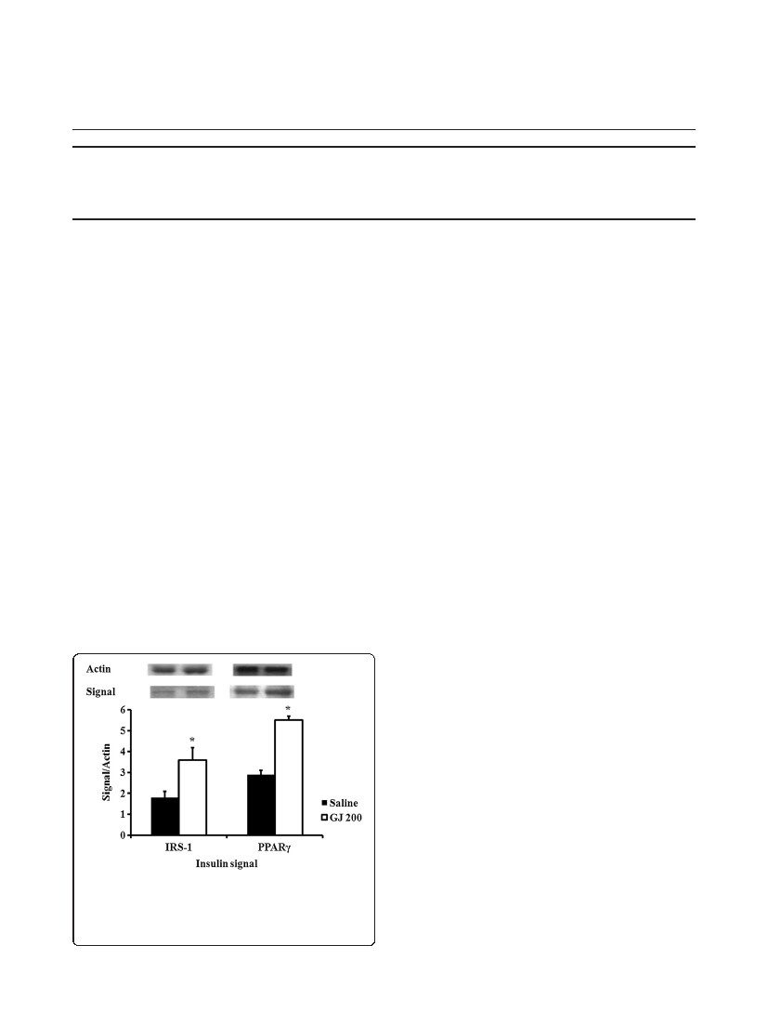
Chen et al. BMC Complementary and Alternative Medicine 2014, 14:30
http://www.biomedcentral.com/1472-6882/14/30
Page 5 of 7
Table 2 Changes in insulin sensitivity after GJ 200 feeding to SIIR rats
0 min
SIIR GJ 200
(mg/kg)
Glucose (mg/dL)
Insulin (μU/mL)
ISI × 103
HOMA
150.54 ± 12.84
178.92 ± 17.30
0.67 ± 0.01
7.23 ± 2.0
30 min
125.42 ± 7.59
0.85 ± 0.06*
3.76 ± 0.72*
*
60 min
105.90 ± 0.61**
165.77 ± 25.63
1.05 ± 0.18*
3.57 ± 0.45*
170.07 ± 17.41
GJ: Gardenia jasminoides; SIIR: steroid induced insulin resistant; ISI: insulin sensitivity index = 1/(log[fasting insulin μU/mL] + log[fasting glucose mg/dL]). Results are
expressed as ISI × 103 in this experiment; HOMA: homeostasis model assessment = (fasting plasma insulin level [μU/mL] × fasting plasma glucose [mmol/L])/22.5.
*p < 0.05, **p < 0.005 vs. 0 min, Student’s t-test, n = 6.
dose, GJ 200 mg/kg, in subsequent experiments (Table 1
and Figures 1 and 2).
Dexamethasone is a type of adrenal hormone that has
an anti-inflammatory effect. However, it also causes pa-
tients with DM to require additional insulin doses and
increases IR [38]. In the present study, rats were injected
with dexamethasone to induce IR. Dexamethasone can
induce gluconeogenesis and increase plasma glucose
levels and inhibit insulin secretion. In an animal experi-
ment, steroid therapy decreased the expression of glucose
transporter-2 protein in β cells [39,40]. Dexamethasone
also decreases adenosine monophosphate levels [41] and
activates voltage-gated potassium channels [42]. A study
reported increased β-cell apoptosis after corticosteroid re-
ceptor activation [38]. Therefore, insulin secretion is
inhibited by dexamethasone. These mechanisms are asso-
ciated with exacerbated DM control and its complications
after corticosteroid therapy.
GJ extracts lowered plasma glucose level in the SIIR
rats. Several previous studies report that GJ has a hypo-
lipidemic effect. One study reported that lower blood
lipid levels are associated with decreased plasma glucose
levels [19]. This hypoglycemic mechanism may be due
to the improvement of IR or enhancement of signaling
proteins in the insulin signaling pathways [19].
A study reports that long-term oral administration of GJ
results in a hypolipidemic effect. In other studies, Obesity
animals were fed GJ, which exerted a hypolipidemic effect;
meanwhile, GJ was fed for 1 to 4 weeks before serum lipid
examination in other studies [8]. Since the hypolipidemic
effect is beneficial for the action of insulin to lower plasma
glucose levels, this is possibly why insulin sensitivity was
elevated in the present study. Because of the limitation of
this study’s design, the 60-min experimental duration was
too short to fully observe changes in plasma lipids (unpub-
lished results). The long-term effect of GJ on the relation-
ship between plasma lipids and IR is worth investigating
in the future.
IR develops mainly in the liver, skeletal muscle, and adi-
pose tissue. Skeletal muscle cells have difficulty converting
plasma glucose into glycogen under IR conditions [43]. In
the liver, insulin reduces glycogenolysis and gluconeogene-
sis [3]. Therefore, the energy of food can be stored, keep-
ing plasma glucose within the normal range. However,
when IR develops, such homeostasis is blocked and hyper-
glycemia is not preventable [44]. In the experiment ana-
lyzing changes in intracellular insulin signaling proteins in
SIIR rats, PPARγ signaling was augmented after GJ feed-
ing (Figure 4). This hypoglycemic mechanism is similar to
that observed with thiazolidinediones.
The main hypoglycemic mechanism of thiazolidine-
diones occurs in adipose tissue, enhancing free fatty acid
uptake by adipocytes [45]. Thiazolidinediones can also
lower serum triglyceride and non-esterified fatty acids.
PPARγ activation also induces adipocyte differentiation
and decreases glucose release from the liver, enhancing
glycogen storage in skeletal muscle cells [40]. Since the
hypoglycemic effect of GJ is similar to that of thiazolidi-
nediones, GJ may be able to induce insulin sensitivity
and prevent DM development. Thus, GJ has the poten-
tial to be used as an insulin sensitizer and even as a sub-
stitute for thiazolidinediones [19].
Figure 4 Change in intracellular insulin signaling protein to
actin ratio in steroid-induced insulin-resistant (SIIR) rats 60 min
after treatment. IRS-1: insulin receptor substrate-1, PPAR:
peroxisome proliferative-activated receptor. p < 0.05 vs. saline,
Student’s t-test, n = 6.
Conclusions
In conclusion, improvement of IR can effectively lower
plasma glucose and prevent hyperinsulinemia and/or
lower the required doses of oral anti-diabetes agents.
Chen et al. BMC Complementary and Alternative Medicine 2014, 14:30
http://www.biomedcentral.com/1472-6882/14/30
Page 6 of 7
Thiazolidinediones effectively decrease IR, but their side
effects limit their clinical application [28-30]. Although
the hypoglycemic effect of GJ is similar to that of thiazo-
lidinediones, it is possible that GJ will not cause similar
side effects in clinical therapy. Therefore, GJ is a poten-
tial insulin-sensitizing agent for patients with type 2 DM
and/or adjuvant therapy [19,20].
Abbreviations
DM: Diabetes mellitus; GJ: Gardenia jasminoides; ISI: Insulin sensitivity index;
PPAR: Peroxisome proliferator-activated receptor; SIIR: Steroid-induced
insulin-resistant.
Competing interests
The authors declare that they have no competing interests.
7.
8.
9.
10.
11.
12.
13.
Authors’ contributions
YIC, YWC and JCC drafted the manuscript, and acquired and analyzed data.
CYT and YCL assisted with the acquisition of funding and provided the
research environment. YIC managed the execution of the experiments and
animal models. SCL, YNC, and CCT have supervised and monitored the
execution of this study. TCT and SLC made substantial contributions to the
study concept, study design, and critical revision of the manuscript’s
important intellectual content and submitted the manuscript for publication.
All authors read and approved the final manuscript.
Acknowledgements
We thank the National Science Council of Taiwan (NSC101-2320-B-212-001-
MY2, NSC101-2632-E-212-001-MY3) and Taichung Veterans General Hospital
and Da-Yeh University joint project (TCVGH-DYU-1018303) for funding this
research. We also thank Miss Xin-Ping Ku for her assistance.
Author details
1Graduate Institute of Biotechnology, National Chung Hsing University,
Taichung, Taiwan. 2College of Life Sciences, National Tsing Hua University,
Hsinchu, Taiwan. 3Department of Internal Medicine, Lee’s General Hospital,
Miaoli, Taiwan. 4Department of Orthopedics, Taichung Veterans General
Hospital, Taichung City, Taiwan. 5Department of Acupuncture, China Medical
University Hospital and School of Chinese Medicine, China Medical
University, Taichung, Taiwan. 6Department of Biotechnology, National
Formosa University, Yunlin County, Taiwan. 7Department of BioIndustry
technology, Da-Yeh University, Changhua County, Taiwan. 8Chinese Medicine
Department E-D Hospital, I-Shou University, Kaohsiung, Taiwan. 9School of
Chinese Medicine for Post-Baccalaureate, I-Shou University, Kaohsiung,
Taiwan. 10Department of Medicinal Botanicals and Health Applications,
Da-Yeh University, Changhua, Taiwan.
Received: 30 September 2013 Accepted: 15 January 2014
Published: 18 January 2014
References
1. Zafiriou S, Stanners SR, Saad S, Polhill TS, Poronnik P, Pollock CA:
Pioglitazone inhibits cell growth and reduces matrix production in
human kidney fibroblasts. J Am Soc Nephrol 2005, 16(3):638–645.
2. Arkan MC, Hevener AL, Greten FR, Maeda S, Li ZW, Long JM, Wynshaw-Boris
A, Poli G, Olefsky J, Karin M: IKK-beta links inflammation to obesity-
induced insulin resistance. Nat Med 2005, 11(2):191–198.
3. Kovacs P, Stumvoll M: Fatty acids and insulin resistance in muscle and
liver. Best Pract Res Clin Endocrinol Metab 2005, 19(4):625–635.
4. Dresner A, Laurent D, Marcucci M, Griffin ME, Dufour S, Cline GW, Slezak LA,
Andersen DK, Hundal RS, Rothman DL, et al: Effects of free fatty acids on
glucose transport and IRS-1-associated phosphatidylinositol 3-kinase
activity. J Clin Invest 1999, 103(2):253–259.
5. Ghazzi MN, Perez JE, Antonucci TK, Driscoll JH, Huang SM, Faja BW,
Whitcomb RW: Cardiac and glycemic benefits of troglitazone treatment
in NIDDM. The Troglitazone Study Group. Diabetes 1997, 46(3):433–439.
6. Bastarrachea RA, Lopez-Alvarenga JC, Bolado-Garcia VE, Tellez-Mendoza J,
Laviada-Molina H, Comuzzie AG: Macrophages, inflammation, adipose
tissue, obesity and insulin resistance. Gac Med Mex 2007, 143(6):505–512.
14.
15.
16.
17.
18.
19.
20.
21.
22.
23.
24.
25.
26.
27.
28.
29.
30.
Yuan M, Konstantopoulos N, Lee J, Hansen L, Li ZW, Karin M, Shoelson SE:
Reversal of obesity- and diet-induced insulin resistance with salicylates
or targeted disruption of Ikkbeta. Science 2001, 293(5535):1673–1677.
Boden G, Laakso M: Lipids and glucose in type 2 diabetes: what is the
cause and effect? Diabetes Care 2004, 27(9):2253–2259.
DeFronzo RA, Ferrannini E: Insulin resistance. A multifaceted syndrome
responsible for NIDDM, obesity, hypertension, dyslipidemia, and
atherosclerotic cardiovascular disease. Diabetes Care 1991, 14(3):173–194.
Liu Z, Fu C, Wang W, Xu B: Prevalence of chronic complications of type 2
diabetes mellitus in outpatients - a cross-sectional hospital based survey
in urban China. Health Qual Life Outcomes 2010, 8:62.
Bailey CJ, Day C: Avandamet: combined metformin-rosiglitazone
treatment for insulin resistance in type 2 diabetes. Int J Clin Pract 2004,
58(9):867–876.
Bakris G, Viberti G, Weston WM, Heise M, Porter LE, Freed MI: Rosiglitazone
reduces urinary albumin excretion in type II diabetes. J Hum Hypertens
2003, 17(1):7–12.
Bell DS: Beneficial effects resulting from thiazolidinediones for treatment
of type 2 diabetes mellitus. Postgrad Med 2003, Spec No:35–44.
DeFronzo RA, Goodman AM: Efficacy of metformin in patients with non-
insulin-dependent diabetes mellitus. The Multicenter Metformin Study
Group. N Engl J Med 1995, 333(9):541–549.
Einhorn D, Rendell M, Rosenzweig J, Egan JW, Mathisen AL, Schneider RL:
Pioglitazone hydrochloride in combination with metformin in the
treatment of type 2 diabetes mellitus: a randomized, placebo-controlled
study. The Pioglitazone 027 Study Group. Clin Ther 2000, 22(12):1395–1409.
Maggs DG, Buchanan TA, Burant CF, Cline G, Gumbiner B, Hsueh WA,
Inzucchi S, Kelley D, Nolan J, Olefsky JM, et al: Metabolic effects of
troglitazone monotherapy in type 2 diabetes mellitus. A randomized,
double-blind, placebo-controlled trial. Ann Intern Med 1998,
128(3):176–185.
Boyle PJ, King AB, Olansky L, Marchetti A, Lau H, Magar R, Martin J: Effects
of pioglitazone and rosiglitazone on blood lipid levels and glycemic
control in patients with type 2 diabetes mellitus: a retrospective review
of randomly selected medical records. Clin Ther 2002, 24(3):378–396.
Fan C, Li Q, Zhang Y, Liu X, Luo M, Abbott D, Zhou W, Engelhardt JF:
IkappaBalpha and IkappaBbeta possess injury context-specific functions
that uniquely influence hepatic NF-kappaB induction and inflammation.
J Clin Invest 2004, 113(5):746–755.
Zhang CY, Parton LE, Ye CP, Krauss S, Shen R, Lin CT, Porco JA Jr, Lowell BB:
Genipin inhibits UCP2-mediated proton leak and acutely reverses
obesity- and high glucose-induced beta cell dysfunction in isolated
pancreatic islets. Cell Metab 2006, 3(6):417–427.
Sheng L, Qian Z, Zheng S, Xi L: Mechanism of hypolipidemic effect of
crocin in rats: crocin inhibits pancreatic lipase. Eur J Pharmacol 2006,
543(1–3):116–122.
Herder C, Schneitler S, Rathmann W, Haastert B, Schneitler H, Winkler H,
Bredahl R, Hahnloser E, Martin S: Low-grade inflammation, obesity, and
insulin resistance in adolescents. J Clin Endocrinol Metab 2007,
92(12):4569–4574.
Shulman GI: Cellular mechanisms of insulin resistance. J Clin Invest 2000,
106(2):171–176.
Hotamisligil GS: Inflammation and metabolic disorders. Nature 2006,
444(7121):860–867.
Del Prato S, Volpe L: Rosiglitazone plus metformin: combination therapy
for Type 2 diabetes. Expert Opin Pharmacother 2004, 5(6):1411–1422.
Marcy TR, Britton ML, Blevins SM: Second-generation thiazolidinediones
and hepatotoxicity. Ann Pharmacother 2004, 38(9):1419–1423.
Fukuen S, Iwaki M, Yasui A, Makishima M, Matsuda M, Shimomura I:
Sulfonylurea agents exhibit peroxisome proliferator-activated receptor
gamma agonistic activity. J Biol Chem 2005, 280(25):23653–23659.
Yue TL: Cardioprotective effects of thiazolidinediones, peroxisome
proliferator-activated receptor-gamma agonists. Drugs Today (Barc) 2003,
39(12):949–960.
Goldstein BJ, Cobitz AR, Hand LM, Chen H: Are the metabolic effects of
rosiglitazone influenced by baseline glycaemic control? Curr Med Res
Opin 2003, 19(3):192–199.
Kermani A, Garg A: Thiazolidinedione-associated congestive heart failure
and pulmonary edema. Mayo Clin Proc 2003, 78(9):1088–1091.
Lin EH, Katon W, Von Korff M, Rutter C, Simon GE, Oliver M, Ciechanowski P,
Ludman EJ, Bush T, Young B: Relationship of depression and diabetes

Chen et al. BMC Complementary and Alternative Medicine 2014, 14:30
http://www.biomedcentral.com/1472-6882/14/30
Page 7 of 7
31.
32.
33.
34.
35.
36.
37.
38.
39.
40.
41.
42.
43.
44.
45.
self-care, medication adherence, and preventive care. Diabetes Care 2004,
27(9):2154–2160.
Knowler WC, Barrett-Connor E, Fowler SE, Hamman RF, Lachin JM, Walker
EA, Nathan DM: Reduction in the incidence of type 2 diabetes with
lifestyle intervention or metformin. N Engl J Med 2002, 346(6):393–403.
Scheen AJ: Combined thiazolidinedione-insulin therapy: should we be
concerned about safety? Drug Saf 2004, 27(12):841–856.
Zhou J, Huang K: Peroxynitrite mediates muscle insulin resistance in mice
via nitration of IRbeta/IRS-1 and Akt. Toxicol Appl Pharmacol 2009,
241(1):101–110.
Elias JM, Gown AM, Nakamura RM, Wilbur DC, Herman GE, Jaffe ES, Battifora
H, Brigati DJ: Quality control in immunohistochemistry. Report of
a workshop sponsored by the Biological Stain Commission.
Am J Clin Pathol 1989, 92(6):836–843.
Xu YP, Liang L, Wang XM: The levels of Pdx1/insulin, Cacna1c and Cacna1d,
and beta-cell mass in a rat model of intrauterine undernutrition. J Matern
Fetal Neonatal Med 2011, 24(3):437–443.
Salgado AL, Carvalho L, Oliveira AC, Santos VN, Vieira JG, Parise ER: Insulin
resistance index (HOMA-IR) in the differentiation of patients with
non-alcoholic fatty liver disease and healthy individuals. Arq Gastroenterol
2010, 47(2):165–169.
Retnakaran R: The insulin secretion-sensitivity index-2 (ISSI-2) and the
measurement of beta-cell function in women with gestational diabetes.
Endocr J 2010, 57(11):1007. author reply 1009–1010.
Ranta F, Avram D, Berchtold S, Dufer M, Drews G, Lang F, Ullrich S:
Dexamethasone induces cell death in insulin-secreting cells, an effect
reversed by exendin-4. Diabetes 2006, 55(5):1380–1390.
Ohneda M, Johnson JH, Inman LR, Unger RH: GLUT-2 function in glucose-
unresponsive beta cells of dexamethasone-induced diabetes in rats.
J Clin Invest 1993, 92(4):1950–1956.
Gremlich S, Roduit R, Thorens B: Dexamethasone induces posttranslational
degradation of GLUT2 and inhibition of insulin secretion in isolated
pancreatic beta cells. Comparison with the effects of fatty acids.
J Biol Chem 1997, 272(6):3216–3222.
Philippe J, Giordano E, Gjinovci A, Meda P: Cyclic adenosine
monophosphate prevents the glucocorticoid-mediated inhibition of
insulin gene expression in rodent islet cells. J Clin Invest 1992,
90(6):2228–2233.
Ullrich S, Berchtold S, Ranta F, Seebohm G, Henke G, Lupescu A, Mack AF,
Chao CM, Su J, Nitschke R, et al: Serum- and glucocorticoid-inducible
kinase 1 (SGK1) mediates glucocorticoid-induced inhibition of
insulin secretion. Diabetes 2005, 54(4):1090–1099.
Kruszynska YT, Mukherjee R, Jow L, Dana S, Paterniti JR, Olefsky JM: Skeletal
muscle peroxisome proliferator- activated receptor-gamma expression in
obesity and non- insulin-dependent diabetes mellitus. J Clin Invest 1998,
101(3):543–548.
Antuna-Puente B, Feve B, Fellahi S, Bastard JP: Obesity, inflammation and
insulin resistance: which role for adipokines. Therapie 2007, 62(4):285–292.
Takashima T, Fujiwara Y, Higuchi K, Arakawa T, Yano Y, Hasuma T, Otani S: PPAR-
gamma ligands inhibit growth of human esophageal adenocarcinoma cells
through induction of apoptosis, cell cycle arrest and reduction of ornithine
decarboxylase activity. Int J Oncol 2001, 19(3):465–471.
doi:10.1186/1472-6882-14-30
Cite this article as: Chen et al.: Peroxisome proliferator-activated receptor
activating hypoglycemic effect of Gardenia jasminoides Ellis aqueous
extract and improvement of insulin sensitivity in steroid induced insulin
resistant rats. BMC Complementary and Alternative Medicine 2014 14:30.
Submit your next manuscript to BioMed Central
and take full advantage of:
• Convenient online submission
• Thorough peer review
• No space constraints or color ﬁgure charges
• Immediate publication on acceptance
• Inclusion in PubMed, CAS, Scopus and Google Scholar
• Research which is freely available for redistribution
Submit your manuscript at
www.biomedcentral.com/submit

