Manufacturing Technique and Property Evaluation of Polyester/Polypropylene Fasciated Yarn Used in Geogrids
Jin-Mao Chen¹, Ching-Wen Lou^{2, a}, Ching-Wen Lin³, Wen-Hao Hsing⁴ and Jia-Horng Lin^{1, 5, 6, b}
¹Laboratory of Fiber Application and Manufacturing, Department of Fiber and Composite Materials, Feng Chia University, Taichung City 407, Taiwan, R.O.C.
²Institute of Biomedical Engineering and Material Science, Central Taiwan University of Science and Technology, Taichung 406, Taiwan, R.O.C.
³Department of Fashion Design, Asia University, Taichung 41354, Taiwan, R.O.C.
⁴The Department of Textile Engineering, Chinese Culture University, Taipei 11114, Taiwan, R.O.C.
⁵School of Chinese Medicine, China Medical University, Taichung 40402, Taiwan, R.O.C.
⁶Department of Biotechnology, Asia University, Taichung 41354, Taiwan, R.O.C.
Corresponding email: ªcwlou@ctust.edu.tw, ^{b}jhlin@fcu.edu.tw
Keywords: geogrid, fasciated yarn, polypropylene (PP) fiber, high strength polyester (HSPET) fiber
Abstract. The successive civil engineering disasters in recent years make the use of geomaterial for disaster prevention popular. Geogrids, one type of geo-material, function as soil reinforcement. This study uses polypropylene (PP) fibers to wrap high strength polyester (HSPET) fibers, forming the PP/HSPET fasciated yarn. PP fibers are acid-resistant and alkali-resistant, and thus serve as the skin of the fasciated yarn. HSPET fibers, the core of the fasciated yarn, protect and prolong the service life of the resulting geo-material products. Finally, the influence of mechanical parameters on the appearance and strength of the fascinated yarn is explored.
Introduction
Geogrids, primary reinforcement materials in geo-materials, are composed of a certain amount of regular mesh, which allows soils, rock, and other geo-materials to pass through. The major component of geogrids is polymers, the most common of which are polyethylene (PE), polypropylene (PP), and polyester (PET). French engineer, Henri Vidal, proposed the Principle of Reinforced Earth in 1966, and due to its great effect, this reinforcement material discussed in the principle has been widely used in geoengineering. With the rapid development of geomaterials in the 1980’s, geotextiles and geogrids became widely used in building retaining walls and reinforced embankments [1]. Among these geo-materials, fibers are commonly used in geotextiles [2-6]. In this study, PP fibers wrap the HSPET fibers to form PP/HSPET fasciated yarns that will be used to make geogrids. The mechanical parameters are then explored to determine their influence on the surface and mechanical properties of the PP/HSPET fasciated yarns.

Experimental
Materials
The HSPET fiber is 1000 denier (D), and has a strength of 8.0 g/den and an elongation of 12.0 %. The PP fiber is 900 D, and has a strength of 2.5 g/den and an elongation of 64.0 %.

Preparation of Sample
HSPET fibers are combined and then Z-twisted with 25 twists per meter to form a 20000 D HSPET plied yarn with a strength of 8.7 g/den. On a cord knitting machine (DH CK-06, Dah Heer Industrial Co., Ltd), the HSPET plied yarns are wrapped by PP fibers to form the PP/HSPET fasciated yarns. The knitting needle tube has an outer diameter of 8 mm and an inner diameter of 6 mm, and contains 12 knitting needles. In this study, the numbers of knitting needles are 12 and 6; the latter occurs after the removal of every other needle from the former arrangement of 12 needles and thus has an interval arrangement. The needles release the latch to hook the skin (PP fibers) which is previously held by the neighboring needle, the needle two over, and the opposite needle, and thus respectively forming the three knit structures－neighboring arrangement (NA), interval arrangement (IA) and opposite arrangement (OA). Ten fasciated yarns of each specification are subsequently tested for tensile strength and elongation by an Instron 5566 (Instron, USA) as specified in CNS 11263.
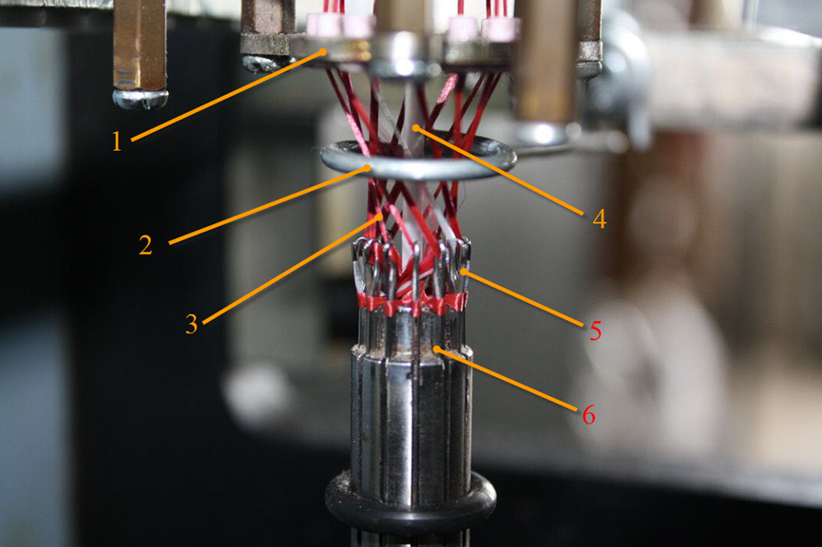
Figure 1. The cord knitting machine containing 1) carrier, 2) needle latch guard bar, 3) PP fibers, 4) HSPET plied yarn, 5) knitting needle, and 6) knitting needle tube.

Results and discussion

Influence of the Number of Knitting Needles and Knit Structures on the Appearance of the PP /HSPET Fasciated Yarns
Figure 1 shows that in the PP/HSPET fasciated yarns made either by 6 or 12 knitting needles, the skin can cover the core nicely. The fasciated yarn made by 12 needles has a 5-mm diameter, and that made by 6 needles has a 4.4-mm diameter. In order to meet the specification of a Crochet Machine for the further production of geogrids, the suitable amount of knitting needles is determined to be 6.
Figure 3 shows that with an ever-greater interval between needles, the PP/HSPET fasciated yarns have a smaller diameter, making them more compact. When the PP fibers are knitted by needles that have a greater interval, they can wrap the HSPET plied yarns with greater force. As a result, the greater the interval between needles, the smaller the diameter of the fasciated yarns. Therefore, as can be seen by comparing Figure 2 (c) to Figure 2 (b), the PP fibers are able to wrap the HSPET plied yarns more tightly. In OA and IA, the core is not exposed and the skin materials do not easily unwrap, and thus, these are two yarns chosen for the following mechanical property evaluations.
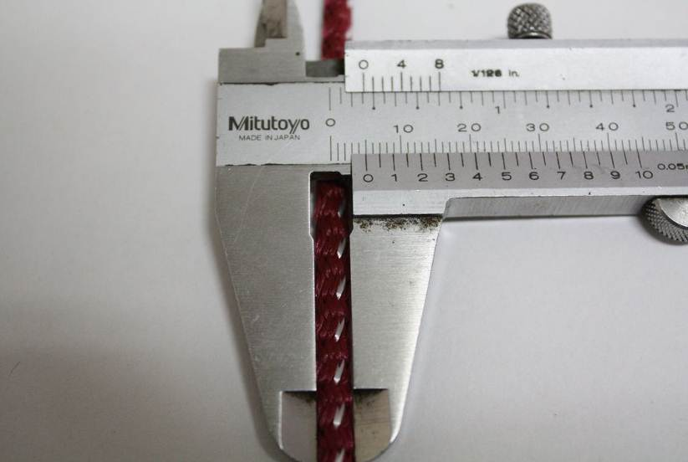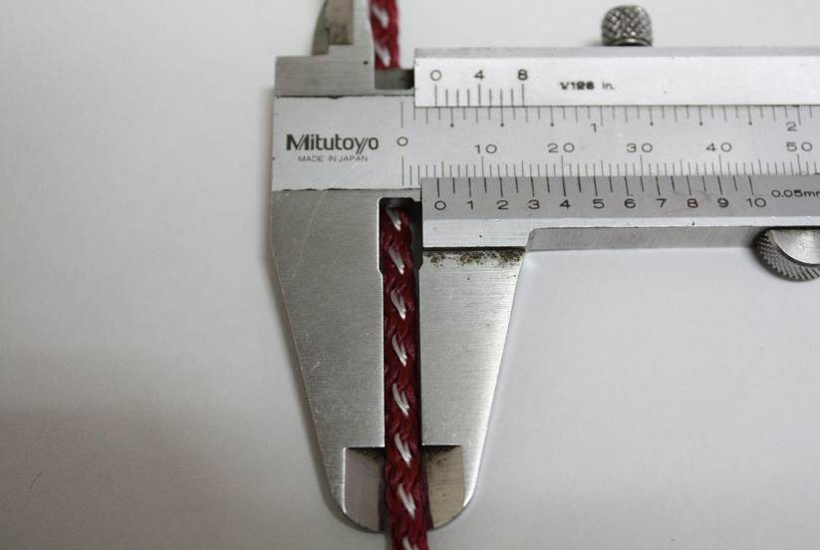
a
b
Figure 2. The image of the PP/HSPET fasciated yarns made by a) 12 and b) 6 knitting needles.
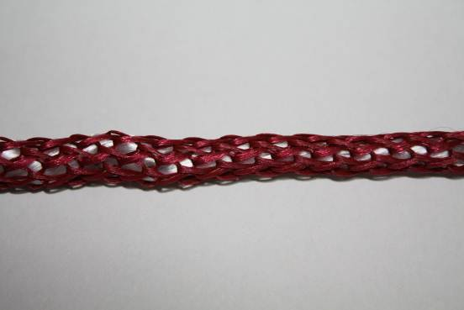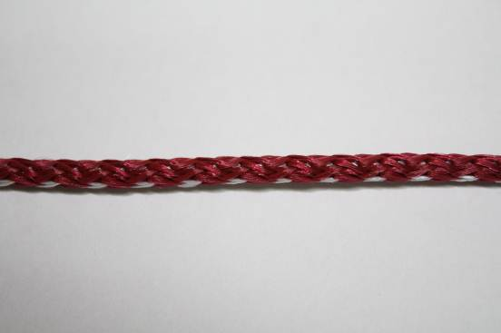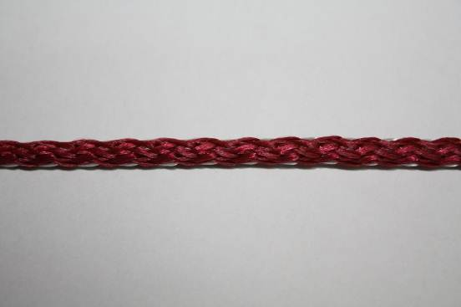
a
b
c
Figure 3. The knit structures of the PP/HSPET fasciated yarns: a)NA, b) IA, and c) OA.

Influence of the Knit Structures on the Mechanical Properties of the PP /HSPET Fasciated Yarns
Figure 4 shows that OA has a greater tensile strength but a lower displacement, 2 mm, than IA. Moreover, when IA and OA are both extended to 50 mm, OA requires a strength of 100 kgf and IA requires a strength of 95 kgf. This is because the skin of OA can wrap the core more tightly and thus creates a complete wrapping. The shrink in OA’s core is smaller, resulting in an even transmission of power when a force is exerted on OA. As a result, OA has a greater tensile strength but a smaller displacement.

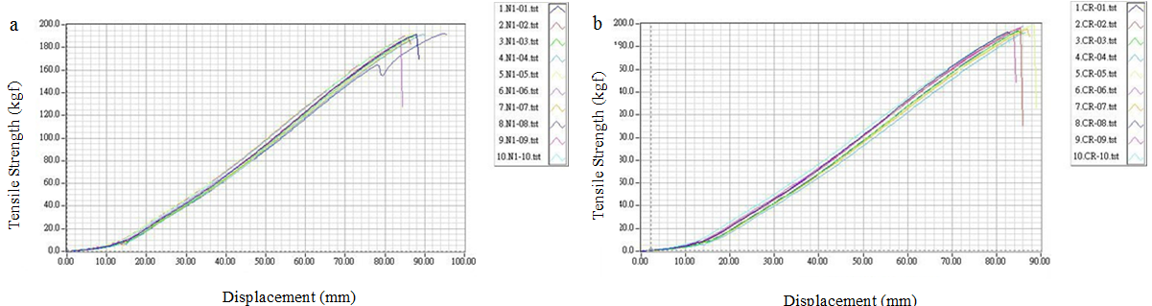
Figure 4. The tensile strength and displacement of the a) IA and b) OA
Conclusion
Of the three knit structures, OA has the optimum wrapping, giving it properties of high tensile strength and low displacement and qualifying it for use in the production of geogrids.
Acknowledgements
This work would especially like to thank National Science Council of the Republic of China,
Taiwan, for financially supporting this research under Contract NSC 101-2621-M-166-034-101.
References
- H.J. Koo, Y.K. Kim, Lifetime prediction of geogrids for reinforcement of embankments and slopes, Polym. Test. 24 (2005) 181-188.
- J.H. Lin, A.P. Chen, J.Y. Lin, T.A. Lin, C.W. Lou, Manufacturing Technique and Mechanical Properties of Environment-Protective Composite Nonwoven Fabrics, Advanced Materials Research. 287-290 (2011) 2673-2676.
- J.H. Lin, C.H. Huang, C.Y. Hsiao, K.C. Tai, J.M. Chen, C.W. Lou, Manufacturing Technique of High Modulus Complex Ply Yarn and Stiffening Geogrids, Advanced Materials Research. 332-334 (2011) 1101-1104.
- J.H. Lin, C.M. Lin, C.Y. Kuo, C.W. Lin, C.T. Hsieh, C.W. Lou, Manufacture Technology of Novel Reinforcing Composite Geotextile Made of Recycled Nonwoven Selvages, Advanced Materials Research. 123-125 (2010) 137-140.
- J.M. Chen, S.H. Chiang, J.H. Lin, Production and Applications of Geogrids with Functional Stainless Steel/PP Composite Yarns, Text Res J. 78 (2008) 1098-1109.
- J.H. Lin, The Effect of Acid and Alkali Treatment on theMechanical Properties of High Performance PP/PET Composite Geogrids, J Adv Mater-Covina. 38 (2006) 63-67.

