Process Evaluation of the Health-care and Protective Composite Nonwoven
Ching-Wen Lou^{1, b}, Ya-Lan Hsing², Ying-Huei Shih², Ting-Ting Li³, Wen-Hao Hsing⁴ and Jia-Horng Lin^{2,5,a}
¹Institute of Biomedical Engineering and Material Science, Central Taiwan University of Science and Technology, Taichung 406, Taiwan.
²Laboratory of Fiber Application and Manufacturing, Department of Fiber and Composite Materials, Feng Chia University, Taichung City 407, Taiwan.
³School of Textiles, Department of Textiles, Tianjin Polytechnic University, Tianjin 300387, China.
⁴The Department of Textile Engineering, Chinese Culture University, Taipei 11114, Taiwan.
⁵School of Chinese Medicine, China Medical University, Taichung 40402, Taiwan.
ªjhlin@fcu.edu.tw, ^{b}cwlou@ctust.edu.tw
Keywords: far-infrared emissivity, low-Tm PET fiber, stab resistance.
Abstract. This study uses Far-infrared fiber (FIR), PET fiber, and Low-T_{m} PET fiber to prepare FIR/PET/Low-T_{m} PET composite nonwoven. In the processing, the FIR fiber was constant as 10 wt%, and low-T_{m} PET fiber was varied from 10, 30, 50, 70 and 90 wt% in order to understand thermo-bonding effect on nonwovens. After being hot-pressed, the FIR/PET Low-T_{m} PET composite nonwoven was evaluated in terms of tensile strength, bursting strength, air permeability, stab resistance and FIR emissivity. The study shows that tensile strength along cross machine (CD) is higher than that along machine direction (MD), and stronger with increase of low-T_{m} PET fiber. However, the bursting strength and stab resistance generates the weak property only at 50 wt% of low-T_{m} PET fibers. The air permeability and far-infrared emissivity display optimal when the low-T_{m} PET fiber contained 90 wt%.
Introduction
The fiber made by PET polymer has occupied a huge market of clothing fiber including textile industry, plastic[1], film[2] and nonwoven due to its excellent mechanical property. Low-T_{m} PET fiber is a kind of sheath-core fiber whose core is the common PET fiber. With this characteristic, its sheath softens but the core maintains when melting at high temperature. Thus it is properly used as thermo bonding points in nonwoven. The far-infrared ray in wavelength of 4.0 μm~14 μm is beneficial to human body besides thermal insulation. In addition, it causes water molecules vibrating in human being to accomplish resonance, activating water molecular, accelerating the cell metabolism, absorbing the nutrient and excluding rubbish and finally promoting the biological growth [3]. From 2010 to 2012, Lin et al. have utilized fiber materials, nonwoven, plastic plate and Knit fabric in far infrared ray products [4-7]. In this study, the combined far-infrared fiber (FIR), PET fiber, low-T_{m} PET fiber were used for expectation of the health care and protective functionality due to fibers respective characteristic. Nowadays, hard and sharp weapons are easily obtained, thus ordinary people and policemen are subjected to the threats from sharp weapons more than guns. This makes the development of stab resistance clothing becomes more and more important [8]. As protective clothing, its comfortableness and flexibility also need to be taken into consideration [9]. Textiles become the main constitution for individual protective appliances. Taking protective clothes for example, the main purpose is to avoid the wearer getting hurt and even death when exposing to the danger using technical textiles and industrial textiles [10].
Experimental
Experimental Materials
PET fiber: three-dimensional crimp and hollow flame-retarding fiber, supplied by Far Eastern New Century Corporation, Taiwan; fineness: 6D; length 51mm; melting point: 265℃. Low-T_{m} PET fiber: supplied by Far Eastern New Century Corporation, Taiwan. fiber fineness: 4D; length: 51mm; sheath melting-point: 110℃. Far-infrared fiber (FIR): supplied by True Young Co., Ltd., Taiwan; fiber fineness: 6D; length: 64mm; far-infrared concentration: 1.5%.
Experimental Procedure
The FIR fiber, PET fiber and Low-T_{m} PET fiber were firstly blended via opener(TYM-40) and feeder(TYM-1210) in proportions of 10/80/10, 10/60/30, 10/40/50, 10/20/70,10/0/90 wt%/wt%/wt%. The FIR fibers were constant as 10 wt%. and low-T_{m} PET fiber was varied from 10, 30, 50, 70 and 90 wt%. After combing by roller-carder (TYA1130N) and laminating by vertical lapper and then needle-punching by needle-punching machine (HT-8204D), the FIR/PET/ Low-T_{m} PET nonwoven was prepared by hot-pressing process. Each nonwovens was measured in aspects of tensile strength (ASTM D5035), bursting strength(ASTM F2054-07), air permeability (ASTM D737-04), constant-rate stab resistance (ASTM F1342-05) and far-infrared emissivity (FTTS-FA-010) tests for looking for the optimal blending parameter.
Results and Discussion
Tensile property
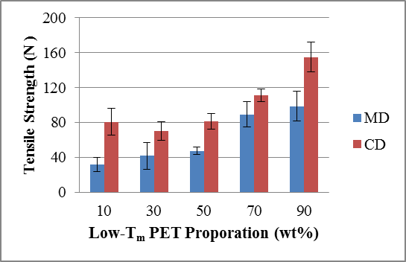
Fig. 1 Comparison of tensile strength of FIR/PET/ Low-T_{m} PET nonwoven along MD and CD in different proportions of Low-T_{m} PET fibers.
Figure 1 shows that tensile property becomes higher when low-T_{m} PET fiber increases, because melting low-T_{m} PET penetrates pores in nonwoven, making fiber thermal bonded and space narrowed. The tensile strength along CD is higher than that along MD, which is due to more fibers orientated in CD than in MD from combing, lapping and needle-punching process. It is concluded that when nonwoven consisted of 10/0/90 wt%/wt%/wt% FIR/PET/Low-T_{m} PET has the maximum tensile strength regardless of CD or MD.
Bursting property
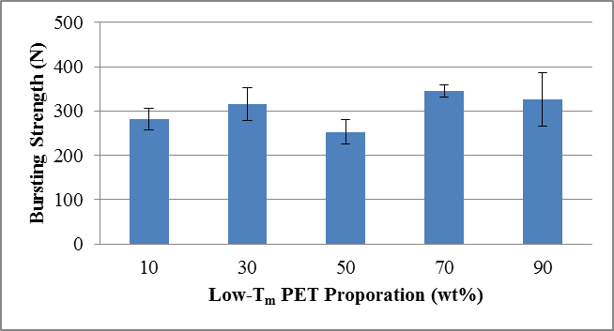
Fig.2 Comparison of bursting strength of FIR/PET/Low-T_{m} PET nonwoven with different proportions of Low-T_{m} PET fibers.
Figure 2 shows that the bursting strength appears double peaks, respectively at 30 wt% and 70 wt% of low-T_{m} PET fibers. But 50 wt% of low- T_{m} PET fiber has significantly lowest bursting strength. This is due to its unstable state. Maybe insufficient interface bonding between fibers makes nonwoven easily damaged. Comparatively, nonwovens with 90 wt% low-T_{m} polyester still have good bursting property.
Air permeability property
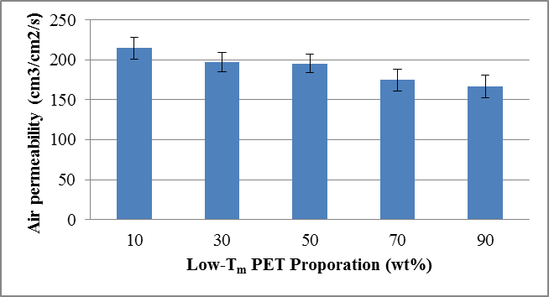
Fig.3 Comparison of air permeability of FIR/PET/Low-T_{m} PET nonwoven with different proportions of Low-T_{m} PET fibers.
It is observed when low-T_{m} PET fiber adds, air permeability appear a remarkable decrease (shown in Fig.3). This is because more low- T_{m} PET fiber melts, more nonwoven’s pore fills in and less air penetrates. But at 90 wt% of low-T_{m} PET fiber, nonwoven still has excellent air permeability of above 150 cm³/cm²/s.
Stab resistance property
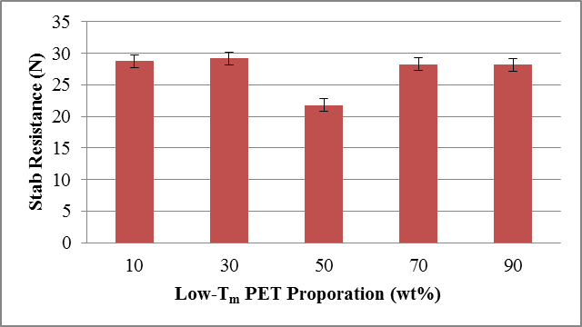
Fig.4 Comparison of stab resistance of FIR/PET/Low-T_{m} PET nonwoven with different proportions of Low-T_{m} PET fibers.
It is displayed that when the low- T_{m} PET fiber was from 30 wt% to 50 wt%, the stab resistance shows a decline; but opposite from 50% to 70% (shown in Fig.4). When low- T_{m} PET fiber content was 10%, 30%, 70%, and 90%, the stab resistance property were almost the same. Only at 50% of the low- T_{m} PET fiber, the stab resistance property was the weakest. After hot-pressing, more low- T_{m} PET fiber addition cause the sample become stiffer. Thus maybe 50% of low-T_{m} PET is the critical points that transforms from viscoelasticity to plastic, resulting in sample easily damaged by puncture energy.
Far-infrared emissivity
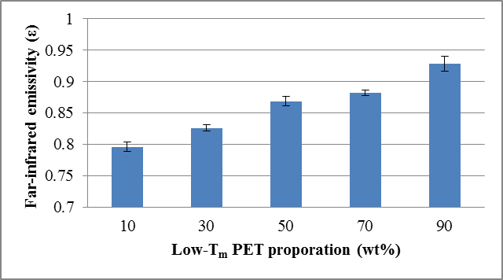
Fig.5 Comparison of far-infrared emissivity of FIR/PET/ Low-T_{m} PET nonwoven with different proportions of Low-T_{m} PET fibers.
By changing of low-T_{m} PET fiber content, the thermo-melting amount was affected afterwards. The gap of nonwoven would be filled, thus making nonwovens compact. Even that the FIR fiber content was constant in this test, the less air among nonwovens increases the far-infrared emissivity because the air has lower emissivity than fibers. Therefore, the emissivity of far-infrared ray is elevated with more low-T_{m} PET fibers. The highest far-infrared emissivity appears when the low-T_{m} PET fibers contained 90 wt%.
Conclusion
The study researches on the tensile strength, bursting strength, air permeability, stab resistance and far-infrared emissivity of FIR/PET/ Low-T_{m} PET nonwovens. It is found that nonwoven becomes stiffer after hot pressing as increase of low-T_{m} PET fibers, accordingly the size of pore among nonwovens becomes smaller. Nonwoven containing 50 wt% low-T_{m} PET presents unstable state. In summary, 90 wt% low-T_{m} PET fibers were chosen as the optimal blending parameters in our future health-care and protective clothing according to five measurements.
Acknowledgements
This work would especially like to thank National Science Council of the Taiwan, for financially supporting this research under Contract NSC 101-2622-E-166-001.
References
- A.C.-Y. Wonga and K.Z. Liangb: J Mater Process Tech, Vol. 63(1997), p. 510–513.
- X. Ping, M. Z. Wang and X. W. Ge: Radiation Physics and Chemistry, Vol. 80(2011), p. 632–637.
- M. G. Lin: Journal of the China Textile Institute, 8(1999), p. 100.
- C. M. Lin and J. H. Lin: J Eng Fiber Fabr Vol. 7(2012), p.106-113.
- C.W. Lou, C.H. Huang, K.C. Tai, C.W. Lin and J. H. Lin: Accept to Journal of Thermoplastic Composite Materials(2011).
- J. H. Lin, T. L. Kuo, C. W. Lin, C.M. Lin, C. T. Hsieh and C. W. Lou: Advanced Materials Research Vol.123-125(2010, p.73-76.
- J. H. Lin, Y. T. Huang, C. M. Lin, Y. C. Yang, C. T. Hsieh and C. W. Lou: Advanced Materials Research Vol. 97-101(2010), p. 1790-1793.
- N. Wang, Y. M. Zhao, J. Y. Yu and L. D. Cheng: Shanghai Textile Science and Technology, Vol. 33(2005), p.22.
- W. H. Ma, Evaluation of Manufacturing Process and Stab Resistance of TPU Laminated Composite Fabrics. Feng Chia University, master dissertation, 2008.
- R. A. Scott, Textile for Protection, Woodhead Publishing, 3-30(2005).

