Misdiagnosis as idiopathic hyperuricemia and hyperlipidemia in a family with mild form of glycogen storage disease Type 1a
Jeng-Jer Shieh, PhD,^{a,b*} Yung-Hsiu Lu, MS,^{c*} Ju-Hui Hsu, MS,^{d} Tina Jui-Ting Wu, MS,^{d} Shi-Wei Huang, MS,ª Hsiao-Chi Yu, MS,^{d} Chih-Hao Sun, MD,^{e} Hong-Jen Chiou, MD,^{f} Chinsu Liu, MD, PhD,^{g} Ming-Yu Lo, MS,^{d} Yu-Ping Hsieh, MS,^{d} Ching-Yuang Lin MD, PhD,^{h} Dau-Ming Niu, MD, PhD ^{c,d}
From:
ªInstitute of Biomedical Sciences, National Chung Hsing University, Taichung, Taiwan.
^{b}Department of Education and Research, Taichung Veterans General Hospital, Taichung, Taiwan.
^{c}Institute of Clinical Medicine, School of Medicine, National Yang-Ming University
^{d}Departments of Pediatrics, ^{e}Department of Pathology, ^{f}Department of Radiology ^{g}Department of Surgery, Veterans General Hospital, Taipei, Taiwan.
^{h}Clinical Immunological Center, College of Medicine, China Medical University and Hospital. Taichung, Taiwan.

*Both authors contributed equally to this work.

Abbreviated title: Mild form of GSD type 1a
Corresponding author
Dau-Ming Niu, MD, PhD
Institute of Clinical Medicine, School of Medicine
National Yang-Ming University
No.155, Sec.2, Linong Street, Taipei, 112 Taiwan (ROC)
Tel: 886-2-66109696, Fax: 886-2-28767181
E-mail: dmniu1111@yahoo.com.tw

Financial Disclosures: The authors have no financial arrangement or potential conflict of interest to disclose.

Writing Assistance: This manuscript was reviewed for style and language by Rodolphe Ruffy, MD (www.cardioscript.com). Dr. Ruffy was compensated for his services by discretionary institutional funds.
Abstract
The manifestations of glycogen storage disease type 1a (GSD 1a) are usually so prominent in childhood that it is usually readily diagnosed by pediatricians. However, a mild form of the disease may only become apparent in adolescents or adults. We observed a brother and sister with subtle manifestations of the disease, discovered after the brother’s son was diagnosed with typical GSD 1a. The adult siblings never suffered from hypoglycemia, had normal fasting blood glucose and liver transaminases at the time of diagnosis, and were taller than average Chinese. Their only notable disease manifestations were recurrent gouty arthritis with hyperuricemia and hyperlipidemia in adolescence. When diagnosed, the brother had multiple benign and malignant hepatic tumors, and died of fulminante metastatic hepatocellular carcinoma, 6 months after liver transplantation. p.M121V/p.R83H and p.M121V/p.M121V genotypic constellations of the G6Pase gene were identified in this family. Both siblings were homozygous for the newly identified p.M121V mutation. The infant had compound heterozygous mutations, p.R83H and p.M121V. We recommend that mild GSD should be considered in the adolescences with unexplained hyperuricemia and hyperlipidemia, despite the presence of normal blood glucose levels. This report also reminds us that hepatocellular carcinoma could develop even in very mild GSD 1a patients.
Key words: glycogen storage disease type 1a, hyperuricemia, hyperlipidemia, hepatocellular carcinoma.

Introduction
Glycogen storage disease type 1a (GSD Ia; McKusick 232200) is a major disorder of carbohydrate, purine, and lipid metabolism, which causes marked hypoglycemia, hepatomegaly and growth retardation.^{1,2} Other metabolic abnormalities associated with GSD 1a include lactic acidemia, hyperlipidemia, and hyperuricemia, and its long-term complications include gout, hepatic adenomas, osteoporosis, nephrolithiasis and progressive renal disease.³ The disease is often diagnosed in infancy, with severe hypoglycemic episodes (such as seizures or changes in consciousness). In milder cases of GSD 1a, severe hypoglycemic episodes may not occur, but growth retardation and hepatomegaly are invariably present in early childhood,^{4,5} and are usually so prominent that it can be diagnosed by an experienced pediatrician without difficulty. However, when only some manifestations (such as gouty arthritis, hyperuricemia and hyperlipidemia) of GSD 1a appear during adolescence or adulthood, it could easily be misdiagnosed.
Patient no 1
A 25-month-old boy was brought to our pediatric clinic for evaluation of short stature. On initial physical examination, he was 80-cm tall (<3%)⁶ and weighed 12 kg (25%).⁶ Because of a protuberant abdomen due to hepatomegaly and a doll-like face, we suspected GSD. Laboratory examinations revealed an abnormal liver function, lactic acidemia, hyperlipidemia, fasting hypoglycemia and hyperuricemia (Table 1). On abdominal ultrasound examination, the liver vertical dimension was 16.2 cm at the midclavicular line, with mild fatty infiltration. The diagnosis of GSD 1a was confirmed by mutational analysis of the G6PC gene. His family history revealed that the father and a paternal aunt had also been hyperuricemic and hyperlipidemic since adolescence.
Patient no 2
This 32 year-old man from a consanguineous family was the father of patient no 1 (Figure 1). He was first noted to be hyperuricemic and hyperlipidemic at 16 years of age. Furthermore, at 19 years of age, he presented with hepatomegaly of undetermined origin, and a 2 x 2 cm² hepatic hemangioma was suspected. Since the liver function was normal, no further hepatic studies were obtained. He had been placed on a uricosuric regimen for recurrent gouty arthritis since he was 21 years old, without apparent improvement. At the age of 29 years, it was reported that he had suffered from mid-epigastric discomfort, and multiple hepatic adenomas with intra-tumoral hemorrhages were detected. No specific diagnosis was made or treatment recommended at that time.
When we first saw him, his height was 175 cm (75%-90%)⁷ and he weighed 67 kg. His father is 168 cm, mother 160 cm (figure 1). Laboratory examinations revealed the presence of lactic acidemia, hyperlipidemia, hyperuricemia, and normal liver function tests (Table 1). Computed tomography and hepatic magnetic resonance imaging revealed the presence of 4 heterogeneous masses, the largest measuring 13.4 x 13.0 cm in diameter (Figure 2). The hepatitis B serum antibodies and antigens studies were negative. The diagnosis of GSD1a was confirmed by mutational analysis of G6PC gene.
The patient underwent transplantation of a cadaver donor liver 4 months after diagnosed with GSD 1a. Hepatocellular carcinoma was noted on pathologic examination of his liver (Figure 3), without apparent metastatic dissemination. After an uneventful recovery from the transplant operation, fulminant metastastic disease developed 6 months later (Figure 3) and, despite immediate initiation of chemotherapy, the patient died within 2 months. The tumor markers, alpha-fetoprotein (AFP) and carcinoembryonic (CEA) remained normal throughout the course of his illness.
Patient no 3
This 34 year-old woman, an older sister of patient no 2, was suffering from recurrent gouty arthritis when she was first found to suffer from hyperuricemia and hyperlipidemia at 18 years of age. Various uricosuric and antihyperlipidemic agents were prescribed, which were ineffective. At the age of 21 years, she was noted to have an enlarged fatty liver. Since her liver function was normal, it was not investigated further. She had a stable conjugal relationship and 2 healthy children. On physical examination, she was 162 cm tall (75%)7 and weighed 52 kg. Screening laboratory examinations revealed the presence of lactic acidemia, hyperlipidemia and hyperuricemia (Table 1). On abdominal ultrasound examination the vertical dimension of the liver was 18.2 cm at the midclavicular line, with presence of mild fatty infiltration.
Mutation analysis and expression study for novel mutation
The primer sequences used for amplification of each exon of the G6PC gene and the PCR conditions for each primer were according to a previous report.^{8,9} Cycle sequencing revealed that patient no 1 had compound heterozygous p.R83H (c.G248A) and p.M121V (c.A361G) mutations and patients no 2 and 3 were homozygous for the p.M121V mutation. (Figure 1) p.R83H is a common GSD 1a mutation among the Chinese.⁸ p.M121V is a newly identified missense mutation and this new mutation was detected in none of the 50 healthy controls. This mutant was then constructed and expressed in COS-1 cells. After subtracting the background activity of COS-1 cells, the G6Pase activities of p.M121V was 7.8% of the wild type (Table 2).
Discussion
The p.R83H mutation is one of five mutations in the active site residues, which can completely abolish the enzymatic activity of G6Pase.¹⁰⁻¹¹ The p.M121V mutation is located at transmembrane helix-3, which is more flexible and tolerant of change than other helix domains.¹² Therefore, it is reasonable to assume that p.M121V mutation retains a considerable residual enzyme activity and causes a mild phenotype of GSD 1a. The vitro expression study of the p.M121V mutation proved that this mutation indeed retained 7.8 % of wild-type activity. Interestingly, a related mutation p.M121I has been identified in Maltese puppies ¹³. In vitro expression study, this mutation also showed that it retained a considerable residual enzyme activity, 6.6 % of wild-type activity of canine G6Pase. However, in contrast to our patients, the puppies presented with typical phenotype of GSD 1A, which included massive hepatomegaly and failure to thrive, etc. In another report, a mild GSD 1a patient in Japan, who is homozygous for p.P257L mutation, showed normal stature and had never experienced a symptomatic hypoglycemic episode. However, the vitro expression study of this mutation showed only 1.2% of wild-type G6PC activity.¹⁴ In contrast, a compound heterozygous patient with p.E110Q and p.G222R mutations that retain 16% and 2.6 % of wild-type G6PC activity, manifests typical severe symptoms of GSD-1a.¹⁵ Rake et al also reported variable phenotypes among affected siblings with the same G6PC genotype.¹⁶ All these inconsistent results may indicate the presence of other modified factors and/or genes in the manifestations of GSD1a patients.
In this report, patient 2 was found to have an enlarged fatty liver in her twenties, but at that time it was regarded as a general condition of fatty liver (non-alcoholic steatohepatitis) with hyperlipidemia/ hyperuricemia. This raised a very important question, “How should doctors distinguish between people with hyperlipidemia/ hyperuricemia and a fatty liver and those with such mild form of GSD-1a?”. In this case, fasting serum lactate testing may be a good choice to distinguish these two conditions. In addition to the severe hyperlipidemia hyperuricemia (or/and gouty arthritis) which is usually inconsistent with the severity of the obesity of the adolescence patients, an elevated serum lactate level should be a good marker to differentiate these two conditions. The serum lactate often elevates during fasting, even when the mild GSD-1a patients have normoglycemia. However, interpretation of the result of lactate determination should be very careful owing to the high false positive rate of this test since tourniquet use, improper sample handling, and difficult blood draws all contribute to inappropriately elevated lactates.
One of the important points in this report is that the mild patient ended up dying of hepatocellular carcinoma. A similar condition was also found in a very mild GSD patient ¹⁷. These findings also raised an interesting question “Why did these mild patients contract hepatocellular carcinoma when it is relatively rare in the severe cases?”. What implications does this have for management of patients with GSD? Gene therapy has been successfully performed in mice and dogs with this disease, and discussions are on-going regarding human gene therapy trials. These case reports have implications on potential gene therapy in humans since partial correction may be setting people up to be like the subjects described in these case reports. If partial correction normalized glucose but elevated lactates persist (like was seen in the dogs), are we potentially setting people up for hepatocellular carcinoma in the future?
Another important point is that AFP and CEA remained within normal limits throughout the course of the disease in patient no 2. This finding was also noted in several previous studies.^{18,19} Including our patient, AFP was normal in 8 out of 10 patients and CEA was normal in all 7 patients in which it was measured. Therefore, the reliability of AFP and CEA as markers of hepatocellular carcinoma in GSD 1a needs to be reconsidered, and priority should be given to imaging studies when following patients presenting with GSD 1a and hepatocellular adenomas. When a rapid growth or poorly defined margins of an adenoma are noted, it is recommended to proceed with vigorous interventional therapy.
Another noteworthy finding of this study is that patient 2 was noted to have persistent severe microcytic anemia without identified reasons (for example, iron deficiency or Thalassemia).
Recently, Weinstein et al proved that hepcidin, a peptide hormone in controlling the release of iron from cells, may play a major causative role in the GSD-induced- anemia.²⁰ More recently, several reports indicated that hepcidin was related to several types of carcinoma²¹ and could be considered as a tumor marker.²² We believe that it will be very interesting to understand if hepcidin could be used as a tumor marker for the GSD-induced-hepatocellular carcinoma, especially, when AFP and CEA are not reliable in this type of tumor.

References
1. Chen YT. Glycogen storage diseases. In: Scriver CR, Beaudet AL, Sly WS, Valle D, Childs B, Kinzler KW, Vogelstein B, eds. The Metabolic and Molecular Bases of Inherited Disease. 8th ed. New York: McGraw-Hill Inc. 2001:1521-1551
2. Chou JY, Mansfield BC. Mutations in the glucose-6-phosphatase-alpha (G6PC) gene that cause type Ia glycogen storage disease. Hum Mutat. 2008;29(7):921-930
3. Rake JP, Visser G, Labrune P, et al. Glycogen storage disease type I: diagnosis, management, clinical course and outcome. Results of the European Study on Glycogen Storage Disease Type I (ESGSD I). Eur J Pediatr. 2002;161:S20-34
4. Matern D, Seydewitz HH, Bali D, et al. Glycogen storage disease type I: diagnosis and phenotype/genotype correlation. Eur J Pediatr. 2002;161:S10-9
5. Akanuma J, Nishigaki T, Fujii K, et al. Glycogen storage disease type Ia: molecular diagnosis of 51 Japanese patients and characterization of splicing mutations by analysis of ectopically transcribed mRNA from lymphoblastoid cells. Am J Med Genet.
6. Hsiao RL, Miau TS, Lu CC, et al. A survey on weight and height of children (1 month-7 years) and plotting of growth curves (1 month-18 years) in Taiwan, 1987-1988. Zhonghua Min Guo Xiao Er Ke Yi Xue Hui Za Zhi. 1990;31:166-175 [In Chinese]
7. Chen W, Tsai CY, Chen AC, et al. Growth charts of Taiwanese youth: norms based on health-related physical fitness. Mid Taiwan J Med. 2003;8:S85-93
8. Lei KJ, Shelly LL, Pan CJ, et al. Mutations in the glucose-6-phosphatase gene that cause glycogen storage disease type 1a. Science. 1993;262(5133):580-583
9. Wong LJC, Hwu WL, Dai P, et al. Molecular genetics of glycogen-storage disease type 1a in Chinese patients of Taiwan. Mol Genet Metab. 2001;72(2):175-180.
10. Hemrika W, Wever R. A new model for the membrane topology of glucose-6-phosphatase: the enzyme involved in von Gierke disease. FEBS Lett. 1997;409(3):317-319
11. Stukey J, Carman GM. Identification of a novel phosphatase sequence motif. Protein Sci. 1997;6:469-472
12. Lei KJ, Pan CJ, Liu JL, et al. Structure-function analysis of human glucose-6-phosphatase, the enzyme deficient in glycogen storage disease type 1a. J Biol Chem. 1995;270(20):11882-11886
13. Kishnani PS, Bao Y, Wu JY, et al. Isolation and nucleotide sequence of canine glucose-6-phosphatase mRNA: identification of mutation in puppies with glycogen storage disease type Ia. Biochem Mol Med. 1997;61(2):168-177
14. Takahashi K, Akanuma J, Matsubara Y, et al. Heterogeneous mutations in the glucose-6-phosphatase gene in Japanese patients with glycogen storage disease type Ia. Am J Med Genet. 2000;92(2):90-4
15. Parvari R, Lei, K-J, Szonyi L, et al. Two new mutations in the glucose-6-phosphatase gene cause glycogen storage disease in Hungarian patients. Eur J Hum Genet. 1997;5(4):191–195
16. Rake JP, ten Berge AM, Visser G, et al. Identification of a novel mutation (867delA) in the glucose-6-phosphatase gene in two siblings with glycogen storage disease type Ia with different phenotypes. Hum Mutat. 2000;15(4):381
17.Cassiman D, Libbrecht L, Verslype C, et al. An adult male patient with multiple adenomas and a hepatocellular carcinoma: Mild Glycogen Storage Disease type Ia. J Hepatol. 2010;53(1):213-7.
18. Franco LM, Krishnamurthy V, Bali D, et al. Hepatocellular carcinoma in glycogen storage disease type Ia: a case series. J Inherit Metab Dis. 2005;28(2):153-162
19. Limmer J, Fleig WE, Leupold D, et al. Hepatocellular carcinoma in type I glycogen storage disease. Hepatology. 1988;8(3):531-537
20. Weinstein DA, Roy CN, Fleming MD, et al. Inappropriate expression of hepcidin is associated with iron refractory anemia: implications for the anemia of chronic disease. Blood. 2002;100(10):3776-3781
21. Ward DG, Roberts K, Brookes MJ, et al. Increased hepcidin expression in colorectal carcinogenesis. World J Gastroenterol. 2008;14(9): 1339-1345
22. Kamai T, Tomosugi N, Abe H, et al. Increased serum hepcidin-25 level and increased tumor expression of hepcidin mRNA are associated with metastasis of renal cell carcinoma. BMC Cancer. 2009;9:270-279

FIGURE legends
FIGURE 1: Family pedigree
The individual genotypes are shown. Black-filled symbols indicate the M121V mutation. Slashes indicate the R83H mutation. The patients no 2 and 3 were issued from a consanguineous marriage. The parents of patient no 1 were unrelated, and the patient no 1 inherited the R83H allele from the mother and p.M121V from the father.
FIGURE 2: T1 weighted magnetic resonance images of the liver.
A large, confluent, soft tissue mass with heterogeneous enhancement (arrow) is present in the left lobe.
FIGURE 3: Histopathology of the liver and hepatocellular carcinoma
A. Hepatocytes with pale, glycogen-rich cytoplasm - Hematoxylin-eosin, original magnification x 200.
B. Well-differentiated hepatocellular carcinoma with trabecular pattern - Hematoxylin-eosin, original magnification x 100.

TABLE 1 Characteristics of each study patient at the time of diagnosis
 |  | Patient no
 | Normal values | 1 | 2 | 3
Age  Body height, cm  Biochemistry  Fasting blood sugar, mg/dl  Total cholesterol, mg/dl  Total triglycerides, mg/dl  Uric acid, mg/dl  Lactate, mg/dl  Liver transaminases  Alanine transaminase, U/l  Aspartate aminotransferase, U/l  Hematology  Erythrocytes, count/µl  Hemoglobin, g/dl  Mean corpuscular volume, fl  Blood gases  pH  HCO₃, mmol/l  Ultrasound vertical dimension of the liver  at the midclavicular line, cm | 65-115  125-240  20-200  1.8-7.2  5-15  5-45  15-55  3.7 x 10⁹ -5.3 x 10⁹  11.5 -15.5  80-95  7.35-7.45  22-26  13-15 (adult) | 25 months  83 (<3%)  60  224  290  8.5  73.7  92  108  4.82 x 10⁹  13.5  82.3  7.37  11.5  16.4 | 32 years  175 (90%)  65  186  312  11.5*  40.4  45  53  5.07 x 10⁹  9.6  60  7.38  20  16.8 | 34 years  162 (75%)  67  269  926  8.9*  23.9  42  32  3.19 x 10⁹  9.9  91.5  7.36  20  18.2
*during allopurinol treatment

TABLE 2 Phosphohydrolase activity of human G6Pase p.M121V mutant constructs

Mutation | Phosphohydrolase activity, nmole/min/mg
Mock | 4.22 ± 0.26 (0 %)
Wild type | 63.72 ± 2.28 (100 %)
p.M121V | 8.85 ± 1.00 (7.8%)
Data are presented as the mean ± S.E. Numbers in parentheses represent the percentage of WT enzymatic activity.

Figure 1
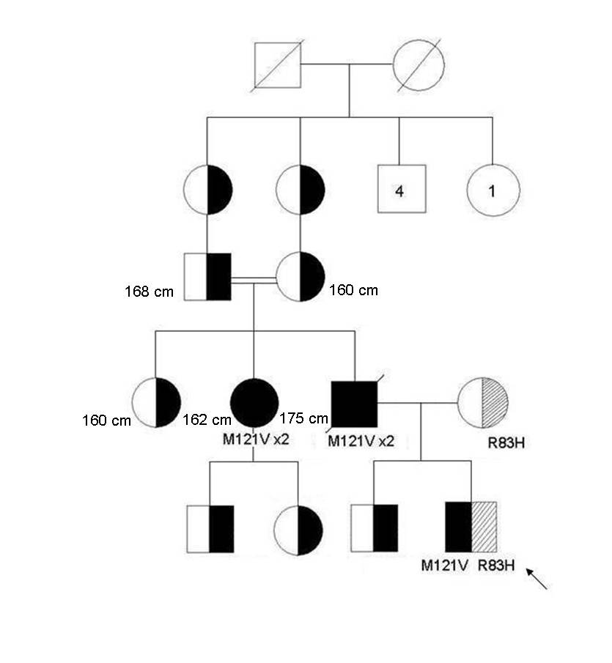
Figure 2

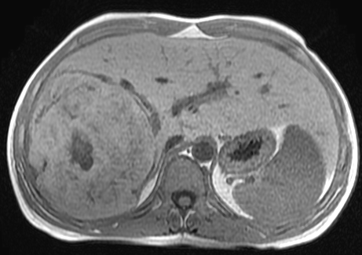

Figure 3
A B
