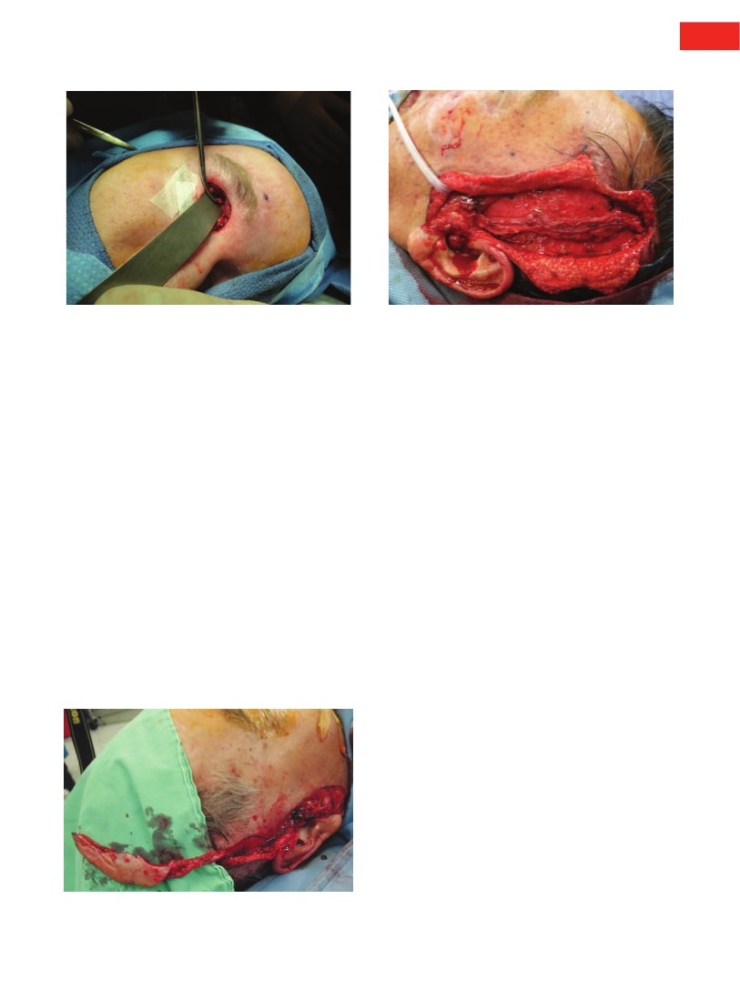
Volume 131, Number 5 • Letters
Fig. 5. Intraoperative view of the resection of the frontal branch
trunk deep within the orbit, from which recurrent pain and neu-
roma formation in scar can be minimized.
Fig. 2. Distal dissection of the pedicle into the hair-bearing skin.
DISCLOSURE
The author has no financial interest to declare in relation
to the content of this communication.
REFERENCE
1. Dellon AL. Discussion: Occipital artery vasculitis not identi-
fied as a mechanism of occipital neuralgia-related chronic
migraine headaches. Plast Reconstr Surg. 2011;128:915–917.
Extended Applications of Vascularized
Preauricular and Helical Rim Flaps in
Reconstruction of Nasal Defects
Sir:
e read with interest the clinical study by Zhang
et al. regarding use of the preauricular free flap
in reconstruction of nasal defects.1 The authors pre-
sented their significant experience of using this flap
in 63 patients. According to their data, in 70 percent
of cases, it was necessary to use interposition vascu-
lar grafts from the thigh due to the small size of the
W
Fig. 1. Dissection of the flap based on the distal end of the
superficial temporal vessels.
angular artery and especially the concomitant vein,
which were inadequate for safe anastomosis. Even
though the authors reported a low complication rate
with the use of interposition grafts, there is a potential
risk of complication when vascular grafts are needed.2
In our practice, in order to avoid interposition grafts,
we prefer to harvest the flap contralateral from the defect
site and to use as recipient vessels the ipsilateral superfi-
cial temporal vessels. The recipient vessels are dissected
distally into the hair-bearing skin so that enough length
can be obtained; they are then transposed through a sub-
cutaneous tunnel near the nasal defect (Figs. 1 and 2).
Our method has the potential problem that the
distal end of the superficial temporal vessels may be
small, making the anastomosis quite tedious. This
problem is overcome by harvesting the flap based on
the distal end of the superficial temporal vessels, as a
retrograde blood flow flap. With this maneuver, we are
able to harvest the flap with a long pedicle and, finally,
to decide the best size match between the pedicle and
the recipient vessels, performing the anastomosis with-
out tension. Furthermore, as the authors mention, the
retrograde blood flow of the flap based on the distal
end of the superficial temporal vessels is reliable and
cannot compromise the survival of the flap.
Another benefit of performing the above-modified
method of reconstruction in older patients is that we
are able to perform subcutaneous rhytidectomy in
combination with the free flap. After the flap is har-
vested, the donor-site defect can undergo primary
closure in a manner similar to a face lift procedure.
Using the contralateral superficial temporal vessels as
recipient vessels and creating the subcutaneous tunnel,
we are able to excise the redundant preauricular skin
from the recipient site, leaving a scar similar to that
with a face lift. We believe that, apart from the symmet-
rical result, the facial rejuvenation can enhance patient
satisfaction, especially after a major operation such as a
tumor excision and free flap reconstruction.
In conclusion, our modified method has the fol-
lowing benefits: (a) it avoids vessel interposition
847e
Plastic and Reconstructive Surgery • May 2013
grafts, (b) it avoids a thigh scar, (c) there is good
size matching between the donor and recipient ves-
sels, and (d) one can perform rhytidectomy in older
patients simultaneously with the free flap operation.
DOI: 10.1097/PRS.0b013e31828ecad2
Stamatis Sapountzis, M.D.
Department of Plastic Surgery
China Medical University Hospital
Taichung, Taiwan
Correspondence to Dr. Chen
Department of Plastic Surgery
China Medical University Hospital
China Medical University
2, Yuh-der Road
Taichung, Taiwan
d19722@mail.cmuh.org.tw
Hung-Chi Chen, M.D., M.H.A.
texture, and color when reconstructing nasal ala. It also
provides all three layers, as skin, cartilaginous framework,
and lining, which are necessary for both functional and
aesthetic purposes. In our practice, the majority of the
defects involved nasal alae, and we found the retrograde
flow flaps were optimal for ipsilateral defects with partic-
ular concerns on pedicle insetting and nasal ala shaping.
In this situation, no matter which recipient vessels—the
ipsilateral facial or superficial temporal vessels—were
used, the interposition vascular grafts were needed.
Apparently this is just opposite to Drs. Sapountzis and
Chen’s method. In addition, since the superficial tempo-
ral vascular system is a versatile option for facial recon-
struction,2 we would like to save one side for potential use
rather than destroy both sides in one operation.
In conclusion, we appreciate the opportunity to
discuss the technique viewpoints raised by our article.
Drs. Sapountzis and Chen’s suggestion also could be an
alternative in certain cases.
DOI: 10.1097/PRS.0b013e318287a016
DISCLOSURE
The authors have no conflicts of interest to declare in rela-
tion to the content of this communication.
REFERENCES
1. Zhang YX, Yang J, Wang D, et al. Extended applications of
vascularized preauricular and helical rim flaps in reconstruc-
tion of nasal defects. Plast Reconstr Surg. 2008;121:1589–1597.
2. Cheng HT, Lin FY, Chang SC. Evidence-based analysis of vein
graft interposition in head and neck free flap reconstruc-
tion. Plast Reconstr Surg. 2012;129:853e–854e.
Danru Wang, M.D.
Department of Plastic and Reconstructive Surgery
Ninth People’s Hospital
Shanghai Jiao Tong University School of Medicine
Shanghai, People’s Republic of China
Correspondence to Dr. Qian
Department of Plastic and Reconstructive Surgery
Shanghai Ninth People’s Hospital
Shanghai JiaoTong University School of Medicine
639 Zhi Zao Ju Road
Shanghai 200011, People’s Republic of China
qianyunliang@126.com
Yunliang Qian, M.D.
Reply: Extended Applications of Vascularized
Preauricular and Helical Rim Flaps in
Reconstruction of Nasal Defects
Sir:
We thank Drs. Sapountzis and Chen for their
attention to our previous article regarding partial nasal
reconstruction with vascularized auricular flaps.1 In
order to avoid the interposition vascular grafts, the
authors harvested the retrograde flow flap from the
contralateral side and used the ipsilateral temporal
superficial vessels as the recipient vessels. We agree
that their modification might have the benefits they
described in the letter.
However, in the figures they provided, the flap
seems to be only a soft-tissue flap and not the com-
posite flap with auricular cartilage we usually harvest.
Since the nasal defect was not shown in those figures,
we could not judge which nasal subunit was involved
in this case from the shape of that flap. We are very
interested to know, in the case of a full-thickness nasal
defect, whether the contralateral preauricular flap
could repair the three-dimensional deformity.
As we wrote in the article,1 our nasal reconstruction
goal is not to “fill holes” but rather to restore delicate
three-dimensional structures. The helical rim, especially
the helical root, offers the best match in terms of shape,
DISCLOSURE
The authors have no financial interest to declare in rela-
tion to the content of this communication.
REFERENCES
1. Zhang YX, Yang J, Wang D, et al. Extended applications of
vascularized preauricular and helical rim flaps in reconstruc-
tion of nasal defects. Plast Reconstr Surg. 2008;121:1589–1597.
2. Tan O, Atik B, Ergen D. Temporal flap variations for craniofa-
cial reconstruction. Plast Reconstr Surg. 2007;119:152e–163e.
Protective Lipofilling Allows Immediate
Expander-Implant Reconstruction in the Setting
of Postoperative Radiotherapy
Sir:
e read with great interest the Discussion written
by Dr. Cordeiro1 to Dr. Kronowitz’s article2 in the
October 2012 issue of Plastic and Reconstructive Surgery
and the letter by Dr. Bonomi et al.3 in the November
2012 issue. Postmastectomy radiation therapy will
indeed be one of the most important issues for plastic
W
848e

