
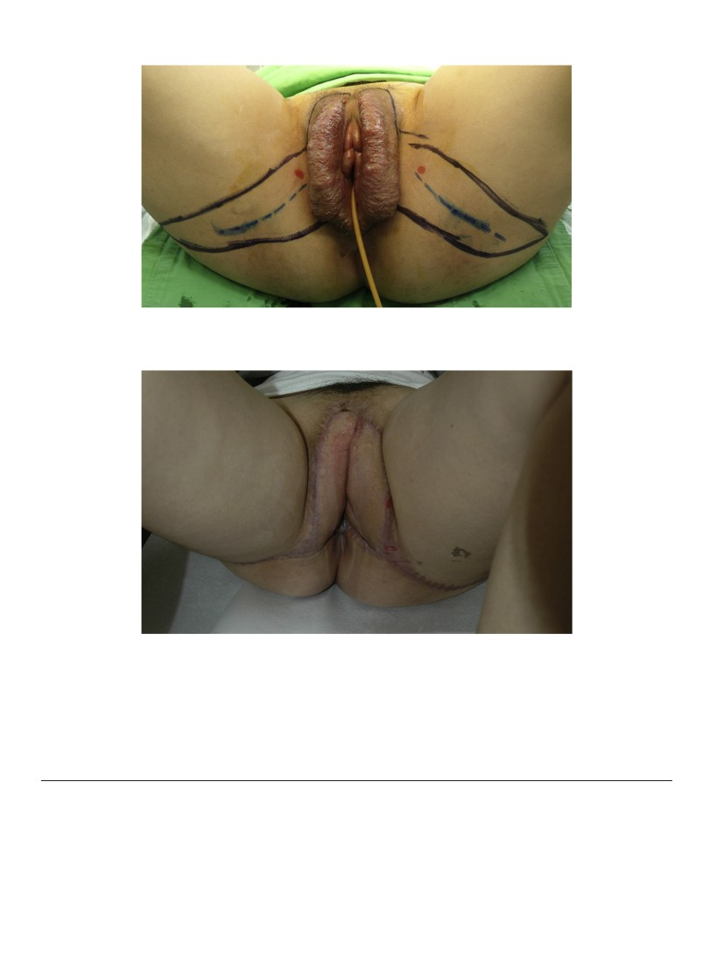
BRIEF COMMUNICATIONS
179
unaccounted for problem at the time of pregnancy and breastfeeding,
and should therefore be evaluated in these patients.
Conﬂict of interest
The authors declare no conﬂict of interest.
References
[1] Karatas M, Basaran C, Ozgul E, Tarhan C, Agildere AM. Postpartum sacral stress
fracture: an unusual case of low-back and buttock pain. Am J Phys Med Rehabil
2008;87(5):418–22.
[2] Lin JT, Lutz GE. Postpartum sacral fracture presenting as lumbar radiculopathy:
a case report. Arch Phys Med Rehabil 2004;85(8):1358–61.
[3] Lourie H. Spontaneous osteoporotic fracture of the sacrum. An unrecognized
syndrome of the elderly. JAMA 1982;248(6):715–7.
[4] Dussa CU, El Daief SG, Sharma SD, Hughes PL. Atraumatic fracture of the sacrum in
pregnancy. J Obstet Gynaecol 2005;25(7):716–7.
[5] Beltran LS, Bencardino JT. Lower back pain after recently giving birth: postpartum
sacral stress fractures. Skeletal Radiol 2011;40(4):481–2.
0020-7292/$ – see front matter © 2013 International Federation of Gynecology and Obstetrics. Published by Elsevier Ireland Ltd. All rights reserved.
http://dx.doi.org/10.1016/j.ijgo.2012.11.007
Radical resection and reconstruction with bilateral gluteal fold perforator ﬂaps for
vulvar hemangiolymphangioma
Stamatis Sapountzis, Dhruv Singhal, Hung-Chi Chen ⁎
Department of Plastic Surgery, China Medical University Hospital, Taichung, Taiwan
a r t i c l e
i n f o
Article history:
Received 8 November 2012
Received in revised form 5 December 2012
Accepted 15 January 2013
Keywords:
Gluteal fold perforator ﬂap
Reconstruction
Resection
Vulvar hemangiolymphangioma
Hemangiolymphangioma is a rare type of lymphatic malforma-
tion characterized by vascular and lymphatic elements on histologic
examination [1]. The present paper reports a rare case of vulvar
hemangiolymphangioma and the successful surgical reconstruction
with bilateral gluteal fold perforator ﬂaps.
A 16-year-old patient was referred in August 2012 for progressive
swelling of the genitals that had been ongoing for 8 years. The patient
complained of intermittent discharge of a white ﬂuid mixed with
blood from her perineum since the age of 8 years. On physical exam-
ination, erythema and tenderness of the labia majora were present,
with friable bleeding upon palpation. Seven months prior to evalua-
tion, the patient had experienced an episode of massive perineal
hemorrhage resulting in severe anemia (7 g/dL). The hemorrhage
was managed conservatively with pressure and blood transfusions.
The following month the patient underwent sclerotherapy, but no
subsequent reduction in mass size or symptoms was noted. Given
the severity of the patient's condition, the decision was ultimately
made to proceed with a radical resection of the involved areas.
Bilateral vulvectomy was performed and the resulting defect was
reconstructed with bilateral gluteal fold ﬂaps based on internal
pudendal artery perforators (Fig. 1). The ﬂap dimensions were
15 × 6 cm on the right and 17 × 8 cm on the left side. Both the defect
and donor sites were primarily closed (Fig. 2). The postoperative
course was uneventful and histological examination conﬁrmed the
diagnosis of hemangiolymphangioma. Microscopically, numerous
dilated vessels and lymphatic channels with focal increased
perilymphatic and perivascular lymphoplasmacytic inﬁltration were
noted.
Lymphatic malformations/lymphangiomas are classiﬁed micro-
scopically into 4 categories: (1) lymphangioma circumscriptum; (2)
cavernous lymphangioma; (3) cystic hygromas; and (4) acquired
progressive lymphangiomas [1]. When these channels ﬁll with
blood, the lesion is termed a mixed hemangiolymphangioma.
Hemangiolymphangiomas invade surrounding tissues and recur
locally. These lesions are distinct from simple lymphangiomas or
hemangiomas [2].
Different management strategies for the management of lymph-
angiomas include observation, laser treatment, sclerotherapy, and
complete surgical excision, which is considered the gold standard
[3]. In the present case, the severity of symptoms and recent massive
hemorrhage justiﬁed radical resection of the lesion.
The resulting defect was closed with bilateral gluteal fold ﬂaps—a
fasciocutaneous ﬂap nourished by internal pudendal artery perfora-
tors. The advantages of this ﬂap, compared with more traditional
ﬂaps such as the vertical rectus abdominis and gracilis muscle ﬂaps,
are the lower donor site morbidity and better cosmetic result [4].
Conﬂict of interest
None.
References
[1] Shetty DC, Urs AB, Rai HC, Ahuja N, Manchanda A. Case series on vascular malfor-
mation and their review with regard to terminology and categorization. Contemp
Clin Dent 2010;1(4):259–62.
⁎ Corresponding author at: Department of Plastic Surgery, China Medical University
Hospital/China Medical University, 2 Yuh-der Road, Taichung, Taiwan. Tel.: +886 4
22052121x1509; fax: +886 4 22030777.
E-mail address: D19722@mail.cmuh.org.tw (H.-C. Chen).
180
BRIEF COMMUNICATIONS
Fig. 1. Vulvar hemangiolymphangioma. Note the design of the planned bilateral gluteal fold ﬂaps. The perforators from the internal pudendal artery were detected with a handheld
Doppler (red marks).
Fig. 2. Postoperative result.
[2] Meher R, Garg A, Raj A, Singh I. Lymphangioma of Tongue. Internet J Otorhinolaryngol
2005;3(2).
[3] Shah TN, Shekokar S, Venkatesh S, Santosh KV, Santosh KV. Lymphangioma
circumscriptum of the vulva: a rare case report. Eur J Obstet Gynecol Reprod Biol
2012;165(1):131–2.
[4] Hashimoto I, Nakanishi H, Nagae H, Harada H, Sedo H. The gluteal-fold ﬂap for vul-
var and buttock reconstruction: anatomic study and adjustment of ﬂap volume.
Plast Reconstr Surg 2001;108(7):1998–2005.
0020-7292/$ – see front matter © 2013 International Federation of Gynecology and Obstetrics. Published by Elsevier Ireland Ltd. All rights reserved.
http://dx.doi.org/10.1016/j.ijgo.2012.12.007

