A Novel Emulsion-Type Adjuvant Containing CpG Oligodeoxynucleotides Enhances CD8⁺ T-Cell-mediated Anti-tumor Immunity
Ying-Chyi Song ª, Han-Yin Cheng ª, Chih-Hsiang Leng ^{a,b}, Sheng-Kuo Chiang ª, Chih-Wei Lin ª, Pele Chong ^{a,b}, Ming-Hsi Huang ^{a,}* , and Shih-Jen Liu ^{a,b,}*
ª National Institute of Infectious Diseases and Vaccinology, National Health Research Institutes, Miaoli, Taiwan
^{b} Graduate Institute of Immunology, China Medical University, Taichung, Taiwan
* Corresponding Author: Shih-Jen Liu, E-mail: levent@nhri.org.tw; and Ming-Hsi Huang, huangminghsi@nhri.org.tw
ABSTRACT
PELC is a novel emulsion-type adjuvant that contains the bioresorbable polymer poly (ethylene glycol)-block-poly (lactide-co-ε-caprolactone) (PEG-b-PLACL), Span®85 and squalene. To investigate whether PELC is able to enhance CTL responses of antigens for treating tumor, peptide or protein antigen derived from HPV16 E7 were formulated with PELC nanoparticles and CpG oligodeoxynucleotide. We identified that PELC formulation could delay release of antigens in vittro and in vivo. We assessed the immunogenicity of an H-2D^{b}-restricted CTL epitope RAHYNIVTF (RAH) formulated with PELC or PELC/CpG and investigated the ability of these formulations to promote tumor regression. Following a single-dose subcutaneous injection in mice, we found that the RAH peptide formulated with PELC/CpG (RAH/PELC/CpG) resulted in increased numbers of IFN-γ-secreting cells and RAH-specific CD8⁺ T cells and an enhanced cytotoxic T cell response compared with RAH formulated with PELC or CpG alone. The tumor-bearing mice received a single-dose injection of RAH/PELC/CpG, which induced complete tumor regression. These results demonstrated that peptide antigen formulated with PELC/CpG nanoparticles is feasible for cancer immunotherapy.
KEYWORDS: adjuvant; immunotherapy; human papillomavirus (HPV); cervical cancer; CpG oligodeoxynucleotide
- Introduction
Human papillomavirus (HPV) infection is the most common cause of cervical cancer. Over 100 HPV types have been identified; some of the types that have been detected in cervical cancer are called “high-risk” HPV [1]. The four HPV types most frequently found among women worldwide with cervical cancer are types 16, 18, 33 and 58. Currently, there are two protein-based HPV vaccines (Cervarix® for types 16 and 18 and Gardasil® for types 6, 11, 16 and 18) used to prevent HPV infection and cervical intraepithelial neoplasia [2-7]. Both vaccines contain the HPV capsid protein (L1), which can induce neutralizing antibodies that block virus infection but cannot destroy virally infected or cancer cells. However, the high cost of the HPV vaccines limits mass vaccination in developing countries. Therefore, the development of efficient therapeutic approaches for cervical cancer is still needed. The HPV E7 oncoprotein is highly conserved among different genotypes [8,9]; moreover, it is a tumor-specific and a tumor-rejection antigen. Therefore, some studies have designed the E7 protein as the target for the development of therapeutic vaccines for treating HPV16-associated cancer and its precursor lesions [10-12]. In addition, the evolution of vaccine strategies has seen a move from whole organisms to recombinant proteins, with further development towards the most minimalist epitope possible. Nonetheless, a major challenge remains to turn poor immunogenic epitopes into potent and effective vaccines.
In general, vaccines contain adjuvants to enhance the immunity against the immunogens and to thereby make the vaccine more effective. Aluminum-based mineral salts are currently incorporated as adjuvants in prophylactic HPV vaccines (Cervarix® and Gardasil®). These adjuvants effectively induce protective antibody titers against virus entry but do not induce Th1 responses or CTLs for killing HPV-infected or cervical cancer cells [13]. To this end, many new adjuvant formulations are being examined in various preclinical and clinical trials for treating cervical cancer [14]. On the basis of their mechanisms of action, adjuvants can be broadly divided into delivery systems and immunopotentiators [15,16]. The delivery systems (for example, liposomes and MF59) may target antigens to the key cells and/or sites necessary to colocalize antigens and immunopotentiators [17,18]. In our previous study, we introduced a new delivery system adjuvant (PELC) for the development of vaccines that was a water-in-oil-in-water nanoemulsion composed of a bioresorbable polymer, Span®85, and squalene [19]. In this emulsion, squalene was selected as the core oil, bioresorbable poly (ethylene glycol)-block-poly (lactide-co-ε-caprolactone) (PEG-b-PLACL) served as a hydrophilic emulsifier, and Span®85 acted as a hydrophobic emulsifier to stabilize the water/squalene interface. We also showed that a single-dose injection of the PELC nanoparticle-formulated inactivated H5N1 virus vaccine in mice induced potent antigen-specific antibody titers [20]. Moreover, emulsified PELC nanoparticles containing inactivated H5N1 virus and CpG (an immunostimulatory oligodeoxynucleotide containing unmethylated cytosine-guanosine motifs) induced a cross-protecting antibody response against a heterologous virus strain [21]. However, whether the peptide/protein formulated with the PELC nanoparticle can induce cytotoxic T lymphocyte responses still needs to be investigated.
Immunopotentiators activate innate immunity directly (for example, cytokines) or through pattern-recognition receptors (PRRs, such as those for bacterial components). The Toll-like receptors (TLRs) are a family of PRRs that are an important link between innate and adaptive immunity. Some studies have shown that TLR ligands have adjuvant activity and enhance antigen-specific antibody and cell-mediated immune responses, especially when they are combined with delivery systems that promote their uptake and delivery into antigen-presenting cells [22-24]. For clinical studies, TLR9 is generally stimulated with synthetic oligodeoxynucleotides containing one or more unmethylated CpG dinucleotides. In humans, CpG has been used as an adjuvant for infectious disease vaccination [25,26] and in the development of cancer therapy [27]. In a mouse model, CpG has also been shown to induce T helper 1 (Th1) immune responses, which are characterized by the production of IFN-γ and the generation of IgG2a [28,29]. Moreover, previous study had demonstrated that different liposomes with CpG ODN significantly increased Th1-biased cytokines and augmented cell mediated immune response [30].
For this article, we selected an H-2D^{b}-restricted CTL epitope (amino acids 49-57, RAHYNIVTF) (RAH) derived from HPV 16 E7 protein or the recombinant mutant E7 (rE7m) [31] as models to study the cellular immune responses to the peptide/protein formulated with PELC or with a combination of PELC and CpG and to evaluate whether the candidate vaccine formulations could be used as a tool for cancer immunotherapy. We examined the cellular immune responses and the tumor regression in mice that received a single injection of RAH peptide alone or of RAH peptide formulated with PELC, CpG, or a PELC/CpG combination. This study demonstrated that peptide antigen formulated with both a delivery system (PELC) and an immunopotentiator (CpG) could induce strong CTL responses against cervical cancer.
- Materials and methods
  - Materials
The H-2D^{b}-restricted CTL epitope (amino acids 49-57, RAHYNIVTF) (RAH) derived from the HPV16 E7 protein was synthesized in-house by the solid phase method using an automated peptide synthesizer, model PS-3 from Protein Technologies, Inc. (Tucson, AZ, U.S.A.), employing the fluorenylmethoxycarbonyl (Fmoc) group for α-amino group protection. The final de-blocking step was carried out with Reagent K (a mixture of TFA/thioanisole/phenol/water/EDT). The crude peptide was recovered by a precipitation method with ether as the non-solvent and further purified by reversed-phase HPLC using a gradient elution. Mass spectrometry data were obtained from an Agilent 1100 Series LC/MSD high-performance ion trap mass spectrometer to ensure that purity higher than 90% was obtained. The peptide was dissolved in DMSO (Sigma, MO, USA) at a stock concentration of 10 mg/ml. CpG ODN was synthesized by Invitrogen Taiwan Ltd. and given as a 10 μg dose dissolved in PBS or in the antigenic media. The CpG ODN sequence used was 5’-TCC ATG ACG TTC CTG ACG TT-3’ with a phosphorothioate backbone. The TC-1 cell line, a mouse epithelial cell line transformed with the oncogenes Ras and HPV16 E6 and E7, was a kind gift from Dr. T-C. Wu (Johns Hopkins University, USA). TC-1 cells were cultured in DMEM (GIBCO-BRL, NY) supplemented with 10% heat-inactivated fetal bovine serum (HyClone, Logan, Utah), penicillin (100 U/ml) and streptomycin (100 µg/ml) (GIBCO-BRL, NY, USA). Complete RPMI-10 medium contained RPMI-1640 supplemented with 10% (v/v) heat-inactivated fetal calf serum, 25 mM HEPES (Biological industries, Beit Haemek, Israel), penicillin (100 U/ml) and streptomycin (100 µg/ml).

  - The preparation of PELC
PELC is a squalene nanoemulsion stabilized by Span®85 (sorbitan trioleate, Sigma-Aldrich, Steinheim, Germany) and PEG-b-PLACL, as previously described [19,20,32]. Briefly, 120 mg of PEG-b-PLACL, 0.8 ml of phosphate buffered saline (PBS), and 1.1 ml of an oily solution consisting of squalene (Sigma-Aldrich, Steinheim, Germany) and Span®85 (85/15, v/v) were emulsified using a Polytron®PT 3100 homogenizer (Kinematica AG, Switzerland) at 6,000 rpm for 5 min. The emulsified PELC formulation was stored at 4 °C until use. PELC-formulated vaccine was prepared for experiments by re-dispersing 200 mL of stock emulsion into 1800 mL of bulk vaccine and mixing with a test tube rotator (Labinco LD-79, Netherlands) at 5 rpm at least 1 hr before injection. The microscopic aspects of the emulsions were monitoring with an optical microscope (Olympus DP70 Digital Microscope Camera, Melville, NY, USA). Particle size distribution was determined by the laser light scattering technique. Peptide release experiments were performed with the inverted dialysis tube method [33]. Briefly, RAH-containing formulations (50 μg per 50 μl) were first placed in a dialysis chamber (cut-off 0.2 μm), and then the device was immersed in a 1.5 ml eppedorf containing 1 mL ddH₂O and placed at 37 °C. At different time intervals, the RAH release was regularly determined by the micro bicinchoninic acid (BCA) method (MicroBCATM protein assay kit; Thermo, IL, USA).
  - In vivo fluorescence imaging
Alexa Fluor® 647-conjugated RAH peptide (RAH-Alexa 647, absorption 650 nm; fluorescence emission 668 nm) was purchased from GeneDireX (Nevada, USA). C57BL/6 mice were subcutaneously injected with 50 μg of RAH-Alexa 647 combined with CpG (10 μg), PELC (10%) or both. Before using Spectrum Imaging System, mice were anesthetized with isoflurane at a maintenance concentration of 2.5%, and oxygen pressurized at 4 kg/cm² in conjunction with XGI-8 Anesthesia System. After treatment, in-life fluorescence analysis was performed at 6, 30, 48, 72, 144, 168, 240, 336 and 384 hr by using a Xenogen IVIS® Spectrum 200 Imaging System (Caliper Life Sciences, USA). The fluorescent measurement and region of interest (ROI) were quantified and analyzed by using IVIS Living Image 4.0 software package.
  - Animals
Female C57BL/6 mice, 6-12 weeks of age, were obtained from the National Laboratory Animal Breeding and Research Center (Taipei, Taiwan). All animals were housed at the Animal Center of National Health Research Institutes (NHRI) and maintained in accordance with the institutional animal care protocol. All of the animal studies were approved by the animal committee of the NHRI (NHRI-IACUC-095-051-A).

  - The detection of peptide-specific CD8⁺ T cells
C57BL/6 mice were immunized subcutaneously once with H-2D^{b}-restricted CTL peptide (RAH; 10 µg) mixed with or without 10 µg of murine CpG ODN (Invitrogen) in PELC (10%) adjuvant. After one week, splenocytes were harvested, and the RAH-specific CD8⁺ T cells were detected by tetramer staining using a PE-labeled RAH tetramer (Beckman Coulter, CA, USA) and a FITC-labeled anti-CD8 mAb (eBioscience, CA, USA). The stained RAH-specific CD8⁺ T cells were analyzed by flow cytometry.
For the ELISPOT assay, spleens from immunized mice were harvested and the response of IFN-γ-secreting cells was determined by ELISPOT after 48 h of peptide or protein re-stimulation. Briefly, 2 × 10⁵ splenocytes were incubated with irrelevant peptide or RAH peptide in an anti-IFN-γ-coated PVDF plate for 48 h. After the incubation, the cells were removed, and a biotinylated anti-IFN-γ antibody (eBioscience, San Diego, CA, USA) was added to each well. The plates were then incubated at 37 °C for 2 h. Following the addition of the avidin-HRP reagent (eBioscience, CA, USA), the assay was developed with a 3-amine-9-ethyl carbazole (AEC; Sigma-Aldrich, MO, USA) staining solution. The reaction was stopped after 4-6 min by placing the plate under tap water. The spots were then counted using an ELISPOT reader (Cellular Technology Ltd., Shaker Heights, OH, USA).

  - In vivo cytolysis assay
C57BL/6 mice were immunized subcutaneously once with RAH (10 µg) mixed with or without 10 µg of murine CpG ODN in PELC (10%) adjuvant, and then after 7 days, CFSE-labeled target cells were adoptively transferred into the mice. The target cells were prepared from syngeneic splenocytes treated with RBC lysis buffer (Biolegend) for 2 min to remove red blood cells. The cells were divided into two parts, one of which was pulsed with 5 µg/ml of RAH peptide for 30 min at 37 °C. After the splenocytes were washed in PBS, cells only (non-peptide) and RAH peptide-pulsed cells were labeled at final concentrations of 1 µM CFSE (Molecular Probes, Eugene, OR) or 10 µM CFSE, respectively, for 15 min at 37 °C. The splenocytes were added to ice-cold complete RPMI medium to stop the CFSE labeling. The cells only and RAH-pulsed splenocytes were re-suspended in PBS and remixed at a ratio of 1:1. The CFSE-labeled cells (2×10⁷ per mouse) were adoptively transferred via tail vein injection into the immunized mice. The experimental cells were harvested 18 h after adoptive transfer and analyzed using FACSCalibur (Becton Dickinson Immunocytometry Systems, San Jose, CA). Two equations were used to determine the percentage of lysis. The adjustment factor (A) was calculated by dividing the percent of cells loaded without peptide by the percent of cells loaded with RAH peptide in naïve controls. For the percent lysis equation, the average of the As from 4 naïve mice was calculated, and the following equation was used: % Specific lysis = [(% non-peptide × A) - % RAH peptide]/ (% non-peptide × A).

  - Tumor regression study in mice
To assess the therapeutic value of the vaccines, tumors were first generated by injecting 2 × 10⁵ TC-1 cells into the abdominal region of the mice, and seven days later, the mice were subcutaneously vaccinated in a separate abdominal region with the indicated dose of vaccine formulated with PELC at 100 µl/dose. The tumor volume and tumor free survival of the mice was monitored over a 50-day post-tumor implantation period.

  - Statistical analysis
The graphs and statistical analyses were performed using GraphPad Prism version 5.02 (GraphPad Software, Inc.). Multiple comparisons of the fluorescent measurement between groups and time points were calculated by using the ANOVA model followed by a Bonferroni posttest on log10-transformed values. Comparison of T cell immune responses between groups was determined by a multiple comparison test. The differences were considered significant as P<0.05.
- Results
  - The formulation of antigens with PELC
The preparation of the PELC-formulated nanoparticle as an adjuvant follows a two-step manufacturing process, as shown in Fig. 1A. In the first step, the aqueous solution of PEG-b-PLACL and the oil phase of squalene and Span®85 were pre-emulsified to form a stable and isotropic emulsion dubbed PELC. The aqueous solutions of antigen (RAH) and/or immunopotentiator (CpG) were mixed to form homogeneous particles in the second step. The size distribution of these particles was measured with a microscope and a particle size analyzer. Two different sizes were observed, relatively large particles of 1 μm and smaller ones of 200 nm (Fig. 1B). Notably, several studies have verified that small solutes or nanoparticles (<50 nm) are internalized by antigen-presenting cells (APCs) through macropinocytosis [34], whereas poly(lactide-co-glycolide) microparticles (>500 nm) and MF59 oil-in-water emulsion 200 nm in size can be internalized APCs through phagocytosis without specific recognition [34,35]. Here, PELC-formulated particles possess proper sizes for APCs uptake to facilitate the induction of cell-mediated immunity. To evaluate whether this type of formulation allows the antigen or immunopotentiator to be controlled and slowly released, an in vitro release experiment was performed using RAH as a model peptide. Fig. 1C shows the cumulative release of RAH from the PELC formulation. In the case of RAH without adjuvant, more than 90% of the loaded RAH was released into the aqueous solution within 48 h. However, the release of the PELC-formulated RAH occurred with a significant delay, and less than 30% of the RAH was released during the same period of time (Fig. 1C). These data showed that an aqueous solution of antigen, when formulated with PELC, forms homogeneous particles that delay the release of antigen. This delay may lessen the extent of degradation and, thereby, protect the antigen and facilitate its expression.
Fig. 1. PELC-formulated peptide/protein vaccine. (A) The schematic representation of the PELC-formulated peptide/protein vaccine preparation. The preparation of PELC-adjuvanted peptide vaccine follows a two-step procedure that includes emulsification and dispersion. First, an aqueous solution containing PEG-b-PLACL and an oily phase consisting of squalene and Span®85 were homogenized to form a stable and isotropic emulsion, PELC. Next, the pre-emulsified stock was dispersed into a peptide/protein solution to form homogeneous nanoparticles in the second step. (B) Homogeneous fine particles were observed with an Olympus DP70 microscope and laser light scattering analysis. (C) Cumulative release of RAH peptide from the PELC formulation. RAH was formulated with or without 10% PELC (50 µg per 50 µl) and placed in a dialysis chamber in a eppendorf containing 1 ml ddH₂O. RAH release was monitored by the MicroBCA method. The data are presented as the mean + SD of four samples.
  - PELC delay the release of antigen in vivo
To investigate the release rate of PELC-formulated peptide antigen in vivo, mice were immunized with various formulations that contains RAH-Alexa 647 and in-life fluorescence analysis was performed at 0, 6, 30, 48, 72, 144, 168, 240, 336 and 384 hr. After the injection, the fluorescence signal was clearly presented on the dorsum of mice at 0 hr in each group. After 72 hr, the fluorescence signal dropped dramatically in both RAH-Alexa 647 alone (RAH group) and RAH-Alexa 647 mixed with CpG (RAH/CpG group) (Fig. 2A). Data analysis from ROI showed us that the fluorescence signals had about 75-80 % decrement at 30 hr in RAH and RAH/CpG groups (Fig. 2B). On the other hand, the significant amount of fluorescence signals were still visible in the PELC formulated groups (RAH/PELC and RAH/CpG/PELC) at 240 hr (Fig. 2A,B). Both in vitro and in vivo results demonstrated that the PELC emulsified delivery system could serve as either carrier or vehicle to deliver biologically active agents (e.g., RAH peptide and CpG immunostimulatory adjuvants) to immune cells in a targeted and prolonged manner, thus effectively probing and manipulating the vaccine immunogenicity. These data were also confirmed in protein antigen (data not shown). Herein, PELC nanoemulsion has a depot effect that providing sustained release profile of peptide/protein antigens.
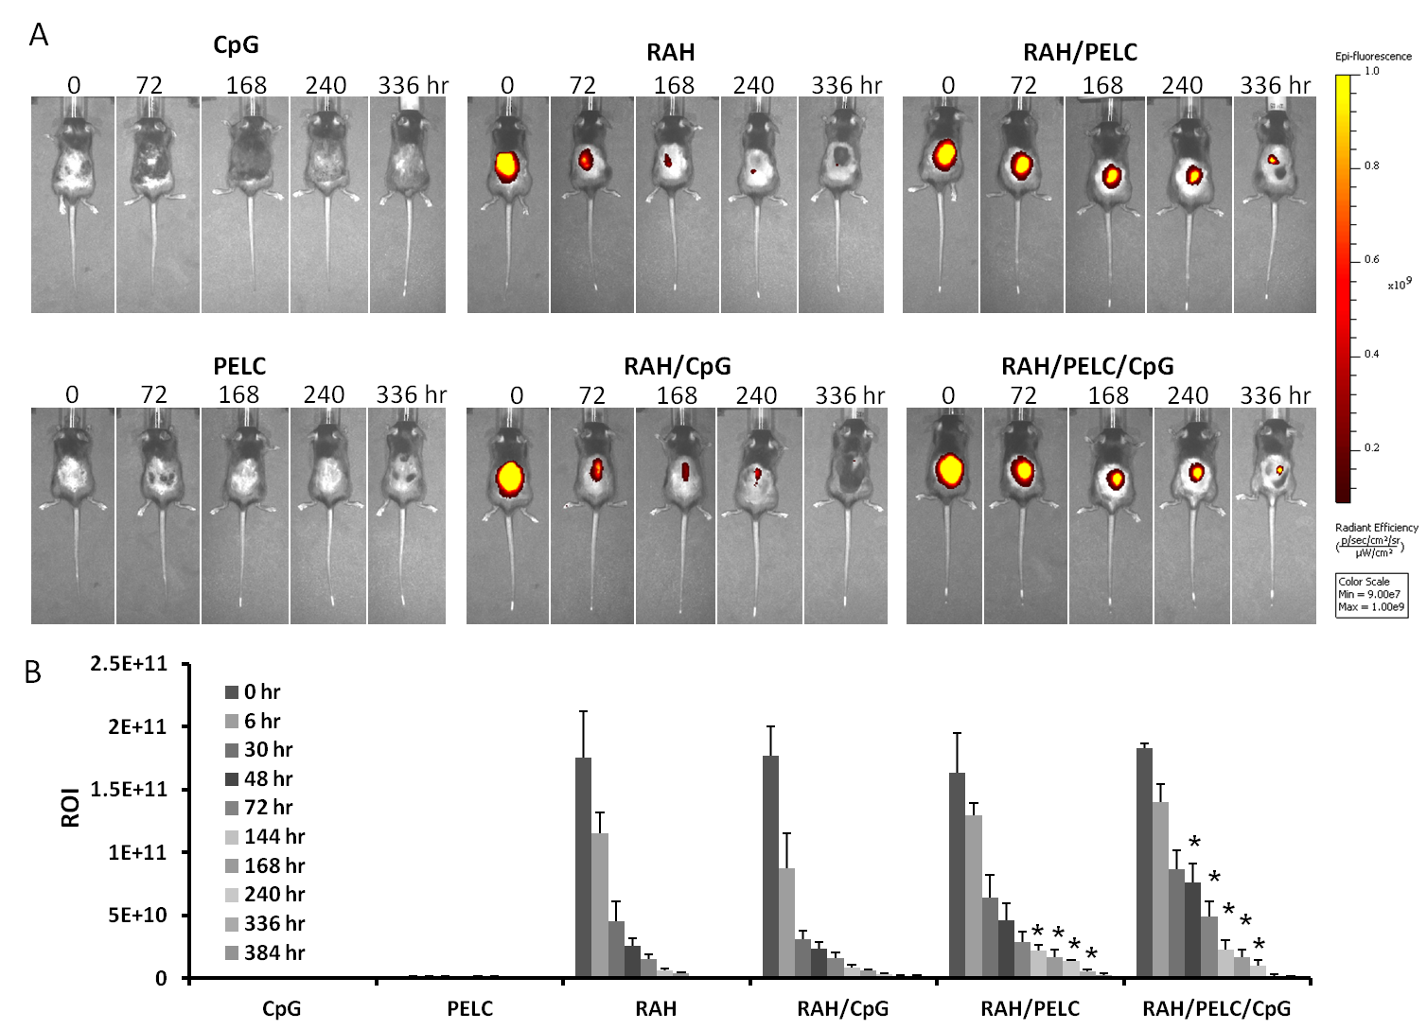Fig. 2. Release of PELC-formulated RAH-Alexa 647 in vivo. C57BL/6 mice were subcutaneously immunized with 50 μg of RAH-Alexa 647 combined with CpG (10 μg), PELC (10%) or both. (A) In-life fluorescence image was performed at different time course by using a Xenogen IVIS® Spectrum 200 Imaging System. (B) The fluorescent measurement and region of interest (ROI) were analyzed by using IVIS Living Image 4.0 software package. Data are expressed as the mean + SEM of three animals per group. * P < 0.05 versus RAH.

  - The RAH peptide formulated with PELC and/or CpG enhances specific CD8⁺ T cells
As we demonstrated that PELC nanoemulsion could prolong release of antigen, we will identify the immune response of antigen after formulation with PELC and combination with or without CpG. The immunogenicity of the RAH peptide antigen after formulation with PELC, CpG or PELC/CpG was determined in mice relative to the induction of the tumor antigen-specific CD8⁺ T cell response. The RAH peptide was formulated with various emulsion formulae or PBS and injected subcutaneously into C57BL/6 mice. After 7 days, splenocytes were isolated from the immunized mice and re-stimulated in vitro in the presence of RAH. Among the various formulations, we found that RAH formulated with PELC/CpG (RAH/PELC/CpG) induced the highest number of RAH-specific CD8⁺ T cells (0.32%) after immunization (Fig. 3A). However, there were no significant induction of RAH-specific CD8⁺ T cells in the immunization with the RAH peptide formulated with PELC or CpG alone compare to the RAH in PBS formulation (Fig. 3A). To further investigate the RAH-specific IFN-γ-secreting cells after immunization, the splenocytes from vaccinated mice were re-stimulated with RAH. We found that the number of specific IFN-γ-secreting cells was increased by immunization with RAH/PELC/CpG compared with RAH, RAH/PELC or RAH/CpG (Fig. 3B). Immunization with either RAH/PELC or RAH/CpG also resulted in slightly increased IFN-γ-secreting cells compared with RAH alone.
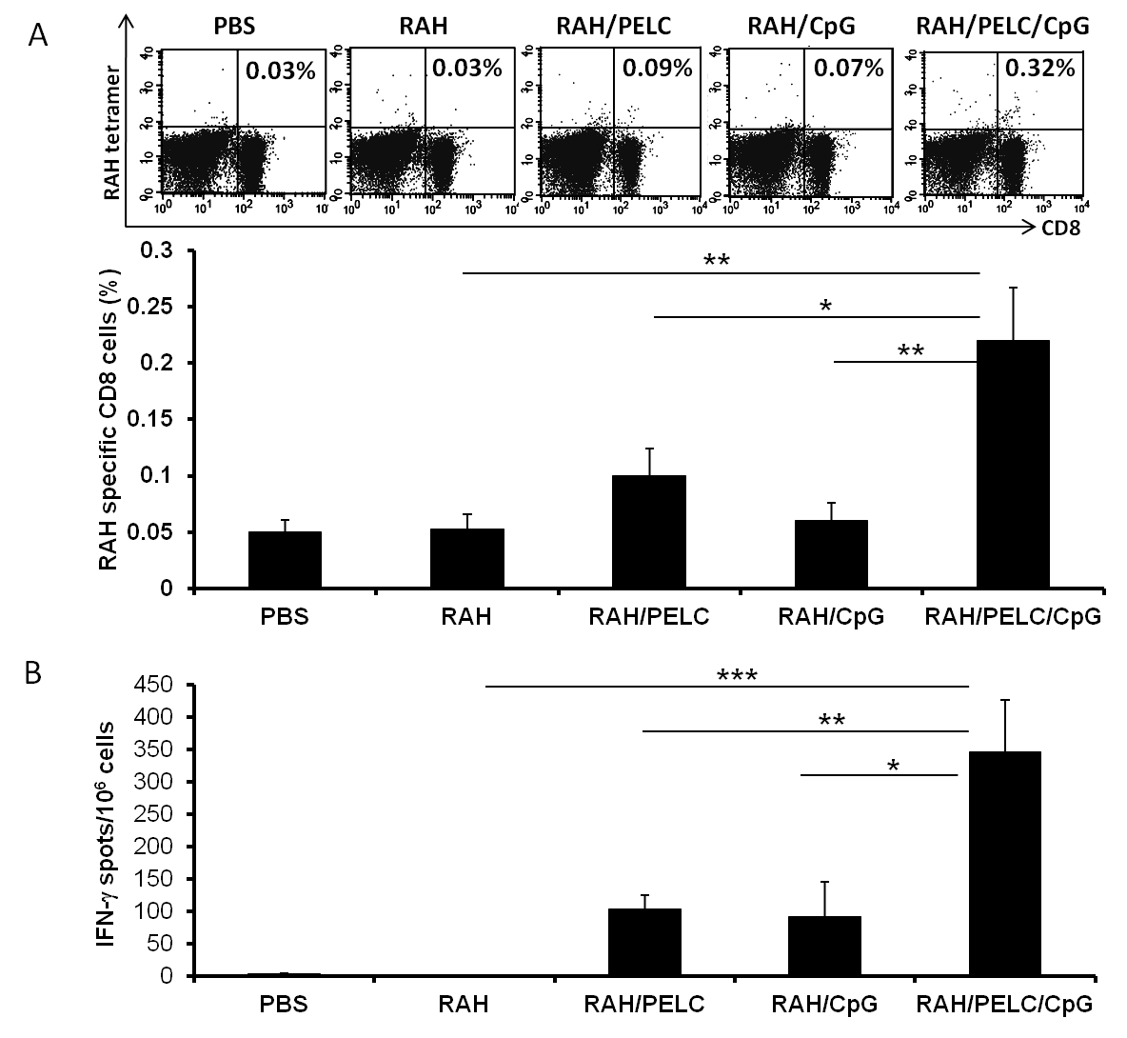Fig. 3. The RAH peptide formulated in PELC and CpG enhanced specific CD8⁺ T cells. Mice were subcutaneously administered a single injection with PBS, RAH (10 µg), RAH formulated in PELC (10%) (RAH/PELC), RAH admixed with CpG (10 µg) (RAH/CpG), or RAH formulated in PELC and CpG (RAH/PELC/CpG). (A) After 7 days, splenocytes were stained with a PE-conjugated RAH/MHC tetramer and FITC-labeled anti-CD8 antibody. The percentage of double-positive-staining cells relative to the total number of cells is indicated within each panel. In the down panel of Fig. 3A, the results are expressed as the mean + SEM of the percentage with double positive staining cells. (B) Splenocytes from immunized mice were stimulated with the RAH peptide (1 µg) and examined for IFN-γ-secreting cells with ELISPOT. Data are expressed as the mean + SEM of four animals per group. * P < 0.05, ** P < 0.01, *** P < 0.001.

  - The RAH peptide formulated with PELC and CpG elicits a CTL response
We additionally sought to study the efficiency of different formulations for inducing a specific CTL response. To this end, the CTL responses were detected using the in vivo CTL assay. Briefly, mice were immunized with RAH mixed with or without CpG in PELC adjuvant. Seven days later, the immunized mice were adoptively transferred with CFSE-labeled target cells for 18 h. The purpose of this assay is to evaluate whether immunized mice can kill peptide-pulsed cells specifically. Unvaccinated mice showed similar amounts of specific lysis as mice vaccinated with RAH peptide alone; RAH/PELC-immunized mice exhibited a mildly increased killing activity. In the presence of CpG ODN, the RAH peptide or RAH/PELC could induce strong cytotoxic effects (Fig. 4A). The percentages of specific lysis were 0.52, 0.26, 0.90, 14.69, and 64.84% in the Control, RAH, RAH/PELC, RAH/CpG, and RAH/PELC/CpG groups, respectively (Fig. 4B). This result indicates that PELC adjuvant combined with CpG synergistically elicits a CTL response when used in a peptide vaccine.
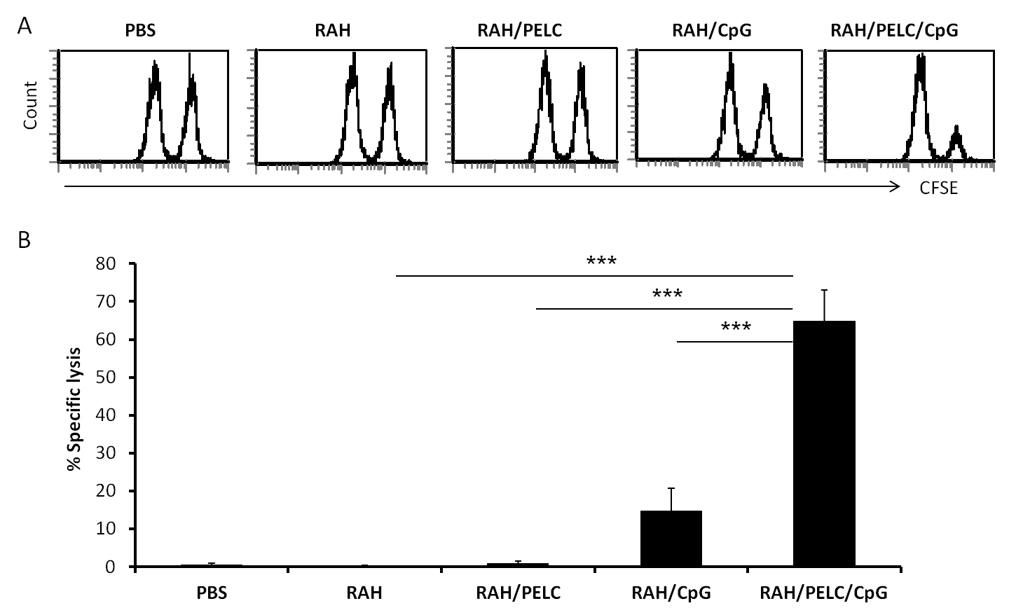Fig. 4. The RAH peptide formulated in PELC and CpG elicited a cytotoxic T cell response in vivo. Naïve spleen cells were pulsed with or without 5 µg/ml of RAH and then were stained with 10 µM CFSE or 1 µM of CFSE, respectively, for 15 minutes at 37°C. Both types of CFSE-labeled cells were injected into vaccinated mice, and after 18 h, the spleens were collected and analyzed by flow cytometry. The following equation was used to determine specific lysis: % Specific lysis = [(% non-peptide × A) - % RAH peptide]/ (% non-peptide × A). The experiment was repeated twice. Adjustment factor (A) = RAH peptide/ non-peptide from naïve controls. Data are expressed as the mean + SEM of four animals per group. *** P < 0.001.
  - The RAH peptide formulated with PELC and/or CpG induces an anti-tumor effect
To determine whether the higher CTL response reflected anti-tumor activity in vivo, different RAH formulations were injected once 7 days after tumor inoculation. We found that immunization with RAH/PELC or RAH/CpG delayed the tumor growth, but the tumor totally regressed in the group that had been immunized with RAH/PELC/CpG (Fig. 5A). The mice in the PBS control or RAH alone groups all dead before day 50 after tumor implantation. In contrast, the tumor-free survival rates were 30%, 50% and 100% for the RAH/PELC, RAH/CpG and RAH/PELC/CpG group, respectively (Fig. 5B). To extend the application of this formulation, recombinant mutant E7 protein (rE7m) was formulated with PELC/CpG (rE7m/PELC/CpG) to immunize mice once. Significant CD8⁺ T cell response and tumor regression were observed after administering rE7m/PELC/CpG compared to rE7m/PELC or rE7m/CpG (Supplemental Fig. 1). Taken together, PELC combined with CpG adjuvant in a peptide/protein vaccine provides a robust CTL response and anti-tumor activity.
Fig. 5. The RAH peptide formulated in PELC and CpG induced a large anti-tumor effect. TC-1 tumor-bearing mice (6 animals/group) received a single injection subcutaneously with PBS, RAH (10 µg), RAH formulated in PELC (10%) (RAH/PELC), RAH admixed with CpG (10 µg) (RAH/CpG), or RAH formulated in PELC and CpG (RAH/PELC/CpG). (A) The tumor volume is shown as length × width × width/2 (mm³). The data are expressed as the mean + SEM. (B) Tumor free survival rate was monitored over a 50-day post-tumor implantation period. Tumor-free mice were defined as having a non-enlarging mass <100 mm³ in volume.
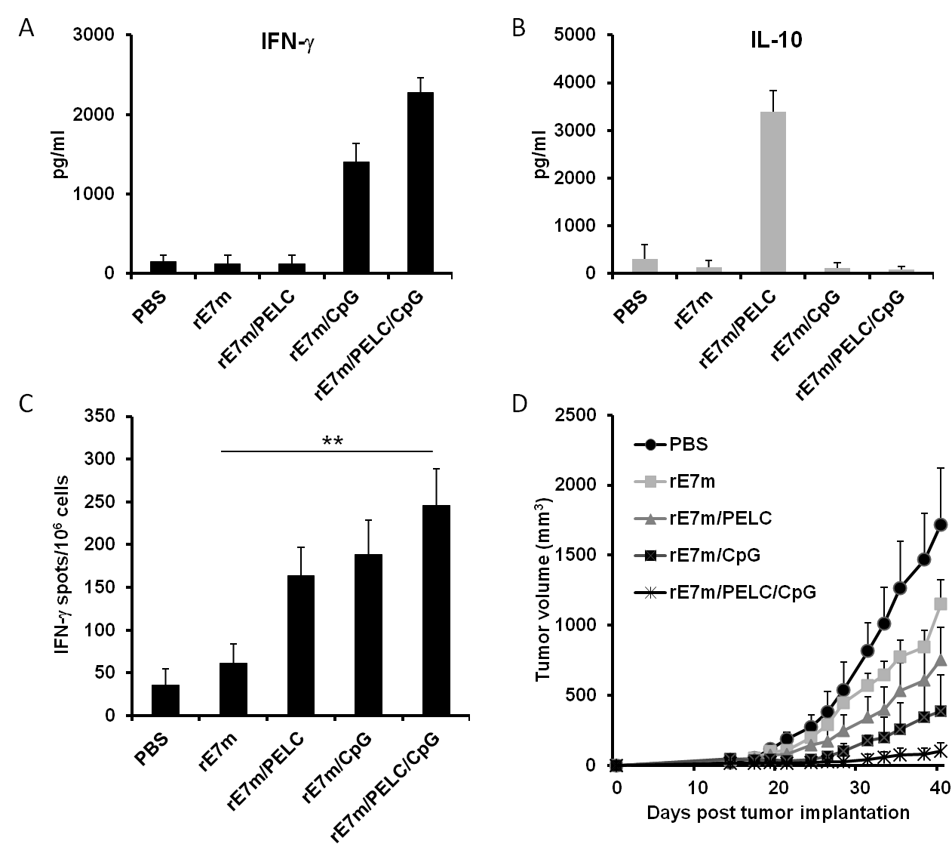Supplemental Fig. 1. rE7m antigen formulated in PELC and CpG enhanced high CD8 T cell immunity and anti-tumor effect. Mice were subcutaneously administered with PBS, rE7m (30 µg), rE7m formulated in PELC (10 %) (rE7m/PELC), rE7m admixed in CpG (10 µg) (rE7m/CpG), or rE7m formulated in PELC and CpG (rE7m/PELC/CpG). After two weeks, splenocytes were stimulated with the rE7m (10 µg) for 5 days and the levels of (A) IFN-γ and (B) IL-10 in the culture supernatant were measured by ELISA. Data are expressed as means + SEM of two animals per group. (C) Splenocytes from immunized mice were stimulated with the rE7m (10 µg) and examined for IFN-γ-secreting cells by ELISPOTs. Data are expressed as means + SEM of three animals per group. ** P < 0.01. (D) TC-1 tumor-bearing mice (6 animals/group) received a single injection with PBS, rE7m, rE7m/PELC, rE7m/CpG, or rE7m/PELC/CpG. The tumor diameters are shown (mm³). Data are expressed as means + SEM.
- Discussion
The use of synthetic peptides and proteins as vaccines is safe, but because of poor immunogenicity, adjuvants are critical for inducing protective immunity. Based on their effective mechanisms, adjuvants can be divided into two types-antigen delivery systems and immunopotentiators. The induction of CTL responses using a peptide immunogen is not easy in the absence of adjuvants. To induce CTLs for killing cancer cells, the use of both an antigen delivery system and an immunopotentiator might generate synergistic effects. In the present study, we showed that using a synthetic peptide derived from HPV16 E7 or the recombinant mutant E7 (rE7m) as the immunogen could induce a significant anti-tumor effect in the presence of PELC and CpG. These new formulations could be potentially therapeutic vaccines for HPV-associated cancers.
The development of a W/O/W emulsion-type adjuvant (PELC) for cancer immunotherapy. In theory, good antigen delivery systems are able to target antigen-presenting cells, such as dendritic cells, efficiently or prolong antigen presentation by preventing degradation. Antigen delivery systems include emulsion-type adjuvants and particulate-type adjuvants. An oil-in-water (O/W) emulsion-type adjuvant, MF59, has been used in flu vaccines, which has been shown to enhance antibody titers in an elderly population [36,37]. MF59 has the advantages of low oil content and high injectability when performing vaccination. Regarding the mechanisms of adjuvant action, MF59 possesses high efficiency to the induction of an early and strong cytokine- and chemokine-rich environment at the site of injection, and the beneficial of modulation of genes involved in leukocyte migration and antigen presentation [38]. The E7 protein formulated in MF59 can generate CTL responses against E7-expressing cells, but the anti-tumor effect in vivo has not been reported [39]. In addition, the combination of polylactide co-glycolide polymer (PLG) microparticles and MF59 induced CTL activity against HIV-1 p24 gag [40]. However, further studies of MF59 as an adjuvant for cancer immunotherapy are limited. In contrast, the water-in-oil (W/O) emulsion-type adjuvant possesses dispersed antigenic media and continuous oily phases. This type of adjuvant has been evaluated to ascertain the innocuity of the vaccine and to achieve long-term protective immune responses. However, conventional incomplete Freund's adjuvant (IFA) causes extensive tissue inflammations at the injection site, so IFA is restricted for research purposes to laboratory animals. Unlike W/O/W adjuvant PELC, W/O adjuvant IFA generate long-lived depots in the injection site that may lead to the trapping of tumor-specific CD8+ T cells at the injection site instead of promoting an effective T cell response at the tumor site as described in the literature [41]. The new generation of W/O adjuvant, MontanideTM ISA51 and ISA 720, has been used in clinical studies of cancer immunotherapy. The long peptides (23-45 amino acids) of HPV16 E6 and E7 formulated with ISA-51 induced strong T cells responses in a phase I clinical trial [42]. In a further evaluation of the therapeutic efficacy of this formulation, HPV16-positive women with high-grade vulvar intraepithelial neoplasia were evaluated. Nine of twenty vaccinated patients showed complete regression of all lesions and eradication of the virus [43,44]. These results showed that a peptide vaccine formulated with an emulsion-type adjuvant could generate strong T cell responses against an intraepithelial neoplasm. In the present study, PELC is a water-in-oil-in-water (W/O/W) emulsion-type adjuvant that is generally recognized as a more stable formulation [19]. It is probable that W/O/W not only reserved the depot effects intrinsic to W/O but also combined the antigen presentation effects belonging to O/W. Another advantage of the PELC formulation is that the pre-made emulsified PELC can simply be mixed with antigen before injection. This approach could reduce the potential for the incomplete emulsification of the vaccine because of the variability in individual compliance with procedures. Except for emulsion-type adjuvants, the peptides or proteins of HPV16 E7 have been incorporated into cationic liposomes, acid-degradable hydrogel particles [45] or virosomes [46] to treat established tumor models and have been shown to induce strong anti-tumor immunity [47-49]. These data demonstrated that an antigen delivery system adjuvant could be used to treat cancer. Here, our report showed that an easy-to-prepare PELC emulsion that was formulated with peptide enhanced the therapeutic effects of a cancer vaccine; in the presence of the TLR9 agonist (CpG) and PELC, the peptide formulation synergistically elicited anti-tumor immunity.
The incorporation of a TLR ligand in the PELC formulation enhanced anti-tumor activity. In addition to the delivery systems used in a vaccine adjuvant, the use of immunopotentiators as adjuvants also plays an important role in increasing the vaccine efficacy of immunogens, especially for peptides with poor immunogenicity. Immunopotentiators include cytokines (IL-2, GM-CSF) [46], chemokines (CCL5) [51], and innate receptor ligands (TLR2, TLR4 and TLR9) [52-54]. Because the innate receptors recognize conserved molecules expressed by a wide variety of infectious agents, using innate receptor ligands as adjuvants may mimic the natural infection of microbes. Currently, innate receptor ligands are recognized to be the new generation of adjuvants [55]. The TLR2 ligand, bacterial lipopeptide, has been used to manufacture Lyme disease vaccine (LYMErix™) [56] and was licensed by the FDA in 1998 for general use. The monophosphoryl lipid A (MPL) is a TLR4 ligand that has been combined with aluminum salt (known as AS04) for hepatitis B vaccine (FENDrix®) or HPV vaccine (Cervarix®) [57]. Most recently, the unmethylated CpG motif in bacterial DNA has been identified as a TLR9 ligand that stimulates endosomal TLR9 in antigen-presenting cells (i.e., DC or macrophage). The synthetic oligodeoxynucleotide (ODN) contains unmethylated cytosine-guanosine motifs (CpG) that are usually composed of a phosphorothioate nucleotide. The preclinical studies indicated that CpG has a good safety profile and improves the activity of vaccines targeting infectious diseases and cancer [58-64]. The Pan-DR Th epitope has been conjugated to a peptide of HPV16 E7 and formulated in a liposome and ISA-51 (called VacciMax®) with CpG and was shown to eradicate established tumors in vivo [65]. The combination therapy with cholera toxin-E7 fusion protein-pulsed DCs and the local treatment of the tumor with CpG was required for the complete eradication of cancer [66]. A new, low-dose, chemically stabilized form of the E7SOs (E7SOx) that has been combined with CpG as an adjuvant elicits a strong long-lasting protection against E7-expressed cancer [67]. Mansilla et al. reported that intravenous injection with the extracellular domain of fibronectin fused with E7, in combination with the TLR3 ligand, polyinosinic-polycytidylic acid (pIC), or CpG complexed with cationic lipids, was able to eradicate large established TC-1 tumors [68]. These promising results indicate that immunopotentiator CpG could be very useful as an adjuvant in cervical cancer immunotherapy.
- Conclusion
Our work presented here demonstrated that immunization of mice with the RAH peptide formulated with PELC or CpG alone induced specific CD8⁺ T cell responses and an anti-tumor effect. However, immunization with RAH/PELC mildly influenced the killing activity, presumably due to the difference in the induction times of the CD8⁺ T cell responses between immunization with RAH/PELC and RAH/CpG. Moreover, PELC-formulated peptide vaccine in the presence of CpG synergistically elicited a CTL response and inhibited tumor growth. This formulation may attenuate peptide degradation to protect the antigen and increase the half-life of the antigen. Taken together, we found that a peptide/protein antigen formulated with the novel emulsion-type adjuvant combined with an immune potentiator (TLR9 ligand) could induce strong CTL responses against cancer. The combination of an antigen delivery system and immunopotentiators is a superb strategy for the development of therapeutic tumor vaccines.
ACKNOWLEDGMENTS
This study was supported by grants from the National Health Research Institutes (VC-100-PP-04 to S.-J. Liu and VC-100-PP-05 to M.-H. Huang). The authors thank T-C- Wu at Johns Hopkins University for the TC-1 cells.

References:
[1] J.M. Walboomers, M.V. Jacobs, M.M. Manos, F.X. Bosch, J.A. Kummer, K.V. Shah, P.J. Snijders, J. Peto, C.J. Meijer, N. Munoz, Human papillomavirus is a necessary cause of invasive cervical cancer worldwide, J. Pathol. 189 (1999) 12-19.
[2] J. Paavonen, D. Jenkins, F.X. Bosch, P. Naud, J. Salmeron, C.M. Wheeler, S.N. Chow, D.L. Apter, H.C. Kitchener, X. Castellsague, N.S. de Carvalho, S.R. Skinner, D.M. Harper, J.A. Hedrick, U. Jaisamrarn, G.A. Limson, M. Dionne, W. Quint, B. Spiessens, P. Peeters, F. Struyf, S.L. Wieting, M.O. Lehtinen, G. Dubin, Efficacy of a prophylactic adjuvanted bivalent L1 virus-like-particle vaccine against infection with human papillomavirus types 16 and 18 in young women: an interim analysis of a phase III double-blind, randomised controlled trial, Lancet 369 (2007) 2161-2170.
[3] J. Paavonen, P. Naud, J. Salmeron, C.M. Wheeler, S.N. Chow, D. Apter, H. Kitchener, X. Castellsague, J.C. Teixeira, S.R. Skinner, J. Hedrick, U. Jaisamrarn, G. Limson, S. Garland, A. Szarewski, B. Romanowski, F.Y. Aoki, T.F. Schwarz, W.A. Poppe, F.X. Bosch, D. Jenkins, K. Hardt, T. Zahaf, D. Descamps, F. Struyf, M. Lehtinen, G. Dubin, Efficacy of human papillomavirus (HPV)-16/18 AS04-adjuvanted vaccine against cervical infection and precancer caused by oncogenic HPV types (PATRICIA): final analysis of a double-blind, randomised study in young women, Lancet 374 (2009) 301-314.
[4] B. Romanowski, P.C. de Borba, P.S. Naud, C.M. Roteli-Martins, N.S. De Carvalho, J.C. Teixeira, F. Aoki, B. Ramjattan, R.M. Shier, R. Somani, S. Barbier, M.M. Blatter, C. Chambers, D. Ferris, S.A. Gall, F.A. Guerra, D.M. Harper, J.A. Hedrick, D.C. Henry, A.P. Korn, R. Kroll, A.B. Moscicki, W.D. Rosenfeld, B.J. Sullivan, C.S. Thoming, S.K. Tyring, C.M. Wheeler, G. Dubin, A. Schuind, T. Zahaf, M. Greenacre, A. Sgriobhadair, Sustained efficacy and immunogenicity of the human papillomavirus (HPV)-16/18 AS04-adjuvanted vaccine: analysis of a randomised placebo-controlled trial up to 6.4 years, Lancet 374 (2009) 1975-1985.
[5] The FUTURE II Study Group, Quadrivalent vaccine against human papillomavirus to prevent high-grade cervical lesions, N. Engl. J. Med. 356 (2007) 1915-1927.
[6] S.M. Garland, M. Hernandez-Avila, C.M. Wheeler, G. Perez, D.M. Harper, S. Leodolter, G.W. Tang, D.G. Ferris, M. Steben, J. Bryan, F.J. Taddeo, R. Railkar, M.T. Esser, H.L. Sings, M. Nelson, J. Boslego, C. Sattler, E. Barr, L.A. Koutsky, Quadrivalent vaccine against human papillomavirus to prevent anogenital diseases, N. Engl. J. Med. 356 (2007) 1928-1943.
[7] N. Munoz, S.K. Kjaer, K. Sigurdsson, O.E. Iversen, M. Hernandez-Avila, C.M. Wheeler, G. Perez, D.R. Brown, L.A. Koutsky, E.H. Tay, P.J. Garcia, K.A. Ault, S.M. Garland, S. Leodolter, S.E. Olsson, G.W. Tang, D.G. Ferris, J. Paavonen, M. Steben, F.X. Bosch, J. Dillner, W.K. Huh, E.A. Joura, R.J. Kurman, S. Majewski, E.R. Myers, L.L. Villa, F.J. Taddeo, C. Roberts, A. Tadesse, J.T. Bryan, L.C. Lupinacci, K.E. Giacoletti, H.L. Sings, M.K. James, T.M. Hesley, E. Barr, R.M. Haupt, Impact of human papillomavirus (HPV)-6/11/16/18 vaccine on all HPV-associated genital diseases in young women, J. Natl. Cancer Inst. 102 (2010) 325-339.
[8] S. Motoyama, C.A. Ladines-Llave, S. Luis Villanueva, T. Maruo, The role of human papilloma virus in the molecular biology of cervical carcinogenesis, Kobe J. Med. Sci. 50 (2004) 9-19.
[9] M.A. Stanley, M.R. Pett, N. Coleman, HPV: from infection to cancer, Biochem. Soc. Trans. 35 (2007) 1456-1460.
[10] K. Hellner, K. Munger, Human papillomaviruses as therapeutic targets in human cancer, J. Clin. Oncol. 29 (2011) 1785-1794.
[11] J.H. Su, A. Wu, E. Scotney, B. Ma, A. Monie, C.F. Hung, T.C. Wu, Immunotherapy for cervical cancer: Research status and clinical potential, BioDrugs 24 (2010) 109-129.
[12] S.H. van der Burg, C.J. Melief, Therapeutic vaccination against human papilloma virus induced malignancies, Curr. Opin. Immunol. 23 (2011) 252-257.
[13] E.B. Lindblad, Aluminium adjuvants--in retrospect and prospect, Vaccine 22 (2004) 3658-3668.
[14] K. Lin, K. Doolan, C.F. Hung, T.C. Wu, Perspectives for preventive and therapeutic HPV vaccines, J. Formos. Med. Assoc. 109 (2010) 4-24.
[15] A. Pashine, N.M. Valiante, J.B. Ulmer, Targeting the innate immune response with improved vaccine adjuvants, Nat. Med. 11 (2005) S63-68.
[16] M. Singh, D. O'Hagan, Advances in vaccine adjuvants, Nat. Biotechnol. 17 (1999) 1075-1081.
[17] D.T. O'Hagan, Recent developments in vaccine delivery systems, In: M.M. Levine, J.B. Kaper, R. Rappuoli, M. Liu, M.F. Good, (Eds.) New Generation Vaccines, 3th ed. Marcel Dekker Inc., New York, 2004, pp. 259-270.
[18] E. Yuba, C. Kojima, A. Harada, Tana, S. Watarai, K. Kono, pH-Sensitive fusogenic polymer-modified liposomes as a carrier of antigenic proteins for activation of cellular immunity, Biomaterials 31 (2010) 943-951.
[19] M.H. Huang, A.H. Chou, S.P. Lien, H.W. Chen, C.Y. Huang, W.W. Chen, P. Chong, S.J. Liu, C.H. Leng, Formulation and immunological evaluation of novel vaccine delivery systems based on bioresorbable poly (ethylene glycol)-block-poly (lactide-co-epsilon-caprolactone), J. Biomed. Mater. Res. B. Appl. Biomater. 90 (2009) 832-841.
[20] M.H. Huang, C.Y. Huang, S.C. Lin, J.H. Chen, C.C. Ku, A.H. Chou, S.J. Liu, H.W. Chen, P. Chong, C.H. Leng, Enhancement of potent antibody and T-cell responses by a single-dose, novel nanoemulsion-formulated pandemic influenza vaccine, Microbes. Infect. 11 (2009) 654-660.
[21] M.H. Huang, S.C. Lin, C.H. Hsiao, H.J. Chao, H.R. Yang, C.C. Liao, P.W. Chuang, H.P. Wu, C.Y. Huang, C.H. Leng, S.J. Liu, H.W. Chen, A.H. Chou, A.Y. Hu, P. Chong, Emulsified nanoparticles containing inactivated influenza virus and CpG oligodeoxynucleotides critically influences the host immune responses in mice, PLoS One 5 (2010) e12279.
[22] B.C. Baudner, V. Ronconi, D. Casini, M. Tortoli, J. Kazzaz, M. Singh, L.D. Hawkins, A. Wack, D.T. O'Hagan, MF59 emulsion is an effective delivery system for a synthetic TLR4 agonist (E6020), Pharm. Res. 26 (2009) 1477-1485.
[23] M. Singh, G. Ott, J. Kazzaz, M. Ugozzoli, M. Briones, J. Donnelly, D.T. O'Hagan, Cationic microparticles are an effective delivery system for immune stimulatory cpG DNA, Pharm. Res. 18 (2001) 1476-1479.
[24] J.S. Thomann, B. Heurtault, S. Weidner, M. Brayé, J. Beyrath, S. Fournel, F. Schuber, B. Frisch, Antitumor activity of liposomal ErbB2/HER2 epitope peptide-based vaccine constructs incorporating TLR agonists and mannose receptor targeting, Biomaterials 32 (2011) 4574-4583.
[25] C.L. Cooper, H.L. Davis, M.L. Morris, S.M. Efler, M.A. Adhami, A.M. Krieg, D.W. Cameron, J. Heathcote, CPG 7909, an immunostimulatory TLR9 agonist oligodeoxynucleotide, as adjuvant to Engerix-B HBV vaccine in healthy adults: a double-blind phase I/II study, J. Clin. Immunol. 24 (2004) 693-701.
[26] S.A. Halperin, G. Van Nest, B. Smith, S. Abtahi, H. Whiley, J.J. Eiden, A phase I study of the safety and immunogenicity of recombinant hepatitis B surface antigen co-administered with an immunostimulatory phosphorothioate oligonucleotide adjuvant, Vaccine 21 (2003) 2461-2467.
[27] A.M. Krieg, Development of TLR9 agonists for cancer therapy, J. Clin. Invest. 117 (2007) 1184-1194.
[28] R.S. Chu, O.S. Targoni, A.M. Krieg, P.V. Lehmann, C.V. Harding, CpG oligodeoxynucleotides act as adjuvants that switch on T helper 1 (Th1) immunity, J. Exp. Med. 186 (1997) 1623-1631.
[29] R.D. Weeratna, M.J. McCluskie, Y. Xu, H.L. Davis, CpG DNA induces stronger immune responses with less toxicity than other adjuvants, Vaccine 18 (2000) 1755-1762.
[30] E. Erikci, M. Gursel, I. Gursel, Differential immune activation following encapsulation of immunostimulatory CpG oligodeoxynucleotide in nanoliposomes, Biomaterials 32 (2011) 1715-1723.
[31] C.Y. Huang, J.J. Chen, K.Y. Shen, L.S. Chang, Y.C. Yeh, I.H. Chen, P. Chong, S.J. Liu, C.H. Leng, Recombinant lipidated HPV E7 induces a Th-1-biased immune response and protective immunity against cervical cancer in a mouse model. PLoS One 7 (2012) e40970.
[32] M.H. Huang, C.Y. Huang, S.P. Lien, S.Y. Siao, A.H, Chou, H.W. Chen, S.J. Liu, C.H. Leng, P. Chong, Development of multi-phase emulsions based on bioresorbable polymers and oily adjuvant, Pharm. Res. 26 (2009) 1856-1862.
[33] J. Aucouturier, L. Dupuis, V. Ganne, Adjuvants designed for veterinary and human vaccines, Vaccine 19 (2001) 2666-2672.
[34] S.T. Reddy, M.A. Swartz, J.A. Hubbell, Targeting dendritic cells with biomaterials: developing the next generation of vaccines, Trends Immunol. 27 (2006) 573-579.
[35] A. Seubert, S. Calabro, L. Santini, B. Galli, A. Genovese, S. Valentini, S. Aprea, A. Colaprico, U. D'Oro, M.M. Giuliani, M. Pallaoro, M. Pizza, D.T. O'Hagan, A. Wack, R. Rappuoli, E. De Gregorio, Adjuvanticity of the oil-in-water emulsion MF59 is independent of Nlrp3 inflammasome but requires the adaptor protein MyD88. Proc. Natl. Acad. Sci. USA. 108 (2011) 11169-11174.
[36] V. Parodi, D. de Florentiis, M. Martini, F. Ansaldi, Inactivated influenza vaccines: recent progress and implications for the elderly, Drugs Aging 28 (2011) 93-106.
[37] W.E. Beyer, J.J. Nauta, A.M. Palache, K.M. Giezeman, A.D. Osterhaus, Immunogenicity and safety of inactivated influenza vaccines in primed populations: a systematic literature review and meta-analysis, Vaccine 29 (2011) 5785-5792.
[38] F. Mosca, E. Tritto, A. Muzzi, E. Monaci, F. Bagnoli, C. Iavarone, D. O'Hagan, R. Rappuoli, E. De Gregorio, Molecular and cellular signatures of human vaccine adjuvants. Proc. Natl. Acad. Sci. USA. 105 (2008) 10501-6.
[39] X. Zhu, M. Tommasino, K. Vousden, E. Sadovnikava, R. Rappuoli, L. Crawford, M. Kast, C.J. Melief, P.C. Beverley, H.J. Stauss, Both immunization with protein and recombinant vaccinia virus can stimulate CTL specific for the E7 protein of human papilloma virus 16 in H-2d mice, Scand. J. Immunol. 42 (1995) 557-563.
[40] D.T. O'Hagan, M. Ugozzoli, J. Barackman, M. Singh, J. Kazzaz, K. Higgins, T.C. Vancott, G. Ott, Microparticles in MF59, a potent adjuvant combination for a recombinant protein vaccine against HIV-1, Vaccine 18 (2000) 1793-1801.
[41] Y. Hailemichael, Z. Dai, N. Jaffarzad, Y. Ye, M.A. Medina, X.F. Huang, S.M. Dorta-Estremera, N.R. Greeley, G. Nitti, W. Peng, C. Liu, Y. Lou, Z. Wang, W. Ma, B. Rabinovich, K.S. Schluns, R.E. Davis, P. Hwu, W.W. Overwijk, Persistent antigen at vaccination sites induces tumor-specific CD8⁺ T cell sequestration, dysfunction and deletion. Nat. Med. 19 (2013) 465-472.
[42] G.G. Kenter, M.J. Welters, A.R. Valentijn, M.J. Lowik, D.M. Berends-van der Meer, A.P. Vloon, J.W. Drijfhout, A.R. Wafelman, J. Oostendorp, G.J. Fleuren, R. Offringa, S.H. van der Burg, C.J. Melief, Phase I immunotherapeutic trial with long peptides spanning the E6 and E7 sequences of high-risk human papillomavirus 16 in end-stage cervical cancer patients shows low toxicity and robust immunogenicity, Clin. Cancer Res. 14 (2008) 169-177.
[43] G.G. Kenter, M.J. Welters, A.R. Valentijn, M.J. Lowik, D.M. Berends-van der Meer, A.P. Vloon, F. Essahsah, L.M. Fathers, R. Offringa, J.W. Drijfhout, A.R. Wafelman, J. Oostendorp, G.J. Fleuren, S.H. van der Burg, C.J. Melief, Vaccination against HPV-16 oncoproteins for vulvar intraepithelial neoplasia, N. Engl. J. Me. 361 (2009) 1838-1847.
[44] C.J. Melief, Synthetic vaccine for the treatment of lesions caused by high risk human papilloma virus, Cancer J. 17 (2011) 300-301.
[45] T.T. Beaudette, E.M. Bachelder, J.A. Cohen, A.C. Obermeyer, K.E. Broaders, J.M. Frechet, E.S. Kang, I. Mende, W.W. Tseng, Davidson MG and Engleman EG: In vivo studies on the effect of co-encapsulation of CpG DNA and antigen in acid-degradable microparticle vaccines, Mol. Pharm. 6 (2009) 1160-1169.
[46] A.R. Kammer, M. Amacker, S. Rasi, N. Westerfeld, C. Gremion, D. Neuhaus, R. Zurbriggen, A new and versatile virosomal antigen delivery system to induce cellular and humoral immune responses, Vaccine 25 (2007) 7065-7074.
[47] Z. Cui, L. Huang, Liposome-polycation-DNA (LPD) particle as a carrier and adjuvant for protein-based vaccines: therapeutic effect against cervical cancer, Cancer Immunol. Immunother. 54 (2005) 1180-1190.
[48] W. Chen, W. Yan, L. Huang, A simple but effective cancer vaccine consisting of an antigen and a cationic lipid, Cancer Immunol. Immunother. 57 (2008) 517-530.
[49] W. Chen, L. Huang, Induction of cytotoxic T-lymphocytes and antitumor activity by a liposomal lipopeptide vaccine, Mol. Pharm. 5 (2008) 464-471.
[50] M.G. Tovey, C. Lallemand, Adjuvant activity of cytokines, Methods Mol. Biol. 626 (2010) 287-309.
[51] N. Lapteva, X.F. Huang, CCL5 as an adjuvant for cancer immunotherapy, Expert. Opin. Biol. Ther. 10 (2010) 725-733.
[52] M.S. Duthie, H.P. Windish, C.B. Fox, S.G. Reed, Use of defined TLR ligands as adjuvants within human vaccines, Immunol. Rev. 239 (2011) 178-196.
[53] E. Celis, Toll-like receptor ligands energize peptide vaccines through multiple paths, Cancer Res. 67 (2007) 7945-7947.
[54] J.T. Evans, C.W. Cluff, D.A. Johnson, M.J. Lacy, D.H. Persing, J.R. Baldridge, Enhancement of antigen-specific immunity via the TLR4 ligands MPL adjuvant and Ribi.529, Expert. Rev. Vaccines 2 (2003) 219-229.
[55] F. Steinhagen, T. Kinjo, C. Bode, D.M. Klinman, TLR-based immune adjuvants, Vaccine 29 (2011) 3341-3355.
[56] A.C. Steere, V.K. Sikand, F. Meurice, D.L. Parenti, E. Fikrig, R.T. Schoen, J. Nowakowski, C.H. Schmid, S. Laukamp, C. Buscarino, D.S. Krause, Vaccination against Lyme disease with recombinant Borrelia burgdorferi outer-surface lipoprotein A with adjuvant. Lyme Disease Vaccine Study Group, N. Engl. J. Med. 339 (1998) 209-215.
[57] N. Garcon, L. Segal, F. Tavares, M. Van Mechelen, The safety evaluation of adjuvants during vaccine development: the AS04 experience, Vaccine 29 (2011) 4453-4459.
[58] B. Burke, V.R. Gomez-Roman, Y. Lian, Y. Sun, E. Kan, J. Ulmer, I.K. Srivastava, S.W. Barnett, Neutralizing antibody responses to subtype B and C adjuvanted HIV envelope protein vaccination in rabbits, Virology 387 (2009) 147-156.
[59] D. Verthelyi, V.W. Wang, J.D. Lifson, D.M. Klinman, CpG oligodeoxynucleotides improve the response to hepatitis B immunization in healthy and SIV-infected rhesus macaques, AIDS 18 (2004) 1003-1008.
[60] G.J. Weiner, CpG oligodeoxynucleotide-based therapy of lymphoid malignancies, Adv. Drug Deliv. Rev. 61 (2009) 263-267.
[61] A. Carpentier, F. Laigle-Donadey, S. Zohar, L. Capelle, A. Behin, A. Tibi, N. Martin-Duverneuil, M. Sanson, L. Lacomblez, S. Taillibert, L. Puybasset, R. Van Effenterre, J.Y. Delattre, A.F. Carpentier, Phase 1 trial of a CpG oligodeoxynucleotide for patients with recurrent glioblastoma, Neuro. Oncol. 8 (2006) 60-66.
[62] P. Mukherjee, L.B. Pathangey, J.B. Bradley, T.L. Tinder, G.D. Basu, E.T. Akporiaye, S.J. Gendler, MUC1-specific immune therapy generates a strong anti-tumor response in a MUC1-tolerant colon cancer model, Vaccine 25 (2007) 1607-1618.
[63] G. Sen, Q. Chen, C.M. Snapper, Immunization of aged mice with a pneumococcal conjugate vaccine combined with an unmethylated CpG-containing oligodeoxynucleotide restores defective immunoglobulin G antipolysaccharide responses and specific CD4+-T-cell priming to young adult levels, Infect. Immun. 74 (2006) 2177-2186.
[64] C.C. Amaral, I.P. Garcia, G.F. Fernandes, S.R. Almeida, Z.P. Camargo, M.C. Souza, Adjuvant effect of synthetic oligodeoxyribonucleotides (CpG-ODN) from the Paracoccidioides brasiliensis gp43 gene on the Th2-Th1 immunomodulation of experimental paracoccidioidomycosis, Scand. J. Immunol. 62 (2005) 325-333.
[65] P. Daftarian, M. Mansour, A.C. Benoit, B. Pohajdak, D.W. Hoskin, R.G. Brown, W.M. Kast, Eradication of established HPV 16-expressing tumors by a single administration of a vaccine composed of a liposome-encapsulated CTL-T helper fusion peptide in a water-in-oil emulsion, Vaccine 24 (2006) 5235-5244.
[66] A.G. Chandy, M. Nurkkala, A. Josefsson, K. Eriksson, Therapeutic dendritic cell vaccination with Ag coupled to cholera toxin in combination with intratumoural CpG injection leads to complete tumour eradication in mice bearing HPV 16 expressing tumours, Vaccine 25 (2007) 6037-6046.
[67] M.L. Cerutti, L.G. Alonso, S. Tatti, G. de Prat-Gay, Long-lasting immunoprotective and therapeutic effects of a hyperstable E7 oligomer based vaccine in a murine human papillomavirus tumor model, Int. J. Cancer 130 (2012) 1813-1820.
[68] C. Mansilla, P. Berraondo, M. Durantez, M. Martinez, N. Casares, L. Arribillaga, F. Rudilla, J. Fioravanti, T. Lozano, L. Villanueva, P. Sarobe, F. Borras, C. Leclerc, J. Prieto, J.J. Lasarte, Eradication of large tumors expressing human papillomavirus E7 protein by therapeutic vaccination with E7 fused to the extra domain a from fibronectin, Int. J. Cancer 131 (2012) 641-651.

Figure captions:
Fig. 1. PELC-formulated peptide/protein vaccine. (A) The schematic representation of the PELC-formulated peptide/protein vaccine preparation. The preparation of PELC-adjuvanted peptide vaccine follows a two-step procedure that includes emulsification and dispersion. First, an aqueous solution containing PEG-b-PLACL and an oily phase consisting of squalene and Span®85 were homogenized to form a stable and isotropic emulsion, PELC. Next, the pre-emulsified stock was dispersed into a peptide/protein solution to form homogeneous nanoparticles in the second step. (B) Homogeneous fine particles were observed with an Olympus DP70 microscope and laser light scattering analysis. (C) Cumulative release of RAH peptide from the PELC formulation. RAH was formulated with or without 10% PELC (50 µg per 50 µl) and placed in a dialysis chamber in a eppendorf containing 1 ml ddH₂O. RAH release was monitored by the MicroBCA method. The data are presented as the mean + SD of four samples.
Fig. 2. Release of PELC-formulated RAH-Alexa 647 in vivo. C57BL/6 mice were subcutaneously immunized with 50 μg of RAH-Alexa 647 combined with CpG (10 μg), PELC (10%) or both. (A) In-life fluorescence image was performed at different time course by using a Xenogen IVIS® Spectrum 200 Imaging System. (B) The fluorescent measurement and region of interest (ROI) were analyzed by using IVIS Living Image 4.0 software package. Data are expressed as the mean + SEM of three animals per group. * P < 0.05 versus RAH.
Fig. 3. The RAH peptide formulated in PELC and CpG enhanced specific CD8⁺ T cells. Mice were subcutaneously administered a single injection with PBS, RAH (10 µg), RAH formulated in PELC (10%) (RAH/PELC), RAH admixed with CpG (10 µg) (RAH/CpG), or RAH formulated in PELC and CpG (RAH/PELC/CpG). (A) After 7 days, splenocytes were stained with a PE-conjugated RAH/MHC tetramer and FITC-labeled anti-CD8 antibody. The percentage of double-positive-staining cells relative to the total number of cells is indicated within each panel. In the down panel of Fig. 3A, the results are expressed as the mean + SEM of the percentage with double positive staining cells. (B) Splenocytes from immunized mice were stimulated with the RAH peptide (1 µg) and examined for IFN-γ-secreting cells with ELISPOT. Data are expressed as the mean + SEM of four animals per group. * P < 0.05, ** P < 0.01, *** P < 0.001.

Fig. 4. The RAH peptide formulated in PELC and CpG elicited a cytotoxic T cell response in vivo. Naïve spleen cells were pulsed with or without 5 µg/ml of RAH and then were stained with 10 µM CFSE or 1 µM of CFSE, respectively, for 15 minutes at 37°C. Both types of CFSE-labeled cells were injected into vaccinated mice, and after 18 h, the spleens were collected and analyzed by flow cytometry. The following equation was used to determine specific lysis: % Specific lysis = [(% non-peptide × A) - % RAH peptide]/ (% non-peptide × A). The experiment was repeated twice. Adjustment factor (A) = RAH peptide/ non-peptide from naïve controls. Data are expressed as the mean + SEM of four animals per group. *** P < 0.001.

Fig. 5. The RAH peptide formulated in PELC and CpG induced a large anti-tumor effect. TC-1 tumor-bearing mice (6 animals/group) received a single injection subcutaneously with PBS, RAH (10 µg), RAH formulated in PELC (10%) (RAH/PELC), RAH admixed with CpG (10 µg) (RAH/CpG), or RAH formulated in PELC and CpG (RAH/PELC/CpG). (A) The tumor volume is shown as length × width × width/2 (mm³). The data are expressed as the mean + SEM. (B) Tumor free survival rate was monitored over a 50-day post-tumor implantation period. Tumor-free mice were defined as having a non-enlarging mass <100 mm³ in volume.

