Full Mouth Dental Treatment Of A Child With Congenital Lipodystrophy :
A Case Report

Introduction :
Lipodystrophy syndromes represent a group of rare, heterogeneous disorders characterized by abnormal or degenerative conditions of the body's adipose tissue,frequently with fat accumulation in non-atrophic depots and ectopic sites such as liver and muscle. ^{1,2}
The disease could be classified into localized,partial and generalized lipoatrophy according to the severity. Congenital generalized lipodystrophy was first described in 1954 by Berardinelli and was further characterized by Seip, hence the eponym Berardinelli-Seip congenital lipodystrophy (BSCL).^{3,4} It is a rare disease,the estimated worldwide prevalence is 1 in 10 million population.It has been reported in approximately 250 patients of various ethnic origins.²
Congenital generalized lipodystrophy (CGL) patients are usually recognizable from birth, due to their extreme muscular appearance, which is caused by the absence of subcutaneous fat.⁵Genetic testing can help confirm the disease, as mutations in the AGPAT2 gene is indicative of type 1 CGL, a mutation in the BSCL2 gene is indicative of type 2 CGL, and mutations in the CAV1 and PTRF genes are indicative of type 3 CGL and type 4 CGL respectively.^{6,7,8}
The patient with lipodystrophy also suffered from metabolic disturbances such as insulin resistance with type 2 diabetes,acanthosis nigricans,hypertriglyceridaemia,
liver steatosis and hypertension.^{9,10}Women may be hirsute and this can be associated with the presence of polycystic ovarian syndrome (PCOS).⁹
The patient with specific type lipodystrophy might have problems of mandibulo-acral dysplasia . ³ The presence of dental abnormalities such as talon cusps, macrodontia, and aberrant tooth morphology has been described. The presence of such dental abnormalities may represent an interesting association with endocrine disturbances.¹¹
In our case ,the patient was suffered from type 2 CGL which has a greater likelihood of psychomotor retardation and intellectual impairment. ⁸
Case report :
A 3 year 8 months old girl came to our pediatric dentistry department of China Medical University hospital on 2011.12.26 for management regarding the early childhood caries.The chief complaints of the patient according to her mother include cavities on teeth and gingival bleeding.Her medical history revealed lipodystrophy (BSCL2 gene mutation) and mental retardation.She was suffered from gum and nasal
bleeding due to liver function impairment on 2011.02.26. The patient could not cooperate with us and could not understand us due to her mental retardation, consider about her condition of severe tooth decay and medical history of liver function impairment and mental retardation,dental treatment under general anesthesia was suggested . The appointment of full mouth dental treatment under general anesthesia was arranged on 2012.01.09.
Before treatment , both extra-oral and intra-oral examination was performed. Extra-oral examination showed hirsutism,musculinized and acromegaloid features, including enlargement of hands,feet, and jaw (Fig 1a).Intra-oral examination and periapical film showed early childhood caries with multiple residual roots.Her oral hygiene was very poor with plaque accumulation(Fig 2a-Fig 2e ; Fig 3a-3d).
Based on the results of the examination, a treatment plan was formulated as follows and performed on 2012.01.09(Fig 4a-Fig 4e;Fig5a-5d) :
- Teeth with caries without pulp involvement restored with light-cured composite resin : 54,55,64,65
- Stainless steel crown restoration or light-cured composite resin restoration after pulpectomy for teeth with deep and extended caries involve pulp : 53,63,73,74,75,83,84,85
- Removal of residual roots and unrestorable teeth and suture with 4-0 vicryl after gelfom application : 51,52,61,62,71,81
Healing within normal limit of the extraction wounds was observed 1 week after
full mouth dental treatment under general anesthesia.The patient was continually follower up for another 6 months at 3-month intervals. All the restoration and stainless steel crowns were intact without symptoms.
Discussion :
Congenital generalized lipodystrophy is a rare autosomal recessive hereditary disease , characterized by an extreme scarcity of fat in the subcutaneous tissues.^{12,13}
Since the possibility of mental retardation,the patient with congenital generalized lipodystrophy (especially type 2 CGL) might cannot cooperate during dental treatment. In our case,the patient cannot cooperate with daily tooth brushing and her oral hygiene is very poor,which is companied with early childhood caries.
Liver disease with fatty metamorphosis and cirrhosis is another constant feature, and hepatosplenomegaly tends to produce a markedly protuberant abdomen.
Childhood death due to massive GI bleeding has been reported frequently.
Diabetes mellitus usually begins in the teenage years. Occasionally, congenital anomalies of the heart, bones, and kidneys also are found. These patients have abnormal autonomic modulation, reflected by an increased heart rate and a pronounced reduction in heart rate variability.¹⁴
All the diseases associated lypodistrophy and the presence of dental abnormalities may influence our dental treatment ,we need to give more attendance to the possibility of bleeding tendency and hypoglycemia and consult other attending physicians before the dental treatment .Regarding to the dental abnormalities and acromegaloid features in some cases,long term follow up and consulting with plastic surgeon, oral surgeon, and orthodontist may be also needed.
Dental treatment of patient with congenital lipodystrophy can be complex and challenging . There are many factors including the mental problem and other medical problems such as metabolic disturbances,liver disease and abnormal facial features that we need to consider about during our treatment.

References :
- Herranz P, de Lucas R, Perez-España L, Mayor M. Lipodystrophy syndromes. Dermatol Clin. Oct 2008;26(4):569-78
- Abhimanyu Garg, M.D. Acquired and Inherited Lipodystrophies. N Engl J Med 2004; 350:1220-1234
- Berardinelli, W. An undiagnosed endocrinometabolic syndrome: report of 2 cases. Journal of Clinical Endocrinology and Metabolism. 1954;14:193-204.
- SeipM.&TrygstadO. Generalized lipodystrophy. Archives of Disease in Childhood. 1993;38:447-453.
- Khandpur, Sujay. Congenital generalized lipodystrophy of Berardinelli-Seip type: A rare case. Indian Journal Of Dermatology, Venereology And Leprology. October 16, 2012. p. 402.
- GargA.WilsonR.BarnesR.AriogluE.ZaidiZ.GurakanF.KocakN.O´RahillyS.TaylorS.I.PatelS.B.&BowcockA.M. A gene for congenital generalized lipodystrophy maps to human chromosome 9q34. Journal of Clinical Endocrinology and Metabolism 1999;84:3390-3394.
- AgarwalA.K.DeariogluE.A.S.AkkocN.TaylorS.I.BowcockA.M.BarnesR.I.&GargA. AGPAT2 is mutated in congenital generalized lipodystrophy linked to chromosome 9q34. Nature Genetics 2002; 31:21-23.
- Van Maldergem, Lionel. Berardinelli-Seip Congenital Lipodystrophy University of Washington, Seattle. Retrieved September 05, 2012.
- Houshang Monajemi, Erik Stroes, Robert A. Hegele, Eric Fliers. Inherited lipodystrophies and the metabolic syndrome.Clinical Endocrinology 2007; 67, 479 –484
- Viégas RF, Diniz RV, Viégas TM, Lira EB, Almeida DR. Cardiac involvement in total generalized lipodystrophy (Berardinelli- Seip syndrome) Arq. Bras. Cardiol. September 2000;75 (3): 243–8.
- Solanki M, Patil SS, Baweja DK, Noorani H, Pk S. Talon cusps, macrodontia, and aberrant tooth morphology in Berardinelli-Seip syndrome. Oral Surg Oral Med Oral Pathol Oral Radiol Endod. Jan 2008;105(1):e41-7.
- James, William D.; Berger, Timothy G.; et al.Andrews' Diseases of the Skin: clinical Dermatology. Saunders Elsevier 2006. p. 495.
- Rajab A, Khaburi M, Spranger S, Kunze J, Spranger J.Congenital generalized lipodystrophy, mental retardation, deafness, short stature, and slender bones: a newly recognized syndrome? Am J Med Genet A. Sep 1 2003;121A(3):271-6.
- Faria CA, Moraes RS, Sobral-Filho DC, Rego AG, Baracho MF, Egito ES, et al. Autonomic modulation in patients with congenital generalized lipodystrophy (Berardinelli-Seip syndrome). Europace. Apr 17 2009;

Full Mouth Dental Treatment Of A Child With Congenital Lipodystrophy :
A Case Report
圖片
1a 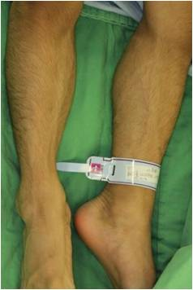
Fig.1a. Hirsutism,musculinized and acromegaloid features, including enlargement of hands,feet, and jaw
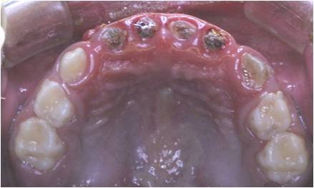2a
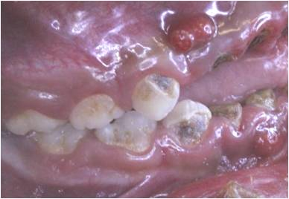2b 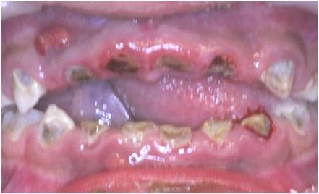2c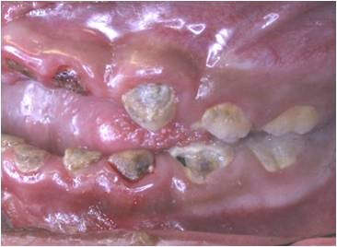 2d
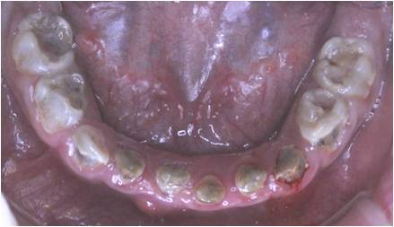2e
Fig. 2a~2e. Intraoral photograph before full mouth dental treatment under general anesthesia
3a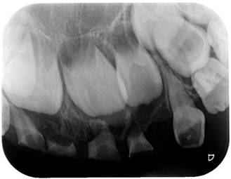3b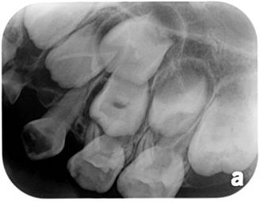3c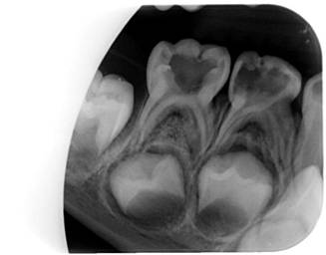3d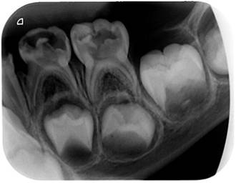
Fig. 3a~3d. Periapical film before full mouth dental treatment under general anesthesia

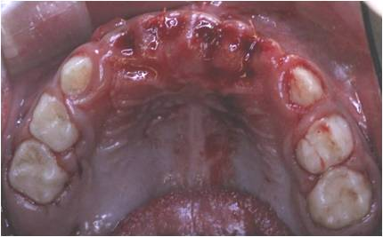4a
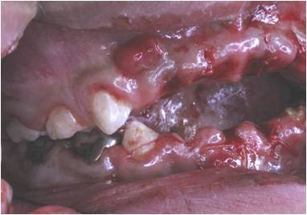4b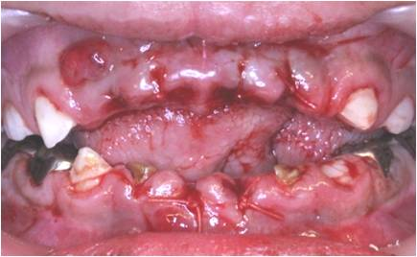4c4d
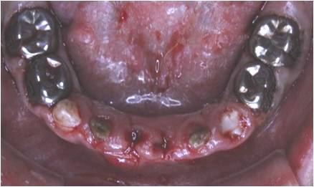4e
Fig. 4a~4e. Intraoral photograph after full mouth dental treatment under general anesthesia
5a 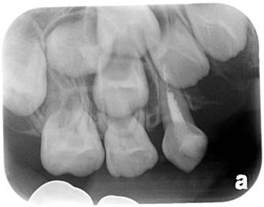5b 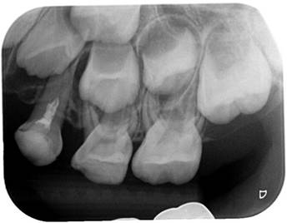5c 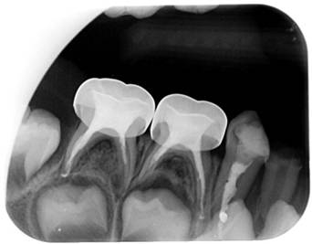5d 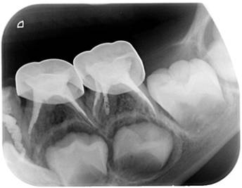
Fig. 5a~5d. Periapical film after full mouth dental treatment under general anesthesia

