Vitamin D Receptor Variability and Physical Activity are Jointly Associated with Low Handgrip Strength and Osteoporosis in Community-Dwelling Elderly People in Taiwan: The Taichung Community Health Study for Elders (TCHS-E)

Fang-Yang Wu, PhD^{#,1}, Chiu-Shong Liu, MD, MPH^{#,2,3}, Li-Na Liao, MSc¹, Chia-Ing Li, PhD^{3,4}, Chih-Hsueh Lin, MD^{2,3,5}, Chuan-Wei Yang, MPH^{4,5}, Nai-Hsin Meng, MD^{3,6}, Wen-Yuan Lin, MD, PhD^{2,3}, Chiu-Kai Chang, MD^{3,6}, Jen-Hao Hsiao, MPH⁷, Tsai-Chung Li, PhD*^{,8,9}, and Cheng-Chieh Lin, MD, PhD*^{,2,3}

¹Department of Public Health, College of Public Health, China Medical University, Taichung, Taiwan
²Department of Family Medicine, China Medical University Hospital, Taichung, Taiwan
³School of Medicine, College of Medicine, China Medical University, Taichung, Taiwan
⁴Department of Medical Research, China Medical University Hospital, Taichung, Taiwan
⁵Ph.D. Program for Aging, College of Medicine, China Medical University, Taichung, Taiwan
⁶Department of Physical Medicine and Rehabilitation, China Medical University Hospital, Taichung, Taiwan
⁷Bioinformatics and Biostatistics Core, Center of Genomic Medicine, National Taiwan University
⁸Graduate Institute of Biostatistics, College of Management, China Medical University, Taichung, Taiwan
⁹Department of Healthcare Administration, College of Health Science, Asia University, Taichung, Taiwan
#Equal contribution as the first author
*Corresponding authors: Cheng-Chieh Lin and Tsai-Chung Li; correspondence to Tsai-Chung Li, China Medical University, 91 Hsueh-Shih Road, Taichung, 40402, Taiwan, Tel: 886-4-22053366 ext. 6605, Fax: 886-4-22078539, e-mail: tcli@mail.cmu.edu.tw.
Summary
We studies 472 elders to assess joint association of vitamin D receptor (VDR) variability and physical activity on low handgrip strength (LHS) and osteoporosis (OST). Our findings showed higher risks of OST were associated with physically inactive elders with some specific VDR variations, highlighting the importance of promotion program for physical activity.
Abstract
Purpose: The aim of this study was to determine the joint association between vitamin D receptor (VDR) variability and physical activity on low handgrip strength (LHS) and osteoporosis (OST) in community-dwelling elders.
Methods: Bone mineral density (BMD) of the lumbar spine (LS), the femoral neck (FN), and the total hip (TH) were measured by Dual-energy X-ray absorptiometry. Four SNPs (rs7975232, rs1544410, rs2239185, and rs3782905) of the VDR gene were examined in 472 participants.
Results: Physical inactivity and each of the 4 SNPs were jointly associated with a significantly greater risk of LHS in people than that associated with each of the VDR SNPs or low physical activity alone. Physically inactive men with the AG or AA genotype of rs2239185 had a significantly greater risk of overall, LS, and FN OST than those of physically active men with the GG genotype (odds ratio [OR]: 3.57, 95% confidence interval [CI]: 1.10-11.65; OR: 4.74, 95% CI: 1.43-15.70; and OR: 5.06, 95% CI: 1.08-23.71, respectively). Similarly, physically inactive women with the CG or CC genotype of rs3782905 and the AG or AA genotype of rs1544410 had a significantly greater risk of FN OST than physically active women with the GG genotype (OR: 5.33, 95% CI: 1.23-23.06 and OR: 5.36, 95% CI: 1.11-25.94, respectively).

Conclusions: VDR polymorphisms and physical activity are jointly associated with LHS and OST in elders. Health care programs should promote physical activity among elders as a cost-effective way to prevent LHS and OST, especially in those who may be genetically predisposed.
Key words: VDR gene; SNP; physical activity; handgrip strength; osteoporosis; elders.

Introduction
The vitamin D receptor (VDR) gene is located in the chromosome 12q13 region. This receptor is the main receptor that binds 1α,25-dihydroxyvitamin D₃ [1,25(OH)₂D₃] [1]. Previous study proved 1,25(OH)₂D₃ once bound to its nuclear receptor, leading to changes in the gene transcription of mRNA and subsequent specific protein synthesis [2]. Most studies of VDR gene have focused on the 3' untranslated region (UTR), which include BsmI (tagSNP rs1544410), ApaI (tagSNP rs7975232), and TaqI [3-5]. These SNPs have been shown to be in high linkage disequilibrium (LD), and a part of the LD extended to the 3' UTR [5]. The correlations observed with the VDR SNPs could be illustrated by LD between these associated VDR SNPs and polymorphisms. Unusual non-synonymous variations in VDR cause vitamin D - resistant rickets, and more general variants promote variability in bone mineral density (BMD) and susceptibility to osteoporosis (OST) [6].
Genetic factors contribute significantly to the risk of low BMD, with heritability estimated at 63% to 79% [7]. Variability in the VDR gene is the most extensively studied genetic factor that affects BMD [8,9]. A previous study revealed a positive correlation between the VDR genotype and BMD, and that SNPs of the VDR gene may provide a hint to affect to low bone mass [10]. However, the evidence for an influence of the VDR polymorphism on bone density and OST in elderly is still controversial, with both positive and negative associations reported in various studies [11-13].
Aging is accompanied by a decrease in muscle strength and muscle mass, even in healthy elderly people [14,15]. Vitamin D deficiency is correlated with muscle weakness, and is common in elderly people [16]. Annweiler et al. reported a significant correlation between low serum vitamin D and low quadriceps [17] and handgrip [18] strength in community-dwelling women aged 75 years and older. Geusens et al. showed that non-obese women aged 70 years and older who had the BsmI bb genotype of the VDR gene had greater handgrip and quadriceps strength than those with the BB genotype [19].
Physical activity is an important modifiable risk factor for BMD and muscle strength. Previous cross-sectional and longitudinal studies have shown associations between physical activity and BMD, OST, and bone fracture in men [20,21] and premenopausal [20,22] and postmenopausal [20] women. Evidence from cross-sectional and longitudinal studies also suggests that physical activity increases muscle strength and physical performance [23,24]. Although previous studies among premenopausal women suggested that VDR polymorphisms mediate the effects of physical activity on BMD [25,26], the joint effect of physical activity and genetic factors on handgrip strength and OST have not been examined.
We hypothesized that the tag SNPs, rs7975232 (ApaI), rs1544410 (BsmI), rs2239185, and rs3782905 (Ddel) of the VDR gene are correlated with low handgrip strength (LHS) and an increased risk of OST. We also proposed that their effects would vary with changes in environmental factors, such as physical activity. In our current study, we investigated the joint effect of VDR genetic variants and physical activity on LHS and OST of the femoral neck (FN), lumbar spine (LS), and total hip (TH) in community-dwelling elderly people in Taiwan.
Methods
Study subjects
Our study was part of the Taichung Community Health Study for Elders. The details of our study design and the recruitment of participants have been described previously [27]. Four SNPs (rs7975232, rs1544410, rs2239185, and rs3782905) of the VDR gene were examined in 480 unrelated elderly people, and genotypes were obtained for 472 participants. The numbers of participants excluded from analysis due to missing data at LS, FN, and TH sites were 2, 3, and 5, respectively. One hundred and three participants with OST (36 men and 67 women) and 369 control participants (215 men and 154 women) were included in the current analysis. Our study was approved by the Human Research Committee of China Medical University Hospital. Signed, informed consent was obtained from each participant.
Measurements
A Tsutsumi TTM dynamometer (Tokyo, Japan) was used to evaluate isometric handgrip strength. The participants were in a standing position, arms at their side, not touching their body. The elbow was slightly bent. Each participant was asked to squeeze the dynamometer with as much force as possible, being careful to squeeze only once for each measurement. Three trials were conducted with a pause of 10-20 seconds to avoid the muscle fatigue. The result of each trial was recorded to the nearest kilogram. If the difference was within 3 kg, the test was complete. If the difference between any two measures was more than 3 kg, then we repeated the test once more after a rest period. We used the three best measurements as the data, and the average handgrip strength of each hand was calculated. The highest average handgrip strength between the left and right hands was used as the participant’s handgrip strength. We defined LHS as handgrip strength in the lowest quintile, based on sex and body mass index (BMI) subgroups, as described by Fried et al. [28].
Dual-energy X-ray absorptiometry (DXA) (GE-LUNAR DPX PRO, Lunar Corporation, Madison, WI, USA) was applied to measure the BMD (g/cm²) of the anteroposterior LS (L1-L4), left and right FN, and left and right TH. Whole-body DXA measurements were recorded with the participants lying supine, clad only in their underwear, with no metal items. The whole-body composition analysis provides data on various regions, such as the spine, the neck, the arms, the legs, and the torso. The DXA equipment was calibrated daily using a standardized phantom method. The lowest value of BMD between the left- and right-side measurements for the FNs and THs was used as each participant's FN BMD and TH BMD, respectively. The lowest value of BMD among LS, FN, and TH sites was defined as his/her overall BMD value. The overall and site-specific OSTs were defined as a BMD T score less than or equal to -2.5 standard deviations (SDs), according to the diagnostic criteria established by the World Health Organization [29].
Physical activity was defined as current participation in regular leisure-time activities for at least 30 min per week for at least 6 months. The sociodemographic and lifestyle characteristics and the self-reported health status for each participant were recorded using self-administered questionnaires. The BMI was calculated as body weight divided by height squared (kg/m²). Blood samples were collected in the morning after a 12-h fasting period, and were analyzed within 4-h of collection. The serum levels of triglycerides, high-density lipoprotein cholesterol (HDL-C), glucose, uric acid, and albumin were measured using a Synchron LX20 automatic blood analyzer (Beckman Coulter, Fullerton, CA, USA).
DNA preparation, SNP selection, and SNP genotyping
Genomic DNA was isolated from the blood samples using the QIAamp DNA Blood Kit (Qiagen, Chatsworth, CA, USA). The concentration of the purified DNA was quantified using a ND-2000c spectrophotometer (NanoDrop Technologies, Wilmington, DE, USA). We selected the rs7975232, rs1544410, rs2239185, and rs3782905 SNPs in the intron of VDR based on the findings for the CHB population in the International HapMap Project. The SNP genotyping was performed using an Illumina VeraCode GoldenGate genotyping assay (Illumina, San Diego, CA, USA). We also evaluated the risk of genotyping failure.
Statistical analysis
The demographic and clinical characteristics were examined, including age, sex, physical activity, and the biochemical variables. The continuous variables are reported as the mean ± SD, and the categorical variables are reported as the number and percentage of observations. Two-sample t tests, one-way analysis of variance, Chi-square tests, and the Fisher exact test were used for the bivariate analyses. Because the distribution of the triglycerides and high-sensitivity C-reactive protein levels were skewed, the data were normalized using a natural log-transformation, and the geometric mean ± SD of each was calculated. The bivariate analyses of the continuous and categorical data and the log-transformations were performed using the SAS, Version 9.3, computer software (SAS Institute, Cary, NC, USA). Statistical significance was set at a 2-sided P < .05. A Hardy-Weinberg equilibrium (HWE) analysis was performed using the PLINK, Version 1.07, computer software (http://pngu.mgh.harvard.edu/purcell/plink). The correlation coefficients (r²) between the SNPs were calculated to quantify pair-wise measures of LD using the Haploview, Version 4.2, computer software. A logistic-regression analysis with and without (crude model) adjustment for age, BMI, and physical activity was used to examine whether each SNP was associated with LHS and OST of the LS, FN, or TH using the PLINK software, and the odds ratios (ORs) and 95% confidence intervals (CIs) were calculated. Genotypic, additive, dominant, and recessive models were used for the single-SNP association analysis. Interactions between each SNP and physical activity were also examined.
Results
Demographic and clinical characteristics
The analysis of the demographic and clinical characteristics for the participants are summarized in Table 1. Our study included 103 elderly OST participants (36 men and 67 women) and 369 elderly control participants (215 men and 154 women). The BMI, the handgrip strength, the overall BMD, the LS BMD, the FN BMD, the TH BMD, and the physical activity were significantly lower among both men and women in the OST group, compared with those of the control group (P < .05 for all). The female OST participants also had significantly lower fasting plasma glucose and uric acid levels than those of the control group (P < .05).
Genotype and allele frequencies of variants in the VDR gene and their association with handgrip strength and BMD
The minor-allele frequency (MAF) of the 4 SNPs in the VDR gene were > 5.0% in our sample. The genotype frequencies for the men and women were compared. The frequencies of the AA genotype for rs7975232, rs1544410, and rs2239185 among women were 11.0%, 0.5%, and 7.3%, respectively. The frequencies of the AA genotype for rs7975232, rs1544410, and rs2239185 among men were 12.4%, 0.4%, and 12.4%, respectively. The frequences of the CC genotype of rs3782905 was 1.8% among women and 2.8% among men. No significant difference in sex was observed between the various VDR genotypes. The genotype frequencies of 4 VDR SNPs in men and women were in accordance with the Hardy-Weinberg equilibrium law in our sample using the genetic equilibrium test (all SNPs P > .05). According to the genotypes frequencies, the SNPs were in a weak LD (r² ≤ 0.13 for all). A strong allelic association between rs7975232 and rs2239185 was also determined (r² = 0.88). The handgrip strength of women carrying the AC genotype of rs7975232 was significantly lower than those of the CC genotype (P < .05) (Table 2).
Effect of VDR variation on LHS, overall OST, and site-specific OST
The logistic regression models were adjusted for age, BMI, and physical activity. The genotype and dominant models showed that genotype AC and allele A of rs7975232 was associated with an increased risk of LHS (crude OR: 2.51; 95% CI: 1.11-5.67 and crude OR: 2.21; 95% CI: 1.01-4.86, respectively) among women, respectively (Table 3). After the multivariate adjustments, the dominant model showed that women with the C allele of rs3782905 had a 2.23 times greater risk of overall OST, and a 2.60 times greater risk of FN OST.
The genotype model shows that the AA genotypes of rs7975232 and rs2239185 were each associated with an increased risk of LHS among men (adjusted OR: 3.63; 95% CI: 1.16-11.41 and adjusted OR: 3.45; 95% CI: 1.15-10.39, respectively). In the additive model, for every additional A allele of rs7975232 and rs2239185, the risk of LHS increased 2.05-fold (95% CI: 1.20-3.51) and 1.88-fold (95% CI: 1.11-3.18), respectively. In the dominant models, the A alleles of rs7975232 and rs2239185 were associated with a 3.09 (95% CI: 1.37-6.98) and a 2.27 (95% CI: 1.05-4.89) times greater risk of LHS, respectively (Table 3).
Joint effect of VDR variations and physical activity on the risk of LHS, overall OST, and site-specific OST
The analysis of LHS, overall OST, and site-specific OST were adjusted for age and BMI. In both physically inactive men and women, we observed that a markedly increase in odds ratio of LHS associated with increased number of minor allele of each VDR genotype (Figure 1). Physically inactive elders with the AC or AA genotype of rs7975232 had a significantly higher risk of LHS than those physically active elders with the CC genotype of rs7975232 (OR: 17.69, 95% CI: 4.79-65.38 in women and OR: 18.68, 95% CI: 5.23-66.67 in men in Figure 1, panels 1 and 5, respectively). Similarly, in both men and women, physically inactive elders carrying the AG or AA genotype of SNPs rs1544410 and rs2239185 had a significantly higher risk of LHS than those physically active elders carrying the GG genotype (OR: 8.37, 95% CI: 1.71-40.95; OR: 16.57, 95% CI: 4.44-61.83; OR: 31.14, 95% CI: 4.04-240.22; and OR: 15.99, 95% CI: 4.82-53.05, respectively; Figure 1, panels 2, 3, 6, and 7). The CG or CC genotype of rs3782905 was associated with a higher risk of LHS in physically inactive elders (OR: 9.13, 95% CI: 2.38-35.01 and OR: 5.72, 95% CI: 1.29-25.45, respectively; Figure 1, panels 4 and 8).
Physically inactive men carrying the AC or AA genotype of rs7975232 had a significantly greater risk of overall OST, LS OST, and FN OST than those of active men carrying the CC genotype (OR: 4.57, 95% CI: 1.35-15.42; OR: 5.95, 95% CI: 1.73-20.51; and OR: 6.18, 95% CI:1.29-29.65, respectively; Figure 2A, panels 1-3). Similarly, physically inactive men carrying the AG or AA genotype of rs2239185 had a significantly greater risk of overall OST, LS OST, and FN OST than those of active men carrying the GG genotype (OR: 3.57, 95% CI: 1.10-11.65; OR: 4.74, 95% CI: 1.43-15.70; and OR: 5.06, 95% CI:1.08-23.71, respectively; Figure 2A, panels 5-7; interaction of rs2239185 and physical activity at LS OST in elderly men: P < .05). The GG genotype of rs1544410 and rs3782905 was associated with a greater risk of LS OST in physically inactive men (OR: 2.88, 95% CI: 1.03-8.04 and OR: 3.74, 95% CI: 1.22-11.45, respectively; Figure 2A, panels 4 and 8).
Physically active women with the CG or CC genotype of rs3782905 had significantly greater risks of overall OST and TH OST than those of physically active women with the GG genotype (OR: 2.50, 95% CI: 1.15-5.47 and OR: 3.60, 95% CI: 1.02-12.69, respectively; Figure 2B, panels 1 and 3). In addition, the GG genotype of rs3782905 was associated with a greater risks of TH OST in physically inactive women (OR: 3.80, 95% CI: 1.11-13.05; Figure 2B, panel 3). Physically inactive women with the AG or AA genotype of rs1544410 and the CG or CC genotype of rs3782905 and had a significantly higher risk of FN OST than that of active women with the GG genotypes of each (OR: 5.33, 95% CI: 1.23-23.06 and OR: 5.36, 95% CI: 1.11-25.94, respectively; Figure 2B, panels 2 and 4).
Discussion
The most frequently studied polymorphisms of the VDR gene include ApaI (tagSNP rs7975232), BsmI (tagSNP rs1544410) and TaqI [3-5]. The rs7975232, rs1544410, and rs2239185 SNPs analyzed in our study were contained within 3' regulatory area and were in LD with 3' UTR polymorphisms [30]. The rs3782905 SNP is another intronic polymorphism [1], situated in intron 2, are noncoding and do not alter the amino acid sequence of the VDR protein [31,32]. Although these polymorphisms are not likely to be functional [1], they can be used as markers to examine a functional allele, owing to the LD. The 3' UTR region of the VDR gene is involved in the regulation of VDR expression [30]. Therefore, this gene polymorphism may play a key role in gene transcription or mRNA stability [10].
In our cohort study of apparently healthy Taiwanese community-dwelling elderly people, the distributions of rs7975232 (ApaI), rs1544410 (BsmI), rs2239185, and rs3782905 between the OST cases and the controls were similar for men and women (data not shown). Our results showed that an LD existed between the 4 SNPs, with strong allelic associations between rs7975232 and rs2239185 (r² = 0.88), and that a weaker LD existed between the other SNPs examined. Racial diversity has been shown to affect the frequency of gene polymorphisms [33]. Significantly different distributions of the minor allele (A) of rs7975232 (ApaI) have been reported for African (63-68%), Caucasian (57-60%), and Chinese (30-31%) populations (data available from the International HapMap Project, http://hapmap.ncbi.nlm.nih.gov; Data Rel 27 Phase II+III, Feb 09). The distribution of this allele variant was 31% in our Taiwanese cohort.
Morrison at al. first reported that the VDR genotype is a genetic marker of bone-density, and that variation in VDR may provide a hint to a predisposition to low bone mass [10]. Correlations between VDR polymorphisms and BMD have been reported for different populations [34,35]. However, other studies have not found such correlations [36,37]. A previous study demonstrated that a change in LS BMD was correlated with rs1544410 (BsmI) [38]. In addition, rs7975232 (ApaI) has been shown to be an independent polymorphism, and the CC genotype has been shown to be associated with higher LS BMD [39]. Furthermore, VDR alleles have been shown to have a weak effect on FN BMD and a stronger effect on LS BMD [40,41]. Our data showed that the mean LS and TH BMDs in elderly men with the CC or AA genotypes of rs7975232 were significantly higher than those of men with the AC genotype. However, we did not detect a similar influence in elderly women.
The conflicting findings of previous studies of the relationship between VDR genetic polymorphisms and BMD might be partially explained by insufficient sample size [42], the effects of LD with functionally vital genetic variants, or the influence of environmental factors that mediate the effects of genotype on BMD [43]. Some environmental factors, including physical activity, are associated with BMD levels [44]. However, the joint effect of genetics and physical activity on BMD has not been examined. Our study is the first to show that rs1544410 and low physical activity exert a joint effect on FN OST in elderly women, and that rs2239185 and low physical activity exert a joint effect on overall OST, FN OST, and LS OST in elderly men. Clear differences exist in the incidences of LHS and OST between men and women. Previous studies have shown that sex may be considered as an environmental factor that affects genotype-specific disease risk, and that sex may warrant substantial consideration in analyses of diseases with skewed sex ratios [45]. Our results are consistent with this finding.
Previous studies have shown that rs1544410 (BsmI) is associated with the strength of the quadriceps muscle and handgrip in non-obese elderly women [19]. In our study, we found that physical inactivity and each of the 4 VDR SNPs analyzed were jointly associated with LHS in elderly people. We also observed that an increasing number of the minor alleles of each VDR genotype was associated with a progressively increased risk of LHS in physically inactive elderly people. Thus, physically inactive elderly people with these VDR risk alleles are more likely to have LHS than their physically active counterparts. Furthermore, physically inactive elderly people with these VDR risk alleles are more likely to develop OST than physically active elderly people with or without these VDR risk alleles. Elderly people should be encouraged to engage in physical activity to prevent OST and LHS, especially those who may be genetically predisposed to these conditions.
In conclusion, VDR genetic polymorphisms and physical activity are jointly associated with LHS and OST in elderly people in Taiwan. Because the VDR SNPs analyzed in our study were tag SNPs with a LD in the literature, functional or non-coding variants in the 3' UTR of VDR may explain our associations. Health care programs should promote physical activity among elderly people as a cost-effective way to prevent LHS and OST, especially in those who may be genetically predisposed to these conditions.
Acknowledgments
This study was supported by grants from the National Health Research Institutes of Taiwan (NHRI-EX98-9838PI), China Medical University (CMU102-S-17), and the Taiwan Department of Health Clinical Trial and Research Center of Excellence (DOH102-TD-B-111-004).
Conflicts of interest
Fang-Yang Wu, Chiu-Shong Liu, Li-Na Liao, Chia-Ing Li, Chih-Hsueh Lin, Chuan-Wei Yang, Nai-Hsin Meng, Wen-Yuan Lin, Chiu-Kai Chang, Jen-Hao Hsiao, Tsai-Chung Li, and Cheng-Chieh Lin declare that they have no conflict of interest.
References
1. Haussler MR, Whitfield GK, Haussler CA, Hsieh JC, Thompson PD, Selznick SH, Dominguez CE, Jurutka PW (1998) The nuclear vitamin D receptor: biological and molecular regulatory properties revealed. Journal of bone and mineral research : the official journal of the American Society for Bone and Mineral Research 13 (3):325-349. doi:10.1359/jbmr.1998.13.3.325
2. Freedman LP (1999) Transcriptional targets of the vitamin D3 receptor-mediating cell cycle arrest and differentiation. The Journal of nutrition 129 (2S Suppl):581S-586S
3. Tsai KS, Hsu SH, Cheng WC, Chen CK, Chieng PU, Pan WH (1996) Bone mineral density and bone markers in relation to vitamin D receptor gene polymorphisms in Chinese men and women. Bone 19 (5):513-518
4. Lins TC, Vieira RG, Grattapaglia D, Pereira RW (2011) Population analysis of vitamin D receptor polymorphisms and the role of genetic ancestry in an admixed population. Genetics and molecular biology 34 (3):377-385. doi:10.1590/S1415-47572011000300003
5. Uitterlinden AG, Fang Y, Van Meurs JB, Pols HA, Van Leeuwen JP (2004) Genetics and biology of vitamin D receptor polymorphisms. Gene 338 (2):143-156. doi:10.1016/j.gene.2004.05.014
6. Holick MF (2003) Vitamin D: A millenium perspective. Journal of cellular biochemistry 88 (2):296-307. doi:10.1002/jcb.10338
7. Ng MY, Sham PC, Paterson AD, Chan V, Kung AW (2006) Effect of environmental factors and gender on the heritability of bone mineral density and bone size. Annals of human genetics 70 (Pt 4):428-438. doi:10.1111/j.1469-1809.2005.00242.x
8. Liu YZ, Liu YJ, Recker RR, Deng HW (2003) Molecular studies of identification of genes for osteoporosis: the 2002 update. The Journal of endocrinology 177 (2):147-196
9. Ferrari SL, Rizzoli R (2005) Gene variants for osteoporosis and their pleiotropic effects in aging. Molecular aspects of medicine 26 (3):145-167. doi:10.1016/j.mam.2005.01.002
10. Morrison NA, Qi JC, Tokita A, Kelly PJ, Crofts L, Nguyen TV, Sambrook PN, Eisman JA (1994) Prediction of bone density from vitamin D receptor alleles. Nature 367 (6460):284-287. doi:10.1038/367284a0
11. Melhus H, Kindmark A, Amer S, Wilen B, Lindh E, Ljunghall S (1994) Vitamin D receptor genotypes in osteoporosis. Lancet 344 (8927):949-950
12. Spector TD, Keen RW, Arden NK, Morrison NA, Major PJ, Nguyen TV, Kelly PJ, Baker JR, Sambrook PN, Lanchbury JS, et al. (1995) Influence of vitamin D receptor genotype on bone mineral density in postmenopausal women: a twin study in Britain. Bmj 310 (6991):1357-1360
13. Keen RW, Major PJ, Lanchbury JS, Spector TD (1995) Vitamin-D-receptor-gene polymorphism and bone loss. Lancet 345 (8955):990
14. Lexell J (1995) Human aging, muscle mass, and fiber type composition. J Gerontol A Biol Sci Med Sci 50 Spec No:11-16
15. Hurley BF (1995) Age, gender, and muscular strength. J Gerontol A Biol Sci Med Sci 50 Spec No:41-44
16. Gloth FM, 3rd, Gundberg CM, Hollis BW, Haddad JG, Jr., Tobin JD (1995) Vitamin D deficiency in homebound elderly persons. JAMA 274 (21):1683-1686
17. Annweiler C, Schott-Petelaz AM, Berrut G, Kressig RW, Bridenbaugh S, Herrmann FR, Beauchet O (2009) Vitamin D deficiency-related quadriceps weakness: results of the Epidemiologie De l'Osteoporose cohort. J Am Geriatr Soc 57 (2):368-369. doi:10.1111/j.1532-5415.2009.02118.x
18. Annweiler C, Beauchet O, Berrut G, Fantino B, Bonnefoy M, Herrmann FR, Schott AM (2009) Is there an association between serum 25-hydroxyvitamin D concentration and muscle strength among older women? Results from baseline assessment of the EPIDOS study. The journal of nutrition, health & aging 13 (2):90-95
19. Geusens P, Vandevyver C, Vanhoof J, Cassiman JJ, Boonen S, Raus J (1997) Quadriceps and grip strength are related to vitamin D receptor genotype in elderly nonobese women. Journal of bone and mineral research : the official journal of the American Society for Bone and Mineral Research 12 (12):2082-2088. doi:10.1359/jbmr.1997.12.12.2082
20. Morseth B, Emaus N, Wilsgaard T, Jacobsen BK, Jorgensen L (2010) Leisure time physical activity in adulthood is positively associated with bone mineral density 22 years later. The Tromso study. European journal of epidemiology 25 (5):325-331. doi:10.1007/s10654-010-9450-8
21. Vivanco-Munoz N, Jo T, Gerardo HB, Juan T, Clark P (2012) Physical activity and dark skin tone: protective factors against low bone mass in Mexican men. Journal of clinical densitometry : the official journal of the International Society for Clinical Densitometry 15 (3):374-379. doi:10.1016/j.jocd.2012.03.007
22. Englund U, Nordstrom P, Nilsson J, Bucht G, Bjornstig U, Hallmans G, Svensson O, Pettersson U (2011) Physical activity in middle-aged women and hip fracture risk: the UFO study. Osteoporosis international : a journal established as result of cooperation between the European Foundation for Osteoporosis and the National Osteoporosis Foundation of the USA 22 (2):499-505. doi:10.1007/s00198-010-1234-1
23. Ip EH, Church T, Marshall SA, Zhang Q, Marsh AP, Guralnik J, King AC, Rejeski WJ, Investigators L-PS (2013) Physical activity increases gains in and prevents loss of physical function: results from the lifestyle interventions and independence for elders pilot study. J Gerontol A Biol Sci Med Sci 68 (4):426-432. doi:10.1093/gerona/gls186
24. Tikkanen P, Nykanen I, Lonnroos E, Sipila S, Sulkava R, Hartikainen S (2012) Physical activity at age of 20-64 years and mobility and muscle strength in old age: a community-based study. J Gerontol A Biol Sci Med Sci 67 (8):905-910. doi:10.1093/gerona/gls005
25. Jarvinen TL, Jarvinen TA, Sievanen H, Heinonen A, Tanner M, Huang XH, Nenonen A, Isola JJ, Jarvinen M, Kannus P (1998) Vitamin D receptor alleles and bone's response to physical activity. Calcified tissue international 62 (5):413-417
26. Salamone LM, Glynn NW, Black DM, Ferrell RE, Palermo L, Epstein RS, Kuller LH, Cauley JA (1996) Determinants of premenopausal bone mineral density: the interplay of genetic and lifestyle factors. Journal of bone and mineral research : the official journal of the American Society for Bone and Mineral Research 11 (10):1557-1565. doi:10.1002/jbmr.5650111024
27. Lin CC, Li CI, Chang CK, Liu CS, Lin CH, Meng NH, Lee YD, Chen FN, Li TC (2011) Reduced health-related quality of life in elders with frailty: a cross-sectional study of community-dwelling elders in Taiwan. PLoS One 6 (7):e21841. doi:10.1371/journal.pone.0021841 PONE-D-11-02005 [pii]
28. Fried LP, Tangen CM, Walston J, Newman AB, Hirsch C, Gottdiener J, Seeman T, Tracy R, Kop WJ, Burke G, McBurnie MA (2001) Frailty in older adults: evidence for a phenotype. J Gerontol A Biol Sci Med Sci 56 (3):M146-156
29. Kanis JA (2007) Assessment of osteoporosis at the primary health-care level. World Health Organization Collaborating Centre for Metabolic Bone Diseases, University of Sheffield
30. Ingles SA, Haile RW, Henderson BE, Kolonel LN, Nakaichi G, Shi CY, Yu MC, Ross RK, Coetzee GA (1997) Strength of linkage disequilibrium between two vitamin D receptor markers in five ethnic groups: implications for association studies. Cancer epidemiology, biomarkers & prevention : a publication of the American Association for Cancer Research, cosponsored by the American Society of Preventive Oncology 6 (2):93-98
31. Engelman CD, Fingerlin TE, Langefeld CD, Hicks PJ, Rich SS, Wagenknecht LE, Bowden DW, Norris JM (2008) Genetic and environmental determinants of 25-hydroxyvitamin D and 1,25-dihydroxyvitamin D levels in Hispanic and African Americans. The Journal of clinical endocrinology and metabolism 93 (9):3381-3388. doi:10.1210/jc.2007-2702
32. Ochs-Balcom HM, Chennamaneni R, Millen AE, Shields PG, Marian C, Trevisan M, Freudenheim JL (2011) Vitamin D receptor gene polymorphisms are associated with adiposity phenotypes. The American journal of clinical nutrition 93 (1):5-10. doi:10.3945/ajcn.2010.29986
33. Ioannidis JP, Ntzani EE, Trikalinos TA (2004) 'Racial' differences in genetic effects for complex diseases. Nature genetics 36 (12):1312-1318. doi:10.1038/ng1474
34. Kurabayashi T, Tomita M, Matsushita H, Yahata T, Honda A, Takakuwa K, Tanaka K (1999) Association of vitamin D and estrogen receptor gene polymorphism with the effect of hormone replacement therapy on bone mineral density in Japanese women. American journal of obstetrics and gynecology 180 (5):1115-1120
35. Willing M, Sowers M, Aron D, Clark MK, Burns T, Bunten C, Crutchfield M, D'Agostino D, Jannausch M (1998) Bone mineral density and its change in white women: estrogen and vitamin D receptor genotypes and their interaction. Journal of bone and mineral research : the official journal of the American Society for Bone and Mineral Research 13 (4):695-705. doi:10.1359/jbmr.1998.13.4.695
36. Thakkinstian A, D'Este C, Eisman J, Nguyen T, Attia J (2004) Meta-analysis of molecular association studies: vitamin D receptor gene polymorphisms and BMD as a case study. Journal of bone and mineral research : the official journal of the American Society for Bone and Mineral Research 19 (3):419-428. doi:10.1359/JBMR.0301265
37. Zintzaras E, Rodopoulou P, Koukoulis GN (2006) BsmI, TaqI, ApaI and FokI polymorphisms in the vitamin D receptor (VDR) gene and the risk of osteoporosis: a meta-analysis. Disease markers 22 (5-6):317-326
38. Ferrari S, Rizzoli R, Chevalley T, Slosman D, Eisman JA, Bonjour JP (1995) Vitamin-D-receptor-gene polymorphisms and change in lumbar-spine bone mineral density. Lancet 345 (8947):423-424
39. Christensen MH, Apalset EM, Nordbo Y, Varhaug JE, Mellgren G, Lien EA (2013) 1,25-dihydroxyvitamin D and the vitamin D receptor gene polymorphism Apa1 influence bone mineral density in primary hyperparathyroidism. PLoS One 8 (2):e56019. doi:10.1371/journal.pone.0056019
40. Blimkie CJR, Chilibeck PD, Davison KS (1996) Bone mineralization patterns: reproductive endocrine, calcium, and physical activity influences during the life span. In: Bar-Or O, Lamb DR, Clarkson PM (eds) Perspectives in Exercise and Sports Medicine, vol 9. Exercise and the Female: A Life Span Approach. Carmel, IN : Cooper Pub. Group, pp 73-145
41. Wolff I, van Croonenborg JJ, Kemper HC, Kostense PJ, Twisk JW (1999) The effect of exercise training programs on bone mass: a meta-analysis of published controlled trials in pre- and postmenopausal women. Osteoporosis international : a journal established as result of cooperation between the European Foundation for Osteoporosis and the National Osteoporosis Foundation of the USA 9 (1):1-12
42. Houston LA, Grant SF, Reid DM, Ralston SH (1996) Vitamin D receptor polymorphism, bone mineral density, and osteoporotic vertebral fracture: studies in a UK population. Bone 18 (3):249-252
43. Ferrari SL, Rizzoli R, Slosman DO, Bonjour JP (1998) Do dietary calcium and age explain the controversy surrounding the relationship between bone mineral density and vitamin D receptor gene polymorphisms? Journal of bone and mineral research : the official journal of the American Society for Bone and Mineral Research 13 (3):363-370. doi:10.1359/jbmr.1998.13.3.363
44. Blanchet C, Giguere Y, Prud'homme D, Dumont M, Rousseau F, Dodin S (2002) Association of physical activity and bone: influence of vitamin D receptor genotype. Medicine and science in sports and exercise 34 (1):24-31
45. Naganathan V, Macgregor A, Snieder H, Nguyen T, Spector T, Sambrook P (2002) Gender differences in the genetic factors responsible for variation in bone density and ultrasound. Journal of bone and mineral research : the official journal of the American Society for Bone and Mineral Research 17 (4):725-733. doi:10.1359/jbmr.2002.17.4.725

Figure Legends
Figure 1. Adjusted odds ratios for low hand grip strength for 4 SNPs in the presence and absence of physical activity in women (Panels 1-4) and men (Panels 5-8). Adjusted odds ratio from model additionally considering age and BMI.
NA: not available.
*: P < .05; **: P < .01; ***: P < .001.

Figure 2A. Significant adjusted odds ratios of overall osteoporosis (OST) as well as OST at lumbar spine (LS), and femoral neck (FN) for SNPs rs7975232 (Panels 1-3) and rs2239185 (Panels 5-7), and OST at LS for SNPs rs1544410 (Panel 4) and rs3782905 (Panel 8) in the presence and absence of physical activity in men. Adjusted odds ratios were from model additionally considering age and BMI. Interaction of rs2239185 and physical activity at LS OST in elderly men was significant (P < .05).
*: P < .05; **: P < .01; ***: P < .001.

Figure 2B. Significant adjusted odds ratios of overall osteoporosis (OST) as well as OST at femoral neck (FN) and total hip (TH) for SNP rs3782905 (Panels 1-3) and OST at FN for SNP rs1544410 (Panel 4) in the presence and absence of physical activity in women. Adjusted odds ratios were from model additionally considering age and BMI.
*: P < .05; **: P < .01; ***: P < .001.

Table 1. Characteristics of study subjects according to osteoporosis status.
Characteristic | Women (n=221) |  |  | Men (n=251)
Characteristic | OST Cases | Controls |  | OST Cases | Controls
N (%) | 67 (30.3) | 154 (69.7) |  | 36 (14.3) | 215 (85.7)
Age (years) | 75.3 ± 6.1* | 71.7 ± 4.7* |  | 76.7 ± 7.3* | 74.4 ± 6.3*
BMI (kg/m²) | 21.7 ± 3.2* | 24.3 ± 3.1* |  | 20.6 ± 3.2* | 24.0 ± 2.9*
Handgrip strength (kg) | 18.6 ± 6.9* | 21.9 ± 4.3* |  | 29.7 ± 6.6* | 34.0 ± 5.8*
Bone mineral density (BMD, g/cm²)
Overall BMD | 0.604 ± 0.076* | 0.777 ± 0.101* |  | 0.635 ± 0.088* | 0.842 ± 0.120*
LS BMD | 0.770 ± 0.100* | 1.028 ± 0.135* |  | 0.887 ± 0.112* | 1.178 ± 0.195*
FN BMD | 0.613 ± 0.102* | 0.778 ± 0.101* |  | 0.641 ± 0.089* | 0.843 ± 0.121*
TH BMD | 0.663 ± 0.103* | 0.848 ± 0.107* |  | 0.691 ± 0.098* | 0.928 ± 0.135*
Behaviors
Physical activity | 43 (64.2)* | 124 (80.5)* |  | 25 (69.4)* | 184 (85.6)*
Smoking | 2 (3.0) | 5 (3.3) |  | 17 (47.2) | 76 (35.4)
Alcohol drinking | 4 (6.0) | 10 (6.5) |  | 12 (33.3) | 68 (31.6)
Biochemical marker
FPG (mmol/L) | 5.7 ± 1.0* | 6.0 ± 1.8* |  | 5.8 ± 1.2 | 6.0 ± 1.1
Total cholesterol (mmol/L) | 5.1 ± 0.8 | 5.2 ± 0.9 |  | 4.9 ± 1.0 | 4.9 ± 0.9
Triglycerides (mmol/L)# | 1.1 ± 1.6 | 1.2 ± 1.6 |  | 1.0 ± 1.7 | 1.1 ± 1.7
LDL-C (mmol/L) | 3.0 ± 0.7 | 3.0 ± 0.8 |  | 2.9 ± 0.8 | 3.0 ± 0.8
HDL-C (mmol/L) | 1.3 ± 0.4 | 1.3 ± 0.3 |  | 1.3 ± 0.5 | 1.1 ± 0.3
hs-CRP (nmol/L)# | 0.92 ± 2.93 | 1.03 ± 3.29 |  | 0.91 ± 3.28 | 1.03 ± 3.17
IL-6 (pg/mL) | 3.9 ± 4.5 | 3.6 ± 3.7 |  | 4.8 ± 5.1 | 4.2 ± 4.2
TNF-α (pg/mL) | 3.2 ± 4.8 | 3.5 ± 8.1 |  | 4.3 ± 6.9 | 5.2 ± 15.4
Albumin (g/L) | 42.6 ± 3.7 | 43.2 ± 3.1 |  | 42.0 ± 3.7 | 43.1 ± 3.3
Creatinine (μmol/L) | 79.4 ± 65.0 | 73.0 ± 63.4 |  | 93.2 ± 28.8 | 99.2 ± 54.5
eGFR (ml/min/1.73m²) | 77.0 ± 25.5 | 79.4 ± 20.5 |  | 76.9 ± 25.2 | 71.1 ± 18.7
BUN (mmol/L) | 5.7 ± 3.4 | 5.2 ± 2.2 |  | 5.9 ± 2.7 | 5.6 ± 2.2
Uric Acid (μmol/L) | 300.5 ± 74.0* | 331.2 ± 77.6* |  | 378.2 ± 122.3 | 378.0 ± 80.9
Disease History
Previous falls history | 18 (26.9) | 44 (28.6) |  | 9 (25.7) | 32 (14.9)
Hypertension | 25 (38.5) | 73 (48.0) |  | 14 (38.9) | 109 (51.2)
Diabetes | 5 (7.5) | 16 (10.5) |  | 7 (19.4) | 37 (17.5)
Hyperlipidemia | 16 (23.9) | 54 (35.8) |  | 4 (11.1) | 44 (21.4)
CVA | 5 (7.6) | 5 (3.3) |  | 3 (8.3) | 8 (3.9)
Cancer | 4 (6.1) | 9 (6.1) |  | 2 (5.7) | 10 (4.9)
Data were presented as mean±SD for continuous variables or n (%) for categorical variables.
OST: osteoporosis; BMI: body mass index; LS: lumbar spine; FN: femoral neck; TH: total hip; FPG: fasting plasma glucose; hs-CRP: high-sensitivity C-reactive protein; eGFR: estimated glomerular filtration rate; BUN: blood urea nitrogen; CVA: cerebral vascular accident.
#: Geometric mean was presented.
*: P < .05 between cases and controls.
Table 2. Genotype and allele distributions of study subjects as well as handgrip strength and bone mineral density distributions according to genotype status stratified by genderª.
SNP | Genotype or allele | n (%) | Handgrip strength (kg) |  | Bone mineral density (g/cm²)
 |  |  |  |  | Overall | LS | FN | TH
Women |  |  | (n=220) |  | (n=221) | (n=220) | (n=219) | (n=218)
rs7975232 | CC | 106 (50.5) | 21.7 ± 4.5 |  | 0.731 ± 0.118 | 0.943 ± 0.170 | 0.734 ± 0.116 | 0.798 ± 0.129
 | AC | 81 (38.6) | 19.6 ± 6.9^{b} |  | 0.713 ± 0.137 | 0.943 ± 0.175 | 0.721 ± 0.146 | 0.783 ± 0.152
 | AA | 23 (11.0) | 21.1 ± 3.3 |  | 0.732 ± 0.097 | 0.942 ± 0.138 | 0.734 ± 0.096 | 0.799 ± 0.111
 | C | 293 (69.8)
 | A* | 127 (30.2)
rs1544410 | GG | 189 (86.7) | 20.9 ± 5.1 |  | 0.724 ± 0.122 | 0.955 ± 0.173 | 0.726 ± 0.121 | 0.793 ± 0.132
 | AG | 28 (12.8) | 20.4 ± 7.6 |  | 0.737 ± 0.134 | 0.925 ± 0.180 | 0.756 ± 0.156 | 0.804 ± 0.161
 | AA | 1 (0.5) | 18.7 ± 0.0 |  | 0.488 ± 0.000 | 0.804 ± 0.000 | 0.488 ± 0.000 | 0.647 ± 0.000
 | G | 406 (93.1)
 | A* | 30 (6.9)
rs2239185 | GG | 111 (50.5) | 21.4 ± 4.9 |  | 0.732 ± 0.121 | 0.941 ± 0.173 | 0.74 ± 0.126 | 0.803 ± 0.136
 | AG | 93 (42.3) | 20.0 ± 6.2 |  | 0.708 ± 0.127 | 0.960 ± 0.182 | 0.709 ± 0.127 | 0.775 ± 0.139
 | AA | 16 (7.3) | 21.8 ± 3.3 |  | 0.760 ± 0.108 | 0.936 ± 0.128 | 0.761 ± 0.107 | 0.822 ± 0.106
 | G | 315 (71.6)
 | A* | 125 (28.4)
rs3782905 | GG | 149 (67.4) | 20.9 ± 5.4 |  | 0.733 ± 0.116 | 0.957 ± 0.168 | 0.738 ± 0.119 | 0.803 ± 0.127
 | CG | 68 (30.8) | 21.0 ± 5.6 |  | 0.709 ± 0.140 | 0.940 ± 0.181 | 0.711 ± 0.141 | 0.775 ± 0.153
 | CC | 4 (1.8) | 19.2 ± 1.0 |  | 0.671 ± 0.061 | 0.815 ± 0.200 | 0.694 ± 0.076 | 0.722 ± 0.097
 | G | 366 (82.8)
 | C* | 76 (17.2)
Men |  |  | (n=250) |  | (n=251) | (n=250) | (n=250) | (n=249)
rs7975232 | CC | 119 (49.2) | 34.4 ± 5.9 |  | 0.824 ± 0.138 | 1.164 ± 0.225 | 0.826 ± 0.136 | 0.910 ± 0.149
 | AC | 93 (38.4) | 32.6 ± 6.6 |  | 0.802 ± 0.138 | 1.105 ± 0.194 | 0.803 ± 0.138 | 0.882 ± 0.161
 | AA | 30 (12.4) | 32.7 ± 5.3 |  | 0.811 ± 0.140 | 1.148 ± 0.204 | 0.813 ± 0.143 | 0.885 ± 0.153
 | C | 331 (68.4)
 | A* | 153 (31.6)
rs1544410 | GG | 220 (88.7) | 33.5 ± 6.3 |  | 0.815 ± 0.137 | 1.141 ± 0.212 | 0.817 ± 0.136 | 0.899 ± 0.154
 | AG | 27 (10.9) | 32.9 ± 4.7 |  | 0.788 ± 0.145 | 1.100 ± 0.212 | 0.791 ± 0.149 | 0.854 ± 0.155
 | AA | 1 (0.4) | 25.3 ± 0.0 |  | 0.766 ± 0.000 | 1.120 ± 0.000 | 0.766 ± 0.000 | 0.822 ± 0.000
 | G | 467 (94.2)
 | A* | 29 (5.8)
rs2239185 | GG | 120 (48.0) | 34.2 ± 6.0 |  | 0.823 ± 0.138 | 1.164 ± 0.225 | 0.824 ± 0.136 | 0.907 ± 0.150
 | AG | 99 (39.6) | 32.6 ± 6.4 |  | 0.804 ± 0.140 | 1.106 ± 0.198 | 0.806 ± 0.141 | 0.886 ± 0.164
 | AA | 31 (12.4) | 33.1 ± 5.6 |  | 0.797 ± 0.128 | 1.137 ± 0.192 | 0.797 ± 0.128 | 0.867 ± 0.139
 | G | 339 (67.8)
 | A* | 161 (32.2)
rs3782905 | GG | 186 (74.4) | 33.7 ± 6.3 |  | 0.815 ± 0.133 | 1.132 ± 0.198 | 0.817 ± 0.132 | 0.892 ± 0.147
 | CG | 57 (22.8) | 33.0 ± 5.6 |  | 0.806 ± 0.146 | 1.148 ± 0.235 | 0.806 ± 0.145 | 0.904 ± 0.170
 | CC | 7 (2.8) | 30.0 ± 6.9 |  | 0.775 ± 0.187 | 1.151 ± 0.364 | 0.775 ± 0.187 | 0.850 ± 0.231
 | G | 429 (85.8)
 | C* | 71 (14.2)
Data were presented as n (%) for genotypes and alleles or mean±SD for handgrip strength and bone mineral density.
LS: lumbar spine; FN: femoral neck; TH: total hip.
*: Minor allele.
a: All P > .05 from Hardy-Weinberg Equilibrium test.
b: P < .05 for comparing with CC genotype using Bonferroni multiple comparison tests.

Table 3. Comparison of LHS, overall OST, and FN OST among the genotype, additive, dominant and recessive models.
SNP | Genotype or minor allele | LHS |  |  | Overall OST |  |  | OST at FN
SNP | Genotype or minor allele | COR (95% CI) | AOR (95% CI)ª |  | COR (95% CI) | AOR (95% CI)ª |  | COR (95% CI) | AOR (95% CI)ª
Women |  | (n=220) |  |  | (n=221) |  |  | (n=219)
Genotype model
rs7975232^{c} | AC | 2.51 (1.11, 5.67)* | 2.09 (0.80, 5.51) |  | 1.14 (0.61, 2.14) | 1.01 (0.49, 2.09) |  | 1.69 (0.73, 3.88) | 1.56 (0.62, 3.90)
 | AA | 1.30 (0.33, 5.07) | 3.19 (0.69, 14.71) |  | 0.85 (0.31, 2.37) | 0.87 (0.29, 2.63) |  | 0.75 (0.16, 3.59) | 0.92 (0.18, 4.67)
rs1544410^{c} | AG | 1.25 (0.44, 3.58) | 0.98 (0.29, 3.35) |  | 1.62 (0.71, 3.68) | 1.60 (0.61, 4.21) |  | 1.86 (0.69, 5.07) | 1.80 (0.60, 5.41)
 | AA | － | － |  | － | － |  | － | －
rs2239185^{c} | AG | 1.96 (0.91, 4.23) | 2.02 (0.81, 5.01) |  | 1.03 (0.57, 1.86) | 0.94 (0.48, 1.86) |  | 1.82 (0.84, 3.94) | 1.78 (0.77, 4.12)
 | AA | 1.08 (0.22, 5.28) | 3.00 (0.51, 17.49) |  | 0.75 (0.23, 2.51) | 0.89 (0.25, 3.21) |  | 0.50 (0.06, 4.08) | 0.68 (0.08, 5.90)
rs3782905^{c} | CG | 0.63 (0.27, 1.47) | 0.65 (0.24, 1.78) |  | 1.64 (0.89, 3.03) | 2.02 (0.99, 4.11) |  | 2.22 (1.03, 4.78)* | 2.80 (1.19, 6.63)*
 | CC | － | － |  | 8.46 (0.85, 83.76) | 9.30 (0.86, 100.90) |  | － | －
Additive model
rs7975232 | A | 1.44 (0.84, 2.45) | 1.88 (0.95, 3.70) |  | 1.00 (0.64, 1.54) | 0.96 (0.59, 1.56) |  | 1.11 (0.62, 1.97) | 1.15 (0.61, 2.17)
rs1544410 | A | 1.13 (0.42, 3.07) | 0.95 (0.29, 3.19) |  | 1.85 (0.87, 3.97) | 2.03 (0.85, 4.86) |  | 2.38 (0.99, 5.72) | 2.61 (1.00, 6.82)
rs2239185 | A | 1.38 (0.78, 2.43) | 1.86 (0.91, 3.78) |  | 0.94 (0.59, 1.50) | 0.94 (0.56, 1.58) |  | 1.18 (0.66, 2.12) | 1.26 (0.66, 2.41)
rs3782905 | C | 0.57 (0.25, 1.29) | 0.62 (0.23, 1.63) |  | 1.87 (1.08, 3.22)* | 2.25 (1.20, 4.21)* |  | 1.68 (0.85, 3.32) | 2.00 (0.95, 4.24)
Dominant model
rs7975232 | A | 2.21 (1.01, 4.86)* | 2.26 (0.90, 5.67) |  | 1.08 (0.60, 1.94) | 0.98 (0.50, 1.90) |  | 1.46 (0.65, 3.26) | 1.40 (0.59, 3.36)
rs1544410 | A | 1.20 (0.42, 3.41) | 0.97 (0.28, 3.29) |  | 1.77 (0.79, 3.94) | 1.86 (0.73, 4.76) |  | 2.17 (0.84, 5.64) | 2.23 (0.78, 6.38)
rs2239185 | A | 1.82 (0.86, 3.85) | 2.10 (0.87, 5.10) |  | 0.98 (0.55, 1.75) | 0.93 (0.49, 1.78) |  | 1.59 (0.74, 3.41) | 1.62 (0.71, 3.68)
rs3782905 | C | 0.59 (0.25, 1.37) | 0.63 (0.23, 1.71) |  | 1.80 (0.99, 3.27) | 2.23 (1.11, 4.46)* |  | 2.06 (0.96, 4.42) | 2.60 (1.11, 6.13)*
Recessive model
rs7975232 | A | 0.81 (0.23, 2.91) | 2.27 (0.54, 9.55) |  | 0.81 (0.30, 2.15) | 0.87 (0.30, 2.53) |  | 0.58 (0.13, 2.63) | 0.76 (0.16, 3.69)
rs1544410 | A | － | － |  | － | － |  | － | －
rs2239185 | A | 0.76 (0.17, 3.52) | 2.08 (0.39, 11.15) |  | 0.75 (0.23, 2.40) | 0.91 (0.26, 3.19) |  | 0.37 (0.05, 2.89) | 0.52 (0.06, 4.27)
rs3782905 | C | － | － |  | 7.17 (0.73, 70.25) | 7.22 (0.68, 77.08) |  | － | －
Men |  | (n=250) |  |  | (n=251) |  |  | (n=250)
Genotype model
rs7975232^{c} | AC | 2.26 (1.10, 4.63)* | 2.92 (1.23, 6.94)* |  | 1.68 (0.78, 3.61) | 1.77 (0.76, 4.15) |  | 2.50 (0.89, 7.05) | 2.62 (0.83, 8.23)
 | AA | 2.50 (0.94, 6.61) | 3.63 (1.16, 11.41)* |  | 1.15 (0.35, 3.80) | 1.01 (0.26, 3.85) |  | 2.07 (0.49, 8.83) | 2.12 (0.41, 10.96)
rs1544410^{c} | AG | 1.20 (0.46, 3.17) | 1.68 (0.55, 5.12) |  | 1.39 (0.49, 3.93) | 1.54 (0.45, 5.28) |  | 2.07 (0.64, 6.67) | 2.91 (0.67, 12.66)
 | AA | － | － |  | － | － |  | － | －
rs2239185^{c} | AG | 1.82 (0.91, 3.63) | 1.96 (0.86, 4.47) |  | 1.57 (0.73, 3.37) | 1.55 (0.67, 3.61) |  | 2.35 (0.84, 6.61) | 2.23 (0.71, 7.00)
 | AA | 2.46 (0.97, 6.22) | 3.45 (1.15, 10.39)* |  | 1.46 (0.48, 4.41) | 1.17 (0.33, 4.11) |  | 2.79 (0.74, 10.58) | 2.91 (0.62, 13.70)
rs3782905^{c} | CG | 0.85 (0.39, 1.84) | 0.84 (0.34, 2.06) |  | 0.52 (0.19, 1.41) | 0.52 (0.17, 1.54) |  | 0.34 (0.08, 1.50) | 0.31 (0.06, 1.61)
 | CC | 1.60 (0.30, 8.58) | 1.10 (0.15, 8.04) |  | 2.17 (0.40, 11.7) | 2.43 (0.37, 15.89) |  | 1.55 (0.18, 13.57) | 1.81 (0.16, 21.07)
Additive model
rs7975232 | A | 1.69 (1.08, 2.65)* | 2.05 (1.20, 3.51)* |  | 1.22 (0.73, 2.01) | 1.19 (0.68, 2.09) |  | 1.58 (0.85, 2.96) | 1.65 (0.80, 3.4)
rs1544410 | A | 1.58 (0.68, 3.68) | 2.08 (0.78, 5.54) |  | 1.24 (0.46, 3.35) | 1.15 (0.38, 3.49) |  | 1.79 (0.59, 5.39) | 2.05 (0.56, 7.52)
rs2239185 | A | 1.61 (1.04, 2.50)* | 1.88 (1.11, 3.18)* |  | 1.29 (0.78, 2.11) | 1.19 (0.68, 2.08) |  | 1.74 (0.94, 3.21) | 1.79 (0.87, 3.70)
rs3782905 | C | 1.00 (0.54, 1.85) | 0.92 (0.45, 1.87) |  | 0.85 (0.41, 1.76) | 0.89 (0.40, 1.96) |  | 0.63 (0.22, 1.77) | 0.64 (0.20, 2.02)
Dominant model
rs7975232 | A | 2.31 (1.18, 4.56)* | 3.09 (1.37, 6.98)* |  | 1.54 (0.74, 3.20) | 1.56 (0.70, 3.49) |  | 2.40 (0.89, 6.47) | 2.50 (0.84, 7.45)
rs1544410 | A | 1.41 (0.56, 3.52) | 1.94 (0.67, 5.64) |  | 1.33 (0.47, 3.75) | 1.35 (0.40, 4.54) |  | 1.98 (0.62, 6.37) | 2.63 (0.62, 11.21)
rs2239185 | A | 1.96 (1.02, 3.75)* | 2.27 (1.05, 4.89)* |  | 1.54 (0.75, 3.17) | 1.45 (0.65, 3.21) |  | 2.46 (0.92, 6.56) | 2.38 (0.81, 7.01)
rs3782905 | C | 0.92 (0.45, 1.90) | 0.87 (0.37, 2.03) |  | 0.66 (0.28, 1.60) | 0.68 (0.26, 1.78) |  | 0.46 (0.13, 1.60) | 0.44 (0.11, 1.79)
Recessive model
rs7975232 | A | 1.66 (0.69, 4.00) | 2.13 (0.76, 5.95) |  | 0.90 (0.29, 2.75) | 0.77 (0.22, 2.76) |  | 1.27 (0.35, 4.61) | 1.29 (0.29, 5.73)
rs1544410 | A | － | － |  | － | － |  | － | －
rs2239185 | A | 1.82 (0.78, 4.25) | 2.48 (0.91, 6.79) |  | 1.17 (0.42, 3.27) | 0.95 (0.29, 3.12) |  | 1.75 (0.55, 5.59) | 1.91 (0.47, 7.69)
rs3782905 | C | 1.66 (0.31, 8.82) | 1.14 (0.16, 8.31) |  | 2.46 (0.46, 13.19) | 2.79 (0.43, 17.97) |  | 1.85 (0.21, 16.14) | 2.28 (0.20, 25.90)
OST: osteoporosis; COR: crude odds ratio; 95% CI: 95% condifence interval; AOR: adjusted odds ratio.
a: Adjustment of age, BMI, and physical activity.
*: P < .05.
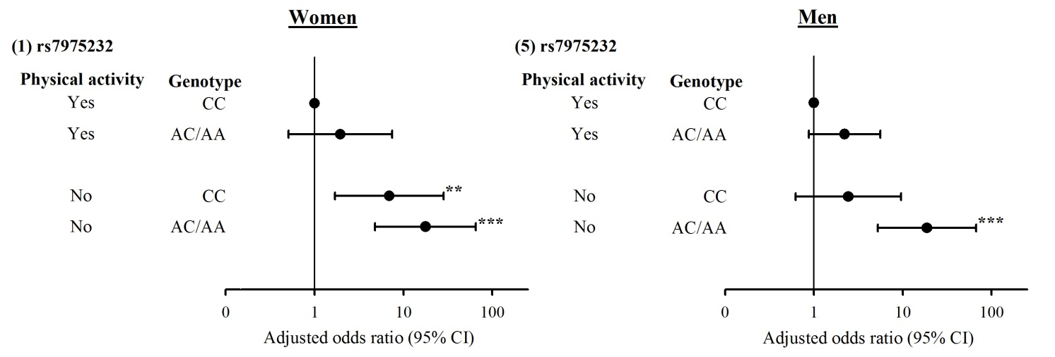
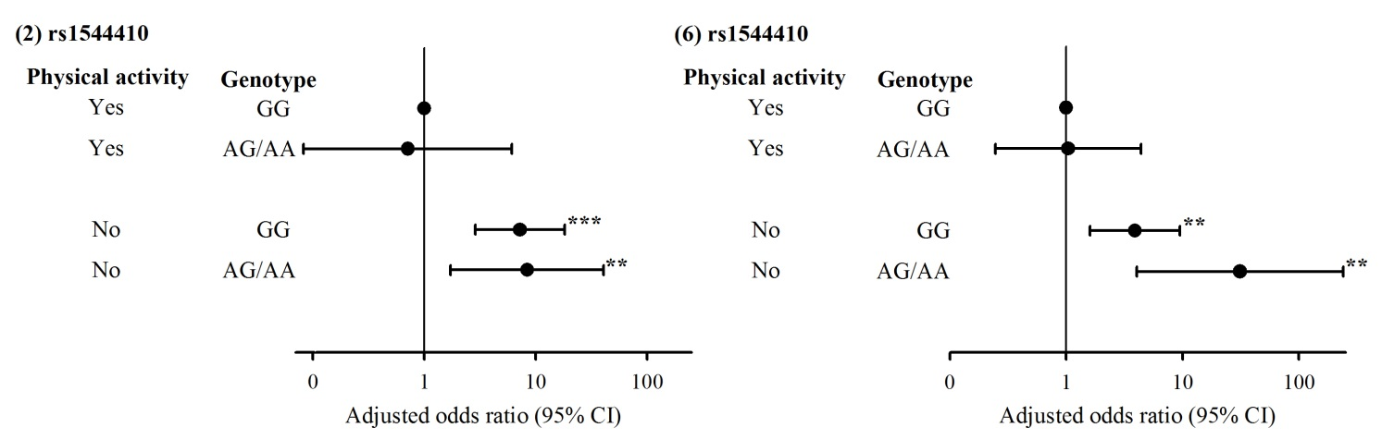
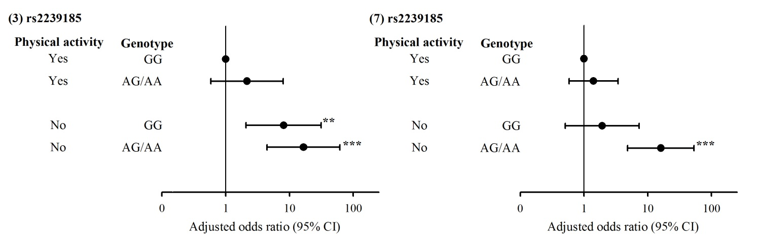
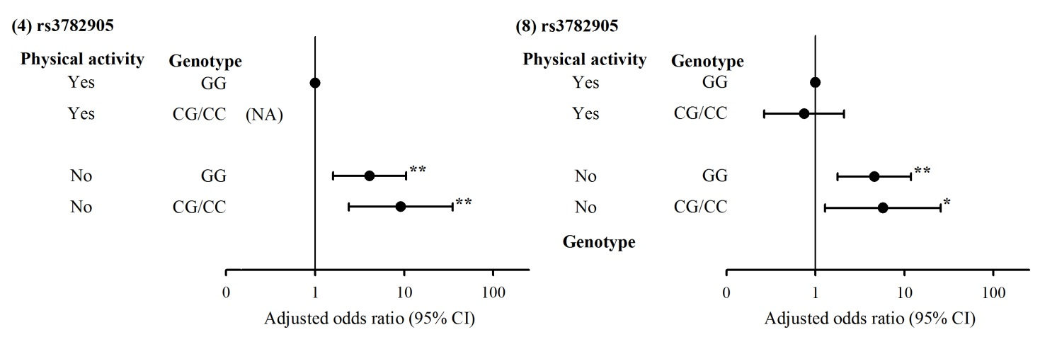
Figure 1. Adjusted odds ratios for low hand grip strength for 4 SNPs in the presence and absence of physical activity in women (Panels 1-4) and men (Panels 5-8). Adjusted odds ratio from model additionally considering age and BMI.
NA: not available.
*: P < .05; **: P < .01; ***: P < .001.

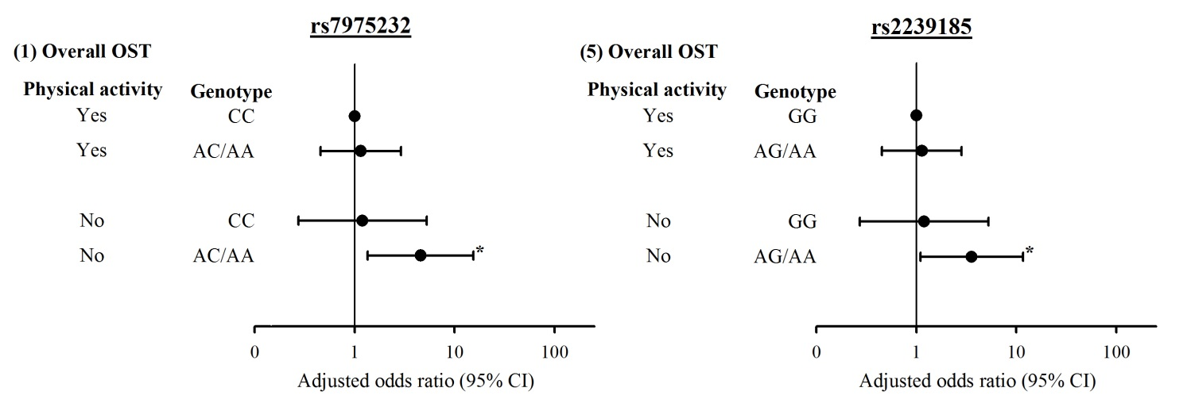
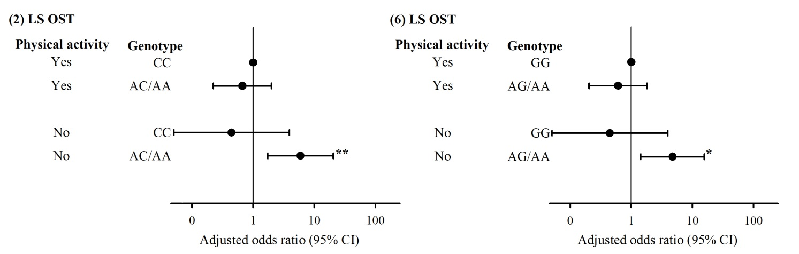
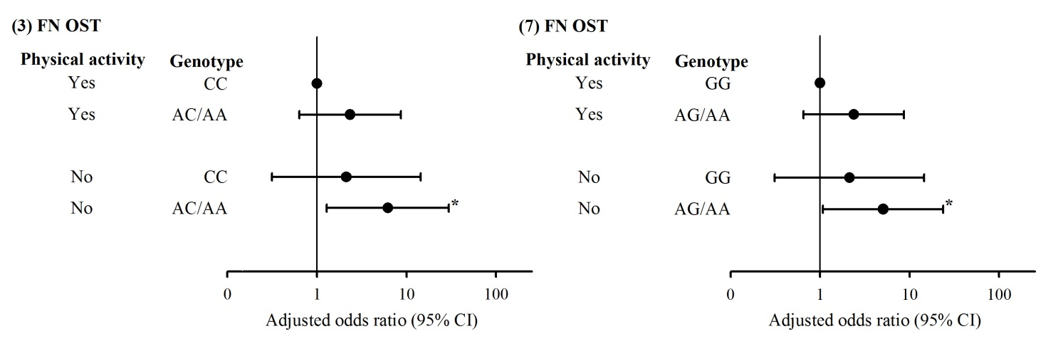
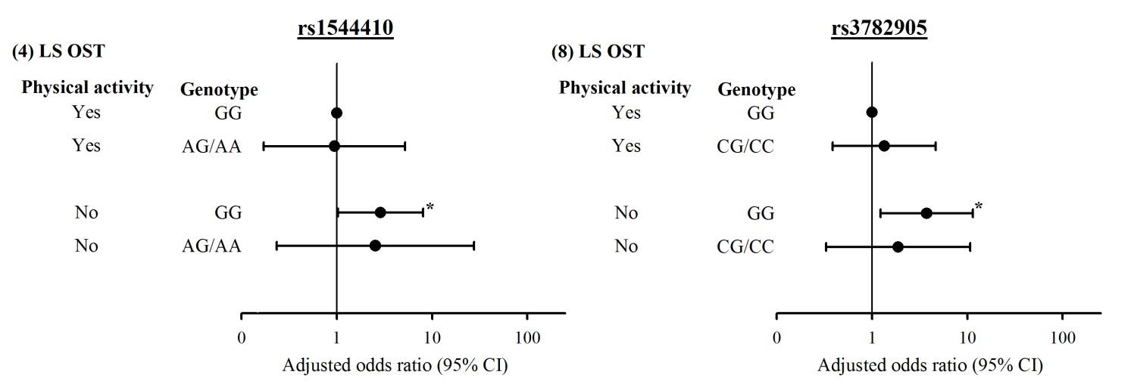
Figure 2A. Significant adjusted odds ratios of overall osteoporosis (OST) as well as OST at lumbar spine (LS), and femoral neck (FN) for SNPs rs7975232 (Panels 1-3) and rs2239185 (Panels 5-7), and OST at LS for SNPs rs1544410 (Panel 4) and rs3782905 (Panel 8) in the presence and absence of physical activity in men. Adjusted odds ratios were from model additionally considering age and BMI. Interaction of rs2239185 and physical activity at LS OST in elderly men was significant (P < .05).
*: P < .05; **: P < .01; ***: P < .001.

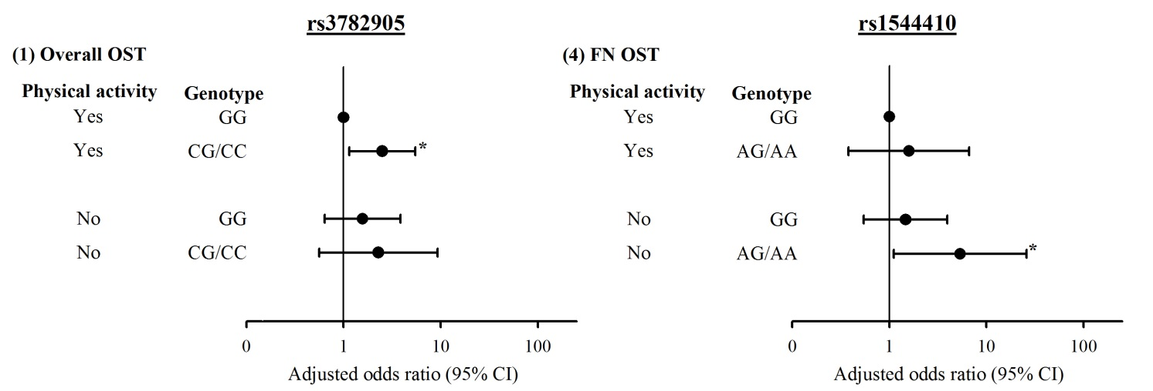
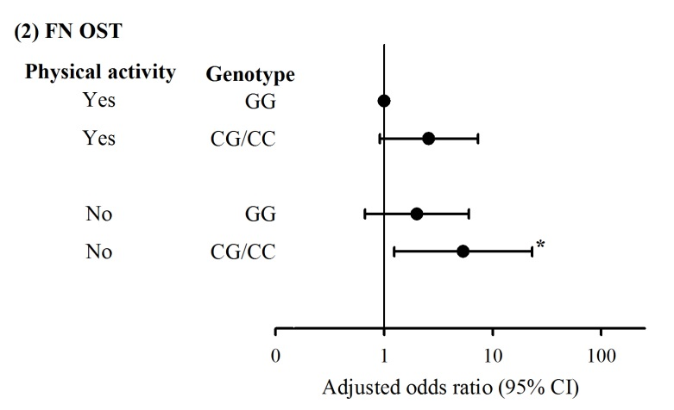
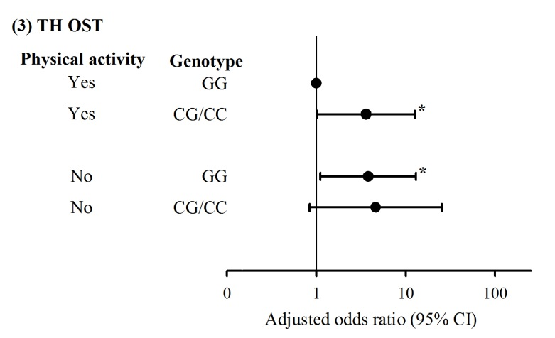
Figure 2B. Significant adjusted odds ratios of overall osteoporosis (OST) as well as OST at femoral neck (FN) and total hip (TH) for SNP rs3782905 (Panels 1-3) and OST at FN for SNP rs1544410 (Panel 4) in the presence and absence of physical activity in women. Adjusted odds ratios were from model additionally considering age and BMI.
*: P < .05; **: P < .01; ***: P < .001.

