Exploring the X-ray and γ−ray properties of the redback
millisecond pulsar PSR J1723-2837

C. Y. Hui1, P. H. T. Tam2, J. Takata3, A. K. H. Kong2, K. S. Cheng3, J. H. K. Wu2, L. C.
C. Lin4 and E. M. H. Wu3

ABSTRACT

We have investigated the X-ray and γ−ray properties of the redback millisec- ond pulsar PSR J1723-2837 with XMM-Newton, Chandra and Fermi. We have discovered the X-ray orbital modulation of this binary system with the minimum that coincides with the phases of radio eclipse. The X-ray emission is clearly non-thermal in nature which can be well described by a simple power-law with a photon index of ∼ 1.2. The phase-averaged luminosity is ∼ 9 × 1031 erg/s in
0.3-10 keV which consumes ∼ 0.2% of the spin-down power. We have detected the γ−ray emission in 0.1 − 300 GeV from this system at a signiﬁcance of ∼ 6σ for the ﬁrst time. The γ−rays in this energy range consumes ∼ 2% of the spin- down power and can be modeled by a power-law with a photon index of ∼ 2.6. We discuss the high energy properties of the new redback in the context of an intrabinary shock model.

Subject headings: gamma rays: stars — Pulsars: individual (PSR J1723-2837)
— X-rays: binaries

1. Introduction

In the last few years, a new population of eclipsing binary millisecond pulsars (MSPs) has emerged. Although the range of orbital period spanned by these systems is similar to that of “black widow” MSPs (Pb 泛 20 hrs), their companion masses (Mc ∼ 0.2 − 0.4M⊙) are signiﬁcantly larger than that of black widows

1 Department of Astronomy and Space Science, Chungnam National University, Daejeon 305-764, Korea

2 Institute of Astronomy and Department of Physics, National Tsing Hua University, Hsinchu, Taiwan

3 Department of Physics, University of Hong Kong, Pokfulam Road, Hong Kong

4 General Education Center, China Medical University, Taichung 40402, Taiwan

(Mc ≪ 0.1M⊙) (Roberts 2013). This population is dubbed as “redbacks”. Chen
et al. (2013) suggest the determining factor for producing black widows or redbacks is the eﬃciency of companion evaporation. They further argue that redback systems do not evolve into black widows with time.

More than a dozen of redbacks have been identiﬁed so far.1 PSR J1023+0038 is the ﬁrst identiﬁed redback MSP which provides evidence for the transition from an X-ray binary to a radio MSP (Archibald et al. 2009, 2010; Thorstensen & Armstrong 2005). These systems are suggested to have their states possibly swinging between rotation and accretion power phases according to the mass transfer rate (Shvartsman 1970; Burderi et al. 2001). Recent observations of episodic accretion from the redbacks PSR J1023+0038 (Patruno et al. 2013; Takata et al. 2013) and PSR J1824-2452I (Papitto et al. 2013) are consistent with this scenario.

PSR J1723-2837, which is a redback, has its radio and optical properties been recently reported (Crawford et al. 2013). The dispersion measure suggests it locates at a distance of 0.75 ± 0.10 pc (Crawford et al. 2013). Its rotational period and orbital period are 1.86 ms and 14.8 hr, respectively. The spin-down luminosity of the pulsar is

estimated as E˙
= 4.6 × 1034 erg s−1. The mass of its companion lies in a range of 0.4 − 0.7M

and optical spectroscopy indicates it is a G-type star. The pulsar follows a nearly circular orbit. The eclipse of radio pulses takes ∼ 15% of the orbit which is twice the Roche lobe size inferred for the companion (Crawford et al. 2013). In this Letter, we report the results from our X-ray and γ−ray analysis of this system.
⊙

2. Observation & Data Analysis

2.1. XMM-Newton observations

PSR J1723-2837 has been observed by XMM-Newton on 3 March 2011 for a total expo- sure of ∼ 56 ks with all EPIC cameras operated in full frame mode (Obs. ID: 0653830101) which provides a fairly uniform orbital coverage. With the updated instrumental cal- ibrations, we generated all the event ﬁles with XMM Science Analysis Software (XMMSAS version 12.0.1). We selected only the data in the energy range of 0.3 − 10 keV and those events correspond to the pattern in the range of 0 − 12 for MOS1/2 cameras and 0 − 4 for the PN camera. Bad pixels were also excluded. The eﬀective exposures for MOS1, MOS2 and

1 see http://apatruno.wordpress.com/about/millisecond-pulsar-catalogue/ for updated information.

PN after ﬁltering are found to be ∼ 50.7 ks, ∼ 49.6 ks and ∼ 49.3 ks respectively. Within
a source region of 20 arcsec radius around the pulsar timing position (RA=17h23m23.1856s Dec=-28◦37′ 57.17′′ (J2000)), there are 4993 cts, 3655 cts and 13261 cts (source+background) extracted from MOS1, MOS2 and PN CCDs, respectively. All the EPIC data are found to be unaﬀected by CCD pile-up.

We ﬁrstly searched for the orbital modulation in X-ray. Before any temporal analysis performed, we have applied barycentric correction to the arrival times of all the events by using the updated planetary ephemeris JPL DE405. Then we subtracted the background in the individual camera by adopting an annular region with inner/outer radius of 25 arc- sec/45 arcsec centered at the pulsar position. Although the soft proton ﬂares have contaminated the data in several regions of the CCDs, examining the light curve of the aformentioned small region-of-interest reveals no ﬂare-like events. There- fore, we keep all data in order to optimize the orbital coverage for the analysis. Using the radio ephemeris for PSR J1723-2837 (Tab. 2 in Crawford et al. 2013), we folded the background-subtracted light curves at the orbital period. The X-ray modulation can be clearly seen with all three cameras. In order to improve the photon statistics, we combine all the EPIC data and the resultant folded light curve is shown in Figure 1. We adopted the time of ascending node (MJD 55425.320466) to be the epoch of phase zero. Due to the incomplete orbital coverage after data ﬁltering, there is gap at the orbital phase interval
0.14 − 0.18 in this XMM-Newton data.

The minimum of the X-ray orbital modulation occurs at the same phase interval that radio eclipse has been observed in 1.4-3.1 GHz (cf. Fig. 1 in Crawford et al. 2013) which is illustrated by the shaded region in Figure 1. This interval encompasses the inferior conjunc- tion (INFC) at a phase of ∼ 0.25 where the pulsar is behind its companion. Apart from the region around INFC, some observations at 2 GHz peformed in the phase interval of
0.5 − 0.6 also could not detect the pulsar (Crawford et al. 2013). However, in exam- ining the X-ray orbital modulation at this interval, we cannot identify any peculiar behavior. On the other hand, the maximum of the modulation is found in the orbital phase interval of
0.7 − 0.9 which encompasses the superior conjunction (SUPC). (see Fig. 1). In this interval, we have found a dip near a phase of ∼ 0.8.

For investigating its X-ray spectral properties, we extracted the source and background spectra from the same regions adopted in the temporal analysis. We grouped the spectra obtained individually from MOS1 and MOS2 so as to have at least 50 counts per bin. For the PN spectrum, we grouped it to have at least 60 counts per bin. The spectra obtained from all three cameras are ﬁtted simultaneously to the tested models. All the uncertainties quoted in this paper are 1σ for 2 parameters of interest (i.e.

∆χ2= 2.3).

First, we have examined the phase-averaged X-ray spectrum of PSR J1723-2837. We found that a simple absorbed power-law model can describe the observed spectral data reasonably well (χ2 = 171.84 for 179 d.o.f ). The best-ﬁt model yields a column density of NH = 2.31+0.28 × 1021 cm−2 , a photon index of ΓX = 1.19 ± 0.05 and a normalization of
−0.25

1.10+0.08 −4
0.07 × 10
−
photons keV−1
cm−2
s−1
at 1 keV. The best-ﬁt NH is consistent with the

value inferred from the optical extinction AV = 1.2 of this system (Crawford et al. 2013; Predehl & Schmitt 1995). The unabsorbed energy ﬂux in 0.3 − 10 keV is fx = 1.32+0.19 ×
−0.16
10−12 erg cm−2 s−1. At a distance of 0.75 kpc, this corresponds to an X-ray luminosity of Lx ∼ 8.9 × 1031 erg s−1 . For the tested thermal models, they are not able to provide any adequate description of the data. While a black body yields a reduced χ2 much larger than unity, the thermal bremsstrahlung model results in an unphysically high temperature (kT > 200 keV).

We proceeded to investigate if the spectral properties vary at diﬀerent orbital phases. We have extracted the spectra from two phase ranges, 0.2-0.4 and 0.7-0.9 which encompass INFC and SUPC respectively. For the INFC interval, the best-ﬁt yields an NH = 2.94+2.30 ×
−1.25
1021 cm−2 and ΓX = 1.23+0.32 . On the other hand, the corresponding parameters for the SUPC interval are estimated as NH = 2.01+0.49 ×1021 cm−2 and ΓX = 1.09±0.09. Within the statistical uncertainties, the spectral parameters inferred in these two intervals are consistent with the phase-averaged values. Hence, we conclude that there is no convincing evidence for the orbital-dependent X-ray spectral behavior found from this data.
−0.19
−0.43

2.2. Chandra observation

Chandra observed PSR J1723-2837 with the Advanced CCD Imaging Spectrometer (ACIS) on 2012 July 11 (ObsID: 13713). The orbital coverage is continuous with a sum of good time interval of 55ks, which is slightly more than one orbital cycle. The ACIS was operated with a sub-array mode to achieve a timing resolution of
0.4s. Due to the loss of eﬃciency for the sub-array model, the eﬀective exposure is shorter (49.9 ks). Similar to the XMM-Newton observation, we performed barycentric correction to the arrival times of all the events by using the updated planetary ephemeris JPL DE405. PSR J1723-2837 is clearly seen and is the brightest source in the image. In order to reduce the background, we limited our analysis in the 0.3–7 keV band. Using a circular source region with a radius of 4 arcsec, there are 4468 counts for subsequent anal- ysis. An annular source free region centered at PSR J1723-2837 was used for background subtraction.

We extracted the 0.3–7 keV lightcurve of PSR J1723-2837; similar to the XMM-Newton observation, the 14.8-hr orbital modulation is clearly seen (see Fig. 1). Although the number of counts is much less than that of XMM-Newton, the lightcurve proﬁle is consistent with the XMM-Newton’s one. In spite of the large error bars, it is worth noting that
there is a hint for the dip at phase ∼ 0.8 seen in the XMM-Newton.

For spectral analysis, we ﬁrst investigated the phase-averaged spectrum. The spectrum can be well described (χ2= 186.85 for 204 d.o.f ) with an absorbed power-law model with NH = (1.68 ± 0.34) × 1021 cm−2 and ΓX = 1.00 ± 0.07. The unabsorbed 0.3–10 keV ﬂux is

1.64+0.04
0.06 × 10
−
−12
erg cm−2
s−1
. The spectrum of Chandra is only slightly harder than that of

XMM-Newton. Since PSR J1723-2837 is bright for Chandra, some pile-up may contaminate the spectral analysis. We also included a pile-up model and found that the pile-up fraction is only 1.7% and the spectral parameters are more or less the same. We then performed a phase-resolved spectroscopy using the same phase bins for INFC and SUPC as in the XMM- Newton data. Both spectra can be ﬁt with an absorbed power-law. For INFC, the best ﬁt
is NH = (3.51+1.42 ) × 1021 cm−2 and ΓX = 1.35 ± 0.22, while for SUPC the corresponding
−1.15
parameters are NH = (1.3 ± 1.0) × 1021 cm−2 and ΓX = 0.82 ± 0.17. Like in the XMM-Newton
data, there is no evidence for orbital dependent spectral variability.

For better constraining the INFC and SUPC spectral shape, we simulta- neously ﬁtted the spectra obtained by XMM-Newton and Chandra in these two intervals. The cross-calibration was accounted by allowing the normalizations to be diﬀerent for these two telescopes. Assuming NH is variable at diﬀer-

ent orbital phases, we obtained NH = 4.39+1.23 × 1021 cm−2, ΓX = 1.48+0.17
and

−1.00
−0.14

NH = 2.01+0.47 × 1021cm−2, ΓX = 1.05 ± 0.08 for INFC and SUPC respectively. The
−0.39
spectral parameters inferred in these phase intervals can be reconciled within 2σ uncertainties. We have also explored the possibility that there is no signiﬁcant variation of NH across the orbit. We jointly ﬁtted individual power-law model
to the INFC and SUPC spectra with NH in the individual model tied together.

This yields NH = 2.47+0.46 × 1021 cm−2 and ΓX = 1.23+0.11 , ΓX = 1.12+0.08
for INFC

−0.42
−0.08
−0.04

and SUPC respectively. The photon indices in these two intervals are consistent
within 1σ uncertainties. Therefore, we do not found any conclusive evidence of the spectral variation across the orbit.

2.3. Fermi Large Area Telescope observations

The γ-ray data used in this work were obtained between 2008 August 4 and 2013 July 15, available at the Fermi Science Support Center 2. We used the Fermi Science Tools v9r31p1 package to reduce and analyze the Pass7 data in the vicinity of PSR J1723-2837. To reduce the contamination from Earth albedo γ-rays, we excluded events with zenith angles greater than 100◦. We used events with energies between 100 MeV and 300 GeV in the binned likelihood analysis. The corresponding instrumental response functions were used.

We ﬁrst chose a rectangular region of dimension 28◦×28◦ centered on the radio timing position as our region-of-interest (ROI). We subtracted the background contribution by including the Galactic diﬀuse model (gal 2yearp7v6 v0.ﬁts) and the isotropic background (iso p7v6source.txt), as well as all sources in the second Fermi/LAT catalog (2FGL; Nolan et al. 2012) within the circular region of 25◦ radius around PSR J1723-2837. We assumed the respective spectrum in the 2FGL catalog for the sources considered. The normalization of the diﬀuse components and spectral parameter values of sources within 5◦ from PSR J1723-
2837 were allowed to vary.

Using the “source”-class events and assuming a power-law spectrum at the pulsar po- sition, the maximized test-statistic (TS) value (Mattox et al. 1996) we obtained for the PSR J1723-2837 position is 38.3, corresponding to a detection signiﬁcance of 6.2σ. The power-law index is Γγ = 2.6 ± 0.1. The photon ﬂux from the power-law ﬁt is (3.5 ± 0.7) ×
10−8 photons cm−2 s−1 , and the energy ﬂux is (1.5 ± 0.3) × 10−11 erg cm−2 s−1, corresponding to the γ-ray luminosity of Lγ ∼ 1033 erg s −1 at a distance of 0.75 kpc. Since the contribu- tion by the proper motion of the pulsar to the spin-down rate is uncertain, the spin-down luminosity thus calculated can be treated as an upper bound. There- fore, Lγ would be no smaller than ∼2% of the spin-down luminosity. A ﬁt using a power-law with an exponential cutoﬀ did not provide a reliable ﬁt parameter sets.. We also chose diﬀerent ROIs to verify our results.

Given the proximity of PSR J1723-2837 to the Galactic Center where the Galactic γ-ray diﬀuse background is high, we also performed a binned likelihood analysis using “clean”-class events in a smaller ROI of dimension 21◦×21◦ centered on the radio timing position. The TS value thus obtained is 24.2, corresponding to a detection signiﬁcance of 4.9σ. Taking into account the above likelihood results using “source” events and “clean” events as well as the γ-ray count map shown in Fig. 3, we believe that the detection of the γ-ray source is robust.

2 http://fermi.gsfc.nasa.gov/ssc/

To better estimate the γ-ray position, we performed an unbinned analysis of the front- converted “clean”-class events larger than 500 MeV using gtfindsrc, resulting in the position
at RA(J2000)=260◦. 906, Dec(J2000)=−28◦. 631, with statistical uncertainty 0.13◦ at the 68%
conﬁdence level, which is consistent with the position of PSR J1723-2837. The background- subtracted count map of the 2◦×2◦ region centered on the radio position, constructed using the “clean” class events, is shown in Figure 3.
A nearby source, 1FGL J1725.5-2832 is only ∼1◦ away from PSR J1723-
2837 (see Fig. 3). We studied their relation by adding 1FGL J1725.5-2832 in the background source model. It turns out that essentially the same group of photons contribute to the TS values of both sources. Therefore, 1FGL J1725.5-
2832 was not included in the background source model in the aforementioned analysis.

Using the radio ephemeris reported in Crawford et al. (2013) in the fol- lowing, we searched for possible γ-ray variability related to the orbital modulation. We divided the photons into two phase-intervals, one centered at the SUPC (0.5-1.0), the other centered at the INFC (0.0-0.5), and performed binned likelihood analysis for each group of photons, using “source” events and same analysis cuts and source model as described in the full-orbit analysis. No diﬀerence of the spectral parameters were found between SUPC and INFC. We also searched for any periodic signals using H -test (de Jager & Bu¨sching 2010). Neither the γ-ray periodicity related to the orbital period nor the rotation period was found. However, the bright Galactic diﬀuse emission, uncertainties in the ephemeris used over the Fermi data span, and small photon statistics from the source make our periodicity searches less sensitive.

3. Discussion

With a simple one-dimensional model (Takata et al. 2012), we constrain the pulsar wind parameters of PSR J1723-2837. Since the radio eclipse at several GHz lasts only 15% of its orbit (Crawford et al. 2013), we may expect the shock wraps the companion star and its distance from the pulsar is on the order of the semi-ma jor axis, which is a ∼ 3.7 × 1010/ sin i cm, where i is the orbital inclination angle. Based on the measurement of the Doppler velocity of the companion, Crawford et al. (2013) suggested the inclination angle of i ∼ 30◦ − 41◦ for PSR J1723-2837. The radio eclipse also suggests the angle of ﬂow from the companion star measured from the pulsar is θa ∼ 2π × 0.15 = 0.94. If the pulsar wind is emitted spherically then the fraction of the pulsar wind stopped by the outﬂow is ∼ 5%. The magnetic ﬁelds upstream (B1) and behind

(B2) the shock are estimated as B1 ∼ (Lsd σ/a2 c)1/2 and B2 = 3B1 , where σ is the ratio of the magnetic energy to kinetic energy of the cold relativistic pulsar wind and we assume it to be smaller than unity (i.e. kinetically dominated ﬂow). At the shock, the pulsar wind particles are accelerated beyond the Lorentz factor (Γ1 ) of the cold relativistic pulsar wind in the upstream region. For the maximum Lorentz factor of the accelerated particles, it is determined by balancing the accelerating time scale, τacc ∼ Γme c/(eB2), and the synchrotron cooling time scale, τs ∼ 9m3c5/(4e4B2Γ).
e

The observed X-ray photon index ΓX ∼ 1.2 may imply the power law index of the particle distribution at the shock is p ∼ 1.4. For the usual power law index p ∼ 2 − 2.5 of the shock acceleration, this hard photon index in the spectrum will be reproduced if the typical synchrotron energy (E1) of the minimum Lorentz factor Γ1 is larger than 10 keV. The photons index changes from α = (p + 1)/2 above E1 to α = 3/2 below E1 . In such a case, the X-ray emission properties break the degeneracy of σ and Γ1 in the emission model. For example, we can ﬁt the observed properties α ∼ 1.2 and fx ∼ 1.3 × 10−12erg cm−2 s−1 with (σ, Γ1 ) ∼ (0.1, 5 × 104). The predicted Lorentz factor Γ1 ∼ 5 × 104 is similar to those of the original black widow pulsar PSR B1957+20 (Wu et al. 2012). As there is no evidence of spectral break found in 0.3-10 keV, observations with state-of-the-art hard X-ray telescopes, NuSTAR and the upcoming Astro-H will be important for constraining E1.

Because PSR J1723-2837 follows an almost circular orbit, the shock distance from the pulsar does not vary across the orbit, suggesting the spectral properties of the intrinsic shock emissions do not modulate with the orbital phase. The variation of the observed ﬂux will be caused by either Doppler boosting eﬀect with a mildly relativistic ﬂow of the shocked
ﬂow or physical eclipse of the emission region. However, these two eﬀects will not produce a signiﬁcant variation in the spectrum. The observed amplitude (see Figure 1) implies
the Doppler factor is ∼ 1 − 2, which does not cause a signiﬁcant change in the spectral
shape. Furthermore, the synchrotron cooling time scale of the particles that emit photons of energies < 10 keV is τs ∼ 33(B2/10G)−3/2(Es /10keV)−1/2s, which is longer than the crossing time scale of the emission region, τc ∼ 1s. The distribution of the particles and therefore the spectral shape of X-ray emission in < 10 keV does not evolve in the emission region. As a result, even if the partial region of the emission region is covered by the star, the observed spectral shape is the same with that for whole emission regions.

For black widow/redback pulsars, the magnetospheric emissions and pulsar wind emis- sions produce the GeV gamma-rays. For the original black widow pulsar PSR B1957+20, Wu et al. (2012) suggested both the magnetospheric and the pulsar wind emissions con-

tribute to the GeV emissions seen by Fermi. With the results described in section 2.3, it is unclear which process operates for the observed gamma-rays for PSR J1723-2837, because neither pulsar’s spin period nor orbital modulation was founded in the current Fermi data, and whether or not there is a cutoﬀ in the spectrum is inconclusive. A single power-law feature in the observed spectrum in 0.1–300 GeV band would suggest that the gamma-rays are emitted by the pulsar wind particles accelerated at the shock. In this case, the synchrotron radiation process explains the observed emissions around 100 MeV and the inverse-Compton process oﬀ the stellar photons contributes to the
emissions above ∼ 10 GeV.

The shocked particles that emit the synchrotron photons will produce TeV photons through the inverse-Compton oﬀ the stellar photons, for which the eﬀective temperature is Tef f ∼ 4800 − 6000K. Based on the calculation with the isotropic photon ﬁelds, we can estimate the ﬂux above > 100GeV as F>100GeV ∼ 5 × 10−13erg cm−2 s−1, which could possibly be measured by the planned Cherenkov Telescpe Array (CTA). The measurement of the CTA on the redback systems will provide us additional information such as Lorentz factor of the relativistic pulsar wind and the maximum Lorentz factor of the shocked particles, etc.

CYH is supported by the National Research Foundation of Korea through grant 2011-
0023383. PHT is supported by the National Science Council of the Republic of China (Tai- wan) through grant NSC101-2112-M-007-022-MY3. JT and KSC are supported by a GRF grant of HK Government under HKU7009 11P. AKHK is supported by the National Science Council of the Republic of China (Taiwan) through grant NSC100-2628-M-007-002-MY3 and NSC100-2923-M-007-001-MY3. LCCL is supported by the National Science Council through grants NSC 101-2112-M-039-001-MY3.

REFERENCES

Archibald, A. M., et al. 2010, ApJ, 722, 88

Archibald, A. M., et al. 2009, Science, 324, 1411

Burderi, L., et al. 2001, ApJ, 560, L71

Crawford, F., et al. 2013, ApJ, 776, 20

Chen, H.-L., Chen, X.F., Tauris, T. M., & Han, Z.W. 2013, ApJ, 775, 27

de Jager, O. C., Bu¨sching, I. 2010, A&A, 517, L9

Mattox, J. R., et al. 1996, ApJ, 461, 396

Nolan, P. L., et al. 2012, ApJS, 199, 31

Papitto, A., et al. 2013, Nature, 501, 517

Patruno, A., et al. 2013, arXiv:1310.7549

Predehl, P., & Schmitt, J. H. M. M. 1995, A&A, 293, 889

Roberts, M. S. E. 2013, Proceedings of the International Astronomical Union, Volume 291, pp. 127-132

Shvartsman, V. F. 1970, R&QE, 13, 1428

Takata, J., et al. 2012, ApJ, 750, 70

Takata, J., et al. 2013, arXiv:1312.0605

Thorstensen, J. R., & Armstrong, E. 2005, AJ, 130, 759

Wong, Z. et al. 2009, ApJ, 703, 2017

Wu, E. M. H., et al. 2012, ApJ, 761, 181

This preprint was prepared with the AAS LATEX macros v5.2.
0.1

Chandra
counts/s
0.4
0.5
0.06
0.08

XMM-Newton
0.3

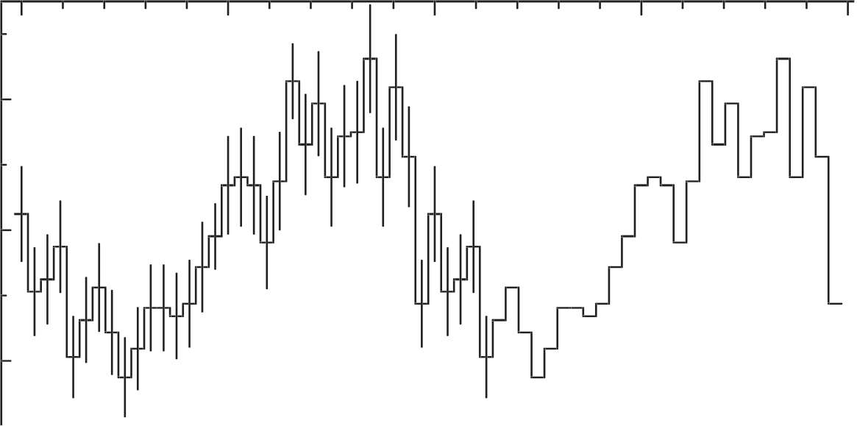
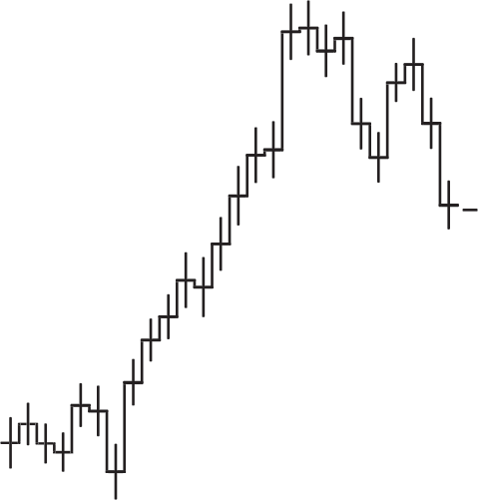
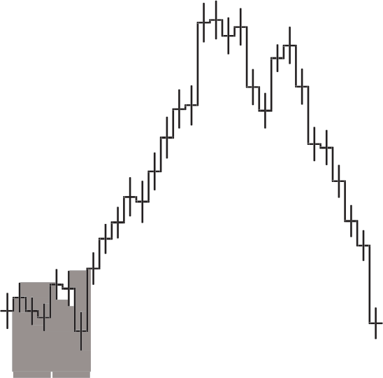
0 0.5 1 1.5 2
0.2
Phase

Fig. 1.— The background-subtracted light curves of PSR J1723-2837 as observed by Chandra ACIS in 0.3 −7 keV (upper panel) and by XMM-Newton in 0.3 −10 keV
with the data from all EPIC cameras combined (lower panel). The same data have been repeated for another orbital cycle for demonstrating the modulation clearly. The shaded region illustrates the range of the radio eclipse. The dotted line and the dashed line illustrate the phases of INFC and SUPC respectively.

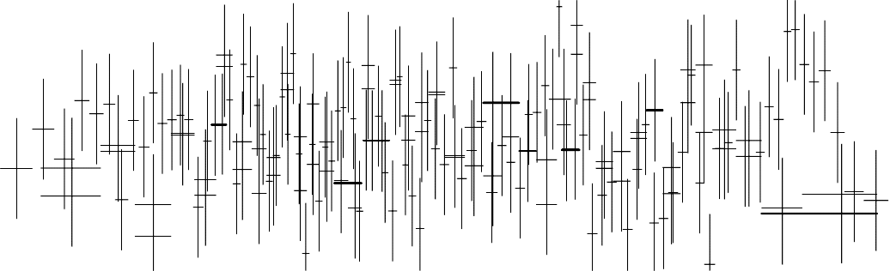
0.1

0.01
normalized counts s−1 keV−1

10−3

2

0
χ

−2

0.5
1 2 5
Energy (keV)

Fig. 2.— The phase-averaged X-ray spectra of PSR J1723-2837 as observed by XMM-Newton and simultaneously ﬁtted to an absorbed power-law model (upper panel) and contribution to the χ2-ﬁt statistic (lower panel).

-29:00:00.0

Fermi LAT
0.1-300 GeV
-28:00:00.0

1FGL J1725.5-2832
Declination (J2000)
30:00.0

28:00.0 27:00.0 26:00.0 25:00.0 24:00.0 23:00.0 22:00.0 21:00.0 17:20:00.0 19:00.0
30:00.0

Right Ascension (J2000)

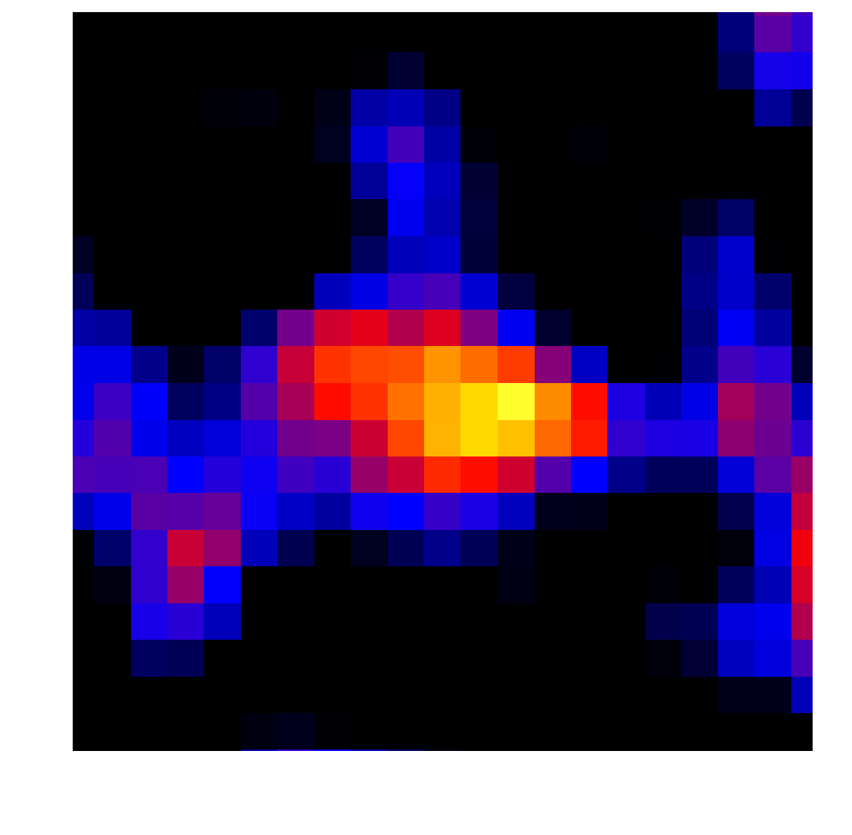
1.1 1.7 2.2 2.8 3.4 4 4.6 5.2 5.8 6.4 7

Fig. 3.— The background-subtracted 0.1–300 GeV γ-ray count map, smoothed with a
Gaussian width of 0◦. 3, of the 2◦×2◦ region centered on PSR J1723-2837, whose radio timing position is indicated by the black cross. The blue circle indicates the error circle of the best-ﬁt postion at the 68% conﬁdence-level. The error eclipse of 1FGL J1725.5-2832, which is not regarded as a background source (see Sect. 2.3), is shown.

