THE ROLE OF PENTACYCLIC TRITERPENOIDS IN THE ALLELOPATHIC EFFECTS OF Alstonia scholaris

CHAO-MIN WANG¹, HSIAO-TING CHEN², TSAI-CHI LI¹, JEN-HSIEN WENG², YUN-LIAN JHAN¹, SHI-XUN LIN¹, CHANG-HUNG CHOU^{1,2,3,4*}

¹Research Center for Biodiversity, China Medical University, Taichung 40402, Taiwan.
²Graduate Institute of Ecology and Evolutionary Biology, China Medical University, Taichung 40402, Taiwan.
³Department of Biological Sciences, National Sun Yat-sen University, Kaohsiung 80424, Taiwan.
⁴Department of life Sciences, National Cheng Kung University, Tainan 701, Taiwan.

*Author for correspondence:
Chang-Hung Chou, Ph.D
Academician, Academia Sinica
Chair Professor and Director
Research Center for Biodiversity and Graduate Institute of Ecology and Evolutionary Biology, China Medical University, Taichung, Taiwan

Address: Room 720, 7F, Lifu Hall, 91, Hsueh-Shih Road, Taichung, 40402, Taiwan.
E-mail: choumasa@mail.cmu.edu.tw
Tel: +886-4-2205-3366, ext. 1633. Fax: +886-4-2207-1500
Abstract—Alstonia scholaris is a tropical evergreen tree native to South and Southeast Asia. Alstonia forests frequently lack understory species. However, potential mechanisms—particularly the allelochemicals involved—remain unclear. In the present study, we identified allelochemicals of A. scholaris, and clarified the role of allelopathic substances from A. scholaris in interactions with neighbouring plants. We showed that the leaves, litter, and soil from A. scholaris inhibited growth of Bidens pilosa—a weed found growing abundantly near A. scholaris forests. The allelochemicals were identified as pentacyclic triterpenoids including betulinic acid, oleanolic acid, and ursolic acid by using ¹H and ¹³C-NMR spectroscopy. The half-maximal inhibitory concentration (IC₅₀) for radical growth of B. pilosa and L. sativa ranged from 78.8 µM to 735.2 µM, and ursolic acid inhibited seed germination of B. pilosa. The triterpenoid concentrations in the leaves, litter, and soil were quantified by using liquid chromatography-electrospray ionization/tandem mass spectrometry. The results showed that ursolic acid was present in forest soil at a concentration of 3095 µg/g, i.e. exceeding the IC₅₀. In the field, ursolic acid accumulated abundantly in the soil in A. scholaris forests, and suppressed weed growth during summer and winter. Our results indicate that A. scholaris pentacyclic triterpenoids influence the growth of neighbouring weeds by inhibiting seed germination, radical growth, and functioning of photosystem II.

Key Words—Alstonia scholaris, Allelopathy, Pentacyclic triterpenoid, Ursolic acid, Photosynthesis inhibition.
INTRODUCTION
The species Alstonia scholaris, belonging to the family Apocynaceae, is widely distributed throughout tropical regions of Africa and Asia. A. scholaris, which is commonly called blackboard tree or devil tree, is a tropical evergreen tree native to South and Southeast Asia. The chemical constituents of Alstonia spp. have been extensively investigated, and almost 400 compounds have been reported . Further, the leaves of A. scholaris have historically been used in ‘Dai’ ethnopharmacology to treat chronic respiratory diseases Extracts of A. scholaris not only possess a wide spectrum of pharmacological activities , but also inhibit germination and seedling growth of several weed species . Recently, showed that aqueous leaf extracts of A. scholaris contain potent herbicidal constituents for the management of parthenium weed. Therefore, A. scholaris may have strong allelopathic potential; further, allelopathic interactions may play an important role in the dominance of A. scholaris plant communities.
Although allelopathic substances may comprise polyphenols, flavonoids, alkaloids, and triterpenoids. only indole alkaloids and triterpenoids have been reported from A. scholaris . .
The objectives of the present study were to determine which part of A. scholaris influences weed growth and to establish whether there are allelopathic substances in A. scholaris. In addition, we also tried to elucidate which phytotoxic function (inhibition of weed germination, radicle growth, or photosynthesis system) plays a role in the allelopathy of A. scholaris. Finally, we measured the concentration of putative allelochemicals in soil and weed coverage in the field to evaluate the role of pentacyclic triterpenoids in the allelopathic effects of A. scholaris.
METHODS AND MATERIALS
Field Measurement of Botanical Composition and Species Coverage. The field experimental site was located in an A. scholaris forest near Mingdao University (N 23°52'15.17" and E 120°29'47.13"), Changhua County, Taiwan. We conducted a transect experiment on the forest floor and adjacent grassland area, by setting 9 consecutive quadrants (each measuring 2 m × 1 m). In each quadrant, we estimated the species coverage from the trunk of an A. scholaris tree. The relative coverage of each weed was defined as: (the area of target weed/the area of quadrant) × 100%. All estimates of species coverage were replicated 3 times. As a control, we used the same design in the grassland area adjacent to the A. scholaris forest.

Sample Collection. We collected leaves of A. scholaris from the field experimental site in March, June, September, and December of 2011 and 2012. The leaves were air-dried for further extraction. Dry leaves were ground into powder for use in pot experiments. Soil samples from the field experimental site were collected for chemical analysis. A total of 10 g of soil was soaked in 90 ml of methanol and shaken for 72 h at 200 rpm. The samples were centrifuged at 2500 rpm, after which the supernatants were collected and filtered through a 0.45-µm filter (Millipore, MA, USA) prior to liquid chromatographic analysis.

Preparation of Aqueous Extracts. We prepared aqueous and methanolic extracts (5 g of sample plus 95 ml of double-distilled water or methanol) of leaves and litter for bioassays. The pH and osmotic concentrations of the extracts were determined by using a pH meter (UB-10, Denver Instrument, USA) and a cryoscopic osmometer (Osmomat 030, Gonotec), respectively.

Pot Experiments. For pot experiments, we collected soil, leaf, and litter samples from the field experimental site. The soil samples were collected from the soil surface to a depth of 10 cm, and filtered with a 60-mesh screen. All of the materials were air-dried at room temperature. Pots (18 cm in width) were filled with 100 g of sandy loam soil mixed with either 5 g or 10 g of leaves or litter powder from A. scholaris. As a control, we used soil without leaves or litter powder. Seeds of Bidens pilosa were sown in a control pot for germination. When seedlings reached a height of approximately 5 cm, they were transplanted into each treatment pot and irrigated daily with tap water. The height of each plant was measured daily until 59 days after transplanting.

Bioassays. The aqueous extract of A. scholaris leaves was assayed by using the standard sponge bioassay ; the double-distilled water was used as a control. Tested seeds of Lactuca sativa and Brassica chinensis were purchased from the Known-You seed company in Taiwan. In addition, we collected seeds of B. pilosa from the experimental field site for bioassay. The seed germination rate and radical length were measured after 72 hr of incubation.

Isolation and Identification of Phytotoxins. We extracted 5 kg of air-dried A. scholaris leaves 3 times in methanol, according to the standard extraction procedures . The methanolic extract was concentrated to yield 395 g of dry residue. Triterpenoids were obtained by using column chromatography with silica gel (Merck, USA), Sephadex LH-20 (Pharmacia, USA), and RP-18 (Merck, USA) columns (2.5 cm × 80 cm) to obtain 3 pure compounds—compound 1 (12.62 mg), compound 2 (40.67 mg), and compound 3 (102.27 mg). We identified the purified compounds with ¹H-NMR and ¹³C-NMR spectroscopy (Bruker Avance 400) and mass spectrometry (MS) (Bruker Daltonics Esquire HCT).

Quantification of Triterpenoids in Soil. Supernatants of soil methanolic extracts were prepared, passed through 0.22-µm filters (Millipore), and placed in sample vials for liquid chromatography (LC) analysis. We quantified the concentrations of betulinic acid, oleanolic acid, and ursolic acid by using LC-MS/MS analysis with an Atlantis T3 RP-18 column (150 mm × 2.1 mm; 3 µm; Waters, Milford, MA). In each case, the injection volume was 5 µl. The column was eluted with buffer A (distilled water/acetonitrile/formic acid; 95/5/0.1, v/v/v) and buffer B (acetonitrile/formic acid; 100/0.1, v/v) at a flow rate of 0.25 ml/min and temperature of 25°C. The solvent program was as follows: 0 to 30% B over the first 5 min; isocratic for 5 min; 30 to 80% B over the next 10 min; isocratic for 10 min; 80 to 95% B over the next 10 min; 0% B for the final 10 min of the programThe molecular ion peaks and mass spectra were compared with those of reference substances. The analysis was initially carried out by using full-scan, data-dependent MS/MS, from m/z 100 to m/z 1000. All of the liquid chromatography-electrospray ionization/tandem mass spectrometry (LC-ESI-MS/MS) data were processed by using Bruker Daltonics Data analysis software (version 4.0). All compounds were prepared at a concentration range of 0.01–500 µg/ml. Quantification of triterpenoids was performed using the selected ion monitoring mode. The separated [M-H]– ion chromatogram was selected at m/z 455 for the specific parent ion of triterpenoids. Good linearity of the calibration curves was achieved using freshly prepared samples, with mean values for the regression equation of y = 6E + 07x + 1E+07 (r² = 0.9997) for betulinic acid, y = 552577x + 5E+07 (r² = 0.9983) for oleanolic acid, and y = 353895x + 3E+07 (r² = 0.9985) for ursolic acid.

Chlorophyll Fluorescence Measurements. Cucumber (Cucumis sativus) seeds were grown in a growth chamber at 25°C, under a 12 hr light/12 hr dark photoperiod, and irradiated with 150 µmol photon/m²sec for 10 days. The 10-day-old seedlings were placed in solutions containing 2 mM of ursolic acid, betulinic acid or oleanolic acid. The inhibitory effect of triterpenoids on photosynthetic capacity was evaluated by analysing chlorophyll fluorescence parameters with the portable chlorophyll fluorescence analyser PAM-2100 (Pulse Amplitude Modulate Fluorometer; Walz Heinz GmbH, Effeltrich, Germany), which. provides data for producing rapid light curves. Experimental data were collected in a sequence of actinic illumination, with light intensities increasing from 5 to 2300 μmol/m²sec in 10 steps; the duration of each illumination period was 10 sec. The maximum quantum efficiency of photosystem II (PSII) (F_{v}/F_{m}), initial fluorescence (F₀), maximum fluorescence (F_{m}), and electron transport rate (ETR) are reliable indicators of plant growth . The chlorophyll parameters were calculated by using the following formula :
F_{v}/F_{m} = (F_{m} − F₀)/F_{m}
The ETR = the quantum yield × 0.84 × 0.5 × PPFD, where PPFD is the photosynthetic photon flux density of active radiation, 0.84 is the assumed light absorbance of the sample, and 0.5 corrects for 2 quanta of light required for the transport of 1 electron.

Statistical Analyses. We used one-way ANOVA and the unpaired t-test to test for the effects of allelopathic substances on seed germination, radical growth, and photosynthetic capacity of each species. Means were evaluated using Duncan’s multiple range test. The level of significance was fixed at P < 0.05. All statistical analyses were performed by using SPSS v. 13.0 for Windows.
RESULTS
Field Measurement. Table 1 shows the coverage of each investigated weed species in the field experimental site as a percentage of the total species coverage. In comparison with the adjacent grassland control site, the floor of the Alstonia forest showed significantly low relative weed growth. However, at distances of 1 m and 3 m from the Alstonia forest, the relative weed growth increased three to ten-fold, respectively. The relative coverage of the dominant species, B. pilosa, was 0% on the floor of the A. scholaris forest, but increased substantially at distances of 1 to 3 m away from the Alstonia forest. In the grassland control site B. pilosa was the dominant species. Only shade-adapted or shade-tolerant species, such as Chamaedorea seifrizii, Maba buxifolia, Murraya paniculata, Passiflora suberosa, and Solanum nigrum , were found on the floor of the A. scholaris forest.

Allelopathic Activity of A. scholaris. In comparison with the control soil and soil sampled from outside the A. scholaris forest (AS-out), the leaves, litter, and soil from A. scholaris inhibited growth of B. pilosa (Fig. 1). The inhibitory effect of soil sampled from inside the forest (AS-in) could no longer be detected 24 days after transplanting. In contrast, the inhibitory effects of leaves and litter were sustained for 59 days. We further evaluated the inhibitory effect of extracts of A. scholaris on seed germination, radical growth, and photosynthetic capacity. The pH and osmotic concentrations of the leachates and the extracts were listed in Table S2 Previous study indicated that the osmotic concentration below 25 milliosmol is not responsible for of the inhibitory effects in the bioassay . In this study, only 5% aqueous leaf extract has an osmotic strength of 42 milliosmol. Therefore, the suppression of growth caused by 5% aqueous leaf extract way be primarily due to the osmotic effect. The methanol and aqueous extracts of A. scholaris leaves and litter inhibited radical growth of Lactuca sativa, Br. chinensis, and B. pilosa (Fig. 2). Interestingly, methanol and aqueous extracts of A. scholaris inhibited seed germination of B. pilosa, but not of L. sativa or Br. chinensis. Furthermore, methanol and aqueous extracts of A. scholaris leaves and litter had no significant effect on the maximum quantum efficiency of PSII, but caused a significant decrease in the ETR (Fig. 3).

Identification of Allelochemicals from the Leaves of A. scholaris. On the basis of negative electrospray ionization-mass spectrometry (ESI-MS) of the molecular ion peak at m/z 455.35, matched with the number of carbons and hydrogens recorded by using NMR spectroscopy, we identified Compound 1 as a colourless powder with the molecular formula C₃₀H₄₈O₃ (calculated, 456.36) (Table S3, Figs S1 and S2). On the basis of the 7 degrees of unsaturation, ¹³C-NMR, and distortionless enhancement by polarization transfer (DEPT), we determined the presence of 1 double bond in the molecule. The ¹H-NMR spectrum revealed the presence of 6 singlet methyl groups at δ_{H} 1.19 (3H, s, H₂₃), δ_{H} 0.98 (3H, s, H₂₄), δ_{H} 0.80 (3H, s, H₂₅), δ_{H} 1.03 (3H, s, H₂₆), δ_{H} 1.05 (3H, s, H₂₇), and δ_{H} 1.77 (3H, s, H₃₀); a pair of olefinic protons at δ_{H} 4.91 and δ_{H} 4.74 (each one H, s), characteristic of an exocyclic methylene group; and a carbinolic proton at δ_{H} 3.40 (t, J = 8.0 Hz, H₃), referring to the axial and α orientation. Further, δ_{H} 3.53 (m, H₁₉), δ_{H} 2.58 (d, J = 12.0 Hz, H₁₆), δ_{H} 2.68 (m, H₁₃), and δ_{H} 2.21 (m, H₂₁) were characteristic of a lupine triterpenoid . The ¹³C-NMR spectrum showed the presence of 30 carbons comprising 6 methyl groups (δ14.6, δ16.0, δ16.1, δ19.1, δ28.3, δ109.6), 11 methylene groups (δ18.4, δ19.1, δ20.9, δ25.8, δ27.9, δ29.9, δ30.9, δ32.5, δ34.5, δ37.2, δ39.2), 6 methine groups (δ38.3, δ47.4, δ49.4, δ55.6, δ77.8), and 7 quaternary carbons (δ37.2, δ39.2, δ40.8, δ42.5, δ56.3, δ151.0, δ178.5). On the basis of the above analyses, the NMR spectral data of compound 1 were similar to those previously reported for betulinic acid (Fig. 4).
On the basis of positive ESI-MS of the molecular ion peak at m/z 479.40 ([M+Na]⁺), matched with the number of carbons and hydrogens recorded by using NMR spectroscopy, we identified Compound 2 as a colourless powder with the molecular formula C₃₀H₄₈O₃ (calculated, 456.36) (Table S4, Figs S3 and S4). On the basis of the 7 degrees of unsaturation, ¹³C-NMR, and DEPT, we determined the presence of 5 rings, plus 1 acidic carbonyl group and 1 olefinic group, in the molecule. In addition, we confirmed the presence of 30 carbons consisting of 7 methyl groups, 10 secondary, 5 tertiary, and 8 quaternary carbons. The¹H-NMR spectrum revealed the presence of 7 singlet methyl groups at δ_{H} 1.22 (3H, s, H₂₃), δ_{H} 1.0 (3H, s, H₂₄), δ_{H} 0.93 (3H, s, H₂₅), δ_{H} 1.03 (3H, s, H₂₆), δ_{H} 1.26 (3H, s, H₂₇), δ_{H} 0.99 (3H, s, H₂₉), and δ_{H} 1.03 (3H, s, H₃₀); a signal of olefinic proton at δ_{H} 5.47 (H, s, H₁₂); and a carbinolic proton at δ_{H} 3.44 (dd, H₃), referring to the characteristic axial and α orientation of oleanolic triterpenoid. The ¹³C-NMR spectra showed the presence of 30 carbons comprising 7 methyl groups (δ15.6, δ16.5, δ17.5, δ23.7, δ26.1, δ28.7, δ33.2), 10 methylene groups (δ18.7, δ23.6, δ23.7, δ28.0, δ28.2, δ33.2, δ33.2, δ34.2, δ38.8, δ46.4), 5 methine groups (δ41.9, δ48.0, δ55.7, δ78.0, δ122.4), and 8 quaternary carbons (δ30.9, δ37.3, δ39.3, δ39.6, δ42.1, δ46.6, δ144.8, δ180.4). On the basis of the above observations, the NMR spectral data of compound 2 were similar to those previously reported for oleanolic acid (Fig. 4).
On the basis of positive ESI-MS of the molecular ion peak at m/z 479.40 ([M+Na]⁺), matched with the number of carbons and hydrogens recorded by using NMR spectroscopy, we obtained Compound 3 as a white powder with the molecular formula C₃₀H₄₈O₃ (calculated, 456.36) (Table S5). On the basis of ¹³C-NMR and DEPT, we determined the presence of 5 rings, plus 1 acidic carbonyl group and 1 olefinic group, in the molecule. The ¹H-NMR spectrum revealed the presence of 7 singlet methyl groups at δ_{H} 1.22 (3H, s, H₂₃), δ_{H} 1.02 (3H, s, H₂₄), δ_{H} 0.93 (3H, s, H₂₅), δ_{H} 1.02 (3H, s, H₂₆), δ_{H} 1.21 (3H, s, H₂₇), δ_{H} 1.02 (3H, s, H₂₉), and δ_{H} 0.97 (3H, s, H₃₀); a signal of olefinic proton at δ_{H} 5.46 (H, s, H₁₂); and a carbinolic proton at δ_{H} 3.43 (dd, H₃), referring to the axial and α orientation. The ¹³C-NMR spectrum showed the presence of 30 carbons comprising 7 methyl groups (δ15.6, δ16.5, δ17.4, δ17.4, δ21.3, δ23.8, δ28.7), 9 methylene groups (δ18.7, δ23.5, δ24.8, δ28.0, δ28.6, δ31.0, δ33.5, δ37.2, δ39.0), 7 methine groups (δ39.2, δ39.3, δ48.0, δ53.5, δ55.7, δ78.0, δ125.5), and 7 quaternary carbons (δ37.4, δ39.4, δ39.9, δ42.4, δ48.0, δ139.2, δ179.9). On the basis of the above observations, the NMR spectral data of compound 3 were similar to those previously reported for ursolic acid (Fig. 4).

Concentrations of Triterpenoids in Leaves, Litter, and Soil. Table 2 shows the concentrations of triterpenoids in fresh leaves, dry litter, and soil of A. scholaris, as calculated by using LC-MS/MS analysis. We determined no significant differences in the concentrations of ursolic acid between leaves and litter. In contrast, oleanolic acid accumulated in the litter layer and was apparently immediately degraded in the soil, so that we were unable to detect oleanolic acid in soil from any of the quadrants. In soil, the concentrations of ursolic acid from the colony to the edge of forest decreased about ten-fold. As the distance increased to 3 m, the concentration of ursolic acid decreased still further. None of the triterpenoids was detected in soil from the control quadrant adjacent to the A. scholaris forest (Table 2).

Biological Activity of Pentacyclic Triterpenoids. Table 3 shows the allelopathic effect of the 3 pentacyclic triterpenoids on seed germination and radical growth of plants, as measured by using the standard sponge bioassay. The half-maximal inhibitory concentrations (IC₅₀) of the 3 triterpenoids for radical growth of B. pilosa and L. sativa ranged from 78.8 µM to 735.2 µM. These triterpenoids inhibited the radicle length of L. sativa and germination of B. pilosa significantly at concentration under 101.6 µM. The IC₅₀ values for seed germination of L. sativa and radical growth of B. pilosa differed significantly among the 3 pentacyclic triterpenoids. We evaluated the inhibitory effects of triterpenoids on photosynthetic capacity by analysing chlorophyll fluorescence parameters. No significant change of ETR, but a significant decrease of ETR_{max} was detected in response to oleanolic acid treatment. In betulinic acid treatment, both ETR and ETR_{max} were decreased over 40%. In response to ursolic acid treatments, 30% inhibition of ETR and ETR_{max} were detected (Fig. 5).

Allelopathic Activity of Ursolic Acid in the Field. The concentration of ursolic acid in A. scholaris soil was determined in 2011 and 2012 using LC-MS/MS analysis. The concentration of ursolic acid was significantly negatively correlated with weed coverage during the summer (r² = 0.9034, P < 0.001, n = 9) and winter (r² = 0.5184, P < 0.001, n = 8) (Fig. 6). Our results indicate that accumulation of ursolic acid in the soil can suppress weed growth in the field.
DISSUSSION
In the present study, we isolated and identified allelochemicals from the leaf and litter of A. scholaris as pentacyclic triterpenoids—oleanolic acid, betulinic acid, and ursolic acid—using ¹H and ¹³C-NMR spectroscopy. We found the same compounds in soil associated with A. scholaris plants. A. scholaris extracts and ursolic acid exhibited inhibitory activities against B. pilosa, indicating that ursolic acid is the major allelopathic substance of A. scholaris. Limited data regarding the allelopathic activity of triterpenes or triterpenoids are available. reported that lupane triterpenes stimulated germination of L. sativa seeds at both high and low concentrations. Triterpenoid acids are known to be mainly active against monocotyledon species and to show higher activity levels than do other triterpenes . reported that fallen leaves of L. camara reduced the growth of the aquatic weed Eichhornia crassipes and the alga Microcystis aeruginosa. Two fractions with high inhibitory activity were isolated and identified as the pentacyclic triterpenoids lantadene A and lantadene B. Both compounds significantly inhibited growth of E. crassipes and M. aeruginosa at low concentrations. Those observations support the hypothesis that triterpenoids present in A. scholaris may play a major role in allelopathic interactions with neighboring plants.
Plants deposit compounds that alter the chemical and physical properties of the soil, with consequences for the soil microbial community and the growth of neighbouring plants. In the present study, we showed that soil from the floor of the A. scholaris forest inhibited growth of B. pilosa. Studies have demonstrated that naturally occurring allelochemicals are present in the soil in sufficient quantities to cause allelopathic effects on herbs . In the present study, we isolated 3 pentacyclic triterpenoids from the leaves and litter of A. scholaris and showed that only ursolic acid accumulated abundantly in the soil floor of the A. scholaris forest. The bacteria in the rhizosphere of A. scholaris may be able to utilize oleanolic acid, but not ursolic acid. Soil degradation of betulinic acid and oleanolic acid may result from biotransformation by rhizosphere microorganisms. Furthermore, the alkaloids previously isolated from A. scholaris were not detected in the soil by using LC-MS/MS analysis (data not shown). Thus, we propose the hypothesis that some plant leachates play an important role in altering the soil microbial community, and that underground ecosystem functioning is also affected by interactions with functional microorganisms. Further studies are required to evaluate the impact of microbial degradation of triterpenoids in the rhizosphere of A. scholaris, and the influences of these triterpenoids on neighbouring plants.
Photosystem II (PSII) damage is often the first manifestation of stress in a leaf, and therefore this physiological parameter is frequently used in the determination of biotic and abiotic stresses on plants . reported that ferulic acid significantly reduced the quantum efficiency of PSII reaction centres in dark-adapted leaves of lettuce. Moreover, the efficiency of PSII in C-3 plant species (Dactylis glomerata, Lolium perenne, and Rumex acetosa) was inhibited by benzoxazolin-2(3H)-one (BOA) and cinnamic acid . Our results showed that ursolic acid not only inhibited germination and radical growth of the dominant weed, B. pilosa, but also regulated PSII. Considerable attention has been paid to investigate the interaction between allelochemicals and PSII; however, our present study is the first to demonstrate that triterpenoids exhibit an inhibitory effect on PSII.
The objective of the present study was to elucidate the allelopathic chemical interaction between A. scholaris and neighbouring plant species. We showed that A. scholaris influences the growth of B. pilosa via accumulation of ursolic acid, which can inhibit weed germination, radicle growth, and functioning of PSII. Further, allelopathic interactions between A. scholaris and neighbouring species involve physiological and chemical interactions. Our demonstration of remarkable suppression of the notorious weed, B. pilosa, by debris of A. scholaris may lead to its use as a naturally occurring herbicide in controlling weed growth in sustainable agriculture.

ACKNOWLEDGEMENTS
This study was financially supported by grants from the National Science Council of Taiwan (NSC99-2622-B-039-003-CC3, NSC101-2811-B-039-013, NSC101-2621-B-039-001, NSC102-2313-B-039-001 and NSC102-2811-B-039-005) to C. H. Chou. Additionally, technical assistance with chemical data analysis from Instrument Analysis Centers at the China Medical University and the National Chung Hsing University is greatly appreciated.
REFERENCES

Bjorkman O, Demmig B (1987) Photon yield of O-2 evolution and chlorophyll fluorescence characteristics at 77-K among vascular plants of diverse origins. Planta 170 (4):489-504. doi:10.1007/Bf00402983
Boonchuay W, Court WE (1976) Alkaloids of Alstonia scholaris from Thailand. Planta Med 29 (4):380-390. doi:10.1055/s-0028-1097681
Cai XH, Du ZZ, Luo XD (2007) Unique monoterpenoid indole alkaloids from Alstonia scholaris. Org Lett 9 (9):1817-1820. doi:10.1021/ol0705301
Cai XH, Tan QG, Liu YP, Feng T, Du ZZ, Li WQ, Luo XD (2008) A cage-monoterpene indole alkaloid from Alstonia scholaris. Org Lett 10 (4):577-580. doi:10.1021/ol702682h
Chatterjee A, Mukherjee B, Ray AB, Das B (1965) The alkaloid of the leaves of Alstonia scholaris R. Br. Tetrahedron Lett (41):3633-3637
Chou CH (1999) Methodologies for allelopathic research: from fields to laboratory. In: Macías FA, Galindo, J.C.G., Molinillo, J.M.G., and Cutler, H.G. (ed) Recent advances in allelopathy, Vol. 1: A science for the future, vol 1. vol 1. International Allelopathy Society. Servicio De Publicaciones Universidad de Càdiz, Spain, pp 3-24
Chou CH (2010) Role of allelopathy in sustainable agriculture: Use of allelochemicals as naturally occurring bio-agrochemicals. Allelopathy J 25 (1):3-16
Chou CH, Fu CY, Li SY, Wang YF (1998) Allelopathic potential of Acacia confusa and related species in Taiwan. J Chem Ecol 24 (12):2131-2150
Chou CH, Young CC (1974) Effect of osmotic concentration and pH on plant growth. Taiwania 19:157-165
Dutta SC, Bhattacharya SK, Ray AB (1976) Flower alkaloids of Alstonia scholaris. Planta Med 30 (1):86-89. doi:10.1055/s-0028-1097699
El-Askary HI, El-Olemy MM, Salama MM, Sleem AA, Amer MH (2012) Bioguided isolation of pentacyclic triterpenes from the leaves of Alstonia scholaris (Linn.) R. Br. growing in Egypt. Nat Prod Res 26 (18):1755-1758. doi:10.1080/14786419.2011.608848
Fortuin FTJM, Omta SWP (1980) Growth analysis and shade experiment with Solanum nigrum L, the black nightshade, a leaf and fruit vegetable in West-Java. Neth J Agr Sci 28 (4):199-210
Gandhi M, Vinayak VK (1990) Preliminary evaluation of extracts of Alstonia scholaris bark for in vivo antimalarial activity in mice. J Ethnopharmacol 29 (1):51-57
Hemalatha K, Satyanarayana D, Subrahmanyam EVS (2008) Phytochemical constituents of root bark of Alstonia scholaris. R. Br. Asian J Chem 20 (7):5405-5408
Hussain MI, Gonzalez L, Reigosa MJ (2010) Phytotoxic effects of allelochemicals and herbicides on photosynthesis, growth and carbon isotope discrimination in Lactuca sativa. Allelopathy J 26 (2):157-174
Hussain MI, Reigosa MJ (2011) Allelochemical stress inhibits growth, leaf water relations, PSII photochemistry, non-photochemical fluorescence quenching, and heat energy dissipation in three C-3 perennial species. J Exp Bot 62 (13):4533-4545. doi:10.1093/Jxb/Err161
Ikuta A, Itokawa H (1988) Triterpenoids of Paeonia japonica callus tissue. Phytochemistry 27 (9):2813-2815. doi:10.1016/0031-9422(88)80668-X
Jagetia GC, Baliga MS (2006) Evaluation of anticancer activity of the alkaloid fraction of Alstonia scholaris (Sapthaparna) in vitro and in vivo. Phytother Res 20 (2):103-109. doi:10.1002/ptr.1810
Javaid A, Shafique S, Bajwa R, Shafique S (2010) Parthenium management through aqueous extracts of Alstonia scholaris. Pak J Bot 42 (5):3651-3657
Kato-Noguchi H, Saito Y, Suenaga K (2012) Involvement of allelopathy in the establishment of pure colony of Dicranopteris linearis. Plant Ecol 213 (12):1937-1944. doi:10.1007/s11258-012-0096-3
Kong CH, Wang P, Zhang CX, Zhang MX, Hu F (2006) Herbicidal potential of allelochemicals from Lantana camara against Eichhornia crassipes and the alga Microcystis aeruginosa. Weed Res 46 (4):290-295. doi:10.1111/j.1365-3180.2006.00509.x
Lin SC, Lin CC, Lin YH, Supriyatna S, Pan SL (1996) The protective effect of Alstonia scholaris R. Br. on hepatotoxin-induced acute liver damage. Am J Chin Med 24 (2):153-164. doi:10.1142/S0192415X96000207
Macabeo APG, Krohn K, Gehle D, Read RW, Brophy JJ, Cordell GA, Franzblau SG, Aguinaldo AM (2005) Indole alkaloids from the leaves of Philippine Alstonia scholaris. Phytochemistry 66 (10):1158-1162. doi:10.1016/j.phytochem.2005.02.018
Macias FA, Simonet AM, Galindo JCG (1997) Bioactive steroids and triterpenes from Melilotus messanensis and their allelopathic potential. J Chem Ecol 23 (7):1781-1803. doi:10.1023/B:Joec.0000006451.19649.A0
Maxwell K, Johnson GN (2000) Chlorophyll fluorescence - a practical guide. J Exp Bot 51 (345):659-668. doi:10.1093/jexbot/51.345.659
Pires MV, Almeida AAF, Figueiredo AL, Gomes FP, Souza MM (2011) Photosynthetic characteristics of ornamental passion flowers grown under different light intensities. Photosynthetica 49 (4):593-602. doi:10.1007/s11099-011-0075-2
Rauch FD, Murakami PK (1994) Comparison between 2 controlled-release fertilizers on selected foliage plants in an artificial potting mix. Fert Res 39 (2):89-95. doi:10.1007/Bf00750907
Reyes T, Nell TA, Barrett JE, Conover CA (1996) Irradiance level and fertilizer rate affect acclimatization of Chamaedorea elegans Mart. Hortscience 31 (5):839-842
Seebacher W, Simic N, Weis R, Saf R, Kunert O (2003) Complete assignments of H-1 and C-13 NMR resonances of oleanolic acid, 18 alpha-oleanolic acid, ursolic acid and their 11-oxo derivatives. Magn Reson Chem 41 (8):636-638. doi:10.1002/Mrc.1214
Shafique S, Javaid A, Bajwa R, Shafique S (2007) Effect of aqueous leaf extracts of allelopathic trees on germination and seed-borne mycoflora of wheat. Pak J Bot 39 (7):2619-2624
Shang JH, Cai XH, Feng T, Zhao YL, Wang JK, Zhang LY, Yan M, Luo XD (2010a) Pharmacological evaluation of Alstonia scholaris: anti-inflammatory and analgesic effects. J Ethnopharmacol 129 (2):174-181. doi:10.1016/j.jep.2010.02.011
Shang JH, Cai XH, Zhao YL, Feng T, Luo XD (2010b) Pharmacological evaluation of Alstonia scholaris: anti-tussive, anti-asthmatic and expectorant activities. J Ethnopharmacol 129 (3):293-298. doi:10.1016/j.jep.2010.03.029
Sharma OP, Sharma S, Pattabhi V, Mahato SB, Sharma PD (2007) A review of the hepatotoxic plant Lantana camara. Crit Rev Toxicol 37 (4):313-352. doi:10.1080/10408440601177863
Sultana N, Saleem M (2010) Phytochemical studies on Alstonia scholaris. Z Naturforsch B 65 (2):203-210
Wang CM, Jhan YL, Yen LS, Su YH, Chang CC, Wu YY, Chang CI, Tsai SY, Chou CH (2013a) The allelochemicals of litchi leaf and its potential as natural herbicide in weed control. Allelopathy J 32 (2):157-174
Wang CM, Li TC, Jhan YL, Weng JH, Chou CH (2013b) The impact of microbial biotransformation of catechin in enhancing the allelopathic effects of Rhododendron formosanum. PLoS One:In Press. doi:10.1371/journal.pone.0085162
Wang F, Ren FC, Liu JK (2009) Alstonic acids A and B, unusual 2,3-secofernane triterpenoids from Alstonia scholaris. Phytochemistry 70 (5):650-654. doi:10.1016/j.phytochem.2009.03.007
Weng JH, Chien CT, Chen CW, Lai XM (2011) Effects of osmotic- and high-light stresses on PSII efficiency of attached and detached leaves of three tree species adapted to different water regimes. Photosynthetica 49 (4):555-563. doi:10.1007/s11099-011-0072-5
Weng JH, Jhaung LH, Lin RJ, Chen HY (2010) Relationship between photochemical efficiency of photosystem II and the photochemical reflectance index of mango tree: merging data from different illuminations, seasons and leaf colors. Tree Physiol 30 (4):469-478. doi:10.1093/treephys/tpq007

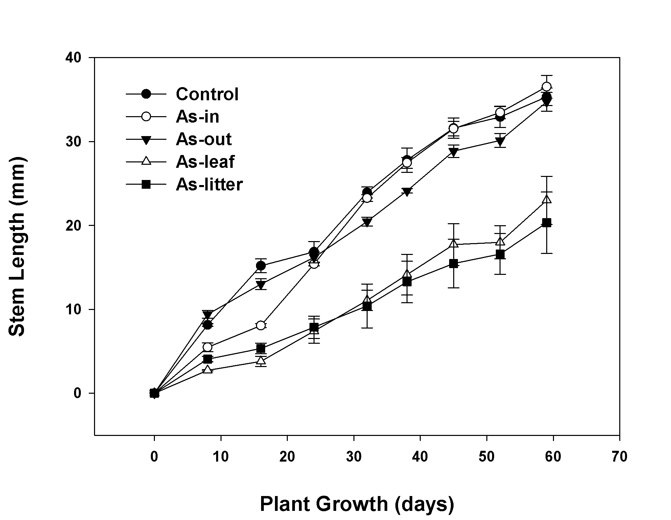
Fig. 1 Growth of Bidens pilosa in pots containing soil mixed with leaf or litter powder of Alstonia scholaris, or control soil. Changes in stem length of B. pilosa were measured until 59 days after transplanting. Data are represented as the mean ± SE (n = 3)
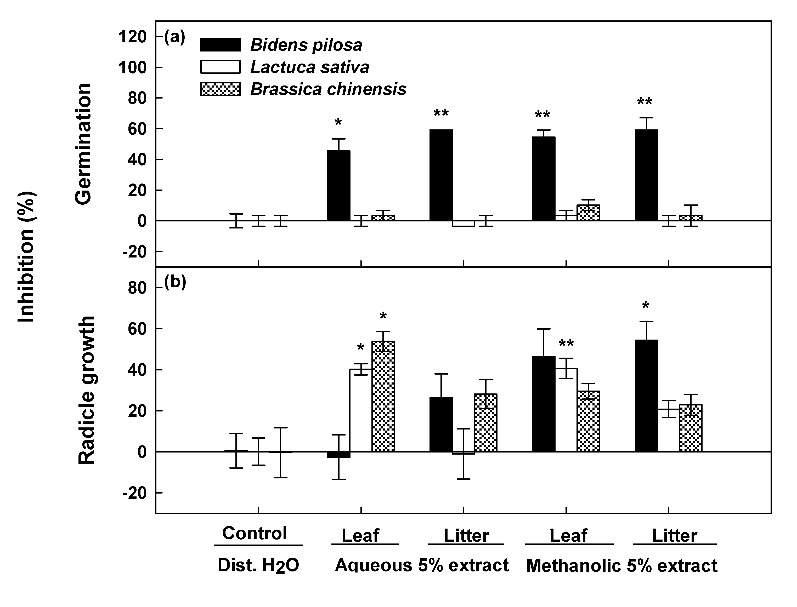
Fig. 2 Effects of Alstonia scholaris extracts on seed germination and radical growth of Lactuca sativa, Brassica chinensis, and Bidens pilosa. The bioassay was conducted using aqueous extracts of leaves and litter, methanolic extracts of leaves and litter, and distilled water as a control. Data are represented as the mean ± SE (n = 3). ***, **, and * indicate significant differences between the control and treatments at P < 0.001, P < 0.01, and P < 0.05, respectively, according to the unpaired t-test
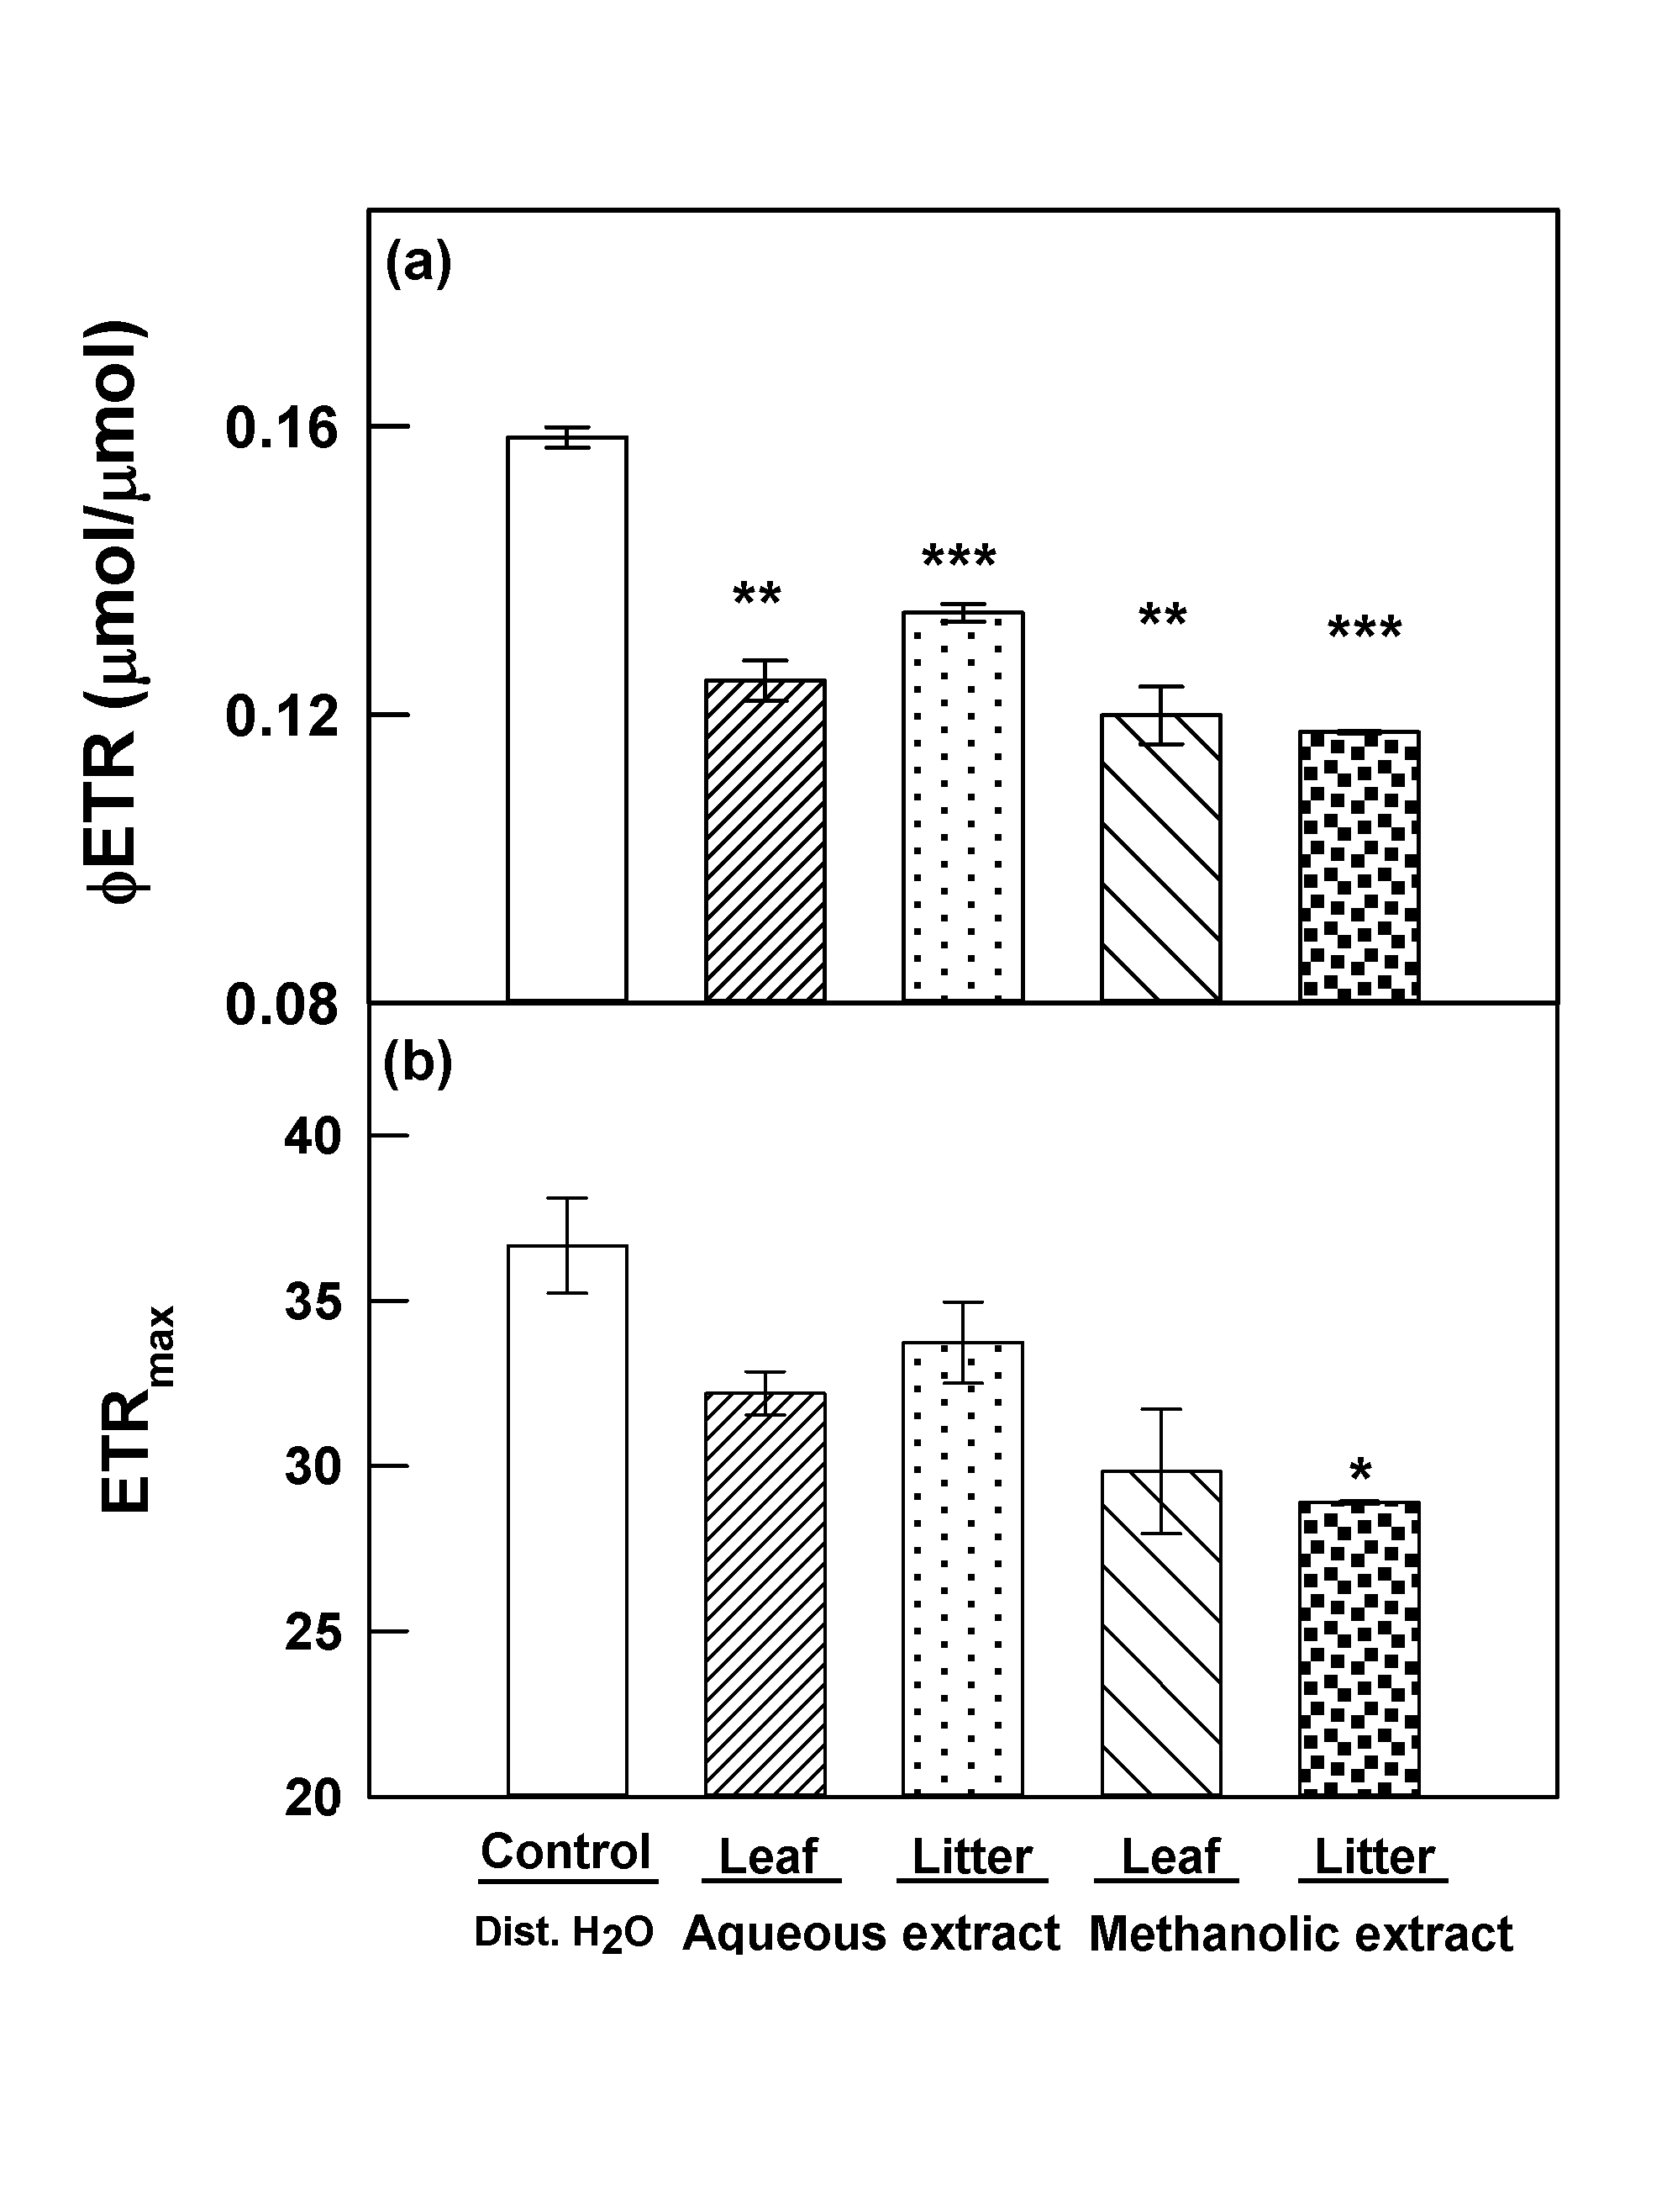
Fig. 3 Effects of 5% aqueous and 5% methanolic extracts of leaves and litter of Alstonia scholaris on the electron transport rate (ETR) of cucumber seedlings. Data are represented as the mean ± SE (n = 4). ***, **, and * indicate significant differences between the control and treatments at P < 0.001, P < 0.01, and P < 0.05, respectively, according to the unpaired t-test

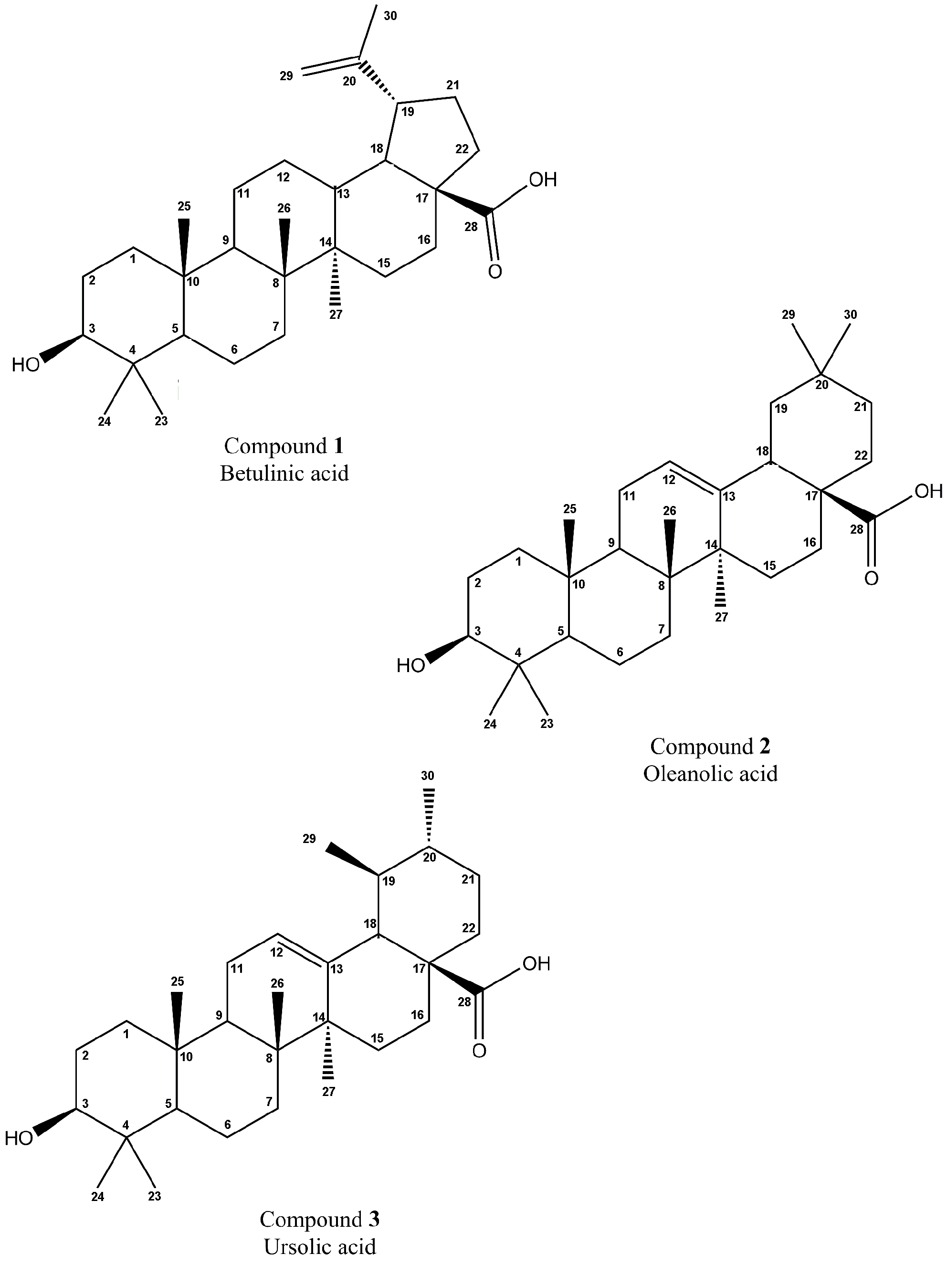

Fig. 4 Chemical structures of the pentacyclic triterpenoids isolated from the leaves of Alstonia scholaris

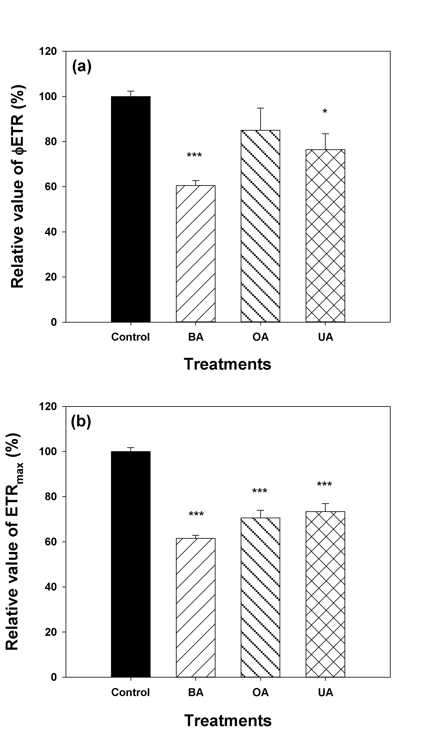

Fig. 5 Effects of betulinic acid (BA), oleanolic acid (OA), and ursolic acid (UA) on the electron transport rate (ETR) of cucumber seedlings. The cucumber seedlings were incubated in solutions containing 2 mM of triterpenoids. Data are represented as the mean ± SE (n = 4). *** and * indicate significant differences between the control and treatments at P < 0.001 and P < 0.05, respectively, according to the unpaired t-test
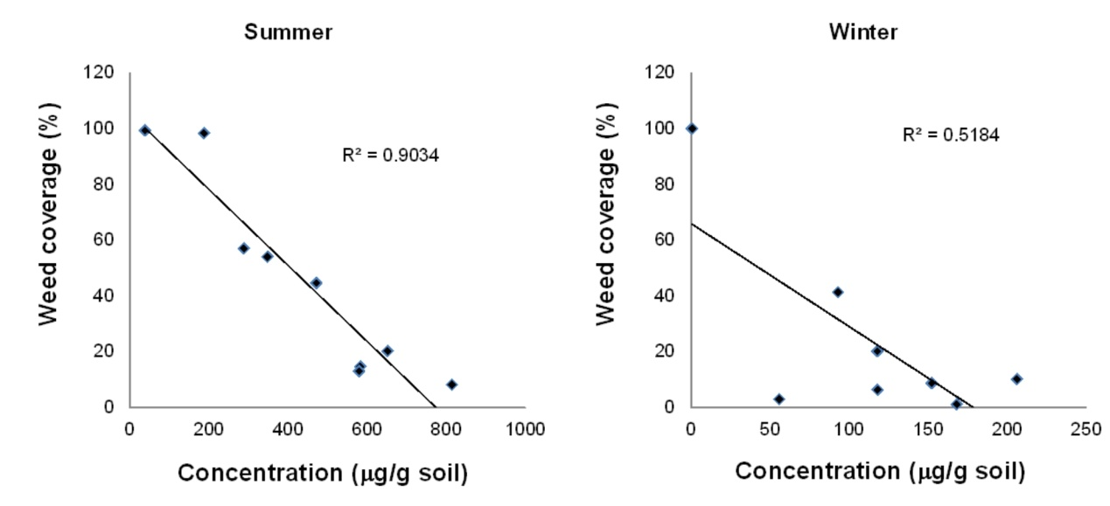
Fig. 6 Negative correlation between the concentration of ursolic acid and weed coverage in the field during the summer and winter of 2011 and 2012

Table 1 Relative coverage (%) of each of the investigated weed species in the field experimental site. The grassland area adjacent to the Alstonia scholaris forest was used as a control site

 | Underneath | Distance from A. scholaris, meter
Plant species | A. scholaris | 1 | 3 | > 5 (control)
Bidens pilosa | - | 18.9 ± 15.5ab | 57.8 ± 16.8c | 66.7 ± 33.3cd
Chamaedorea seifrizii | 3.1 ± 0.2*a | - | - | -
Chamaesyce hirta | - | - | - | 7.6 ± 7.6ab
Conyza canadensis | - | 0.4 ± 0.4a | - | 0.4 ± 0.4a
Cyperaceae family | - | 0.3 ± 0.2a | 7.6 ± 7.2ab | -
Eleusine indica | - | - | - | 18.5 ± 18.4ab
Maba buxifolia | 1.3 ± 0.4a | 0.2 ± 0.2a | - | -
Murraya paniculata | 2.3 ± 0.1a | - | - | -
Passifiora suberosa | 0.2 ± 0.2a | 0.4 ± 0.2a | - | -
Poaceae family | - | - | - | 4.0 ± 4.0ab
Solanum nigrum | 0.2 ± 0.1a | - | - | -
Youngia japonica | - | 5.6 ± 1.5ab | 18.6 ± 12.8ab | -
Total relative coverage (%) | 7.0 ± 0.2ab | 25.7 ± 14.1b | 83.9 ± 14.9de | 97.1 ± 2.9e
*Data are represented as the mean ± SD (n = 3). Different letters indicate significant differences (P < 0.05) according to Duncan’s multiple range test
Table 2 Concentrations of the 3 isolated triterpenoids in different parts of Alstonia scholaris. Part A, samples of leaves and litter. Part B, soil samples collected from the floor of the A. scholaris forest (AS-in), and at distances of 1 m, 2 m, and 3 m from the A. scholaris forest. The grassland area adjacent to the A. scholaris forest was used as a control site (AS-out)

Materials | Concentration (µg/g soil or dry material)
Materials | Ursolic acid | Betulinic acid | Oleanolic acid
Part A
Leaf | 2450.2 ± 600.4a* | 5.8 ± 0.2a | 12.5 ± 2.8a
Litter | 2344.1 ± 342.6a | 8.7 ± 0.8b | 66.3 ± 2.4b
Part B
AS-out | n.d. | n.d. | n.d.
3 m | 191.1 ± 51.7b | n.d. | n.d.
2 m | 447.8 ± 49.6b | n.d. | n.d.
1 m | 682.2 ± 40.1b | 1.2 ± 0.1c | n.d.
AS-in | 3095.7 ± 659.5a | 4.3 ± 0.8d | n.d.
*Data are represented as the mean ± SE (n = 3). Different letters indicate significant differences (P < 0.05) according to Duncan’s multiple range test; n.d.: Not detectable
Table 3 Half-maximal inhibitory concentrations (IC₅₀) of triterpenoids on seed germination and radical growth of Bidens pilosa and Lactuca sativa

 | Half-maximal inhibitory concentrations (IC₅₀, µM)
 | Radical length |  |  |  |  | Germination
Triterpenoids | B. pilosa |  | L. sativa |  |  |  | B. pilosa |  | L. sativa
Betulinic acid | 217.1 ± 6.6a* |  | 78.8 ± 3.1d |  |  |  | 31.9 ± 4.9a |  | 182.1 ± 0.1c
Oleanolic acid | 468.4 ± 33.8b |  | 94.2 ± 2.1d |  |  |  | 50.0 ± 21.6a |  | 87.2 ± 0.1b
Ursolic acid | 735.2 ± 0.1c |  | 101.6 ± 0.1d |  |  |  | 46.2 ± 0.1a |  | >2000
*Data are represented as the mean ± SE (n = 3). Different letters indicate significant differences (P < 0.05) according to Duncan’s multiple range test

