Journal of Gastroenterology and Hepatology
Review



Differential roles of serum HBV DNA and HBsAg level in predicting virological breakthrough in patients receiving lamivudine therapy
For
Peer

Journal: | Journal of Gastroenterology and Hepatology
Manuscript ID: | JGH-00396-2013
Manuscript Type: | Original Article - Hepatology (Clinical)
Date Submitted by the Author: | 25-Mar-2013
Complete List of Authors: | Su, Chien-Wei; Taipei Veterans General Hospital, Division of  Gastroenterology, Department of Medicine;  Wu, Chun-Ying; Taichung Veterans General Hospital, Division of  Gastroenterology  Hung, Hung-Hsu; Taipei Veterans General, Division of Gastroenterology, Department of Medicine  Wu, Chu-Hui; Taipei Veterans General Hospital, Department of Medical  Research and Education  Sheen, I-Jane; National Yang-Ming University, Institute of Clinical Medicine Wu, Jaw-Ching; Taipei Veterans General Hospital, Department of Medical Research and Education; Institute of Clinical Medicine, National Yang-Ming University School of Medicine
 | Hepatitis B, anitviral therapy < Hepatology, Hepatitis B, clinical < Hepatology, Viral hepatitis < Hepatology
Key Words:



4 Differential roles of serum HBV DNA and HBsAg level in predicting virological
5
6
7 breakthrough in patients receiving lamivudine therapy
8
9
10 Short running title: HBsAg level predicts HBV DNA breakthrough
11
12
13
14
15 Chien-Wei Su1,2,3, Chun-Ying Wu,2,4,5,6 Hung-Hsu Hung2,3,7, Chu-Hui Wu,8 I-Jane
16
17
For
18 Sheen3, and Jaw-Ching Wu3,8
19
20 Contributions: Drs. CW Su and CY Wu contributed equally to this work.
21
22
23
Peer
24 1Division of Gastroenterology, Department of Medicine, 8Department of Medical
25 Research and Education, Taipei Veterans General Hospital, Taipei, Taiwan
26
27 2Faculty of Medicine, and 3Institute of Clinical Medicine, School of Medicine,
28 National Yang-Ming University, Taipei, Taiwan
29
30 4Division of Gastroenterology, Taichung Veterans General Hospital, Taichung;
Review
31 5Department of Public Health and Graduate Institute of Clinical Medicine, China
32
33 Medical University, Taichung;
34 6Department of Life Sciences, National Chung-Hsing University, Taichung;
35 7Division of Gastroenterology, Department of Medicine, Cheng Hsin General
36
37 Hospital, Taipei, Taiwan
38
39
40 Address for correspondence and reprint requests:
41 Jaw-Ching Wu, M.D. Ph.D.
42
43 Department of Medical Research and Education, Taipei Veterans General Hospital
44 and Institute of Clinical Medicine and Cancer Research Center, National Yang-Ming
45
46 University
47 201 Shih-Pai Road, Sec. 2, Taipei 112, Taiwan
48 Tel: 886-2-28712121 ext. 3218; Fax: 886-2-28745074
49
50 E-mail: jcwu@vghtpe.gov.tw
3 Disclosures: The authors have no potential conflicts (financial, professional, or
4
5
6 personal) of interest.
7
8 Grant Support: This study was supported by grants from the National Science
9
10 Council of Taiwan (NSC 101-2314-B-075-013-MY2), Taipei Veterans General
11
12 Hospital (V95C1-014, VGHUST100-G7-2-1), Yang-Ming University (101AC-T501,
13
14 Ministry of Education, Aim for the Top University Plan), and the Center of Excellence
15
16 for Cancer Research at TVGH (DOH101-TD-C-111-007), Taipei, Taiwan.
17
For
18 Abbreviations: ALT, alanine aminotransferase; ant-HBe, antibody against HBeAg;
19
20 BCP, basal core promoter; CHB, chronic hepatitis B; HBeAg, hepatitis B e antigen;
21
22 HBsAg, hepatitis B surface antigen; HBV, hepatitis B virus; HCC, hepatocellular
Peer
23
24 carcinoma; HCV, hepatitis C virus; HDV, hepatitis D virus; HR, Hazard ratio; NUC,
25
26
27 nucleos(t)ide; VB: virological breakthrough
28
29 Writing assistance: Gene Alzona Nisperos MD
30
Review
31
32
33
34
35
36
37
38
39
40
41
42
43
44
4 ABSTRACT
5
6
7 Background and aim: The role of serum hepatitis B surface antigen (HBsAg) level in
8
9 determining virological breakthrough (VB) for patients with hepatitis B virus (HBV)
10
11
12 infection receiving lamivudine remains unclear. We aimed to evaluate the impact of
13
14
15 serum HBsAg levels on VB among patients receiving lamivudine therapy, especially
16
17
For
18 in a setting of low HBV viral load.
19
20
21 Methods: We enrolled 268 consecutive treatment-naïve patients who underwent
22
23 lamivudine therapy for chronic hepatitis B (CHB). Factors in terms of VB were
Peer
24
25
26 analyzed by multivariate analysis.
27
28
29 Results: After a median treatment duration of 67.1 weeks, 102 patients had VB.
30
Review
31
32 Multivariate analysis showed that positive hepatitis B e antigen (HBeAg) (Hazard
33
34
35 ratio, HR 2.179, p=0.012) and HBV DNA levels ≥2000 IU/mL after 6 months of
36
37 lamivudine therapy (HR 5.460, p<0.001) were independent risk factors predicting VB.
38
39
40 The cumulative VB rates stratified by HBeAg positive and negative at 3 years were
41
42
43 44.7% and 26.3%, respectively. At 3 years, the cumulative VB rates stratified by the
44
45
46 HBV DNA <2000 and ≥2000 IU/mL after 6 months of therapy were 25.5% and
47
48
49 79.4%, respectively. For HBeAg-positive patients with serum HBV DNA <2000
50
51 IU/mL after 6 months of therapy, baseline HBsAg levels ≥20000 IU/mL was the only
4 >2000 IU/mL after 6 months of therapy could predict subsequent VB. In patients with
5
6
7 lower on-treatment viral load, baseline serum HBsAg level is associated with the
8
9 emergence of VB, especially for those with serum positive HBeAg.
10
11
12
13
14
15 Key words: hepatitis B; lamivudine; surface antigen; virological breakthrough
16
17
For
18
19
20
21
22
23
Peer
24
25
26
27
28
29
30
Review
31
32
33
34
35
36
37
38
39
40
41
42
43
44
4 INTRODUCTION
5
6
7 Chronic hepatitis B virus (HBV) infection remains a global public health threat.
8
9 At least 350 million individuals are chronic carriers of the virus worldwide.1, 2 Several
10
11
12 risk factors have been correlated with poor prognosis for patients with chronic
13
14
15 hepatitis B (CHB), including male sex, older age, family history of infection, serum
16
17
For
18 HBV DNA levels >2000 IU/mL, genotype C or D, HBV genome mutations,
19
20 concurrent viral infections, and exposure to aflatoxin.3-5
21
22
23 Among the risk factors, active viral replication can be suppressed by adequate
Peer
24
25
26 anti-viral therapy. Lamivudine is the first nucleos(t)ide analogue (NUC) to be
27
28
29 approved as treatment of CHB. However, the major limitation of lamivudine is the
30
Review
31
32 high rate of drug resistance during therapy.6, 7 The emergence of lamivudine resistance
33
34
35 is usually accompanied by a rebound in viral load (virological breakthrough, VB).
36
37 Acute exacerbation of hepatitis may also occur, leading to hepatic decompensation or
38
39
40 even mortality. Moreover, the protective effect of lamivudine in delaying the
41
42
43 progression of liver cirrhosis and reducing the risk of hepatocellular carcinoma (HCC)
44
45
46 diminishes if the patient has VB during treatment.8, 9
47
48
49 Consequently, recent treatment guidelines recommend that entecavir and
50
51 tenofovir are better treatment for CHB.10 Nonetheless, lamivudine is still widely
4 monotherapy and 11.7% of these patients have sero-clearance of hepatitis B surface
5
6 antigen (HBsAg).7 Thus, it is necessary to identify super-responders of lamivudine
7
8
9 therapy with low incidences of drug resistance in the long-term anti-viral therapy.
10
11
12 Regarding those with high risk of drug resistance, early detection and the addition of
13
14
15 or prompt switching to other NUCs may achieve optimal virological response and
16
17
For
18 decrease the incidence of drug resistance after salvage anti-viral therapy.11, 12
19
20
21 Recent studies demonstrate that a decline of HBV DNA and HBsAg levels can
22
23 predict treatment response in patients with CHB during pegylated interferon therapy.13,
Peer
24
25
26 14 However, for patients who receive NUC therapy, although on-treatment serum
27
28
29 HBV DNA level is crucial for the emergence of drug resistance, whether serum
30
Review
31
32 HBsAg level also determines the development of VB remains unclear.15, 16 The
33
34
35 predictive ability of serum HBsAg levels for treatment response of NUC may be
36
37 masked by the high HBV viral replication,17 but may be more apparent in a setting of
38
39
40 low viral load during therapy. To validate this hypothesis, this study was conducted to
41
42
43 evaluate the impact of serum HBV DNA and HBsAg levels on VB among patients
44
4 METHODS
5
6
7 Patients and follow-up
8
9 Two hundred and sixty-eight treatment-naive consecutive patients with CHB
10
11
12 who underwent oral lamivudine treatment (100 mg daily) at Taipei Veterans General
13
14
15 Hospital between December 1999 and September 2008 were retrospectively analyzed.
16
17
For
18 The inclusion criteria were age >18 years, positive serum HBsAg for more than 6
19
20
21 months, serum alanine aminotransferase (ALT) levels >80 IU/L, serum HBV DNA
22
23 levels >2000 IU/L, and continuous lamivudine therapy for at least 6 months.
Peer
24
25
26 The exclusion criteria were previous use of anti-viral therapy for CHB, presence
27
28
29 of HCC, current use of immune-modulating drugs, prior organ transplantation, and
30
Review
31
32 concurrent infection with hepatitis C virus (HCV), hepatitis D virus (HDV), or human
33
34
35 immunodeficiency virus. Serum samples were obtained at baseline and every 3
36
37 months during the administration of lamivudine.
38
39
40 The hospital’s Institutional Review Board approved the study protocol, which
41
42
43 complied with the standards of the Declaration of Helsinki.
44
45
46 Biochemical and serological markers
47
48
49 Serum biochemistries were measured using the Roche/Hitachi Modular Analytics
50
51 Systems (Roche Diagnostics GmbH, Mannheim, Germany). Serum HBsAg levels
4 HBeAg (anti-HBe), and antibody to HDV were tested using a radio-immunoassay kit
5
6
7 (Abbott Laboratories, North Chicago, IL), while anti-HCV was assessed by a
8
9 second-generation enzyme immunoassay kit (Abbott Laboratories, North Chicago,
10
11
12 IL).
13
14
15 Quantification of HBV DNA, HBV genotyping and definition of HBV VB
16
17
For
18 The HBV DNA levels were measured by a Cobas Amplicor HBV monitor
19
20
21 (Roche Diagnostic System, Basel, Switzerland) with a detection limit of 300
22
23 copies/mL. In this test, 5.82 copies/mL was equal to 1 IU/mL. VB was defined as an
Peer
24
25
26 increase in serum HBV DNA level of more than 1 log10 IU/mL compared to the
27
28
29 lowest HBV DNA level.10 Genotyping of HBV was performed by PCR restriction
30
Review
31
32 fragment length polymorphism of the surface gene of HBV and was further verified
33
34 by sequencing as previously described.4, 18 The precore/core region of HBV DNA was
35
36
37 also sequenced to detect mutations within this segment.18
38
39
40 Detection of HBV polymerase mutations by INNO-LiPA
41
42
43 In this cohort, 178 patients were tested for HBV polymerase mutations by
44
4 lamivudine and adefovir resistance (codons 80, 173, 180, 181, 204, and 236).19
5
6
7 Statistical analysis
8
9 All statistical analyses were performed using the SPSS 17.0 for Windows (SPSS.
10
11
12 Inc., Chicago, IL, USA). Pearson chi-square analysis was used to compare categorical
13
14
15 variables and the Mann-Whitney U-test was used to compare continuous variables.
16
17
For
18 Cumulative VB rates after lamivudine therapy were estimated by the Kaplan-Meier
19
20
21 method and compared using Cox’s proportional hazards model.
22
23 Variables with statistical significance (p<0.05) or proximate to it (p<0.1) by
Peer
24
25
26 univariate analysis underwent multivariate analysis using a forward stepwise logistic
27
28
29 regression model. A two-tailed p<0.05 was considered statistically significant.
30
Review
31
32 The predicting ability of VB among baseline and on-treatment parameters was
33
34 further determined by comparing the Akaike information criterion (AIC).20, 21 The
35
36
37 lower the AIC, the more informative and discriminative the model is.
38
39
40
41
42
43
44
45
46
47
48
49
50
51
4 RESULTS
5
6
7 Baseline clinical characteristics
8
9 One hundred and forty patients had positive HBeAg in sera, while the remaining
10
11
12 128 patients were HBeAg-negative CHB. Compared to those with negative HBeAg in
13
14
15 sera, HBeAg-positive patients had younger age, lower proportion of males and those
16
17
For
18 with liver cirrhosis, and a trend of higher baseline ALT and lower bilirubin levels
19
20
21 (Table 1). Regarding virological factors, baseline serum HBsAg and HBV DNA
22
23 levels were both lower in HBeAg-negative patients. Moreover, there was a positive
Peer
24
25
26 correlation between serum levels of HBsAg and HBV DNA in HBeAg-negative
27
28
29 patients (r2= 0.415, p<0.001). However, the correlation was not apparent in
30
Review
31
32 HBeAg-positive patients (r2= 0.007, p=0.381). HBeAg-negative patients had a higher
33
34
35 proportion of genotype B HBV infection and pre-core mutant. Nonetheless, the
36
37 proportion of basal core promoter (BCP) mutations was similar between the two
38
39
40 groups.
41
42
43 Among the 246 patients with available data for HBV genotyping, 151 were
44
4 On-treatment parameters stratified by HBeAg status
5
6
7 After lamivudine therapy, the interval between the time of starting treatment and
8
9 the time of ALT normalization (40 U/L) was comparable between HBeAg-positive
10
11
12 and HBeAg-negative patients (Table 1). Regarding virological response, 49 (23.0%)
13
14
15 patients had serum HBVDNA levels ≧2000 IU/mL after 6 months of lamivudine
16
17
For
18 therapy. Although HBeAg-positive patients had higher rates of on-treatment serum
19
20
21 HBV DNA levels ≧2000 IU/mL (37.1% vs. 9.3%, p<0.001), they also had larger
22
23 reduction of HBV DNA compared to HBeAg-negative patients. Similarly, in terms of
Peer
24
25
26 serologic response, serum HBsAg levels and the reduction of HBsAg from baseline
27
28
29 were both higher in HBeAg-positive patients. Lamivudine resistance detected by
30
Review
31
32 INNO-LiPA was more common in HBeAg-positive patients than in HBeAg-positive
33
34
35 patients (20.8% vs. 8.3%, p<0.001).
36
37 Risk factors associated with HBV virological breakthrough
38
39
40 After median treatment duration of 67.1±59.3 weeks, 102 patients had HBV
41
42
43 DNA breakthrough. By univariate analysis, baseline factors, including positive
44
45
46 HBeAg, serum HBsAg levels >20000 IU/mL, and HBV DNA ≥108 IU/mL were risk
47
48
49 factors predicting VB during lamivudine treatment (Table 2; Fig. 1). The cumulative
50
51 VB rates at 3 years were 44.7% for HBeAg-positive patients and 26.3% for
4 The on-treatment factors after 6 months of therapy, including ALT level, HBsAg
5
6
7 ≥10000 IU/mL, HBV DNA ≥2000 IU/mL, and presence of lamivudine resistance by
8
9 INNO-LiPA were risk factors predicting VB. The cumulative VB rates at 3 years were
10
11
12 25.5% for those with of <2000 IU/mL, and 79.4% for those with ≥2000 IU/mL,
13
14
15 respectively (p<0.001) (Fig. 1).
16
17
For
18 Multivariate analysis showed that positive HBeAg (hazard ratio, HR 2.179,
19
20
21 p=0.012) and HBV DNA after 6 months of therapy ≥2000 IU/mL (HR 5.460,
22
23 p=0.001) were independent risk factors of VB (Table 3). For HBeAg-positive patients,
Peer
24
25
26 serum HBV DNA levels ≥2000 IU/mL after 6 months of lamivudine therapy (HR
27
28
29 7.132, p<0.001) was the only independent risk factor associated with subsequent VB.
30
Review
31
32 Regarding HBeAg-negative patients, baseline serum ALT levels (HR 0.998, p=0.033)
33
34
35 and serum HBV DNA levels ≥2000 IU/mL after 6 months of lamivudine therapy (HR
36
37 2.712, p=0.031) were crucial in determining VB.
38
39
40 Impact of HBsAg levels on HBV DNA breakthrough during lamivudine therapy
41
42
43 Patients with baseline serum HBsAg ≥20000 IU/mL had higher incidences of VB
44
4 on-treatment serum HBV DNA levels, and the combination of these two assays. As
5
6
7 shown in Table 4, serum HBV DNA levels after 6 months of lamivudine had lower
8
9 AIC values in predicting VB than baseline serum HBsAg levels had, both in
10
11
12 HBeAg-positive and in HBeAg-negative patients. Moreover, the combination of
13
14
15 baseline HBsAg and on-treatment serum HBV DNA levels had the lowest AIC values,
16
17
For
18 suggesting it could provide more discriminative ability for predicting VB than
19
20
21 on-treatment serum HBV DNA levels alone.
22
23 Because on-treatment HBV DNA level was the most important risk factor
Peer
24
25
26 associated with VB in this cohort, it may confound the influence of serum HBsAg
27
28
29 levels. Consequently, risk factors that predict VB in patients with serum HBV DNA
30
Review
31
32 levels <2000 IU/mL after 6 months of lamivudine therapy were analyzed (Fig.2C-E).
33
34
35 For HBeAg-positive patients, baseline HBsAg levels ≥20000 IU/mL was the only risk
36
37 factor correlated with VB during lamivudine therapy (Table 5). For HBeAg-negative
38
39
40 patients, the cumulative VB rates were similar between patients with high and low
41
42
43 baseline HBsAg levels .
44
45
46
47
48
49
50
51
4 DISCUSSION
5
6
7 The present study has several major findings. First, we demonstrate that for
8
9 patients with CHB and active viral replications, there is a positive correlation between
10
11
12 serum levels of HBsAg and HBV DNA in HBeAg-negative patients; but this
13
14
15 correlation is not apparent in HBeAg-positive patients. Second, serum HBV DNA
16
17
For
18 level >2000 IU/mL at 6 months after the start of therapy is the most important risk
19
20
21 factor predicting subsequent VB for CHB patients treated with lamivudine. Moreover,
22
23 the combination of testing baseline serum HBsAg and on-treatment HBV DNA levels
Peer
24
25
26 could raise its discriminative ability. Third, for patients with lower on-treatment viral
27
28
29 load, baseline serum HBsAg level is associated with VB, especially for those with
30
Review
31
32 positive HBeAg in sera. Fourth, by the sensitive INNO-LiPA test, 15.7% of patients
33
34
35 have lamivudine resistance viral mutants after 6 months of lamivudine therapy and
36
37 have higher incidences of developing VB with continuous lamivudine therapy (Table
38
39
40 2), implying that this method may be applied for the early detection of drug resistance
41
42
43 in CHB patients treated with NUC.
44
4 with inadequate on-treatment virological response, which is defined as serum HBV
5
6
7 DNA levels ≥2000 IU/mL after 24 weeks of therapy, the addition of adefovir or
8
9 tenofovir is suggested to prevent the emergence of resistance. The present study also
10
11
12 demonstrates that serum HBV DNA levels ≥2000 IU/mL after 6 months of lamivudine
13
14
15 therapy is the most important risk factor for predicting the emergence of subsequent
16
17
For
18 VB. This suggests that monitoring serum HBV DNA levels is the key component in
19
20
21 predicting VB for CHB patients treated with lamivudine.
22
23 Nevertheless, a previous study demonstrated that lamivudine-resistant HBV
Peer
24
25
26 mutants can still be selected even in patients with undetectable serum HBV DNA by
27
28
29 PCR during lamivudine therapy.24 Moreover, in our cohort, for patients who had
30
Review
31
32 serum HBV DNA <2000 IU/mL after 6 months of lamivudine therapy, their
33
34
35 cumulative VB rate at 3 years was still as high as 25.5%. It is therefore crucial to
36
37 elucidate the mechanism and identify risk factors of VB in low levels of viral
38
39
40 replication during lamivudine therapy.
41
42
43 Serum HBsAg levels have been validated to predict the natural history of
44
45
46 patients with CHB.25 Tseng et al demonstrated that in HBeAg-negative CHB patients
47
48
49 with serum HBV DNA level <2000 IU/mL, serum HBsAg level ≥1000 IU/mL was the
50
51 major risk factor for developing HCC.17 Thus, testing serum HBsAg level may serve
4 Among CHB patients who receive NUCs therapy, Chan and colleagues
5
6
7 demonstrated that patients with serum HBsAg level ≤2 log10 IU/mL at the end of
8
9 treatment have lower incidences of virological relapse after therapy.26, 27 Hadziyannis
10
11
12 showed that after 4-5 years of long-term adefovir therapy, patients with lower serum
13
14
15 HBsAg levels at the end of treatment have higher incidences of achieving sustained
16
17
For
18 virological response and clearing HBsAg after therapy.28 As most of the patients have
19
20
21 undetectable serum HBV DNA levels at the end of therapy, lower serum HBsAg
22
23 levels may serve as a supplementary indication to guide treatment cessation of
Peer
24
25
26 long-term NUCs therapy with successful virological response.
27
28
29 Although serum HBsAg levels are correlated with durability after
30
Review
31
32 discontinuation of NUCs therapy, the application of serum HBsAg levels for
33
34
35 predicting treatment efficacy and VB during therapy is still controversial. Previous
36
37 studies demonstrate that serum HBsAg level decline slowly during NUC therapy.29
38
39
40 This reflects the lower incidence of HBsAg sero-clearance during short-term NUCs
41
42
43 therapy. Fung and Lee both showed that baseline serum HBsAg levels and
44
4 with NUCs, the predictive value of serum HBsAg for evaluating the efficacy of NUC
5
6
7 therapy may be relatively limited.
8
9 As regards VB during NUC therapy, the role of serum HBsAg levels is not fully
10
11
12 elucidated. In our current study, for patients with higher baseline serum HBsAg levels,
13
14
15 the incidence of VB is still high even in the setting of low viral load during therapy,
16
17
For
18 especially for those with positive HBeAg in sera. Interestingly, our study also shows
19
20
21 that there is a positive correlation between serum HBsAg and HBV DNA levels in
22
23 HBeAg-negative patients; but this correlation is not significant in HBeAg-positive
Peer
24
25
26 patients. As the production of HBsAg may be from translation of transcriptionally
27
28
29 active covalently-closed circular DNA (cccDNA), or from translation of viral genes
30
Review
31
32 transcribed from integrated HBV DNA sequences in the host genome.33 Serum
33
34 HBsAg levels may reflect intra-hepatic HBV cccDNA and intra-hepatic HBV DNA.34
35
36
37 On possible mechanism is that in HBeAg-positive patients, higher serum HBsAg
38
39
40 levels may indicate higher intra-hepatic HBV cccDNA levels, which serve as a
41
42
43 reservoir and template for HBV replication. Consequently, the higher intra-hepatic
44
45
46 HBV cccDNA levels may contribute to the higher incidences of VB in the setting of
47
48
49 low serum HBV DNA levels during lamivudine therapy. However, more experiments
50
51 are warranted to validate this hypothesis.
4 detected when they comprise 20-25% of the viral population.23 Zoulim demonstrated
5
6
7 that the incidence of emerging lamivudine-resistant viral strains after 6 months of
8
9 therapy is around 6% by this method.35 In the present cohort, using the more sensitive
10
11
12 INNO-LiPA method, which can detect variants at a proportion of 5% of the total
13
14
15 population, the rate of drug resistant mutants is as high as 15.6% after 6 months of
16
17
For
18 lamivudine therapy. This indicates that the INNO-LiPA method can be applied for
19
20
21 earlier detection of drug resistance in CHB patients treated with NUC.
22
23 One of the major limitations of this study is the retrospective study design. The
Peer
24
25
26 impact of compliance and medication adherence on the VB could not be evaluated. A
27
28
29 recent study conducted by Hongthanakorn demonstrated that the cumulative VB rate
30
Review
31
32 at 5 years is 46.1% for CHB patients receiving NUCs.36 However, nearly 40% of VB
33
34
35 is not related to resistance to NUCs detected by the sensitive line probe assay. Instead,
36
37 non-adherence is the major cause of these VBs. Thus, aside on-treatment serum HBV
38
39
40 DNA monitoring, counseling on medication adherence is also crucial for CHB
41
42
43 patients being treated with NUCs.
44
4 levels could increase the predicting ability. Among patients with lower on-treatment
5
6
7 viral load, baseline serum HBsAg level is associated with the emergence of VB,
8
9 especially for those with positive HBeAg in sera. We suggest that all CHB patients
10
11
12 with higher baseline serum HBsAg levels should receive NUCs with high potency and
13
14
15 genetic barriers to prevent the emergence of VB.
16
17
For
18
19
20
21
22
23
Peer
24
25
26
27
28
29
30
Review
31
32
33
34
35
36
37
38
39
40
41
42
43
44
45
46
47
48
49
50
51
4 REFERENCES
5
6 [1] Liaw YF, Chu CM. Hepatitis B virus infection. Lancet. 2009; 373: 582-92.
7 [2] Lok AS, McMahon BJ. Chronic hepatitis B. Hepatology. 2007; 45: 507-39.
8
9 [3] Yang HI, Sherman M, Su J, et al. Nomograms for risk of hepatocellular
10 carcinoma in patients with chronic hepatitis B virus infection. J Clin Oncol. 2010; 28:
11 2437-44.
12
13 [4] Su CW, Huang YH, Huo TI, et al. Genotypes and viremia of hepatitis B and D
14 viruses are associated with outcomes of chronic hepatitis D patients. Gastroenterology.
15
16 2006; 130: 1625-35.
17 [5] Kao JH, Liu CJ, Jow GM, Chen PJ, Chen DS, Chen BF. Fine mapping of
For
18 hepatitis B virus pre-S deletion and its association with hepatocellular carcinoma.
19
20 Liver Int. 2012; 32: 1373-81.
21 [6] Lok AS, Lai CL, Leung N, et al. Long-term safety of lamivudine treatment in
22
23 patients with chronic hepatitis B. Gastroenterology. 2003; 125: 1714-22.
Peer
24 [7] Fasano M, Lampertico P, Marzano A, et al. HBV DNA suppression and HBsAg
25 clearance in HBeAg negative chronic hepatitis B patients on lamivudine therapy for
26
27 over 5 years. J Hepatol. 2012; 56: 1254-8.
28 [8] Liaw YF, Sung JJ, Chow WC, et al. Lamivudine for patients with chronic
29
30 hepatitis B and advanced liver disease. N Engl J Med. 2004; 351: 1521-31.
Review
31 [9] Eun JR, Lee HJ, Kim TN, Lee KS. Risk assessment for the development of
32
33 hepatocellular carcinoma: according to on-treatment viral response during long-term
34 lamivudine therapy in hepatitis B virus-related liver disease. J Hepatol. 2010; 53:
35 118-25.
36
37 [10] EASL clinical practice guidelines: Management of chronic hepatitis B virus
38 infection. J Hepatol. 2012; 57: 167-85.
39
40 [11] Buti M, Elefsiniotis I, Jardi R, et al. Viral genotype and baseline load predict the
41 response to adefovir treatment in lamivudine-resistant chronic hepatitis B patients. J
42 Hepatol. 2007; 47: 366-72.
43
44 [12] Lampertico P, Vigano M, Manenti E, Iavarone M, Lunghi G, Colombo M.
45 Adefovir rapidly suppresses hepatitis B in HBeAg-negative patients developing
3 in chronic hepatitis B patients at 3 years. Aliment Pharmacol Ther. 2012; 35: 1326-35.
4 [16] Lee JM, Ahn SH, Kim HS, et al. Quantitative hepatitis B surface antigen and
5
6 hepatitis B e antigen titers in prediction of treatment response to entecavir.
7 Hepatology. 2011; 53: 1486-93.
8
9 [17] Tseng TC, Liu CJ, Yang HC, et al. High levels of hepatitis B surface antigen
10 increase risk of hepatocellular carcinoma in patients with low HBV load.
11 Gastroenterology. 2012; 142: 1140-9 e3; quiz e13-4.
12
13 [18] Wu JC, Huang YH, Chau GY, et al. Risk factors for early and late recurrence in
14 hepatitis B-related hepatocellular carcinoma. J Hepatol. 2009; 51: 890-7.
15
16 [19] Mirandola S, Campagnolo D, Bortoletto G, Franceschini L, Marcolongo M,
17 Alberti A. Large-scale survey of naturally occurring HBV polymerase mutations
For
18 associated with anti-HBV drug resistance in untreated patients with chronic hepatitis
19
20 B. J Viral Hepat. 2011; 18: e212-6.
21 [20] Hosmer DW, Hosmer T, Le Cessie S, Lemeshow S. A comparison of
22
23 goodness-of-fit tests for the logistic regression model. Stat Med. 1997; 16: 965-80.
Peer
24 [21] Hsu CY, Lee YH, Hsia CY, et al. Performance status in patients with
25 hepatocellular carcinoma: determinants, prognostic impact, and ability to improve the
26
27 Barcelona Clinic Liver Cancer system. Hepatology. 2013; 57: 112-9.
28 [22] Chen CJ, Yang HI, Su J, et al. Risk of hepatocellular carcinoma across a
29
30 biological gradient of serum hepatitis B virus DNA level. Jama. 2006; 295: 65-73.
Review
31 [23] Keeffe EB, Dieterich DT, Han SH, et al. A treatment algorithm for the
32
33 management of chronic hepatitis B virus infection in the United States: 2008 update.
34 Clin Gastroenterol Hepatol. 2008; 6: 1315-41; quiz 286.
35 [24] Svicher V, Alteri C, Gori C, et al. Lamivudine-resistance mutations can be
36
37 selected even at very low levels of hepatitis B viraemia. Dig Liver Dis. 2010; 42:
38 902-7.
39
40 [25] Jang JW, Yoo SH, Kwon JH, et al. Serum hepatitis B surface antigen levels in the
41 natural history of chronic hepatitis B infection. Aliment Pharmacol Ther. 2011; 34:
42 1337-46.
43
44 [26] Chan HL, Wong GL, Chim AM, Chan HY, Chu SH, Wong VW. Prediction of
45 off-treatment response to lamivudine by serum hepatitis B surface antigen
46
47 quantification in hepatitis B e antigen-negative patients. Antivir Ther. 2011; 16:
48 1249-57.
49 [27] Liang Y, Jiang J, Su M, et al. Predictors of relapse in chronic hepatitis B after
50
51 discontinuation of anti-viral therapy. Aliment Pharmacol Ther. 2011; 34: 344-52.
52 [28] Hadziyannis SJ, Sevastianos V, Rapti I, Vassilopoulos D, Hadziyannis E.
3 HBsAg decline during long-term potent nucleos(t)ide analogue therapy for chronic
4 hepatitis B and prediction of HBsAg loss. J Infect Dis. 2011; 204: 415-8.
5
6 [30] Fung J, Lai CL, Young J, et al. Quantitative hepatitis B surface antigen levels in
7 patients with chronic hepatitis B after 2 years of entecavir treatment. Am J
8
9 Gastroenterol. 2011; 106: 1766-73.
10 [31] Wursthorn K, Jung M, Riva A, et al. Kinetics of hepatitis B surface antigen
11 decline during 3 years of telbivudine treatment in hepatitis B e antigen-positive
12
13 patients. Hepatology. 2010; 52: 1611-20.
14 [32] Heathcote EJ, Marcellin P, Buti M, et al. Three-year efficacy and safety of
15
16 tenofovir disoproxil fumarate treatment for chronic hepatitis B. Gastroenterology.
17 2011; 140: 132-43.
For
18 [33] Liaw YF. Clinical utility of hepatitis B surface antigen quantitation in patients
19
20 with chronic hepatitis B: a review. Hepatology. 2011; 54: E1-9.
21 [34] Chan HL, Wong VW, Tse AM, et al. Serum hepatitis B surface antigen
22
23 quantitation can reflect hepatitis B virus in the liver and predict treatment response.
Peer
24 Clin Gastroenterol Hepatol. 2007; 5: 1462-8.
25 [35] Zoulim F, Poynard T, Degos F, et al. A prospective study of the evolution of
26
27 lamivudine resistance mutations in patients with chronic hepatitis B treated with
28 lamivudine. J Viral Hepat. 2006; 13: 278-88.
29
30 [36] Hongthanakorn C, Chotiyaputta W, Oberhelman K, et al. Virological
Review
31 breakthrough and resistance in patients with chronic hepatitis B receiving
32
33 nucleos(t)ide analogues in clinical practice. Hepatology. 2011; 53: 1854-63.
34
35
36
37
38
39
40
41
42
43
44
3
4 Table 1. Demographic data of patients who received lamivudine for chronic
5
6
7 hepatitis B, stratified by HBeAg status
8

9
10
11
12
13
14 Baseline characteristics
15
All
(n=268)
HBeAg
positive
(n=140)
HBeAg p
negative
(n=128)

16 Age (years, mean±SD) 42.3±13.7 35.2±10.8 50.0±12.3 <0.001

17 Sex (male/female) (%) 202/66 (75.4/24.6) 93/47
For
18
19 (66.4/33.6)
109/19

(85.2/14.8)
0.001

20 ALT (U/L)* 297.5;
21 158.0-549.0
22
333.0;

174.0-622.0
238.0; 118.0/427.0 0.056

23 Total bilirubin
Peer
24 (mg/dL)*
25
1.0; 0.7-1.8 1.0; 0.7-1.5 1.2; 0.8-2.0 0.068

26 Genotype (B/C) (%) 144/87
27 (62.3/37.7)
28 HBsAg (IU/mL)* 3392.0;
29
30 856.0-10538.0
31 HBV DNA (IU/mL)* 7.90x106;
32
33 2.87x105-1.10x108
64/55

(53.8/46.2)

8208.0;

1846.0-17548.0
Review
3.6x107;
1.39x106-1.10x108
80/32

(71.4/28.6)

1893.0;

573.0-5133.0
2.10x106;
40300.0-2.46x107
0.020

<0.001

0.002

34 BCP
35 (A1762T,G1764A)
36
37 (M/W) (%)
38 Pre-core mutant
39
40 (G1896A) (M/W) (%)
101/102 (49.8/50.2)

104/99 (51.2/48.8)
50/49 (50.5/49.5)

30/69 (30.3/69.7)
51/53 (49.0/51.0)

74/30 (71.2/28.8)
0.945

<0.001

41 Cirrhosis (yes/no) (%) 45/223
42 (16.8/83.2)
43
44 6 months after lamivudine treatment
45 ALT(U/L)* 28.0;
46
47 21.0-40.0
15/125 (10.7/89.3)

26.0;

19.0-38.3
30/98 (23.4/76.6)

31.0;

23.0-41.0
0.009

0.940

48 Time to ALT
49 normalization
50
51 (months, mean±SD)
5.31±6.75 5.68±7.71 4.90±5.52 0.367

52 HBV DNA (IU/mL)* 131.0;
570.5;
43.4;
0.499

3 HBV DNA reduction
4
5 from baseline
6 (IU/mL)*
6.54 x106;
2.10x105-1.10x108
3.55x107;
9.50x105-1.10x108
2.05x106;
3.35x104-2.22x107
0.004

7 HBsAg (IU/mL)* 1814.0;
8
9 588.0-3914.0

2194.0;

904.0-4842.0

1257.0;

436.0-3358.0

0.006

10 HBsAg reduction
11
12 from baseline
13 (IU/mL)*
14 6th months INNO-LiPA
15
16 Lamivudine
17 resistance (180 or 204)
For
18
1005.0;

-334.5-8350.5

28/150 (15.7/84.3)
3393.0;

-192.5-16576.0

22/84 (20.8/79.2)
143.0;

-382.0-1353.5

6/66 (8.3/91.7)
<0.001

<0.001

20 *Expressed as median (25 and 75 percentiles)
21
22 Abbreviations: SD, standard deviation; BCP, basal core promoter; M, mutant; W, wild
23
Peer
24
25
26
27
28
29
30
Review
31
32
33
34
35
36
37
38
39
40
41
42
43
44

3 Table 2. Univariate analysis of risk factors associated with HBV DNA
4 breakthrough during lamivudine therapy
5
6
 | Hazard  ratio | 95% confidence  interval | Standard  error | p
Baseline
Age (years) | 0.988 | 0.974-1.003 | 0.007 | 0.108
Sex (female/male) | 0.776 | 0.503-1.200 | 0.222 | 0.255
ALT (U/L) | 0.999 | 0.999-1.000 | 0.000 | 0.058
Bilirubin (mg/dL) | 0.965 | 0.915-1.017 | 0.027 | 0.186
HBeAg (yes/no) | 2.227 | 1.473-3.556 | 0.210 | <0.001
HBsAg ≥20000/<20000 | 2.216 | 1.342-3.658 | 0.256 | 0.001
IU/mL  HBV DNA ≥108/<108 IU/mL | 1.669 | 1.093-2.547 | 0.216 | 0.016
Genotype C/B | 1.487 | 0.984-2.247 | 0.211 | 0.058
BCP(A1762T,G1764A) W/M | 1.157 | 0.739-1.809 | 0.228 | 0.524
Pre-core mutant (G1896A) | 1.521 | 0.968-2.390 | 0.231 | 0.069
W/M
6th month on treatment
ALT (U/L) | 1.002 | 1.001-1.004 | 0.001 | 0.002
Time to ALT normalization | 1.015 | 0.996-1.036 | 0.010 | 0.129
(months)
HBs Ag ≥10000/<10000 | 2.194 | 1.089-4.417 | 0.357 | 0.028
IU/mL
HBV DNA ≥2000/ <2000 | 5.764 | 3.709-8.958 | 0.225 | <0.001
IU/mL
Lamivudine resistance by | 1.085 | 1.018-1.155 | 0.032 | 0.012
INNO-LiPA (yes/no)

7
8
9
10
11
12
13
14
15
16
17
For
18
19
20
21
22
23
Peer
24
25
26
27
28
29
30
Review
31
32
33
34
35
36
37
38
39
40
41
42 Abbreviations: BCP, basal core promoter; M, mutant; W, wild
43
44
45
3 Table 3. Multivariate analysis of risk factors predictive of HBV DNA
4 breakthrough during lamivudine therapy
5
6

7
8
9
10 All patients (n=268)
Hazard
ratio
95% confidence
interval
Standard p
error

11 HBeAg (yes/no) 2.179 1.188-4.000 0.310 0.012

12 The 6th month HBV DNA
13
14 ≥2000 /<2000 IU/mL
15 The HBeAg positive (n=140)*
16
17 The 6th month HBV DNA
For
18 ≥2000 /<2000 IU/mL
19 The HBeAg negative (n=128)&
20

5.460 3.144-9.482 0.282 0.001

7.132 3.879-13.112 0.311 <0.001

21 ALT (baseline) 0.998 0.995-1.000 0.001 0.033

22 The 6th month HBV DNA
Peer
23
24 ≥2000 /<2000 IU/mL
25
2.712 1.094-6.722 0.463 0.031

26 *Baseline HBsAg >20000IU/ml, the 6th month ALT, and the 6th month HBV DNA
27 ≥2000 IU/mL were enrolled in the multivariate analysis
28 & Baseline ALT, the 6th month ALT, and the 6th month HBV DNA level were enrolled
29
30 in the multivariate analysis
Review
31
32
33
34
35
36
37
38
39
40
41
42
43
44

3 Table 4. Comparison of Akaike information criterion values for predicting
4 virological breakthrough during lamivudine therapy among baseline HBsAg
5
6 levels, on-treatment HBVDNA levels, and the combination of these two
7 assays
8
9
10 Akaike
11 information
12 criterion
13
14
15 All patients
16
17 Baseline serum HBsAg > 20000 IU/mL 893.009
For
18
19
20 6 months serum HBV DNA > 2000 IU/mL 793.306
21

22 Combining baseline HBsAg > 20000 IU/mL and 6 months
23 serum HBV DNA > 2000 IU/mL
Peer
24
25
26 HBeAg-positive patients
27
721.449

28 Baseline serum HBsAg > 20000 IU/mL 523.026
29
30 6 months serum HBV DNA > 2000 IU/mL 419.814
Review
31
32

33 Combining baseline HBsAg > 20000 IU/mL and 6 months
34 serum HBV DNA > 2000 IU/mL
35
36
37 HBeAg-negative patients
38
401.985

39 Baseline serum HBsAg > 20000 IU/mL 265.741
40
41 6 months serum HBV DNA > 2000 IU/mL 254.170
42
43

44 Combining baseline HBsAg > 20000 IU/mL and 6 months
45 serum HBV DNA > 2000 IU/mL
220.288

3 Table 5. Risk factors associated with HBV DNA breakthrough during lamivudine
4 therapy for HBeAg-positive and serum HBV DNA levels <2000 IU/mL at 6
5
6 months post-therapy
7

8
9
10
11 Baseline
12
Hazard ratio
95% confidence interval
Standard p
error

13 Age (years) 1.007 0.967-1.048 0.021 0.746
14 Sex (female/male) 0.977 0.375-2.547 0.489 0.963
ALT (U/L) | 1.000 |  | 0.999-1.001 | 0.000 | 0.868
Bilirubin (mg/dL) | 0.998 |  | 0.892-1.118 | 0.058 | 0.976
HBsAg ≥20000/<20000 | 3.022 |  | 1.132-8.064 | 0.501 | 0.027
IU/mL
HBV DNA ≥108/<108 IU/mL 1.132 |  | 0.446-2.878 |  | 0.476 | 0.794

15
16
17
For
18
19
20
21
22 Genotype C/B 0.938 0.770-1.143 0.101 0.526
Peer
23
24 BCP(A1762T,G1764A) W/M 0.771 0.258-2.298 0.557 0.640

25 Pre-core mutant (G1896A)
26
27 W/M
28 6th month on treatment
1.301 0.402-4.206 0.599 0.661

29 ALT (U/L) 0.992 0.958-1.026 0.018 0.632
30
Review

31 Time to ALT normalization
32 (months)
33
34 HBs Ag ≥10000/<10000
35 IU/mL
36 Lamivudine resistance by
37
38 INNO-LiPA (yes/no)
39
1.000 0.900-1.111 0.054 0.996

1.564 0.361-6.773 0.748 0.550

0.940 0.773-1.144 0.100 0.538

40 Abbreviations: BCP, basal core promoter; M, mutant; W, wild
41
42
43
44

3 FIGURE LEGEND
4
5 Figure 1. Baseline and on-treatment characteristics predicting virological
6
7
8 breakthrough for chronic hepatitis B patients treated by lamivudine.
9
10
11 Patients with (A) positive HBeAg in sera, (B) baseline serum HBV DNA levels
12
13 ≥108 IU/mL, (C) baseline HBsAg ≥20000 IU/mL, and (D) HBV DNA levels
14
15
16 ≥2000 IU/mL 6 months post-therapy had higher incidences of developing
17
For
18
19 virological breakthrough during lamivudine therapy compared to their
20
21
22 counterparts. (E) Patients with genotype C had a trend of higher rate of
23
Peer
24
25 virological breakthrough than those with genotype B.
26
27
28 Figure 2. The impact of baseline serum HBsAg levels on HBV DNA virological
29
30 breakthrough for patients receiving lamivudine therapy stratified by HBeAg
Review
31
32
33 status. (A) Among HBeAg-positive patients, those with baseline serum HBsAg
34
35
36 level ≥20000 IU/mL had higher incidences of developing virological
37
38
39 breakthrough during lamivudine therapy than these with <20000 IU/mL
40
41
42 (p=0.036). (B) Among patients with HBeAg-negative chronic hepatitis B, the
43
44 cumulative virological breakthrough rates were comparable between patients
3
4 than those with HBsAg <20000 IU/mL (p=0.074), (D) especially for
5
6
7 HBeAg-positive patients (p=0.020). (E) The cumulative virological breakthrough
8
9 was comparable between HBeAg-negative patients with baseline HBsAg levels
10
11
12 ≥20000 IU/mL and those with <20000 IU/mL (p=0.369).
13
14
15
16
17
For
18
19
20
21
22
23
Peer
24
25
26
27
28
29
30
Review
31
32
33
34
35
36
37
38
39
40
41
42
43
44

1
2
3
4
5
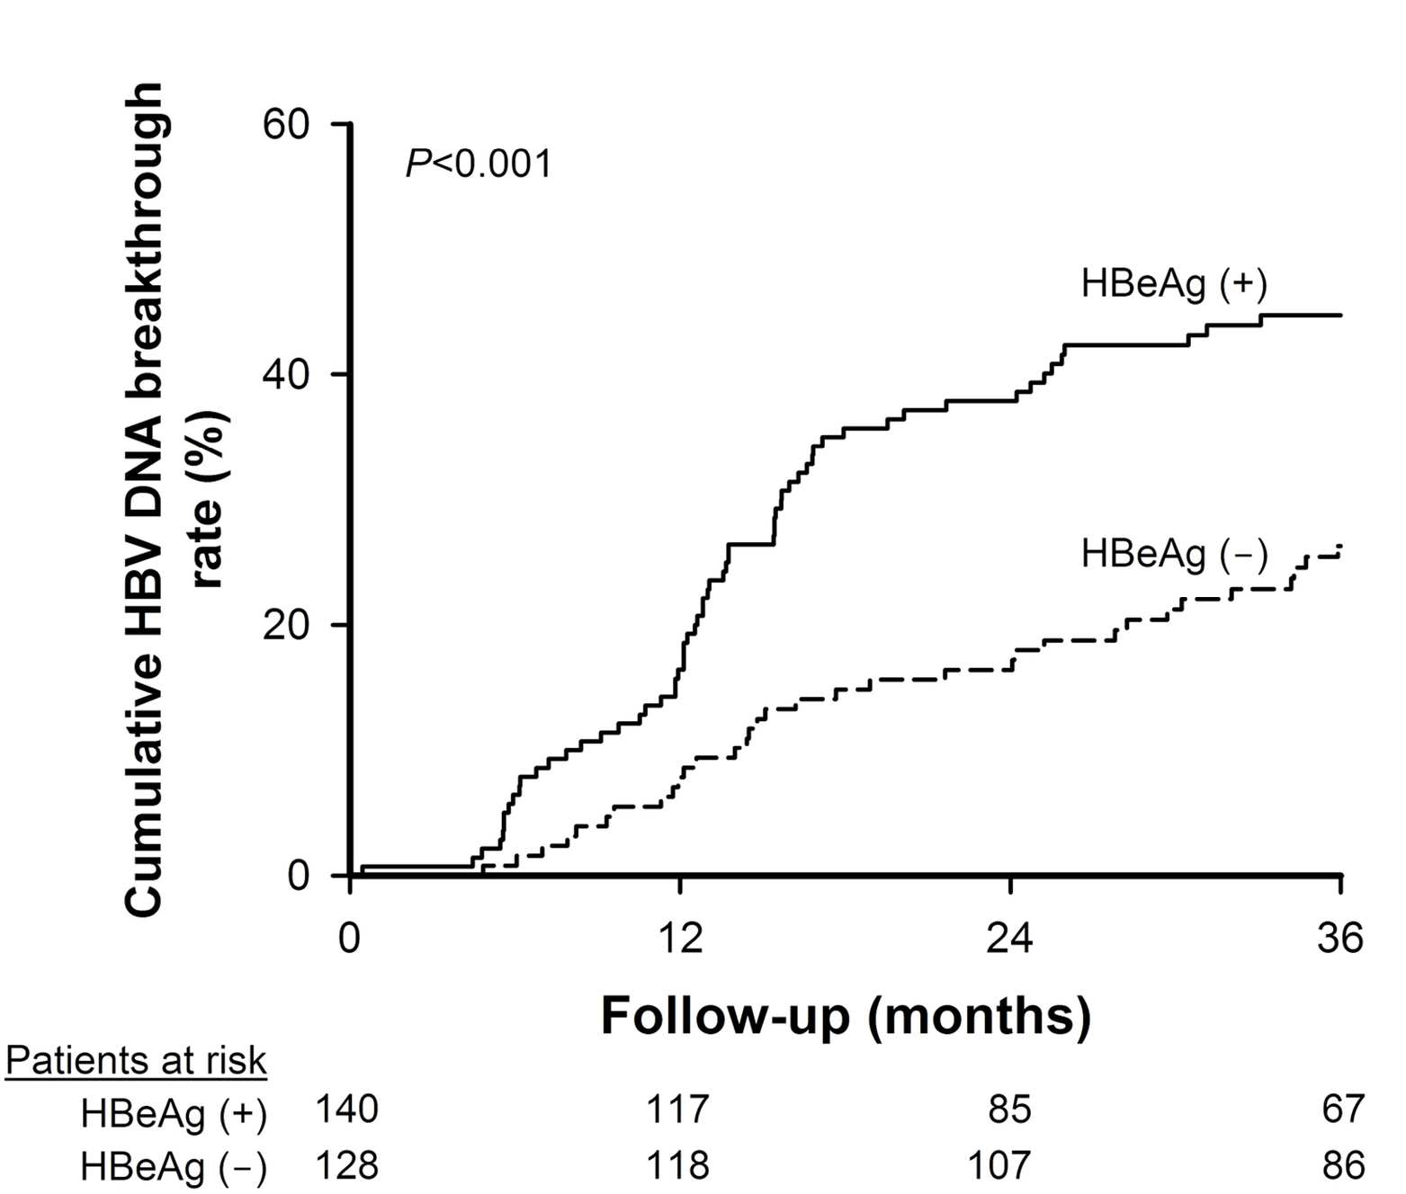
6

For

Peer
7
8
9
10
11
12
13
14
15
16
17
18
19
20
21
22
23
24
25
26
27
28
29
30
Review
31
32
33
34
35 Baseline and on-treatment characteristics predicting virological breakthrough for chronic hepatitis B patients
36 treated by lamivudine. Patients with (A) positive HBeAg in sera, (B) baseline serum HBV DNA levels ≥108
37 IU/mL, (C) baseline HBsAg ≥20000 IU/mL, and (D) HBV DNA levels ≥2000 IU/mL 6 months post-therapy
38 had higher incidences of developing virological breakthrough during lamivudine therapy compared to their
39 counterparts. (E) Patients with genotype C had a trend of higher rate of virological breakthrough than those
40 with genotype B.
41 127x108mm (300 x 300 DPI)
42
43
44

1
2
3
4
5
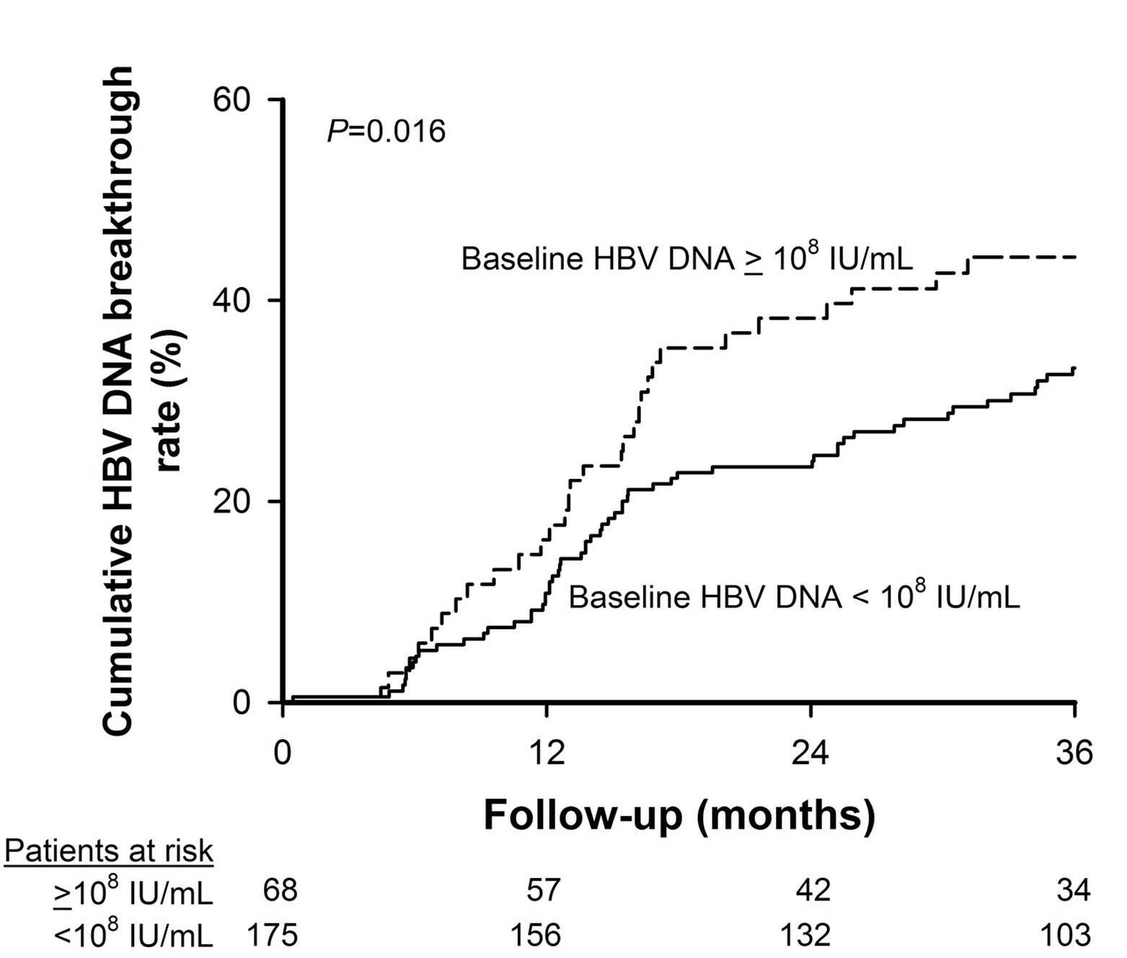
6

For

Peer
7
8
9
10
11
12
13
14
15
16
17
18
19
20
21
22
23
24
25
26
27
28
29
30
Review
31
32
33
34
35 Baseline and on-treatment characteristics predicting virological breakthrough for chronic hepatitis B patients
36 treated by lamivudine. Patients with (A) positive HBeAg in sera, (B) baseline serum HBV DNA levels ≥108
37 IU/mL, (C) baseline HBsAg ≥20000 IU/mL, and (D) HBV DNA levels ≥2000 IU/mL 6 months post-therapy
38 had higher incidences of developing virological breakthrough during lamivudine therapy compared to their
39 counterparts. (E) Patients with genotype C had a trend of higher rate of virological breakthrough than those
40 with genotype B.
41 127x108mm (300 x 300 DPI)
42
43
44

1
2
3
4
5
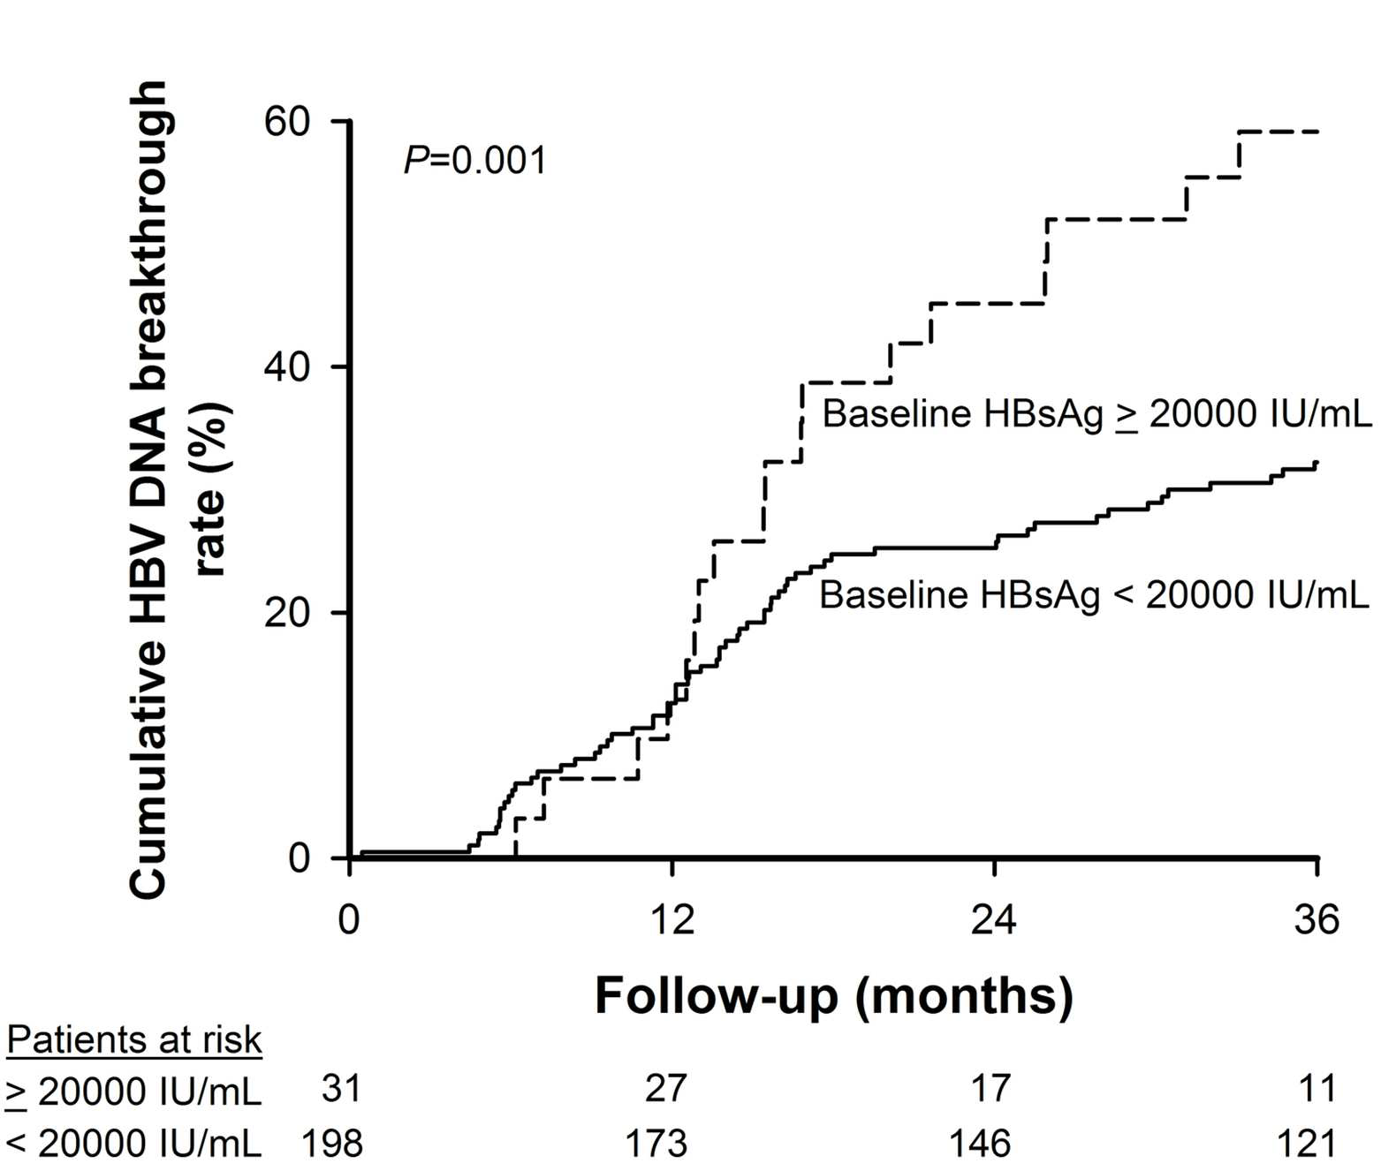
6

For

Peer
7
8
9
10
11
12
13
14
15
16
17
18
19
20
21
22
23
24
25
26
27
28
29
30
Review
31
32
33
34
35 Baseline and on-treatment characteristics predicting virological breakthrough for chronic hepatitis B patients
36 treated by lamivudine. Patients with (A) positive HBeAg in sera, (B) baseline serum HBV DNA levels ≥108
37 IU/mL, (C) baseline HBsAg ≥20000 IU/mL, and (D) HBV DNA levels ≥2000 IU/mL 6 months post-therapy
38 had higher incidences of developing virological breakthrough during lamivudine therapy compared to their
39 counterparts. (E) Patients with genotype C had a trend of higher rate of virological breakthrough than those
40 with genotype B.
41 127x107mm (300 x 300 DPI)
42
43
44

1
2
3
4
5
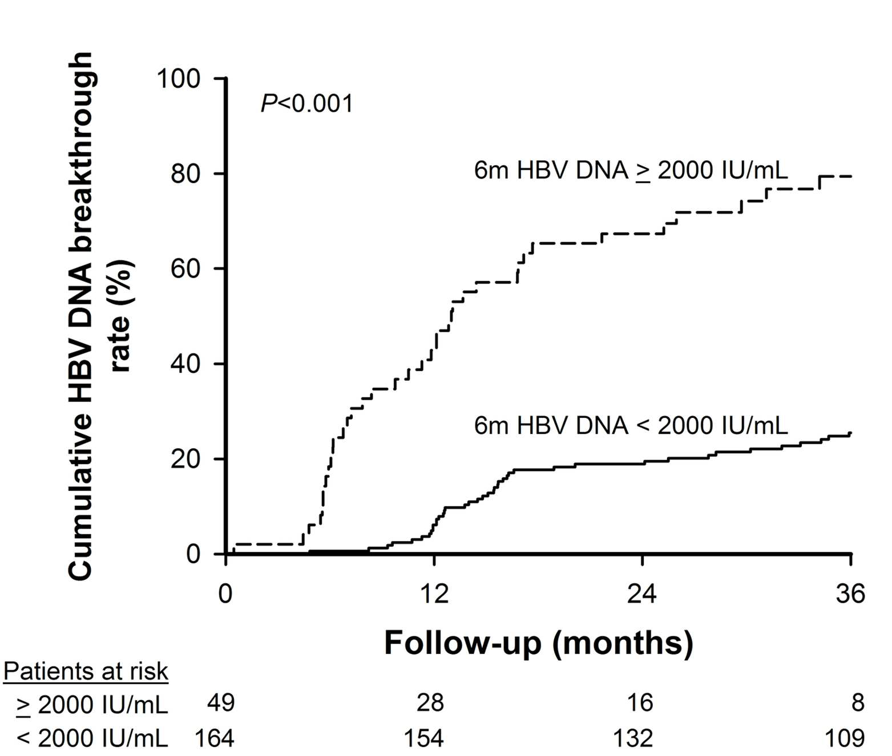
6

For

Peer
7
8
9
10
11
12
13
14
15
16
17
18
19
20
21
22
23
24
25
26
27
28
29
30
Review
31
32
33
34
35 Baseline and on-treatment characteristics predicting virological breakthrough for chronic hepatitis B patients
36 treated by lamivudine. Patients with (A) positive HBeAg in sera, (B) baseline serum HBV DNA levels ≥108
37 IU/mL, (C) baseline HBsAg ≥20000 IU/mL, and (D) HBV DNA levels ≥2000 IU/mL 6 months post-therapy
38 had higher incidences of developing virological breakthrough during lamivudine therapy compared to their
39 counterparts. (E) Patients with genotype C had a trend of higher rate of virological breakthrough than those
40 with genotype B.
41 127x107mm (300 x 300 DPI)
42
43
44

1
2
3
4
5
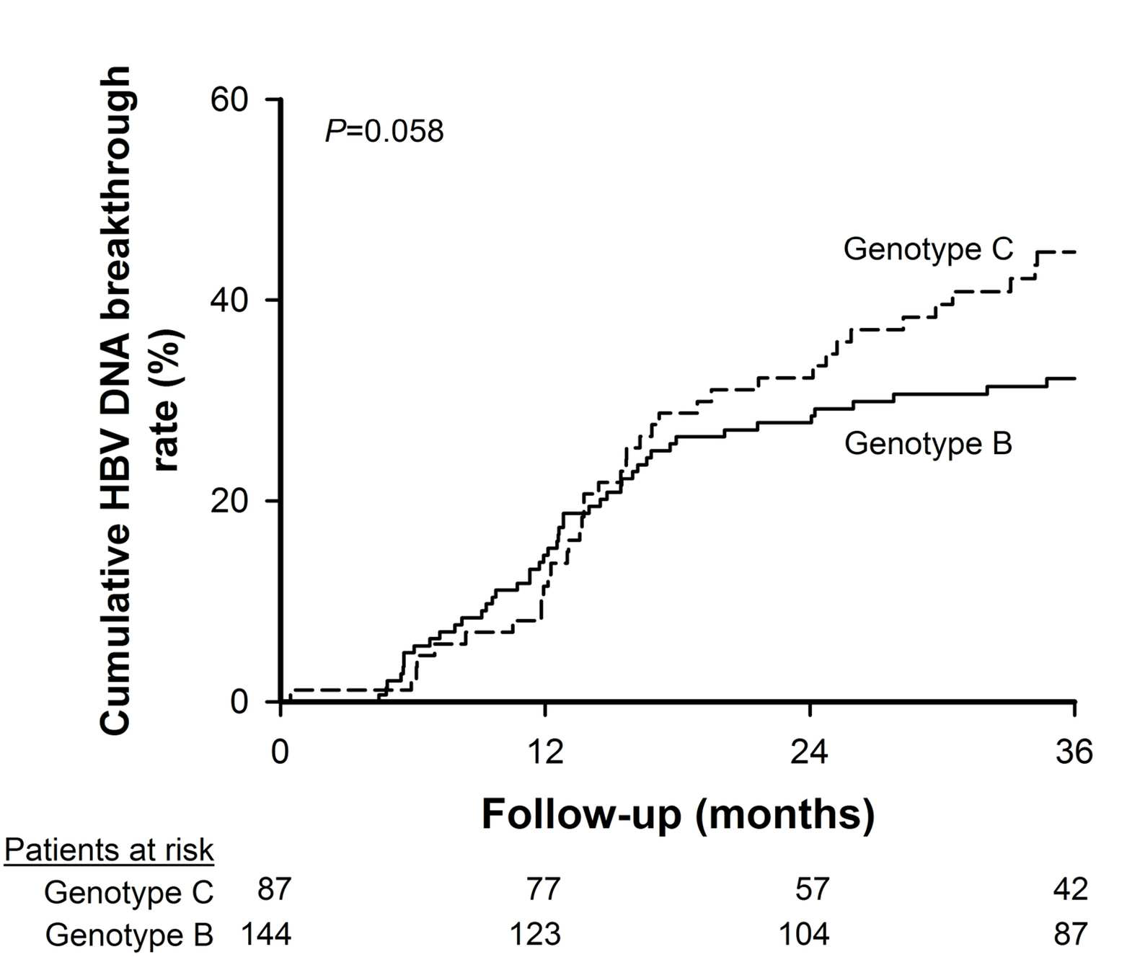
6

For

Peer
7
8
9
10
11
12
13
14
15
16
17
18
19
20
21
22
23
24
25
26
27
28
29
30
Review
31
32
33
34
35 Baseline and on-treatment characteristics predicting virological breakthrough for chronic hepatitis B patients
36 treated by lamivudine. Patients with (A) positive HBeAg in sera, (B) baseline serum HBV DNA levels ≥108
37 IU/mL, (C) baseline HBsAg ≥20000 IU/mL, and (D) HBV DNA levels ≥2000 IU/mL 6 months post-therapy
38 had higher incidences of developing virological breakthrough during lamivudine therapy compared to their
39 counterparts. (E) Patients with genotype C had a trend of higher rate of virological breakthrough than those
40 with genotype B.
41 127x108mm (300 x 300 DPI)
42
43
44

1
2
3
4
5
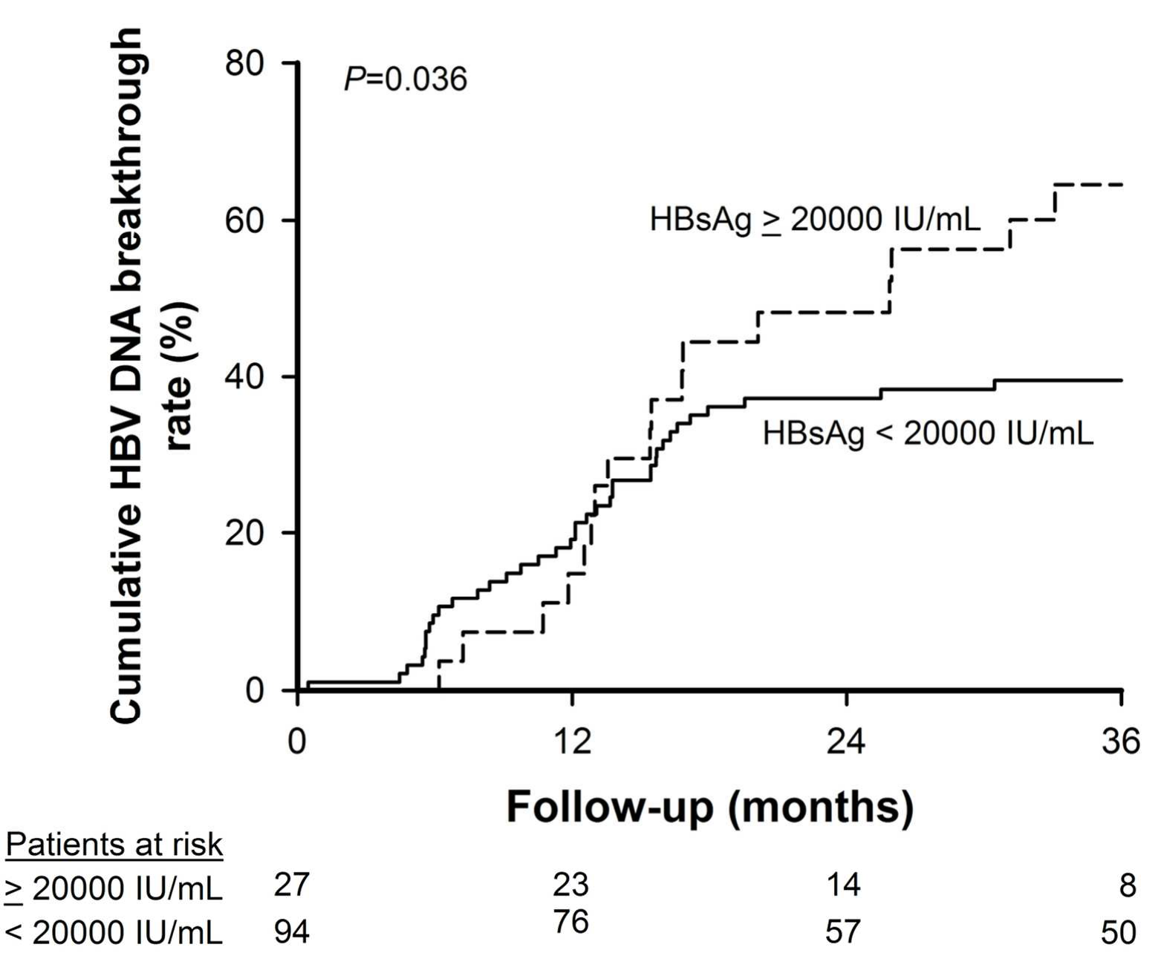
6

For

Peer
7
8
9
10
11
12
13
14
15
16
17
18
19
20
21
22
23
24
25
26
27
28
29
30
Review
31
32
33
34
The impact of baseline serum HBsAg levels on HBV DNA virological breakthrough for patients receiving
35 lamivudine therapy stratified by HBeAg status. (A) Among HBeAg-positive patients, those with baseline
36 serum HBsAg level ≥20000 IU/mL had higher incidences of developing virological breakthrough during
37 lamivudine therapy than these with <20000 IU/mL (p=0.036). (B) Among patients with HBeAg-negative
38 chronic hepatitis B, the cumulative virological breakthrough rates were comparable between patients with
39 baseline HBsAg levels ≥20000 IU/mL and those with <20000 IU/mL (p=0.952). For patients who received
40 lamivudine therapy and had serum HBV DNA <2000 IU/mL six months post-therapy, (C) patients with
41 baseline serum HBsAg ≥20000 IU/mL had a trend of lower rates of virological breakthrough than those with
42 HBsAg <20000 IU/mL (p=0.074), (D) especially for HBeAg-positive patients (p=0.020). (E) The cumulative virological breakthrough was comparable between HBeAg-negative patients with baseline HBsAg levels
43 ≥20000 IU/mL and those with <20000 IU/mL (p=0.369).
44 122x100mm (300 x 300 DPI)

1
2
3
4
5
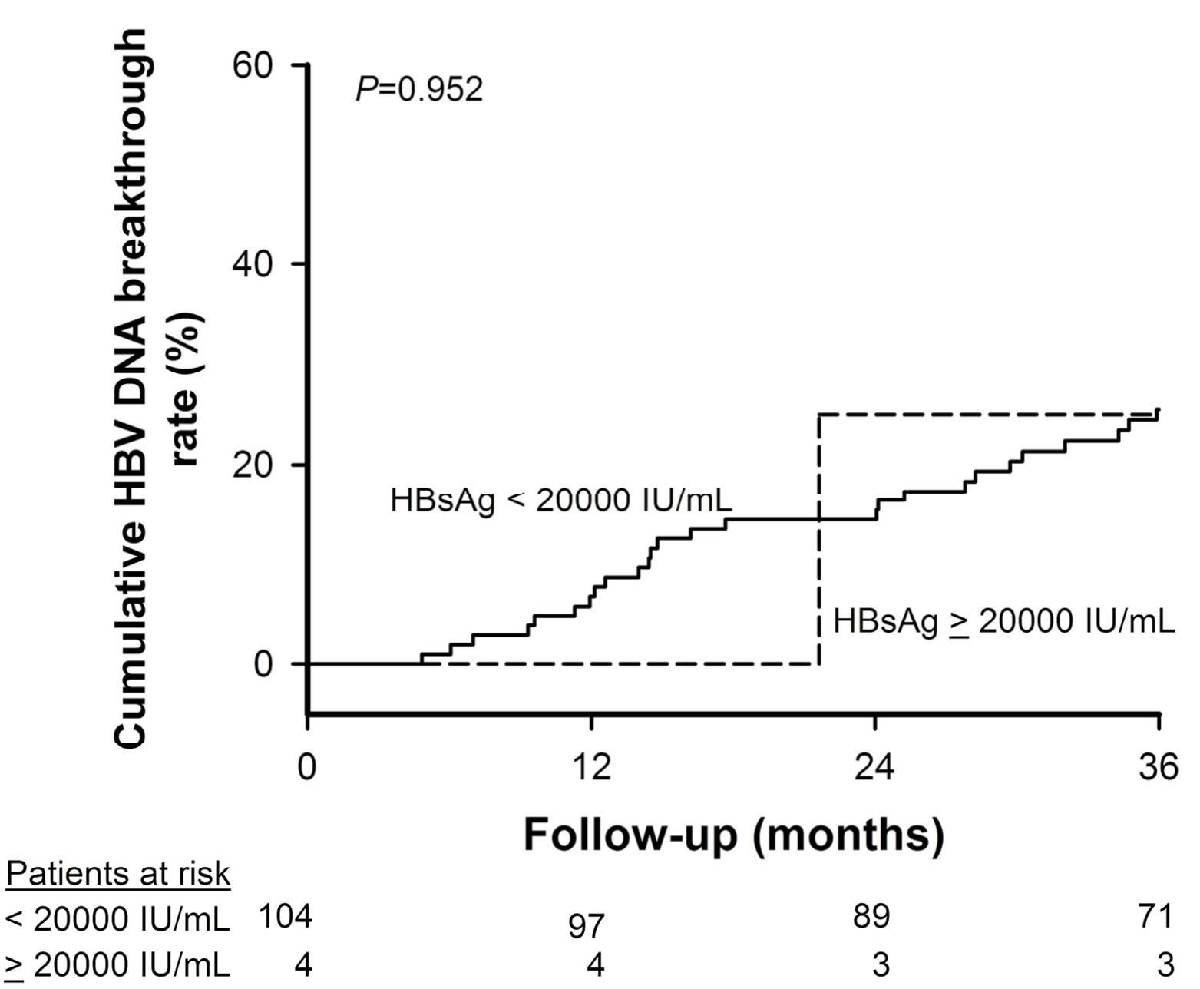
6

For

Peer
7
8
9
10
11
12
13
14
15
16
17
18
19
20
21
22
23
24
25
26
27
28
29
30
Review
31
32
33
34
The impact of baseline serum HBsAg levels on HBV DNA virological breakthrough for patients receiving
35 lamivudine therapy stratified by HBeAg status. (A) Among HBeAg-positive patients, those with baseline
36 serum HBsAg level ≥20000 IU/mL had higher incidences of developing virological breakthrough during
37 lamivudine therapy than these with <20000 IU/mL (p=0.036). (B) Among patients with HBeAg-negative
38 chronic hepatitis B, the cumulative virological breakthrough rates were comparable between patients with
39 baseline HBsAg levels ≥20000 IU/mL and those with <20000 IU/mL (p=0.952). For patients who received
40 lamivudine therapy and had serum HBV DNA <2000 IU/mL six months post-therapy, (C) patients with
41 baseline serum HBsAg ≥20000 IU/mL had a trend of lower rates of virological breakthrough than those with
42 HBsAg <20000 IU/mL (p=0.074), (D) especially for HBeAg-positive patients (p=0.020). (E) The cumulative virological breakthrough was comparable between HBeAg-negative patients with baseline HBsAg levels
43 ≥20000 IU/mL and those with <20000 IU/mL (p=0.369).
44 122x100mm (300 x 300 DPI)

1
2
3
4
5
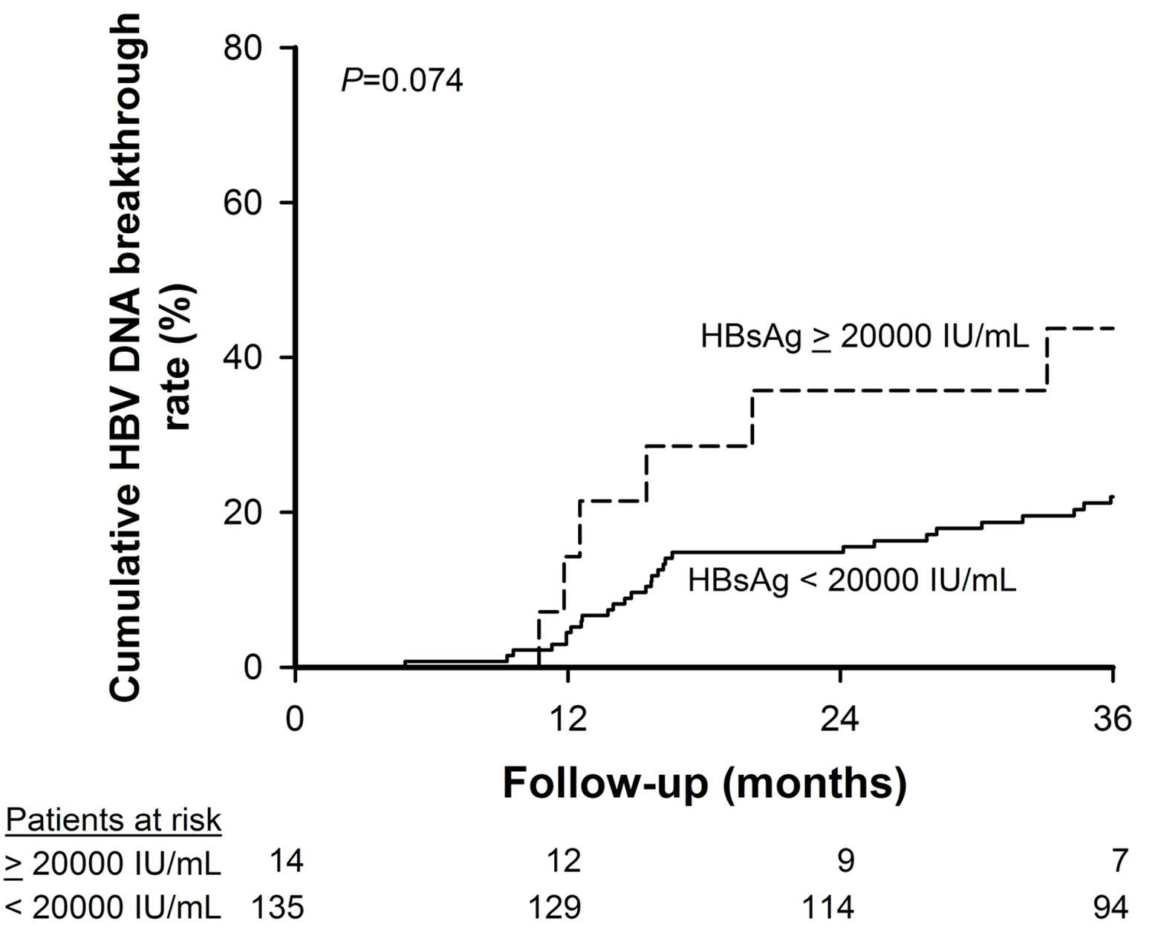
6

For

Peer
7
8
9
10
11
12
13
14
15
16
17
18
19
20
21
22
23
24
25
26
27
28
29
30
Review
31
32
33
34 The impact of baseline serum HBsAg levels on HBV DNA virological breakthrough for patients receiving
35 lamivudine therapy stratified by HBeAg status. (A) Among HBeAg-positive patients, those with baseline
36 serum HBsAg level ≥20000 IU/mL had higher incidences of developing virological breakthrough during
37 lamivudine therapy than these with <20000 IU/mL (p=0.036). (B) Among patients with HBeAg-negative chronic hepatitis B, the cumulative virological breakthrough rates were comparable between patients with
38 baseline HBsAg levels ≥20000 IU/mL and those with <20000 IU/mL (p=0.952). For patients who received
39 lamivudine therapy and had serum HBV DNA <2000 IU/mL six months post-therapy, (C) patients with
40 baseline serum HBsAg ≥20000 IU/mL had a trend of lower rates of virological breakthrough than those with
41 HBsAg <20000 IU/mL (p=0.074), (D) especially for HBeAg-positive patients (p=0.020). (E) The cumulative
42 virological breakthrough was comparable between HBeAg-negative patients with baseline HBsAg levels
43 ≥20000 IU/mL and those with <20000 IU/mL (p=0.369).
44 119x96mm (300 x 300 DPI)

1
2
3
4
5
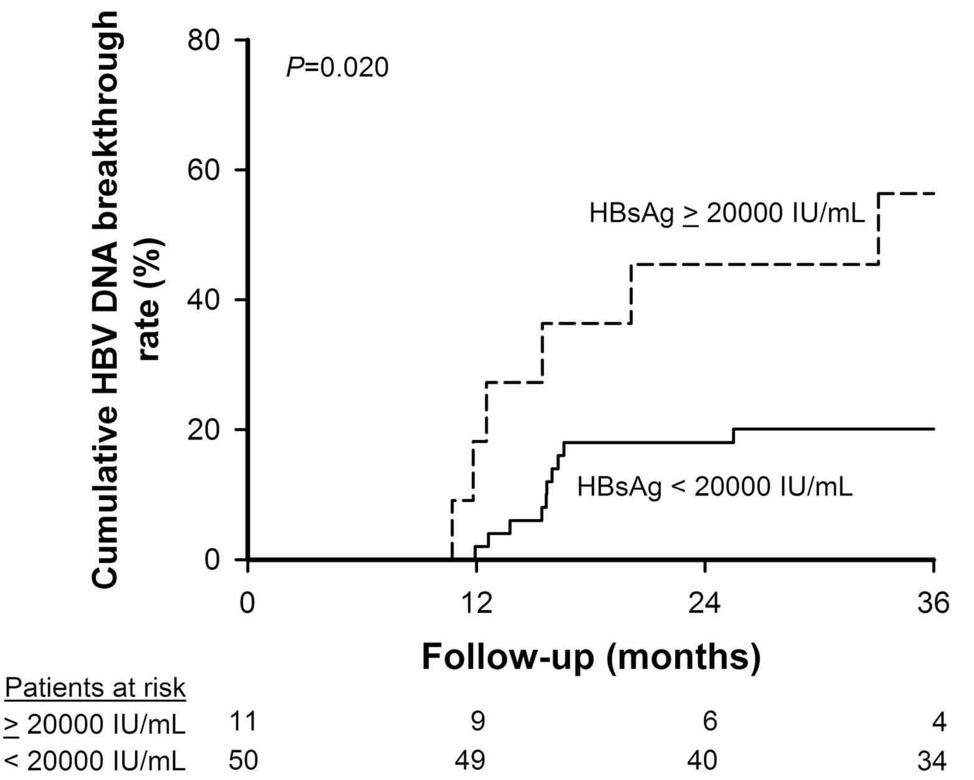
6

For

Peer
7
8
9
10
11
12
13
14
15
16
17
18
19
20
21
22
23
24
25
26
27
28
29
30
Review
31
32
33
34 The impact of baseline serum HBsAg levels on HBV DNA virological breakthrough for patients receiving
35 lamivudine therapy stratified by HBeAg status. (A) Among HBeAg-positive patients, those with baseline
36 serum HBsAg level ≥20000 IU/mL had higher incidences of developing virological breakthrough during
37 lamivudine therapy than these with <20000 IU/mL (p=0.036). (B) Among patients with HBeAg-negative chronic hepatitis B, the cumulative virological breakthrough rates were comparable between patients with
38 baseline HBsAg levels ≥20000 IU/mL and those with <20000 IU/mL (p=0.952). For patients who received
39 lamivudine therapy and had serum HBV DNA <2000 IU/mL six months post-therapy, (C) patients with
40 baseline serum HBsAg ≥20000 IU/mL had a trend of lower rates of virological breakthrough than those with
41 HBsAg <20000 IU/mL (p=0.074), (D) especially for HBeAg-positive patients (p=0.020). (E) The cumulative
42 virological breakthrough was comparable between HBeAg-negative patients with baseline HBsAg levels
43 ≥20000 IU/mL and those with <20000 IU/mL (p=0.369).
44 119x96mm (300 x 300 DPI)

1
2
3
4
5
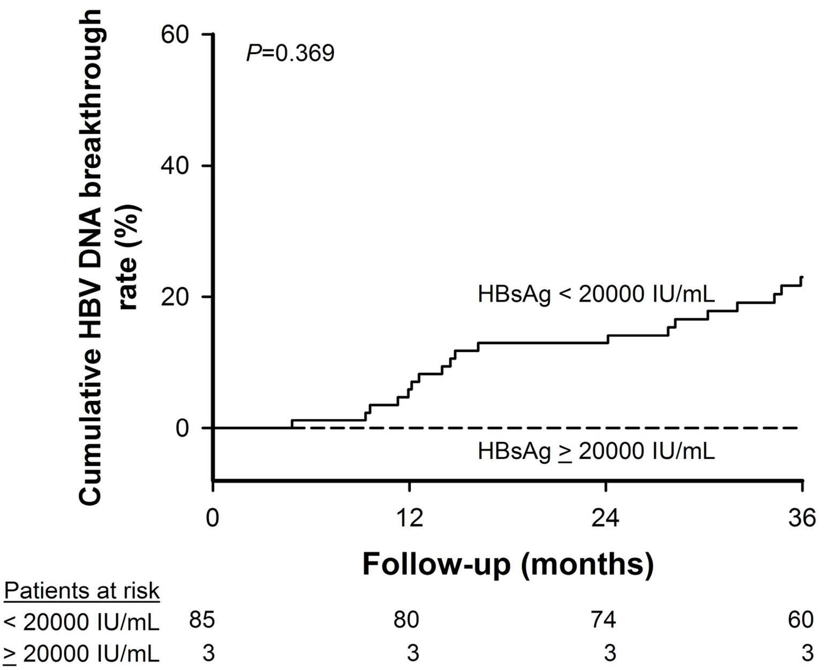
6

For

Peer
7
8
9
10
11
12
13
14
15
16
17
18
19
20
21
22
23
24
25
26
27
28
29
30
Review
31
32
33
34 The impact of baseline serum HBsAg levels on HBV DNA virological breakthrough for patients receiving
35 lamivudine therapy stratified by HBeAg status. (A) Among HBeAg-positive patients, those with baseline
36 serum HBsAg level ≥20000 IU/mL had higher incidences of developing virological breakthrough during
37 lamivudine therapy than these with <20000 IU/mL (p=0.036). (B) Among patients with HBeAg-negative chronic hepatitis B, the cumulative virological breakthrough rates were comparable between patients with
38 baseline HBsAg levels ≥20000 IU/mL and those with <20000 IU/mL (p=0.952). For patients who received
39 lamivudine therapy and had serum HBV DNA <2000 IU/mL six months post-therapy, (C) patients with
40 baseline serum HBsAg ≥20000 IU/mL had a trend of lower rates of virological breakthrough than those with
41 HBsAg <20000 IU/mL (p=0.074), (D) especially for HBeAg-positive patients (p=0.020). (E) The cumulative
42 virological breakthrough was comparable between HBeAg-negative patients with baseline HBsAg levels
43 ≥20000 IU/mL and those with <20000 IU/mL (p=0.369).
44 119x96mm (300 x 300 DPI)

