Kidney Stone Distribution Caused by Melamine and Cyanuric Acid in Rats

Yng-Tay Chen ^{a,b}, Bang-Ping Jiann ^{c}, Chieh-Hao Wu ^{d}, Jhaol-Huei Wu ^{d}, Shih-Chieh Chang ^{e}, Maw-Sheng Chien ^{d}, Shih-Ling Hsuan ^{d}, Yi-Lo Lin ^{d}, Ter-Hsin Chen ^{d}, Fuu-Jen Tsai ^{a,b}, and Jiunn-Wang Liao ^{d, *}

ª Human Genetic Center, China Medical University Hospital, Taichung, Taiwan.
^{b} Department of Biomedical Informatics, Asia University, Taichung, Taiwan.
^{c} Department of Medical Education and Research, Kaohsiung Veterans General Hospital, Kaohsiung, Taiwan.
^{d} Graduate Institute of Veterinary Pathobiology, National Chung Hsing University, Taichung, Taiwan.
^{e} Department of Veterinary Medicine, National Chung Hsing University, Taichung, Taiwan.

*Corresponding Author:
Jiunn-Wang Liao, Graduate Institute of Veterinary Pathobiology, National Chung Hsing University, Taichung, Taiwan, ROC.
Email: jwliao@dragon.nchu.edu.tw

Abstract
Background: Melamine (M), which is composed of multi-amine, has been used as a food additive to falsely increase protein contents. Furthermore, cyanuric acid (CA) is a derivative of melamine. It is known that these mixtures can cause renal toxicity.
Methods: The objective of this study was to investigate the possible target cells during acute renal toxicity of melamine and cyanuric acid (MCA) mixture crystals in vivo. Rats were provided with a lethal dose of MCA (1:1; 400 mg/kg) and observed after 0.5, 1, 3, 12, 24, and 48- hour (h) intervals.
Results: MCA caused degeneration/necrosis in the proximal tubules starting at 12 h and increased at 24 and 48 h. A small number of yellow-green crystals were observed in the dilated distal renal tubules at 48 h post treatment. Ultrastructurally, pyknosis, mitochondrial vesicles, and cellular swelling were found in the proximal tubular cells at 0.5 h. Small needle-like crystals in the cytoplasm and large crystals in the lumen of tubules indicated physical damage to the renal cells.
Conclusion: These results clearly reveal that in the MCA-induced renal toxicity model, crystals are distributed to both the proximal and distal tubules in rats. The proximal tubular cells may be initially injured and subsequently block the distal tubules with MCA crystals during early acute intoxication.

Keywords
Melamine and cyanuric acid, Acute toxicity, Renal crystals, Distribution
- Introduction
In 2004 and 2007, an outbreak of melamine and cyanuric acid contamination in dog and cat food products occurred, causing kidney failure and kidney stones. [1-3]. In 2008, Chinese infant formula adulterated with melamine caused babies to develop kidney and bladder stones [4]. Melamine is composed of multiamine, and is added to food to falsely increase its protein content [5]. A recent study showed the melamine metabolite formed by microbial metabolism plays the crucial role in causing kidney damage in rats [6]. However, whether cyanuric acid is added to melamine or is a breakdown product of it is still unclear.
Prior to the incident, melamine, cyanuric acid, and other analogs were well investigated. The median lethal dose (LD₅₀) of melamine and cyanuric acid orally administered in rats was found to be 3161 and 7700 mg/kg body weight, respectively, indicating that these two substances are of low toxicity. Whatever the causes were of acute renal failure in dogs and cats in the 2004 and 2007 events, the combination of melamine and cyanuric acid appeared to be more toxic than each substance alone, and it increased renal toxicity substantially [7]. Renal failure is currently speculated to be a result of urine concentration caused by crystallization in kidneys, leading to tubular cell necrosis, regeneration, and expansion. After long-term damage, renal fibrosis and inflammatory cell infiltration occur [8]. Using rat models, renal crystal formation following the ingestion of a melamine-cyanuric acid mixture (1:1) was investigated to gain insight into MCA-induced renal toxicity [8].
Kidney stone formation has been related to supersaturated-urine. A continuing supersaturated urine concentration, an increase in crystallization, and crystal nuclei formation lead to the gathering of crystals to form stones over time [9]. Crystal deposition in renal tubule causes tubular expansion, resulting in chronic inflammation, chemotaxis of inflammatory cells with inflammatory cytokine secretion and elevation of oxidative stress. Previous studies have shown that the shape of melamine-cyanurate crystals is rounded in vivo and needle-like in vitro, and that the crystal shape was unaffected by the pH level [10]. As with other common kidney stones, melamine and cyanuric acid-related renal stones are similar to the stone formation theory. Whether crystalline and tubular obstructions play the main role in renal failure has yet to be determined. No obstructive nephropathic symptoms such as hydronephrosis or cystic kidney have been found with renal failure as a result of a melamine and cyanuric acid combination. Melamine mixed with cyanuric acid could obviously have strong toxic effects, but other mechanisms related to the toxic effects still require further study [11,12].
This study was conducted to further investigate the target cells of acute nephrotoxicity in MCA-intoxicated rats and elucidate the possible pathogenesis at different time points within 48 h.

- Materials and Methods
  - Chemicals
Melamine (M, 2, 4, 6-triamino-1, 3, 5-triazine) was obtained from Sigma (MO, USA) and cyanuric acid (CA, s-triazine-2, 4, 6-triol) was obtained from Merck (Darmstadt, Germany). The chemical purity of the commercially obtained materials was 99% for melamine and 98% for cyanuric acid.

2.2. Animals
Male Sprague-Dawley rats (six in the control group and five in the experimental group, 4 weeks old) were obtained from the National Laboratory Animal Center (Taipei, Taiwan). The rats weighed 140-160 grams at the time of the study. Animals were housed individually in cages and given lab chow ad libitum (Purina 5001, St. Louis, MO, USA). The temperature of the room housing the animals was maintained at 22-25 ℃, the relative humidity at 50-70 %, and photoperiods were 12 h/day. This study was approved by the Institutional Animal Care and Use Committee (IACUC) of National Chung-Hsing University (IACUC: 98-83).
Experiments were conducted to investigate the renal toxicity of MCA on target cells. Therefore, a 400 mg/kg lethal dose of MCA was selected, based on previous studies [13]. Melamine and cyanuric acid have poor water solubility at 3230 mg/L and 2000 mg/L, respectively [5]. Therefore, propylene glycol (PEG-200) was used as the delivery vehicle. A single dose of MCA (400 mg/kg/bw) was orally gavaged. The administered volume of MCA was 10 mL/kg body weight. For the time-course study, rats were observed in the six time courses of 0.5, 1, 3, 12, 24, and 48 h intervals. For reducing the use of laboratory animals, only one control group (48 h) was designed and sacrificed at the end of experiment.

  - Hematological, biochemical and urinary examinations
The animals were anesthetized using 3 % isoflurane inhalation, and blood was drawn from the abdominal aorta artery at the end of the experiment. Blood was collected separately in anticoagulant EDTA tubes and serum separator tubes (Vacationer, Franklin Lakes, NJ, USA). Whole blood from the anticoagulant tubes was stored at 4 °C, and parameters of WBC, RBC, hematocrit, mean corpuscular volume, mean corpuscular hemoglobin, mean corpuscular hemoglobin concentration, hemoglobin, and platelets were analyzed on a blood cell counter (Sysmex K-4500, Toa Medical Electronics Co., Kobe, Japan). Blood smears were stained with Weigert's Iron Hematoxylin Stain Kit (AJP Scientific Inc., NJ, USA) for cellular differentiation. The percentages (%) of lymphocytes, neutrophils, and monocytes in leukocytes were calculated. Blood urea nitrogen (BUN) and creatinine were analyzed by enzymatic methods using an automatic analyzer (Chiron Diagnostics Corporation, OH, USA). Also, serum calcium, magnesium, phosphate, and potassium were measured using an AVL Model 9130 automatic electrolyte analyzer (AVL Scientific Corporation).

  - Urinary examination
Rat urine samples were collected at 0.5, 1, 3, 12, 24 and 48 h intervals. Urine sediments were centrifuged, and the total number of leukocytes, RBC, epithelial cells, and crystals were evaluated under light microscope (BX-51, Olympus, Tokyo, Japan).

  - Histopathological examination
At necropsy, the kidneys were weighed and sectioned transversely. The middle section of the other half of each kidney was fixed in 10% neutral buffered formaldehyde. The formaldehyde-fixed tissues were trimmed, embedded in paraffin, sectioned (Leica RM 2145, Nussloch, Germany), and stained with the hematoxylin and eosin (H&E) method, then evaluated under light microscope for histopathology. For semi-quantitative grading of renal toxicity, lesion severity was graded using the criteria developed by Shackelford et al. (2002)[14] as follows: 1 = minimal (< 10%); 2 = slight (11-25%); 3 = moderate (26-50%); 4 = moderate/severe (51-75%); and 5 = severe/high (76-100%).

  - Scanning electron microscope observation
The remaining part of each kidney was cut into 0.5 × 0.5 × 0.5 mm pieces and fixed in 2.5% glutaraldehyde solution for examination under a scanning electron microscope. The tissue was dehydrated with serial alcohol. The samples were fixed on copper containing carbon glue and put into the Critical Point Dryer (CPD). The surface of the sample was coated with gold, and morphological changes of the MCA crystals in kidneys were observed using scanning electron microscopy. Crystals were further detected by SEM-EDS.

  - Transmission Electron microscope examination
After soaking in neutral phosphate buffer, the kidney tissues were cut and post-fixed in 1% osmium tetroxide for 3h. The tissues were dehydrated with serial alcohol in order to dry completely and embedded in LR White acrylic resin. The embedded samples were sliced in thicknesses of 90 nm. The slices were stained with uranyl acetate and lead citrate and observed under a transmission electron microscope (1200EX, JEOL, Tokyo, Japan).

  - Statistical analysis
Data are expressed as means ± SD. A statistical difference test was performed between the control and treated groups by Student's t-test. Differences are regarded as significant at P< 0.05.

- Results
3.1. Clinical Observation
No obvious clinical symptoms were found in the control group or in the 0.5, 1, 3, and 12 h MCA treated groups. However, the 24 and 48 h MCA treated rats became anorexic, weak, depressed, and developed a rough coat before being sacrificed. No dead rats were noted within the 48 h treatment group.

3.2. Hematology and Serum Biochemistry
The parameters of WBC values increased significantly with the segmented and banded neutrophil ratios of the 12, 24 and 48h groups significantly increased, while the lymphocytic ratio was relatively decreased (P< 0.05) (Table 1). The values of BUN, creatinine, calcium, phosphorus, magnesium and potassium ions in sera increased significantly in the 12 to 24 and 48 h groups (P< 0.05). Lower but insignificant decreases were also noted in the levels of sodium in sera as well (P> 0.05) (Table 2).

  - Urinary Sediment Parameters
Urine examination showed that urine volume significantly increased in the 0.5, 1 and 3 h groups (P< 0.05), but decreased in the 12, 24, and 48 h post-treatment groups. Urine occult blood appeared with leukocytes in the 12, 24 and 48 h groups. Urine sediment values showed that RBCs, WBCs, casts and crystals increased significantly in the 12 h interval (P< 0.05)(Table 3). In addition, MCA crystals were also incidentally found at 3 h, with brown, round, and radiated crystals (Fig. 1).

  - Organ Weight and Gross Findings of Kidneys
The relative kidney weight of rats at 12, 24, and 48 h post-treatment increased significantly (Table 4). Gross findings revealed that affected kidneys were enlarged and became pale in the 12, 24 and 48 h groups. Grossly, yellow-white needle-like crystals with radiating arrangements were randomly deposited on the cut surface of kidneys at the junction of the cortex and medulla in the 24 and 48 h post-treatment rats (Fig. 2).

  - Histopathological Evaluation of Kidneys
The semi-quantitative histopathological scores for renal toxicity at each time interval are shown in Table 5. The kidneys of the 0.5 h group showed no observable lesions; however, a minimal degree of fluid retention in the renal tubular cavity, an increase in proximal tubular degeneration and necrosis, inflammatory cell infiltration, and expansion of the glomerulus cavity were found starting from the 1 h post-treatment rats. In the 3, 12, 24, and 48 h groups, microscopic lesions in kidneys were graded as slight to moderate. Furthermore, severe degeneration and necrosis in the proximal tubular epithelial cells, lumen expansion, and an increase in fluid retention with increasing severity over time, were observed. With increasing time, the lesions in the 24 and 48 h groups consisted of neutrophils and inflammatory cell aggregation surrounding the MCA crystals with renal tubular epithelial cell regeneration (Table 4 and Fig. 3).

  - Ultrastructural changes of MCA in kidneys
Two kinds of crystals, deposited as lamellar-like and needle-like in shape, about 60 × 150 μm and 50 × 50 μm, respectively (Fig. 4A and 4B), were found in kidneys under scanning electron microscopy at 48 h. Both types of crystals were further detected by SEM-EDS, with nitrogen as the main element in the crystals, along with the proportions of carbon, nitrogen, and oxygen in these two types of crystals being 32.41%, 43.79%, and 23.8%, and 29.74%, 45.85%, and 24.41% (Fig. 4C and 4D), respectively.
Ultrastructurally, normal kidney structure was observed in the control rats (Fig. 5A). The kidneys in the 0.5 h group developed cellular swelling and mitochondrial vacuoles along with multiple holes in the microvilli in the proximal tubular cells (Fig. 5B). Injured renal cells displayed pyknosis, irregular organelles, and mitochondrial vesicles in the 1 h group (Fig. 5C). Numerous hollow crystals appearing as translucent spaces were deposited in the proximal tubular lumen at 3 h post-treatment. The edges of the crystals were rough and sharp. The blank stripes were suspected to have been composed of cellular debris, organic materials, protein, or other materials that formed the crystal nucleus (Fig. 5D). In the 12 h group, an increase of transudate, cellular swelling, organelle disruption, and irregular crystals were found in the proximal tubular cells (Fig. 5E), whereas the distal tubular epithelial cells still maintained normal cell membrane integrity. In the 24 h group, erythrocytes and transudate fluid were noted in the lumen of the tubules. Furthermore, affected cells became swollen and displayed nuclear pyknosis and mitochondrial vesicles in the proximal tubular cells (Fig. 5F). In the 48 h group, multiple round crystals blocked the lumen of the proximal tubules, and microvilli were damaged by crystals. Numerous needle-like crystals were observed inside the dead cells (Fig. 5G).

- Discussion
The combination of melamine and cyanuric acid is known to cause severe renal toxicity, and male rats are sensitive to this mixture [7]. Co-administration of melamine and cyanuric acid for only 3 d can apparently induce nephrotoxicity [15]. Recent reports have also shown that the kidney is the primary target organ [16].
Although melamine mixed with cyanuric acid have been shown to induce toxic effects, the target cells still require further study [11,12,17]. While crystalline and tubular obstructions are known to play a role in renal failure, it is not easy to differentiate the characteristics of stone distribution in renal toxicity. Using rat models, renal crystal formation following the ingestion of a melamine-cyanuric acid mixture was used to gain insight into how it induces renal toxicity [18]. In this study, male rats were gavaged with a single lethal dose of 400 mg/kg/bw melamine and cyanuric acid and observed after 0.5, 1, 3, 12, 24 and 48 h. Results showed that an increase of BUN and creatinine in the serum indicated renal cellular disorder and death. Electrolytic imbalance in the serum was also found. Furthermore, no effects on BUN, creatinine or ion changes in rats were observed in the early stages before 12 h. Urine examination showed that urine volume significantly increased in the 0.5, 1 and 3 h groups, whereas a decrease was noted in the 12, 24, and 48 h groups. Urine occult blood appeared with leukocytes in the 12, 24 and 48 h groups. The pathogenesis of MCA-induced renal toxicity might be renal filtration injured by MCA crystals. We found an increase in potassium and phosphate ion in MCA-treated rat’s kidney. To maintain the proportion of calcium and phosphorus in the body, calcium ion concentration was then raised from secondary sources, such as bones or tissues. These above parameters indicating acute renal failure occurred 12 h post MCA intoxication in a time-dependent manner.
In the histopathological examination (Table 5), the main lesions in the 3, 12, 24 and 48 h groups were proximal tubular epithelial cell degeneration and necrosis in kidneys, indicating the proximal tubular epithelial cells might be initially injured by the MCA needle-like crystals. Furthermore, dilation and transudates increased with time. Then, Bowman’s space expansion with transudate accumulation, yellow-green round MCA crystal deposition with interstitial inflammatory cell aggregation was found in the distal renal tubules. This result was similar to that observed in the dogs and cats that ate the pet food contaminated with melamine and cyanuric acid in 2004 and 2007, as well as to the results observed in vitro [3,4].
Previous studies have shown that the shape of melamine-cyanurate crystals is round in vivo and needle-like in vitro and was unaffected by pH [10]. Crystal deposition in the kidney was extremely rare in the 48 h group, suggesting that (1) The highest concentration of melamine residue in the rat’s kidney was 3 h after melamine and cyanuric acid treatment and most of the melamine (approximately 90 %) was eliminated within 24 h (data not shown); (2) The structure of the crystal formation over a short time might be loose or very small, or weakly bonded with hydrogen binding [19]. The initial formation of crystals could have been dissolved in water or were difficult to be observed.
After examining melamine and cyanuric acid crystals under scanning electron microscopy and SEM-EDS, we suggest that these crystals can be divided into two types: lamellar-like and needle-like crystals. These crystals contain striations and rough edges. We believe that acute renal failure was caused by physical damage or the penetration of renal tubular cells. The combination of melamine and cyanuric acid (each at 25 mg/kg/day for 14 consecutive days) has previously been shown to be more toxic to the examined organs than melamine alone (50 mg/kg/day for 14 consecutive days), and resulted in ultrastructural pathological injury to the liver, kidney, spleen, stomach wall, and small intestine of mice [20]. Our results show melamine and cyanuric acid crystals to be translucent, striated and irregular in shape. Presumably, this is the structure of the crystal nucleus.
Based on the shape and location of the melamine and cyanuric acid crystals, we suggest that melamine and cyanuric acid crystals can be divided into three types. The size of the first-type is the same as tubular cavity diameter, approximately 12 × 15 μm, with most accumulating in the proximal tubular lumen. Under higher magnification, the edge of the crystal was sharp, allowing it to directly penetrate the proximal tubule cell membrane or microvilli. Physical damage resulted in loss or reduction of proximal renal epithelial cell microvilli, cellular swelling, cellular flattening, irregular nuclei, and vacuolization of the mitochondria. The second-type is approximately 2 × 2 μm, and crystals were located in the distal tubule cells but without cellular injury. The third-type of crystals were needle-like, approximately 1 × 2 μm in size, and located in the proximal tubule cell membrane. The destruction of proximal tubules caused by this type was similar to that of the first type of crystal.
In conclusion, the rough crystals initially cause physical injury to the proximal tubular cell membrane, leading to permeability alterations, mitochondrial vacuolization, and then cellular degeneration. As a result of renal tubular degeneration and necrosis, transudate will accumulate in the Bowman’s space, leading to an increase of back pressure. Crystal nuclei can also facilitate crystal formation and deposition in the renal tubules. The proximal tubular cells might be injured initially and then result in obstruction of the distal tubules by MCA crystals. Ultimately, acute renal failure is induced by lethal doses of MCA.

Conflict of interest statement
The authors have no conflict of interest with respect to this work.

Acknowledgments
The authors thank the National Science Council of ROC for financially supporting this research under contracts NSC 99-2313-B-005-008-MY3 and Ministry of Education, Taiwan, ROC, under the ATU plan. The authors would also like to thank Mr. Ian Cochrane-Lusk for English revision of the manuscript.

References
[1] Brown CA, Jeong KS, Poppenga RH., et al. Outbreaks of renal failure associated with melamine and cyanuric acid in dogs and cats in 2004 and 2007. J Vet Diagn Invest 2007;19:525-31.
[2] Puschner B, Poppenga RH, Lowenstine LJ., et al. Assessment of melamine and cyanuric acid toxicity in cats. J Vet Diagn Invest 2007;19:616-24.
[3] Thompson ME, Lewin-Smith MR, Kalasinsky VF., et al. Characterization of melamine- containing and calcium oxalate crystals in three dogs with suspected pet food-induced nephrotoxicosis. Vet Pathol 2008;45:417-26.
[4] Lam CW, Lan L, Che X., et al. Diagnosis and spectrum of melamine-related renal disease: plausible mechanism of stone formation in humans. Clin Chim Acta 2009;402:150-5.
[5] Bischoff K. Melamine and cyanuric acid. In: Gupta RC, ed. Reproductive and Developmental Toxicology. Kentucky, USA: Academic Press; 2011;367-72.
[6] Zheng X, Zhao A, Xie G, et al. Melamine-induced renal toxicity is mediated by the gut microbiota. Sci Transl Med 2013;5:172ra22.
[7] Chen KC, Liao CW, Cheng FP., et al. Evaluation of subchronic toxicity of pet food contaminated with melamine and cyanuric acid in rats. Toxicol Pathol 2009;37:959-68.
[8] Kim CW, Yun JW, Bae IH.,et al. Determination of spatial distribution of melamine- cyanuric acid crystals in rat kidney tissue by histology and imaging matrix-assisted laser desorption/ionization quadrupole time-of-flight mass spectrometry. Chem Res Toxicol 2010;23:220-7.
[9] Tsujihata M. Mechanism of calcium oxalate renal stone formation and renal tubular cell injury. Int J Urol 2008;15:115-20.
[10] Taksinoros S, Murata H. Effects of serum proteins on in vitro melamine-cyanurate crystal formation. J Vet Med Sci 2012;74(12):1569-73.
[11] Dobson RL, Motlagh S, Quijano M., et al. Identification and characterization of toxicity of contaminants in pet food leading to an outbreak of renal toxicity in cats and dogs. Toxicol Sci 2008;106:251-62.
[12] Kobayashi T, Okada A, Fujii Y., et al.The mechanism of renal stone formation and renal failure induced by administration of melamine and cyanuric acid. Urol Res 2010;38:117- 25.
[13] Jacob CC, Reimschuessel R, Von Tungeln LS., et al. Dose-response assessment of nephrotoxicity from a seven-day combined exposure to melamine and cyanuric acid in F344 rats. Toxicol Sci 2011;119:391-7.
[14] Shackelford C, Long G, Wolf J., et al. Qualitative and quantitative analysis of nonneoplastic lesions in toxicology studies. Toxicol Pathol 2002;30:93-6.
[15] Park D, Kim TK, Choi YJ., et al. Increased nephrotoxicity after combined administration of melamine and cyanuric acid in rats. Lab Anim Res 2011;27(1):25-8.
[16] Early RJ, Yu H, Mu XP., et al. Repeat oral dose toxicity studies of melamine in rats and monkeys. Arch Toxicol 2013;87(3):517-27.
[17] Choi L, Kwak MY, Kwak EH., et al. Comparative nephrotoxicity induced by melamine, cyanuric acid, or a mixture of both chemicals in either Sprague-Dawley rats or renal cell lines. J Toxicol Environ Health Part A 2010;73:1407-19.
[18] WHO (2009). Toxicological and health aspects of melamine and cyanuric acid, Report of a WHO Expert Meeting, In: collaboration with FAO and supported by Health Canada. Health Canada.
[19] Abbas AK, and Lichtman AH. Cellular and molecular Immunology 5th: Effector Mechanisms of Immune Responses. Winsland Hose I. P243-263, 2003.
[20] Yin RH, Wang X, Wang XZ., et al. Effect of melamine in the absence and presence of cyanuric acid on ultrastructure of visceral organs in male mice. Isr J Vet Med 2013; 68(1):56-64.
Figure Legends
Figure 1.
Urinary sediments of rats gavaged with 400 mg/kg melamine and cyanuric acid (1:1) combination. (A) In the 3 h group, melamine-cyanuric acid crystals (arrow) appeared in urine. (B) Occult blood of RBCs (arrow) appeared in urine at 12 h. (C) Increase of epithelial cells (arrow) in urine at 12 h group, and (D) elevated values of WBCs in the 12 and 24 h groups.

Figure 2.
Relative weights and gross findings of the kidneys of rats gavaged with 400 mg/kg melamine and cyanuric acid after 0.5, 1, 3, 12, 24 and 48 h. When compared to the 0 h group, MCA-treated rat kidneys showed enlargement, paleness and yellowish pointed crystals deposited on the cut surface in the 12, 24 and 48 h groups. Crystals were mainly deposited in the corticomedullar junction and medulla (cross section presented in the right corner).

Figure 3.
Histopathological alternations in the cortex and medulla of kidneys from rats at 0.5, 1, 3, 12, 24 and 48 h after being gavaged with 400 mg/kg melamine and cyanuric acid (A) The 24 and (B) 48 h post-treatment kidneys presented tubular dilation, contained proteineous transudate in the Bowman’s space of glomeruli (arrow).and proximal tubular degeneration/ necrosis. (C) The kidneys had numerous MCA crystals deposited (arrowhead) in the collecting tubules and (D) numerous neutrophils and mononuclear cells aggregated around the MCA crystals (arrow), H&E stain, 400×.

Figure 4.
Morphology of MCA crystals from the kidneys of rats 48 h after being gavaged with 400 mg/kg melamine and cyanuric acid were observed by scanning electronic microscope (SEM). Crystals appeared as either (A) needle-like or (B) lamellar-like types, respectively. (C) To detect the percentage of atoms, crystals were detected by SEM-EDS. (D) The results revealed the crystals mainly contained 45.85 % nitrogen.

Figure 5.
Ultrastructural findings in the kidneys of rats 0.5, 1, 3, 12, 24 and 48 h after being gavaged with 400 mg/kg melamine and cyanuric acid were observed by transmissible electronic microscope (TEM). (A) Control group, (B) the 0.5 h group, injured cells became swollen and numerous vesicles were found in mitochondria. (C). In the 3 h group, nuclei were pyknotic, irregular crystals formed and increased transudate fluid was present in the lumen of the proximal tubules, and (D) numerous clear spaces of crystals were located in the distal lumens in the 12 h group. (F) In the 24 h group, erythrocytes and transudative fluid was present in the lumen of the tubules, nuclei were absent and swollen mitochondria were found in the proximal tubules. (G) In the 48 h group, round crystals blocked the proximal tubular lumen, (H) numerous needle-like crystals (arrow) were also observed in the cytoplasm of affected renal cells.

Fig. 1

(A)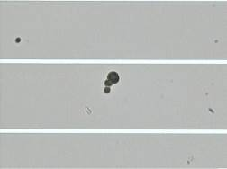 (B)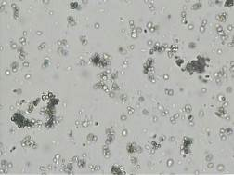
(C)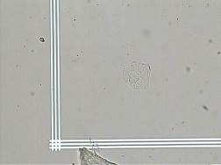 (D)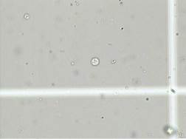

Fig. 2

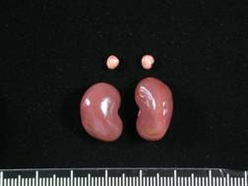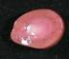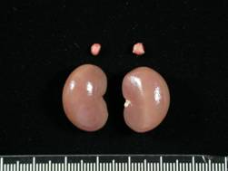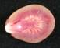
0h
12h
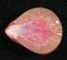
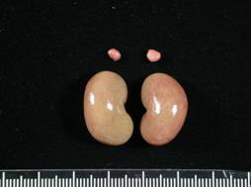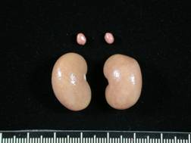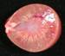
24h
48h
Fig. 3
(A)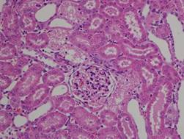 (B)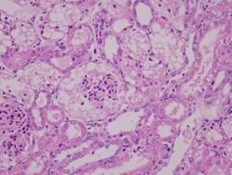
(C)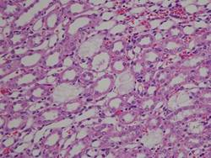 (D)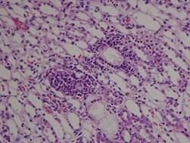

Fig. 4
(A)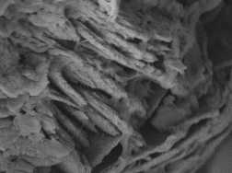 (B)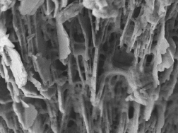
(C)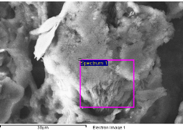
(D)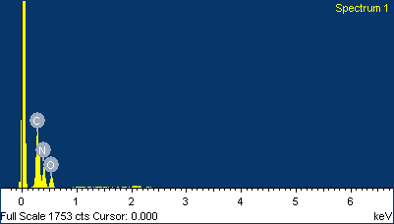

Fig. 5
(A)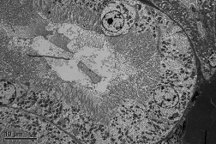 (B)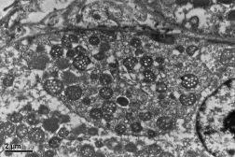
(C)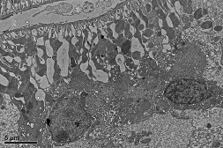 (D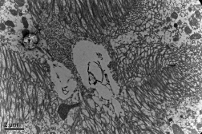
S
(E)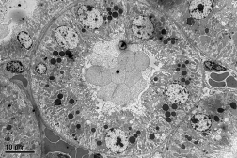 (F)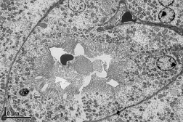
N

(G)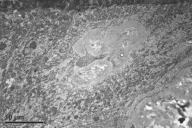 (H)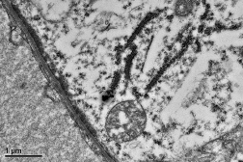
S

Table 1. White Blood Cell Differentiation Alterations of Rats Gavaged with 400 mg/kg Melamine and Cyanuric Acid After 0.5, 1, 3, 12, 24 and 48 h Intervals .
Time | WBC | Lymphocyte | Neutrophil (%) |  | Monocyte
(hr) | (10³/ul) | (%) | Band | Segmented | (%)
Control | 6.5±1.8 | 92.8±2.5 | 0.0±0.0 | 6.0±2.1 | 1.0±0.6
0.5 | 10.6±2.2* | 91.6±2.5 | 0.0±0.0 | 6.2±1.7 | 2.0±0.6*
1 | 6.9±0.7 | 88.8±3.7 | 0.4±0.4 | 7.2±2.0 | 3.6±2.2*
3 | 8.4±3.4 | 86.6±4.6* | 0.8±0.9 | 11.2±4.7 | 1.4±1.5
12 | 12.0±1.5* | 64.0±10.2* | 3.3±1.4* | 30.3±0.9* | 2.3±0.9*
24 | 8.3±2.6 | 72.2±5.9* | 2.4±1.5* | 22.8±5.3* | 2.6±1.0*
48 | 5.5±2.1 | 65.2±14.1* | 6.4±4.3* | 28.0±11.2* | 0.4±0.4
Data are expressed as the mean±SD (control n = 6, treatment n=5).
* Significant difference between the control and treated groups at P < 0.05.

Table 2. Biochemistrical Analysis of Rats Gavaged with 400 mg/kg Melamine and Cyanuric Acid After 0.5, 1, 3, 12, 24 and 48 h Intervals

Time | BUN | Creatinine | Calcium | Phosphorus | Magnesium | Potassium | Sodium
(h) | (mg/dL) | (mg/dL) | (mg/dL) | (mg/dL) | (mg/dL) | (mmole/L) | mmole/L
Control | 10.1±2.8 | 0.3±0.1 | 9.2±2.5 | 9.1±2.4 | 3.6±0.6 | 5.2±0.8 | 130.0±19.8
0.5 | 13.3±2.1 | 0.4±0.0* | 10.0±0.7 | 9.6±1.2 | 4.1±1.1 | 6.6±1.3 | 142.0±7.3
1 | 10.8±1.6 | 0.4±0.1 | 10.5±0.6 | 10.4±1.5 | 3.6±0.2 | 5.6±0.2 | 136.0±7.8
3 | 12.5±3.9 | 0.4±0.1 | 10.2±1.2 | 10.8±2.1 | 4.4±0.9 | 6.3±1.8 | 146.0±4.4
12 | 60.0±45.3* | 1.0±0.4* | 11.8±0.3* | 12.8±1.2* | 4.5±0.2* | 6.3±0.5* | 133.8±7.1
24 | 135.8±25.2* | 2.8±0.6* | 15.0±0.8* | 17.7±1.8* | 4.8±1.2 | 7.4±1.2* | 125.6±14.8
48 | 304.1±27.6* | 5.3±1.1* | 15.7±1.5* | 22.3±1.9* | 5.5±1.0* | >10.0* | 121.2±19.4

Data are expressed as the mean±SD (control n = 6, treatment n=5).
* Significant difference between the control and treated groups at P< 0.05.

Table 3. Urinary Sediments of Rats Gavaged with 400 mg/kg Melamine and Cyanuric Acid After 0.5, 1, 3, 12, 24 and 48 h Intervals.
Time  (h) | Volume  (ml/12hr) | Urinary sediments (×10³)
Time  (h) | Volume  (ml/12hr) | RBC | WBC | EPI | CAST | CRSYTAL
Control | 15.6±12.8 | 0.1±0.4 | 3.1±2.3 | 0.0±0.0 | 0.5±0.5 | 1.5±1.2
0.5 | 40.8±9.8* | 0.0±0.0 | 0.8±1.3 | 0.2±0.4 | 0.2±0.4 | 0.4±0.5
1 | 36.0±11.4* | 0.4±0.8 | 1.0±1.0 | 0.6±1.3 | 0.0±0.0 | 0.8±0.4
3 | 36.6±10.7* | 0.8±1.7 | 5.2±4.0 | 0.6±0.5* | 0.2±0.4 | 0.8±0.4
12 | 15.7±7.1 | 357.0±370.9* | 31.3±25.7* | 0.3±0.8 | 9.1±7.3* | 3.0±0.8*
24 | 3.1±3.1 | 1.2±0.5 | 4.2±8.5 | 0.5±1.0 | 0.0±0.0 | 0.4±0.5
48 | 2.1±1.3* | 2.8±2.7 | 17.4±12.2* | 1.6±2.0 | 0.6±1.3 | 0.2±0.4

Table 4. Absolute and Relative Organ Weight Alterations of Rats Gavaged with 400 mg/kg Melamine and Cyanuric Acid After 0.5, 1, 3, 12, 24 and 48 h Intervals

Time | Kidney
(h) | (g) | (%)¹
Control | 2.2±0.2 | 0.9±0.0
0.5 | 2.0±0.2 | 0.8±0.1*
1 | 2.2±0.2 | 0.9±0.0
3 | 2.7±0.6 | 1.1±0.2
12 | 3.4±0.4* | 1.4±0.1*
24 | 3.8±0.4* | 1.5±0.1*
48 | 4.3±0.5* | 1.7±0.1*
¹ Relative organ weight (%) = [organ weight (g)/ final body weight (g)] × 100.
Data are expressed as the mean±SD (control n = 6, treatment n=5).
* Significant difference between the control and treated groups at P< 0.05.

Table 5. Semi-quantitative Scoring of Rat Kidney Gavaged with Melamine and Cyanuric Acid After 0.5, 1, 3, 12, 24 and 48 h Intervals.
Histopathological findings | Melamine and cyanuric acid (1:1), 400 mg/kg
Histopathological findings | Control | 0.5 | 1 | 3 | 12 | 24 | 48
Degeneration/necrosis, proximal tubule, cortex | 0 | 0 | 0.2±0.4 | 2.0±0.7* | 2.2±0.4* | 2.8±0.4* | 4.0±0.7*
Degeneration/necrosis, distal and collecting tubules, cortex to medulla | 0 | 0 | 0 | 0.2±0.4 | 0.6±0.9 | 1.9±0.9* | 1.6±0.9*
Crystal deposition, MCA, distal and collecting tubules, cortex to medulla | 0 | 0 | 0 | 0 | 1.0±0.0 | 1.0±0.0 | 2.0±0.0*
Dilation, glomerular space contain with proteineous transudate | 0 | 0 | 0.4±0.5 | 0.2±0.4 | 0.8±0.8 | 1.4±0.9* | 3.6±1.5*
Dilation, proximal tubule, cortex | 0 | 0 | 0 | 2.0±0.7* | 4.4±0.9* | 5.0±0.0* | 5.0±0.0*
Dilation, distal and collecting tubules, cortex to medulla | 0 | 0 | 0 | 0.2±0.4 | 0.6±0.9 | 2.2±0.4* | 2.6±0.5*
Infiltration, inflammatory cell, cortex and medulla | 0 | 0 | 0.4±0.5 | 0.6±0.9 | 2.0±0.7* | 1.6±0.5* | 1.6±0.9*
Proteineous transudate, tubule,, cortex | 0 | 0 | 0.6±0.5* | 2.4±0.9* | 3.4±0.5* | 3.8±0.4* | 3.6±0.5*
Regeneration, tubule, cortex and medulla | 0 | 0 | 0 | 0 | 0 | 0 | 2.2±0.4*
Data are expressed as the mean±SD (control n = 6, treatment n=5).
* Significant difference between the control and treated groups at P< 0.05.

