A Misplaced Kidney in a Middle Aged Woman
Shih Cyuan Chen,¹MD, Jyun Shan Jheng,¹MD, Che Wen Hsu,¹MD, Jiung Hsiun Liu,^{1,2} MD, Chiu Ching Huang,^{1,2} MD

- Kidney Institute and Division of Nephrology, Department of Internal Medicine, China Medical University Hospital, Taiwan ROC
- School of Medicine, China Medical University, Taiwan ROC

Running head: Misplaced Kidney in a Middle Aged Woman

Address for Correspondence: Dr Liu Jiung Hsiun Liu, Kidney Institute and Division of Nephrology, Department of Internal Medicine, China Medical University Hospital, Taichung, Taiwan ROC.

Email: jiunghsiun@yahoo.com.tw

A 45-year-old woman with an unremarkable medical history presented with lower abdomen fullness that had persisted over the preceding several months. Laboratory test results were within normal limits, except for microscopic haematuria on urinalysis. Radiographs and ultrasonography both failed to identify the left kidney (Fig. 1). Intravenous pyelography (IVP) identified a functional left kidney, which was in an abnormal position and on an abnormal axis (Figs. 2 and 3).

What is the diagnosis for the abnormally located kidney?
- Ectopic kidney
- Nephroptosis
- Kidney dysplasia
- Ureteropelvic junction obstruction
- Duplicate collecting system

Answer: A

Discussion
Cases of displaced kidneys in clinical practice are not particularly rare. In such cases, coexisting deformities can occur, often prompting appropriate surgical correction.¹ The diagnosis of ectopic kidney can be achieved via ultrasonography, IVP (as demonstrated herein), radionuclide scanning, computed tomography and magnetic resonance imaging. One beneficial feature of IVP is that it can provide valuable information regarding concomitant anomalies in cases of displaced kidneys. In addition, IVP can assess the length of the ureter of the affected kidney and can provide crucial information to distinguish between ectopic kidney and nephroptosis. Further, ectopic and congenital unascended kidneys need to be carefully differentiated from acquired nephroptosis. In the latter case, the length of the ureter is normal.
An ectopic kidney is defined as the abnormal location of a kidney due to a developmental anomaly. This condition occurs as a result of the arrest of the affected kidney’s ascent during its migration of the kidney during gestation. The incidence of ectopic kidney is from 1:500 to 1:1100.¹ Most patients with ectopic kidneys remain asymptomatic throughout their life, and the clinical diagnosis is estimated to be only 1 in 10,000 patients.^{2,3} Moreover, an ectopic kidney often occurs in concert with other abnormalities such as agenesis of the opposite kidney, vascular malformation, and genital anomalies.⁴⁻⁶
The ectopic kidney can be associated with renal stones, abdominal pains, and infection. For example, urine can flow retrograde from the urinary bladder to the affected kidney, and abdominal pain and infection subsequent to either reflux or ureteral obstruction can occur.^{2,3} If an obstruction, either with or without evidence of stones, is noted, surgery may be indicated to correct the anatomic position of the errant kidney and/or to remove the stone(s). Surgery may ultimately permit better drainage of urine and avoid further damage to the kidney.
In the present case, no abnormalities were noted in either the right kidney or genital tract. The only abnormality was that the left kidney was located in the renal pelvis (without calculi or hydronephrosis). The cause of microscopic haematuria in initial presentation was not known via a series of examinations in this case. However, it was spontaneous recovery in the subsequent follow-up. Therefore, it could not be fully excluded the possibility that the microscopic haematuria might induce from an unidentified tiny stone. On the other hand, an ectopic kidney could cause referred pain, which is atypical for colic, and could be misdiagnosed as either acute appendicitis or pelvic organ inflammatory disease in female pateints.⁶ It is therefore imperative to conduct appropriate testing to make a definitive diagnosis from this case.

References
- Benjamin JA, Tobin CE. Abnormalities of kidneys, ureters and perinephric fascia-anatomic and clinical study. J Urol 1951;65:715-33.
- Gleason PE, Kelalis PP, Husmann DA, Kramer SA. Hydronephrosis in renal ectopia: incidence, etiology and significance. J Urol 1994;151:1660-1.
- Lu CC, Tain YL, Yeung KW, Tiao MM. Ectopic pelvic kidney with urinary tract infection presenting as lower abdominal pain in a child. Pediatr Neonatol 2011;52:117-20.
- Kang IJ, Lee SH, Lee SM, Lim CH, Yoon JH, Kim TW, et al. A case of congenital single ectopic kidney in pelvis of patients with proteinuria. Korean J Nephrol 2005;24:137-40.
- Malek RS, Kelalis PP, Burke EC. Ectopic kidney in children and frequency of association with other malformations. Mayo Clin Proc 1971;46:461-7.
- Kumar S, Bolla SR, Vollala VR. Unilateral ectopic kidney in the pelvis − a case report. Chang Gung Med J 2011;34:10-2.

Figure Legends
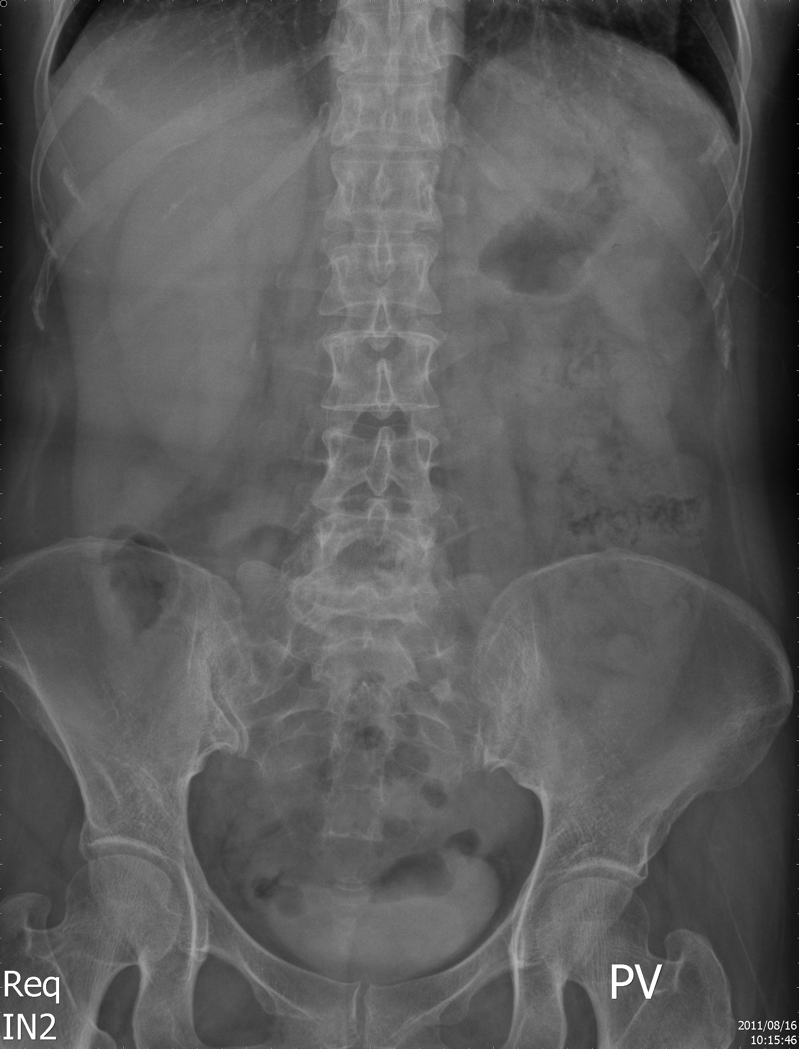
Fig. 1. The left kidney shadow was absent on initial kidneys-ureters-bladder x-ray.

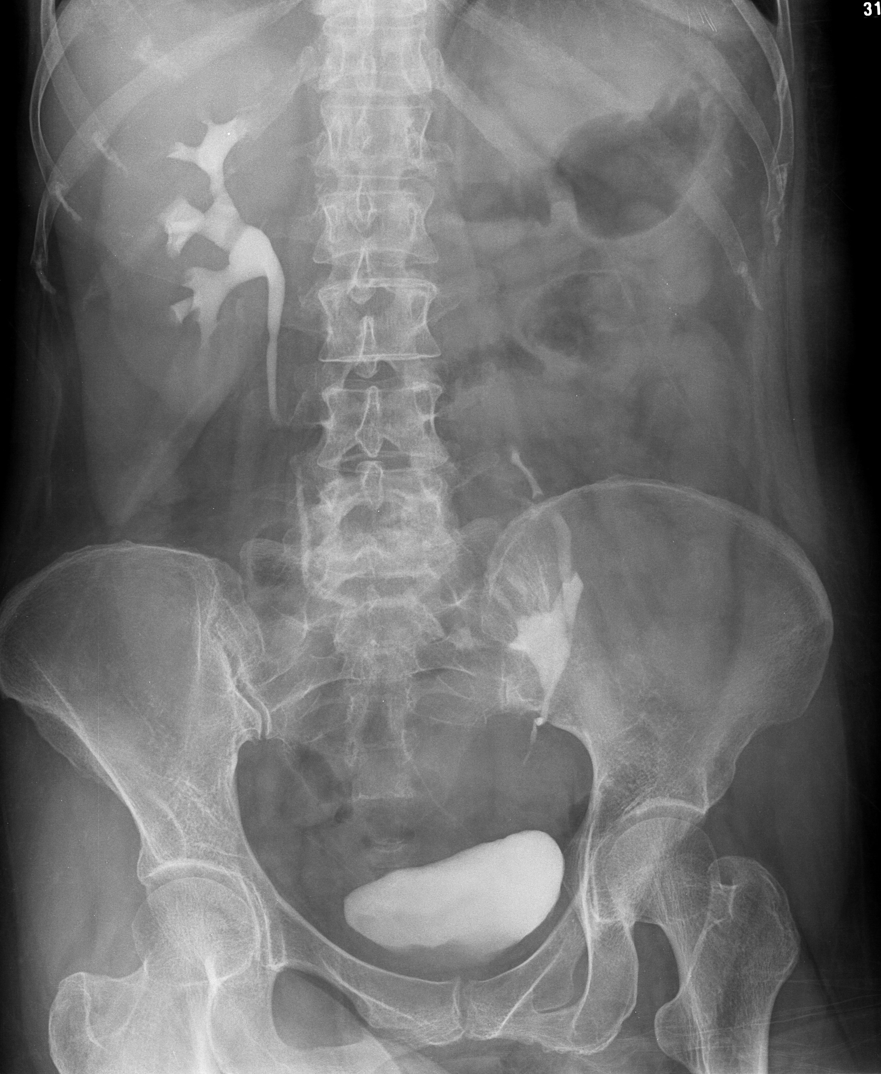
Fig. 2. The intravenous pyelography showed low position of the left functional kidney, with an abnormal axis.
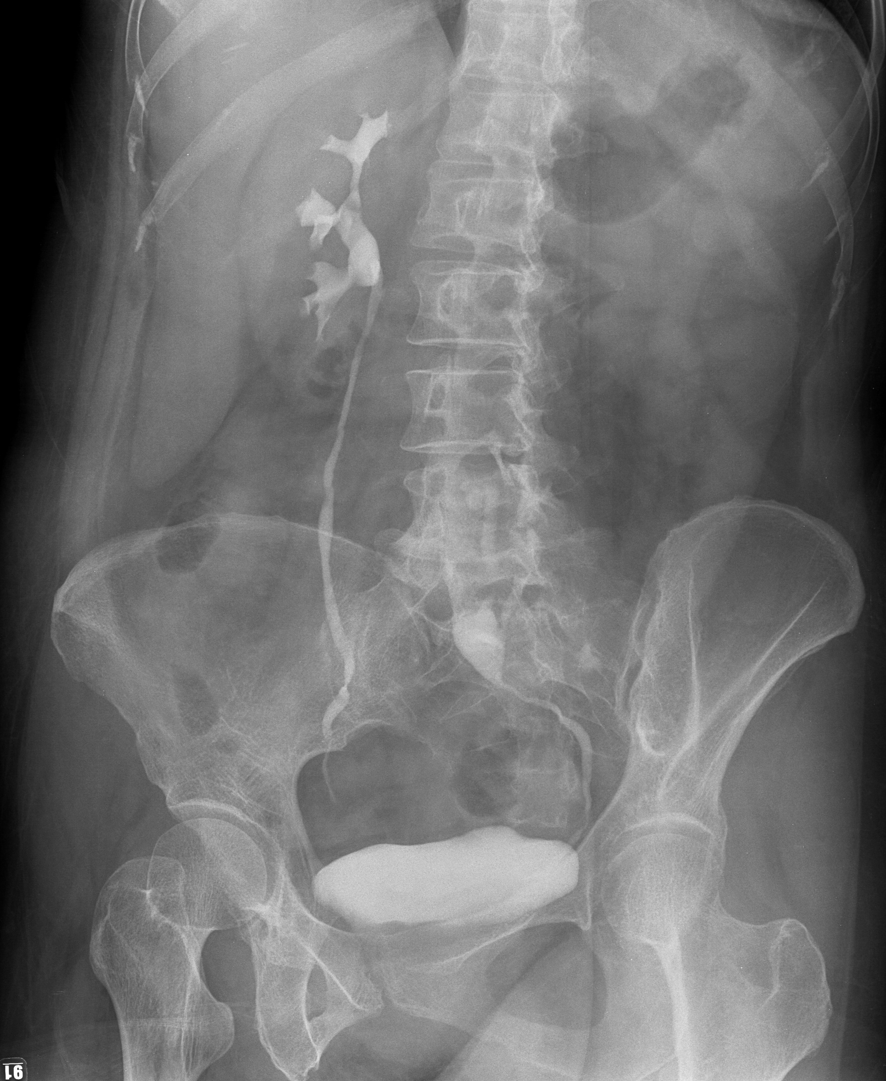
Fig. 3. The intravenous pyelography showed the length of the ureter was shortening in the left kidney.

