Assessment Tool of Virtual Reality Game-based Treatment for Patients with Imbalance and Vestibular Dysfunction
Abstract. Dizziness is a major consequence of imbalance and vestibular dysfunction. It prevents people performing their routine tasks and may lead to severe injuries due to unexpected falling. Appropriate medicine treatment can alleviate the syndrome of dizziness. In addition, past research showed that dizziness can be further reduced if vestibular function rehabilitation exercises are regularly practiced. Nevertheless, these rehabilitative exercises are usually time-consuming and tedious. Plenty of patients cannot stand with those repetitive exercises and simply stop practicing. In order to encourage patients to stick to the rehabilitation process, interactive rehabilitative gaming systems were introduced in the recent research. Virtual Reality (VR) technology is specially used to simulate daily activities for enhancing treatment performance. This paper illuminates the concept and design of novel VR rehabilitative games adopted by Cawthorne-Cooksey exercise, which is commonly used in clinical for imbalance and vestibular dysfunction rehabilitation. In this study, forty-eight patients suffered from vestibular dysfunction and thirty-six normal subjects were participated within two months period. Patients, who completed training processes, on average have better results in terms of their gaming parameters and balance indices. Further analysis with Support Vector Machine (SVM) classifier reveals the fact that treated patients are prone to be grouped into normal subjects. The tendency become obvious if regular treatments are carried out. Our clinical observations and survey results also convey that the proposed VR gaming system can motivate patients to regularly perform rehabilitation and make them be aware of the effectiveness of the treatment.

- Introduction
Imbalance and vestibular dysfunction usually lead to dizziness [1]. Common dizzy types are Meniere's disease, Benign Positional Vertigo, Vertebrobasilar insufficiently, and Vestibular neuritis, and sick headache. Dizziness may persist for minutes, hours, or even longer; thus, it interrupts people's daily routines and affects their quality of life. During dizzying, people may experience shaking, tilting, difficulty in standing, and prone to fall, because they may sense motion when no motion is occurring relative to earth’s gravity [2-4]. Therefore, dizziness may cause severe danger to those people who are holding glass/knife in the kitchen or standing in the bathroom. Worst of all, the syndrome of dizziness will keep deteriorating if no treatment is applied.

Common treatments are vestibular surgery, medicine treatment, and balance training exercises. Past research reveal that the combination of these treatments can effectively reduce the syndrome of dizziness [5]. Compared to surgery and medicine treatment, balance training is non-invasive and suitable for majority of patients in general. Cawthorne-Cooksey is a balance training exercise designed to improve patients' ability of keeping balance by training patients' ability to control their eyeball movement, head movement, extremities stretch, and bilateral body balance. Through repeating these training movements, patients’ ability of cervico-ocular reflex should be enhanced and the reflex provides better compensation for retaining balance situation during dizzying [5-6]. Cawthorne-Cooksey vestibular rehabilitation exercise requires the participants to move their eyeballs without moving the orientation of their head, move their head without changing their body position, rotate and bend their body with the force of the waist, rotate head and shoulder with the force of the shoulder, and throw/catch objects in between two hands. These training practices are usually time-consuming and tedious because they need to be repeated multiple times. In addition, it is difficult to customize training practices for individual patients because the differences among the patients are not quantifiable.

To overcome the limitation of the traditional training methods, interactive VR game-based rehabilitation programs and sensor-based recording systems are introduced [2, 7-10]. These integrated systems not only motivate patients to exercise regularly, but also quantify the rehabilitative process into meaningful balance indices [11-12]. In addition, VR technology makes games more playful and close to daily life. Physical therapists can adjust the game contents and difficulty based on individual patient’s life experience. Along with the maturity of vision-based technology, optical tracking and skeleton detection libraries provided by Microsoft Kinect further captures abundant information of human motion. These camera-based recording systems largely reduce the need of manual interference for the rehabilitative training process. Full rehabilitation systems should be able to provide immediate visual, auditory, and tactile feedback to make patients more involved in the training processes and gain better training effectiveness.
Game-based rehabilitation method has been used previously for rehabilitation of neurologic conditions [15-19], musculoskeletal disorders [20-22], or elderly adults [23-25]. However, few studies have used video games to assess balance levels [26]. A previous study of patients with a heterogeneous history of lower extremity injury, showed that their balance activity scores had poor correlation between center of pressure outcomes and Star Excursion Balance Test reach distances [26]. This study adopted VR video games adopted from Cawthorn-Cooksey Exercise and machine learning based classifiers as a balance assessment tool for people with vestibular dysfunction. Classifiers are trained and cross-validated with features of center of pressure trajectory and self-calculated variables of interest. The consistent findings between the performance data and balance assessment measured suggest that this VR game-based exercise may be applicable to clinical assessment and rehabilitation of people with vestibular dysfunction.
- Preliminary
  - Cawthorn-Cooksey Exercise
Traditional Cawthorn-Cooksey Exercises can be categorized into seven series of movements: eyeball movement, head movement, waist rotation movement, stooping down movement, shoulder rotation movement, body rotation movement with eyes closed, and ball throwing test. In the eyeball movement practice, subjects are requested to look up and down, left and right, stare at their index fingers while their fingers move up and down, left and right, forward and backward from slowly to fast. Their head should not move during the eyes movement. Head movement practice requires subjects to lean forward, backward without losing balance and rotate their head to left and then to right. Then subjects are requested to rotate their waist with their shoulder hunch up in the waist rotation movement. In stooping down movement practice, subjects are request to pick up some lightweight objects on the ground. Then subjects are requested to rotate their head and shoulder with their eyes open and closed. Lastly, subjects are requested to throw a tennis ball from left hand and right hand back and forth. Both hands should be placed at the same height of their eyes, so that their eyes can keep track the balls movement continuously.
  - Balance Index: Statokinesigram (SKG)
Center of pressure is a common method to quantify balance. SKG is derived from a time series recording of the center of pressure. By plotting a time series of the center of pressure in 2D scatter plot, an envelope area can be visualized to represent the distribution of the body balance. SKG is the envelope area. The method adopted in this research to calculate SKG is based on convex hull calculation: a minimum convex polygon search algorithm to enclose all center of pressure records. Therefore, if a normal subject is requested to stand still. The convex hull/SKG area should be small. However, this may not be the case for those patients with vestibular dysfunction. Therefore, SKG can be an important index to assess the level of body balance. In addition to SKG index, multiple balance indices can be derived from SKG, such as maximum mediolateral (maxML) and anteroposterior (maxAP) trajectory excursion, mean mediolateral (meanML) and anteroposterior (meanAP) trajectory excursion, and standard deviation of mediolateral (meanML) and anteroposterior (meanAP) trajectory excursion. This derived indices does not necessary to have high dependency with SKG index; thus, they are suitable to be used as SVM parameters.
  - Support Vector Machine (SVM)
SVM is a classifier which attempts to separate data set into defined categories with maximum barriers in between. Intuitively, a good separation can be obtained by finding hyper-planes that have the largest distance to the nearest training data point of every category. Barriers, formally named as margins, represent the distances to from one categories to the others and the problem becomes finding maximum margins among categories. However, some data set may contain data points which cannot be separated with linear hyper-planes. This means that those data are not linear separable, but may be separable with high-order non-linear hyper-planes, such as quadratic hyper-planes. To overcome this limitation, kernel trick is usually performed to project those data points into higher feature dimensions; presumably, those data points can be projected into a space where they are linear separable. Commonly used kernels are linear, quadratic, and Gaussian kernels. Another trick usually applied is the penalty of misclassification. By increasing the weights of penalty, the occurrence of training error should be reduced. However, the trained model may over-fit with the training samples and lose generality. A reasonable solution is to search possible penalty candidates exhaustively with optimization tools and perform cross-validation process with the data samples and SVM. Processing data points with SVM classifier is simple if each data point is correctly labeled for every group. Correct labels should be assigned with reliable and unambiguous ground truth, such as labels of patients and normal subjects. In training processes, normal and offset vectors of the hyper-planes can be obtained. Testing data should be projected on to the obtained hyper-planes to determine which group they belong to. Overall accuracy can be computed by analyzing the differences between the projected results and the labels of testing data.
- System Architecture
The proposed interactive rehabilitation system consists of sensor systems, VR game-based training systems, and data analysis modules (Figure 1). Four VR game-based training tasks are adopted from Cawthorn-Cooksey vestibular rehabilitation exercise: eyeball movement, head movement, extremities stretch, and bilateral body balance. The content of these games and game difficulties can be adjusted by the physical therapists based on the condition of the individual patients. The prototype VR games are implemented to fulfill the functionality of Cawthorn-Cooksey exercise. Appropriate adjustments based on the feedback of physical therapist and patients are made to provide satisfactory user experience. Patients are expected to wear 3D glasses and receive real-time gaming feedback in terms of visual and audio output while using the training system. They are expected to follow the visual and audio guidance to complete the assigned game tasks within given time limits. Their kinematic information in each game session is recorded by the optical tracking system and Microsoft Kinect. This information are served as real-time gaming inputs and it is converted into balance assessment features for further data analysis. WiiFit is specially used as a center of pressure measuring system and SKG and its derivation can be directly extracted from WiiFit recordings. These balance indices/features are analyzed by standard statistical tools and machine learning software, such as SVM.

Figure 1. System Overview
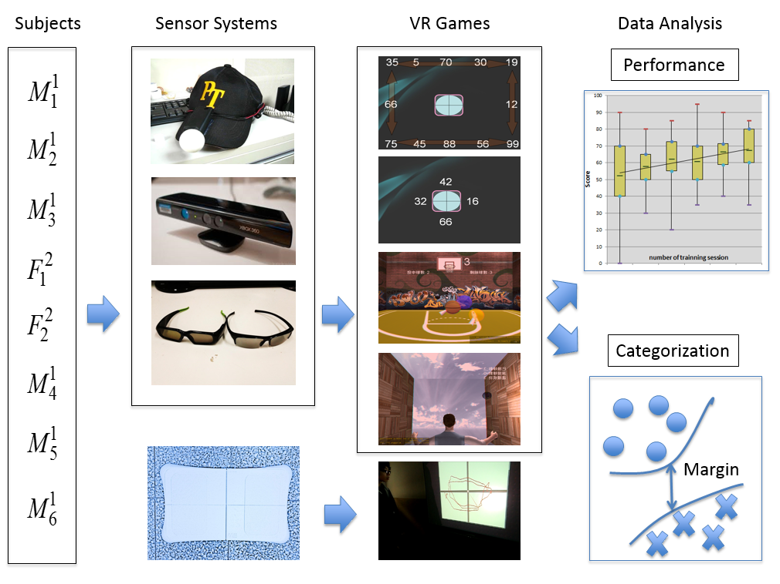
- Virtual Reality Rehabilitative games adopted by Cawthorn-Cooksey Exercise
Four VR rehabilitative games are designed to fulfill the tasks of Cawthorn-Cooksey exercise: eyeball movement, head movement, extremities stretch, and bilateral body balance. Patients should follow the visual and audio guidance to complete each tasks. Note that body rotation movement, including, head, shoulder, and waist are combined into extremities stretch movement practice.
  - Eye Movement
The goal of the eyeball movement practice is to train subjects’ ability to control their eyeball to move to arbitrary direction in a controllable speed. Subjects are asked to move their eyeball without changing their head orientation and body posture. When the training starts, a series of random numbers are shown clockwise/counterclockwise on the margin of the screen. Participants should keep their head in a static position and move their eyeballs in order to read the number on the margin of the screen. The size of the margin and speed of the random number generation are adjustable for satisfying physical limitations of the individual participants. There are 25 trials per game session and the ratio of hit (read the correct number) and miss (read incorrectly or miss a digit) are recorded as a balance index/feature for further data analysis. Note that if the head of a subject moves while he/she attempt to read a digit, a sound should ring to notify a failed trial. A red square shown in the center of the game image regulates the maximum tolerance of the head movement.
  - Head Movement
The game for training head movement is similar to the eyeball movement training game. Instead, this practice is to train the subjects’ ability to control their head movement while their eyes are staring at a virtual object. Participants are requested to gaze on a red box in the center of the screen and read the random number around the red box by moving their head. Random number are shown clockwise/counterclockwise on the margin of the red box. The location of the random numbers can be adjusted depending on whether the participant reaches his/her maximum range of the head rotation. There are 20 trials per game session and the ratio of hit (read the correct number) and miss (read incorrectly or miss a digit) are recorded as a balance index/feature for further data analysis. Note that if a timeout event happens because of no response from the subject for a certain amount of time, the game should pause until the subject is ready.
  - Stretch Movement
In order to encourage users to perform stretch movement, a basketball shooting game is designed. Users should stoop and grasp a virtual basketball in the game, straighten up, lift their arms above the shoulder level, and rotate their head/shoulder/waist to throw a virtual basketball a randomly assigned basket in the game. During the practice, users should move their head, shoulder and stretch their arms to assigned levels. The ratio of hit or miss is recorded as performance indices as well. There are 10 trials per game session and the ratio of hit (finish a series of actions for a basketball shooting) and miss (fail to finish a basketball shooting trial within a time limit) are recorded as a balance index/feature for further data analysis. Note that complete body movements and extremities trajectory are recorded and indexed by timestamps.
  - Bilateral Coordination Movement
The last game is bilateral coordination movement practice. Participants are request to throw and catch a virtual ball alternatively by both hands. When the participant touches a virtual ball with one hand, the ball should be automatically thrown to the contralateral side and the participant is required to catch the ball with the contralateral hand. The throwing process should continue until the users miss a catch. There were 10 trials per game session and the number of rounds (throwing and catching a ball are recorded as a balance index/feature for further data analysis.
- Evaluation
  - Experiment Setup
Forty-eight patients suffered from vestibular dysfunction were recruited consecutively within two months period. Subsequent appointments for training sessions are made with subjects who are willing to continue the VR game-based treatment. In order to make the experimental results unbiased, some prerequisites are applied when we select experiment participants. The training tasks and the balance test were conducted by licensed physical or occupational therapists currently in practice. The included participants are aged 18 years and above, diagnosed with chronic vestibular dysfunction for more than 3 months that were refractory to medication, and they should be capable of participating in balance rehabilitation based on VR without cognitive dysfunction. Those patients belong to the following categories are excluded: weakness or paralysis in the lower limbs, or currently undertaking drugs, medical, or surgical vestibular ablation treatment. All participants provided informed consent for the study, which was approved by the Cathay General Hospital CT100008 Institutional Review Board. In addition to recruiting forty-eight patients with vestibular dysfunction in the study, thirty-six normal subjects are invited to join the study to provide data samples of normal subjects without vestibular dysfunction. These normal subjects’ data are treated as gold standards to indicate how well healthy subjects can achieve in terms of balance indices.

Table 1. Characteristics of Study Subjects to Evaluate Interactive 3-dimensional Virtual Reality Rehabilitation for Chronic Imbalance and Vestibular Dysfunction *

Group | Normal (N=36) | Patients (N=48)
Characteristic | Mean ± SD | Mean ± SD
No. subjects | 36 | 48
Age (y) | 18~29 | 18~89
All subjects | - | 64 ± 16
< 60 y (n = 19) | 22(n = 36) | 46 ± 11
≥ 60 y (n = 38) | - | 74 ± 8
Sex (male/female) | 20/16 | 25 / 32
Height (cm) | - | 162 ± 8
Weight (kg) | - | 62 ± 13
* Data reported as number or mean ± SD
In order to make the rehabilitation processes smooth, a copy of the technical manual was provided to assist the therapists in operating the interactive rehabilitation system. Therapists are requested to conduct WiiFit balance test before and after each training session. All subjects after completing the sixth trial are invited to join our survey, targeting on analyzing the sufficiency of gaming instructions, game appearance, system usefulness/playfulness, motivation promotion, and the easiness in terms of daily use for all game types: eye movement, head movement, hand stretching, and bilateral balance. In addition, subjects' personal information and their type of dizziness are recorded: Benign Paroxysmal Positional Vertigo, BPPV, Meniere’s disease, Vestibular neuritis, vertebrobasilar insufficiency, VBI, and headache induced dizziness.
  - Data Analysis
Sensed data are converted into balance indices and gaming features before analyzing. Patients are partitioned into three groups: before treatment, undertaking treatment, and after treatment. When comparing data between normal subjects and patients, all three patients’ group are merged together and labelled as patients. Table 2 presents the balance indices comparison between thirty-six normal subjects and forty-eight patients. Mean and standard deviation, and statistical significance are calculated. Table 3 shows the comparison between patients before treatment and patients after treatment. Patients before treatment are marked as pretest and patients after treatment are marked as posttest. We select the 3nd balance trials as pretest and the second-last balance trials as posttest. It is because that some patients reported feeling dizziness when they wear 3D glasses at the first time. To exclude this situation, we treat the first and second trial as a practice session and use the 3nd trials as pretest data. On the other hand, we try to avoid bring bias into the analysis. The second-last balance trials are selected to avoid possible biases in the last trials, such as mental bias.

Table 2. Balance Index Analysis of Study Subjects to Evaluate Interactive 3-dimensional Virtual Reality Rehabilitation for Chronic Imbalance and Vestibular Dysfunction *

Balance index† | Normal (N=36)  mean±SD | Patient (N=48)  mean±SD | t-value | Significance
maxML | 0.87 ±0.34 | 1.37±1.35 | -2.455 | 0.017(*)
maxAP | 1.35 ± 0.33 | 2.49±1.56 | -4.928 | **
meanML | 0.62 ± 0.13 | 0.72±0.41 | -1.471 | 0.147
meanAP | 0.73 ± 0.16 | 0.97±0.64 | -2.460 | 0.017(*)
SKG | 1.59 ±1.01 | 6.08±16.28 | -1.908 | 0.062
Significance Level = 0.05
* p < 0.05 ** p < 0.01

Table 3. Balance Index Analysis of Patients (pre/post tests, N=48) to Evaluate Interactive 3-dimensional Virtual Reality Rehabilitation for Chronic Imbalance and Vestibular Dysfunction *

Balance index† | Posttest  mean±SD | Pretest  mean±SD | t-value | Significance
maxML | 1.68±1.32 | 1.24±0.85 | 2.563 | 0.014(*)
maxAP | 2.28±1.17 | 2.37±1.20 | -0.540 | 0.592
meanML | 0.63±0.37 | 0.62±0.34 | 0.120 | 0.905
meanAP | 0.81±0.56 | 0.90±0.66 | -1.210 | 0.232
SKG | 5.72±8.08 | 4.50±8.75 | 1.438 | 0.157
Significance Level = 0.05
* p < 0.05 ** p < 0.01

In addition to statistical analysis, machine learning-based classification is used to assess patients’ recovery. Statistical analysis illustrates the characteristics of the collected data. However, it does not provide an effective method to distinguish the severity of patients’ vestibular dysfunction, though mean of the balance indices could be a rough estimation. Since we have multiple gaming features and balance indices, we may be able to use high-dimension classification technique to quantifiably category patients’ recovery. SVM is adopted with four kinds of labels: patients before treatment, undertaking treatment, after treatment, and normal subjects. These labels represent different severity of vestibular dysfunction. Multiple classifiers are trained based on different labels combination, for instance, labels of forty-eight patients before treatment versus thirty-six normal subjects. The comparison table are listed in Table 4. The result matrix is symmetric because interchanging labels (1 and 0) does not change classification results, but simply assign classified categories with opposite labels. Notice that because each patient’s physical condition is different, he/she may receive different number of rehabilitation treatments. Therefore, finding the label: patients undertaking treatment is tricky. To maintain fairness and randomness, we random sample the patients’ trials excluding the first, second, third, second to the last, and the last trials. These labels are used in labeling of patients before/after treatment or biased as discussed before.

Table 4. SVM classification results (best results among all kernels) (N=48)
Labelled  as 0/1 | Before Treatment | During Treatment | After  Treatment | Normal Subjects (N=36)
Before Treatment | NA | 51.63% | 73.77% | 94.85%
During Treatment |  | NA | 62.21% | 80.41%
After  Treatment |  |  | NA | 65.98%
Normal  Subjects |  |  |  | NA

- Discussion and Future work
Few observations are made from the statistical analysis and SVM classification results. First of all, by observing the mean value of the statistical analysis in Table 2, we can identify that normal subjects have better balance indices compared with patients in general. Their average deviation of center of gravity is lesser than patients; therefore, their all five balance indices are less than patients’ and the variance of the five balance indices is smaller as well. Except for meanML, all other balance indices are statistically significant better. It is because normal subjects have better ability to maintain their balance, the differences among normal subjects are small, and the distinction in terms of balance between normal subject and patients are obvious. Nevertheless, this comparison does not mean that patients can become as good as the normal subjects after rehabilitative treatment. After all, normal subjects are composed of younger teenagers. Instead, this comparison provides an extreme case to show the differences and trends between patients and normal subjects.

Table 3 differentiates further by splitting patients into two groups: before treatment and after treatment. We can observe that treated patients has less average deviation of center of gravity, because their balance indices values are smaller on average than the measurement they did before treatment. By combining the observations in Table 2 and Table 3, we can conclude that patients become better in controlling their balance after treatment and they might be closer to the normal subject after taking more VR rehabilitative treatment. Note that the differences of standard deviations of the patient before and after treatment are not significant because each patient’s physical condition is different and the numbers of treatment are not even for all patients. Some patients are participated more training based on the judgment made by the recommendation of therapists. Nevertheless, the recovery trend in terms of balance indices should not be affected.

In addition to understand the recovery trend from the sensed data, building an assessment tool to estimate patients’ dizziness condition is of interest. This idea is to categorize a new patient in terms of his/her dizzy severity based on existing known patients’ balance indices and gaming parameters features. Using mean and standard deviation data may not be a reasonable solution because a new patient may have partial balance features better/worse than average. Unless all of the balance features are better/worse than average, we cannot judge the patient’s dizzy severity. To overcome this problem, SVM is adopted to categorize patients with high-dimensional feature space. Table 4 shows the comparison results. A quick observation can be made is that classifying patients before treatment and normal subject is simple and classifying two adjacent labels in the table is relatively harder. This observation provides an important hint to build an assessment tool with machine learning methods; that is, we can train a set of parameters by partition existing data into patients’ and normal subjects’ categories. A new-comer can be quickly assessed based on the projected categories (patients or normal subjects). To validate this method, we split the patients and normal subjects’ data into four category (before treatment, undertaking treatment, after treatment, and normal subject). By analyzing the classification accuracy, we can conclude that a subject with better ability to control their balance is prone to be classified into normal subject category. It is because the classification accuracy between data of treated patients and normal subject is much lower than the classification accuracy between the data of untreated and normal subject. This trend is clear for the case undertaking treatment. SVM is trained by finding maximum barriers in high dimensional feature space; therefore, it is much robust to tolerate variance and the trained parameters are less likely to be changed when new training data comes in. By using different SVM kernels, including linear, quadratic, and Gaussian, we can explore the rough structure of the sensed features. However, the best classification results of the six categories are obtained with different kernels. This result implies that either the internal structure of the feature space is too complex or more data are necessary to avoid possible over-fit issues. Fortunately, the same training and testing model can be used iteratively to better model the feature space. A new type of patient patterns can be included by re-training processes to complete the assessment model. Once most patients’ gaming and balance patterns are recorded, this assessment tool can provide quick assessment to efficiently identify dizzy severity.

Figure 2. Kernels Comparison (Six data categories from top to bottom are 1. Before treatment vs During treatment, 2. Before treatment vs After treatment, 3. Before treatment vs Normal subjects, 4. During treatment vs After treatment, 5. During treatment vs Normal subjects, and 6. After treatment vs Normal subjects)
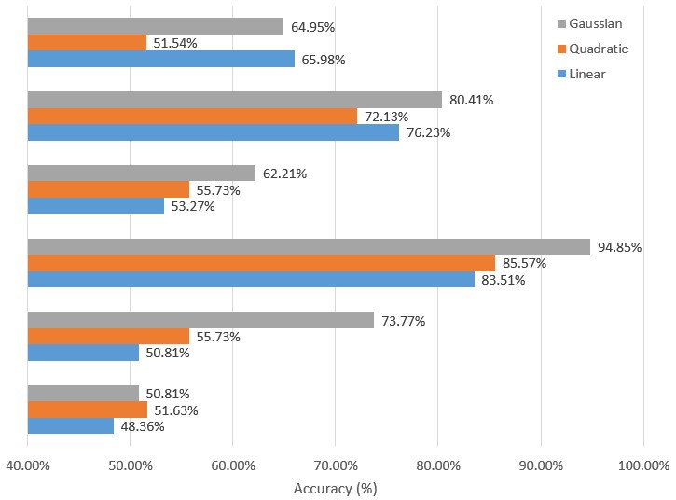
1
2
3
4
5
6
The proposed interactive VR rehabilitation training system effectively helps those patients with vestibular dysfunction to improve their balance scores. Game parameters and balance indices collected from motion capturing sensors enable rehabilitation performance tread analysis and categorization. Physical therapists can adjust game contents and hierarchical difficulty level based on their understanding of individual patients’ physical conditions. In addition, real-time visual and audio feedbacks about subject’s performance effectively motivate subjects to use the rehabilitation system and understand their progress. Based on the results of this study, larger clinical tests may be designed to test the effectiveness of this system and improve rehabilitation performance for chronic imbalance caused by vestibular dysfunction. Future study may include analysis of the subjective perception of the patients, fine-grained classification based on the severity of the dizziness syndrome, and the effects of psychological and emotional factors on rehabilitation performance.
- Conclusion
This paper proposes a series of novel and interactive virtual reality games adopted by Cawthorne-Cooksey exercise for promoting imbalance and vestibular dysfunction rehabilitation. In order to evaluate the performance of system, collected quantified game parameters and balance indices are analyzed by statistical tools and SVM classifier. Patients who completed training process have better results in terms of their gaming parameters and balance indices on average. The further analysis with SVM classifier reveals the fact that treated patients are prone to be grouped into normal subjects. The tendency become obvious if regular treatments are carried out. The results of the follow-up questionnaire show that using new VR technology for rehabilitation is helpful to facilitate imbalance and vestibular dysfunction rehabilitation.

Reference
- Monsell EM. New and revised reporting guidelines from the Committee on Hearing and Equilibrium. American Academy of Otolaryngology-Head and Neck Surgery Foundation, Inc. Otolaryngol Head Neck Surg 1995,113:176-178.
- Gauchard GC, Jeandel C, Perrin PP: Physical and sporting activities improve vestibular afferent usage and balance in elderly human subjects. Gerontology 2001,47:263-270.
- Greenspan SL, Myers ER, Maitland LA, Resnick NM, Hayes WC: Fall severity and bone mineral density as risk factors for hip fracture in ambulatory elderly. JAMA 1994,271:128-133.
- Luukinen H, Herala M, Koski K, Honkanen R, Laippala P, Kivelä SL: Fracture risk associated with a fall according to type of fall among the elderly. Osteoporos Int 2000,11:631-634.
- Schubert MC, Whitney SL: From Cawthorne-Cooksey to biotechnology: where we have been and where we are headed in vestibular rehabilitation? J Neurol Phys Ther 2010,34:62-63.
- Corna S, Nardone A, Prestinari A, Galante M, Grasso M, Schieppati M: Comparison of Cawthorne-Cooksey exercises and sinusoidal support surface translations to improve balance in patients with unilateral vestibular deficit. Arch Phys Med Rehabil 2003,84:1173-1184.
- Adamovich SV, Fluet GG, Merians AS, Mathai A, Qiu Q: Incorporating haptic effects into three-dimensional virtual environments to train the hemiparetic upper extremity. IEEE Trans Neural Syst Rehabil Eng 2009,17:512-520.
- Holden MK: Virtual environments for motor rehabilitation: review. Cyberpsychol Behav 2005,8:187-211.
- Lahiri U, Warren Z, Sarkar N: Design of a gaze-sensitive virtual social interactive system for children with autism. IEEE Trans Neural Syst Rehabil Eng 2011,19:443-452.
- Weiss PL, Katz N: The potential of virtual reality for rehabilitation. J Rehabil Res Dev 2004,41:vii-x
- Hunag MC, Chen E, Xu W, Sarrafzadeh M: Gaming for upper extremities rehabilitation. Proceeding of conference on Wireless Health 2012, 27.
- Huang MC, Xu W, Su Y, Lange B, Chang CY, Sarrafzadhe M: SmartGlove for upper extremities rehabiliation gaming assessment. Proceeding of conference on Pervasive Technologies Related to Assistive Environment 2012, 20.
- Takagi A, Fujimura E, Suehiro S: A new method of statokinesigram area measurement. Application of a statistically calculated ellipse. In: Igarashi M, Black FO (Eds) Vestibular and visual control on posture and locomotor equilibrium. Karger: Basel, pp.74-79, 1985.
- Paillard T, Costes-Salon C, Lafont C, Dupui P: Are there differences in postural regulation according to the level of competition in judoists? Br J Sports Med 2002,36:304-305.
- Meldrum D, Herdman S, Moloney R, Murray D, Duffy D, Malone K, French H, Hone S, Conroy R, McConn-Walsh R: Effectiveness of conventional versus virtual reality based vestibular rehabilitation in the treatment of dizziness, gait and balance impairment in adults with unilateral peripheral vestibular loss: a randomised controlled trial. BMC Ear Nose Throat Disord 2012,12:3.
- Deutsch JE, Brettler A, Smith C, Welsh J, John R, Guarrera-Bowlby P, Kafri M: Nintendo wii sports and wii fit game analysis, validation, and application to stroke rehabilitation. Top Stroke Rehabil 2011,18:701-719.
- Esculier JF, Vaudrin J, Bériault P, Gagnon K, Tremblay LE: Home-based balance training programme using Wii Fit with balance board for Parkinsons's disease: a pilot study. J Rehabil Med 2012,44:144-150.
- Meldrum D, Glennon A, Herdman S, Murray D, McConn-Walsh R: Virtual reality rehabilitation of balance: assessment of the usability of the Nintendo Wii(®) Fit Plus. Disabil Rehabil Assist Technol 2012,7:205-210.
- Lange B, Flynn S, Proffitt R, Chang CY, Rizzo AS: Development of an interactive game-based rehabilitation tool for dynamic balance training. Top Stroke Rehabil 2010,17:345-352.
- Baltaci G, Harput G, Haksever B, Ulusoy B, Ozer H: Comparison between Nintendo Wii Fit and conventional rehabilitation on functional performance outcomes after hamstring anterior cruciate ligament reconstruction: prospective, randomized, controlled, double-blind clinical trial. Knee Surg Sports Traumatol Arthrosc 2012, Apr 29.
- Fung V, Ho A, Shaffer J, Chung E, Gomez M: Use of Nintendo Wii Fit™ in the rehabilitation of outpatients following total knee replacement: a preliminary randomised controlled trial. Physiotherapy 2012,98:183-188.
- Miller CA, Hayes DM, Dye K, Johnson C, Meyers J: Using the Nintendo Wii Fit and body weight support to improve aerobic capacity, balance, gait ability, and fear of falling: two case reports. J Geriatr Phys Ther 2012,35:95-104.
- Bateni H: Changes in balance in older adults based on use of physical therapy vs the Wii Fit gaming system: a preliminary study. Physiotherapy 2012,98:211-216.
- Daniel K: Wii-hab for pre-frail older adults. Rehabil Nurs 2012,37:195-201.
- Rendon AA, Lohman EB, Thorpe D, Johnson EG, Medina E, Bradley B: The effect of virtual reality gaming on dynamic balance in older adults. Age Ageing 2012,41:549-552.
- Wikstrom EA: Validity and reliability of Nintendo Wii Fit balance scores. J Athl Train 2012,47:306-313.

- Acknowledgement

We are grateful for the support of Cathay General Hospital and National Central University, Taiwan, under 101CGH-NCU-A4.

