Original Paper

Metabolism and pharmacokinetics of anthraquinones in Rheum palmatum in rats and ex-vivo antioxidant activity

Chi-Sheng Shia¹, Shin-Hun Juang ², Shang-Yuan Tsai ², Pei-Hua Chang¹, Sheng-Chu Kuo¹, Yu-Chi Hou*² and Pei-Dawn Lee Chao*²

Affiliation

¹Institute of Pharmaceutical Chemistry, China Medical University, Taichung, Taiwan, R.O.C
²School of Pharmacy, China Medical University, Taichung, Taiwan, R.O.C.

Correspondence author: Pei-Dawn Lee Chao, Yu-Chi Hou
School of Pharmacy, China Medical University,
91 Hsueh-Shih Rd, Taichung, Taiwan 404, ROC.
Tel: 886-4-22053366-5107 Fax: 886-4-22031028
E-mail: pdlee@gmail.com hou5133@gmail.com

Abstract
Anthraquinones are a major group of polyphenols in the rhizome of Rheum palmatum L. (RP). This study investigated the metabolism and pharmacokinetics of anthraqinones in RP decoction in rats. The concentrations of four anthraquinones including aloe-emodin, rhein, emodin, chrysophanol, and their glycosides in the decoction were quantitated by HPLC before and after acid hydrolysis with the results indicating that the anthraquinones mainly existed as glycoside form except rhein. Rats were orally administered RP decoction and blood samples were assayed by HPLC before and after treatments with sulfatase and ß-glucuronidase. It was found that the glucuronides of aloe-emodin, rhein, emodin and chrysophanol were predominant in the blood, whereas their aglycones were not detected except rhein. In conclusion, the anthraquinones were subject to rapid and extensive conjugation metabolism in rats and the serum metabolites of RP exhibited potential free radical scavenging effect on AAPH-induced hemolysis at pharmacologically relevant concentrations.

Key words: Rheum palmatum; Polygonaceae; metabolism; anthraquinones; pharmacokinetics; AAPH

Abbreviations
RP, Rheum palmatum L. ; AAPH, 2,2’-azobis(2-amidinopropane hydrochloride); S/G, sulfates/glucuronides; G, glucuronides; C_{max}, the peak serum concentration; AUC, the areas under the curve; MRT, mean residence time.
Introduction
The rhizome of Rheum palmatum L. (RP, Polygonaceae) is widely used in clinical Chinese medicine as a remedy for digestive disease such as constipation, gastritis, enteritis, gastric ulcer and hepatitis [1]. Nowadays, it is also used in the treatment of various chronic diseases, like inflammation, atherosclerosis, diabetes and cancer [2]. Anthraquinones are a major group of polyphenol constituents in RP, including aloe-emodin, rhein, emodin, chrysophanol (structures shown in Figure 1) and their glycosides [3]. Several beneficial effects of anthraquinones including anticancer [4-8], antivirus [9], antioxidation [10] and anti-diabetic activities [11] have been reported in recent decade. Despite these promising results, it remains unclear whether these activities can be extended to in vivo effects on account of the fact that hitherto published results were essentially based on in vitro studies without understanding the metabolism and pharmacokinetics of anthraquinones in animals.
Over the past decade, regarding the metabolic fates of polyphenolic flavonoids, the researchers gradually realized that under most cases the glycosides and aglycones of polyphenols are not present in the circulation, whereas the major molecules were glucuronides or/and sulfates of the aglycones [12-14]. As to the biological fates of anthraquinones, given the limited information available in literature, it is thus highly meaningful to conduct an investigation into the metabolism and pharmacokinetics of anthraquinones in RP decoction in rats.
Moreover, for more than two decades, the free radical-mediated peroxidation of membrane lipid and oxidative damage of DNA has long been thought to be associated with a variety of health problems, such as cancer, atherosclerosis, neurodegenerative diseases and aging. As an extension of our pharmacokinetic study, the serum metabolite of RP was prepared from rats and the activity against 2,2’-azobis(2-amidinopropane hydrochloride) (AAPH)-induced hemolysis was evaluated.

Materials and Methods
Chemicals
Aloe-emodin (purity 95%), rhein (purity 95%), emodin (purity 90%), chrysophanol (purity 98%), AAPH, β-glucuronidase (type B-1 from bovine liver, containing 1,240,000 units/g of β-glucuronidase)), sulfatase (type H-1 from Helix pomatia, containing 14,000 units/g of sulfatase and 498,800 units/g of β-glucuronidase) and 2-methylanthraquinone (purity 95%) were purchased from Sigma Chemical Co. (St. Louis, Mo). Acetonitrile, methanol and ethyl acetate were LC grade and purchased from Mallinckrodt Baker, Inc. (Phillipsburg, NJ). L(+)-Ascorbic acid (purity 99.5%) was obtained from RdH Laborchemikalien GmbH & Co. KG (Seelze). Other reagents were HPLC grade or analytical reagent grade. Milli-Q plus water (Millipore, Bedford, MA) was used throughout this study.

Instrumentation
The HPLC apparatus included a pump LC-10AT (Shimadzu, Kyoto), a photodiode array detector SPD-M10AVP (Shimadzu, Kyoto) and an automatic injector SIL-10A (Shimadzu, Kyoto). The Cosmosil 5C18-AR II column (4.6×250 mm, 5 μm) was equipped with a guard column (4.6×50 mm, 5 μm) (GL Science Inc., Tokyo). ELISA Reader was a product of Thermo Electron Co..

Preparation of RP decoction
The rhizomes of Rheum palmatum were purchased from a Chinese drug store in Taichung, Taiwan. The origin of the crude drug was identified microscopically by one of the authors, Dr. Yu-Chi Hou. A specimen (CMURP1 ) was deposited in the Institute of Chinese Pharmaceutical Sciences, China Medical University. Three hundred mL of water was added to the crude drug of RP (15 g) and heating was carried out on a gas stove. After boiling, gentle heating continued until the volume reduced to less than 30 mL. The mixture was filtered while hot and sufficient water was added to make 30 mL and frozen at −30°C for later use. The final concentration of RP decoction was equivalent to 0.5 g/mL of crude drug.

Quantitation of anthraquinones in RP decoction and the acid hydrolysate
RP decoction (200 µL) was added with 200 µL of 2-methylanthraquinone solution (10.0 µg/mL in methanol) as internal standard and 20 µL were subjected to HPLC analysis. The mobile phase consisted of acetonitrile (A) – 0.1 % phosphoric acid (B) and the gradient elution program was as follows: A/B: 50/50 (0 min), 60/40 (10 min), 85/15 (15 min), 85/15 (20 min), and 50/50 (25 min). The detection wavelength was set at 250 nm and the flow rate was 0.9 mL/min [15]. Acid hydrolysis of 1 mL of the decoction was conducted using 1 mL of 1.2 N HCl and the reaction was carried out at 80°C in a water bath for 6 h in the presence of 25 mg of ascorbic acid. The hydrolysate was then added with sufficient methanol to make 2.0 mL before HPLC analysis. The glycoside contents of aloe-emodin, rhein, emodin, and chrysophanol were determined by subtracting the concentrations of each aglycone in the decoction from those of correspondent aglycones in the acid hydrolysate.

HPLC fingerprinting of RP decoction and the acid hydrolysate
The RP decoction and its acid hydrolysate were subject to another elution program for better fingerprinting. The mobile phase consisted of acetonitrile (A) – 0.1 % phosphoric acid (B) and programmed as follows: A/B: 17/83 (0 min), 28/72 (30 min), 80/20 (60 min), 17/83 (70 min) and 17/83 (80 min). The detection wavelength was set at 250 and the flow rate was 0.7 mL/min.

Drug administration and blood collection
After overnight fasting, six male Sprague-Dawley rats were administered orally with 10.0 mL/5.0 g/kg of RP decoction via gastric gavage. Food was withheld for 3 h after drug administration. Blood samples (0.8 mL) were withdrawn via cardiac puncture at 10, 30, 60, 120, 180, 300, 480 and 720 min after dosing. After standing for 10 min at room temperature, blood was centrifuged at 10,000 g to obtain serum. The animal study adhered to “The Guidebook for the Care and Use of Laboratory Animals (2002)” (Published by the Chinese Society for the Laboratory Animal Science, Taiwan, R.O.C.). The Committee of Animal Management in China Medical University approved this animal protocol.

Detection of glycosides and aglycones of anthraquinones in serum
Serum sample was added with 4-fold volume of methanol, vortexed and centrifuged at 10,000 g. The supernatant was evaporated to dryness by blowing nitrogen. The residue was reconstituted with mobile phase and subject to HPLC analysis using the same elution program as for fingerprinting of RP decoction.

Quantitation of anthraquinones and their glucuronides and sulfates in serum
The concentrations of anthraquinone aglycones and their conjugated metabolites in serum were determined before and after treatments of β-glucuronidase and sulfatase, respectively. For the quantitation of glucuronides, 100 µL of serum was mixed with 50 µL of β-glucuronidase (1000 units/mL in pH 5 acetate buffer), 50 µL of ascorbic acid (100 mg/mL) and incubated at 37°C for 4 h under anaerobic condition and protected from light. For the quantitation of sulfates, 100 µL of serum was mixed with 50 µL of sulfatase (1000 units/mL in pH 5 acetate buffer), 50 µL of ascorbic acid (100 mg/mL) and incubated at 37°C for 2 h under anaerobic condition and protected from light. After hydrolysis, the serum was acidified with 50 µL of 0.1 N HCl and partitioned with 250 µL of ethyl acetate (containing 0.6 µg/mL of 2-methylanthraquinone as internal standard). The ethyl acetate layer was evaporated under nitrogen gas to dryness and reconstituted with 50 µL of mobile phase, then 20 µL was subjected to HPLC analysis.
For the assay of anthraquinone aglycones, 100 µL of serum sample was subjected to the process described above except for the addition of enzyme-free buffer. The mobile phase consisted of acetonitrile (A) – 0.1 % phosphoric acid (B) and programmed was as follows: A/B: 55/45 (0 min), 60/40 (10 min), 85/15 (15 min), 85/15 (20 min), and 55/45 (25 min). The detection wavelength was set at 250 nm and the flow rate was 1.0 mL/min. For calibrator preparation, 100 µL of serum each spiked with various concentrations of anthraquinones was added with 100 µL of pH 5 buffer. The later procedure was the same as that described above for serum samples. The standard curves were plotted by linear regression of the peak area ratios (each anthraquinone to internal standard) against concentrations of individual anthraquinone.

Validation of assay method for serum
The system suitability was evaluated through intra-day and inter-day analysis of precision and accuracy. The accuracy of this method was further assessed with recovery studies by spiking anthraquinones into blank serum in triplicates to afford 0.3, 0.6, and 1.3 μg/mL for aloe-emodin, emodin, and chrysophanol, and 1.6, 3.1, and 6.3 μg/mL for rhein. Recovery was assessed by comparing the peak area obtained from extracted serum spiked with standards to that obtained from unextracted standards in extracted serum matrix representing 100% recovery. The LLOQ (lower limit of quantitation) represents the lowest concentration of analysis in a sample that can be determined with acceptable precision and accuracy, whereas LOD (limit of detection) represents the lowest concentration of analysis in a sample that can be detected (with S/N>3).

Preparation of serum metabolites of RP
After overnight fast, five rats were administered orally with 10 ml/5.0 g/kg of RP decoction via gastric gavage. Half hour later, a second dose was boosted. At 20 min after the second dose, rats were sacrificed and then 15 mL of blood were withdrawn from each rat to obtain serum. Four volumes of methanol was mixed with serum and centrifuged to remove proteins. The supernatant was evaporated under vacuum to dryness and then reconstituted with phosphate-buffered saline (PBS) to afford 1-, 1/2-, 1/4-, 1/8- and 1/16- fold serum levels. In addition, blank serum was collected from rats after overnight fast and processed in the same manner to prepare a sample of serum control.

Effect of serum metabolites of RP on AAPH -induced hemolysis
Three Sprague-Dawley rats were fasted overnight, blood was withdrawn via cardiac puncture and collected into vacutainer tubes containing EDTA. After removing plasma and buffy coat, erythrocytes were washed 5 times with 2-fold volume of cold PBS. During the last wash, the erythrocytes were centrifuged at 3000 g for 10 min to obtain a packed cell preparation. The packed erythrocytes were then suspended in 4-fold volume of PBS. To 100 μL of erythrocyte suspension, the mixtures of 100 μL of 200 mM AAPH (in PBS) and 200 μL of PBS containing various concentrations of RP serum metabolites or L-ascorbic acid (as a positive control) were added. The reaction mixture was shaken gently and incubated at 37°C for 0, 1, 2, 3, and 4 h. After incubation, the reaction mixture was added with 600 μL of PBS and centrifuged at 10,000 g for 1 min. Then, the absorbance of the supernatant was measured at 540 nm. The percentages of hemolysis inhibition were calculated by the following equation:
Hemolysis inhibition (%) = [absorbance_{control} – absorbance_{sample} ] / absorbance_{control} × 100%

Data analysis
The pharmacokinetic parameters were calculated using noncompartment model with the aid of WINNONLIN (version 1.1, SCI software, Statistical Consulting, Inc., Apex, NC). The area under the serum concentration - time curve (AUC_{0–720}) was calculated using trapezoidal rule to 720 min. The peak plasma concentration (C_{max}) was obtained from experimental observation. Data of anti-hemolysis assay were statistically compared using ANOVA.

Results
Figures 2 (a) and (b) show the HPLC fingerprints of RP decoction and its acid hydrolysate, respectively. It is obvious that rhein is the most abundant anthraquinone either before or after hydrolysis. By employing photodiode array detector, the peaks 1, 2, 3, and 4 were tentatively assigned as glycosides of aloe-emodin, rhein, emodin, and chrysophanol, respectively, based on the very similarity of their UV absorption spectrum. Upon acid hydrolysis, the peaks 1, 2, 3, 4 disappeared and resulted in marked enhancement of peaks 5, 6, 7, and 8, a clear indication of the conversion of anthraquinone glycosides to their aglycones. Our quantitation found that the original decoction contained 207, 1392, 269 and 108 μg/mL of the free forms of aloe-emodin, rhein, emodin and chrysophanol, respectively. After acid hydrolysis, the contents of each compound were increased by 379, 212, 423 and 245 μg/mL for aloe-emodin, rhein, emodin, and chrysophanol, respectively. It reveals that these anthraquinones in RP decoction were mainly existing as glycoside form except rhein.
Figure 3 shows typical HPLC fingerprints of serum specimen deproteinized with methanol (a) and after treatment with sulfatase/glucuronidase (b). From the figure, we can infer that rhein was the only rhubarb anthraquinone present as free form in the serum, whereas other anthraquinones emerged after treatment with sulfatase or glucuronidase. The optimum hydrolysis condition had been determined by a preliminary study. During the hydrolysis reaction, ascorbic acid was added to avoid the oxidative decay of anthraquinones. The quantitation method of anthraquinones in rat serum was developed and validated in this study, and the chromatograms are shown in Figure 4. The coefficients of variation and the relative errors of intraday and interday analysis were each below 10% and 20%. The recoveries were 94.8 ─ 101.2%, 87.6 ─ 93.5%, 95.2─ 97.0%, and 81.1─ 93.2% for aloe-emodin, rhein, emodin and chrysophanol. The LLOQs were 0.1, 0.8, 0.2, 0.1 μg/mL and LODs were 0.03, 0.06, 0.04 and 0.01 μg/mL for aloe-emodin, rhein, emodin and chrysophanol, respectively.
Following RP administration, figures 5 (a), (b), (c) and (d) depict the serum profiles of the sulfates/glucuronides and glucuronides of various anthraquinones as well as rhein free form. It can be found that the conjugated metabolites of various anthraquinones emerged rapidly after RP administration. The pharmacokinetic parameters are listed in Tables 2 and 3. Both glucuronides/sulfates and free form of rhein were present in serum. The AUC_{0–720} of rhein free form was 30% of rhein sulfates/glucuronides, which had significantly longer MRT. The serum profiles showed that glucuronides were the principal metabolites of aloe-emodin and emodin, whereas chrysophanol presented as both glucuronides and sulfates. The C_{max} and AUC_{0–720} of the sulfates/glucuronides of anthraquinones are ranked in consistent order of rhein > emodin > chrysophanol > aloe-emodin.
Table 3 shows the contents of each anthraquinone in 1- fold serum level of RP metabolites which was used in the AAPH study. Figure 6 shows the effects of various concentrations of RP serum metabolites and ascorbic acid on AAPH-induced hemolysis. All tested concentrations of RP serum metabolites exhibited significant anti-hemolysis effect in concentration - dependent manner and the IC₅₀ was about 1/8- fold of serum level.

Discussion
Decoction is a traditional dosage form of RP in Clinical Chinese medicine. A previous study has reported the fingerprint of R. tanguticum Maxim. ex Balf. for the purpose of quality control [15]. This study established the HPLC fingerprints of RP decoction and its acid hydrolysate in order to identify the relatively polar anthraquinone glycosides. The fingerprints of RP decoction revealed the presence of anthraquinone aglycones including aloe-emodin, rhein, emodin, and chrysophanol with retention times later than 50 min, whereas their glycoside peaks were found between 0–40 min and had been identified through acid hydrolysis. The marked increases of various anthraquinones after acid hydrolysis indicated that they were mainly present as glycoside forms in RP decoction except rhein. Upon acid hydrolysis, the changes of chromatogram were very consistent with that resulted from fermentation with rat enteral microflora [16]. For the quantitation of anthraquinones in the RP decoction and serum specimens, 2-methylanthraquinone was used as internal standard, which is not naturally occurring in the plant or as a metabolite of RP decoction.
When RP decoction was orally administered, the putative glycoside peaks of aloe-emodin, rhein, emodin and chrysophanol were not found in the deproteinized serum as shown in Figure 3 (a). This can be explained by that the relatively polar glycosides were too hydrophilic to permeate through the enterocyte membrane. Besides, no anthraquinone aglycones were detected except rhein, implying that only rhein can enter the circulation per se. Contrary to the biological fates of most polyphenols, the presence of rhein free form in serum seems a special feature. Our finding was in good agreement with an in vitro study reporting relatively low glucuronidation activity of UDP-glucuronyltransferases toward carboxylic acids like rhein [17].
Constrained by the unavailability of authentic compounds of sulfates and glucuronides of various anthraquinones, quantitation of conjugated metabolites was conducted indirectly after hydrolysis with sulfatase and glucuronidase. While serum samples were treated with β-glucuronidase or sulfatase, peaks of aloe-emodin, emodin and chrysophanol emerged and the peak of rhein markedly enhanced as shown in Figure 3 (b), indicating the presence of glucuronides/sulfates of anthraquinones in serum. The conjugated metabolites of various anthraquinones were detected since the first sampling time after dosing, allowing us to confirm that anthraquinones were rapidly and extensively metabolized by conjugation reactions after oral administration of RP decoction.
Owing to considerable amount of glucuronidase in the sulfatase (type H-1) used in this study, treatment with sulfatase resulted in the hydrolysis of both sulfates and glucuronides. Comparison of the aglycone profiles between treatments with sulfatase and glucuronidase showed that those of emodin and aloe-emodin were essentially superposable, which indicated that glucuronides were their major metabolites, but sulfates were negligible. In contrast, the aglycone profiles of rhein and chrysophanol after treatment with sulfatase/glucuronidase were higher than those after treatment with glucuronidase, especially during the absorption phase. So evidently besides glucuronides, considerable amount of sulfates of rhein and chrysophanol were present in serum. Through subtracting the AUC_{0–720} of glucuronides from that of correspondent glucuronides/sulfates, the AUC_{0–720} of the sulfates of rhein and chrysophanol appeared to contribute 25% of the total exposure of glucuronides/sulfates, indicating that sulfates were minor metabolites.
Comparison of the total systemic exposure among four anthraquinones including free form and their glucuronides/sulfates showed an order of rhein > emodin > chrysophanol > aloe-emodin. When the ratios of C_{max}/dose and AUC_{0–720}/dose were calculated and compared among four anthraquinones (data not shown), the results indicated that the bioavailabilities of rhein, emodin and chrysophanol were comparable, whereas aloe-emodin was the least bioavailable. This fact might be explained by that aloe-emodin could be oxidized to rhein in vivo [18].
Lately there has been voluminous in vitro bioactivity assays reported on polyphenol aglycones. For instance, various potential activities of rhein, aloe-emodin emodin and chrysophanol have been demonstrated [4, 5, 19-21]. However, based on our pharmacokinetic findings that their free forms were not present in blood except rhein, the in vitro bioactivities might not appropriately predict their in vivo effects. We therefore propose that the conjugated metabolites of anthraquinones may play more important role for in vivo activities than their aglycones. In past few years, several studies have found that the sulfates/glucuronides of flavonoids such as morin and quercetin demonstrated more promising bioactivities than their aglycones [22-24]. In order to mimic the in vivo situation, we further prepared the serum metabolites of RP from rat based on our pharmacokinetic study. In contrast to blank serum, RP serum metabolites exerted dose - dependent and time - dependent inhibitory effect on AAPH-induced hemolysis. The inhibition potency of 1/8 fold of serum level was comparable to that caused by 125 µM of ascorbic acid. The potential protection of erythrocyte membrane from free-radical attack provide an important pathophysiological basis for making use of RP as a remedy for free-radical related diseases.
In conclusion, anthraquinones including aloe-emodin, rhein, emodin and chrysophanol in RP decoction are rapidly and extensively metabolized into their glucuronides or/and sulfates in rats, mainly glucuronides. Only rhein was partly present in its free from in the blood. The bioactivities of the metabolites of anthraquinones of anthraquinone have to be further studied for a better understanding of the in vivo effects of various anthraquinones in RP.

Acknowledgements
The work was in part supported by the National Science Council, ROC (NSC96-2320-B039-006-MY3, NSC 96-2320-B-039-037-MY3); the Committee on Chinese Medicine and Pharmacy, ROC (CCMP96-RD-019); and China Medical University, Taichung, Taiwan, ROC (CMU97-256).

References
¹ Shen YJ, Li YK. Pharmacology of Traditional Chinese Medicines. Shanghai Science and Technology Publishing House: Shanghai, China. 1997.
² Ji YB, He SW, Ma YL, Li J; Yang C, Liu LL. Pharmacological Action and Application of Anticancer Traditional Chinese Medicines. Heilongjiang Science and Technology Publishing House: Ha’erbin, China, 1999.
³ Li TSC. Chinese and Related North American Herbs: Phytopharmacology and Therapeutic Values. CRC Press: Boca Raton, FL, USA, 2002.
⁴ Shi YQ, Fukai T, Sakagami H, Kuroda J, Miyaoka R, Tamura M, Yoshida N, Nomura T. Cytotoxic and DNA damage-inducing activities of low molecular weight phenols from rhubarb. Anticancer Res 2001; 21: 2847-2853.
⁵ Pecere T, Sarinella F, Salata C, Gatto B, Bet A, Dalla Vecchia F, Diaspro A, Carli M, Palumbo M, Palu G l. Involvement of p53 in specific anti-neuroectodermal tumor activity of aloe-emodin. Int J Cancer 2003; 106: 836-847.
⁶ Huang Q, Lu G, Shen HM, Chung MC, Ong CN. Anti-cancer properties of anthraquinones from rhubarb. Med Res Rev 2007; 27: 609-630.
⁷ Kuo PL, Hsu YL, Ng LT, Lin CC. Rhein inhibits the growth and induces the apoptosis of Hep G2 cells. Planta Med 2004; 70: 12-16.
⁸ Guo J, Xiao B, Liu Q, Zhang S, Liu D, Gong Z. Anticancer effect of aloe-emodin on cervical cancer cells involves G2/M arrest and induction of differentiation. Acta Pharmacol Sin 2007; 28: 1991-1995.
⁹ Shuangsuo D, Zhengguo Z, Yunru C, Xin Z, Baofeng W, Lichao Y, Yan'an C. Inhibition of the replication of hepatitis B virus in vitro by emodin. Med Sci Monit 2006; 12: BR302- BR306.
¹⁰ Cai Y, Sun M, Xing J, Corke H. Antioxidant phenolic constituents in roots of Rheum officinale and Rubia cordifolia: Structure-radical scavenging activity relationships. J Agric Food Chem 2004; 52: 7884-7890.
¹¹ Zheng JM, Zhu JM, Li LS, Liu ZH. Rhein reverses the diabetic phenotype of mesangial cells over-expressing the glucose transporter (GLUT1) by inhibiting the hexosamine pathway. Br J Pharmacol 2008; 153: 1456-1464.
¹² Hou YC, Chao PDL, Ho HJ, Wen CC, Hsiu SL. Profound difference in pharmacokinetics between morin and its isomer quercetin in rats. J Pharm Pharmacol 2003; 55: 199-203.
¹³ Lai MY, Hsiu SL, Tsai SY, Hou YC, Chao PDL. Comparison of metabolic pharmacokinetics of baicalin and baicalein in rats. J Pharm Pharmacol 2003; 55: 205-209.
¹⁴ Chao PDL, Hsiu SL, Hou YC. Flavonoids in herbs: biological fates and potential interactions with xenobiotics. J Food Drug Anal 2002; 10: 219-228.
¹⁵ Jin W, Ge RL, Wei QJ, Bao TY, Shi HM, Tu PF. Development of high-performance liquid chromatographic fingerprint for the quality control of Rheum tanguticum Maxim. ex Balf. J Chromatogr A 2006; 1132: 320-324.
¹⁶ Lin YT, Chang PH, Wen KC, Yu CP, Chao PDL, Hou YC, Hsiu SL. Presystemic Metabolism of Anthraquinone Polyphenols in Rhubarb. Mid-Taiw J Med 2004; 9: 87-95.
¹⁷ Tukey RH and Strassburg CP. Human UDP-glucuronosyltransferases: metabolism, expression, and disease. Annu Rev Pharmacol Toxicol 2000; 40: 581-616.
¹⁸ Lang W. Pharmacokinetic-metabolic studies with ¹⁴C-aloe emodin after oral administration to male and female rats. Pharmacology 1993; 47: 110-119.
¹⁹ Zamek-Gliszczynski MJ, Hoffmaster KA, Nezasa K, Tallman MN, Brouwer KLR. Integration of hepatic drug transporters and phase II metabolizing enzymes: Mechanisms of hepatic excretion of sulfate, glucuronide, and glutathione metabolites. Eur J Pharm Sci 2006; 27: 447-486.
²⁰ Wohlfarth C, Efferth T. Natural products as promising drug candidates for the treatment of hepatitis B and C. Acta Pharmacol Sin 2009; 30: 25-30.
²¹ Lee MS, Sohn CB. Anti-diabetic properties of chrysophanol and its glucoside from rhubarb rhizome. Biol Pharm Bull 2008; 31: 2154-2157.
²² Fang SH, Hou YC, Chang WC, Hsiu SL, Chao PDL, Chiang BL. Morin sulfates/glucuronides exert anti-inflammatory activity on activated macrophages and decreased the incidence of septic shock. Life Sci 2003; 74: 743-756.
²³ Hsieh CL, Chao PDL, Fang SH. Morin sulphates/glucuronides enhance macrophage function in microgravity culture system. Eur J Clin Invest 2005; 35: 591-596.
²⁴ Yang JH, Hsia TC, Kuo HM, Chao PDL, Chou CC, Wei YH, Chung JG. Inhibition of lung cancer cell growth by quercetin glucuronides via G2/M arrest and induction of apoptosis. Drug Metab Dispos 2006; 34: 296-304.

Legends for Figures
Figure 1 Chemical structures of anthraquinones.

Figure 2. HPLC fingerprints of RP decoction (a) and its acid hydrolysate (b). 1: aloe-emodin glycoside, 2: rhein glycoside, 3: emodin glycoside, 4: chrysophanol glycoside, 5: aloe-emodin, 6: rhein, 7: emodin, 8: chrysophanol.

Figure 3. HPLC chromatograms of a serum specimen deproteinized with methanol (a) and after treatment with sulfatase/glucuronidase (b) following oral administration of RP decoction to rats. 1: aloe-emodin, 2: rhein, 3: emodin, 4: chrysophanol.

Figure 4. HPLC chromatograms of (a): blank serum spiked with standards of aloe-emodin (2.5 μg/mL), rhein (15.0 μg/mL), emodin (5.0 μg/mL), chrysophanol (2.5 μg/mL) and (b): a serum specimen hydrolyzed with ß-glucuronidase. 1: aloe-emodin, 2: rhein, 3: emodin, 4: chrysophanol, IS: 2-methylanthraquinone.

Figure 5. Mean (±S.E.) serum concentration – time profiles of the free form, glucuronides (G), sulfates/glucuronides (S/G) of aloe-emodin (a), rhein (b), emodin (c) and chrysophanol (d) in six rats after oral administration of RP decoction.

Figure 6. Effects of various levels of RP serum metabolites on APPH-induced hemolysis. Data are expressed as mean ± S.D. of triplicates.

 | R₁ | R₂
Aloe-emodin | H | CH₂OH
Rhein | H | COOH
Emodin | OH | CH₃
Chrysophanol | H | CH₃

Figure 1

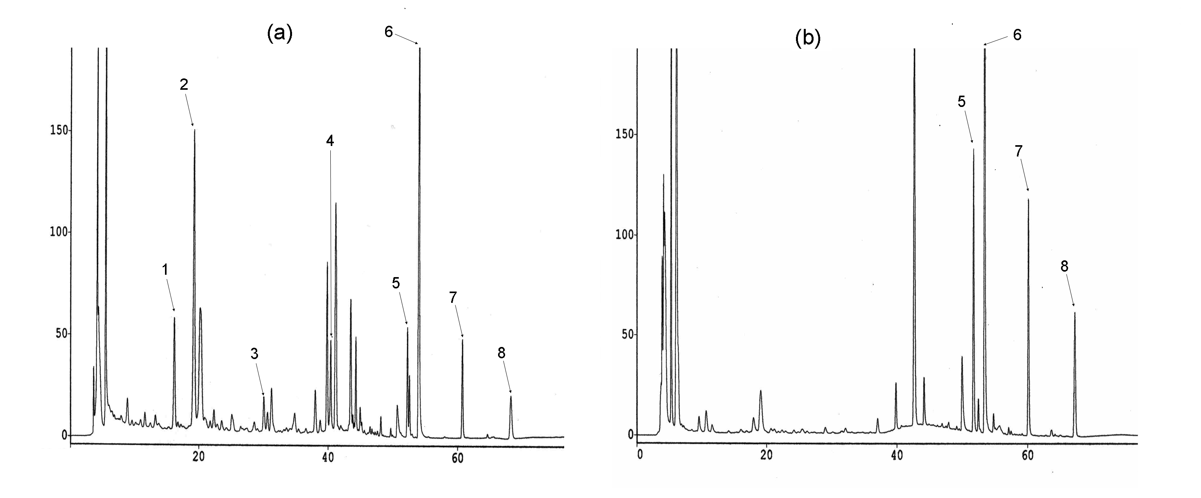
Figure 2.

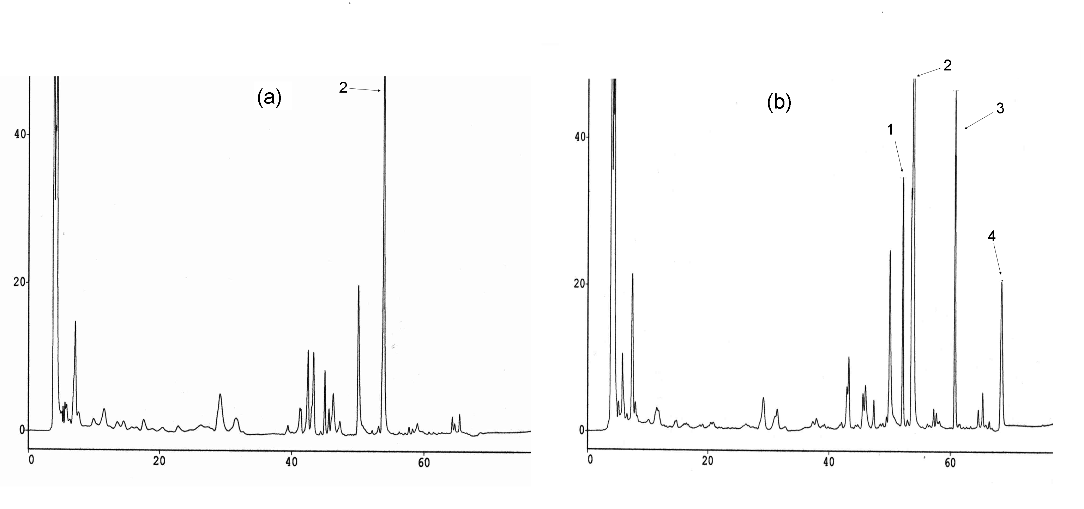

Figure 3.

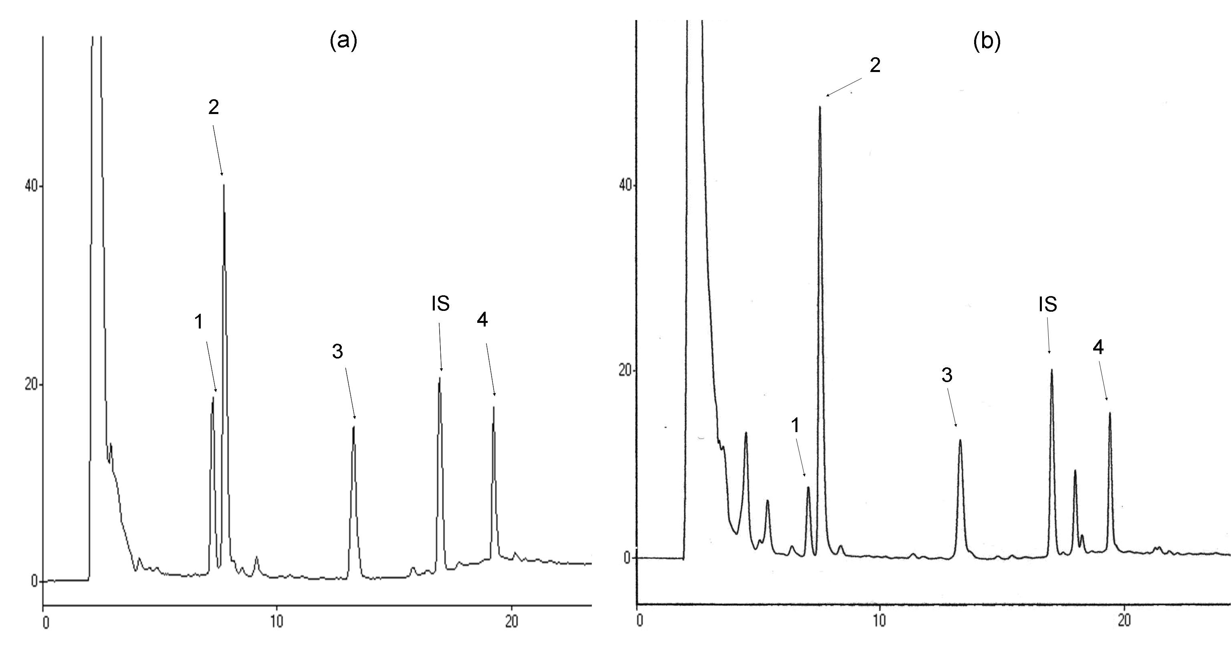

Figure 4.

(a)

(b)

(c)

(d)

Figure 5.

Figure 6.

Table 1. Pharmacokinetic Parameters of Anthraquinone Sulfates/Glucuronides (S/G) and Glucuronides (G) in Six Rats after Oral Administration of RP Decoction (5.0 g/kg).

Parameters | Aloe-emodin S/G | Emodin S/G | Chrysophanol S/G
C_{max} | 3.1 ± 0.3 | 11.2 ± 1.5 | 7.5 ± 0.9
AUC_{0–720} | 366.8 ± 52.1 | 1702.7 ± 247.8 | 941.8 ± 130.4
MRT | 79.9 ± 7.3 | 158.0 ± 7.9 | 123.0 ± 10.0
Parameters | Aloe-emodin G | Emodin G | Chrysophanol G
C_{max} | 2.9 ± 0.3 | 10.2 ± 1.3 | 4.2 ± 0.7
AUC_{0–720} | 346.3 ± 52.8 | 1757.6 ± 308.4 | 685.3 ± 113.6
MRT | 80.3 ±7.2 | 156.9 ±6.5 | 144.7 ± 14.4
Data expressed as mean ± S.E.
C_{max} (nmol/mL): concentration of peak serum level.
AUC_{0–720} (nmol⋅min/mL): area under blood concentration – time curve to 720 min.
MRT (min): mean residence time.

Table 2. Pharmacokinetic Parameters of Free Form, Sulfates/Glucuronides (S/G)
and Glucuronides of Rhein in Six Rats after Oral Administration of RP Decoction (5.0 g/kg).
Parameters | Free form |  |  | S/G |  |  | G
C_{max} | 26.9 | ± 7.2 | 36.5 |  | ± 4.1 | 24.4 |  | ± 1.6
AUC_{0–720} | 1369.5 | ± 337.9 | 4641.4 |  | ± 510.2 | 3457.5 |  | ± 484.2
MRT | 54.0 | ± 6.5 | 103.1 |  | ± 5.8 | 101.8 |  | ± 4.7
Data expressed as mean ± SE.
C_{max} (nmol/mL): concentration of peak serum level.
AUC_{0–720} (nmol⋅min/mL): area under blood concentration – time curve to 720 min.
MRT (min): mean residence time.

Table 3. Contents (μM) of Various Anthraquinones in the RP Serum Metabolites
Prepared for Anti-hemolysis Test.
Molecular forms | aloe-emodin |  | rhein |  | emodin |  | chrysophanol
Free form | N.D. |  | 17.5 | ± 0.7 | N.D. |  | N.D.
Sulfates/glucuronides | 5.2 | ± 0.5 | 17.8 | ± 3.9 | 3.1 | ± 0.5 | 3.1 | ± 1.2
Glucuronides | 4.8 | ± 0.1 | 18.4 | ± 1.3 | 5.9 | ± 0.1 | 2.3 | ± 0.5

Data expressed as mean ± S.D. of triplicates.
N.D: not detected

