Antioxidant and Cytoprotective Activities of Ocimum Gratissimum Extracts against Hydrogen Peroxide Induced Toxicity in Human HepG2 Cells
YUNG-WEI CHIU ^{1,2＃}, HUNG-JEN LO ^{3＃}, HSIN-YU HUANG^{4,5}, PEI-YU CHAO^{6,7}, JIN-MING HWANG⁸, PEI-YUN HUANG⁹ , SHYH-JER HUANG¹⁰, JER-YUH LIU^{10, 11*}, TE-JEN LAI^{2, 12*}

^{1.} Emergency department, Tungs’ Taichung MetroHarbor Hospital, Taichung, Taiwan R.O.C.
^{2.} Institute of Medicine, Chung Shan Medical University, Taichung, Taiwan, R.O.C.
^{3.} Center of Teacher Education, National Taiwan University of Physical Education and Sport, Taichung, Taiwan, R.O.C.
^{4.} Department of Food Science and Biotechnology, National Chung Hsing University, Taichung, Taiwan, R.O.C.
^{5.} Department of Early Childhood Education, Wu Feng University, Chiayi, Taiwan, R.O.C.
^{6.} Department of Leisure Industry Management, National Chin-Yi University of Technology, Taichung, Taiwan, R.O.C.
^{7.} Graduate Institute of Basic Medical Science, China Medical University, Taichung, Taiwan, R.O.C.
^{8.} School of Applied Chemistry, Health Care and Management College, Chung Shan Medical University, Taichung, Taiwan, R.O.C.
^{9.} Institute of Biochemistry and Biotechnology, Chung Shan Medical University, Taichung, Taiwan, R.O.C.
^{10.} Center for Molecular Medicine, China Medical University Hospital, Taichung, Taiwan, R.O.C.
^{11.} Graduate Institute of Cancer Biology, China Medical University, Taichung, Taiwan, R.O.C.
^{12.} Department of Psychiatry, Chung Shan Medical University Hospital, Taichung, Taiwan R.O.C.

＃ Equal contribution in this paper.
*Author for correspondence. +886-4-2473-0022 ext.11010;
Fax: +886-4-22347028; E-mail: hyhuang2011@gmal.com.

ABSTRACT

Ocimum gratissimum is used as a traditional folk medicine in many countries. The objective of this study was to evaluate the antioxidant activities of the aqueous Ocimum gratissimum extract (OGE) and its cytoprotective activity against hydrogen peroxide induced toxicity in Human HepG2 cells. The results revealed that the total phenolic content reached a high 20% of the OGE. In the 2, 2-diphenyl-1-picrylhydrazyl (DPPH) assay, OGE reached 80% reduction of free radicals at the plateau concentration of 40 μg/mL, which indicates that OGE contains significant free radicals scavenging activity. OGE pre-treatment in a dose-dependent manner restored the decrease in cell viability in H₂O₂-treated HepG2 cells (P < 0.05) and effectively reduced thiobarbituric acid reactive substance (TBARS) formation at 20-80 μg/mL. These finding indicated that aqueous extract of Ocimum gratissimum exerts antioxidant capacity and protective effects on oxidative stress in HepG2 cell , which makes OGE a promising therapeutics in liver diseases.

Key words: Ocimum gratissimum, antioxidants, oxidative stress, hydrogen peroxide, free radical scavenging activity, lipid peroxidation

INTRODUCTION

Oxidative stress is defined as an increase in reactive oxygen species (ROS) and / or a decrease in the antioxidant defense mechanisms⁽¹⁾. Accumulation of highly reactive radicals above cells’ defenses may affect cellular functionality and integrity by damaging critical molecules such as lipids, proteins and nucleotides, which can ultimately cause pathological change and even cell death⁽²⁾. Membrane lipids present in subcellular organelles are highly susceptible to free radical damage. During lipid peroxidation, a large number of toxic byproducts such as 4-hydroxy nonenal and malondialdehyde are formed, which can form adducts with DNA and induce mutagenesis, carcinogenicity and apoptosis⁽³⁾. Antioxidants play an important role in inhibiting and scavenging radicals, thus providing protection against such pathologic processes.
The liver is the main organ responsible for metabolism of both endogenous and exogenous compounds and therefore one of the target organs for the toxic action of xenobiotics or their reactive metabolites⁽⁴⁾. These xenobiotics can generate ROS / free radicals during metabolic process in hepatocytes. Although hepatocytes physiologically use ROS as second messengers which play a role in modulating normal cellular functions⁽⁵⁾, imbalance between the production and removal of reactive oxygen species (ROS) causes oxidative stress. Oxidative stress has been recognized to be involved in the etiology of numerous liver diseases^{(6, 7)}, and oxidative stress mediated-damage may result in inflammatory and fibrotic processes in the liver⁽⁴⁾. Appropriate levels of intracellular antioxidant capability to eliminate the harmful effects of ROS, including endogenous and exogenous antioxidant systems, is crucial for maintaining normal cellular function. Since the liver is the primary organ to collect exogenous antioxidant from gastrointestinal tract, oral natural antioxidant phytochemicals are known effective therapeutics in liver diseases⁽⁷⁾.
The genus Ocimum, belonging to the family Lamiaceae (previously known as Labiatae), has strong-smelling aromatic flavor and has been used as traditional herbs in many cultures since ancient time. Ocimum gratissimum, which is widely distributed in tropical and warm temperate geolocations, is one of the well-known medicinal plants in the Ocimum family and commonly used in folk medicine⁽⁸⁻¹⁰⁾. It is also commonly used as a spice in its unprocessed form in most dishes in West Africa, where it is locally referred to as “Scent Leaf” and ”tree basil”⁽¹¹⁾. Ocimum gratissimum is known for its multiple pharmacological properties and has been prepared in a variety of forms for consumption, such as “Chit-Chan-Than” in Taiwan⁽¹²⁾ and “Vana Tulsi.” in India^{(13, 14)}. This medicinal plant has shown potential anthelmintic, antibacterial, antifungal, and antiviral activities⁽¹⁵⁻¹⁹⁾, while more recent researches focus on its capabilities in immune-modulation^{(20, 21)}, and cancer chemoprevention. In a recent study from our laboratory, the extract of Ocimum gratissimum (OGE) protected the heart of Sprague Dawley rats against CCl₄-induced cirrhosis-associated cardiac hypertrophy and fibrosis [Evidence-based Complementary and Alternative Medicine. 2012, 2012: 139045.; Chang HC, Chiu YW, Lin YM, Chen RJ, Lin JA, Tsai FJ, Tsai CH, Kuo YC, Liu JY, and Huang CY. Herbal Supplement Attenuation of Cardiac Fibrosis in Rats with CCl4-Induced Liver Cirrhosis. Chinese Journal of Physiology. In press. 2013] and attenuated H₂O₂-induced chromosome damage in cardiac H9c2 cells⁽²⁹⁾. The implication in these studies that OGE might be beneficial to the treatment of liver and heart diseases, prompts the further study into the mechanism of the antioxidant property of polyphenolics in OGE in its protection of the liver.
Dietary antioxidants, which have a protective role against oxidative stress, have been proposed as therapeutic agents to counteract liver oxidative damage. To elucidate the hepatoprotetive properties of OGE was adopted to simulate food ingestion and hepatic absorption in this study. The HepG2 human hepatoma cell line is considered to be a good model for studying in vitro xenobiotic metabolism and toxicity in the liver⁽³⁰⁾. In this study, total phenolic content of OGE was tested and we evaluated the effects on free radicals scavenging, lipid peroxidation inhibition, and cytoprotective activity against hydrogen peroxide induced toxicity in Human HepG2 cells.

MATERIALS AND METHODS

- Plant Material and Preparation of Extract

Extraction procedures of O. gratissimum were performed in a qualified process. Briefly, the leaves and stems of O. gratissimum were harvested and washed in clear running water, and then air-dried for 1 week to make into a coarse powder. The powdered vegetal materials (400 g) were homogenized with distilled water (1000 mL) using a polytron. The homogenate was incubated at 95°C for 1 hour (h) and then filtered through two layers of gauze. The filtrate was centrifuged at 20,000 g, 4ºC for 15 min to remove insoluble pellets and the supernatant was thereafter collected, lyophilized and stored at -20°C until used. Before the assays, the extract powder (OGE) was dissolved at required concentration.

- Total Phenolic Content Measurement

For polyphenol content measurement, a method used by Singleton et al. (1965)⁽³¹⁾ was used: 10 mL distilled H₂O, 0.5 mL Folin-Ciocalteu reagent, and 1 mL of the extract were mixed. After shaking the solution and placing it at room temperature for 15 mins, 3 mL of 20% Na₂CO₃ (sodium carbonate) was added, and heated at 100°C for 1 min in a water bath. The absorbance of samples was measured at 725 nm by using a spectrophotometer.

Calibration was performed using caffeic acid and a calibration curve was obtained (y = 124.3x + 0.080; R² = 0.9988 in the range 0 to 100 μg/10 ml). Food Chemistry, 100(4), 1544-1551 {Haiyan, 2007 #93}. Phenols were determined using a calibration curve for 0.5 mg kg⁻¹, 1 mg kg⁻¹, 2.5 mg kg⁻¹, 5 mg kg⁻¹, 10 mg kg⁻¹ of caffeic acid {Buratti, 2007, 19071462}. The total phenolic content was calibrated to caffeic acid standard, which data were expressed as caffeic acid equivalent (mg CAE) of dry materials (g) by percentage (%) compared with caffeic acid (2 µg/mL)^{(32, 33)}.

- DPPH Scavenging Activity

The DPPH radical scavenging ability of OGE was determined basically according to the method of Shimada et al.^{(34, 35)} with some modification. Briefly, 5 mL of OGE, along with 5 mL of α-tocopherol and BHA methanolic solutions for reference, was mixed with 1 mL of freshly prepared DPPH (α,α-Diphenyl-β-picrylhydrazyl) solution (0.1 mM, in 95% Methanol). The reaction mixture, with varying concentrations of the extract or reference (0-140 μg/mL), was shaken well and incubated for 50 min at room temperature and the absorbance of the resulting solution was read at 517 nm against a blank. The radical scavenging activity was measured as a decrease in the absorbance of DPPH and was calculated using the following equation:

Scavenging effect % = [1-(A₅₁₇ of sample/A₅₁₇ of control)]

- Cell Culture

The human hepatoma cells HepG2 (BCRC No. 60025) were obtained from Bioresources Collection and Research Center and maintained in Dulbecco’s modified Eagle’s medium supplemented with 10% v/v fetal bovine serum (Gibco BRL, Gaithersburg, MD, USA) and 100 μg/mL penicillin/streptomycin (Sigma-Aldrich Chemie, Munich, Germany) at 37℃ in a humidified atmosphere containing 5% CO₂. HepG2 cells were seeded in 24-well culture plates at an initial density of 2 × 10⁵ cells/mL and grown to approximately 80% confluence. Oxidative stress was induced by treating with freshly prepared H₂O₂. Cells were pretreated with OGE at indicated concentrations for 24 h, and then the medium containing H₂O₂ (final concentration at 441 nM) was added and incubated for indicated amounts of time. After the incubation, the cells were washed with phosphate-buffered saline (PBS; 25 mM sodium phosphate, 150 mM NaCl, pH 7.2) and then collected for the subsequent analysis. For morphological analysis, the cells were observed for change in the size and number under Inverted Microscope (Olympus Corp., Japan) at 40X magnification.

- MTT Assay

Cell viability was determined by MTT assay. HepG2 cells were exposed to H₂O₂ or with or without pretreatment of the test samples (OGE). To determine the cytotoxicity of hydrogen peroxide, HepG2 was treated with 5 different concentrations of H₂O₂ (441 nM, 882 nM, 1764 nM, 3528 nM, 7056 nM). 882nM of H₂O₂ caused over 50% cell death after 2 h, when compared with the untreated control cells. Thus, the concentration of 882 nM of H₂O₂ was chosen as appropriate concentration for subsequent experiments on the effect of OGE. HepG2 cells were starved for 12 h and pretreated with various indicated concentrations of OGE for 24 h, and then treated H₂O₂ for 24 h. After treatments, medium was removed, and the HepG2 cells were incubated with MTT (0.5 μg/mL) at 37℃ for 4 h. The viable cell number was directly proportional to the production of formazan, which was dissolved in isopropanol and determined by measuring the absorbance at 570 nm using a microplate reader.

- TBARs Assay

Lipid peroxidation was determined based on the amount of thiobarituric acid-reactive substances (TBARS)⁽³⁶⁾ and with minor modifications and the result expressed as nmole of malondialdehyde (MDA)/mg protein⁽³⁷⁾. Briefly, equal volumes of leaf extract and 882 nM H₂O₂ in FBS free DMEM were added to each well and the cell plate was incubated for 24 h. HepG2 cells were lysed using a freezing-thawing method. After lysis, 0.2 mL cell suspension was added to the TBA reagent (1.5 mL of 20% acetic acid, 1.5 mL of 8.1% sodium dodecylsulfate and 1.5 mL of 0.8% TBA). This mixture was incubated at 90℃ for 1 h and then cooled. Four milliliters of a mixture of n-butanol and pyridine (15 : 1, v/v) was added, and the whole mixture was centrifuged (15 mins at 1500 g). The fluorescence of the samples was detected at an excitation wavelength of 515 nm and an emission wavelength of 555 nm in a F4500 fluorescence spectrophotometer (Hitachi, Japan) and 1, 1, 3, 3-tetramethoxypropane was used as the TBAR standard.

- Statistical Analysis

The experimental results are expressed as the mean ± SD. Data were assessed using analysis of variance (ANOVA). Student's t-test was used in the comparison between groups. P value less than 0.05 was considered statistically different.

RESULTS AND DISCUSSION

- Qualification and Yields of Ocimum Gratissimum Extract Preparation

It is generally assumed that the use of food supplements is safe and efficacious, given that they have been used for human consumption for centuries. Much attention has been focused on the protective function in recent years, especially antioxidative effect, of naturally occurring compounds and on the mechanisms of their action. However, understanding their mechanisms of action as a preventive or therapeutic modality is one of the main challenges for modern science. In the area of natural extracts, it is very important that different information be considered simultaneously: agronomic, extraction process, chemical composition of the extracts and the functional properties. The extraction process as well as its condition defines the type of substances that will be extracted⁽²⁵⁾. Thus, qualification in whole process is necessary.
In our works, leaves and stems of Ocimum gratissimum were harvested at Nantou County, Taiwan, R.O.C in daytime during autumn season (September to November, 2006), and identified by Institute of Biochemistry and Biotechnology, Chung Shan Medical University. The powdered vegetal materials defined as dry starting material. Figure 1 showed the extract yields of the leaves and stems. The yield of Ocimum gratissimum extract (OGE) of leaves and stems were 18.0 (72 g/400 g) and 7.0% (28 g/ 400 g) respectively, with reference to the dry starting material.
The genus Ocimum, a member of the Lamiaceae family, contains more than 200 species⁽³⁸⁾. Botanical identification of the Ocimum species can be complicated due to several occurring varieties and the variation in chemical composition. Moreover, some studies reported that differences observed in the biological activity in essential oils of Ocimum species obtained in different seasons of the year⁽³⁹⁾. A previous report indicated that chemical composition of Ocimum species varies according to the time of plant collection and preparation of extract⁽⁴⁰⁾. As a vegetable and food of Ocimum species, blanching could inactivate and wash out of the vitamin C but cause a signiﬁcant increase in the total phenol content of the vegetables⁽²⁶⁾. Considering factors to affect the constituents of boiled aqueous extract, our procedures of O. gratissimum extraction were performed under a qualified process.

- Total Phenolic Content of Ocimum Gratissimum Extract

Plants, the main sources of antioxidants, comprise a great diversity of compounds including flavonoids (eg. anthocyanins, flavonols, and flavones) and several classes of non-flavonoids (eg. phenolic acids) as phenolics^{(41, 42)}. These polyphenolic compounds vary in structure, the number of phenolic hydroxyl groups and their position, leading to variation in their antioxidative capacity. Polyphenols are bioactive substances widely distributed in plants and are important constituents of the human diet. Determination of total phenolic content is one of important parameters to estimate the amount of antioxidants⁽⁴³⁾.
The results of total phenolic content in the leaves stems are presented in Figure 1. The amount of phenolic content observed in leaves and stems extract were found to be 20 and 9% respectively. Our data showed that phenolic components of leaves extract are higher more than 2-fold of stems extract. To maintain high quality of phenolic content and extraction yield, we adopted extract of leaves in further experiments.

Caffeic acid (3,4-dihydroxycinnamic acid){Ye, 2010, 21056309}

- Free Radical Scavenging Activity of Ocimum Gratissimum Extract

The DPPH scavenging effect of OGE is illustrated in Figure 2 with BHA and α-tocopherol as references. Concentration effects of OGE and references were observed, and radical-scavenging capacity increased with increasing concentration. At a concentration of 20 μg/mL, α-tocopherol and BHA reached near the plateau of radical-scavenging activities, while a similar ability of OGE was observed at 40 μg/mL. Under same experimental conditions with positive control counterparts, the scavenging effect of OGE, BHA, or -tocopherol, each at 100 μg/mL, on DPPH radical was 81, 78, or 86%, respectively, and in descending order: α-tocopherol > OGE > BHA. The result indicates that OGE exerts significant effect on scavenging free radicals.
In the DPPH assay, the ability of the examined extract which acts as donor of hydrogen atoms or electrons in transformation of DPPH into its reduced form DPPH-H was investigated. The DPPH radical has been widely used to test the free radical scavenging ability of various natural products and has been accepted as a model compound for free radicals originating in lipids⁽³⁴⁾. The examined extracts of O. gratissimum were able to reduce the stable, purple-colored radical DPPH into yellow-colored DPPH-H. Polyphenols easily transfer a hydrogen atom to lipid peroxil cycle and form the aryloxyl, which being incapable of acting as a chain carrier, couples with another radical thus quenching the radical process^{(44, 45)}. Therefore, the content of total phenolic compounds in the extracts might explain their high antioxidant activities. The OGE at 40 μg/mL or above showed higher DPPH scavenging activity than those of BHA at same concentration. Nenadis et al.⁽⁴⁶⁾reported that artificial antioxidants (BHA) have effective antioxidant activity even at low levels (50 μM); however, the toxicity of BHA has to be considered in the use of these artificial antioxidants. As compared with the commercial antioxidants of BHT or α-tocopherol, the plant, especially leaves, can be exploited as an important source of natural antioxidants with health-protective potentials.

- Cytotoxicity Protection Activity of Ocimum Gratissimum Extract on HepG2 Cells

Hydrogen is a physiologic oxidant currently used in the evaluation of the antioxidant potential of phenolic compounds or plant extracts in cellular assays⁽⁴⁷⁻⁴⁹⁾. It can easily cross cell membranes, producing deleterious effects within the original or neighboring cells, being regarded as one of the principal intermediaries of cytotoxicity induced by oxidative stress⁽⁵⁰⁾. Thus, the cyto-protective properties of OGE against H₂O₂ -induced cell death or damage can be observed by the cell viability enhancement.
When HepG2 cells alone were exposed to H₂O₂, cell viability significantly decreased in comparison with untreated control cells (see Table 1). Figure 3 showed that HepG2 cells exposed to H₂O₂ (882 nM) was inhibited by about 75% compared with untreated cells, and this was reduced by pretreatment with OGE (20 - 100 µg/mL). The morphological change of HepG2 cells were demonstrated on Figure 4. As could be seen from Figure 3, the OGE was capable of inhibiting H₂O₂-induced cell death with viability rates of 34 ± 5.01%, 45 ± 4.68%, 51 ± 5.28%, 60 ± 4.85% and 65 ± 5.70 % at extract concentrations of 20, 40, 60, 80 and 100 μg/mL, respectively. When compared with H₂O₂-treated groups (26 ± 5.12%), all concentrations used in this study significantly abrogated the toxicity induced in the cells by H₂O₂ (P < 0.05) in a dose-dependent manner. These results demonstrated that OGE have significant protective effects against H₂O₂-induced cytotoxicity in HepG2 cells.
Human HepG2 cells represent a well-characterized, reliable model that has been widely used to study the biochemical variation in antioxidant defense systems^{(51, 52)}. HepG2 cells retain the activity of many phase I, phase II and antioxidant enzymes ensuring that they constitute a good tool to study cytoprotective, genotoxic and antigenotoxic effects of the testing compounds^{(53, 54)}. In addition, the steady-state antioxidant defense level is higher in HepG2 cells than other hepatic cells, which makes it easier to detect variations in the responses under different conditions ^{(55, 56)}. On Table 1, OGE alone did not affect HepG2 cell viability at concentrations below 100 µg/mL. Therefore, our findings suggest that OGE is safe at therapeutic level and has the significant ability to prevent oxidative stress. It may protect cells from oxidative stress by H₂O₂ mediated disruption of cellular antioxidant systems.

- Effects of Ocimum Gratissimum Extract on Lipid Peroxidation

Lipid peroxidation is an autocatalytic process, which is a common consequence of cell damage and death. This process may cause peroxidative tissue damage in inﬂammation, cancer, toxicity of xenobiotics and aging⁽⁵⁷⁾. TBARS assay has been a very popular method extensively used to evaluate the antioxidant activity of a compound or group of compounds in lipid peroxidation systems⁽⁵⁸⁾. Hydrogen peroxide toxicity led to severe oxidative stress in Human HepG2 cells. Table 1 shows that the amount of TBARS increased about 3.5-fold in H₂O₂ (882 nM) treated HepG2 cells when compared with control cells. We examined whether pretreated with the OGE extract contribute TBARS decrease in H₂O₂-induced HepG2 cells. As could be seen from Table 1, the dramatic increase in the TBARS level of the H₂O₂- treated group (0.33 ± 0.07 nmol/mg) compared with the control group (0.09 ± 0.05 nmol/mg). The extracts significantly reduced the elevated TBARS levels at the 20 - 80 μg/mL dose levels (see Figure 5). The OGE was capable of inhibiting TBARS formation when compared with H₂O₂-treated HepG2 cells, with levels of 0.17 ± 0.04 nmol/mg, 0.15 ± 0.05 nmol/mg and 0.23 ± 0.03 nmol/mg at extract concentrations of 20, 40 and 80 μg/mL, respectively. Pretreatment with OGE caused a significantly decrease in the concentration of TBARS (p < 0.05).
Lipid peroxidation is one of the reactions induced by oxidative stress and is a key process in many pathological events⁽⁵⁹⁾. ROS may initiate and propagate lipid peroxidation, of which, the end product MDA possesses genotoxic and mutagenic properties⁽⁶⁰⁾. Increased MDA accumulation has been noted in response to H₂O₂ and can induce damage to various biological macromolecules, including DNA, RNA, proteins and lipids. The cytotoxic effects of H₂O₂ on HepG2 cells were shown by its strong inhibition of cell viability and MDA formation. Our results indicate that the OGE is capable of reducing H₂O₂- induced cytotoxicity and lipid peroxidation. Thus, the prevented lipid peroxidation may explain its cytoprotective property on the cell membrane damage caused by the radicals.

CONCLUSION

These findings indicate that the aqueous Ocimum gratissimum extracts exert antioxidant and protective activity against oxidative stress induced by hydrogen peroxide on Human HepG2 cells. The polyphenolic contents and the antioxidant activity proved OGE to possess higher values of antioxidant phytochemicals. The exhibited properties of aqueous Ocimum gratissimum extracts may implicated to the promising oral nutraceuticals in hepatoprotective effects by diary supplements or pharmacological preparations.

ACKNOWLEDGEMENTS

We thank the support by the National Science Council, Republic of China (NSC 98-2320-B-039-042-MY3 and NSC 99-2632-B-039 -001-MY3) and in part by the Taiwan Department of Health Cancer Research Center of Excellence (DOH100-TD-C-111-005), Taiwan, Republic of China.

REFERENCES

1. Heyman, S. N., Rosen, S. and Rosenberger, C. 2011. A role for oxidative stress. Contrib. Nephrol. 174: 138-148.

2. Wang, L., Yen, J. and Liang, H. L. et al. 2003. Antioxidant effect of methanol extracts from lotus plumule and blossom (Nelumbo nucifera Gertn.). J. Food Drug Anal. 11: 60-66.

3. Saygili, E. I., Konukoglu, D. and Papila, C. et al. 2003. Levels of plasma vitamin E, vitamin C, TBARS, and cholesterol in male patients with colorectal tumors. Biochemistry (Mosc.). 68: 325-328.

4. Jaeschke, H., Gores, G. J. and Cederbaum, A. I. et al. 2002. Mechanisms of hepatotoxicity. Toxicol. Sci. 65: 166-176.

5. Valko, M., Leibfritz, D. and Moncol, J. et al. 2007. Free radicals and antioxidants in normal physiological functions and human disease. Int. J. Biochem. Cell Biol. 39: 44-84.

6. Loguercio, C. and Federico, A. 2003. Oxidative stress in viral and alcoholic hepatitis. Free Radic. Biol. Med. 34: 1-10.

7. Vitaglione, P., Morisco, F. and Caporaso, N. et al. 2004. Dietary antioxidant compounds and liver health. Crit. Rev. Food Sci. Nutr. 44: 575-586.

8. Onajobi, F. D. 1986. Smooth muscle contracting lipid-soluble principles in chromatographic fractions of Ocimum gratissimum. J. Ethnopharmacol. 18: 3-11.

9. Ilori, M., Sheteolu, A. O. and Omonigbehin, E. A. et al. 1996. Antidiarrhoeal activities of Ocimum gratissimum (Lamiaceae). J. Diarrhoeal Dis. Res. 14: 283-285.

10. Fandohan, P., Gnonlonfin, B. and Laleye, A. et al. 2008. Toxicity and gastric tolerance of essential oils from Cymbopogon citratus, Ocimum gratissimum and Ocimum basilicum in Wistar rats. Food Chem. Toxicol. 46: 2493-2497.

11. Matasyoh, L. G., Matasyoh, J. C. and Wachira, F. N. et al. 2010. Chemical composition and antimicrobial activity of the essential oil of Ocimum gratissimum L. Growing in Eastern Kenya. Afr. J. Biotechnol. 6: 760-765.

12. Lin, C., Lin, J. and Chang, C. 1995. Evaluation of hepatoprotective effects of “Chhit-Chan-Than” from Taiwan. Pharm. Biol. 33: 139-143.

13. Mahapatra, S. K., Chakraborty, S. P. and Das, S. et al. 2009. Methanol extract of Ocimum gratissimum protects murine peritoneal macrophages from nicotine toxicity by decreasing free radical generation, lipid and protein damage and enhances antioxidant protection. Oxid. Med. Cell. Longev. 2: 222-230.

14. De Mattia, F., Bruni, I. and Galimberti A. et al. 2011. A comparative study of different DNA barcoding markers for the identification of some members of Lamiacaea. Food Res. Int. 44: 693-702.

15. Dubey, N. K., Tiwari, T. N. and Mandin, D. et al. 2000. Antifungal properties of Ocimum gratissimum essential oil (ethyl cinnamate chemotype). Fitoterapia. 71: 567-569.

16. Pessoa, L. M., Morais, S. M. and Bevilaqua, C. M. et al. 2002. Anthelmintic activity of essential oil of Ocimum gratissimum Linn. and eugenol against haemonchus contortus. Vet. Parasitol. 109: 59-63.

17. Ayisi, N. K. and Nyadedzor, C. 2003. Comparative in vitro effects of AZT and extracts of Ocimum gratissimum, Ficus polita, Clausena anisata, Alchornea cordifolia, and Elaeophorbia drupifera against HIV-1 and HIV-2 infections. Antiviral Res. 58: 25-33.

18. Martin, K. W. and Ernst, E. 2003. Herbal medicines for treatment of bacterial infections: A review of controlled clinical trials. J. Antimicrob. Chemother. 51: 241-246.

19. Silva, M. R., Oliveira, J. G. Jr. and Fernandes, O. F. et al. 2005. Antifungal activity of Ocimum gratissimum towards dermatophytes. Mycoses. 48: 172-175.

20. Costa, R. S., Carneiro, T. C. and Cerqueira-Lima, A. T. et al. 2012. Ocimum gratissimum Linn. and rosmarinic acid, attenuate eosinophilic airway inflammation in an experimental model of respiratory allergy to Blomia tropicalis. Int. Immunopharmacol. 13: 126-134.

21. Mahapatra, S. K., Chakraborty, S. P. and Roy, S. 2011. Immunomodulatory role of Ocimum gratissimum and ascorbic acid against nicotine-induced murine peritoneal macrophages in vitro. Oxid. Med. Cell. Longev. 2011: 734319.

22. Nangia-Makker, P., Tait, L. and Shekhar, M. P. et al. 2007. Inhibition of breast tumor growth and angiogenesis by a medicinal herb: Ocimum gratissimum. Int. J. Cancer. 121: 884-894.

23. Chen, H. M., Lee, M. J. and Kuo, C. Y. et al. 2011. Ocimum gratissimum aqueous extract induces apoptotic signalling in lung adenocarcinoma cell A549. Evid. Based Complement. Alternat. Med. 2011.

24. Vieira, R. F., Grayer, R. J. and Paton, A. et al. 2001. Genetic diversity of Ocimum gratissimum L. based on volatile oil constituents, flavonoids and RAPD markers. Biochem. Syst. Ecol. 29: 287-304.

25. Leal, P. F., Chaves, F. C. M. and Ming, L. C. et al. 2006. Global yields, chemical compositions and antioxidant activities of clove basil (Ocimum gratissimum L.) extracts obtained by supercritical fluid extraction. J. Food Process Eng. 29: 547-559.

26. Oboh, G. 2005. Effect of blanching on the antioxidant properties of some tropical green leafy vegetables. LWT-Food Sci. Technol. 38: 513-517.

27. Trevisan, M. T., Vasconcelos Silva, M. G. and Pfundstein, B. et al. 2006. Characterization of the volatile pattern and antioxidant capacity of essential oils from different species of the genus Ocimum. J. Agric. Food Chem. 54: 4378-4382.

28. Dambolena, J. S., Zunino, M. P. and López, A. G. et al. 2010. Essential oils composition of Ocimum basilicum L. and Ocimum gratissimum L. from Kenya and their inhibitory effects on growth and fumonisin production by Fusarium verticillioides. Innov. Food Sci. Emerg. Technol. 11: 410-414.

29. Lee, M. J., Chen, H. M. and Tzang, B. S. et al. 2011. Ocimum gratissimum aqueous extract protects H₉C₂ myocardiac cells from H₂O₂-induced cell apoptosis through Akt signalling. Evid. Based Complement. Alternat. Med. 2011.

30. Knasmuller, S., Parzefall, W. and Sanyal, R., et al. 1998. Use of metabolically competent human hepatoma cells for the detection of mutagens and antimutagens. Mutat. Res. 402: 185-202.

31. Singleton, V. L. and Rossi, J. A. 1965. Colorimetry of total phenolics with phosphomolybdic-phosphotungstic acid reagents. Am. J. Enol. Vitic. 16: 144-158.

32. Kim, D. O., Jeong, S. W. and Lee, C. Y. 2003. Antioxidant capacity of phenolic phytochemicals from various cultivars of plums. Food Chem. 81: 321-326.

33. Shukla, S., Mehta, A. and John, J. et al. 2009. Antioxidant activity and total phenolic content of ethanolic extract of Caesalpinia bonducella seeds. Food Chem. Toxicol. 47: 1848-1851.

34. Shimada, K., Fujikawa, K. and Yahara, K. et al. 1992. Antioxidative properties of xanthan on the autoxidation of soybean oil in cyclodextrin emulsion. J. Agric. Food Chem. 40: 945-948.

35. Yamaguchi, T., Takamura, H. and Matoba, T. et al. 1998. HPLC method for evaluation of the free radical-scavenging activity of foods by using 1,1-diphenyl-2-picrylhydrazyl. Biosci. Biotechnol. Biochem. 62: 1201-1204.

36. Ohkawa, H., Ohishi, N. and Yagi, K. 1979. Assay for lipid peroxides in animal tissues by thiobarbituric acid reaction. Anal. Biochem. 95: 351-358.

37. Blaner, W. S., Hendriks, H. F. and Brouwer, A. et al. 1985. Retinoids, retinoid-binding proteins, and retinyl palmitate hydrolase distributions in different types of rat liver cells. J. Lipid Res. 26: 1241-1251.

38. Hakkim, F. L., Arivazhagan, G. and Boopathy, R. 2008. Antioxidant property of selected Ocimum species and their secondary metabolite content. J. Med. Plants Res. 2: 250-257.

39. Freire, C. M., Marques, M. O. and Costa, M. 2006. Effects of seasonal variation on the central nervous system activity of Ocimum gratissimum L. Essential oil. J. Ethnopharmacol. 105: 161-166.

40. Madeira, S. V., Rabelo, M. and Soares, P. M. et al. 2005. Temporal variation of chemical composition and relaxant action of the essential oil of Ocimum gratissimum L. (Labiatae) on guinea-pig ileum. Phytomedicine. 12: 506-509.

41. Ulubelen, A., Mericli, A. H. and Mericli, F. 2004. Diterpenes and norditerpenes from the roots of Dorystoechas hastata. Pharmazie. 59: 301-303.

42. Kao, Y. T., Lu, M. and Chen, C. 2011. Preliminary analyses of phenolic compounds and antioxidant activities in tea pollen extracts. J. Food Drug Anal. 19: 470-477.

43. Velioglu, Y. S., Mazza, G., Gao, L., et al. 1998. Antioxidant activity and total phenolics in selected fruits, vegetables, and grain products. J. Agric. Food Chem. 46: 4113-4117.

44. Ruberto, G., Baratta, M. T., Biondi, D. M., et al. 2001. Antioxidant activity of extracts of the marine algal genus Cystoseira in a micellar model system. J. Appl. Phycol. 13: 403-407.

45. Wu, J.J. Chiang, M.T. and Chang, Y.W. et al. 2011. Correlation of major components and radical scavenging activity of commercial tea drinks in taiwan. J. Food Drug Anal. 19: 289-300.

46. Nenadis, N., Zafiropoulou, I. and Tsimidou, M. 2003. Commonly used food antioxidants: A comparative study in dispersed systems. Food Chem. 82: 403-407.

47. Choi, Y. J., Kang, J. S. and Park, J. H., et al. 2003. Polyphenolic flavonoids differ in their antiapoptotic efficacy in hydrogen peroxide-treated human vascular endothelial cells. J. Nutr. 133: 985-991.

48. Nakayama, T. 1994. Suppression of hydroperoxide-induced cytotoxicity by polyphenols. Cancer Res. 54: 1991s-1993s.

49. Zou, Y. P., Lu, Y. H. and Wei, D. Z. 2010. Protective effects of a flavonoid-rich extract of Hypericum perforatum L. against hydrogen peroxide-induced apoptosis in PC12 cells. Phytother. Res. 24 Suppl 1: S6-S10.

50. Halliwell, B. 1992. Reactive oxygen species and the central nervous system. J. Neurochem. 59: 1609-1623.

51. Alia, M., Ramos, S. and Mateos, R. et al. 2005. Response of the antioxidant defense system to tert-butyl hydroperoxide and hydrogen peroxide in a human hepatoma cell line (HepG2). J. Biochem. Mol. Toxicol. 19: 119-128.

52. Gan, N., Mi, L. and Sun, X. et al. 2010. Sulforaphane protects Microcystin-LR-induced toxicity through activation of the Nrf2-mediated defensive response. Toxicol. Appl. Pharmacol. 247: 129-137.

53. Kosar, M., Dorman, H. J. and Can Baser, K. H. et al. 2004. Screening of free radical scavenging compounds in water extracts of Mentha samples using a postcolumn derivatization method. J. Agric. Food Chem. 52: 5004-5010.

54. Knasmuller, S., Mersch-Sundermann, V. and Kevekordes, S. et al. 2004. Use of human-derived liver cell lines for the detection of environmental and dietary genotoxicants; current state of knowledge. Toxicology. 198: 315-328.

55. Chen, L., Yang, X. and Jiao, H. et al. 2002. Tea catechins protect against lead-induced cytotoxicity, lipid peroxidation, and membrane fluidity in HepG2 cells. Toxicol. Sci. 69: 149-156.

56. Alia, M., Mateos, R. and Ramos, S. et al. 2006. Influence of quercetin and rutin on growth and antioxidant defense system of a human hepatoma cell line (HepG2). Eur. J. Nutr. 45: 19-28.

57. Kurata, M., Suzuki, M. and Agar, N. S. 1993. Antioxidant systems and erythrocyte life-span in mammals. Comp. Biochem. Physiol. B. 106: 477-487.

58. Moon, J. K. and Shibamoto, T. 2009. Antioxidant assays for plant and food components. J. Agric. Food Chem. 57: 1655-1666.

59. Valko, M., Rhodes, C. J. and Moncol, J. et al. 2006. Free radicals, metals and antioxidants in oxidative stress-induced cancer. Chem. Biol. Interact. 160: 1-40.

60. Huang, H. Y., Helzlsouer, K. J. and Appel, L. J. 2000. The effects of vitamin C and vitamin E on oxidative DNA damage: Results from a randomized controlled trial. Cancer Epidemiol. Biomarkers Prev. 9: 647-652.

Table 1.
 | Cell viability (%) | MDA (nmol/mg of protein)
Control | 100 ± 0.02 | 0.09 ± 0.05
Treatment (OGE)
20 ug/mL | 99 ± 0.27 | 0.11 ± 0.02
40 ug/mL | 96 ± 2.75 | 0.143 ± 0.04
80 ug/mL | 93 ± 2.78 | 0.12 ± 0.05
H₂O₂ 882 nM | 26 ± 5.12* | 0.33 ± 0.07#
Cell were pre-culture in 24 well (2 ×10⁵ cell/well in 10 mL of complete DMEM medium) and starved for 12h and then incubate with indicated concentrations of OGE or H₂O₂ 882 nM alone for 24h. Data were expressed as mean ± SD (n = 3) . *P < 0.01 significant different compare with the all other group (n = 3). #P < 0.05 compare with all other group (n = 3).

Figure 1.

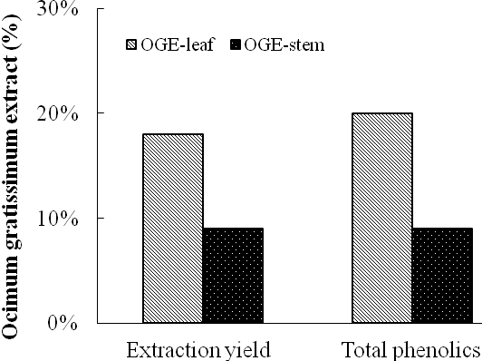

Figure 2.

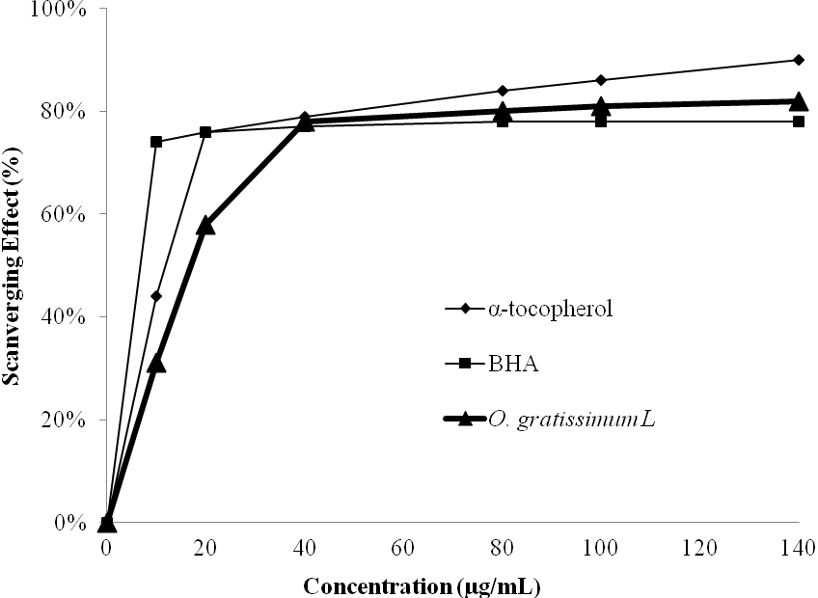

Figure 3.

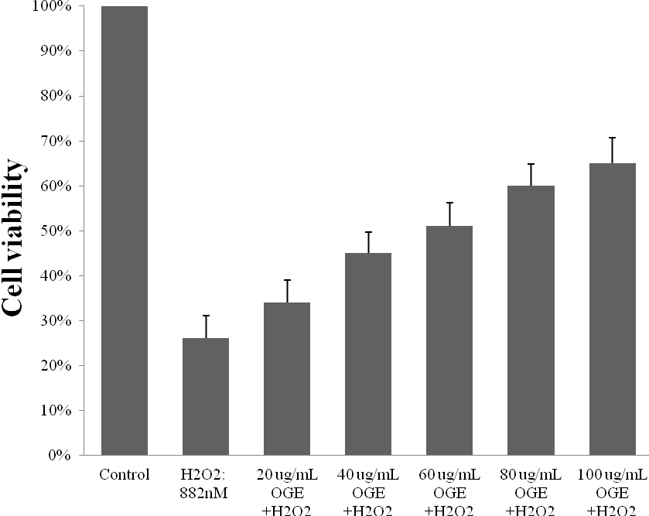

Figure 4.
(C) OGE 40 μg/mL
+ H₂O₂ 882 nM
(A) Control: 100%
(B) H₂O₂ 882 nM
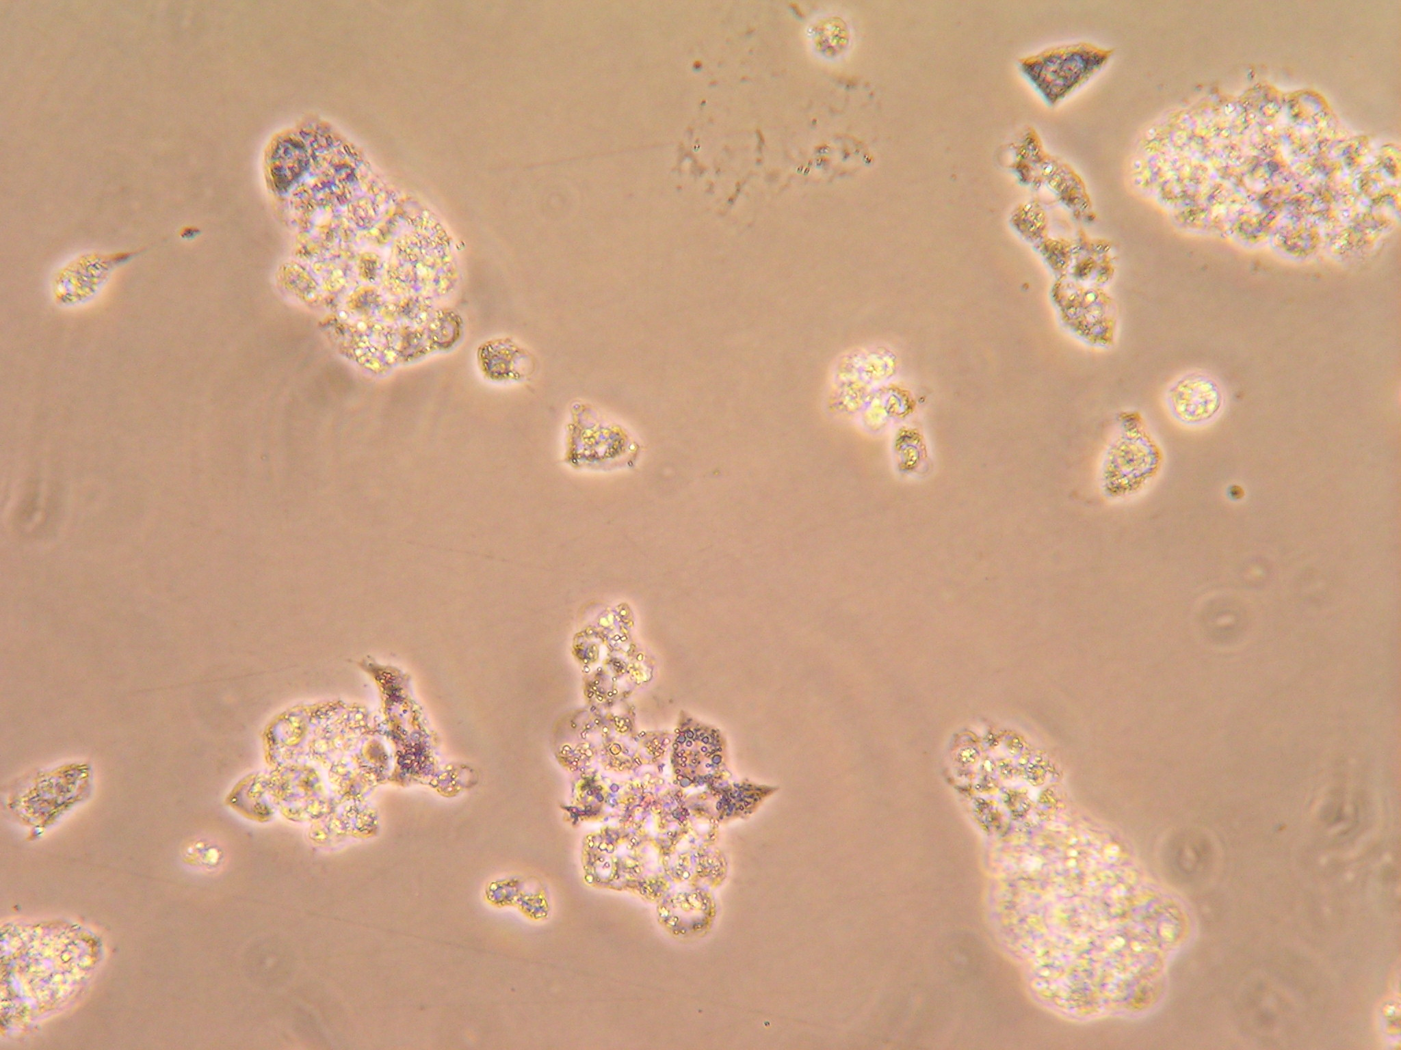
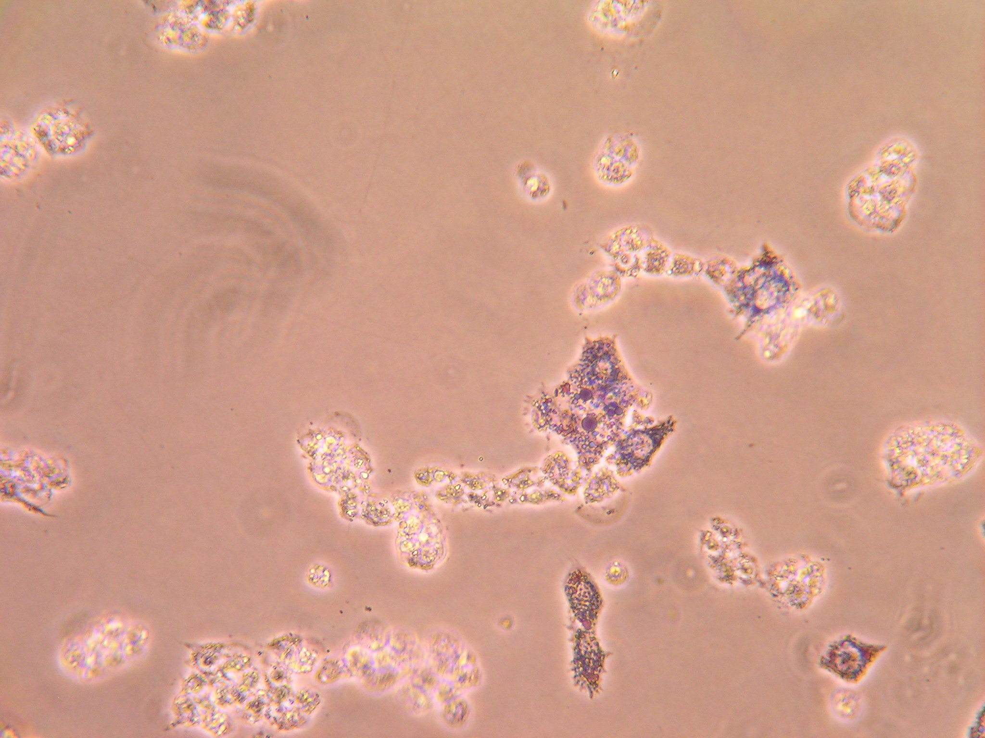
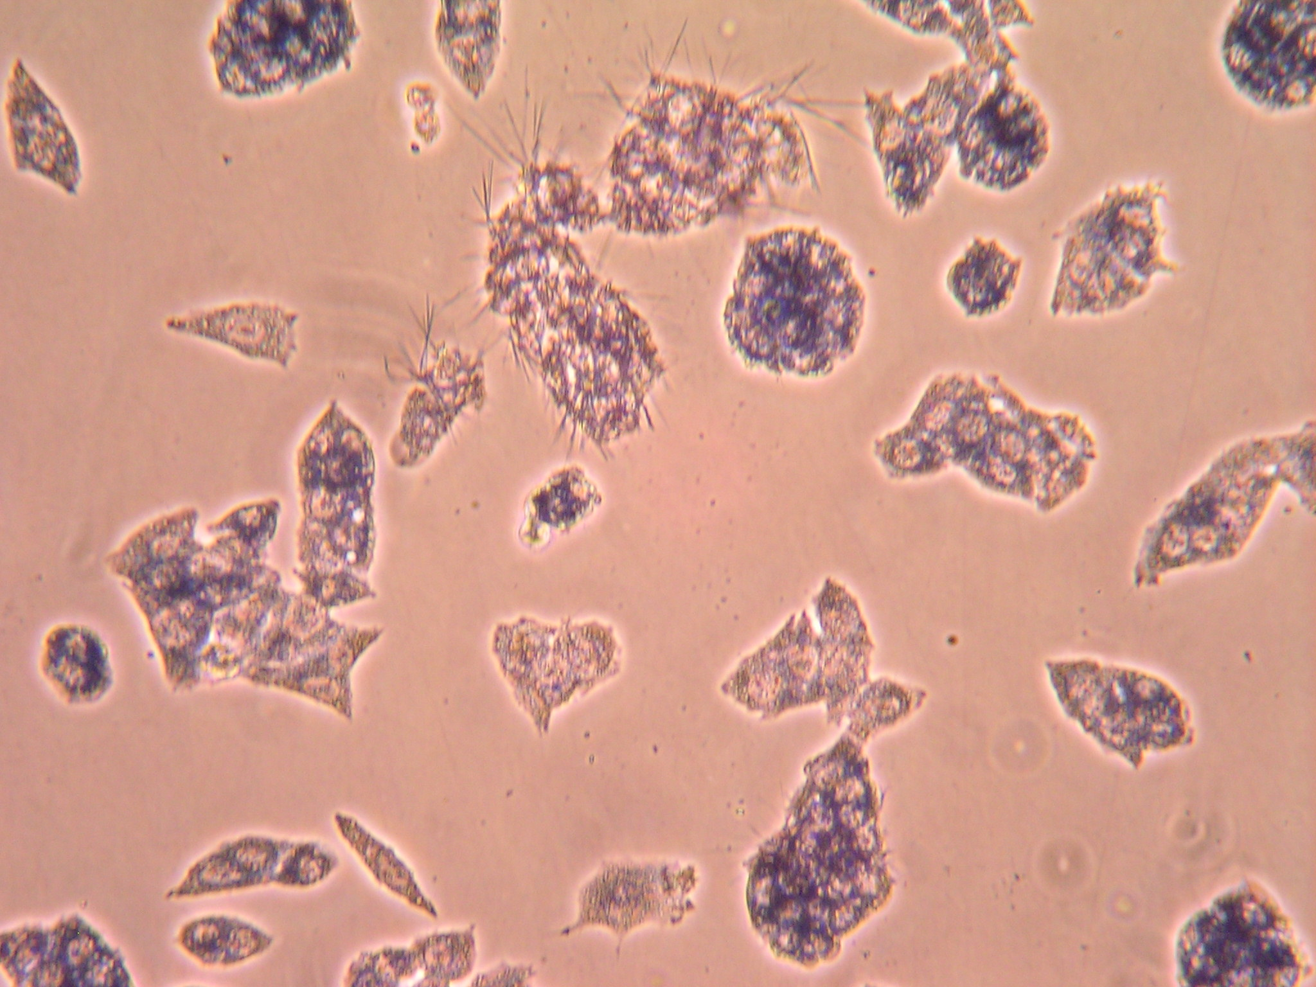

(D) OGE 60μg/mL
+ H₂O₂ 882 nM

(E) OGE 80μg/mL
+ H₂O₂ 882 nM

(F) OGE 100 μg/mL
+ H₂O₂ 882 nM

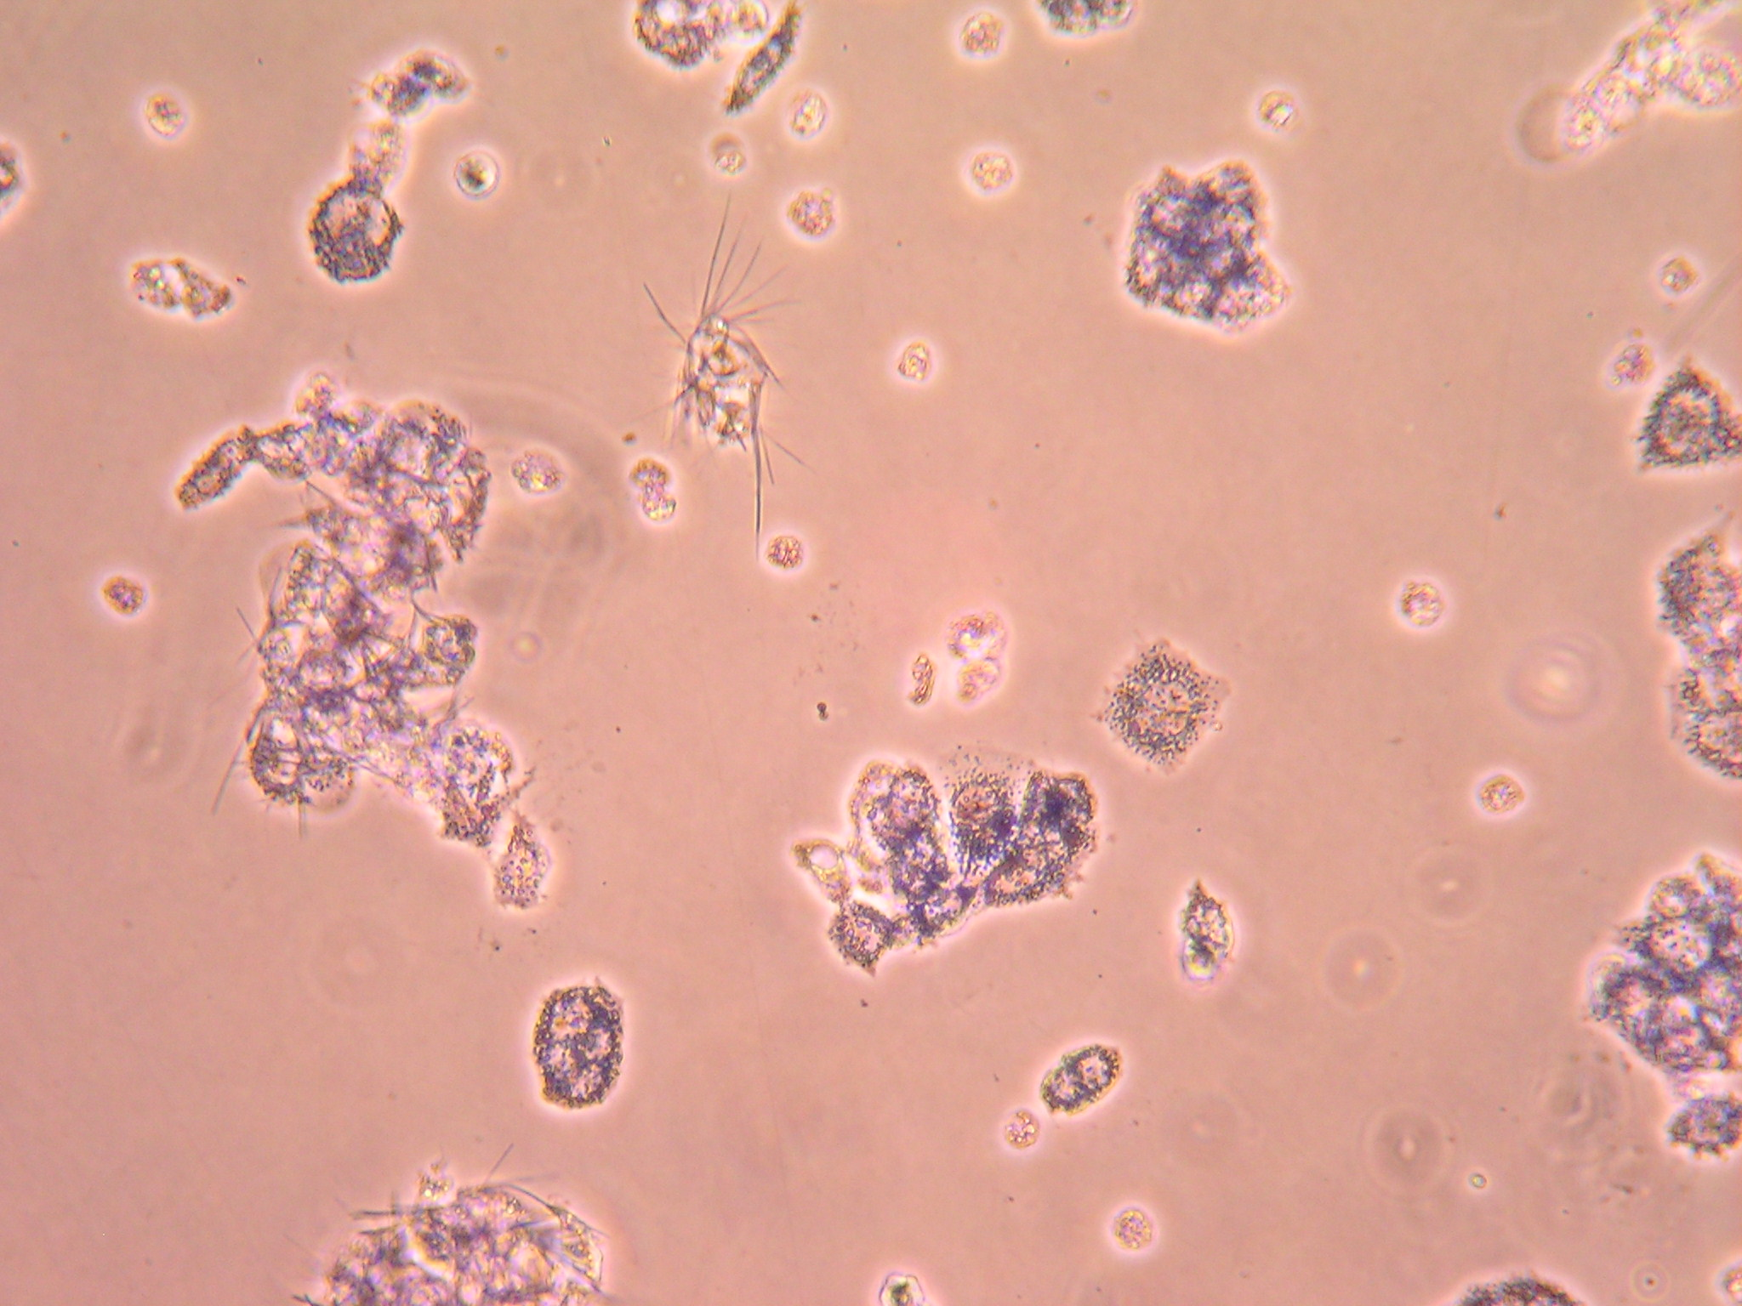
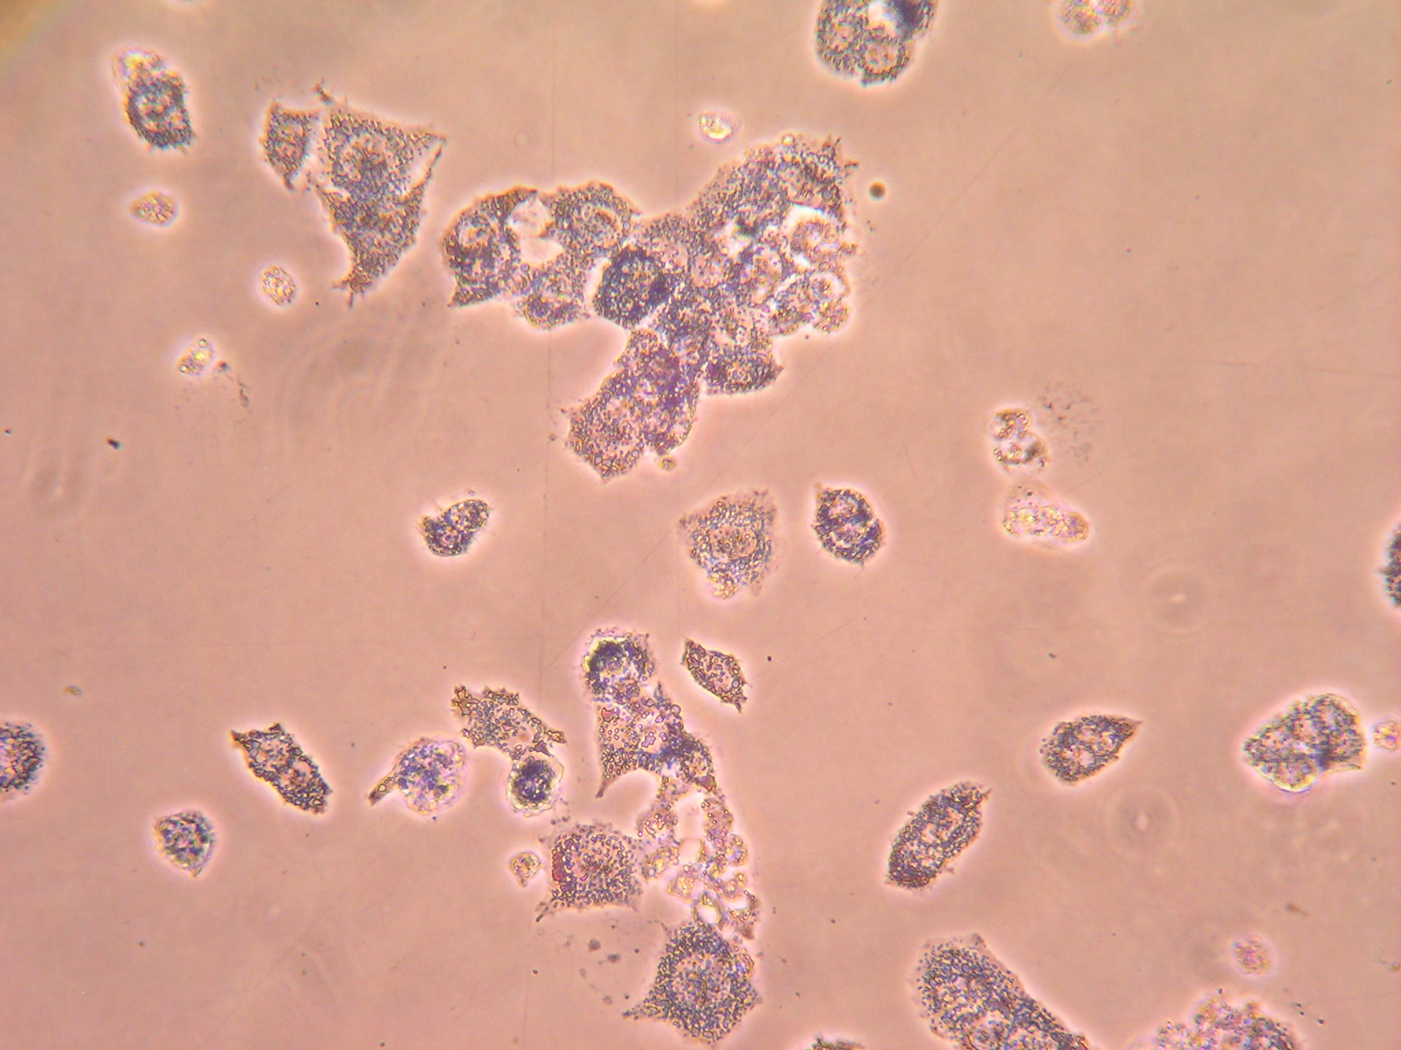
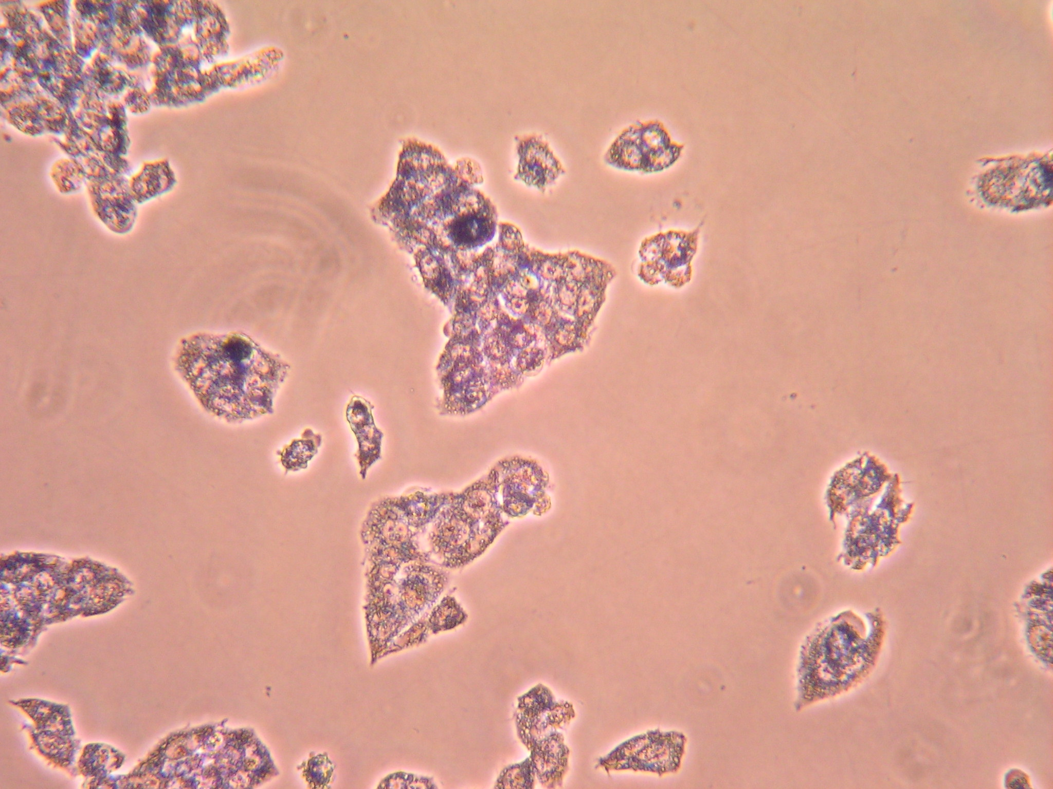

Figure 5.

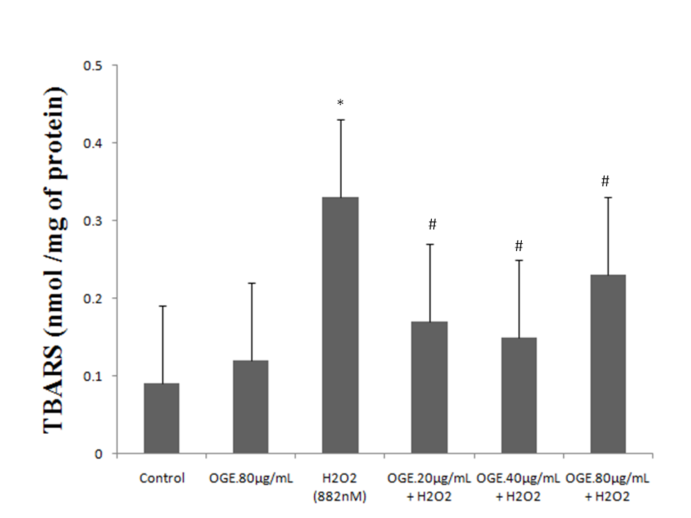

Figure Legends
Figure 1. Relative yield and total phenolic content of O. gratissimum extract (OGE) of leaves and stems.
Figure 2. DPPH radical scavenging activities of OGE. Results are presented as the mean ± SD of 3 independent experiments in triplicate.
Figure 3. Effect of Ocimum gratissimum L. extract (OGE) on HepG2 cell viability. HepG2 cells were preculture in 24 well (2 ×10⁵ cell/well in 10 mL of complete DMEM medium) and starved for 12 h, then pretreated with OGE at the indicated concentrations for 24h prior to incubation with 882 nM H₂O₂. Cell viability was then determined by MTT assay and expressed as mean ± SD, n = 3. ＃P < 0.01 significant different compare with the control normal cells (n = 3). * P < 0.05 in comparison with H₂O₂ treated cells.
Figure 4. The effect of Ocimum gratissimum L. extract (OGE) on HepG2 morphology under H₂O₂- induced cytotoxicity. Microphotographs (40×objective; phase contrast optics) of HepG2 cells were taken after treating for 24 h as described in Section 2. (A) control, (B) H₂O₂ 882 nM, (C) OGE 40 µg/mL + H₂O₂ 882 nM, (D) OGE 60 µg/mL + H₂O₂ 882 nM, (E) OGE 80 µg/mL + H₂O₂ 882 nM, and (F) OGE 100 µg/mL + H₂O₂ 882 nM.
Figure 5. Cell were preculture in 10-cm dish (4 ×10⁶ cell/dish in 10mL of complete DMEM medium) for 12 h and then incubated with various concentration OGE before the addition of H₂O₂ for 24 h. Data were expressed as mean ± SD. *P < 0.01 significant different compare with the control group (n = 3). #P < 0.05 compare with the treatment with H₂O₂ alone (n = 3).

七層塔水萃物的抗氧化活性以及對人類HepG2細胞在過氧化氫誘導之毒性下的細胞保護效果

邱永偉^{1,2}、 羅鴻仁³、黃昕瑀^{4,5,}、趙佩玉^{6,7}、黃俊銘⁸、黃珮芸⁹、黃士哲、劉哲育^{10,11}、賴德仁^{2,12}

¹童綜合醫院高壓氧治療中心 ²中山醫學大學醫學研究所 ³國立臺灣體育運動大學師資培育中心 ⁴中興大學食品暨應用生物科技學系 ⁵吳鳳科技大學幼兒保育系⁶勤益科技大學休閒產業管理系 ⁷中國醫藥大學基礎醫學研究所 ⁸中山醫學大學應用化學系 ⁹中山醫學大學生化暨生物科技研究所 ¹⁰中國醫藥大學癌症生物學研究所 ¹¹中國醫藥大學分子醫學中心 ¹²中山醫學大學附設醫院身心科

中文摘要
七層塔在許多國家都被作為傳統民俗藥物之用。本研究主要目的是評估七層塔水萃物的抗氧化活性，以及其對過氧化氫誘導人類HepG2細胞產生毒性的保護作用。研究的結果顯示，七層塔水萃物的總酚含量高達20%，且在DPPH試驗中，七層塔的濃度在40 μg/mg時，自由基清除活性可以達到80 %並接近高原期，顯示七層塔具有顯著的掃除自由基的能力。在過氧化氫處理的HepG2細胞先以七層塔作前處理，七層塔能夠依劑量依賴性的方式來復原細胞的存活率(P < 0.05)，並於濃度20至80 mg/mL時，可有效地減少TBARS的形成。綜上所述，七層塔水萃物不僅具抗氧化活性，對HepG2細胞的氧化壓力有保護作用，未來可能可以開發作為治療肝臟相關疾病藥物之用途。
＃本文第一、第二作者貢獻相同
＊通訊作者: 劉哲育、賴德仁

