A Chinese Herb Formula decreases the monocarboxylate transporter-mediated absorption of valproic acid in rats

Chung-Ping Yu ª, Shang-Yuan Tsai ª, Long-Jung Kao ^{b}, Pei-Dawn Lee Chao ª, Yu-Chi Hou ^{a,c,*}

ª School of Pharmacy, China Medical University, Taichung, Taiwan, R.O.C.
^{b} School of Chinese Pharmaceutical Sciences and Chinese Medicine Resources, China Medical University, Taichung, Taiwan, R.O.C.
^{c} Department of Medical Research, China Medical University Hospital, Taichung, Taiwan 404, R.O.C.

Corresponding author at: Dr. Yu-Chi Hou, School of Pharmacy, China Medical University, Taichung, Taiwan 404, R.O.C.. Tel and Fax: 886-4-22031028
E-mail address: hou5133@gmail.com (Y. C. Hou)

Abstract
Huang-Qin-Tang (HQT), a Chinese medicine prescription containing Scutellariae Radix (SR), Paeoniae Radix (PR), Glycyrrhizae Radix (GR) and JuJubae Fructus (JF), was used for the treatments of cold with symptoms of abdominalgia and diarrhea. Valproic acid (VPA) is an antiepileptic drug with narrow therapeutic window. This study investigated the effect of coadministration of HQT on the pharmacokinetics of VPA, a probe drug for monocarboxylate transporter (MCT). Rats were administered VPA alone (200.0 mg/kg) and coadministered HQT (8.0 g/kg) at 0.5 h before VPA and 1.5 h after VPA in crossover designs. In addition, the chronic effect of HQT was also evaluated by coadministration of the 7th dose at 0.5 h before VPA. The serum concentration of VPA was determined by a fluorescence polarization immunoassay. The results showed that coadministration of HQT at 0.5 h before VPA significantly decreased the AUC_{0-t} and C_{max} by 62% and 77%, respectively, whereas coadministration of HQT at 1.5 h after VPA exerted no significant influence. When the 7th dose of HQT was given at 0.5 h before VPA, the AUC_{0-t} and C_{max} of VPA were markedly decreased by 65% and 82%, respectively. Mechanism study revealed that the MCT-mediated uptake of fluorescein was inhibited by HQT and each component herbs. In conclusion, the MCT-mediated absorption of VPA was significantly decreased by concomitant administration of HQT.

Keywords: Valproic acid, Huang-Qin-Tang, pharmacokinetics, herb-drug interaction.
Introduction
Valproic acid (VPA), 2-propylpentanoic acid (chemical structure shown in Fig. 1), is a widely used anticonvulsant and mood-stabilizing drug, but with narrow therapeutic window. Subtherapeutic level of VPA would fail to control the epileptic seizure. Conversely, supertherapeutic level of VPA would cause adverse reactions such as hepatotoxicity and teratogenicity (Bryant and Dreifuss 1996). In pharmacokinetic aspect, VPA is metabolized primarily by direct glucuronidation to form the acyl glucuronide (VPA-G) and also by β-oxidation (Davis et al. 1994; Gibbs et al. 2004). In the bloodstream, VPA is strongly bound to proteins (Palaty and Abbott, 1995). Previous studies have reported that VPA (pka = 4.56) was a substrate of monocarboxylate transporter (MCT), an influx transporter in the intestine (Utoguchi and Audus 2000; Ushigome et al. 2001).
Huang-Qin-Tang (HQT), a widely used prescription described in Treatise on Exogenous Febrile Disease, has been used to treat dysentery and nowadays its use has been expanded to the treatments of cold with symptoms of abdominalgia and diarrhea. HQT contains four herbs including Scutellariae Radix (SR, roots of Scutellaria baicalensis), Paeoniae Radix (PR, roots of Paeonia lactiflora) and Glycyrrhizae Radix (GR, roots of Glycyrrhiza uralensis) in a ratio of 3:3:1 and a few Jujubae Fructus (JF, seeds of Ziziphus jujuba). In regard to the complex chemical nature of HQT, SR contains many flavonoids such as baicalin, baicalein, wogonoside and wogonin; PR contains monoterpenes such as paeoniflorin and albiflorin; GR contains triterpenes such as glycyrrhizin and glycyrrhetic acid, which have been reported to have a variety of pharmacological effects such as anti-inflammatory, anti-ulcer, anti-virus, anti-tumor activities (Takagi and Harada 1969; Ikemoto et al. 2000; Aly et al. 2005; Huang et al. 2006; Fiore et al. 2008).
Among the known constituents in HQT, we hypothesize that the carboxylic acids such as baicalin, wogonoside, glycyrrhizin and glycyrrhetic acid may compete with VPA for the MCT-mediated absorption. Therefore, this study investigated the effect of HQT on the pharmacokinetics of VPA, a probe drug for MCT, in rats. In addition, cell line model was used to investigate the underlying mechanism.
Materials and Methods
Materials and Reagents
The component crude drugs were supplied by an herbal drugstore in Taichung, Taiwan. The origins of SR (CMU-1905-5), PR (CMU-1905-9), GR (CMU-1905-7) and JF (CMU-1905-10) were identified by Dr. Yu-Chi Hou and voucher specimens were deposited in China Medical University. VPA, fluorescein, ethyl paraben, glycyrrhizin, sodium dodecyl sulfate (SDS), dimethyl sulfoxide (DMSO), calcium chloride, triton X-100, 2-morpholinoethanesulfonic acid monohydrate (MES monohydrate) and 3-(4′,5′-dimethylthiazol-2′-yl)-2,5-diphenyltetrazolium bromide (MTT) were purchased from Sigma (St. Louis, MO, USA). Dulbecco's Modified Eagle Medium (DMEM), trypsin/EDTA and Hank's Buffered Salt Solution (HBSS) were purchased from Invitrogen (Grand Island, NY, USA). Baicalin, baicalein, wogonin, paeoniflorin, salicylic acid (SA) was provided by Wako (Osaka, Japan). TDx kit was supplied by Abbott Laboratories (Abbott Park, IL, USA). Milli-Q plus water (Millipore, Bedford, MA, U.S.A.) was used throughout this study.

Preparation and characterization of HQT decoction
According to the composition ratio of each crude drug in HQT described in literature, 214.5 g of SR, 214.5 g of PR, 72.0 g of GR and a few JF were weighed to make a total of 500 g, to which 10 L of water was added and heated on a gas stove until reduced to below half volume, and then the mixture was filtered while hot with gauze. The filtrate was gently boiled until the volume reduced to less than 500 mL, then sufficient water was added to afford a concentration of 1 g/mL, and frozen at -20 ºC for later use. Then, an HPLC method was developed and validated to characterize the HQT decoction. Briefly, after vortexed with MeOH and centrifuged, the supernatant (200 µL) was added 200 µL of ethyl paraben solution (25 µg/mL in methanol) as internal standard, and 20 µL was subjected to HPLC analysis. The HPLC instrumentation included one pump (LC-10ATVP; Shimadzu), an UV detector (SPD-10A; Shimadzu), an automatic injector (SIL-10A; Shimadzu), and an Apollo C18 column (4.6×250 mm, 5 μm). The mobile phase consisted of acetonitrile (A) and 0.1 % phosphoric acid (B). A gradient elution was programmed as follows: A/B: 15/85 (0 min), 34/66 (20-30 min), 50/50 (40-50 min), and 15/85 (55-60 min). The detection wavelength was set at 240 nm and the flow rate was 1.0 mL/min.

Animals and drug administration
Male Sprague-Dawley rats were supplied by National Laboratory Animal Center (Taipei, Taiwan) and kept in the animal center of China Medical University (Taichung, Taiwan) in a 12 h light-dark cycle, constant temperature environment prior to study. The animal study adhered to “The Guidebook for the Care and Use of Laboratory Animals” published by the Chinese Society of Animal Science, Taiwan, ROC. This animal protocol was approved by the Institutional Animal Care and Use Committee of China Medical University, Taiwan.
Rats weighing 430-520 g were fasted 12 h before experiment. In each study, rats were divided into two groups, one group given VPA alone and the other group given VPA with HQT. All studies were carried out in crossover design. In order to investigate the effects of dosing regimen of HQT on VPA pharmacokinetics, three experiments were conducted. In experiment I, 200.0 mg/kg of VPA was given orally to rats with and without HQT (8.0 g/kg) at 0.5 h before VPA via gastric gavage. In experiment II, rats were administered VPA alone and coadministered HQT at 1.5 h after VPA. In experiment III, rats were given VPA alone and administered the 7th dose of HQT at 0.5 h before VPA. The control rats received equal volume of water as HQT. A period of two weeks was allowed between treatments for wash-out.

Blood collection
Blood samples (0.4 mL) were withdrawn via cardiopuncture at 5, 30, 60, 120, 240, 480, 720 and 1440 min after oral administration of VPA. The blood samples were collected in microtubes and centrifuged at 10,000 g for 15 min to obtain the serum, which was stored at
-30 ºC before analysis.

Determination of VPA concentration in serum
Valproic acid concentration in serum was measured by a specific monoclonal fluorescence polarization immunoassay (Abbott, Abbott Park, IL, USA). Validation of the calibration curve was carried out by testing three controls with concentrations of 37.5, 75.0 and 120.0 μg/mL right before assay of samples. Otherwise, a new calibration curve would be constructed if necessary. The assay was calibrated for concentrations from 0 to 150.0 μg/mL and the lower limit of quantitation is 0.7 μg/mL.

Cell line and culture conditions
Caco-2, the human colorectal adenocarcinoma cell line, was obtained from the Food Industry Research and Development Institute (Hsinchu, Taiwan). Cells were cultured in DMEM medium supplemented with 20 % fetal bovine serum (Biological Industries Ltd., Kibbutz Beit Haemek, Israel), 100 units/mL of penicillin, 100 μg/mL of streptomycin, and 292 μg/mL of glutamine. Cells were grown at 37 ºC in a humidified incubator containing 5 % CO₂. The medium was changed every other day and cells were subcultured when 80 % confluency was reached. Cells between passages 49 and 69 were used in this study.

Cell viability assay
The effects of the tested agents, salicylic acid, fluorescein and DMSO on the viability of Caco-2 cells were evaluated by MTT assay (Mosmann 1983). Cells were seeded into a 96-well plate. After overnight incubation, the tested agents were added into the wells and incubated for 2 h, then 15 μL of MTT (5 mg/mL) was added into each well and incubated for additional 4 h. During this period, MTT was reduced to formazan crystal by live cells. Acid-SDS (10 %) solution was added to dissolve the purple crystal at the end of incubation and the optical density was detected at 570 nm by a microplate reader (BioTex, Highland Park, Winooski, VT, U.S.A.).

Effects of HQT, the component herbs and the acidic constituents on MCT-mediated transport
The uptake assay of fluorescein, a fluorescent substrate of MCT, was modified from a previous method (Kuwayama et al. 2002). Briefly, Caco-2 cells (5×10⁴) were cultured between days 7 and 9 in a 24-well plate before transport study. After removal of the culture medium, the cells were washed twice with incubation buffer (HBSS, pH 6.0) and then incubated with 0.5 mL of the same buffer for 15 min at 37 ºC. After removal of the incubation buffer, each well was added 0.5 mL of incubation buffer containing ﬂuorescein (10 μM) in the absence and presence of tested agents. After 5-min incubation, the supernatants were removed and cells washed with incubation buffer for three times. Subsequently, 200 μL of 0.1 % Triton X-100 was added to lyse the cells and the fluorescence was measured with excitation at 485 nm and emission at 528 nm. To quantitate the content of protein in each well, 10 μL of cell lysate was added to 200 μL of diluted protein assay reagent (Bio-Rad, Hercules, CA, U.S.A.) and the optical density was measured at 570 nm. The relative intracellular accumulation of fluorescein was calculated by comparing with that of control after correction of protein content.

Data analysis
The pharmacokinetic parameters of VPA were calculated using noncompartment model with the aid of WinNonlin® (version 1.1, SCI software, Statistical Consulting, Inc., Apex, NC, USA). The peak serum concentration (C_{max}) was obtained from experimental measurement. The area under the serum concentration-time curve (AUC_{0-t}) was calculated using trapezoidal rule to the last point. One-way ANOVA with Scheffe’s test and unpaired Student’s t-test were used to analyze the differences among groups in the pharmacokinetic study and cell line study, respectively.
Results
Quantitation of known constituents in HQT decoction
Fig. 2 shows the HPLC chromatogram of five known constituents in HQT decoction, which were satisfactorily resolved within 50 min by a gradient elution. The quantitation results showed that the concentrations of paeoniflorin, baicalin, baicalein, glycyrrhizin and wogonin in the HQT decoction (1.0 g/mL) were 12.2, 37.4, 8.1, 3.9 and 5.7 μM, respectively.

Pharmacokinetic study
Fig. 3 (A) and (B) depict the serum profiles of VPA after oral administration of VPA alone, coadministration of HQT at 0.5 h before VPA and 1.5 h after VPA, respectively. Fig. 3 (C) shows the serum profiles of VPA after administration of VPA alone and coadministration of the 7th dose of HQT at 0.5 h before VPA. The pharmacokinetic parameters of VPA after various treatments are shown in Table 1. After coadministration with HQT at 0.5 h before VPA, the C_{max} and AUC_{0-t} of VPA were significantly decreased by 77% and 62%, respectively, whereas the MRT was significantly increased by 124%. However, when HQT was given at 1.5 h after VPA, no significant changes of the pharmacokinetic parameters of VPA were found. In addition, after coadministration with the 7th dose of HQT, the C_{max} and AUC_{0-t} of VPA were significantly decreased by 82% and 65%, respectively, whereas the MRT was significantly increased by 81%.

Transport study
In order to identify the possible involvement of MCT in the observed pharmacokinetic interaction, Caco-2 cells were used for transport study employing fluorescein as a typical substrate of MCT. MTT assay showed that incubation of HQT, SR, PR, GR and JF at the concentration of 2.5 mg/mL with Caco-2 cells for 2 h exerted no significant influences on cell viability (data not shown). In transport assay, the accumulations of fluorescein in Caco-2 cells measured after 5-min co-incubation with HQT and its component herbs are shown in Fig. 4. Salicylic acid, as a positive control of MCT inhibitor, at 100 μM significantly decreased the intracellular concentration of fluorescein by 37 %. HQT, PR, SR, GR and JF at 0.25 and 2.5 mg/mL all significantly decreased the intracellular accumulation of fluorescein by 41-58 %.
Fig. 5 shows the effects of acidic constituents including baicalin (BI), glycyrrhizin (GZ) and glycyrrhetic acid (GA) on the intracellular accumulation of fluorescein. The results indicated that BI, GZ and GA at 20 and 50 μM significantly decreased the intracellular accumulation of fluorescein by 22-33 %.
Discussion
The quantitation results showed that the relative contents of the major constituents in HQT decoction was in the order of baicalin > paeoniflorin > baicalein > wogonin > glycyrrhizin. Coadministration of HQT at 0.5 h before VPA significantly decreased the C_{max} and AUC_{0-t} of VPA, indicating that HQT markedly reduced the bioavailability of VPA. By observing the profiles in the early phase between treatments, we could infer that the interaction between HQT and VPA should occur mainly at the absorption site. Moreover, when HQT was administered at 1.5 h after VPA, no alteration of VPA pharmacokinetics was observed, suggesting that the absorption of VPA was not significantly affected when HQT was given 1.5 h later. These facts indicated that HQT inhibited the absorption of VPA only when they were coexisting in the intestine. In addition, when the 7th dose of HQT was given at 0.5 h before VPA, the C_{max} and AUC_{0-t} of VPA were also significantly reduced as single dose of HQT did, indicating that the chronic effect of HQT was comparable to its acute effect.
In regard to the mechanism of VPA absorption, owing to its small molecular weight (144.2) and the moderate log P (2.7), VPA might be absorbed as nonionized form by either paracellular penetration or passive diffusion (Cato et al. 1995; Kumar et al. 2000). In addition, based on its pKa value (4.56), VPA should exist in part as anionic form in the intestine, which would be absorbed through carrier-mediated uptake (Cato et al. 1995; Ushigome et al. 2001). Two previous studies have pointed out that a proton-coupled MCT was involved in the uptake of VPA on the brush-border membrane (Utoguchi and Audus 2000; Ushigome et al. 2001). Therefore, we suspected that the decreased absorption of VPA caused by HQT might stem from the inhibition on the MCT-mediated absorption.
In order to understand the underlying mechanism of HQT-VPA interaction, a transport assay was performed using Caco-2 cells. Fluorescein was used as a MCT substrate and salicylic acid used as a positive control of MCT inhibitor. The results revealed that the MCT-mediated uptake transport of fluorescein was inhibited by HQT. In order to identify the causative herbs in HQT, the effects of SR, PR, GR and JF on the uptake of fluorescein were also investigated. The results indicated that SR, PR, GR and JF all significantly inhibited the uptake of fluorescein. Therefore, the inhibitory effect of HQT might be resulted from the additive effect of four component herbs.
Regarding the causative constituents in HQT, baicalin, glycyrrhizin and glycyrrhetic acid, which were carboxylic acids and probable substrates/inhibitors of MCT, all revealed considerable inhibitory activity on the MCT-mediated uptake of fluorescein. Therefore, the decreased absorption of VPA by HQT might arise in part from baicalin, glycyrrhizin and glycyrrhetic acid. Besides, previous studies have reported that phenolic acids frequently occurring in herbal plants are putative substrates of MCT (Konishi and Shimizu 2003; Konishi et al. 2004), such as p-coumaric acid in SR (Lu et al. 2011) and ferulic acid in JF (Wang et al. 2011), which may also contribute to the inhibitory effect on MCT. We therefore speculate that any herb containing rich carboxylates may exert inhibitory effect on MCT-mediated absorption of acidic pharmaceuticals.
In conclusion, HQT significantly decreased the bioavailability of VPA through inhibiting the MCT-mediated absorption of VPA.

Acknowledgement
The work was, in part, supported by the National Science Council, R.O.C. (NSC 99-2320-B-039-017-MY3, NSC 99-2628-B-039-005-MY3 and NSC 99-2320-B-039-005-MY3) and China Medical University, Taichung, Taiwan, R.O.C. (CMU100-S-17, CMU100-S-05).

References
Aly, A.M., Al-Alousi, L. and Salem, H.A., 2005. Licorice: a possible anti-inflammatory and anti-ulcer drug. AAPS PharmSciTech 6, E74-82.
Bryant, A.E., 3rd and Dreifuss, F.E., 1996. Valproic acid hepatic fatalities. III. U.S. experience since 1986. Neurology 46, 465-469.
Cato, A., 3rd, Pollack, G.M. and Brouwer, K.L., 1995. Age-dependent intestinal absorption of valproic acid in the rat. Pharmaceutical Research 12, 284-290.
Davis, R., Peters, D.H. and McTavish, D., 1994. Valproic acid. A reappraisal of its pharmacological properties and clinical efficacy in epilepsy. Drugs 47, 332-372.
Fiore, C., Eisenhut, M., Krausse, R., Ragazzi, E., Pellati, D., Armanini, D. and Bielenberg, J., 2008. Antiviral effects of Glycyrrhiza species. Phytotherapy Research 22, 141-148.
Gibbs, J.P., Adeyeye, M.C., Yang, Z. and Shen, D.D., 2004. Valproic acid uptake by bovine brain microvessel endothelial cells: role of active efflux transport. Epilepsy Research 58, 53-66.
Huang, W.H., Lee, A.R. and Yang, C.H., 2006. Antioxidative and anti-inflammatory activities of polyhydroxyflavonoids of Scutellaria baicalensis GEORGI. Bioscience, Biotechnology and Biochemistry 70, 2371-2380.
Ikemoto, S., Sugimura, K., Yoshida, N., Yasumoto, R., Wada, S., Yamamoto, K. and Kishimoto, T., 2000. Antitumor effects of Scutellariae radix and its components baicalein, baicalin, and wogonin on bladder cancer cell lines. Urology 55, 951-955.
Konishi, Y., Hitomi, Y. and Yoshioka, E., 2004. Intestinal absorption of p-coumaric and gallic acids in rats after oral administration. Journal of Agriculture and Food Chemistry 52, 2527-2532.
Konishi, Y. and Shimizu, M., 2003. Transepithelial transport of ferulic acid by monocarboxylic acid transporter in Caco-2 cell monolayers. Bioscience, Biotechnology and Biochemistry 67, 856-862.
Kumar, S., Wong, H., Yeung, S.A., Riggs, K.W., Abbott, F.S. and Rurak, D.W., 2000. Disposition of valproic acid in maternal, fetal, and newborn sheep. I: placental transfer, plasma protein binding, and clearance. Drug Metabolism and Disposition 28, 845-856.
Kuwayama, K., Miyauchi, S., Tateoka, R., Abe, H. and Kamo, N., 2002. Fluorescein uptake by a monocarboxylic acid transporter in human intestinal Caco-2 cells. Biochemical Pharmacology 63, 81-88.
Lu, Y., Joerger, R. and Wu, C., 2011. Study of the chemical composition and antimicrobial activities of ethanolic extracts from roots of Scutellaria baicalensis Georgi. Journal of Agriculture and Food Chemistry 59, 10934-10942.
Mosmann, T., 1983. Rapid colorimetric assay for cellular growth and survival: application to proliferation and cytotoxicity assays. Journal of Immunological Methods 65, 55-63.
Palaty, J. and Abbott, F.S., 1995. Structure-activity relationships of unsaturated analogues of valproic acid. Journal of Medicinal Chemistry 38, 3398-3406.
Takagi, K. and Harada, M., 1969. [Pharmacological studies on herb paeony root. II. Anti-inflammatory effect, inhibitory effect on gastric juice secretion, preventive effect on stress ulcer, antidiuretic effect of paeoniflorin and combined effects with licorice component Fm 100]. Yakugaku Zasshi 89, 887-892.
Ushigome, F., Takanaga, H., Matsuo, H., Tsukimori, K., Nakano, H., Ohtani, H. and Sawada, Y., 2001. Uptake mechanism of valproic acid in human placental choriocarcinoma cell line (BeWo). European Journal of Pharmacology 417, 169-176.
Utoguchi, N. and Audus, K.L., 2000. Carrier-mediated transport of valproic acid in BeWo cells, a human trophoblast cell line. International Journal of Pharmacology 195, 115-124.
Wang, B.N., Liu, H.F., Zheng, J.B., Fan, M.T. and Cao, W., 2011. Distribution of phenolic acids in different tissues of jujube and their antioxidant activity. Journal of Agriculture and Food Chemistry 59, 1288-1292.
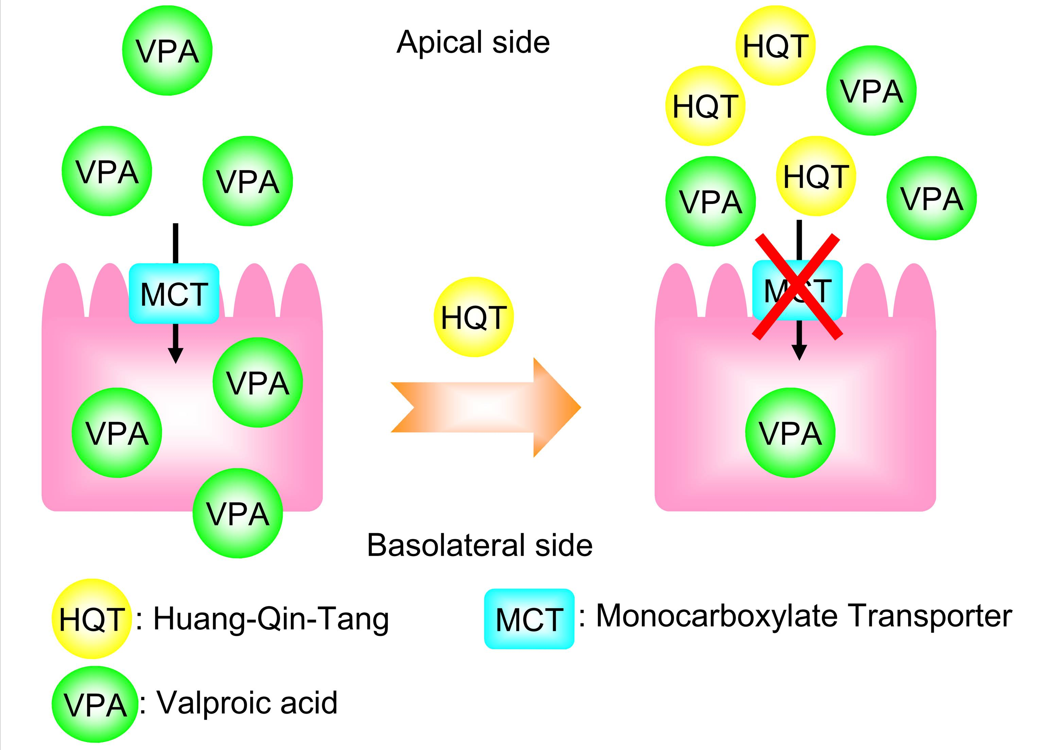

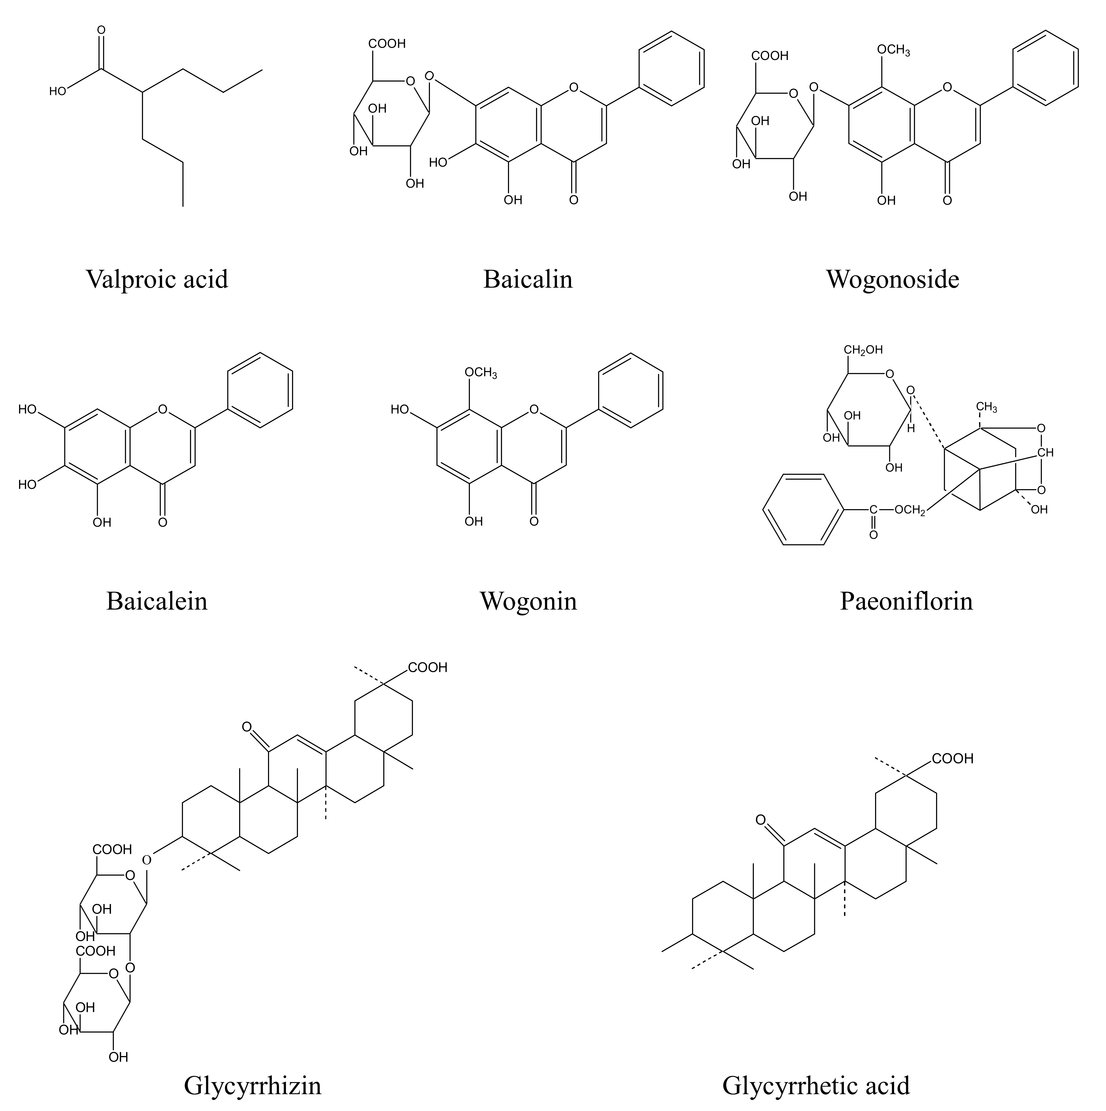

Fig. 1 Chemical structures of valproic acid, baicalin, baicalein, wogonoside, wogonin, paeoniflorin, glycyrrhizin and glycyrrhetic acid.

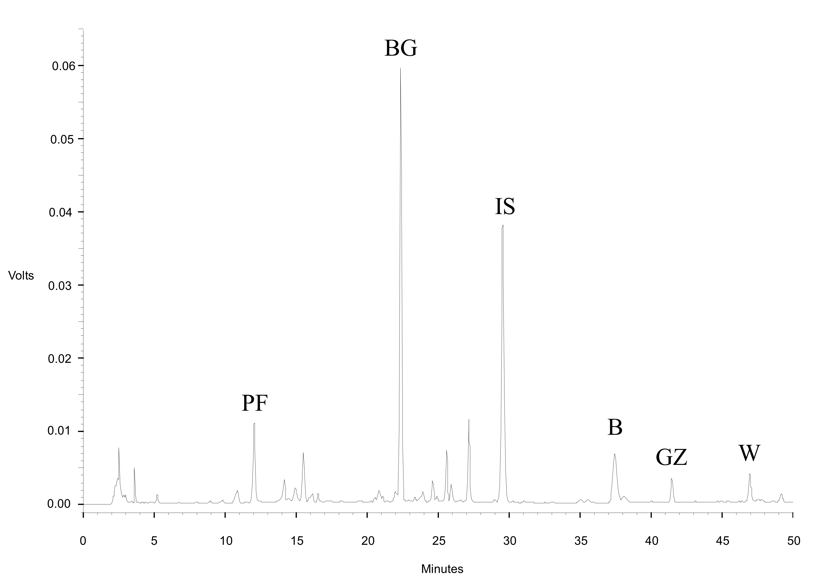

Fig. 2 HPLC chromatogram of HQT decoction.
PF: paeoniflorin, BG: baicalin, B: baicalein, GZ: glycyrrhizin, W: wogonin, IS: ethyl paraben

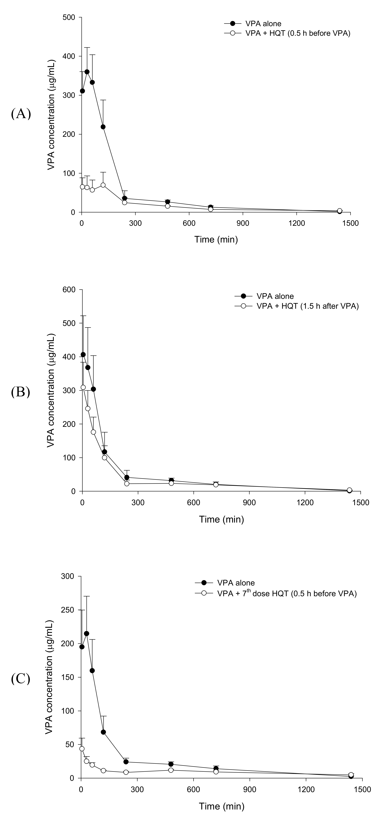
Fig. 3 Mean (± S.E.) serum concentration - time profiles of VPA after administration of VPA alone (●) and coadministration with HQT (○, 8.0 g/kg) at 0.5 h before VPA (A), 1.5 h after VPA (B) and coadministiation of the 7th dose of HQT at 0.5 h before VPA (C).

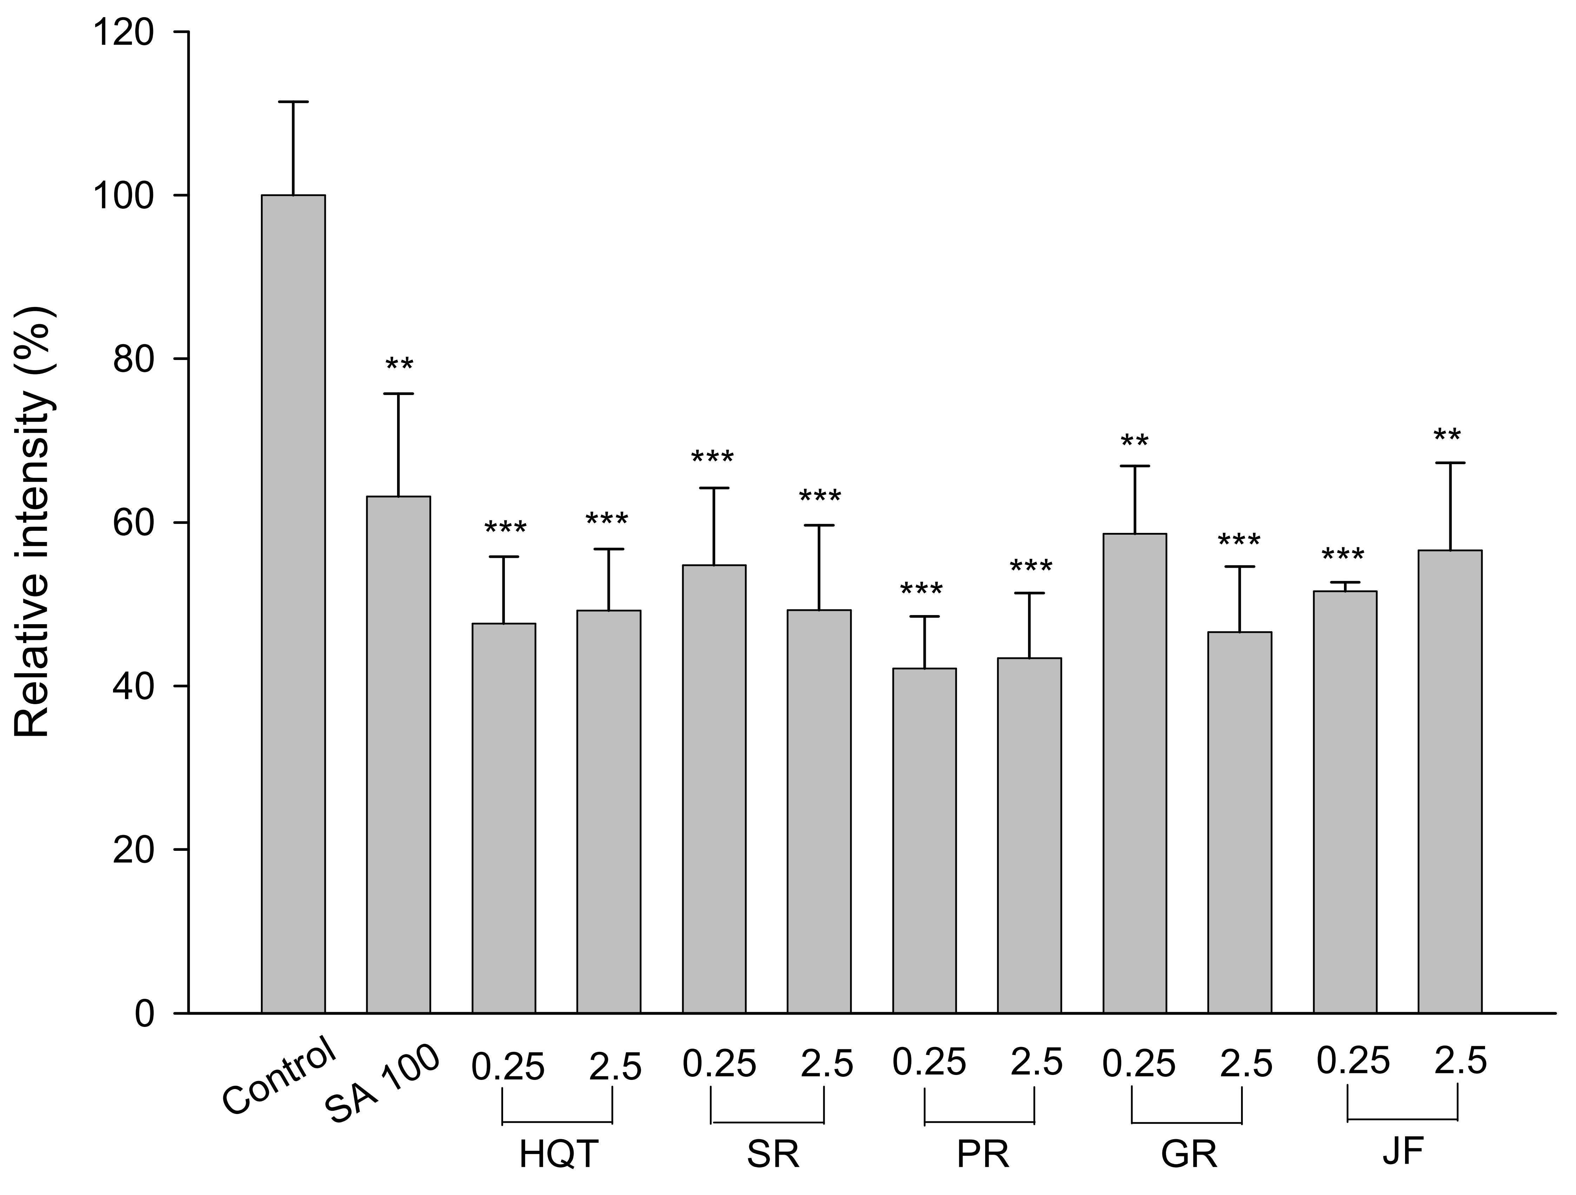

Fig. 4 Effects of HQT, SR, PR, GR, JF (mg/mL) and salicylic acid (SA, 100 μM) on the intracellular concentration of fluoroscein in Caco-2 cells. **p < 0.01, *** p < 0.001

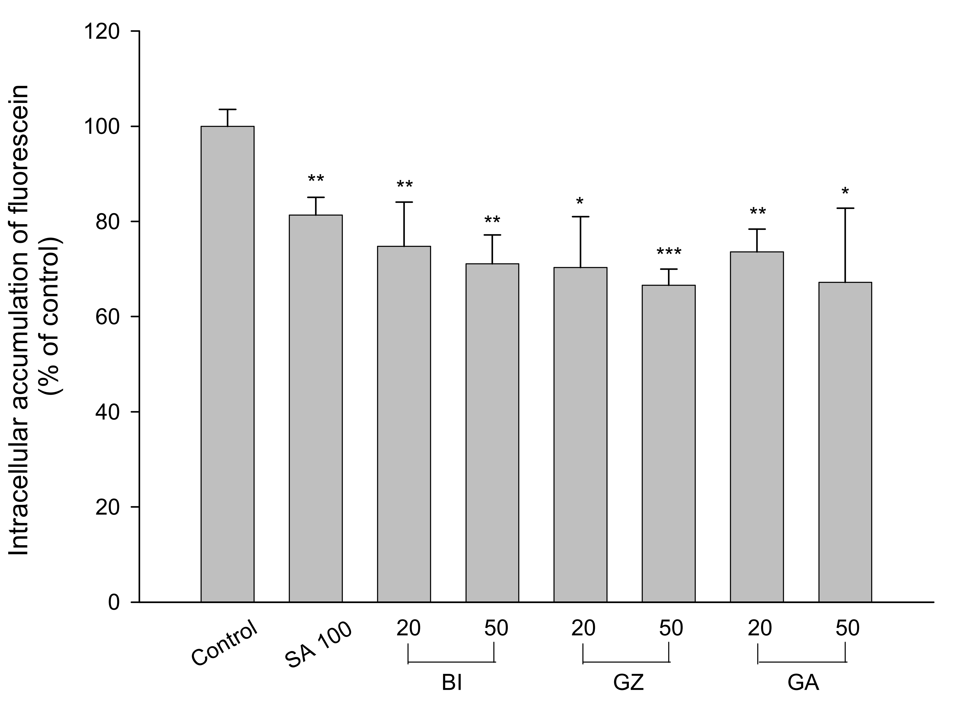

Fig. 5 Effects of baicalin (BI), glycyrrhizin (GZ), glycyrrhetic acid (GA) (μM) and salicylic acid (SA, 100 μM) on the intracellular concentration of fluorescein in Caco-2 cells. *p < 0.05, **p < 0.01, *** p < 0.001
Table 1
Pharmacokinetic parameters of VPA after oral administration of VPA (200.0 mg/kg) alone and various coadministration treatments with HQT (8.0 g/kg), in rats.
Parameters  Treatments |  | C_{max} |  | AUC₀₋₁₄₄₀ |  | MRT
I  (n=8) | VPA alone | 384.6 | ±38.5 | 63.9 | ±8.4 | 171.4 | ±22.6
I  (n=8) | HQT (0.5 h before VPA) | 87.4 | ±20.1 *** | 24.1 | ±4.3 ** | 383.4 | ±44.8 **
I  (n=8) | HQT (0.5 h before VPA) | (-77 %) |  | (-62 %) |  | (124 %)
II  (n=5) | VPA alone | 392.4 | ±62.9 | 58.6 | ±5.1 | 229.8 | ±35.3
II  (n=5) | HQT (1.5 h after VPA) | 385.6 | ±37.0 | 69.1 | ±9.6 | 268.9 | ±37.1
III  (n=6) | VPA alone | 235.6 | ±37.5 | 39.1 | ±4.7 | 299.5 | ±35.0
III  (n=6) | 7th dose HQT (0.5 h before VPA) | 43.5 | ±10.6 ** | 13.7 | ±1.1 ** | 541.8 | ±29.7 **
III  (n=6) | 7th dose HQT (0.5 h before VPA) | (-82 %) |  | (-65 %) |  | (81 %)
Data expressed as mean ± S.E.
** P < 0.01, *** P < 0.001
C_{max}: peak serum level.
AUC₀₋₁₄₄₀: area under the serum concentration-time curve to 1440 min.
MRT: mean residence time.

