Noni increased the systemic exposure of methotrexate in rats through inhibition on multi-drug resistance protein 2 (MRP 2) and breast cancer resistance protein (BCRP)
Pei-Wen Hsu ª, Chi-Sheng Shia ª, Chen-Teng Wu ^{b}, Nai-Wen Chang ^{c}, Pei-Dawn Lee Chao ^{a,*} and Yu-Chi Hou ^{a, d,*}
ª School of Pharmacy, China Medical University, Taichung, Taiwan, R.O.C.
^{b} Department of Surgery, Fong-Yuan Hospital, Taichung County, Taiwan, R.O.C.
^{c} Department of Biochemistry, China Medical University, Taichung, Taiwan, R.O.C.
^{d} Department of Medical Research, China Medical University Hospital, Taichung, Taiwan, R.O.C.
Address: No.91 Hsueh-Shih Road, Taichung, Taiwan 40402, R.O.C
Email:
Pei-Wen Hsu: u9755004@cmu.edu.tw
Chi-Sheng Shia: shiashia77@yahoo.com.tw
Chen-Teng Wu: ctengwu@fyh.dooh.gov.tw
Nai-Wen Chang: nwchang@mail.cmu.edu.tw
Pei-Dawn Lee Chao: pdlee@mail.cmu.edu.tw
Yu-Chi Hou: houyc@mail.cmu.edu.tw
Correspondence: Pei-Dawn Lee Chao and Yu-Chi Hou, School of Pharmacy, China Medical University, No.91 Hsueh-Shih Road, Taichung, Taiwan 40402, R.O.C
* These authors contributed equally to this work.
E-mail address: pdlee@mail.cmu.edu.tw and houyc@mail.cmu.edu.tw
Telephone/Fax number: +886-4-22031028
ABSTRACT
Methotrexate (MTX) is an important immunosuppressant with narrow therapeutic window. The transport of MTX was associated with multi-drug resistance proteins (MRPs) and breast cancer resistance protein (BCRP). Noni fruit is a phenolics rich health food. This study set out to investigate the effect of noni juice on MTX pharmacokinetics and the underlying mechanisms. Rats were administered MTX with and without single dose or the 7th dose of noni juice (6 mL/kg). The serum MTX concentrations were determined using a specific monoclonal fluorescence polarization immunoassay. The results revealed that single dose and multiple doses of noni juice significantly increased the AUC_{0-t}, C_{max} and MRT of MTX. A further inquiry into the underlying mechanism indicated that noni metabolites inhibited the activities of MRP 2 and BCRP. In conclusion, concomitant intake of noni juice significantly increased the systemic exposure of MTX through inhibition on MRP 2 and BCRP.
Keywords: food-drug interaction; noni; methotrexate (MTX); multi-drug resistance proteins (MRPs); breast cancer resistance protein (BCRP)
1. Introduction
Methotrexate (MTX), an important immunosuppressant with narrow therapeutic window, is widely used in post-allergenic organ transplant, and also used in psoriasis and rheumatoid arthritis (Bagatini, et al., 2011; Bleyer, 1978; Tishler, Caspi, & Yaron, 1993). The adverse reactions to MTX include vomiting, nausea, diarrhea, hepatotoxicity, myelosuppression, mucositis and dermatitis (Stark, Jackson, Carey, Arfeen, & Proctor, 1989). The oral bioavailability of MTX exhibits wide variability and 85% of MTX is excreted renally in its parent form (Grim, Chladek, & Martinkova, 2003; Seideman, Beck, Eksborg, & Wennberg, 1993). Recent studies indicated that the transport of MTX was associated with multidrug resistance-associated proteins (MRPs) and breast cancer resistance protein (BCRP) (Vlaming, et al., 2011). Clinically, a number of reports have been made concerning the potential undesirable interactions between MTX and non-steroidal anti-inflammatory drugs (NSAIDs), such as diclofenac, metamizole, salicylate, ibuprofen and naproxen, which resulted in acute renal failure even death (Bagatini, et al., 2011; Maiche, 1986; Myllykangas-Luosujarvi, Aho, & Isomaki, 1995; Tracy, et al., 1992). MRP 2 and BCRP were reported being involved in the mechanism of NSAIDs-MTX interactions (El-Sheikh, Heuvel, Koenderink, & Russel, 2007; Lagas, Kruijssen, Wetering, Beijnen, & Schinkel, 2009).
Noni juice (the fruit juice of Morinda citrifolia, Rubiaceae), is used worldwide as a health food. The popularity of noni products in the U.S. stems from its claims of being a “cure-all” for a variety of diseases (McClatchey, 2002), such as diabetes (Nayak, Marshall, Isitor, & Adogwa, 2011), inflammation (Dussossoy, et al., 2011) and cancer (Wang & Su, 2001). In the European Union, noni juice was approved and registered as a “Novel Food” in 2003 (European Commission, 2003). Noni fruits contain a variety of phenolics including flavonoids, coumarin, anthraquinones, and lignans (chemical structures shown in Figure 1) (Dussossoy, et al., 2011; Potterat, Felten, Dalsgaard, & Hamburger, 2007). Recent studies have shown that the conjugated metabolites of phenolics are substrates of MRPs or BCRP (Alvarez, et al., 2011; Brand, et al., 2008). Based on these findings, we hypothesized that phenolic metabolites of noni juice might compete with MTX for the renal excretion mediated by MRPs or BCRP. Therefore, this study investigated the effect of coadministration of noni juice on MTX pharmacokinetics in rats, and the underlying mechanisms were explored by using in vitro cell models.

2. Materials and methods
2.1. Chemicals and reagents
Methotrexate (25 mg/mL) was purchased from Wyeth Pharma Gmbh Co. Ltd (Wolfratshausen, Germany). Scopoletin (purity >98%) was obtained from TCI (Tokyo, Japan). Rutin (purity 95%), quercetin (purity 95%), myricetin (purity 96%), kaempferol (purity 90%), isorhamnetin (purity 95%), protocatechuic acid (purity 97%), vanillin (purity 97%) and 6, 7-dihydroxycoumarin (6,7-DMC, purity 98%) were purchased from Sigma (St. Louis, MO, U.S.A.). L-(+)-Ascorbic acid, phosphoric acid and sodium hydroxide solution (1 mol/L) were obtained from Riedel-deHaën AG (Seelze, Germany). Ethyl acetate and methanol were purchased from Mallinckrodt Baker, Inc. (Phillipsburg, NJ, U.S.A.). Sodium acetate was obtained from Kohusan Chemical Works, Ltd. (Tokyo, Japan). Noni juice was manufactured by Agrolabs Co. (Hillside, NJ, U.S.A.). MK571, mitoxantrone (MXR) and Ko143 were obtained from Enzo (Farmingdale, NY, U.S.A.). 5-chloromethylfluorescein diacetate (CMFDA), Dulbecco’s modified Eagle medium (DMEM), trypsin, Hank’s buffered salt solution (HBSS) and 4-(2-hydroxyethyl)-1-piperazineethanesulfonic acid (HEPES) were purchased from Invitrogen (Grand Island, NY, U.S.A.). Fetal bovine serum (FBS) was obtained from Biological Industries (Kibbutz, BH, Israel). Milli-Q plus water (Millipore, Bedford, MA) was used for all processes.

2.2. Instrumentation
The high performance liquid chromatography (HPLC) apparatus included a system controller (SCL-10A), a pump (SCL-10AT), an UV-vis detector (SCL-10A), an autoinjector (SIL-10AF) and degasser (ERC-3415α) (above all from Shimadzu, Kyoto, Japan). A RP-18e column (Apollo, 250 mm ×4.0 mm) was used with a prefilter (Isolation Technologies, IL, U.S.A.).

2.3. Quantitation of noni juice
Noni juice (300 μL) was added 700 μL of methanol, and the mixture was vortexed and centrifuged at 10,000 g for 15 min. The supernatant (100 μL) was mixed with an equal volume of internal standard solution (10 μg/mL of 6,7-DMC in methanol). Twenty microliter of the mixture was subject for HPLC analysis. The mobile phase consisted of 0.1% phosphoric acid (A) and methanol (B), and a gradient elution was programmed as follows: A/B: 60/40 (0–10 min) and 30/70 (30–40 min). The flow rate was 1.0 mL/min and detection wavelength was set at 340 nm.

2.4. Animals and drug administration
Nineteen male Sprague-Dawley rats (350-450 g) were supplied by the National Laboratory Animal Center (Taipei, Taiwan) and randomly divided into three groups. The rats were fasted for 12 h before dosing and food was withheld for another 3 h. MTX oral solution was prepared by dilution with deionized water to afford a concentration of 2.5 mg/mL. Control rats (n=7) were orally given MTX (5 mg/kg b.w.) with water (6 mL/kg b.w.) via gastric gavage. The second group of rats (n=6) received oral MTX (5 mg/kg b.w.) with single dose of noni juice (6 mL/kg b.w.). In addition, the third group of rats (n=6) were given six doses of noni juice (6 mL/kg b.w.) twice daily, and the 7th dose was given with MTX. The fourth group of rats (n=6) were given diclofenac (as a positive control, 25 mg/kg) with MTX (5 mg/kg). All animal experiments adhered to “The Guidebook for the Care and Use of Laboratory Animals (2002)” published by the Chinese Society of Animal Science, Taiwan, R.O.C.

2.5. Blood sample collection
The blood samples of rats were withdrawn via cardiac puncture at 15, 30, 60, 120, 240, 480, 720, 1440 and 2160 min after dosing of MTX. The sera were collected by centrifuging at 10,000 g for 15 min and stored at -20°C until analysis.

2.6. Determination of MTX concentration in serum
The serum MTX concentration was measured by a specific monoclonal fluorescence polarization immunoassay using a TDx kit (Abbott, Abbott Park, IL, U.S.A.). The assay was calibrated for concentrations ranging from 0 to 1.0 μmol/L. The lower limit of quantitation (LLOQ) of this assay is 0.02 μmol/L.

2.7. Cell line and culture conditions
Madin-Darby canine kidney type II cells with human MRP 2 (MDCK II-MRP 2) and BCRP (MDCK II-BCRP) were kindly provided by Prof. Dr. Piet Borst (Netherlands Cancer Institute, Amsterdam, Netherlands). Cells were grown in DMEM medium supplemented with 10% FBS, 100 units/mL of penicillin, 100 μg/mL of streptomycin and 292 μg/mL of glutamine at 37ºC in a humidified incubator containing 5% CO₂. The medium was changed every other day and cells were sub cultured when 80% to 90% confluence was reached.

2.8. Preparation of serum metabolites of noni
In order to mimic the molecules interacting with MRP 2 and BCRP in enterocytes and kidney, the serum metabolites of noni were prepared from rats. Briefly, noni juice (6 mL/kg) was orally administered to rats after overnight fast, and blood was collected via cardiopuncture at 30 min after dosing. Blood was centrifuged to obtain serum, which was then vortexed with 4-fold volume of methanol. After centrifuging at 10,000 g for 15 min, the supernatant was concentrated in a rotatory evaporator under vacuum to dryness. To the residue, appropriate volume of water was added to afford a solution with 10-fold serum concentration, which was divided into aliquots and stored at -80℃ for later use. On the other hand, blank serum was withdrawn from control rats given water alone and processed similarly to prepare blank specimens for comparison with correspondent serum metabolites of noni.

2.9. Effect of noni metabolites on MRP 2 activity
MDCKII-MRP 2 was used as a model to evaluate the effect of noni metabolites on MRP 2-mediated transport. CMFDA was used as a substrate of MRP 2. MK571 (5 μM) was used as a positive control of MRP 2 inhibitor. MDCKII-MRP 2 cells (1×10⁵ cells/well) were cultured in each well of a 96-well plate. After overnight incubation, the tested agents (CMFDA plus MK571 or CMFDA plus noni metabolites) were added into each well. Following 30-min incubation, 0.1 % Triton X-100 was added to lyse the cells, and the fluorescence was measured with excitation at 485 nm and emission at 528 nm. The relative intracellular accumulation of glutathione-methylfluorescein (GSMF), a fluorescent metabolite of CMFDA and a substrate of MRP 2, was calculated by comparing with that of control after protein correction.

2.10. Effect of noni metabolites on BCRP activity
MDCKII-BCRP was used as a model to evaluate the effect of noni metabolites on BCRP-mediated transport. MXR was used as a substrate of BCRP. Ko143 (0.5 μM) was used as a positive control of BCRP inhibitor. Briefly, 1 mL of cell suspension (~10⁶ cells) was pre-incubated with serum blank control, noni metabolites or Ko143 at 37°C for 15 min. After 15-min incubation, 5 μM of MXR was then added into cells. Following co-incubation for another 40 min, the accumulation was stopped by the addition of ice-cold phosphate buffered saline (PBS) and centrifuged. The intracellular fluorescence of MXR was measured by a FACScan flow cytometry (Becton Dickinson Immunocytometry Systems, San Jose, CA, U.S.A.) equipped with a standard argon laser for 488-nm excitation and 670 nm bandpass filter. A total of 10,000 cells were analyzed for each sample.

2.11. Statistical analysis
Pharmacokinetic parameters were calculated by the noncompartment model of WinNonlin (version 1.1 SCI software, Statistical Consulting, Inc., Apex, NC, U.S.A). The peak serum concentration (C_{max}) was calculated based on experimental measurement. The areas under the curves (AUC_{0-t}) from time zero to last were calculated by the trapezoidal rule. Pharmacokinetic parameters among various treatment groups were compared using one-way analysis of variance (ANOVA) with Scheffe’s test. Data of transport study activity were statistically compared using unpaired Student’s t-test. Statistical significance level was set at p < 0.05.

3. Results
3.1. Characterization of noni juice
Figure 2 shows the HPLC chromatogram of phenolic standards and noni juice. Scopoletin and rutin were the major phenolics in the noni juice, and quercetin, protocatechuic acid were blow LOD, whereas alizarin, myricetin, kaempferol, isorhamnetin and vanillin were not detectable. Good linearity existed over the concentration range of 1.0-50.0 μg/mL and 2.0-62.5 μg/mL for scopoletin (R²=0.9981) and rutin (R²=0.9998), respectively. Validation of the analytical method showed that the coefficients of variation were below 15% and the relative errors were below 14% for intra-day and inter-day assays. The LLOQ of scopoletin and rutin were 1.0 and 2.0 μg/mL, and the LOD were 0.03 and 0.06 μg/mL, respectively. Table 1 listed the concentrations of phenolic constituents in noni juice, showing that the concentrations of scopoletin and rutin in noni juice were 4.7 μg/mL and 22.1 μg/mL, respectively. Accordingly, a dose of noni juice given to rats (6 mL/kg) contained 28.2 μg/kg of scopoletin and 132.4 μg/kg of rutin.

3.2. Effect of noni juice on the pharmacokinetics of MTX in rats
The serum MTX concentration–time profiles after oral administration of MTX alone and coadministered with single dose, the 7th dose of noni juice and diclofenac are shown in Figure. 3. The pharmacokinetic parameters of MTX after giving MTX alone and various treatments are listed in Table 2. When MTX was coadministered with single dose of noni, the C_{max}, AUC_{0-t} and MRT of MTX were significantly enhanced by 75%, 58% and 32%, respectively. Following repeated dosing of noni, the AUC_{0-t} and MRT of MTX were significantly enhanced by 111% and 43%, respectively. As a positive control, a single dose of diclofenac significantly increased the C_{max} and AUC_{0-t} of MTX by 105% and 52%, respectively.

3.3. Effect of noni metabolites on MRP 2 activity
Figure 4 shows the effect of noni metabolites on the accumulation of GSMF, a fluorescent substrate of MRP 2, in MDCKII-MRP 2 cells. The intracellular concentration of GSMF was significantly increased by 55% and 29% in the presence of noni metabolites at 1/2- and 1/4-fold serum concentrations, respectively, when compared with correspondent blank serum, whereas 1/8-fold serum concentration of noni metabolites exerted no influence.

3.4. Effect of noni metabolites on MXR activity
Figure 5 shows the effect of noni metabolites on the accumulation of MXR, a florescent substrate of BCRP, in MDCKII-BCRP cells. The intracellular concentration of MXR was significantly increased by 73% and 25% in the presence of noni metabolites at 1- and 1/2-fold serum concentrations, respectively, when compared with correspondent blank serum, whereas 1/4-fold of noni metabolites exerted no influence.
4. Discussions
The results that single-dose noni juice significantly increased the peak serum concentration, systemic exposure and mean residence time of MTX strongly support the fact that noni juice enhanced the oral bioavailability and exposure time of MTX. In order to reach the steady state of blood level, pretreatment with seven doses of noni juice was performed. It is found that repeated dosing of noni also markedly increased the systemic exposure of MTX and in a greater magnitude. Recently, potential NSAIDs-MTX interaction have been reported in patient receiving MTX for inflammatory arthritis (Bagatini, et al., 2011; Kruger, 2012). In order to compare it with NSAIDs-MTX interaction, diclofenac, which modulated the transport of MTX by inhibiting MRPs and BCRP (Lagas, et al., 2009; McClatchey, 2002), was used as an in vivo positive control. From the results, it could be seen clearly that influences on Cmax and AUC of MTX by diclofenac were comparable to those caused by single dose of noni (6 mL/kg). Hence, we can assume that the underlying mechanisms of noni-MTX interaction may be similar to those in NSAIDs-MTX interaction.
MTX, a dicarboxylate, is present as anion under physiological condition, and its excretion was mediated by anion transporters, such as MRPs and BCRP (Vlaming, et al., 2011). Observing the serum profiles of MTX after various treatments, we detected serum levels of MTX not only elevated in the elimination phase but also markedly enhanced in the absorption phase treated either with single or multiple doses of noni juice. These facts might be attributed to the inhibition on the efflux transport of MTX into gut lumen and urine mediated by MRPs and/or BCRP.
Natural phenolics are rapidly absorbed and extensively metabolized by conjugation reaction (Rice-Evans, 2004; Barrington, et al., 2009). However, most in vitro studies reporting the modulation of phenolics on drug transporters were simply performed with the commercially available parent form, which apparently did not mimic the virtual molecular form of phenolics interacting with interior transporters in the body. With regard to the constituents of noni, a previous pharmacokinetic study of healthy subjects reported that scopoletin glucuronide was found in the serum after intake of noni (Issell, Franke, & Fielding, 2008). Moreover, quercetin sulfates and glucuronides were found as the major metabolites when rutin was administered to humans and rats (Yang, et al., 2005; Erlund, et al., 2000). Based on these findings, we thus proposed that the serum metabolite of noni could mimic the molecules interacting with MRP 2 and BCRP located on the plasma membrane of enterocytes or renal tubular cells. As shown in Figures 4 and 5, the efflux functions of MRP 2 and BCRP were inhibited by the serum metabolites of noni juice in concentration-dependent manner. This finding was in part consistent with a previous study unrevealing that the phase II metabolite of quercetin was inhibitor of MRP 2 (Zanden, et al., 2007). This study is the first work reporting that noni metabolites inhibited the MRP 2- and BCRP- mediated efflux transport.
Beyond MRPs and BCRP, organic anion transporters (OATs) have been reported as well to be associated with the influx of MTX and could be modulated by anionic chemicals (Anzai, Kanai, & Endou, 2006). Quercetin conjugates with OATs has been documented (Wong, Botting, Orfila, Al-Maharik, & Williamson, 2011). In addition, a rat study has found that morin, a positional isomer of quercetin, enhanced the bioavailability of MTX in rats by inhibiting OAT 1(Hong, Jin, & Han, 2008). Given these, the involvement of OATs in the mechanism of noni-MTX interaction warranted clarification in the future.
Noni juice, an antioxidant supplement, is one of the best-selling global health food in recent decades. Although the intake of noni juice has been associated with a variety of human health benefits (Dussossoy, et al., 2011; Wang & Su, 2001), the safety of coadministration of noni juice with critical medicines remains unproven. In this study, noni juice markedly increased the areas under the curves and exposure time of MTX, which might result in higher efficacy or toxicity of MTX. On account of this important discovery, caution should be exercised when critical acidic pharmaceuticals is coadministered with noni juice. In conclusion, the oral bioavailability of MTX was significantly increased by noni juice through inhibition on the efflux transport mediated by MRP 2 and BCRP.

Abbreviations used
MTX, methotrexate; MRPs, multi-drug resistance proteins; BCRP, breast cancer resistance protein; NSAIDs, non-steroidal anti-inflammatory drugs; HPLC, high-performance liquid chromatography; C_{max}, the peak blood concentration; AUC_{0-t}, the areas under the curves from time zero to last; MRT, mean residence time.

Acknowledgment
This work was supported by the National Science Council (NSC 99-2320-B-039-017-MY3) and Department of Health, Taiwan, ROC (DOH102-HO-1086).
References
Alvarez, A. I., Vallejo, F., Barrera, B., Merino, G., Prieto, J. G., Tomas-Barberan, F., & Espin, J. C. (2011). Bioavailability of the glucuronide and sulfate conjugates of genistein and daidzein in breast cancer resistance protein 1 knockout mice. Drug Metabolism and Disposition, 39, 2008-2012.
Anzai, N., Kanai, Y., & Endou, H. (2006). Organic anion transporter family: current knowledge. Journal of Pharmacological Sciences, 100, 411-426.
Bagatini, F., Blatt, C. R., Maliska, G., Trespash, G. V., Pereira, I. A., Zimmermann, A. F., Storb, B. H., & Farias, M. R. (2011). Potential drug interactions in patients with rheumatoid arthritis. The Brazilian Journal of Rheumatology, 51, 20-39.
Barrington, R., Williamson. G., Bennett, R. N., Davis, B. D., Brodbelt, J. S., & Kroon, P.A., (2009). Absorption, conjugation and efflux of the flavonoids, kaempferol and galangin, using the intestinal CaCo-2/TC7 cell model. Journal of Functional Foods, 1, 74–87.
Bleyer, W. A. (1978). The clinical pharmacology of methotrexate: new applications of an old drug. Cancer, 41, 36-51.
Brand, W., Wel, P. A., Rein, M. J., Barron, D., Williamson, G., Bladeren, P. J., & Rietjens, I. M. (2008). Metabolism and transport of the citrus flavonoid hesperetin in Caco-2 cell monolayers. Drug Metabolism and Disposition, 36, 1794-1802.
Dussossoy, E., Brat, P., Bony, E., Boudard, F., Poucheret, P., Mertz, C., Giaimis, J., & Michel, A. (2011). Characterization, anti-oxidative and anti-inflammatory effects of Costa Rican noni juice (Morinda citrifolia L.). Journal of Ethnopharmacology, 133, 108-115.
El-Sheikh, A. A., Heuvel, J. J., Koenderink, J. B., & Russel, F. G. (2007). Interaction of nonsteroidal anti-inflammatory drugs with multidrug resistance protein (MRP) 2/ABCC2- and MRP4/ABCC4-mediated methotrexate transport. Journal of Pharmacology and Experimental Therapeutics, 320, 229-235.
Erlund, I., Kosonen, T., Alfthan, G., Maenpaa, J., Perttunen, K., Kenraali, J., Parantainen, J., & Aro, A. (2000). Pharmacokinetics of quercetin from quercetin aglycone and rutin in healthy volunteers. European Journal of Clinical Pharmacology, 56, 545-553.
European Commission. 2003/426/EC: commission decision of 5 June 2003 authorising the placing on the market of “noni juice” (juice of the fruit of Morinda citrifolia L.) as a novel food ingredient under regulation (EC) No 258/97 of the European parliament and of the council. Official Journal of the European Union, L 144 (June 12), 0012.
Grim, J., Chladek, J., & Martinkova, J. (2003). Pharmacokinetics and pharmacodynamics of methotrexate in non-neoplastic diseases. Clinical Pharmacokinetics, 42, 139-151.
Hong, S. S., Jin, M. J., & Han, H. K. (2008). Enhanced systemic availability of methotrexate in the presence of morin in rats. Biopharmaceutics and Drug Disposition, 29, 189-193.
Issell, B. F., Franke, A., & Fielding, R. M. (2008). Pharmacokinetic study of noni fruit extract. Journal of Dietary Supplements, 5, 373-382.
Kruger, K. (2012). Drug-drug interactions in antirheumatic treatment. Zeitschrift fur Rheumatologie, 71, 209-215.
Lagas, J. S., van der Kruijssen, C. M., van de Wetering, K., Beijnen, J. H., & Schinkel, A. H. (2009). Transport of diclofenac by breast cancer resistance protein (ABCG2) and stimulation of multidrug resistance protein 2 (ABCC2)-mediated drug transport by diclofenac and benzbromarone. Drug Metabolism and Disposition, 37, 129-136.
Maiche, A. G. (1986). Acute renal failure due to concomitant action of methotrexate and indomethacin. Lancet, 1, 1390.
McClatchey, W. (2002). From Polynesian healers to health food stores: changing perspectives of Morinda citrifolia (Rubiaceae). Integrative Cancer Therapies, 1, 110-120.
Myllykangas-Luosujarvi, R., Aho, K., & Isomaki, H. (1995). Death attributed to antirheumatic medication in a nationwide series of 1666 patients with rheumatoid arthritis who have died. Journal of Rheumatology, 22, 2214-2217.
Nayak, B. S., Marshall, J. R., Isitor, G., & Adogwa, A. (2011). Hypoglycemic and Hepatoprotective Activity of Fermented Fruit Juice of Morinda citrifolia (Noni) in Diabetic Rats. Evidence-Based Complementary and Alternative Medicine, 2011, Doi:10.1155/2011/875293.
Potterat, O., Felten, R. V., Dalsgaard, P. W., & Hamburger, M. (2007). Identification of TLC markers and quantification by HPLC-MS of various constituents in noni fruit powder and commercial noni-derived products. Journal of Agricultural and Food Chemistry, 55, 7489-7494.
Rice-Evans, C. (2004). Flavonoids and isoflavones: absorption, metabolism, and bioactivity. Free Radical Biology and Medicine, 36, 827-828.
Seideman, P., Beck, O., Eksborg, S., & Wennberg, M. (1993). The pharmacokinetics of methotrexate and its 7-hydroxy metabolite in patients with rheumatoid arthritis. British Journal of Clinical Pharmacology, 35, 409-412.
Stark, A. N., Jackson, G., Carey, P. J., Arfeen, S., & Proctor, S. J. (1989). Severe renal toxicity due to intermediate-dose methotrexate. Cancer Chemotherapy and Pharmacology, 24, 243-245.
Tishler, M., Caspi, D., & Yaron, M. (1993). Long-term experience with low dose methotrexate in rheumatoid arthritis. Rheumatology International, 13, 103-106.
Tracy, T. S., Krohn, K., Jones, D. R., Bradley, J. D., Hall, S. D., & Brater, D. C. (1992). The effects of a salicylate, ibuprofen, and naproxen on the disposition of methotrexate in patients with rheumatoid arthritis. European Journal of Clinical Pharmacology, 42, 121-125.
Vlaming, M. L., Esch, A., Steeg, E., Pala, Z., Wagenaar, E., Tellingen, O., & Schinkel, A. H. (2011). Impact of abcc2 [multidrug resistance-associated protein (MRP) 2], abcc3 (MRP3), and abcg2 (breast cancer resistance protein) on the oral pharmacokinetics of methotrexate and its main metabolite 7-hydroxymethotrexate. Drug Metabolism and Disposition, 39, 1338-1344.
Wang, M. Y., & Su, C. (2001). Cancer preventive effect of Morinda citrifolia (Noni). Annals of the New York Academy of Sciences, 952, 161-168.
Wong, C. C., Botting, N. P., Orfila, C., Al-Maharik, N., & Williamson, G. (2011). Flavonoid conjugates interact with organic anion transporters (OATs) and attenuate cytotoxicity of adefovir mediated by organic anion transporter 1 (OAT1/SLC22A6). Biochemical Pharmacology, 81, 942-949.
Yang C.Y., Hsiu S.L, Wen K.C., Lin S.P, Tsai S.Y., Hou Y.C. & Chao P.D.L. (2005) Bioavailability and metabolic pharmacokinetics of rutin and quercetin in rats. Journal of Food and Drug Analysis, 13, 244-250.
Zanden, J. J., Woude, H., Vaessen, J., Usta, M., Wortelboer, H. M., Cnubben, N. H., & Rietjens, I. M. (2007). The effect of quercetin phase II metabolism on its MRP1 and MRP2 inhibiting potential. Biochemical Pharmacology, 74, 345-351.
Figures Caption
Figure 1. Chemical structures of scopoletin (a), alizarin (b), rutin (c) and methotrexate (d).
Figure 2. HPLC chromatograms of scopoletin (1), 6,7-dihydroxycoumarin (2, internal standard), rutin (3), myricetin (4), quercetin (5), kaempferol (6), isorhamnetin (7) and alizarin (8) in standard solution (lines a-d) and noni juice (line e).
Figure 3. Mean (±S.E.) serum concentration – time profiles of MTX after oral administration of MTX alone (5 mg/kg) and coadministration with single dose, the 7th dose of noni juice (6 mL/kg) and diclofenac (as positive control, 25 mg/kg) to rats.
Figure 4. Effects of noni metabolites (NM, 1/2-, 1/4- and 1/8-fold serum concentrations) and MK571 (5 μM) on the intracellular accumulation of GSMF in MDCKII-MRP 2 cells.
*p < 0.05 and ** p < 0.01.
Figure 5. Effects of noni metabolites (NM, 1-, 1/2- and 1/4-fold serum concentrations) and Ko143 (0.5 μM) on the intracellular accumulation of MXR in MDCKII-BCRP cells.
*p < 0.05, ** p < 0.01 and *** p < 0.001.
Table Caption
Table 1. Concentrations of phenolic constituents in noni juice.
Table 2. Pharmacokinetic parameters of MTX in rats after giving MTX (5 mg/kg) alone and coadministration with single dose, the 7th dose of noni juice (6 mL/kg) and diclofenac (as positive control, 25 mg/kg) to rats.

(b)
(a)
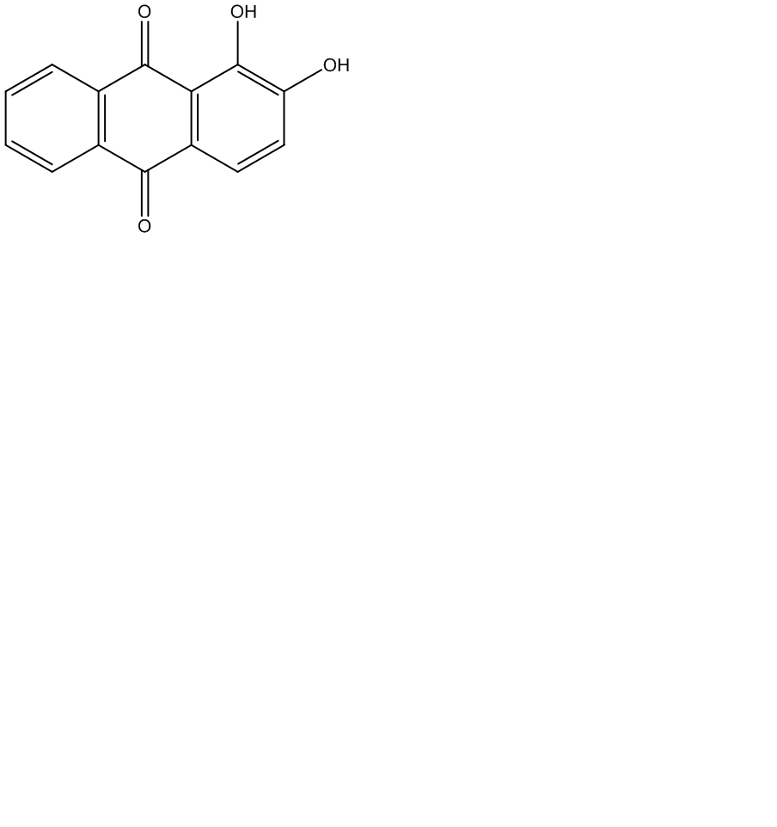
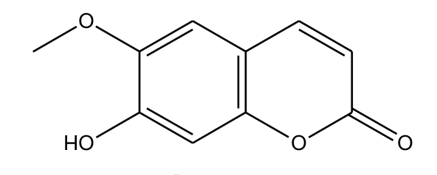

(c)
(d)

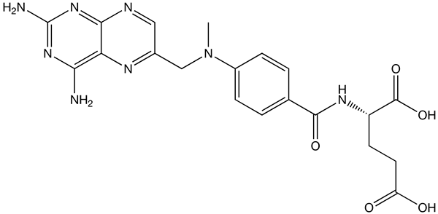
Figure 1.
Figure 2.
1
2
3
4
5
6
7
8
a
b
c
d
e
Table 1.
Compounds | μg/mL ± S.D.
rutin | 22.1 ± 0.05
scopoletin | 4.7 ± 0.01
quercetin | < LOD
protocatechuic acid | < LOD
myricetin | N.D.
kaempferol | N.D.
isorhamnetin | N.D.
vanillin | N.D.
alizarin | N.D.
Values are expressed as mean ±S.D.
N.D.: not detectable.
LOD: limit of detection.
Figure 3.
Table. 2
Treatments  Parameter | MTX alone  (n=7) |  |  | MTX + noni  single dose  (n=6) |  |  | MTX + noni  7th dose  (n=6) |  |  | MTX + diclofenac  single dose  (n=6)
C_{max} | 0.20 | ± | 0.01ª | 0.35 | ± | 0.06^{b} | 0.29 | ± | 0.02^{ab} | 0.41 | ± | 0.06^{b}
 |  |  |  | (＋75%) |  |  | (＋45%) |  |  | (＋105%)
AUC_{0-t} | 134.1 | ± | 14.6ª | 211.4 | ± | 33.9^{b} | 282.8 | ± | 6.2^{b} | 204.5 | ± | 19.8^{b}
 |  |  |  | (＋58%) |  |  | (＋111%) |  |  | (＋52%)
MRT | 707.0 | ± | 71.3ª | 930.8 | ± | 60.9^{b} | 1013.7 | ± | 39.7^{b} | 656.3 | ± | 54.2ª
 |  |  |  | (＋32%) |  |  | (＋43%)
C_{max} (μmol/L): peak serum concentration.
AUC_{0-t} (μmol · min/L): area under the curve from time zero to the last point.
MRT (min): mean residence time.
Date are expressed as means ±S.E. Means in a given row without a common superscript differ at p < 0.05. A mean with superscript “ª” was significantly different from a mean with superscript “^{b}”.
Figure 4.
Figure 5.

