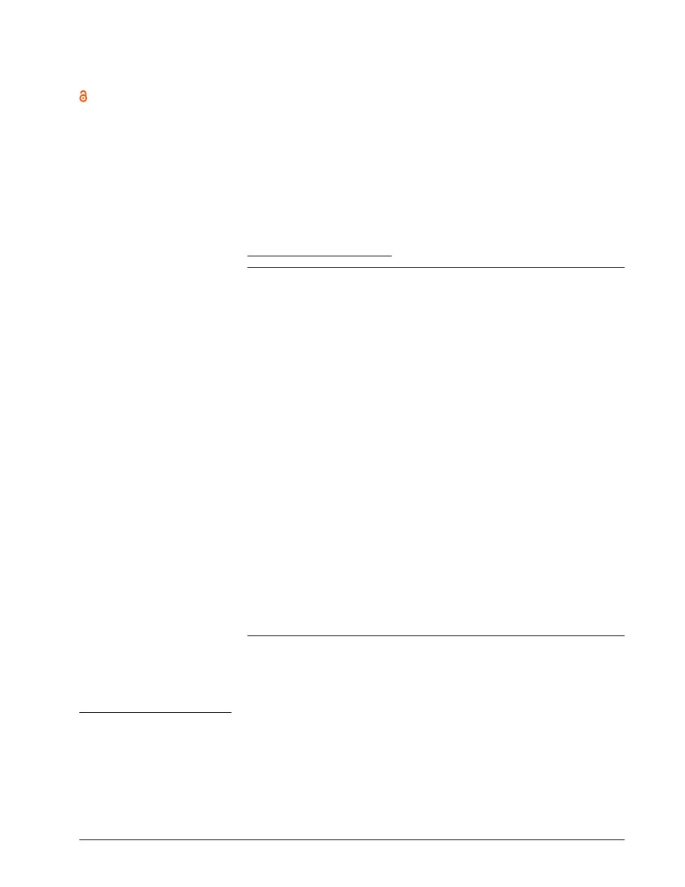
Neuropsychiatric Disease and Treatment
Open Access Full Text Article
Dovepress
open access to scientific and medical research
T
U
A
Shaw-Ji Chen 1,2
Chung-Hung Chang 3
Hsin-Chi Tsai 2,4
Shao-Tsu Chen 2,4
Chaucer CH Lin 2,4
1
Superior antidepressant effect occurring
1 month after rTMS: add-on rTMS for subjects
with medication-resistant depression
This article was published in the following Dove Press journal:
Neuropsychiatric Disease and Treatment
9 March 2013
Number of times this article has been viewed
F
O
O
R
P
Y
P
O
C
r
fo
t
o
N
n
io
t
a
ic
l
b
u
p
Department of Psychiatry, Mackay
Memorial Hospital Taitung Branch,
Taitung; 2School of Medicine,
Buddhist Tzu Chi University, Hualien;
3Department of Psychiatry, China
Medical University Hospital, Taichung;
4Department of Psychiatry, Buddhist Tzu
Chi General Hospital, Hualien, Taiwan
R
O
H
OrIGINAL rESEArCH
Abstract: Depression is a major psychiatric disorder. The standard treatment for depression is
antidepressant medication, but the responses to antidepressant treatment are only partial, even
poor, among 30%–45% of patients. Refractory depression is defined as depression that does
not respond to antidepressant therapy after 4 weeks of use. There is evidence that repetitive
transcranial magnetic stimulation (rTMS) may exert effects in treating psychiatric disorder
through moderating focal neuronal functions. High-frequency rTMS on the left prefrontal area
and low-frequency rTMS on the right prefrontal area were shown to be effective in alleviating
depressive symptoms. Given the statistically significant antidepressant effectiveness noted, the
clinical application of rTMS as a depression treatment warrants further studies. Application of
rTMS as an add-on therapy would be a practical research model. High-frequency (5–20 Hz)
rTMS over the left dorsolateral prefrontal cortex was found to have a significant effect
on medication-resistant depression. In the present study, we not only measured the acute
antidepressant effect of rTMS during treatment and immediately after its completion but also
evaluated participants 1 month after completion of the treatment protocol. Study participants
were divided into two groups: an active rTMS group (n = 10) and a sham group (n = 10).
The active rTMS group was defined as participants who received the rTMS protocol, and the
sham group was defined as participants who received a sham rTMS procedure. A significant
Hamilton Depression Rating Scale score reduction was observed in both groups after the fifth
and tenth treatments. However, those in the active rTMS group maintained their improvement
as measured one month after completion of the rTMS protocol. Participants who received active
rTMS were more likely to have persistent improvement in depression scores than participants
who received sham rTMS.
Keywords: major depressive disorder, repetitive transcranial magnetic stimulation, treatment-
resistant depression, efficacy, adverse effect
Introduction
Correspondence: Shao-Tsu Chen
Department of Psychiatry, Buddhist
Tzu-Chi General Hospital and Tzu Chi
University, Institute of Pharmacology and
Toxicology, Buddhist Tzu Chi General
Hospital, Hualien City, 970 Taiwan
Tel +886 3 856 1825 2106
Fax +886 3 833 2317
Email shaotsu.tw@yahoo.com.tw
Major depressive disorder (MDD) is not a rare disorder in the general population.
In the 21st century, it has become one of the most prevalent disorders in the world,
with a gradually increasing disease burden.1 Standard medical treatment includes
many different psychotherapy and antidepressant medications.2 However, more than
30% of patients receiving antidepressants do not respond well to these drugs.3,4
Repetitive transcranial magnetic stimulation (rTMS) is a new technique that
is increasingly popular for the treatment of neurologic and psychiatric diseases.5,6
Because antidepressants cannot help all depressed people, the use of rTMS to treat
MDD is reported with increasing frequency around the world.7 High-frequency
(5–20 Hz) rTMS over the left dorsolateral prefrontal cortex (DLPFC) was found to
Neuropsychiatric Disease and Treatment 2013:9 1–5
© 2013 Chen et al, publisher and licensee Dove Medical Press Ltd. This is an Open Access article
which permits unrestricted noncommercial use, provided the original work is properly cited.
submit your manuscript | www.dovepress.com
Dovepress
40466
1

Chen et al
Dovepress
have a significant effect on medication-resistant depression
in meta-analyses.7–11 However, few studies with good sham-
controlled designs have been performed in East Asia in order
to investigate subacute effects of high-frequency rTMS.12,13
Given the dearth of studies of rTMS for MDD in East
Asia, we sought to evaluate the efficacy of rTMS in treating
depressed Chinese patients. In addition, previous studies of
the efficacy of rTMS in treating MDD have focused on the
acute antidepressant effect during treatment. In the present
study, we not only measured the acute antidepressant effect of
rTMS during treatment and immediately after its completion
but also evaluated participants 1 month after completion of
the treatment protocol. The study protocol was approved by
the institutional review board of the Department of Health
of the Republic of China (Taiwan).
receive the protocol in our hospital. The clinical trial was
performed using a double blind and randomized design. All
subjects joining the trial gave informed consent before they
entered the protocol.
rTMS protocol
A well-trained psychiatrist (CHC) performed rTMS using a
magnetic stimulator (Magstim Company Ltd, Whitland, UK)
with four booster modules with a figure-eight-shaped coil.
Participants were seated upright in a comfortable chair during
the procedure. Before the first treatment, we determined
the motor threshold at rest for the right abductor pollicis
muscle, as in previous studies.14,15 The DLPFC stimulation
was defined as 5 cm in front of the site of the right abductor
pollicis muscle in the parasagittal plane (the thumb), as
described previously.16
None of the patients had received rTMS prior to this
study. Each patient underwent 10 sessions of rTMS over
the left DLPFC within 4 weeks, at 90% motor threshold.
Sham stimulation occurred in exactly the same manner as
active rTMS, except that the angle of the coil, rather than
being tangential to the skull, was at 90 degrees to the skull.
This created a similar sensation in the patient but appeared
not to actually stimulate the motor cortex as in the active
condition. Other parameters of stimulation characteristics
were as follows: 20 Hz, 20 trains of 2 seconds duration,
12 minutes per session, 10 sessions of stimulation over a
2-week period (10 weekdays).
Methods
Participants
The participants in this study were recruited from our hospital
from January 1, 2008, to October 31, 2008. Patients who
had received a diagnosis of MDD according to Diagnostic
and Statistical Manual of Mental Disorders, Fourth Edition.
criteria were evaluated using the Mini-International
Neuropsychiatric Interview. Participants were also required to
have treatment-resistant depression that had not responded to
two different antidepressants administered for 6 weeks each.
Patients were excluded from the study if they were considered
to have a high risk of suicide. Patients were also excluded if
they had any physical abnormality such as a head injury or
epilepsy or if they had an implanted pacemaker.
In the screening phase, if a patient had a score of over
24 on the Beck Depression Inventory, version 2 (BDI-II), he
or she was invited to complete a subsequent interview. Those
with scores of over 18 on the 17-item Hamilton Depression
Rating Scale (HAM-D) were entered into the trial. Initially,
60 inpatients were selected and asked to visit our clinics for
the study. A total of 34 patients completed the screening
process and met the inclusion criteria.
Study participants were randomized into two groups:
an active rTMS group and a sham group. They received
the same antidepressant and keep unchanged dosage during
the rTMS protocol. The active rTMS group was defined as
participants who received the rTMS protocol, and the sham
group was defined as participants who received a sham
rTMS procedure. A total of 13 patients were unable to be
hospitalized during the rTMS protocol, so they were not
included in this study. The final study sample consisted of
21 people because people who met the criteria were able to
Psychiatric assessment
Two scales were used to evaluate the efficacy of rTMS in
medication-resistant depression: the BDI-II and the 17-item
HAM-D. In addition, the Young Mania Rating Scale (YMRS)
was used because of a previous report of rTMS-induced
mania.17 The Brief Psychotic Rating Scale (BPRS) was used
if the participant suffered from depression with psychotic
features. Thus, assessments using the BDI-II, HAM-D,
YMRS, and BPRS were performed before the start of the
treatment protocol, after the fifth treatment session, after
the tenth treatment session, and 1 month after completion of
ten treatment sessions. The raters who evaluated the patients
did not know whether a participant had been assigned to the
rTMS or sham group.
Statistical analysis
The sex and age of study participants were recorded.
The effects of rTMS on BDI-II and HAM-D scores were
analyzed. Analysis was performed using SPSS software
2
submit your manuscript | www.dovepress.com
Neuropsychiatric Disease and Treatment 2013:9
Dovepress

Dovepress
Add-on rTMS for medication-resistant depression
(v 13.0; IBM Corporation, Armonk, NY, USA), and the level
of statistical significance was set at P , 0.05.
Results
A total of 21 participants (9 males and 12 females) entered
the trial. The baseline YMRS and BPRS scores were less
than 4 in both groups, and they remained stable during and
after the trial. One patient in the sham group withdrew from
the study because of unspecified somatic complaints. Thus,
20 patients completed the trial and 1 month follow-up. Of
these 20 patients, 10 were in the active rTMS group and 10
were in the sham group. The patients’ ages ranged from 20 to
62 years, and the mean (SD) age was 44.1 (4.4) years in the
active rTMS group and 47.3 (3.5) years in the sham group,
as shown in Table 1.
The baseline mean (SD) BDI-II scores were 32.1 (4.5)
in the active rTMS group and 37.8 (2.4) in the sham group.
The BDI-II scores after the fifth treatment were 26.5 (3.8)
in the active rTMS group and 29.2 (3.4) in the sham group.
The BDI-II scores after the tenth treatment were 24.2 (4.4)
in the active rTMS group and 26.0 (4.9) in the sham group.
The BDI-II scores 1 month after the completion of treatment
were 25.9 (8.4) in the active rTMS group and 21.8 (2.7) in
the sham group. No significant difference was found in the
change in BDI-II scores between the two groups (Table 1).
The baseline mean (SD) HAM-D scores were 23.5 (1.9)
in the active rTMS group and 24.9 (1.9) in the sham group.
The HAM-D scores after the fifth treatment were 16.1 (2.8)
in the active rTMS group and 17.5 (1.6) in the sham group.
The HAM-D scores after the tenth treatment were 9.6 (1.5)
in the active rTMS group and 12.3 (1.4) in the sham group.
A significant change was observed in both groups after the
fifth and tenth treatments. However, those in the active
Table 1 BDI-II and HAM-D scores of active rTMS and sham groups
Variable
Male, n (%)
Age, years
Baseline BDI-II score
After 5th treatment BDI-II score
After 10th treatment BDI-II score
1 month after treatment BDI-II score
Baseline HAM-D score
After 5th treatment HAM-D score
After 10th treatment HAM-D score
Percentage of responder after 10th treatment HAM-D score
1 month after treatment HAM-D score
responder 1 month after treatment HAM-D score
rTMS group maintained their improvement as measured by
the HAM-D 1 month after the completion of treatment. The
HAM-D scores 1 month after the completion of treatment
were 9.8 (1.6) in the active rTMS group and 16.4 (1.5) in the
sham group with the difference being statistically significant.
If we used a 50% decrease in the HAM-D scores as the cut-
off point of a responder, there were no significant differences
between two groups after the tenth treatment but the active
rTMS group was significantly superior than the sham group
1 month after the protocol (Table 1).
The YMRS and BPRS scores were less than 4 at baseline
in both groups. These scores remained stable during the trial
and 1 month after the completion of treatment.
Discussion
The change in HAM-D scores indicates that participants in
both study groups improved after the completion of treatment
(Table 1). There were similar responders in the two groups after
the tenth treatment. This result differs from previous reports
of a significant difference between active and sham rTMS
groups immediately after the completion of treatment.12,15,18
However, in the present study, participants in the active
rTMS group retained their improvement after 1 month, with
a significant difference observed between the two groups.
Thus, participants receiving active rTMS had a longer
antidepressant-like response than did participants receiving
sham treatment. Percentage of responders in the active
rTMS group was also significantly higher in comparision to
the sham group. The longer-term effect of rTMS is not well
understood, and studies with longer follow-up are needed to
evaluate the duration of its effectiveness.
No significant difference was observed between the
two groups in change in BDI-II scores. This result differs
Active rTMS (n = 10)
3 (30.0)
44.1 (4.4)
31.4 (4.5)
26.5 (3.8)
24.2 (4.4)
25.9 (8.4)
23.5 (1.9)
16.1 (2.8)
9.6 (1.5)
7 (70%)
9.8 (1.6)*
7 (70%)*
Sham (n = 10)
6 (60.0)
47.3 (3.5)
37.8 (2.4)
29.2 (3.4)
26.0 (4.9)
21.8 (2.7)
24.9 (1.9)
17.5 (1.6)
12.3 (1.4)
8 (80%)
16.4 (1.5)
2 (20%)
Notes: Unless otherwise indicated, data are given as mean (SD). *P , 0.05 for comparison between the two groups (t test).
Abbreviations: BDI-II, Beck Depression Inventory, version 2; HAM-D, Hamilton Depression rating Scale; rTMS, repetitive transcranial magnetic stimulation.
Neuropsychiatric Disease and Treatment 2013:9
submit your manuscript | www.dovepress.com
Dovepress
3

Chen et al
Dovepress
from those of previous reports. 12,19 It is important to
evaluate the difference between raters’ reports and self-
report measurements such as the BDI-II in order to better
evaluate the antidepressant effect of active rTMS. The
discrepant antidepressant effects evaluated by HAM-D and
BDI have at least four possible explanations: First, they are
evaluated in different ways.20 HAM-D is an observer rating
and BDI is a self-report. Second, they measure different
depression symptoms.21,22 The HAM-D accentuates somatic
and behavioral symptoms of depression, whereas the BDI
emphasizes the subjective experience of depression. Third,
they have different sensitivity and effect sizes. In the course
of antidepressant treatment, a more pronounced decline
in HAMD than in BDI scores has often been reported.21,22
Fourth, the discrepancy between HAM-D and BDI is not
a unique phenomenon. It was also reported in a previous
rTMS study.23
Although the discrepant change in HAM-D and BDI
scores existed, our study still demonstrated the antidepressant
effect of rTMS. However, the effect was “modest,” just
as Garcia-Toro et al claimed.23 The effects might be more
related to somatic and behavioral symptoms than subjective
experiences. Therefore, the antidepressant effect of rTMS
could be noticed more easily by the observer rather than the
patients themselves.
Some limitations of this study may affect interpretation
of its results. First, the sex distribution was not the same in
the two groups; thus, the effect of rTMS may differ between
female and male populations. Another limitation is that all
the data were collected while the patients were also using
antidepressant medication. The possibility that the difference
in change in HAM-D scores between the two groups was
influenced by the combined effect of antidepressants and
rTMS cannot be excluded.
and as an assistant professor at Tzu-Chi University when he
joined this study. CCHL currently works as a medical director
at Eli Lilly and Company (Taiwan/Hong Kong/Macau), as
a consultant psychiatrist at Tzu-Chi General Hospital, and
as an adjunct assistant professor at Tzu-Chi University.
STC received a grant from Tzu-Chi General Hospital, Tzu-
Chi University, and the National Science Council (Taiwan,
Republic of China). The authors report no other conflicts of
interest in this work.
References
Conclusion
In summary, this study revealed an effect of rTMS that
remained 1 month after the completion of treatment.
Participants who received active rTMS were more likely to
have persistent improvement in depression scores than were
participants who received sham rTMS. This information may
be useful in future planning of rTMS treatment for MDD or
other psychiatric diseases. Further studies of the duration of
effectiveness of rTMS are warranted.
Disclosure
HCT received a grant from Tzu-Chi General Hospital. CCHL
worked as a fulltime psychiatrist at Tzu-Chi General Hospital
1. World Health Organization. The World Health Report 2001 – Mental
Health: New Understanding, New Hope. Geneva: World Health
Organization; 2001. Available from: http://www.who.int/whr/2001/en/.
Accessed January 10, 2013.
2. Andrade P, Noblesse LH, Temel Y, et al. Neurostimulatory and ablative
treatment options in major depressive disorder: a systematic review.
Acta Neurochir (Wien). 2010;152:565–577.
3. Keller MB, Lavori PW, Mueller TI, et al. Time to recovery, chronicity,
and levels of psychopathology in major depression. A 5-year prospective
follow-up of 431 subjects. Arch Gen Psychiatry. 1992;49:809–816.
4. Rush AJ, Trivedi M, Fava M. Depression, IV: STAR*D treatment trial
for depression. Am J Psychiatry. 2003;160:237.
5. Lopez-Ibor JJ, Lopez-Ibor MI, Pastrana JI. Transcranial magnetic
stimulation. Curr Opin Psychiatry. 2008;21:640–644.
6. Rossini PM, Rossi S. Transcranial magnetic stimulation: diagnostic,
therapeutic, and research potential. Neurology. 2007;68:484–488.
7. Lam RW, Chan P, Wilkins-Ho M, Yatham LN. Repetitive transcranial
magnetic stimulation for treatment-resistant depression: a systematic
review and metaanalysis. Can J Psychiatry. 2008;53:621–631.
8. Koerselman F, Laman DM, van Duijn H, van Duijn MA, Willems MA.
A 3-month, follow-up, randomized, placebo-controlled study of repetitive
transcranial magnetic stimulation in depression. J Clin Psychiatry.
2004;65:1323–1328.
9. Gross M, Nakamura L, Pascual-Leone A, Fregni F. Has repetitive
transcranial magnetic stimulation (rTMS) treatment for depression
improved? A systematic review and meta-analysis comparing the
recent vs the earlier rTMS studies. Acta Psychiatr Scand. 2007;116:
165–173.
10. Schutter DJ, van Honk J. The cerebellum in emotion regulation:
a repetitive transcranial magnetic stimulation study. Cerebellum.
2009;8:28–34.
11. Padberg F, George MS. Repetitive transcranial magnetic stimulation
of the prefrontal cortex in depression. Exp Neurol. 2009;219:2–13.
12. Su TP, Huang CC, Wei IH. Add-on rTMS for medication-resistant
depression: a randomized, double-blind, sham-controlled trial in
Chinese patients. J Clin Psychiatry. 2005;66:930–937.
13. Li CT, Wang SJ, Hirvonen J, et al. Antidepressant mechanism of add-on
repetitive transcranial magnetic stimulation in medication-resistant
depression using cerebral glucose metabolism. J Affect Disord.
2010;127:219–229.
14. Padberg F, Zwanzger P, Keck ME, et al. Repetitive transcranial
magnetic stimulation (rTMS) in major depression: relation between
efficacy and stimulation intensity. Neuropsychopharmacology. 2002;27:
638–645.
15. Pascual-Leone A, Rubio B, Pallardo F, Catala MD. Rapid-rate
transcranial magnetic stimulation of left dorsolateral prefrontal cortex
in drug-resistant depression. Lancet. 1996;348:233–237.
16. George MS, Nahas Z, Molloy M, et al. A controlled trial of daily left
prefrontal cortex TMS for treating depression. Biol Psychiatry. 2000;48:
962–970.
17. Huang CC, Su TP, Shan IK. A case report of repetitive transcranial
magnetic stimulation-induced mania. Bipolar Disord. 2004;6:444-5.
4
submit your manuscript | www.dovepress.com
Neuropsychiatric Disease and Treatment 2013:9
Dovepress

Dovepress
18. Li X, Nahas Z, Kozel FA, Anderson B, Bohning DE, George MS. Acute
left prefrontal transcranial magnetic stimulation in depressed patients
is associated with immediately increased activity in prefrontal cortical
as well as subcortical regions. Biol Psychiatry 2004;55:882–890.
19. Demirtas-Tatlidede A, Mechanic-Hamilton D, Press DZ, et al. An
open-label, prospective study of repetitive transcranial magnetic
stimulation (rTMS) in the long-term treatment of refractory
depression: reproducibility and duration of the antidepressant effect in
medication-free patients. J Clin Psychiatry. 2008;69:930–934.
20. Lambert MJ, Hatch DR, Kingston MD, Edwards BC. Zung, Beck,
and Hamilton Rating Scales as measures of treatment outcome:
a meta-analytic comparison. J Consult Clin Psychol. 1986;54:
54–59.
Add-on rTMS for medication-resistant depression
21. Demyttenaere K, De Fruyt J. Getting what you ask for: on the selectivity
of depression rating scales. Psychother Psychosom. 2003;72:61–70.
22. Schneibel R, Brakemeier EL, Wilbertz G, Dykierek P, Zobel I,
Schramm E. Sensitivity to detect change and the correlation of clinical
factors with the Hamilton Depression Rating Scale and the Beck Depression
Inventory in depressed inpatients. Psychiatry Res. 2012;198:62–67.
23. Garcia-Toro M, Mayol A, Arnillas H, et al. Modest adjunctive benefit
with transcranial magnetic stimulation in medication-resistant
depression. J Affect Disord. 2001;64:271–275.
Neuropsychiatric Disease and Treatment
Publish your work in this journal
Neuropsychiatric Disease and Treatment is an international, peer-
reviewed journal of clinical therapeutics and pharmacology focusing
on concise rapid reporting of clinical or pre-clinical studies on a
range of neuropsychiatric and neurological disorders. This journal
is indexed on PubMed Central, the ‘PsycINFO’ database and CAS.
Dovepress
The manuscript management system is completely online and includes
a very quick and fair peer-review system, which is all easy to use. Visit
http://www.dovepress.com/testimonials.php to read real quotes from
published authors.
Submit your manuscript here: http://www.dovepress.com/neuropsychiatric-disease-and-treatment-journal
Neuropsychiatric Disease and Treatment 2013:9
submit your manuscript | www.dovepress.com
Dovepress
5

