Effects of Propylthiouracil on the Production of Aldosterone in Rat Zona Glomerulosa Cells

Hsiao-Fung Pu¹, Chia-Wen Lin¹, Hsiao-Wei Lee¹, and Paulus S. Wang^{1, 2, 3, 4,*}
¹Department and Institute of Physiology, School of Medicine,
²Laboratory Animal Center, National Yang-Ming University, Taipei 11221, Taiwan ³Department of Medical Research and Education, Taipei Veterans General Hospital, Taipei 11217, Taiwan, and ⁴Department of Medical Research and Education, Taipei City Hospital, Taipei 10341, Taiwan, Republic of China
Running Title: PTU on aldosterone secretion

*Corresponding author: Paulus S. Wang, Ph. D., Department and Institute of Physiology, School of Medicine, National Yang-Ming University, Shih-Pai, Taipei, Taiwan 11221, Republic of China, Tel. no.: +886-2-28267082, Fax no.: +886-2-28264049, E-mail: pswang@gmail.com
This study was supported by the grant NSC97-2320-B-010-017-MY3 from the National Science Council, and awards to Paulus S. Wang from the Medical Research and Advancement Foundation in memory of Dr. Chi-Shuen Tsou.
Abstract
Propylthiouracil (PTU), an anti-thyroid drug, is widely used for the treatment in hyperthyroid patients. Previous studies indicate that thyroxine inhibit the spontaneous and adrenocorticotropin (ACTH)-stimulated corticosterone secretion by acting directly at adrenal glands via decrease cAMP production. It has also been shown that PTU suppresses corticosterone release by male rat zona fasciculata-reticularis cells. However, the direct effects and mechanisms of PTU on the aldosterone production in adrenal zona glomerulosa (ZG) cells are still unclear. ZG cells were prepared from adrenocortical tissues of male rats, and then challenged with or without angiotensin II (10⁻⁷, 10⁻⁶ M), ACTH (10⁻⁹ M), A23187 (10⁻⁵ M), cyclopiazonic acid (CPA, 10⁻⁵ M), forskolin (10⁻⁵ M), 8-Br-cAMP (10⁻⁵ M), trilostane (10⁻⁶ M, 3β-HSD inhibitor) or steroidogenic precursors (e.g. 10⁻⁶ M 25-OH-cholesterol and 10⁻⁷, 10⁻⁵ M corticosterone) at 37℃ for 1 h. Our results showed that PTU (0-3 mM) dose-dependently decreased the aldosterone release in response to the above hormones, drugs and the steroidogenic precursors in vitro. PTU also decreased steroidogenic acute regulatory (StAR) protein expression, but did not alter the protein expression of P450 side chain cleavage enzyme (P450scc) during steroidogenesis of aldosterone. These results suggested that PTU has a direct inhibitory effect on aldosterone production via cAMP, and Ca²⁺ down stream pathway and the steroidogenic enzymes activities including P450scc and aldosterone synthase, as well as StAR protein expression.

Key Words: PTU, adrenal gland, ZG cell, aldosterone, cAMP, calcium, StAR protein, P450scc

Introduction

Propylthiouracil (PTU) is widely used for treatment of hyperthyroidism patients (1) such as Graves’ disease (14). In general, PTU inhibits thyroid hormone synthesis by inhibiting the iodination and coupling actions (17). Leydig cells from PTU-treated male rats diminish testosterone production by inhibiting P450 side chain cleavage enzyme (P450scc) function and steroidogenic acute regulatory (StAR) protein expression (7). PTU also inhibits testosterone secretion via the decrease of 17β-hydroxysteroid dehydrogenase (17β-HSD) activity and cAMP downstream pathway in monkey (6). Acute treatment with PTU decreases the progesterone release by granulosa cells via a thyroid-independent mechanism involving the inhibition of cAMP and calcium downstream pathways, the activity of steroidogenic enzymes, and StAR protein function (3). Whereas long-term treatment with PTU was results in an increase of pregnenolone production in rat granulosa cells (4).
Thyroid-adrenal interaction was firstly recognized by Hoskins (8), who found that animals treated with thyroid extract resulted in hypertrophy of the adrenal glands. Previously studies also demonstrated that chronic administration of PTU in rats resulted in a decrease of plasma corticosterone concentration (10, 11). Thyroxine inhibits the spontaneous and ACTH-stimulated secretion of corticosterone by acting directly at adrenal glands via a decrease of cAMP production (5).
We have investigated the direct effects of PTU on corticosterone secretion both in vivo and in vitro (10) by rat zona fasciculata-reticularis (ZFR) cells. However, the direct effects of PTU on aldosterone secretion by rat zona glomerulosa (ZG) cells are not known. In the present study, we examined the direct acute effects of PTU on the production of aldosterone and activities of the steroidogenic enzymes in rat adrenal ZG cells.

Materials and Methods

Animals

Male Sprague-Dawley rats (3 - 4 months old) were purchased from the National Yang-Ming University Animal Center. They were housed under controlled conditions of temperature (22 ± 1℃) and light (14-10 light-dark) with free access to food and water. All animal experimentation was conducted humanely and in conformance with the policy statement of the Committee of the National Yang-Ming University.

Preparation of Adrenal ZG Cells

The method for the preparation of dispersed ZG cells was modified from the method of Whitehouse and Abayasekara (16) with minor modifications (9). Rats were decapitated, and the adrenal glands were rapidly excised and stored at an ice-cold 0.9% NaCl solution. After removal of excess fat, the capsule zone (mainly ZG cells) from 8 to 10 adrenal glands was assigned as one dispersion, then incubated with collagenase (2 mg dissolved in 1 ml Krebs-Ringer bicarbonate buffer with 3.6 mmol K⁺/L, 11.1 mmol glucose/L and 0.2% bovine serum albumin; pH 7.4; KRBGA)(Sigma, St. Louis, Mo., USA) at 37℃ in a shaking water bath for 1 h (100 cycles/min). At the end of incubation, the capsule zone was dispersed and filtered. Cells were collected by centrifugation at 4℃, 200 × g for 10 min. The cell pellets were washed with de-ionized water to disrupt red blood cells and the osmolarity were restored immediately with 10-fold Hank’s balanced sodium solution (HBSS, Sigma). The ZG cells (1 × 10⁵ cells/0.3 ml) were pre-incubated with KRBGA medium for 1 h at 37℃ in a shaker bath (100 cycles/min) aerated with 95% O₂ + 5% CO₂.

Drugs Treatment

The ZG cells were incubated with 0.3 ml KRBGA medium, and treated with or without angiotensin II (Sigma, 10⁻⁷, 10⁻⁶ M), A23187 (Sigma, 10⁻⁵ M; a Ca²⁺ ionophore), cyclopiazonic acid (Sigma, 10⁻⁵ M; a specific inhibitor of Ca²⁺-ATPase in the sarcoplasmic and endoplasmic reticulum, CPA)(12), adrenocorticotropin (Sigma, 10⁻⁹ M; ACTH), forskolin (Sigma, 10⁻⁵ M; an adenylyl cyclase activator), 8-bromo-cAMP (Sigma, 10⁻⁵ M; a permeable cAMP analogue, 8-Br-cAMP), 25-hydroxy-cholesterol (Sigma, 10⁻⁶ M; membrane permeable cholesterol, 25-OH-cholesterol), trilostane (Sigma, 10⁻⁶ M; 3β-HSD inhibitor), corticosterone (Sigma, 10⁻⁷, 10⁻⁵ M; the precursor of aldosterone) in the absence or presence of PTU (0 - 3 mM) for 1 h. At the end of incubation, 0.2 ml ice-cold KRBGA medium was added to stop the incubation. The media were centrifuged at 200 × g for 10 min and stored at -20℃, until analyzed for aldosterone and pregnenolone by radioimmunoassay (RIA).

Western Blotting

To determine the changes in the protein expression of P450scc and StAR, ZG cells (1 × 10⁵ cells) were treated with PTU (0, 1.5 mM) for 1 h. At the end of incubation, cells were washed twice with ice-cold normal saline, and then homogenized, and the protein was extracted in 50 μl homogenization buffer (1.5% Na-lauroyl-sacrosine, 2.5 mM Tris base, 1 mM EDTA, 0.1% phenylmethyl sulfonylfluoride, pH 7.8). The cell extract was centrifuged at 12,500 × g for 12 min at 4℃. The supernatant was collected and the protein concentration was determined by Bradford assay (18).
Equal amount of proteins (40 μg per sample) was subjected to Western blot analysis. Blots were incubated with either anti-StAR (1:2,000), anti-P450scc (1:2,000) or anti-β-actin (1:8,000) antibodies at 4℃ for overnight. After washing three times (15, 5, 5 min, respectively) in Tris Buffer Saline Tween-20 (20 mM Tris, 50 mM NaCl, 1% Tween-20, pH 7.6; TBST), the blots were incubated with a horseradish peroxidase-conjugated goat anti-rabbit secondary antibody (1:8,000) for 1 h at 4℃. After washing three times in TBST (15, 5, 5 min, respectively), blots were visualized with a chemiluminescent detection system (ECLTM Western blotting detection reagents, Amersham International plc., Bucks, UK) as described by the manufacture.

Aldosterone and Pregnenolone RIA

Media aldosterone level was determined by RIA as described elsewhere (9). With anti-aldosterone No.JJC-088, the sensitivity was 4 pg per assay tube. The intra- and inter-assay coefficients of variation (CV) were 6.2% (n=4) and 5.8% (n=4), respectively.
The concentration of pregnenolone in the media was determined by RIA (2, 9) with anti-pregnenolone antiserum purchased from Biogenesis Inc (Sandown, NH, U.S.A.). The sensitivity of the pregnenolone RIA was 16 pg per assay tube. The intra- and inter-assay CV were 2.9% (n=6) and 5.5% (n=6), respectively.

Statistical Analysis
All data were expressed as means ± SEM. Data were processed by one-way analysis of variance (ANOVA) using the SPSS system. Multiple comparisons were performed where one-way ANOVA was significant, using the Duncan’s multiple-range test (13). In some cases, Student’s t-test was employed for the comparison between two groups. Differences between means were considered significant when P < 0.05, and highly significant when P < 0.01.
Results

Effects of PTU on Spontaneous and Angiotensin II-Induced Aldosterone Release

Administration of PTU (0, 0.75, 1.5, and 3 mM) in combination with angiotensin II (0, 10⁻⁷, 10⁻⁶ M) for 1 h, basal aldosterone secretion was decreased in a dose-dependent manner (P < at least 0.05, Fig. 1, upper panel). Angiotensin II-induced aldosterone secretion was increased as compared to the vehicle group (P < 0.01), and angiotensin II (10⁻⁷, 10⁻⁶ M)-induced aldosterone secretion was also suppressed by PTU (0.75, 1.5, and 3 mM) in a dose-dependent manner (P < at least 0.05, Fig. 1, middle and lower panels).

Roles of Extracellular Ca²⁺ Influx and Intracellular Ca²⁺ Mobilization in the Effects of PTU on Aldosterone Release

Further to elucidate the role of Ca²⁺ in PTU-suppressed aldosterone secretion by rat adrenal ZG cells, A23187 (10⁻⁵ M) and CPA (10⁻⁵ M) were used. ZG cells treated with A23187 (10⁻⁵ M, Fig. 2, upper panel) and CPA (10⁻⁵ M, Fig. 2, lower panel) for 1 h resulted in a significant (P < 0.01) increase in aldosterone release as compared with the vehicle group. A23187- and CPA-stimulated aldosterone release in ZG cells was also suppressed by the treatment of PTU (0.75, 1.5, and 3 mM)(P < at least 0.05) in a dose-dependent manner.

cAMP Downstream Pathway Involved in the PTU- Suppressed Aldosterone Release

Administration of ACTH (10⁻⁹ M), forskolin (10⁻⁵ M) and 8-Br-cAMP (10⁻⁵ M) produced a significant increase in aldosterone release (P < 0.01, Fig. 3). ACTH-, forskolin-, and 8-Br-cAMP-enhanced aldosterone production was also suppressed by the administration of PTU in the ZG cells (P < 0.05, Fig. 3).

Effects of PTU on the Activities of Steroidogenic Enzymes in ZG Cells

To investigate the effect of PTU on the activity of aldosterone synthase, ZG cells were treated with corticosterone (10⁻⁷, 10⁻⁵ M; the precursor of aldosterone). Our results showed that corticosterone significant enhanced aldosterone production in a dose-dependent manner (P < 0.01, Fig. 4). PTU (1.5 mM) suppressed both basal and corticosterone-facilitated aldosterone release (P < at least 0.05, Fig. 4).
In order to observe the effect of PTU on the activity of P450scc, rat adrenal ZG cells were incubated with or without trilostane (10⁻⁶ M, 3β-HSD inhibitor) in combination with or without 25-OH-cholesterol (10⁻⁶ M) in the presence or absence of PTU (1.5 mM). We found that despite of the presence of 25-OH-cholesterol, administration of ZG cells with trilostane increased production of pregnenolone. PTU (1.5 mM) decreased the production of pregnenolone in response to trilostane plus 25-OH-cholesterol. (Fig. 5, P < 0.01).

Effect of PTU on the Protein Expression of StAR and P450_{SCC}

Administration of PTU (1.5 mM) for 1 h, the protein level of StAR and P450scc in ZG cells was analyzed by Western blotting (Fig. 6A). β-actin (45 KD) was used as an internal control. Based on the ratio of internal control, StAR (P < 0.05, Fig. 6B, upper panel) but not P450scc (Fig. 6B, lower panel) protein expression was suppressed by administration of PTU (1.5 mM).
Discussion

The present results demonstrate that PTU inhibits the spontaneous, angiotensin II- and ACTH-stimulated aldosterone secretion. Furthermore, our results indicated that PTU has a direct inhibitory effect on aldosterone production via the inhibition of the cAMP-, and Ca²⁺-downstream pathway, and the steroidogenic enzyme activity such as P450scc, aldosterone synthase and StAR protein expression.
ACTH is the major tropic hormone to regulate steroidogenesis in adrenal cortical cells. It has been well established that ACTH stimulates the secretion of aldosterone via increase cAMP production. According to our results, we found a marked increase in the aldosterone release induced by administration of forskolin or 8-Br-cAMP (Fig. 3), and these stimulatory effects were suppressed by PTU (Fig. 3). These observations suggest that the inhibitory effects of PTU on aldosterone production in rat ZG cells are associated with a cAMP downstream pathway.
In the present study, both A23187 (a Ca²⁺ ionophore) and CPA (an inhibitor of sarcoplasmic reticular Ca²⁺-ATPase) (12) were used to demonstrate the effect of PTU on Ca²⁺ influx and Ca²⁺ mobilization. Our results showed that A23187 and CPA increased aldosterone release by ZG cells, but PTU inhibited the stimulatory effect (Fig. 2). It suggested that the inhibitory effects of PTU on aldosterone release in rat ZG cells were associated with an intracellular Ca²⁺ mobilization downstream pathway. The final step in aldosterone biosynthesis is the conversion of corticosterone to aldosterone under the catalyzation of the aldosterone synthase. We found that PTU (1.5 mM) markedly attenuated the stimulatory effects caused by corticosterone. This result suggested that PTU had a suppressive effect on aldosterone synthase activity.
It is well known that the rate-limiting step of steroidogenesis is the conversion of cholesterol into pregnenolone by P450scc enzyme. In order to observe the effects of PTU on the activity of P450scc, rat ZG cells were incubated with or without trilostane (10⁻⁷ M) and/or 25-OH-cholesterol in the presence or absence of PTU (1.5 mM). In the present study, trilostane was employed to block 3β-HSD activity, and the accumulation of pregnenolone is a sensitive index for the activity of P450scc. Our results showed that despite of the presence of 25-OH-cholesterol, administration of ZG cells with trilostane increased the production of pregnenolone. PTU (1.5 mM) also decreased the production of pregnenolone in response to trilostane in combination with 25-OH-cholesterol (Fig. 5). These results suggest that PTU reduced the secretion of aldosterone by ZG cells partially via an inhibition on the activity of P450scc, the rate-limiting enzyme for the conversion of cholesterol to pregnenolone during aldosterone biosynthesis.
The StAR protein, a 30 kDa phosphoprotein, mediates transfer cholesterol from the outer mitochondria membrane to the inner mitochondria membrane, where it can react with P450scc. Based on our Western blot analysis, the amount of StAR protein was decreased after administration of PTU (1.5 mM). On the other hand, the amount of cytochrome P450scc was not significantly altered by PTU. These results suggested that the decline of P450scc function was only due to the change of activity. Data obtained from regulated expression of StAR and the accompanying increased in steroid biosynthesis, proposed that StAR is rapidly synthesized in the cytosol in response to hormone stimulation and is quickly targeted to the mitochondria via a specific receptor on the outer membrane of mitochondria. After transferring cholesterol into mitochondria, StAR would be catabolized. In the present studies, the protein expression of P450scc and StAR were examined by Western blotting. Under the challenge of PTU, StAR but not P450scc protein expression was inhibited, which suggest that PTU may regulate the generation of StAR protein.
In conclusion, our results demonstrate that PTU can act directly on the rat adrenal ZG cells to suppress aldosterone production via the mechanism involving pathways of cAMP and Ca²⁺ and the steroidogenic enzymes activities of P450scc, and aldosterone synthase, as well as protein expression of StAR.
References

1. Bournaud, C. and Orgiazzi, J. Embryopathies and antithyroid drugs. Ann. Endocrinol. 64:366-369, 2003.
2. Chang, L.L., Kau, M.M., Wun W.S.A, Ho, L.T. and Wang, P.S. Effects of fasting on corticosterone production by zona fasciculata-reticularis cells in ovariectomized rats. J. Invest. Med. 50:86-94, 2002.
3. Chen, J.J., Wang, S.W., Chien, E.J. and Wang, P.S. Direct effect of propylthiouracil on progesterone release in rat granulosa cells. Brit. J. Pharmacol. 139:1564-1570, 2003.
4. Chen, M.C., Wang, S.W., Kan, S.F., Wu, Y. C. and Wang, P.S. Stimulatory effects of propylthiouracil on pregnenolone production through upregulation of steroidogenic acute regulatory protein expression in rat granulosa cells. Toxicol. Sci. 118:667-674, 2010.
5. Chen, Y.H., Lo, M.J., Kau, M.M., Tsai, S.C., Chiao, Y.C., Chen, J.J., Liaw, C., Lu, C.C., Lee, B.P., Chen, S.C., Fang, V.S., Ho, L.T. and Wang, P.S. Inhibition of corticosterone secretion by thyroxine in male rats. Chinese J. Physiol. 40:25-30, 1997.
6. Chiao, Y.C., Chao, H.L., Huang, S.W. and Wang, P.S. Direct effects of propylthiouracil on testosterone production in monkeys. Chinese J. Physiol. 43:55-59, 2000.
7. Chiao, Y.C., Cho, W.L. and Wang, P.S. Inhibition of testosterone production by propylthiouracil in rat Leydig cells. Biol. Reprod. 67:416-422, 2000.
8. Hoskins, R.G.. Congenital thyroidism: an experimental study of the thyroid in relation to other organs of internal secretion. Am. J. Physiol. 26:426-438, 1910.
.9. Kau, M.M., Lo, M.J., Tsai, S.C., Chen, J.J., Pu HF, Chien EJ, Chang, L.L. and Wang, P.S. Effects of prolactin on aldosterone secretion in rat zona glomerulosa cells. J. Cell. Biochem. 72:286-293, 1999.
10. Lo, M.J., Wang, S.W., Kau, M.M., Chen, J.J., Chen, Y.H., Fang, V.S., Ho, L.T. and Wang, P.S. Pharmacological effects of propylthiouracil on corticosterone secretion in male rats. J. Investig. Med. 46:444-452, 1998.
11. Sanchez-Franco, F., Femandez, L., Femandez, G. and Cacicedo, L. Thyroid hormone action on ACTH secretion. Horm. Metab. Res. 21:550-552, 1989.
12. Soler, F., Plenge-Tellechea, F., Fortea, I. and Fernandez-Belda, F. Cyclopiazonic acid effect on Ca²⁺-dependent conformational states of the sarcoplasmic reticulum ATPase. Implication for the enzyme turnover. Biochemistry 37:4266-4274, 1998.
13. Steel, R.G.D and Torrie, J.H. Principles and Procedures of Statistics, 2 ed. New York: McGraw-Hill, 1980.
14. Streetman, D.D. and Khanderia, U. Diagnosis and treatment of Graves’ disease. Ann. Pharmacother. 37:1100-1109, 2003.
15. Waterman, M.R. and Simpson E.R. Regulation of the biosynthesis of cytochrome P-450 involved in steroid hormone synthesis. Mol. Cell. Endocrinol. 39:81-89, 1985.
16. Whitehouse, B.J. and Abayasekara, D.R.E. Roles of type I and type II isoenzymes of cyclic AMP-dependent protein kinase in steroidogenesis in rat adrenal cells. J. Mol. Endocrinal. 12:195-202, 1994.
17. Yang, Y. and Gordon, C.J. Regulated hypothermia in the hypothyroid rat induced by administration of propylthiouracil. Am. J. Physiol. – Regul. Integr. Comp. Physiol. 272:R1390-R1395, 1997.
18. Zor, T. and Selinger, Z. Linearization of the Bradford protein assay increases its sensitivity: theoretical and experimental studies. Anal. Biochem. 236:302-308, 1996.
Figure legends

Fig. 1. Effects of PTU (0 - 3 mM) on aldosterone release by male rat ZG cells treated with or without angiotensin II (10⁻⁷, 10⁻⁶ M). Each column represents mean ± SEM. *, **: P < 0.05, P < 0.01 compared to corresponding control. ^{+, ++}: P < 0.05, P < 0.01 compared to respective vehicle group.

Fig. 2. Effects of PTU (0 - 3 mM) on aldosterone release by male rat ZG cells treated with or without A23187 (10⁻⁵ M) and cyclopiazonic acid (10⁻⁵ M). Each column represents mean ± SEM. *, **: P < 0.05, P < 0.01 compared to corresponding control. ⁺⁺: P < 0.01 compared to respective vehicle group.

Fig. 3. Effects of PTU (1.5 mM) on aldosterone release by male rat ZG cells treated with or without ACTH (10⁻⁹ M), forskolin (10⁻⁵ M) and 8-Br-cAMP (10⁻⁵ M). Each column represents mean ± SEM. *: P < 0.05 compared to respective control. ⁺⁺: P < 0.01 compared to respective vehicle group.

Fig. 4. Effects of PTU (1.5 mM) on the activity of aldosterone synthase by male rat ZG cells treated with or without steroidogenic precursors corticosterone (10⁻⁷, 10⁻⁵ M). Each column represents mean ± SEM. * P < 0.05 , ** P < 0.01 compared to respective control group. ⁺⁺ P < 0.01 compared to respective vehicle group.

Fig. 5. Effects of PTU (1.5 mM) on the activities of P450scc by male rat ZG cells treated with or without 25-OH-cholesterol (10⁻⁶ M), trilostane (10⁻⁶ M) and 25-OH-cholesterol plus trilostane. Each column represents mean ±SEM. **: P < 0.01 compared to respective control. ⁺⁺: P <0.01 compared to respective vehicle group.

Fig. 6. Effects of PTU (1.5 mM) on P450scc and StAR protein expression. Each column represents mean ± SEM. *: P < 0.05 compared to respective control.

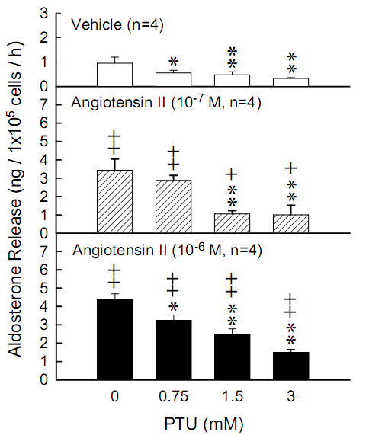

Fig. 1.
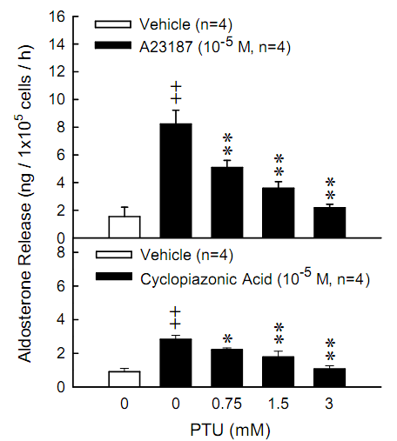

Fig. 2.

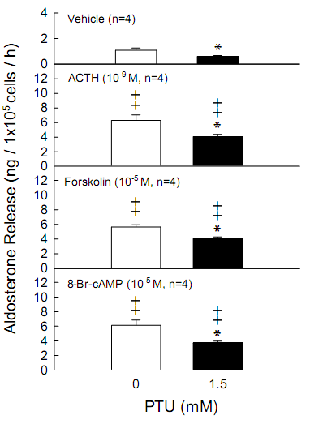

Fig. 3.

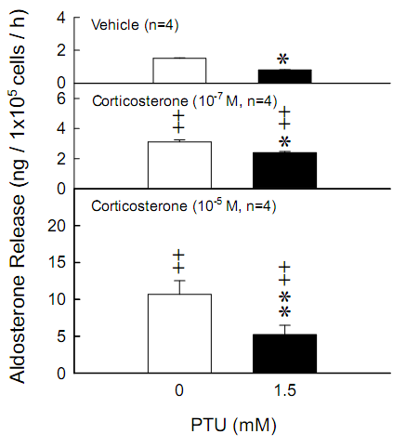

Fig. 4.

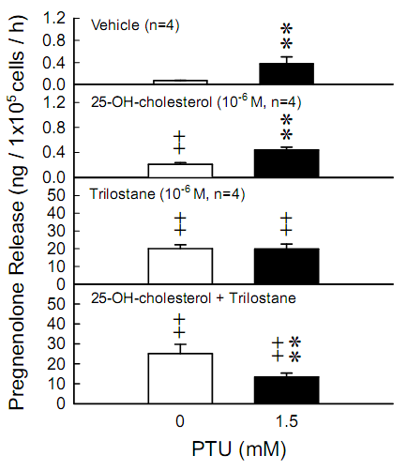

Fig. 5.

(A)
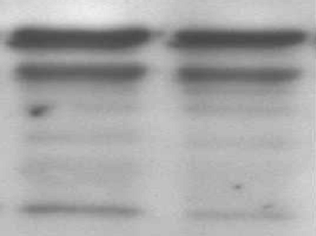
P450scc
β-Actin

StAR

(B)
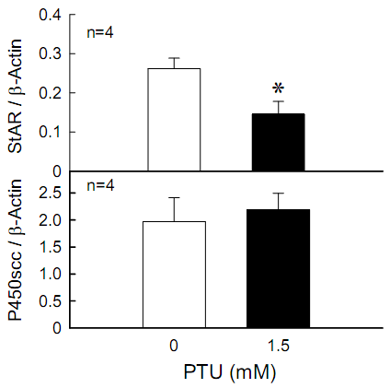

Fig. 6.

