Potent inhibition of human neutrophil activations by bractelactone, a novel chalcone from Fissistigma bracteolatum

Yang-Chang Wu a, b, 1, Munisamy Sureshbabu c, 1, Yao-Ching Fang c, 1, Yi-Hsiu Wu c, Yu-Hsuan Lan d, Fang-Rong Chang a, Ya-Wen Chang c, Tsong-Long Hwang c, e,⁎

a Graduate Institute of Natural Products, Kaohsiung Medical University, Kaohsiung 807, Taiwan
b Graduate Institute of Integrated Medicine, College of Chinese Medicine, China Medical University, Taichung 404, Taiwan
c Graduate Institute of Natural Products, College of Medicine, Chang Gung University, Taoyuan 333, Taiwan
d School of Pharmacy, China Medical University, Taichung 404, Taiwan
e Chinese Herbal Medicine Research Team, Healthy Aging Research Center, Chang Gung University, Kweishan, Taoyuan 333, Taiwan

a b s t r a c t

Fissistigma bracteolatum is widely used in traditional medicine to treat inﬂammatory diseases. However, its active components and mechanisms of action remain unclear. In this study, (3Z)-6,7-dihydroxy-4-methoxy-
3-(phenylmethylidene)-5-(3-phenylpropanoyl)-1-benzofuran-2(3H) (bractelactone), a novel chalcone from F. bracteolatum, showed potent inhibitory effects against superoxide anion (O• −) production, elastase release, and CD11b expression in formyl-L-methionyl-L-leucyl-L-phenylalanine (FMLP)-induced human neutrophils.
2
• −

However, bractelactone showed only weak inhibition of phorbol myristate acetate-caused O2
production

The peak cytosolic calcium concentration ([Ca2+]i) was unaltered by bractelactone in FMLP-induced neutrophils,
but the decay time of [Ca2+]i was signiﬁcantly shortened. In a calcium-free solution, changes in [Ca2+]i caused by the addition of extracellular Ca2+ were inhibited by bractelactone in FMLP-activated cells. In addition, bractelactone did not alter the phosphorylation of p38 MAPK, ERK, JNK, or AKT or the concentration of cAMP. These results suggest that bractelactone selectively inhibits store-operated calcium entry (SOCE). In agreement with this concept, bractelactone suppressed sustained [Ca2+]i changes in thapsigargin-activated neu- trophils. Furthermore, bractelactone did not alter FMLP-induced formation of inositol 1,4,5-triphosphate. Taken together, our results demonstrate that the anti-inﬂammatory effects of bractelactone, an active ingredient of F. bracteolatum, in human neutrophils are through the selective inhibition of SOCE.
Keywords: Bractelactone Calcium Elastase,Fissistigma bracteolatum,Neutrophils, Superoxide anion

Introduction

The genus Fissistigma (Annonaceae) consists of about 80 species which are mainly distributed in Asia and Australia. Annonaceous plants are important economic crops in Asia. Several of the plants are widely used in traditional medicine to treat rheumatoid arthritis and other inﬂammatory diseases (Hwang et al., 2009a; Zhu et al.,
2010). Other researchers and ourselves reported that annonaceous

Abbreviations: AC, adenylate cyclase; AKT, protein kinase B; cAMP, cyclic adenosine
3′,5′-monophosphate; CB, cytochalasin B, bractelactone (3Z)-6,7-dihydroxy-4-methoxy-
3-(phenylmethylidene)-5-(3-phenylpropanoyl)-1-benzofuran-2(3H); FMLP, formyl-L- methionyl-L-leucyl-L-phenylalanine; GPCR, G protein-coupled receptor; IP3, inositol
1,4,5-triphosphate; O• −, superoxide anion; PKA, protein kinase A; LDH, lactate dehydro-
2
genase; ROS, reactive oxygen species; SOCE, store-operated Ca2+ entry; SOD, superoxide dismutase; WST-1, 2-(4-iodophenyl)-3-(4-nitrophenyl)-5-(2,4-disulfophenyl)-2H-tetra- zolium, monosodium salt.
⁎ Corresponding author at: Graduate Institute of Natural Products, College of Medicine,
Chang Gung University, 259 Wen-Hwa 1st Road, Kweishan, Taoyuan 333, Taiwan. Fax: + 886 3 2118506.
E-mail address: htl@mail.cgu.edu.tw (T.-L. Hwang).
1 These authors contributed equally to this work.
plants have several bioactive compounds, such as alkaloids (Schmidt et al., 2010; Thuy et al., 2012), tetrahydrofurans, ﬂavonoids, acetogenins (Aminimoghadamfarouj et al., 2011; Liaw et al., 2010; Rodrigues dos Santos Lima et al., 2009), and phenanthrenes (Zhu et al., 2010). F. bracteolatum Chatt is a climbing shrub, mainly distribut- ed in southern China and Vietnam. This plant is used as a traditional medicine for curing bone fractures, contusions, and strains and for stopping bleeding and treating inﬂammatory diseases (Deng et al.,
2002; Lien et al., 2000). Despite these practices, the active ingredients and pharmacological mechanisms of F. bracteolatum remain to be established.
Activated human neutrophils play a critical role in a variety of acute and chronic inﬂammatory diseases (Arazna et al., 2013; Mantovani et al., 2011; Nemeth and Mocsai, 2012; Smith, 1994). In response to speciﬁc stimuli, neutrophils can secrete a myriad of proinﬂammatory mediators and proteolytic enzymes which are associated with multiple inﬂammatory diseases such as rheumatoid arthritis (Cascao et al., 2010; Nemeth and Mocsai, 2012), chronic obstructive pulmonary disease (Blidberg et al., 2012; Stevens et al.,
2011), and acute respiratory distress syndrome (Grommes and

Soehnlein, 2011; Narasaraju et al., 2011). Stimulation of neutrophils leads to their increased oxygen consumption through the activity
purchased from Dojindo (Kumamoto, Japan). A23187, N-(2-((p- bromocinnamyl)amino)ethyl)-5-isoquinolinesulfonamide (H89), pros-

of NADPH oxidase which generates superoxide anions (O2
), a
taglandin E1 (PGE1), and phenylmethylsulfonyl ﬂuoride (PMSF) were

• −

precursor of reactive oxygen species (ROS). This phenomenon is the so-called respiratory burst (Dahlgren and Karlsson, 1999). Inﬂam- matory responses of ROS can either directly or indirectly damage sur- rounding tissues (Mitra and Abraham, 2006; Smith, 1994). Neutrophil granules contain multiple serine proteases which are released by a process called degranulation; among the serine proteases, elastase is a great contributor to tissue destruction in chronic inﬂammatory dis- eases (Pham, 2006; Watorek et al., 1988). Suppression of extensive respiratory burst and degranulation in activated neutrophils by natu- ral products is considered an effective strategy to ameliorate inﬂam- matory diseases.
In a search for new anti-inﬂammatory agents from natural
sources, (3Z)-6,7-dihydroxy-4-methoxy-3-(phenylmethylidene)-5-(3- phenylpropanoyl)-1-benzofuran-2(3H) (bractelactone) (Fig. 1), a novel chalcone containing cinnamic acid isolated from stems of F. bracteolatum
• −
purchased from Calbiochem (San Diego, CA, USA). Antibodies were obtained from Cell Signaling (Beverly, MA, USA). Other chemicals were purchased from Sigma (St. Louis, MO, USA). When drugs were dissolved in dimethyl sulfoxide (DMSO), the ﬁnal concentration of DMSO in cell experiments never exceeded 0.4% and did not affect the parameters measured.

Extraction and isolation. The MeOH extract (48 g) of F. bracteolatum stems was subjected to silica gel column chromatography and eluted with increasingly polar n-hexane/CHCl3/EtOAc/MeOH mixtures; the eluents were combined into 15 fractions on the basis of thin layer chromatography (TLC). Fraction 7 was eluted with CHCl3 to give bractelactone (42 mg, purity > 97%). The structure of bractelactone was determined by mass (MS) and nuclear magnetic resonance (NMR) spectroscopic methods (Lan et al., 2005). Bractelactone was

(Lan et al., 2005), was found to potently inhibit O2
production, elastase
obtained as yellow needles, and displayed UV absorption at 294 and

release, and CD11b expression in formyl-L-methionyl-L-leucyl- L-phenylalanine (FMLP)-activated human neutrophils. The aim of this study was to investigate the effects of bractelactone on human neutro- phil functions and its action mechanisms. Calcium (Ca2+) signaling plays an important role in activation of human neutrophils such as migration, respiratory burst, and degranulation. Activation of the G protein-coupled receptor (GPCR) triggers Ca2+ release from intracellu- lar stores, and induces extracellular Ca2+ inﬂux. Thus, speciﬁc inhibitors of Ca2+ signaling are currently being investigated as anti-inﬂammatory drugs because of their suppressive effects on neutrophil functions. Our data show that bractelactone inhibits FMLP-induced human neutrophil activations by speciﬁcally attenuating extracellular Ca2+ inﬂux.

Materials and methods

Reagents. Dextran, Ficoll-Paque Plus, and nitrocellulose membranes were purchased from Pharmacia (Uppsala, Sweden). Hank's balanced salt solution (HBSS) was obtained from Gibco (Grand Island, NY, USA). Fluo-3-AM and hydroethidine (HE) were obtained from Molecu-
lar Probes (Eugene, OR, USA). 2-(4-Iodophenyl)-3-(4-nitrophenyl)-
228 nm. The molecular formula was conﬁrmed to be C25H20O6 by HR-FAB-MS (m/z 416.1252, calcd. 416.1260). 1H-NMR (400 MHz, CDCl3) δ: 13.51 (1H, s, 2′-OH), 8.13 (1H, s, H-3″), 7.43–8.02 (5H, m, H-5″–9″), 7.22–7.43 (5H, m, H-2–6), 5.50 (1H, s, 3′-OH), 4.27 (3H, s,
6′-OCH3), 3.41 (1H, t, J = 7.2 Hz, H-α), 3.05 (1H, t, J = 7.2 Hz, H-β).
13C-NMR (100 MHz, CDCl3) δ: 203.6 (C-β′), 164.8 (C-1″), 152.3
(C-2′), 147.3 (C-6′), 146.5 (C-4′), 142.7 (C-3″), 140.6 (C-1), 133.7
(C-4″), 132.1 (C-3′), 131.5 (C-5″/9″), 130.7 (C-6″/8″), 128.5 (C-2/3/
5/6), 128.3 (C-7″), 126.2 (C-4), 119.1 (C-2″), 107.6 (C-5′), 101.8 (C-1′), 60.6 (6′-OCH3), 44.4 (C-α), 30.0 (C-β). IR (KBr) νmax 3492,
3026, 2938, 2217, 1776, 1640, 1600, 1424, 1348, 1268, 1174, 1008,
957 cm− 1.

Preparation of human neutrophils. Blood was taken from healthy human donors (20–30 years old) by venipuncture, using a protocol ap- proved by the Institutional Review Board of Chang Gung Memorial Hos- pital. Neutrophils were isolated with a standard method of dextran sedimentation prior to centrifugation in a Ficoll Hypaque gradient and the hypotonic lysis of erythrocytes (Boyum et al., 1991). Puriﬁed neu- trophils contained > 98% viable cells, as determined by a trypan blue ex-
2+

5-(2,4-disulfophenyl)-2H-tetrazolium monosodium salt (WST-1) was
clusion method. Neutrophils were resuspended in Ca
-free HBSS

buffer at pH 7.4 and maintained at 4 °C for further experiments.

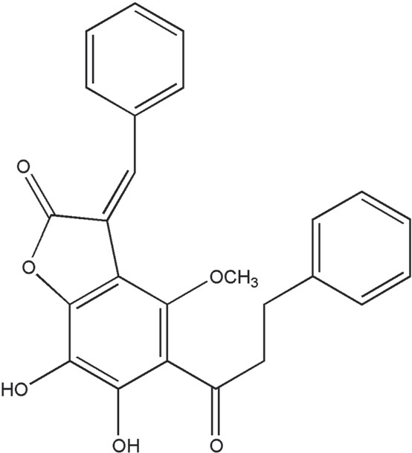
Measurement of extracellular O• −
2
generation. The assay of O• −
genera-

tion was based on the superoxide dismutase (SOD)-inhibitable reduc- tion of WST-1 (Tan and Berridge, 2000). After supplementation with
2
0.3 mM WST-1 and 1 mM Ca2+, freshly isolated neutrophils
(6 × 105 cells/ml) were equilibrated at 37 °C for 2 min and incubated with bractelactone for 5 min. Cells were activated with FMLP (100 nM) or phorbol myristate acetate (PMA, 5 nM) for 10 min. Cyto- chalasin B (CB) at 1 μg/ml was incubated for 3 min before the addition of FMLP. Changes in absorbance with the reduction of WST-1 at 450 nm were continually monitored in a double-beam, six-cell positioner spec- trophotometer with constant stirring (U-3010, Hitachi, Tokyo, Japan).

Determination of intracellular O• −
2
. The intracellular production of

• − in stimulated neutrophils using HE was quantiﬁed in individual
O
2
cells by ﬂow cytometry (Kalyanaraman et al., 2012). HE at 1 μM was loaded into neutrophils and incubated at 37 °C for 10 min. Bractelactone was added to the suspensions for 5 min, and then FMLP (0.1 μM) was added and incubated for 5 min in the presence of CB (1 μg/ml). Ice-cold HBSS was added to the suspensions to stop
• −

the reaction. O2
release was monitored by ﬂow cytometry (FACScan,

Becton Dickinson, San Jose, CA, USA).

Fig. 1. Chemical structure of (3Z)-6,7-dihydroxy-4-methoxy-3-(phenylmethylidene)-
5-(3-phenylpropanoyl)-1-benzofuran-2(3H) (bractelactone).
Measurement of ROS release. ROS were measured using a luminol- enhanced chemiluminescence (LECL) method. Neutrophils (2 × 105)

were preincubated at 37 °C for 5 min in 300 μl HBSS containing luminol (37.5 μM) and horseradish peroxidase (HRP; 6 U/ml). Cells were activat- ed by FMLP (100 nM)/CB (1 μg/ml) in a preincubation with drugs for
5 min, and LECL responses were detected using a multimode microplate reader (Inﬁnite 200 PRO, Tecan, Männedorf, Switzerland).
Determination of inositol 1 phosphate (IP1) levels. Quantiﬁcation of IP1 accumulated in neutrophils was determined using a homogeneous time-resolved ﬂuorescence assay kit (Cisbio, Bedford, MA, USA), and the assay was performed according to the manufacturer's instructions. Neutrophils (2.5 × 107/ml) were pretreated with LiCl (50 mM) for
15 min and incubated with drugs for 5 min at 37 °C. FMLP was then

• − • −

O2 -scavenging activity. The O2
-scavenging ability of bractelactone
added, and the reaction mixture was incubated for 15 min. IP1 produc-

was assayed by xanthine/xanthine oxidase (XO) in a cell-free system. The assay buffer (50 mM Tris (pH 7.4), 0.3 mM WST-1, and 0.02 U/ml XO) was equilibrated at 37 °C for 2 min and incubated with or without bractelactone for 5 min. After incubation, 0.1 mM xanthine was added to the assay buffer for 15 min at 30 °C, and the absorbance associated
• −
tion was detected by the addition of lysis buffer containing the IP1-d2 conjugate followed by the addition of an Eu-cryptate-labeled anti-IP1 antibody. Time-resolved ﬂuorescence at 620 and 665 nm was mea- sured with PHERAstar and RUBYstar after incubation at room tempera- ture for 60 min.

with the O2
-induced WST-1 reduction was measured at 450 nm.

Determination of intracellular cAMP concentrations. Neutrophils were

Measurement of elastase release. Degranulation of azurophilic granules was determined by elastase release (Hwang et al., 2009b). Experiments were performed using MeO–Suc–Ala–Ala–Pro–Val–p-nitroanilide as the elastase substrate. Brieﬂy, after supplementation with MeO–Suc–Ala– Ala–Pro–Val–p-nitroanilide (100 μM), neutrophils (6 × 105 cells/ml) were equilibrated at 37 °C for 2 min and incubated with bractelactone for 5 min. Cells were activated with 100 nM FMLP and 0.5 μg/ml CB for 10 min, and changes in absorbance at 405 nm were continually monitored to assay elastase release. Results are expressed as a percent of elastase release in the FMLP/CB-activated drug-free control group.
To assay whether bractelactone exhibits inhibitory ability toward elastase activity, a direct elastase activity assay was performed in a cell-free system. Neutrophils (6 × 105/ml) were incubated for 15 min in the presence of FMLP (100 nM)/CB (2.5 μg/ml) at 37 °C. Cells were then centrifuged at 1000 g for 5 min at 4 °C in order to collect the elas- tase from the supernatant. The supernatant was equilibrated at 37 °C for 2 min and incubated with or without bractelactone for 5 min. After incubation, MeO–Suc–Ala–Ala–Pro–Val–p-nitroanilide (100 μM) was added to the reaction mixtures. Changes in absorbance at 405 nm were continually monitored for 10 min to assay the elastase activity.

Measurement of CD11b expression. Neutrophils (2.5 × 106/ml) were equilibrated at 37 °C for 2 min and incubated with bractelactone for
5 min. Cells were activated by FMLP (100 nM) for 5 min in the presence of CB (0.5 μg/ml). The reaction was stopped by placing cells on ice, and then cells were centrifuged at 4 °C. After removing the supernatants, cells were resuspended in 0.5% bovine serum albumin for immunoﬂuo- rescent staining of FITC-labeled-anti-CD11b (1 μg) (eBioscience, San Diego, CA, USA) for 90 min at 4 °C. CD11b expression was measured by ﬂow cytometry.

Measurement of lactate dehydrogenase (LDH) release. Release of LDH into the cell medium indicates cell-membrane damage. LDH re- lease was determined by commercially available reagents (Promega, Madison, WI, USA), and was evaluated by changes in absorbance at
incubated with bractelactone for 5 min before stimulation with FMLP for another 1 min. Dodecytrimethylammonium bromide (0.5%) was added to lyse cells and terminate the reaction. Samples were then centrifuged at 3000 g for 5 min at 4 °C. Supernatants were used as a source for cAMP samples. cAMP levels were assayed using enzyme im- munoassay kits (Amersham Biosciences, Buckinghamshire, UK), and the assay was performed according to the manufacturer's instructions.

Immunoblotting analysis of whole-cell lysates. Neutrophils were incu- bated with bractelactone for 5 min at 37 °C before being stimulated with FMLP for another 1 min. Cells were pelleted and resuspended in ice-cold relaxation buffer (20 mM Tris–HCl (pH 7.4), 150 mM NaCl,
2 mM Na3VO4, 1 mM EGTA, 1 mM NaF, 1 mM phenylmethylsulfonyl ﬂuoride, 1% dilution of a Sigma protease inhibitor cocktail, 1% dilution of Sigma phosphatase inhibitor cocktails, and 1% Triton X-100). Samples were centrifuged at 14,000 g for 20 min at 4 °C to yield whole-cell ly- sates. Proteins derived from whole-cell lysates were separated by sodi- um dodecylsulfate-polyacrylamide gel electrophoresis (SDS-PAGE) using 12% polyacrylamide gels and blotted onto nitrocellulose mem- branes. Immunoblotting was performed using the indicated antibodies and HRP-conjugated secondary antibodies (Cell Signaling Technology, Beverly, MA, USA). Immunoreactive bands were visualized by an en- hanced chemiluminescence system from PerkinElmer (Boston, MA, USA).

Statistical analysis. The value of the 50% inhibitory concentration (IC50) was calculated by the concentration response curves from in- dependent experiments with Sigmaplot software (Jandel Scientiﬁc, San Rafael, CA, USA). Data are expressed as the mean ± S.E.M., and comparisons were statistically calculated by Student's t-test or analy- sis of variance (ANOVA). A value of p b 0.05 was considered statistical- ly signiﬁcant.

Results

• −

490 nm. Cytotoxicity was represented by LDH release in cell-free me-
Bractelactone signiﬁcantly inhibits O2
production, ROS generation, and

dium as a percentage of the total LDH in this system. The total LDH re- leased was determined by lysing cells with 0.1% Triton X-100 for
30 min at 37 °C.

Measurement of calcium concentration. Neutrophils were loaded with
elastase release in FMLP-induced human neutrophils

From stems of F. bracteolatum, ﬁve compounds were isolated: bractelactone, piperolactam A, aristololactam BIII, aristololactam BII, and ﬁssilandione. In order to explore the anti-inﬂammatory constituents
• −

2 μM ﬂuo-3 AM at 37 °C for 45 min. After being washed, cells
of stems of F. bracteolatum, the effects of these ﬁve isolates on O2
gen-

(3 × 106 cells/ml) were resuspended in Ca2+-free HBSS. The change in
ﬂuorescence was monitored using a Hitachi F-4500 spectroﬂuorometer
eration were assayed in FMLP-activated human neutrophils (Lan et al.,
2005). Among them, bractelactone showed the most-potent inhibitory
• −

in a quartz cuvette with a thermostat (37 °C) and continuous stirring.
effect on O2
production in FMLP/CB-activated human neutrophils

The excitation wavelength was 488 nm, and the emission wavelength was 520 nm. FMLP or thapsigargin was used to increase [Ca2+]i in the presence and absence of 1 mM Ca2+. [Ca2+]i was calibrated by the ﬂuorescence intensity as follows: [Ca2+]i = Kd ×[(F − Fmin)/(Fmax − F)]; where F is the observed ﬂuorescence intensity, Fmax and Fmin were re- spectively obtained by the addition of 0.05% Triton X-100 and 20 mM
EGTA, and Kd was taken to be 400 nM.
with an IC50 value of 0.65 ± 0.06 μM (Fig. 2A). Neutrophil respiratory burst is a very important event in many inﬂammatory disorders. The
• − produced by NADPH oxidase in human neutrophils can be converted to various ROS that are strongly antimicrobial but which also
O
2
cause tissue damage. Our data showed that FMLP/CB-induced ROS gen- eration was also inhibited by bractelactone (Fig. 2B). However, exposure of human neutrophils to high concentrations of bractelactone (10 μM)

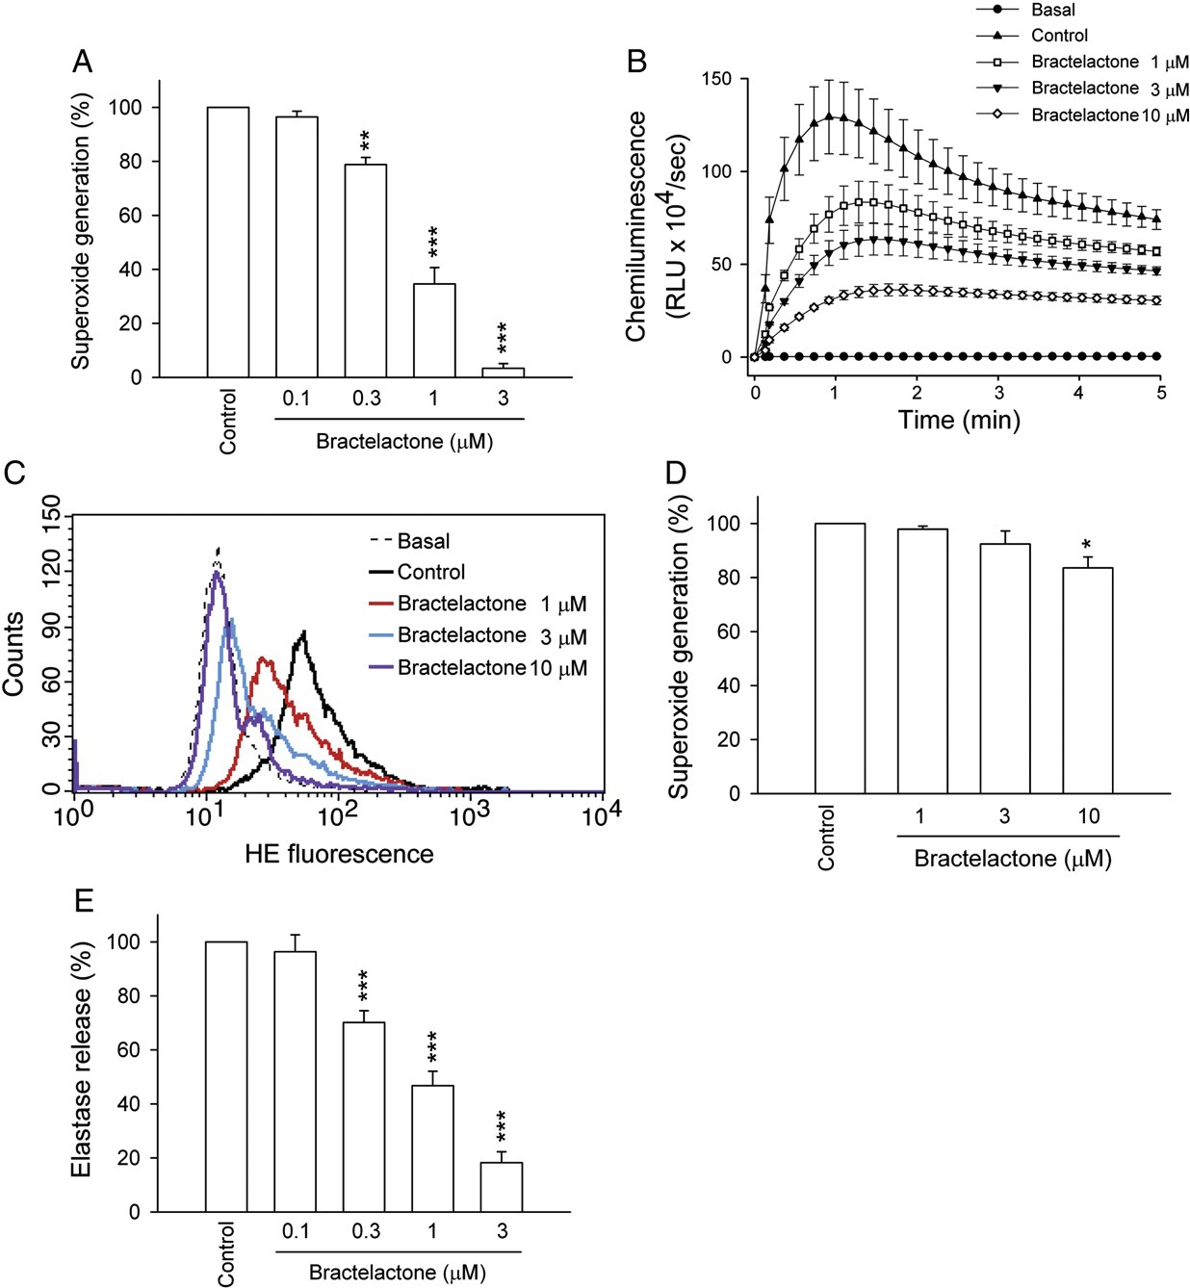

Fig. 2. Effects of bractelactone on O2•− production, ROS generation and elastase release in human neutrophils. Human neutrophils were preincubated with DMSO (control) or
• −

bractelactone for 5 min before activation by FMLP/CB. O2
production and ROS generation were respectively measured using SOD-inhibitable WST-1 reduction (A) and an LECL

method (B). C, intracellular O2
• −
generation in HE-labeled neutrophils was induced by FMLP/CB and quantiﬁed in individual cells by ﬂow cytometry. D, O2
production was induced

by PMA and measured using SOD-inhibitable WST-1 reduction. E, elastase release was induced by FMLP/CB and measured spectrophotometrically at 405 nm. All data are expressed as the mean ± S.E.M. (n =3–6). **p b 0.01; ***p b 0.001 compared to the control.
• −

showed only slight inhibition of PMA-induced O• −
2
production (Fig. 2D).
• −
integrity of cell membranes, as assayed by LDH release (data not

In addition, bractelactone (1, 3, and 10 μM) reduced intracellular O2
production by human neutrophils in response to FMLP/CB (Fig. 2C). Diphenyleneiodonium (10 μM) and apocycin (300 μM), inhibitors of
shown). These data indicate that inhibition of respiratory burst and
degranulation by bractelactone was not due to cytotoxicity.

• −

NADPH oxidase, were used as positive controls and completely repressed
• −
Bractelactone shows no effect on O2
scavenging and only weakly

O2 production and ROS release (data not shown).
Neutrophil degranulation was also measured according to the ex- tent of release of the primary granule-derived protease, elastase. Bractelactone (0.1–3 μM) also reduced elastase release in FMLP/ CB-activated neutrophils in a concentration-dependent manner
inhibits elastase activity

Many natural bioactive compounds from plant species were shown to display direct scavenging activity of free radical species (Middleton et al., 2000). To investigate whether bractelactone
• −

with an IC50 value of 0.85 ± 0.09 μM (Fig. 2E). Culturing cells in the
shows an O2
-scavenging capability, bractelactone responses were ana-

presence of bractelactone (0.3–30 μM) for 15 min did not affect the
lyzed in a cell-free xanthine/XO system. Bractelactone at concentrations

of up to 30 μM failed to alter WST-1's reduction caused by O• −
2
genera-

tion. SOD (20 U/ml) was used as a positive control in the xanthine/XO
system. Additionally, bractelactone (3 and 30 μM) did not affect the re-
• −

moval of O2
by SOD (0.2 U/ml) (Fig. 3A). These results rule out the
• −

possibility that the inhibitory effects of bractelactone on O2
• −
release

occur through the direct scavenging of O2
. Additionally, bractelactone

did not alter uric acid formation in the xanthine/XO system (data not shown), suggesting that it displays no effect on XO activity. On the other hand, to understand whether bractelactone is able to inhibit elastase activity, a direct elastase activity assay was performed in a cell-free system. As shown in Fig. 3B, bractelactone inhibited elastase activity in a cell-free system at higher concentrations with an IC50 value of 8.95 ± 2.26 μM.

Bractelactone reduces CD11b expression in FMLP-induced human neutrophils

The migration of neutrophils into tissues is a crucial event in the inﬂammatory response. To investigate whether bractelactone reduces integrin expression in FMLP/CB-treated human neutrophils, the amount of CD11b expression on the cell surface was assayed. Stimu- lation of human neutrophils with FMLP resulted in signiﬁcant upregulation of CD11b expression. Moreover, bractelactone (1 and
3 μM) signiﬁcantly inhibited CD11b expression in FMLP/CB-activated

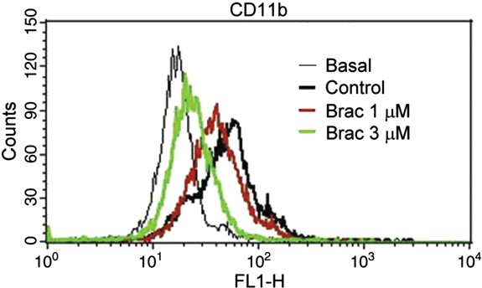
Fig. 4. Bractelactone inhibits CD11b expression in FMLP-activated human neutrophils. Cells (2.5 × 106/ml) were preincubated with DMSO (control) or bractelactone (Brac, 1 and 3 μM) for 5 min before stimulation with FMLP/CB for another 5 min. The ﬂuores- cence intensity of FITC-labeled-anti-CD11b was monitored using ﬂow cytometry as described in “Materials and methods”. Representative traces from one of the four ex- periments are shown.

examine whether the cAMP pathway is involved in the inhibitory effects of bractelactone, cAMP levels were assayed in this study. Rolipram (3 μM), a PDE4 inhibitor, induced a signiﬁcant increase in cel- lular cAMP concentrations in activated human neutrophils. In contrast, bractelactone (0.3, 1, and 3 μM) failed to alter cAMP levels (Fig. 5A).
• −

human neutrophils (Fig. 4).
Moreover, the inhibition of O2
generation and elastase release

The cAMP pathway is not involved in the inhibitory effects of bractelactone

Elevation of cAMP levels in neutrophils is associated with inhibi- tion of human neutrophil functions (Anderson et al., 1998). To

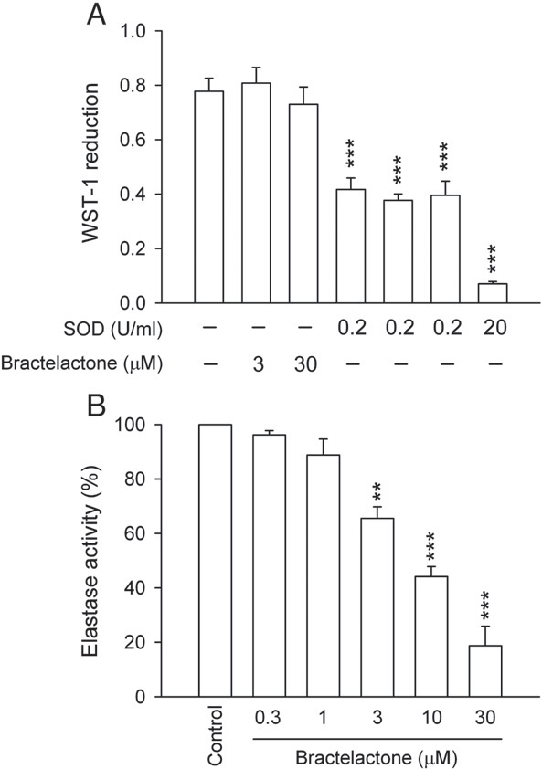

Fig. 3. Effects of bractelactone on O2 production and elastase activity in cell-free systems. A, O• − generation by xanthine/xanthine oxidase was measured using SOD-inhibitable
2
• −
WST-1 reduction. Reduction of WST-1 was measured spectrophotometrically at 450 nm in the presence of bractelactone with and without SOD. B, elastase activity was assayed in cell-free conditioned medium in the presence of bractelactone. All data are expressed as the mean ± S.E.M. (n = 4 or 6). **p b 0.01; ***p b 0.001 compared to the control.
in FMLP-activated neutrophils by bractelactone was not reversed by the protein kinase A (PKA) inhibitor, H89 (3 μM). (Figs. 5B, C). PGE1 (an adenylate cyclase activator) was used as a positive control. These data suggest that bractelactone does not activate the cAMP signaling pathway.

Bractelactone inhibits Ca2+ mobilization

It is well known that activation of the FMLP receptor initiates formation of inositol 1,4,5-triphosphate (IP3) for Ca2+ release from intracellular endoplasmic reticular (ER) stores (Ohta et al., 1985). Such Ca2+ release depletes ER Ca2+ stores and subsequently initiates Ca2+ entry via store-operated Ca2+ entry (SOCE) (Itagaki et al., 2002; Salmon and Ahluwalia, 2011; Schaff et al., 2010). Interestingly, FMLP-induced peak [Ca2+]i values were not altered by bractelactone, whereas the time taken for [Ca2+]i to return to half of the peak values (t1/2) was signiﬁcantly shortened by bractelactone (0.3, 1 and 3 μM) in a concentration-dependent manner (Fig. 6A, Table 1). Thapsigargin, a speciﬁc inhibitor of ER Ca2+-ATPases (ERCAs), is able to induce inﬂux of Ca2+ through SOCE by blocking ER Ca2+ re-uptake (Salmon and Ahluwalia, 2011). Bractelactone did not alter initial [Ca2+]i increases but suppressed sustained [Ca2+]i changes in thapsigargin-activated human neutrophils (Fig. 6B, Table 1), suggesting that bractelactone in- hibits SOCE. In line with this hypothesis, bractelactone did not affect the FMLP-induced increase in [Ca2+]i values in Ca2+-free medium; however, [Ca2+]i values after the subsequent addition of 1 mM Ca2+ were inhibited by bractelactone (Fig. 7A). The latter response was also conﬁrmed when bractelactone was added after FMLP (Fig. 7B, Table 2).

Bractelactone does not inhibit IP1 formation

IP3 can be broken down into IP2 and then IP1 within cells, and the lifetime of IP3 is very short. IP1 accumulates and can be detected in cells after LiCl pretreatment. To verify whether phospholipase C (PLC)/IP3 is involved in the inhibitory effects of bractelactone, IP1 for- mation was assayed. FMLP induced a signiﬁcant increase in IP1 pro- duction. However, bractelactone (0.3, 1, and 3 μM) did not alter FMLP-induced IP1 levels in human neutrophils. IP1 formation was completely inhibited by the positive control, U73122 (1 μM), a PLC inhibitor (Fig. 8).

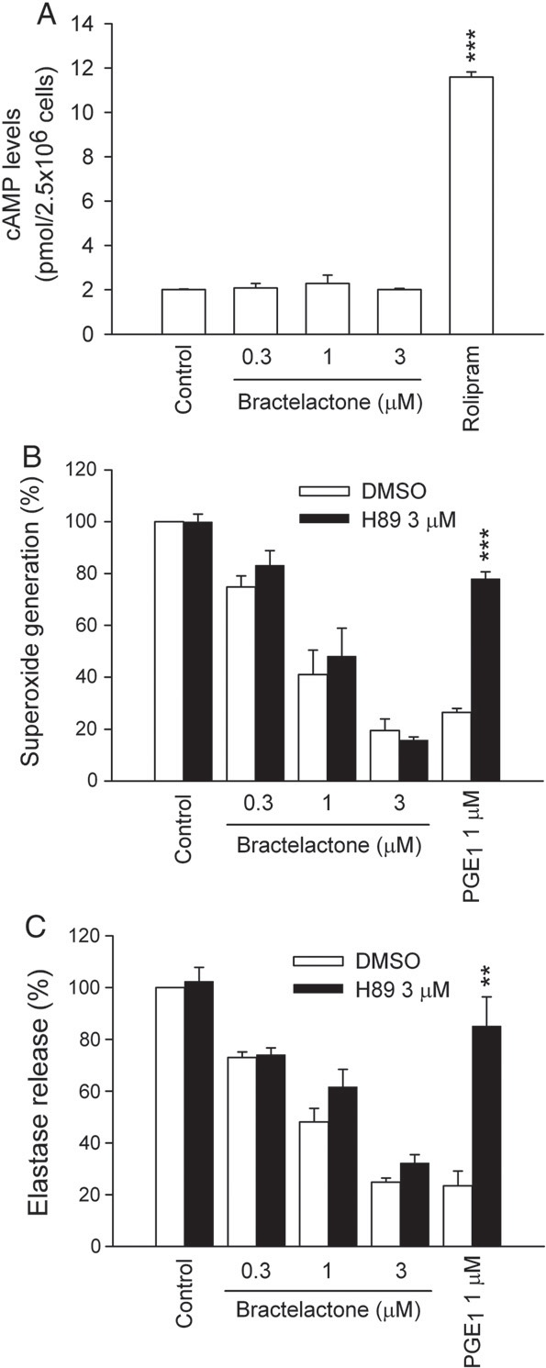

Fig. 5. The cAMP pathway is not involved in bractelactone-caused inhibition. A, human neutrophils were incubated with DMSO (control), bractelactone (0.3, 1, and 3 μM) or rolipram (3 μM) for 5 min before stimulation with and without FMLP (0.1 μM) for an-
• −

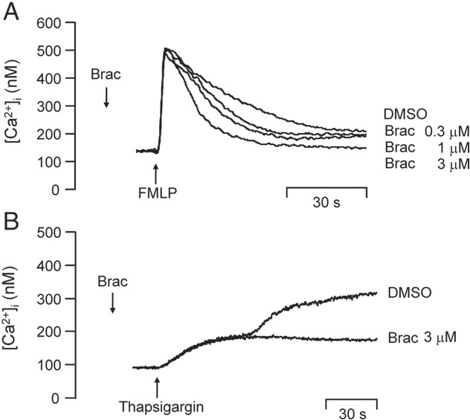

Fig. 6. Effects of bractelactone on Ca2+ mobilization in FMLP- or thapsigargin-activated human neutrophils. Fluo 3-loaded neutrophils were incubated with bractelactone (0.3, 1, or 3 μM) for 5 min before stimulation with FMLP (0.1 μM) (A) or thapsigargin (0.5 μM) (B). Mobilization of Ca2+ was determined in real time in a spectroﬂuorometer. Represen- tative traces from one of the three or ﬁve experiments are shown.

2007; Rane et al., 1997). To investigate whether the phosphorylation of MAPKs and Akt in FMLP-activated human neutrophils was reduced by bractelactone, activated forms of p38 MAPK, ERK, JNK, and Akt were determined by a Western blot analysis. Stimulation of human neutrophils with FMLP resulted in the rapid and signiﬁcant phosphor- ylation of p38 MAPK, ERK, JNK, and Akt. However, bractelactone (0.3,
1, and 3 μM) did not alter FMLP-induced phosphorylation of p38
MAPK, ERK, JNK, or Akt in human neutrophils (Fig. 9).

Discussion

The aims of the present study were to explore the effects of bractelactone, a novel bioactive compound isolated from stems of F. bracteolatum, on adhesion, respiratory burst, and degranulation in FMLP-activated human neutrophils. Also, the signaling pathways re- sponsible for bractelactone-caused inhibition were investigated. Our results show for the ﬁrst time that bractelactone potently inhibits FMLP-induced human neutrophil activation through speciﬁcally inhibiting SOCE.
The migration of neutrophils into tissues is a crucial event in the inﬂammatory response and comprises three essential biological pro- cesses of rolling, adhesion, and transmigration (Albelda et al., 1994). Bractelactone diminished FMLP-induced upregulation of CD11b ex- pression, indicating that it can attenuate neutrophil adhesion. Both oxidative stress and elastase accumulation by activated neutrophils

Table 1
Effects of brectelactone on peak intracellular calcium concentrations [Ca2+]i, and the time taken for this concentration to decline to half of its peak values (t1/2) in FMLP-

other 1 min. cAMP levels were measured by enzyme immunoassay kits. O2
genera-
or thapsigargin-activated neutrophils.

tion (B) and elastase release (C) were induced by FMLP/CB. H89 (3 μM) was

preincubated for 5 min before the addition of bractelactone and PGE1. All data are
FMLP Thapsigargin

expressed as the mean ± S.E.M. (n = 3 or 4). **p b 0.01; ***p b 0.001 compared to the
corresponding DMSO control.

Peak [Ca
2+]i t1/2 1st [Ca
2+]i 2nd [Ca
2+]i

Bractelactone does not alter phosphorylation of mitogen-activated protein kinases (MAPKs) or protein kinase B (Akt)

Activation of human neutrophils with FMLP leads to activation of an array of intracellular protein kinases, and activation of MAPKs and Akt is associated with neutrophil activities (Burelout et al.,
nM s nM nM

Control 354.76 ± 14.83 26.20 ± 1.59 143.18 ± 20.72 254.80 ± 18.67
Bractelactone
0.3 μM 372.00 ± 17.50 17.24 ± 1.16⁎⁎
1 μM 361.18 ± 18.02 16.89 ± 2.04⁎⁎
3 μM 350.49 ± 23.12 10.45 ± 0.93⁎⁎⁎ 136.80 ± 12.54 134.83 ± 18.44⁎⁎
For all data, values are the mean ± S.E.M. (n =3–5). ⁎⁎p b 0.01, and ⁎⁎⁎p b 0.001 compared with the control.

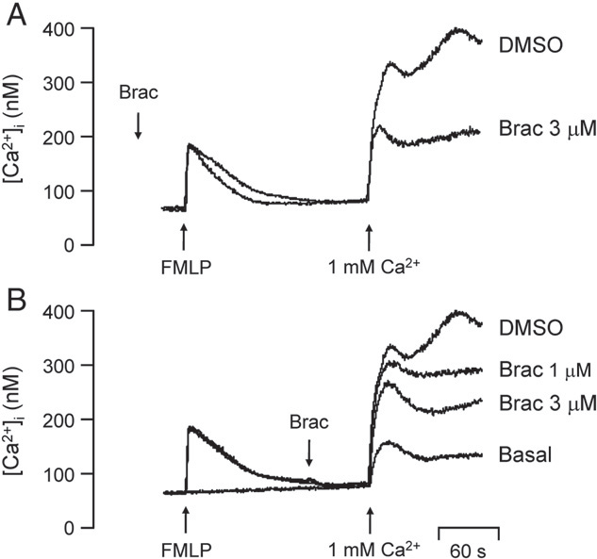

Fig. 7. Bractelactone reduces extracellular Ca2+ inﬂux in FMLP-activated human neu- trophils. Fluo 3-loaded neutrophils were incubated with bractelactone (Brac, 3 μM)

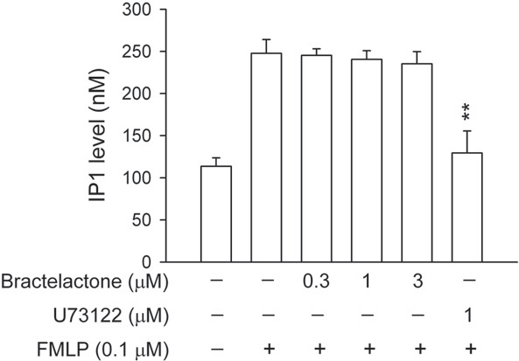

Fig. 8. Bractelactone did not inhibit IP1 formation. Human neutrophils were incubated with DMSO, bractelactone (0.3, 1, and 3 μM), or U73122 (1 μM) for 5 min before stim- ulation with FMLP (0.1 μM) for 15 min at 37 °C. The IP1 level was analyzed by a homo- geneous time-resolved ﬂuorescence assay kit. All data are expressed as the mean ± S.E.M. (n = 4). **p b 0.01 compared to the corresponding DMSO control.

1997; Selvatici et al., 2006). Bractelactone failed to alter PMA, a po-
• −

for 5 min and then activated by 0.1 μM FMLP in Ca2+-free HBSS followed by the addi-
tent PKC activator, induced O2
production in intact cells, and
• −

tion of 1 mM Ca2+ (A). B, bractelactone (1 and 3 μM) was added after the addition of
exhibited no signiﬁcant ability to scavenge O2
or inhibit elastase ac-

FMLP. Traces shown are from three or four different experiments. All data are expressed as the mean ± S.E.M. (n = 4).

are well known to be involved in the pathogenesis of inﬂammatory diseases. Activation of neutrophils results in enhanced oxygen con- sumption via activation of NADPH oxidase leading to the generation
• −
tivity in cell-free systems. These data indicate that inhibition of neu-
trophil activation by bractelactone occurs by modulating a novel cellular signaling pathway. However, the results suggest that bractelactone might not act through the MAPK or PI3K/Akt pathways because bractelactone did not inhibit FMLP-caused phosphorylation of p38 MAPK, ERK, JNK, and Akt.
FMLP binds to the GPCR that stimulates PLC to catalyze
2+

of O2
, a phenomenon called respiratory burst (Dahlgren and
• −
phosphoinosital 4,5-biphosphate into IP3 to trigger rapid Ca
2+
release

Karlsson, 1999). Production of O2
and ROS is linked with the killing
from intracellular ER Ca
stores (Berridge, 2009; Downey et al.,

of invading microorganisms, but it can directly or indirectly cause damage by destroying surrounding tissues. Moreover, neutrophil granules contain multiple serine proteases. Among them, elastase, stored in large amounts in azurophilic granules, degrades extracellu- lar matrixes and plasma proteins via its proteolytic activity, and also stimulates proinﬂammatory cytokines and cellular receptors (Korkmaz et al., 2010). We found that bractelactone potently
• −
1995; Matron et al., 2010). Other researchers and ourselves have reported that FMLP-induced Ca2+ mobilization is correlated with respi- ratory burst and degranulation of human neutrophils (Cockeran et al.,
2012; Hwang et al., 2009b). Consistent with this, BAPTA-AM (10 and
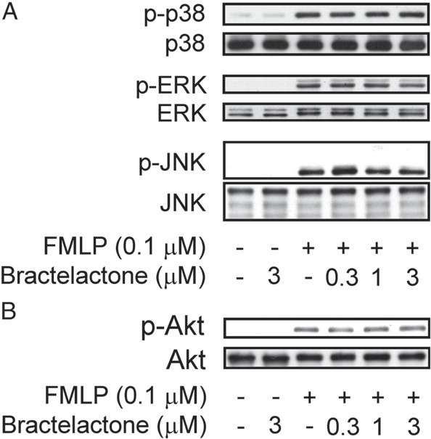
20 μM), a cell-permeable Ca2+ chelator, reduced the production of

inhibited O2
production, ROS generation, and elastase release in

FMLP-induced human neutrophils. These data support our hypothesis that bractelactone can act as an anti-inﬂammatory agent.
The intracellular signaling mechanisms responsible for neutrophil activation are very complex and remain elusive. Protein kinases per- form key responses in a majority of signaling pathways and form in- teractive networks for activation of most events in the intracellular and extracellular milieu. MAPK cascades (p38 kinase, ERK, and JNK) and phosphatidylinositol-3-kinase (PI3K)/Akt signaling systems are mediated by interactions of FMLP with its receptors in multiple intra- cellular activities (Burelout et al., 2007; Lin et al., 2005; Rane et al.,

Table 2
Effect of bractelactone on extracellular Ca2+ mobilization in FMLP-activated human neutrophils. Fluo 3-loaded neutrophils were incubated with bractelactone (1 or
3 μM) before or after the addition of FMLP in Ca2+-free HBSS followed by the addition
of 1 mM Ca2+.
 | Before FMLP |  | After FMLP
 | Peak [Ca2+]i |  | Peak [Ca2+]i
 | nM |  | nM
Control | 245.13 ± 46.77 |  | 270.42 ± 27.03
Bractelactone  1 μM | – |  | 149.28 ± 6.98⁎⁎

3 μM 78.84 ± 12.16⁎⁎ 95.03 ± 15.33⁎⁎⁎
Fig. 9. Bractelactone did not alter phosphorylation of MAPK or Akt. Human neutrophils were incubated with DMSO or bractelactone (0.3, 1, and 3 μM) for 5 min before stim- ulation with FMLP (0.1 μM) for 1 min at 37 °C. Phosphorylation of p38, p42/44, JNK (A)

and Akt (B) was analyzed by an immunoblot analysis using antibodies against the

For all data, values are the mean ± S.E.M. (n = 4). ⁎⁎p b 0.01, and ⁎⁎⁎p b 0.001 compared with the control.
phosphorylated form and the total amount of each protein. Representative images from one of three–six experiments are shown.

• − and release of elastase in FMLP-activated human neutrophils (data not shown). Signiﬁcantly, the peak [Ca2+]i concentration was unaltered by bractelactone in FMLP-induced neutrophils, but the decay time of [Ca2+]i was signiﬁcantly shortened. Moreover, FMLP-induced IP3 for- mation was not altered by bractelactone, indicating that inhibition of [Ca2+]i by bractelactone is not through alteration of the PLC/IP3 signal- ing pathway. Many reports showed that cAMP is a second messenger that regulates an array of physiological activities in cells. Other re- searchers and ourselves reported that increased intracellular cAMP levels are associated with multiple intracellular activities such as respiratory burst and degranulation of neutrophils (Anderson et al., 2009; Yu et al.,
O
2
2011). Gαs proteins induce adenylyl cyclase enzymes that catalyze ATP to cAMP, whereas it is degraded by phosphodiesterases. Rolipram, a well-known inhibitor of phosphodiesterase 4, did not alter peak [Ca2+]i levels but decreased the t1/2 value of [Ca2+]i in FMLP-activated human neutrophils (Yu et al., 2011). In addition, our previous reports in- dicated that inhibition of human neutrophil functions by the chalcone derivatives, viscolin and 3′-isopropoxychalcone, was cAMP-dependent (Hwang et al., 2006a,b). It was noted that bractelactone, a natural chalcone compound, signiﬁcantly reduced the decay time of [Ca2+]i in FMLP-activated human neutrophils. However, bractelactone did not
• −
References

Albelda, S.M., Smith, C.W., Ward, P.A., 1994. Adhesion molecules and inﬂammatory in- jury. FASEB J. 8, 504–512.
Aminimoghadamfarouj, N., Nematollahi, A., Wiart, C., 2011. Annonaceae: bio-resource for tomorrow's drug discovery. J. Asian Nat. Prod. Res. 13, 465–476.
Anderson, R., Goolam Mahomed, A., Theron, A.J., Ramaﬁ, G., Feldman, C., 1998. Effect of rolipram and dibutyryl cyclic AMP on resequestration of cytosolic calcium in FMLP- activated human neutrophils. Br. J. Pharmacol. 124, 547–555.
Anderson, R., Theron, A.J., Gravett, C.M., Steel, H.C., Tintinger, G.R., Feldman, C., 2009.
Montelukast inhibits neutrophil pro-inﬂammatory activity by a cyclic AMP- dependent mechanism. Br. J. Pharmacol. 156, 105–115.
Arazna, M., Pruchniak, M.P., Zycinska, K., Demkow, U., 2013. Neutrophil extracellular trap in human diseases. Adv. Exp. Med. Biol. 756, 1–8.
Berridge, M.J., 2009. Inositol trisphosphate and calcium signalling mechanisms.
Biochim. Biophys. Acta 1793, 933–940.
Blidberg, K., Palmberg, L., Dahlen, B., Lantz, A.S., Larsson, K., 2012. Increased neutrophil migration in smokers with or without chronic obstructive pulmonary disease. Respirology 17, 854–860.
Boyum, A., Lovhaug, D., Tresland, L., Nordlie, E.M., 1991. Separation of leucocytes: improved cell purity by ﬁne adjustments of gradient medium density and osmolality. Scand. J. Immunol. 34, 697–712.
Burelout, C., Naccache, P.H., Bourgoin, S.G., 2007. Dissociation between the transloca- tion and the activation of Akt in fMLP-stimulated human neutrophils—effect of prostaglandin E2. J. Leukoc. Biol. 81, 1523–1534.
Cascao, R., Rosario, H.S., Souto-Carneiro, M.M., Fonseca, J.E., 2010. Neutrophils in rheu- matoid arthritis: more than simple ﬁnal effectors. Autoimmun. Rev. 9, 531–535.

change cAMP levels, and its inhibitory effects on O2
generation and
Cockeran, R., Mutepe, N.D., Theron, A.J., Tintinger, G.R., Steel, H.C., Stivaktas, P.I.,

elastase release were not restored by a PKA inhibitor. These results indi- cate that the cAMP pathway is not involved in bractelactone-mediated inhibition of neutrophil activation. The increase in [Ca2+]i induced by thapsigargin, an inhibitor of ERCAs, was initiated by the slow release of Ca2+ from intracellular Ca2+ stores, which caused considerable and sustained extracellular Ca2+ entry. Signiﬁcantly, bractelactone did not affect initial thapsigargin-induced [Ca2+]i increases but suppressed sustained [Ca2+]i changes. On the basis of our data, we suggest that bractelactone regulates [Ca2+]i mobilization by blocking SOCE. To inves- tigate this hypothesis, cells were treated with bractelactone before and after the addition of FMLP in Ca2+-free medium. The sustained phase of [Ca2+]i elevation by the subsequent addition of extracellular Ca2+ was inhibited by bractelactone. Results again support the inhibition of human neutrophil activations by bractelactone occurring through a blockade of extracellular Ca2+ inﬂux. SOCE is a major mechanism for ex- tracellular Ca2+ inﬂux in many cells and has several important physio- logical functions. It is not clear from the present ﬁndings whether bractelactone has the same effect in other cells. Also, the in vivo re- sponses of bractelactone need to be further systematically investigated.
A core of epidemiological observations suggests that natural bioactive compounds exhibit essential roles in preventing anti-inﬂammatory dis- eases, and these compounds can be used to treat multiple ailments (Ojima, 2008; Winslow and Kroll, 1998). Studying the pharmacological mechanisms of potential herbs would be valuable in developing better therapeutic strategies, and the compound structure is useful as a lead for further structural modiﬁcations to improve anti-inﬂammatory activ- ities (Ganesan, 2008; Kingston, 2011; Ojima, 2008). Our present study shows that bractelactone, a novel chalcone isolated from the medicinal herb F. bracteolactum, inhibits adhesion, respiratory burst, and degranu- lation in activated human neutrophils. Multiple observations made in the study suggest that bractelactone exhibits its anti-inﬂammatory effects by speciﬁcally blocking SOCE. The unique chemical structure and pharma- cological function of bractelactone support its further development as a novel therapeutic agent for treating neutrophilic inﬂammation.

Conﬂict of interest statement

There are no conﬂicts of interest.

Acknowledgments

This work was supported by grants from Chang Gung University (EMRPD1A0881, CMRPD160211~2, and CMRPD180221~3) and the National Science Council, Taiwan (NSC 99-2320-B-182-006-MY3).
Richards, G.A., Feldman, C., Anderson, R., 2012. Calcium-dependent potentiation
of the pro-inﬂammatory functions of human neutrophils by tigecycline in vitro. J. Antimicrob. Chemother. 67, 130–137.
Dahlgren, C., Karlsson, A., 1999. Respiratory burst in human neutrophils. J. Immunol.
Methods 232, 3–14.
Deng, Y., Chen, J., Wu, F.E., 2002. Two new aporphine alkaloids from Fissistigma bracteolatum. Chin. Chem. Lett. 13, 862–864.
Downey, G.P., Fukushima, T., Fialkow, L., 1995. Signaling mechanisms in human neu- trophils. Curr. Opin. Hematol. 2, 76–88.
Ganesan, A., 2008. The impact of natural products upon modern drug discovery. Curr.
Opin. Chem. Biol. 12, 306–317.
Grommes, J., Soehnlein, O., 2011. Contribution of neutrophils to acute lung injury. Mol.
Med. 17, 293–307.
Hwang, T.L., Leu, Y.L., Kao, S.H., Tang, M.C., Chang, H.L., 2006a. Viscolin, a new chalcone from Viscum coloratum, inhibits human neutrophil superoxide anion and elastase release via a cAMP-dependent pathway. Free Radic. Biol. Med. 41, 1433–1441.
Hwang, T.L., Yeh, S.H., Leu, Y.L., Chern, C.Y., Hsu, H.C., 2006b. Inhibition of superoxide anion and elastase release in human neutrophils by 3′-isopropoxychalcone via a cAMP-dependent pathway. Br. J. Pharmacol. 148, 78–87.
Hwang, T.L., Li, G.L., Lan, Y.H., Chia, Y.C., Hsieh, P.W., Wu, Y.H., Wu, Y.C., 2009a. Potent inhibition of superoxide anion production in activated human neutrophils by isopedicin, a bioactive component of the Chinese medicinal herb Fissistigma oldhamii. Free Radic. Biol. Med. 46, 520–528.
Hwang, T.L., Su, Y.C., Chang, H.L., Leu, Y.L., Chung, P.J., Kuo, L.M., Chang, Y.J., 2009b.
Suppression of superoxide anion and elastase release by C18 unsaturated fatty acids in human neutrophils. J. Lipid Res. 50, 1395–1408.
Itagaki, K., Kannan, K.B., Livingston, D.H., Deitch, E.A., Fekete, Z., Hauser, C.J., 2002.
Store-operated calcium entry in human neutrophils reﬂects multiple contributions from independently regulated pathways. J. Immunol. 168, 4063–4069.
Kalyanaraman, B., Darley-Usmar, V., Davies, K.J., Dennery, P.A., Forman, H.J., Grisham, M.B., Mann, G.E., Moore, K., Roberts II, L.J., Ischiropoulos, H., 2012. Measuring reac- tive oxygen and nitrogen species with ﬂuorescent probes: challenges and limita- tions. Free Radic. Biol. Med. 52, 1–6.
Kingston, D.G., 2011. Modern natural products drug discovery and its relevance to bio- diversity conservation. J. Nat. Prod. 74, 496–511.
Korkmaz, B., Horwitz, M.S., Jenne, D.E., Gauthier, F., 2010. Neutrophil elastase, protein- ase 3, and cathepsin G as therapeutic targets in human diseases. Pharmacol. Rev.
62, 726–759.
Lan, Y.H., Chia, Y.C., Chang, R.F., Hwang, T.L., Liaw, C.C., Wu, Y.C., 2005. Potential anti- inﬂammatory activities of bracteolactone and other compounds isolated from Fissistigma bracteolatum. Helv. Chim. Acta 88, 905–909.
Liaw, C.C., Wu, T.Y., Chang, F.R., Wu, Y.C., 2010. Historic perspectives on Annonaceous acetogenins from the chemical bench to preclinical trials. Planta Med. 76, 1390–1404. Lien, T.P., Porzel, A., Schmidt, J., Sung, T.V., Adam, G., 2000. Chalconoids from Fissistigma
bracteolatum. Phytochemistry 53, 991–995.
Lin, P., Welch, E.J., Gao, X.P., Malik, A.B., Ye, R.D., 2005. Lysophosphatidylcholine mod- ulates neutrophil oxidant production through elevation of cyclic AMP. J. Immunol.
174, 2981–2989.
Mantovani, A., Cassatella, M.A., Costantini, C., Jaillon, S., 2011. Neutrophils in the activation and regulation of innate and adaptive immunity. Nat. Rev. Immunol. 11, 519–531.
Matron, C., Chakravarti, A., Allaeys, I., Poubelle, P.E., 2010. PKC-delta controls the fMLF- induced overproduction of superoxide by neutrophils. Free Radic. Biol. Med. 48,
207–215.
Middleton Jr., E., Kandaswami, C., Theoharides, T.C., 2000. The effects of plant ﬂavo- noids on mammalian cells: implications for inﬂammation, heart disease, and cancer. Pharmacol. Rev. 52, 673–751.
Mitra, S., Abraham, E., 2006. Participation of superoxide in neutrophil activation and cytokine production. Biochim. Biophys. Acta 1762, 732–741.

Narasaraju, T., Yang, E., Samy, R.P., Ng, H.H., Poh, W.P., Liew, A.A., Phoon, M.C., van Rooijen, N., Chow, V.T., 2011. Excessive neutrophils and neutrophil extracellular traps contribute to acute lung injury of inﬂuenza pneumonitis. Am. J. Pathol. 179,
199–210.
Nemeth, T., Mocsai, A., 2012. The role of neutrophils in autoimmune diseases.
Immunol. Lett. 143, 9–19.
Ohta, H., Okajima, F., Ui, M., 1985. Inhibition by islet-activating protein of a chemotactic peptide-induced early breakdown of inositol phospholipids and Ca2+ mobilization in guinea pig neutrophils. J. Biol. Chem. 260, 15771–15780.
Ojima, I., 2008. Modern natural products chemistry and drug discovery. J. Med. Chem.
51, 2587–2588.
Pham, C.T., 2006. Neutrophil serine proteases: speciﬁc regulators of inﬂammation. Nat.
Rev. Immunol. 6, 541–550.
Rane, M.J., Carrithers, S.L., Arthur, J.M., Klein, J.B., McLeish, K.R., 1997. Formyl peptide receptors are coupled to multiple mitogen-activated protein kinase cascades by distinct signal transduction pathways: role in activation of reduced nicotinamide adenine dinucleotide oxidase. J. Immunol. 159, 5070–5078.
Rodrigues dos Santos Lima, L.A., Santos Pimenta, L.P., Diamantino Boaventura, M.A.,
2009. Two new adjacent bis-tetrahydrofuran annonaceous acetogenins from seeds of Annona cornifolia. Planta Med. 75, 80–83.
Salmon, M.D., Ahluwalia, J., 2011. Pharmacology of receptor operated calcium entry in human neutrophils. Int. Immunopharmacol. 11, 145–148.
Schaff, U.Y., Dixit, N., Procyk, E., Yamayoshi, I., Tse, T., Simon, S.I., 2010. Orai1 regulates intracellular calcium, arrest, and shape polarization during neutrophil recruitment in shear ﬂow. Blood 115, 657–666.
Schmidt, F., Le Douaron, G., Champy, P., Amar, M., Seon-Meniel, B., Raisman-Vozari, R., Figadere, B., 2010. Tryptamine-derived alkaloids from Annonaceae exerting
neurotrophin-like properties on primary dopaminergic neurons. Bioorg. Med. Chem. 18, 5103–5113.
Selvatici, R., Falzarano, S., Mollica, A., Spisani, S., 2006. Signal transduction pathways triggered by selective formylpeptide analogues in human neutrophils. Eur. J. Pharmacol. 534, 1–11.
Smith, J.A., 1994. Neutrophils, host defense, and inﬂammation: a double-edged sword.
J. Leukoc. Biol. 56, 672–686.
Stevens, T., Ekholm, K., Granse, M., Lindahl, M., Kozma, V., Jungar, C., Ottosson, T., Falk- Hakansson, H., Churg, A., Wright, J.L., Lal, H., Sanfridson, A., 2011. AZD9668: pharma- cological characterization of a novel oral inhibitor of neutrophil elastase. J. Pharmacol. Exp. Ther. 339, 313–320.
Tan, A.S., Berridge, M.V., 2000. Superoxide produced by activated neutrophils efﬁcient-
ly reduces the tetrazolium salt, WST-1 to produce a soluble formazan: a simple colorimetric assay for measuring respiratory burst activation and for screening anti-inﬂammatory agents. J. Immunol. Methods 238, 59–68.
Thuy, T.T., Quan, T.D., Anh, N.T., Van Sung, T., 2012. Cytotoxic and antimicrobial aporphine alkaloids from Fissistigma poilanei (Annonaceae) collected in Vietnam. Nat. Prod. Res. 26, 1296–1302.
Watorek, W., Farley, D., Salvesen, G., Travis, J., 1988. Neutrophil elastase and cathepsin G: structure, function, and biological control. Adv. Exp. Med. Biol. 240, 23–31. Winslow, L.C., Kroll, D.J., 1998. Herbs as medicines. Arch. Intern. Med. 158, 2192–2199. Yu, H.P., Hsieh, P.W., Chang, Y.J., Chung, P.J., Kuo, L.M., Hwang, T.L., 2011. 2-(2-
Fluorobenzamido)benzoate ethyl ester (EFB-1) inhibits superoxide production by human neutrophils and attenuates hemorrhagic shock-induced organ dysfunction in rats. Free Radic. Biol. Med. 50, 1737–1748.
Zhu, H., Lu, X., Sun, X., Xu, Q., Jiao, B., 2010. Dihydrochalcones and phenanthrene deriv- atives from Fissistigma bracteolatum. J. Med. Coll. PLA 25, 226–234.

