Synthesis of Flavones and γ-Benzopyranones Using Mild Sonogashira Coupling and 18-Crown-6 Ether Mediated 6-endo Cyclization

Da-Wei Chuang,[a] Mohamed El-Shazly,[a,b] Barve Balaji D.,[a,c] Yu-Ming Chung,[a]
Fang-Rong Chang,*[a] and Yang-Chang Wu*[a,d,e,f]

Keywords: Synthetic methods / Oxygen heterocycles / Cross-coupling / Cyclization / Michael addition

An efficient method for the synthesis of flavones and γ- benzopyranones has been developed utilizing a mild Sono- gashira coupling and 18-crown-6 ether mediated 6-endo cy- clization of o-alkynoylphenyl acetates. By using this strategy,
flavones and γ-benzopyranones bearing electron-donating groups, halogens, and simple alkyl substituents were synthe- sized in satisfactory yields.

Introduction

Flavones are ubiquitous compounds that can be found in almost every plant of the world. These γ-benzopyranone- containing natural products not only play vital roles in plant physiology but also provide great benefits to human- kind. There are many studies demonstrating their biological functions including their antioxidant, anti-inflammatory, antimicrobial, antiviral, and antitumor effects.[1] Several flavone derivatives have been entered into clinical trials as potent anticancer agents such as flavopiridol (1)[2] and flav- one-8-acetic acid (2).[3] Others such as cromolyn (3)[4] and flavoxate (4)[5] are already available for medical use (Fig- ure 1).
The synthesis of flavone derivatives has always been an interesting topic in the field of organic and medicinal chem- istry. Some common approaches have been developed in- cluding the cyclization of chalcones, the Baker–Venkatara- man rearrangement, and carbonylative annulations of iodo- phenols.[6] Although these reactions are quite effective, most

[a] Graduate Institute of Natural Products, Kaohsiung Medical
University,
Kaohsiung 807, Taiwan
Fax: +886-7-3114773
E-mail: aaronfrc@kmu.edu.tw
[b] Department of Pharmacognosy and Natural Products
Chemistry, Faculty of Pharmacy, Ain-Shams University,
Cairo 11566, Egypt
[c] Department of Medicinal and Applied Chemistry, Kaohsiung
Medical University,
Kaohsiung 807, Taiwan
[d] School of Chinese Medicine, College of Chinese Medicine,
China Medical University,
Taichung 404, Taiwan
[e] Natural Medicinal Products Research Center, China Medical
University Hospital,
Taichung 404, Taiwan
[f] Center for Molecular Medicine, China Medical University
Hospital,
Taichung 404, Taiwan
 Supporting information for this article is available on the
WWW under http://dx.doi.org/10.1002/ejoc.201200529.
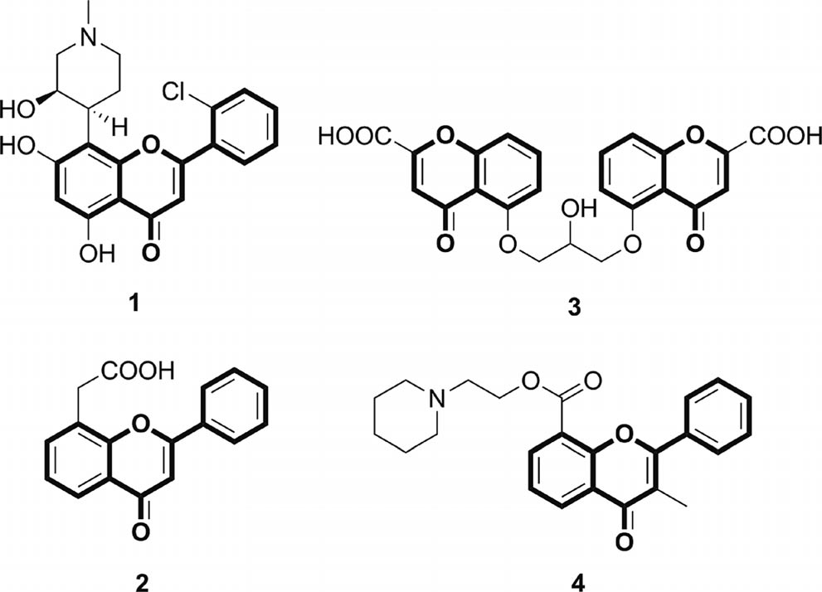

Figure 1. Examples of important flavone derivatives.

of them suffer from serious disadvantages such as harsh conditions, low yields, and tedious workup or isolation pro- cedures. In recent years, the synthesis of flavones through the cyclization of o-alkynoylphenol or its derivatives has be- come an attractive topic,[7] partly because of the feasibility of this method in the chemical and pharmaceutical indus- tries.
Previously, the reported procedures for the synthesis of o-alkynoylphenols called for the use of strong base, utilizing a 1,2-addition reaction of lithiated arylacetylenes or similar Grignard reagents to salicylaldehydes.[7c,7d,8] This restricted the range of functional groups allowed in the starting mate- rials and, consequently, in the products. An alternative solu- tion to this problem is the application of a mild Sonoga- shira coupling, in which terminal acetylenes are treated with acid chlorides in the presence of Pd and CuI as cocata- lysts.[9]
The synthesis of o-alkynoylphenol by the direct coupling of salicyloyl chloride and terminal acetylenes along with a

Pd catalyst was reported by Chiusoli et al.[10] However, un- der the reported conditions, only moderate amounts of o- alkynoylphenol accompanied with minor amounts of flav- one (5) and unwanted aurone (6) were formed (see Table 3 for the structures of 5 and 6). They claimed the formation of 6 might result from the addition of Pd to the OH group followed by an intramolecular triple-bond insertion and re- ductive elimination reactions. These findings imply the cru- cial need for OH protection to improve o-alkynoylphenol yield.

Results and Discussion

In this work, unsubstituted and substituted o-alkynoyl- phenyl acetates were prepared from acetate-protected sali- cylic acid derivatives. For unsubstituted derivatives, the Sonogashira coupling was carried out according to the lit- erature procedures.[9b] The coupling reactions between com- mercially available o-acetylsalicyloyl chloride and phenyl- acetylenes provided o-alkynoylphenyl acetates in high yields (75–90 %, Table 1, Entries 1–6). In addition, the reactions with alkyl-substituted acetylenes afforded the products in good yields (61–82 %, Table 1, Entries 7–9). However, the syntheses of the substituted o-alkynoylphenyl acetates were achieved through a one-pot procedure that utilized substi- tuted salicylates as the starting materials. The acetate-pro- tected salicylic acids were transformed into the correspond- ing acyl chlorides with oxalyl chloride in THF (tetra- hydrofuran), followed by the direct sequential addition of the terminal acetylenes, the Pd/CuI catalysts, and Et3N.

Table 1. Sonogashira coupling of o-acetylsalicyloyl chloride with terminal acetylenes.[a]

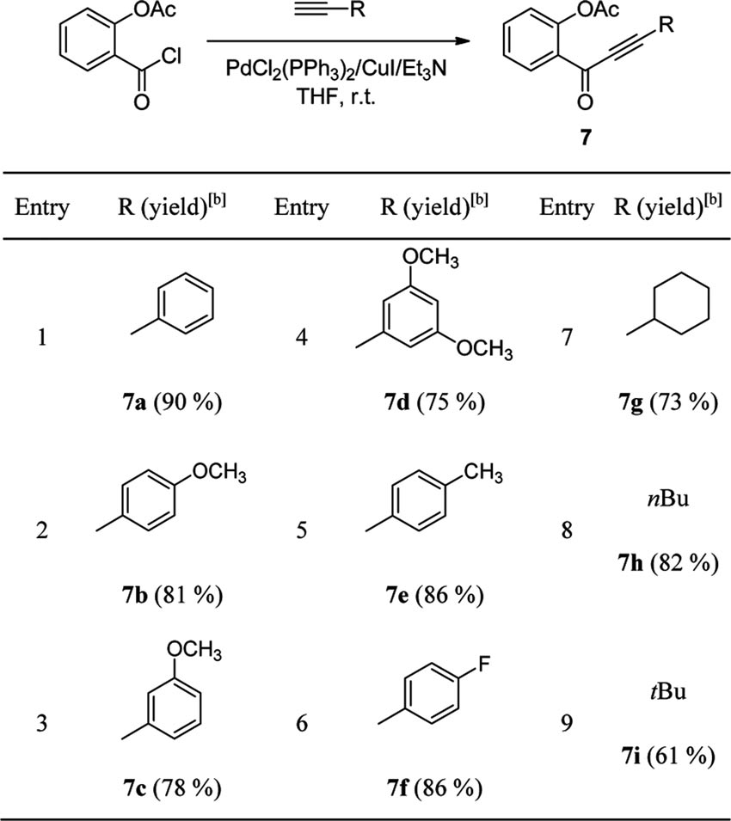
[a] Reagents and conditions: o-acetylsalicyloyl chloride (0.5 mmol), terminal acetylenes (1 equiv.), PdCl2(PPh3)2 (0.03 equiv.), CuI (0.06 equiv.), Et3N (1.5 equiv.), THF (3 mL), 1 h. [b] Isolated yields.

Among the different protecting groups used in organic syn- thesis, the acetate group was selected herein, because of its ease of accessibility, low cost, and feasibility of deprotec- tion.
Conducting the one-pot reaction solely under nitrogen produced acetylene dimers resulting from a Glaser coupling reaction. Mixing hydrogen with nitrogen significantly re- duced the formation of dimers.[11] Thus, different substi- tuted o-alkynoylphenyl acetates bearing electron-donating and electron-withdrawing groups were prepared utilizing the developed mixed-gas one-pot protocol (Table 2).

Table 2. One-pot mixed-gas Sonogashira coupling.[a]

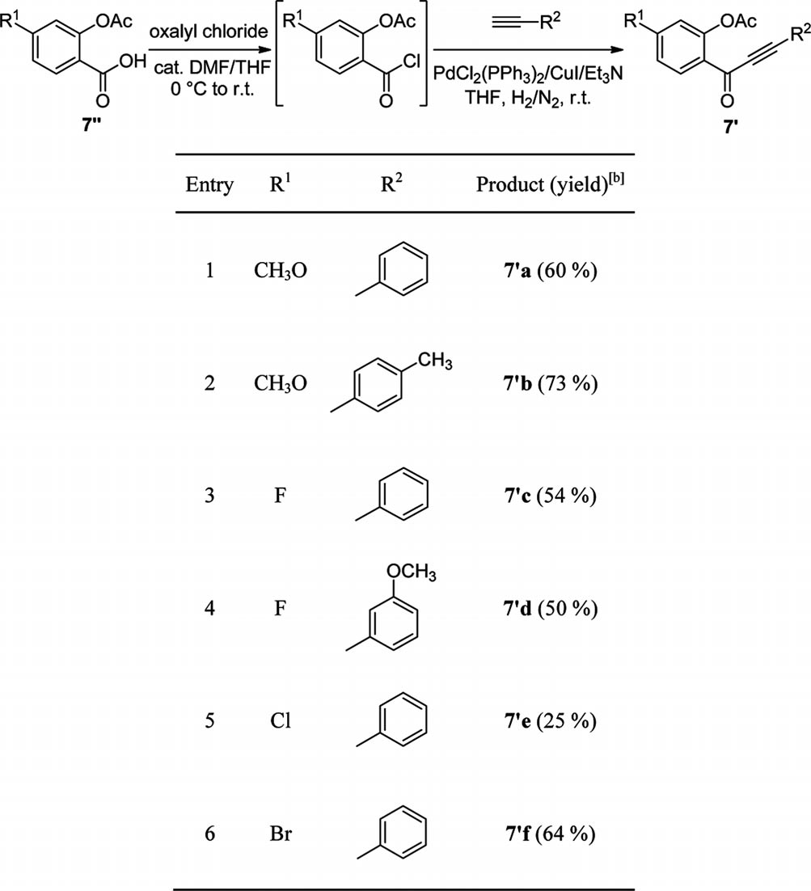
[a] Reagents and conditions: 7 (0.5 mmol), oxalyl chloride
(2 equiv.), DMF (N,N-dimethylformamide, 3 drops), THF (4 mL),
2 h; terminal acetylenes (3 equiv.), PdCl2(PPh3)2 (0.03 equiv.), CuI (0.06 equiv.), Et3N (3.5 equiv.), under H2/N2, 2 h. [b] Isolated yields.

In previous reports, the cyclization of o-alkynoylphenol or its TBS-protected derivatives generally led to the forma- tion of two products, γ-benzopyranone 5 through a 6-endo cyclization pathway and benzofuranone 6 through a 5-exo cyclization pathway (Table 3). Compounds 5 and 6 are formed in variable amounts depending on the reaction con- ditions.[7a]
The initial examination of cyclization step started by the treatment of o-alkynoylphenyl acetate 7 with 1.0 equiv. of tBuOK in dry THF at 0 °C without any additive under ni- trogen. After 1 h, the starting material was recovered in a large quantity (40 %) accompanied by 28 % of the deacety- lated o-alkynoylphenol. Only minor amounts of flavone (5,
4 %) and aurone (6, 11 %) were obtained (Table 3, Entry 1). By increasing tBuOK to 1.5 equiv. and even to 2.0 equiv., the starting material was totally consumed, but the major

Table 3. Screening of cyclization conditions.[a]

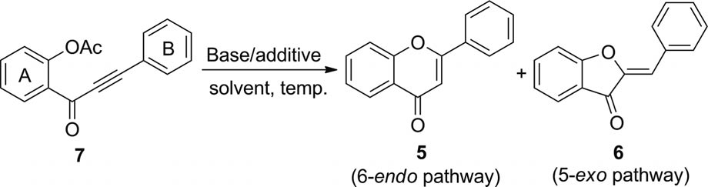
Entry | Base (equiv.) | 18-Crown-6 [equiv.] | Solvent | Temp. [°C] | Time  [min] | 7 | Yield [%][b]  5 | 6
1[c] tBuOK (1.0) – THF 0 60 40 4 11
2 | tBuOK (1.5) | – | THF | 0 | 30 | – | 20 | 75
3 | tBuOK (2.0) | – | THF | 0 | 30 | – | 18 | 38
4 | tBuOK (1.0) | 0.1 | THF | 0 | 30 | 22 | 49 | 32
5 | tBuOK (1.0) | 1.0 | THF | 0 | 30 | 10 | 60 | 31
6 | tBuOK (2.0) | 2.0 | THF | 0 | 30 | – | 66 | 10
7 | tBuOK (2.5) | 2.5 | THF | 0 | 30 | – | 71 | 6
8 | CH3OK (2.5) | 2.5 | THF | 0 | 30 | – | 75 | –
9 | CH3OK (2.5) | 2.5 | THF | 55 | 30 | – | 66 | –
10 | TfOK (2.5) | 2.5 | THF | 0 | ON[d] | 100 | – | –
11 | KOAc (2.5) | 2.5 | THF | 0 | ON[d] | 69 | 24 | 13
12 | KF (2.5) | 2.5 | THF | 0 | ON[d] | 39 | 38 | 37

13
CH3OK (2.5) | 2.5 | ACN | 0 | 30 | – | 45 | –
CH3OK (2.5) | 2.5 | dioxane | 0 | 30 | – | 55 | 30
CH3OK (2.5) | 2.5 | DMF | 0 | 30 | – | 40 | –
CH3OK (2.5) | 2.5 | CH2Cl2 | 0 | 30 | – | 74 | 23
CH3OK (2.5) | 2.5 | THF | 0 | 15 | – | 78 | –
CH3OK (2.5) | 2.5 | THF | 25 | 15 | – | 76 | –

14
15
16
17[e]
18[f]

[a] Reagents and conditions: 7 (0.1 mmol), base, 18-crown-6 ether, solvent, see Experimental Section for detailed procedure. [b] Isolated yields. [c] The de-acetylated o-alkynoylphenol was also obtained in 28 % yield along with 5, 6, and 7. [d] Overnight = ON. [e] The starting material was consumed after 3 min with a small amount of unidentified spots. The reaction was completed in 15 min. [f] The reaction was conducted under atmospheric conditions without nitrogen and ice bath.

product was 6 (Table 3, Entries 2 and 3). However, the ad- dition of 0.1 equiv. of 18-crown-6 ether led to 5 as the major product (49 %, Table 3, Entry 4). Using 18-crown-6 ether in equal amounts to tBuOK increased the formation of flav- one (5), and the best result was obtained when 2.5 equiv.
of both tBuOK and 18-crown-6 ether were used (Table 3, Entries 5–7).
Surprisingly, changing from bulky tBuOK to the less hin- dered CH3OK accompanied by using equal equivalents of
18-crown-6 ether led to 5 as the sole product in 75 % yield

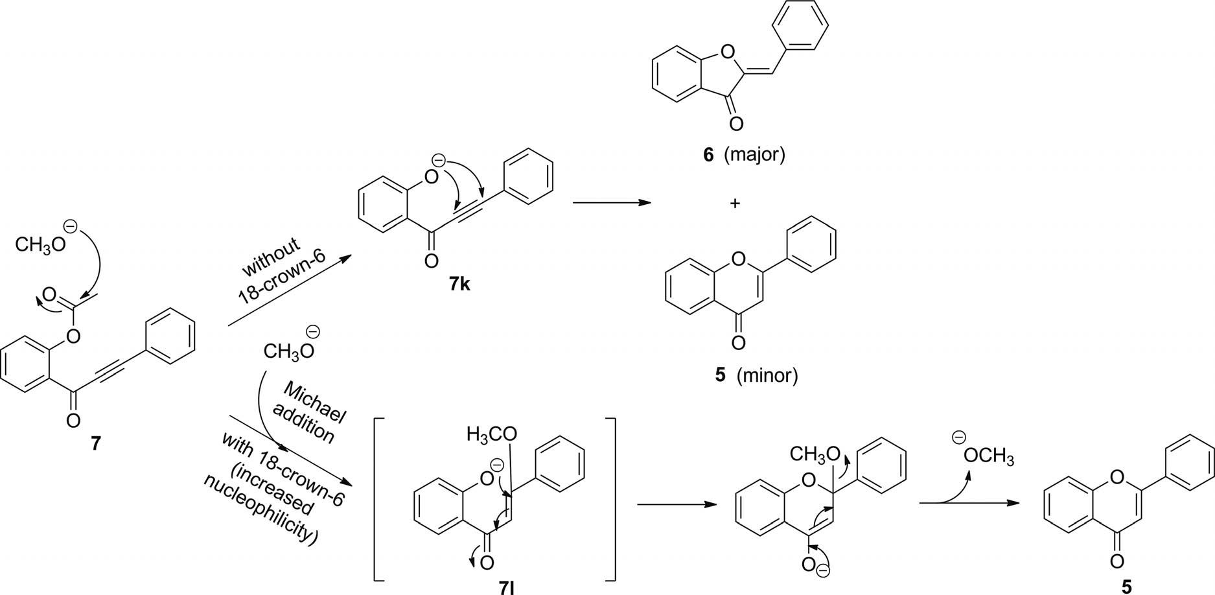

Scheme 1. Plausible mechanism.

