Quantitative Flow Measurement by Digital Subtraction Angiography in Cerebral Carotid Stenosis Using Optical Flow Method

Tzung-Chi Huang¹, Tung-Hsin Wu², Yang-Hsin Lin^{1,2}, Wan-Yuo Guo^{3,4}, Wei-Chien Huang⁵,
Chung-Jung Lin^{3,4*}

¹Department of Biomedical Imaging and Radiological Science, China Medical University, Taiwan
²Department of Biomedical Imaging and Radiological Sciences, National Yang-Ming University, Taiwan
³Radiology Department, Taipei Veterans General Hospital, Taiwan
⁴School of Medicine, National Yang-Ming University, Taiwan
⁵Graduate Institute of Cancer Biology, China Medical University, Taiwan

*Corresponding author: Chung-Jung Lin, M.D.
Radiology Department, Taipei Veterans General Hospital, Taiwan,
201 Shi-Pai Road, Sec. 2, Taipei, Taiwan 11217
Tel: 886-2-28757612
E-mail: bcjlin@gmail.com

Abstract:
Objective: We analyzed intracranial regional blood flows using an optical flow method (OFM) and digital subtraction angiography in patients with internal carotid artery (ICA) stenosis. We also retrospectively explored the correlation between the patients’ diagnoses and the severity of the ICA stenoses.
Materials and Methods: OFM, an image-processing algorithm to estimate motion, was applied to determine the mean velocity V_{mean} in the vessels. A group of 40 patients without vascular anomalies acted as the control group. The patients were classified as having either moderate stenosis (< 80%, n=14) or severe stenosis (>80%, n=23).
Results: The V_{mean} of the ICAs was significantly lower in the stenotic group compared with the control group (p<0.01). The V_{mean} of the ICAs was inversely correlated with the severity of the stenosis (p<0.05). The receiver operating characteristic curve of the V_{mean} in an AP view showed substantial discriminatory power, with an optimal cutoff value of 3.48 pixels/frame for the detection of patients with carotid stenosis. The sensitivity and specificity were 84% and 50%, respectively. On a lateral view, the best cutoff for the V_{mean} was 4.01 pixels/frame, and the sensitivity and specificity were 92% and 43%, respectively.
Conclusions: Digital subtraction angiography combined with the OFM is a feasible parametric method for intracranial blood flow measurements in patients with moderate to severe carotid stenosis.

Introduction
Understanding hemodynamic conditions is essential to correctly diagnose and guide the proper treatment of cerebrovascular lesions. Atherosclerotic plaques in carotid arteries cause luminal stenosis and lead to insufficient cerebral flow¹. These stenoses constitute 10-15% of all cerebrovascular illnesses. The modern practice of neuro-interventional procedures aims to provide peri-therapeutic hemodynamic information to guide proper strategies². For example, detecting flow changes during stenting procedures can prevent inadequate balloon angioplasty inflation or thromboembolic events. Both outcomes can subsequently reduce blood flow and thus should be corrected intra-operatively.
Single-photon emission computed tomography (SPECT) studies are considered the gold standard to diagnose stenosis, but they are often not accepted by patients in clinical settings³. Doppler ultrasound is faster and has superior temporal resolution for evaluating intraluminal flow, but it is vulnerable to inter-observer variations and has limited access to the entire intracranial vasculature due to the thickness of the cranial bones. Recently, non-invasive imaging modalities such as CT and MR angiography (MRA) have been used to provide not only structural imaging⁴⁻⁵ but also hemodynamic information. Flow quantification measurements can be acquired using phase-contrast MRA⁶. Perfusion CT can quantify blood flow and correlate it with cerebral dieases⁷⁻⁹. For angiography, Siemens has recently developed the syngo iFlow, which allows for dynamic flow evaluation with visualization of a complete run in full color. In terms of flow analysis, Shpilfoygel, S.D. et al. reviewed over 100 manuscripts related to flow measurement using digital subtraction angiography and illustrated the advantage of using optical flow-type methods in conjunction with DSA¹⁰. However, no investigator has estimated the hemodynamic significance of occlusive cerebrovascular diseases in clinical patients.
Digital subtraction angiography (DSA) has been the gold standard in diagnosing complex neurovascular pathology for the past 80 years despite its invasive nature¹¹⁻¹², and it is the only imaging modality capable of providing endovascular treatment. Vascular morphology is well demonstrated in flat-panel angiosuites with a high spatial and temporal resolution. However, quantitative measurements of circulation time, cerebral blood flow and volume using DSA have not been well-explored. Such measurements primarily depend on CT or MR perfusion studies outside of the angiosuite, and the results are not immediately available¹³⁻¹⁵. The real-time monitoring of peri-operative changes in blood flow currently depends on subjective and non-quantitative empirical inspection. Thus, having an available flow analysis using DSA would be appreciated as a part of the neuro-interventional angiosuite.
The optical flow method (OFM) has been widely applied to estimate motion in image processing¹⁶⁻²⁰. Analysis of the ratio of the image intensity changes over time is the primary theoretical basis of the OFM. With contrast-medium motion in DSA imaging, functional information from blood-flow distribution images as well as flow velocities with a high temporal resolution can be obtained. Our aim was to explore the correlation between the mean internal carotid artery (ICA) flow velocity using DSA imaging with the optical flow method and the degree of severity of the ICA stenosis. Furthermore, we also aimed to assess the sensitivity and specificity of the optimal mean ICA flow measurement for the detection of patients with carotid stenosis.

Materials and Methods
Patient population
Between January and August of 2011, 41 patients with unilateral moderate-to-severe carotid stenosis (>60% occlusion by the NASCET criteria) were referred for stenting. Among these patients, 37 received stenting and were available for analysis after excluding patients with chronic renal insufficiency (n=2), congestive heart disease (n=1), and suboptimal imaging quality due to motion artifacts (n=1). This experimental group was divided into two subgroups: 14 individuals with the moderate carotid stenosis (between 60% and 80%) comprised subgroup A. Their mean age was 71 years old, with a range of 35 to 83 years old. Twenty-three subjects with severe carotid stenosis exceeding 80% comprised subgroup B. Their mean age was 69 years old, with a range of 42 to 82 years old. We enrolled 40 patients over the same period (mean age: 62.3 years old; 31 male and 9 female) without evident intracranial vascular anomalies as the control group. These patients were initially referred for DSA under clinical suspicion of other intracranial diseases that did not affect intracranial circulation.

Imaging acquisition
Angio-catheters were placed at the C4 vertebral body level for common carotid angiography. A total of 12 ml of 60% diluted contrast medium (iopamidol, 300 mg iodine/ml) was injected as a bolus in 1.5 sec using a power injector in the angiosuite (AXIOM-Artis Zee® Siemens HealthCare, Germany). Anterior-posterior (AP) and lateral images were simultaneously obtained at 6 frames/sec each for both the pre- and post-operative acquisitions in the target and control vessel segments. To mitigate observer bias, each angiogram was independently divided into the leading arterial phase and the following venous phase by an interventional neuroradiologist with 4 years of experience and a diagnostic neuroradiologist with 3 years of experience. Only the arterial phase was included for the optical flow method analysis to obtain the mean ICA flow. The beginning of the arterial phase was defined as the first timeframe in which the contrast appeared in the cerebral internal carotid artery (ICA), and the end of the arterial phase was defined as the first timeframe in which the contrast appeared in the M4 branch of the middle cerebral artery (MCA). Five regions of interest (ROIs) consisting of 7x7 pixels each were chosen on straight segments of the ICA from the petrous to the supraclinoid portion on both AP and lateral views (see * in Fig. 1) during the arterial phase. The average of the 5 arterial ROIs represented the mean arterial flow velocity. When an intended ROI overlapped with other vasculature, we repositioned the ROI to a suitable upstream or downstream location for better sampling. The collection and review of the clinical data for this project was approved by the institutional review board of the hospital.

Blood flow estimation and accuracy
We have developed a method for blood flow estimation in optical images based on an optical flow method (OFM), which links all of the moving subjects between phases of optical images¹⁷⁻²⁰. The gradient-base OFM calculates the flow information according to the changes in the image intensity on two successive images, and the unit of blood flow is pixels per second. Our previous study included a case report of the quantitative peri-therapeutic blood flow changes in a cerebral arteriovenous malformation treated by embolization using optical flow estimation with DSA¹⁷. We have also previously reported the spatial accuracy of blood flow estimates calculated using the OFM¹⁸⁻²⁰. Simulation of digital images to examine the accuracy of the OFM yielded an error of approximately one pixel compared with the reference¹⁸. Compared with hemodynamic analysis, the mean difference was small according to computational fluid flow modeling¹⁹. Recently, we have applied the OFM to quantify the relative velocities of blood flows using angiography and to investigate vascular analyses in hepatocellular carcinoma patients who underwent transarterial chemoembolization treatments. The calculated velocities using OFM with DSA were compared with the Doppler ultrasound measurements and were highly consistent²⁰. In the present study, the OFM algorithm was applied to estimate the blood flow in the arterial phase using parametric color-coding at an equivalent scale to facilitate inter-group comparisons.
The OFM was applied to calculate the velocity matrix on two successive images. The velocity matrix includes lateral and inferior-superior displacements for each voxel in the images. The OFM calculation equation is shown below.
$v^{(n+1)}＝v^{(n)}+∇f\left(\frac{∇f\text{.}v^{(n)}+\frac{∂f}{∂t}}{α^{2}+{\left\|∇f\right\|}^{2}}\right)$
, where n is the number of iterations, v^{(n)} is the average velocity driven from the surrounding voxels, f is the image intensity, and α is the weighting factor, which was empirically set at 5 for DSA imaging.

Statistical analysis
The V_{mean} is presented as the mean ± S.D. for each group. The differences between the mean values in the stenotic and healthy subjects were tested for significance using the Mann-Whitney U test. The SAS statistical software 9.2 (SAS Institute, Inc., Cary, NC) was used to compare the V_{mean} between the two stenotic subgroups. Linear regression analysis was used to compare the V_{mean} between the different stenosis groups. The results were considered significant at p < 0.05. Finally, the selection of an appropriate V_{mean} cut-off point to correctly identify stenotic patients was determined using the receiver operating characteristic curve²¹.

Results
For the classification of the arterial phase of the angiograms for OFM analysis, the intraclass correlation of the two observers was 0.82. Visualizations of the blood flow measurements with color scales for a selected stenotic patient (AP and lateral views) are presented in Fig. 1. There are more areas with colors representing higher speeds in the control group compared with the stenotic group on both the AP and lateral views (Figs. 1a and 1c, Figs. 1b and 1d, respectively). Color-coding superimposed on the DSA image quantitatively illustrates the flow value determined using OFM. For example, the red color in the image and the color bar in Fig. 1 quantitatively indicate a maximum flow of 5 pixels/frame. The distribution of the study population with respect to the flow velocity is depicted in an AP view in Fig. 2a and in a lateral view in Fig. 2b. The mean V_{mean} values in the stenotic and healthy subjects are reported in Table 1. The flow in the stenotic carotid arteries was significantly lower than in the control group (AP: 2.60±1.38 vs. 3.67±1.66 pixels/frame; lateral: 2.47±1.16 vs. 3.65±1.63 pixel/frame). When the stenosis group was further divided into two subgroups using an 80% degree of stenosis as the cut-off value, this decrease in flow remained statistically significant compared to the control group (p <0.05 and p <0.01, Table 1). The significant decrease in the V_{mean} in relation to the degree of stenosis was also demonstrated using a linear regression analysis. The V_{mean} differed significantly between the below- and over-80% stenosis groups on both the AP and lateral views. The receiver operating characteristic (ROC) curve for single values of V_{mean} for the AP velocity (Fig. 3a, Table 2-1) showed substantial discriminatory power (area under curve =0.706), and the optimal V_{mean} cut-off value to detect patients with carotid stenosis was 3.48 pixels/frame. The sensitivity and specificity were 84% and 50%, respectively. On the lateral view, the optimal V_{mean} cut-off value was 4.01 pixels/frame, with a sensitivity and specificity of 92% and 43%, respectively (Fig. 3b, Table 2-2).

Discussion
The gradient-based OFM calculates the flow according to changes in the image intensity on two successive images and gives the unit of blood flow in pixels per second. Flow motion defined in pixel (image intensity) changes over time is different from the true velocity, which is generally expressed in distance moved over time (cm/s), but pixels/frame and cm/s are strongly associated with each other in terms of scale and field of view²⁰. Color-coding superimposed on DSA imaging quantitatively illustrates the flow value determined using OFM, e.g., the red color (on the image and the color bar of Fig. 1) quantitatively indicates a flow of 5 pixels/frame. However, on conventional angiography the hemodynamics are illustrated by sequential opacification of the vascular structures using grey scale. The interpretation is qualitative rather than quantitative, and it is usually based on the physician’s experience and observation, which can subsequently help refine the clinical therapeutic strategy. However, there were other limitations of the present OFM method that deserve attention. The optical flow was derived from the distribution of the apparent velocities of movement in the brightness patterns between the images. The “smoothness constraint” for the motion component in the direction of the local gradient was applied²⁰. Thus, when the flow was turbulent in the collateral circulation or moving rapidly, the flow estimation calculations using the OFM were inaccurate.
Detecting decreased flow motion provides a hemodynamic marker to evaluate flow changes during a procedure. Understanding the flow changes will facilitate decision-making with respect to adequate balloon angioplasty or the detection of a thromboembolism. The previous literature had already shown that significant stenosis resulted in decreased blood flow, so we used this knowledge as a reference to validate the feasibility of using OFM to detect flow changes in disease groups and during stenting procedures¹. The present study is among the first to report relative quantifications of blood flow using DSA in patients with occlusive cerebrovascular disease. A significant decrease in blood flow velocity between patients with vascular stenotic disease and healthy controls has been consistently reported in the literature^{22,23}. The present study agrees with previous reports of flow reduction in patients with high-grade vascular stenosis. Furthermore, this study also demonstrated reduced blood flow in the moderate stenosis group (between 60%-80%). The quantitative method provided the most advantageous cut-off point, which corresponded to a velocity of 3.48 pixels/frame (sensitivity = 84%; specificity = 50%) in the AP view and 4.01 pixels/frame (sensitivity = 92%; specificity = 43%) in the lateral view of the patients. For the AP view, a low velocity increased the specificity but decreased the sensitivity. Lower velocities, although more specific, significantly reduced the sensitivity (Table 2-1). These results lead us to suggest that a reduced ICA V_{mean} is an indirect and objective diagnostic sign of stenosis. The relationship between the decrease in V_{mean} and stenosis requires more detailed investigation. On the lateral view, the relationships between the mean ICA velocity and the sensitivity and specificity do not appear to be constant. The specificity was generally low (43% at maximum), which meant that the usefulness of the lateral view with the present technology was limited to the detection of healthy vascular territories (Table 2-2).
There were other limitations of this study that deserve our attention. First, we selected the arterial phase of the DSA based on the decisions of experienced neuroradiologists, thus introducing possible effects related to subjective biases. To minimize inter-observer variability, the objective selection of the phases through time-density curves from independent component analysis, for example, would facilitate quantitative analysis^{8,24}. Second, the blood flow in the superclinoid portion could also theoretically have been underestimated in the severely stenotic subpopulation due to the influx of un-opacified blood from collateral vessels off the circle of Willis. Lastly, the selected angiogram could only reflect the regional cerebral hemodynamic status. An angiogram of the entire brain can be obtained using a pigtail catheter in the aortic arch. However, the rationale for the dose of radiation deserves further investigation.
The promising initial results of our peri-procedural hemodynamic evaluation suggest that the concept of “one-stop shopping” in the angiosuite might be feasible and may benefit more patients suffering from acute cerebrovascular illnesses. This application can benefit patients by eliminating the need for transfers between different imaging modalities, allowing practitioners to initiate the proper therapy as soon as possible.

Conclusion:
Relative quantitative blood flow measurements using the optical flow method in carotid stenosis patients were presented in this study. Our results demonstrated that the optical flow analysis enhanced the inherent superior temporal advantage of DSA, which transformed it into a powerful parametric hemodynamic marker for therapeutic determinations. Digital subtraction angiography combined with the OFM is a feasible parametric method for intracranial blood flow measurements in patients with moderate-to-severe carotid stenosis.

Acknowledgments
We acknowledge the financially support of the Funding Research Project of China Medical University Grant (CMU97-218).

References
- Mayberg MR, Wilson SE, Yatsu F. Carotid Endarterectomy and Prevention of Cerebral Ischemia in Symptomatic Carotid Stenosis. JAMA. 1991;266(23):3289-3294
- Struffert T, Deuerling-Zheng Y, Kloska S. Flat detector CT in the evaluation of brain parenchyma, intracranial vasculature, and cerebral blood volume: a pilot study in patients with acute symptoms of cerebral ischemia. AJNR Am J Neuroradiol. 2010;31(8):1462–1469
- Derdeyn CP, Powers WJ, Grubb RL. Hemodynamic effects of middle cerebral artery stenosis and occlusion. AJNR American journal of neuroradiology. 1998;19:1463-1469
- Zhijun Cai, Er-Wei Bai, Ge Wang, Melhem J. Sharafuddin, Hicham T. Abada. Dose reduction with adaptive bolus chasing computed tomography angiography, Journal of X-Ray Science and Technology. 2010;18:15-25
- Henri Bai, Kai Zeng, Erwei Bai, Ge Wang, Manual control of patient table for bolus-chasing CT angiography. Journal of X-Ray Science and Technology. 2008;16:23-31
- Jiang J, Strother C, Johnson K. Comparison of blood velocity measurements between ultrasound Doppler and accelerated phase-contrast MR angiography in small arteries with disturbed flow. Phys Med Biol. 2011;56:1755-1773
- Ellen G, Ian C, Rajan J, Sachin K. Cerebral perfusion CT: technique and clinical applications. Radiology. 2004;231:632-644
- So A, Wisenberg G, Islam A. Non-invasive assessment of functionally relevant coronary artery stenoses with quantitative CT perfusion: preliminary clinical experiences. Eurpean Radiology. 2012;22:39-50
- Xyda A, Haberland U, Klotz E. Brain volume perfusion CT performed with 128-detector row CT system in patients with cerebral gliomas: A feasibility study. Eurpean Radiology. 2011;21:1811-1819
- Shpilfoygel S, Close R, Valentino D, Duckwiler G, X-ray videodensitometric methods for blood flow and velocity measurement: a critical review of literature. Med. Phys. 2000; 27:2008-23
- Greitz T. A radiologic study of the brain circulation by rapid serial angiography of the carotid artery. Acta Radiologica. 1956;140:1-123
- Moniz E. L’ence ́phalographie arte ́rielle: Son importance dans la localisation des tumeurs ce ́ re ́ brales. Revue Neurologique. 1927;1:48-72
- Sourbron S. Technical aspects of mr perfusion. European journal of radiology. 2010;76:304-313
- Cronqvist M, Wirestam R, Ramgren B, Brandt L, Romner B, Nilsson O, Säveland H, Holtås S, Larsson E-M. Endovascular treatment of intracerebral arteriovenous malformations: Procedural safety, complications, and results evaluated by mr imaging, including diffusion and perfusion imaging. AJNR American journal of neuroradiology. 2006;27:162-176
- Wakhloo AK, Lieber BB, Siekmann R, Eber DJ, Gounis MJ. Acute and chronic swine rete arteriovenous malformation models: Hemodynamics and vascular remodeling. AJNR American journal of neuroradiology. 2005;26:1702-1706
- B. K. P. Horn and B. G. Schunck. Determining optical flow. Artificial Intelligence. 1981 17:185-203
- Huang T-C, Wu T-H, Lin C-J, Mok G S-P, Guo W-Y. Peri-therapeutic quantitative flow analysis of arteriovenous malformation on digital subtraction angiography. Journal of vascular surgery. 2012;56:812-815
- Huang T-C, Lin W-C, Wu C-C, Zhang G, Lin K-P. Experimental estimation of blood flow velocity through simulation of intravital microscopic imaging in micro-vessels by different image processing methods. Microvasc Res. 2010;80:477-83
- Tzu-Ching Shih, Yan-Hsien Lin, Yung-Jen Ho, Hung-Da Hsiao, Yung-Hui Huang and Tzung-Chi Huang. Hemodynamic analysis of vascular stenting treatment outcome: Computational fluid dynamics method vs optical flow method. Journal of X-Ray Science and Technology. 2012;20:469-481
- Ho YJ, Chang MB, Lin YH, Yao CH, Huang TC, Quantitative Portal Vein Velocity of Liver Cancer Patients with Transcatheter Arterial Chemoembolization on Angiography. The ScientificWorld Journal. 2012; 830531 (doi:10.1100/2012/830531)
- McNeil BJ, Keeler E, Adelstein SJ. Primer on certain elements of medical decision making. N Engl J Med. 1975;293:211-5
- Schreiber WG, Gtickel F, Stritzke P. Cerebral blood flow and cerebrovascular reserve capacity: estimation by dynamic magnetic resonance imaging. Journal of Cerehral Blood Flow and Metabolism. 1998;18: 1143-1156
- Brauer P, Kochs E, Werner C. Correlation of transcranial Doppler sonography mean flow velocity with cerebral blood flow in patients with intracranial pathology. J Neurosurg Anesth. 1998;10:80-85
- Shpilfoygel SD, Close RA, Valentino DJ, Duckwiler GR. X-ray videodensitometric methods for blood flow and velocity measurement: A critical review of literature. Med Phys. 2000;27:2008-2023

Table 1. Mean value ± S.D. of ICA velocity in a population of 40 normal subjects and 37 stenosis patients
 |  | AP View | Lat. View
Normal |  | 3.67±1.66ª | 3.65±1.63ª
Stenosis |  | 2.60±1.38ª | 2.47±1.16ª
<80% |  | 3.23±1.84^{b} | 2.70±1.43^{b}
≥80% |  | 2.22±0.85^{b} | 2.33±0.96^{b} | (pixel/frame)
a,b Level of significance between values with the same letter (a: p≦0.01, b: p≦0.05, based on Mann-Whitney U-test

Table 2-1. List of top six mean ICA flow values on AP view to determine the sensitivity and specificity for the detection of stenosis
Velocity | Sensitivity | Specificity
3.48 | 84% | 50%
3.29 | 81% | 53%
3.12 | 78% | 55%
2.9 | 70% | 63%
2.76 | 62% | 70%
2.69 | 59% | 73%

Table 2-2. List of top six mean ICA flow values on lateral view to determine the sensitivity and specificity for the detection of stenosis
Velocity | Sensitivity | Specificity
4.01 | 92% | 43%
4.33 | 95% | 38%
4.26 | 92% | 40%
3.98 | 89% | 43%
4.65 | 97% | 33%
4.53 | 95% | 35%

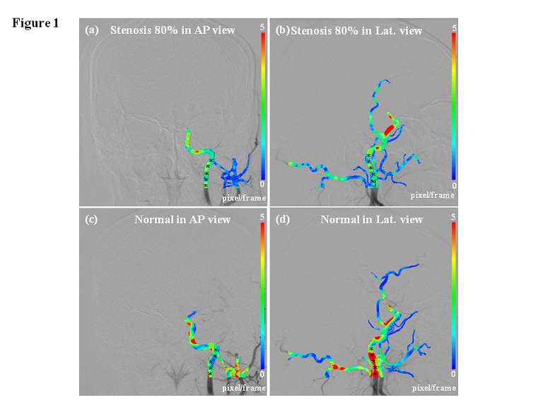
Fig. 1: Blood flow estimation with parametric color-coding calculated using the optical flow method for selected cases. (a) AP view of a patient with 80% stenosis. (b) Lateral view of a patient with 80% stenosis. (c) AP view of a normal subject. (d) Lateral view of a normal subject.
pixel/frame
0
5

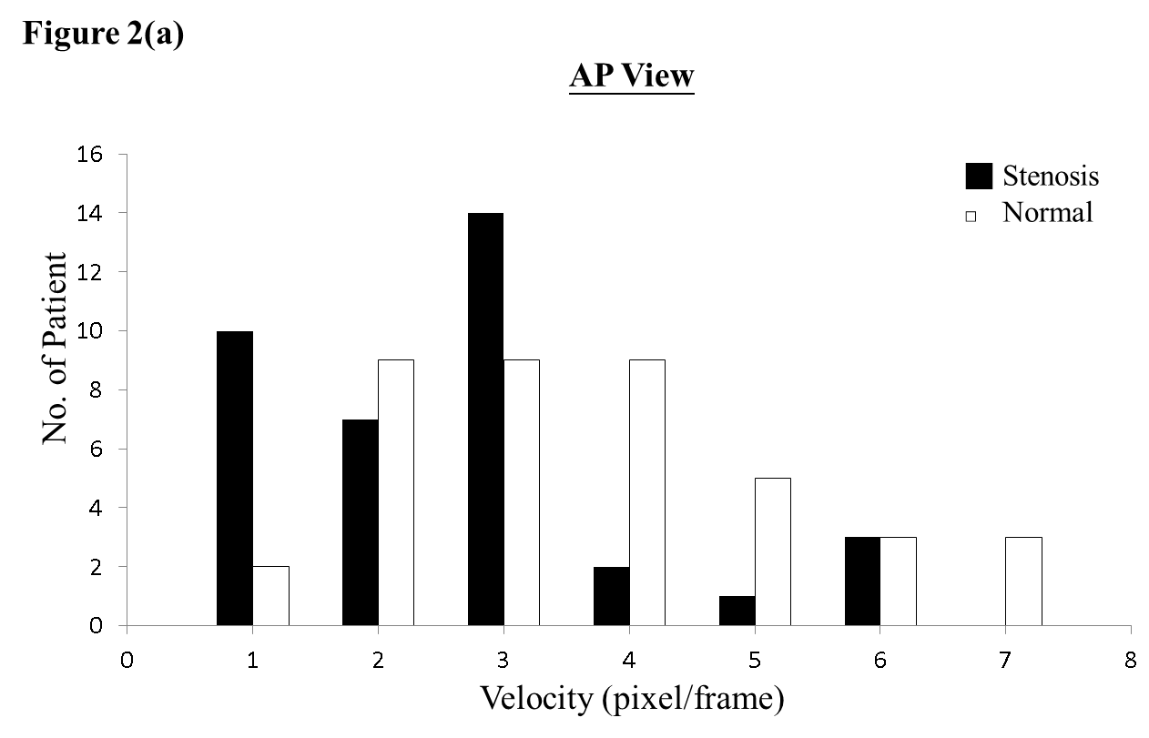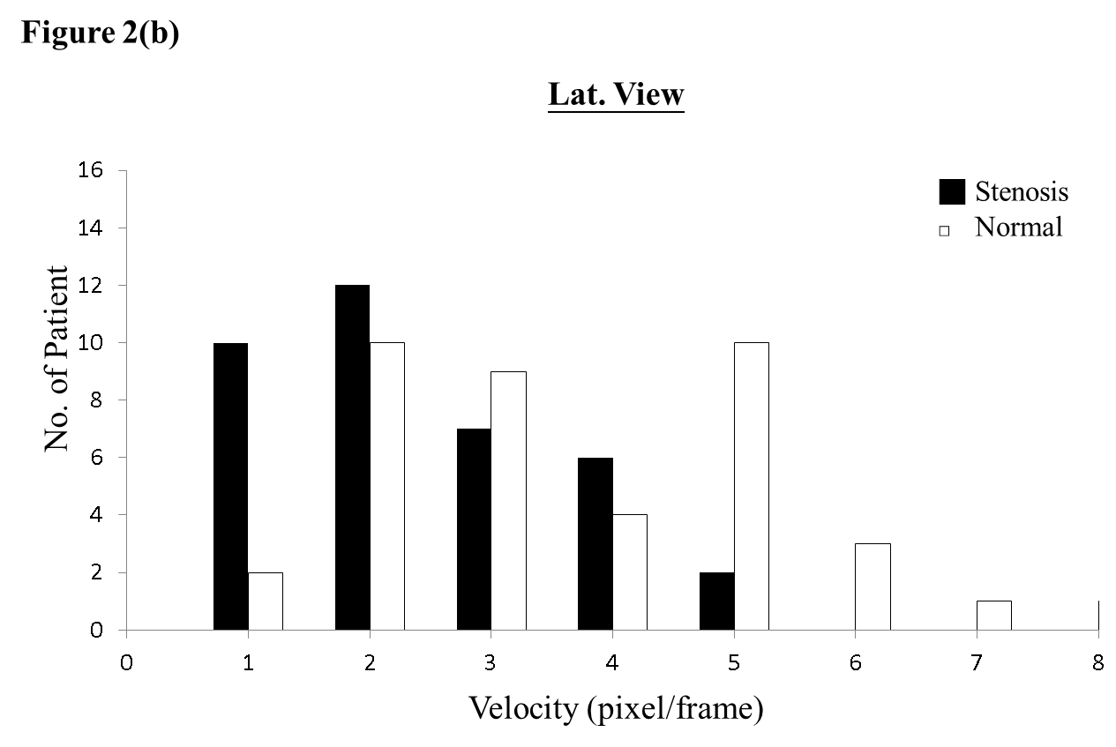
Fig. 2: Distribution of the study population (37 stenosis patients and 40 normal subjects) in relation to mean ICA flow. (a) AP view. (b) Lateral view.

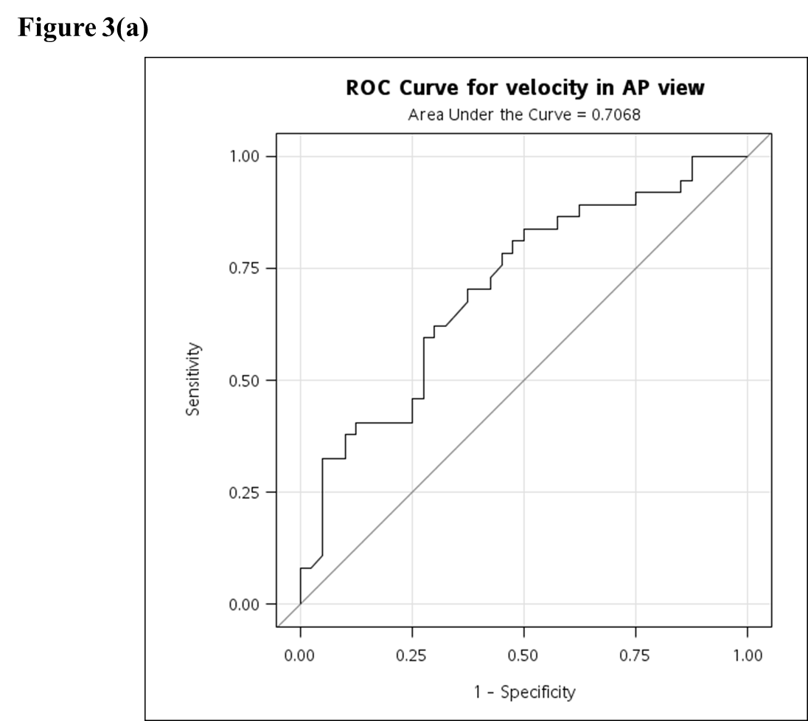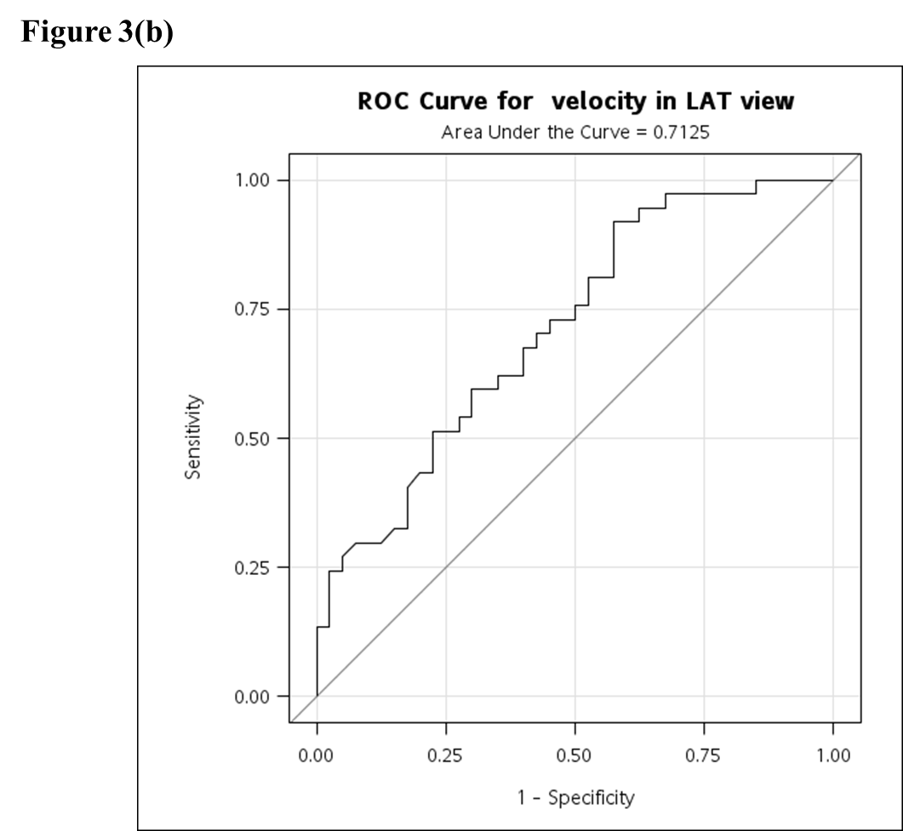
Fig. 3: Receiver operator characteristic curve (ROC) showing the relationship between the sensitivity and specificity of V_{mean} for normal and stenotic subjects. (a) AP view. (b) Lateral view.

