Exploring the Spatial and Temporal Relationships between Mosquito Population Dynamics and Dengue Outbreaks Based on Climatic Factors

Ching-Tsan Tsai
Professor
Dept. of Public Health, College of Public Health, China Medical University
E-mail: drcttsai@gmail.com

Fung-Chang Sung
Dean and Chair Professor
Dept. of Public Health, College of Public Health, China Medical University
E-mail: fcsung@mail.cmu.edu.tw

Patrick S. Chen (Corresponding author)
Professor
Dept. of Information Management, College of Management, Tatung University
E-mail: chenps@ttu.edu.tw

Shu-Chiung Lin
Assistant Professor
Dept. of Information Management, College of Management, Tatung University
E-mail: sclin@ttu.edu.tw

Abstract
Identifying the impact of climatic factors on mosquito population dynamics is of great importance for dengue outbreak control. The purpose of this study is to develop an approach to predict spatial/temporal mosquito reproduction and disease outbreaks. The prediction of a dengue outbreak is only possible if the temporal relationship between mosquito replication and the weather is known. At present, this is unclear and needs to be examined. Moreover, because the development of mosquito density is a dynamic process in the course of time, it should be observed as closely as possible, in this study in a one-day timeframe. This paper makes a thorough study of the situation in southern Taiwan and analyzes a large amount of data from 1999 to 2004 related to dengue cases and larval density. We first use the method, k-means, to conduct data clustering and derive representative larvae replication patterns. Then, we propose mathematical models to approximate the development of larval density, describe the expansion of mosquito activity areas, and construct a surveillance system to raise alerts based on real-time input of weather data and larval indices. Analysis of historic data reveals some new information on the spatial and temporal relationships between larval density and dengue outbreaks. In Taiwan, if the weather becomes or remains warm and humid for 6 days after a bout of rain, there can be a sharp increase in the larval mosquito population. About 7 days after the Breteau index begins to rise, larval density reaches its climax; and, about 12 days after the climax of larval density, cases of dengue may be reported. The system is tested using subsequent data from 2005 to 2009 and shows satisfactory accuracy. Numerous data support these findings, and this new knowledge is thus validated and can be used to assist public health professionals to take effective dengue control measures.
Keywords: Aedes aegypti, Dengue, Biological Modeling, Public Health Surveillance System

1. Introduction
It is well known that dengue is a disease transmitted by mosquitoes and that rainfall has an impact on the replication of mosquitoes (Li et al. 1985; Gubler 2002; Burattini et al. 2008). It is also argued that a large number of virus-carrying mosquitoes are likely to cause dengue epidemics (Goh et al. 1987; Gubler and Clark 1995; Hales et al. 2002; Favier et al. 2005; Juliano and Lounibo 2005). However, in practice, such information is often received too late for public health professionals to take effective measures so that dengue epidemic recurs year for year, and, in some cases, cannot be effectively controlled. There are multiple reasons for this. Amongst is the difficulty for estimating to what extent mosquitoes will replicate after a bout of rain and how widely they will extend their activity areas.
Effective disease prevention can be achieved if the environment can be kept as clean as possible (Hwang 1993; WHO 1997; Kay et al. 2002; Heintze et al. 2007; Seng et al. 2008). Similarly, epidemic control can be more effective if the mosquito replication is known as early as possible (Focks et al. 1995; Burattini et al. 2008). Since climatic change is one of the major factors influencing dengue outbreaks, many researchers have made efforts to study the relationship between dengue outbreaks and the seasonal change in temperature or fluctuations in rainfall, for example, Moore et al. (1978) in Puerto Rico, Pontes et al. (2000) in Fortaleza, Brazil, and Hu et al. (2006) in Brisbane, Australia. Some studies even make a cyclic assessment of dengue epidemics (e.g. Keating 2001). Although these studies help us to understand the relationships between dengue outbreaks and climatic change, they will not contribute too much to precise prediction because dengue often occurs to different time each year. There are studies using weekly data in their models and achieving one-week-ahead in prediction (e.g. Yu et al. 2010). But their prediction is referring to the outbreak of dengue cases that is are too late for prevention because the development lag from larva to adult, host seeking, successful imbibing of an infectious blood meal, and intrinsic incubation, in total, would take some 20 days. Therefore, we come to the idea to monitor vectors after their first appearance in order to manage dengue outbreak in time. Here we propose to observe the development of larvae of the vector in the smallest timeframe of one-day. Because, in our study area, climatic data are published daily by the Central Weather Bureau (CWB; http://www.cwb.gov.tw) and information on larvae is collected and published regularly by Centers for Disease Control (CDC; http://www.cdc.gov.tw/), it is appropriate to develop an approach based on these data to assist the control and prevention of the disease.
In a subtropical area such as Taiwan, the annual average temperature is 22ºC, the average relative humidity is 80%, and the annual average rainfall is 2,500 mm, hence mosquitoes are able to thrive in such an environment. There are also possibilities of serious outbreaks of dengue fever (DF) and dengue hemorrhagic fever (DHF) in such an area (Harris et al. 1998; Mackenzie et al. 2004). According to the Taiwan CDC, from 1999 to 2009, 11,775 cases of infection, 316 cases of DHF, and 31 deaths occurred. Preventing the spread of dengue is one of the most critical public health problems in Taiwan (Yu et al. 2011). In the area we studied — a harbor city, Kaohsiung, and an agricultural county, Pintung — 3.7 million people live in an area of 5,700 km². Historically, these are two areas seriously infected. In Taiwan, the dengue virus is mainly carried by Aedes aegypti (and also by A. albopictus) (Hawley 1998; Lien 2004), the distribution of which is illustrated in Figure 1.
Hayles et al. (1972), Mourya et al. (2004), Thavara et al. (2004), Promprou et al. (2005), and not the last, McMeniman et al. (2009) provide basic knowledge on mosquito biology, which is referenced in this study. These studies pointed out that, when the temperature is too high (above 30ºC) or too low (below 20ºC) and the relative humidity is not in the range of 70-80%, transmission of the virus is less efficient, the life span of mosquitoes is shortened, and fewer survive.
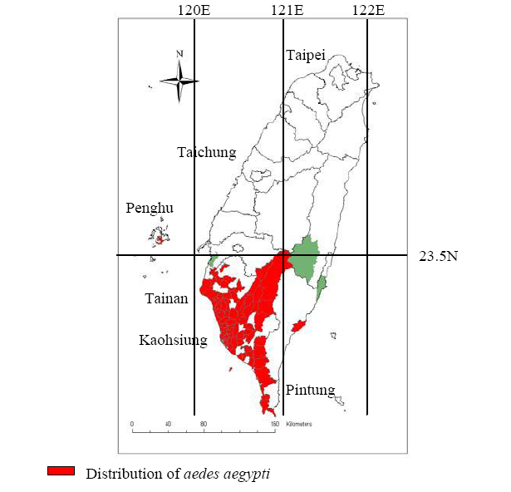
Fig. 1 Distribution of Aedes aegypti in Taiwan∗

Many models of mosquito population dynamics have been suggested (Focks et al. 1995; Ritchie and Montague 1995; Porphyre et al. 2005; Tewa et al. 2009). For example, A study on the development of mosquitoes (A. vexans) in Barkedji, Senegal, unveiled that they emerge about 3-4 days after a bout of rain and develop in a bell-shaped manner (Ndiaye et al. 2006). Another research attempted to predict outbreaks of Ross River virus disease using a polynomial distribution lag (PDL) regression procedure to estimate regression models for time-series data (Hu et al. 2006). The PDL assumes that the effect of an input variable X on a dependent variable Y is distributed over time. If the value of X at time t is changed, Y will experience an immediate effect at time t, and will also experience a delayed effect at times t+1, t+2, … up to t+q for a given limit q. The concept of distribution lag is also used to shape our model.
Although numerous researches pointed out that weather variables are practical predictors of dengue incidences (Wu et al. 2007; Hurtado-Díaz et al. 2007), there are some points should be cleared. For example, an observation in Northeast Thailand showed that a DHF epidemic started in a hot, dry season and ended before the rainy season was over (Eamchan et al. 1989; Kuno 1995). This is not completely agreeable with common expectations that the spread of dengue is highly correlated with rainfall.
The spread of a dengue epidemic varies in different time and different places. An investigation on the maintenance of viral transmission for extended periods over 7 years showed that, after the first major epidemic, small outbreaks occur at intervals of about 4 years (Medeiros et al. 2011). A study applying the focal nature of DF to schematize the relative risk of spread within a particular space-time window identified a very high-risk area at a short distance (15 m) over a short period (6 days). It also pointed out that the next three distance peaks are 20 m, 45 m and 80 m, corresponding to areas of housing, and that the maximum extent of dengue transmission focuses is 400 m and 40 days (Trans et al. 2004).
Several models have been proposed for the prediction of epidemics. For example, empirical models are able to describe the potential effect of population and climate changes on DF distribution (Hales et al. 2002). Stochastic simulation models can be used to describe the urban daily dynamics of the spread of dengue (Focks et al. 1995). Many models based on regressions are used to predict weekly or monthly DHF cases (Halide and Ridd 2008; Yu et al. 2011).
The standard treatment for mosquito density and larval density is given by WHO (1972). Because it is difficult to measure the density of mosquitoes in a given area precisely, they use the Breteau index (BI) of larvae instead. BI stands for the number of positive containers per 100 premises inspected. For example, a study on a dengue outbreak in Playa Municipality, Havana, Cuba, suggested that a larval density of BI > 1 and BI_{max} ≥ 4 (BI_{max} being the highest BI per block for each neighborhood of the case and control blocks) be regarded as a suitable threshold and target, respectively, for community-based dengue prevention. Their results are based on a high-risk area and the thresholds may not constitute a globally suitable index (Sanchez et al. 2006). Another study asserted that the least chance of an outbreak of DF is associated with a BI < 5, while the risk of an outbreak is high when larval density is BI ≥ 49 (Lien 1988).
Disease prevention and control are only effective when they are carried out as early as possible. Our suggestion is to start the study with weather data and information on larvae because they are available every day. In the next section, we will provide a method for calculating vector emergence and spread in both space and time from the climatic and environmental perspective to determine larvae reproduction patterns. From these patterns and mosquito activity areas, we will establish mathematical models and construct a surveillance system to provide real-time predictions.

2. Materials and Methods
A complete collection of 30,241 records from the Taiwan CDC for the period 1999-2004 is used. The data include information on larvae, locations, and illnesses. The daily larval information collected from villages includes date of collection, larval density expressed in BI, and the location of collection; the location information includes county/city, township, and villages; and the information on illnesses includes patient’s age and gender, date of infection, area of residence, and serotype. We also receive 160,000 records of weather data in the corresponding period from the Central Weather Bureau. The weather data include date, temperature, relative humidity, and rainfall collected from weather stations (with ID like 467440) and rainfall stations (with ID like C1V360). In addition, we obtained electronic geographical data from the National Geographical Information System (http://ngis.moi.gov.tw). Based on these geographical information and climatic data, we are able to analyze the impact of these data on the spread of A. aegypti and determine the relationship between the mosquito density and dengue infection. To analyze the impact of climatic factors on the vector population dynamics and to explore the relationship between larval density and dengue infection, we will use a clustering technique to monitor the data pattern. The variables used for clustering are shown in Table 1.

Table 1 A segment of data from Ren-Ai village, Linyuan township, Kaohsiung city, August 11-30, 2000
Remarks | Date | BI | Temperature  ( ºC) | Humidity (%) | Rainfall (mm) | Cases  (patients)
- | 8/11 | 0 | 29.6 | 82 | 0 | 0
Initial day | 8/12 | 2 | 28.5 | 82 | 126 | 0
2nd day | 8/13 | 3 | 29.7 | 93 | 18 | 0
3rd day | 8/14 | 16 | 26.2 | 96 | 25 | 0
4th day | 8/15 | 18 | 25.6 | 82 | 23 | 0
5th day | 8/16 | 20 | 28.0 | 80 | 0 | 0
6th day | 8/17 | 40 | 28.8 | 78 | 0 | 0
7th day | 8/18 | 54 | 29.1 | 81 | 0 | 0
8th day | 8/19 | 24 | 29.6 | 82 | 0 | 0
9th day | 8/20 | 10 | 29.7 | 78 | 0 | 0
10th day | 8/21 | 2 | 27.8 | 76 | 34 | 0
11th day | 8/22 | 0 | 27.9 | 88 | 3 | 0
12th day | 8/23 | 0 | 28.7 | 79 | 0 | 0
13th day | 8/24 | 0 | 27.9 | 79 | 0 | 0
14th day | 8/25 | 0 | 26.5 | 88 | 0 | 0
15th day | 8/26 | 0 | 29.7 | 85 | 0 | 0
16th day | 8/27 | 0 | 29.3 | 78 | 0 | 3
17th day | 8/28 | 0 | 29.7 | 85 | 0 | 1
18th day | 8/29 | 0 | 29.7 | 86 | 0 | 0
19th day | 8/30 | 0 | 29.4 | 82 | 0 | 0

2.1. Development of larval density
We will use the method, k-means, to solve data clustering problem and find representative groups in our data set. K-means aims to minimize an objective function, in this case a squared error function (Ordonez 2006). Our objective function is$M=\sum_{j=1}^{k}{\sum_{i=1}^{n}{||}}x_{i}^{(j)}−c_{j}||^{2}$, where , a distance measure between a data point$x_{i}^{(j)}$and the cluster center$c_{j}$, indicates the distance of n data points from their respective cluster centers.
Table 1 shows an example of the larval density change and its relationship between climate variables and cases reported. In the example, the larval density begins with a BI of 2, reaching a climax of 54 on the 7th day and declining to 0 on the 11th day. Using a mathematical function (Eq. 1), we can approximate the development of larval density.
According to the example in Table 1 and our observations, about 3-4 days after the BI curve reaches its climax, it usually quickly declines to a negligibly small level, mostly because effective measures such as cleanup and disinfection have been adopted (de Wet et al. 2005). On the 19th day (but with some deviation, as shown in Table 1 on the 16th day), cases of dengue may be reported by clinics. If we take the 7-day latency into account (retrieved from http://www.who.org), about 11-12 days after the BI curve reaches its climax, and some inhabitants might be infected. This can be explained as follows: after the 7-day incubation period, infection/exposure to the virus takes 11-12 days, due to the developmental lag from larva to adult (about 2 days, depending on the temperature), the time to find a host and successfully infect it while imbibing its blood (possibly 2-3 days), and the extrinsic incubation period (about 8-10 days). Therefore, the cycle from the initial observation of larvae to dengue infection will last for 19-21 days. Under the weather condition that it remains warm and humid, the curve can be described as
$x_{i}=x_{0}+η∗i∗e^{−\frac{{\left(n−i\right)}^{2}}{n}},i=1,\text{.}\text{.}\text{.},n$ (Eq. 1)
where $x_{0}$: the initial value of the first-day’s BI when it becomes non-zero (in our data set $x_{0}$= 2.6, n = 7). $x_{0}$ is the first-day BI average of the samples in which BI rises; n is the days needed for BI to increase from its initial value to its climax.
$x_{i}$: possible BI on the i-th day.
$η$: rate of increase. In our data set, the average rate of increase is 6.55 because it takes averagely 6.7 (~7) days to reach the highest larval density of $x_{\text{max}}=\text{46}\text{.}5$in average. Therefore, the average rate of increase is calculated as$η=\frac{(x_{\text{max}}−x_{0})}{n}=\frac{(\text{46}\text{.}5−2\text{.}6)}{6\text{.}7}=6\text{.}\text{55}$
When the environmental cleanup is incomplete after the larval density increases, BI can remain high for a longer period. In this case, the mosquitoes produce new generations. If h is a reproduction function and x a BI value, then h(x) denotes the number of BI reproduced after a cycle (of 7 days). After several cycles, the larval density accumulates as shown in Table 2.

Table 2 Additive effect of larval reproduction
Day  Cycle | 0 | 1 | 2 | 3 | 4 | 5 | 6 | 7 | 8 | 9 | 10 | 11
1st cycle | 2.6 | 9.6 | 12.3 | 12.9 | 13.5 | 19.8 | 45.6 | 46.3 | 28.9 | 24.1 | 7.1 | …
 | - | - | - | - | - | - | - | h(2.6) | h(9.6) | h(12.3) | h(12.9) | …
 |  |  |  |  |  |  |  |  | h(2.6) | h(9.6) | h(12.3) | …
 |  |  |  |  |  |  |  |  |  | … | …
Total | 2.6 | 9.6 | 12.3 | 12.9 | 13.5 | 19.8 | 45.6 | 46.3+  h(2.6) | 28.9+ h(9.6) +h(2.6) | … | …

Larval density is additive, i.e., it sums up all BI values in the same interval of all cycles. This corresponds to the concept of distribution lag mentioned in Hu et al. (2006), in which the larval density decreases slightly at first and then increases again. Figure 2 shows the effect of additive larval density, whereby the development of BI curve is wavy and a second wave follows the first. Larval density can remain high for a long period, especially when no effective control measures are adopted.

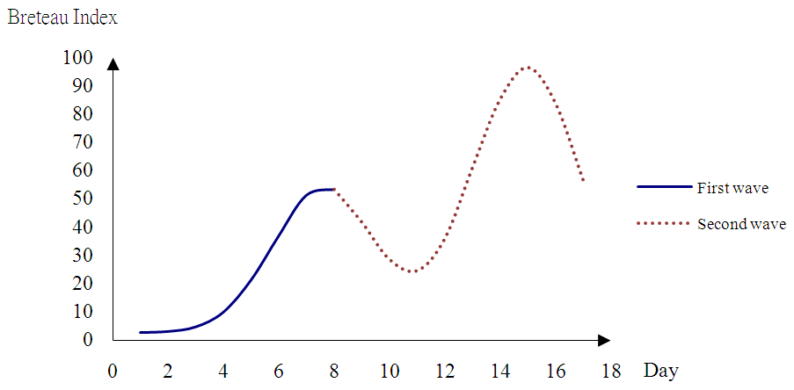
Fig. 2 Additive effect of larval density in which a second wave follows the first

2.2. Extension of the activity areas of mosquitoes
Adult mosquitoes are assumed to concentrate within a certain area where they grew up and form a focus. Gradually, they could fly elsewhere, leading to the expansion of their activity areas (Nelson 1986; Larkin et al. 1995). We further assume that the adults lay eggs to produce new generations in the places they can reach. As mentioned before, it is difficult to precisely determine the density of mosquitoes in an area, we assume it to be proportional to the average BI in that area. For simplicity, let us assume the initial activity area $v_{0}$ is a circle (Halstead 2005), which can be calculated by
(Eq.2)
where r(t₀) is the initial radius and t₀ is the initial time.

According to Hwang (1993), most mosquitoes do not fly more than 100 meters in a day. The initial density $d_{0}$ of mosquitoes is then defined as
(Eq. 3)
if there are x mosquitoes concentrated in the area considered.

Assuming that the mosquitoes are able to fly $k<\text{100}$ m a day and if an observation site is m meters away from the initial area, then we may define a diffusive factor α of the mosquitoes as $α=m∗κ$, where $κ∈[0,1]$ is to indicate the ability of a mosquito to fly away, assuming that it does not take unidirectional flight.
To determine the mosquito density at a particular site $(x,y)$ and time $t$ (in relation to its original place $(\overline{x},\overline{y})$ at time $\overline{τ}$), we use the following formula to calculate the density $F(x,y,t,\overline{x},\overline{y},\overline{τ})$ at that site. The mosquito activity extends in a circle and the density is reduced inversely proportional to the distance from the center of the circle. The formula is
$F(x,y,t,\overline{x},\overline{y},\overline{τ})=\frac{d_{0}}{4\text{πα}t}\text{exp}(−\frac{(x−\overline{x})^{2}+(y−\overline{y})^{2}}{4α(t−τ)})$ (Eq. 4)

If there are several vector sources, as shown in Figure 3, we may sum up all calculated densities as
$F(x,y,t,\overline{x_{i}},\overline{y_{i}},\overline{τ_{i}})=\sum_{i=1}^{n}{\frac{d_{i}}{4\text{πα}t}\text{exp}(−\frac{(x−\overline{x_{i}})^{2}+(y−\overline{y_{i}})^{2}}{4α(t−τ_{i})}})$ (Eq. 5)

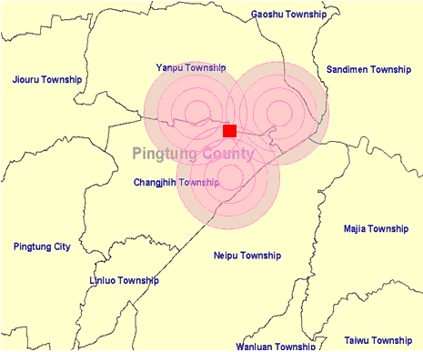
Fig. 3 Prediction of mosquito density for a particular site with three vector sources

Many factors influence how long an epidemic will last and how far a dengue focus will extend. A study on the spread of dengue in French Guiana, which is mostly comprised of rural areas, suggested 400 m and 40 days as the spatial and temporal boundaries of maximum dengue transmission in a dengue focus (Tran et al. 2004). Another study in highly populated southern Taiwan came to the conclusion that, during an epidemic, the high risk of DF extends to an area with a radius of about 20 km around its outbreak foci and the neighborhood will be at higher risk of infection for about 20 weeks. The risk is highest within the first 2 weeks (Yu et al. 2011).

3. Results and Discussion
Since it is commonly accepted that significant factors influencing the strength of a DF epidemic are temperature, humidity, and rainfall (Kuhn et al. 2005), we will also interpret the data analysis described in the previous section in terms of climatic factors of rainfall, temperature, and relative humidity. First, the precision of the prediction made by (Eq. 1) can be measured by mean squared prediction error (MSPE), which is the expected sum of squared deviations of the fitted value g from the unobservable function f. The ascending phase and the average larval densities actually measured and approximated are listed in Table 3. The average larval density depends on the massive larval reproduction samples from 1999 to 2004 in our data set. The MSPE = $E\left[\sum_{i=1}^{n}{(g(x_{i})−f(x_{i}))^{2}}\right]$= 383.87, i.e., the mean daily prediction error is$\sqrt{\frac{\text{MSPE}}{n}}$= 5.9. Therefore, using our model to predict larval density expressed in BI might result in a $±5\text{.}9$ deviation for the coming day.

Table 3 The average approximated and actually measured larval densities
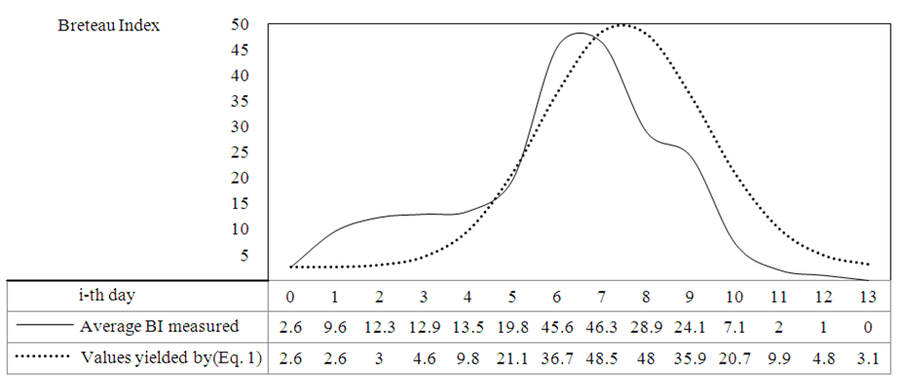

3.1. Temporal relationship between rainfall and larval density
Outdoor containers are often sources of mosquitoes, and rainfall often introduces water into containers. Table 4 shows a segment of weather data in association with larval density in 1997: it rained on 1997/07/08 and then stopped 2 days later, and massive larvae appeared about 7 days after the rain. Many similar cases were found in the data collection we studied. Table 5 shows a few examples from 1999 to 2002 to demonstrate the temporal relationship between highest BI and rainfall. From the numerous examples in the dataset, we can verify our assertion that the highest BI values occur about 6-7 days after it rains abundantly and then remains warm and humid.

Table 4 Relationship between rainfall and development of larval density
Weather station | Date | Humidity  (%) | Temperature  (ºC) | Mean BI | Median BI | Max. BI | Rainfall  (mm)
467440 | 1997/07/08 | 87 | 28.2 | Begin to rain |  |  | 27
467440 | 1997/07/09 | 88 | 28.5 |  |  |  | 3.67
467440 | 1997/07/10 | 81 | 29.6 |  |  |  | 0
467440 | 1997/07/11 | 82 | 29.7 |  |  |  | 0
467440 | 1997/07/12 | 83 | 29.6 |  |  |  | 0
467440 | 1997/07/13 | 77 | 29.8 |  |  |  | 0
467440 | 1997/07/14 | 74 | 29.4 | 8.67 The 7th day 18 |  |  | 0
467440 | 1997/07/15 | 74 | 29.0 |  |  |  | 0
467440 | 1997/07/16 | 77 | 29.8 | 7.5 | 3 | 24 | 0
467440 | 1997/07/17 | 78 | 30.1 |  |  |  | 0
467440 | 1997/07/18 | 78 | 29.9 | 3.5 | 4 | 4 | 0

Table 5 A few examples showing the temporal relationship between the highest BI and rainfall
Date | BI (highest) | It rained n days before (days) | Rainfall (mm)
- | - | - | -
1999/08/17 | 22.67 | 5 | 138
1999/08/27 | 30 | 6 | 21.5
2000/06/02 | 24 | 7 | 12
2000/06/16 | 45 | 4 | 33
2001/06/05 | 27 | 14 | 52.5
2001/06/29 | 30 | 7 | 3.5
2001/07/30 | 21.57 | 6 | 19.5
2001/08/08 | 40 | 6 | 17
2002/06/06 | 21 | 7 | 16
2002/06/26 | 21.57 | 7 | 16
2002/08/06 | 21.5 | 2 | 52.5
- | - | - | -

The BI value is negligible most of the time. Occasionally, we may observe a day with a BI slightly greater than 0, but the observed value often diminishes over the next few days, or remains less than 5 without rising to an alarming level. To predict whether an initial larval density of BI > 0 will increase, we have to observe the climatic conditions. If it rains continuously after the first observation of BI > 0, there is less danger of a positive development. Furthermore, if the temperature drops sharply to a level that is unfavorable for larvae to survive, the danger is also lessened. It will become a dangerous situation when the temperature drops only by less than 3ºC after the initial day of observation. A. aegypti thrives in an environment of 28 ± 2°C and 70-80% relative humidity (Mourya et al. 2004). It is thus reasonable to modify Eq. 1 as
$x_{i}=x_{0}+g(h,t)∗η∗i∗e^{−\frac{(n−i)^{2}}{n}},i=1,\text{.}\text{.},n$ (Eq. 6)

where g(h,t): a function of humidity (h) and temperature (t) with $g(h,t)∈\left\{−1,1\right\}$. When the environment is favorable for mosquitoes, g(h,t) is assigned 1, otherwise it is -1. In general, if abs(t_{i}-t₀) ≤ 3 and h_{i} ≥ 70, then g(h,t) = 1 otherwise it is -1.
3.2. Temporal relationship between vector reproduction and cases of dengue
Once the BI curve reaches an alarming high in an area, an outbreak of DF may occur, and clinical cases may be reported within 11-12 days after larval density reaches its highest level. Figure 4 shows the temporal relationship between mosquito replication and dengue outbreaks. A cycle from the initial observation of BI ≧ 0 to the reporting of dengue illnesses will last for 19-21 days. This temporal relationship is vital for controlling and preventing the epidemic because effective countermeasures can be taken in time.

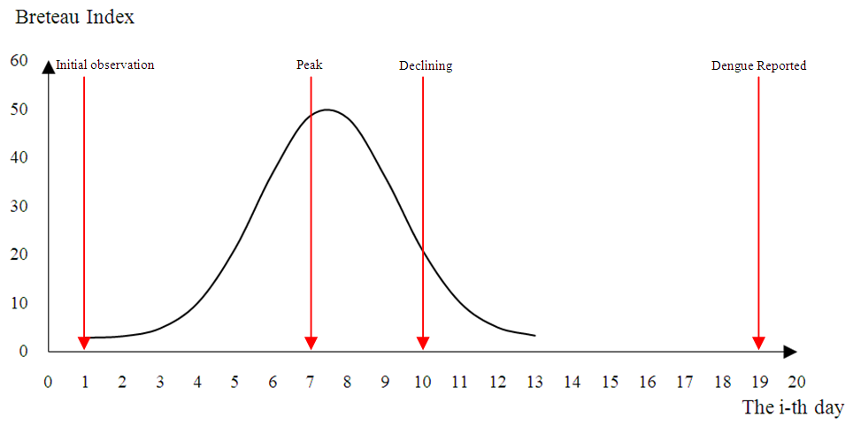
Fig. 4 Temporal relationship between mosquito reproduction and dengue outbreaks

3.3. A public health surveillance system for DF
Based on the results obtained in this study, we can construct a surveillance system for DF. An intelligent information system would help us to control and prevent disease in advance and also provide advice to governments and public health professionals on actions to be taken (Reiter and Gubler 1997; Wagner et al. 2001; Grigg et al. 2006). The system constructed in this study is described in Figure 5, where daily weather data and larval density are the main inputs for evaluation. BIs and climatic data are originally the historic data from 1999-2004 used for the examination of expansion patterns and the establishment of mathematical models. The data are subsequently supplemented. A geographic information system (GIS) module provides up-to-date electronic geographical data to represent topography in the areas observed. Other geographical variables, such as parks, farmland, and fields, are also used to model the real environment because of their impacts on the spread of the disease (Guzmán and Kouri 2002; Nagao et al. 2003). The knowledge base is a database of mosquito expansion patterns and mathematical models to be fed into the inference machine to handle reasoning. Meanwhile, the daily weather data and vector density are inputs for the inference engine to evaluate in real-time mode, and alerts are raised from results of the evaluation.
Although models and patterns are provided in this study, the thresholds and parameters are location-dependent (Favier et al. 2005). In other regions, other values should be adopted especially those of larval density and climatic data.
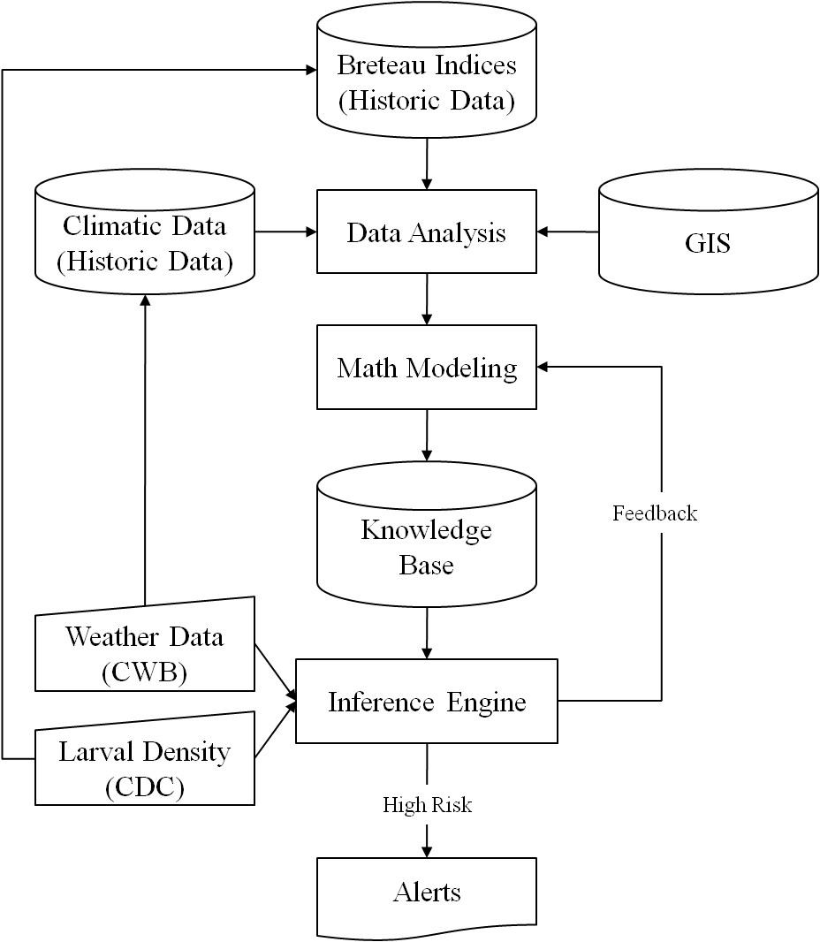
Fig. 5 Structure of a public health surveillance system for DF

Since this system was implemented, it has monitored 52,488 further records of larval density and 32,866 records of weather data from 2005 to 2009 in Kaohsiung City and Pintung County. It reported 210 alarming situations in which larval density (BI) was greater than 49 and gave alerts to the high risk of dengue outbreaks. Among the 210 alarming situations, five records had a larval density (BI) greater than 200 and eight records between 100 and 199, as shown in Table 6.♣ The temperature in the alarming cases was between 25ºC and 30ºC, and the relative humidity between 67% and 100%. The observed rainfall during the days of risky larval development was in general low, but it did rain for 1-16 days (average, 4.8 days) before and the rainfall was between 0.5 mm and 103 mm (average, 42.7 mm).

Table 6 Examples of alarming situations of dengue outbreak in Kaohsiung City between 2005 and 2009
Township | Village | Date | BI | Weather station | Temperature  (ºC) | Humidity  (%) | Rainfall  (mm) | It rained n days before and rainfall  (days/mm)
Alian | A-Lian | 2005/06/08 | 100~199 | C0V370 | 26.5 | N/A | 0 | 5 | 103
Fengshan | Zhong-Zheng park | 2005/06/10 | ≥200 | 467440 | 28.7 | 80 | 5.5 | 7 | 103
Ziguan | Chi-Kan | 2005/06/20 | 100~199 | 467440 | 28.9 | 82 | 34.5 | 4 | 33.5
Mituo | Guang-He | 2005/06/22 | 100~199 | 467440 | 29.3 | 82 | 1 | 2 | 34.5
Fengshan | Feng-Dong | 2005/07/01 | 100~199 | 467440 | 30.0 | 73 | 0 | 3 | 57
Qianzhen | Ming-Zheng | 2005/10/26 | 100~199 | 467440 | 26.8 | 72 | 0 | 16 | 0.5
Xinxing | Jian-Xing | 2006/07/20 | 100~199 | 467440 | 29.8 | 80 | 0 | 4 | 49
Sanmin | Da-Ming | 2008/05/29 | 100~199 | 467440 | 27.4 | 84 | 56 | 7 | 17
Xinxing | Qiu-Shan | 2009/07/06 | ≥200 | 467590 | 28.8 | 79 | 0 | 3 | 49.5
Lingya | Ling-Zhou | 2009/07/21 | 100~199 | 467440 | 29.6 | 81 | 0 | 3 | 28.5
Qianzhen | Zhen-Bei | 2009/09/28 | ≥200 | 467440 | 28.7 | 79 | 5.5 | 1 | 5
Zuoying | Guo-Feng | 2009/09/29 | ≥200 | 467440 | 28.7 | 80 | 1 | 5 | 2.5
Qianzhen | Min-Quan | 2009/10/02 | ≥200 | 467440 | 29.2 | 78 | 0 | 2 | 72.5

4. Conclusions
It is always desirable to issue warnings of epidemic outbreaks as early as possible so that public health professionals can take effective measures for prevention and control. In this study we proposed an approach to analyze daily information on larvae and weather data to determine early signs of disease outbreak. To facilitate data analysis, we have derived various models and patterns from a large set of historic data to anticipate spatial/temporal mosquito population and disease outbreaks. The models in turn serve as a basis for the construction of a workable surveillance system.
This study provided some new knowledge on the temporal relationships between mosquito population dynamics and dengue outbreaks. About 7 days after a bout of rain, if the weather remains warm and humid, there may be a sharp increase in the mosquito population. This is an indication for the action that indoor and outdoor containers should be emptied to remove larvae so that dengue outbreaks can be avoided.
The development of mosquito density is a temporal process. We further explored the temporal relationship between rainfall and mosquito density development. Rainfall does not have an immediate impact on the multiplication of mosquitoes, and continuous rain can even destroy the habitats of larvae. However, this type of rainfall contributes to the maintenance of a humid environment for larvae to survive.
Finally, we have to take into account lakes, rivers, coasts, woods, and mountains that significantly influence the mosquito spread. This will be elaborated in the forthcoming work.

Acknowledgment
The authors would like to thank three anonymous reviewers and Professor Mark I. Hwang for invaluable guidance and suggestions which helped bring out the best in this paper and also thank National Science Council, Taiwan, R.O.C. for its support under the research contract number NSC 99-2410-H-036-004. We are grateful to Taiwan Centers for Disease Control and Central Weather Bureau for providing vital data.

References

Burattini MN, Chen M, Chow A, Coutinho FAB, Goh KT, Lopez LF, Ma S, Massad E (2008) Modelling the control strategies against dengue in Singapore. Epidemiology and Infection 136(3):309-319.

de Wet N, Slaney D, Ye W, Warrick R, Hales S (2005) Hotspots for biosecurity and vector-borne disease risk analysis. 1st National Symposium on Conservation Medicine. 7-8 July, Auckland.

Eamchan P, Nisalak A, Foy HM, Chareonsook OA (1989) Epidemiology and control of dengue virus infections in Thai village in 1987. The American Society of Tropical Medicine and Hygiene 41(1):95-101.

Favier C, Degallier N, Dubois MA (2005) Dengue epidemic modeling: stakes and pitfalls. Asia Pacific Biotechnology News 9(22):1191-1194.

Focks DA, Daniels E, Haile DG, Keesling JE (1995) A simulation model of the epidemiology of urban dengue fever: literature analysis, model development, preliminary validation, and samples of simulation results. The American Society of Tropical Medicine and Hygiene 53(5):489-506.

Goh KT, Ng SK, Chan YC, Lim SJ, Chua EC (1987) Epidemiological aspects of an outbreak of dengue fever/dengue haemorrhagic fever in Singapore. Southeast Asian Journal of Tropical Medicine and Public Health 18(3):295-302.

Grigg M, Alfred B, Keller C, Steele JA (2006) Implementation of an Internet-based geographic information system: the Florida experience. Journal of Public Health Management and Practice 2(2):139-145.

Gubler DJ (2002) Epidemic dengue/dengue hemorrhagic fever as a public health, social and economic problem in the 21st century. Trends in Microbiology 10(2):100-103.

Gubler DJ, Clark GG (1995) Dengue/dengue hemorrhagic fever: The emergence of a global health problem. Emerging infectious Diseases, 1(2): 55-57.

Guzmán MG, Kouri G (2002) Dengue: an update. The Lancet Infectious Diseases 2(1):33-42.

Hales S, Wet N., Maindonald J, Woodward A (2002) Potential effect of population and climate changes on global distribution of dengue fever: an empirical model. The Lancet 360(9336):830-834.

Halide H, Ridd P (2008) A predictive model for dengue hemorrhagic fever epidemics. Int J Environ Health Res 18(4):253-265.

Halstead SB (2005) Dengue: an update. Asia Pacific Biotechnology News 9(22):1187-1190.

Harris E, Roberts TG, Smith L, Selle J, Kramer LD, Valle S, Sandoval E, Balmaseda, A (1998) Typing of dengue viruses in clinical specimens and mosquitoes by single-tube multiplex reverse transcriptase PCR. Journal of Clinical Microbiology 36(9):2634-2639.

Hawley WA (1998) The biology of Aedes albopictus. Journal of the American Mosquito Control Association Supplement 1:1-39.

Hayles LB, McLintock J, Saunders JR (1972) Laboratory studies on the transmission of Western Equine Encephalitis virus by Saskatchewan mosquitoes 1. Culex tarsalis. Can. J. Comp. Med. 36:83-88.

Heintze C, Garrido MV, Kroeger A (2007) What do community-based dengue control programmes achieve? A systematic review of published evaluations. Transactions of the Royal Society of Tropical Medicine and Hygiene 101:317-325.

Hu W, Tong S, Mengersen K, Oldenburg B (2006) Rainfall, mosquito density and the transmission of Ross River virus: A time-series forecasting model. Ecological modeling 196(3-4):505-514.

Hurtado-Diaz M, Riojas-Rodriguez H, Rothenberg SJ, Gomez-Dantes H, Cifuentes E (2007) Short communication: impact of climate variability on the incidence of dengue in Mexico. Trop Med Int Health 12(11):1327-1337.

Hwang JS (1993) Ecology and integrated control of Aedes mosquitoes in dengue epidemic areas in Taiwan (in Chinese). Ph.D. thesis, National Taiwan University, Taiwan, R.O.C.

Juliano SA, Lounibo LP (2005) Ecology of invasive mosquitoes: effects on resident species and on human health. Ecology Letters 8: 558-574.

Kay BH, Nam VS, Tien TV, Yen NT, Phong TV, Diep VT, Ninh TU, Bektas A, Aaskov JG (2002) Control of Aedes vectors of dengue in three provinces of Vietnam by use of Mesocyclops (Copepoda) and community-based methods validated by entomologic, clinical, and serological surveillance. Am. J. Trop. Med. Hyg. 66:40-48.

Keating J (2001) An investigation into the cyclical incidence of dengue fever. Social Science & Medicine 53(12):1587-1597.

Kuhn K, Campbell-Lendrum D, Haines A, Cox J (2005) Using climate to predict infectious disease epidemics. World Health Organization, Geneva, Switzerland.

Kuno G (1995) Review of the factors modulating dengue transmission. Epidemiologic Reviews 17(2):321-335.

Larkin TS, Sweeney AW, Carruthers RI (1995) Simulation of the dynamics of a microsporidian pathogen of mosquitoes. Ecological Modeling 77:143-165.

Li CF, Lim TW, Lee HL. Fang R (1985) Rainfall, abundance of Aedes aegypti and dengue infection in Selangor, Malaysia. The Southeast Asian Journal of Tropical Medicine and Public Health 16(4):560-568.

Lien JC (1988) On the bionomics of Aedes (Stegomyia) mosquitoes in Taiwan (in Chinese). Proceedings of the First Seminar on the Control of Vectors and Pests; Taiwan, R.O.C.: Environmental Protection Administration 63-74.

Lien JC (2004) Indices of Aedes in Taiwan (in Chinese) http://www.books.com.tw/exep/prod/booksfile.php?item=0010278495. Accessed on June 25, 2005

Mackenzie JS, Gubler DJ, Petersen LR (2004) Emerging flaviviruses: the spread and resurgence of Japanese encephalitis, West Nile and dengue viruses. Nature Medicine 10(12):98-109.

McMeniman CJ, Lane RV, Cass BN, Fong AWC, Sidhu M, Wang YF, O’Neill SL (2009) Stable introduction of a life-shortening Wolbachia infection into the mosquito Aedes aegypti. Science 323:141-144.

Medeiros LCdC, Castilho CAR, Braga C, de Souza WV, Regis L, et al. (2011) Modeling the dynamic transmission of dengue fever: investigating disease persistence. PLoS Negl Trop Dis 5(1): e942. doi:10.1371/journal.pntd.0000942.

Moore CG, Cline BL, Ruiz-Tiben E, Lee D, Romney-Joseph H, Rivera-Correa E (1978) Aedes aegypti in Puerto Rico: environmental determinants of larval abundance and relation to dengue virus transmission. Am J Trop Med Hyg 27:1225-1231.

Mourya DT, Yadav P, Mishra AC (2004) Effect of temperature stress on immature stages and susceptibility of Aedes Aegypti mosquitoes to Chikungunya virus. The American Society of Tropical Medicine and Hygiene 70(4): 346-350.

Nagao Y, Thavara U, Chitnumsup P, Tawatsin A, Chansang C, Campbell-Lendrum D (2003) Climatic and social risk factors for Aedes infestation in rural Thailand. Tropical Medicine and International Health 8(7):650-659.

Ndiaye PI, Bicout DJ, Mondet B, Sabatier P (2006) Rainfall triggered dynamics of Aedes mosquito aggressiveness. Journal of Theoretical Biology 243(2):222-229.

Nelson MT (1986) Aedes aegypti: biology and acology. Washington DC :PAHO/WHO Collaborating Centers.

Ordonez C (2006) Integrating K-means clustering with a relational DBMS using SQL. IEEE Transactions on Knowledge and Data Engineering 18(2):188- 201.

Pontes RJ, Freeman J, Oliveira-Lima JW, Hodgson JC, Spielman A (2000) Vector densities that potentiate dengue outbreaks in a Brazilian city. Am J Trop Med Hyg 62:378-383.

Porphyre T, Bicout DJ, Sabatier P (2005) Modelling the abundance of mosquito vectors versus flood dynamics. Ecological Modeling 183:173-181.

Promprou S, Jaroensutasinee M, Jaroensutasinee K (2005) Climatic factors affecting dengue haemorrhagic fever Incidence in Southern Thailand. Dengue Bulletin 29:41-48.

Reiter P, Gubler DJ (1997) Surveillance and control of urban dengue vector. In DJ Gubler and G Kuno (eds.) Dengue and hemorrhagic fever, New York, CAB International 425-462.

Ritchie SA, Montague CL (1995) Simulated populations of the black salt marsh mosquito in a Florida mangrove forest. Ecological Modeling 77:123-141.

Sanchez L, Vanlerberghe V, Alfonso L, Marquetti MC, Guzman MG, Bisset J, Stuyft P (2006) Aedes aegypti larval indices and risk for dengue epidemics. Emerging Infectious Diseases 12(5):800-806.

Seng CM, Setha T, Nealon J, Socheat D, Chantha N, Nathan MB (2008) Community-based use of the larvivorous fish Poecilia reticulata to control the dengue vector Aedes aegypti in domestic water storage containers in rural Cambodia. Journal of Vector Ecology 33(1):139-144.

Tewa JJ, Dimi JL, Bowong S (2009) Lyapunov functions for a dengue disease transmission model. Chaos, Solitons & Fractals 39(2):936-941.

Thavara U, Tawatsin A, Chompoosri J (2004) Evaluation of attractants and egg-laying substrate preference for oviposition by Aedes albopictus (Diptera: Culicidae). Journal of Vector Ecology 29 (1):66-72.

Tran A, Deparis X, Dussart P, Morvan J, Rabarison P, Remy F, Polidori L, Gardon J (2004) Dengue spatial and temporal patterns, French Guiana, 2001. Emerging Infectious Diseases 10(4):615-621.

Wagner MM, Tsui FC, Espino JU, Dato VM, Sittig DF, Caruana RA, McGinnis LF, Deerfield DW, Druzdzel MJ, Fridsma DB (2001) The emerging science of very early detection of disease outbreaks. Journal of Public Health Management and Practice 7(6):51-59.

WHO (1972) A system of world-wide surveillance for vectors. The Weekly Epidemiological Record 47(7):73-84.

WHO (1997) Dengue haemorrhagic fever: diagnosis, treatment, prevention and control. World Health Organization, 2nd Geneva.

Wu PC, Guo HR, Lung SC, Lin CY, Su HJ (2007) Weather as an effective predictor for occurrence of dengue fever in Taiwan. Acta Trop 103(1):50-57.

Yu HL, Yang SJ, Yeh HJ, Christakos G (2011) A Spatio-temporal climate-based model of early dengue fever warning in southern Taiwan. Stochastic Environmental Research and Risk Assessment 25:485-494.

 From the training instruction for dengue control of the Centers for Disease Control, Taiwan, R.O.C. http://www.cdc.gov.tw/public/Data/79131623271.pdf. Accessed on October 20, 2010.
T♣ Since 2002, the Taiwan CDC began to introduce a classification system of larval density based on the recommendation of WHO with density figures on a scale from 1 (low) to 9 (high) (WHO, 1972). For consistency in this paper, we convert the density figures into BI in Table 6.

