Predicting Cortical Bone Strength from DXA and Dental Cone-Beam CT

Jui-Ting Hsu¹, Ying-Ju Chen², Ming-Tzu Tsai³, Howard Haw-Chang Lan⁴
Fu-Chou Cheng², Michael YC Chen¹, Shun-Ping Wang^{5*}

¹School of Dentistry, College of Medicine
China Medical University, Taichung, 404 Taiwan
²Stem Cell Medical Research Center, Department of Medical Research
Taichung Veterans General Hospital, Taichung, 407 Taiwan
³Department of Biomedical Engineering
Hungkuang University, Taichung, 433 Taiwan
⁴Department of Radiology
Taichung Veterans General Hospital, Taichung, 407 Taiwan
⁵Department of Orthopaedics
Taichung Veterans General Hospital, Taichung, 407 Taiwan

Running title: Cortical Bone Strength from DXA and Dental CBCT
Corresponding author:
Shun-Ping Wang, MD
Department of Orthopaedics
Taichung Veterans General Hospital
No. 160, Sec. 3, Chung-Kang Rd, Taichung 407, Taiwan
Tel.: +886-4-23592525 ext 5101
E-mail: richard@ms32.url.com.tw; wsp0120@yahoo.com.tw
Abstract
Objective: This study compared the capabilities of dual-energy X-ray absorptiometry (DXA) and dental cone-beam computed tomography (CBCT) for predicting the cortical bone strength of rat femurs and tibias.

Materials and Methods: Specimens of femurs and tibias obtained from 14 rats were first scanned with DXA to obtain the areal bone mineral density (BMD) of the midshaft cortical portion of the bones. The bones were then scanned using dental CBCT to measure the volumetric cortical bone mineral density (vCtBMD) and the cross-sectional moment of inertia (CSMI) for calculating the bone strength index (BSI). A three-point bending test was conducted to measure the fracture load of each femur and tibia. Bivariate linear Pearson analysis was used to calculate the correlation coefficients (r values) among the CBCT measurements, DXA measurements, and three-point bending parameters.

Results: The correlation coefficients for the associations of the fracture load with areal BMD (measured using DXA), vCtBMD (measured using CBCT), CSMI (measured using CBCT), and BSI were 0.585 (p=0.028) and 0.532 (p=0.050) (for the femur and tibia, respectively), 0.638 (p=0.014) and 0.762 (p=0.002), 0.778 (p=0.001) and 0.792 (p<0.001), and 0.822 (p<0.001) and 0.842 (p<0.001), respectively.

Conclusion: CBCT was found to be superior to DXA for predicting cortical bone fracture loads in rat femurs and tibias. The BSI, which is a combined index of densitometric and geometric parameters, was especially useful. Further clinical studies are needed to validate the predictive value of BSI obtained from CBCT and should include testing on human cadaver specimens.

Keywords: cone-beam computed tomography (CBCT); dual-energy X-ray absorptiometry (DXA); three-point bending; bone strength; rat femur; rat tibia
- Introduction
The ability to measure bone strength using noninvasive methods is important for evaluating fracture risk according to the severity of osteoporosis [1,2], as well as to the early-stage stabilization of artificial implants after implantation in bone (e.g., dental or orthopedic implants) [3,4]. Dual-energy X-ray absorptiometry (DXA) is one of the methods commonly used in the clinical field of orthopedics for evaluating bone mineral content (BMC) and bone mineral density (BMD) [5]. The areal BMD (in g/cm²) measured through DXA is calculated by dividing the obtained BMC (in g) by the projected bone area (in cm²) [6-8]. Bone quality cannot be determined simply using BMD since, in addition to the intrinsic mechanical quality of the bone, geometric characteristics (size, shape, and macroarchitecture) are important attributes influencing the strength of particular bones [9]. For example, BMD obtained using DXA represents two-dimensional (2D) bone-density information that does not provide data regarding the structural stiffness characteristics, which are related to the bone’s shape [6,10].

Numerous researchers have recently used microcomputed tomography (micro-CT) to measure bone geometry and strength [11-13]. Micro-CT also provides three-dimensional (3D) images of bone architecture and various parameters that influence the strength of trabecular bone (e.g., trabecular bone volume, trabecular number, trabecular separation, trabecular thickness, and structure model index). However, because of the limited scan range, micro-CT is mostly used for the bones of small animals (rats or mice) or extracted human bones [12,14,15], and is applied more in laboratory-based research than in the clinical field of orthopedics. In clinical orthopedic practice, quantitative computed tomography (QCT) [5,16,17] or peripheral quantitative computed tomography (pQCT) [6,9,10,18-20] are commonly used to assist in determining the bone BMD. In addition to measuring BMD, pQCT can obtain the 3D geometric parameters of bones. Ferretti and colleagues [7,9] proposed predicting bone bending strength by using pQCT to measure several bone parameters, including the bone strength index (BSI), cross-sectional moment of inertia (CSMI), and volumetric cortical bone mineral density (vCtBMD). Siu et al. [6] and Moisio et al. [10] suggested that bone strength can be predicted more accurately using pQCT than DXA.

In addition to QCT and pQCT, which are commonly used in orthopedics, in recent years dental computed tomography (CT)—also known as dental cone-beam CT (CBCT)—has been used in the dental field. The resolution of CBCT (typically 75–400 μm) is better than that of traditional CT. Nomura et al. [21] found a linear correlation between the voxel values of CBCT and the contents of hydroxyapatite (HA) rod samples, and some researchers have used CBCT to examine the alveolar bone density of patients to serve as references in presurgical evaluations for dental implants [22-24]. Furthermore, the dosage required for CBCT is much less than that for traditional CT [25-28], making CBCT an appropriate method for postsurgical follow-up assessments of changes in bone quality [29,30].

While several studies have evaluated the feasibility of pQCT and DXA for measuring bone strength, few have examined the utility of dental CBCT in assessing cortical bone strength. Most studies have focused on CBCT as a tool for evaluating alveolar bone density before performing dental implantation. Therefore, the present study compared the abilities of DXA and CBCT to predict cortical bone strength in rat femurs and tibias. The hypothesis tested was that the capabilities of CBCT in elucidating and judging BMD and bone shape would make CBCT a better predictor of cortical bone strength than is DXA.

2. Materials and Methods
2.1 Specimen preparation
Fourteen femurs and 14 tibias were collected from 7 healthy male Sprague-Dawley rats [age = 4 months of age, weight = 335±10 g (mean±standard deviation)]. The femurs and tibias of each rat were harvested within 5 min after death. The bone specimens were wrapped with gauze soaked in saline and stored in a –20°C freezer. The study procedures were carried out in strict accordance with the recommendations in the Guide for the Care and Use of Laboratory Animals of the National Institutes of Health. Animal Research Ethics approval was obtained from the Research Ethics Committee of the Taichung Veterans General Hospital (Permit Number: La-101955). All surgery was performed under sodium pentobarbital anesthesia, and all efforts were made to minimize suffering.

2.2 DXA and dental CBCT measurements
The BMDs of the femur and tibia were measured at the midshaft region using the small-laboratory-animal scan mode of the Lunar Prodigy Advanced System (GE, Madison, WI, USA) (Figure 1). The midshaft regions of the femur and tibia were defined as shown in Figure 1. The BMD was calculated from the BMC of the measured area. The measurement values were calculated automatically using Encore 2007 small-animal software (version 11.20.068, GE, Madison, WI, USA). The DXA machine was calibrated according to the manufacturer’s instructions.

A dental CBCT device (AZ 3000, Asahi Roentgen, Japan) was used to obtain the CBCT images of each femur and tibia (Figure 1). The scanning parameters were set at 85 kV, 3 mA, and a voxel resolution of 155 μm. When performing the CBCT scans for all bone specimens, two phantoms with predetermined HA concentrations [0.25 and 0.75 g/cm³ HA BMD phantoms obtained from Skyscan (Skyscan, Aartselaar, Belgium)] were constructed in order to calculate the vCtBMD of the bones. The obtained CBCT images were loaded into professional medical imaging software (Mimics, Materialise, Leuven, Belgium) to calculate the vCtBMD values (in g/cm³) of the midshaft portions of the femurs and tibias (Figure 2). Five images of the midshaft portion of each femur and tibia were then imported into ImageJ 1.45s (Rasband, W.S., ImageJ, US National Institutes of Health, Bethesda, Maryland, USA) [31] to measure the CSMI (in mm⁴) of the femurs and tibias and for finally calculating the BSI (= vCtBMD × CSMI) [9].

2.3 Three-point bending test
After removing their soft tissues, each femur or tibia was placed on a specially designed loading apparatus on a material testing system (JSV-H1000, Japan Instrumentation System, Nara, Japan), as shown in Figure 2. Loads were applied at distances of 40% and 45% of the total femoral and tibial lengths from the anatomic inferior side. The two supporting locations were separated by 20 mm (Figure 2). A static preload of 1 N was applied to fix the bone specimens between the contacts. The loading speed of the crosshead was set to 20 mm/min using the displacement control mode. The force-vs-displacement data were acquired and recorded at a sampling rate of 40 points/second until the bone specimen was fractured. The strength (fracture load) was determined as the highest point of the obtained curve.

2.4 Statistical analysis
The mean, standard deviation, and coefficient of variation (CV) were calculated for all measurements. The Shapiro-Wilk test was used to determine if the measurements conformed to a normal distribution. The paired-sample t-test was used to compare differences between the measurements and the results of the CBCT, DXA, and three-point bending test between the femurs and tibias from the same rat. A bivariate linear Pearson analysis was used to calculate the corresponding correlation coefficients (r values). All statistical analyses of the data were performed using OriginPro software (Version 8, OriginLab, Northampton, MA, USA). The level of the statistical significance was set at P<0.05.
3. Results
3.1 Densitometric, geometric, and mechanical test results
The measured densitometric, geometric, and mechanical parameters of the rat femurs and tibias are summarized in Table 1. All of the experimental data were normally distributed (p<0.05). The CV was largest for the BSI (32.75% and 35.11% for femurs and tibias, respectively) and smallest for the vCtBMD (6.74% and 8.06%). The densitometric parameters (BMD measured by DXA and vCtBMD measured by CBCT), geometric parameter (CSMI measured by CBCT), combined densitometric and geometric parameters (BSI, = CSMI × vCtBMD), and fracture load were all significantly higher for the femurs than for the tibias (P<0.001).

3.2 Correlations between radiologic measurements and mechanical test results
The correlation coefficients for the associations of the fracture loads with the areal BMD (measured using DXA), vCtBMD (measured using CBCT), CSMI (measured using CBCT), and BSI (combined densitometric and geometric parameters) were 0.585 (p=0.028) and 0.532 (p=0.050) (for the femur and tibia, respectively; Figure 3), 0.638 (p=0.014) and 0.762 (p=0.002) (Figure 4), 0.778 (p=0.001) and 0.792 (p<0.001) (Figure 5), and 0.822 (p<0.001) and 0.842 (p<0.001) (Figure 6), respectively. The strong associations meant that the following linear expressions accurately describe the fracture load for the bone specimens: Fracture load_{Femur} = 0.0029 BSI_{Femur} + 80.562 and Fracture load_{Tibia} = 0.0088 BSI_{Tibia} + 65.123.

4. Discussion
It would be very helpful if noninvasive methods could be used to accurately measure the BMD in order to predict bone strength. DXA has been the most common method, but it only provides 2D information regarding bone density and hence is of limited use in determining the strength of an actual bone structure. Previous studies have shown that compared to DXA, pQCT provides more information about the geometric parameters of bones, and is superior for predicting bone strength [6,10]. Dental CBCT has recently become a popular method for evaluating alveolar bone density prior to dental implantation [22-24]. Researchers have recognized the ability of CBCT to predict BMD [21], although no studies have predicted the strength of long bones using dental CBCT. The present study is the first to evaluate the bone strength of cortical bones using dental CBCT, and the obtained results indicate that CBCT is superior to DXA for predicting cortical bone fracture loads.

Bone strength is commonly used in evaluations of the risk of bone fractures. Both the material (or densitometric) parameters (i.e., the intrinsic mechanical quality of the bone) and the geometric parameters of the bone shape (i.e., the size, shape, and macroarchitecture) affect bone strength. Therefore, the 2D areal BMD (measured using DXA) cannot be used to accurately determine the bone strength [9]. The correlation coefficient between the areal BMD of rat femurs as measured using DXA and fracture loading was found to be 0.585 (p=0.028). This represents a moderate correlation, slightly weaker than that obtained by Siu et al. [6] (r = 0.612) for the correlation between fracture load and areal BMD (measured using DXA) for the femurs of 23 goats. These different findings can be attributed to the sample variance of the two studies. The variances among the rats included in the present study (age = 4 months, weight = 335±10 g) were small, leading to a narrower distribution of the BMD for the femurs with a CV of 10.23%, which was smaller than the value of 15.0% found by Siu et al. (age = 4–6 years, weight = 26–30 kg).

The measurements of the geometric parameters of bones obtained using noninvasive methods could be useful when evaluating bone strength. Although micro-CT provides several parameters for trabecular and cortical bones, it is not commonly used in clinical settings because it can only be applied to small specimens. Siu et al. [6] and Moisio et al. [10] studied goat femurs, goat humeri, and beagle femurs, and found that the BSI of the midshaft cortical bone portions of long bones measured using pQCT yielded better predictions of the bone fracture load than did the areal BMD obtained using DXA. These findings imply that pQCT not only measures densitometric parameters (volumetric BMD) of bones but also—with the addition of the geometric parameters (i.e., CSMI) of bones—can more accurately predict bone strength.

Dental CBCT is characterized by lower cost, smaller spatial volume, and lower radiological dosages relative to traditional CT, which has made CBCT popular in clinical dental diagnosis and treatment services. CBCT can be used to determine the shape of bones precisely [32,33] due to its ability to differentiate among bone tissues. In addition, its higher spatial resolution means that it should be possible to use it to measure the CSMI of rat femurs and tibias accurately, such as those used in this study. In addition to the ability of CBCT to precisely measure geometric shapes, recent studies have examined its effectiveness in determining the bone BMD. Nackaerts et al. [34] showed that the intensity values in CBCT were not reliable because they are influenced by the actual device used and the sample positioning. However, most CBCT models use a flat panel detector (FPD) instead of image intensifier (I.I) type [21]. The FPD is quiet, has a wider dynamic range than I.I., and provides improved image quality [35]. In addition, Nomura et al. [36] demonstrated that there was strong correlation between the voxel values and concentrations of iodine solutions, but that the variance of the voxel values was larger than the CT number from multiplied CT. Nomura et al. [21] have recently indicated that CBCT might be able to determine BMC from the voxel values of dental CBCT. Therefore, the present study used dental CBCT to measure the vCtBMD of rat bones.

Animal bones are typically used in biomechanical studies since human cadaveric bones are difficult to obtain. Although the results of studies that use bones from large animals with similar bone structures to humans, such as dogs and goats, are more appreciated, many studies have used rat femurs or tibias in such tests [9,19,37,38]. In addition, although the three-point bending test does not measure the pure bending moment, since this type of measurement includes the shear stress, it is used for measuring bone strength [6,9,10,18,19,37,39,40] more often than are compression, torsion, and tension tests. Furthermore, the groups in this study were larger (comprising 14 samples/group) than the recommended minimum of 11 samples proposed by Leppanen et al. [41] when applying the three-point bending test to evaluate the bone fracture load.

The fracture load was slightly higher for the femurs (111.26±12.63 N) than for the tibias (98.51±13.93 N). This contrasts with Jamsa et al. [18] finding that the fracture load was slightly higher for mouse tibias (21.1±6.4 N) than for mouse femurs (19.9±4.3 N) when using a three-point bending test, which may reflect differences in the bone structure between rats and mice. We further analyzed the findings of studies that used rat femurs. The measured femur fracture load was 111.26±12.63 N in our study, while it was 162.22±17.06 N, 163±26.1 N (for a daily intake of 2000 ppm Mg), and 340±60 N (estimated from figures) in the studies of Jiang et al. [19], Stendig-Lindberg et al. [39], and Iwamoto [42], respectively. In addition to factors such as the type, age, and weight of the rats possibly leading to significantly different results, the span distance between the two ends in the three-point bending test is a primary factor influencing the measured fracture load. In the present study the span distance was set to 20 mm, which was wider than that used in previous experiments and therefore yielded a lower fracture load. However, the rat femur vCtBMD densitometric parameter was slightly smaller in this study (1264.48±85.21 mg/cm³) than those obtained by Leppanen et al. [40] (1431±334 mg/cm³) and Jiang et al. [19] (1334.15±11.97 mg/cm³), while the femur CSMI geometric parameter obtained in this study (8.58±2.55 mm⁴) was slightly larger than that obtained by Leppanen et al. (7.85±2.29 mm⁴).

Our experimental results show that the correlation coefficients of the obtained BSI (= CSMI × vCtBMD) with the femur and tibia fracture loads were 0.822 and 0.842, respectively. These values are lower than that of 0.94 obtained by Ferretti et al. [9] for between the fracture load and the BSI of rat femurs measured using pQCT. This could be mainly attributable to Ferretti et al. [9] using both rats that had normal bone quality and those that were treated with dexamethasone or aluminum hydroxide, which is likely to have resulted in a larger variation in the cortical BMD values of the specimens. However, Siu et al. [6] found (using pQCT) a correlation coefficient of only 0.334 between BSI_{CSMI} and the fracture load of goat femurs whose quality was similar to that of the normal bone in the present study. Nevertheless, using BSI_{cross-sectional area} as an indicator to predict the fracture load of femurs increased the correlation coefficient to 0.697. In addition, Moisio et al. [10] also used pQCT to measure beagle femurs, and found that the adjusted r² between the BSI and the fracture load was 0.877. Both the CBCT used in the present study and the pQCT used in previous studies to measure the combined densitometric and geometric parameters of bones, such as BSI (= vCtBMD × CSMI or vCtBMD × cross-sectional area), yield better predictions of bone strength than the areal BMD that is measured using DXA. These results show that, in addition to pQCT, CBCT is an appropriate method for evaluating the strength of cortical bone (quantified as the fracture load).

The limitations of this study should be considered. First, because of the difficulty of obtaining human cadaveric bones, rat bones were used in this preliminary study. Although the results of this study are based on a rat model, the described experimental procedure could be applied to human bones when they become available. Second, only 14 femurs and tibias were used in this study. Although this is more than the 11 samples proposed by Leppanen et al. [41] when applying the bending test to evaluate the bone fracture load, more samples may be needed to better quantify the association between fracture load and measured parameters. Third, this study used dental CBCT to evaluate only the cortical bone strength, and so future studies should explore the ability of CBCT to predict the strength of trabecular bone. Fourth, the bone strength is affected not only by densitometric (density) and geometric (CSMI) parameters, but also by other factors such as inhomogeneity (in the bone density distribution), anisotropy, and the strain rate.

5. Conclusion
Based on the results obtained from rat bones in vitro, the vCtBMD, CSMI, and BSI obtained using dental CBCT all provided superior predictions of cortical bone bending fracture loads than did areal BMD measured using DXA. Furthermore, strong correlations were found between the BSI (= vCtBMD × CSMI) and the fracture loads (r = 0.822 and 0.842 for femurs and tibias, respectively). Subject to the limitations of the sample size and the experimental setup, dental CBCT is a noninvasive method that requires low radiological dosages to predict bone strength, and might constitute a suitable alternative to pQCT, especially when frequent radiological examinations must be conducted within a short time period.

Acknowledgement
The authors thank Dr. Yu-Fen Li from the Institute of Biostatistics, China Medical University for her assistance with the statistical analyses.
References
1. Cawthon PM, Ewing SK, Mackey DC, Fink HA, Cummings SR, et al. (2012) Change in hip bone mineral density and risk of subsequent fractures in older men. J Bone Miner Res doi: 10.1002/jbmr.1671.
2. Scibora LM, Ikramuddin S, Buchwald H, Petit MA (2012) Examining the Link Between Bariatric Surgery, Bone Loss, and Osteoporosis: a Review of Bone Density Studies. Obes Surg: 1-14.
3. Hsu JT, Lai KA, Chen Q, Zobitz ME, Huang HL, et al. (2006) The relation between micromotion and screw fixation in acetabular cup. Comput Methods Programs Biomed 84: 34-41.
4. Huang HL, Tu MG, Fuh LJ, Chen YC, Wu CL, et al. (2010) Effects of elasticity and structure of trabecular bone on the primary stability of dental implants. J Med Biol Eng 30: 85-89.
5. Link TM (2012) Osteoporosis Imaging: state of the art and advanced imaging. Radiology 263: 3-17.
6. Siu WS, Qin L, Leung KS (2003) pQCT bone strength index may serve as a better predictor than bone mineral density for long bone breaking strength. J Bone Miner Metab 21: 316-322.
7. Ferretti J (1995) Perspectives of pQCT technology associated to biomechanical studies in skeletal research employing rat models. Bone 17: S353-S364.
8. Genant HK, Engelke K, Fuerst T, Glüer CC, Grampp S, et al. (1996) Noninvasive assessment of bone mineral and structure: state of the art. J Bone Miner Res 11: 707-730.
9. Ferretti JL, Capozza RF, Zanchetta JR (1996) Mechanical validation of a tomographic (pQCT) index for noninvasive estimation of rat femur bending strength. Bone 18: 97-102.
10. Moisio K, Podolskaya G, Barnhart B, Berzins A, Sumner D (2003) pQCT provides better prediction of canine femur breaking load than does DXA. J Musculoskelet Neuronal Interact 3: 240-245.
11. Bagi CM, Hanson N, Andresen C, Pero R, Lariviere R, et al. (2006) The use of micro-CT to evaluate cortical bone geometry and strength in nude rats: correlation with mechanical testing, pQCT and DXA. Bone 38: 136-144.
12. Dumas A, Brigitte M, Moreau M, Chrétien F, Baslé M, et al. (2009) Bone mass and microarchitecture of irradiated and bone marrow-transplanted mice: influences of the donor strain. Osteoporos Int 20: 435-443.
13. Ravoori M, Czaplinska AJ, Sikes C, Han L, Johnson EM, et al. (2010) Quantification of mineralized bone response to prostate cancer by noninvasive in vivo microCT and non-destructive ex vivo microCT and DXA in a mouse model. PLoS One 5: e9854.
14. Huang HL, Hsu JT, Chen MYC, Liu C, Chang CH, et al. (2012) Microcomputed tomography analysis of particular autogenous bone graft in sinus augmentation at 5 months: differences on bone mineral density and 3D trabecular structure. Clin Oral Investig: 1-8.
15. Fei J, Peyrin F, Malaval L, Vico L, Lafage-Proust MH (2010) Imaging and quantitative assessment of long bone vascularization in the adult rat using microcomputed tomography. Anat Rec (Hoboken) 293: 215-224.
16. Chen WP, Hsu JT, Chang CH (2003) Determination of Young's modulus of cortical bone directly from computed tomography: a rabbit model. J Chin Inst Eng 26: 737-745.
17. Huang HL, Tsai MT, Lin DJ, Chien CS, Hsu JT (2010) A new method to evaluate the elastic modulus of cortical bone by using a combined computed tomography and finite element approach. Comput Biol Med 40: 464-468.
18. Jämsä T, Jalovaara P, Peng Z, Väänänen HK, Tuukkanen J (1998) Comparison of three-point bending test and peripheral quantitative computed tomography analysis in the evaluation of the strength of mouse femur and tibia. Bone 23: 155-161.
19. Jiang GZ, Matsumoto H, Hori M, Gunji A, Hakozaki K, et al. (2008) Correlation among geometric, densitometric, and mechanical properties in mandible and femur of osteoporotic rats. J Bone Miner Metab 26: 130-137.
20. Bensamoun SF, Hawse JR, Subramaniam M, Ilharreborde B, Bassillais A, et al. (2006) TGFbeta inducible early gene-1 knockout mice display defects in bone strength and microarchitecture. Bone 39: 1244-1251.
21. Nomura Y, Watanabe H, Shirotsu K, Honda E, Sumi Y, et al. (2012) Stability of voxel values from cone‐beam computed tomography for dental use in evaluating bone mineral content. Clin Oral Implants Res doi: 10.1111/j.1600-0501.2012.02420.x.
22. Isoda K, Ayukawa Y, Tsukiyama Y, Sogo M, Matsushita Y, et al. (2012) Relationship between the bone density estimated by cone‐beam computed tomography and the primary stability of dental implants. Clin Oral Implants Res 23: 832-836.
23. Benavides E, Rios HF, Ganz SD, An CH, Resnik R, et al. (2012) Use of cone beam computed tomography in implant dentistry: the international congress of oral implantologists consensus report. Implant Dent 21: 78-86.
24. Song YD, Jun SH, Kwon JJ (2009) Correlation between bone quality evaluated by cone-beam computerized tomography and implant primary stability. Int J Oral Maxillofac Implants 24: 59.
25. Fanning B (2011) CBCT--the justification process, audit and review of the recent literature. J Ir Dent Assoc 57: 256.
26. Koong B (2010) Cone beam imaging: is this the ultimate imaging modality? Clin Oral Implants Res 21: 1201-1208.
27. Gray CF (2010) Practice-based cone-beam computed tomography: a review. Prim Dent Care 17: 161-167.
28. Nada RM, Maal TJ, Breuning KH, Berge SJ, Mostafa YA, et al. (2011) Accuracy and reproducibility of voxel based superimposition of cone beam computed tomography models on the anterior cranial base and the zygomatic arches. PLoS One 6: e16520.
29. Chang HW, Huang HL, Yu JH, Hsu JT, Li YF, et al. (2012) Effects of orthodontic tooth movement on alveolar bone density. Clin Oral Investig 16: 679-688.
30. Hsu JT, Chang HW, Huang HL, Yu JH, Li YF, et al. (2011) Bone density changes around teeth during orthodontic treatment. Clin Oral Investig 15: 511-519.
31. Doube M, Klosowski MM, Arganda-Carreras I, Cordelieres FP, Dougherty RP, et al. (2010) BoneJ: Free and extensible bone image analysis in ImageJ. Bone 47: 1076-1079.
32. Marmulla R, Wörtche R, Mühling J, Hassfeld S (2005) Geometric accuracy of the NewTom 9000 cone beam CT. Dentomaxillofac Radiol 34: 28-31.
33. Bissonnette JP, Moseley D, White E, Sharpe M, Purdie T, et al. (2008) Quality assurance for the geometric accuracy of cone-beam CT guidance in radiation therapy. Int J Radiat Oncol Biol Phys 71: S57-S61.
34. Nackaerts O, Maes F, Yan H, Couto Souza P, Pauwels R, et al. (2011) Analysis of intensity variability in multislice and cone beam computed tomography. Clin Oral Implants Res 22: 873-879.
35. Baba R, Ueda K, Okabe M (2004) Using a flat-panel detector in high resolution cone beam CT for dental imaging. Dentomaxillofac Radiol 33: 285-290.
36. Nomura Y, Watanabe H, Honda E, Kurabayashi T (2010) Reliability of voxel values from cone‐beam computed tomography for dental use in evaluating bone mineral density. Clin Oral Implants Res 21: 558-562.
37. Ke H, Shen V, Qi H, Crawford D, Wu D, et al. (1998) Prostaglandin E2 increases bone strength in intact rats and in ovariectomized rats with established osteopenia. Bone 23: 249-255.
38. Yamano S, Berley JA, Kuo WP, Gallucci GO, Weber HP, et al. (2010) Effects of nicotine on gene expression and osseointegration in rats. Clin Oral Implants Res 21: 1353-1359.
39. Stendig-Lindberg G, Koeller W, Bauer A, Rob PM (2004) Prolonged magnesium deficiency causes osteoporosis in the rat. J Am Coll Nutr 23: 704S-711S.
40. Leppanen O, Sievanen H, Jokihaara J, Pajamaki I, Jarvinen TL (2006) Three-point bending of rat femur in the mediolateral direction: introduction and validation of a novel biomechanical testing protocol. J Bone Miner Res 21: 1231-1237.
41. Leppänen OV, Sievänen H, Järvinen TLN (2008) Biomechanical testing in experimental bone interventions—May the power be with you. J Biomech 41: 1623-1631.
42. Iwamoto J, Seki A, Takeda T, Sato Y, Yamada H (2005) Effects of risedronate on femoral bone mineral density and bone strength in sciatic neurectomized young rats. J Bone Miner Metab 23: 456-462.

TABLE LEGENDS
Table 1. Experimentally measured densitometric and geometric parameters of the femurs and tibias obtained from DXA and CBCT. The fracture loads based on the three-point bending test are also listed.

FIGURE LEGENDS

Figure 1. Radiologic measurements of bone specimens: DXA (left) and CBCT (right).

Figure 2. Five CBCT cross-sectional scans, the sites of the DXA scanning measurements, and the three-point bending test: femur (left) and tibia (right). (The force-vs-displacement curves were recorded using the three-point bending test for femur #6 and tibia #10.)

Figure 3. Correlation between fracture load (measured using a three-point bending test) and areal BMD (measured using DXA).

Figure 4. Correlation between fracture load (measured using a three-point bending test) and vCtBMD (measured using CBCT).

Figure 5. Correlation between fracture load (measured using a three-point bending test) and CSMI (measured using CBCT).

Figure 6. Correlation between fracture load (measured using a three-point bending test) and BSI (= CSMI × vCtBMD).
Table 1. Experimentally measured densitometric and geometric parameters of the femurs and tibias obtained from DXA and CBCT. The fracture loads based on the three-point bending test are also listed.
 | Parameter | Unit | Femur (N=10) |  |  | Tibia (N=10) |  |  | P values
 | Parameter | Unit | Mean±SD | CV(%) |  | Mean±SD | CV(%) |  | P values
DXA | BMD | mg/cm² | 133.69±13.69 | 10.23 |  | 103.29±10.34 | 10.00 |  | <0.0001
CBCT | vCtBMD | mg/cm³ | 1264.48±85.21 | 6.74 |  | 936.50±75.44 | 8.06 |  | <0.0001
CBCT | CSMI | mm⁴ | 8.58±2.55 | 29.68 |  | 3.98±1.17 | 29.36 |  | <0.0001
CBCT | BSI |  | 10937.58±3582.43 | 32.75 |  | 3775.20±1325.60 | 35.11 |  | <0.0001
MT | Fracture load | N | 111.26±12.63 | 11.25 |  | 98.51±13.93 | 14.14 |  | 0.006
SD = standard deviation; CV = coefficient of variation (SD/mean×100%); DXA = dual-energy X-ray absorptiometry (DXA); CBCT = cone beam computed tomography; MT = mechanical test (three-point bending test); BMD = bone mineral density; vCtBMD = volumetric cortical bone mineral density; CSMI = cross-sectional moment of inertia; BSI = bone strength index

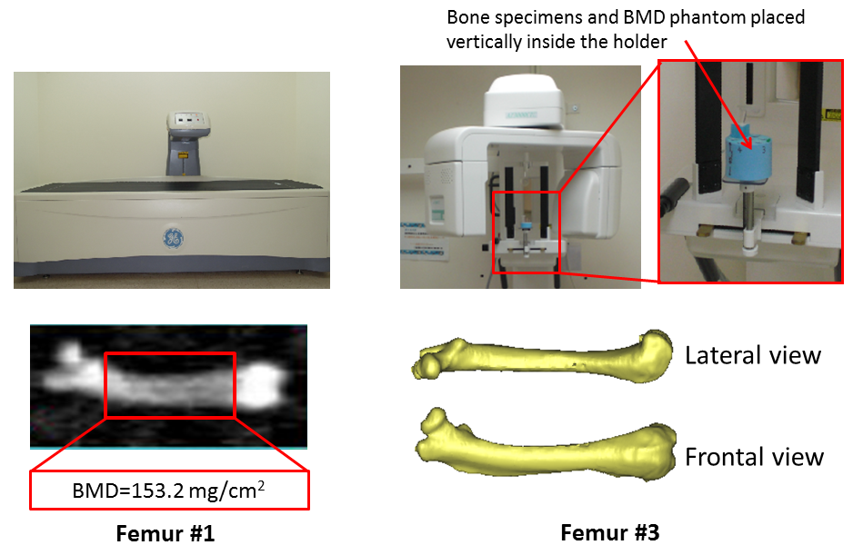
Figure 1. Radiologic measurements of bone specimens: DXA (left) and CBCT (right).

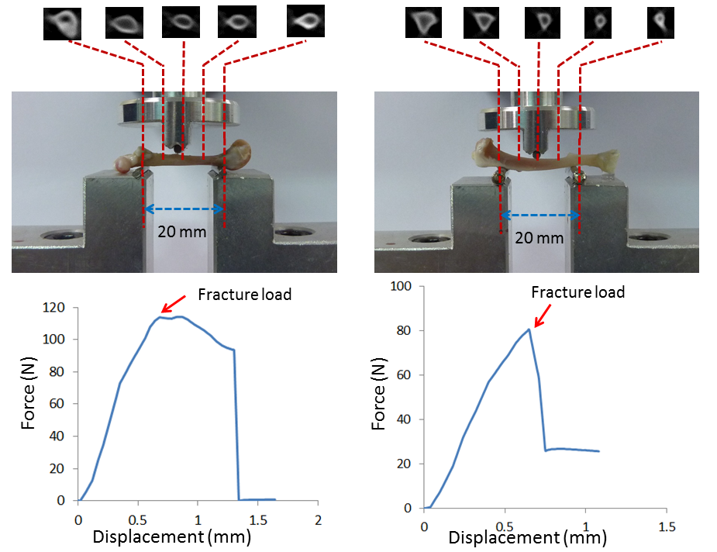
Figure 2. Five CBCT cross-sectional scans, the sites of the DXA scanning measurements, and the three-point bending test: femur (left) and tibia (right). (The force-vs-displacement curves were recorded using the three-point bending test for femur #6 and tibia #10.)

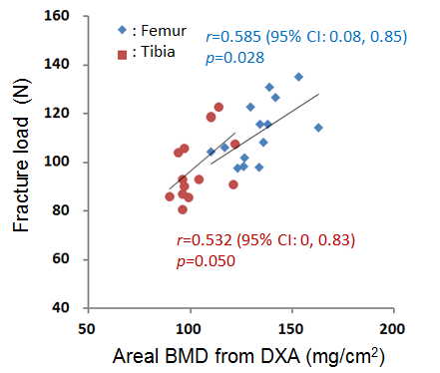
Figure 3. Correlation between fracture load (measured using a three-point bending test) and areal BMD (measured using DXA).

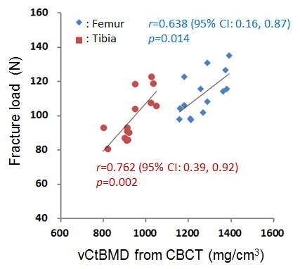
Figure 4. Correlation between fracture load (measured using a three-point bending test) and vCtBMD (measured using CBCT).

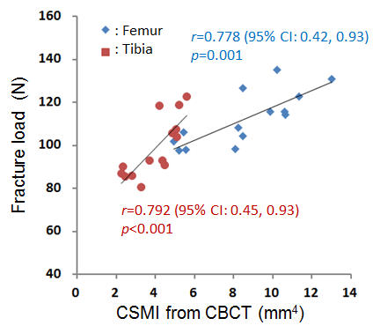
Figure 5. Correlation between fracture load (measured using a three-point bending test) and CSMI (measured using CBCT).

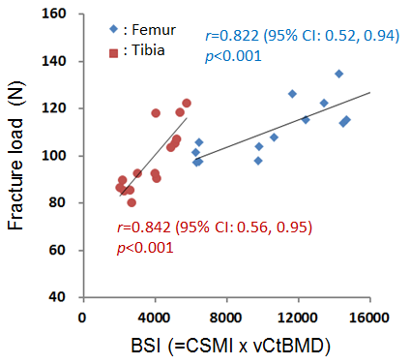
Figure 6. Correlation between fracture load (measured using a three-point bending test) and BSI (= CSMI × vCtBMD).

