LUTS (2012) 4, 62–66

REVIEW ARTICLE

Outcome Measurement of Overactive Bladder

Chi-Shun LIEN and Eric CHIEH-LUNG CHOU∗
Department of Urology, China Medical University Hospital and School of Medicine, China Medical University, Taiwan,

Republic of China

Overactive bladder (OAB) is a common disease. The diagnosis of OAB is based on its symptoms without physiological markers of disease activity. Frequently used assessment methods for OAB include frequency volume chart; urodynamic studies; patient-reported outcomes questionnaires, such as the Overactive Bladder Questionnaire, King’s Health Questionnaire, patient perception of bladder conditions; and OAB symptom score. The severity of OAB and degree of improvement after treatment can be obtained by comprehensive evaluation. However, a consensus of which evaluations should be used to define the severity of OAB is still lacking. We expect a proper OAB assessment with universal acceptance in the future.

Key words assessment, overactive bladder, questionnaire, symptom score

1. INTRODUCTION

Overactive bladder (OAB) is defined by the Interna-tional Continence Society (ICS) as a complex of symptoms characterized by urgency, with or without urge inconti-nence, usually with frequency and nocturia, if there is no proven infection or other obvious pathology.¹ OAB sig-nificantly impacts health-related quality of life (HRQL). Patients with OAB are more liable to acquire a urinary tract infection and have a higher incidence of falling accidents, fracture, sleep disorder and depression.²

Overactive bladder greatly affects physical and social functioning, including work, sleep, and sexual and inter-personal relationships.^{3 – 5} Because of the symptom of frequency, OAB patients usually reduce water (fluid) intake and limit daily activity to avoid discomfort.⁶ OAB, especially in patients with urge incontinence, eventually has a negative impact on HRQL.

The assessment of OAB is very important for patients and physicians. The severity of OAB and degree of improvement after treatment can be obtained by com-prehensive evaluation. However, a consensus of what symptoms or evaluations should be used to define OAB is still lacking.⁷ Previous studies have used the number of urinary incontinence or episodes of urgency to evaluate the severity of OAB or treatment outcome.^{8,9} However, taking into account the nature and definition of OAB, this approach may not properly reflect a patient’s condition.

Urgency is the pivotal symptom, defined by the ICS as ‘‘the complaint of a sudden compelling desire to void that is difficult to defer’’. Urgency is a subjective symptom. Most normal people without OAB will have the feeling of ‘‘urge to void’’ when their bladder is full; thus, it is not easy to distinguish it from ‘‘pathological’’ urgency. The ICS therefore suggested that the term ‘‘desire to void’’ is more appropriate for describing normal filling sensation.

In addition, the diagnosis of OAB is based on voiding symptoms. Urinary symptoms are not life-threatening and do not affect the physiological function. Regarding OAB affecting the quality of life, the same symptoms may have different effects and impacts on different people; therefore, the needs of patients with OAB and methods of treating them will vary and must be considered. Fre-quently used assessment methods for OAB are described below.

2. FREQUENCY VOLUME CHART (FVC)

The FVC is an important tool to understand the behav-ior of voiding. In the FVC, frequency is defined as the number of voids recorded during waking hours, includ-ing the last void before sleep and the first void after waking and rising in the morning. Nocturia is the num-ber of voids recorded during a night’s sleep; each void is preceded and followed by sleep.¹ The FVC is essential for the differential diagnosis of nocturia, to determine the bladder capacity of patients, and whether they have nocturnal polyuria.

The FVC records the status of micturition, but it does not reflect the status of urgency. Therefore, we can-not evaluate the severity of OAB by FVC alone. The FVC could be one of the references for the assessment of OAB.

∗ Correspondence: Eric Chieh-Lung Chou, MD, Department of Urology, China Medical University Hospital, No. 2, Yu-Der Road, Taichung, Taiwan. Tel: +886-4-22304336; Fax: +886-4-22304336. Email: ericchou66@yahoo. com.tw

Received 20 September 2011; revised 30 November 2011; accepted 2 Decem-ber 2011.

DOI: 10.1111/j.1757-5672.2011.00126.x

 2012 Blackwell Publishing Asia Pty Ltd

3. URODYNAMIC STUDIES

The diagnosis of OAB is based on symptoms, not urodynamic studies. Therefore, urodynamic studies are not required for patients with OAB before treatment is started. However, experts may arrange urodynamics if patients have a poor response to conservative or medical treatments for OAB.

Common urodynamic findings related to OAB are detrusor overactivity (DO) and increased filling sensa-tion (Fig. 1). It is noteworthy that DO may be shown in patients without any symptoms of OAB. On the con-trary, DO does not appear in many patients with obvious symptoms of OAB during urodynamic examination.¹⁰ Therefore, urodynamics may provide information for clinicians, especially before starting invasive treatment for OAB, but are not suitable for the assessment of the severity of OAB and treatment outcomes.

4. PATIENT-REPORTED OUTCOMES (PRO)

Brubaker et al. proposed the concept of patient-reported outcomes (PRO) in 2006.¹¹ The influences of OAB on patients are very subjective. Previous studies showed that the objective assessments, such as voiding diaries and urodynamics have only a very weak rela-tionship with OAB symptoms.¹² Therefore, using PRO to evaluate the condition of OAB is more appropriate.

5. HEALTH-RELATED QUALITY OF LIFE (HRQL)

5.1. General HRQL measures

Health-related quality of life is considered a key out-come in treatment evaluation.¹³ Abrams et al. used the
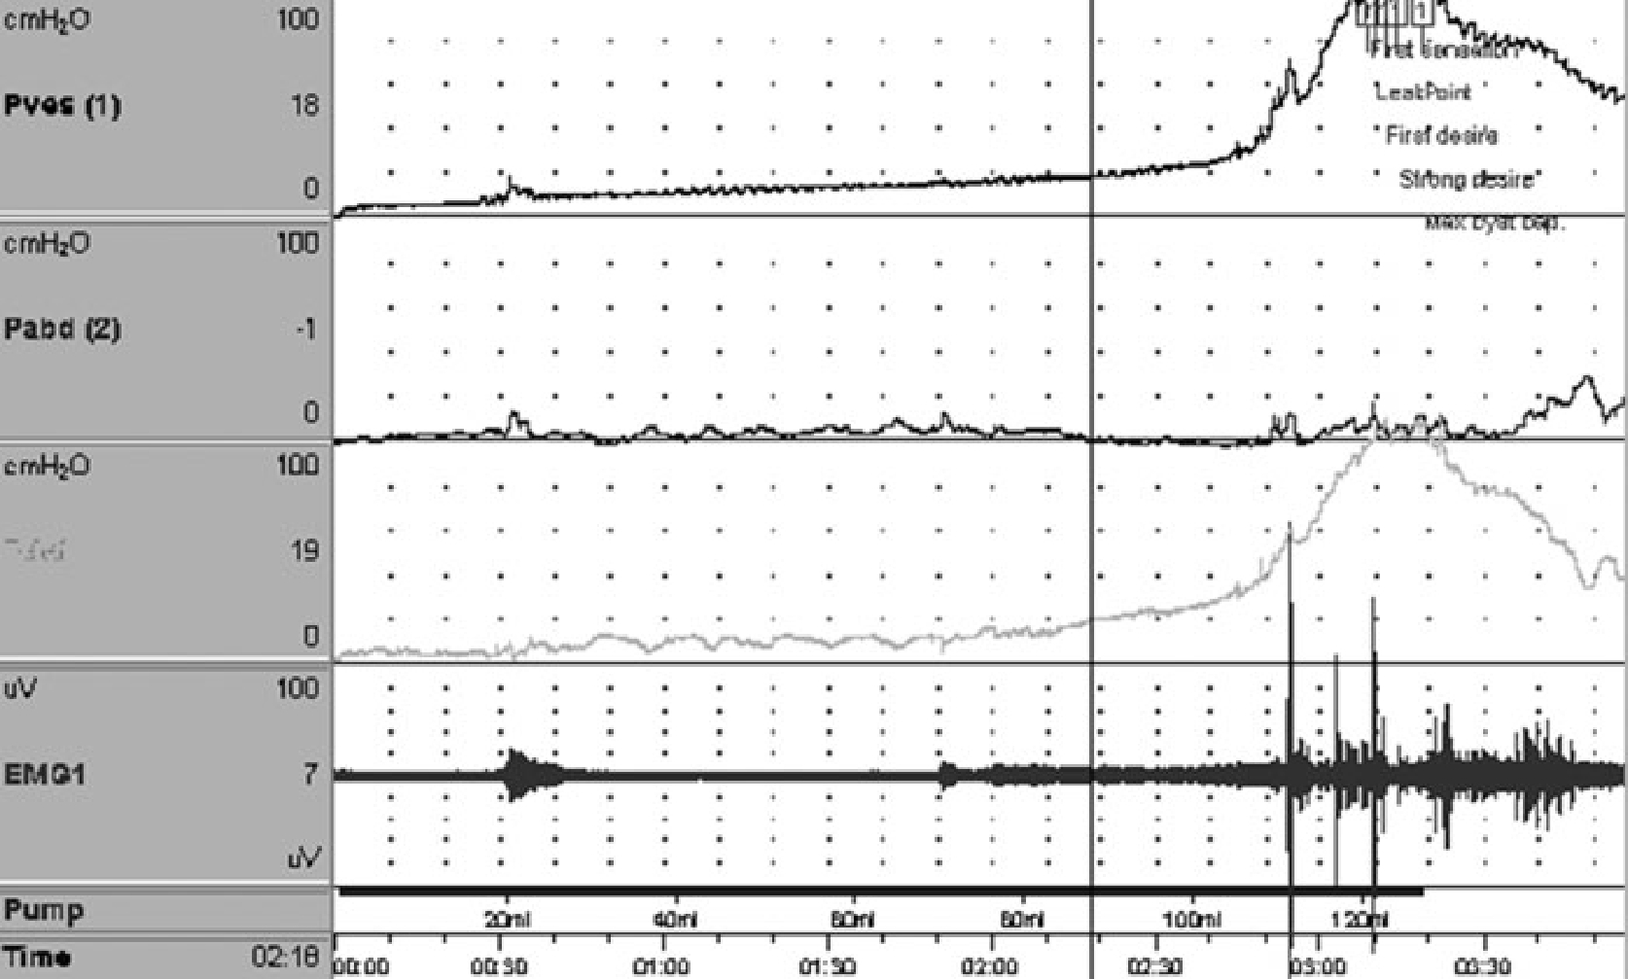
Outcome Measurement of OAB 63

Medical Outcomes Study 36-Item Short-Form Health Sur-vey to evaluate patients with OAB and compared it with patients with diabetes mellitus in terms of vitality; men-tal health; and physical, social, and emotional function. The results showed that patients with OAB had lower scores.¹⁴ General HRQL can be used as a tool for assessing OAB.

5.2. Disease-specific HRQL measures

Although general HRQL measures are useful in OAB assessment, different urinary symptoms may lead to dif-ferent distress in life. For example, urgency incontinence and mixed incontinence have a greater negative impact on HRQL compared with stress incontinence.^{15,16}

Compared with general HRQL measures, the disease-specific HRQL assessment should be able to reflect the disease severity and the effectiveness of treatment more precisely in patients with OAB. Commonly used disease-specific HRQL measures for OAB are described below.

5.3. Overactive Bladder Questionnaire (OAB-q)

Coyne et al. developed the OAB-q, which is widely used for the evaluation of OAB treatment outcomes.¹⁷ Matza et al. reviewed HRQL questionnaires for urinary incontinence and OAB, and demonstrated that the only instrument available for use with patients with OAB was the Overactive Bladder Questionnaire.¹⁸

This questionnaire addresses patient-reported out-comes, such as symptom bother and HRQL. The authors mentioned that although the King’s Health Questionnaire and other instruments have been validated in a sample

Fig. 1 Detrusor overactivity in patients with overactive bladder.

 2012 Blackwell Publishing Asia Pty Ltd

64 Chi-Shun Lien and Eric Chieh-Lung Chou

of incontinent OAB patients, the OAB-q is the first questionnaire for continent and incontinent OAB-specific, subjective patient-reported outcome measures.¹⁷

The initial OAB-q consisted of 62 items (13 symptom, 4 general, and 44 HRQL questions) and was designed for self-administration. Symptom items addressed both the frequency and bother of frequency, urgency, nocturia and incontinence symptoms. HRQL items addressed coping behaviors, work, commuting and travel, sleep, physi-cal activities, social activities, self-esteem/psychological well-being, relationships and sexual functioning.¹⁷ Item reduction was carried out to excludeitems with high floor/ceiling responses, low item-to-total correlations or low factor loadings. The final OAB-q consisted of an 8-item symptom bother scale and a 25-item HRQL scale.

According to Coyne’s report, the OAB-q detected the differences between normal and OAB patients, indicating that continent OAB has a very real impact on HRQL. OAB-q is a widely accepted tool for measuring OAB-related symptoms and HRQL in clinical management and treatment outcome evaluation. However, the disadvan-tage of OAB-q is obvious. It takes a long time for patients to complete the 33 items. Patients may feel uncomfortable answering all the questions. This disadvantage limits the applications in clinical practice.¹⁹

5.4. OAB-q Short Form (OAB-q SF)

The OAB-q Short Form (OAB-q SF) was derived from the original OAB-q to minimize the burden of the respon-dent. The reliability, validity, and responsiveness of the OAB-q are still retaining. The 8-item symptom bother scale of the OAB-q was reduced to 6 items, and the 25-item HRQL scale of the OAB-q was reduced to 13 items.

Although when compared with the OAB-q the items and content of OAB-q SF are reduced, the OAB-q SF adequately captures the range of OAB symptom bother defined by the patient sample.²⁰ The OAB-q SF demon-strated good internal consistency reliability, concurrent validity, discriminant validity, and responsiveness. The OAB-q SF has been included in the International Con-sultation on Incontinence Modular Questionnaire (ICIQ-OAB) module to assess the impact of OAB on the lives of patients.

5.5. King’s Health Questionnaire (KHQ)

The KHQ is a 33-item, multidimensional, disease-specific questionnaire. KHQ was developed by Kelleher et al.²¹ The KHQ consists of the following summated, multi-item HRQL domains: Role Limitations, Physical Limitations, Social Limitations, Personal Relationships, Emotions, Sleep and Energy, and Severity (Coping) Mea-sures. In addition, two 1-item questions address Inconti-nence Impact and General Health Perceptions. The KHQ domains are scored on a 0 (best) to 100 (worst) scale. The KHQ is a valid instrument that can discriminate between normal and clinically diagnosed OAB patients^{22,23} and is

widely accepted for evaluating the QoL and severity of disease in patients with OAB.

5.6. Patient perception of bladder conditions (PPBC)

Most questionnaires that evaluate the impact of OAB and treatment outcomes are multi-item, such as the OAB-q. The advantage of multi-item questionnaires is that they are a rich source of information on numerous domains of the patient’s life, but their disadvantages are difficulties in scoring and quick interpretation. Coyne et al. developed a single, global measure to assess the patient’s overall per-ceived bladder condition.¹⁹ A single-item global measure is practical because of brevity, along with ease of use and interpretation.²⁴

Coyne’s PPBC was developed for patients with urinary problems as a global assessment of bladder conditions and is recommended as a global outcome measure for uri-nary incontinence.²⁵ The PPBC is a single-item measure that assesses subjective impressions of current urinary problems. Patients are asked to rate their perceived blad-der condition on a 6-point scale ranging from 1 (no problems at all) to 6 (many severe problems). Score changes typically range from −2 to 2, with negative val-ues indicating patient improvement. The PPBC has been demonstrated as reliable for a small sample of patients with OAB.

According to Coyne’s report, the PPBC was highly responsive to improvements in micturition frequency, urgency episodes, incontinent episodes, and patient-reported HRQL. The advantages of the PPBC are its sim-plicity and usefulness. However, we must take note of the limitations of single-item global measures. A single-item, global measure cannot provide the depth or breadth of information that can be obtained from multi-item mea-sures. A treatment may have differential effects on various symptoms or domains of HRQL, whereas a multi-item questionnaire would be more appropriate for determining specific effects.¹⁹

5.7. Single-item measures of OAB symptom treatment correlate with patient satisfaction

Michel et al. tried to find a simpler, preferably single item scale for routine clinical practice in the evaluation of patients with OAB. Their study compared multiple single-item scales at baseline and after treatment with patient-reported overall rating of treatment efficacy.²⁶

A total of 4450 patients with overactive bladder were enrolled and treated with solifenacin for 12 weeks. In addition to assessing the basic overactive bladder symp-toms, the following single-item rating scales were applied: Indevus Urgency Severity Scale, Urgency Perception Scale, Visual Analog Scale (VAS), quality of life question of the IPSS, and general health and bladder problem questions of the KHQ. When compared to patient-reported efficacy, the VAS and the bladder problem question of the KHQ showed the closest correlation. The authors con-cluded that the VAS and the bladder problem questions of the KHQ show the greatest promise as single-item scales to assess problem intensity in OAB patients.²⁶

 2012 Blackwell Publishing Asia Pty Ltd

5.8. OAB Symptom Score (OABSS)

Overactive bladder is a combination of symptoms, both subjective and objective. Benign prostate hyperpla-sia (BPH) for example contains irritative and obstructive symptoms and the complexity of voiding symptoms make its evaluation difficult. In 1992, the American Urological Association introduced the International Prostate Symp-toms Score (IPSS).²⁷ The IPSS may not perfectly reflect the condition of each patient with BPH, but the IPSS has the advantages that it is simple, and its use is widespread. The IPSS has applied in daily clinical evaluation and in research programs. We expect that, like the IPSS, the OAB Symptom Score (OABSS) will become accepted by most physicians.

Homma et al. published the OABSS in 2006. This is a single symptom score that employs a self-report questionnaire to quantify OAB symptoms. The authors selected four symptoms: daytime frequency, nighttime frequency, urgency, and urgency incontinence for the questionnaire²⁸ (Appendix I). The overall score is the simple sum of the four symptom scores.

Traditionally, a questionnaire has many items with the same minimum and maximum score (e.g. IPSS).²⁷ However, with the OABSS, scales vary. For instance, the item ‘‘How often do you have a sudden desire to urinate, which is difficult to defer?’’ (urgency) ranges from 0 to 5. Scores for ‘‘How often do you leak urine because you cannot defer the sudden desire to urinate?’’ (urge incontinence) also range from 0 to 5. ‘‘How many times do you typically wake up to urinate from sleeping at night until waking in the morning?’’ (nocturia) ranges from 0 to 3, while ‘‘How many times do you typically urinate from waking in the morning until sleeping?’’ (frequency) ranges from 0 to 2. Homma mentioned that the relative weight among the four scores was determined on the basis of the maximal influence rate of the symptom in the epidemiologic survey.²⁹ As urgency is the core symptom of OAB, the design of OABSS is meant to show a clear separation between subjects with OAB and controls.

One source of concern is that the OABSS was developed and validated using only Japanese patients. The authors did mention that cultural background may affect the psychometric properties of symptom questionnaires.²⁸

6. OABSS IN TRADITIONAL CHINESE

Although different questionnaires are now available and validated for OAB, most of them are written in English. For non-English-speaking people, the question-naires must be translated into the appropriate language. In 2006, Acquadro et al. translated the OABq into 14 languages.³⁰ The process included six steps: (i) two for-ward translations; (ii) comparison and reconciliation of the translations; (iii) back-translation; (iv) comparison of the source and back-translation; (v) review by one urol-ogist or gynecologist; and (vi) a comprehension test, using patients. However, none of these versions was in traditional Chinese.

In 2008, the president of the Taiwan Continence Soci-ety (TCS), Professor Kuo, commenced linguistic validation
Outcome Measurement of OAB 65

and other elements of production of a Chinese version of the Homma OABSS. The process involved forward- and back-translation, and review by urologists and gynecolo-gists in expert meetings in Taiwan (hosted by Professor Kuo) and in Japan (hosted by Professor Homma). The validated OABSS in Traditional Chinese is now available (Appendix II) and posted on the official website of the TCS (http://www.tcs.org.tw).

7. CONCLUSION

OAB is a symptom-based condition without physio-logical markers of disease activity. Appropriate tools are needed to assess patients with OAB. There is still no con-sensus for the evaluation of OAB. Patients may need to be assessed from different aspects, such as clinical symptoms, FVC, and multi-item questionnaires to obtain patient-reported outcomes to fully understand the condition in patients with OAB. On the other hand, a simple and effec-tive symptom score is needed to meet the requirements of clinical work. Translation and linguistic validation of the questionnaires is important and practical. We also look forward to OAB assessment with universal acceptance of in the future.

REFERENCES

1. Abrams P, Cardozo L, Fall M et al. The standardisation of terminology of lower urinary tract function: report from the Standardisation Sub-committee of the International Conti-nence Society. Neurourol Urodyn 2002; 21: 167–78.

- Brown JS, McGhan WF, Chokroverty S. Comorbidities asso-ciated with overactive bladder. Am J Manag Care 2000; 6(Suppl 11): S574–9.

- Coyne KS, Zhou Z, Bhattacharyya SK, Thompson CL, Dhawan R, Versi E. The prevalence of nocturia and its effect on health-related quality of life and sleep in a community sample in the USA. BJU Int 2003; 92: 948–54.

- Coyne KS, Payne C, Bhattacharyya SK et al. The impact of urinary urgency and frequency on health-related quality of life in overactive bladder: results from a national community survey. Value Health 2004; 7: 455–63.

- Stewart WF, Van Rooyen JB, Cundiff GW et al. Prevalence and burden of overactive bladder in the United States. World J Urol 2003; 20: 327–36.

- Kelleher CJ, Resse PR, Pleil AM et al. Health-related qual-ity of life of patients receiving extended-release toltero-dine for overactive bladder. Am J Manag Care 2002; 8: 608–15.

- Wein AJ, Rovner ES. Definition and epidemiology of over-active bladder. Urology 2002; 60(Suppl 5): 7–12.

- Chapple CR, Khullar V, Gabriel Z et al. The effects of anti-muscarinic treatments in overactive bladder: an update of a systematic review and meta-analysis. Eur Urol 2008; 54: 543–62.

- Novara G, Galfano A, Secco S et al. A systematic review and meta-analysis of randomized controlled trials with antimus-carinic drugs for overactive bladder. Eur Urol 2008; 54: 740–64.

- Hashim H, Abrams P. Is the bladder a reliable witness for predicting detrusor overactivity? J Urol 2006; 175: 191–5.

- Brubaker L, Chapple C, Coyne KS, Kopp Z. Patient-reported outcomes in overactive bladder: importance for determining clinical effectiveness of treatment. Urology 2006; 68(Suppl 2): 3–8.

- Kelleher C. Quality of life and urinary incontinence. Baillieres Best Pract Res Clin Obstet Gynaecol 2000; 14: 363–79.

 2012 Blackwell Publishing Asia Pty Ltd

66 Chi-Shun Lien and Eric Chieh-Lung Chou

- Leidy NK, Revicki DA, Geneste B. Recommendations for evaluating the validity of quality of life claims for labeling and promotion. Value Health 1999; 2: 113–27.

- Abrams P, Kelleher C, Lerr L et al. Overactive bladder sig-nificantly affects quality of life. Am J Manag Care 2000; 6: s580–90.

APPENDIX I

Overactive Bladder Symptom Score (OABSS)∗
Homma et al.

Question Frequency Score

- Coyne KS, Zhou Z, Thompson C et al. The impact on health-related quality of life of stress, urge and mixed urinary incontinence. BJU Int 2003; 92: 731–5.

- Wyman JF, Harkins SW, Choi SC et al. Psychosocial impact of urinary incontinence in women. Obstet Gynecol 1987; 70: 378–81.

- Coyne K, Revicki D, Hunt T et al. Psychometric validation of an overactive bladder symptom and health-related quality of life questionnaire: the OAB-q. Qual Life Res 2002; 11: 563–74.

- Matza LS, Zyczynski TM, Bavendam T. A review of quality of life questionnaires for urinary incontinence and overactive bladder: which ones to use and why. Curr Urol Rep 2004; 5: 336–42.

- Coyne KS, Matza LS, Kopp Z, Abrams P. The validation of the patient perception of bladder condition (PPBC): a single-item global measure for patients with overactive bladder. Eur Urol 2006; 49: 1079–86.

How many times do you typically urinate from waking in the morning until sleeping at night?

How many times do you typically wake up to urinate from sleeping at night until waking in the morning?

How often do you have a sudden desire to urinate, which is difficult to defer?

How often do you leak urine because you cannot defer the sudden desire to urinate?

≤7 | 0
8–14 | 1
≥15 | 2
0 | 0
1 | 1
2 | 2
≥3 | 3
Not at all | 0
Less than once a week | 1
Once a week or more | 2
About once a day | 3
Two to four times a day | 4
Five times a day or more | 5
Not at all | 0
Less than once a week | 1
Once a week or more | 2
About once a day | 3
Two to four times a day | 4
Five times a day or more | 5

- Coyne KS, Lai JS, Zyczynski T et al. An overactive bladder symptom and quality-of-life short form: development of the Overactive Bladder Questionnaire Short Form (OAB-q SF). 34th Joint Meeting of the International Continence Society and the International UroGynecological Association, Paris, France. 2004.

- Kelleher CJ, Cardozo LD, Khullar V et al. A new question-naire to assess the quality of life of urinary incontinent women. Br J Obstet Gynaecol 1997; 104: 1374–9.

- Nixon A, Coleman S, Sabounjian L et al. A validated patient reported measure of urinary urgency severity in overac-tive bladder for use in clinical trials. J Urol 2005; 174: 604–7.

- Oliver S, Fowler C, Mundy A, Craggs M. Measuring the sen-sations of urge and bladder filling during cystometry in urge incontinence and the effects of neuromodulation. Neurourol Urodyn 2003; 22: 7–16.

- Sloan JA, Aaronson N, Cappelleri JC, Fairclough DL, Varricchio C. Assessing the clinical significance of single items relative to summated scores. Mayo Clin Proc 2002; 77: 479–87.

- European Agency for the Evaluation of Medicinal Products and Committee for Proprietary Medicinal Products. Note for Guidance on the Clinical Investigation of Medicinal Products for the Treatment of Urinary Incontinence, London, United Kingdom. 2002.

- Michel MC, Oelke M, Vogel M, de la Rosette JJ. Which single-item measures of overactive bladder symptom treat-ment correlate best with patient satisfaction? Neurourol Urodyn 2011; 30: 510–4.

- Barry MJ, Fowler FJ Jr, O’Leary MP et al. The American Urological Association symptom index for benign prostatic hyperplasia. J Urol 1992; 148: 1549–57.

- Homma Y, Yoshida M, Seki N et al. Symptom assessment tool for overactive bladder syndrome–overactive bladder symptom score. Urology 2006; 68: 318–23.

- Homma Y, Kakizaki H, Gotoh M et al. Epidemiologic survey on lower urinary tract symptoms in Japan (in Japanese).

J Neurogen Bladder Soc 2003; 14: 266–77.

- Acquadro C, Kopp Z, Coyne KS et al. Translating overactive bladder questionnaires in 14 languages. Urology 2006; 67: 536–40.

∗Patients were instructed to circle the score that best applied to their urinary condition during the past week; the overall score was the sum of the four scores.

APPENDIX II

Overactive Bladder Symptom Score (OABSS) in Chinese

version
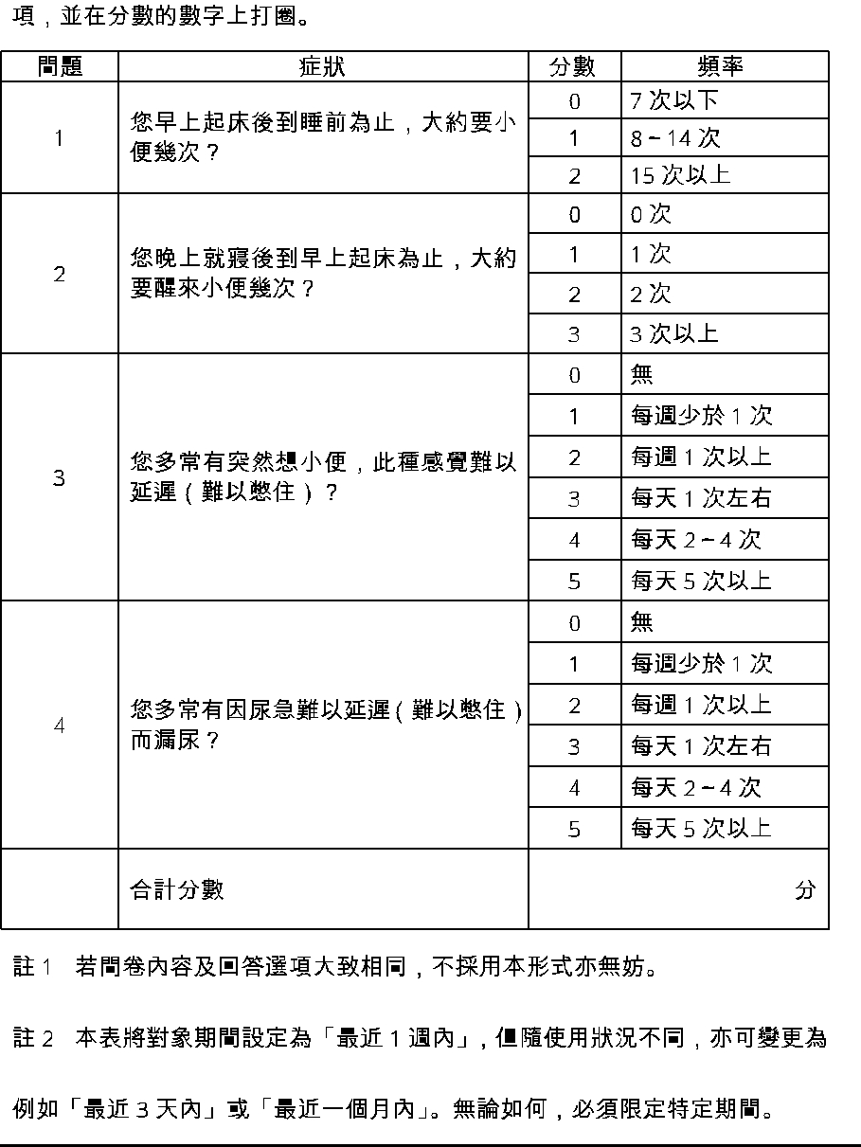

 2012 Blackwell Publishing Asia Pty Ltd

PDF to Word

