+ MODEL
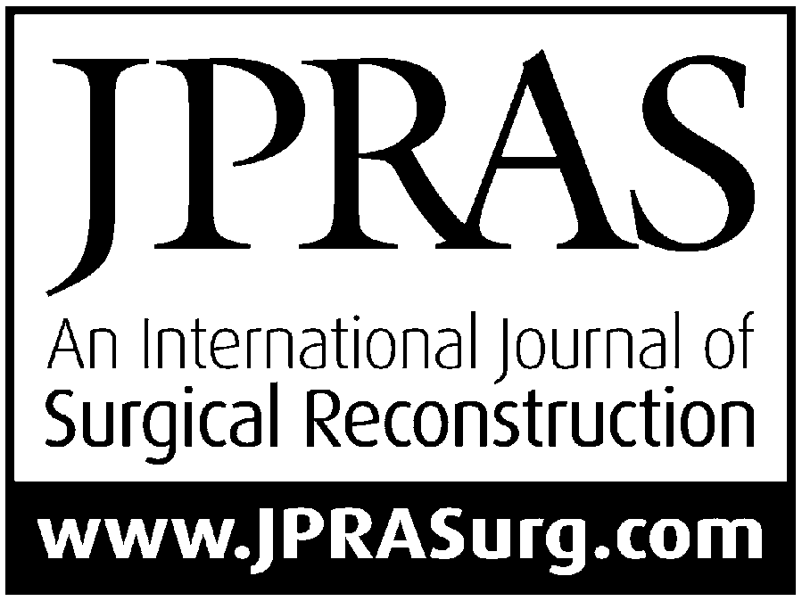

Journal of Plastic, Reconstructive & Aesthetic Surgery (2012) xx, 1e7



Three uses of an extra length of jejunum in
pharyngo-oesophageal reconstruction with free jejunal flap*

Francesco Perrone a,b, Agnese Nitto a,b, Yueh-bih Tang c, Shih-heng Chen a,b, Hung Chi Chen a,b,*

a Plastic Surgery Department, China Medical University Hospital, 2, Yuh Der Road, Taichung, Taiwan
b Department of Medicine, China Medical University, 2, Yuh Der Road, Taichung, Taiwan
c Plastic Surgery Department, National Taiwan University Hospital, Taipei, Taiwan

Received 11 April 2012; accepted 3 August 2012

KEYWORDS
Free jejunal flap; Pharyngo-jejunal junction;
Jejuno-oesophageal junction;
Jejuno-colonic
junction; Seromuscular flap; Free jejunal diversionary conduit; Pharyngo-cutaneous fistula
Summary Background: The free jejunal flap is a widely spread method of pharyngo- oesophageal reconstruction and can also be used in patients presenting with aspiration tendency following treatment for head and neck cancers or caustic injury of the upper aero-digestive tract to create a separate food pathway, the free jejunal diversionary conduit.
Methods: Sixteen patients, 13 males and 3 females, aged between 32 and 66 years, under- going pharyngo-oesophageal reconstruction with a free jejunal flap between October 2005 and July 2011, were included in this study. An extra length of jejunum was used in 10 patients for widening of the upper portion of a prefabricated free jejunal flap, in three patients who developed a leak at the jejuno-oesophageal junction during the follow-up for creation of a seromuscular flap that was used to seal off the leak and in three patients with aspiration tendency for simultaneous creation of a free jejunal diversionary conduit and a separate pharyngo-cutaneous fistula.
Results: All flaps survived completely. No complication was observed at the pharyngo- jejunal junction during the follow-up in patients reconstructed with the prefabricated free jejunal flap. No recurrence of the leak was observed in patients treated with a seromuscular flap during the follow-up period. Patients with a free jejunal diversionary conduit did not experience episodes of aspiration and no obstruction of the pharyngo-cutaneous fistula was noted in the postoperative period.

* The paper has been supported with institutional funding.
* Corresponding author: Plastic Surgery Department, China Medical University Hospital, 2, Yuh Der Road, Taichung, Taiwan. Tel.: þ886
4 2205 2121x1509.
E-mail address: D19722@mail.cmuh.org.tw (H.C. Chen).

1748-6815/$ - see front matter ª 2012 British Association of Plastic, Reconstructive and Aesthetic Surgeons. Published by Elsevier Ltd. All rights reserved. http://dx.doi.org/10.1016/j.bjps.2012.08.003

Please cite this article in press as: Perrone F, et al., Three uses of an extra length of jejunum in pharyngo-oesophageal reconstruction with free jejunal flap, Journal of Plastic, Reconstructive & Aesthetic Surgery (2012), http://dx.doi.org/10.1016/j.bjps.2012.08.003

+ MODEL
2 F. Perrone et al.

Conclusions: We want to encourage the use of an extra length of jejunum in pharyngo- oesophageal reconstruction with a free jejunal flap because it helps to manage postopera- tive complications, such as leakage and stricture, and it does not increase the morbidity related to the reconstruction. Furthermore, we believe that the creation of a separate phar yngo-cu tane ous fistula represe nts another step forward in the improvem ent of pharyngo-oesophageal reconstruction with a free jejunal diversionary conduit.
ª 2012 British Association of Plastic, Reconstructive and Aesthetic Surgeons. Published by
Elsevier Ltd. All rights reserved.

Debate continues over the most suitable method of pharyngo-oesophageal reconstruction. Several methods have been employed depending on the extent of the defect. Gastric pull-up is indicated when a total oesophagectomy is required, but it is less applicable for high cervical oeso- phageal or hypopharyngeal lesions that extend superiorly towards the base of the tongue; a pectoralis major flap is used for partial defects of the hypopharynx or cervical oesophagus; colonic interposition is reserved for cases in which previous surgery makes gastric pull-up impossible (such as previous gastrectomy); fascio-cutaneous free flaps, such as radial forearm or antero-lateral thigh flap, are used primarily in patients who are not candidates for more extensive procedures using abdominal viscera; and a free colon flap can be used when the defect is wide and involves the oropharynx, with the advantage of a simultaneous voice
restoration.1 Since its introduction in 1959 by Seidenberg
et al.,2 the free jejunal flap became a widely spread method of pharyngo-oesophageal reconstruction, thanks to natural mucus lubrication, maintenance of peristalsis, low
morbidity and mortality rates and high rate of success.
In this report, we are going to present how an extra length of jejunum can help to manage common complica- tions following pharyngo-oesophageal reconstruction with a free jejunal flap or used for simultaneous creation of a free jejunal diversionary conduit and a separate pharyngo-cutaneous fistula3 in patients presenting with aspiration tendency following treatment for head and neck cancers or caustic injury of the upper aero-digestive tract.

Methods

Sixteen patients, 13 males and three females, aged between
32 and 66 years undergoing pharyngo-oesophageal recon- struction with a free jejunal flap between October 2005 and July 2011 were included in this study. An extra length of jejunum was used in all patients. Patients’ charts were retrospectively reviewed and data regarding patient demo- graphics, type of cancer, surgical procedures, perioperative and postoperative courses, adjuvant therapies and compli- cations were recorded. Oesophagography with barium meal and a computed tomography scan of chest and neck were performed during the follow-up period. Swallowing was evaluated according to the type of ingested food (solid, semisolid or fluid), alteration of eating habits, weight status and necessity of dietary supplementation. A 7-point Likert scale was used to evaluate the deglutition, where 1 indicated severe complaints and an inability to swallow and 7 indicated
satisfactory swallowing without any complaints.4 Presence of
leakage was clinically defined by at least one of the following at any time after the reconstruction with a free jejunal flap5: (1) any evidence of cervical wound infection requiring anti- biotics or drainage; (2) radiologic evidence (by contrast pharyngo-oesophagogram) of anastomotic leakage; or (3) radiographic evidence of contained anastomotic leakage significant enough to delay resumption of oral feeding.
A stricture was defined as clinical symptoms of dysphagia, confirmed by endoscopic evidence of a nar- rowed lumen.7
The study was approved by the Institutional Review
Board of our Hospital.

Surgical technique

Widening of the upper portion of the free jejunal flap
A laparotomy was performed and 30-cm segment of jejunum supplied by the 2nd jejunal artery was prepared distal to the ligament of Treitz and cut at both ends. Before division of the flap pedicle, the proximal portion of the jejunal segment was folded on itself and two side-to-side double-layer sutures were performed. A reservoir was then obtained by discarding the internal common wall included between anterior and posterior suture lines by passing through a 7-cm longitudinal incision of the top wall of the folded flap. After division of the flap pedicle, the flap was transferred to the neck, where recipient vessels (transverse cervical artery and external jugular vein) had been prepared, and placed in an isoperistaltic fashioning. Following completion of the vessel anastomoses, the inlet of the reservoir was sutured to the pharyngeal remnant and the distal end of the jejunal conduit was sutured to the upper end of the oesophageal stump or to the upper end of the interposed colon according to primary disease and any previous reconstruction (Figure 1(a) and (b)). Two 14 F feeding tubes were inserted into the lumen of the jejunal conduit passing through the nostrils and they were kept in place for 3 weeks. The flap was covered by local skin flaps and split-thickness skin grafts. Bowel continuity was in the end restored after placement of a jejunostomy feeding tube and the abdomen closed.

Seromuscular flap
A neck incision was made along the previous vertical scar and the jejuno-oesophageal junction was exposed, then divided. The jejunal conduit was dissected and mobilised and a 3-cm segment of jejunum was isolated from its lower end with ligation of the vascular arcades connecting the segment to the flap. Once sufficient mobility was achieved, the isolated segment of jejunum was opened on the antimesenteric side,

Please cite this article in press as: Perrone F, et al., Three uses of an extra length of jejunum in pharyngo-oesophageal reconstruction with free jejunal flap, Journal of Plastic, Reconstructive & Aesthetic Surgery (2012), http://dx.doi.org/10.1016/j.bjps.2012.08.003

+ MODEL
Uses of an extra length of jejunum in pharyngo-oesophageal reconstruction 3

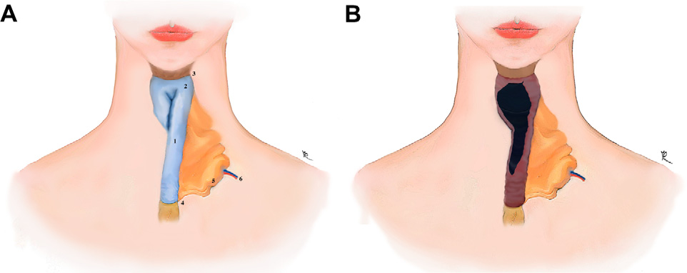

Figure 1 (A) 1 Z Free jejunal flap; 2 Z Upper portion of the flap folded on itself and sutured on anterior and posterior midline to create a reservoir; 3 Z Junction between pharyngeal remnant and reservoir; 4 Z Junction between distal end of the jejunal conduit and the upper end of the oesophageal stump (or interposed colon); 5 Z Flap mesentery; 6 Z Flap pedicle: 2nd jejunal artery and concomitant vein. (B) Lumen of the jejunal reservoir after resection of internal common wall between the 2 suture lines performed before the flap inset by passing through a 7-cm longitudinal incision of the top wall of the flap.

the submucosa inflated with normal saline 0.9% and the mucosa removed by scissors (Figure 2(a)). The leaking enteral junction was then redone by a double-layer suture and superior and inferior borders of the obtained seromus- cular flap, 7 3 0.5 cm, were fixed with few interrupted sutures on antero-lateral aspect of the jejuno-oesophageal junction without any tension to seal off the leak. The muscular side of the seromuscular flap was placed next to the enteral junction with the mesenteric axis parallel to the anastomotic suture line (Figure 2(b)). Two 14-F feeding tubes were inserted into the lumen of the new conduit passing from the nostrils and they were kept in place for 3 weeks until healing of the enteral anastomosis.

Pharyngo-cutaneous fistula
A 10-cm skin incision was performed in the neck below the mandibular margin and a subperiosteal flap was raised from the mandibular region, protecting from injury the mental nerve and the marginal mandibular branch of the facial nerve. A 10-cm vertical skin incision was then performed in the neck for preparation of the recipient vessels, the transverse cervical artery and the external jugular vein. A laparotomy was performed and 30-cm segment of jejunum supplied by the 2nd jejunal artery was prepared distal to
the ligament of Treitz and cut at both ends. Before division of the flap pedicle, a 10-cm jejunal length was isolated from the distal portion of the jejunal segment. The vascular arcades connecting the shorter to the longer jejunal segment were ligated to obtain a prefabricated chimaeric flap. The flap pedicle was divided and the chimaeric flap was transferred to the neck for simultaneous creation of a free jejunal diversionary conduit3 and a separate pharyngo-cutaneous fistula. Both jejunal segments were placed into the neck in an isoperistaltic fashion. After completion of the vessel anastomosis, the proximal portion
of the longer jejunal segment was passed above the mandibular body and under the subperiosteal flap and its upper end was sutured into a slit opened in the left buc- cogingival sulcus. A two-layer suture was performed between the distal end of the longer jejunal segment and the upper end of the oesophageal stump or the upper end of the interposed colon, according to primary disease and any previous reconstruction. Then, the proximal end of the shorter jejunal segment was sutured to the pharyngeal remnant while the distal end of the same jejunal segment was passed through an opening in the neck skin to create a cutaneous orifice (Figure 3). A 14-F nasogastric tube was kept inside the fistula as a stent for 2 weeks and two 14 F

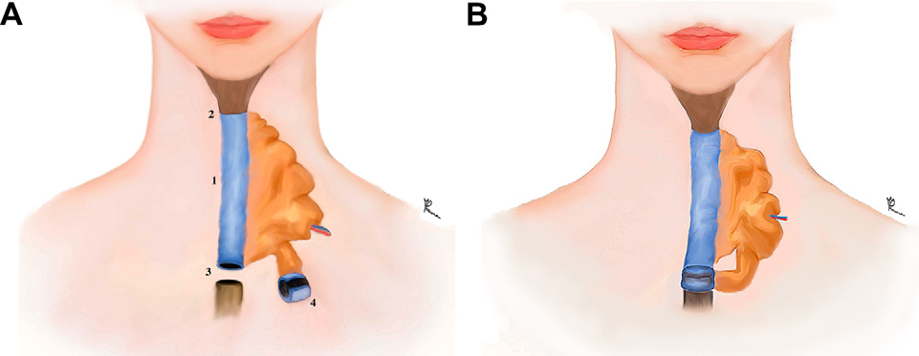

Figure 2 (A) 1 Z Free jejunal conduit; 2 Z Pharyngo-jejunal junction; 3 Z Jejuno-oesophageal junction following division;
4 Z Sero-muscular flap obtained from the distal portion of the jejunal conduit. (B) Inset of the sero-muscular flap with few interrupted sutures along its superior and inferior border without any tension over antero-lateral aspect of a redone jejuno- oesophageal junction.

Please cite this article in press as: Perrone F, et al., Three uses of an extra length of jejunum in pharyngo-oesophageal reconstruction with free jejunal flap, Journal of Plastic, Reconstructive & Aesthetic Surgery (2012), http://dx.doi.org/10.1016/j.bjps.2012.08.003

+ MODEL
4 F. Perrone et al.

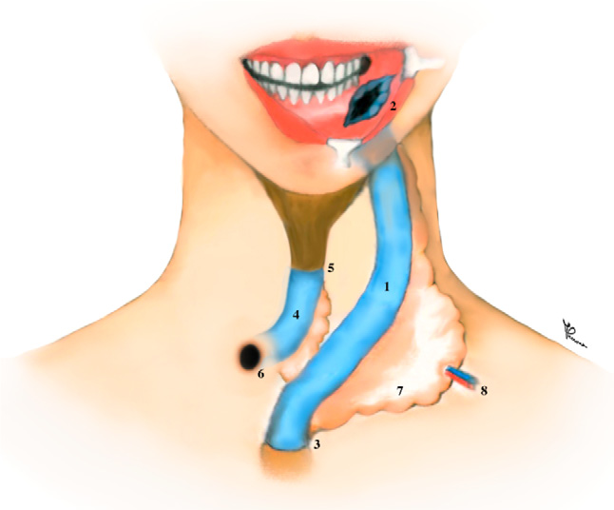

Figure 3 1 Z Free jejunal diversionary conduit; 2 Z Inlet of the new food pathway opening in the bucco-gingival sulcus;
3 Z Jejuno-oesophageal/colonic junction; 4 Z Shorter jejunal segment used as an isoperistaltic pharyngo-cutaneous fistula to evacuate food and fluids accidentally swallowed through the ordinary posterior route after creation of the new anterior food pathway; 5 Z Junction between pharyngeal remnant and fistula; 6 Z External orifice of the pharyngo-cutaneous fistula opening on the neck skin; 7 Z Flap mesentery; 8 Z Flap
nd

Group 3 included three patients presenting with swal- lowing dysfunction and aspiration tendency, who were treated with simultaneous creation of a new food pathway, the free jejunal diversionary conduit, and a separate conduit used as a pharyngo-cutaneous fistula. The average follow-up period in this group was only 4 months and all patients were still under swallowing training at the moment of the functional evaluation. These patients did not expe- rience episodes of aspiration and no obstruction of the pahryngo-cuntaneous conduit was noted in the post- operative period (Table 3).

Discussion

An extra length of jejunum can be used for pharyngo- oesophageal reconstruction and prevention or treatment of complications such as leakage and stricture, or for the simultaneous creation of a new food pathway, the free jejunal diversionary conduit, and a separate conduit used as a pharyngo-cutaneous fistula in cases of aspiration tendency.
The literature showed a variable leakage rate ranging from 7 to 31 percent in pharyngo-oesophageal reconstruc- tion with a free jejunal flap,6 while in a retrospective evaluation of leakage rate in a series of 201 free jejunal flaps performed by the senior author at our unit the leakage rate was 5% (unpublished data).
The leak occurs most commonly at the pharyngo-jejunal

pedicle: 2
jejunal artery and concomitant vein.
junction, due to size discrepancy between the pharyngeal

nasogastric tubes were kept inside the free jejunal diver- sionary conduit for 3 weeks to decompress the flap and
remnant and the jejunal lumen especially in case of total pharyngolaryngectomy with resection of the tongue base
7,8

allow healing of the enteral anastomoses. The flap was
undergoing radiotherapy.
Although there is no demon-

covered by local skin flaps and split-thickness skin grafts. Bowel continuity was in the end restored after placement of a jejunostomy feeding tube and the abdomen closed.

Results

Group 1 included 10 patients with an average follow-up duration of 29 months presenting with hypopharyngeal cancer, who underwent pharyngo-oesophageal reconstruc- tion with a free jejunal flap that was enlarged at the cephalic portion to improve the size match with the pharyngeal remnant. All patients included in this group started feeding from the mouth within 3 weeks after reconstruction. At the end of the follow-up period, six patients presented with an average score of 5.6 on the 7-point Likert scale. No compli- cation at the pharyngo-jejunal junction was observed in the follow-up period (Table 1).
Group 2 included three patients with an average follow- up duration of 32 months presenting with hypopharyngeal cancer, who underwent pharyngo-oesophageal reconstruc- tion with a free jejunal flap. They developed leakage at the jejuno-oesophageal junction during the follow-up period. Following unsuccessful conservative treatments, a seromus- cular flap was used to seal off the leaks in these patients. In all patients, the seromuscular flap was obtained from the distal portion of the flap. After revision surgery, two patients presented with a score of 6 and one patient with a score of 5 on the 7-point Likert scale. No more recurrence of the leakage was observed after revision surgery (Table 2).
stration of a significant relationship between radiotherapy
and fistula formation, it is noteworthy that conservative approach to salivary leakage in irradiated patients is not likely to be successful. To minimise the risk of fistula formation, attention must be paid to flap design and blood supply, ischaemic time and anastomotic technique.6
Since 2005, we have used a seromuscular flap obtained from the distal portion of the free jejunal flap to seal off any leak at the jejuno-oesophageal junction. Due to its lymphatic and vascular properties, the submucosal layer of the flap promoted a better healing of the enteral anasto- mosis. In addition, the flap reduced tension on the enteral anastomosis, that may otherwise induce anastomotic
failure.9 In the last 20 years, a seromuscular flap has been
employed in the treatment of high-risk intestinal anasto- moses,10 infected aortic stumps,11 vesicovaginal fistulas and rectovaginal fistulas12 and broncho-cutaneous fistulas.13 Furthermore, we have recently reported the use of a seromuscular flap to prevent anastomotic leakage in head and neck reconstruction with a free ileocolon flap.14 The use of a seromuscular flap was successful in our patients without recurrence of the leak. The seromuscular flap avoided the use of local flaps and reduced patient morbidity. The flap was easily obtained from distal portions of the jejunal flap because our routine strategy in pharyngo-oesophageal reconstruction with a free jejunal flap is to transfer to the neck an additional length of jejunum, so that a segment of jejunum can be isolated without any impact on the swallowing function if need arises. The seromuscular flap did not pose any problem with

Please cite this article in press as: Perrone F, et al., Three uses of an extra length of jejunum in pharyngo-oesophageal reconstruction with free jejunal flap, Journal of Plastic, Reconstructive & Aesthetic Surgery (2012), http://dx.doi.org/10.1016/j.bjps.2012.08.003

+ MODEL
Uses of an extra length of jejunum in pharyngo-oesophageal reconstruction 5

Table 1 List of patients in group 1. M Z Male; F Z Female; HPC Z hypopharyngeal cancer; EC Z esophageal cancer; FJF Z free jejunal flap.
Sex, Age Primary Previous Preoperative Final reconstruction Follow-up Swallowing Conditions disease reconstruction feeding function
route

M, 55 HPC Colonic Discontinuous Prefabricated FJF with 3 years 6 Died of interposition use of a a widened upper portion recurrence 3
jejunostomy years after the tube reconstruction
with FJF M, 64 HPC None Mouth Prefabricated FJF with 6 years 6 Alive
a widened upper portion
M, 59 HPC None Discontinuous Prefabricated FJF with 2 years 7 Loss to
use of a a widened upper portion follow-up 2 jejunostomy years after tube reconstruction
with FJF M, 55 HPC None Mouth Prefabricated FJF with 1 year 6 Alive
a widened upper portion
M, 48 HPC None Mouth Prefabricated FJF with 1.5 years 5 (no Alive a widened upper portion teeth)
M, 57 HPC Colonic Discontinuous Prefabricated FJF with 4 years 5 Alive interposition use of a a widened upper portion
jejunostomy tube
F, 52 HPC None Mouth Prefabricated FJF with 1.5 years 5 Alive a widened upper portion
M, 65 HPC þ EC None Mouth Prefabricated FJF with 6 months 3 Died from a widened upper portion neoplastic cachexia 6
months after reconstruction with FJF
M, 51 HPC None Discontinuous Prefabricated FJF with 2 years 7 Alive use of a a widened upper portion
jejunostomy tube
M, 63 HPC Colonic Discontinuous Prefabricated FJF with 2.5 years 6 Alive interposition use of a a widened upper portion
jejunostomy tube
The swallowing function has been assessed by using a 7-point Leikert’s scale3 where 1e2 Z Severe complaints with liquid oral intake;
3e4 Z Moderate complaints with semisolid oral intake; 5e7 Z Form minimal to no complaints with solid oral intake.

food passage because it was sutured on the antero-lateral aspect of the jejuno-oesophageal junction without any tension; furthermore, an isoperistaltic orientation was maintained so that neither food stasis nor food regurgita- tion was observed in the follow-up period in our patients.
Reported rates of stricture formation following pharyngo-oesophageal reconstruction with a free jejunal flap range from 15% to 22%.15,16 The role of radiotherapy in stricture formation has not been demonstrated yet and the only factor that has been associated with this late compli- cation is the prolonged inflammation prior to the sponta- neous closure of a fistula that may lead to a stricture of the enteral anastomosis with consequent dysphagia.6
Several techniques for enlargement of the cephalic portion of the graft with the purpose of improving the size
match between the pharyngeal remnant and the flap lumen, preventing fistula and stricture formation at this level, have been reported in the literature: Harashima et al. proposed the use of a double-folded intestinal graft17; Jones et al. advocated the use of a double-lumen jejunal transfer18; Yoshida et al. suggested to use of a jejunal patch flap rotated into the cephalic portion of the jejunal flap to create a funnel19; and Nakatsuka et al. have reported the use of an extended patch flap able to match very high pharyngeal defects.20 Similar techniques have been used across the last 25 years also in general surgery in ileoanal anastomoses after procto-colectomy.21e24
Our cephalic expansion of the jejunal graft was techni- cally easy, improved the size match between the pharyn- geal remnant and the flap lumen, improved swallowing

Please cite this article in press as: Perrone F, et al., Three uses of an extra length of jejunum in pharyngo-oesophageal reconstruction with free jejunal flap, Journal of Plastic, Reconstructive & Aesthetic Surgery (2012), http://dx.doi.org/10.1016/j.bjps.2012.08.003

+ MODEL
6 F. Perrone et al.

Table 2 List of patients in group 2. M Z Male; HPC Z Hypopharyngeal cancer; FJF Z Free jejunal flap; SM flap Z Sero- muscular flap.
Sex, Age Primary Reconstruction Revision surgery for Follow-up Swallowing function Conditions disease leakage
M, 47 HPC FJF SM flap 18 months 3 years 5, no recurrence Alive following reconstruction of the leak
with FJF due to leak at the jejuno-oesophageal junction
M, 55 HPC FJF SM flap 8 months 2 years 6, no recurrence Alive following reconstruction of the leak
with FJF due to leak at the jejuno-oesophageal junction
M, 66 HPC FJF SM flap 12 months 2 years 6, no recurrence Alive following reconstruction of the leak
with FJF due to leak at the jejuno-oesophageal junction
The swallowing function has been assessed by using a 7-point Leikert’s scale.3

function by working as a funnel and presented no compli- cation during the postoperative period.
Laryngeal organ preservation is increasingly becoming a realistic goal in locally advanced cancers of the upper aerodigestive tract. Recent efforts have centred on che- moradiation that may offer anatomic organ salvage without necessarily functional preservation.25 However, difficulties in swallowing are a common acute problem in patients undergoing radiotherapy. Once the acute effects have subsided, radiation-induced xerostomia and decreased pharyngeal mobility may cause long-term dysphagia.26
Furthermore, pharyngeal contraction and clearance of the food bolus from the hypopharynx during swallowing are more important factors than laryngo-pharyngeal sensation
in determining the prevalence of aspiration in patients who underwent radiotherapy.27
In patients with swallowing dysfunction and aspiration tendency, the free jejunal flap can be used for the simul- taneous creation of a new food pathway, the free jejunal diversionary conduit, and a separate conduit used as pharyngo-cutaneous fistula. Throughout the rehabilitation period these patients learn to eat via a new anterior route, whose inlet is opened in the buccogingival sulcus, and to breathe through the regular posterior route. The pharyngo- cutaneous fistula evacuates food and fluids accidentally swallowed through the posterior route, preventing aspira- tion episodes. After an average rehabilitative period of 4 months, the pharyngo-cutaneous fistula can be closed

Table 3 List of patients in group 3. M Z Male; F Z Female; CI Z Caustic injury of the upper aero-digestive tract; NPC Z Naso- pharyngeal cancer.
Sex, Primary Previous Preoperative Final reconstruction Follow-up Swallowing Conditions
Age disease reconstruction feeding route function

F, 38 CI Colonic Jejunostomy Diversion loop þ new 3 months 3 Alive interposition tube fashion of
oesophago-cutaneous fistula
F, 32 Excessive None Jejunostomy Diversion loop þ new 3 months 2 Alive use of the tube fashion of
vocal cords oesophago-cutaneous
(schizophrenic fistula patient)
M, 48 NPC None, the Jejunostomy Diversion loop þ new 6 months 4 Alive cancer was tube fashion of
previously oesophago-cutaneous treated with fistula chemoradiotherapy
The swallowing function has been assessed by using a 7-point Leikert’s scale.3

Please cite this article in press as: Perrone F, et al., Three uses of an extra length of jejunum in pharyngo-oesophageal reconstruction with free jejunal flap, Journal of Plastic, Reconstructive & Aesthetic Surgery (2012), http://dx.doi.org/10.1016/j.bjps.2012.08.003

+ MODEL
Uses of an extra length of jejunum in pharyngo-oesophageal reconstruction 7

because patients learnt how to manage the new food pathway during both day- and nighttime.5,28
The new fashioning of a pharyngo-cutaneous fistula pres- ents several advantages compared to the use of the previous skin tube: it spares the use of local flaps, with a decreased morbidity for the patient, and it is more effective than skin tubes in evacuating fluids and food accidentally swallowed through the posterior route, due to better lubrication and peristalsis. It does not require any maintenance. Further- more, it can be used as a monitor loop for early detection of vascular compromise in the early postoperative period.
In conclusion, we want to encourage the use of an extra length of jejunum in pharyngo-oesophageal reconstruction with a free jejunal flap because it helps to manage post- operative complications, such as leakage and stricture, and it does not increase the morbidity related to the recon- struction. We think that 30 cm is the maximum length of jejunum that can be reliably transferred as a free flap. Furthermore, we believe that the creation of a new type of pharyngo-cutaneous fistula represents another step forward in the improvement of pharyngo-oesophageal reconstruction with a free jejunal diversionary conduit.

Conflict of interest statement

None.

References

1. Mardini S, Salgado CJ, Kim Evans KF, et al. Reconstruction of the esophagus and voice. Plast Reconstr Surg 2010 Aug;126(2):
471e85.
2. Seidenberg B, Rosenak SS, Hurwitt ES, et al. Immediate reconstruction of the cervical esophagus by a revascularized isolated jejunal segment. Ann Surg 1959 Feb;149(2):162e71.
3. Chen HC, Chana JS, Chang CH, et al. A new method of
subcutaneous placement of free jejunal flaps to reconstruct a diversionary conduit for swallowing in complicated phar- yngoesophageal injury. Plast Reconstr Surg 2003 Nov;112(6):
1528e33.
4. Chen HC, Gharb BB, Rampazzo A, et al. Simultaneous restora- tion of voice function and digestive tract continuity in patients with synchronous primaries of hypopharynx and thoracic esophagus with pedicled ileocolon flap. Surgery 2011;149:662.
5. Heitmiller RF, Fischer A, Liddicoat JR. Cervical esophagogastric anastomosis: results following esophagectomy for carcinoma. Dis. Esophagus 1999;12:264.
6. Chan YW, Ng RW, Liu LH, et al. Reconstruction of circumferential
pharyngeal defects after tumor resection: reference or prefer- ence. J Plast Reconstr Aesthet Surg 2011 Aug;64(8):1022e8.
7. Moradi P, Glass GE, Atherton DD, et al. Reconstruction of
pharyngolaryngectomy defects using the jejunal free flap: a 10-year experience from a single reconstructive center. Plast. Reconstr. Surg 1960;126:2010.
8. Chang DW, Hussussian C, Lewin JS, et al. Analysis of phar-
yngocutaneous fistula following free jejunal transfer for total laryngopharyngectomy. Plast. Reconstr. Surg 2002;109:1522.
9. Reece GP, Bengtson BP, Schusterman MA. Reconstruction of the pharynx and cervical esophagus using free jejunal transfer. Clin Plast Surg 1994;21:125e36.
10. Moriura S, Nakahara R, Ichikawa T. A new pedicled seromus- cular flap technique for high-risk intestinal anastomoses. Surg Today 1997;27(4):379e81.
11. Shah DM, Buchbinder D, Leather RP, et al. Clinical use of the seromuscular jejuna patch for protection of the infected aortic stump. Am J Surg 1983;146:198e202.
12. Mraz JP, Sutory M. An alternative in surgical treatment of post irradiation vescicovaginal and rectovaginal fistulas: the sero- muscular intestinal graft. J Urol 1994;151:357e9.
13. Moriura S, Kimura A, Ikeda S, et al. Pedicled jejunal sero- muscular flap for bronchocutaneous fistula. Ann Thorac Surg
1995;59:1568e70.
14. Perrone F, Gharb BB, Rampazzo A, et al. The use of a chimaeric sero-muscular flap to prevent anastomotic leakage in head and neck reconstruction with free ileocolon flap. J Plast Reconstr Aesthet Surg 2012 Feb 24 [Epub ahead of print].
15. Reece GP, Schusterman MA, Miller MJ, et al. Morbidity and
functional outcome of free jejunal transfer reconstruction for circumferential defects of pharynx and cervical esophagus. Plast Reconstr Surg 1995 Nov;96(6):1307e16.
16. Schusterman MA, Shestak K, de Vries EJ, et al. Reconstruction of cervical esophagus: free jejunal transfer versus gastric pull- up. Plast Reconstr Surg 1990 Jan;85(1):16e21.
17. Harashina T, Inoue T, Andoh T, et al. Reconstruction of cervical
esophagus with free double-folded intestinal graft. Br J Plast
Surg 1985 Oct;38(4):483e7.
18. Jones NF, Eadie PA, Myers EN. Double lumen free jejunal transfer for reconstruction of the entire floor of mouth, pharynx and cervical oesophagus. Br J Plast Surg 1991 Jan;
44(1):44e8.
19. Yoshida T, Shimizu S, Sakai N, et al. Expansion of the oral end of free revascularised jejunum with a jejunal patch flap rotated like a folding fan. Br J Plast Surg 1998 Mar;51(2):
103e8.
20. Nakatsuka T, Harii K, Takushima A, et al. Prefabricated free jejunal transfer: a new reconstructive technique for high pharyngeal defects. Plast Reconstr Surg 1999 Feb;103(2):
458e64.
21. Schoetz Jr DJ, Coller JA, Veidenheimer MC. Ileoanal reservoir for ulcerative colitis and familial polyposis. Arch Surg 1986 Apr;
121(4):404e9.
22. Marcello PW, Roberts PL, Schoetz Jr DJ, et al. Long-term results of the ileoanal pouch procedure. Arch Surg 1993;128:
500e3.
23. Schwartz SI, Shires GT. Principles of surgery. 7th ed. New York: McGraw-Hill Health Professions Division; 1999.
24. Greenfield LJ, Mulholland MW. Surgery: scientific principles and practice. 3rd ed. Philadelphia: Lippincott Williams & Wil- kins; 2001.
25. Sumer BD, Gastman BR, Nussenbaum B, et al. Microvascular
flap reconstruction of major pharyngeal resections with the intent of laryngeal preservation. Arch Otolaryngol Head Neck Surg 2009 Aug;135(8):801e6.
26. Hughes PJ, Scott PM, Kew J, et al. Dysphagia in treated naso-
pharyngeal cancer. Head Neck 2000 Jul;22(4):393e7.
27. Ku PK, Vlantis AC, Leung SF, et al. Laryngopharyngeal sensory deficits and impaired pharyngeal motor function predict aspi- ration in patients irradiated for nasopharyngeal carcinoma. Laryngoscope 2010 Feb;120(2):223e8.
28. Ozkan O, Mardini S, Salgado CJ, et al. Tubed deltopectoral flap for creation of a controlled esophagocutaneous fistula in patients with persistent choking following esophageal recon- struction with free diversionary jejunum. Ann Plast Surg 2005
Dec;55(6):648e53.

Please cite this article in press as: Perrone F, et al., Three uses of an extra length of jejunum in pharyngo-oesophageal reconstruction with free jejunal flap, Journal of Plastic, Reconstructive & Aesthetic Surgery (2012), http://dx.doi.org/10.1016/j.bjps.2012.08.003

