Table 1.
Mean concentration of metals in water, sediment (dry weight), and artificial feed from the sampling site of Fangyuan Township, Changhua County, Taiwan. Samples were taken in September, 2009.
Metal | Water  (μg L⁻¹)  (n = 3) | Sediment  (μg g⁻¹ d.w.)  (n = 3) | Artificial feed  (μg g⁻¹)  (n = 3) | Water quality standards for aquaculture pond water  (μg L⁻¹)ª | Sediment quality standards (μg g⁻¹)^{b}
 |  |  |  |  | Threshold Effects Level | Probable Effects Level
As | 32.9±10.3 | 4.0±0.9 | 0.6±0.08 | 50 | - | -
Cd | 0.03±0.01 | 0.1±0.07 | 0.2±0.01 | 10 | 1.2 | 9.6
Co | 23.1±0.3 | 24.8±2.7 | 2.2±0.2 | - | - | -
Cr | 0.8±0.3 | 51.2±16.6 | 3.6±0.4 | - | 81 | 370
Cu | 32.1±14.3 | 56.7±3.2 | 2.7±0.4 | 30 | 34 | 270
Mn | 195.9±36.0 | 176.8±13.0 | 58.5±2.0 | 50 | - | -
Ni | 61.4±1.8 | 44.2±4.7 | 4.9±0.2 | - | - | -
Pb | 0.8±0.4 | 6.6±0.5 | 0.9±0.05 | 100 | 46.7 | 218
Se | 60.1±2.2 | 0.9±0.07 | 1.0±0.09 | 50 | - | -
Zn | 8.8±2.1 | 246.8±11.2 | 93.2±3.2 | 500 | 150 | 410
ª Adopted from Taiwan EPA (1998)
^{b} Adopted from USEPA (1995)

Table 2.
Comparison of metal concentrations (mean±sd) in different muscle tissues (μg g⁻¹ wet weight) for both with/without skin in two species of fish from the sampling site of Fangyuan Township, Changhua County, Taiwan. Samples were taken in September, 2009.
Metal | Tilapia (μg g⁻¹ wet weight) |  |  |  |  |  |  |  | Milkfish (μg g⁻¹ wet weight) |  |  |  |  |  |  |  |  | Criteriaª  (μg g⁻¹)
Metal | Dorsal muscle |  |  |  | Ventral muscle |  |  |  | Dorsal muscle |  |  |  |  | Ventral muscle |  |  |  | Criteriaª  (μg g⁻¹)
Metal | With  skin | Without  skin | p-value |  | With  skin | Without  skin | p-value |  | With  skin | Without  skin |  | p-value |  | With  skin | Without  skin | p-value |  | Criteriaª  (μg g⁻¹)
As | 1.27±0.83 | 1.18±0.76 | 0.644 |  | 1.44±0.67 | 1.20±0.76 | 0.303 |  | 1.26±0.84 |  | 1.10±0.74 | 0.375 |  | 1.33±0.99 | 1.21±0.70 | 0.676 |  | 0.5
Cd | 0.01±0.00 | 0.01±0.00 | 0.083 |  | 0.09±0.28 | 0.03±0.03 | 0.368 |  | 0.01±0.01 |  | 0.01±0.01 | 0.096 |  | 0.02±0.01 | 0.02±0.01 | 1.000 |  | 0.1
Co | 1.59±0.65 | 0.77±0.71 | 0.000*** |  | 1.09±0.71 | 1.60±1.60 | 0.214 |  | 2.19±1.36 |  | 1.78±1.32 | 0.238 |  | 1.83±0.88 | 1.56±0.87 | 0.384 |  | -
Cr | 2.46±3.43 | 2.27±1.40 | 0.817 |  | 3.45±2.03 | 3.17±1.50 | 0.589 |  | 1.76±0.74 |  | 1.81±0.90 | 0.808 |  | 2.92±1.60 | 1.92±0.73 | 0.005** |  | 2.0
Cu | 3.17±1.95 | 2.37±1.23 | 0.036* |  | 3.87±2.30 | 3.48±1.34 | 0.414 |  | 2.97±2.10 |  | 0.88±1.30 | 0.000*** |  | 2.21±2.66 | 0.18±0.35 | 0.004** |  | 50
Mn | 13.3±24.0 | 9.40±5.40 | 0.430 |  | 20.0±14.8 | 12.4±8.46 | 0.010** |  | 14.5±7.72 |  | 11.9±7.53 | 0.054 |  | 16.8±13.6 | 14.6±11.5 | 0.490 |  | -
Ni | 2.27±2.20 | 2.32±1.82 | 0.934 |  | 2.88±1.35 | 3.12±1.97 | 0.655 |  | 2.80±1.49 |  | 2.26±2.02 | 0.270 |  | 2.84±2.73 | 1.78±1.82 | 0.108 |  | -
Pb | 0.14±0.09 | 0.49±0.33 | 0.053 |  | 0.43±0.30 | 0.53±0.38 | 0.256 |  | 0.68±0.33 |  | 0.26±0.25 | 0.067 |  | 1.10±1.06 | 0.33±0.27 | 0.046* |  | 0.5
Se | 2.70±0.49 | 2.48±0.63 | 0.011* |  | 3.95±0.78 | 3.30±0.88 | 0.004** |  | 2.89±0.94 |  | 3.02±0.80 | 0.338 |  | 3.49±1.13 | 2.83±0.89 | 0.004** |  | 1.0
Zn | 61.4±22.4 | 39.7±17.8 | 0.000*** |  | 62.5±19.0 | 40.7±26.3 | 0.001*** |  | 57.7±13.7 |  | 41.7±25.0 | 0.003** |  | 51.0±14.4 | 45.7±16.2 | 0.200 |  | 50
ª Adopted from China National Standards Management Department (2001)
Table 3.
Comparison of metal concentrations (mean±sd) measured in ventral muscle with skin (μg g⁻¹ wet weight) of tilapia in this study with those found in the literatures.
 | Ling et al., 2009 | Cheung et al., 2008 | Lin et al., 2005 | This study
Tissue | VS* | Muscle | Muscle | VS
As | 0.64±0.14 | 0.65±0.84 | 0.32±0.22 | 1.44±0.67
Cd | -- | 0.09±0.04 | -- | 0.09±0.28
Cr | 0.24±0.03 | 0.15±0.06 | 0.60±0.38 | 3.45±2.03
Cu | 1.48±0.32 | 0.19±0.07 | 1.34±1.34 | 3.87±2.30
Mn | 23.14±1.03 | -- | 0.45±0.47 | 20.0±14.8
Ni | 1.18±0.28 | 0.13±0.11 | 0.14±0.08 | 2.88±1.35
Pb | 0.75±0.35 | 0.29±0.10 | 0.18±0.19 | 0.43±0.30
Se | 0.86±0.50 | -- | 0.42±0.06 | 3.95±0.78
Zn | 33.76±5.55 | 8.61±1.14 | 10.79±3.35 | 62.5±19.0
* VS = Ventral muscle with skin

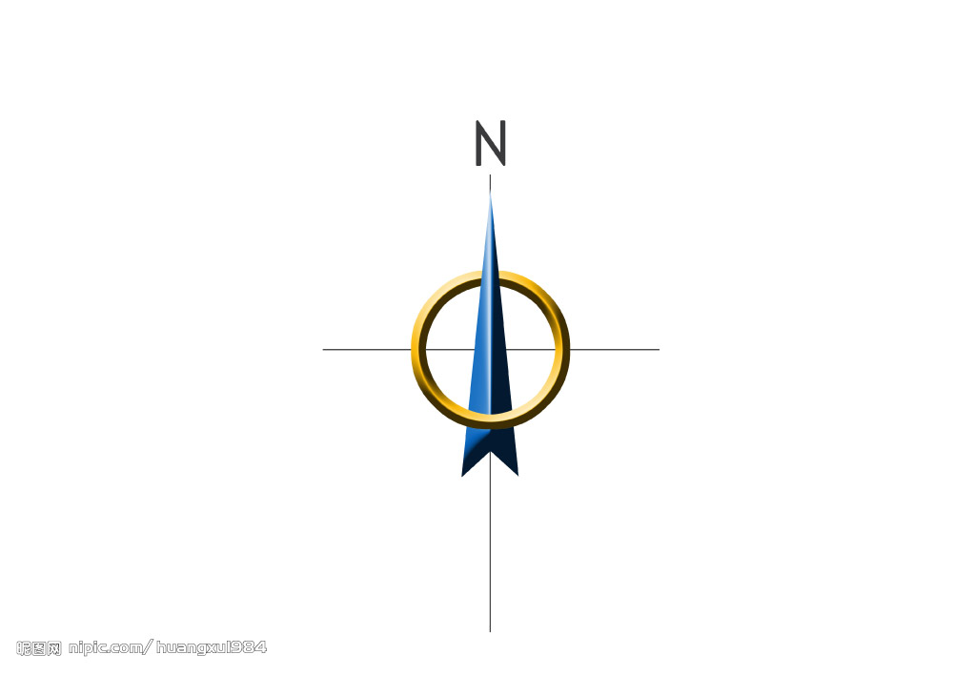
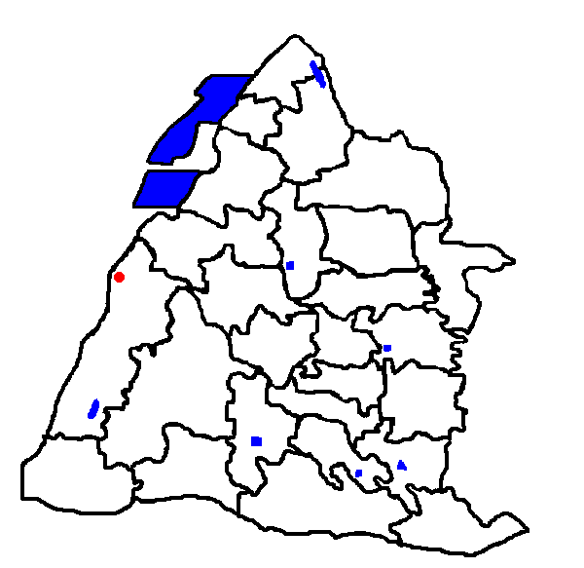
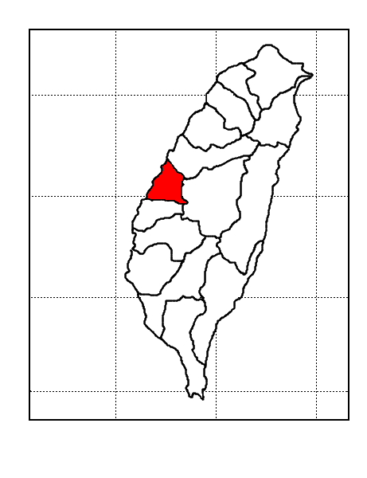
Changhua coastal industrial park
Chuansing
industrial park
Fangyuan
industrial park
Fusing
industrial park
Tianjhong
industrial park
Dashin
industrial park
Beidou industrial park
Bitou industrial park
Sampling site
25°N
24°N
23°N
22°N
120°E
121°E
122°E
Taiwan
Changhua
County

Fig. 1.
Map of fishery pond sampled for this study and industrial parks in the Changhua County in Taiwan.

Fig. 2.
The ratios of metal concentrations in sediment to pond water in this study. The ratio is expressed in Log scale.

Ventral muscle
Dorsal muscle
(a) Tilapia
*
*
*
*
*

Ventral muscle
Dorsal muscle
*
*
*
*
*
(b) Milkfish

Fig. 3.
Comparison of metal concentrations in dorsal and ventral muscles of (a) tilapia, and (b) milkfish.
(* p < 0.05; ** p < 0.01; *** p < 0.001)

Tilapia
Milkfish

Fig 4.
Mean metal pollution index (MPI) of tilapia and milkfish for dorsal muscle without skin (DN), dorsal muscle with skin (DS), ventral muscle without skin (VN), and ventral muscle with skin (VS).

Fig. 5.
Concentration profiles of ten metals in (a) pond water, (b) sediment, (c) artificial feed, (d) muscle tissue of tilapia, and (e) muscle tissue of milkfish.

Fig. 6.
Correlation of selected metals in (a) muscle of tilapia and sediment/artificial feed, and (b) muscle of milkfish and sediment/artificial feed.

