Ginkgo biloba extract attenuates oxLDL-induced endothelial dysfunction via an AMPK-dependent mechanism

Hsiu-Chung Ou,^{1*}Yueh-Ling Hsieh,^{1*} Nae-Cherng Yang,^{2,3} Kun-Ling Tsai,¹ Kai-Ling Chen,¹ Chiou-Sheng Tsai,⁴ I-Ju Chen,⁵ Bor-Tsang Wu,^{1‡} and Shin-Da Lee^{1,6‡}

¹Department of Physical Therapy and Graduate Institute of Rehabilitation Science, China Medical University, Taichung, Taiwan; ²School of Nutrition, Chung Shan Medical University, Taichung, Taiwan; ³Department of Nutrition, Chung Shan
Medical University Hospital, Taichung, Taiwan; ⁴Department of Pathology and Laboratory Medicine, Taichung Veterans General Hospital, Taichung, Taiwan; ⁵Department of Physical Education, Asia University, Taichung, Taiwan; and
⁶Department of Healthcare Administration, Asia University, Taichung, Taiwan

Submitted 20 March 2012; accepted in final form 10 October 2012

Ou H, Hsieh Y, Yang N, Tsai K, Chen K, Tsai C, Chen I, Wu B, Lee S. Ginkgo biloba extract attenuates oxLDL-induced endothelial dysfunction via an AMPK-dependent mechanism. J Appl Physiol 114: 274–285, 2013. First published November 29, 2012;
doi:10.1152/japplphysiol.00367.2012.—Atherosclerosis is a complex inflammatory arterial disease, and oxidized low-density lipoprotein (oxLDL) is directly associated with chronic vascular inflammation. Previous studies have shown that Ginkgo biloba extract (GbE) acts as a therapeutic agent for neurological and cardiovascular disorders. However, the mechanisms mediating the actions of GbE are still
largely unknown. In the present study, we tested the hypothesis that GbE protects against oxLDL-induced endothelial dysfunction via an AMP-activated protein kinase (AMPK)-dependent mechanism. Human umbilical vein endothelial cells were treated with GbE, followed by oxLDL, for indicated time periods. Results from Western blot
showed that GbE inhibited the membrane translocation of the NADPH oxidase subunits p47^{phox} and Rac-1 and attenuated the increase in protein expression of membrane subunits gp91 and p22^{phox} caused by oxLDL-induced AMPK dephosphorylation and subsequent PKC activation. AMPK-1-specific small interfering RNA-transfected cells that had been exposed to GbE followed by oxLDL revealed elevated levels of PKC and p47^{phox}. In addition, exposure to oxLDL resulted
in reduced AMPK-mediated Akt/endothelial nitric oxide (NO) synthase signaling and the induction of phosphorylation of p38 mitogenactivated protein kinase, which, in turn, activated NF-B-mediated inflammatory responses, such as the release of interleukin-8, the expression of the adhesion molecule, and the adherence of monocytic cells to human umbilical vein endothelial cells. Furthermore, oxLDL upregulated the expression of inducible NO synthase, thereby augmenting the formation of NO and protein nitrosylation. Pretreatment with GbE, however, exerted significant cytoprotective effects in a dose-dependent manner. Results from this study may provide insight into a possible molecular mechanism by which GbE
protects against oxLDL-induced endothelial dysfunction.

Ginkgo; endothelial; oxLDL; ROS; AMPK

OXIDIZED LOW-DENSITY LIPOPROTEIN (oxLDL) plays a crucial role in the initiation and progression of atherosclerosis. Oxidative stress and the generation of reactive oxygen species (ROS), including superoxide and nitric oxide (NO), are thought to play
an important role in the regulation of pro-atherosclerotic and anti-atherosclerotic processes in the vessel wall. Increased levels of ROS can lead to decreased NO bioavailability, resulting in a reduced ability of the endothelium to control vessel
tone. In addition, excess ROS can induce downstream inflammatory responses by activating diverse signaling pathways through covalent modifications of target molecules (“redox signaling”), such as nuclear factor-B (NF-B). NO produced
by endothelial NO synthase (eNOS) is an important vasodilator that possesses multiple anti-atherosclerotic properties. For example, eNOS-derived NO has been shown to inhibit platelet aggregation, impede the expression of vascular adhesion molecules, and suppress vascular smooth muscle cell proliferation.
The major sources of ROS generation include the mitochondrial respiratory chain and enzymes such as NADPH oxidase (NOX), xanthine oxidase, uncoupled NOS, 5-lipooxygenase, and cyclooxygenases (COX). The effects of ROS, however, are
counterbalanced by a large number of endogenous antioxidants and antioxidant enzymes, such as superoxide dismutase, catalase, and glutathione reductases. Enhanced NOX activity has been reported to be strongly associated with the development of atherosclerosis (34). The mechanisms involved in oxLDLinduced
superoxide generation via activation of endothelial NOX have been well characterized. The process by which the NOX enzyme complex is activated begins with the phosphorylation of p47^{phox}, which causes the translocation of the p47^{phox}/p67^{phox} complex to the plasma membrane, where p47^{phox} interacts with p22^{phox} and p67^{phox} acts as the NOX activator through direct protein-protein interaction (3). ROS
produced by NOX have been reported to be involved in apoptosis of endothelial cells, oxidation of low-density lipoproteins, as well as hypertrophy and proliferation of vascular myocytes. AMP-activated protein kinase (AMPK), a heterotrimeric enzyme
consisting of a catalytic subunit () and two regulatory subunits ( and ), is an energy sensor that is ubiquitously expressed in vascular cells. AMPK-1 is the major isoform of AMPK, and AMPK-2 is the minor isoform in endothelial cells. AMPK regulates energy balance and controls metabolism in cells. The enzyme can also be activated by extracellular stimuli, such as leptin, adiponectin, and catecholamines (18, 36). AMPK has been reported to possess anti-atherosclerotic effects by upregulating the Akt/eNOS/NO signaling pathway (20) and by suppressing the activation of NOX in vascular tissues (19). The most direct evidence for a link between AMPK and NOX comes from a study by Alba et al. (1), who showed that treatment of neutrophils with 5=-aminoimidazole-4-carboxamide ribonucleoside (AICAR), an AMPK activator, or 5=-AMP suppressed the production of superoxide induced by phorbol esters or formyl peptides (fMLP). In addition, AMPK has been suggested to attenuate phosphorylation of the p47phox subunit, thus preventing its transmembrane
activation (1).
Ginkgo biloba extract (GbE), a defined complex mixture containing 24% Ginkgo flavone glycoside and 6% terpenlactones (ginkgolides, bilobalide), is extracted from the leaves of the Ginkgo biloba tree. It is widely used clinically in Asia for the
treatment of mild cognitive impairment. The flavonoids (ginkgoflavone glycosides, bioflavonoids) and terpenoids (ginkgolides and bilobalide) in GbE have been found to possess anti-tumor (38), anti-aging (6), hepatoprotective (23), and cardioprotective
properties (32). Although GbEs possess some protective effects against the development of atherosclerosis, the mechanism remains to be fully elucidated. Our recent investigation demonstrated that GbE attenuated oxLDL-induced oxidative
functional damage in endothelial cells by reducing the degree of ROS generation, one of the earliest signals in oxLDLinduced endothelial dysfunction (27). In addition, Lin et al. (16) reported that GbE inhibits endotoxin-induced smooth
muscle cell proliferation via suppression of toll-like receptor 4 expression and NOX activation. Liu et al. (17) reported that isoginkgetin, a compound derived from the leaves of Ginkgo biloba, enhanced adiponectin secretion from differentiated adiposarcoma cells via AMPK activation. We, therefore, explored whether inhibition of NOX correlates with the protective effect of GbE against oxLDL-induced endothelial dysfunction, and, if so, whether AMPK, an upstream regulator of PKC-mediated NOX activation and the Akt/eNOS signaling pathway, is involved
in the process.

MATERIALS AND METHODS
Reagents. Chemicals were obtained from the following companies: GbE, a defined complex mixture containing 24% Ginkgo flavone glycoside (primarily composed of quercetin, kaempferol, isorhamnetin) and 6% terpenlactones (ginkgolides A, B, and C and bilobalide) extracted from Ginkgo biloba leaves, was obtained from Dr. Willmar
Schwabe (Karlsruhe, Germany); compound C, diphenyleneiodonium (DPI), Ro-32–0432, hispidin, and AICAR were obtained from Sigma (St. Louis, MO); medium 199 (M199), fetal bovine serum, and trypsin-EDTA were obtained from Gibco (Grand Island, NY); low serum growth supplement was obtained from Cascade Biologics
(Portland, OR); dihydroethidium (DHE) was obtained from Molecular Probes (Eugene, OR); anti-eNOS, anti-phospho-eNOS, anti-Rac-1, and anti-p47phox were purchased from BD Biosciences Pharmingen (San Diego, CA); anti-gp91, anti-p22phox, anti-NF-B/p65, anti- IB-, anti-inducible NO synthase (iNOS), and anti-nitrotyrosine
were obtained from Transduction Laboratories; anti-flotillin-1, antip38, anti-phospho-p38, anti-PKC-/, anti-phospho-AMPK-, and anti-AMPK- were obtained from Cell Signaling. AMPK-1-specific small interfering RNA (siRNA) (sc-29673) was purchased from Santa Cruz Biotechnology.
Cell cultures. This experiment was approved by the Research Ethics Committee of the China Medical University Hospital. After receiving written consent from the parents, fresh human umbilical cords were obtained from normal full-term neonates shortly after birth and suspended in Hanks’ balanced salt solution (Gibco) at 4°C.
Human umbilical vein endothelial cells (HUVECs) were isolated from human umbilical cords with collagenase and used at passage 2–3, as previously described (14). After dissociation, the cells were collected and cultured on gelatin-coated culture dishes in M199 with low-serum growth supplement, 100 IU/ml penicillin, and 0.1 mg/ml streptomycin. Subcultures were performed with trypsin-EDTA. Media were
refreshed every 2 days. The identity of umbilical vein endothelial cells was confirmed by their cobblestone morphology and strong positive immunoreactivity to von Willebrand factor. THP-1, a human monocytic leukemia cell line, was obtained from ATCC (Rockville, MD) and cultured in RPMI with 10% fetal bovine serum at a density of 2–5 106 cells/ml, as suggested in the product specification sheet
provided by the vendor. Lipoprotein separation. Human plasma was obtained from the Taichung Blood Bank (Taichung, Taiwan), and LDL was isolated using sequential ultracentrifugation ( 1.019 –1.210 g/ml) in KBr solution containing 30 mM EDTA, stored at 4°C in a sterile, dark
environment, and used within 3 days, as previously described (28). Immediately before the oxidation tests, LDL was separated from EDTA and from diffusible low-molecular-weight compounds by gel
filtration on PD-10 Sephadex G-25 M gel (Pharmacia) in 0.01 mol/l phosphate-buffered saline (136.9 mmol/l NaCl, 2.68 mmol/l KCl, 4 mmol/l Na2HPO4, 1.76 mmol/l KH2PO4) at pH 7.4. Copper-modified LDL (1 mg protein/ml) was prepared by exposing LDL to 10 M CuSO4 for 16 h at 37°C.
Measurement of ROS production. The effect of GbE on ROS production in HUVECs was determined by a fluorometric assay using DHE as a probe for the presence of superoxide. After preincubation for 2 h with the indicated concentrations of GbE, HUVECs were incubated with DHE for 1 h, followed by incubation with oxLDL for
2 h. In parallel experiments, cells were preincubated with inhibitor of AMPK (compound C), inhibitor of PKC- (Ro32–0432), inhibitor of PKC- (hispidin), or inhibitor of ROS (DPI) 1 h before treatment with GbE. The fluorescence intensity was measured at 540-nm excitation and 590-nm emission (before and after exposure to oxLDL) using a fluorescence microplate reader (Labsystems). The percentage increase
in fluorescence per well was calculated by the formula [(Ft2Ft0)/Ft0] 100, where Ft2 is the fluorescence at 2 h of oxLDL exposure, and Ft0 is the fluorescence at 0 min of oxLDL exposure.
Preparation of nuclear and cytosolic fractions. Nuclear and cytosolic fractions were isolated with a Nuclear and Cytoplasmic Extraction kit (Pierce Chemical, Rockford, IL). After the incubation period, HUVECs were collected by centrifugation at 600 g for 5 min at 4°C. The pellets were washed twice with ice-cold PBS, followed by the
addition of 0.2 ml of cytoplasmic extraction buffer A and vigorous mixing for 15 s. Ice-cold cytoplasmic extraction buffer B (11 l) was added to the solution. After vortex mixing, nuclei and cytosolic fractions were separated by centrifugation at 16,000 g for 5 min. The cytoplasmic extracts (supernatants) were stored at 80°C. Nuclear extraction buffer was added to the nuclear fractions (pellets), which were then mixed by vortexing on the highest setting for 15 s. The mixture was iced, and a 15-s vortex was performed every 10 min for a total of 40 min. Nuclei were centrifuged at 16,000 g for 10 min. The nuclear extracts (supernatants) were stored at 80°C until use. Preparation of membrane and cytosolic fractions. A cellular membrane fraction was prepared with Mem-PER (Pierce), according to the manufacturer’s instructions. The Mem-PER system consists of three
reagents. Reagent A is a cell lysis buffer, reagent B is a detergent
dilution buffer, and reagent C is a membrane solubilization buffer.
After the incubation period, HUVECs were collected by centrifugation
at 600 g for 5 min at 4°C. Each cell pellet, containing 5 106
cells, was lysed at room temperature using Mem-PER reagent A.
Membrane proteins were solubilized on ice with Mem-PER reagent C
diluted 2:1 with Mem-PER reagent B. Reagents A and B/C were
supplemented with Halt protease inhibitor cocktail (Pierce Biotechnology).
The solubilized protein mixture was centrifuged at 10,000 g
for 3 min at 4°C to remove cellular debris. The clarified supernatant
was heated at 37°C for 10 min, followed by centrifugation at 10,000
g for 2 min to produce separate membrane and hydrophilic protein
fractions. Immunoblotting. HUVECs were grown to confluence, pretreated with GbE for 2 h, and then stimulated with oxLDL for indicated time periods. After treatment, cytosolic/membrane protein fractions of cells were extracted with a Mem-PER kit, and cytosolic/nuclear protein fractions of cells were extracted with a Cytoplasmic Extraction kit, according to the manufacturer’s instructions (Pierce). AMPK, phospho-
AMPK, eNOS, phospho-eNOS, iNOS, p38, phospho-p38, nitrotyrosine,
COX-II, and IB levels in cytosol, the membrane translocation
of p47phox, Rac-1, and PKC-/, and the nuclear translocation
of NF-B p65 were determined by SDS-PAGE and immunoblot
assay. The blots were incubated with blocking buffer (1PBS and
5% nonfat dry milk) for 1 h at room temperature and then probed with
primary antibodies (1:1,000 dilutions) overnight at 4°C, followed by
incubation with horseradish peroxidase-conjugated secondary antibody
(1:5,000) for 1 h. To control equal loading of total protein in all
lanes, blots were stained with mouse anti -actin antibody (1:50,000
dilution) for cytosolic fractions, mouse anti-flotillin-1 (1:1,000) for
plasma membrane fractions, and anti-PCNA (1:1,000) for nuclear
fractions. The bound immunoproteins were detected by an enhanced
chemiluminescent assay (Amersham, Berkshire, UK). The intensities
were quantified by densitometric analysis (Digital Protein DNA Imagineware,
Huntington Station, NY). Transfection with siRNA. On-target Plus SMART pool siRNAs
for nontargeting control and AMPK-1 were purchased from Santa
Cruz Biotechnology. Transient transfection was carried out using
INTERFERin siRNA transfection reagent (Polyplus Transfection),
according to the manufacturer’s instructions. Three days after
transfection, cells were treated with reagent, as indicated for
further experiments. Enzyme-linked immunosorbent assay. Interleukin (IL)-8 concentrations in the cell culture supernatants were determined using the
Quantikine Human Immunoassay kit. Briefly, HUVECs were cultured to confluence in 24-well plates and pretreated for 2 h with or without indicated concentrations of GbE, followed by incubation with oxLDL (130 g/ml) for 24 h. At the end of the treatment period, 100-l aliquots of cell culture media were transferred to anti-IL-8 antibodycoated wells and incubated for 2 h. Peroxidase-conjugated secondary
polyclonal antibody was then added to each well. Following a wash to remove any unbound antibody-enzyme reagents, a substrate solution was added to each well, and the reaction was allowed to develop for
20 min. Color development was stopped, and absorbance was measured
at 450 nm using a microplate reader (Molecular Devices,
Sunnyvale, CA). Adhesion molecule expression. To determine whether GbE could
modify oxLDL-induced adhesion molecule expression, HUVECs
were grown to confluence and pretreated with GbE for 2 h and then
stimulated with oxLDL (130 g/ml) for 24 h. At the end of stimulation,
HUVECs were harvested and incubated with FITC-conjugated
anti-monocyte chemotactic protein-1 (MCP-1) for 45 min at room
temperature. After HUVECs had been washed three times, their
immunofluorescence intensity was analyzed by flow cytometry using
a Becton Dickinson FACScan (Mountain View, CA).
Adhesion assay. HUVECs at a density of 1 105 cells/ml were
cultured in 96-well flat-bottom plates (0.1 ml/well) for 1–2 days.
HUVECs were then pretreated with the indicated concentrations of
GbE for 2 h, followed by stimulation with oxLDL (130 g/ml) for 24
h. Medium was removed, and 0.1 ml/well of THP-1 cells (prelabeled
with BCECF-AM 4 M for 30 min in RPMI at 1 106 cell/ml
density) were added to HUVECs. Cells were allowed to adhere at
37°C for 1 h in a 5% CO2 incubator. Nonadherent cells were gently
aspirated. Plates were washed three times with M-199. The number of
adherent cells was estimated by microscopic examination, and then
the cells were lysed with 0.1 ml 0.25% Triton X-100. The fluorescence
intensity was measured at 485-nm excitation and 538-nm
emission using a fluorescence microplate reader (Labsystems).
Statistical analyses. Results are expressed as means
SE. Differences between groups were analyzed using one-way ANOVA followed
by Bonferroni’s post hoc test. A P value 0.05 was considered to represent statistical
significance.

RESULTS
GbE decreased the oxLDL-induced membrane assembly of
the NOX complex. First, we determined whether GbE suppresses
the oxLDL-induced activation of NOX. The membrane translocation
assay showed that the levels of p47phox and Rac-1 in
membrane fractions were three- to fourfold higher in HUVECs
treated with oxLDL for 1 h than in untreated cells (Fig. 1, A–C).
In addition, the protein levels of gp91 and p22phox were
significantly higher in HUVECs exposed to oxLDL for 24 h
than in untreated cells. However, pretreatment of oxLDLexposed
cells with GbE (12.5–100 g/ml) led to a dosedependent
reduction in membrane translocation of p47phox and
Rac-1 and a dose-dependent reduction in protein levels of gp91
and p22phox (Fig. 1, D–F, all P 0.05). GbE inhibited the oxLDL-mediated suppression of AMPK phosphorylation. AMPK has been shown to act as a physiological
suppressor of NOX in endothelial cells (2). We, therefore,
analyzed whether GbE protects against the oxLDL-mediated
suppression of AMPK phosphorylation. As shown in
Fig. 2, A and B, treatment of HUVECs with oxLDL (130
g/ml) for 1 h resulted in the suppression of phosphorylation
of AMPK-; however, pretreatment with GbE blocked the
oxLDL-induced suppression of phosphorylation of AMPK-
in a dose-dependent manner (Fig. 2, A and B, all P
0.05). GbE protected against oxLDL-mediated PKC activation.
Previous studies have shown that AMPK- inhibits the activation
of PKC (4, 21), and that PKC is an upstream mediator
of NOX (8). We, therefore, explored whether GbE suppresses
the activity of NOX by interfering with the PKC signaling
pathway. As shown in Fig. 2, C and D, HUVECs exposed to
oxLDL for 1 h revealed a marked increase in the level of
phosphorylated PKC-/ relative to controls; however, HUVECs
that had been pretreated with GbE before being exposed to
oxLDL showed a dose-dependent decrease in the level of phosphorylated
PKC-/ relative to HUVECs that had been exposed
to oxLDL only. In addition, the effect of GbE on suppression of
oxLDL-induced PKC-/ activation was abolished by adding
the AMPK inhibitor (compound C), suggesting that PKC-/
is a target of GbE downstream of AMPK activation.
Knockdown of AMPK impairs the inhibitory effects of GbE
on oxLDL-induced activation of PKC and subsequent membrane
translocation of p47phox and Rac-1. To further determine
whether GbE-induced activation of AMPK inhibits oxLDLinduced
activation of PKC-/ and the subsequent activation
of NOX, we silenced AMPK-1 gene expression by transfecting
HUVECs with AMPK-1-specific siRNA. The level of
AMPK-1 protein expression was reduced by 70% relative to
control cells 48 h after transfection with AMPK-1 siRNA
(data not shown). As shown in Fig. 3, the inhibitory effects of
GbE on oxLDL-induced phosphorylation of PKC-/ and
membrane translocation of p47phox and Rac-1 were abolished
in cells that had been transfected with AMPK-1 siRNA.
GbE suppressed the generation of ROS induced by oxLDL in
HUVECs. Next, we examined the suppressive effects of GbE
and various pharmacological inhibitors on oxLDL-induced
ROS generation using DHE as a fluorescence probe. We found
that treatment with 130 g/ml oxLDL for 2 h resulted in a
10-fold increase in ROS generation, relative to control cells,
whereas the level of ROS was similar to that in the control
group that had been pretreated with GbE (100 g/ml) (Fig. 4).
In addition, the generation of ROS caused by oxLDL was
inhibited by the PKC- inhibitor Ro32-0432, the PKC- inhibitor
hispidin, and the NOX inhibitor DPI. Furthermore, the
effect of GbE on suppression of oxLDL-induced ROS was
antagonized in cells that had been pretreated with the inhibitor
AMPK (compound C), indicating that GbE inhibited oxLDLinduced
ROS generation via modulation of AMPK-suppressed
PKC-/-activated NOX. GbE activates the AMPK/Akt/eNOS signaling pathway. To
investigate whether the AMPK/Akt/eNOS signaling pathway is
involved in the protective effects of GbE, we performed a
Western blot analysis using phosphor-specific Akt (Ser473)
and phosphor-eNOS (Ser1177) antibodies. As expected, cells
exposed to GbE exhibited a dose-dependent increase in levels
of phosphorylated Akt and eNOS (Fig. 5, A–C, all P 0.05).
To further explore whether AMPK functions upstream of
Akt/eNOS, cells were transfected with AMPK-specific siRNA.
We found that GbE-induced attenuation of oxLDL-impaired
Akt/eNOS was abolished in cells that had been transfected with
AMPK-specific siRNA and in cells that had been exposed to
compound C (Fig. 5). In addition, application of AICAR, a
specific activator of AMPK, resulted in normal Akt/eNOS
signaling, which suggests that GbE targets the Akt/eNOS
pathway.
GbE inhibited NF-B activation via modulation of p38
MAPK. ROS-induced activation of p38 MAPK results in the
nuclear translocation and subsequent activation of NF-B,
which, in turn, regulates the expression of proinflammatory
genes (26). We, therefore, determined whether the effects of
GbE are associated with the p38 MAPK-NF-B signaling
pathway. We found that oxLDL had no effect on the level of
p38 MAPK expression; however, exposure to oxLDL mark- edly increased the level of phosphorylation of p38 MAPK. In parallel experiments, pretreatment with GbE resulted in a dose-dependent reduction in levels of p38 MAPK phosphorylation
(Fig. 6, A and B). NF-B is a heterodimeric protein composed of different
combinations of members of the Rel family of transcription
factors. Its activation requires the dissociation and subsequent
nuclear translocation of IB, where NF-B presents as a
primary p65/p50 heterodimer that binds directly to its cognate
DNA sequence. As shown in Fig. 6, A, C, and D, after exposure
to oxLDL, IB was degraded, thereby causing nuclear translocation
of NF-Bp65 (all P 0.05). GbE inhibited the expression of inflammatory proteins and
the adherence of monocytes. We explored the effect of GbE on
downstream inflammatory events related to NF-B activation
in endothelial cells exposed to oxLDL, namely the expression
of COX-II, the release of the inflammatory cytokine IL-8, and
expression of the adhesion molecule MCP-1. The protein
levels of COX-II, IL-8, and MCP-1 were significantly higher in
HUVECs that had been incubated for 24 h with oxLDL at 130
g/ml than in untreated control cells; however, GbE significantly
inhibited these NF-B-mediated inflammatory responses
in a dose-dependent manner (Fig. 7, A–D). To test the
effect of GbE on monocyte adhesion to HUVECs, confluent
monolayers of HUVECs were pretreated with GbE (100 g/
ml) for 2 h and then stimulated with oxLDL (130 g/ml) for 24
h, followed by incubation with THP-1 cells for 1 h at 37°C. As
shown in Fig. 7E, oxLDL stimulated the adherence of THP-1
cells to HUVECs; however, GbE treatment inhibited the attachment
of those adhesion molecules to HUVECs. Simultaneous
treatment of HUVECs with oxLDL plus GbE and
pharmacological inhibitors, including the AMPK inhibitor
compound C, abolished the inhibitory effects of GbE on
monocytic adherence. Furthermore, the addition of inhibitors
of PKC isoforms, namely Ro32-0432 (PKC- inhibitor) and
hispidin (PKC- inhibitor), definitely attenuated the degree of
monocytic adherence caused by oxLDL. GbE attenuated oxLDL-enhanced iNOS protein expression and protein nitrosylation. Next, we determined the effects of GbE on protein expression of iNOS as well as NO content and the formation of nitrotyrosine, a stable final metabolite of peroxynitrate that can serve as a fingerprint for peroxynitrite-mediated damage of cellular proteins after exposure to oxLDL. As shown in Fig. 8, oxLDL-enhanced iNOS protein expression levels returned
to levels close to those seen in control cells when HUVECs were treated with 100 g/ml GbE before stimulation with oxLDL. Furthermore, we found that pretreatment with GbE suppressed the oxLDL-induced release of NO and the nitrosylation of tyrosine residues. In addition, cells exposed to the iNOS inhibitor 1400W showed
markedly lower levels of NO.

DISCUSSION
Our laboratory’s previous study demonstrated that GbE
attenuates oxLDL-induced oxidative functional damage in endothelial
cells by modulating the ROS-mediated apoptotic
signaling pathway (27). In this study, we demonstrated that
GbE quenches oxidative stress by activating AMPK, a negative
regulator of PKC-activated NOX. Furthermore, we showed
that GbE protected against the aberrant phosphorylation of Akt
and eNOS, which normally leads to the suppression of p38-
mediated NF-B activation and, consequently, the suppression
of downstream inflammatory responses, such as the release of
IL-8 and the expression of the adhesion molecule MCP-1 in
human endothelial cells (Fig. 9).
NOX-derived ROS plays an important role in the development
of atherosclerotic lesions. In addition, the activation of
Rac-1 and p47phox is involved in the generation of superoxide,
a molecule that stimulates inflammatory gene expression
through a redox-sensitive signaling pathway in vascular endothelial
cells (25). Hsieh et al. showed that antioxidants capable
of reducing ROS levels protected against the development of
endothelial dysfunction, and that antioxidants that did not
reduce ROS levels were ineffective (10). AMPK dysregulation
has been shown to contribute to obesity and to the vascular
consequences of metabolic syndrome. AMPK acts as a negative
regulator of NOX by preventing the serine phosphorylation and
membrane translocation of p47phox (35). Our findings that expo-sure of AMPK-specific siRNA-transfected HUVECs to GbE
resulted in the translocation of p47phox and the activation of
Rac-1 and PKC provide compelling evidence that GbE exerts
its protective effects via the AMPK signaling pathway. Our
results are consistent with those reported in recent studies. For
example, tempol, a potent antioxidant, was shown to inhibit
oxLDL-triggered endoplasmic reticulum stress in vivo via
activation of AMPK (7), and rosiglitazone, a hypoglycemic
agent, was shown to activate AMPK, which, in turn, prevented
PKC-activated NOX caused by high glucose (4).
Cross talk between AMPK and Akt protein kinases is required
for several cellular responses in endothelial cells, but the relative role of the two kinases remains controversial. Some
studies have reported that Akt acts as a negative regulator of
AMPK. In rat hearts, it has been shown that insulin treatment
decreased AMPK Thr172 phosphorylation in an Akt-dependent
manner (9). In perfused mouse hearts, insulin treatment resulted
in reduced phosphorylation of AMPK Thr172, which was
inversely correlated with Akt phosphorylation (13). In addition,
transgenic mice overexpressing a constitutively active
form of Akt displayed decreased phosphorylation of cardiac
AMPK, and isolated neonatal cardiac myocytes infected with
an adenovirus expressing constitutively active forms of Akt
suppressed AMPK phosphorylation (13). This kind of inhibition
has been attributed to the direct phosphorylation of
AMPK-1 by Akt, which negatively interferes with the liver
kinase B1-mediated phosphorylation of AMPK-1 (9). Hu et
al. (11) found that exposure of H2O2-stimulated endothelial
cells to an Akt inhibitor resulted in a marked increase in
AMPK activity. In contrast, some studies have demonstrated
that AMPK lies upstream of Akt in the pathway leading to
eNOS activation and NO production (29, 31). It has been
shown that transduction with a dominant-negative form of
AMPK suppressed Akt Ser473 phosphorylation and eNOS activity in endothelial cells in response to hypoxia (22). The
finding that the inhibitory effects of the dominant-negative
form of AMPK on endothelial cell migration and differentiation
could be reversed by cotransduction with a constitutively
active Akt (22) is consistent with the idea that Akt is a
downstream kinase of AMPK in the signaling pathways leading
to eNOS activation. In HUVECs, Ouchi et al. found that
transduction with a dominant-negative form of AMPK abolished
adiponectin-induced Akt phosphorylation, eNOS phosphorylation,
and cell migration and differentiation (29). However,
they also noted that transduction of HUVECs with a
dominant-negative form of Akt blocked the adiponectin-stimulated
phosphorylation of Akt and eNOS and inhibited the
migration and differentiation of cells without altering AMPK
phosphorylation, suggesting that AMPK is upstream of Akt in
this pathway (29). In bovine aortic endothelial cells, siRNAmediated
knockdown of AMPK-1 resulted in impaired vascular
endothelial growth factor-stimulated Akt phosphorylation,
eNOS phosphorylation, cell migration, and tube formation,
whereas Akt knockdown did not affect AMPK activation
(15). Our experiments involving siRNA-mediated knockdown
approaches to silence AMPK-1 yielded results that are consistent
with these latter observations. In the present study, we
demonstrated that the ability of GbE to attenuate oxLDLinduced
Akt dephosphorylation and eNOS activation was abolished
in cells exposed to a pharmacological inhibitor of AMPK
and in cells that had undergone transfection with AMPK
siRNA (Fig. 5). In addition, AICAR, a specific activator of
AMPK, reversed the oxLDL-induced impairment of Akt/eNOS
signaling, indicating that Akt/eNOS is a target of GbE downstream
of AMPK activation. NO is produced by eNOS at concentrations in the nanomolar
range under normal physiological conditions. At those concentrations,
NO has been shown to have anti-inflammatory and
protective effects by inhibiting the activation of NF-B via
stabilizing the IB- protein and mediating the nitrosylation of
Cys62 on the p50 subunit (30). In contrast, iNOS produces NO
at concentrations in the micromolar range. At those concentrations,
NO can lead to activation of NF-B, which, in turn, leads
to the upregulation of several major proinflammatory mediators,
such as cytokines and adhesion molecules, and increased
monocytic adherence. In the present study, we found that some
of the adverse effects of oxLDL, namely inhibition of Akt and
eNOS phosphorylation and activation of p38 and NF-B, were
abrogated by GbE treatment. In addition, pretreatment with
compound C, a selective AMPK inhibitor, abolished the suppressive
effects of GbE on oxLDL-induced PKC-/ phosphorylation
(Fig. 2, C and D) and antagonized the effect of
GbE on inhibition of monocytic adherence (Fig. 7E), suggesting
that the protective effect of GbE is due, at least in
part, to its ability to upregulate AMPK, a suppressor of
PKC-mediated p47phox activation, and stimulate the Akt/
eNOS signaling pathway. The plasma concentration of circulating oxLDL in healthy
individuals is thought to be low (1–5 g protein/ml). Huang et al.
(12) found that the plasma concentration of circulating oxLDL
was seven times higher in patients with acute myocardial angina
than in healthy control subjects. Furthermore, Nishi et al. (24)
found that oxLDL levels in carotid plaques were nearly 70 times
higher than oxLDL levels in plasma. Thus the concentrations of
oxLDL used in this work are a reasonable estimate of those
present in patients with vascular disease due to endothelial
dysfunction. The dose of GbE used in the present study (range,
12.5–100 g/ml) is relatively high compared with the levels of
its flavonoid constituents found in plasma after ingestion. For
example, Ude et al. (33) reported that a single dose of 600 mg/kg EGb 761 administered to rats resulted in maximum
plasma concentrations of 176 ng/ml for quercetin, 341 ng/ml
for kaempferol, and 183 ng/ml for isorhamnetin/tamarixetin.
However, repeated administration of the same dose for 8 days
led to an approximate 4.5-fold increase in the plasma concentration
of quercetin, an 11.5-fold increase in that of kaempferol,
and a 10-fold increase in the plasma concentration of
isorhamnetin/tamarixetin (33). It is reported that GbE phospholipid
dramatically improve its bioavailability in rat (5).
However, the circulating levels of flavonoids and terpene
trilactones in human plasma after a single dose of GbE are still
unknown because the pharmacokinetics of the pharmacologically
active components of GbE have not been completely
established. It is also unknown whether prolonged use of
GbE leads to chronic accumulation of some of the components
in different tissues. In humans, the recommended
intravenous dose of GbE for patients with chronic vascular
disease is 87.5 mg/day (37). A rough estimation (e.g., 5
liters of blood) of the potentially achieved plasma levels
(10 –20 g/ml) suggests that the concentrations (12–100
g/ml) used in the present study may have been achieved
after intravenous application of GbE.
In summary, we found that GbE attenuates oxLDL-induced
endothelial dysfunction via an AMPK-dependent mechanism.
Our findings provide insight into a possible molecular mechanism
by which GbE protects against oxLDL-induced endothelial
dysfunction.

GRANTS
This study was supported in part by Taiwan Department of Health Clinical
Trial and Research Center of Excellence (DOH101-TD-B-111-004), National
Science Council Grants NSC 101-2320-B-039-039, and China Medical University
Grant CMU99-ASIA-06, Taiwan, Republic of China.
DISCLOSURES
No conflicts of interest, financial or otherwise, are declared by the author(s).
AUTHOR CONTRIBUTIONS
Author contributions: H.-C.O., Y.-L.H., N.-C.Y., and I.-J.C. conception and
design of research; H.-C.O., Y.-L.H., and N.-C.Y. interpreted results of
experiments; H.-C.O., K.-L.T., and K.-L.C. prepared Figs.; H.-C.O. drafted
manuscript; H.-C.O., Y.-L.H., and S.-D.L. edited and revised manuscript;
Y.-L.H. , B.-T. W., and S.-D.L. approved final version of manuscript; N.-C.Y.,
K.-L.T., and C.-S.T. analyzed data; K.-L.T. and K.-L.C. performed experiments.
REFERENCES
1. Alba G, El Bekay R, Alvarez-Maqueda M, Chacon P, Vega A,
Monteseirin J, Santa Maria C, Pintado E, Bedoya FJ, Bartrons R,
Sobrino F. Stimulators of AMP-activated protein kinase inhibit the
respiratory burst in human neutrophils. FEBS Lett 573: 219–225, 2004.
2. Arora S, Vaishya R, Dabla PK, Singh B. NAD(P)H oxidases in coronary
artery disease. Adv Clin Chem 50: 65–86, 2010.
3. Bedard K, Krause KH. The NOX family of ROS-generating NADPH
oxidases: physiology and pathophysiology. Physiol Rev 87: 245–313,
2007.
4. Ceolotto G, Gallo A, Papparella I, Franco L, Murphy E, Iori E,
Pagnin E, Fadini GP, Albiero M, Semplicini A, Avogaro A. Rosiglitazone
reduces glucose-induced oxidative stress mediated by NAD(P)H
oxidase via AMPK-dependent mechanism. Arterioscler Thromb Vasc Biol
27: 2627–2633, 2007.
5. Chen ZP, Sun J, Chen HX, Xiao Liu D YY, Chen J, Cai H, Cai BC.
Comparative pharmacokinetics and bioavailability studies of quercetin,
kaempferol and isorhamnetin after oral administration of Ginkgo biloba
extracts, Ginkgo biloba extract phospholipid complexes and Ginkgo biloba
extract solid dispersions in rats. Fitoterapia 81: 1045–1052, 2010.
6. Diamond BJ, Shiflett SC, Feiwel N, Matheis RJ, Noskin O, Richards
JA, Schoenberger NE. Ginkgo biloba extract: mechanisms and clinical
indications. Arch Phys Med Rehabil 81: 668–678, 2000.
7. Dong Y, Zhang M, Wang S, Liang B, Zhao Z, Liu C, Wu M, Choi HC,
Lyons TJ, Zou MH. Activation of AMP-activated protein kinase inhibits
oxidized LDL-triggered endoplasmic reticulum stress in vivo. Diabetes
59: 1386–1396, 2010.
8. Hong NJ, Silva GB, Garvin JL. PKC- mediates flow-stimulated superoxide
production in thick ascending limbs. Am J Physiol Renal Physiol
298: F885–F891, 2010.
9. Horman S, Vertommen D, Heath R, Neumann D, Mouton V, Woods
A, Schlattner U, Wallimann T, Carling D, Hue L, Rider MH. Insulin
antagonizes ischemia-induced Thr172 phosphorylation of AMP-activated
protein kinase alpha-subunits in heart via hierarchical phosphorylation of
Ser485/491. J Biol Chem 281: 5335–5340, 2006.
10. Hsieh CC, Yen MH, Yen CH, Lau YT. Oxidized low density lipoprotein
induces apoptosis via generation of reactive oxygen species in vascular
smooth muscle cells. Cardiovasc Res 49: 135–145, 2001.
11. Hu Z, Chen J, Wei Q, Xia Y. Bidirectional actions of hydrogen peroxide
on endothelial nitric-oxide synthase phosphorylation and function: cocommitment
and interplay of Akt and AMPK. J Biol Chem 283: 25256–
25263, 2008.
12. Huang H, Mai W, Liu D, Hao Y, Tao J, Dong Y. The oxidation ratio of
LDL: a predictor for coronary artery disease. Dis Markers 24: 341–349, 2008.
13. Kovacic S, Soltys CL, Barr AJ, Shiojima I, Walsh K, Dyck JR. Akt
activity negatively regulates phosphorylation of AMP-activated protein
kinase in the heart. J Biol Chem 278: 39422–39427, 2003.
14. Kuo WW, Huang CY, Chung JG, Yang SF, Tsai KL, Chiu TH, Lee
SD, Ou HC. Crude extracts of Solanum lyratum protect endothelial cells
against oxidized low-density lipoprotein-induced injury by direct antioxidant
action. J Vasc Surg 50: 849–860, 2009.
15. Levine YC, Li GK, Michel T. Agonist-modulated regulation of AMPactivated
protein kinase (AMPK) in endothelial cells. Evidence for an
AMPK -Rac1 -Akt -endothelial nitric-oxide synthase pathway. J Biol Chem 282:20351–20364, 2007.
16. Lin FY, Chen YH, Chen YL, Wu TC, Li CY, Chen JW, Lin SJ.
Ginkgo biloba extract inhibits endotoxin-induced human aortic smooth
muscle cell proliferation via suppression of toll-like receptor 4 expression
and NADPH oxidase activation. J Agric Food Chem 55: 1977–1984, 2007.
17. Liu G, Grifman M, Macdonald J, Moller P, Wong-Staal F, Li QX.
Isoginkgetin enhances adiponectin secretion from differentiated adiposarcoma
cells via a novel pathway involving AMP-activated protein kinase.
J Endocrinol 194: 569–578, 2007.
18. Long YC, Zierath JR. AMP-activated protein kinase signaling in metabolic
regulation. J Clin Invest 116: 1776–1783, 2006.
19. McCarty MF, Barroso-Aranda J, Contreras F. AMP-activated kinase
may suppress NADPH oxidase activation in vascular tissues. Med Hypotheses
72: 468–470, 2009.
20. Michell BJ, Chen Z, Tiganis T, Stapleton D, Katsis F, Power DA, Sim
AT, Kemp BE. Coordinated control of endothelial nitric-oxide synthase
phosphorylation by protein kinase C and the cAMP-dependent protein kinase. J Biol
Chem 276: 17625–17628, 2001.
21. Mugabo Y, Mukaneza Y, Renier G. Palmitate induces C-reactive protein
expression in human aortic endothelial cells. Relevance to fatty acidinduced
endothelial dysfunction. Metabolism 60: 640–648, 2011.
22. Nagata D, Mogi M, Walsh K. AMP-activated protein kinase (AMPK)
signaling in endothelial cells is essential for angiogenesis in response to
hypoxic stress. J Biol Chem 278: 31000–31006, 2003.
23. Naik SR, Panda VS. Antioxidant and hepatoprotective effects of Ginkgo
biloba phytosomes in carbon tetrachloride-induced liver injury in rodents.
Liver Int 27: 393–399, 2007.
24. Nishi K, Itabe H, Uno M, Kitazato KT, Horiguchi H, Shinno K, Nagahiro
S. Oxidized LDL in Carotid Plaques and Plasma Associates With Plaque
Instability. Arterioscler Thromb Vasc Biol 22: 1649–1654, 2002.
25. Nobuo S, Toshiyuki I, Koichi S, Tatsuya S, Takayuki S, Nobutaka I,
Shu-ichi S, Masashi K, Hironori U, Hiroshi O, Koji S, Tamio T, Yukio
M, Yasuchika T. Role of LOX-1 in monocyte adhesion-triggered redox,
Akt/eNOS and Ca2 signaling pathways in endothelial cells. J Cell
Physiol 220: 706–715, 2009.
26. Oh YT, Lee JY, Lee J, Kim H, Yoon KS, Choe W, Kang I. Oleic acid
reduces lipopolysaccharide-induced expression of iNOS and COX-2 in
BV2 murine microglial cells: possible involvement of reactive oxygen
species, p38 MAPK, and IKK/NF-kappaB signaling pathways. Neurosci
Lett 464: 93–97, 2009.
27. Ou HC, Lee WJ, Lee IT, Chiu TH, Tsai KL, Lin CY, Sheu WH.
Ginkgo biloba extract attenuates oxLDL-induced oxidative functional
damages in endothelial cells. J Appl Physiol 106: 1674–1685, 2009.
28. Ou HC, Lee WJ, Lee SD, Huang CY, Chiu THTsai KL, Hsu WC,
Sheu WH. Ellagic acid protects endothelial cells from oxidized lowdensity
lipoprotein-induced apoptosis by modulating the PI3K/Akt/eNOS
pathway. Toxicol Appl Pharmacol 248: 134–143, 2010.
29. Ouchi N, Kobayashi H, Kihara S, Kumada M, Sato K, Inoue T,
Funahashi T, Walsh K. Adiponectin stimulates angiogenesis by promoting
cross-talk between AMP-activated protein kinase and Akt signaling in
endothelial cells. J Biol Chem 279: 1304–1309, 2004.
30. Peng HB, Libby P, Liao JK. Induction and stabilization of I kappa B
alpha by nitric oxide mediates inhibition of NF-kappa B. J Biol Chem 270:
14214–14219, 1995.
31. Procopio C, Andreozzi F, Laratta E, Cassese A, Beguinot F, Arturi F,
Hribal ML, Perticone F, Sesti G. Leptin-stimulated endothelial nitricoxide
synthase via an adenosine 5=-monophosphate-activated protein kinase/
Akt signaling pathway is attenuated by interaction with C-reactive
protein. Endocrinology 150: 3584–3593, 2009.
32. Tunali-Akbay T, Sener G, Salvarli H, Sehirli O, Yarat A. Protective
effects of Ginkgo biloba extract against mercury(II)-induced cardiovascular
oxidative damage in rats. Phytother Res 21: 26–31, 2007.
33. Ude C, Paulke A, Noldner M, Schubert-Zsilavecz M, Wurglics M.
Plasma and brain levels of terpene trilactones in rats after an oral single
dose of standardized Ginkgo biloba extract EGb 761(R). Planta Med 77:
259–264, 2011.
34. Vendrov AE, Madamanchi NR, Hakim ZS, Rojas M, Runge MS.
Thrombin and NAD(P)H oxidase-mediated regulation of CD44 and
BMP4-Id pathway in VSMC, restenosis, and atherosclerosis. Circ Res 98:
1254–1263, 2006.
35. Wang S, Zhang M, Liang B, Xu J, Xie Z, Liu C, Viollet B, Yan D, Zou
MH. AMPK alpha2 deletion causes aberrant expression and activation of
NAD(P)H oxidase and consequent endothelial dysfunction in vivo: role of
26S proteasomes. Circ Res 106: 1117–1128, 2010.
36. Witters LA, Kemp BE, Means AR. Chutes and ladders: the search for
protein kinases that act on AMPK. Trends Biochem Sci 31: 13–16,
2006.
37. Wu YZ, Li SQ, Zu XG, Du J, Wang FF. Ginkgo biloba extract improves
coronary artery circulation in patients with coronary artery disease: contribution
of plasma nitric oxide and endothelin-1. Phytother Res 22:
734–739, 2008.
38. Zhang Y, Chen AY, Li M, Chen C, Yao Q. Ginkgo biloba extract
kaempferol inhibits cell proliferation and induces apoptosis in pancreatic
cancer cells. J Surg Res 148: 17–23, 2008.

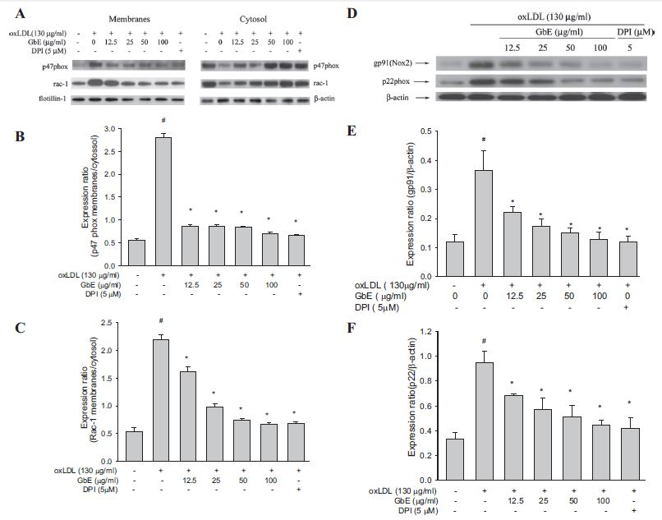
Fig. 1. Ginkgo biloba extract (GbE) attenuated the level of NADPH oxidase membrane assembly. Human umbilical vein endothelial cells (HUVECs) were pretreated for 2 h with the indicated concentrations of GbE, followed by stimulation with oxidized low-density lipoprotein (oxLDL) (130 g/ml) for 1 h (A–C) or 24 h (D–F). Preparation of membrane and cytosolic proteins is described in the MATERIALS AND METHODS section. The levels of cytosolic protein and membrane protein were normalized to the levels of -actin and flotillin-1, respectively. Representative Western blots (A and D) and summary data (B, C, E, and F) show that GbE protected against oxLDL-induced p47phox (B) and Rac-1 (C) translocation to the plasma membrane, as well as inhibited the expression of gp91 (E) and p22phox (F). The values represent means
SE from three separate experiments. #P 0.05 vs. untreated control. *P
0.05 compared with oxLDL-treated cells. DPI and DP, diphenyleneiodonium.

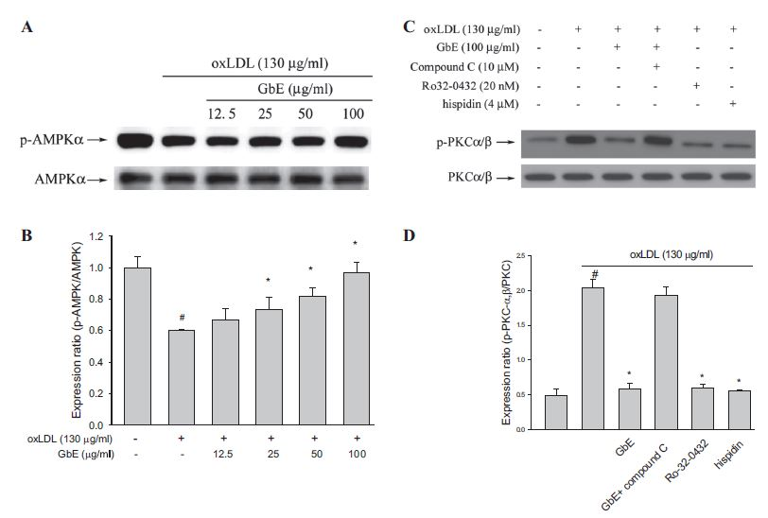

Fig. 2. Administration of GbE as well as that of various pharmacological inhibitors protected against oxLDL-induced AMP-activated protein kinase (AMPK)
dephosphorylation (A and B) and subsequent PKC activation (C and D). HUVECs were pretreated with GbE (12.5–100 g/ml) for 2 h, followed by exposure
to oxLDL (130 g/ml) for a further 1-h period. In PKC phosphorylation experiments, inhibitors of AMPK (compound C), PKC- (Ro32–0432), and PKC- (hispidin) were added 1 h before the administration of GbE. Representative Western blots (A and C) and summary data (B and D) show that GbE protected against oxLDL-induced AMPK dephosphorylation and PKC-/ phosphorylation. The values represent means SE of three separate experiments. #P0.05 vs. untreated control. *P0.05 compared with
oxLDL treatment.

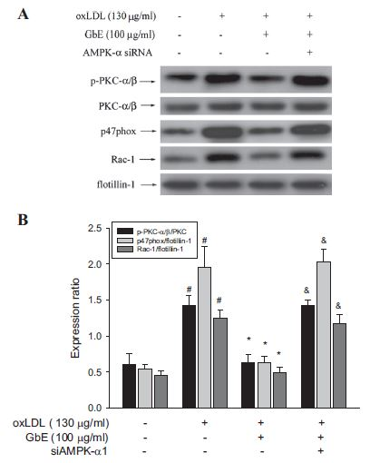

Fig. 3. The effect of GbE on oxLDL-enhanced PKC-/ and p47phox activation
was blocked in cells that had been transfected with AMPK-1-specific small
interfering RNA (siRNA) (siAMPK-1). In AMPK knockdown experiments,
HUVECs were transfected with AMPK-1 siRNA for 48 h and then treated
with 100 g/ml of GbE for 2 h, followed by exposure to 130 g/ml oxLDL for
1 h. Preparation of membrane and cytosolic proteins is described in the
MATERIALS AND METHODS section. The levels of cytosolic and membrane
proteins were normalized to the levels of -actin and flotillin-1, respectively.
Representative Western blots (A) and summary data (B) show that GbE
protected against oxLDL-induced AMPK dephosphorylation and PKC-/
phosphorylation and p47phox and Rac-1 translocation to the plasma membrane.
The values represent means SE of three separate experiments. #P 0.05 vs.
untreated control. *P 0.05 compared with oxLDL treatment. &P 0.05 compared with
oxLDL plus GbE treatment.

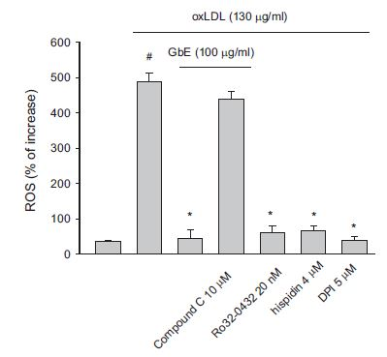
Fig. 4. Effects of GbE on oxLDL-induced ROS generation in endothelial cells.
HUVECs were preincubated for 2 h with GbE (100 g/ml), followed by
treatment with 130 g/ml oxLDL for another 2 h. To evaluate the role that
AMPK plays in suppressing PKC-mediated NADPH oxidase activation in cells
exposed to oxLDL, cells were preincubated with compound C, Ro32-0432,
hispidin, or DPI 1 h before treatment with GbE. The values represent means
SE of three separate experiments. #P 0.05 vs. untreated control. *P 0.05 compared with oxLDL treatment.

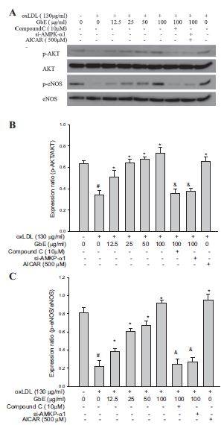
Fig. 5. GbE prevented the impairment of the Akt/endothelial nitric oxide (NO)
synthase (eNOS) pathway caused by exposure to oxLDL. HUVECs were
pretreated for 2 h with the indicated concentrations of GbE followed by oxLDL
(130 g/ml) for an additional 1 h. In a parallel experiment, HUVECs were
transfected with AMPK siRNA for 48 h before treatment with oxLDL.
A: Western blot was carried out to evaluate the expression of Akt, eNOS,
phospho-Akt (p-Akt), and phospho-eNOS (p-eNOS). B: p-Akt/Akt expression
ratio. C: p-eNOS/eNOS expression ratio. The values represent means SE of
three separate experiments. #P0.05 vs. untreated control. *P 0.05 compared with oxLDL treatment. &P0.05 compared with oxLDL plus GbE
treatment.

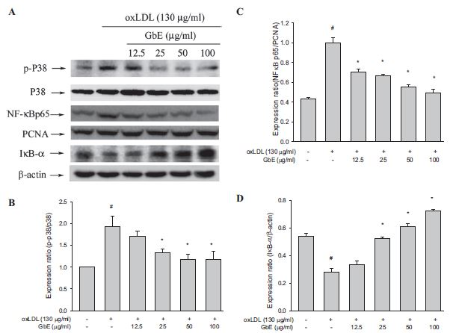
Fig. 6. Effect of GbE on p38-mediated NF-B activation caused by oxLDL. Pretreatment of HUVECs with indicated concentrations of GbE attenuated p38
activation, IB- degradation, and NF-B activation caused by oxLDL. HUVECs were pretreated with GbE (12.5–100 g/ml) for 2 h, followed by incubation with oxLDL (130 g/ml) for 1 h. A: at the end of the incubation period, cells were lysed, and proteins were analyzed by Western blot. B–D: protein levels of phospho-p38, NF-B, and IB- were normalized to the level of total p38, PCNA, and -actin, respectively. Data illustrated on the graph bars represent the mean SE of three separate experiments. #P0.05 vs. untreated control. *P 0.05 compared with oxLDL treatment.

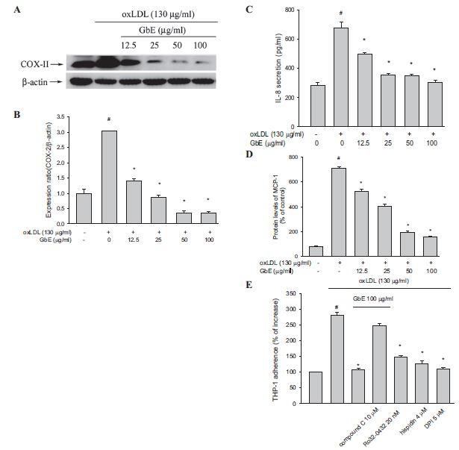
Fig. 7. Effects of GbE on NF-B-mediated inflammatory responses. HUVECs were pretreated for 2 h with or without indicated concentrations of GbE (12.5–100
g/ml), followed by incubation with oxLDL (130 g/ml) for 24 h. B–D: at the end of the incubation period, the levels of COX-II, interleukin (IL)-8, and
monocyte chemotactic protein (MCP)-1 protein expression were determined by Western blot, ELISA, and flow cytometry, respectively. E: cells were pretreated
with each inhibitor 1 h before GbE treatment and then incubated for 24 h with oxLDL (130 g/ml). OxLDL-induced adhesiveness of THP-1 to HUVECs was
measured as described in the MATERIALS AND METHODS section. The values represent means SE from three separate experiments. #P 0.05 vs. untreated control.
*P0.05 compared with oxLDL treatment.

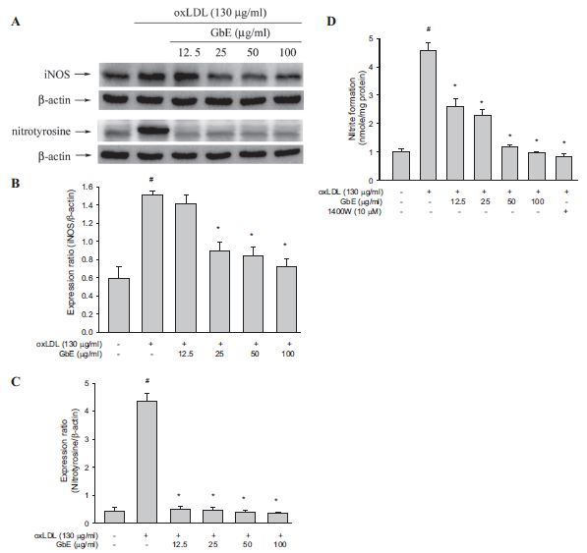
Fig. 8. GbE suppressed the oxLDL-induced upregulation of inducible NO synthase (iNOS) protein expression and nitration of tyrosine residues (A–C) and
oxLDL-enhanced NO (D). HUVECs were pretreated for 2 h with the indicated concentrations of GbE, followed by stimulation with oxLDL (130 g/ml) for 24 h. At the end of the incubation period, the level of iNOS and nitrotyrosine (normalized to the levels of -actin) were determined by immunoblotting; contents of NO in media were assayed using Griess reagent and ELISA. The values represent means SE from three separate experiments. #P0.05 vs. untreated control. *P0.05 compared with
oxLDL treatment.

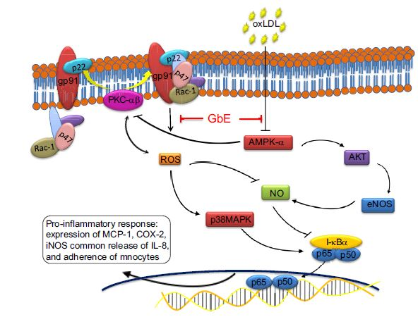
Fig. 9. Schematic diagram showing the signaling cascades involved in the attenuation of inflammatory responses in oxLDL-exposed cells treated with GbE. As depicted, GbE
inhibited the signaling cascades initiated by oxLDL-generated ROS. Lines with arrowheads indicates activation or induction, and lines with bars on the end indicate
inhibition or blockade.

