Otological and audiological features in patients with Turner syndrome
Kai-Chieh Chan¹, Pa-Chun Wang², Chen-Ming Wu¹, Wan-Ling Ho³, Fu-Sung Lo⁴
¹Division of Otology, Department of Otolaryngology Head & Neck Surgery, Chang Gung Memorial Hospital, Linkou, Taiwan
²Department of Otolaryngology, Cathay General Hospital, Taipei, Taiwan
Fu Jen Catholic University School of Medicine, Taipei County, Taiwan
Department of Public Health, College of Public Health, China Medical University , Taichung, Taiwan
³Department of Pediatrics, Shin Kong Wu Ho-Su Memorial Hospital, Taipei, Taiwan.
⁴Division of Pediatric Endocrinology, Chang Gung Children’s Medical Center, Chang Gung Memorial Hospital, Linkou, Taiwan.

Running title:
Otological and audiological features in patients with Turner syndrome

Reprint requests and correspondence to:

Dr. Fu-Sung Lo
Division of Pediatric Endocrinology, Chang Gung Children’s Medical Center, Chang Gung Memorial Hospital, Linkou, Taiwan.
5, Fu-Shin Street, Kweishan Taoyuan 333, TAIWAN
TEL: 886-3-3281200 ext.8969
FAX: 886-3-3288957
E-mail address: lofusu@adm.cgmh.org.tw

Abstract

Objective:
It has been well known that hearing impairment is prevalent among patients with Turner syndrome (TS). However, the incidence and characteristics of hearing loss with TS in the Asian context have been under-reported in the literatures, because most reports were from the Western’s countries. Therefore, the aims of this study are to report the otological and audiological features and to analyze the associated factors for hearing loss in Taiwan’s TS patients.
Methods:
Patients with TS were enrolled for otological evaluations and pure tone audiometry tests in a cross-sectional study. Clinical features of TS were assessed to explore the associations with hearing loss.
Results:
Forty-six TS patients (mean age 17.3 years old, range 5-34 y) were enrolled. History of recurrent otitis media (OM) was found in 22 cases (47.8%), and 5 cases (23.8%) had been treated with ventilation tubes. Otoscopy revealed 45.6 % patients with eardrum abnormalities including middle ear effusion, retracted eardrums, adhesion, myringosclerosis and tympanoplasty graft. Auricular abnormalities were noted in 10 (21.7%) patients including low-set ear, cupped auricle in and abnormally protruding ear. Six patients (13%) had been treated with middle ear surgery and the myringotomy with ventilation tube was performed in 5 of them. Analysis of audiometric data revealed that there were 5 cases (10.7%) with conductive hearing loss (CHL) and 8 cases (17.4%) with sensorineural hearing loss (SNHL). CHL (p=0.0192), rather than SNHL, was more commonly seen in those with a history of recurrent OM.
Conclusions:
Recurrent OM was encountered in approximately one-half of TS patients, and its related sequelae may be associated with CHL in their early lives according to this cohort. We suggest that assiduous and appropriate treatment for OM should be rendered in their childhood in order to prevent future hearing impairment.

Keywords: Turner syndrome; Hearing loss; Recurrent otitis media

- Introduction

Tuner syndrome (TS) is one of the most common chromosomal abnormalities, occurring in 1 in 20,000 female live births [1]. TS is caused by a total or partial deletion of one X-chromosome in all or some cells. The main characteristics of the syndrome are short stature, ovarian insufficiency due to ovarian dysgenesis with failure to enter puberty spontaneously, and infertility. Other associated anormalies were webbing of the neck, high arched palate, low set ears, micrognathia, low posterior hair line, cubitus valgus, coarctation of the aorta, horseshoe kidney and autoimmune diseases.
Previous reports ( Table 1) addressed the increased incidence of otitis media (OM) and hearing loss in TS. The incidence of recurrent OM is TS varied greatly from 12 %[16] to 91%[20]. However, the cause of recurrent OM in TS still remains unknown till now. Approximately 50% of the female TS patients may suffer from hearing loss according to a large-scale population study (200 cases) [17].The pattern of hearing loss may be conductive, sensorineural or mixed. Generally, the etiology for conductive hearing loss (CHL) has been thought to attribute to repeated OM, which may result from lymphedema by Eustachian tube malfunction [4] and anatomic shortening of the skull base. Recent researches showed a significant association between CHL and ENT history, including recurrent OM [14], monosomy 45,X [14,18], the degree of the deletion of p arm (short arm of the X chromosome)[8] or congenital craniofacial abnormalities [18].
The pathophysiology of sensorineural hearing loss (SNHL) in TS is not yet fully understood, and it has been reported to show an association with deletion of the short arm of the X chromosome [9,12] or prevalence in 45 X group [19]. In addition, it usually begins in late childhood or early adulthood and it frequently gradually progressive. Furthermore, it is characterized with SNHL by symmetrical sensorineural dis in the mid frequency range in girsl as youg as 6 years [7]. Recently, Hederstierna et al. [23] indicated young and middle-aged TS women have a progressive type of SNHL, deterioration rapidly in adult age [23].
To the best of our knowledge, previous reports regarding the incidence and characteristics of hearing loss in TS patients were mostly from the Western populations; only one study was from Asia [16]. Thus, the purposes of this study are to clarify the otological and audiological features and to explore the causative factors for hearing loss in Taiwan’s TS patients.

- Materials and Methods

2.1 Subjects
Forty-six female patients with TS who were referred from the pediatric endocrine department to the ENT clinic, participated in this study. Informed consent was obtained and the study was approved by the Institutional Review Board of the Chang Gung Memorial Hospital. The mean age was 17.3 y with a range of 5 to34 y (Fig. 1). All were diagnosed by the phenotypic characteristics of TS and karyotypic evidence of an X chromosome abnormality with fewer than 30% normal cells on a 50-cell blood karyotype. Twenty-seven of the 46 patients (58.7%) had the classic monosomy 45,X and the remaining 19 patients (41.3%) had the mosaic karyotype (Table 2).

2.2 Otolaryngological and audiological examination
Otolaryngological evaluation was performed by an experienced ENT specialist. In addition to a detailed medical history, information on otological states, including the onsets of the present and past middle ear infection problems and otological surgery history, were taken. Otoscopic examination for tympanic membrane findings was also recorded. Evaluation of craniofacial anomalies including high arched palate, low-set ears, micrognathia and auricular abnormalities were also achieved.
Pure tone hearing thresholds in decibel hearing Hearing Level (dBHL) were determined by air and bone conduction in a soundproof booth according. The test frequencies were 0.125, 0.25, 0.5,1,2,4, and 8 kHz. Hearing impairment was assessed according to the criteria of the Genetic Deafness (GENDEAF) study group [21].
Definitions
Type of hearing loss
The classification of the hearing loss type into conductive, mixed or sensorineural was based on the three frequency air conduction pure tone average (500, 1000 and 2000 Hz). CHL was defined as an average bone conduction threshold of 20 dBHL and an average air–bone gap of 15 dBHL. Hearing loss was classified as sensorineural when the average bone conduction threshold was >20 dBHL and the average air–bone gap was <15 dBHL. A mixed hearing loss comprised an average bone conduction threshold >20 dBHL and an average air–bone gap of 15 dBHL.
Degree of hearing loss
Degree of clinical hearing loss was based on a four frequency pure tone average (500, 1000, 2000 and 4000 Hz). Hearing thresholds 20 dBHL were considered within age-independent normal limits. A mild hearing loss ranged from >20 to 40 dBHL. Thresholds ranging from >40 to 70 dBHL were classified as moderate. Hearing loss was classified as severe for thresholds >70 to <95 dBHL, and hearing 95 dB HL was classified as profound.
2.3 Imaging
High resolution computed tomography (HRCT) of temporal bone was performed in 10 subjects.
2.4 Statistical analysis
Data of this cross-sectional study were retrospectively reviewed and analyzed. Clinical variables of previous recurrent OM history, karyotypes (45,X vs. mosaic), and the characteristics of craniofacial abnormalities were assessed to explore their associations with hearing loss in TS patients using Fisher’s exact test. A level of p < 0.05 was considered to indicate statistical significance.

3. Results
3.1 Recurrent otitis media
Recurrent OM was defined as more than 3 acute attacks of purulent middle ear infection with acute symptom per year, during at least in 1 year. History of recurrent OM was found in 22 cases (47.8%), and 5 cases (23.8%) had been treated with ventilation tubes.

3.2 Craniofacial abnormality findings
Craniofacial abnormalities were composed of high arched palate in 30 (65.2%) patients, micrognathia in 29 (63%) patients, low posterior hairline in 29 (63%) patients, and auricular abnormalities in 10 (21.7%) patients including low-set ear in 4 cases, cupped auricle in 3 patients and abnormally protruding ear in 3 patients.

3.3 Otoscopic findings
Forty-six percent (21/46) of patients with one or more abnormal eardrum findings including retracted eardrum (10 ears), middle ear effusion (2 ears), adhesion (2 ears), myringosclerosis (18 ears), atrophic scar (2 ears) and tympanoplasty graft (1ear). The most common finding of otoscopy was myringosclerosis. There was no eardrum perforation or cholesteatoma detected.

3.4 Surgical interventions
Six patients (13%) have had middle ear surgery. Of them, 5 cases (10.9%) underwent myringotomy with ventilation tubes for persistent middle ear effusion. One case (2.2 %) received tympanomastoidectomy for chronic otitis media with mastoiditis. Among the 5 cases with myringotomy with ventilation tubes, two cases have undergone two times of ventilation tubes, and one case even has had four times of ventilation tubes. The remaining 2 cases have received a ventilation tube once.

3.5 Audiological findings
Audiometric results (Fig. 2) showed that there were 5 cases (10.7%) with 8 ears and 8 cases (17.4%) with 13 ears diagnosed with CHL and SNHL, respectively. Of them, mild hearing loss (21-40 dBHL) occurred in 15 ears. Moderate (41-70 dBHL) hearing loss was found in 6 ears. There was no severe (71-95 dBHL) hearing loss detected. When a hearing dip was defined as being at least 15 dBHL greater in a frequency (or serial frequencies) than in both the lower and higher frequencies, 2 cases (4.3%), 4 ears showed the bilateral symmetric hearing dip in the mid frequency region of 1 to 2 kHz. Further statistical analysis revealed that CHL was found to be associated with recurrent OM (p=0.0192). However, karyotypes (45,X or Mosaic) and craniofacial anomalies (high arched palate, micrognathia, external ear abnormalities, or lower posterior hair line) were not associated with CHL (p>0.05). On the other hand, we did not discover that any clinical features was associated with SNHL (p>0.05) in this study (Table 3).
3.6 HRCT and MRI findings
Eight HRCT showed only sclerotic mastoid cavity without tympanomastoid pathology or inner ear anomaly. Of the two cases with significantly abnormal findings, one had the evidence of chronic OM with mastoiditis prior to a tympanomastoidectomy procedure. The other one had an abnormal soft tissue density mass in ptrous apex and sequentially followed by MRI examination which proved to be “cholesterol granuloma” (Fig. 3).

4. Discussion
Published case series (Table 1) have varied greatly in the reported incidences of recurrent OM among TS from 12% [16] to 91% [20]. In our study, the incidence of recurrent OM in TS patients was 47.8%, in concordance with the previous reports [3, 6,14]. However, it is still unknown why these patients have an increased incidence of OM. The etiology of recurrent OM in TS patients may be most likely multifactorial and is thought to be related to 1) lymphatic hypoplasia followed by persistent lymphatic effusions in the middle ear cleft, 2) aberrant anatomic shaping of structures derived from the first and second brachial arches leads to a brachycephaly and high-arched palate [10, 22], causing abnormally horizontal Eustachian tubes, and possible palatal dysfunction predisposing to OM. In addition, Barrens et al. [9] postulated an interesting hypothesis of CCD (cell cycle delay) on the mechanisms behind the syndromic auricular anomalies and OM. Owing to the growth disturbances of the mastoid and the cranial base resulted from the cell cycle delay and the lack of growth regulating genes such as SHOX/PHOG gene, the placement and the function of Eustachian tube was affected. Recurrent OM is frequently encountered in TS, short girls with recurrent OM problems should be referred to a pediatric endocrinologist if TS has not been previously diagnosed.
Our study showed the incidence of CHL (10.7%) which was compatible with previous reports (Table 1) of the incidences of CHL from 6% [4] to 44 % [7] in TS patients. The CHL in TS was thought to be resulted from tympanic membrane pathology and chronic middle ear disease due to middle ear effusion and frequent OM in childhood [4, 5, 7]. In addition, ENT history [14], monosomy 45,X [14, 18], the degree of the deletion of p arm (short arm of the X chromosome)[8] or congenital craniofacial abnormalities [18] has been also proved to be associated with CHL. We found that recurrent OM history was the causative factor for CHL in TS subjects, which was consistent with the previous report [14]. However, Morimoto [16] et al. did not agree that middle ear infection could be a risk factor for CHL in TS patients. Besides, all individuals with a CHL (5 cases, 8ears) experienced recurrent OM in this study, with otoscopic findings of middle ear effusion (1 case), retracted eardrums (3 cases), adhesive otitis media (1 case) and previous middle ear surgery (1 case). These findings indicated that recurrent OM may predispose to chronic middle ear or mastoid diseases which develop CHL in their early lives. Furthermore, Ostberg et al. [14] showed that the prevalence of CHL remains fairly constant with time. Therefore, the only possible intervention to reduce CHL in TS patients is aggressive and appropriate treatment of OM in childhood.
In literature review of Table 1, the incidences of SNHL among TS patients varied greatly from 9% [20] to 83% [12]. However, our study showed a relatively low incidence of 17.4% in SNHL (age range 5-34 y), which was also in concordance with a 19% incidence (age range 6-25 y) reported by Serra et al. [11]. Most of our cases were mainly teenagers (mean age 16.8 y), which was consistent with the observation that SNHL usually begins in TS adolescence or early adulthood. The incidence of SNHL in our study was relatively lower than that in other young and middle-aged women studies. This could be explained by a trend ” age-related SNHL progresses with increasing age” : Sculerati et al. [1] reported a 14 % incidence of SNHL (predominantly 11-15 y, only 1 over 20 y) , Bergamachi et al. [18] 15.6% (age range 3-24 y), Dhooge et al.[15] 39% (mean 24 y), Morimoto et al. [16] 49% (age range 8-40 y), Hultcranz et al. [3] 78% (age range 36-67 y), and Hultcranz [12] 83% (age range 4-68 y). Furthermore, Hederstierna et al. [23] conducted a longitudinal study in 69 middle-aged TS women and found that these patients had a progressive type of SNHL, deteriorating rapidly in adult age with the rate of decline was 0.8-2.2 dBHL per year especially in the high frequency region. Thus, TS patients and their patients should be well provided with the information about the characteristic and prognosis of SNHL.
The pathophysiology of SNHL is not yet fully understood and it seems mostly to be of a cochlear origin [24].Although SNHL has been reported to show an association with the deletion of the short arm of the X chromosome [9,12] or prevalence in 45 X group [19]. Besides, there has been some debate about the hypothesis that SNHL of TS is a sequela from previous OM. However, our result showed that recurrent OM was not associated with SNHL, which was similar to the report of Ostberg et al. [14]. In addition, Barrenas et al. [8] suggested that SNHL in TS is mainly due to a growth disturbance of the organ of Corti rather than middle ear infection.
The literature characterizes the “Turner-type” SNHL as a bilateral symmetric mid frequency dip, maximal at 2 kHz, with an average hearing loss of 35 dBHL [4,11]. Hultcranz et al. [3, 5] have ever reported that more than 50% of TS cases with MFSNHL. Women with TS often develop a mid frequency dip in their teens or in early adult age [5, 7]. The earliest onset at 6 years of age has ever reported [7]. Furthermore, Hultrcantz [11] suggested the MFSNHL may be correlated with karyotype, especially 45,X or 45,X/46 Xi(Xq). However, we only observed two cases, 4 ears of MFSNHL type in the 1 to 2 kHz region; their ages were 21 and 23 yr, and the karyotypes were 45,X and 45X/46,XY, respectively. A possible reason for this discrepancy is the different definition of MFSNHL between the two study groups: we defined it as a characteristic elevation of the threshold exceeding 15 dBHL in the 1 to 2 kHz, whereas Hultcrantz et al. defined it as exceeding 5 dBHL. Recently, Hederstierna et al. [23] found that the presence of a mid frequency dip was a strong predictor for a future high rate of hearing decline with subsequent social consequences in adult age. Thus, TS patients with SNHL should be offered a regular audiometry evaluation and hearing rehabilitation while needed.
This is a small sample-sized, cross-sectional study and attention must be given to avoid confounding factors as far as possible. However, there may have been others which were not taken into account. Recall bias is a possible confounding factor in this cohort, especially the history of recurrent OM. Although most patients’ records were available in our hospital, the history of recurrent OM was referred to some parents’ memory while they sought medical care in other institution. Thus, more large-scale, well-controlled, longitudinal studies to explore the association between clinical features and hearing loss in TS patients are warranted.
5. Conclusion
According to current evidence, recurrent OM is a common, but important otological characteristic in Taiwanese TS patients. Besides, CHL, not SNHL, was more associated with the history of recurrent OM in their early lives. Therefore, TS patients with OM should be treated promptly and properly in childhood and followed at a frequent interval to minimize the further sequelae of hearing impairment.

Table 1 Review of previous study concerning audiological features in Turner syndrome in recent 20 years
Author Case |  | Age range | Recurrent | CHL/MHL | SNHL | Factors affecting HL
 |  | (years) | otitis media
Sculerati et al  (1990) [2] | 22 | 1–40 | 82% | 36/23% | 14%
Hultcrantz et al (1994) [3] | 44 | 36–67 | 52% | 0/12% | 78%
Sculerati et al  (1996) [4] | 24 | 3–62 | 88% | 6% | 50% | No relation with  parental origin of  X chromosome Karyotype
Hultcrantz and  Sylven. (1997) [5] | 40 | 16–34 | 68% | 0/8% | 45%
Benazzo M et al  (1997) [6] | 62 | 5–32 | 48% | 26% | 21%
Stenberg et al  (1998) [7] | 56 | 4–15 | 61% | 44% | 14%
Barrenas et al  (1999) [8] | 115 | 4–60 | 68% | 26% | 17% | Degree of deletion  of the p-arm with CHL
Barrenas et al  (2000) [9] | 119 | 4–73 | 70% | 26% |  | SNHL and auricular anomalies with 45,X
Gungor et al  (2000) [10] | 38 | 3–38 | 68% | 11/21%
Serra et al  (2003) [11] | 21 | 6–25 | 19% | 43/10% | 19%
Hultcrantz et al  (2003) [12] | 325 | 4–68 | 61% |  | 83% | Age and karyotype with SNHL
Beckman et al  (2004) [13] | 113 | 15–52 | 33% | 19% | 47%
Ostberg et al  (2004) [14] | 138 | 16–67 | 56% | 19% | 57% | CHL was more common in in ENT(OM) history and 45,X
Dhooge et al  (2005) [15] | 41 | Median age  = 24 yr | 66% | 21% | 39%
Morimoto et al  (2006) [16]  King et al  (2007) [17]  Bergamachi et al  (2008) [18]  Gawron et al  (2008) [19]  Parkin et al. (2009) [20]  Makishima et al  (2009) [21]  Present study | 33  200  173  51  23  91  46 | 8–40  7-61  3-24  2-30  1-16  7-61  4-33 | 12%  NA  NA  20%  91%  76%  48% | 24%  9/3%  38.7%  12/6%  10.7% | 49%  34%  15.6%  18%  9%  63%  17.4% | Age, karyotype, body height with HFSNHL  Air conduction threshold were  associated with p arm of chromosome X  CHL was associated with 45,X and craniofacial anormalities  SNHL seems to prevail in 45, X  CHL was associated with  recurrent OM
CHL: conductive hearing loss, SNHL: sensorineural hearing loss, MHL: mixed hearing loss,
HFSNHL: high-frequencysensorineural hearing loss, OM: otitis media
Table 2
Distribution of karyotype in Turner syndrome patients
Karyotype Cases number (%)
45,X 27(58.7%)
45,X/46,XX 2(4.3%)
45,X/46,XY 2(4.3%)
45,X/46,X,i(Xq ) 2(4.3%)
45,X/46,X+mar 3(6.5%)
45,X/46,X,+ring 4(8.7%)
45,X/46,XdelXq 1(2.3%)
45,X/47,XXY 1(2.3%)
46,X,i(Xq) 2(4.3%)
46,XdelXp 2(4.3%)

Total 46(100%)

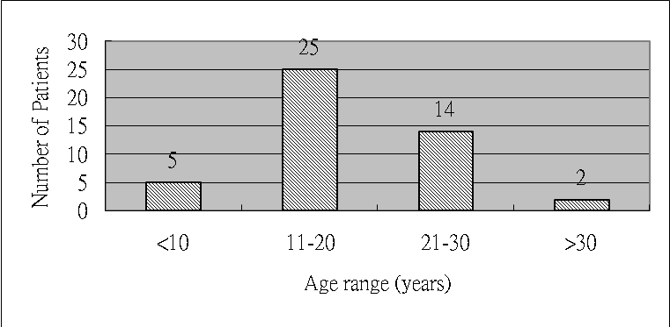

Legend of Figure 1:
Fig. 1 Age distribution of study population (n=46).

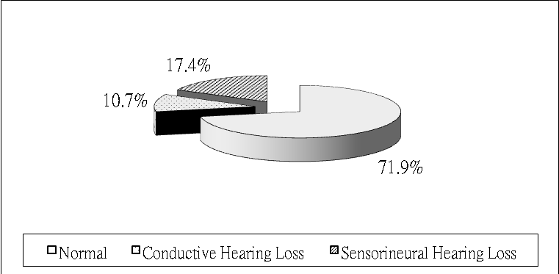
Legend of Figure 2:
Fig. 2 The distribution of hearing loss in pure tone audiometry in Turner syndrome.

Table 3
Associations between clinical features and hearing loss in TS patients
Clinical features (n=46) CHL (n=5) p value^{b} SNHL (n=8) p value^{b}
Karyotype 45,X (27) 3 0.5810 5 1.0000
Recurrent OM history (22) 5 0.0192 * 6 0.1278
High arched palate (30) 5 0.1470 5 1.000
Micrognathia (29) 4 0.6998 6 0.6905
Lower posterior hair line (29) 3 1.0000 7 0.2263
Auricular abnormalityª (10) 1 1.0000 1 0.6641 ________________________________________
CHL: conductive hearing loss, SNHL: sensorineural hearing loss, OM: otitis media.
ª low-set ear, cupped auricle and abnormally protruding ear.
^{b} Fisher ‘s exact test, two-tailed.
* statistically significant, p< 0.05. (since have shown actual number, * can be deleted)

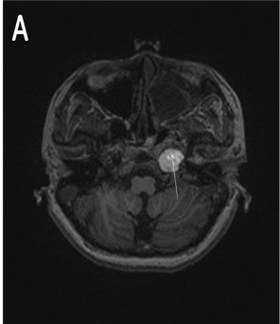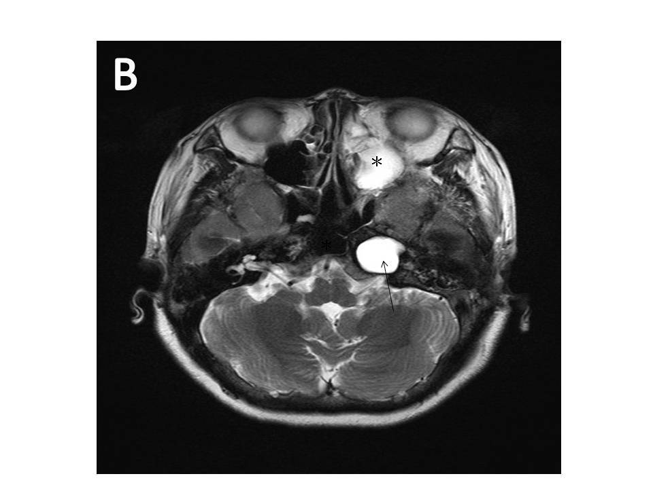
Legend of Figure 3:
Fig.3 Both axial T1-weighted image (A) and T2-weighted image (B) displayed an expansible hyperintense density mass ( bright white signal) in ptrosal apex(arrow), which represented the characteristic of “cholesterol granuloma”. Concomitant rhinosinusitis was also seen (*). (If want to put this MRI, may need to discuss petrous apex cholestroal granuloma in TS patients, common?)

Referrences
[1] M.B. Ranke, P. Saenger, Turner’s syndrome, Lancet. 358 (2001) 309-314.
[2] N. Sculerati, J. Ledesma-Medina, D.N. Finegold, S.E. Stool, Otitis media and hearing loss in Turner syndrome, Arch Otolaryngol Head Neck Surg. 116 (1990) 704-707.
[3] M. Hultcrantz, L. Sylven, E. Borg, Ear and hearing problems in 44 middle-aged women with Turner’s syndrome, Hear Res. 76 (1994) 127-132.
[4] N. Sculerati, C. Oddoux, C.M. Clayton, J.W. Lim, H. Oster, Hearing loss in Turner syndrome, Laryngoscope 106 (1996) 992-997.
[5] M. Hultcrantz, L. Sylven, Turner’s syndrome and hearing disorders in women aged 16-34, Hear Res. 103 (1997) 69-74.
[6] M. Benazzo, M. Cerniglia, D. Larizza,V.S. Russotto, T. Figar, Otological and audiological aspects in Turner syndrome, J Audiol Med. 6 (1997) 147-159.
[7] A.E. Stenberg, O. Nylen, M. Windh, M. Hultcrantz, Otological problems in children with Turner’s syndrome, Hear Res. 124 (1998) 85-90.
[8] M.L. Barrenas, O. Nylen, C. Hanson, The influence of karyotype on the auricle, otitis media and hearing in Turner syndrome, Hear Res. 138 (1999) 163-170.
[9] M.L. Barrenas, K. Landin-Wilhelmsenb, C. Hansonc, Ear and hearing in relation to genotype and growth in Turner syndrome, Hear Res. 144 (2000) 21-28.
[10] N. Gungor, B. Boke, E. Belgin, E. Tuncbilek, High frequency hearing loss in Ullrich-Turner syndrome, Eur J Pediatr. 159 (2000) 740-744.
[11] A. Serra, S. Cocuzza, E. Caruso, M. Mancuso, I. La Mantia, Audiological range in Turner’s syndrome, Int J Pediatr Otorhinolaryngol. 67 (2003) 841-845.
[12] M. Hultcrantz, Ear and hearing problems in Turner’s syndrome, Acta Otolaryngol. 123 (2003) 253-257.
[13] A. Beckman, G.S. Conway, B. Cadge, Audiological features of Turner’s syndrome in adults, Int J Audiol. 43 (2004) 533-544.
[14] J.E. Ostberg, A. Beckman, B. Cadge, G.S. Conway, Oestrogen deficiency and growth hormone treatment in childhood are not associated with hearing in adults with Turner syndrome, Horm Res. 62 (2004) 182-186.
[15] I.J. Dhooge, E.De Vel, C. Verhoye, M. Lemmerling, B. Vinck, Otologic disease in Turner syndrome, Otol Neurotol. 26 (2005) 145-150.
[16] N. Morimoto, T.Tanaka, H. Taiji, R. Horikawa, Y. Naiki, Y. Morimoto, et al, Hearing loss in Turner syndrome, J. Pediatr. 149 (2006) 697-701.
[17] K.A. King, T. Makishima, C.K. Zalewski, V.K. Bakalov, A.J. Griffith, C.A. Bondy, et al., Analysis of auditory phenotype and karyotype in 200 females with Turner syndrome, Ear Hear. 28 (2007) 831-841.
[18] R.Bergamaschi, C. Bergonzoni, L. Mazzanti, E. Scarano, F. Mencarelli, F. Messina, M. Rosano, et al., Hearing loss in Turner syndrome: Result of a multicentric study, J. Endocrinol. Invst. 31 (2008) 779-783.
[19] W. Gawron, B. Wikiera, B. Rostkowska-Nadolska, K. Orendorz-Fraczkowska, A. Noczynska, Evaluation of hearing organ in patients with Turner syndrome, Int J Pediatr Otorhinolaryngol. 72 (2008) 575-579.
[20] T. Makishima, K.King, C.C. Brewer, C.K. Zalewski, J. Butman, V.K. Bakalov, et al., Otolaryngologic markers for the early diagnosis of Turner syndrome, Int J Pediatr Otorhinolaryngol. 73 (2009) 1564-1567.
[21] M. Mazzoli, G.V. Camp, V. Newton, N. Girbini, F. Declau, A. Parving, et al., Recommendation for the description of genetic and audiological data for families with nonsyndromic heredity hearing impairment, Audiolog Med. 1 (2003) 148-150.
[22] S.A. Temtamy, I. Ghali, M.A. Salam, F.H. Hussein, E.H.A.A. Ezz, M.A. Salah, Karyotype/phenotype correlation in females with short stature, Clin. Genet. 41 (1992) 147-151.
[23] C. Hederstierna, M. Hultcrantz, U. Rosenhall, A longitudinal study of hearing decline in women with Turner syndrome, Acta Otolaryngol. 129 (2009) 1434-1441.

[24] C.Hederstierna C, M. Hultcrantz, U. Rosenhall, Estrogen and hearing from a clinical point of view; characteristics of auditory function in women with Turner syndrome, Hear Res. 252 (2009) 3-8.

