

Withanolides-Induced Breast Cancer Cell Death Is
Correlated with Their Ability to Inhibit Heat Protein 90

Hui-Chun Wang1, Yi-Ling Tsai1, Yang-Chang Wu2,3, Fang-Rong Chang1,3, Mei-Hsin Liu1, Wen-Ying Chen4, Chin-Chung Wu1*
1 Graduate Institute of Natural Products, Kaohsiung Medical University, Kaohsiung, Taiwan, 2 School of Chinese Medicine, College of Chinese Medicine, China Medical University, Taichung, Taiwan, 3 Cancer Center, Kaohsiung Medical University Hospital, Kaohsiung, Taiwan, 4 Basic Medical Science Education Center, Fooyin University, Kaohsiung, Taiwan

Abstract
Withanolides are a large group of steroidal lactones found in Solanaceae plants that exhibit potential anticancer activities. We have previously demonstrated that a withanolide, tubocapsenolide A, induced cycle arrest and apoptosis in human breast cancer cells, which was associated with the inhibition of heat shock protein 90 (Hsp90). To investigate whether other withanolides are also capable of inhibiting Hsp90 and to analyze the structure-activity relationships, nine withanolides with different structural properties were tested in human breast cancer cells MDA-MB-231 and MCF-7 in the present study. Our data show that the 2,3-unsaturated double bond-containing withanolides inhibited Hsp90 function, as evidenced by selective depletion of Hsp90 client proteins and induction of Hsp70. The inhibitory effect of the withanolides on Hsp90 chaperone activity was further confirmed using in vivo heat shock luciferase activity recovery assays. Importantly, Hsp90 inhibition by the withanolides was correlated with their ability to induce cancer cell death. In addition, the withanolides reduced constitutive NF-kB activation by depleting IkB kinase complex (IKK) through inhibition of Hsp90. In estrogen receptor (ER)-positive MCF-7 cells, the withanolides also reduced the expression of ER, and this may be partly due to Hsp90 inhibition. Taken together, our results suggest that Hsp90 inhibition is a general feature of cytotoxic withanolides and plays an important role in their anticancer activity.

Citation: Wang H-C, Tsai Y-L, Wu Y-C, Chang F-R, Liu M-H, et al. (2012) Withanolides-Induced Breast Cancer Cell Death Is Correlated with Their Ability to Inhibit
Heat Protein 90. PLoS ONE 7(5): e37764. doi:10.1371/journal.pone.0037764
Editor: Aamir Ahmad, Wayne State University, United States of America
Received December 5, 2011; Accepted April 24, 2012; Published May 31, 2012
Copyright: @ 2012 Wang et al. This is an open-access article distributed under the terms of the Creative Commons Attribution License, which permits unrestricted use, distribution, and reproduction in any medium, provided the original author and source are credited.
Funding: This work was supported by grants from National Science Council of Taiwan. The funders had no role in study design, data collection and analysis, decision to publish, or preparation of the manuscript.
Competing Interests: The authors have declared that no competing interests exist.
* E-mail: ccwu@kmu.edu.tw

Introduction

Withanolides are a group of naturally occurring steroidal lactones which are found in certain genera of the Solanaceae family. Some withanolide-containing plants have been known as folk remedies for centuries. For example, Withania somnifera contains a major withanolide- withaferin A, has been traditionally used in India for treatment of arthritis and other musculoskeletal conditions, and as a general tonic [1]. Pharmacological studies have revealed that besides anti-inflammatory activity, withanolides possess immunoregulatory, anti-tumor, anti-angiogenic, anti-inva- sive, and chemopreventive effects [2]. In addition, there are over
350 withanolides isolated and identified to date [3]; the diverse structural analogs provide a great opportunity for the study of structure-activity relationships, target identification, and lead optimization. Therefore, withanolides represent promising lead compounds for development of new anticancer drugs.
In our previous study, we have found that tubocapsenolide A, a novel withanolide from a native Taiwanese plant Tubocapsicum anomalum (Franchet and Savatier) Makino (Solanaceae), exhibited significant cytotoxicity against a panel of cancer cell lines [4]. Further study on the mechanism of action revealed that tubocapsenolide A inhibited the function of heat shock protein
90 (Hsp90) through thiol oxidation, and thus caused the depletion
of Hsp90 client proteins, including Akt, CDK4, cyclin D, and mutant P53 [5]. Because Hsp90 client proteins play critical roles in the regulation of cell proliferation, survival, and apoptosis, it is suggested that tubocapsenolide A exerted its anticancer effect by inhibiting Hsp90. Subsequent to our study, Yu et al. reported that another withanolide withaferin A also has the same inhibitory effect on Hsp90 [6]. More recently, by using molecular docking approach, Grover et al. predicted that WA has the potential to inhibit the association of Hsp90 to its co-chaperone Cdc37 by disrupting the stability of attachment of Hsp90 to Cdc37 [7]. Therefore, we wondered whether the Hsp90-inhibitory effect is a general characteristic of withanolides and contributes to their anticancer effect. In the present study, we compared nine withanolides with different structural features for their cytotoxicity and Hsp90-inhibitory activity, and found a good correlation between these two effects. In addition, structure activity analysis revealed a critical requirement of the a, b-unsaturated ketone unit in the ring A of withanolides for the inhibitory effect on Hsp90.

Materials and Methods

Materials
Tubocapsenolide A, tubocapsenolide B, tubocapsanolide C, tubocapsanolide E, and anomanolide A were isolated from

Withanolides Inhibit Heat Protein 90

Tubocapsicum anomalum as described previously [4]. 4b-Hydroxy- withanolide, withanolide E, and peruvianolide H were isolated from Physalis peruviana [8]. Withaferin A was purchased from ChromaDex (Irvine, CA). The purities of the withanolides used in the study are over 98% determined by high pressure liquid chromatography. The withanolides were dissolved in DMSO, and the final concentration of DMSO in culture medium was 0.1%. Anti-Poly(ADP-ribose)polymerase, anti-caspase-3, anti-Raf-1, an- ti-CDK4 antibodies were from Santa Cruz Biotechnology Inc. (Santa Cruz, CA). Anti-Akt, anti-IKKa, anti-IKKb, anti-IkB, anti-phospho-IkB, anti-NF-kB, and anti-phospho-NF-kB antibod- ies were from Cell Signaling Technology (Beverly, MA). Anti- Hsp90 and anti-Hsp70 antibodies were from Stressgen Biotech- nologies (San Diego, CA). ONE-GloTM luciferase assay system was purchased from Promega (Madison, WI). Geldanamycin, N- acetylcysteine, 3-(4,5-dimethyl-thiazol-2-yl)-2,5-diphenyl tetrazoli- um bromide (MTT), and all other chemicals were obtained from Sigma Chemical Co (St Louis, MO).

Cell culture
MDA-MB-231 and MCF-7 human breast cancer cells were obtained from American Tissue Culture Collection. Cells were
incubated at 37uC in a humidified atmosphere containing 5% CO2 in RPMI 1640 medium, supplemented with 10% fetal bovine serum, penicillin (100 IU/ml) and streptomycin (100 mg/ml). The cells were harvested by trypsinization and plated 24 h before treatment with the test drugs.

Evaluation of cell viability
16104 cells were plated into each well of a 96-well plate and treated with the various concentrations of drugs for different indicated times. At the end of each time point, 100 ml of MTT solution (0.5 mg/ml) was added to each well. Cells were then incubated at 37uC for 1 h. The MTT crystals in each well were solubilized with 100 ml of DMSO. Absorbance was read at
550 nm.

Western blot assay
Following exposure to various drugs, cancer cells were washed with PBS and lysed for 10 min at 4uC in a lysis buffer (50 mM Tris-HCl, 150 mM NaCl, 1 mM EDTA, 1 mM EGTA, 1% Triton X-100, 20 mg/ml leupeptin, 2 mM sodium orthovanadate,
1 mM phenylmethylsulfonyl fluoride, 5 mM sodium fluoride, and
5,000 units/ml aprotinin). Equal proteins were separated by SDS-

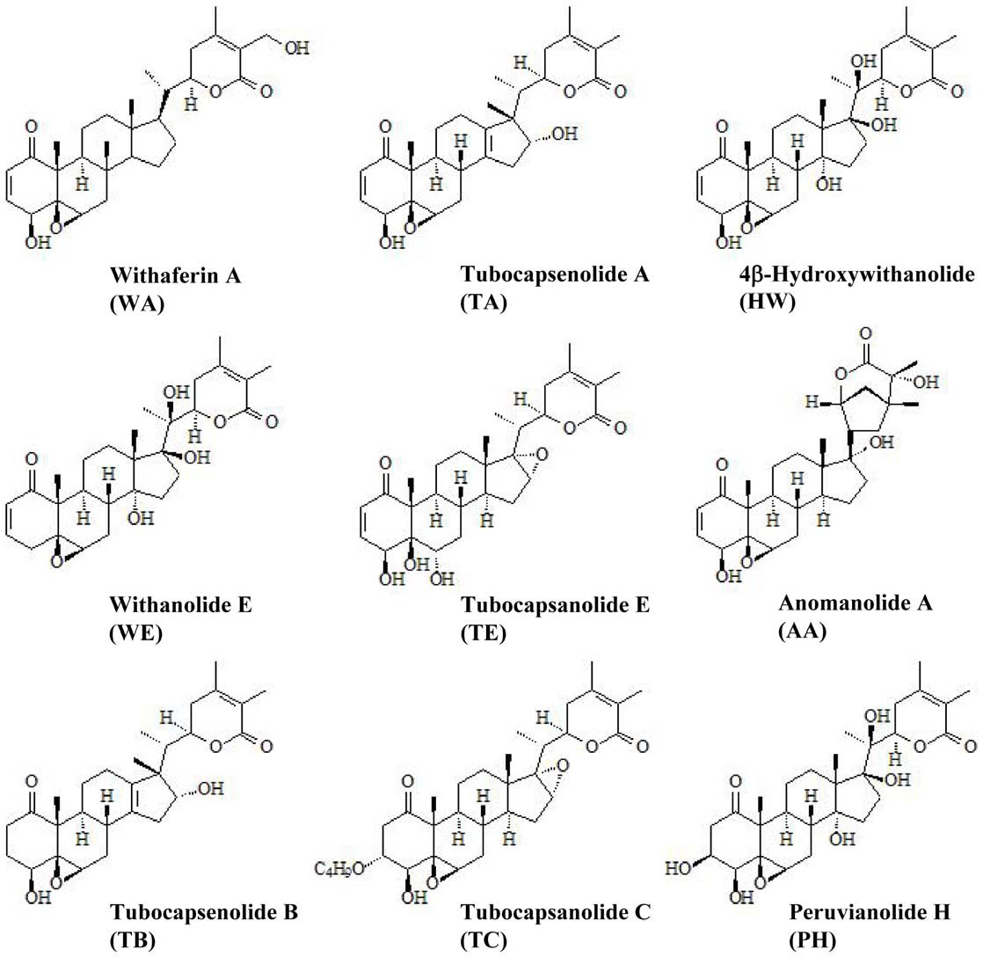

Figure 1. Chemical structures of the withanolide compounds.
doi:10.1371/journal.pone.0037764.g001

