Acute and Chronic Administrations ofRheum palmatum Reduced the Bioavailability of Phenytoin in Rats: A New Herb-Drug Interaction

Ying-Chang CHI ^{1＃}, Shin-Hun Juang ¹,Wai Keung Chui ⁴, Yu-Chi Hou ^{2,3*},Pei-Dawn Lee Chao ^{2*}
Affiliation
¹Institute of Pharmaceutical Chemistry, China Medical University, Taichung, 40402, Taiwan
²School of Pharmacy, China Medical University, Taichung, 40402, Taiwan
³Department of Medical Research, China Medical University Hospital, Taichung, 40402, Taiwan
⁴ Department of Pharmacy, Faculty of Science, National University of Singapore 18 Science Drive 4, Singapore 117543

* Corresponding author: Pei-Dawn Lee Chao, School of Pharmacy, China Medical University, 91 Hsueh-Shih Road, Taichung, 40402, Taiwan.
Yu-Chi Hou, School of Pharmacy, China Medical University, 91 Hsueh-Shih Road, Taichung, 40402, Taiwan.
E-mail: pdlchao@gmail.com hou5133gmail.com
Tel.:+886 4 22031028 Fax:+886 4 22031028
Abstract
The rhizome of Rheum palmatum (RP) is a commonly used herb in clinical Chinese medicine. Phenytoin (PHT) is an antiepileptic with narrow therapeutic window. This study investigated the effects on the pharmacokinetic properties of PHT in a rat model upon acute and chronic coadministration of RP. An elucidation on the mechanism of the herb-drug interaction was also attempted. Rats were orally administered with PHT (200 mg/kg) with and without RP decoction (single dose and seven doses of 2 g/kg) in a crossover design. Blood samples were collected via cardiac puncture at predetermined time points. The serum concentrations of PHT, PHT glucuronide (PHT-G), 4-hydroxyphenytoin (HPPH) and HPPH glucuronide (HPPH-G) were determined by HPLC method. Cell line models were used to identify the underlying mechanisms. The results showed that coadminstration of single dose or multiple doses of RP significantly decreased the C_{max} and AUC_{0-t} as well as the K₁₀ of PHT, PHT-G, HPPH and HPPH-G. Cell line studies revealed that RP significantly induced the P-gp mediated efflux of PHT and inhibited the MRP 2 medicated transport of PHT and HPPH. In conclusion, acute and chronic coadministrations of RP markedly decreased the oral bioavailability of PHT via activation of P-gp, although the MRP 2-mediated excretion of PHT and HPPH were inhibited. It is recommended that caution should be exercised during concurrent use of RP and PHT.
Keywords
Rheum palmatum, Phenytoin, P-glycoprotein, multi-drug resistance protein 2, herb-drug interaction

Abbreviations
RP: Rheum palmatum, PHT: phenytoin, PHT-G: phenytoin-glucuronide, HPPH: 4-hydroxyphenytoin, HPPH-G: 4-hydroxyphenytoin-glucuronide, P-gp: P-glycoprotein, MRP: multidrug resistance proteins 2, CYP 2C: cytochrome P-450 2C, LLOQ: lower limit of quantitation, LOD: limit of detection, C_{max}: the peak serum concentration, AUCs: the areas under the curves, K₁₀: the elimination rate.
Introduction
The rhizome of Rheum palmatum (RP, Dahuang) is one of the important herbs widely used in China, Russia and Arabia . The major constituents of RP include a variety of anthraquinones such as aloe-emodin, rhein, emodin, chrysophanol and physion , which have been reported to show various beneficial effects, including neuroprotective, antioxidant, anti-inflammatory and anticancer activities. Recent pharmacokinetic studies of RP have revealed that the anthraquinones were all predominantly present as glucuronides and sulfates in the blood and they are also putative substrates of multidrug resistance proteins (MRPs), namely the anion transporters.
Phenytoin (PHT), a widely used antiepileptic with narrow therapeutic window, follows nonlinear pharmacokinetics, and thus therapeutic drug monitoring is usually recommended during its use . The adverse reactions of PHT include drowsiness, dysarthria, tremor and cognitive difficulties . PHT has been reported as substrates of P-glycoprotein (P-gp) and MRP 2, whose expression determined the regulation of PHT level in the brain . Approximately 50% of patients exhibit a favorable therapeutic effect with plasma concentrations of 8-10 μg/mL. PHT is metabolized to its main metabolite 4-hydroxyphenytoin (HPPH) by cytochrome P450 (CYP) 2C9 and to a minor extent by CYP 2C19 . Both PHT and HPPH are metabolized by glucuronidation to form PHT glucuronide (PHT-G) and HPPH glucuronide (HPPH-G), respectively .
In recent decades, the use of complementary and alternative medicine has been increasing worldwide. A number of herbs have been reported to alter the pharmacokinetics of some drugs that led to diminished efficacy or adverse events. For instance, Ginkgo biloba has been found to decrease the serum level of PHT by inducing CYP 2C19 activity and St. John's wort has been shown to significantly decrease the oral bioavailability of digoxin by inducing P-gp activity . Based on our understanding on the metabolic fates and pharmacokinetics of PHT and anthraquinones in RP, we hypothesized that the metabolites of anthraquinones might compete with PHT, HPPH, PHT-G or HPPH-G for anion transporters such as MRP 2. As such coadministration of RP and PHT may give rise to adverse effects, therefore, this study was set up to investigate the acute and chronic effects of coadministration of RP on the pharmacokinetic properties of PHT in rats. In addition, cell line models would be used to explore the underlying mechanism of this herb-drug interaction.
Materials and Methods
Chemicals and reagents
PHT (purity 99%), HPPH (purity 98%), aloe-emodin (purity 95%), rhein (purity 95%), emodin (purity 95%), chrysophanol (purity 98%), physcion (purity 98%), verapamil (purity 99%), propylparaben (purity 99%), 2-methylanthraquinone (purity 95%), rhodamine 123 (purity 99%) and 3-(4,5-dimethylthiazol-2-yl)-2,5-diphenyl tetrazolium bromide (MTT) were purchased from Sigma Chemical Co. (St. Louis, MO, U.S.A.). L(+)-Ascorbic acid was obtained from Riedel-deHaën Laborchemikalien GmbH & Co. KG (Seelze, Germany). Fetal bovine serum was supplied by Biological Industries Ltd., Kibbutz Beit Haemek, Israel). L-glutamine, penicillin, streptomycin, non-essential amino acid, trypsin-EDTA and Hank’s balanced salt solution (HBSS) were purchased from Invitrogen Inc. (Carlsbad, California, U.S.A.). Total protein assay kit was purchased from Bio-Rad Inc. (Mississauga, Ontario, Canada). Other reagents were HPLC grade or analytical grade. Milli-Q plus water (Millipore, Bedford, MA, USA) was used throughout this study.

Preparation and characterization of RP decoction
The crude drug of RP was purchased from a Chinese drugstore in Taichung, Taiwan. The origin was identified by Dr. Yu-Chi Ho via microscopic examination. A voucher specimen (CMU-P-1905-9) was deposited in the college of pharmacy, China medical University. Water (5 L) was added to 250 g of the crude drug. After maceration for 1 h, the mixture was heated to boiling and gentle heating was continued for about 2 h until the volume was reduced to less than 2.5 L. The mixture was filtered while hot and the filtrate was concentrated further by gentle boiling until the volume was reduced to below 500 mL, after which sufficient water was added to make 500 mL. The resultant concentrate was divided into aliquots of 40 mL and stored at -20°C for later use.
The concentrations of aloe-emodin, rhein, emodin, chrysophanol and physcion in RP decoction and its hydrolysate were determined by a HPLC method. For acid hydrolysis, a portion of the decoction (1.0 mL) was added 1.2 N HCl (1 mL), 25 mg of ascorbic acid and incubated at 80°C for 30 min. This method was determined by a previous preliminary study. The mixture was then added with 4.0 mL of methanol. After vortexing and centrifugation, the supernatant (100 µL) was mixed with 100 µL of internal standard in the form of 2-methylanthraquinone solution (50 µg/mL in methanol) and 20 µL of this solution was subjected to HPLC analysis. A gradient elution was carried out using a mobile phase consisting of 0.1% phosphoric acid (A) and acetonitrile (B) that were mixed in the following program: A/B = 50/50 (0-10 min), 15/85 (15-22 min), 50/50 (27-30 min). The detection wavelength was set at 280 nm and the flow rate was maintained at 1.0 mL/min. The concentration of anthraquinone glycoside was estimated from the difference of aglycone concentrations between RP decoction and its acid hydrolysate.

Animals and drug administration
Male Sprague-Dawley rats were supplied by National Laboratory Animal Center (Taipei, Taiwan) and kept in the animal center of the China Medical University (Taichung, Taiwan). The animal protocol was approved by the Institutional Animal Care and Use Committee of the China Medical University. The animal study was conducted with adherence to “The Guidebook for the Care and Use of Laboratory Animals” published by the Chinese Society of Animal Science, Taiwan, ROC. The rats (300-400 g) were fasted for 12 h before drug administration. PHT was dissolved in dil. NaOH (pH 9) to afford a solution of 20.0 mg/mL, which was given via gastric gavage to seven rats at 200.0 mg/kg with and without a concomitant oral dose of RP decoction (single dose and seven doses of 2 g/kg) in a crossover design. The RP decoction was administered right before PHT.

Blood collection
Blood samples (0.5 mL) were withdrawn via cardiac puncture at time points of 0, 15, 30, 60, 120, 240, 480 and 720 min after oral administration of PHT. The blood samples were collected in microtubes and centrifuged at 10,000 g for 15 min to obtain the serum, which was stored at -70°C before analysis.

Determination of PHT and its metabolites in serum
For the determination of free forms of PHT and HPPH, 100 μL of serum sample was mixed with 50 μL of pH 5 acetate buffer and 50 μL of ascorbic acid (100 mg/mL). The mixture was extracted with 200 μL of ethyl acetate (containing propyl paraben as internal standard, 5 µg/mL). The ethyl acetate layer was evaporated under N₂ to dryness and reconstituted with an appropriate volume of acetonitrile and then subjected to HPLC analysis.
For the assay of PHT-G and HPPH-G in serum, indirect determination was carried out through hydrolysis with β-glucuronidase in pH 5 acetate buffer. Serum sample (100 μL) was mixed with 50 μL of β-glucuronidase (1000 units/mL) and 50 μL of ascorbic acid (100 mg/mL) and incubated at 37°C for 60 min under anaerobic condition. After hydrolysis, the analytical procedures followed that for the assay of the free forms as described above.

Cell lines and cell culture
LS 180, the human colon adenocarcinoma cell line, was obtained from the Food Industry Research and Development Institute (Hsinchu, Taiwan). The nontransfected and MRP 2-overexpressing MDCK II cell lines were kindly provided by Prof. Piet Borst (Dutch Cancer Institute, Amsterdam, the Netherlands). The cell lines were cultured in DMEM medium supplemented with 10% fetal bovine serum, 0.1mM nonessential amino acid (LS 180 only), 100 units/mL of penicillin, 100 μg/mL of streptomycin, and 292 μg/mL of glutamine. Cells were grown at 37°C in a humidified incubator containing 5% CO₂. The medium was changed every other day, and the cells were subcultured until 80-90% confluency was reached.

Cytotoxicity assay
Verapamil hydrochloride and rhodamine 123 (rho 123) were dissolved in water. PHT and HPPH were dissolved in dil. NaOH (pH 9.0). Indomethacin was dissolved in MeOH and the final concentration of MeOH in medium was below 0.1% (v/v). LS 180, MDCK II and MDCK II-MRP 2 cells (1×10⁵ cells/well) were seeded into 96-well plates. After overnight incubation, the test agents were added into the wells and incubated for 72 h and then 15 μL of MTT (5 mg/mL) was added into each well and incubated for additional 4 h. During this period, MTT was reduced to formazan crystal by live cells. An acidic SDS (10%) solution was added to solubilize the purple crystal formed at the end of incubation and the optical density was measured at 570 nm by a microplate reader (Nunc, Denmark).
Transport study of PHT in LS 180
LS 180 cells (passage 50 to 60) were seeded on 12-well plates at a density of 5×10⁵ cells/well. Before the experiment, the medium was removed and the cells were quickly rinsed with ice-cold HBSS transport buffer consisting of HEPES (10 mM, pH 7.4.). To determine whether PHT is a substrate of P-gp, PHT (10 μM) and rho 123 in HBSS (10 μM, 200 μL) were incubated with and without verapamil (100 μM) for 90 min. After various incubations described above, cells were lysed with 200 μL of 0.1% Triton X-100 for 30 min. To determine the concentration of rho 123 in the cell lysate, a fluorescent plate reader with excitation at 485 nm and emission at 528 nm was used.

Preparation and characterization of serum metabolites of RP (RPM)
In order to mimic the molecules interacting with MRP 2 in the kidney, RPM was prepared using rats. After overnight fasting, rats were given RP decoction at 2 g/kg. Blood was collected at 30 min after dosing. The serum was added with 3-fold methanol. After vortex and centrifuged at 10,000g for 15 min, the supernatant was dried in a rotatory evaporator under vacuum. To the residue, an appropriate volume of water was added to afford a solution with a 10-fold serum concentration, which was divided into aliquots and stored at -80°C for later use.
The procedures for the characterization of RPM followed that of a previous study (Shia et al 2009). Briefly, 100 μL of serum sample were mixed with 50 μL of sulfatase (containing 1000 units/mL of sulfatase and 35,600 units/mL of β-glucuronidase) and 50 μL of ascorbic acid (100 mg/mL) and incubated at 37°C for 10 min under anaerobic condition. After hydrolysis, the serum was acidiﬁed with 50 μL of 0.1 N HCl and extracted with 250 μL of ethyl acetate (containing 2-methylanthraquinone as internal standard, 1 μg/mL). The ethyl acetate layer was evaporated under N₂ to dryness and reconstituted with an appropriate volume of methanol prior to HPLC analysis.
In addition, the serum of rats given water only was collected to prepare the blank control. The blank serum was processed as described above, and diluted to various folds of serum concentration for the comparison with correspondent concentration of RPM.

Transport study of PHT and HPPH in MDCK II and MDCK II-MRP 2
MDCK II and MDCK II-MRP 2 cells within 10 passages were seeded on 12-well plates at a density of 3×10⁵ cells/well. Before experiment, the medium was removed and the cells were quickly rinsed with ice-cold HBSS transport buffer. To determine whether PHT and HPPH are substrate of MRP 2, PHT (10 μM), HPPH (10 μM) and indomethacin (50, 100 and 200 μM, as a positive control of MRP 2 inhibitor) were incubated with MDCK II and MDCK II-MRP 2 for 60 min.
In another study, RPM and indomethacin (100 μM) in HBSS were pre-incubated with MDCK II-MRP 2 for 30 min. The supernatants were removed and cells were washed three times with ice-cold PBS. Then, PHT (10 μM) and HPPH (10 μM) were co-incubated with and without RPM (1-, 0.5- and 0.25-fold of serum concentrations) and indomethacin (100 μM) with MDCK II-MRP 2 for another 30 min. After incubation, the cells were rapidly washed twice with ice-cold HBSS buffer and lysed with 200 μL of 0.1% Triton X-100 for 30 min.
Total protein content in the lysate (5 μL) was determined by Braford method , and bovine serum albumin was used as the standard. The protein contents in each well were used for data correction.

Determination of PHT and HPPH concentrations in cell lysate
For the assay of PHT and HPPH, 200 μL of cell lysate was extracted with 200 μL of ethyl acetate (containing propyl paraben as internal standard, 5 µg/mL). The ethyl acetate layer was evaporated under N₂ to dryness and reconstituted with an appropriate volume of acetonitrile, then subject to HPLC analysis.

Assay and method validation of PHT and HPPH in serum and cell lysate
An HPLC method using a mixture of methanol and 0.05% phosphoric acid (48:52) as mobile phase was developed and validated for the assay of PHT and HPPH in serum and cell lysate. The detection wavelength was set at 214 nm and the flow rate was 1.0 mL/min. The calibration ranges of PHT and HPPH were 0.2-50.0 µg/mL for serum and cell lysate.
The precision and accuracy of the analytical method was evaluated by intra-day and inter-day analysis of triplicate standards within one day and over a period of three days. Recoveries from serum and cell lysate were calculated based on the detected concentrations in serum and cell lysate compared with those in water. LOQ (Limit of Quantitation) represents the lowest concentration of analyte that can be determined with acceptable precision and accuracy with coefﬁcients of variation and relative errors below 15% and 20%, respectively. LOD (Limit of Detection) represents the lowest concentration of analyte that can be detected with S/N＞3.

Data analysis
The areas under the serum concentration-time curves (AUC_{0-t}) of PHT, PHT-G, HPPH and HPPH-G were calculated using noncompartment model (version 1.1, SCI software, Statistical Consulting, Inc., Apex, NC, USA). The peak serum concentrations (C_{max}) were from experimental data. One-way ANOVA with Sheffe test was used for statistical comparison taking p < 0.05 as significant.
Results

Characterization of RP decoction
Fig. 1 shows the chromatograms of the RP decoction before and after acid hydrolysis. Quantitation results showed that the concentrations of aloe-emodin, rhein, emodin, chrysophanol and physcion were 0.9, 2.0, 0.5, 0.4, 0.1 nmol/mL in the decoction, and 2.3, 3.8, 2.0, 1.8, 0.7 nmol/mL in the acid hydrolysate of decoction, respectively. Accordingly, a dose of 2 g/4 mL/kg RP was found to contain 9.2, 15.2, 8.0, 7.2 and 2.8 nmol/kg of aloe emodin, rhein, emodin and chysophanol with the relevant glycosides, respectively.

Assay of PHT and HPPH in serum and method validation
In serum assay, the calibration curves of PHT and HPPH showed good linearity in the concentration range of 0.2 - 50 µg/mL. The precision evaluation revealed that all coefﬁcients of variation were below 15% and the accuracy analysis showed that the relative errors to the true concentrations were below 10%. The LLOQ of PHT and HPPH were 0.4 µg/mL and the LOD were 0.01 and 0.02 µg/mL respectively.

Effect of RP on PHT pharmacokinetics in rats
Fig. 2 depicts the mean serum concentration - time profiles of PHT, PHT-G, HPPH and HPPH-G after oral administration of PHT alone and oral coadministration with single dose and pretreatment with seven doses of 2 g/kg of RP. The pharmacokinetic parameters of PHT, PHT-G, HPPH and HPPH-G are listed in Table 1. Coadministration of RP with single dose of 2 g/kg significantly decreased the C_{max} of PHT, PHT-G, HPPH and HPPH-G by 51.0, 51.7, 43.9, 42.5% and reduced the AUC₀₋₇₂₀ by 36.9, 51.7, 30.3 and 22.8, respectively. Pretreatment with seven doses of RP significantly decreased the C_{max} of PHT, PHT-G, HPPH and HPPH-G by 53.1%, 65.1%, 46.3%, 44.3% and reduced their AUC₀₋₇₂₀ by 51.9%, 64.8%, 37.5% and 30.6%, respectively. In addition, the K₁₀ of PHT, PHT-G HPPH and HPPH-G were significantly decreased upon acute and chronic coadministrations of RP.

Transport studies of PHT and HPPH
The effects of RP and verapamil on the intracellular accumulation of PHT in LS 180 cells are shown in Fig. 3 RP at 2.0, 1.0 and 0.5 mg/mL significantly decreased the intracellular accumulation of PHT by 43.6, 37.3 and 22.9%, indicating RP concentration-dependently activated the efflux function of P-gp.
Fig. 4 shows that the differences of intracellular accumulation of PHT and HPPH in presence and absence of indomethacin in MDCK II and MDCKII-MRP 2. The results showed that the accumulations of PHT and HPPH in MDCKII were higher than those in MDCK II-MRP 2. In addition, the intracellular accumulations of PHT and HPPH were significantly increased by indomethacin in both cell lines.
In order to mimic the molecules interacting with MRP 2 in kidney, the RPM of rats was prepared and characterized. HPLC analysis of RPM showed that it contained 2.3, 13.0, 4.1 and 2.0 μM of glucuronides/sulfates (G/S) of aloe-emodin, rhein, emodin, chrysophanol, respectively, and 6.4 μM of rhein free form in the serum.
The effects of RPM and indomethacin on the intracellular accumulation of PHT and HPPH in MDCK II-MRP 2 are shown in Fig. 5 RPM at 1-fold serum concentrations significantly increased the intracellular accumulation of PHT and HPPH by 51.7% and 46.7%. As a positive control, indomethacin at 100 μM signiﬁcantly increased the intracellular accumulation of PHT and HPPH by 54.2% and 44.1%, respectively.
Discussions

Owing to the general abundance of polyphenol glycosides in plants, characterization of the RP decoction used in this study was carried out to measure the concentrations of aloe-emodin, rhein, emodin, chrysophanol and physicon before and after acid hydrolysis. Quantitation results showed that upon acid hydrolysis the concentrations of aloe-emodin, rhein, emodin, chrysophanol and physicon increased by 416%, 85%, 345%, 402% and 367% respectively, implying that the RP decoction contained aloe-emodin, emodin, chrysophanol and physicon mainly in their glycoside form, whereas rhein was an exception existing more in the free form.
The assay methods of PHT and HPPH in serum and cell lysate were similar to a previously reported study but with some modifications made and they were validated in this study . The determination of PHT-G and HPPH-G was performed indirectly through hydrolysis with β-glucuronidase . Coadministration of single dose and pretreatment with the seven doses of RP all significantly decreased the AUC and C_{max} of PHT, PHT-G, HPPH and HPPH-G, suggesting that RP decreased the oral bioavailability of PHT. The serum profiles revealed that the early exposure of PHT was markedly decreased, inferring that the absorption of PHT was hampered. This fact suggested that acute and chronic coadministrations of RP would result in diminished efficacy of PHT.
Based on previous studies which claimed that PHT was a substrate of P-gp and CYP 2C , it is reasonable to assume that RP may induce P-gp or CYP 2C and thus resulting in the decreased absorption of PHT. However, the unaffected ratio of the AUC of HPPH plus HPPH-G to that of PHT plus PHT-G (data not shown) can be inferred that the decreased absorption of PHT cannot be attributed to the enhanced metabolism mediated by CYP 2C. Subsequently, the possible involvement of P-gp in this interaction was investigated by using LS 180 cells to measure the effect of RP on the efflux transport of PHT. The result showed a decrease in intracellular accumulation of PHT in the presence of RP indicated that the activity of P-gp could have been induced, which might explain the decreased absorption of PHT in rats. These results could also echo previous studies reporting that overexpression of P-gp could cause a decrease in PHT levels in the rats .
While the rats were coadministered with RP in single dose and pretreated with seven doses, the significantly decreased K₁₀ of PHT, PHT-G, HPPH and HPPH-G indicated that eliminations of both the parent form and the metabolites were inhibited in rats. It has been reported that majority of the dose of PHT was excreted as HPPH-G and only small amount was excreted as PHT-G in human urine , thus it could be assumed that renal excretion of HPPH-G and PHT-G might also involve renal MRP 2 like PHT . Therefore, the study suspected that RP might decrease the renal elimination of PHT, PHT-G, HPPH and HPPH-G through the inhibition of MRP 2.
To explore the possible involvement of MRP 2 in this interaction, transport assays of PHT and HPPH in the presence and absence of indomethacin (Indo), an inhibitor of MRP 2, was conducted in MDCK II and MDCK II-MRP 2. The results showed that intracellular accumulation of PHT and HPPH were lower in MDCK II-MRP 2 than the MDCK II, thus suggesting that both PHT and HPPH were substrates of MRP 2. Moreover, the intracellular accumulations of PHT and HPPH in MDCK II-MRP 2 and MDCK II signiﬁcantly increased by Indo has led to the confirmation that PHT and HPPH were substrates for MRP 2. Hence, the results from this study would be the first report in literature that indicate HPPH to be a substrate of MRP 2. Whether HPPH-G and PHT-G are also substrates of MRP 2 cannot be determined from this study because the authentic standards are not commercially available.
Our previous pharmacokinetic study of RP indicated that G/S of aloe-emodin, rhein, emodin and chrysophanol were the major molecules in the circulation, and rhein existed in part as free form , which were putative substrates of MRPs. Therefore, the serum metabolite of RP (RPM) was prepared and characterized for mimicking the molecules that interacted with MRP 2 in the kidney. A transport study was subsequently carried out using RPM to measure the effect on the transport of PHT and HPPH in MDCK II-MRP 2. The increased accumulation of PHT and HPPH in MDCK II-MRP 2 indicated that the efflux activity of MRP 2 was inhibited by RPM. It can be proposed that the G/S of various anthraquinones and rhein free form in RPM, existing as anions under pH 7.4 and being putative substrates of MRP 2, are the causative agents that decreased the elimination rates of PHT, PHT-G, HPPH and HPPH-G following coadministration of RP.
Although the elimination of PHT was inhibited by RPM, the effect of decreasing the absorption of PHT caused by RP is much stronger than that on the elimination of PHT upon observing the serum profiles in Fig. 2. Therefore, an overall effect of decreased systemic exposures of PHT, PHT-G, HPPH and HPPH-G can be mainly attributable to a significant activation of P-gp by RP. Therefore it is predicted that the combined therapy of RP with any western medicines which are P-gp substrates, such as digoxin and cyclosporine, can result in diminished efficacy of the western medicine.
In conclusion, acute and chronic coadministration of RP and PHT can significantly decrease the systemic exposure of PHT, PHT-G, HPPH and HPPH-G in the rats mainly via the activation of P-gp, although their eliminations mediated by MRP 2 were inhibited. Therefore, the results from this investigation conclude that caution will need to be exercised when RP and PHT are used concurrently.
Acknowledgment

The work was in part supported by National Science Council, ROC. (NSC 99-2320-B-039-017-MY3, NSC99-2628-B-039-005-MY3) and China Medical University, Taichung, Taiwan, ROC (CMU100-S-17, CMU100-S-05).
References
¹ Unkovskaya M. Rhubarb: the wondrous drug. 1993; 37: 221.
² Han J; Ye, M; Xu, M; Qiao, X; Chen, H; Wang, B; Zheng, J; Guo, DA. Comparison of phenolic compounds of rhubarbs in the section deserticola with Rheum palmatum by HPLC-DAD-ESI-MSn. Planta Med 2008; 74: 873-879.
³ Shia CS; Tsai, SY; Lin, JC; Li, ML; Ko, MH; Chao, PD; Huang, YC; Hou, YC. Steady-state pharmacokinetics and tissue distribution of anthraquinones of Rhei Rhizoma in rats. J Ethnopharmacol 2011; 137: 1388-1394.
⁴ Wang CC, Huang, YJ, Chen, LG, Lee, LT, Yang, LL. Inducible nitric oxide synthase inhibitors of Chinese herbs III. Rheum palmatum. Planta Med 2002; 68: 869-874.
⁵ Shia CS; Juang, SH; Tsai, SY; Chang, PH; Kuo, SC; Hou, YC; Chao, PD. Metabolism and pharmacokinetics of anthraquinones in Rheum palmatum in rats and ex vivo antioxidant activity. Planta Med 2009; 75: 1386-1392.
⁶ Kuo PL, Hsu, YL, Ng, LT, Lin, CC. Rhein inhibits the growth and induces the apoptosis of Hep G2 cells. Planta Med 2004; 70: 12-16.
⁷ Gu JW, Hasuo, H, Takeya, M, Akasu, T. Effects of emodin on synaptic transmission in rat hippocampal CA1 pyramidal neurons in vitro. Neuropharmacology 2005; 49: 103-111.
⁸ Li CY, Hou, YC, Lee Chao, PD, Shia, CS, Hsu, IC, Fang, SH. Potential ex vivo immunomodulatory effects of San-Huang-Xie-Xin-Tang and its component herbs on mice and humans. J Ethnopharmacol 2010; 127: 292-298.
⁹ Odani A; Hashimoto, Y; Otsuki, Y; Uwai, Y; Hattori, H; Furusho, K; Inui, K. Genetic polymorphism of the CYP2C subfamily and its effect on the pharmacokinetics of phenytoin in Japanese patients with epilepsy. Clin Pharmacol Ther 1997; 62: 287-292.
¹⁰ Falconer MA, Davidson, S. Coarse features in epilepsy as a consequence of anticonvulsant therapy. Report of cases in two pairs of identical twins. Lancet 1973; 2: 1112-1114.
¹¹ Lefebvre EB, Haining, RG, Labbe, RF. Coarse facies, calvarial thickening and hyperphosphatasia associated with long-term anticonvulsant therapy. N Engl J Med 1972; 286: 1301-1302.
¹² Potschka H, Loscher, W. In vivo evidence for P-glycoprotein-mediated transport of phenytoin at the blood-brain barrier of rats. Epilepsia 2001; 42: 1231-1240.
¹³ Potschka H, Fedrowitz, M, Loscher, W. Multidrug resistance protein MRP2 contributes to blood-brain barrier function and restricts antiepileptic drug activity. J Pharmacol Exp Ther 2003; 306: 124-131.
¹⁴ Bajpai M, Roskos, LK, Shen, DD, Levy, RH. Roles of cytochrome P4502C9 and cytochrome P4502C19 in the stereoselective metabolism of phenytoin to its major metabolite. Drug Metab Dispos 1996; 24: 1401-1403.
¹⁵ Yasumori T; Chen, LS; Li, QH; Ueda, M; Tsuzuki, T; Goldstein, JA; Kato, R; Yamazoe, Y. Human CYP2C-mediated stereoselective phenytoin hydroxylation in Japanese: difference in chiral preference of CYP2C9 and CYP2C19. Biochem Pharmacol 1999; 57: 1297-1303.
¹⁶ Nakajima M, Sakata, N, Ohashi, N, Kume, T, Yokoi, T. Involvement of multiple UDP-glucuronosyltransferase 1A isoforms in glucuronidation of 5-(4'-hydroxyphenyl)-5-phenylhydantoin in human liver microsomes. Drug Metab Dispos 2002; 30: 1250-1256.
¹⁷ Yamanaka H; Nakajima, M; Hara, Y; Katoh, M; Tachibana, O; Yamashita, J; Yokoi, T. Urinary excretion of phenytoin metabolites, 5-(4'-hydroxyphenyl)-5-phenylhydantoin and its O-glucuronide in humans and analysis of genetic polymorphisms of UDP-glucuronosyltransferases. Drug Metab Pharmacokinet 2005; 20: 135-143.
¹⁸ von Moltke LL; Weemhoff, JL; Bedir, E; Khan, IA; Harmatz, JS; Goldman, P; Greenblatt, DJ. Inhibition of human cytochromes P450 by components of Ginkgo biloba. J Pharm Pharmacol 2004; 56: 1039-1044.
¹⁹ Andelic S. [Bigeminy--the result of interaction between digoxin and St. John's wort]. Vojnosanit Pregl 2003; 60: 361-364.
²⁰ Bradford MM. A rapid and sensitive method for the quantitation of microgram quantities of protein utilizing the principle of protein-dye binding. Anal Biochem 1976; 72: 248-254.
²¹ Caraco Y, Muszkat, M, Wood, AJ. Phenytoin metabolic ratio: a putative marker of CYP2C9 activity in vivo. Pharmacogenetics 2001; 11: 587-596.
²² Aliwarga T; Cloyd, JC; Goel, V; Brundage, RC; Marino, SE; Leppik, IE; Remmel, RP. Excretion of the principal urinary metabolites of phenytoin and absolute oral bioavailability determined by use of a stable isotope in patients with epilepsy. Ther Drug Monit 2011; 33: 56-63.
²³ Bankstahl JP, Loscher, W. Resistance to antiepileptic drugs and expression of P-glycoprotein in two rat models of status epilepticus. Epilepsy Res 2008; 82: 70-85.
²⁴ van Vliet EA; van Schaik, R; Edelbroek, PM; Voskuyl, RA; Redeker, S; Aronica, E; Wadman, WJ; Gorter, JA. Region-specific overexpression of P-glycoprotein at the blood-brain barrier affects brain uptake of phenytoin in epileptic rats. J Pharmacol Exp Ther 2007; 322: 141-147.
²⁵ Maynert EW. The metabolic fate of diphenylhydantoin in the dog, rat and man. J Pharmacol Exp Ther 1960; 130: 275-284.
²⁶ Smith RG, Daves, GD, Jr., Lynn, RK, Gerber, N. Hydantoin ring glucuronidation: characterization of a new metabolite of 5,5-diphenylhydantoin in man and the rat. Biomed Mass Spectrom 1977; 4: 275-279.
²⁷ Jedlitschky G, Hoffmann, U, Kroemer, HK. Structure and function of the MRP2 (ABCC2) protein and its role in drug disposition. Expert Opin Drug Metab Toxicol 2006; 2: 351-366.
²⁸ Auansakul AC, Vore, M. The effect of pregnancy and estradiol-17 beta treatment on the biliary transport maximum of dibromosulfophthalein, and the glucuronide conjugates of 5-phenyl-5-p-hydroxyphenyl[14C]hydantoin and [14C]morphine in the isolated perfused rat liver. Drug Metab Dispos 1982; 10: 344-349.

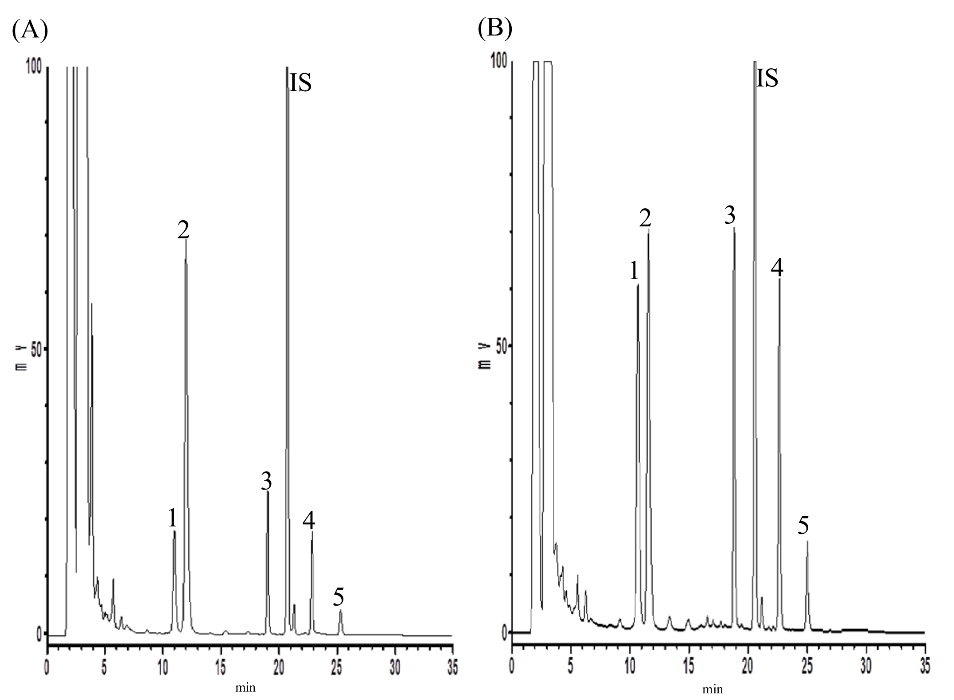
Fig. 1 HPLC chromatograms of RP decoction before (A) and after (B) acid hydrolysis. 1: aloe-emodin, 2: rhein, 3: emodin, 4: chrysophanol, 5: physcion, IS: 2-methylanthraquinone.
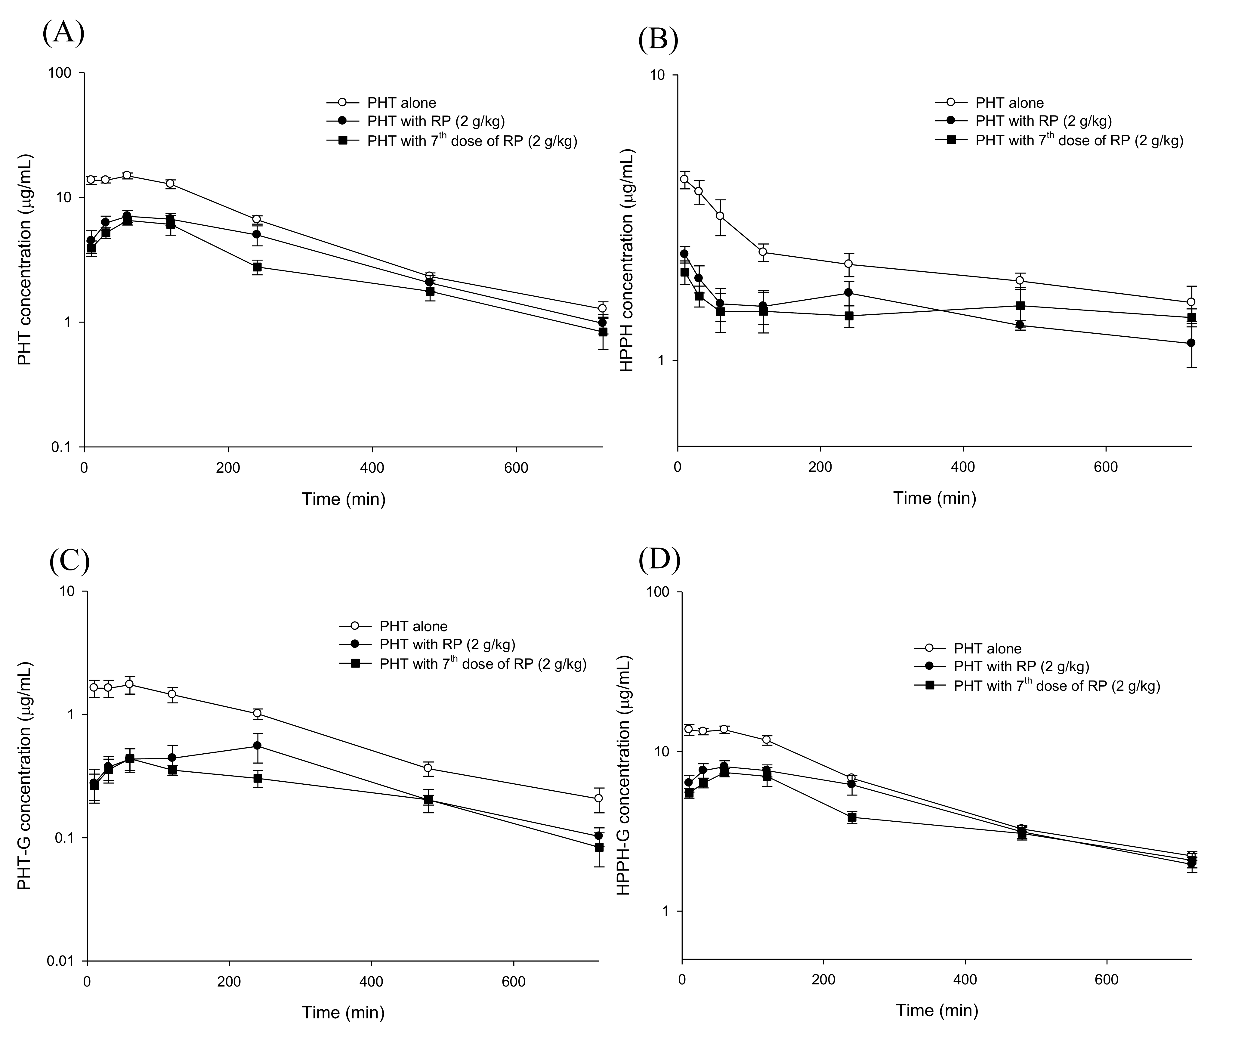

Fig. 2 Mean (±S.E.) serum concentration-time profiles of PHT (A), HPPH (B), PHT-G (C) and HPPH-G (D) after oral administration of PHT alone (200 mg/kg) (○), coadministration with single dose (●) and 7th dose of 2 g/kg (■) of RP decoction in six rats.

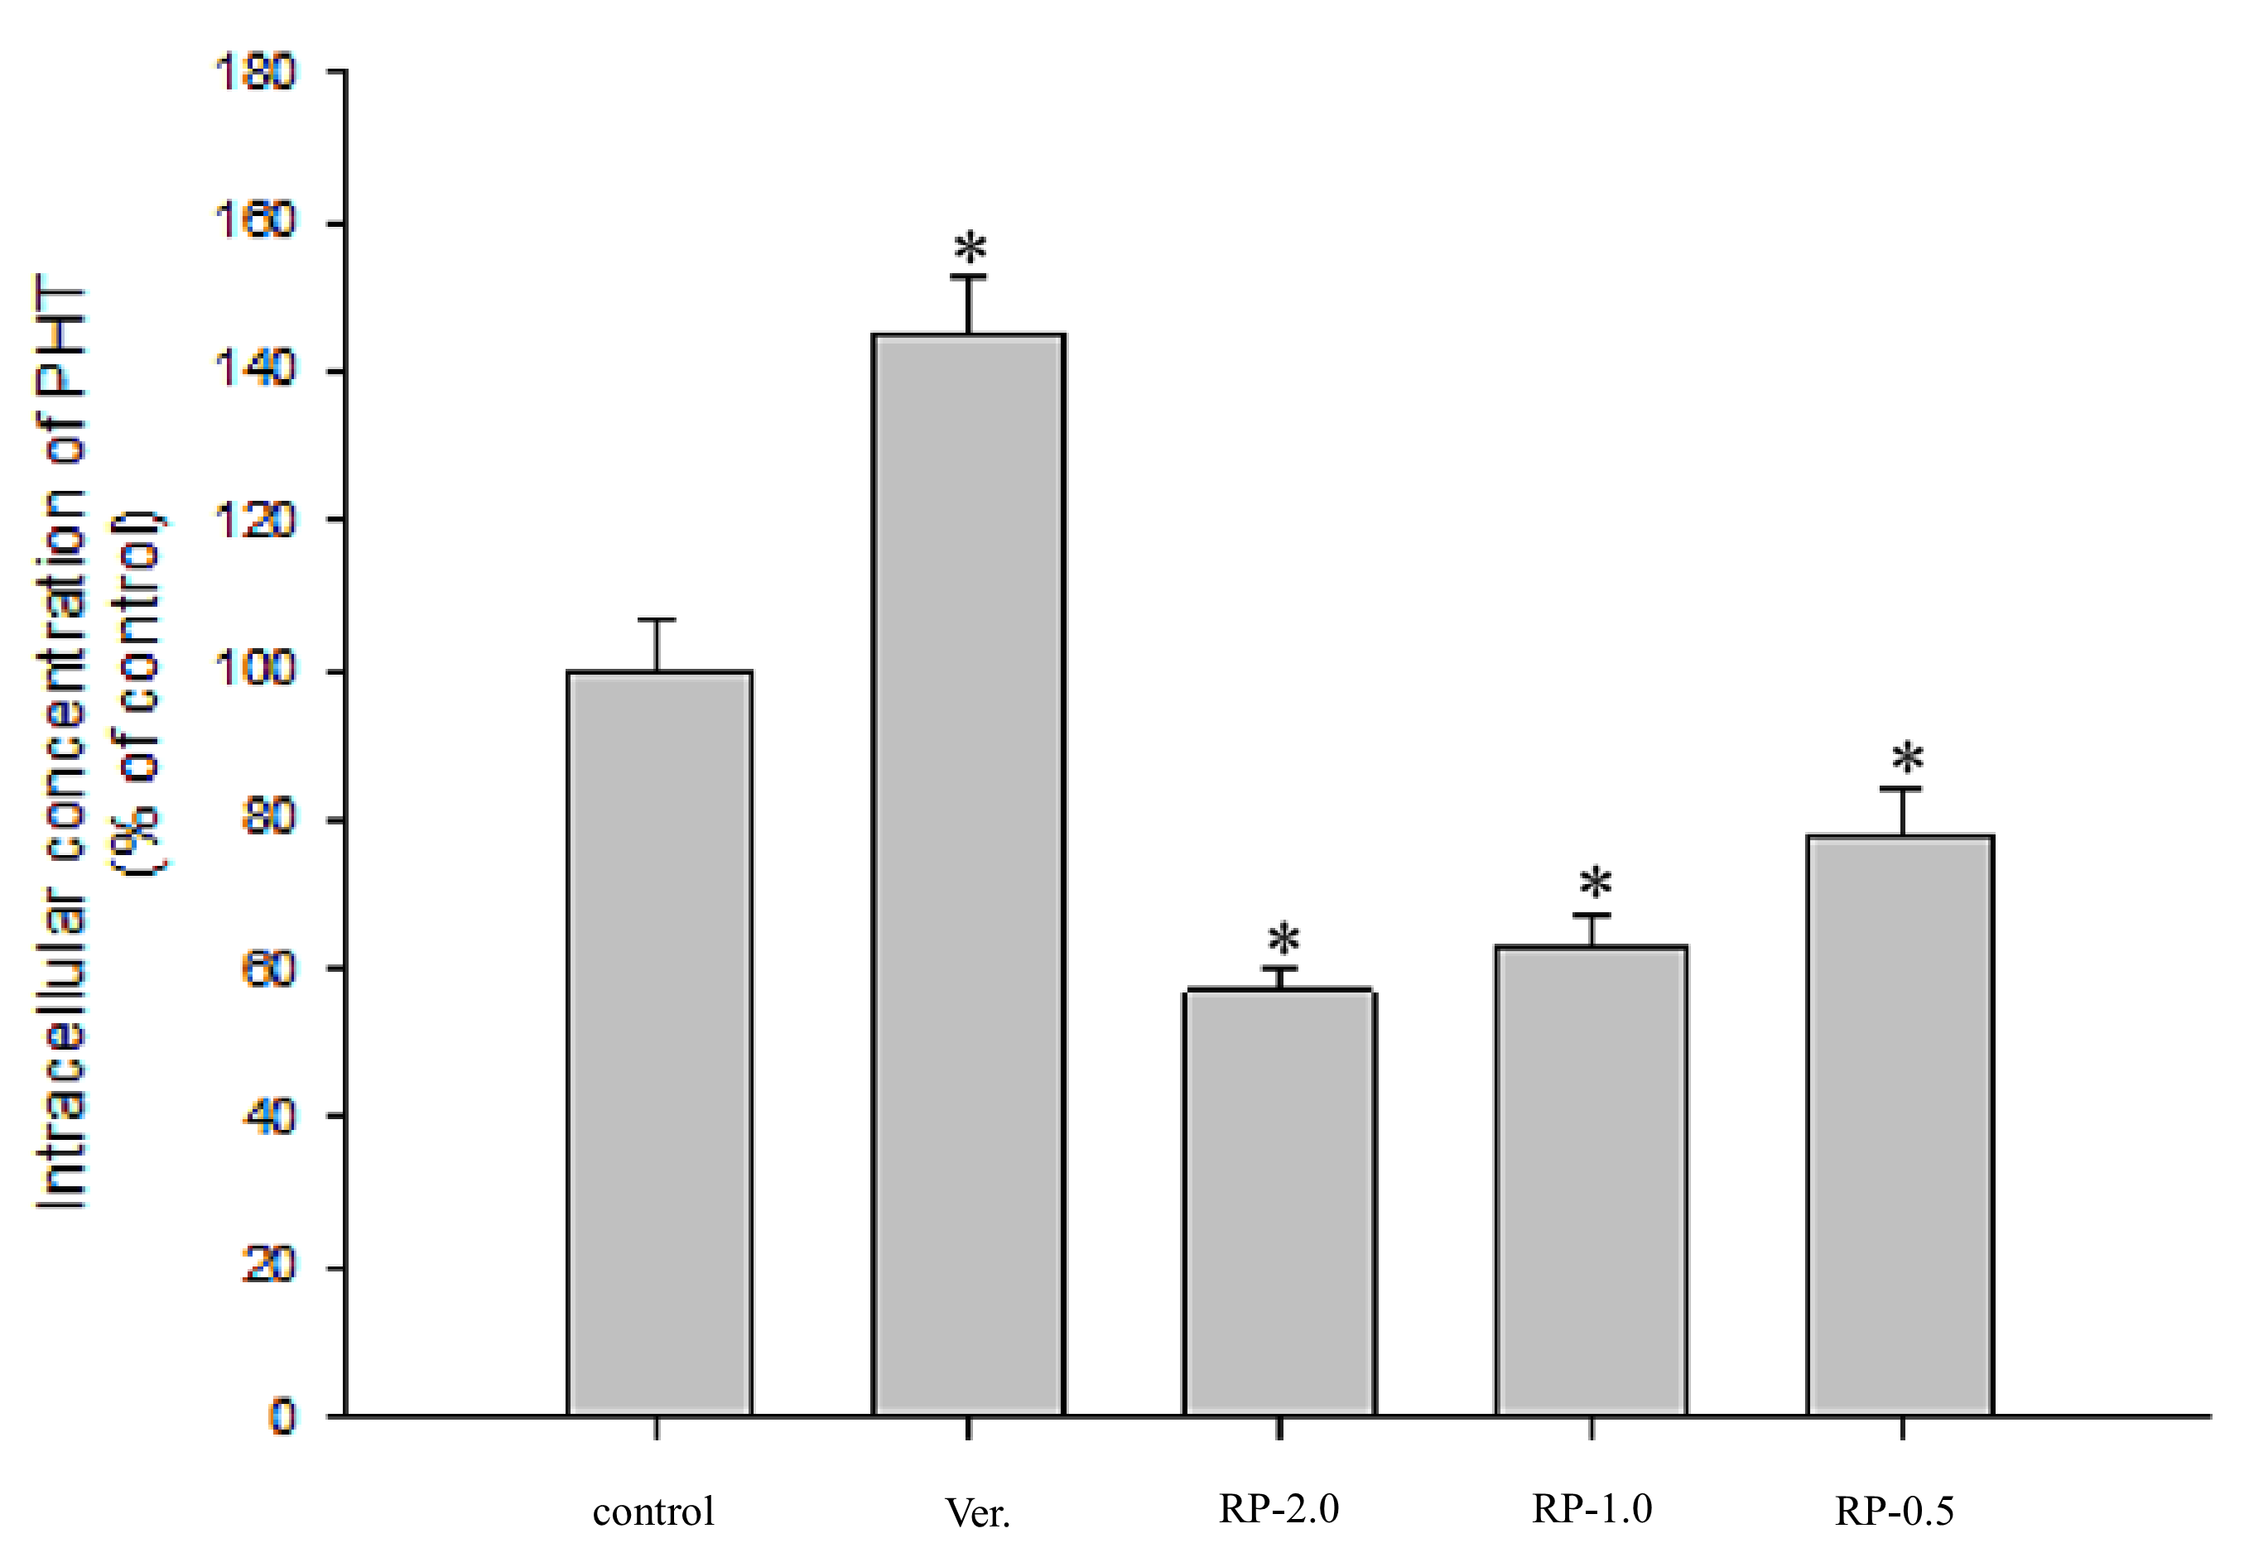
Fig. 3 Effects of RP (2.0, 1.0 and 0.5 mg/mL) and verapamil (Ver, 100 μM as a positive control of P-gp inhibitor) on the accumulation of PHT in LS 180 cells. Data expressed as mean ± S.D. of four determinations. *p < 0.05

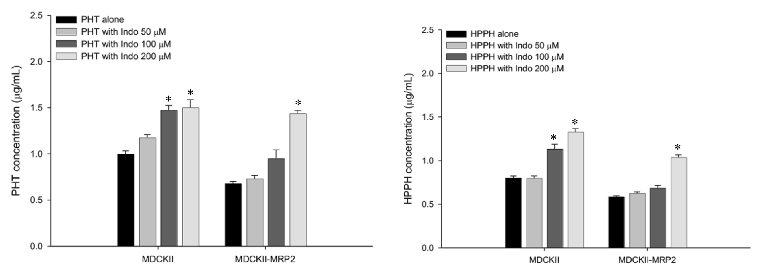
Fig. 4 Effects of indomethacin (Indo) on the intracellular accumulation of PHT (10 μM) and HPPH (10 μM) in MDCKII and MDCKII-MRP 2 cells. Data expressed as mean ± S.D. of four determinations. *p < 0.05

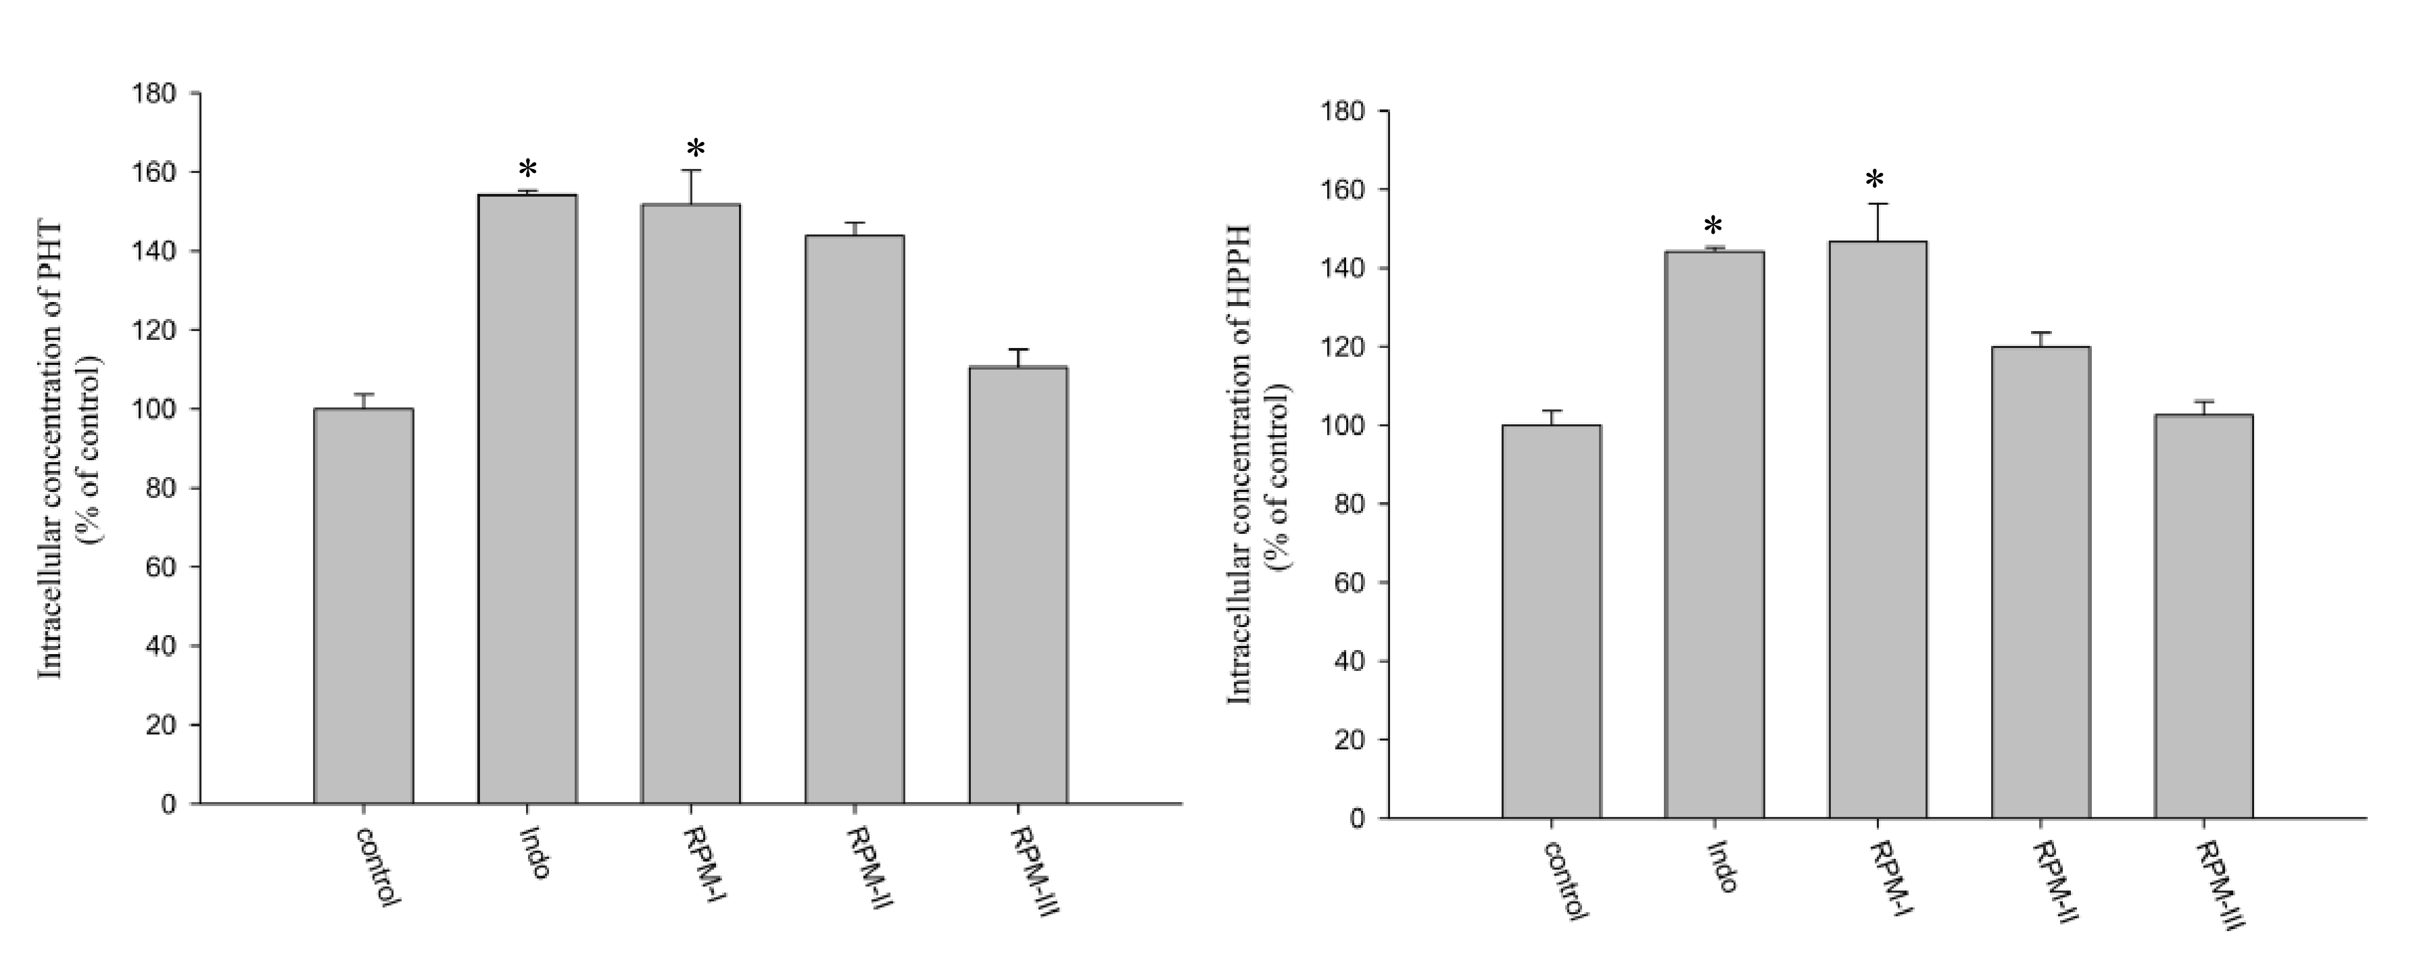
Fig. 5 Effects of RP metabolites (RPM) and indomethacin (Indo, 100 μM as a positive control of MRP 2 inhibitor) on the accumulation of PHT and HPPH in MDCKII-MRP2 cells. Data expressed as mean ± S.D. of five determinations. *p < 0.05. RPM-I, II, III: 1.0-, 0.5- and 0.25-fold serum concentration, respectively. (1.0-fold: containing 2.3 μM of aloe emodin G/S, 6.4 μM of rhein, 13.0 μM of rhein G/S, 4.1 μM of emodin G/S and 2.0 μM of chysophanol G/S).

Table 1 Pharmacokinetic parameters of PHT, PHT-G, HPPH and HPPH-G in six rats receiving oral PHT (200 mg/kg) alone and coadministration with single dose and seven doses of RP decoction (2 g/kg).
Treatments  Parameters |  | PHT alone |  | PHT + RP  (2 g/kg) |  | PHT + RP  (7th dose of 2 g/kg)
PHT | C_{max} | 15.7 | ±0.7^{a} | 7.5  (-51.0 | ±0.6 ^{b}  ±5.1%) |  | 7.3  (-53.1 | ±0.6 ^{b}  ±3.7%)
 | AUC₀₋₇₂₀ | 4261.3 | ±146.8^{a} | 2650.0  (-36.9 | ±211.1^{b}  ±6.6%) |  | 2024.9  (-51.9 | ±209.0 ^{b}  ±5.3%)
 | K₁₀ | 0.0039 | ±0.0002 ^{a} | 0.0028  (-27.9 | ±0.0003 ^{b}  ±7.9%) |  | 0.0025  (-30.4 | ±0.0002 ^{b}  ±6.2%)
PHT-G | C_{max} | 1.7 | ±0.2^{a} | 0.8  (-51.7 | ±0.1 ^{b}  ±4.2%) |  | 0.5  (-65.1 | ±0.1^{b}  ±10.4%)
 | AUC₀₋₇₂₀ | 557.2 | ±59.9 ^{a} | 232.5  (-51.7 | ±37.9 ^{b}  ±12.1%) |  | 172.5  (-64.8 | ±22.1 ^{b}  ±8.5%)
 | K₁₀ | 0.0033 | ±0.0003 ^{a} | 0.0019  (-51.5 | ±0.0002 ^{b}  ±4.9%) |  | 0.0023  (-39.9 | ±0.0003 ^{b}  ±7.3%)
HPPH | C_{max} | 4.5 | ±0.3ª | 2.5  (-43.9 | ±0.1 ^{b}  ±4.6%) |  | 2.3  (-46.3 | ±0.1 ^{b}  ±6.9%)
 | AUC₀₋₇₂₀ | 1556.0 | ±81.5 ª | 1058.3  (-30.3 | ±45.1 ^{b}  ±5.7%) |  | 954.0  (-37.5 | ±49.8 ^{b}  ±5.0%)
 | K₁₀ | 0.0013 | ±0.0002 ª | 0.0008  (-67.9 | ±0.0003 ^{b}  ±13.8%) |  | 0.0003  (-76.6 | ±0.0001 ^{b}  ±7.0%)
HPPH-G | C_{max} | 14.8 | ±0.7 ^{a} | 8.4  (-42.5 | ±0.5 ^{b}  ±4.0%) |  | 8.1  (-44.3 | ±0.5 ^{b}  ±4.2%)
 | AUC₀₋₇₂₀ | 4482.9 | ±114.7 ª | 3430.8  (-22.8 | ±208.5 ^{b}  ±6.3%) |  | 3099.9  (-30.6 | ±155.0 ^{b}  ±3.7%)
 | K₁₀ | 0.0039 | ±0.0002 ª | 0.0018  (-53.6 | ±0.0002 ^{b}  ±3.9%) |  | 0.0016  (-59.3 | ±0.0002 ^{b}  ±4.7%)
^{a, b} Significant difference at P < 0.05 denoted by different letters.
C_{max} (μg/mL)：peak serum concentration.
AUC₀₋₇₂₀ (μg ⋅min/mL)：areas under the curves from time zero to the last point.
K₁₀：the elimination rate (min⁻¹).
Values are means ± SE.

