A new herb–drug interaction of Polygonum cuspidatum, a resveratrol‐rich

nutraceutical, with carbamazepine in rats
Ying-Chang Chiª, Shiuan-Pey Lin^{b},Yu-Chi Hou^{b,c,*}

ª Institute of Pharmaceutical Chemistry, China Medical University, Taichung, 40402, Taiwan
^{b} School of Pharmacy, China Medical University, Taichung, 40402, Taiwan
^{c} Department of Medical Research, China Medical University Hospital, Taichung, 40402, Taiwan

* Correspondence to and first author: Dr. Yu Chi Hou, School of Pharmacy, China Medical University, 91 Hsueh-Shih Road, Taichung, 40402, Taiwan.
Tel.:+886 4 22031028.
E-mail: hou5133@gmail.com

ABSTRACT
Carbamazepine (CBZ), an antiepileptic with narrow therapeutic window, is a substrate of CYP 3A which metabolizes CBZ to carbamazepine-10,11-epoxide (CBZE), an active metabolite. This study investigated the acute and chronic effects of the rhizome of Polygonum cuspidatum (PC) on CBZ pharmacokinetics in rats and the underlying mechanisms. Rats were orally administered CBZ (200 mg/kg) alone and coadministered with single dose and seven doses of PC (2 g/kg) in a crossover design. The concentrations of CBZ and CBZE in serum and various tissues were determined by HPLC method. The results showed that PC significantly increased the AUC_{0-t} of CBZ and CBZE, whereas the formation rate of CBZE was decreased. Tissue analysis showed that the concentrations of CBZ and CBZE in brain, liver and kidney were significantly increased by PC. Cell studies indicated that the efflux function of MRP 2 was inhibited by the serum metabolites of PC. In conclusion, coadministration of PC significantly increased the systemic exposure and brain concentrations of CBZ and CBZE through inhibiting CYP 3A and MRP 2.
Keywords: Polygonum cuspidatum; Carbamazepine; Carbamazepine-10,11-epoxide; Herbal–drug interaction; CYP 3A; MRP 2
Introduction
Carbamazepine (CBZ) is a widely used antiepileptic, but with narrow therapeutic window . The side effects include teratogenic effect, epidermal necrolysis and Stevens-Johnson syndrome . In pharmacokinetic aspect, CBZ was mainly metabolized by CYP 3A4 to form carbamazepine-10,11-epoxide (CBZE), an active metabolite which has been shown to contribute to both seizure control and toxicity . CBZ has been reported as a substrate of P-glycoprotein (P-gp) and multidrug resistance-associated protein 2 (MRP 2) , which were efflux pumps and believed to be associated with drug resistance of antiepileptic drugs .
The content of reactive oxygen species generation is considered as one of the leading causes of generalized epilepsy associated with recurrent seizures in the brain, thus antioxidants are widely used to prevent epilepsy . Among natural antioxidants, resveratrol is a polyphenolic stilbene contained in Polygonum cuspidatum (PC), grapes and peanuts . PC is widely used in China and Japan as a medicinal plant. Nowadays, many resveratrol rich dietary supplements in the market are extracted from PC, which also contains considerable amount of emodin, a polyphenolic anthraquinone with excellent antioxidation activity .
In pharmacokinetic aspect, resveratrol and emodin were found extensively metabolized to their glucuronides and sulfates , which were putative substrates of MRPs and may have potential to inhibit MRPs . In addition, resveratrol and its conjugated metabolite resveratrol 3-sulfate have been reported as inhibitors of CYP 3A . We thus hypothesized that coadministration of PC might inhibit MRPs or/and CYP 3A to result in alteration of CBZ pharmacokinetics. Therefore, this study investigated the acute and chronic effects of PC on the pharmacokinetics and tissue distribution of CBZ and CBZE in rats. Furthermore, cell models were used for exploring the underlying mechanism of the pharmacokinetic interaction.
Materials and methods
Chemicals and reagents. CBZ, CBZE, resveratrol, emodin, indomethacin (all purity 98%), verapamil, ethyl paraben, propyl paraben, butyl paraben, rhodamine 123 (all purity 99%), and 3-(4,5-dimethylthiazol-2-yl)-2,5-diphenyl tetrazolium bromide (MTT) were purchased from Sigma Chemical Co. (St. Louis, MO, U.S.A.). 5-Chloromethyl-fluorescein diacetate (CMFDA) was obtained from Molecular Probes (Eugene, OR, U.S.A.). Dimethyl sulfoxide (DMSO) and polyethylene glycol 400 (PEG 400) were purchased from Merck Chemical Co. (Hohenbrunn, Germany). Fetal bovine serum was supplied by Biological Industries Ltd., (Kibbutz Beit Haemek, Israel). L-glutamine, penicillin, streptomycin, non-essential amino acid, trypsin-EDTA and Hank’s balanced salt solution (HBSS) were purchased from Invitrogen Inc. (Carlsbad, California, U.S.A.). Total protein assay kit was purchased from Bio-Rad Inc. (Mississauga, Ontario, Canada). Other reagents were HPLC grade or analytical grade.
Cell lines and cell culture. LS 180 was obtained from the Food Industry Research and Development Institute (Hsinchu, Taiwan). The MRP 2-overexpressing MDCK II cell line was kindly provided by Dr. Piet Borst (Dutch Cancer Institute, Amsterdam, the Netherlands). LS 180 and MDCK II-MRP 2 cell lines were cultured in DMEM medium supplemented with 10% fetal bovine serum, 0.1 mM nonessential amino acid (LS 180 cell line only), 100 units/mL of penicillin, 100 μg/mL of streptomycin, and 292 μg/mL of glutamine. The medium was changed every other day.
Preparation and characterization of PC decoction. The crude drug of PC was purchased from a Chinese drug store in Taichung, Taiwan. The origin was identified by Dr. Yu-Chi Ho via microscopic examination and a specimen was deposited in China Medical University. Four liters of water were added to 200 g of crude drug. After maceration for 1 h, heating was carried out on a gas stove. After boiling, gentle heating was continued for about 2 h until the volume reduced to below 2 L. The mixture was filtered while hot and the filtrate was concentrated with gentle heating until the volume reduced to below 400 mL, to which sufficient water was added to make 400 mL and divided into aliquots of 40 mL, and frozen at -20°C for later use.
The concentrations of resveratrol and emodin in PC decoction and in the acid hydrolysate were determined by HPLC method. For the acid hydrolysis, a portion of the decoction (1.0 mL) was hydrolyzed with 1.2 N HCl (1 mL) in the presence of 25 mg of ascorbic acid and incubated at 80°C for 2 h, which was determined by a preliminary study. The mixture was then added with 4.0 mL of methanol. After vortex and centrifugation, the supernatant (100 µL) was added with 100 μL of butyl paraben solution (10 µg/mL in methanol as the internal standard), and 20 µL was subject to HPLC analysis. The gradient mobile phase comprised 0.1% phosphoric acid (A) and acetonitrile (B): A/B = 64/36 (0 - 8 min), 30/70 (11 - 16 min), 64/36 (19 - 25 min). The detection wavelength was set at 280 nm and the flow rate was 1.0 mL/min.
Animals and drug administration. Male Sprague-Dawley rats were supplied by National Laboratory Animal Center (Taipei, Taiwan) and kept in the animal center of China Medical University (Taichung, Taiwan). The animal protocol was approved by the Institutional Animal Care and Use Committee of China Medical University. The animal study adhered to “The Guidebook for the Care and Use of Laboratory Animals” published by the Chinese Society of Animal Science, Taiwan, ROC. The rats (300 - 400 g) were fasted for 12 h before drug administration. CBZ was dissolved in DMSO:PEG 400:water (1:5:4) to afford a solution (20.0 mg/mL) and given 200.0 mg/kg orally to six rats without and with a concomitant oral dose of PC decoction (single dose of 2 g/4 mL//kg and the 7th dose of 2 g/4 mL//kg, twice daily) in crossover design. Another group of six rats (300 - 400 g) were injected an intravenous bolus of CBZ (20.0 mg/kg) via tail vein without and with an oral dose of PC (2 g/kg), which was given immediately after CBZ.
Blood and tissue collection. Blood samples (0.5 mL) were withdrawn via cardiopuncture at 0, 15, 30, 60, 120, 240, 480, 720, 1440 and 2160 min after oral administration of CBZ. Following intravenous bolus of CBZ, blood samples were collected at 0, 5, 30, 60, 120, 240, 360, 480 and 720 min. The blood was centrifuged at 10,000 g for 15 min to obtain the serum, which was stored at -70°C before analysis.
In tissue distribution study, five rats (300-400 g) in each group were orally administered CBZ (200.0 mg/kg) without and with a concomitant oral dose of PC (2 g/kg). Rats were then sacrificed at 12 h after dosing. Following systemic perfusion using a peristalsis pump, various organs including brain, liver and kidney were removed, washed with normal saline, blotted dry with filter paper and then accurately weighed. The tissues were homogenized in saline solution (700 mg/mL) and the homogenates were stored at -30°C until analysis.
Effect of emodin on CYP 3A4 activity. Vivid CYP450 screening kits (Invitrogen, Carlsbad, CA) was used to evaluate the effect of emodin at a series concentrations on the activity of CYP 3A4. All of the procedures were performed according the manual provided by the manufacturer. Briefly, after emodin was incubated with CYP450 recombinant Baculosomes, glucose-6-phosphate and glucose-6-phosphate dehydrogenase in 96-well black plate at room temperature for 20 min, a specific CYP 3A4 substrate (Vivid BOMR) and NADP⁺ were added and incubated at room temperature for another 30 min. At the end of incubation, ketoconazole was added to stop the reaction, and the fluorescence was measured with an excitation at 530 nm and an emission at 590 nm.
Preparation and characterization of the serum metabolites of PC, resveratrol and emodin. In order to mimic the molecules interacting with MRP 2 in kidney, the serum metabolites after administration with PC was prepared (PCM). Furthermore, pure compounds, i.e. resveratrol and emodin, were also administered to rats to prepare the serum metabolites of resveratrol (RM) and emodin (EM). Briefly, rats after overnight fasting were given PC, resveratrol and emodin orally at doses of 2 g/kg, 5 mg/kg and 20 mg/kg, respectively. Blood was collected at 30 min after dosing.
Characterization of an aliquot of serum sample was conducted. Brieﬂy, 100 μL of serum was mixed with 50 μL of sulfatase (containing 1000 units/mL of sulfatase and 35,600 units/mL of β-glucuronidase) and 50 μL of ascorbic acid (100 mg/mL) and incubated at 37°C for 2 h under anaerobic condition. After hydrolysis, the serum was acidiﬁed and partitioned with ethyl acetate (containing propyl paraben as internal standard, 1 μg/mL). The ethyl acetate layer was evaporated under N₂ to dryness and reconstituted with an appropriate volume of methanol prior to HPLC analysis.
Besides characterization, the serum was added with 3-fold methanol. After vortex and centrifuged at 10,000g for 15 min, the supernatant was concentrated in a rotatory evaporator under vacuum to dryness. To the residue, an appropriate volume of water was added to afford a solution with a 10-fold serum concentration, which was divided into aliquots and stored at -70°C.
In addition, the serum of rats administered water only was collected to prepare the blank control specimen for comparison with the serum metabolites of PC decoction. In addition, the serum of rats administered PEG 400 alone was also collected to prepare the blank control specimen for comparison with the serum metabolites of resveratrol and emodin, which had been dissolved in PEG 400 for oral dosing. The blank serum was processed as described above, and diluted to various folds of serum concentration for the comparison with correspondent concentration of PCM, RM and EM.
Cytotoxicity assay. Verapamil hydrochloride and rhodamine 123 (rho 123) were dissolved in water. CBZ, CBZE, indomethacin and CMFDA were dissolved in MeOH. The final concentration of MeOH in medium was below 0.2% (v/v). LS 180 and MDCK II-MRP 2 cells (1×10⁵ cells/well) were seeded into 96-well plates. After overnight incubation, the tested agents were added into the wells and incubated for 72 h, then 15 μL of MTT (5 mg/mL) was added into each well and incubated for additional 4 h. An acid SDS (10%) solution was added to dissolve the purple crystal at the end of incubation, and the optical density was detected at 570 nm by a microplate reader.
Transport studies of CBZ and CBZE. LS 180 and MDCK II-MRP 2 cells were cultured as described above. LS 180 cells (passage 50 to 60) were seeded on 12-well plates at a density of 5×10⁵ cells/well. Before experiment, the medium was removed and the cells were rinsed with ice-cold HBSS transport buffer consisting of HEPES (10 mM, pH 6.0). To determine whether CBZ is a substrate of P-gp, CBZ (10 μM) and rho 123 (10 μM) were incubated in parallel without and with verapamil (100 μM) for 90 min.
MDCK II-MRP 2 cells were used within 10 passages. The cells were seeded on 12-well plates at a density of 3×10⁵ cells/well. Before experiment, the medium was removed and the cells were quickly rinsed with ice-cold HBSS transport buffer. To determine whether CBZ and CBZE were substrates of MRP2, CBZ (10 μM), CBZE (10 μM) and CMFDA (10 μM) were incubated individually with MDCK II-MRP 2 cells for 60 min.
PCM (1.0-, 0.5- and 0.25- fold of serum concentrations), RM (1.0-, 0.5- and 0.25- fold of serum concentrations), EM (3.0-, 1.5- and 0.75- fold of serum concentrations) and indomethacin (100 μM, as positive control of MRP 2 inhibitor) in HBSS were pre-incubated with MDCK II-MRP 2 cells for 30 min. The supernatants were removed and cells were washed three times with ice-cold PBS. Then, CBZE (10 μM) was co-incubated with and without PCM, RM, EM and indomethacin again with MDCK II-MRP 2 cells for another 60 min. After incubation, the cells were rapidly washed twice with ice-cold HBSS buffer.
After various incubation described above, cells were lysed with 200 μL of 0.1% Triton X-100 for 30 min. To determine the concentration of 5-chloromethyl- fluorescein (CMF) in the cell lysate, the metabolite of CMFDA, a fluorescent plate reader with excitation at 485 nm and emission at 528 nm was used. Total protein content in the lysate was determined by Braford method, and bovine serum albumin was used as the standard.
Determination of CBZ and CBZE concentrations in serum, tissue and cell lysate. The serum (100 µL), tissue homogenate (200 μL) and cell lysates (200 μL) were acidified with 10% volume of 0.1 N HCl, and the mixture was partitioned with equal volume of ethyl acetate (containing ethyl paraben as internal standard, 3 μg/mL). The ethyl acetate layer was evaporated under N₂ to dryness and reconstituted with 50 μL of methanol prior to HPLC analysis.
An HPLC method using a mixture of methanol and 0.05% phosphoric acid (52:48) as mobile phase was developed and validated for the assays of CBZ and CBZE in serum, tissue homogenate and cell lysate. The detection wavelength was set at 214 nm and the flow rate was 1.0 mL/min. The concentration ranges of the calibrators of CBZ and CBZE were 0.4 - 100.0 μg/mL for serum, 0.4 - 50.0 μg/mL for tissue homogenate and cell lysate.
The precision and accuracy of the analytical method was evaluated by intra-day and inter-day analysis of triplicate standards within one day and over a period of three days. Recoveries from tissue and cell samples were assessed by comparing the peak area obtained from extracted sample spiked with standards to that obtained from unextracted standards in extracted sample matrix, which represents 100% recovery. LLOQ (Lowest Limit of Quantitation) represents the lowest concentration of analyte that can be determined with acceptable precision and accuracy with coefﬁcients of variation and relative errors below 15% and 20%, respectively. LOD (Limit of Detection) represents the lowest concentration of analyte that can be detected with S/N＞3.
Data analysis. The areas under the serum concentration-time curves (AUC_{0-t}) of CBZ and CBZE after oral and intravenous dosing were calculated using noncompartment model (version 1.1, SCI software, Statistical Consulting, Inc., Apex, NC, USA). The formation rate of CBZE (K₀₁) was estimated from the slope of absorption phase in a semi-log plot. The peak serum concentrations (C_{max}) were from experimental data. One-way ANOVA with Sheffe test was used for statistical comparison taking p < 0.05 as significant.
Results
Characterization of PC decoction. Figure 1 shows the chromatograms of PC decoction before and after acid hydrolysis. Quantitation results indicated that the concentrations of resveratrol and emodin were 1.2 and 2.1 mM in the decoction, 1.6 and 10.4 mM in the decoction hydrolysate, respectively. Accordingly, a dose of 2 g/kg PC contained 6.4 μmol/kg of resveratrol with its glycosides, and 41.6 μmol/kg of emodin with its glycosides.
Serum assay of CBZ and CBZE. Figure 2 shows the HPLC chromatograms of CBZ and CBZE in serum. The calibration curves of CBZ and CBZE showed good linearities in the range of 0.4 - 100 µg/mL. The recoveries of CBZ and CBZE from serum were 95.4-96.7% and 93.2-97.0%, respectively. The LLOQ of CBZ and CBZE were 0.4 µg/mL and the LOD were 0.02 and 0.01 µg/mL, respectively.
Acute and chronic effects of PC on CBZ pharmacokinetics in rats. Figure 3 depicts the mean serum concentration - time profiles of CBZ and CBZE after oral administration of CBZ alone and coadministration with single dose and pretreatment with seven doses of 2 g/kg of PC. The pharmacokinetic parameters of CBZ and CBZE are listed in Table 1. The results found that acute coadministration of single dose of PC and pretreatment with seven doses of PC significantly increased the AUC₀₋₂₁₆₀ of CBZ by 139.7 and 109.7%, and enhanced the AUC₀₋₂₁₆₀ of CBZE by 82.0 and 46.8%, respectively. The K₀₁ of CBZE was significantly decreased by 63.3 and 61.8%, respectively. The C_{max} of CBZE was only significantly increased by single dose of PC.
Figure 4 depicts the mean serum concentration - time profiles of CBZ and CBZE after an intravenous bolus of CBZ alone and oral coadministration with 2 g/kg of PC. The pharmacokinetic parameters of CBZ and CBZE are listed in Table 2, showing that the AUC₀₋₄₈₀ was not affected by PC, whereas the C_{max} and AUC₀₋₇₂₀ of CBZE were significantly increased by 17.5 and 14.6%, respectively.
Effect of PC on the tissue distribution of CBZ and CBZE in rats. In tissue assay, calibration curves of CBZ and CBZE exhibited good linearities in the range of 0.4 - 50 µg/mL. The concentrations of CBZ and CBZE in brain, liver and kidney at 12 h after dosing with CBZ alone and coadministration of PC are shown in Table 3. PC significantly increased the concentrations of CBZ and CBZE by 276.3 and 121.0% in brain, 148.5 and 115.6% in liver, 257.7 and 110.8% in kidney, respectively. The ratio of CBZE concentration in kidney to serum was markedly increased by 63.9%, whereas those ratios of brain and liver to serum were not significantly altered.
Characterization of the serum metabolites of PC decoction, resveratrol and emodin. HPLC analysis showed that PCM contained 6.3 and 35.7 nmol/mL of glucuronides/sulfates (G/S) of resveratrol and emodin, respectively. RM and EM were determined to contain 6.5 and 11.0 nmol/mL of G/S of resveratrol and emodin, respectively, whereas no free forms of resveratrol and emodin were detected.
Cytotoxicity assay. More than 90% of cells were viable at the concentrations of CBZ at 10 μM in LS 180, and CBZ and CBZE at 10 μM in MDCK II-MRP 2. In addition, PCM, RM and EM at 1.0-fold serum concentration did not possess any noticeable cytotoxicity against MDCK II-MRP 2.
Transport studies of CBZ and CBZE in LS 180. Figure 5 shows the effects of verapamil on the intracellular accumulations of CBZ and rhodamine 123 in LS 180 cells, indicating the intracellular accumulation of rhodamine 123 was significantly increased by verapamil, whereas that of CBZ was not affected.
Effect of emodin on CYP 3A activity. The effects of emodin on CYP 3A activity are shown in Figure 6. Emodin at 1.0, 2.0 and 4.0 μM signiﬁcantly decreased CYP 3A activity by 26.6, 23.9 and 33.6%, respectively. As a positive control, ketoconazole at 10 μM signiﬁcantly decreased CYP 3A activity by 91.6%.
Transport study of CBZ and CBZE in MDCKII and MDCKII-MRP 2. Figure 7 shows the effects of indonethacin on the intracellular accumulations of CBZ, CBZE and CMF in MDCK II-MRP 2 cells, indicating the intracellular accumulation of CBZE and CMF was significantly increased by indonethacin, whereas that of CBZ was not affected.
Effects of PCM, RM and EM on the transport of CBZ and CBZE in MDCK II-MRP 2. The effects of PCM, RM, EM and indomethacin on the intracellular accumulation of CBZE compared to those of the correspondent concentration of blank controls are shown in Figure 8. PCM at 1.0- (containing 6.3 μM of resveratrol G/S and 35.7 μM of emodin G/S) and 0.5-fold serum concentrations significantly increased the intracellular accumulation of CBZE by 45.1 and 35.5 %. RM at 1.0- (containing 6.5 μM of resveratrol G/S) and 0.5-fold serum concentrations significantly increased the intracellular accumulation of CBZE by 40.5 and 31.2 %. In order to mimic the concentration of emodin G/S in PCM, EM at 3.0- (containing 36.0 μM of emodin G/S), 1.5- and 0.75-fold serum concentrations were tested, and the results showed significant increase of the intracellular accumulation of CBZE by 35.7, 21.0 and 25.9%, respectively. As a positive control, indomethacin at 100 μM signiﬁcantly increased the intracellular accumulation of CBZE by 36.7%.
Discussions
Owing to the abundant occurrence of polyphenolic glycosides in nature, characterization of the PC decoction used in this study was performed by HPLC method to quantitate the concentrations of resveratrol and emodin before and after acid hydrolysis. Our results showing that upon acid hydrolysis the concentrations of resveratrol and emodin increased by 35% and 398%, respectively, indicated that the decoction contained resveratrol mainly as aglycone, whereas emodin glycoside was the major form.
In pharmacokinetic study, coadministration of either single dose or multiple doses of PC all enhanced the AUC_{0-t} of CBZ and CBZE, suggesting that acute and chronic administrations of PC significantly increased the oral bioavailability of CBZ and may increase the antiepileptic effect. In regard to the extent of influence, no significant difference was found between two treatment groups, implying that the mechanisms involved in this pharmacokinetic interaction were probably saturated at single dose of 2 g/kg of PC.
Based on the decreased formation rate of CBZE and increased AUC of CBZ, it clearly illuminated that PC inhibited CYP 3A which metabolized CBZ to CBZE. In contrast, while CBZ was given intravenously, that PC did not affect the formation rate of CBZE and the AUC of CBZ led us to infer that the interaction of PC with oral CBZ should occur at the absorption site, where PC probably inhibit enteric CYP 3A. This interaction was similar to that resulted from grapefruit juice and pomegranate juice which also augmented the oral bioavailability of CBZ by inhibiting intestinal CYP 3A .
A previous study has reported that resveratrol decreased the absorption of cyclosporine via induction on the activities of P-gp and CYP 3A in rats . We here investigated the effect of emodin on the activity of CYP 3A. Our results demonstrated that the activity of CYP 3A4 was significantly inhibited by emodin, which might be one of the causative constituents in PC to account for the inhibition on the metabolism of CBZ by CYP 3A in rats.
On the other hand, we contended that PC might inhibit P-gp in the intestine and resulted in the increased bioavailability of CBZ. Firstly, a transport assay of CBZ was conducted using LS 180 cells in order to confirm whether CBZ was a substrate of P-gp. However, the intracellular accumulation of CBZ was not affected by 100 μM of verapamil, indicating that CBZ was not a substrate for P-gp, which was consistent with the findings of several previous studies , only contradicted with one single result .
Despite the decreased formation rate, the AUC of CBZE was increased by PC. Accordingly, we proposed that PC might inhibit the elimination of CBZE in a greater extent than its inhibition on the formation of CBZE. It was known that 90% of CBZ and CBZE excreted by the kidney , where MRP 2 was an important export transporter . However, whether CBZ is a substrate of MRP 2 or not is still controversial till now and the association of CBZE with MRP 2 has not been reported. In order to explore the possible involvement of MRP 2 in this pharmacokinetic interaction, transport assays of CBZ and CBZE as well as CMF, a fluorescent probe of MRP 2, were conducted in MDCK II-MRP 2 cells. The results showing that the intracellular accumulations of CBZE and CMF were increased by indomethacin led us to infer that CBZE was a substrate for MRP 2, which is the first time reported here. Unlike CBZE, the intracellular accumulations of CBZ were not increased, a clear indication that CBZ was not a substrate for MRP 2, which was not in agreement with that concluded by a previous study pointing out the association of MRP 2 variation with the neurological adverse effect of CBZ . We in turn speculate that the adverse effect of CBZ may be arisen from the active metabolite–CBZE rather than the parent form, because herein CBZE was proved as a substrate for MRP 2.
Generally, it has been a consensus that polyphenols are metabolized extensively in the intestine and liver, and G/S are the major forms in the circulation . We thus assumed that the metabolites of polyphenols could mimic the molecules interacting with MRP 2 in the kidney. Hence, we have prepared the serum metabolites from rats to evaluate the modulation effects of PC, resveratrol and emodin on MRP 2 following oral administration. Characterization of PCM showed that it contained G/S of resveratrol and emodin. Likewise, RM and EM consisted of mainly the G/S of resveratrol and emodin, respectively. These results were in good agreement with the biological fates of resveratrol and emodin reported by previous studies .
In the transport study using MDCK II-MRP 2, the increased intracellular accumulations of CBZE caused by PCM, RM and EM demonstrated a consistent manner that the efflux activities of MRP 2 had been inhibited by the G/S of resveratrol and/or emodin. The increased AUC of CBZE thus can be explained by that the inhibition on CBZE elimination overrode the inhibition on the metabolism of CBZ to CBZE. Moreover, the intravenous pharmacokinetic study of CBZ showing decreased elimination rate of CBZE added an evidence to confirm the inhibited elimination of CBZE by oral coadministration of PC.
The tissue distribution assay was performed in this study to acquire further information in brain, kidney and liver. The increased concentrations of CBZ and CBZE in various tissues can be attributed to the enhanced systemic exposure of CBZ and CBZE. The markedly increased brain concentrations of CBZ and CBZE suggested that PC had promising potential to enhance the anti-epileptic effect of CBZ. However, the concentration ratios of CBZ and CBZE in brain to serum were cot affected by PC, indicating the involvement of MRP 2-mediated efflux in brain was negligible. Conversely, the concentration ratio of CBZE in kidney to serum was increased, implying that PC inhibited the export of CBZE at the kidney. As a result, we can infer that MRP 2 in kidney was more important than that in brain in this herb-drug interaction. This inhibition on MRP 2 - mediated export in kidney could explain the decreased elimination of CBZE . In regard to the causative agents, the metabolites of PC in bloodstream, i.e. resveratrol G/S and emodin G/S which were putative substrates of MRP 2 , might compete with CBZE for the urinary excretion mediated by MRP 2.
For epilepsy patients, the use of herbal preparations is not uncommon . PC extract is nowadays easily purchasable as dietary supplement in the market. For patients treated with CBZ, caution should be exercised to avoid toxicity. On the contrary, for those patients developing resistance to CBZ, the combined therapy with PC might be beneficial for reversing the drug resistance of CBZ through inhibition on CYP 3A and/or MRP 2.
In conclusion, the acute and chronic intake of PC significantly enhanced the systemic exposures and brain concentrations of CBZ and CBZE in rats through inhibition on CYP 3A and MRP 2.
Acknowledgements
This work was supported in part by the National Science Council, Taiwan. (NSC 99-2320-B-039-017-MY3 and NSC99-2320-B-039-009-MY3) and China Medical University, Taichung, Taiwan. (CMU99-S-33 and CMU98-S-34).
Conflict of interest statement
The authors have declared that there are no conflicts of interest.
References
Ambroziak, K., et al., 2010. Exposure to antiepileptic drugs does not alter the functionality of P-glycoprotein in brain capillary endothelial and kidney cell lines. Eur. J. Pharmacol. 628, 57-66.
Bertilsson, L., Tomson, T., 1986a. Clinical pharmacokinetics and pharmacological effects of carbamazepine and carbamazepine-10,11-epoxide. An update. Clin. Pharmacokinet. 11, 177-198.
Bertilsson, L., Tomson, T., 1986b. Clinical pharmacokinetics and pharmacological effects of carbamazepine and carbamazepine-10,11-epoxide. An update. Clin. Pharmacokinet. 11, 177-198.
Burns, J., et al., 2002. Plant foods and herbal sources of resveratrol. J. Agric. Food Chem. 50, 3337-3340.
Cermak, R., 2008. Effect of dietary flavonoids on pathways involved in drug metabolism. Expert Opin. Drug Metab. Toxicol. 4, 17-35.
Choi, J.S., et al., 2000. Comparative evaluation of antioxidant potential of alaternin (2-hydroxyemodin) and emodin. J. Agric. Food Chem. 48, 6347-6351.
Devi, P.U., et al., 2008. Seizures, antiepileptics, antioxidants and oxidative stress: an insight for researchers. Expert Opin. Pharmacother. 9, 3169-3177.
Hidaka, M., et al., 2005. Effects of pomegranate juice on human cytochrome p450 3A (CYP3A) and carbamazepine pharmacokinetics in rats. Drug Metab. Dispos. 33, 644-648.
Juan, M.E., et al., 2010. Multidrug resistance proteins restrain the intestinal absorption of trans-resveratrol in rats. J. Nutr. 140, 489-495.
Kaiboriboon, K., et al., 2009. Understanding herb and dietary supplement use in patients with epilepsy. Epilepsia 50, 1927-1932.
Kane, G.C., Lipsky, J.J., 2000. Drug-grapefruit juice interactions. Mayo Clin. Proc. 75, 933-942.
Kim, W.J., et al., 2010. A nonsynonymous variation in MRP2/ABCC2 is associated with neurological adverse drug reactions of carbamazepine in patients with epilepsy. Pharmacogenet Genomics 20, 249-256.
Kwan, P., et al., 2011. Drug-resistant epilepsy. N. Engl. J. Med. 365, 919-926.
Manach, C., et al., 2005. Bioavailability and bioefficacy of polyphenols in humans. I. Review of 97 bioavailability studies. Am. J. Clin. Nutr. 81, 230S-242S.
Nies, A.T., Keppler, D., 2007. The apical conjugate efflux pump ABCC2 (MRP2). Pflugers Arch. 453, 643-659.
O'Leary, K.A., et al., 2003. Metabolism of quercetin-7- and quercetin-3-glucuronides by an in vitro hepatic model: the role of human beta-glucuronidase, sulfotransferase, catechol-O-methyltransferase and multi-resistant protein 2 (MRP2) in flavonoid metabolism. Biochem. Pharmacol. 65, 479-491.
Owen, A., et al., 2001. Carbamazepine is not a substrate for P-glycoprotein. Br. J. Clin. Pharmacol. 51, 345-349.
Potschka, H., et al., 2001. P-glycoprotein and multidrug resistance-associated protein are involved in the regulation of extracellular levels of the major antiepileptic drug carbamazepine in the brain. Neuroreport 12, 3557-3560.
Schaub, T.P., et al., 1999. Expression of the MRP2 gene-encoded conjugate export pump in human kidney proximal tubules and in renal cell carcinoma. J. Am. Soc. Nephrol. 10, 1159-1169.
Schmidt, D., Elger, C.E., 2004. What is the evidence that oxcarbazepine and carbamazepine are distinctly different antiepileptic drugs? Epilepsy Behav. 5, 627-635.
Shia, C.S., et al., 2010. Differences in pharmacokinetics and ex vivo antioxidant activity following intravenous and oral administrations of emodin to rats. J. Pharm. Sci. 99, 2185-2195.
So, E.L., et al., 1994. Seizure exacerbation and status epilepticus related to carbamazepine-10,11-epoxide. Ann. Neurol. 35, 743-746.
Sudha, K., et al., 2001. Oxidative stress and antioxidants in epilepsy. Clin. Chim. Acta 303, 19-24.
Sullivan, F.M., McElhatton, P.R., 1977. A comparison of the teratogenic activity of the antiepileptic drugs carbamazepine, clonazepam, ethosuximide, phenobarbital, phenytoin, and primidone in mice. Toxicol. Appl. Pharmacol. 40, 365-378.
Walle, T., et al., 2004. High absorption but very low bioavailability of oral resveratrol in humans. Drug Metab Dispos 32, 1377-1382.
Warner, T., et al., 1992. Lamotrigine-induced carbamazepine toxicity: an interaction with carbamazepine-10,11-epoxide. Epilepsy Res. 11, 147-150.
Williamson, G., et al., 2007. Interaction of positional isomers of quercetin glucuronides with the transporter ABCC2 (cMOAT, MRP2). Drug Metab. Dispos. 35, 1262-1268.
Williamson, G., Manach, C., 2005. Bioavailability and bioefficacy of polyphenols in humans. II. Review of 93 intervention studies. Am. J. Clin. Nutr. 81, 243S-255S.
Xu, Y., et al., 2012. Resveratrol protects against hyperglycemia-induced oxidative damage to mitochondria by activating SIRT1 in rat mesangial cells. Toxicol. Appl. Pharmacol. 259, 395-401.
Yang, S.Y., et al., 2012. Inductive modulation on P-glycoprotein and cytochrome 3A by resveratrol, a constituent of grapes. Food Chem. 133, 683-688.
Yu, C., et al., 2002. Human, rat, and mouse metabolism of resveratrol. Pharm. Res. 19, 1907-1914.
Yu, C., et al., 2003. Liquid chromatography/tandem mass spectrometric determination of inhibition of human cytochrome P450 isozymes by resveratrol and resveratrol-3-sulfate. Rapid Commun. Mass Spectrom. 17, 307-313.
Zhang, C., et al., 2011. In vitro transport profile of carbamazepine, oxcarbazepine, eslicarbazepine acetate, and their active metabolites by human P-glycoprotein. Epilepsia 52, 1894-1904.
Zhou, S.F., et al., 2008. Substrates and inhibitors of human multidrug resistance associated proteins and the implications in drug development. Curr. Med. Chem. 15, 1981-2039.

Table 1. Pharmacokinetic parameters of carbamazepine (CBZ) and carbamazepine-10,11-epoxide (CBZE) in six rats receiving oral CBZ (200 mg/kg) alone and coadministrations with single dose and pretreatment with seven doses of 2 g/kg of Polygonum cuspidatum (PC).
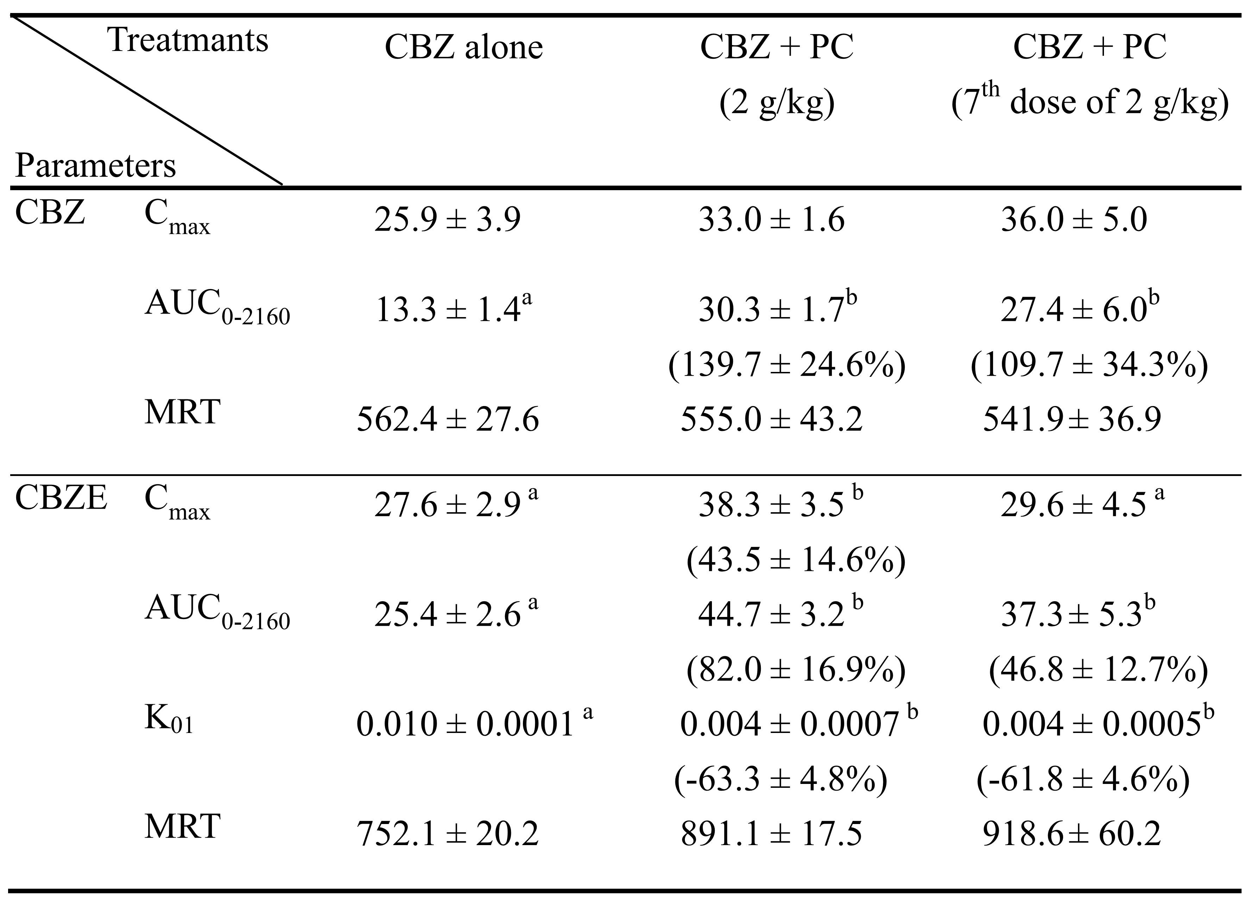
Groups in each section were statistically compared with the control group given CBZ alone.
C_{max} (μg/mL): peak serum concentration
AUC₀₋₂₁₆₀ (mg ⋅min/mL): area under the curves from time 0 to 2160 min
K₀₁: the formation rate (min⁻¹)
MRT: mean resisdence time
Values are means ± SE, p < 0.05
Table 2. Pharmacokinetic parameters of carbamazepine (CBZ) and carbamazepine-10, 11-epoxide (CBZE) in six rats receiving intravenous CBZ alone (20 mg/kg) and coadministration with 2 g/kg of Polygonum cuspidatum (PC).
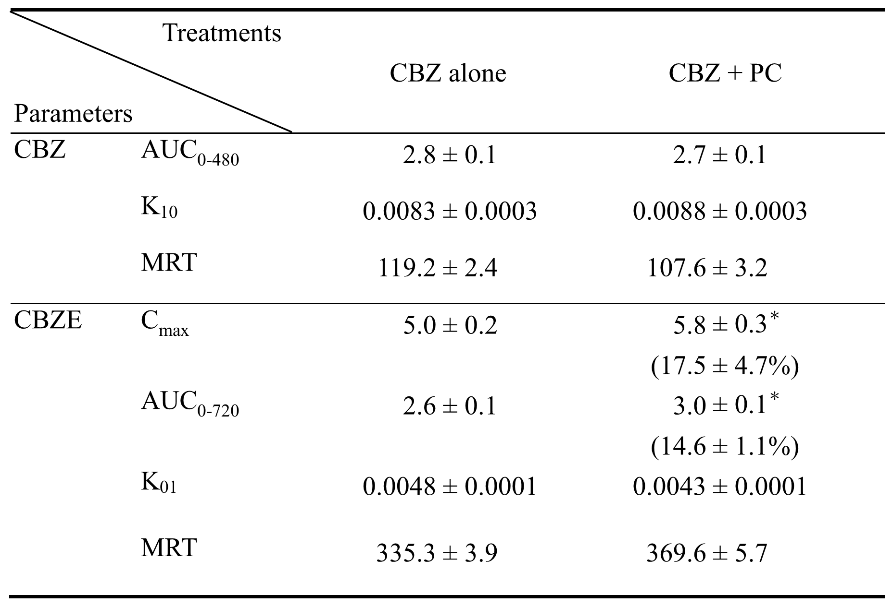
C_{max} (μg/mL): peak serum concentration
AUC (mg ⋅min/mL): area under the curves from time zero to last point
K₀₁: the formation rate (min⁻¹)
MRT: mean resisdence time
Values expressed as mean ± SE
*p < 0.05

Table 3. Concentrations of carbamazepine (CBZ) and carbamazepine-10,11-epoxide (CBZE) in serum (μg/mL) and various tissues (μg/g) at 12 h after oral dosing of CBZ alone (200 mg/kg) and coadministration with 2 g/kg of of Polygonum cuspidatum (PC) in five rats.

Treatments | Brain |  | Liver |  | Kidney |  | Serum
CBZ alone
CBZ | 3.0 | ± 1.0 | 8.3 | ± 2.2 | 4.2 | ± 0.6 | 5.3 | ± 0.5
CBZ T/S | 0.6 | ± 0.2 | 1.6 | ± 0.4 | 0.8 | ± 0.1
CBZE | 5.6 | ± 0.4 | 14.9 | ± 0.9 | 12.1 | ± 1.3 | 17.3 | ± 2.6
CBZE T/S | 0.4 | ± 0.1 | 1.2 | ± 0.4 | 0.7 | ± 0.0
CBZ with PC
CBZ | 11.2  (276.3 | ± 3.3*  ± 109.2%) | 20.7  (148.5 | ± 4.3*  ± 51.6%) | 15.2  (257.7 | ± 3.3*  ± 78.4%) | 16.9  (249.3 | ± 4.0*  ± 105.0%)
CBZ T/S | 0.7 | ± 0.8 | 1.3 | ± 0.1 | 0.9 | ± 0.1
CBZE | 12.3  (121.0 | ± 3.7*  ± 66.5%) | 38.2  (115.6 | ± 6.3*  ± 35.6%) | 25.4  (110.8 | ± 5.0*  ± 41.2%) | 23.8 | ± 5.1
CBZE T/S | 0.5 | ± 0.1 | 1.4 | ± 0.3 | 1.2  (63.9 | ± 0.1*  ± 17.8%)
T/S: Tissue concentration/Serum concentration
*p < 0.05 compared with correspondent data of rats receiving CBZ alone

