Amentoflavone Induced Cell Cycle Arrest and Apoptosis in Human Breast Cancer MCF-7 Cells via Mitochondria-dependent Pathway

Jen-Sheng Pei ¹, Chia-Chi Liu ^{2,9}, Yuan-Nian Hsu ³, Li-Ling Lin ⁴, Shou-Cheng Wang ⁸, Jing-Gung Chung ^{5,*}, Da-Tian Bau ^{6,7,*} and Song-Shei Lin ^{2,*}

Departments of ¹ Pediatrics and ³ Family Medicine, TaoYuan General Hospital, Department of Health, Taiwan, TaoYuan, Taiwan, ROC;
² Departments of Medical Imaging and Radiological Sciences, and ⁴ Center of General Education, Central-Taiwan University of Science and Technology, Taichung, Taiwan, ROC;
⁵ Department of Biological Science and Technology, and ⁶ Graduate Institute of Clinical Medical Science, China Medical University, Taichung, Taiwan.
⁷ Terry Fox Cancer Research Laboratory, China Medical University Hospital, Taichung, Taiwan.
⁸ Department of Internal Medicine, Division of Pulmonary and Critical Care Medicine, Taichung Armed Forces General Hospital, Taichung, Taiwan.
⁹ Cardiovascular Center, Taichung Veterans General Hospital, Taichung, Taiwan.

* These authors contributed equally to this work
Correspondence to: Song-Shei Lin, Da-Tian Bau and Jing-Gung Chung, Department of Medical Imaging and Radiological Science, Central Taiwan University of Science and Technology, No. 666, Buzih Road, Beiten District, Taichung 40605, Taiwan, ROC. Tel: +886 4 22391647 #7111. Email: sslin@ctust.edu.tw; artbau2@gmail.com

Running title: Pei et al: Amentoflavone Induced Cell Cycle Arrest and Apoptosis

Key words: Amentoflavone; Cell Cycle Arrest; Apoptosis; Breast Cancer

Abstract
Amentoflavone, isolated from an ethyl acetate extract of the whole plant of Selaginella tamariscina, is a traditional herb which may exhibit anti-tumor activity. The aim of this study was to investigate the anticancer mechanism(s) of amentoflavone, such as mitochondria-mediated apoptotic cell death, in typical breast cancer MCF-7 cells. The cells treated with amentoflavone exhibited a series of cellular alterations related apoptosis, including DNA and nuclear fragmentation, desregulation of intracellular reactive oxygen species (ROS) and calcium level. In addition, markers of mitochondria-mediated apoptosis, including the reduction of mitochondrial inner-membrane potential, the release of cytochrome c from mitochondria, and activation of caspase 3, were observed. In conclusion, our results present the first evidence that amentoflavone induces apoptosis in MCF-7 breast cancer cells, and is closely related to the mitochondrial dysfunction. Amentoflavone may be a potential therapeutic agent for breast cancer treatment after further evaluation.
Introduction
Breast cancer is the most common invasive cancer among women worldwide, which caused 458,503 deaths in the world (13.7% of cancer deaths in women and 6.0% of overall cancer death in both genders) in 2008 (1, 2). The fight with breast cancer attracts the attention from all the people including medical doctors and basic scientists who are searching for more potent anticancer drugs for cancer patients. The failure of apoptosis inducing in breast cancer cells is the primary obstacle that limits the therapeutic efficacy of anticancer agents, and hence the development of powerful cancer apoptosis-inducing agents has become an urgent mission for translational researchers.
Flavonoids are naturally compounds present in a variety of fruits, vegetables, seeds and Chinese herbal medicines (3, 4). They have many biological properties including antioxidative, anti-inflammatory and antifungus effects. Growing lines of evidence have demonstrated that flavonoids are neuroprotective in a variety of cellular and animal models of neurodegenerative diseases, primarily due to their antioxidative properties (5-8). However, the antitumor capacity of flavonoids was not well evaluated, and the mechanism not well studied. Amentoflavone, 8-(5-(5,7-dihydroxy-4-oxo-4H-chromen-2-yl)-2-hydroxyphenyl)-5,7-dihydroxy-2-(4-hydroxyphenyl)-4H-chromen-4-one, belonging to the biflavonoid class of flavonoids, is abundant in Selaginella tamariscina and has been used for the treatment of cancer in Chinese traditional medicine. It has also been used as an antioxidant, vasorelaxant, anti-HIV and anti-angiogenesis agent (9-12). Nonetheless, there has been no report on the possible effect of amentoflavone on apoptosis, which plays an important role in cancer cell death.
In this study, we have investigated the growth inhibition and cell cycle arrest effects of amentoflavone on MCF-7 cells as well as the inducing of apoptosis. Further, we have examined the intracellular mechanism involved in the process of apoptosis induction.

Materials and Methods
- Chemicals:
Amentoflavone, dimethyl sulfoxide (DMSO), propidium iodide (PI), 3-(4,5-dimethylthiazol-2-yl)-2,5-diphenyl-tetrazolium bromide (MTT) and 40-6-Diamidino-2-phenylindole (DAPI) were purchased from Sigma-Aldrich Corp. (St. Louis, MO, USA). All primary and secondary antibodies were purchased from Santa Cruz Biotechnology Inc. (Santa Cruz, CA, USA). The fluorescent probes 2’,7’-dichlorofluorescin diacetate (DCFH-DA), Indo 1/AM and DiOC6 were from Invitrogen Life Technologies (Carlsbad, CA, USA). Dulbecco’s modified Eagle’s medium (DMEM) and penicillin/streptomycin were obtained from GIBCO/BRL Life Technologies (Cambrex, Walkersville, MD, USA).

- MCF-7 cell culture:
MCF-7 human breast cancer cell line was obtained from American Type Culture Collection (ATCC, Manassas, VA, USA). The cells were cultured in DMEM supplemented with 10% fetal bovine serum (FBS, Hyclone, Logan, UT, USA), 100 mM non-essential amino acid, 2 mM glutamate, 100 U/ml penicillin, and 100 μg/ml stryptomycin. The cultures were incubated at 37℃ in a humidified atmosphere with 5% CO₂. Cells were sub-cultured every 2–3 days to obtain an exponential growth.

- Morphological alteration observation:
About 2 X 10⁵ MCF-7 cells/well in 24-well plates were treated with 250 μM amentoflavone, or only with vehicle (DMSO, 0.1% in culture media) and all cells were incubated for 6 to 72 h. For the morphological changes examination, cells in the well with or without amentoflavone were undertaken and photographed under a phase-contrast microscope.

- Cell viability measurement:
For determining the cell viability, The MTT assay was performed as we previous published (13). Briefly, cells plated into 24-well plates at the density of 3 X 10⁴ MCF-7 cells/well, grown for another 24 h, them treated with 0.1% DMSO or different concentrations of amentoflavone. After the drug treatment, MTT was added to each well at a final concentration of 0.5 mg/ml and the mixture of MTT and cells was further incubated in 37℃ for 4 h. The viable cell number was directly proportional to the production of formazan following the solubilization with isopropanol. The color intensity was measured at 570 nm in a Multiskan MS ELISA reader (Labsystems, Helsinki, Finland). The experiments were performed in triplicate.

- Cell cycle distribution determination:
About 2 X 10⁶/ml MCF-7 cells were seeded in 10-cm dishes and added with or without 250 μM amentoflavone, and all cells were incubated for 0, 6, 12, 24, 48 and 72 h. After incubation the cells were harvested and fixed gently with 70% ethanol, washed twice with PBS and then incubated with PI buffer (4 μg/mL PI, 0.5 μg/ml RNase, and 1% Triton X-100 in PBS) for 30 min in the dark at room temperature. The cells were filtered through a 40-μm nylon filter and the PI stained cells were analyzed for cell cycle distribution and apoptosis (sub-G1 phase) by using a FACS Calibur instrument (BD Biosciences, San Jose, CA) equipped with Cell Quest software as described previously (14-19). The sub-G1 group was representative of mean apoptosis.

- Nucleic acid condensation and DNA damage:
As for DNA damage investigation, the comet assay was performed as previously published (14, 15), and the comet moment was calculated according to the formula Σ0→n [(amount of DNA at distance X) X (distance X)]/total DNA in our previous publications (20, 21).
As for DNA fragmentation assay, MCF-7 cells were plated at 2 X 10⁵ cells/ml in 12-well plates and added amentoflavone for 48 h. Both attached and detached cells were collected and lysed in 100 mM Tris (pH 8.0), 20 mM EDTA and 0.8% N-laurylsarcosine sodium salt on ice. The lysates were incubated with 0.2 mg/ml RNase A for 1 h at 37 °C, then with 4 mg/ml proteinase K for overnight at 50 °C. The DNA was precipitated by adding an equal volume of isopropanol, and loaded on to 2% DNA agarose gels and electrophoresed in 1X TBE buffer for 3 h. Gels were photographed under UV light.

- DNA ladder observation:
DNA fragmentation in MCF-7 cells was exposed to various doses of amentoflavone and determined by DNA gel electrophoresis. MCF-7 cells at 2 X 10⁵ cells/well in 12-well plates were cultured with 0, 100, 150, 200, 250 and 300 μM amentoflavone for 24 h. DNA was isolated (Genomic DNA purification kit, Genemark Technology Co, Ltd, Tainan, Taiwan) and the ladder formation assay were done as previously described (14, 15).

- Mitochondrial membrane potential loss, reactive oxygen species (ROS) and Ca⁺² release analysis:
About 2 X 10⁵ MCF-7 cells/well in 12-well plates were incubated with 250 μM amentoflavone for 0, 24, 48, and 72 h to determine the level of ΔΨm, and the productions of ROS and cytosolic Ca⁺². After cells were incubated for various time periods, all the cells in each treatment were harvested, washed twice by PBS, then re-suspended in 500 μl of 1 μM DiOC6 for the level of ΔΨm, 500 μl of DCFHDA (10 μM) for ROS and in Indo 1/AM (3 μg/ml) for cytosolic Ca⁺² production at 37°C in dark for 30 min. Then all samples were analyzed immediately by flow cytometry as previously described (14, 15).

- Western blotting:
About 5 X 10⁶ MCF-7 cells/well in 6-well plates were incubated with 10 μM amentoflavone for 0, 6, 12, 24, and 48 h. The cells from each treatment were harvested and washed twice with PBS for determination of proteins levels (caspase-3, AIF, Bcl-2, Bax, Bid and p53) associated with apoptosis which were determined by Western blotting. Lysates of treated cells from each well were prepared using lysis buffer as described previously (14, 15). Briefly, each sample was incubated with primary antibody for secondary antibody, detected by ECL reagent kit (Millipore, Billerica, MA) and then autoradiography using X-ray film. Each membrane was re-probed with anti-β-actin antibody to ensure equal protein loaded. The image is the outcome of protein quantification by NIH ImageJ software.

- Statistical analysis:
The quantitative data are shown as mean ± SD. The statistical differences between the amentoflavone-treated and control samples were calculated by Student’s t-test. The P values of less than 0.05 were considered statistically significant. Results are representative of at least three independent experiments.

Results:
- Amentoflavone-induced Morphological Changes and Decreased Percentage of Viable MCF-7 Cells
MCF-7 cells were treated with various doses of amentoflavone for 6, 12, 24, 48 and 72 h, and then the morphological changes were investigated and photographed under a phase-contrast microscope. The results showed that amentoflavone could induce obvious morphological changes and decrease of cell viability in MCF-7 cells dose-dependently (Figure 1A). Also, 100 to 300 μM amentoflavone for both 24 and 48 h could significantly decrease the cell viability of MCF-7 cells dose-dependently (Figure 1B).

- Amentoflavone-induced Apoptosis in MCF-7 Cells
MCF-7 cells were treated with 250 μM of amentoflavone for 6 to 72 h, and harvested to determine the alteration in cell cycle distribution and investigate the increase of typical sub-G1 (apoptosis) phase. The number of cells in each part of the cell cycle distribution and the typical sub-G1 phase were calculated as % of the overall number of cells and the results were shown in Figure 2. The results indicated that amentoflavone induced apoptosis time-dependently together with an obvious decrease of G0/G1 and G2/M phase, especially after 24 h. The percent of apoptotic MCF-7 cells can be induced up to 50% by amentoflavone after 72-h exposure (Figure 2).

- Amentoflavone-induced Chromatin Condensation and DNA Strand Break in MCF-7 Cells
MCF-7 cells were treated with 100 to 300 μM of amentoflacone for 24 h and then harvested for determining the apoptosis by DAPI staining, for DNA damage by Comet assay and for DNA fragmentation by DNA gel electrophoresis. The data were presented in Figure 3(A-D). DAPI staining assay demonstrated that amentoflavone induced chromatin condensation and apoptosis in a dose-dependent manner (Figure 3A). Comet assay demonstrated that 100-300 μM amentoflavone for 24 h induced DNA damage in a dose-dependent manner. The DMSO and H₂O₂ served as negative and positive control for comet observation, respectively (Figure 3B-C). The DNA ladder gel electrophoresis results indicated that amentoflavone induced DNA fragmentation in a dose-dependent manner (Figure 3D).

- Amentoflavone Affected the Levels of Mitochondria Membrane Potential (ΔΨm), Reactive Oxygen Species (ROS), and Cytosolic Ca⁺² in MCF-7 Cells
The MCF-7 cells were treated with 250 μM amentoflavone for different periods of time and measured the levels of ΔΨm, ROS and cytosolic Ca⁺² release by flow cytometry analysis and the results are presented in Figure 4(A-D). There was a significant decrease in ΔΨm level (Figure 4A and 4B) and an increase in intracellular ROS (Figure 4C), and cytosolic Ca⁺² level (Figure 4D) was observed in the 250 μM amentoflavone-treated cells. Figures 4A and 4B indicated that amentoflavone significantly decreased the level of ΔΨm in MCF-7 cells in a time-dependent manner (Figure 4A-B). After 6 h-treatment of amentoflavone, there was a significantly increased cytosolic Ca⁺² levels. After the firing, the elevated cytosolic Ca⁺² levels slowly decreased and returned to the control level at 72 h (Figure 4D). It is interesting to find a biphasic change of ROS level. The ROS level was rapidly elevated at 1 h after amentoflavone treatment, and reached a plateau level at 3 to 12 h. Then, the ROS level was significant lower at 24 h after amentoflavone treatment, and kept the descending trend to 72 h (Figure 4C).

- Amentoflavone Altered the Expression Profile of Apoptosis-associated Proteins in MCF-7 Cells
The MCF-7 cells were treated with 250 μM amentoflavone for 0, 6, 12, 24, and 48 h and then were harvested for determination of apoptosis-associated proteins such as caspase-3, AIF, Bcl-2, Bax, Bid and p53 (Figure 7). The level of antiapoptotic protein Bcl-2 was decreased after 24 h, and the level of pro-apoptotic protein Bax was up-regulated in MCF-7 cells together with AIF after exposure to amentoflavone. The p53 was also increased which could contribute to amentoflavone-induced programmed cell death in MCF-7 cells (Figure 7).

Discussion
In the present study, we have provided the first evidence showing that amentoflavone is an apoptotic inducing agent in MCF-7 cells via mitochondria-dependent pathway. It might be a potential anticancer drug for breast cancer prevention and therapy based on the following observations: (1) amentoflavone induced morphological changes and decreased cell viability of MCF-7 cells; (2) amentoflavone induced the partition of sub-G1 cell cycle phase in MCF-7 cells; (3) amentoflavone induced chromatin condensation and DNA strand break in MCF-7 cells; (4) amentoflavone decreased mitochondria membrane potential, increased ROS (within 12 h) and cytosolic Ca⁺² release in MCF-7 cells; (5) amentoflavone altered the expression of apoptosis-associated proteins in MCF-7 cells. Also, we have found that amentoflavone induced endoplasmic reticulum stress via the alteration of BiP, ATF, GRP-78 and caspase 12 (data not shown).
The treatment of 250 μM amentoflavone induced almost half of the MCF-7 cells underwent programmed cell death after 72 h (Figure 2). Unlike the G0/G1 or G2/M phases which were dramatically decreased by 250 μM amentoflavone, the S phase persisted at about 20% during the 72-h treating period (Figure 2). Thus, it is reasonable to propose that amentoflavone may induce the cell cycle to be arrested at the S phase, rather than G0/G2 or G2/M, as other anticancer drugs may do. The detail mechanism remained to be further investigated.
The caspases play an important role in programmed cell death (22, 23). The caspase-8 and -9 are recognized as the extrinsic initiator and mitochondria-associated caspase, respectively (24). Both caspase8 and -9 can activate the downstream caspase-3 (25), but for a few cases only one was in charge of the activation of caspase-3 (26). In this study, we have also examined the activation of caspase-8 and -9 in amentoflavone-treated MCF-7 cells. The results showed that the protein level of caspase-9 was increased but not as significantly as caspase-3 in Figure 5. However the caspase-8 was not obviously altered (data not shown). Also, the activation of caspase-3 and -9, but not caspase-8 was confirmed by the flow cytometry (data not shown). The almost complete loss of mitochondria membrane potential provided another piece of evidence that mitochondria was involved in the amentoflavone induced MCF-7 apoptosis (Figure 4). To sum up the above information, we may conclude that amentoflavone induced apoptosis in human breast cancer MCF-7 cells via the mitochondria-dependent pathway. Recently, amentoflavone was found to be effective in suppressing fatty acid synthase expression in HER2-positive SKBR3 cells, together with inducing their apoptosis (27). It is interesting that amentoflavone may induce apoptosis via different mechanisms in different breast cancer cell lines. Similar to our findings, amentoflavone was also reported to induce cell cycle arrest at sub-G1 phase, and apoptosis via mitochondria-emanated intrinsic pathways in human cervical cancer SiHa and CaSki cells (28). In animal model, amentoflavone was found to significantly inhibit B16F-10 melanoma-induced solid tumor development in C57BL/6 mice (29) and the alteration pattern of Bcl2, p53 and caspase-3 in amentoflavone-treated B16F-10 melanoma cells was consistent to our findings in MCF-7 cells (29).
In conclusion, this study provided evidence that amentoflavone may induce MCF-7 cells to undergo cell cycle arrest and programmed cell death via the ROS- and Ca⁺²-involved mitochondria-dependent pathway. The involvement of other molecules such as Akt, Our findings provided a pilot molecular model for the amentoflavone as a potential anti-breast cancer by confirming it efficacy in the MCF-7 breast cancer cells.

Acknowledgement
This study was supported by a research grant from TaoYuan General Hospital with the grand supporting number PTH10031. The assistance from Sue-Fung Chen, Huang-Ting Chiang, Yi-Ting Chang, Hong-Xue Ji in Terry Fox Cancer Research Lab in China Medical University were highly appreciated by the authors.

References
- Bray F, Ren JS, Masuyer E and Ferlay J: Global estimates of cancer prevalence for 27 sites in the adult population in 2008. Int J Cancer, 2012.
- Ferlay J, Shin HR, Bray F, Forman D, Mathers C and Parkin DM: Estimates of worldwide burden of cancer in 2008: GLOBOCAN 2008. Int J Cancer 127: 2893-2917, 2010.
- Ross JA and Kasum CM: Dietary flavonoids: bioavailability, metabolic effects, and safety. Annu Rev Nutr 22: 19-34, 2002.
- Beecher GR: Overview of dietary flavonoids: nomenclature, occurrence and intake. J Nutr 133: 3248S-3254S, 2003.
- Dajas F, Rivera-Megret F, Blasina F, Arredondo F, Abin-Carriquiry JA, Costa G, Echeverry C, Lafon L, Heizen H, Ferreira M and Morquio A: Neuroprotection by flavonoids. Braz J Med Biol Res 36: 1613-1620, 2003.
- Mandel S, Weinreb O, Amit T and Youdim MB: Cell signaling pathways in the neuroprotective actions of the green tea polyphenol (-)-epigallocatechin-3-gallate: implications for neurodegenerative diseases. J Neurochem 88: 1555-1569, 2004.
- Simonyi A, Wang Q, Miller RL, Yusof M, Shelat PB, Sun AY and Sun GY: Polyphenols in cerebral ischemia: novel targets for neuroprotection. Mol Neurobiol 31: 135-147, 2005.
- Zhao B: Natural antioxidants for neurodegenerative diseases. Mol Neurobiol 31: 283-293, 2005.
- Mora A, Paya M, Rios JL and Alcaraz MJ: Structure-activity relationships of polymethoxyflavones and other flavonoids as inhibitors of non-enzymic lipid peroxidation. Biochem Pharmacol 40: 793-797, 1990.
- Kang DG, Yin MH, Oh H, Lee DH and Lee HS: Vasorelaxation by amentoflavone isolated from Selaginella tamariscina. Planta Med 70: 718-722, 2004.
- Lin YM, Anderson H, Flavin MT, Pai YH, Mata-Greenwood E, Pengsuparp T, Pezzuto JM, Schinazi RF, Hughes SH and Chen FC: In vitro anti-HIV activity of biflavonoids isolated from Rhus succedanea and Garcinia multiflora. J Nat Prod 60: 884-888, 1997.
- Guruvayoorappan C and Kuttan G: Inhibition of tumor specific angiogenesis by amentoflavone. Biochemistry (Mosc) 73: 209-218, 2008.
- Ying TH, Yang SF, Tsai SJ, Hsieh SC, Huang YC, Bau DT and Hsieh YH: Fisetin induces apoptosis in human cervical cancer HeLa cells through ERK1/2-mediated activation of caspase-8-/caspase-3-dependent pathway. Arch Toxicol 86: 263-273, 2012.
- Yu CS, Huang AC, Yang JS, Yu CC, Lin CC, Chung HK, Huang YP, Chueh FS and Chung JG: Safrole induces G0/G1 phase arrest via inhibition of cyclin E and provokes apoptosis through endoplasmic reticulum stress and mitochondrion-dependent pathways in human leukemia HL-60 cells. Anticancer Res 32: 1671-1679, 2012.
- Tang NY, Huang YT, Yu CS, Ko YC, Wu SH, Ji BC, Yang JS, Yang JL, Hsia TC, Chen YY and Chung JG: Phenethyl isothiocyanate (PEITC) promotes G2/M phase arrest via p53 expression and induces apoptosis through caspase- and mitochondria-dependent signaling pathways in human prostate cancer DU 145 cells. Anticancer Res 31: 1691-1702, 2011.
- Ho YT, Lu CC, Yang JS, Chiang JH, Li TC, Ip SW, Hsia TC, Liao CL, Lin JG, Wood WG and Chung JG: Berberine induced apoptosis via promoting the expression of caspase-8, -9 and -3, apoptosis-inducing factor and endonuclease G in SCC-4 human tongue squamous carcinoma cancer cells. Anticancer Res 29: 4063-4070, 2009.
- Chang YH, Yang JS, Kuo SC and Chung JG: Induction of mitotic arrest and apoptosis by a novel synthetic quinolone analogue, CWC-8, via intrinsic and extrinsic apoptotic pathways in human osteogenic sarcoma U-2 OS cells. Anticancer Res 29: 3139-3148, 2009.
- Wu PP, Kuo SC, Huang WW, Yang JS, Lai KC, Chen HJ, Lin KL, Chiu YJ, Huang LJ and Chung JG: (-)-Epigallocatechin gallate induced apoptosis in human adrenal cancer NCI-H295 cells through caspase-dependent and caspase-independent pathway. Anticancer Res 29: 1435-1442, 2009.
- Hsia TC, Yang JS, Chen GW, Chiu TH, Lu HF, Yang MD, Yu FS, Liu KC, Lai KC, Lin CC and Chung JG: The roles of endoplasmic reticulum stress and Ca2+ on rhein-induced apoptosis in A-549 human lung cancer cells. Anticancer Res 29: 309-318, 2009.
- Wang TS, Hsu TY, Chung CH, Wang AS, Bau DT and Jan KY: Arsenite induces oxidative DNA adducts and DNA-protein cross-links in mammalian cells. Free Radic Biol Med 31: 321-330, 2001.
- Bau DT, Gurr JR and Jan KY: Nitric oxide is involved in arsenite inhibition of pyrimidine dimer excision. Carcinogenesis 22: 709-716, 2001.
- Li J and Yuan J: Caspases in apoptosis and beyond. Oncogene 27: 6194-6206, 2008.
- Stegh AH and Peter ME: Apoptosis and caspases. Cardiol Clin 19: 13-29, 2001.
- Peled M, Shaish A, Greenberger S, Katav A, Hodish I, Ben-Shushan D, Barshack I, Mendel I, Frishman L, Tal R, Bangio L, Breitbart E and Harats D: Antiangiogenic systemic gene therapy combined with doxorubicin administration induced caspase 8 and 9-mediated apoptosis in endothelial cells and an anti-metastasis effect. Cancer Gene Ther 15: 535-542, 2008.
- Nagase M, Shiota T, Tsushima A, Murshedul Alam M, Fukuoka S, Yoshizawa T and Sakato N: Molecular mechanism of satratoxin-induced apoptosis in HL-60 cells: activation of caspase-8 and caspase-9 is involved in activation of caspase-3. Immunol Lett 84: 23-27, 2002.
- Wu Y, Wang D, Wang X, Wang Y, Ren F, Chang D, Chang Z and Jia B: Caspase 3 is activated through caspase 8 instead of caspase 9 during H2O2-induced apoptosis in HeLa cells. Cell Physiol Biochem 27: 539-546, 2011.
- Lee JS, Sul JY, Park JB, Lee MS, Cha EY, Song IS, Kim JR and Chang ES: Fatty Acid Synthase Inhibition by Amentoflavone Suppresses HER2/neu (erbB2) Oncogene in SKBR3 Human Breast Cancer Cells. Phytother Res, 2012.
- Lee S, Kim H, Kang JW, Kim JH, Lee DH, Kim MS, Yang Y, Woo ER, Kim YM, Hong J and Yoon DY: The biflavonoid amentoflavone induces apoptosis via suppressing E7 expression, cell cycle arrest at sub-G(1) phase, and mitochondria-emanated intrinsic pathways in human cervical cancer cells. J Med Food 14: 808-816, 2011.
- Guruvayoorappan C and Kuttan G: Amentoflavone stimulates apoptosis in B16F-10 melanoma cells by regulating bcl-2, p53 as well as caspase-3 genes and regulates the nitric oxide as well as proinflammatory cytokine production in B16F-10 melanoma cells, tumor associated macrophages and peritoneal macrophages. J Exp Ther Oncol 7: 207-218, 2008.

Figure 1

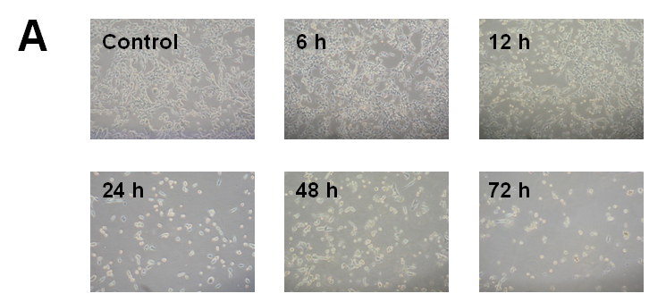

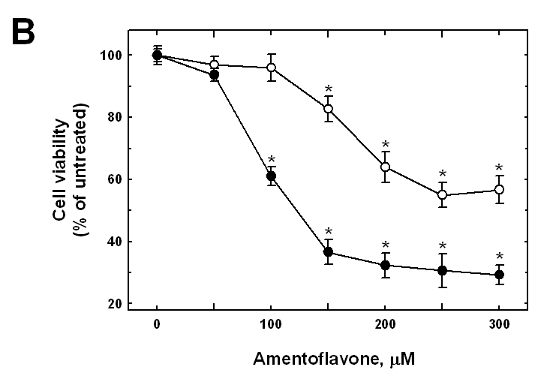

Figure 2

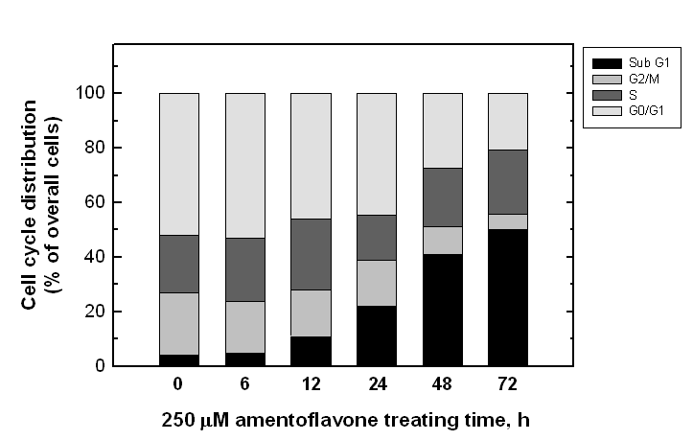

Figure 3

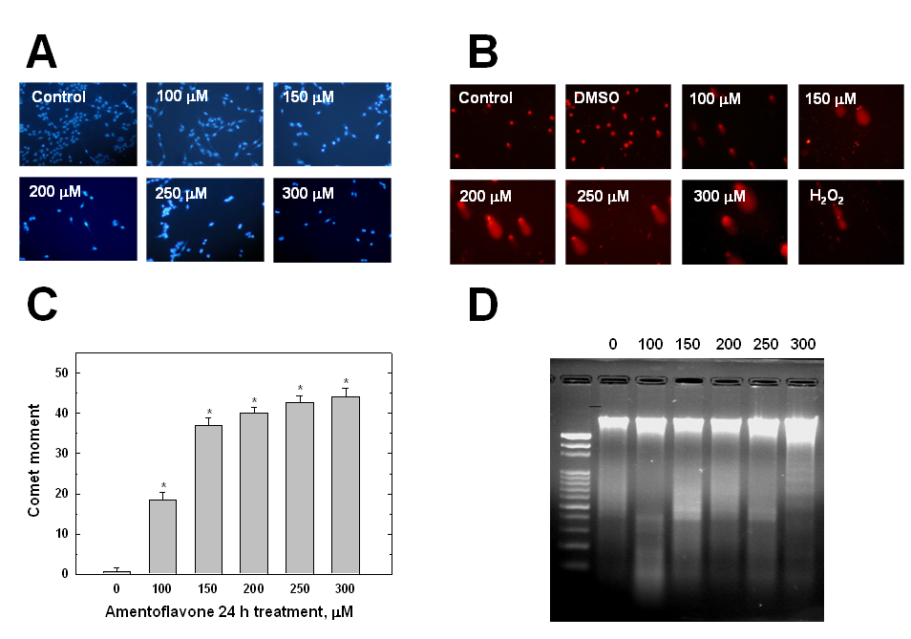

Figure 4

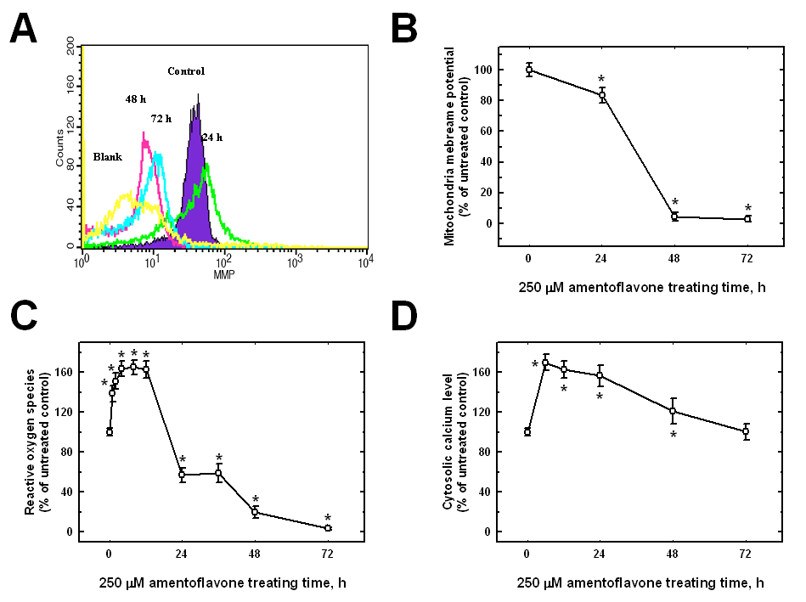

Figure 5

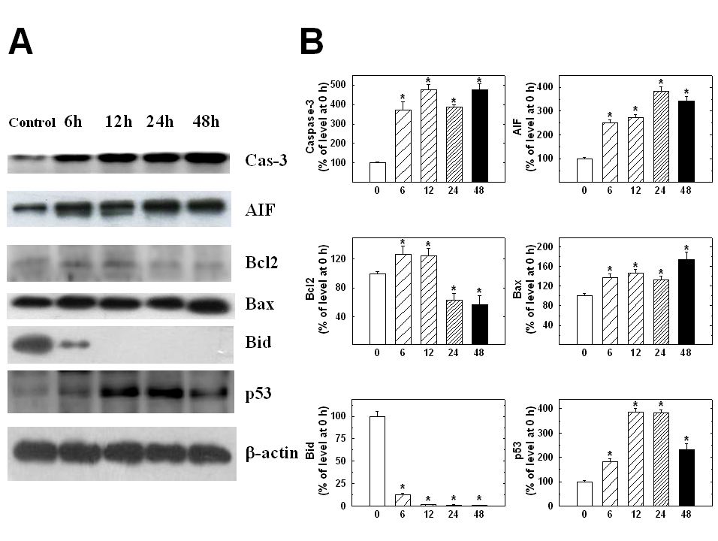

Figure Legends

Figure 1. Amentoflavone induced cell morphological changes and decreases the percentage of viable MCF-7 cells. (A) Cells were cultured in DMEM medium + 10% FBS with 250 μM amentoflavone for 6 to 72 h. The cell morphological changes were examined and photographed by phase-contrast microscopy after 6, 12, 24, 48 and 72 h treatments. (B) The percentages of viable MCF-7 cells were determined as described in Materials and Methods. Each point is mean ± SD of three experiments. *P<0.05, significantly different compared with DMSO-treated control and amentoflavone treatment.

Figure 2. Amentoflavone affected the cell cycle distribution and apoptosis in MCF-7 cells. Cells were cultured with 250 μM amentoflavone for 0, 6, 12, 24, 48 and 72 h. The cells were examined and analyzed for cell cycle distribution and sub-G1 (apoptosis) by flow cytometry as described in Materials and Methods. Each point is mean ± SD of three experiments. * P<0.05, significantly different compared with DMSO-treated control and amentoflavone -treated groups.

Figure 3. Amentoflavone chromatin condensation and DNA strand break in MCF-7 cells. Cells were incubated with various concentrations of amentoflavone for 24 h. The cells were harvested and were examined for chromatin condensation by DAPI staining (A) and DNA damage by Comet assay (B) with quantification of fluorescence intensity (fold of difference between control and amentoflavone treatment) and Comet tail (% of difference between control and amentoflavone treatment) (C) were determined, the DNA fragmentation (D) is performed by DNA gel electrophoresis as described in Materials and Methods. Each point is mean ± SD of three experiments. * P<0.05, significantly different compared with DMSO-treated control and amentoflavone-tereated groups.

Figure 4. Amentoflavone affected the levels of mitochondria membrane potential (ΔΨm), ROS, and cytosolic Ca⁺² in MCF-7 Cells. Cells were treated with 250 μM amentoflavone for 0, 24, 48, or 72 h before being collected, and stained with DiOC6 (1 μM) for the level of ΔΨm (A), DCFH-DA (10 μM) for ROS (B) and Indo 1/AM (3 μg/mL) for cytosolic Ca⁺² production (C) as described in Materials and Methods. Each experiment was done with triple sets (mean ± SD): *P P<0.05, significantly different compared with DMSO-treated control and amentoflavone-treated groups.

Figure 5. Representative Western blotting showing changes in the levels of apoptosis-associated proteins in MCF-7 cells after amentoflavone exposure. Cells were treated with 250 μM amentoflavone for 0, 6, 12, 24 and 48 h before the total proteins were prepared and determined, as described in Materials and Methods. The levels of apoptosis-related protein expressions (caspase-3, AIF, Bcl-2, Bax, Bid, and p53) were estimated by Western blotting analysis and quantitated as described in Materials and Methods.

