Surface Roughnesses and Topographies of Four Commonly Used Orthodontic Archwires

Jian-Hong Yu¹, Li-Chun Wu¹, Jui-Ting Hsu^{1*}, Yin-Yu Chang², Her-Hsiung Huang³, Heng-Li Huang¹

¹ School of Dentistry, College of Medicine
China Medical University and Hospital, Taichung, Taiwan, 404, ROC
² Department of Materials Science and Engineering,
MingDao University, ChangHua, Taiwan, 523, ROC
³ Department of Dentistry, School of Dentistry
National Yang-Ming University, Taipei, Taiwan, 112, ROC

Running Title: Surface Characteristics of Orthodontic Archwire

Corresponding author:
Jui-Ting Hsu, Associate Professor
School of Dentistry, College of Medicine, China Medical University
91 Hsueh-Shih Road, Taichung 40402 Taiwan
Tel. 886-4-22053366 ext. 2308
Fax. 886-4-22014043
E-mail address: jthsu@mail.cmu.edu.tw; richard@ms32.url.com.tw
Abstract

The surface characteristics of orthodontic archwires (such as their topography, roughness, and hardness) are important determinants of the effectiveness of archwire-guided tooth movement. They also affect the corrosion potential and the aesthetics of orthodontic components. This study used surface profilometer and hardness tester to evaluate the surface roughnesses and hardnesses of four common used orthodontic archwires: (1) stainless steel (SS) wire, (2) conventional nickel-titanium (NiTi) alloy wire, (3) improved superelastic NiTi-alloy wire [which also called low-hysteresis (LH) wire], and (4) beta-titanium (TMA) alloy wire. In addition, the surface topography of the four archwires was also obtained from the scanning electron microscopy (SEM). SEM revealed that the surface topography varied between the four types of archwire. LH wire and NiTi wire exhibited similar surface topography, which differed from those of SS wire and TMA wire: SS wire had the smoothest surface (roughness of 0.051±0.023 μm, mean±SD), followed by TMA wire (0.206±0.007 μm) and then NiTi wire (0.627±0.072 μm) and LH wire (0.724±0.117 μm). In addition, the SS wire had the hardest surface (hardness of 405.4 ± 9.9 kg/mm²), followed by TMA wire (303.3 ± 13.2 kg/mm²), and then LH wire (215.1 ± 48.5 kg/mm²) and NiTi wire (195.4 ± 17.2 kg/mm²). The NiTi wire and LH wire had similar surface topographies, surface roughnesses, and hardnesses. It might therefore be unnecessary for orthodontists to substitute NiTi wires with LH wires.

Keywords: Orthodontic archwires, surface roughness, surface topography, surface hardness

1. Introduction
Tooth movement associated with sliding mechanics occurs as a series of steps involving tooth tipping and uprighting [1-3]. However, this is resisted in orthodontics by the presence of frictional forces between the archwire and brackets. The surface properties of orthodontic archwires, such as their roughness, hardness, and topography, may affect the sliding mechanics by influencing the coefficient of friction. Surface properties also determine the aesthetics of dental products as well as the corrosion potential and biocompatibility.

Stainless steel (SS) archwire is one of the most widely used materials in orthodontics, but nickel-titanium (NiTi) archwire and beta-titanium (TMA) archwire have become popular over the past 2 decades. Studies have demonstrated the high spring-back and low friction features of NiTi wire [4-6], and the low stiffness and high formability of TMA wire [7]. Recently developed improved superelastic NiTi-alloy wire, which also called low hysteresis (LH) wire, delivers more stable orthodontic forces in the oral environment [8-11]. However, there have been insufficient scientific reports on the surface properties of LH archwire.

This study evaluated and compared the surface roughnesses, hardnesses, and topographies of the four common used orthodontic archwires (SS, NiTi, TMA, and LH wires).

2. Materials and Methods
2.1 Specimens prepared
The following four types of archwire were tested in this study: SS wire (Sin-Yean, Taipei, Taiwan), conventional NiTi wire (Tomy International, Tokyo, Japan), TMA wire (Ormco, Orange, CA, USA), and LH wire (Tomy International). All the archwires had the same cross-sectional dimensions (0.016×0.022 in).

2.2 Measurements of surface topography
High-resolution field-emission scanning electron microscopy (SEM; model JSM-7000F, JEOL, Tokyo, Japan) was used to evaluate the surface topography of samples of each of the four types of archwires. The surface was viewed on the monitor at 100× and 1000× magnifications.

2.3 Measurements of surface roughness
The surface roughnesses, R_{a}, of the four types of archwire were measured using a commercial profilometer (Surf-Corder SE-1200, Kosaka Laboratory Ltd, Tokyo, Japan). The scanning distance was 4.0 mm, and vertical movements could be measured to an accuracy of ±0.01 μm. The hardware determined automatically the profilometric mean roughness from the surface profile. Eight profilometric scans were performed on different samples of each type of wire, and the obtained data are presented as mean±SD values.

2.4 Measurements of surface hardness
The surface hardnesses of the four types of archwires were measured with a Digital Micro Hardness Tester (Model MXT70, Matsuzawa Seiki, Tokyo, Japan) by applying a 100-g force for 20 seconds. The hardness of each archwire was measured eight times. The surface roughnesses and hardnesses of the four types of archwire were analyzed initially using one-way analysis of variance and Tukey’s test with a 5% level of significance. All statistical analyses were performed using the SAS software package (SAS, Cary, NC, USA).

3. Results
3.1 Surface topographies of the archwires
The surface topographies of the four types of archwire are shown in Figure 1 (100×) and Figure 2 (1000×). Basically, there were no obvious differences in the surface topographies between the four archwires at 100× magnification (Figure 1). However, at 1000× magnification, SS wire exhibited the smoothest surface (Figure 2a), but even new samples had an irregular surface finish. The surface topographies of NiTi wire and LH wire exhibited a fibrous surface finish (Figure 2b and c). The surface topographies of TMA wire differed markedly from those of the other three types of archwire, with irregular cavities being observed (Figure 2d).

3.2 Surface roughnesses of the archwires
The surface roughness (R_{a}) was highest for LH wire (0.724±0.117 μm) and NiTi wire (0.627±0.072 μm), followed by TMA wire (0.206±0.007 μm) and SS wire (0.051±0.023 μm) (Table 1). Tukey’s test showed that the roughness did not differ between LH wire and NiTi wire. Figure 3 shows examples of profilometric scans of the four types of archwire, which reflect the typical surface structure of these wires. SS wire, which was the smoothest in this study, had a roughness with a short wavelength and small amplitude. NiTi wire and LH wire exhibited similar, square-wave-like profilometric scans, but LH-wire scans exhibited a higher amplitude roughness. TMA wire had a roughness with distinctly higher amplitude at a comparable wavelength.

3.3 Surface hardnesses of the archwires
The hardness of the SS wire was 405.4 ± 9.9 kg/mm² (mean ± SD), making it 2.07, 1.9, and 1.3 times harder than the LH, NiTi and TMA archwires (195.4 ± 17.2, 215.1 ± 48.5, and 303.3 ± 13.2 kg/mm², respectively) (Table 1). Tukey’s test showed that the hardness did not differ between LH wire and NiTi wire.
4. Discussion
Evaluating the surface of an orthodontic archwire is important due to its influence on the working characteristics as well as the corrosion potential. The conventional gold standard for sliding mechanics has generally been a combination of SS archwire and brackets. Moreover, SS wire is often used as the reference material in comparisons of the characteristics of other metal types of orthodontic archwire [7]. Besides SS wire, NiTi- and TMA-alloy wires are commonly used in clinical trails. However, these two types of archwire have some disadvantages, such as that their high spring-back feature gradually decreases during the unloading process [12]. Therefore, an LH wire that delivers more stable orthodontic forces in the oral environment has recently been developed [8-11]. However, the surface characteristics of LH wire remain unclear. This study therefore evaluated the surface roughness and topography of LH archwire, and compared it with those of the other three commonly used types of archwire.

In this study, the surface roughness of NiTi wire was significantly higher than that of TMA wire, and the smoothest was SS wire. This order was consistent with the experimental results of Bourauel et al. [13]. The LH wire used in the present study was developed from the conventional NiTi-alloy wire by a technique of double heat treatment, and has a damping capacity to buffer the force transmission to the periodontal ligament, thereby lessening patient discomfort [8]. Therefore, one of the major reasons for there being no significant difference between the surface roughness of LH wire and NiTi wire is the similarity of the compositions of these two alloy types. In addition, the SEM images provided evidence that these wire types have similar surface topographies.

The hardness of the archwire affects the degree of wear [14]. In the current study, the SS wire had the hardest surface, followed by TMA wire and then NiTi wire and LH wire. This order was inconsistent with the experimental results of Hunt et al. [14], who reported that TMA wire was softer than NiTi wire. The main reason for this discrepancy could be the use of different types of NiTi archwires used in the two studies. This assumption might be supported by the hardness of TMA wires measured in this study (303.3 ± 13.2 kg/mm²) being similar to that measured by Hunt et al. (354.9 ± 6.5 kg/mm²). However, the hardness of the NiTi wires measured in the current study (195.4 ± 17.2 kg/mm²) was only around 43% of that in the study of Hunt et al. (446.7 ± 22.0 kg/mm²). The TMA wires used in both studies were obtained from the same company, whereas the NiTi wires were obtained from different companies.

SEM evaluation of the surface characteristics revealed that SS wire had a smooth surface with little irregularity and horizontal wire drawing lines that were probably due to the drawing process during manufacture. In contrast to SS wire, TMA wire had a large number of uniformly distributed pores and exhibited a rough surface, as reported extensively in the literature [15,16].

Considering the surface roughness and the results of studies of frictional forces between different archwires and brackets indicates that complex interactions are present. The frictional force is higher for TMA wire than for SS wire and NiTi wire [17-20], which was attributed to a “cold-welding” feature of TMA wire leading to a repeated “stick-slip” movement of the bracket relative to the archwire [21]. However, the present study found that the surface roughness of TMA wire was only around one-third that of NiTi wire and LH wire, which indicates that the frictional force between the bracket and archwire cannot directly be predicted from the surface roughness of the archwire.

This study was subject to some limitations. The principal technique for determining surface roughness is surface profilometry, in which the topography is scanned along a single line of a preselected area. One of its disadvantages is that surface defects adjacent to the scanning line are not detected and hence do not contribute to the overall measured surface roughness. Although the SEM images could show the surface topography, quantifying the actual two-dimensional surface roughness was not possible in this study. Therefore, future studies should use atomic force microscopy or laser specular reflectance to quantify the two-dimensional surface roughness. However, it should be noted that some previous studies [13,22] have also demonstrated that profilometry is a useful method for measuring the surface roughness.
5. Conclusions
From the experimental results it can be concluded that the NiTi wire and LH wire exhibited similar surface topographies (as assessed using SEM), which differed from those of SS wire and TMA wire. The surface profilometer indicated that SS wire had the smoothest surface, followed by TMA wire and then NiTi wire and LH wire. The SS wire had the hardest surface, followed by TMA wire, and then LH wire and NiTi wire. NiTi wires and LH wires have similar surface topographies, surface roughnesses, and hardnesses, and the LH wire did not exhibit better characteristics in all of the cases examined in this study. It might therefore be unnecessary for orthodontists to substitute NiTi wires with LH wires.
Acknowledgements
The authors thank Professors Che-Shoa Chang and Yuh-Yuan Shiau for their suggestions during this study.

References
[1] D. Drescher, W. Laaser, and H. A. Schumacher, "[Materials technology research on the problem of friction between bracket and arch]," Fortschritte der Kieferorthopadie,50: 256-267, 1989.
[2] J. R. Bednar, G. W. Gruendeman, and J. L. Sandrik, "A comparative study of frictional forces between orthodontic brackets and arch wires," Am J Orthod Dentofacial Orthop,100: 513-522, 1991.
[3] C. A. Frank, and R. J. Nikolai, "A comparative study of frictional resistances between orthodontic bracket and arch wire," Am J Orthod,78: 593-609, 1980.
[4] C. J. Burstone, B. Qin, and J. Y. Morton, "Chinese NiTi wire--a new orthodontic alloy," Am J Orthod,87: 445-452, 1985.
[5] F. Miura, M. Mogi, Y. Ohura, and H. Hamanaka, "The super-elastic property of the Japanese NiTi alloy wire for use in orthodontics," Am J Orthod Dentofacial Orthop,90: 1-10, 1986.
[6] R. Schneevoigt, A. Haase, V. L. Eckardt, W. Harzer, and C. Bourauel, "Laboratory analysis of superelastic NiTi compression springs," Med Eng Phys,21: 119-125, 1999.
[7] A. Verstrynge, J. Van Humbeeck, and G. Willems, "In-vitro evaluation of the material characteristics of stainless steel and beta-titanium orthodontic wires," Am J Orthod Dentofacial Orthop,130: 460-470, 2006.
[8] Y. C. Liaw, Y. Y. Su, Y. L. Lai, and S. Y. Lee, "Stiffness and frictional resistance of a superelastic nickel-titanium orthodontic wire with low-stress hysteresis," Am J Orthod Dentofacial Orthop,131: 578 e512-578, 2007.
[9] K. Iramaneerat, M. Hisano, and K. Soma, "Dynamic analysis for clarifying occlusal force transmission during orthodontic archwire application: difference between ISW and stainless steel wire," J Med Dent Sci,51: 59-65, 2004.
[10] T. J. Evans, and P. Durning, "Aligning archwires, the shape of things to come?--a fourth and fifth phase of force delivery," Br J Orthod,23: 269-275, 1996.
[11] A. Laino, F. Boscaino, and A. Michelotti, Super-elastic wire used in orthodontics, Mondo Ortod,15: 707-714, 1990.
[12] K. Otsubo, "Development of the super-elastic Ti-Ni alloy wire appropriate to the oral environment," J Jpn Orthod Soc,53: 641-650, 1994.
[13] C. Bourauel, T. Fries, D. Drescher, and R. Plietsch, "Surface roughness of orthodontic wires via atomic force microscopy, laser specular reflectance, and profilometry," Eur J Orthod,20: 79-92, 1998.
[14] N. P. Hunt, S. J. Cunningham, C. G. Golden, and M. Sheriff, "An investigation into the effects of polishing on surface hardness and corrosion of orthodontic archwires," The Angle orthodontist,69: 433-440, 1999.
[15] R. P. Kusy, J. Q. Whitley, M. J. Mayhew, and J. E. Buckthal, "Surface roughness of orthodontic archwires via laser spectroscopy," Angle Orthod,58: 33-45, 1988.
[16] V. Krishnan, and K. J. Kumar, "Mechanical properties and surface characteristics of three archwire alloys," Angle Orthod,74: 825-831, 2004.
[17] K. Mendes, and P. E. Rossouw, "Friction: validation of manufacturer's claim," Semin Orthod,9: 236-250., 2003.
[18] V. Cacciafesta, M. F. Sfondrini, A. Ricciardi, A. Scribante, C. Klersy, and F. Auricchio, "Evaluation of friction of stainless steel and esthetic self-ligating brackets in various bracket-archwire combinations," Am J Orthod Dentofacial Orthop,124: 395-402, 2003.
[19] S. Kapila, P. V. Angolkar, M. G. Duncanson, Jr., and R. S. Nanda, "Evaluation of friction between edgewise stainless steel brackets and orthodontic wires of four alloys," Am J Orthod Dentofacial Orthop,98: 117-126, 1990.
[20] J. L. Vaughan, M. G. Duncanson, Jr., R. S. Nanda, and G. F. Currier, "Relative kinetic frictional forces between sintered stainless steel brackets and orthodontic wires," Am J Orthod Dentofacial Orthop,107: 20-27, 1995.
[21] R. P. Kusy, and J. Q. Whitley, "Coefficients of friction for arch wires in stainless steel and polycrystalline alumina bracket slots. I. The dry state," Am J Orthod Dentofacial Orthop,98: 300-312, 1990.
[22] A. Wichelhaus, M. Geserick, R. Hibst, and F. G. Sander, "The effect of surface treatment and clinical use on friction in NiTi orthodontic wires," Dent Mater,21: 938-945, 2005.

TABLE LEGEND
Table 1 Surface roughness and Surface hardnesses of the three orthodontic archwires.

FIGURE LEGENDS
Figure 1. Scanning electron micrographs of orthodontic archwires at 100× magnification: (a) SS wire, (b) NiTi wire, (c) LH wire, and (d) TMA wire.

Figure 2. Scanning electron micrographs of orthodontic archwires at 1000× magnification: (a) SS wire, (b) NiTi wire, (c) LH wire, and (d) TMA wire.

Figure 3. Typical profilometric scans of the four types of archwire: (a) SS wire, (b) NiTi wire, (c) LH wire, and (d) TMA wire.

Table 1 Surface roughness and Surface hardnesses of the three orthodontic archwires.
Archwire type | Surface roughness (Ra) (μm) Mean ± SD | Hardness (kg/mm²)  Mean ± SD
SS | 0.051 ± 0.023 | 405.4 ± 9.9
NiTi | 0.627 ± 0.072 | 195.4 ± 17.2
LH | 0.724 ± 0.117 | 215.1 ± 48.5
TMA | 0.206 ± 0.007 | 303.3 ± 13.2

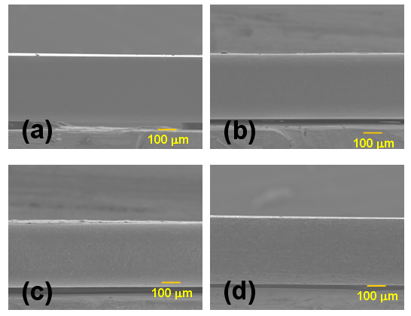
Figure 1. Scanning electron micrographs of orthodontic archwires at 100× magnification: (a) SS wire, (b) NiTi wire, (c) LH wire, and (d) TMA wire.
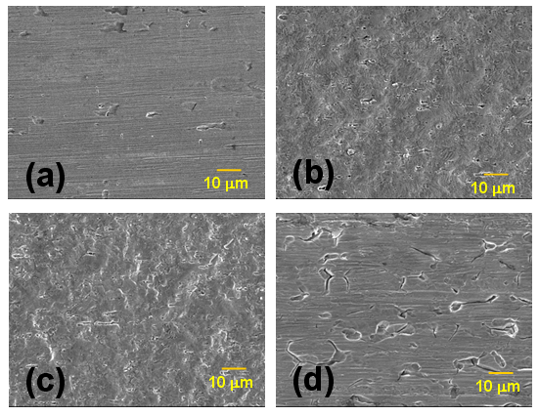
Figure 2. Scanning electron micrographs of orthodontic archwires at 1000× magnification: (a) SS wire, (b) NiTi wire, (c) LH wire, and (d) TMA wire.
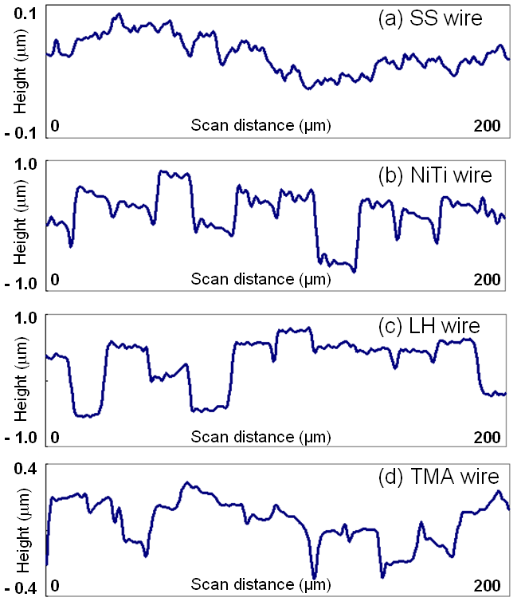
Figure 3. Typical profilometric scans of the four types of archwire: (a) SS wire, (b) NiTi wire, (c) LH wire, and (d) TMA wire.

