ORIGINAL RESEARCH
Game-based shoulder wheel system for rehabilitation
Chang et al

An interactive game-based shoulder wheel system for rehabilitation

Chun-Ming Chang¹
Yen-Ching Chang^{2,3}
Hsiao-Chuan Chang⁴
Li-Wei Chou*^{5,6}
¹Department of Applied Informatics and Multimedia, Asia University, Taichung, Taiwan; ²Department of Medical Informatics, Chung Shan Medical University, Taichung, Taiwan; ³Department of Medical Imaging, Chung Shan Medical University Hospital, Taichung, Taiwan; ⁴Department of Biotechnology, Asia University, Taichung, Taiwan; ⁵Department of Physical Medicine and Rehabilitation, China Medical University Hospital, Taichung, Taiwan; ⁶School of Chinese Medicine, College of Chinese Medicine, China Medical University, Taichung, Taiwan;

*Li-Wei Chou contributed equally to the Corresponding author in this work

Correspondence: Dr Chun-Ming Chang
Department of Applied Informatics and Multimedia, Asia University,
500, Lioufeng Rd, Wufeng, Taichung 41354, Taiwan
Tel +88 642 332 34 56 ext 1853
Fax +88 642 332 07 18
Email cmchang@asia.edu.tw

Background: Increases in the aging population and in the number of accidents have resulted in more people suffering from physical impairments or disabilities. Rehabilitation therapy thus attracts greater attention as a means of helping patients recover and return to a normal life. With the extremely long and tedious nature of traditional rehabilitation, patients are reluctant to continue the entire process, thus the expected effects of the therapy cannot be obtained. Games are well-known to help patients improve their concentration and shift their attention away from the discomfort of their injuries during rehabilitation. Thus, incorporating game technology into a rehabilitation program may be a promising approach.
Methods: In this study, a gaming system used for shoulder rehabilitation was developed. The mechanical parts and electric circuits were integrated to mimic the functionalities of a shoulder wheel. Several games were also designed to suit the rehabilitation needs of the patients based on the age and gender differences among the individual users, enabling individuals to undergo the rehabilitation process by playing games. Two surveys were conducted to evaluate the satisfaction of the participants regarding the gaming system.
Results: The results of the online survey among a larger population coincide with the responses of the hands-on participants through a paper-and-pencil survey. Statistical results suggest that the participants are willing to accept this novel approach.
Conclusion: This gaming system can distract a patient from the sensation of pain or anxiety, and increase their motivation to participate in the therapeutic program. Advantages of low-cost and easy setup increase the attractiveness of this new equipment for various potential users.

Keywords: virtual reality, virtual rehabilitation, shoulder wheel, game design.

Introduction
Advances in technology and medical science improve the quality of life as well as reduce the risk of mortality at various life stages. Those who have lost the ability to function normally because of trauma, surgery, stroke, tumor, or infection can regain as well as maintain independence and a good quality of life through rehabilitation. This process focuses on restoring certain functions of a damaged body part or utilizing education to train individuals to compensate for the damage that cannot be repaired. The treatment typically involves continued sessions of one-to-one training for a number of weeks. Severe cases require long-term care, of which the associated demands may pose the greatest challenge for personal, family, and public resources.
Shoulder pain is an extremely common complaint among the general population, accounting for 5% of all general medical practice consultations. This is the fourth most frequent type of musculoskeletal pain reported by patients to general medical practitioners and physical therapists.¹ Shoulder pain is typically characterized by symptoms in the various joints, muscles, tendons, and bursa involved with shoulder motion.² Such disability of the body affects the person’s daily activities and quality of life. Rehabilitation is the key to returning the shoulder to its original state, which is typically accomplished through simple exercises. Shoulder exercises are useful in the treatment of numerous causes of shoulder pain,^{3,4} and are performed under the direction of a physician to ensure that the proper muscles are targeted for a specific condition.
Shoulder rehabilitation focuses on two important aspects of shoulder motion: flexibility and strength.⁵ Shoulder mobility is commonly improved through the use of certain types of equipment, such as the shoulder wheel, overhead pulley, and finger ladder, among others, in a range of motion exercises. Serious illness or injury often leads to a long, slow return to health. Regardless of the condition, one of the main keys to recovery is participation. Unfortunately, the treatment procedure is usually tedious, and the patients cannot maintain focus during and throughout the training process. The treatment program typically lasts too long for the patient to keep the therapy plan on track. At times, the patient might not remember if he or she has completed enough exercises. Furthermore, traditional rehabilitation has the disadvantages of an absence of computerized sensing, high costs, and an uneven distribution of therapists.
Virtual reality (VR) environments have attracted considerable interest as assistive technologies for rehabilitation.⁶⁻⁸ A player can interact with the computer via a human-machine user-friendly interface. The movements made in the virtual environment mimic those made in the physical environment. Compared with classical rehabilitation, the benefits of virtual rehabilitation include economy of scale, stored patient data, remote data access, low health care costs, interactivity, and patient motivation.^{6,9} A VR rehabilitation system typically consists of a computing platform, feedback sensors, and software. Adamovich et al¹⁰ used a VR environment in combination with robotic devices to assist in the recovery of hand-arm function. A high-end CyberGlove® component (CyberGlove Systems LLC, San Jose, CA) was used for the sensorimotor training of the hemiparetic hand.¹¹ Guberek et al¹² evaluated the level of cooperation and satisfaction associated with practicing arm and hand movements for rehabilitation purposes in cerebral palsy. Several researchers focused on developing software (computer games) to create VR environments and game frameworks on personal computers (PCs).^{13,14}
Most existing VR systems are expensive, heavy, and require frequent technical support. The cost of hardware was reduced by integrating several low-cost components based on a modified Xbox (Microsoft Corporation, Redmond, RA) gaming system for poststroke hand rehabilitation.¹⁵ Raichur et al¹⁶ developed an accelerated stroke rehabilitation platform based on electroencephalography/surface electromyography signals to enable home use. Burke et al¹⁷ proposed a low-cost visual tracking system for home-based, upper-limb stroke rehabilitation, without the need for expensive or special equipment, and it could be independently operated by the patient. Without development efforts, the authors^{18,19} used a commercial off-the-shelf product (Nintendo® Wii gaming system, Nintendo of America, Inc, Redmond, WA) to provide VR therapy. The attention required to play a game can distract the player from the sensation of pain. The gaming system not only increases the willingness of patients to accept the treatment, but also increases their comfort during the process. Thus, incorporating game technology into the rehabilitation program seems to be a promising approach.
In general, the strategy of game design for rehabilitation would be considerably different from that of commercial video games. Burke et al²⁰ identified two principles that are significant to game design: meaningful play and challenge. Meaningful play emerges from the interaction between a player’s actions and the system’s outcomes. Challenge means that a game should be designed to gradually increase in difficulty as it progresses. Ryan et al²¹ demonstrated the value of an iterative, player-centric game design. Furthermore, Magee²² suggested that the game concept requires addictive attributes such as competitiveness, clickability, progressive achievement, rewards, physical and cognitive challenges, as well as entertainment value. Visual or verbal feedback is similarly significant in game playing.
As of this writing, almost all the games on the market have one of seven age suitability ratings set by the Entertainment Software Rating Board.²³ Potential game players span all age groups, and each age group has its preference of games. The number of makers of computer-based and online video games for the elderly is increasing. The agility of elderly players is not comparable with those of adolescents, and thus the former have their own preferences in terms of game content. The Japanese giant, Nintendo, has developed the “Brain Age” game for its DS game console.²⁴ The game features tasks in memory, mathematics, reading, and even music, encouraging players to think by engaging in challenging exercises. Allstate Corporation (Northrbook, IL), incorporated with Posit Science (Posit Science Corporation, San Francisco, CA), also studied the use of video games to improve the driving ability of the elderly.²⁵ Patients in the rehabilitation program might be retained by designing specific games for each age group to increase their motivation to play.
A gender gap exists between males and females in the use of technology. Previous video game users were mostly males, but that situation has changed since 1996 when Mattel Media (Mattel Inc, El Segundo, CA) launched three video games based on the best-selling toy of all time, Barbie (Mattel Inc). Several studies revealed that girls have different preferences in software design. Girls preferred multiplayer modes, and they also enjoyed playing and communicating with other users. Girls were not interested in violent and exaggerated female sexuality content, and were generally afraid to participate in competitive games.²⁶⁻²⁹ Females tended to play card games and chess games. By contrast, males had a strong competitive tendency, and were inclined to challenge and outdo other players. Massive multiplayer online role-playing games (RPGs) and action games were their favorites.³⁰ The studies further suggested that males spent more time and enjoyed playing more computer games than females. Gender differences also existed in both the frequencies and the types of games played.
In this study, we hypothesize that a game is significant for medical rehabilitation, and that gender and age are two crucial factors in designing a game. In applying video games to medical rehabilitation, the system must provide functionalities similar to those of the existing physical therapy equipment. The system is operated by a patient based on the treatment procedure, as determined and established by a therapist. In this paper, we propose a game-based system for shoulder rehabilitation. A homemade, fully functional shoulder wheel that mimics the functionalities of the existing shoulder wheel was constructed. Six games were designed to fit the specific needs of individuals based on gender and age. Two surveys were conducted to evaluate the satisfaction level of the participants.

Materials and methods
Shoulder wheel system
Figure 1 illustrates the architecture of this rehabilitation gaming system. The system is composed of hardware implementation and software design. The hardware is comprised of a homemade shoulder wheel and a control module. The software consists of two subsystems: one for management and another for gaming. The former is used by a therapist to create an account and to review the treatment process. The latter serves as a portal through which a patient can begin the treatment.
A shoulder wheel performs circular motions, and according to its specifications, the diameter of the tubular circle is 37.5 inches with a height adjustable up to 26 inches, and a handle adjustable to 39 inches of arc. We built a shoulder wheel (axial model) using off-the-shelf materials based on these specifications. The homemade shoulder wheel was demonstrated in Figure 2A. A control module was also designed to transform the wheel rotation into control signals to trigger a game, as shown in Figure 2B.
The need for rehabilitation crosses all age groups, whereas the type, level, and goals of rehabilitation often differ by age and gender. According to a research report,³⁰ players above the age of 30 prefer games of strategy. For those below 18 years old, massive multiplayer online games are the first choice. RPGs are favored by those in between these age groups. Given the growing number of both old and young players, we extended the age range of the middle age groups on both ends to balance the age distribution. In this study, six computer games are designed according to the age and gender differences noted among users. Three age groups are classified for each gender, and the game title for each group is illustrated in Table 1. Table S1 shows the corresponding descriptions of these games. Figure 3 demonstrates a sample screenshot of our game titled “Cupid’s Arrow” for female players between the ages of 14 and 45.

Study sample and setting
Our experiments were comprised of two surveys: a paper-and-pencil survey, and an online survey. The paper-and-pencil survey was administered among 68 healthy participants distributed across all age and gender groups, and recruited within a specific community. Each of the participants had never used the shoulder wheels, and thus their opinions would not be biased by any prior experience. In the online survey, 531 subjects participated. The website was open to the public, and no restrictions were established for the qualifications of survey respondents.
The setup of our system is described as follows. The software design of the gaming system was implemented using Visual Basic 6.0 on a Windows XP platform (Microsoft Corporation). The rehabilitation games can be played on PCs as displayed on a standard monitor or on a projector screen. A Microsoft Access database (Microsoft Corporation) was used to manage the information. Both hardware and software were verified to demonstrate the effectiveness of our system. Readers were advised to refer to Chang et al³¹ for the details of the system operation.

Data sources and measures
We designed a survey to characterize the satisfaction level of the participants in using games for shoulder rehabilitation. The survey contained ten statements, as shown in Table S2. Each statement was measured using a five-point Likert scale, with the lowest value of “1” meaning “strongly disagree” and the highest value of “5” meaning “strongly agree.” After all of the surveys were completed and collected, the scores for each statement were computed.
For the paper-and-pencil survey, the system functionalities were briefly explained and demonstrated to familiarize the respondents with the system operation. The participants were asked to rotate the homemade shoulder wheel ten times in clockwise and counterclockwise directions to obtain a feeling for how a conventional shoulder wheel works. After a short break, the participants engaged in hands-on operation of the rehabilitation system. They accessed the specific games according to gender and age, and they then played around with the system. After a treatment session, they were advised to fill out a form in which they indicated what they thought of, or how they felt about the system.
A website was set up to collect more feedback from a large number of respondents for the evaluation of the performance of our rehabilitation system. The system operation procedures for distinct games were videotaped and converted into MPEG-4 format files that were posted online for the public to retrieve through streaming media technology. After viewing the operation procedures, the visitor was guided to the webpage of an online survey and was asked to fill out a survey form.

Data analysis
Four variables were considered in this study: the survey method, game type, gender gap, and age of participants. These variables were analyzed via factorial experiments. The relationships of gender and age with the responses of the paper-and-pencil as well as the online surveys were separately evaluated. All analyses were conducted through the use of the Statistical Package for the Social Sciences 13.0 statistical program (SPSS, IBM Corporation, Armonk, NY). Duncan’s multiple range test was employed to determine the significant differences between the various factors. The statistical significance was determined at a significance level of P < 0.05.

Results
Sample characteristics
A paper-and-pencil survey was administered among 68 healthy participants, with 38 males and 30 females. Table 2 indicates the number of participants in each group and the corresponding distribution ratio. In the online survey, a total of 531 subjects participated, with 287 males and 244 females. Table 3 presents the related information for the online survey.

Gender factor
Significant differences were observed in the gender factor for the survey (F_{(1,628)} = 7.943, P = 0.005). In all survey statements, the satisfaction level of female participants (mean 4.30 ± 0.045) was higher than that of male participants (mean 4.05 ± 0.042). The female users found it easier to accept this new approach for rehabilitation. Statement two obtained the lowest score (mean 3.94 ± 0.096) for both genders, which indicated that the participants did not quite enjoy the immersion in the game environment.

Age factor
Significant differences were observed between different age groups (F_{(2,628)} = 6.575, P = 0.001). The participants could be divided into two subgroups via Duncan’s multiple range test. G2 had a relatively lower score (mean 3.94 ± 0.047). No significant statistical differences were observed between G1 (mean 4.35 ± 0.069) and G3 (mean 4.26 ± 0.048; P = 0.252). G2 participants expected more from this gaming system. G1 participants provided lower scores for statement five (mean 3.73 ± 0.228). They had greater doubts about the functionalities of our system when compared with those of a traditional shoulder wheel.

Relationship between paper-and-pencil survey and online survey
Statistical results indicated that for all statements, the scores of the online survey were higher than those of the paper-and-pencil survey. Although differences were observed between the two survey methods (F_{(1,5915)} = 233.575, P < 0.00), the trends indicated by both surveys were similar. This finding suggests that the results of the paper-and-pencil survey coincide with those of the online survey.
The interaction between gender and age indicated that participants of different genders and age groups favored specific game types. This finding can be observed from the results of the male participants in G2 (mean 3.77 ± 0.053). No significant difference was observed in the interaction between gender and statement (F_{(9,628)} = 0.281, P = 0.980), which suggested the coinciding feelings of both male and female participants regarding the system.

Discussion
The scores of all groups across the ten statements ranged from 3.61 ± 0.61 to 4.86 ± 0.38. Most of the scores were above 4.0. These results indicated that most of the participants were satisfied with the game design, system operation, and expected rehabilitation effects of the mechanism we developed. After using this system, the respondents felt more relaxed than after operating a conventional shoulder wheel.
Examining the data for each gender and age group, the scores for males in the “Ages 14–45” group were slightly lower than those of the other groups (mean 3.83 ± 0.71). We speculated that this range was too broad an age range for only one game to satisfy all the players. A possible solution was to divide this group into subgroups. We also considered providing a wider range of games to fit the distinct needs of each age group. For example, both genders in the “Ages 14–45” group commented on the contents of the game, and those “Above 45” responded on feeling physically present in the game environment.
In addition, participants in the “Under 14” group provided a different thought on the statement, “this system has the same therapeutic effect as the traditional one.” We assumed that several respondents were too young (ages 6 and 7) to understand the statements, and they might not have ever seen an actual shoulder wheel, much less know how it works. We may need to provide further system orientation for this group before asking them to fill out the survey.

Conclusion
Video games have been used as a form of physiological or occupational therapy in a number of studies. A game can motivate a patient to engage in the virtual world, and provide a distraction from pain or anxiety. In this study, a gaming system was constructed for shoulder rehabilitation. The mechanism was designed to simulate the functionalities of an existing shoulder wheel. The control module could capture the movements of the shoulder wheel and transmit the signals to the game on a PC platform. The game categories were designed according to the gender and age of the players. The statistical analysis based on the results of a paper-and-pencil and online survey indicates the efficacy of our gaming system.
Most existing rehabilitation systems provide only one game for a specific application for all potential patients. We observed the gender and age differences and divide the subjects into six groups. Each group had its own favorite choice. Given that one game may not meet all the needs of the participants, each group inevitably selected a wide range of games. The patients in each group could then have more choices instead of playing only the default game.
The development of treatment strategies requires a clear understanding of the ability and motivation of patients to participate in the therapy. This gaming system can distract a patient from pain or anxiety, and increase their motivation for participating in this type of rehabilitation. The system is not intended to replace therapists, but it is meant to be a tool to assist in monitoring the patient’s progress and to ensure that the treatment plan is running smoothly. The advantage of its low cost makes our system suitable for use by patients at home. With a minor modification, our system can also be integrated into a real shoulder wheel. Moreover, this design can be applied to other existing rehabilitation facilities.

Acknowledgments
The authors would like to thank Bing-Yu Hsiao for conducting the surveys.

Disclosure
The authors report no conflicts of interest in this work.

References
- van der Heijden GJ. Shoulder disorders: a state-of-the-art review. Baillieres Best Pract Res Clin Rheumatol. 1999;13(2):187-309.
- International Association for the Study of Pain. Shoulder Pain. Seattle, WA: International Association for the Study of Pain; 2009. Available from: http://www.iasp-pain.org/AM/AMTemplate.cfm?Section=HOME&CONTENTID=9293&SECTION=HOME&TEMPLATE=/CM/ContentDisplay.cfm. Accessed March 15, 2012.
- Ginn KA, Cohen ML. Exercise therapy for shoulder pain aimed at restoring neuromuscular control: a randomized comparative clinical trial. J Rehabil Med. 2005;37(2):115-122.
- Kibler WB, McMullen J, Uhl T. Shoulder rehabilitation strategies, guidelines, and practice. Oper Tech Sports Med. 2000;8(4):258-267.
- O’Sullivan SB, Schmitz TJ. Physical Rehabilitation. 5th ed. Philadelphia: F.A. Davis Company; 2007.
- Burdea G. Keynote address: virtual rehabilitation-benefits and challenges. In: 2003 International Medical Informatics Association Yearbook of Medical Informatics; Heidelberg, Germany: International Medical Informatics Association; 2003:170-176.
- Griffiths M. Video games and health. BMJ. 2005;331(7509):122-123.
- Deutsch JE, Lewis JA, Burdea G. Technical and patient performance using a virtual reality-integrated telerehabilitation system: preliminary finding. IEEE Trans Neural Syst Rehabil Eng. 2007;15(1):30-35.
- Halton J. Virtual rehabilitation with video games: a new frontier for occupational therapy. Occupational Therapy Now. 2008;9(6):12-14.
- Adamovich S, Fluet GG, Merians AS, Mathai A, Qiu Q. Recovery of hand function in virtual reality: Training hemiparetic hand and arm together or separately. Conf Proc IEEE Eng Med Bio Soc. 2008;2008:3475-3478.
- Merians AS, Fluet GG, Qiu Q, Adamovich SV. Robotically facilitated training of the hemiparetic upper extremity as an integrated functional unit in virtual environments. Proceedings of the Virtual Rehabilitation International Conference, 2009. 2009 Jun 29–Jul 2; Haifa, Israel. New York, NY: IEEE; 2009. p. 185-188.
- Guberek R, Schneiberg S, McKinley P, Cosentino F, Levin MF, Sviestrup H. Virtual reality as adjunctive therapy for upper limb rehabilitation in cerebral palsy. Proceedings of the Virtual Rehabilitation International Conference, 2009. 2009 Jun 29–Jul 2; Haifa, Israel. New York, NY: IEEE; 2009. p. 219.
- Zhao R. Computer augmented rehabilitation using games and virtual reality environments. “Long Island Business News”. 2009 Sept 25–Oct 1.
- Watters C, Oore S, Shepherd M, et al. Extending the use of games in health care. Proceedings of the 39th Annual Hawaii International Conference on System Sciences. 2006 Jan 4–7; Kauai, HI. Washington, DC: IEEE Computer Society; 2006. p. 88b.
- Morrow K, Docan C, Burdea G, Merians A. Low-cost virtual rehabilitation of the hand for patients post-stroke. Proceedings of the 2006 International Workshop on Virtual Rehabilitation; 2006 Aug 29–30; New York, NY. New York, NY: IEEE; 2006. p. 6-10.
- Raichur A, Wihardjo G, Banerji S, Heng J. A step towards home-based robotic rehabilitation: an interface circuit for EEG/SEMG actuated orthosis. Proceedings of the IEEE/ASME International Conference on Advanced Intelligent Mechatronics, 2009; 2009 Jul 14–17; Singapore, Singapore. New York, NY: IEEE/ASME; 2009. p. 1998-2003.
- Burke JW, Morrow PJ, McNeill MDJ, McDonough SM, Charles DK. Vision based games for upper-limb stroke rehabilitation. Proceedings of the International Machine Vision and Image Processing Conference; 2008 Sep 5–8; Portrush, Ireland. New York, NY: IEEE; 2008. p. 159-164.
- Ramchandani A, Carroll K, Buenaventura R, Douglas J, Liu J. Wii-habilitation increases participation in therapy. Proceedings of Virtual Rehabilitation, 2008; 2008 Aug 25–27; Vancouver, Canada. New York, NY: IEEE; 2008. p. 69.
- Chen X, Ma C, He J, Xiao Z. Networking telemedicine in portable rehabilitation robot monitor system. Journal of Applied Information Technology. 2007;3(1).
- Burke JW, McNeill MDJ, Charles DK, Morrow PJ, Crosbie JH, McDonough SM. Optimising engagement for stroke rehabilitation using serious games. Visual Computer. 2009;25(12):1085-1099.
- Ryan M, Smith S, Chung B, et al. Rehabilitation Games: Designing Computer Games for Balance Rehabilitation in the Elderly. Available from: http://vivianong.com/wp-content/uploads/2010/01/fdg09.pdf. Accessed August 21, 2011.
- Magee J. Game design – The rehabilitation game [webpage on the Internet]. Derry City, Ireland: University of Ulster. Available from: http://justinmagee.com/Project-Brief-1-Games-Design-The-Rehabilitation-Game. Accessed March 15, 2012.
- Entertainment Software Rating Board. Game ratings & descriptor guide [webpage on the Internet]. Available from: http://www.esrb.org/ratings/ratings_guid.jsp. Accessed August 21, 2011.
- Nintendo Inc. Brain Age 2TM [homepage on the Internet]. Nintendo; 2007. Available from: http://www.brainage.com/launch/index.jsp. Accessed March 15, 2012.
- Allstate Corporation. Allstate examines brain fitness program to improve driver safety [webpage on the Internet]. Northbrook, IL: Allstate Insurance Company; 2008. Available from: http://www.allstatenewsroom.com/channels/news-releases-auto/releases/allstate-examines-brain-fitness-program-to-improve-driver-safety. Accessed March 15, 2012.
- Hartmann T, Klimmt C. Gender and computer games: exploring females’ dislikes. J Comput Mediat Commun. 2006;11(4):910-931.
- Miller L, Chaika M, Groppe L. Girls’ preferences in software design: insights from a focus group. Interpersonal Computing and Technology. 1996;4(2):27-36.
- Phillips A. Soapbox: ARGs and how to appeal to female gamers [webpage on the Internet]. San Francisco, CA: Gamasutra, UBM TechWeb; 2005 [updated November 29, 2005]. Available from: http://www.gamasutra.com/features/20051129/phillips_01.shtml. Accessed March 15, 2012.
- Agosto DE. Girls and Gaming: A Summary of the Research with Implications for Practice. New Brunswick, NJ: Rutgers University; 2003. Available from: http://girlstech.douglass.rutgers.edu/PDF/GirlsAndGaming.pdf. Accessed March 15, 2012.
- iResearch Inc. Online Casual Game Research Report 2006 [webpage on the Internet]. Available from: http://www.iresearch.com.cn/html/consulting/online_game/Free_Classid_23_id_1004.html. Accessed August 21, 2011.
- Chang CM, Chang YC, Hsiao BY. The design of a shoulder rehabilitation game system. Frontier Computing. Proceedings of the IET International Conference on Frontier Computing. Theory, Technologies and Applications; 2010 Aug 4–6; Taichung, Taiwan. New York, NY: IEEE; 2010 p. 151-156.
Table 1 Game titles for each group.
Group number | Age range | Game titles for males | Game titles for Females
G1 | Under 14 | Submarine Hunter | Cockroach Buster
G2 | Ages 14–45 | Trebuchet | Cupid’s Arrow
G3 | Above 45 | Treasure Chest | Match Two

Table 2 The participants of each group for the paper-and-pencil survey.
Group number | Males | Females | ratio (n = 68)
G1 | 7 | 8 | 22%
G2 | 18 | 7 | 37%
G3 | 13 | 15 | 41%
Table 3 The participants of each group for the online survey.
Group number | Males | Females | Ratio (n = 531)
G1 | 63 | 64 | 24%
G2 | 134 | 113 | 47%
G3 | 90 | 67 | 29%

Figure 1 Proposed system architecture.
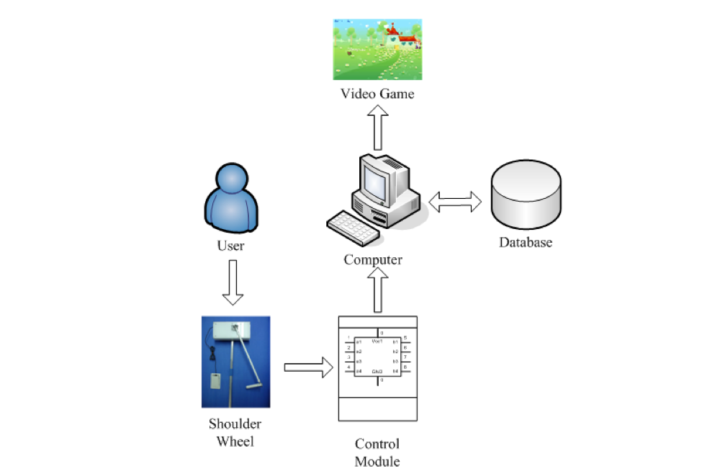
Figure 2 Shoulder wheels.
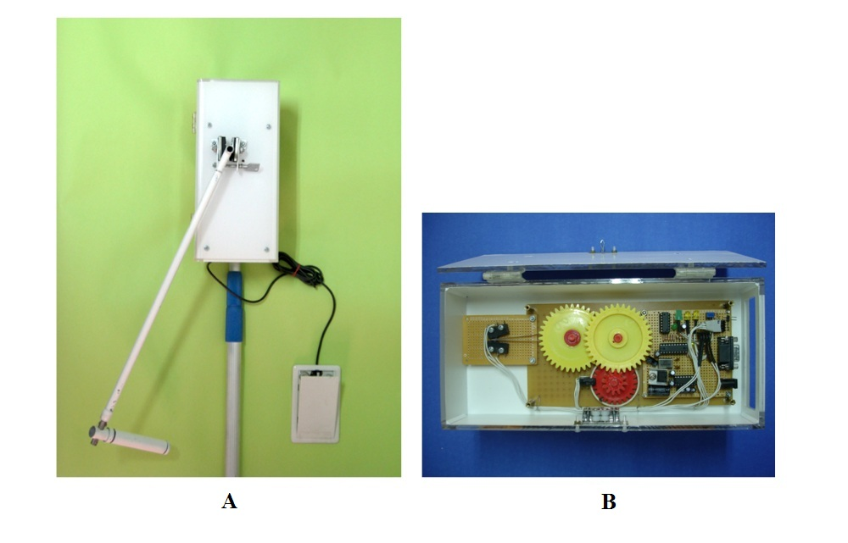
Note: (A) A homemade sample; (B) interior of the control module.
Figure 3 Screenshot of “Cupid’s Arrow” game.
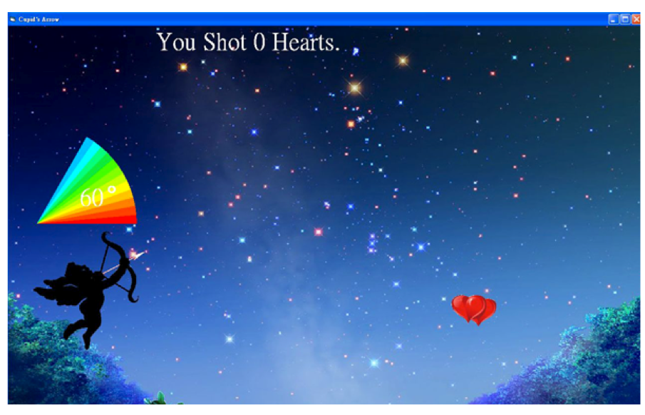
Supplementary materials
Table S1 Brief description of each game title in our system.
Game title | Description
Submarine Hunter | Submarines show up randomly under the water. A player can control a warship’s position horizontally to throw bombs to destroy them.
Trebuchet | Carts appear randomly in the desert. A player can adjust the projection power of the trebuchet to propel a stone to attack them at distinct distances.
Treasure Chest | The secret code of a single-dial lock to open the treasure chest is shown on the top. A player can turn the dial clockwise (counterclockwise) to the appropriate spots to open the box.
Cockroach Buster | Cockroaches show up on the left of the screen. A player can guide the little girl vertically to throw her slipper to smash them.
Cupid’s Arrow | Bending Cupid’s bow and point at the hearts in the sky. A player can adjust the bow to an appropriate angle of attack and release the string to shoot the hearts in the sky.
Match Two | Twelve cards with six pairs of fruit are shown and covered rapidly. A player has to memorize the locations of them. The player then has to rotate the shoulder wheel to move to the appropriate locations and flip two cards consecutively to see if there is a match.

Table S2 Ten statements for the questionnaire.
Statement number | Statement
S1 | You are interested in the contents of the game.
S2 | You feel physically present in the game environment.
S3 | The progress of the game is appropriate.
S4 | The gaming system is easy to operate.
S5 | The gaming system has the same therapeutic effect as the traditional one.
S6 | Playing the system makes you feel more relaxed than operating a conventional shoulder wheel.
S7 | Playing the game can divert your attention and forget the uncomfortableness.
S8 | You can focus on playing the game, and therefore the effectiveness of treatment can be improved.
S9 | The rehabilitation progress is under control using this gaming system.
S10 | Overall, you are satisfied with this gaming system.

