A Case of Study of Investigating Users’ Acceptance Toward Mobile Learning
Shu-Sheng Liaw and Hsiu-Mei Huang
Abstract: Mobile learning (m-learning) is a relatively new learning tool in the pedagogical arsenal to support
students and teachers as they navigate the options available in the expanding world of distance learning. Regarding
to wide application of mobile learning, investigating learners’ acceptance toward it is an essential issue. This
research investigates learners’ acceptance toward m-learning. An m-learning questionnaire survey that based on
168 university students’ attitudes was investigated. From statistical results, learner autonomy of using m-learning,
perceived interaction of using m-learning, quality of m-learning functions, and perceived satisfaction of using
m-learning are positive predictors on m-learning acceptance
Keywords: m-learning, acceptance, questionnaire survey
1 INTRODUCTION
Mobile learning (m-learning) is a relatively new tool in the pedagogical arsenal to support students and teachers as they navigate the options available in the expanding world of distance learning. M-learning is the learning accomplished with the use of small, portable computing devices. These computing devices may include: smart phones, PDAs and similar handheld devices. This type of learning is facilitated by the convergence of the Internet, wireless networks, mobile devices and e-learning systems (McConatha & Praul, 2008). With a mobile or handheld device, the relationship between the device and its owner becomes one-to-one interaction. Mobile devices have the potential to change the way students behave, the way students interact each other and the attitude toward learning (Motiwalla, 2007). The key features of using mobile devices for m-learning, such as one-to-one interaction and place and time independence; are personalization capability and extended reach (Zurita & Nussbaum, 2004). Even though m-learning provides useful overviews of different applications in education, there is an emerging need for a more applicable framework to provide teachers, educational policy-makers and researchers with a better representation of educational affordances of m-learning. Regarding to wide application of mobile learning, investigating learners’ attitudes toward it is an essential issue. This research will investigate learners’ attitudes toward m-learning. At first, we will present an m-learning
Shu-Sheng Liaw General Education Center, China Medical University, Taiwan, ssliaw@mail.cmu.edu.tw Hsiu-Mei Huang Graduate School of Computer Science and Information Technology, National Taichung Institute of Technology, Taiwan, hmhuang@ntit.edu.tw

framework. Furthermore, m-learning questionnaire survey that based on 168 university students will be investigated. In this research, the users
’
acceptance is based on factors such as m-learning interaction, m-learning system
’
s functions, learners
’
autonomy, perceived satisfaction, and perceived usefulness. The last section is discussion.

2 MOBILE LEARNING FRAMEWORK
With the trend of the educational media becoming more portable and individualized, the form of learning is being changed dramatically. This work aims to synthesize the cognition and technology domains to establish a new learning model. Therefore, the mobile learning environment posses many unique characteristics, they are (Chen, Kao & Sheu, 2003): (a), Urgency of learning need, (b), Initiative of knowledge acquisition, (c), Mobility of learning setting, (d), Interactivity of the learning process, (e), Situating of instructional activity, (f), Integration of instructional content. From the viewpoint of Chen, et al. (2003); indeed, the m-learning environment provides a flexible and powerful learning opportunity. Additionally, Liu, et al. (2003) point out that ubiquitous computing that integrates mobile devices, wireless communication, and network technology to construct a mobile learning environment has the following features: (a), reducing the time for tedious activities, (b), engaging students in learning activities, (c), empowering the teacher to monitor students’ learning statues, (d), facilitating group collaborative learning, (e), implementing technology-supported activities smoothly.
3 RESEARCH HYPOTHESES
In this research, we will apply this conceptual model to investigate learners’ attitudes toward the acceptance of m-learning. As Liaw, Hatala, and Huang (2010) stated, based on the activity theory approach, system satisfaction, system activities, learners’ autonomy, and system functions have positive influence on system acceptance toward m-learning. Based on their researching findings, they have proposed a theoretical conceptual model when applying m-learning. Four affordances will improve the acceptance of m-learning systems: enhance learners’ satisfaction, encourage learners’ autonomy, empower system functions, and enrich interaction and communication activities. Fig. 1 presents learners’ acceptance toward m-learning systems.
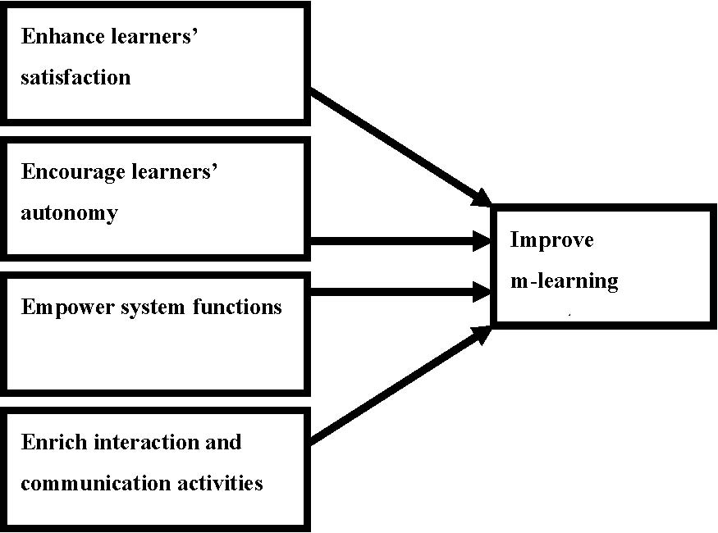

Fig. 1: The acceptance conceptual model of m-learning Based on the Figure 1, this research proposes the following hypotheses: H1 With the increase perceived interaction by using m-learning provides, the acceptance of the m-learning system increases. H2 With the increase perceived satisfaction of using m-learning provides, the acceptance of the m-learning system increases. H3 With the increase learners’ autonomy of using m-learning provides, the acceptance of the m-learning system increases. H4 With the increase quality of m-learning functions provides, the acceptance of the m-learning system increases.
4 RESEARCH DESIGN
4.1 Participants
This study conducts a survey for understanding learner attitudes toward the m-leaning environment. A total of 190 university students were taught on how to use the system. Students were allowed to use the system anytime for a period of one month. After that, a questionnaire survey for m-learning was distributed to participants during class. Participants were invited to complete the questionnaire. All subjects were asked to respond to the questionnaire and their responses were guaranteed to be confidential. All 190 students participated the questionnaire survey. However, 22 missing responses for m-learning questionnaire were eliminated. The study group comprised of 168 students which includes 71 male students and 97 female students.
4.2 Measurement
The questionnaire included three major components: (a) demographic information, (b) computer experience, and (c) attitudes towards m-learning. The following shows the content of the questionnaire.

Demographic information: The demographic component covered gender and the field of study
.
Computer experience: In this component, participants were asked to indicate their experience wit
h
computers, the Internet, PDA, and m-learning
.
Attitudes toward m-learning: Participants were asked to indicate their attitudes towards m-learning
.
These 19 questions were adopting a 7-point Likert scale (ranging from 1 which means
‘
‘
strongl
y
disagree
’
’
to 7 which means
‘
‘
strongly agree
’
’
). The attitudes toward m-learning includes five factors
,
quality of m-learning functions, perceived interaction of using m-learning, perceived satisfaction o
f
using m-learning, learners
’
autonomy of using m-learning, and perceived acceptance toward usin
g
m-learning
.

5 CONCLUSION
The internal consistency reliability was assessed by computing Cronbach's αs. The alpha reliability was highly accepted (α=0.94) and items’ coefficients are presented in Table 1. The values ranged from
0.40 to 0.77. Given the exploratory nature of the study, reliability of the scales was deemed adequate. Table 1: The Mean, Standard Deviation, item-total correlations of m-learning from 1 which means “strongly disagree” to 7 which means “strongly agree”)

Items |  | M |  |  |  |  |  |  |  |  | S.D. | r *
Quality of m-learning functions:
I know how to operate PDA for m-learning |  |  |  |  |  | 2.94 |  |  |  |  | 1.57 |  | 0.39
I know how to navigate web pages with |  |  |  |  |  | 3.15 |  |  |  |  | 1.72 |  | 0.44
PDA
It is convenient to use m-learning to read course materials. |  |  |  |  |  |  |  |  | 5.45 |  | 1.28 |  | 0.73
It is convenient to use PDA for m-learning. |  |  |  |  |  |  |  |  | 4.70 |  | 1.49 |  | 0.72
Perceived interaction of using m-learning:
The m-learning provides interactive opportunities. |  |  |  |  |  |  |  | 5.67 |  |  | 1.38 |  | 0.56
The m-learning | provides opportunities |  | for communication |  |  |  |  |  |  | am 5.61 | 1.39 |  | 0.59
learners.
The m-learning provides opportunities for navigating and download 5.04 |  |  |  |  |  |  |  |  |  |  | 1.35 |  | 0.70
instruction.
Learners’ autonomy of using m-learning:
I am active in finding Internet resources. |  |  |  |  |  |  | 5.65 |  |  |  | 1.61 |  | 0.58
I am active in finding m-learning resources. |  |  |  |  |  |  | 3.71 |  |  |  | 1.68 |  | 0.72
I am active in learning m-learning |  |  |  |  |  |  | 3.71 |  |  |  | 1.67 |  | 0.68
instruction.
Perceived acceptance toward using m-learning:
The system is useful to find Internet |  |  |  | 5.84 |  |  |  |  |  |  | 1.19 |  | 0.59
resources.
The system is useful to retrieve online |  |  |  |  | 5.61 |  |  |  |  |  | 1.28 |  | 0.68

learning instructions.
PDA is a useful tool for m-learning. | 4.94 | 1.38 | 0.75
The system is acceptable to improve my learning capacity. | 4.13 | 1.68 | 0.76
The system is acceptable to improve my problem-solving capacity. | 4.12 | 1.65 | 0.74
Perceived satisfaction of using m-
learning:
I am satisfied with using a PDA to find | 5.73 | 1.46 | 0.57
Internet resources.
I am satisfied with using the m-learning to | 5.46 | 1.46 | 0.55
interact with others.
I am satisfied with m-learning to learn web-based instruction. | 4.01 | 1.58 | 0.71
I am satisfied with m-learning to retrieve online learning resources. | 4.00 | 1.61 | 0.66

r*: Corrected Item-total correlation
For verifying hypotheses H1 to H2, the result of stepwise multiple regression for the path associated with the variables are presented in Table 2. To investigate H1 to H4 , a regression analysis was performed to check the effects of quality of m-learning functions, perceived interaction of using m-learning, perceived satisfaction of using m-learning, and learners’ autonomy of using m-learning on perceived acceptance toward using m-learning. The result showed that all four factors were predictors and learners’ autonomy of using m-learning had more contributions than other three other factors (F(4, 163)=42.19, p<0.001, R2=0.77). Table 2: Regression results of m-learning
Dependent variable | Independent variables | β | R2 | P
Perceived acceptance | Learners’ autonomy | 0.42 | 0.67 | <0.001
 | Perceived interaction | 0.19 | 0.06 | <0.001
 | Quality of functions | 0.21 | 0.02 | <0.001
 | Perceived satisfaction | 0.20 | 0.02 | 0.002

6 DISCUSSION AND CONCLUSION
From the statistical results, this research shows that five factors have significant correlations among them. Furthermore, this research also provides that four factors (learner autonomy of using m-learning, perceived interaction of using m-learning, quality of m-learning functions, and perceived satisfaction of using m-learning) are all predictors on m-learning acceptance. In other words, this research supports the conceptual model proposed in the research which conducted by Liaw, et al. (2010). This research also proves that encouraging learners’ autonomy, enriching interaction activities, empowering system’s functions, and enhancing learners’ satisfaction will directly influence learners’ acceptance toward m-learning. In summary, although the mobile devices have a limitation in screen size, this study confirms that mobile devices are valuable tools for mobile learning. As mobile learning systems have become more

individualized, learner-centered, situated, and ubiquitous, understanding learners acceptance toward those mobile systems are more crucial to enhance learning performance.
ACKNOWLEDGMENT
This study was supported by NSC99-2511-S-039-001-MY2, and CMU98-S-050. The full version will be submitted to as a book chapter.
REFERENCES

1. Chen, Y. S., Kao, T. C., & Sheu, J. P. (2003). A mobile learning system for scaffolding bird watching learning. Journal of Computer Assisted Learning, 19, 347-359.

2. Liu,T. C., Wang, H. Y., Liang, J. K., Chan, T. W., Ko, H. W., & Yang, J. C. (2003). Wireless and mobile technologies to enhance teaching and learning, Journal of Computer Assisted Learning, 19, 371-382.

3. Liaw, S.S., Hatala, M., & Huang, H. M. (2010). Investigating acceptance of mobile learning to assist individual knowledge management: Based on Activity Theory approach. Computers & Education, 54, 446-454.

4. McConatha, d.; & Praul, M. (2008). Mobile learning in higher education: An empirical assessment of a new educational tool. The Turkish Online Journal of Educational Technology; 7(3), 15-21.

5. Motiwalla, L. F. (2007). Mobile learning: a framework and evaluation. Computers & Education, 49(3), 581-596.

6. Zurita, G., & Nussbaum, M. (2004). A constructivist mobile learning environment supported by a wireless handheld network. Journal of Computer Assisted Learning, 20, 235–243

