Early induction of cytokines/cytokine receptors and Cox2, and activation of NF-kappaB in 4-nitroquinoline 1-oxide-induced murine oral cancer model

Yu-Ching Liu^{a,b,1}, Heng-Chien Ho^{c,1}, Miau-Rong Lee^{c}, Kuang-Chi Lai^{d,e}, Chung-Min Yeh^{f}, Yueh-Min Lin^{f}, Tin-Yun Ho^{g,*}, Chien-Yun Hsiang^{h,*}, and Jing-Gung Chung^{i,j,*}

ªDepartment of Medical Research, China Medical University Hospital, Taichung 404, Taiwan
Departments of ^{c}Biochemistry, ^{h}Microbiology and ^{i}Biological Science and Technology, Schools of ^{e}Medicine and ^{g}Chinese Medicine, China Medical University, Taichung 404, Taiwan
^{d}Department of Surgery, China Medical University Beigang Hospital, Yunlin 651, Taiwan
^{b}Department of Veterinary Medicine, National Chung Hsing University, Taichung 402, Taiwan
^{f}Department of Pathology, Changhua Christian Hospital, Changhua 500, Taiwan
^{j}Department of Biotechnology, Asia University, Taichung 413, Taiwan

¹Both authors have equal contribution

Running title: Genes induced early in 4-NQO-induced murine oral cancer

*Corresponding authors. Department of Biological Science and Technology, China Medical University. No 91, Hsueh-Shih Road, Taichung 404, Taiwan. Tel.: +886 4 22053366 ext 2161; fax: +886 4 22053764.
E-mail addresses: jgchung@mail.cmu.edu.tw (J.-G. Chung).

*Tin-Yun Ho, Chien-Yun Hsiang, and Jing-Gung Chung are the joint corresponding authors.

Abstract
The purpose of this study was to identify the genes induced early in murine oral carcinogenesis. Murine tongue tumors induced by the carcinogen, 4-nitroquinoline 1-oxide (4-NQO), and paired non-tumor tissues were subjected to microarray analysis. Hierarchical clustering of upregulated genes in the tumor tissues revealed an association of induced genes with inflammation. Cytokines/cytokine receptors induced early were subsequently identified, clearly indicating their involvement in oral carcinogenesis. Hierarchical clustering also showed that cytokine-mediated inflammation was possibly linked with Mapk6. Cox2 exhibited the greatest extent (9-18 fold) of induction in the microarray data, and its early induction was observed in a 2 h painting experiment by RT-PCR. MetaCore analysis showed that overexpressed Cox2 may interact with p53 and transcriptionally inhibit expression of several downstream genes. A painting experiment in transgenic mice also demonstrated that NF-κB activates early independently of Cox2 induction. MetaCore analysis revealed the most striking metabolic alterations in tumor tissues, especially in lipid metabolism resulting from the reduction of Pparα and Rxrg. Reduced expression of Mapk12 was noted, and MetaCore analysis established its relationship with decreased efficiency of Pparα phosphorylation. In conclusion, in addition to cytokines/cytokine receptors, the early induction of Cox2 and NF-κB activation is involved in murine oral carcinogenesis.

KEYWORDS: oral cancer, 4-NQO, microarray, MetaCore analysis, inflammation.

Introduction
Based upon the reports of the Cancer Registration System (Department of Health, Executive Yuan, Taiwan, ROC) in 2007, the annual incidence of oral malignancy in Taiwan was 5,006 cases for males and 452 cases for females. This corresponded to an incidence rate of 43.12 and 3.98 per 100,000 persons, respectively, of which 93.35% males and 83.63% females were diagnosed with oral squamous cell carcinoma (OSCC). In Taiwan, this malignancy caused an annual mortality of 2,152 males and 160 females in 2007, and it has actually become the fourth leading cause of death for men based on the incidence and mortality rate. Epidemiological studies and statistical analysis indicated that the development of oral tumors in Taiwanese patients was highly associated with betel quid chewing, cigarette smoking, and alcohol consumption . Approximately 90% of OSCC patients chew quid, and there is a relatively low incidence of oral malignancy in females.
A well established mouse model has been developed using the carcinogen 4-nitroquinoline 1-oxide (4-NQO) to induce oral-esophageal carcinogenesis specifically, whereas no tumors occurred in the remainder of the digestive tract, lung, or liver . To date, many studies have induced oral cancer by 4-NQO in mice or rats and have found that certain genes enhance or are involved in oral carcinogenesis, such as LRAT and c-Ha-ras . Furthermore, the alteration of signaling pathways was implicated in oral carcinogenesis, such as that triggered by interferon .
In this report, 4-NQO was used to induce murine tongue tumors, which were subjected to microarray analysis along with the paired non-tumor tissues, and the microarray data were then evaluated using MetaCore. The results indicated the involvement of cytokines/cytokine receptors in the development of oral malignancy and the importance of metabolic alteration in tumor tissues. Furthermore, Cox2 and NF-κB were subsequently identified to be induced early in the initial treatment with 4-NQO.

Materials and Methods
Reagents
4-NQO and ammonium pyrrolidine dithiocarbamate (PDTC as an NF-κB inhibitor) were purchased from Sigma Chemicals; reverse transcriptase was purchased from Epicentre Biotechnologies (Madison, Wisconsin, USA); ProTaq Plus DNA Polymerase for PCR was purchased from Protech Technology (Taipei, Taiwan); the Cox2 inhibitor nimesulide, anti-Mapk6 and anti-NF-κB p65 polyclonal antibodies were purchased from Santa Cruz Biotechnology; anti-Cox2 monoclonal antibody (clone SP21) was purchased from Novus Biologicals (Littleton, Colorado, USA); anti-phospho-Mapk6 (phospho S189) polyclonal antibody was purchased from Abcam (Cambridge, England); and D-luciferin was purchased from Xenogen (Hopkinton, Massachusetts, USA).

Induction of murine tongue tumors by the carcinogen 4-NQO
Mouse experiments were conducted under ethics approval from the China Medical University's Animal Ethics Committee. Murine tongue tumors were induced with the carcinogen 4-NQO, as described previously . Briefly, female C57BL/6J mice (6-week-old) in the experimental group were fed with 4-NQO-containing drinking water, freshly prepared as a final concentration of 0.1 mg/ml. Such treatment was continued for 16 weeks by changing the drinking water weekly, and then replaced with 4-NQO-free drinking water for another 12 weeks. Mice were sacrificed by cervical dislocation and tongue tissues were dissected. Mice in the control group were fed with 4-NQO-free drinking water for 28 weeks and sacrificed by the same way. A pair of tissues indicated that both tumor and adjacent non-tumor tongue tissues were dissected from the same mouse treated with 4-NQO. Three pairs of tissues were subjected to microarray analysis in the experiment.

Oligonucleotide microarray analysis and evaluation of microarray data
Total RNAs were isolated using the TRIzol® Reagent (Life Technologies, Carlsbad, California, USA), quantified at 260 nm by a ND-1000 spectrophotometer (Nanodrop Technologies, Wilmington, Delaware, USA), and qualitated by 2100 Bioanalyzer (Agilent Technologies, Santa Clara, California, USA) with RNA 6000 Nano LabChip kit. Total RNA (0.5 μg) was amplified by a low RNA input fluor linear amp kit (Agilent Technologies) and labeled with Cy3 or Cy5 (CyDye, PerkinElmer, Waltham, Massachusetts, USA) during the in vitro transcription process for non-tumor or tumor tissues, respectively. Two-microgram Cy-labled cRNA was fragmented to an average size of about 50-100 nucleotides by incubation with fragmentation buffer at 60°C for 30 minutes. The fragmented cRNA was then pooled and hybridized to mouse oligo microarray (Agilent Technologies) at 60°C for 17 h. After washing and drying by nitrogen gun blowing, microarrays were scanned with Agilent microarray scanner (Agilent Technologies) at 535 nm for Cy3 and 625 nm for Cy5, respectively. Scanned images were analyzed by Feature Extraction software version 9.1 (Agilent Technologies). This image analysis and normalization software was used to quantify signal and background intensity for each feature and substantially normalized the data by rank-consistency-filtering LOWESS method.
The selection criteria for analysis by MetaCore (GeneGo, Inc., Saint Joseph, Michigan, USA) included genes with a normalized expression ratio of tumor and paired non-tumor tissues of ≧2 or ≦0.5. Genes with ≧2-fold upregulation and genes with ≧6-fold downregulation in all three tumor tissues were further analyzed by MultiExperiment Viewer to establish hierarchical clustering. The unsupervised hierarchical clustering used a Pearson correlation-based distance measure using TM4 system (Saeed et al., 2003).

Short-term treatment of murine tongue tissues with 4-NQO
To profile the alteration of gene expression during initial treatment with 4-NQO, mice in three experimental groups (n=5 for each group) were administered 4-NQO-containing drinking water (0.1 mg/ml) for 2, 4, and 6 days, respectively. Mice in the control group (n=5) were administered 4-NQO-free drinking water for 6 days. For the same purpose, murine tongue tissues in three experimental groups (n=6 for each group) were painted with 4-NQO (2 mg/ml in 20% acetone) for 2, 7, and 18 h, respectively. Tissues in the control group (n=6) were painted with solvent only for 18 h. At the termination of the experiment, all mice in both experiments were sacrificed, and the tongue tissues were dissected for total RNA isolation.

RT-PCR
Equal amounts of total RNA from each mouse in the same group (n=5 or 6) were combined in a single tube and subsequently reversed transcribed to synthesize cDNAs. PCR was performed to examine expression of cytokines/cytokine receptors, Mmps, and genes involved in cell cycle and apoptosis/anti-apoptosis. The sequences of all primer pairs are listed in Table 1, within which mouse β-actin gene (Actb) is used as internal control for normalization. ImageJ was employed to analyze the PCR products of interest and to quantify expression differences.

Effect of Cox2 inhibition on cytokine/cytokine receptor expression
The Cox2 inhibitor, nimesulide, was employed to investigate whether cytokines/cytokine receptors are involved in the anti-carcinogenesis process by Cox2 inhibition. Briefly, mice were divided into 2 groups, both of which were comprised of 6 mice, and painted with 4-NQO (2 mg/ml in 20% acetone) in the tongue tissues. After 2-h, mice in the experimental group were painted with nimesulide (2 mg/ml in 10% PEG400/90% propylene glycol, v/v), and those in the control group were painted with solvent only. Mice were sacrificed 5-h later, and the tongue tissues were dissected for total RNA isolation. RT-PCR was performed as described above to examine expression of cytokines/cytokine receptors.

Immunohistochemical study
The tongue tissues of mice, which were orally administered 4-NQO for 2, 4, and 6 days, were employed to examine expression of Cox2, Mapk6, and phospho-Mapk6 immunohistochemically. Paraffin-embedded tissue sections were deparaffinized and then subjected to the immunohistochemical procedures described previously . The immunostaining intensity was evaluated separately by two pathologists.

Determination of oral NF-κB activation using transgenic mice
The preparation of transgenic mice, carrying the luciferase gene driven by NF-κB-responsive elements, was described previously . To determine whether oral NF-κB was activated by treatment with 4-NQO, the tongue tissues of 3 wild-type mice and 3 transgenic mice were painted with 4-NQO (2 mg/ml in 20% acetone). As a control, 3 transgenic mice were painted with solvent only. The protocols for ex vivo imaging of luciferase activity after 6-h duration were conducted as described previously . The luciferase images were captured using the machine IVIS Imaging System® 200 Series (Xenogen). Signal intensity was quantified as the sum of all detected photon counts from the tissues and presented as photons/sec.

Results
Correlation coefficients, obtained by scatter plot analysis from oligonucleotide microarray and indicated as R values in Figure S1 in the supplementary data, clearly showed similarity in terms of normalized expression ratio between the tongue tumor and paired non-tumor tongue tissue. MetaCore was subsequently applied to analyze 149 upregulated genes and 612 downregulated genes, both of which were filtered by 2-fold cutoff, in all three tumor tissues.

Hierarchical clustering for dysregulated genes
As depicted in Figure 1A, 124 genes with more than 6-fold downregulation in all three tumor tissues were hierarchically clustered. Based on the classification of the biological process by the Human Protein Reference Database (website: http://www.hprd.org/), 29 genes were classified as being involved in metabolism, especially in the energy pathways. This was the most frequent classification in this group of 124 genes.
In contrast to the approximately one-fourth of the downregulated genes involved in metabolism, only 11 out of the 149 upregulated genes participated in metabolic processes (Fig. 1B). Instead, 10 inflammation-related genes, such as Ptgs2 (also known as Cox2), and 13 pro-inflammatory cytokines/cytokines receptors were identified. This accounted for about 15% of upregulated inflammation-associated genes, which plausibly play a critical role in oral carcinogenesis. Our focus will be to examine the expression of inflammation-associated genes in the following experiments.

Early induction of cytokines/cytokine receptors
Two time-course experiments were conducted to illustrate whether cytokines/cytokine receptors and inflammation-associated Mmps were induced early in the tongue tissues and their effect on the cell cycle and apoptosis/anti-apoptosis during the initial treatment with 4-NQO. About one-half of the 38 cytokines/cytokine receptors and 6 Mmp genes were significantly upregulated after 2-, 4-, and 6-day treatment (Fig. 2), indicating their early induction at administration. As exemplified in the cases of Cxcl1 and Mmp12, induction was observed throughout the entire experiment, when compared with the microarray data. However, induction of Ifnb and Mmp13 occurred only in the early and late stages. Both cell cycle-related and anti-apoptic genes were also induced in this situation, although to a lesser extent; marked upregulation was still observed in the cases of Ccne2 and Wee1.
Nevertheless, extensive induction of cytokines/cytokine receptors was demonstrated after 7- and 18-h treatments. Of note, about one-half of the genes in this class were repressed after 2-h treatment. Such 2-h treatments with 4-NQO possibly injured tongue tissues, as indicated by marked repression of Ifng , which was responsible for the reduction of other cytokines, such as Cxcl9 and Cxcl10. Of the 6 Mmps examined, Mmp12 showed a marked reduction at this stage, which possibly resulted from the repression of Ifng . In turn, the reduced cytokines repressed both cell cycle-related and anti-apoptotic genes. Clearly, a shift occurred and caused increased expression of most of the originally reduced genes with 2-h treatment comparable to or up to the basal level with 7-h treatment.

Significance of opposite alteration for Mapk6 and Mapk12
Of 39 Map kinase or kinase-related genes, Mapk6 exhibited the most striking difference (3-8-fold upregulation in the microarray data) (Fig. 3A). RT-PCR analysis also revealed 2-fold induction of Mapk6 after 4-d treatment (data not shown). Likewise, the immunohistochemical study showed more expression after 4-d treatment in the hyperplastic region than in the basal layer (top vs. bottom, left in Fig. 3B). There was no significant difference between the basal layers in the hyperplastic part and in the normal part from the same tongue tissue (left vs. right in Fig. 3B). Of note, increased Mapk6 expression in the hyperplastic region appeared to have more nuclear staining than in the basal layer. Similarly, more nuclear staining was also observed in the detection of phospho-Mapk6 (Fig. 3C). Clearly, not only induction but also enhanced phosphorylation of Mapk6 occurred in the hyperplastic region.
On the other hand, Mapk12 displayed the converse pattern with the highest extent of reduction in this family. As illustrated on the left in Figure 3D, most substrates that are phosphorylated by Mapk12, exhibited unaltered expression in the microarray data. Reduced Mapk12 might mediate less effective phosphorylation and activation of reduced Pparα (right in Fig. 3D). Alternatively, p38 Mapk conferred the same effect on Ppargc1, whose reduced component Ppargc1a (Fig. 1A), in turn, caused less interaction with and activation of Pparα. In a similar manner, Mapk12 reduced Prkcq (for protein kinase C, theta) through the transcription factor Elk1 and decreased activation of reduced myelin basic protein.

Role of Cox2 in the oral carcinogenesis
Of the 149 upregulated genes in the microarray data, Cox2 exhibited the greatest extent of induction (9~18 fold) (3 bars on the left in Fig. 4A). Its early induction was found in the 2-h painting experiment (right in Fig. 4A), and the extent was much more significant with increasing time of oral administration (3 bars in the middle in Fig. 4A). As depicted on the left in Figure 4B, 4-NQO caused hyperplasia, an initial injury, in the tongue epithelia. Cox2 expression in the hyperplastic region was much more evident than in the basal layer at the bottom and in the normal epithelial cells of the same tongue tissue (right in Fig. 4B).
Cox2 also affected cytokine expression, as 9 cytokines were induced in the presence of nimesulide (Fig. 4C). Other than Ccl2, 8 of 9 cytokines exhibited the opposite alteration in the 2-h painting experiment (Fig. 2), whereas Cox2 showed 6-fold induction (right in Fig. 4A) in this situation. Reduction of these 8 cytokines in the initial painting with 4-NQO was unambiguously related to Cox2 induction, clearly indicating the involvement of Cox2 in the initial injury and shift phenomenon between 2- and 7-h painting. Nevertheless, Cox2 was a prerequisite for expression of 5 cytokines, including Cxcl2, Ccl3, Ccl4, Ccl22, and Il24 (Fig. 4C).
As illustrated in Figure 4D, MetaCore analysis of microarray data demonstrated that overexpressed Cox2 might interact with p53 and interfere with p53-dependent transcription , including Ankrd2, Scara3, Copz2, Fam134b, and transcription factor Hic1. In turn, p53 and c-Myc transcriptionally regulated each other. Plausibly, reduction of 6 c-Myc-downstream genes in Figure 4D might, at least in part, correlate with overexpressed Cox2.

NF-κB activation in the initial treatment with 4-NQO
Regulation of Cox2 expression occurs via the NF-κB signaling pathway , and this raised a question of whether early activation of NF-κB is the result of 4-NQO. As depicted in Figure 5A, NF-κB-driven luciferase activity was significantly increased in the region near the tongue tip of the transgenic mice painted with 4-NQO for 6 h, compared with controls. The luciferase activity near the tongue bottom, which was not painted with reagent or solvent, was nearly indistinguishable and apparently driven by endogenous NF-κB in both groups of transgenic mice. The extent of activation was estimated at approximately 3 fold (p=0.019, Fig. 5B). Furthermore, immunohistochemical detection clearly revealed the localization of p65 in the nucleus in both groups of mice painted with 4-NQO, whereas p65 was found primarily in the cytoplasm in control transgenic mice (Fig. 5C). For all cytokines/cytokine receptors examined, the MetaCore network predicted at least 10 cytokines whose expression was directly affected by NF-κB (Fig. 5D). Undoubtedly, early activation of NF-κB made a considerable contribution to cytokine induction by 4-NQO at 7 h and later (Fig. 2).

Dysregulated metabolism of long-chain fatty acids
GeneGo Maps resulting from MetaCore analysis noted 3 striking features. First, 8 out of the first 10 pathways were classified as metabolic alterations in the tumor tissues, especially in lipid metabolism. Second, nearly all genes involved in the first 10 pathways were downregulated. Third, Ppar signaling pathway was altered and participated in the regulation of lipid metabolism with p = 9.52 × 10⁻⁵, as described below.
As shown in Figure S2 in the supplementary data, among 17 genes involved in the metabolism of long-chain fatty acids, downregulation was consistently observed in 9 genes (p = 3.463 × 10⁻⁶). The highest extent of ＞10-fold downregulation was found in Cpt1b (see also Fig. 1A), whose gene product converted acyl-CoA to acyl-carnitine. The upstream formation of acyl-CoA was catalyzed by the gene products of Acsl1 and Acsl6, both of which were also downregulated. Perhaps the transport of long-chain fatty acids into the mitochondrial matrix was severely reduced, an effect that was also reflected in the subsequent β-oxidation, in which 6 downregulated genes participated. Most of the downregulated genes in Figure S2 in the supplementary data also participated in and, therefore, exerted the same effect on the metabolism of unsaturated fatty acids with p = 9.604 × 10⁻⁶ (map not shown).

Altered PPAR signaling pathway for the regulation of lipid metabolism
As shown in Figure S3A in the supplementary data, Cpt1b reduction possibly resulted from the reduced expression of both Pparα and Rxrg (for retinoid X receptor gamma), in which the latter was more than 10-fold downregulated. In addition to Cpt1b, the heterodimer of Pparα and Rxrg regulated expression of Acsl1, Acsl6, Acadl, and Acadm in Figure S2 in the supplementary data. Additionally, the altered Ppar signaling pathway also resulted in the significant reduction of at least 4 genes involved in lipid metabolism and not shown in Figure S2 in the supplementary data, i.e., Cyp27a1, Fabp3, Lpl, and Cd36 (see also Fig. 1A). In turn, a greater than 10-fold reduction of both membrane-bound Cd36 and cytosolic Fabp3 caused the inefficient transport of fatty acids into the cytosol and, finally, into the nucleus as ligands for the heterodimer of Pparα and Rxrg.
In addition to the intrinsic reduction of Pparα and Rxrg, reduced production of 9-cis-retinoic acid may contribute to the alteration of the Ppar signaling pathway. As depicted in Figure S3B in the supplementary data, production of 9-cis-retinoic acid was possibly decreased due to the marked reduction of Adh1, Aldh1a1, and Aldh1a7 (see also Fig. 1A). Conversely, metabolic flow bypassed toward the production of 11-cis-retinol and 11-cis-retinyl ester and 4-oxoretinol with the aid of upregulated Lrat and Cyp26a1. Taken together, the following 3 intrinsic factors retarded lipid metabolism in the tumor tissues: reduction of Pparα and Rxrg, reduction of Cd36 and Fabp3, resulting in reduced transport of fatty acids into the cells, and the reduced production of 9-cis-retinoic acid within the cells.

Altered oxidative phosphorylation
As illustrated in Figure S4 in the supplementary data, the change in oxidative phosphorylation was simpler than the metabolic alteration mentioned above and related to the formation of complexes I and IV (cytochrome c oxidase). For complex I, 11 of 46 different subunits were consistently reduced, although to a lesser extent. In contrast, a more than 20-fold reduction was observed in 3 subunits of cytochrome c oxidase, i.e., Cox6a2, Cox7a1, and Cox8b (see also Fig. 1A). Clearly, production of ATP was severely impaired.

Discussion
Zhang et al. reported high susceptibility of p53 transgenic mice to the development of oral cancer by 4-NQO (Zhang et al., 2006). They showed that, by microarray analysis, dominant-negative p53 mutation (¹³⁵Valp53) affected several cellular processes involved in SCC development, mainly in apoptosis and cell cycle arrest pathways. The significance of both pathways was also demonstrated in our results (Fig. 2). However, when compared to our macroarray data (Fig. 1), the same pattern with differential expression in the oral tumor tissues were only restricted to 4 genes, i.e. Pgam2, Myh4, Tnnt3, and Ereg. Clearly, different genes in both pathways were involved in the oral carcinogenesis of wild-type and transgenic mice.
The results of microarray analysis for human oral premalignancy were reproduced in our mice model. For example, of the 15 downregulated genes listed in Table 2 in their report, 9 genes were consistent with our results. As shown in Figure 1B, inflammation was involved in oral carcinogenesis. Even at 2-h painting, a significant induction was observed in about one-half of the cytokines and cytokine receptors (Fig. 2), of which certain members were involved in distinct malignancies, such as Il6 in pancreatic adenocarcinoma and Cxcl1 in melanoma .
Ifng was a key initiator of injury at this stage. Reduced Ifng was responsible for a reduction of Ccl4, Ccl5, Cxcl9, Cxcl10, Cxcl11 , Cxcl16 , and Ccl22 , as supported by the increase of these cytokines after exposure to interferon gamma in the mouse model or clinical samples. In parallel, such reduction was also reflected in Il12, the upstream inducer of interferon gamma , of which both components Il12a and Il12b were downregulated and caused Ifng reduction. For injury to occur, induced Cox2 (right in Fig. 4A) suppressed Il12 production and affected expression of the downstream genes. Therefore, the initial injury induced by 4-NQO was closely related to Cox2 induction.
In addition to serving as a regulator of cytokine expression (Fig. 4C), overexpressed Cox2 also functioned at the protein level to repress the expression of other genes either directly or indirectly (Fig. 4D). The anti-cancer effect of nimesulide may not be to reduced injury but to reduce p53 inhibition by Cox2 and the suppressed expression of certain cytokines such as Ccl3, which is involved in the development of hepatocellular carcinoma . The incidence of p53 mutation in Taiwanese was characterized near as 50% in OSCC specimens (Hsieh et al., 2001). Zhang et al. provided clear evidence in transgenic mice model that p53 mutation affected apoptosis and cell cycle pathways, and predisposed mice toward the development of OSCC (Zhang et al., 2006). In contrast, p53 showed unaltered expression in our microarray data and, in this situation, its function might be blocked by directly interacting with elevated high level of Cox2 protein (Choi et al., 2009) and thus affecting expression of downstream genes.
Cytokine-induced inflammation was unexpectedly linked to Mapk6 (also known as Erk3), whose induction was initiated at 2-d oral administration. Rai et al. reported 3-8-fold increase of ERK3 expression in 90% of human oral cancer tissues , and this was highly consistent with our microarray data. Dysregulated expression of Mapk6 was also demonstrated in salivary gland malignancy using a transgenic mouse model . In contrast, MetaCore analysis revealed that Mapk12 played a distinct role. The main effect of reduced Mapk12, in combination with reduced Ppargc1, was to augment the effect of Pparα reduction (Fig. 3D), such as regulation of lipid metabolism.
Early activation of NF-κB by 4-NQO was clearly observed in transgenic mice (Fig. 5). To date, several studies have established the concept of NF-κB-mediated Cox2 induction. However, our results indicated that early activation of NF-κB and Cox2 induction are independent events as NF-κB inhibitor PDTC had no effect on Cox2 expression. Nevertheless, they acted similarly by inducing both Ifnb and Ifng in the presence of PDTC (data not shown) or nimesulide. Of note, our study demonstrated that oral carcinogenesis initially proceeded via NF-κB activation/Cox2 induction to affect the expression of downstream cytokines. Alternatively, carcinogenesis independently progressed via certain cytokines whose expression was not affected by NF-κB or Cox2, as exemplified by Cxcl1 (data not shown), although its expression was reported to be transcriptionally activated by NF-κB in other studies (Fig. 5D) .
In this report, analysis of microarray data by MetaCore indicated that most genes involved in metabolism were reduced in the tumor tissues, and the pathways were altered in a cooperative manner; i.e., there were alterations in lipid, amino acid, and carbohydrate metabolism, in the TCA cycle (map not shown) and in the respiratory process. Gene expression profiling by microarray identified more than 20 genes involved in lipid and steroid metabolism with lower expression in blood of breast cancer patients (Aarøe et al., 2010). Simultaneous reduction of Pparα and Rxrg made large contributions to the reduced β-oxidation of lipid metabolism in the tumor tissues. PPARα overexpression mediates apoptosis , and suppression of apoptosis was observed in PPARα knockout mice . In parallel, human RXRG displays the highest frequency of promoter methylation in all three RXR subtypes and is correlated with mRNA reduction in the tumor tissues .
Lpl (for lipoprotein lipase) is a proposed tumor suppressor gene. A greater than 10-fold downregulation of Lpl in the tumor tissues was similarly illustrated in human prostate cancer resulting from chromosomal deletion and hypermethylation . Recently, significant reduction of LPL and FAS (for fatty acid synthase), both for gene expression and activity levels, was revealed in adipose tissue adjacent to tumor lesion (Notarnicola et al., 2012). More importantly, Tang et al. reported that transgenic mice overexpressing human LRAT in the oral cavity were more sensitive to carcinogenesis induced by 4-NQO (3). As in our study, this may shift the metabolic flow from all-trans-retinoic acid and decrease production of 9-cis-retinoic acid, which is a chemopreventive agent and inhibits lung carcinogenesis in mice supplemented with 9-cis-retinoic acid .
The severe reduction of 3 closely related genes, Cox6a2, Cox7a1, and Cox8b (Fig. 1A), represented the most striking alteration in the entire respiratory chain. Accompanied by the decreased expression of several components of complex I, the combined effects caused dysfunction of oxidative phosphorylation. The impairment of cytochrome c oxidase may cause ineffective electron transfer to ATP synthase (complex V) and produce hydrogen peroxide (O₂＋2H⁺＋2e⁻ → H₂O₂), in place of H₂O, which mediates oxidative stress and carcinogenesis . Additionally, like PPARα, the defect in cytochrome c oxidase possibly conferred resistance to apoptosis, a factor known to contribute to carcinogenesis, by decreasing the release of cytochrome c into cytosol .
As shown in Figure 1A, at least 5 genes (Akap6, Ryr1, Cacna1s, Atp2a1, and Phkg1) with marked reduction were involved in the calcium signaling pathway, based on MetaCore analysis and KEGG pathway. Both gene products of Cacna1s (voltage-gated L-type Ca²⁺ channel in the plasma membrane) and Ryr1 (ryanodine receptor 1 in the sarcoplasmic reticulum) served as regulators to balance cytoplasmic free Ca²⁺ . The over 10-fold reduction of both genes will result in reduced cytoplasmic Ca²⁺ and apoptosis resistance. Increased cytoplasmic Ca²⁺ accelerates influx into mitochondria, increases the release of cytochrome c, and induces apoptosis . Due to reduced PPARα, defective cytochrome c oxidase, and reduced cytoplasmic Ca²⁺, apoptosis resistance occurred in the tumor tissues. In turn, reduced cytoplasmic Ca²⁺, directly or in combination with calmodulin, interacts with other proteins to regulate their activities, such as calcineurin A (catalytic) .

Acknowledgments
This study was supported by a research grant DOH100-TD-C-111-005 from Taiwan Department of Health, China Medical University Hospital Cancer Research Center of Excellence.

References
Table 1. Sequences of the primer pairs used in the experiment
Gene name Sequences of primer pair (5’→3’)ª Amplified length (bp)
Ccl2 AGAGAGCCAGACGGGAGGAA 191
GTAGCAGCAGGTGAGTGGGG
Ccl3 CCCCGACTGCCTGCTGCTTC 217
GGGGTTCCTCGCTGCCTCCA
Ccl4 GCACAGCACTCGGCCAGCTT 389
AGTGGCTCCTCCTGCCCTGC
Ccl5 CCCTCACCATCATCCTCACT 185
CCTTCGAGTGACAAACACGA
Ccl7 TGCCACGCTTCTGTGCCTGC 218
GGGCTTCAGCGCAGACTTCCA
Ccl8 AGATCCCCCTTCGGGTGCTGA 274
CGCAGCCCAGGCACCATCTG
Ccl22 GTGGGCATCCACCAAGCCCC 173
GCCTGCTCCTTGCTCCCTGC
Csf2 GGCCTTGGAAGCATGTAGAG 161
CCGTAGACCCTGCTCGAATA
Csf3 CCACACAGAGCGCCATGCCA 115
TGGTGCAGAGCAAGGCGAGC
Cxcl1 AGCCACCCGCTCGCTTCTCT 221
CAAGGCAAGCCTCGCGACCA
Cxcl2 TGCTGCTGGCCACCAACCAC 341
ATCCAGGCTTCCCGGGTGCT
Cxcl5 GAAAGCTAAGCGGAATGCAC 169
GGGACAATGGTTTCCCTTTT
Cxcl7 CTGGGCAGCTCAGCCTCACG 121
TGAAGTGGGCAGGCCCTGGT
Cxcl9 AAAATTTCATCACGCCCTTG 207
TCTCCAGCTTGGTGAGGTCT
Cxcl10 CACACCCCGGTGCTGCGATG 306
GCCTGGGCATGGCACATGGT
Cxcl11 AGTAACGGCTGCGACAAAGT 225
GCATGTTCCAAGACAGCAGA
Cxcl16 GGGACAGAAGGCGCCACCAC 248
CCCTGGTTGCCATCGCCTGG
Cxcr3 TGCTAGATGCCTCGGACTTT 214
CGCTGACTCAGTAGCACAGC
Ifnb TCCAAGAAAGGACGAACATTCG 314
TGAGGACATCTCCCACGTCAA
Ifng CCCACAGGTCCAGCGCCAAG 111
CCCACCCCGAATCAGCAGCG
Il1α CCCGTCCTTAAAGCTGTCTG 161
AATTGGAATCCAGGGGAAAC
Il1β CAGGCAGGCAGTATCACTCA 350
AGGCCACAGGTATTTTGTCG
Il6 ACTGATGCTGGTGACAACCACG 211
GTTTTCTGCAAGTGCATCATCG
Il8rb GGTGGGGAGTTCGTGTAGAA 201
CGAGGTGCTAGGATTTGAGC
Il10 CTCTTACTGACTGGCATGAGGATC 475
CTATGCAGTTGATGAAGATGTCAAATT
Il12a CATCGATGAGCTGATGCAGT 163
CAGATAGCCCATCACCCTGT
Il12b CAGAAGCTAACCATCTCCTGGTTTG 396
TCCGGAGTAATTTGGTGCTTCACAC
Il19 TGCGCGTCTACCTGGCTCCT 214
TGCAGCACACATCTCCAGGCT
Il23a CTGCCCGGGTCTTTGCCCAC 296
CTTGCCCGCTTCCAAGGCCA
Il24 TTAGGACCCTAGCAGGAGCA 163
AGAACCACCCCTGTCACTTG
Inhba TTTCTGTTGGCAAGTTGCTG 193
CGGGTCTCTTCTTCAAGTGC
Osm TCAGGGGTCTGATGACACAA 213
GTGTGAGGTCACCCAGAGGT
Osmr ACACCAAGTCCCTTCCACAG 207
CTCCATGGATTGGCTCATCT
Tgfb1 AGGAGACGGAATACAGGGCTTTCG 303
ATCCACTTCCAACCCAGGTCCTTC
Tnf CTCTTCAAGGGACAAGGCTG 253
CGGACTCCGCAAAGTCTAAG
Tnfsf11 AGCCGAGACTACGGCAAGTA 208
GCGCTCGAAAGTACAGGAAC
Vegfa CAGGCTGCTGTAACGATGAA 207
AATGCTTTCTCCGCTCTGAA
Xcl1 CCCAGCGGCTGCCAGTTCAA 158
ACTGGCCCTGCCATCCACAGT
Abl1 GCAGTTCCTTCCGAGAGATG 195
GAGAACGGAAGCCTGAGTTG
Bub1 TGCATTTTGAAGGTGCAGAG 242
GCGAAAGTGAGGACAAGAGC
Ccna2 CTTGGCTGCACCAACAGTAA 212
ATGACTCAGGCCAGCTCTGT
Ccnb1 CAGTTGTGTGCCCAAGAAGA 216
CTACGGAGGAAGTGCAGAGG
Ccnd1 GGCACCTGGATTGTTCTGTT 232
CAGCTTGCTAGGGAACTTGG
Ccne2 TCTGTGCATTCTAGCCATCG 156
ACAAAAGGCACCATCCAGTC
Ccnh GTATCACAGCAGCAGCCAGA 238
CACAACAGACCGTGGCATAG
Cdc7 TGCGTAGTGGAAGCCTCTTT 214
TGCCTTCTCCAATTTTGTCC
Cdc25b CTCATTAGTGCCCCACTGGT 237
AAAGACACGGGCCTTAGGTT
Cdc25c CCTGGGAGACCAGGACGCCA 161
CCGGGTGTTTCCCTGGCACC
Cdkn1b CAGAATCATAAGCCCCTGGA 224
TCTGACGAGTCAGGCATTTG
Cdkn2b GGCCCTCTACCTTTCAGGAC 130
AGGTACTGACTGCACCCACC
E2f3 GGTCCTAGCTGAAGCACTGG 193
ATGCAGCTGGCAAAGAGAAT
G0s2 GTGCTCGGCCTAGTTGAGAC 244
CACCTGGGTCATGATCTGTG
Pcna GGGTTGGTAGTTGTCGCTGT 172
TCCAGCACCTTCTTCAGGAT
Rrm2 GGCCAGCAAAGCTGCGAGGA 123
AAGACAACGAAGCGGCGGGG
Wee1 GGCTCTGTCAGGCTTTTGTC 189
CGCAGTAAAGCCCTTGAGTC
Bcl2a1b TTTGCAGTCTTTGCCTCCTT 246
TCCACGTGAAAGTCATCCAA
Birc3 TCCCTGTCATCTCACCATGA 239
TGTCTAGCATCAGGCCACAG
Birc5 ATCGCCACCTTCAAGAACTG 193
CAGGGGAGTGCTTTCTATGC
Cflar CGATCCAGTTTTCTGGTGGT 187
CTCGTCCAGTCTCCATCCAT
Tnfaip3 TGCAATGAAGTGCAGGAGTC 200
TGGGCTCTGCTGTAGTCCTT
Traf1 CTGGCGGTCTTAAAGGAGTG 199
GCTTCTCCTTCACCAAGTGC
Actb GCTCGTCGTCGACAACGGCTC 353
CAAACATGATCTGGGTCATCTTCTC
Cox2 GCTGTACAAGCAGTGGCAAA 318
GCTCGGCTTCCAGTATTGAG
Mmp3 CAGACTTGTCCCGTTTCCAT 173
GGTGCTGACTGCATCAAAGA
Mmp8 AACGGTCTTCAGGCTGCTTA 156
ATCAATGGCTTGGACACTCC
Mmp9 GGTCTAGGCCCAGAGGTA 310
GGTCGTAGGTCACGTAGC
Mmp10 CAGGTGTGGTGTTCCTGATG 181
GGAGAAAGTGAGTGGGGTCA
Mmp12 TGGCCATTCCTTGGGGCTGC 151
GGATGGGGGTTTCACTGGGGC
Mmp13 TTTATTGTTGCTGCCCATGA 190
TTTTGGGATGCTTAGGGTTG
ª the upper and lower sequences in each primer pair represents the sense and antisense sequences, respectively.

Figure legends.
Figure 1. Hierarchical clustering of dysregulated genes. A total of 124 downregulated genes (A) and 149 upregulated genes (B) were, after log₂ transformation of the normalized expression ratio, hierarchically clustered. The abbreviations behind the gene name are as follows: M, metabolism; C, cytokines; CR, cytokine receptors; and I, inflammation-related.

Figure 2. Profiling pattern of gene expression. The following two time-course experiments were conducted: short-term tongue painting (left) and longer oral administration (right) with 4-NQO for the lengths of time indicated. RT-PCR was performed to evaluate the expression difference for genes of the following four classes: cytokines/cytokine receptors, Mmps, and those related to the cell cycle and apoptosis/anti-apoptosis. The expression difference, between the experimental groups with 4-NQO application and the control group with solvent only, was analyzed by ImageJ and plotted after log₂ transformation.

Figure 3. Determination of expression for Map kinase and kinase-related genes. (A) Hierarchical clustering for 39 Map kinase and kinase-related genes in the microarray data. (B) and (C) Immunohistochemical detection of Mapk6 (B) and phospho-Mapk6 (C) in the same tongue tissue with hyperplasia at the left and normal epithelial tissue at the right. Magnification, X400. (D) MetaCore analysis for the role of reduced Mapk12. The putative genes affected by Mapk12 are shown on the left with unaltered expression and on the right with reduction.

Figure 4. Early induction of Cox2. (A) Induction of Cox2 at three stages. The left bars represent a normalized expression ratio in each mouse in the microarray data. The middle and right three bars corresponded to those in two time-course experiments in Figure 2 (n=5 or n=6 for each bar). (B) Immunohistochemical detection of Cox2 in the same tongue tissue with hyperplasia to the left and normal epithelial tissue to the right. Magnification, X400. (C) Effect of Cox2 inhibitor nimesulide on the expression of various cytokines/cytokine receptors on the left in Figure 2. The value next to the genes denotes the expression difference between the experimental group with nimesulide application and the control group with solvent only. Induction and reduction are indicated as up and down arrowheads, respectively. (D) MetaCore analysis of the effect of overexpressed Cox2. The reduction of genes, directly or indirectly resulting from overexpressed Cox2, is shown, and transcription factors activating Cox2 expression are also included.

Figure 5. Activation of NF-κB by 4-NQO. (A) Ex vivo imaging. The color overlay on the image represents the photons/sec emitted from the tissues, as indicated by the color scale. The increased luciferase activity in the tongue tip is indicated with a red arrowhead. Abbreviation: TG, transgenic mice; WT, wild-type mice. (B) Quantification of the extent of NF-κB activation. The quantified region was restricted in the tongue tip. (C) Immunohistochemical detection of p65. Localization of p65 in the nucleus was detected in both groups of mice painted with 4-NQO, whereas cytoplasmic staining was primarily found in the control transgenic mice. Magnification, X400. (D) MetaCore analysis of the predicted effect of NF-κB on the expression of various cytokines/cytokine receptors.

Figure 1. 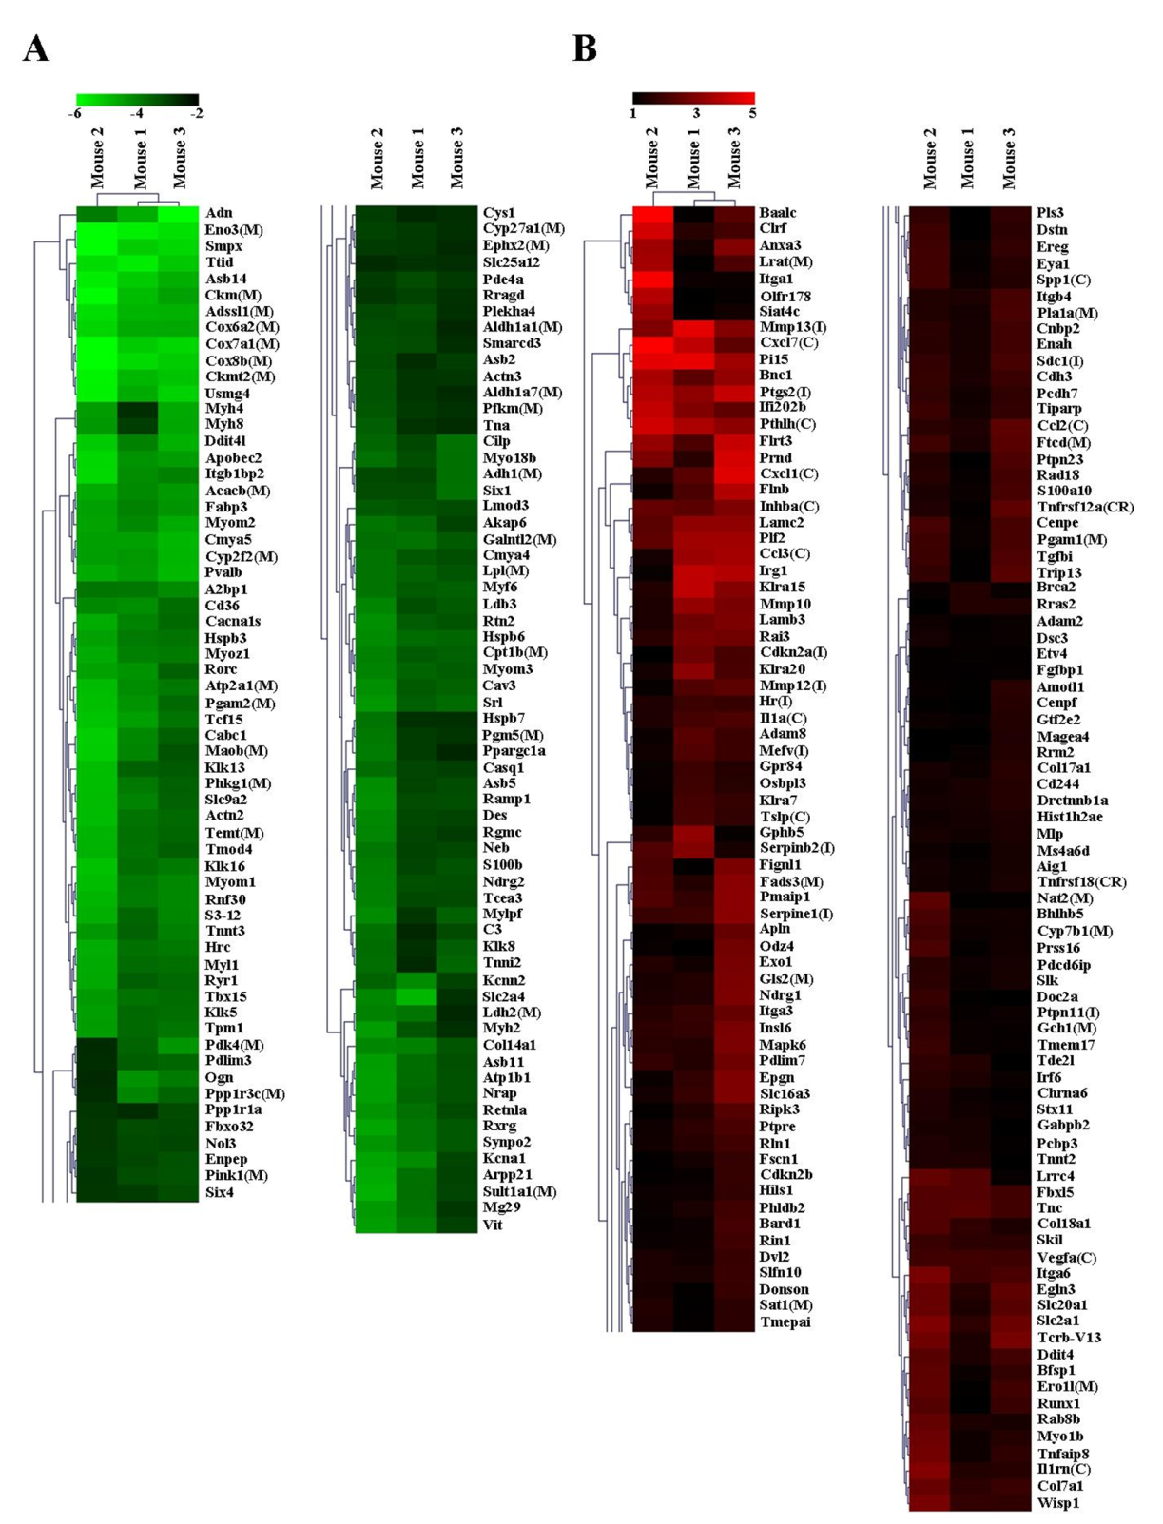
Figure 2.
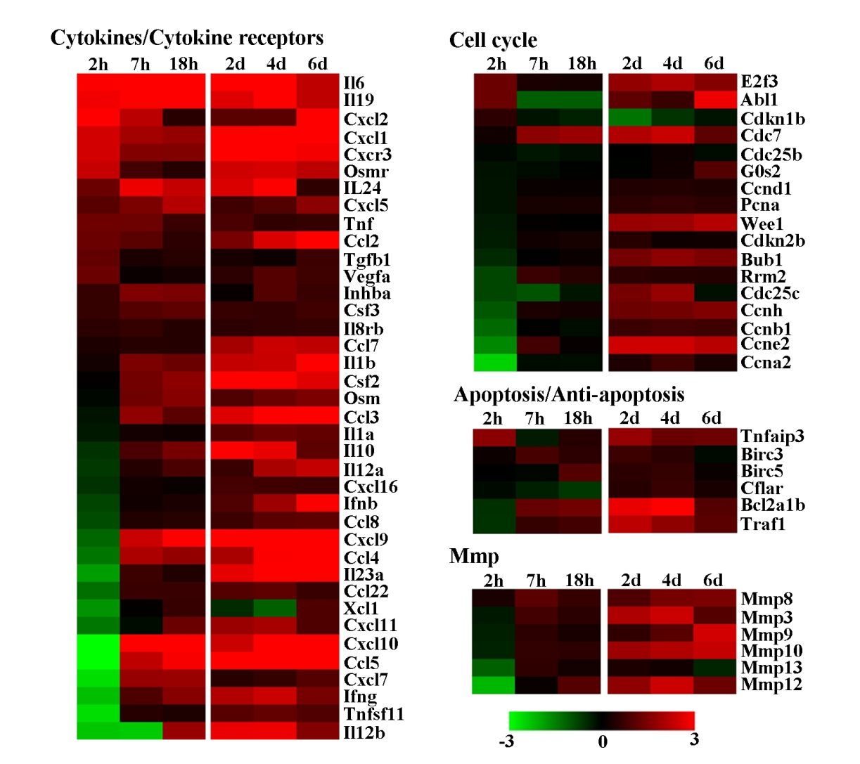
Figure 3.
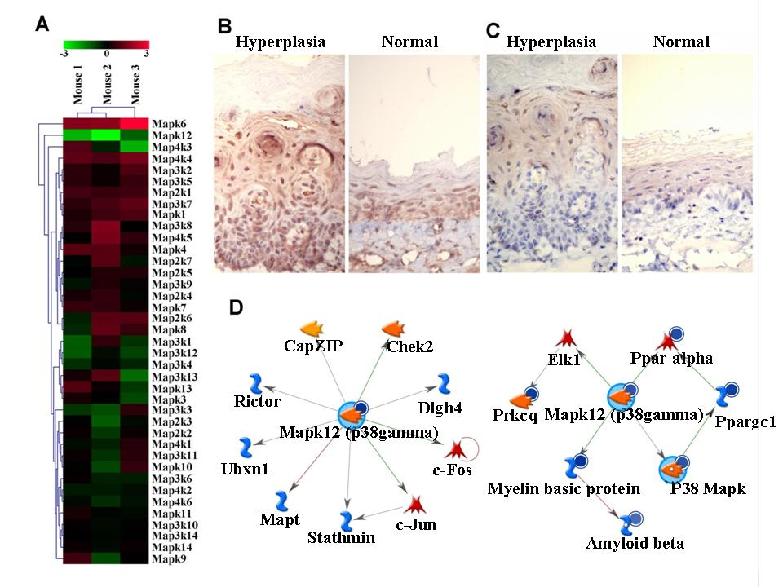
Figure 4.
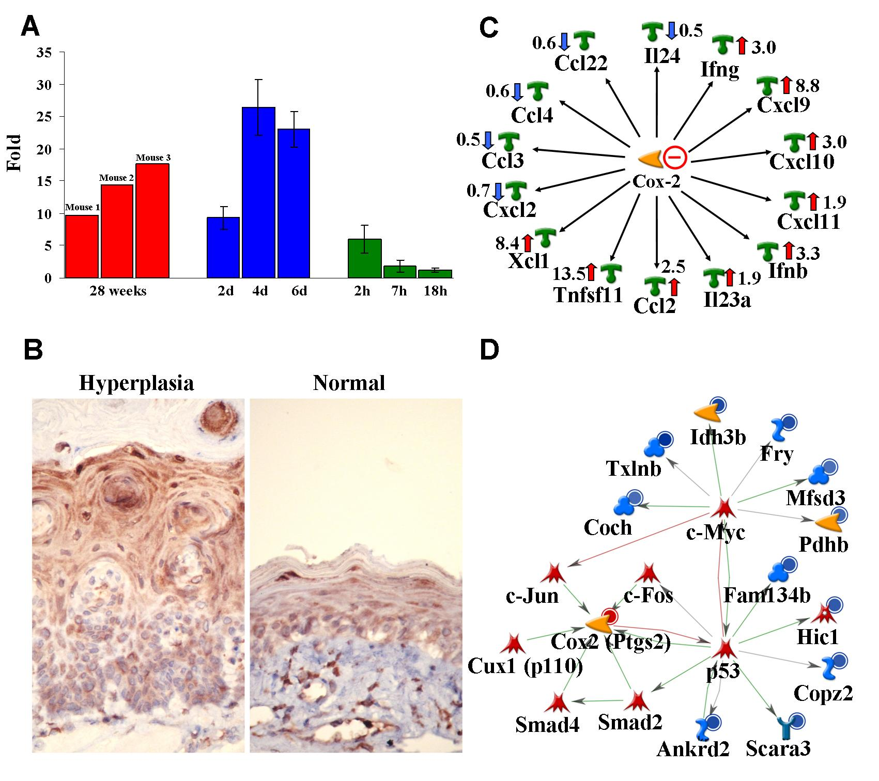
Figure 5.
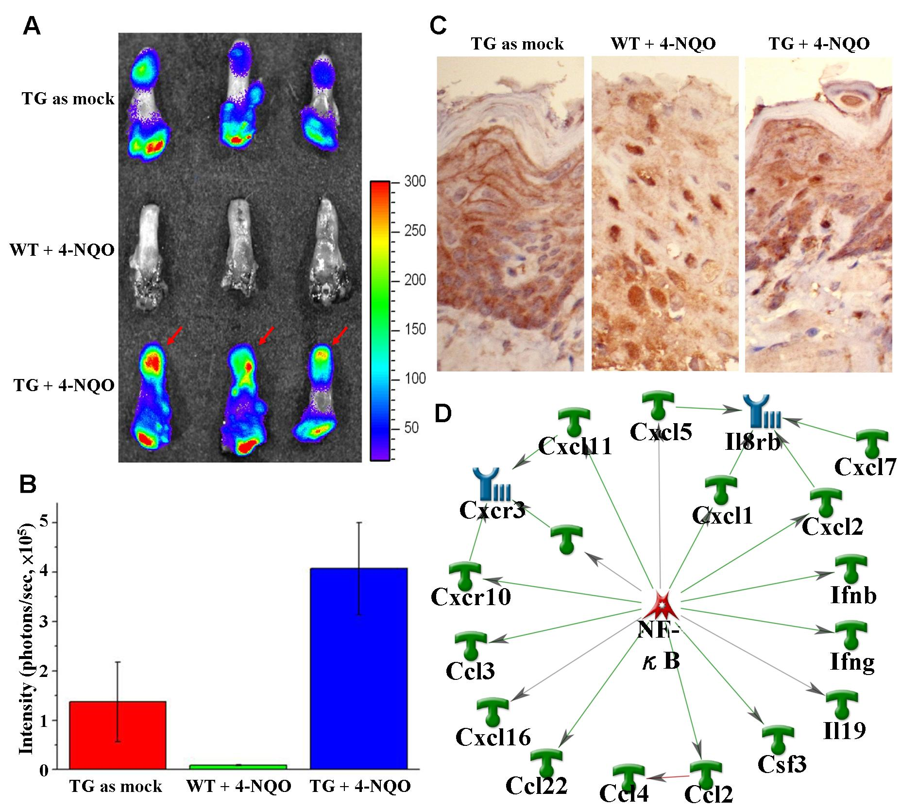
Figure legends in the supplementary online data.
Fig. S1. Scatter plot analysis. The normalized expression ratio for all genes, between the tumor and paired non-tumor tissue, in scatter plot analysis was converted to log2 base and designated as mouse numbering 1, 2, and 3 in X- and Y-axis. R, correlation coefficient.

Fig. S2. Dysregulation of genes involved in the β-oxidation of long-chain fatty acid. Reduced genes, with a normalized expression ratio of ≦0.5 between the tumor and paired non-tumor tissues in all three mice numbered at the top are indicated in blue. Abbreviation: Z, catalysis; CS, complex subunit.

Fig. S3. Alteration of Ppar signaling pathway and 9-cis-retinoic acid production. (A) In the Ppar signaling pathway, the reduced heterodimer of both Pparα and Rxrg caused ineffective activation of downstream genes involved in the lipid transport and metabolism on the right. The 9 reduced downstream genes observed are indicated in bold. (B) Production of 9-cis-retinoic acid was possibly decreased due to marked reduction of genes Adh1, Aldh1a1, and Aldh1a7. The 3 reduced genes and 2 induced genes are indicated as in (A). Both pathways were slightly modified from the corresponding ones in the KEGG pathway.

Fig. S4. Reduction of genes involved in the respiratory process. This figure was divided into the upper and lower parts showing the reduction of the components in complex I and complex IV, respectively.

Supplemental Figure S1
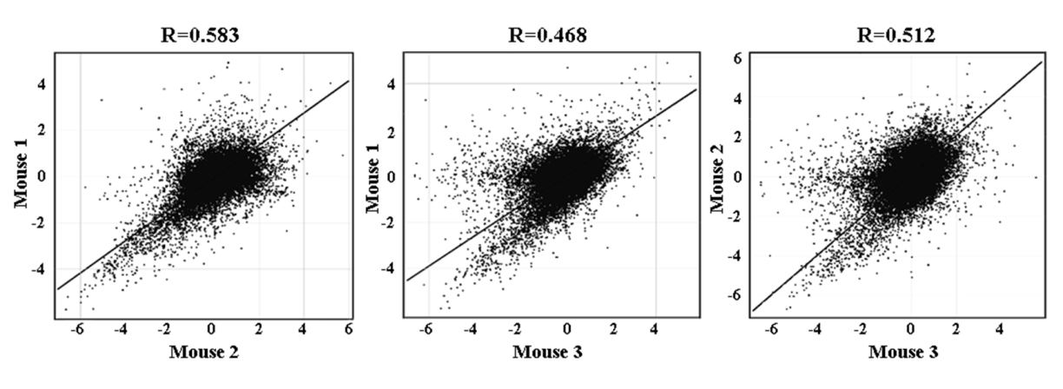
Supplemental Figure S2
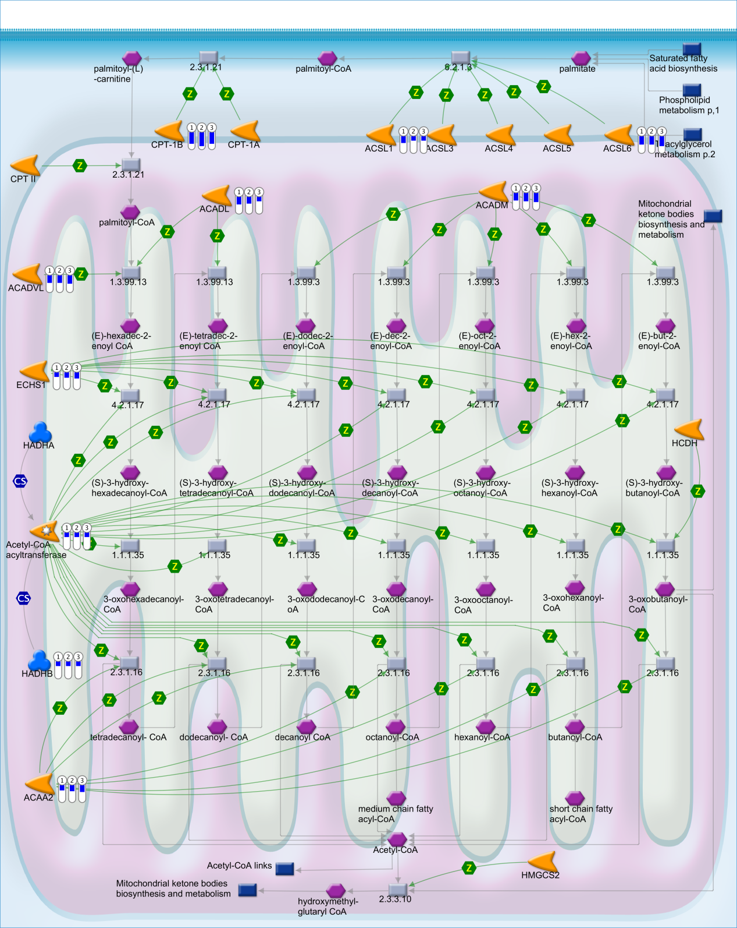
Supplemental Figure S3
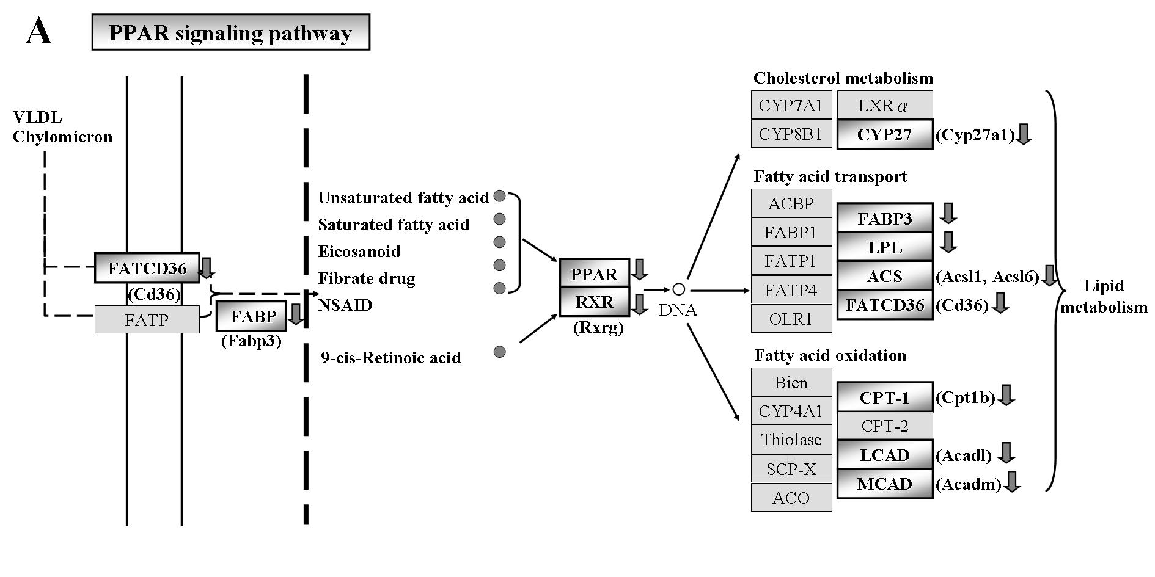
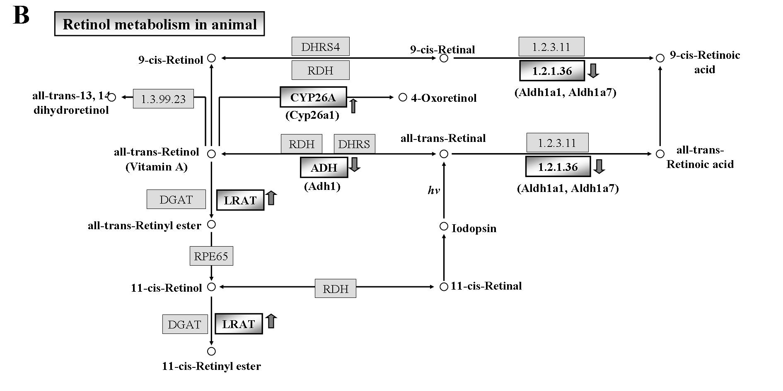
Supplemental Figure S4
