OriginalArticle:
Moutan Cortex Radicis Improves Lipopolysaccharide-induced Acute Lung Injury in Rats through Anti-inflammation

Pin-Kuei Fu^{1,2}; Chi-Tu Yang³; Tung-Hu Tsai⁴; Ching-Liang Hsieh^{5,6,7*}

¹Division of Critical Care & Respiratory Therapy, Department of Internal Medicine, Taichung Veterans General Hospital, Taichung, 40407, Taiwan
²Graduate Institute of Chinese Medical Science, College of Chinese Medicine, China Medical University, Taichung, 40402, Taiwan
³Division of Animal Medicine, Animal Technology Institute Taiwan, Miaoli, 35053, Taiwan
⁴Institute of Traditional Medicine, School of Medicine, National Yang-Ming University, Taipei, 11221, Taiwan
⁵Department of Chinese Medicine, China Medical University Hospital, Taichung, 40402, Taiwan
⁶Graduate Institute of Acupuncture Science, College of Chinese Medicine, China Medical University, Taichung, 40402, Taiwan
⁷Acupuncture Research Center, China Medical University, Taichung, 40402, Taiwan

*Correspondence should be addressed to Dr. Ching-Liang Hsieh, Graduate Institute of Acupuncture Science, College of Chinese Medicine, China Medical University, 91 Hsueh-Shih Road, Taichung 40402, Taiwan, R. O. C.

Running title: Effect of Moutan Cortex Radicis on LPS-induced acute lung injury in rats

Keywords: Moutan Cortex Radicis (MCR); Lipopolysaccharide (LPS); Acute lung injury (ALI); Anti-inflammation.
Abstract
Moutan Cortex Radicis (MCR) is a Chinese herbal medicine that was widely used over a long period as an analgesic, antipyretic, and anti-inflammatory agent in China. Lipopolysaccharide (LPS)-induced acute lung injury (ALI) in rat models is considered similar to adult respiratory distress syndrome (ARDS) in humans. Therefore, the present study investigates the effect of MCR on ALI. The ALI model was developed through the intra-tracheal (IT) administration of LPS (16 mg/kg) to Sprague-Dawley (SD) rats, which formed the LPS group. MCR was orally administered before and after LPS was introduced into rats (MCR-LPS group and LPS-MCR group, respectively). In the MCR-LPS group, rats received MCR 2 g/kg/times 3 times before LPS challenge; the LPS-MCR group received MCR 2 g/kg/times 3 times after LPS challenge. The results of this experiment indicate that the number of total cells and neutrophils and the concentration of protein exudation in bronchoalveolar lavage fluid (BALF) significantly decreased in the MCR-LPS group. Cytokine levels, including levels of interleukin (IL)-1β, macrophage-inflammatory peptide (MIP)-2, IL-6, and IL-10, in BALF were also significantly inhibited at 16 h after LPS administration in the MCR-LPS group. Myeloperoxidase (MPO) activity in lung tissue was reduced in the MCR-LPS and LPS-MCR groups at 16 h after LPS administration. Furthermore, leukocyte infiltration and protein exudation in the alveolar space were less severe in the MCR-LPS group than in the LPS group. Therefore, the findings of this study suggest that the administration of MCR prior to LPS improves ALI, possibly mediating ALI through anti-inflammation.
Introduction
Acute lung injury (ALI) and acute respiratory distress syndrome (ARDS) are responsible for significant morbidity and mortality in critically ill patients (Ware and Matthay, 2000). Inflammatory cascades developed in the lungs are the major manifestations of ALI and ARDS. These inflammatory responses can be summarized as polymorphonuclear neutrophil (PMN) accumulation (Abraham et al., 2000; Chignard and Balloy, 2000; Kinoshita et al., 2000; Abraham, 2003), disruption of epithelial integrity, interstitial edema, and protein exudation leakage into the alveolar space (Ware and Matthay, 2000; Dreyfuss and Ricard, 2005; Sapru et al., 2006). Several animal models, including models with in vivo intra-tracheal (IT) administration of lipopolysaccharide (LPS), have been developed to study the pathophysiologic mechanism of ARDS. These models possess high clinical relevance (van Helden et al., 1997; Matute-Bello et al., 2008; Wang et al., 2008) and have been successfully implemented in our previous studies (Wu et al., 2009a; Wu et al., 2009b; Pin-Kuei Fu, 2012). LPS-induced ALI is considered a neutrophil-dependent ALI that contributes to local recruitment and activation of neutrophils (Sheridan et al., 1997; Abraham et al., 2000; Kinoshita et al., 2000; Abraham, 2003); the release of pro-inflammatory cytokines (Schutte et al., 1996; Matthay et al., 1999; Bauer et al., 2000; Shinbori et al., 2004), such as tumor necrosis factor (TNF)-α, Interleukine (IL)-1β, and IL-6; and the formation of reactive oxygen and nitrogen species (Schutte et al., 1996; Matthay et al., 1999; Williams et al., 1999; Nys et al., 2002). Neutrophil recruitment in the lungs is regarded as a histological hallmark in the progression of ALI (Reutershan and Ley, 2004; Balamayooran et al., 2010; Grommes and Soehnlein, 2011). In rat models with ALI and ARDS, macrophage-inflammatory peptide-2 (MIP-2, also called CXCL2) plays a crucial role in neutrophil accumulation in the lungs (Gupta et al., 1996; Olson and Ley, 2002; Abraham, 2003; Reutershan and Ley, 2004). Whereas MIP-2 (CXCL2) has been suggested as the most important chemoattractant for neutrophil recruitment, TNF-α and IL-1β have been determined to increase the expression of cell adhesion molecules. Activated and recruited neutrophils contribute to increases in protease activity (e.g., myeloperoxidase (MPO) and lysozyme activity) and promote the formation of various oxygen metabolites, finally leading to diffused alveolar matrix damage (Zemans et al., 2009).
Recently, increasing evidence has been presented concerning the connection between coagulation and inflammation in ALI and ARDS (Sapru et al., 2006; Schultz et al., 2006; Slofstra et al., 2006; Ware et al., 2006). High levels of pro-inflammatory cytokines, such as TNF-α, IL-1β, and IL-6, are released during ALI and ARDS, leading to an inflammatory cascade and simultaneously triggering pulmonary coagulopathy (Ware et al., 2005; Sapru et al., 2006; Schultz et al., 2006; Wygrecka et al., 2008). The coagulation cascade is possibly activated because the inflammatory cascade stimulates tissue factor (TF) expression, attenuates fibrinolysis by stimulating the release of plasminogen activator inhibitors (PAI), and finally causes fibrin deposition in the airspaces and lung microvasculature (Levi and Ten Cate, 1999; Abraham, 2000; Ware et al., 2005; Bastarache et al., 2006; Wygrecka et al., 2008). Although pulmonary coagulopathy is now accepted as a new target in the treatment of ALI and ARDS (Schultz et al., 2006; Ware et al., 2006), no effective medicines currently approved by the Food and Drug Administration (FDA) are available to treat these severe diseases.
Moutan cortex Radicis (MCR), the root cortex of Paeonia suffruticosa Andrews, is widely applied as an analgesic, antipyretic, and anti-inflammatory agent in traditional Chinese medicine (TCM; Lin et al., 1999; Tatsumi et al., 2004). In TCM, MCR has been shown to alleviate sickness in humans by eliminating heat, promoting blood flow, and removing blood stasis. Previous studies have demonstrated that MCR has a scavenging effect on free radicals and superoxide anion radicals (Yoshikawa et al., 2000), inhibits the production of ROS and oxidative stress by over-expression of heme oxygenase (HO) and cathechol-O-methyltransferase (COMT) (Rho et al., 2005), and restrains oxidative DNA cleavage (Okubo et al., 2000). MCR is also reported to inhibit eosinophil migration (Kim et al., 2007) and the secretion of IL-8 and monocyte chemotactic protein (MCP)-1 (Oh et al., 2003). The major chemical components of MCR include paeonol, paeonoside, paeonolide, and paeoniflorin (Rho et al., 2005). Paeonol, a major phenolic component of MCR, is reported to improve blood circulation by inhibiting both platelet aggregation and blood coagulation (Hirai et al., 1983; Koo et al., 2010), and to inhibit the expression of cell surface adhesion molecules (Nizamutdinova et al., 2007), pro-inflammatory cytokines such as TNF-α and IL-1β (Hsieh et al., 2006; Pan and Dai, 2009), and reactive oxygen species production (Hsieh et al., 2006; Chae et al., 2009). In addition, recent research performed by the authors of this study has demonstrated that paeonol attenuates LPS-induced ALI through anti-inflammatory and anti-coagulative effects (Fu et al., 2012). However, the paeonol component of MCR employed in our previous study was dissolved in DMSO solution and administered through intra-peritoneal injection. Consequently, this study investigates MCR’s effects and mechanisms when a subtle granular extract formula of MCR widely used in Taiwanese clinical settings to treat ALI is employed as well as the effects of MCR administration before and after LPS challenge.

Materials and Methods
2.1 Reagents
Almost all reagents and media used in this study were purchased from Sigma Chemical (Deisenhofen, Germany), except for specific cytokines. Lipopolysaccharide (LPS; Escherichia coli 0055:B5, Sigma Chemical) was purchased from Sigma Chemical (St. Louis, MO, USA). Pro-inflammatory cytokines, such as TNF-α (BMS622MST, BenderMedsytem), IL-1β (BMS630, BenderMedsystem), and IL-6 (BMS625MST, BenderMedsystem), were purchased from Bender MedSystems (Vienna, Austria). IL-10 (14-8101-62, eBioscience) was purchased from eBioscience Systems (San Diego, CA, USA). MIP-2 (#KRC1022) was purchased from BioSource International, Inc (CA, USA). TATC (ET1020-1 Lot No. 1259916R1) and PAI-1 (Catalog # RPAIKT-TOT) were purchased from Molecular Innovations, Inc (Novi, MI, USA).
2.2 Preparation of MCR
Subtle granular MCR extract (MU DAN PI; KO DA; Product number: 420701903) was obtained from Koda Pharmaceuticas Ltd (Taoyuan, Taiwan). During preparation, 4.34 g of crude MCR was made into 0.67 g of plaster, and the ratio of crude MCR to plaster MCR was 6.5:1. Finally, the plaster was added to 0.33 g of starch to become subtle granular MCR extract.
2.3 High performance liquid chromatography (HPLC) system
Paeonol and paeoniflorin, the major chemical components of MCR, served as the authenticator and quality proof of this drug were used for the chromatographic fingerprint analysis. The plaster was identified using a HPLC system (interface D-7000, Pump L-7100, UV-Vis Detector L-7455, Autosampler L-7200, Hitachi Instruments Service Co. Ltd., Ibaraki-ken, Japan). Separation was carried out on a Mightysil RP-18 reversed-phase column (5μm, 250 mm x 4.6 mm). For paeonol analysis (paeonol as a standard from the laboratory room of Professor Tsai, National Yang-Ming University, Taipei, Taiwan), the mobile phase was set at 38% acetonitrile (mixed with 62% of 0.03% H₃PO₄) with the flow rate 1 ml/min, the column temperature was 30℃ and the detection wave-length was set at 274 nm. For paeoniflorin analysis (paeoniflorin as a standard from China National Institutes for Food and Drug control), the mobile phase was started with 16% acetonitrile (mixed with 62% of 0.03% H₃PO₄) for 25 min with the flow rate 1 ml/min, the column temperature was 30℃ and the detection wave-length was set at 230 nm. The percentage of acetonitrile was increased to 30 % at 25 min, 50% at 30~45 min and finally to 16% at 50 min. A 20 μL injection valve (Rheodyne) was used in all analyses.
The aristolochic acid of MCR was authenticated by using the aristolochic acid (SIGMA, USA) which contains 40% of aristolochic acid I (AA-I) as a standard. All analyses were performed on a HITACHI L-7000 liquid chromatographic system which consisted of a pump (L-7100), a column thermostat, a model 7725i injection value (sample loop 20 μL) and a UV detector (L-7455). The analysis was carried out on a Mightysil RP-18 (GP 250 mm×4.6 mm, 5 μm) column at 30ºC. The mobile phase was a mixture of acetonitrile (45%) and NaH2PO4 buffer (55%, add 6.9g of NaH₂PO₄ into 2ml of 85% H₃PO₄ to a total volume of 1000 ml) with isocratic elution at a flow rate of 1.0 mL/min. The column eluate was monitored at 400 nm. The injection volume was 10 μL.
HPLC fingerprint analysis of paeonol, paeoniflorin and aristolochic acid from subtle granular MCR extract was marker in the Figure 2a-f. Therefore, there has components of paeonol and paeoniflorin in the subtle granular MCR extract, but no aristolochic acid component was detected. Each gram of the extract contained 0.67 g of MCR and an 8.68 mg dose of paeonol, and 15.79 mg dose of paeoniflorin.
2.4 Effects of MCR on LPS-induced ALI
2.4.1 Animals and experimental design
During the animal study, pathogen-free Sprague-Dawley (SD) rats, weighing approximately 250 g to 300 g were obtained from BioLASCO Taiwan Co., Ltd (Taipei, Taiwan). The rats were housed in climate-controlled quarters with a 12-h light and dark cycle and free access to food and water. Animal experiments were conducted according to principles presented in the Guide for the Care and Use of Laboratory Animals, and were approved by the Animal Study Protocol Review Board of Taichung Veterans General Hospital. The rats were randomly divided into 4 groups, and each group consisted of at least 6 rats. Some animals were challenged with IT administration of 16 mg/kg LPS dissolved in 0.5 ml PBS (n=6), whereas others were treated with 3 consecutive doses of orally administered MCR (2 g/Kg) before (n=6) and after (n=6) LPS challenge. The control group received intra-tracheal instillation of PBS only (0.5 ml PBS; n=6). The pre-LPS treatment group was treated with MCR (2 g/Kg, dissolved in 2 ml of distilled water). Groupings and experimental designs are shown in Figure 1. Prior to the experiment, body weight and rectal temperature (RT) were record; the animals were then anesthetized using inhaled 2% isoflurane (Halocarbon Laboratories Div Halocarbon Products Crop, River Edge, NJ) in 0.5 l/min O₂. Following anesthesia, an IT spray was administered by inserting a MicroSprayer® Aerosolizer (Model IA-1B, Penn-Century, Inc., Wyndmoor, PA, USA) into the trachea under visual guidance. The micro-sprayer was then removed and the animals were placed in a vertical position and rotated for 30 s to let the spray distribute evenly throughout the lungs as described in a previous study ( Fu et al., 2012). Sixteen hours after inoculation, RT was measured again and rats were then sacrificed using CO₂ asphyxiation.
2.4.2 Cell counts and total protein assay in bronchoalveolar lavage (BAL)
Sixteen hours after LPS administration, animals were anesthetized through the inhalation of 2% isoflurane in 0.5 l/min O₂, and the thoracic cages of the rats were carefully opened after they were sacrificed. The right main bronchus was subsequently ligated and a catheter was inserted from the trachea into the left lung. Eight milliliters of warm saline (37 °C) was run through the catheter 3 times. Resulting bronchoalveolar lavage fluids (BALF) were then passed through mesh (200 μm) to remove mucus, and centrifugation (1500 g) at 4 °C for 15 min followed. The resulting pellets were re-suspended in 2 ml PBS. Erythrocytes were lysed using cold water and a hypertonic recovery solution (10x HBSS). The erythrocyte-free cell suspension was then washed once using 1x PBS and was employed for total cell count. Finally, 2×10⁵ BALF-derived cells were evenly distributed onto a cytospin slide and then stained with Liu’s stain for 2 min to perform further cell counting under a microscope (Wu et al., 2009a). The resulting supernatants were stored at -70 °C until the analysis stage. The total protein concentrations in BALF were measured using a bicinchoninic acid (BCA) assay according to company protocol (Bradford protein assay, Bio-Rad, Hercules, CA, USA).
2.4.3 The determination of cytokine levels in BALF
Cytokine levels in BALF, such as those for TNF-α (BMS622MST, BenderMedsystem), IL-1β (BMS630, BenderMedsystem), IL-6 (BMS625MST, BenderMedsystem), MIP-2 (#KRC1022), and IL-10 (14-8101-62, eBioscience), were measured using commercially available ELISA kits and in accordance with manufacturer protocol (Assay Designs, Inc. MI, USA). BALF supernatants were added to pre-coated monoclonal antibody microelisa wells and were measured using a micro-plate reader (Microplate Reader BIO-RAD Laboratories, CA, USA) at 450 nm for 15 min. Concentrations of BALF cytokines were measured by comparing the absorbance of standards, and expressed as picograms per milliliter (pg/mL).
Thrombin-anti-thrombin complexes (TATC) were used as a measure of coagulation through the tissue factor pathway; a high TATC level reflects the activation of the coagulation system (Weijer et al., 2004; Slofstra et al., 2006). TATC levels in BALF were measured using the TATC enzyme-linked immunosorbent assay Micrognost kit and by following suggestions from the manufacturer’s instructions (AssayMax human thrombin-antithrombin TAT complex ELISA kit, ET1020-1 Lot No. 1259916R1). The levels of plasminogen activator inhibitor (PAI-1) antigen in BALF were measured by applying a Rat PAI-1 total antigen assay ELISA kit (Catalog # RPAIKT-TOT, Molecular Innovations, MI, USA) according to the manufacturer’s instructions.
2.4.4 Measurement of MPO activity in lung tissue
The level of MPO in lung tissue, a marker of neutrophil infiltration (Abraham, 2003; Zemans et al., 2009), was also measured. Right lung tissues (1 gm) were homogenized in approximately 1.5-4.0 N-ethylmaleimide (Sigma) for 30 s on ice and were then centrifuged at 1.2x10⁴ g for 30 min at 4 °C. The resulting pellet was re-suspended in 4 mL of potassium phosphate buffer (50 mM, pH 6.0) with 0.5% hexadecyltrimethylammonium bromide (HTAB). The sample was sonicated for approximately 30 s-90 s on ice. It was then incubated at 60 °C for 2 h to deactivate tissue MPO inhibitors, and was then centrifuged at 1.2x10⁴ g for 10 min. The supernatant fluids containing MPO were incubated in a 50 mM potassium phosphate buffer (KH₂PO₄, PH 6.0) containing H₂O₂ (1.5 M) and o-dianisidine dihydrochloride (167 mg/ml; Sigma-Aldrich, USA) as substrate for 30 min. Enzymatic activity was determined spectrophotometrically using a 96-well plate reader to measure the change in absorbance at 460 nm.
2.4.5 Assessment of histopathological changes
The right lungs of the rats were fixed with 10% paraformaldehyde through trachea infusion and embedded with paraffin. Hematoxylin and eosin (H&E) staining was conducted using 4-µm tissue slides. Lung injury assessment was conducted following the modified scoring system described by Kristof et al. (Kristof et al., 1998). In brief, two experienced pulmonologists randomly selected 10 fields of lung sections from 3 lobes of right lung tissue for each rat, and used a microscope at 200x magnification to read and score the damaged levels in these sections according to the presence and extent of interstitial cellular infiltration, alveolar protein exudation, and tissue hemorrhage as previously performed in a series of studies written by the authors of the present work (Wu et al., 2009a; Wu et al., 2009b; Fu et al., 2012). The sum of each category from 10 different microscopic fields was recorded as the final damaged score for a rat. The total lung injury score for each rat was determined as the sum of 3 individual scores for alveolar cellularity, protein exudation, and tissue hemorrhage. If the interpretations of the two physicians differed significantly, the slides were checked by a pathologist.
2.5 Statistical Analysis
All data were expressed as mean ± SEM using in vivo data from at least 6 rats. Statistical analysis of the data was conducted using Prism 3.02 software (GraphicPad Software Inc., CA, USA), and one-way ANOVA was applied for multiple comparisons (post hoc Tukey test). Results of p < .05 were considered statistically significant.
Results
3.1 Effects of MCR on RT in LPS-induced ALI rats
The RT in the LPS group at 16 h after LPS administration was lower than that at the baseline (0 h) (p < .05; Figure 3), whereas the RT at 16 h in the MCR-LPS and LPS-MCR groups was similar to RT at the baseline (both p > .05; Figure 3). The RT at 16 h after LPS administration in the PBS group was higher than that at the baseline (p <.05; Figure 3).
3.2 Effects of MCR on BALF leukocyte accumulation and protein exudation in LPS-induced ALI rats
The total leukocyte counts in BALF were higher in the LPS group than in the PBS group at 16 h after LPS administration (p < .05; Figure 4a), and total BALF leukocyte counts were lower in the MCR-LPS and LPS-MCR groups than in the LPS group at 16 h (both p < .05; Figure 4a). The total leukocyte counts for BALF were lower in the MCR-LPS group than in the LPS-MCR group (p < .01; Figure 4a).
The total PMN counts in BALF were higher in the LPS group than in the PBS group at 16 h after LPS administration (p < .05; Figure 4b), and total counts were lower in the MCR-LPS and LPS-MCR groups than in the LPS group at 16 h (both p < .05; Figure 4b). Total PMN counts for BALF were lower in the MCR-LPS group than in the LPS-MCR group (p < .01; Figure 4b).
The protein concentration for BALF was higher in the LPS group than in the PBS and MCR-LPS groups at 16 h after LPS administration (both p < .05; Figure 4c). BALF protein concentration in the LPS-MCR group was similar to that in the LPS group (p > .05; Figure 4c) and also similar to that in the MCR-LPS group (p > .05; Figure 4c).
3.3 Effect of MCR on BALF cytokine levels in LPS-induced ALI rats
The TNF-α level for BALF at 16 h after LPS administration in the LPS group was similar to that found in the PBS, MCR-LPS, and LPS-MCR groups (all p > .05; Figure 5a). The BALF TNF-α level was not significantly different between the PBS and MCR-LPS groups, between the PBS and LPS-MCR groups, or between the MCR-LPS and LPS-MCR groups at 16 h after LPS administration (all p > .05; Figure 5a).
The IL-1β level in BALF was higher in the LPS group than in the PBS and MCR-LPS groups at 16 h after LPS administration (both p < .05; Figure 5b), and this level was not significantly different between the PBS and MCR-LPS groups, between the PBS and LPS-MCR groups, or between the MCR-LPS and LPS-MCR groups at 16 h (all p > .05; Figure 5b).
The MIP-2 level for BALF was higher in the LPS group than in the PBS and MCR-LPS groups at 16 h after LPS administration (both p < .05; Figure 5c), and this level was lower in the MCR-LPS group than in the LPS-MCR group at 16 h (p < .05; Figure 5c). The MIP-2 level was not significantly different between the PBS and MCR-LPS groups or between the PBS and LPS-MCR groups (both p > .05; Figure 5c).
The IL-6 level for BALF was higher in the LPS group than in the PBS, MCR-LPS, and LPS-MCR groups at 16 h after LPS administration (all p < .05; Figure 5d). Furthermore, the level was not significantly different between the PBS and MCR-LPS groups, between the PBS and LPS-MCR groups, or between the MCR-LPS and LPS-MCR groups at 16 h (all p > .05; Figure 5d).
The IL-10 level for BALF was higher in the LPS group than in the PBS and MCR-LPS groups at 16 h after LPS administration (both p < .05; Figure 5e). This level was not significantly different between the PBS and MCR-LPS groups, between the PBS and LPS-MCR groups, or between the MCR-LPS and LPS-MCR groups at 16 h (all p > .05; Figure 5e).
3.4 Effect of MCR on BALF TATC and PAI-1 levels in LPS-induced ALI rats
The BALF TATC level at 16 h after LPS administration in the LPS group was similar to that discovered in the PBS, MCR-LPS, and LPS-MCR groups (all p > .05; Figure 6a). Furthermore, this level was not significantly different between the PBS and MCR-LPS groups, between the PBS and LPS-MCR groups, or between the MCR-LPS and LPS-MCR groups at 16 h after LPS administration (all p > .05; Figure 6a).
The BALF PAI-1 level was higher in the LPS group than in the PBS group at 16 h after LPS administration (p < .05; Figure 6b). This level was not significantly different between the PBS and MCR-LPS groups, between the PBS and LPS-MCR groups, or between the MCR-LPS and LPS-MCR groups at 16 h (all p > .05; Figure 6b).
3.5 Effect of MRC on MPO activity in lung tissue for LPS-induced ALI rats
MPO activity in lung tissue was greater in the LPS group than in the PBS, MCR-LPS, and LPS-MCR groups at 16 h after LPS administration (all p < .05; Figure 7), and MPO was not significantly different between the PBS and MCR-LPS groups, between the PBS and LPS-MCR groups, or between the MCR-LPS and LPS-MCR groups at 16 h (all p > .05; Figure 7).
3.5 Effects of MCR on histopathological changes in the lungs of LPS-induced ALI rats
Histopathological changes in lung tissue were observed 16 h after LPS administration. In the PBS group, fluid and protein accumulation and the infiltration of inflammatory cells and red blood cells was not prominent in the alveolar space (Figures 8a and 8b). By contrast, the alveolar space for rats in the LPS group demonstrated fluid and protein accumulation, large amounts of inflammatory cells, and red blood cell infiltration (Figures 8c and 8d). When MCR was administered orally before LPS challenge (MCR-LPS group), inflammatory cell infiltration and alveolar wall thickening were markedly attenuated and alveolar edema was reduced (Figures 8e and 8f). However, when MCR was administered orally after LPS challenge (LPS-MCR group), marked alveolar hemorrhage and moderate alveolar edema were induced, despite some attenuation in leukocyte infiltration (Figure 8g and 8h). A semi-quantitative analysis of the histopathological scores for rat lungs is shown in Table 1.

Discussion
The results of the present study indicate that treatment with MCR before LPS challenge can reduce histopathological damage scores in LPS-induced ALI rat models, whereas similar results cannot be obtained with MCR treatment after LPS challenge. Pre-treatment with MCR down-regulated the level of the pro-inflammatory cytokines IL-1β and IL-6 as well as the chemokine MIP-2, and also reduced the infiltration of activated PMN and protein-rich exudation in BALF (i.e., the alveolar space). In addition, MPO activity decreased in lung tissue because of MCR treatment. Therefore, we suggest that MCR reduces lung tissue damage in LPS-induced ALI rat models. This effect of MCR is closely related to its anti-inflammatory effects. The results of the present study were also somewhat similar to our previous findings that paeonol (a component of MCR) can inhibit the migration of neutrophils from capillaries into lung tissue, and that it enhances the phagocytotic ability of neutrophils in alveolar space (these results are as of yet unpublished).
Several animal models have been developed to mimic the pathophysiology of ALI after LPS exposure (van Helden et al., 1997; Matute-Bello et al., 2008; Wang et al., 2008). In the present study, we produced a consistent and reproducible rat model to investigate the protective and therapeutic effects of MCR on ALI by delivering LPS directly into the airways of rats in our laboratory (Wu et al., 2009a; Wu et al., 2009b; Fu et al., 2012). Similar to findings from our previous studies, an IT challenge with a high dose of LPS (16 mg/kg) induced hypothermia at 16 h after LPS administration (Fu et al., 2012). The results of the in vivo study indicate that MCR treatment (both pre-LPS and post-LPS treatment) reduce the drop in RT that typically follows LPS challenge. Hypothermia may be an early indicator of sepsis; thus, MCR may play a critical role in preventing sepsis development. The finding that MCR regulates RT after LPS challenge is similar to results presented in our recently published study, which evaluated the effect of paeonol on LPS-induced ALI in rats (Fu et al., 2012).
Numerous studies have provided circumstantial evidence that neutrophil recruitment in lungs is a histological hallmark of ALI (Balamayooran et al., 2010; Grommes and Soehnlein, 2011). The early effects of ALI in humans on pulmonary histopathological changes are characterized by marked accumulation of neutrophils, disruption of epithelial integrity, interstitial edema, and leakage of a large amount of protein into alveolar spaces (Abraham et al., 2000; Chignard and Balloy, 2000; Kinoshita et al., 2000; Ware and Matthay, 2000). Administration of LPS through an intra-alveolar route serves as a model of typical neutrophil-dependent ALI, and induces adhesion and migration of neutrophils from pulmonary capillaries into the alveolar space. In the present study, we demonstrated that treatment with MCR (both pre-LPS and post-LPS treatment) significantly attenuated total cell and neutrophil counts in BALF. A comparison of the MCR-LPS group to the LPS-MCR group demonstrates that pre-treatment with MCR suppresses neutrophil infiltration into and protein-rich fluid flooding of the airspace more significantly than post-treatment (Figure 3).
High levels of pro-inflammatory cytokines, such as TNF-α, IL-1β, and IL-6, perform a central role in the initiation and propagation of the inflammatory cascade in LPS-induced ALI (Schultz et al., 2006; Matute-Bello et al., 2008). Cytokines, such as TNF-α, IL-1β, IL-6, IL-8, and IL-10, that are secreted by alveolar macrophages stimulate more chemotaxis and attract more neutrophils to injured lungs (Strieter and Kunkel, 1994; Kobayashi et al., 1998; Williams et al., 1999; Ware and Matthay, 2000; Shinbori et al., 2004). It has also been suggested that MIP-2 (CXCL2) is the most essential chemoattractant for neutrophil recruitment in the LPS-induced model (Olson and Ley, 2002; Grommes and Soehnlein, 2011). Figure 4 shows that the expression of IL-1β, MIP-2, IL-6, and IL-10 in BALF was significantly lower in the MCR-LPS group than in the LPS group at 16 h after LPS challenge. These reductions may have contributed to the decreased neutrophil count in BALF in the LPS-induced ALI model treated with MCR before LPS challenge. However, in a comparison of the post-LPS treatment group (LPS-MCR) and the LPS group, cytokine levels (except those for IL-6) in BALF in the LPS-MCR group were not significantly lower than those in the LPS group. In addition, MIP-2 expression in the MCR-LPS group was significantly lower than that in the LPS-MCR group. These differences in cytokine expression in BALF may have contributed to the varying effects of pre-treatment and post-treatment with MCR.
Another major pathologic feature of ALI is the deposition of fibrin and platelet plugs, which induces the occlusion of microvasculature in the alveolar space (Ware and Matthay, 2000). When excessive fibrin is deposited in airways, neutrophils and fibroblasts may be further activated. This scenario compromises gas exchange and pulmonary endothelial integrity, decreases alveolar fluid clearance, and finally leads to pulmonary microcirculation damage and death (Sapru et al., 2006). Pulmonary coagulopathy is now accepted as a target in therapeutic studies of acute lung injury or pneumonia (Schultz et al., 2006; Ware et al., 2006; Wygrecka et al., 2008). Available data suggest that high levels of pro-inflammatory cytokines, such as TNF, IL-1β, and IL-6, may activate coagulation cascade by stimulating TF expression. High levels of these cytokines may also attenuate fibrinolysis by stimulating the release of PAI (Abraham, 2000; Ware et al., 2005; Bastarache et al., 2006; Wygrecka et al., 2008). Our previous data showed no significant difference in TATC levels in BALF after paeonol treatment, but demonstrated significantly decreased BALF PAI-1 levels after this treatment (Fu et al., 2012). As shown in Figure 5, treatment with MCR before or after LPS challenge appears to down-regulate the expression of PAI-1 in BALF. However, this result did not reach statistical significance, suggesting that the anti-fibrinolytic effect of MCR is not as substantial as that in paeonol for treating ALI-induced coagulopathy. Whether the differences between administration route and formula for MCR and paeonol (oral treatment vs. intra-peritoneal injection; crude extracts of herbal medicine vs. ethanol extraction of MCR) causes this result should be studied further in the future. Further experiments are also required to clarify target effects on cells and the causal relationship between the anti-inflammatory and anti-coagulative effects of MCR.
MPO activity is a marker of neutrophil activation (Abraham, 2003; Grommes and Soehnlein, 2011). In the LPS-induced ALI model, a large amount of PMN is recruited from peripheral blood into the lung, producing a substantial amount of MPO and reactive oxygen derivatives, and finally resulting in a cascade-like response and tissue damage (Razavi et al., 2004; Grommes and Soehnlein, 2011). Our results showed phenomena similar to those in proposed theories, and demonstrated that, after LPS was administered through IT, large amounts of pro-inflammatory cytokines were expressed in BALF in rat lung parenchyma with enhanced activity of MPO. MCR treatment before LPS challenge significantly reduced LPS-induced pulmonary parenchymal MPO activity and cytokine expression of IL-1β, MIP-2, and IL-6 in BALF. Furthermore, the number of PMNs in BALF decreased 16 h after treatment, suggesting the mechanism by which MCR attenuates LPS-induced ALI.
In conclusion, the results of the current study demonstrate that MCR reduced lung tissue damage in the LPS-induced ALI rat model. This effect of MCR possibly results from its anti-inflammatory properties. Thus, MCR may be a potential therapeutic reagent that can be used to prevent ALI in the future. Further studies should be implemented to investigate these outcomes.

Acknowledgments
This study was supported by grants from the China Medical University, Taichung, Taiwan (CMU99-NSC-02 (2/2)) and in part by the Taiwan Department of Health Clinical Trial and Research Center of Excellence (DOH101-TD-B-111-004).

Conflict of interest:
The authors confirm that there are no known conflicts of interest associated with this publication.
Disclosure Statement for Authors: There was no significant financial support for this work that could have influenced its outcome.
Role of the funding source:
None.

References
Abraham, E., 2000. Coagulation abnormalities in acute lung injury and sepsis. American journal of respiratory cell and molecular biology 22, 401-404.
Abraham, E., Carmody, A., Shenkar, R., Arcaroli, J., 2000. Neutrophils as early immunologic effectors in hemorrhage- or endotoxemia-induced acute lung injury. Am J Physiol Lung Cell Mol Physiol 279, L1137-1145.
Abraham, E., 2003. Neutrophils and acute lung injury. Critical care medicine 31, S195-199.
Balamayooran, G., Batra, S., Fessler, M.B., Happel, K.I., Jeyaseelan, S., 2010. Mechanisms of neutrophil accumulation in the lungs against bacteria. American journal of respiratory cell and molecular biology 43, 5-16.
Bastarache, J.A., Ware, L.B., Bernard, G.R., 2006. The role of the coagulation cascade in the continuum of sepsis and acute lung injury and acute respiratory distress syndrome. Semin Respir Crit Care Med 27, 365-376.
Bauer, T.T., Monton, C., Torres, A., Cabello, H., Fillela, X., Maldonado, A., Nicolas, J.M., Zavala, E., 2000. Comparison of systemic cytokine levels in patients with acute respiratory distress syndrome, severe pneumonia, and controls. Thorax 55, 46-52.
Chae, H.S., Kang, O.H., Lee, Y.S., Choi, J.G., Oh, Y.C., Jang, H.J., Kim, M.S., Kim, J.H., Jeong, S.I., Kwon, D.Y., 2009. Inhibition of LPS-induced iNOS, COX-2 and inflammatory mediator expression by paeonol through the MAPKs inactivation in RAW 264.7 cells. Am J Chin Med 37, 181-194.
Chignard, M., Balloy, V., 2000. Neutrophil recruitment and increased permeability during acute lung injury induced by lipopolysaccharide. Am J Physiol Lung Cell Mol Physiol 279, L1083-1090.
Dreyfuss, D., Ricard, J.D., 2005. Acute lung injury and bacterial infection. Clin Chest Med 26, 105-112.
Grommes, J., Soehnlein, O., 2011. Contribution of neutrophils to acute lung injury. Mol Med 17, 293-307.
Gupta, S., Feng, L., Yoshimura, T., Redick, J., Fu, S.M., Rose, C.E., Jr., 1996. Intra-alveolar macrophage-inflammatory peptide 2 induces rapid neutrophil localization in the lung. American journal of respiratory cell and molecular biology 15, 656-663.
Hirai, A., Terano, T., Hamazaki, T., Sajiki, J., Saito, H., Tahara, K., Tamura, Y., Kumagai, A., 1983. Studies on the mechanism of antiaggregatory effect of Moutan Cortex. Thromb Res 31, 29-40.
Hsieh, C.L., Cheng, C.Y., Tsai, T.H., Lin, I.H., Liu, C.H., Chiang, S.Y., Lin, J.G., Lao, C.J., Tang, N.Y., 2006. Paeonol reduced cerebral infarction involving the superoxide anion and microglia activation in ischemia-reperfusion injured rats. Journal of ethnopharmacology 106, 208-215.
Kim, J., Lee, H., Lee, Y., Oh, B.G., Cho, C., Kim, Y., Shin, M., Hong, M., Jung, S.K., Bae, H., 2007. Inhibition effects of Moutan Cortex Radicis on secretion of eotaxin in A549 human epithelial cells and eosinophil migration. Journal of ethnopharmacology 114, 186-193.
Kinoshita, M., Ono, S., Mochizuki, H., 2000. Neutrophils mediate acute lung injury in rabbits: role of neutrophil elastase. Eur Surg Res 32, 337-346.
Kobayashi, A., Hashimoto, S., Kooguchi, K., Kitamura, Y., Onodera, H., Urata, Y., Ashihara, T., 1998. Expression of inducible nitric oxide synthase and inflammatory cytokines in alveolar macrophages of ARDS following sepsis. Chest 113, 1632-1639.
Koo, Y.K., Kim, J.M., Koo, J.Y., Kang, S.S., Bae, K., Kim, Y.S., Chung, J.H., Yun-Choi, H.S., 2010. Platelet anti-aggregatory and blood anti-coagulant effects of compounds isolated from Paeonia lactiflora and Paeonia suffruticosa. Pharmazie 65, 624-628.
Kristof, A.S., Goldberg, P., Laubach, V., Hussain, S.N., 1998. Role of inducible nitric oxide synthase in endotoxin-induced acute lung injury. Am J Respir Crit Care Med 158, 1883-1889.
Levi, M., Ten Cate, H., 1999. Disseminated intravascular coagulation. N Engl J Med 341, 586-592.
Lin, H.C., Ding, H.Y., Ko, F.N., Teng, C.M., Wu, Y.C., 1999. Aggregation inhibitory activity of minor acetophenones from Paeonia species. Planta medica 65, 595-599.
Matthay, M.A., Geiser, T., Matalon, S., Ischiropoulos, H., 1999. Oxidant-mediated lung injury in the acute respiratory distress syndrome. Critical care medicine 27, 2028-2030.
Matute-Bello, G., Frevert, C.W., Martin, T.R., 2008. Animal models of acute lung injury. Am J Physiol Lung Cell Mol Physiol 295, L379-399.
Nizamutdinova, I.T., Oh, H.M., Min, Y.N., Park, S.H., Lee, M.J., Kim, J.S., Yean, M.H., Kang, S.S., Kim, Y.S., Chang, K.C., Kim, H.J., 2007. Paeonol suppresses intercellular adhesion molecule-1 expression in tumor necrosis factor-alpha-stimulated human umbilical vein endothelial cells by blocking p38, ERK and nuclear factor-kappaB signaling pathways. Int Immunopharmacol 7, 343-350.
Nys, M., Deby-Dupont, G., Habraken, Y., Legrand-Poels, S., Ledoux, D., Canivet, J.L., Damas, P., Lamy, M., 2002. Bronchoalveolar lavage fluids of patients with lung injury activate the transcription factor nuclear factor-kappaB in an alveolar cell line. Clin Sci (Lond) 103, 577-585.
Oh, G.S., Pae, H.O., Choi, B.M., Jeong, S., Oh, H., Oh, C.S., Rho, Y.D., Kim, D.H., Shin, M.K., Chung, H.T., 2003. Inhibitory effects of the root cortex of Paeonia suffruticosa on interleukin-8 and macrophage chemoattractant protein-1 secretions in U937 cells. Journal of ethnopharmacology 84, 85-89.
Okubo, T., Nagai, F., Seto, T., Satoh, K., Ushiyama, K., Kano, I., 2000. The inhibition of phenylhydroquinone-induced oxidative DNA cleavage by constituents of Moutan Cortex and Paeoniae Radix. Biological & pharmaceutical bulletin 23, 199-203.
Olson, T.S., Ley, K., 2002. Chemokines and chemokine receptors in leukocyte trafficking. American journal of physiology. Regulatory, integrative and comparative physiology 283, R7-28.
Pan, L.L., Dai, M., 2009. Paeonol from Paeonia suffruticosa prevents TNF-alpha-induced monocytic cell adhesion to rat aortic endothelial cells by suppression of VCAM-1 expression. Phytomedicine : international journal of phytotherapy and phytopharmacology 16, 1027-1032.
Pin-Kuei Fu, C.-L.W., Tung-Hu Tsai, Ching-Liang Hsieh,, 2012. Anti-Inflammatory and Anticoagulative Effects of Paeonol on LPS-Induced Acute Lung Injury in Rats. Evidence-Based Complementary and Alternative Medicine 2012.
Razavi, H.M., Wang le, F., Weicker, S., Rohan, M., Law, C., McCormack, D.G., Mehta, S., 2004. Pulmonary neutrophil infiltration in murine sepsis: role of inducible nitric oxide synthase. Am J Respir Crit Care Med 170, 227-233.
Reutershan, J., Ley, K., 2004. Bench-to-bedside review: acute respiratory distress syndrome - how neutrophils migrate into the lung. Crit Care 8, 453-461.
Rho, S., Chung, H.S., Kang, M., Lee, E., Cho, C., Kim, H., Park, S., Kim, H.Y., Hong, M., Shin, M., Bae, H., 2005. Inhibition of production of reactive oxygen species and gene expression profile by treatment of ethanol extract of Moutan Cortex Radicis in oxidative stressed PC12 cells. Biological & pharmaceutical bulletin 28, 661-666.
Sapru, A., Wiemels, J.L., Witte, J.S., Ware, L.B., Matthay, M.A., 2006. Acute lung injury and the coagulation pathway: Potential role of gene polymorphisms in the protein C and fibrinolytic pathways. Intensive Care Med 32, 1293-1303.
Schultz, M.J., Haitsma, J.J., Zhang, H., Slutsky, A.S., 2006. Pulmonary coagulopathy as a new target in therapeutic studies of acute lung injury or pneumonia--a review. Critical care medicine 34, 871-877.
Schutte, H., Lohmeyer, J., Rosseau, S., Ziegler, S., Siebert, C., Kielisch, H., Pralle, H., Grimminger, F., Morr, H., Seeger, W., 1996. Bronchoalveolar and systemic cytokine profiles in patients with ARDS, severe pneumonia and cardiogenic pulmonary oedema. The European respiratory journal : official journal of the European Society for Clinical Respiratory Physiology 9, 1858-1867.
Sheridan, B.C., McIntyre, R.C., Jr., Moore, E.E., Meldrum, D.R., Agrafojo, J., Fullerton, D.A., 1997. Neutrophils mediate pulmonary vasomotor dysfunction in endotoxin-induced acute lung injury. J Trauma 42, 391-396; discussion 396-397.
Shinbori, T., Walczak, H., Krammer, P.H., 2004. Activated T killer cells induce apoptosis in lung epithelial cells and the release of pro-inflammatory cytokine TNF-alpha. Eur J Immunol 34, 1762-1770.
Slofstra, S.H., Groot, A.P., Maris, N.A., Reitsma, P.H., Cate, H.T., Spek, C.A., 2006. Inhalation of activated protein C inhibits endotoxin-induced pulmonary inflammation in mice independent of neutrophil recruitment. Br J Pharmacol 149, 740-746.
Strieter, R.M., Kunkel, S.L., 1994. Acute lung injury: the role of cytokines in the elicitation of neutrophils. J Investig Med 42, 640-651.
Tatsumi, S., Mabuchi, T., Abe, T., Xu, L., Minami, T., Ito, S., 2004. Analgesic effect of extracts of Chinese medicinal herbs Moutan cortex and Coicis semen on neuropathic pain in mice. Neuroscience letters 370, 130-134.
van Helden, H.P., Kuijpers, W.C., Steenvoorden, D., Go, C., Bruijnzeel, P.L., van Eijk, M., Haagsman, H.P., 1997. Intratracheal aerosolization of endotoxin (LPS) in the rat: a comprehensive animal model to study adult (acute) respiratory distress syndrome. Experimental lung research 23, 297-316.
Wang, H.M., Bodenstein, M., Markstaller, K., 2008. Overview of the pathology of three widely used animal models of acute lung injury. Eur Surg Res 40, 305-316.
Ware, L.B., Matthay, M.A., 2000. The acute respiratory distress syndrome. N Engl J Med 342, 1334-1349.
Ware, L.B., Bastarache, J.A., Wang, L., 2005. Coagulation and fibrinolysis in human acute lung injury--new therapeutic targets? Keio J Med 54, 142-149.
Ware, L.B., Camerer, E., Welty-Wolf, K., Schultz, M.J., Matthay, M.A., 2006. Bench to bedside: targeting coagulation and fibrinolysis in acute lung injury. Am J Physiol Lung Cell Mol Physiol 291, L307-311.
Weijer, S., Schoenmakers, S.H., Florquin, S., Levi, M., Vlasuk, G.P., Rote, W.E., Reitsma, P.H., Spek, C.A., van der Poll, T., 2004. Inhibition of the tissue factor/factor VIIa pathway does not influence the inflammatory or antibacterial response to abdominal sepsis induced by Escherichia coli in mice. J Infect Dis 189, 2308-2317.
Williams, E.A., Quinlan, G.J., Anning, P.B., Goldstraw, P., Evans, T.W., 1999. Lung injury following pulmonary resection in the isolated, blood-perfused rat lung. The European respiratory journal : official journal of the European Society for Clinical Respiratory Physiology 14, 745-750.
Wu, C.L., Lin, L.Y., Yang, J.S., Chan, M.C., Hsueh, C.M., 2009a. Attenuation of lipopolysaccharide-induced acute lung injury by treatment with IL-10. Respirology 14, 511-521.
Wu, C.L., Lin, L.Y., Yeh, H.M., Chan, M.C., Yang, C.H., Hsueh, C.M., 2009b. Delay of LPS-induced acute lung injury resolution by soluble immune complexes is neutrophil dependent. Shock 32, 276-285.
Wygrecka, M., Jablonska, E., Guenther, A., Preissner, K.T., Markart, P., 2008. Current view on alveolar coagulation and fibrinolysis in acute inflammatory and chronic interstitial lung diseases. Thromb Haemost 99, 494-501.
Yoshikawa, M., Ohta, T., Kawaguchi, A., Matsuda, H., 2000. Bioactive constituents of Chinese natural medicines. V. Radical scavenging effect of Moutan Cortex. (1): Absolute stereostructures of two monoterpenes, paeonisuffrone and paeonisuffral. Chemical & pharmaceutical bulletin 48, 1327-1331.
Zemans, R.L., Colgan, S.P., Downey, G.P., 2009. Transepithelial migration of neutrophils: mechanisms and implications for acute lung injury. American journal of respiratory cell and molecular biology 40, 519-535.
Legends
Figure 1. Experimental designs for the in vivo study. Sprague-Dawley (SD) rats were randomly assigned to 4 groups (n=6 for each group). (A) The PBS group: rats received 0.5 ml of PBS (phosphate buffer saline) through intra-tracheal administration (△) at 0 h and were sacrificed (○) at 16 h; (B) The LPS group: rats received lipopolysaccharide (LPS; 16 mg/kg) through intra-tracheal administration (▲) at 0 h and were sacrificed at 16 h. (C) The MCR-LPS group: rats received oral treatment with Moutan Cortex Radicis (MCR; 2 g/Kg, 3 times) (↑) prior to LPS challenge; (D) The LPS-MCR group: rats received MCR (2 g/Kg; 3 times) after LPS challenge.

Figure 2. HPLC fingerprint analysis of subtle granular MCR extract. Contents of chemical markers of subtle granular MCR extract were detected as follows: both retention time of paeonol were 14.68 min in the standard (a) and in the subtle granular MCR extract (b; #); both retention time of paeoniflorin were 8.46 min in the standard (c) and in the subtle granular MCR extract (d; **); The retention time aristolochic acid I was 15.89 min in the standard (e), but no peak was identified in the subtle granular MCR extract (f; ↓).

Figure 3. Effect of Moutan Cortex Radicis (MCR) on rectal temperature (RT) changes in lipopolysaccharide (LPS)-induced acute lung injury (ALI) in rats. The RT in the PBS group was higher at 16 h than at 0 h, whereas the RT in the LPS group was lower at 16 h after LPS administration than at 0 h. PBS: PBS group; LPS: LPS group; MCR-LPS: MCR-LPS group; LPS-MCR: LPS-MCR group; *p < .05.

Figure 4. Effects of Moutan Cortex Radicis (MCR) on cell analysis and protein exudation level in bronchoalveloar fluid (BALF) for lipopolysaccharide (LPS)-induced acute lung injury (ALI) in rats. Cells counts and protein exudation levels for BALF were measured at 16 h after LPS administration. The total leukocyte counts in BALF were higher in the LPS group than in the PBS, MCR-LPS, and LPS-MCR groups (a); the total leukocyte counts in BALF were lower in the MCR-LPS group than in the LPS-MCR group (a); total PMN counts in BALF were higher in the LPS group than in the PBS, MCR-LPS, and LPS-MCR groups (b); total PMN counts in BALF were lower in the MCR-LPS group than in the LPS-MCR group (b); the protein concentration in BALF was higher in the LPS group than in the PBS and MCR-LPS groups (c); LPS: LPS group; MCR-LPS: MCR-LPS group; LPS-MCR: LPS-MCR group; *p < .05 compared with LPS; #p < .05 compared with MCR-LPS.
Figure 5. Effects of Moutan Cortex Radicis (MCR) on cytokine levels in bronchoalveloar fluid (BALF) for lipopolysaccharide (LPS)-induced acute lung injury (ALI) in rats. Cytokine levels in BALF were measured at 16 h after LPS administration. The TNF-α level in BALF for the LPS group was similar to that for the PBS, MCR-LPS, and LPS-MCR groups (a); the IL-1β level in BALF was higher in the LPS group than in the PBS and MCR-LPS groups (b); the MIP-2 level in BALF was higher in the LPS group than in the PBS and MCR-LPS groups (c); the MIP-2 level in BALF was lower in the MCR-LPS group than in the LPS-MCR group (c); the IL-6 level in BALF was higher in the LPS group than in the PBS, MCR-LPS, and LPS-MCR groups (d); the IL-10 level in BALF was higher in the LPS group than in the PBS and MCR-LPS groups (e); LPS: LPS group; MCR-LPS: MCR-LPS group; LPS-MCR: LPS-MCR group; *p < .05 compared with LPS; #p < .05 compared with MCR-LPS.

Figure 6. Effects of Moutan Cortex Radicis (MCR) on thrombin-anti-thrombin complexes (TATC) level and plasminogen activator inhibitor (PAI-1) level in bronchoalveloar fluid (BALF) for lipopolysaccharide (LPS)-induced acute lung injury (ALI) in rats. TATC and PAI-1 levels were measured at 16 h after LPS administration. The TATC level in BALF for the LPS group was similar to that for the PBS, MCR-LPS, and LPS-MCR groups (a); the PAI-1 level of BALF was higher in the LPS group than in the PBS group (b); LPS: LPS group; MCR-LPS: MCR-LPS group; LPS-MCR: LPS-MCR group; *p < .05 compared with LPS.

Figure 7. Effects of Moutan Cortex Radicis (MCR) on myeloperoxidase (MPO) activity in the lung tissues for lipopolysaccharide (LPS)-induced acute lung injury (ALI) in rats. MPO activity was greater in the LPS group than in the PBS, MCR-LPS, and LPS-MCR groups. LPS: LPS group; MCR-LPS: MCR-LPS group; LPS-MCR: LPS-MCR group; *p < .05 compared with LPS.

Figure 8. Effects of Moutan Cortex Radicis (MCR) on histopathological changes for lipopolysaccharide (LPS)-induced acute lung injury (ALI) in rats. Histopathological damage in lung tissue developed 16 h after LPS (16 mg/kg) administration (at 200x (c), at 400x (d)). The alveolar spaces (＊) were filled with a mixed mononuclear and neutrophilic infiltrate (▶), red blood cells (➝), and protein exudation. Cellular debris and proteinaceous material were present in the air spaces in the lung tissue of the LPS group (at 200x (c), at 400x (d)). No prominent neutrophil infiltration, red blood cells, or protein exudates were seen in the PBS group (at 200x (a), at 400x (b)). The infiltration of neutrophils and protein exudation was reduced in the MCR-LPS group (at 200x (e), at 400x (f)). In the LPS-MCR group (at 200x (g), at 400x (h)), a significant number of alveolar red blood cells, comparable to those seen in the LPS group, appeared. LPS: LPS group; MCR-LPS: MCR-LPS group; LPS-MCR: LPS-MCR group.

Table 1. The effect of MCR on histopathological scores in lipopolysaccharide-induced acute lung injury in rats
 | Cellularity | Protein exudation | Hemorrhage | Total Scores
PBS | 1.6±0.8 | 4.5±0.5  | 5.0±1.2 | 11.1±1.7
LPS | 20.2±1.1# | 13.0±0.9# | 14.9±0.6# | 48.1±2.2#
MCR-LPS | 12.3±0.9#* | 7.9±0.7#* | 12.0±0.4# | 32.2±1.3#*
LPS-MCR | 15.3±0.8#* | 11.1±0.7#$ | 18.4±0.8#*$ | 44.8±1.4#$
Data are presented as mean ± SEM, n=6. PBS: PBS group with PBS challenge; LPS: LPS group with lipopolysaccharide (LPS) challenge; MCR-LPS: MCR-LPS group; oral treatment with Moutan Cortex Radicis (MCR) before LPS challenge. LPS-MCR: LPS-MCR group; treatment with MCR after LPS challenge. #p <.05 compared with PBS; *p < .05 compared with LPS; $p < .05 compared with MCR-LPS.
Figure1.
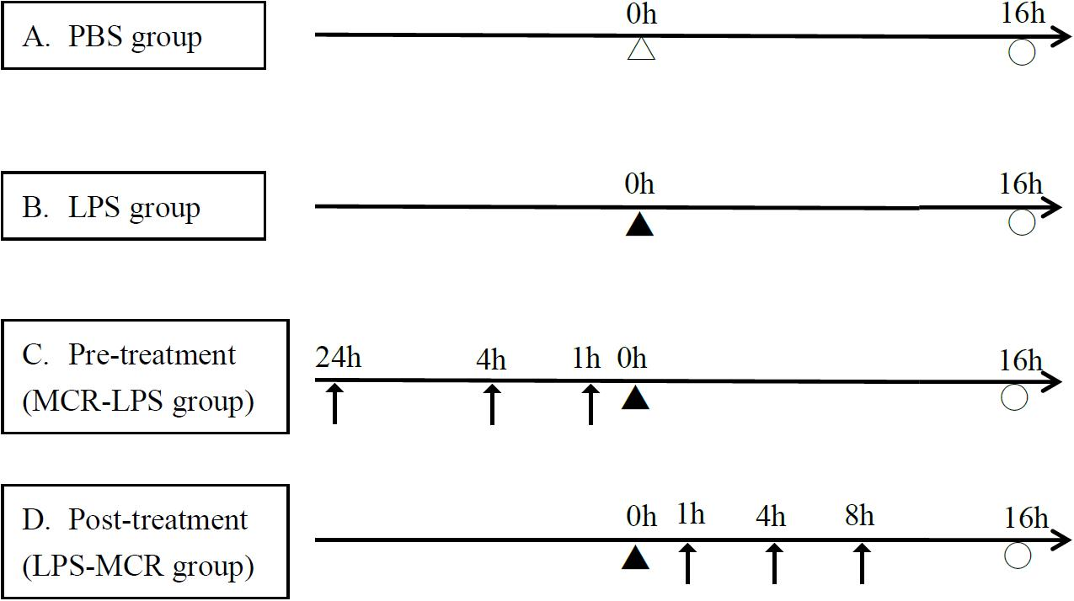
Figure 2.

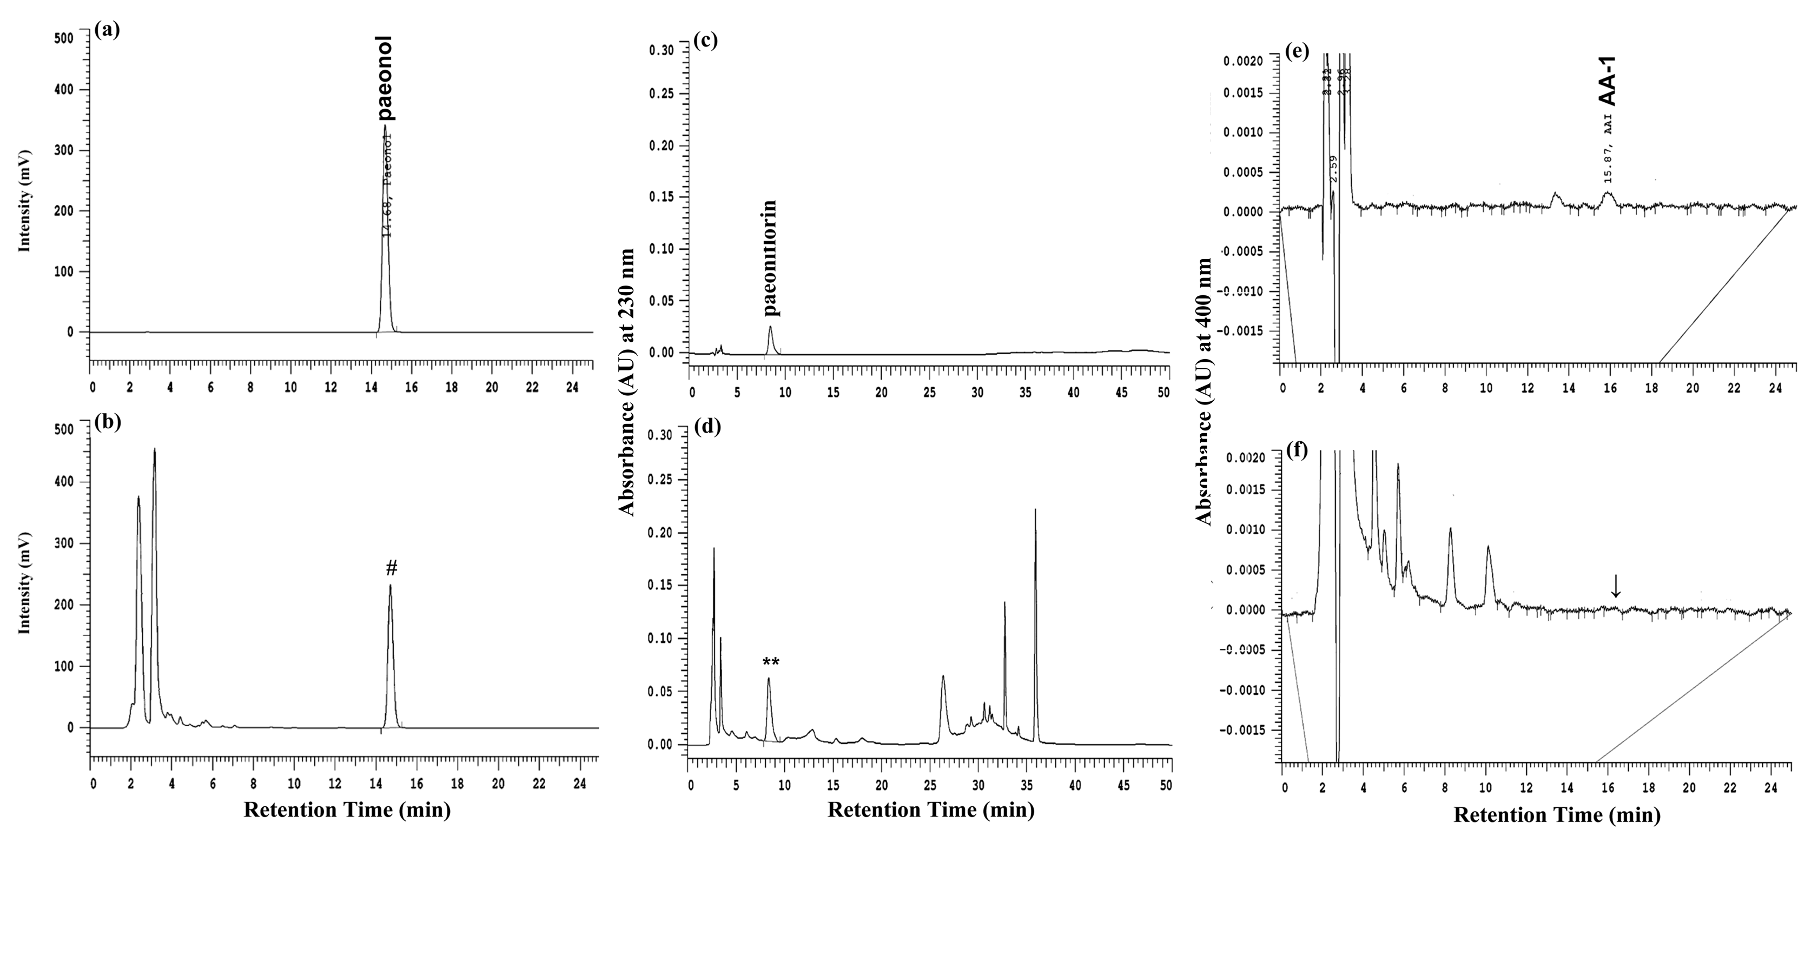
Figure 3.
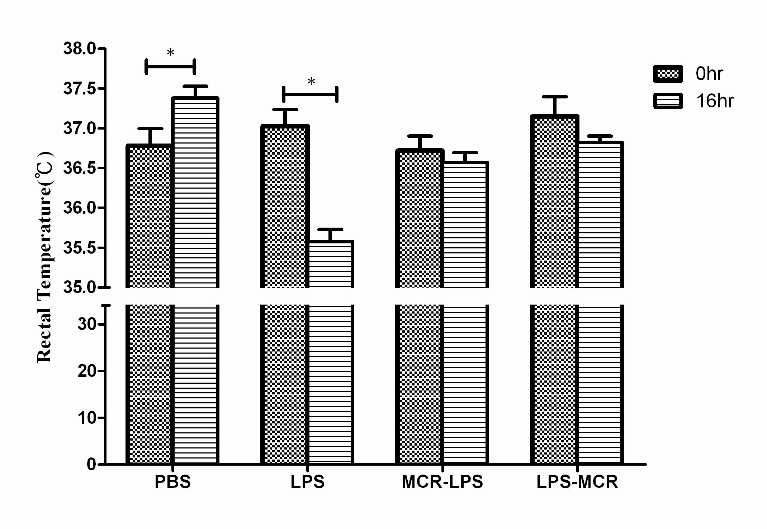
Figure 4.
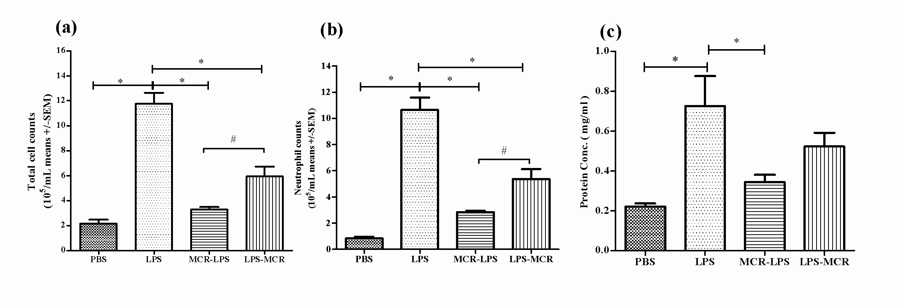
Figure 5.
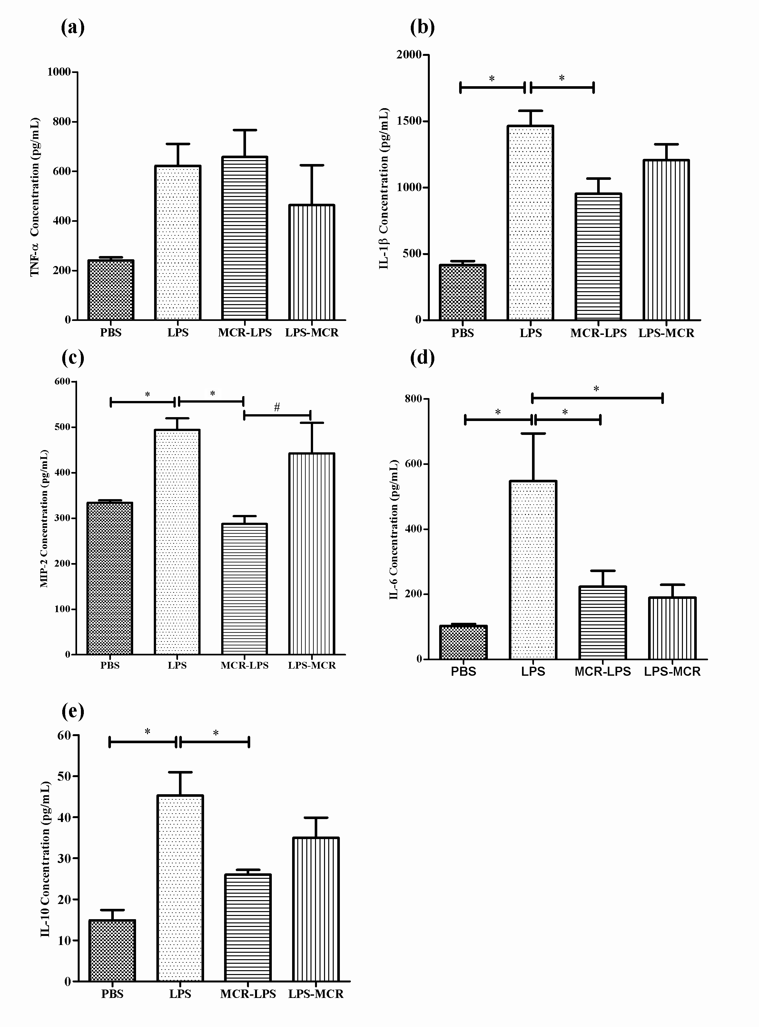
Figure 6.
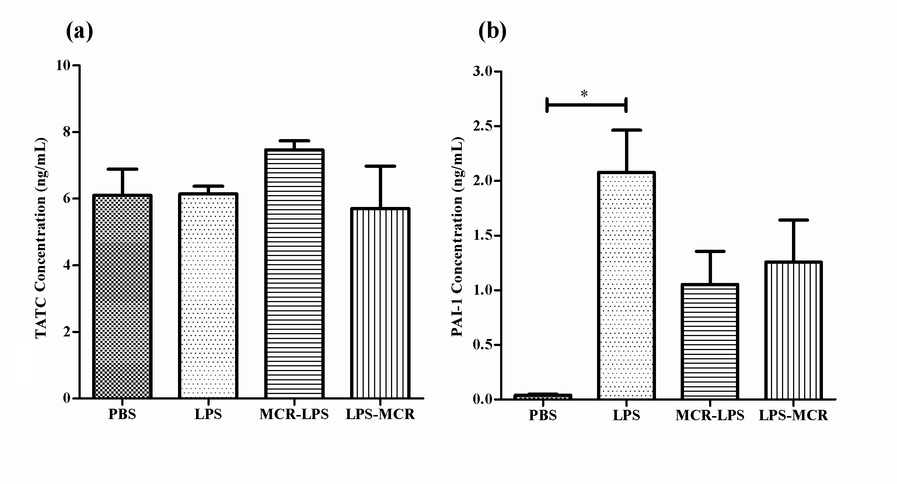
Figure 7
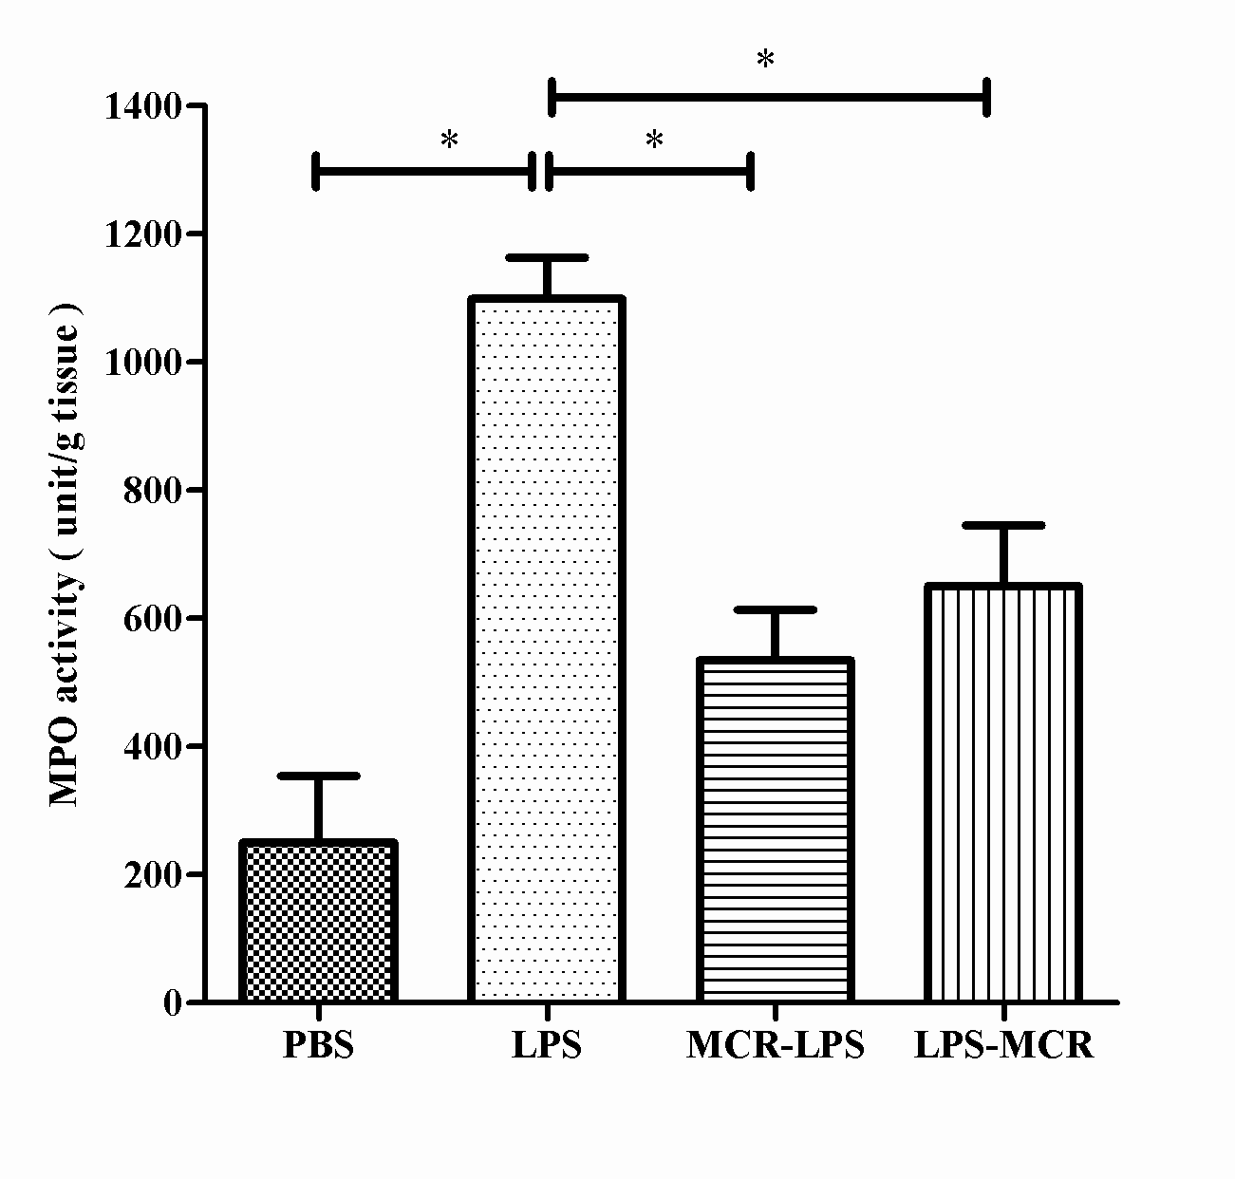
Figure 8.
