Late Intervention-related Complication – Huge Subepicardial Hematoma

Po-Yen Ko, M.D.* †; Chih-Ping Chang, M.D. *†; Chen-Chia Yang, M.D.* †; and Jen-Jyh Lin, M.D. * †

* Division of Cardiology, Department of Medicine, China Medical University Hospital, Taichung 40447, Taiwan
† China Medical University, Taichung 40402, Taiwan

Address correspondence to:
Jen-Jyh Lin, M.D.
Division of Cardiology, Department of Medicine, China Medical University Hospital
2 Yuh-Der Road, Taichung, 40447, TAIWAN
Tel: 886-4-22052121, Ext.: 2371
Fax: 886-4-23602467
E-Mail: kpy0907@hotmail.com

Running title: Late Intervention-related Complication – Huge Subepicardial Hematoma

Key words: hematoma, covered stent, coronary artery perforation

Abstract
A 75-year-old man had a history of triple vessel coronary artery disease, and about a year ago (in August 2009), he had undergone successful PCI to the left circumflex coronary artery (LCX) for management of an in-stent restenosis (ISR) lesion. In September 2010, he began experiencing recurrent episodes of exertional chest pain. Chest radiography showed the left cardiac border bulging upwards. Transthoracic echocardiography and chest computed tomography revealed a huge oval mass of about 10.4 cm × 7.9 cm × 8.6 cm, which showed calcification and was obliterating the LCX. Subsequent coronary angiography revealed a significant ISR, with extravasation of a small amount of contrast material at the stent location, suggesting that the coronary artery had ruptured. We implanted a PTFE-covered stent to seal the coronary perforation and to release the occlusion. The patient was symptom-free and had an uneventful outcome until the 1-year follow up.

Introduction
Coronary artery perforation is a relatively uncommon complication of percutaneous coronary intervention (PCI). Although a majority of these perforations are benign and can often be managed conservatively, some can lead to cardiac tamponade, myocardial infarction, or even death.^{1,2} Herein, we report a rare case of delayed progression of subepicardial hematoma associated with PCI performed about a year ago. The hematoma manifested suddenly during the diagnosis of ischemic heart disease. The patient was successfully treated by implantation of a polytetrafluoroethylene (PTFE)-covered stent to seal the perforation. We emphasize the importance of imaging studies for the initial diagnosis and appropriate management of this disease.
Case report
A 75-year-old man with recently aggravated chest pain was admitted to our institute. He had a history of triple vessel coronary artery disease and a bare metal stent (3.0 × 18 mm, Driver, Metronic) was placed in the left circumflex coronary artery (LCX), and about a year ago (in August 2009), he had undergone successful PCI to the LCX for management of an in-stent restenosis (ISR) lesion. In September 2010, he began experiencing recurrent episodes of exertional chest pain. Physical examination showed that his blood pressure was 120/70 mmHg with a regular pulse of 60 beats per min. His lungs and heart did not show any abnormalities. Chest radiography showed the left cardiac border bulging upwards (Figure 1A). Transthoracic echocardiography (TTE) showed a huge extracardiac mass, probably a hematoma, with high echogenecity, adjacent to the lateral wall of the left ventricle (Figure 1B). Chest computed tomography (CT) revealed a huge oval mass of about 10.4 cm × 7.9 cm × 8.6 cm, which showed calcification and was obliterating the LCX (Figure 1C and 1D). Subsequent coronary angiography revealed a significant ISR, with extravasation of a small amount of contrast material at the stent location, suggesting that the coronary artery had ruptured (Figure 2A). We implanted two PTFE-covered stent (3.0 × 26 mm and 3.5 × 16 mm) to seal the coronary perforation and to release the occlusion. After completion of the procedure, the perforation was completely sealed, and no evidence of extravasation of contrast material was observed (Figure 2B). The patient was symptom-free and had an uneventful outcome until the 1-year follow up.
Discussion
Rupture of the coronary artery rarely occurs among patients undergoing PCI. The most common complication of coronary perforation is the development of hemopericardium, which can lead to cardiac temponade and death. Subepicardial hematoma is an extremely rare complication of coronary perforation, and occurs predominantly in patients who have undergone coronary artery bypass grafting.³ Blood accumulates in the subepicardial space because of the adhesions caused by obliteration of the potential pericardial space after surgical pericardiectomy. The reason for blood loculation at the subepicardium in this patient remains unclear, because the coronary arteries are located on the epicardium. Possibly, the perforation site may be located on the subepicardial side of the coronary artery.
To our knowledge, there are only a few reports of subepicardial hematoma presenting as a complication of PCI in patients who have not undergone cardiac surgery.^{4,5} All of these cases were detected immediately after PCI because of the patients’ unstable hemodynamic status. However, our patient remained asymptomatic for 1 year after the procedure. The hematoma progressed gradually and manifested suddenly during the diagnosis of ischemic heart disease. Hematomas may lead to potentially deadly complications such as cardiac temponade. Hematomas are difficult to diagnose because they may be localized. Interventional cardiologists should always consider the risks of this rare complication. Follow-up imaging studies, including chest radiography, TTE, or CT, may help detect rare complications such as subepicardial hematoma in patients who have undergone complicated interventions.
Although the patient did not undergo IVUS, on the bases of the TTE and the CT findings, he was diagnosed with subepicardial hematoma, 1 year after PCI involving the LCX. Although previous coronary angiograms showed no myocardial blush or extravasation, the echocardiographic and CT findings of this patient were suggestive of LCX hematoma, which indicated extravasation due to coronary perforation. Some case reports have shown the possibility of hematoma resolution over time.^{6,7} Because of persistent extravasation of contrast material and considering the recurrent episodes of ISR at the LCX, first, a surgical approach was considered for managing the hematoma. However, because the patient refused surgical treatment, we finally sealed the perforation via PTFE-covered stent implantation.

The restenosis rate after PTFE-covered stent implantation is known to be high. However, considering the potentially life-threatening complications such as cardiac tamponade, we believed that sealing the perforation via PTFE-covered stent implantation was an acceptable alternative method to prevent this complication.⁸ However, a close follow-up examination of our patient for detecting complications such as late thrombosis and ISR revealed no adverse effects. Therefore, we think that PTFE-covered stent implantation is a safe and effective treatment modality for patients with subepicardial hematoma. To our knowledge, this is the first report of a case of delayed progression of subepicardial hematoma being successfully treated using a PTFE-covered stent. In conclusion, our report provides special images and a novel method for clinical management of this subepicardial hematoma.
Figure 1.
(A) Chest X-ray showed the left cardiac border bulging upwards (arrows). (B) Apical, four-chamber view on transthoracic echocardiography showed a huge extracardiac hematoma adjacent to the lateral wall of the left ventricular (arrows). (C), (D) Computed tomography showed a huge oval mass of about 10.4 cm × 7.9 cm × 8.6 cm, which showed calcification and was obliterating the LCX (arrows).

LCX, left circumflex coronary artery

Figure 2.
(A) Angiography revealed a significant ISR, with extravasation of a small amount of contrast material at the stent location (arrows). (B) Angiography after a PTFE-covered stent was implanted to seal the perforation without evidence of extravasation of contrast material.

ISR, in-stent restenosis

References
1. Fejka M, Dixon SR, Safian RD, O’Neill WW, Grines CL, Finta B,
Marcovitz PA, Kahn JK. Diagnosis, management, and clinical outcome of cardiac tamponade complicating percutaneous coronary intervention. Am J Cardiol 2002;90:1183-6.

2. Von Sohsten R, Kopistansy C, Cohen M, Kussmaul WG 3rd. Cardiac tamponade in the “new device” era: evaluation of 6999 consecutive percutaneous coronary interventions. Am Heart J 2000;140:279-83.

3 . Shekar PS, Stone JR, Couper GS. Dissecting sub-epicardial
hematoma — Challenges to surgical management. Eur J Cardiothorac
Surg. 2004;26:850–3.

4. Rahman N, Sharif H, Jafary FH. Intramyocardial hematoma
after coronary perforation during percutaneous coronary intervention—
anticipated and treated. J Invasive Cardiol 2008;20:
E224–8.

5. Masato Furui, MD · Takeki Ohashi, MD Takeshi Yoshida, MD · et al. Cardiogenic shock without cardiac tamponade caused by a subepicardial hematoma after percutaneous coronary intervention. Gen Thorac Cardiovasc Surg (2011) 59:114–116

6. S Chacko, N abidin, Ma Mamas, M el-omar. Compression syndromes as a complication of percutaneous coronary intervention. Exp Clin Cardiol 2011;16(1):e1-e4.

7. Hye Jin Han, MD, Jin-Oh Choi, MD, Gwan Hyeop Sohn, MD, Kyeong Min Byeon, MD, Yoon Jung Kim, MD, Jin Ho Choi, MD and Seung Woo Park, MD. A Case of Right Coronary Artery Hematoma Detected by Echocardiography after Percutaneous Coronary Intervention. J Cardiovasc Ultrasound 2008;16(4):126-129

8. Li-Sian Lin and Ching-Pei Chen. Right coronary artery pseudoaneurysm treated by graft-stent deployment. Acta Cardiol Sin 2011; 27:259-62
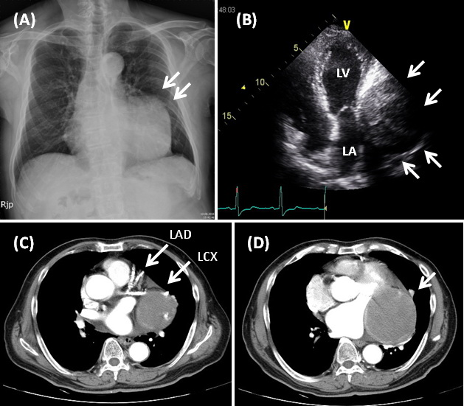
Figure 1
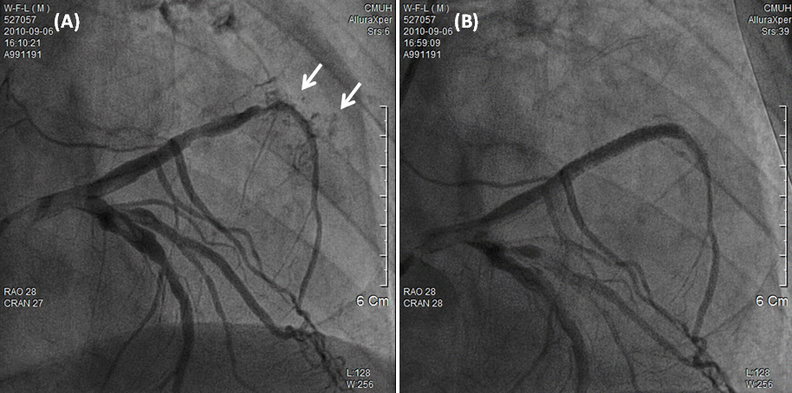
Figure 2

